Volume 01. Electrical Architecture Fundamentals

Chapter 04. Robotics Electrical Architecture

04.01. Robot Controller Architecture
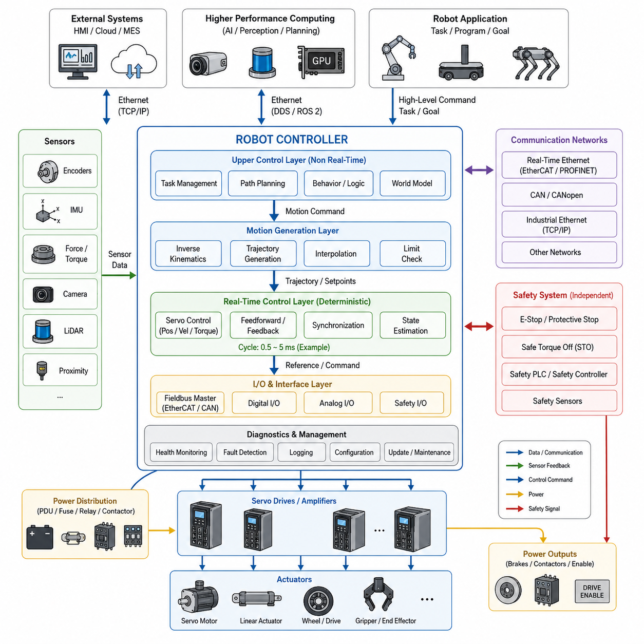
A robot controller is the central computing and coordination element that converts motion commands, task objectives, and sensor information into deterministic actions of the robot. Within the robotics electrical architecture, it connects higher-level software with servo drives, actuators, sensors, communication networks, and safety devices, forming the operational bridge between digital control logic and physical motion.
The controller architecture is normally organized into several computational layers with different timing requirements. High-level functions interpret robot programs, trajectories, navigation goals, or manipulation tasks, while lower layers execute interpolation, kinematic calculations, feedback control, and actuator commands. Separating these functions prevents computationally intensive planning from disturbing time-critical motion control.
At the upper control layer, task commands define what the robot should accomplish rather than directly specifying electrical actuator behavior. A manipulator may receive a target pose, an AMR may receive a destination, and a quadruped may receive a desired velocity. The controller transforms these abstract objectives into coordinated joint, wheel, steering, or propulsion commands through planning and motion-generation functions.
Motion generation converts commanded behavior into trajectories that satisfy position, velocity, acceleration, and often jerk constraints. For articulated robots, inverse kinematics transforms Cartesian targets into joint references, while trajectory interpolation produces continuously updated setpoints. These calculations must respect mechanical limits so that generated motion remains achievable by the physical mechanism and its actuator system.
The real-time control layer executes periodic calculations according to precisely controlled timing. Position, velocity, torque, or current references are exchanged with servo amplifiers at cycle times that may range from milliseconds to fractions of a millisecond. Deterministic scheduling is therefore more important than average computing performance because excessive latency or timing jitter can directly degrade stability and motion quality.
Robot controllers commonly operate with distributed servo electronics rather than directly switching motor power. The central controller calculates coordinated motion references, while servo amplifiers close faster local control loops for current, torque, velocity, or position. This hierarchy distributes computational responsibility and allows the motor-side electronics to respond rapidly even when higher-level trajectory calculations operate at slower rates.
Communication networks are consequently fundamental parts of controller architecture. Real-time industrial Ethernet, EtherCAT, CAN, CANopen, or vendor-specific servo networks may connect the controller with drives and distributed I/O. Higher-bandwidth Ethernet interfaces can connect perception computers or external systems. Different networks are selected according to latency, determinism, bandwidth, synchronization, reliability, and device compatibility.
Sensor interfaces provide the feedback required to estimate the physical state of the robot. Encoders report joint or wheel motion, while IMUs, force-torque sensors, proximity devices, cameras, LiDAR, and other sensors provide information about the body and environment. The controller must associate these measurements with appropriate timestamps and coordinate frames so that control calculations use temporally consistent state information.
Modern robots frequently separate the deterministic robot controller from a higher-performance computing platform. A real-time controller can maintain servo execution and machine-level I/O while an industrial PC, edge computer, or GPU platform performs perception, mapping, optimization, planning, or AI inference. Commands cross a defined interface so that slower or variable AI workloads cannot directly compromise fast actuator control loops.
This separation produces a multi-rate architecture. Perception may update at camera or LiDAR frame rates, planning may operate at tens of cycles per second, trajectory control may operate at hundreds of cycles per second, and motor current regulation may execute at kilohertz rates inside servo drives. Each layer therefore maintains the most recent valid state or command while coordinating information across different execution frequencies.
Safety functions must remain architecturally distinguishable from ordinary robot control. Emergency stops, protective stops, safe torque off, limit monitoring, and safety sensors may use dedicated circuits, safety controllers, or certified communication paths. The normal controller can request safe behavior, but critical protective functions should not depend solely on general-purpose application software continuing to operate correctly.
Power distribution and controller startup behavior are also closely related to architecture. Logic power, sensor power, actuator power, brakes, contactors, and drive-enable signals must enter controlled states during startup and shutdown. The controller typically verifies communication, sensor validity, drive status, safety conditions, and system configuration before enabling motion, preventing uncontrolled actuator activation during initialization.
Diagnostics form another essential controller function because distributed robotic systems can fail at many interfaces. Controllers monitor communication timeouts, encoder faults, drive alarms, temperature, voltage, current, synchronization status, software execution, and safety conditions. Fault information should identify both the affected component and its operational consequence, allowing maintenance personnel or supervisory software to isolate failures efficiently.
Scalable robot controller architectures increasingly use modular interfaces so that actuators, sensors, compute modules, and software components can evolve independently. Standardized communication, device abstraction, configuration management, and well-defined control interfaces reduce coupling between hardware generations. This approach is particularly important when one controller platform must support mobile robots, manipulators, quadrupeds, or other robotic configurations.
Ultimately, robot controller architecture is not a single computer but a coordinated hierarchy of computation, communication, sensing, actuation, power, and safety. Its effectiveness depends on assigning each function to the appropriate timing and reliability domain. Higher layers determine desired behavior, deterministic layers coordinate motion, servo drives execute rapid local regulation, and independent safety mechanisms constrain the entire system when hazardous conditions arise.

04.02. Servo Amplifier Network
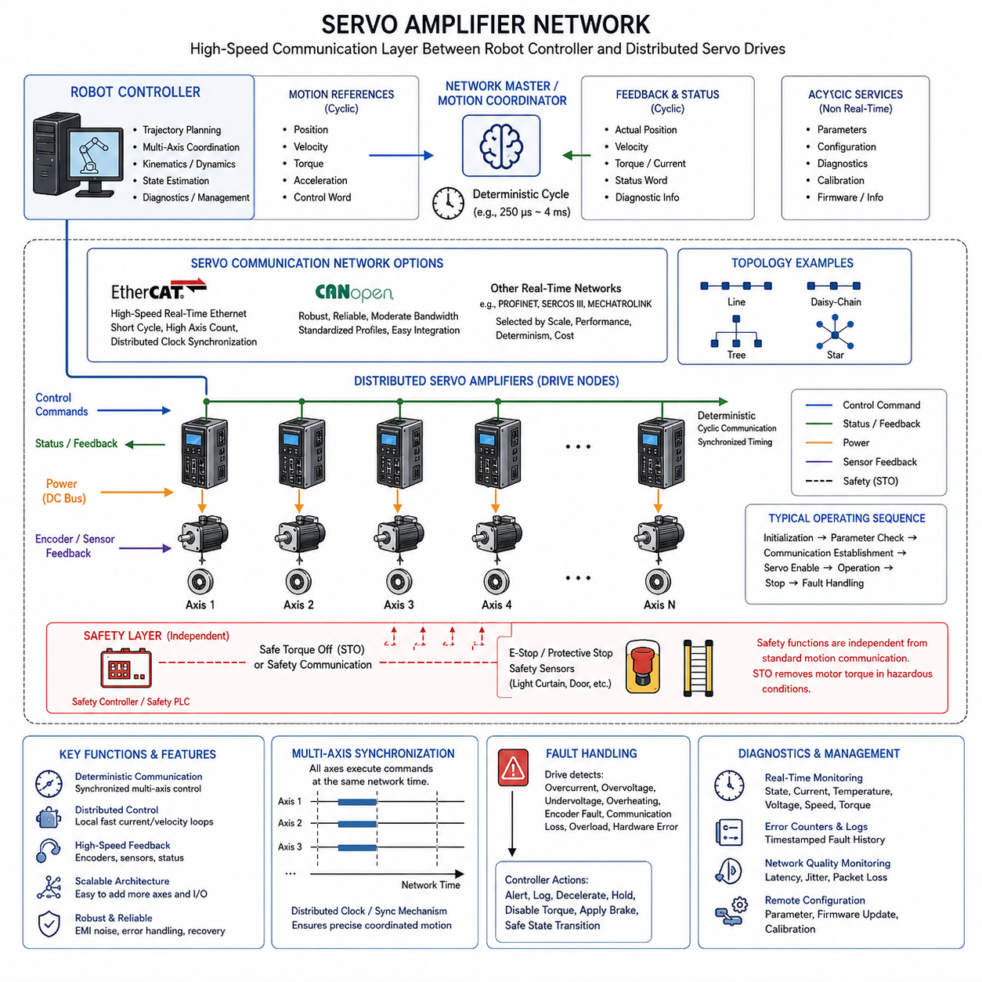
A servo amplifier network forms the high-speed electrical and communication layer between the robot controller and distributed servo drives. Its primary purpose is to deliver synchronized motion references to multiple axes while returning position, velocity, torque, current, status, and diagnostic information. In multi-axis robots, this network enables physically separated actuators to behave as one coordinated motion system.
The robot controller typically operates as the network master or motion coordinator, while servo amplifiers operate as distributed drive nodes. The controller calculates trajectories and axis references, then transmits commands to the appropriate drives according to a deterministic communication cycle. Each amplifier converts these references into local motor-control actions while continuously reporting its operating state to the controller.
A servo amplifier is more than a power conversion device. It contains control electronics that regulate motor current, torque, velocity, or position using feedback from encoders and other internal measurements. Fast current regulation is normally executed locally because the required bandwidth is much higher than that of trajectory planning. This distributed hierarchy reduces communication burden while preserving rapid actuator response.
The network must provide deterministic timing because coordinated robot motion depends on predictable command delivery. Conventional Ethernet can provide high bandwidth but does not inherently guarantee the timing required for tightly synchronized motion. Industrial real-time networks therefore introduce mechanisms for cyclic communication, scheduling, synchronization, and bounded latency so that multiple servo axes receive and execute references at controlled times.
EtherCAT is widely suited to distributed motion architectures because multiple servo drives, I/O devices, and sensors can be connected through a high-speed deterministic Ethernet-based network. Frames pass through connected nodes while process data is exchanged efficiently, supporting short cyclic update periods. Distributed clock mechanisms can synchronize drive nodes so that physically separated axes maintain a common timing reference.
CAN and CANopen provide another practical approach, particularly where bandwidth requirements are moderate and robust distributed control is more important than extremely short cycle times. CAN supplies reliable message arbitration and error handling, while CANopen adds standardized device profiles and communication objects. CANopen-based servo systems can therefore integrate motor controllers, encoders, I/O modules, and other devices through a relatively simple network.
The selection between EtherCAT, CANopen, and other servo communication technologies depends on robot scale and control requirements. High-axis-count manipulators and dynamically coordinated machines may require short cycle times and precise synchronization, favoring real-time Ethernet. Mobile robots with fewer drive axes may use CAN or CANopen effectively because wheel and steering control can often tolerate lower network bandwidth.
Network topology strongly affects physical implementation. Servo amplifiers may be connected using line, daisy-chain, tree, or other supported arrangements depending on the communication technology. Distributed placement near motors can reduce high-current motor cable length but requires additional communication and power routing. Centralized drive cabinets simplify environmental protection while increasing cable distance between amplifiers and actuators.
Multi-axis synchronization is particularly important for manipulators, humanoids, quadrupeds, and coordinated mobile platforms. A commanded Cartesian movement may require several joints to accelerate and decelerate together. If individual drives execute references at inconsistent times, trajectory accuracy deteriorates even when every axis is locally stable. Network synchronization therefore becomes part of the robot's overall motion-control performance.
The servo network normally carries cyclic and acyclic information simultaneously. Cyclic process data contains rapidly changing values such as target position, actual position, velocity, torque, control words, and status words. Acyclic communication is used for parameters, configuration, diagnostics, calibration values, firmware information, and less time-critical service functions. Separating these traffic classes protects deterministic control performance.
Feedback information travels in the opposite direction from motion commands and closes the distributed control hierarchy. Encoders provide rotor or joint position information to the servo amplifier, which may execute local current and velocity loops before returning processed state information to the robot controller. The controller combines these measurements across multiple axes to maintain coordinated trajectory execution and system-level state estimation.
Servo amplifiers also exchange state and enable information through the network. Typical operating sequences include initialization, parameter verification, communication establishment, servo enable, controlled operation, stopping, and fault handling. The controller should verify that every required axis has entered the correct state before coordinated motion begins, preventing one inactive or incorrectly configured drive from producing unexpected mechanical behavior.
Safety functions must be distinguished from ordinary servo communication. A standard motion command requesting zero velocity is not equivalent to a safety-rated stop. Functions such as Safe Torque Off (STO) may use dedicated electrical signals or certified safety communication depending on system architecture. This allows hazardous motor torque to be removed independently of normal trajectory software when a safety condition occurs.
Fault handling is essential because a servo network connects components that experience substantial electrical and mechanical stress. Drives can detect overcurrent, overvoltage, undervoltage, overheating, encoder faults, communication loss, motor overload, and internal hardware errors. The controller must interpret these conditions at system level because a fault on one joint may require coordinated deceleration or stopping of several other axes.
Communication-loss behavior must be explicitly designed rather than treated as an exceptional software event. A servo drive should define what occurs when cyclic commands disappear, synchronization is lost, or the master becomes unavailable. Depending on the robot and hazard analysis, the response may involve controlled deceleration, holding position, disabling torque, applying a mechanical brake, or transitioning into a predefined safe state.
Electrical design also influences servo network reliability. Motor inverter switching produces substantial electromagnetic interference, while communication cables may carry high-speed differential signals near high-current power conductors. Proper grounding, shielding, cable separation, connector selection, termination, and routing are therefore necessary to prevent communication errors. Network architecture and physical harness engineering must consequently be designed together.
Diagnostics should provide visibility from the robot controller down to individual servo axes. Engineers need to identify communication errors, synchronization deviations, drive states, encoder problems, thermal conditions, current limits, and fault histories. Timestamped diagnostic information is especially valuable because many robot failures involve interactions between mechanical loading, electrical behavior, communication timing, and software commands.
Scalable servo amplifier networks allow the same controller architecture to support robots with different numbers and types of actuators. Additional wheel drives, manipulator joints, steering actuators, grippers, or auxiliary axes can be introduced as distributed nodes when communication capacity and timing budgets permit. Standardized interfaces reduce dependence on individual hardware implementations and simplify modular robot development.
Ultimately, the servo amplifier network creates the deterministic bridge between coordinated motion computation and physical actuator execution. The robot controller determines the required multi-axis behavior, the network distributes synchronized references, and each servo amplifier performs rapid local regulation of its motor. Reliable robotics therefore depends not only on powerful controllers and motors, but also on predictable communication connecting them as one integrated control system. A servo amplifier network forms the high-speed electrical and communication layer between the robot controller and distributed servo drives. Its primary purpose is to deliver synchronized motion references to multiple axes while returning position, velocity, torque, current, status, and diagnostic information. In multi-axis robots, this network enables physically separated actuators to behave as one coordinated motion system.
The robot controller typically operates as the network master or motion coordinator, while servo amplifiers operate as distributed drive nodes. The controller calculates trajectories and axis references, then transmits commands to the appropriate drives according to a deterministic communication cycle. Each amplifier converts these references into local motor-control actions while continuously reporting its operating state to the controller.
A servo amplifier is more than a power conversion device. It contains control electronics that regulate motor current, torque, velocity, or position using feedback from encoders and other internal measurements. Fast current regulation is normally executed locally because the required bandwidth is much higher than that of trajectory planning. This distributed hierarchy reduces communication burden while preserving rapid actuator response.
The network must provide deterministic timing because coordinated robot motion depends on predictable command delivery. Conventional Ethernet can provide high bandwidth but does not inherently guarantee the timing required for tightly synchronized motion. Industrial real-time networks therefore introduce mechanisms for cyclic communication, scheduling, synchronization, and bounded latency so that multiple servo axes receive and execute references at controlled times.
EtherCAT is widely suited to distributed motion architectures because multiple servo drives, I/O devices, and sensors can be connected through a high-speed deterministic Ethernet-based network. Frames pass through connected nodes while process data is exchanged efficiently, supporting short cyclic update periods. Distributed clock mechanisms can synchronize drive nodes so that physically separated axes maintain a common timing reference.
CAN and CANopen provide another practical approach, particularly where bandwidth requirements are moderate and robust distributed control is more important than extremely short cycle times. CAN supplies reliable message arbitration and error handling, while CANopen adds standardized device profiles and communication objects. CANopen-based servo systems can therefore integrate motor controllers, encoders, I/O modules, and other devices through a relatively simple network.
The selection between EtherCAT, CANopen, and other servo communication technologies depends on robot scale and control requirements. High-axis-count manipulators and dynamically coordinated machines may require short cycle times and precise synchronization, favoring real-time Ethernet. Mobile robots with fewer drive axes may use CAN or CANopen effectively because wheel and steering control can often tolerate lower network bandwidth.
Network topology strongly affects physical implementation. Servo amplifiers may be connected using line, daisy-chain, tree, or other supported arrangements depending on the communication technology. Distributed placement near motors can reduce high-current motor cable length but requires additional communication and power routing. Centralized drive cabinets simplify environmental protection while increasing cable distance between amplifiers and actuators.
Multi-axis synchronization is particularly important for manipulators, humanoids, quadrupeds, and coordinated mobile platforms. A commanded Cartesian movement may require several joints to accelerate and decelerate together. If individual drives execute references at inconsistent times, trajectory accuracy deteriorates even when every axis is locally stable. Network synchronization therefore becomes part of the robot's overall motion-control performance.
The servo network normally carries cyclic and acyclic information simultaneously. Cyclic process data contains rapidly changing values such as target position, actual position, velocity, torque, control words, and status words. Acyclic communication is used for parameters, configuration, diagnostics, calibration values, firmware information, and less time-critical service functions. Separating these traffic classes protects deterministic control performance.
Feedback information travels in the opposite direction from motion commands and closes the distributed control hierarchy. Encoders provide rotor or joint position information to the servo amplifier, which may execute local current and velocity loops before returning processed state information to the robot controller. The controller combines these measurements across multiple axes to maintain coordinated trajectory execution and system-level state estimation.
Servo amplifiers also exchange state and enable information through the network. Typical operating sequences include initialization, parameter verification, communication establishment, servo enable, controlled operation, stopping, and fault handling. The controller should verify that every required axis has entered the correct state before coordinated motion begins, preventing one inactive or incorrectly configured drive from producing unexpected mechanical behavior.
Safety functions must be distinguished from ordinary servo communication. A standard motion command requesting zero velocity is not equivalent to a safety-rated stop. Functions such as Safe Torque Off (STO) may use dedicated electrical signals or certified safety communication depending on system architecture. This allows hazardous motor torque to be removed independently of normal trajectory software when a safety condition occurs.
Fault handling is essential because a servo network connects components that experience substantial electrical and mechanical stress. Drives can detect overcurrent, overvoltage, undervoltage, overheating, encoder faults, communication loss, motor overload, and internal hardware errors. The controller must interpret these conditions at system level because a fault on one joint may require coordinated deceleration or stopping of several other axes.
Communication-loss behavior must be explicitly designed rather than treated as an exceptional software event. A servo drive should define what occurs when cyclic commands disappear, synchronization is lost, or the master becomes unavailable. Depending on the robot and hazard analysis, the response may involve controlled deceleration, holding position, disabling torque, applying a mechanical brake, or transitioning into a predefined safe state.
Electrical design also influences servo network reliability. Motor inverter switching produces substantial electromagnetic interference, while communication cables may carry high-speed differential signals near high-current power conductors. Proper grounding, shielding, cable separation, connector selection, termination, and routing are therefore necessary to prevent communication errors. Network architecture and physical harness engineering must consequently be designed together.
Diagnostics should provide visibility from the robot controller down to individual servo axes. Engineers need to identify communication errors, synchronization deviations, drive states, encoder problems, thermal conditions, current limits, and fault histories. Timestamped diagnostic information is especially valuable because many robot failures involve interactions between mechanical loading, electrical behavior, communication timing, and software commands.
Scalable servo amplifier networks allow the same controller architecture to support robots with different numbers and types of actuators. Additional wheel drives, manipulator joints, steering actuators, grippers, or auxiliary axes can be introduced as distributed nodes when communication capacity and timing budgets permit. Standardized interfaces reduce dependence on individual hardware implementations and simplify modular robot development.
Ultimately, the servo amplifier network creates the deterministic bridge between coordinated motion computation and physical actuator execution. The robot controller determines the required multi-axis behavior, the network distributes synchronized references, and each servo amplifier performs rapid local regulation of its motor. Reliable robotics therefore depends not only on powerful controllers and motors, but also on predictable communication connecting them as one integrated control system.

04.03. ROS2 Based Architecture
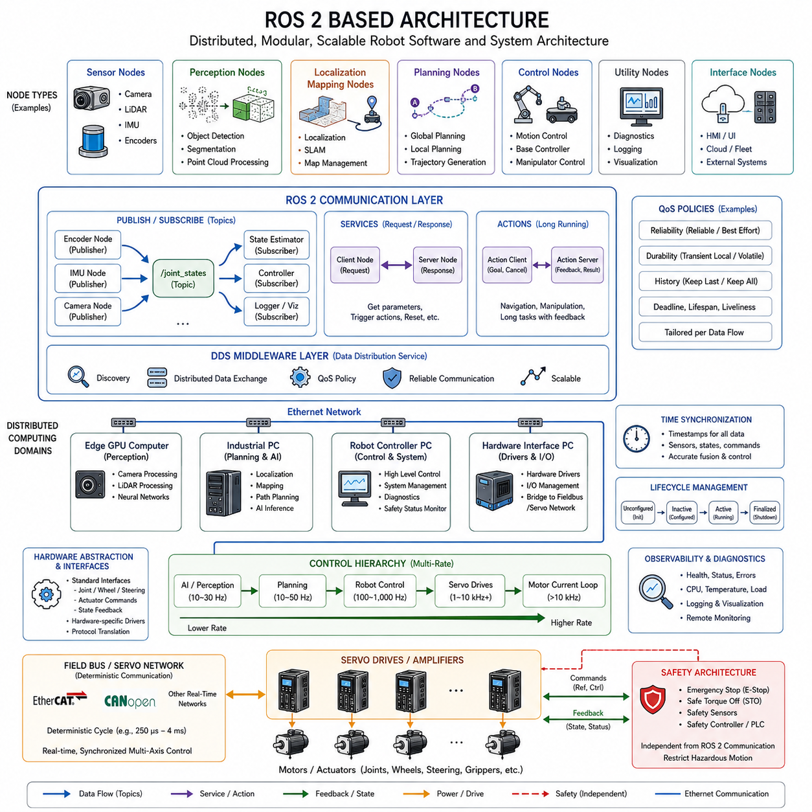
ROS 2 based architecture introduces a distributed software communication framework into the robot electrical and computing architecture. Instead of organizing every function inside one monolithic controller, sensing, perception, localization, planning, control, diagnostics, and external interfaces can operate as separate software components. These components communicate through standardized interfaces while remaining deployable across different processors and computers.
The fundamental software element is the ROS 2 node. A node normally represents a specific functional responsibility such as reading an encoder, processing LiDAR data, estimating robot pose, generating a trajectory, commanding a mobile base, or monitoring system health. Dividing functionality into nodes improves modularity because individual components can be developed, tested, replaced, and restarted without redesigning the complete robot software system.
Nodes exchange continuously produced information through topics using a publisher and subscriber model. A sensor node may publish camera images, joint states, IMU measurements, or point clouds, while several other nodes subscribe to the same information independently. This many-to-many communication structure reduces direct software dependencies and makes it easier to add new perception, logging, visualization, or diagnostic functions.
Services provide request-response communication for operations that do not require continuous streaming. A node can request configuration information, trigger a device operation, reset a subsystem, or obtain a specific result from another node. Actions extend this concept to longer-running operations such as navigation or manipulation tasks, where the requester requires progress feedback and the ability to cancel or modify an executing goal.
ROS 2 communication is built around the Data Distribution Service (DDS) model, although implementations may use different supported middleware technologies. DDS provides discovery, distributed data exchange, and configurable communication behavior without requiring every application node to maintain direct socket connections. This middleware layer allows software components running on different computing devices to participate in a common distributed robotic system.
Quality of Service (QoS) policies are important because robotic data streams have different communication requirements. A control state may require reliable delivery, while a high-rate camera stream may prioritize fresh data over retransmission of old frames. Reliability, durability, history depth, deadline, lifespan, and related policies allow communication behavior to be adapted to the meaning and timing requirements of each data flow.
ROS 2 architecture can span multiple computing domains inside the same robot. Sensor-processing nodes may execute on an edge GPU, navigation and planning may run on an industrial PC, and hardware-interface nodes may operate closer to the robot controller. Ethernet provides the physical communication backbone between these computers, while ROS 2 and DDS provide software-level discovery and message exchange above the network transport.
This distributed structure is especially useful for computationally intensive robotics functions. Cameras and LiDAR can generate large data streams that are processed by GPU-based perception nodes, while localization, mapping, world representation, path planning, and AI inference operate at their own update rates. The resulting commands are then transferred toward lower-level control components responsible for deterministic physical execution.
ROS 2 should not automatically be considered a replacement for a deterministic servo network. Motor current regulation, high-speed servo loops, and tightly synchronized multi-axis control often require dedicated real-time controllers, EtherCAT, CANopen, or equivalent technologies. ROS 2 is therefore commonly positioned above these fast control layers, providing system-level coordination while specialized networks handle actuator-level deterministic communication.
A hardware abstraction boundary helps connect these two domains. ROS 2 control components can expose standardized joint, wheel, steering, or actuator interfaces while hardware-specific drivers translate them into commands understood by the underlying servo system. Feedback from encoders and drives travels in the reverse direction, allowing higher-level ROS 2 software to observe robot state without depending directly on every hardware protocol.
The architecture consequently becomes a multi-rate hierarchy. AI perception may operate according to sensor frame rates, navigation and planning may execute at tens of hertz, robot control may operate at hundreds or thousands of hertz, and internal servo current loops can operate even faster. Interfaces between these layers must preserve valid commands and state information without assuming that every subsystem executes at the same frequency.
Time synchronization becomes increasingly important when multiple computers and sensors participate in the architecture. Camera frames, LiDAR scans, IMU measurements, joint states, and control information must be associated with meaningful timestamps. Accurate timing allows sensor fusion and state estimation algorithms to reconstruct the physical situation consistently even when information originates from devices operating at different rates and locations.
Lifecycle management can improve operational reliability by controlling how software components initialize, configure, activate, deactivate, and shut down. A robot should not begin autonomous motion simply because individual processes have started. Sensor availability, communication status, localization validity, controller readiness, and other prerequisites can be checked before higher-level functions transition into an active operating state.
Diagnostics and observability are natural advantages of a distributed ROS 2 architecture. Nodes can publish health information, communication status, sensor validity, computational load, temperatures, errors, and operating modes. Logging and visualization tools can observe these interfaces without being tightly integrated with the control application, helping engineers analyze failures across sensing, computing, networking, and actuation layers.
Safety architecture must remain clearly separated from ordinary ROS 2 communication. An emergency stop or Safe Torque Off (STO) function should not depend solely on a conventional ROS 2 message reaching the correct application node. Safety-rated controllers, circuits, sensors, and communication mechanisms can independently restrict hazardous motion, while ROS 2 receives safety status and coordinates normal software behavior around those constraints.
Network design must also consider bandwidth and traffic separation. Multiple cameras, 3D LiDAR, maps, and AI outputs can consume substantial Ethernet capacity, while control and diagnostic messages may require predictable delivery. Engineers may therefore use network segmentation, traffic prioritization, suitable QoS policies, and dedicated actuator networks so that large perception streams do not interfere with communication required for physical robot control.
ROS 2 based architecture also supports scalability beyond a single robot computer. New sensors, manipulators, edge processors, user interfaces, or application modules can be integrated through defined topics, services, actions, and hardware interfaces. The same architectural principles can support an AMR, mobile manipulator, quadruped, or other robotic platform while allowing hardware-specific components to remain isolated behind modular interfaces.
Ultimately, ROS 2 provides the distributed software coordination layer that connects sensing, computation, intelligence, and robot control. Its greatest architectural value comes from combining modular nodes, standardized communication, configurable QoS, distributed computing, and hardware abstraction. When integrated with deterministic servo control and independent safety mechanisms, it enables a robot to combine flexible high-level intelligence with reliable low-level physical execution.

04.04. Real Time Control Layer
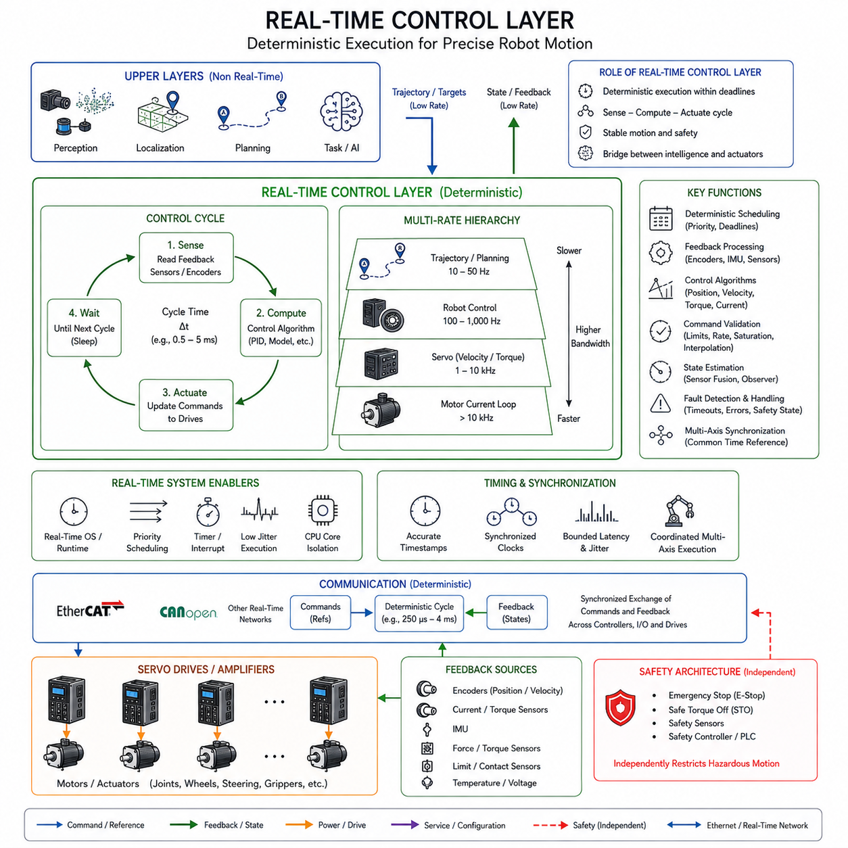
The real-time control layer is the deterministic execution domain that converts planned robot motion into precisely timed commands for physical actuators. It operates below perception, planning, and task-level software, where predictable timing becomes more important than computational flexibility. Its primary responsibility is to maintain stable motion by repeatedly reading feedback, calculating control outputs, and updating actuator references within defined deadlines.
Real-time behavior does not simply mean that calculations are performed quickly. A real-time system must complete critical operations within known timing limits, even when other computational activities are occurring. For robot control, the maximum latency and timing variation are therefore often more important than average execution speed. Missing a control deadline can introduce phase delay, reduce control quality, or destabilize a fast mechanical system.
The control layer normally operates through periodic execution cycles. During each cycle, the controller receives the latest joint, wheel, steering, or actuator states, compares them with commanded references, calculates the required control response, and transmits updated commands. This Sense–Compute–Actuate sequence repeats continuously, creating the feedback loop that connects software calculations with the physical dynamics of the robot.
Different control functions operate at different frequencies. High-level trajectory planning may update at tens of hertz, while joint or mobile-base control can execute at hundreds or thousands of hertz. Servo drives may regulate velocity or torque at still higher frequencies, and motor current loops can operate at several kilohertz or more. The architecture must therefore coordinate multiple control rates rather than assuming one universal execution frequency.
A common hierarchy separates trajectory control, position control, velocity control, torque control, and current regulation according to required bandwidth. The robot controller may calculate position or velocity references, while servo amplifiers execute faster local loops. Motor current regulation is usually placed close to the power electronics because it requires rapid sampling and response. Each lower layer reacts faster than the supervisory layer above it.
Feedback is fundamental to real-time control. Encoders provide position and velocity information, while current sensors, torque sensors, IMUs, force-torque sensors, and other devices can contribute additional state information. The usefulness of these measurements depends not only on accuracy but also on timing. Delayed, inconsistent, or incorrectly timestamped feedback can cause the controller to calculate commands from a state that no longer represents the physical robot.
Deterministic communication is consequently part of the control loop itself. EtherCAT, CANopen, and other real-time communication technologies can transfer commands and feedback between controllers, distributed I/O, and servo amplifiers. The communication cycle must be coordinated with computation and actuator updates so that sensor acquisition, control calculation, message transmission, and drive execution occur in a predictable sequence.
Synchronization becomes especially important in multi-axis robots. A manipulator trajectory may require several joints to reach coordinated positions simultaneously, while quadruped locomotion requires multiple leg actuators to maintain carefully timed relationships. Even small timing differences between axes can produce tracking errors or unwanted forces. Shared clocks and synchronized communication help ensure that distributed servo nodes execute commands against a common time reference.
Real-time scheduling determines when individual software tasks are allowed to execute. Critical control functions are normally assigned predictable priorities and execution periods, while less critical activities such as logging, visualization, parameter management, or user interfaces must not delay them. A real-time operating system or dedicated runtime can provide priority scheduling, bounded interrupt handling, timers, and mechanisms that reduce uncontrolled scheduling variation.
Timing jitter describes variation in the actual execution time of a periodic control task relative to its intended schedule. Even when the average control frequency is correct, excessive jitter can reduce motion smoothness and control stability. Designers therefore analyze worst-case execution time, scheduling latency, communication delay, interrupt behavior, and processor loading rather than evaluating the controller only by its nominal CPU performance.
The real-time control layer also provides an important boundary between higher-level intelligence and direct actuator execution. AI perception, world models, navigation, and planning may produce commands at slower or variable rates. These commands should normally become bounded references, trajectories, or operating targets rather than uncontrolled motor outputs. The real-time layer validates and executes them according to physical constraints and control-loop timing.
This boundary is particularly important in Physical AI systems where GPU-based computation can have variable execution latency. A perception or planning update may arrive at 10, 20, or 30 Hz, while a motion controller continues operating at hundreds of hertz. Between higher-level updates, the real-time controller maintains the latest valid trajectory or setpoint and continuously calculates actuator commands rather than waiting for a new AI inference result during every cycle.
Command validation protects the physical system from inappropriate references. Position, velocity, acceleration, torque, current, and jerk limits can be checked before commands reach lower-level drives. Rate limiters, saturation logic, trajectory interpolation, and operating-state checks can prevent abrupt transitions. These mechanisms create a controlled interface between potentially complex higher-level decisions and the finite capabilities of motors and mechanisms.
State estimation may also participate in the real-time layer when control requires information that cannot be measured directly. Encoder, IMU, force, and other sensor measurements can be combined to estimate velocity, orientation, contact state, or other variables required by the controller. The estimator must operate with sufficiently predictable timing so that its output represents the same physical time horizon as the control calculations consuming it.
Fault detection is integrated closely with deterministic execution. The controller can monitor missed deadlines, communication timeouts, excessive tracking error, invalid sensor data, actuator saturation, drive faults, and synchronization loss. When abnormal conditions occur, predefined responses may include limiting commands, controlled deceleration, holding position, disabling an axis, or requesting a transition to a safer operating state.
Real-time control and functional safety are related but should not be treated as identical concepts. A deterministic controller can perform highly reliable motion control without being a safety-rated system. Emergency stops, Safe Torque Off, safety sensors, and certified protective functions may therefore operate through independent safety circuits or safety controllers. The real-time layer coordinates normal stopping behavior while the safety layer retains authority to restrict hazardous motion.
ROS 2 and similar distributed software frameworks can interface with the real-time layer without replacing its timing discipline. Higher-level ROS 2 nodes may provide trajectories, navigation commands, or actuator targets through defined hardware interfaces. Real-time components then execute the fast control loops, while EtherCAT, CANopen, or dedicated drive interfaces provide deterministic communication toward servo amplifiers and actuators.
Resource isolation becomes increasingly important when real-time control shares hardware with perception or AI workloads. CPU cores, memory access, interrupts, network interfaces, and operating-system services can create interference that increases latency. Dedicated processor cores, real-time priorities, separated communication paths, or physically separate controllers may be used when stronger timing guarantees are required for reliable robot operation.
Ultimately, the real-time control layer transforms asynchronous robot intelligence into continuous, deterministic physical behavior. Higher-level systems decide what the robot should do, while this layer determines how commands are executed reliably from one control cycle to the next. By combining feedback control, deterministic scheduling, synchronized communication, multi-rate execution, command validation, and fault handling, it forms the timing-critical foundation of robot motion.

04.05. Safety Layer Integration
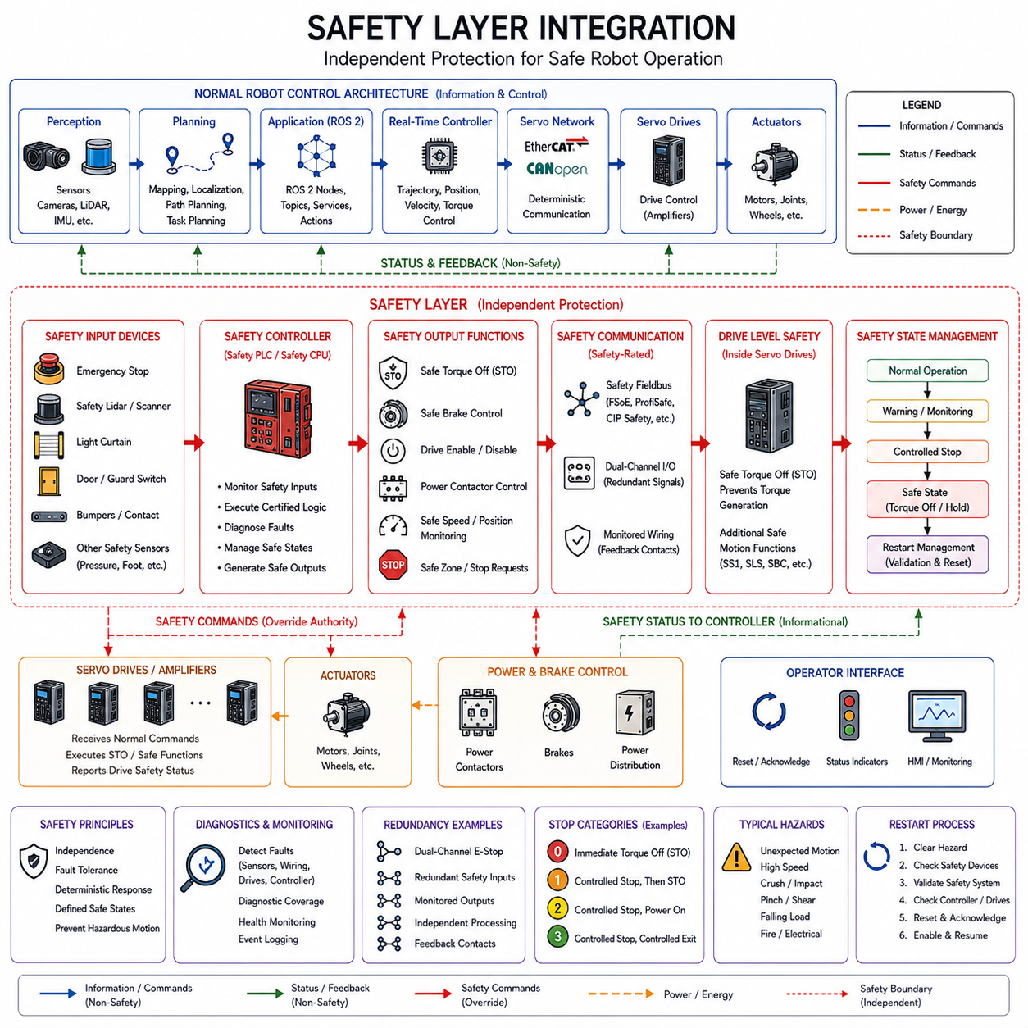
Safety layer integration establishes an independent protection structure around the normal robot control architecture so that hazardous motion can be restricted even when application software, communication, or control functions fail. Rather than treating safety as another software feature, the architecture assigns safety functions to dedicated circuits, safety controllers, sensors, communication paths, and drive-level mechanisms with clearly defined authority over robot motion.
The safety layer operates alongside the normal control hierarchy rather than simply underneath it. Perception, planning, ROS 2 applications, real-time controllers, and servo networks determine normal robot behavior, while the safety system continuously evaluates whether that behavior is permitted. When a hazardous condition is detected, safety logic can override normal commands and force the system toward a predefined safe state.
Emergency Stop is one of the most fundamental protective functions. An emergency-stop device provides an intentional means of stopping hazardous operation when an abnormal situation is recognized. Its signal is normally processed through a safety-rated electrical path rather than ordinary application software. The resulting response can disable actuator torque, initiate an appropriate stopping sequence, or control power switching according to the system design.
Protective stopping extends this concept to automatically detected hazards. Safety LiDAR, light curtains, safety scanners, door switches, bumpers, contact sensors, or other protective devices can define monitored regions and operating conditions. When a person or obstacle enters a protected area, the safety controller can request deceleration, stop motion, or prevent restart until the required safety conditions have been restored.
Safe Torque Off (STO) provides a direct mechanism for preventing a motor drive from generating torque. Unlike a normal zero-velocity command, STO does not depend on the motion-control algorithm continuing to execute correctly. The function is typically implemented within the servo drive or amplifier using safety-related hardware inputs or certified safety communication, creating an important final protection boundary close to the actuator.
Not every safety response requires immediate removal of torque. Depending on the robot and hazard, a controlled stop may first reduce velocity while maintaining active motor control, after which torque can be removed. Other situations may require holding position or activating a mechanical brake. Safety integration therefore requires clearly defined stop categories and state transitions rather than one universal shutdown response.
A safety controller or safety PLC can coordinate protective devices and actuator safety functions across the robot. It evaluates safety inputs, executes certified logic, and generates outputs controlling STO, brakes, contactors, drive enables, or other protective mechanisms. Separating this logic from the general-purpose robot controller reduces dependence on complex application software when executing critical safety functions.
The normal robot controller still requires visibility into safety status. Information such as emergency-stop state, protective-zone status, safety-controller state, drive safety state, or permission to move can be supplied to the control software. This allows trajectory generation and operating logic to respond appropriately, but informational monitoring must not become the only path responsible for executing the underlying safety function.
Integration with the real-time control layer requires a clear division of responsibility. Under normal conditions, the real-time controller performs deterministic position, velocity, torque, and trajectory control. When the safety layer requests a controlled response, the controller may perform coordinated deceleration or motion limitation. However, independent safety mechanisms retain the ability to disable hazardous actuation if the normal controller does not respond correctly.
Servo amplifier integration is therefore central to the safety architecture. Modern drive systems can expose safety functions through dedicated terminals or safety communication interfaces. STO can prevent torque generation, while system-specific designs may incorporate additional safe motion functions. The important architectural principle is that the drive must recognize safety authority independently from ordinary cyclic motion references arriving through the normal servo network.
Communication architecture must distinguish standard robot data from safety-related communication. ROS 2, conventional Ethernet, CAN, or ordinary control messages can distribute operational information, but safety-critical commands may require dedicated wiring or certified safety protocols. This separation prevents normal network behavior, software congestion, or application-level communication faults from becoming uncontrolled dependencies in the protective chain.
Power architecture also interacts with the safety layer. Contactors, relays, drive-enable circuits, brakes, and power distribution units may participate in transitions to safe states. Removing electrical power is not always the first or safest response because an uncontrolled loss of torque can allow a suspended load or robot joint to move. Safety design must therefore coordinate electrical isolation with mechanical behavior and braking requirements.
Mobile robots introduce additional safety considerations because the complete machine can move through shared environments. Safety scanners may establish warning and protective zones around the platform, while velocity-dependent logic can modify those zones according to motion. The safety system may command reduced speed or stopping independently of navigation software, ensuring that failure of localization or planning does not eliminate basic collision protection.
Manipulators require safety integration across multiple coordinated joints. A hazard detected near one part of the robot may require a controlled response from every relevant axis rather than simply disabling one motor. The safety architecture must therefore consider mechanical coupling, gravity, stored energy, payload, braking, and possible motion after torque removal when defining the transition from normal operation to a safe state.
Safety monitoring must also detect failures within the protective system itself. Broken wiring, inconsistent redundant signals, communication loss, sensor faults, contactor feedback errors, or drive safety faults can indicate that protection is no longer trustworthy. Diagnostic coverage and fault detection allow the architecture to prevent normal operation when required safety functions cannot be confirmed as available.
Redundancy is frequently used where a single electrical or logical failure must not eliminate the protective function. Dual-channel emergency-stop circuits, redundant safety inputs, monitored outputs, independent processing paths, and feedback contacts can provide fault tolerance and diagnostic capability. The required degree of redundancy depends on the hazard analysis and the safety integrity expected from the specific robotic application.
Restart behavior is as important as stopping behavior. Removal of an emergency-stop condition or departure of a person from a protective zone should not automatically cause unexpected robot motion. The architecture normally requires appropriate reset conditions, validation of safety devices, confirmation of controller and drive states, and an explicit transition back to operation before actuator commands are accepted again.
Safety integration should consequently be considered throughout the electrical architecture rather than added after motion control has been completed. Sensors, controller interfaces, communication networks, servo drives, power switching, brakes, connectors, and wiring all contribute to the final protective chain. Their interfaces must be designed so that normal control and safety control cooperate without creating hidden dependencies that weaken protection.
Ultimately, safety layer integration creates a supervisory protection boundary around sensing, computation, communication, and actuation. Normal controllers determine how the robot performs its task, while the safety architecture determines whether hazardous motion is allowed to continue. By combining independent sensing, safety logic, safe communication, drive-level torque control, controlled stopping, power management, diagnostics, and restart management, the robot can transition predictably from normal operation toward a defined safe condition when faults or hazards occur.

