Volume 01. Electrical Architecture Fundamentals

Chapter 03. Industrial Electrical Architecture

03.01. PLC Based Architecture
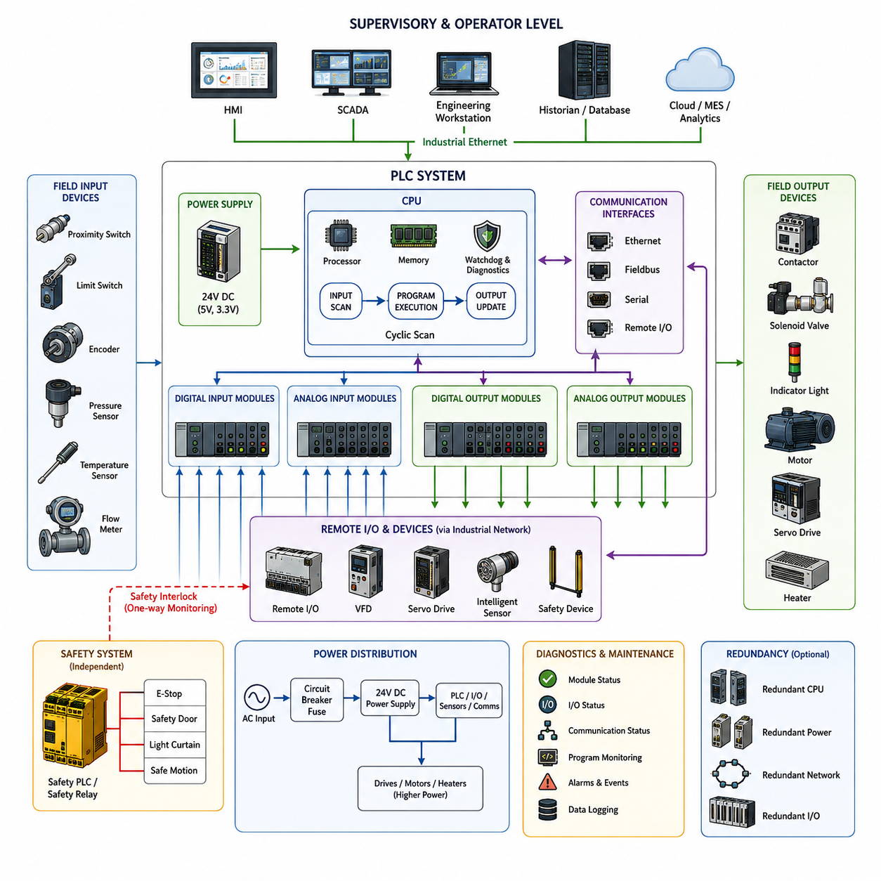
A PLC-based architecture organizes industrial electrical control around a Programmable Logic Controller that executes deterministic logic while coordinating sensors, actuators, drives, operator interfaces, and supervisory systems. The PLC acts as the primary control authority for a machine or process, repeatedly acquiring field inputs, executing the configured control program, and updating outputs according to defined timing and safety constraints.
The fundamental operating model is based on a cyclic scan. During each scan, the PLC reads digital and analog inputs, stores their states in an internal process image, executes control logic using those values, and then writes calculated states to physical outputs. Diagnostic and communication tasks are normally integrated into the same execution framework. This repetitive process provides predictable behavior that is essential for industrial automation.
Field devices form the physical boundary of the architecture. Proximity switches, limit switches, encoders, pressure sensors, temperature sensors, flow meters, and other devices provide information about the process. Output modules connect the PLC to contactors, solenoid valves, indicator devices, motors, and other actuators. Signal conditioning and electrical isolation protect the controller while adapting different voltage, current, and sensor interface standards.
A PLC system may use a compact architecture in which the processor, power supply, and I/O are integrated into one unit, or a modular architecture composed of separate CPU, communication, analog, digital, motion, and specialty modules. Modular systems allow engineers to expand the controller according to machine complexity. Remote I/O stations can further distribute interfaces near equipment, reducing long point-to-point wiring between field devices and the main control cabinet.
The CPU represents the computational center of the PLC. It executes application logic, manages memory, supervises communication, monitors hardware status, and maintains diagnostic information. Unlike general-purpose computers optimized for flexible computing workloads, PLCs emphasize predictable execution, long operational life, environmental robustness, and controlled failure behavior. Watchdogs and hardware diagnostics continuously detect abnormal execution or module failures.
PLC applications are commonly organized around logical functions representing individual machines, process sections, sequences, interlocks, and operating modes. A conveyor system, for example, may contain separate logic for motor commands, sensor validation, material tracking, fault handling, and emergency conditions. This modular organization makes complex automation systems easier to commission, troubleshoot, modify, and maintain throughout a long industrial equipment lifecycle.
Industrial communication extends PLC control beyond local I/O. Remote I/O, variable-frequency drives, servo drives, intelligent sensors, safety devices, and other controllers can communicate through industrial networks rather than individual signal wires. Traditional fieldbus technologies coexist with Industrial Ethernet, allowing the architecture to distribute control equipment physically while preserving coordinated logical operation across the production system.
Human-Machine Interfaces provide operators with a controlled view of the PLC system. The HMI reads process variables, equipment states, alarms, counters, operating modes, and diagnostic information while allowing authorized commands or parameter changes. Larger installations may connect multiple PLCs to SCADA systems, historians, engineering stations, or manufacturing systems, creating hierarchical information flows from physical equipment toward plant-level supervision.
Deterministic behavior is one of the most important characteristics of PLC architecture. Industrial machines often require actions to occur within known timing boundaries rather than merely achieving high average computing performance. PLC task scheduling, cyclic execution, interrupt routines, and real-time communication mechanisms therefore emphasize bounded response. Motion-control applications may use faster synchronized tasks while slower supervisory functions operate at independent rates.
Interlocking is another fundamental architectural principle. Outputs are not determined only by a requested command; they are enabled when required operating conditions are satisfied. A motor start command may depend on guard status, drive readiness, process conditions, upstream equipment, and fault states. These logical dependencies prevent invalid machine states and provide a structured method for coordinating equipment that physically interacts within an automated process.
Safety functions are frequently separated from ordinary machine control. Conventional PLC logic may control production behavior, while safety relays or safety PLCs supervise emergency stops, protective doors, light curtains, safe motion conditions, and other safety-related signals. Although standard and safety control systems exchange status information, safety functions are designed so that ordinary control software cannot improperly override the required protective behavior.
Power distribution and control architecture are closely related in PLC systems. Control power supplies commonly provide regulated DC power for the PLC, sensors, communication devices, and interface electronics, while higher-power circuits feed motors, heaters, drives, and other loads. Relays, contactors, circuit breakers, fuses, and protection devices create controlled electrical boundaries between low-power logic and energy-delivering equipment.
Diagnostics are built into multiple layers of the architecture. PLC hardware can report module faults, communication failures, power abnormalities, I/O errors, and execution problems, while application software can identify process-level faults such as sensor disagreement, actuator timeout, or invalid sequence transitions. Diagnostic information presented through an HMI or engineering workstation reduces troubleshooting time and supports systematic maintenance rather than relying only on physical inspection.
Redundancy can be introduced when process availability justifies additional complexity and cost. Critical installations may employ redundant power supplies, processors, communication paths, network interfaces, or remote I/O connections. The objective is not simply duplication but controlled continuation or transition when a component fails. Redundant architectures therefore require failure detection, state synchronization, switchover logic, and clear definition of acceptable degraded operating modes.
Engineering tools provide the configuration environment for PLC hardware, networks, variables, programs, diagnostics, and commissioning. Engineers define I/O assignments, communication parameters, task execution, control logic, and device relationships within a structured project. Online monitoring allows internal states to be observed during operation, making PLC systems especially practical for commissioning machinery where electrical, mechanical, and software behavior must be examined together.
The PLC also creates a clear separation between machine-level deterministic control and higher-level computing. Industrial PCs, edge computers, databases, analytics platforms, and AI systems can exchange commands, recipes, production information, or optimized parameters with the PLC without directly replacing its time-critical control functions. This separation allows computationally intensive applications to evolve while stable machine-control responsibilities remain within a predictable execution environment.
Modern PLC architectures increasingly combine traditional control principles with Ethernet-based connectivity, distributed I/O, intelligent drives, condition monitoring, edge computing, and plant-wide data integration. However, their architectural foundation remains consistent: field information is acquired reliably, control logic is executed predictably, outputs are applied safely, and system states remain diagnosable. This makes PLC-based architecture a foundational reference for understanding later industrial and robotic electrical architectures.

03.02. Fieldbus Architecture
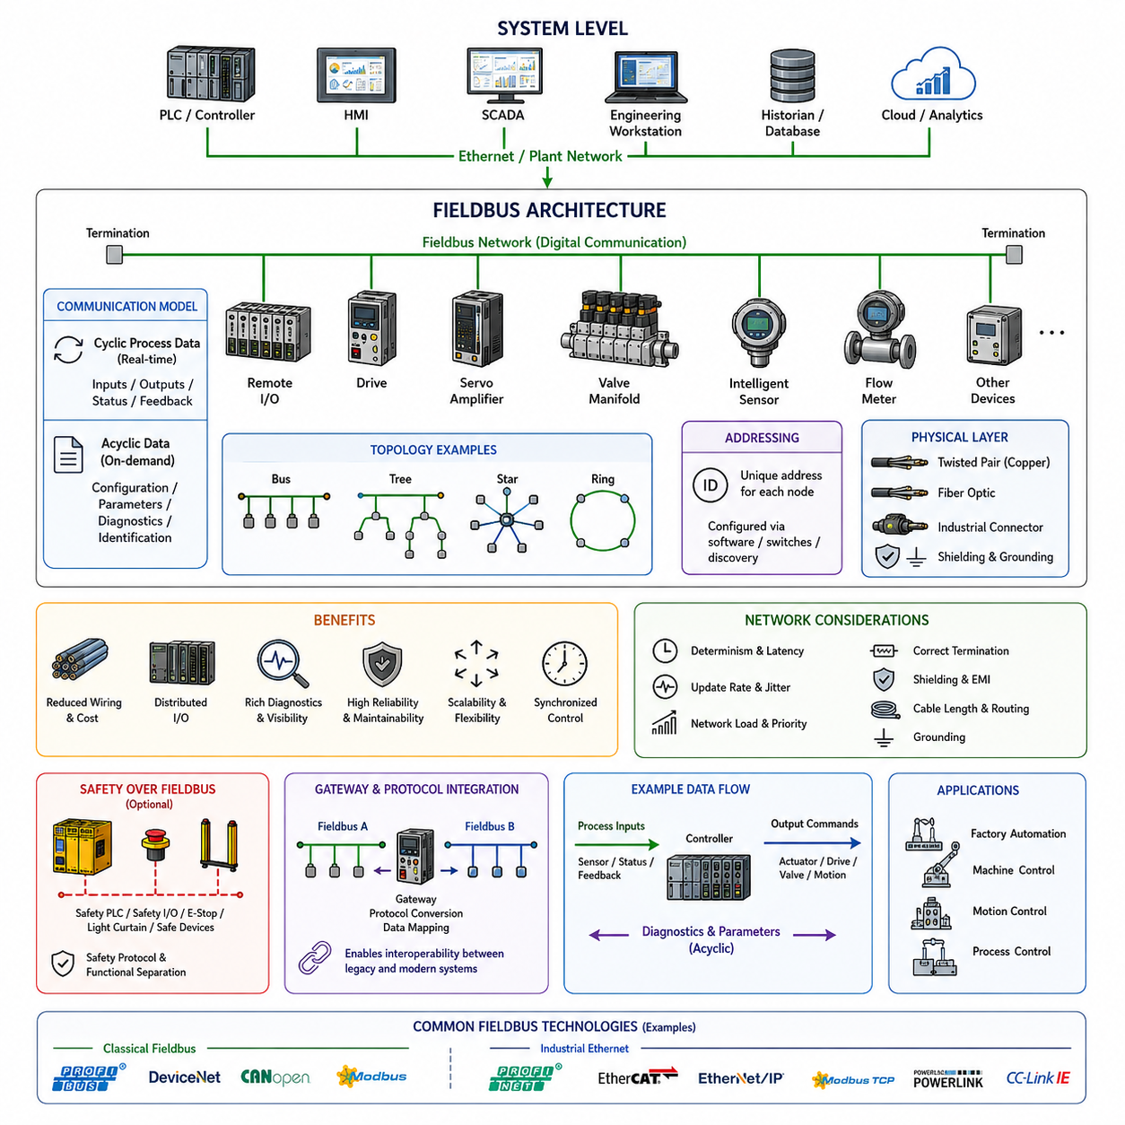
Fieldbus architecture provides a structured communication layer between industrial controllers and distributed field devices. Instead of connecting every sensor and actuator to a central controller through individual point-to-point wires, multiple devices share a digital communication network. Within the industrial electrical architecture, this approach extends PLC-based control toward distributed I/O, intelligent devices, coordinated drives, and networked automation.
Traditional industrial control systems required extensive wiring between the control cabinet and field equipment. Every switch, sensor, valve, relay, and actuator could require dedicated signal conductors, increasing cable volume, installation effort, cabinet terminals, and troubleshooting complexity. Fieldbus technology changes this structure by transporting multiple control variables and device states over a shared communication medium.
A typical fieldbus architecture contains a controller, network interface, communication medium, and multiple field nodes. The controller is commonly a PLC, industrial controller, or dedicated machine controller, while field nodes may include remote I/O modules, motor drives, servo amplifiers, valve manifolds, measurement instruments, and intelligent sensors. Each node exchanges defined process data through the network rather than relying entirely on discrete electrical signals.
The communication relationship between devices may follow master-slave, client-server, producer-consumer, or distributed control principles depending on the selected protocol. Earlier fieldbus systems often used a central master that cyclically requested or exchanged information with subordinate nodes. More advanced industrial networks allow devices to publish data, exchange synchronized process information, or communicate directly when the application requires distributed coordination.
Cyclic communication is particularly important for machine control. Process inputs such as sensor states, measured values, drive feedback, and equipment status are transferred repeatedly at defined intervals, while output commands such as actuator states, speed references, torque commands, and valve positions travel in the opposite direction. Predictable update timing allows the controller to coordinate physical equipment consistently across the network.
A fieldbus also carries acyclic information that does not require continuous real-time exchange. Device configuration, parameter settings, identification information, calibration values, diagnostic records, and maintenance data can be transferred when required. Separating cyclic process data from acyclic service information allows the network to support fast machine operation while providing richer engineering and diagnostic capabilities than conventional hardwired interfaces.
Physical transmission technologies differ considerably among fieldbus systems. Networks may use twisted-pair copper wiring, shielded cables, specialized industrial connectors, optical fiber, or Ethernet-based physical layers. Electrical characteristics, topology, termination, shielding, grounding, cable length, transmission speed, and environmental resistance must therefore be considered as part of the electrical architecture rather than treating communication as a purely software concern.
Network topology determines how controllers and field devices are physically interconnected. Bus, line, tree, star, and ring arrangements are commonly used depending on the communication technology and availability requirements. Traditional fieldbus networks frequently use a shared linear bus, while Industrial Ethernet systems provide greater topology flexibility. The selected topology affects cable routing, expansion capability, fault propagation, maintenance accessibility, and redundancy design.
Device addressing provides a logical identity for each node connected to the network. The controller uses these identities to associate transmitted information with specific devices and process variables. Address configuration may be performed through hardware switches, engineering software, automatic discovery, or network configuration mechanisms. Consistent addressing and device naming are essential because incorrect configuration can cause communication failures or unintended control relationships.
Remote I/O is one of the most important applications of fieldbus architecture. Instead of routing every sensor and actuator cable back to the main control cabinet, remote I/O modules can be installed near the machine or process equipment. Short local wires connect field devices to these modules, while the fieldbus carries aggregated information back to the controller. This architecture can significantly reduce harness length, terminal count, cabinet congestion, and installation effort.
Intelligent motor drives and servo systems gain additional benefits from networked communication. A drive can exchange not only start and stop commands but also velocity, position, torque, operating mode, current, temperature, fault codes, and internal diagnostic information. Servo networks can further coordinate multiple axes using synchronized communication, allowing distributed drive electronics to participate in tightly controlled motion systems without extensive analog or discrete wiring.
Fieldbus architecture improves diagnostics because communication devices can report their internal status through the same network used for control. A PLC or engineering workstation may identify a disconnected node, communication timeout, invalid configuration, sensor failure, drive alarm, or degraded link. This visibility allows technicians to distinguish network, device, wiring, and process faults more efficiently than systems based exclusively on conventional electrical signals.
Determinism and latency are critical design considerations when the network participates directly in machine control. A communication system must deliver required process information within timing limits appropriate to the controlled equipment. Update rate, jitter, synchronization accuracy, network load, message priority, and failure recovery therefore influence control performance. High-speed motion applications normally impose stricter timing requirements than monitoring or supervisory functions.
Reliability depends on both communication protocol behavior and physical installation quality. Incorrect termination, poor shielding, excessive cable length, electromagnetic interference, damaged connectors, grounding problems, or unsuitable routing can produce intermittent communication faults. Industrial fieldbus engineering therefore requires coordination between network configuration and electrical design, particularly when communication cables operate near motors, inverters, contactors, and high-current power conductors.
Industrial communication systems include many technologies optimized for different applications. Classical fieldbus technologies established standardized digital communication for factory and process automation, while Industrial Ethernet extends similar concepts using Ethernet-based infrastructure. The broader architecture may therefore contain multiple network types connected through gateways, communication modules, or controllers, allowing legacy equipment and newer intelligent devices to operate within the same automation system.
Gateways become important when equipment using different protocols must exchange information. A gateway translates or maps process variables between communication domains, while a PLC may also contain multiple communication interfaces and perform integration through application logic. Although protocol conversion increases interoperability, it can introduce additional latency, configuration complexity, diagnostic boundaries, and failure modes that must be considered during architecture design.
Safety-related communication can also be implemented over industrial networks when supported by appropriate safety protocols and certified devices. Safety PLCs, distributed safety I/O, emergency-stop devices, light curtains, drives, and other protective equipment may exchange safety information while maintaining required integrity mechanisms. Safety communication remains logically protected from ordinary control functions even when both types of traffic share portions of the physical network.
Modern fieldbus architecture increasingly converges with Industrial Ethernet, edge computing, and higher-level information systems. PLCs and distributed devices can provide operational data to HMIs, SCADA platforms, historians, industrial PCs, and analytics systems while continuing to perform deterministic machine control. This creates a layered architecture in which field communication connects physical equipment to control systems and higher computational layers.
For robotics and advanced industrial automation, the fieldbus concept establishes an important architectural principle: computation and electrical interfaces do not need to reside in one centralized cabinet. Sensors, I/O modules, motor controllers, servo drives, and intelligent devices can be physically distributed while remaining logically coordinated through deterministic communication. This principle forms an important bridge from traditional PLC systems toward distributed robotic electrical and communication architectures.

03.03. IEC 61131 Overview
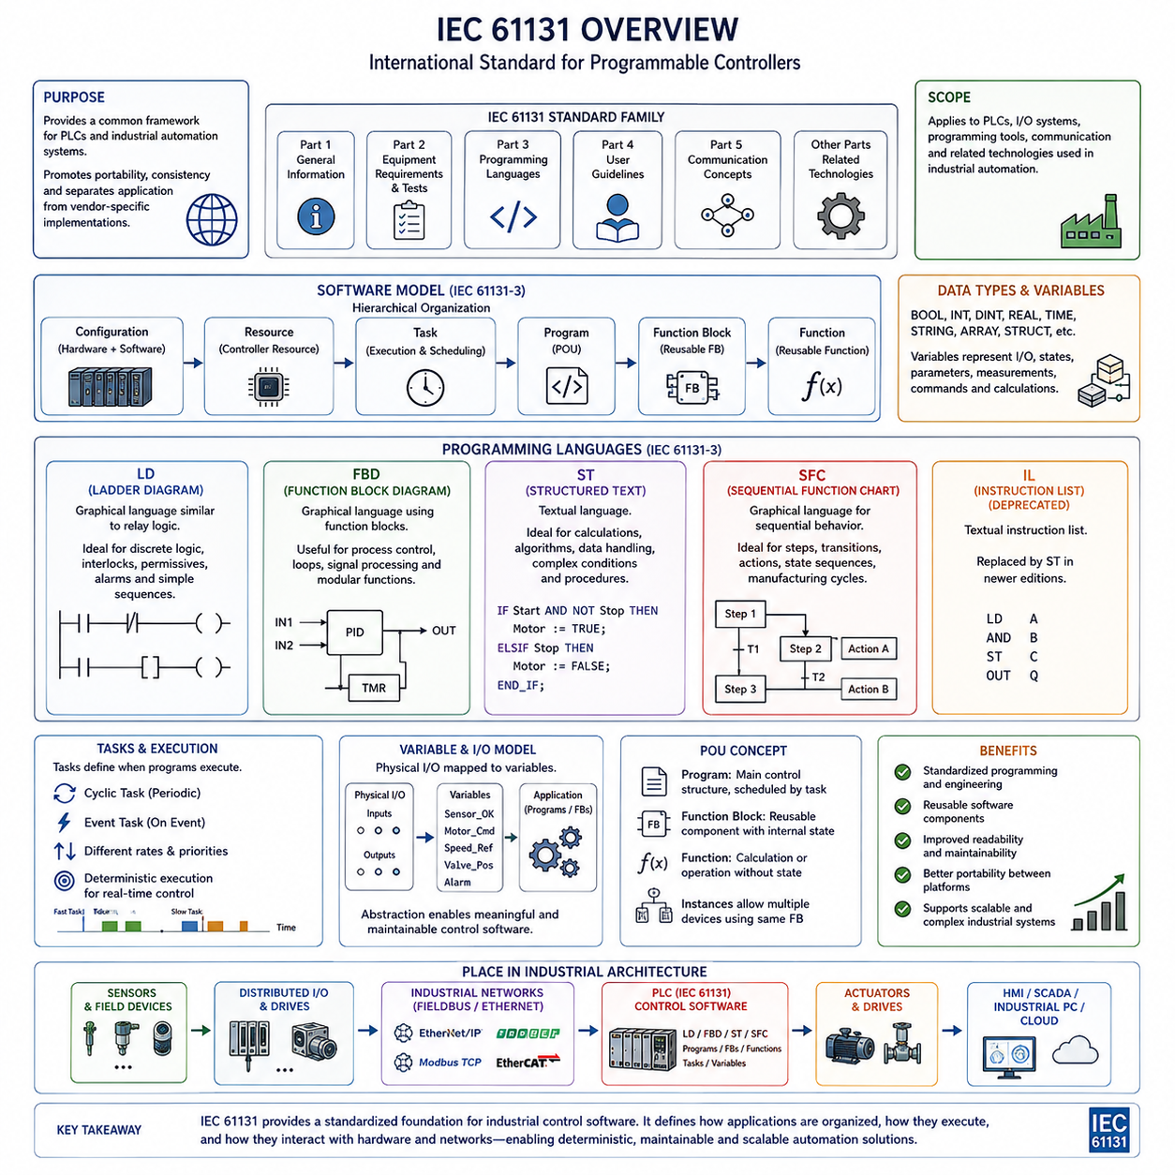
IEC 61131 is an international standards family that establishes a common framework for programmable controllers and their associated industrial automation systems. It provides standardized concepts for controller characteristics, programming models, software organization, communication, and related engineering practices. Within PLC-based industrial electrical architecture, IEC 61131 helps separate control-system implementation from individual vendor-specific conventions.
The standard emerged from the need to reduce fragmentation among programmable controller platforms. Early PLC manufacturers developed different programming methods, terminology, data representations, and engineering environments, making applications difficult to transfer or maintain across systems. IEC 61131 introduced a common conceptual foundation so engineers could describe industrial control applications using more consistent programming and execution principles.
IEC 61131 is organized as a multi-part standard rather than a single programming specification. Its parts address areas such as general information, equipment requirements and tests, programming languages, user guidelines, communication-related concepts, and additional technologies associated with programmable controllers. For control software engineering, IEC 61131-3 is particularly important because it defines programming languages and software organization concepts widely used in PLC systems.
IEC 61131-3 defines a software model in which control applications can be decomposed into manageable elements instead of being treated as one monolithic program. Configuration, resource, task, program, function block, and function concepts provide different levels of organization. This hierarchy allows engineers to associate software execution with controller resources and to structure complex machine behavior according to functional and timing requirements.
The concept of a Program Organization Unit, commonly called a POU, is central to IEC 61131-3. POUs provide reusable software structures for organizing control algorithms and machine functions. The principal forms include programs, function blocks, and functions. Their different execution and data-handling characteristics allow engineers to select an appropriate structure for sequencing, calculations, device control, reusable components, and other automation functions.
A program generally represents a higher-level control organization associated with a particular machine or process function. It can coordinate multiple operations and interact with variables, function blocks, and other software elements. Programs are normally associated with tasks that determine when they execute. This relationship between program organization and task scheduling connects the logical software architecture with the deterministic execution behavior required by industrial controllers.
Functions are intended for operations that calculate a result from defined inputs without retaining the same type of persistent internal execution state expected from function blocks. They are useful for mathematical calculations, conversions, comparisons, scaling, and reusable algorithms. Standardized function concepts encourage engineers to encapsulate frequently repeated operations rather than reproducing equivalent logic throughout an automation application.
Function blocks provide reusable software components that can maintain internal state between executions. This makes them particularly suitable for timers, counters, motor control, valve control, state machines, communication handling, and equipment abstractions. Multiple instances of the same function block can operate independently with their own internal data, enabling industrial applications to represent repeated physical devices using consistent software structures.
IEC 61131-3 historically standardized several PLC programming representations, including Ladder Diagram, Function Block Diagram, Structured Text, Instruction List, and Sequential Function Chart. Instruction List was later deprecated in newer editions, while the remaining representations continue to support different engineering styles. The availability of multiple representations reflects the diverse origins and requirements of industrial automation engineering.
Ladder Diagram, commonly abbreviated as LD, visually resembles relay-based electrical control circuits. Contacts, coils, branches, and related elements express logical conditions and output behavior in a form familiar to electrical and maintenance engineers. It is particularly effective for discrete logic, interlocks, permissive conditions, alarms, and straightforward machine sequences where rapid visual interpretation during commissioning and troubleshooting is valuable.
Function Block Diagram, or FBD, represents control behavior through interconnected functional blocks. Signals flow between blocks representing logic, calculations, timers, controllers, processing functions, or equipment behavior. FBD is useful when the application can be naturally understood as interconnected processing elements and is widely applied to process control, signal processing, control loops, and modular automation functions.
Structured Text, abbreviated as ST, is a textual programming language designed for programmable controller applications. Its syntax supports expressions, assignments, conditional execution, loops, function calls, and structured algorithms. ST is especially useful when control logic involves mathematical operations, data manipulation, complex conditions, arrays, algorithms, or procedures that would become difficult to express clearly using graphical programming representations.
Sequential Function Chart, or SFC, provides a structured representation for sequential behavior. A process can be divided into steps, transitions, and associated actions so that machine operating sequences can be represented according to state progression. This approach is useful for manufacturing cycles, batch processes, startup and shutdown sequences, and other applications in which operations must proceed through clearly defined stages.
Variables and data types provide another important foundation of IEC 61131-3 programming. Control applications operate on Boolean values, integers, real numbers, time values, strings, and other defined data structures. Variables can represent physical I/O signals, internal machine states, parameters, measurements, commands, and intermediate calculations. Explicit data representation improves software readability and reduces ambiguity when information moves between different control functions.
Tasks define how software execution is scheduled within the controller. A task may activate programs periodically, in response to events, or according to execution mechanisms supported by the PLC environment. Different tasks can therefore operate at different rates according to application requirements. Fast control functions may execute frequently, while diagnostics, communication processing, or supervisory logic can operate at slower intervals.
The task concept is closely related to deterministic PLC operation. Industrial control software must often guarantee that critical logic is evaluated within an acceptable time boundary. Engineers therefore consider task periods, priorities, execution time, processor loading, and interactions between control functions. IEC 61131 software organization provides a framework in which these execution requirements can be associated with clearly structured application components.
IEC 61131 also supports the separation between hardware-oriented I/O representation and application-oriented control logic. Physical inputs and outputs can be associated with variables that are subsequently used by programs and function blocks. This abstraction allows software to express concepts such as motor readiness, valve commands, sensor validity, or machine state rather than repeatedly manipulating hardware addresses throughout the control program.
Standardization does not mean that PLC programs are automatically portable between every manufacturer. Vendors may provide different engineering tools, hardware configurations, libraries, extensions, communication functions, motion-control capabilities, and runtime behavior. Nevertheless, common IEC 61131 concepts significantly improve engineering consistency because developers can recognize familiar languages, software structures, variables, tasks, and execution models across different platforms.
In modern industrial architecture, IEC 61131-based control increasingly operates alongside Industrial Ethernet, fieldbus networks, safety controllers, motion systems, industrial PCs, edge computing, and higher-level software. PLC applications remain responsible for predictable machine-level control while other computing layers perform visualization, analytics, optimization, AI processing, or enterprise integration. This preserves deterministic control while allowing industrial systems to adopt more advanced computational capabilities.
For robotics and advanced automation, IEC 61131 provides an important software foundation between electrical architecture and control behavior. Sensors and distributed I/O provide physical information, industrial networks transport that information, PLC software interprets it through standardized control structures, and outputs command drives and actuators. In the attached volume structure, this progression connects PLC-based architecture and fieldbus architecture with later Industrial PC and Industry 4.0 architectures.

03.04. Industrial PC Architecture
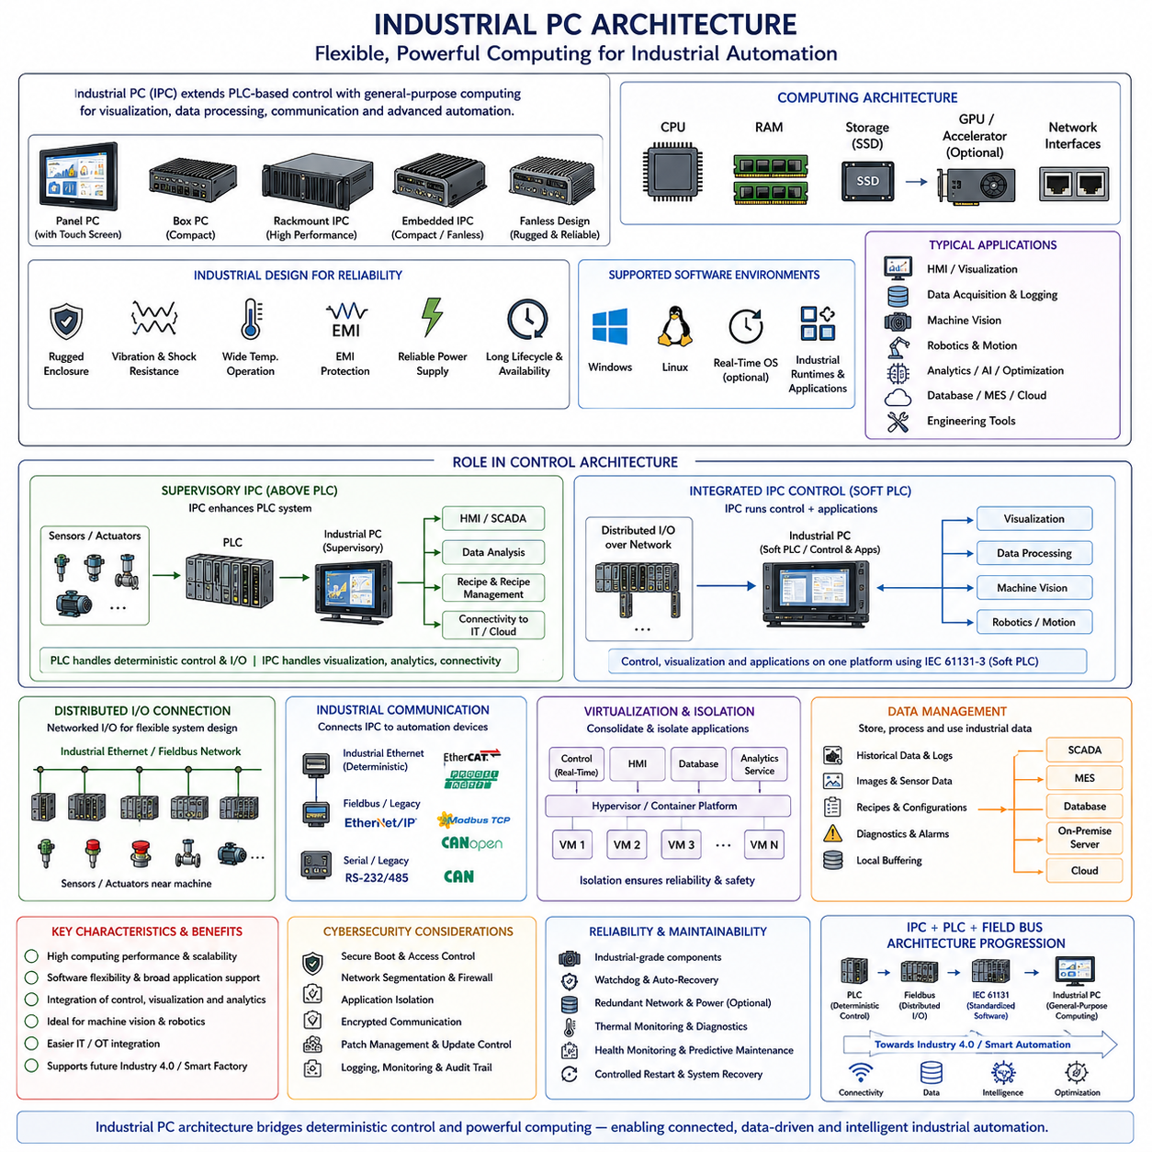
Industrial PC architecture extends industrial control beyond the traditional PLC by introducing general-purpose computing resources designed for factory and machine environments. An Industrial PC, commonly called an IPC, combines PC-class processors, memory, storage, operating systems, and network interfaces with mechanical and electrical designs suitable for industrial operation. It provides a flexible computing layer for control, visualization, data processing, communication, and advanced automation applications.
Unlike conventional office computers, Industrial PCs are engineered for continuous operation under demanding environmental conditions. Industrial systems may experience vibration, shock, dust, electromagnetic interference, elevated temperatures, and unstable power conditions. IPC designs therefore emphasize rugged enclosures, industrial-grade components, controlled thermal management, reliable power supplies, long product availability, and interfaces suitable for integration into machines and control cabinets.
The computing architecture of an IPC generally resembles that of a conventional computer but is optimized for industrial reliability and lifecycle requirements. A CPU performs general-purpose processing while RAM supports active applications and solid-state storage provides operating-system and application persistence. Depending on the workload, the system may also incorporate GPUs, dedicated accelerators, real-time communication interfaces, and specialized expansion cards.
Industrial PCs are available in several physical configurations according to installation requirements. Panel PCs combine computing hardware with an operator display, while box PCs provide compact standalone computing modules for machine installation. Rack-mounted industrial computers support larger computing workloads and centralized installations, whereas embedded IPCs provide smaller form factors for integration directly into equipment. Fanless designs are common where dust resistance and reduced mechanical maintenance are important.
A major architectural advantage of the Industrial PC is software flexibility. Unlike PLC environments centered on dedicated automation runtimes, IPCs can execute general-purpose operating systems and a broad range of industrial applications. These may include visualization software, databases, machine vision, robotics frameworks, communication middleware, analytics, engineering tools, optimization algorithms, and custom applications written using conventional software-development environments.
Real-time behavior remains an important consideration when an IPC participates directly in machine control. A standard desktop operating system does not necessarily guarantee bounded execution latency, so industrial control applications may use real-time operating systems, real-time extensions, dedicated hypervisors, or specialized control runtimes. These technologies allow deterministic tasks to coexist with non-real-time functions such as visualization, logging, database access, or network services.
An IPC can operate as a supervisory computer above a PLC rather than replacing it. In this architecture, the PLC continues to execute deterministic machine logic, interlocks, sequencing, and time-critical I/O control, while the IPC performs computationally intensive or flexible functions. Machine vision, production optimization, data analysis, recipe management, user interfaces, and connectivity to higher-level systems can therefore be separated from the core control loop.
In more integrated architectures, an Industrial PC can directly perform functions traditionally assigned to a PLC. Software-based PLC runtimes, often called soft PLCs, execute control programs on PC-class hardware and may support IEC 61131-3 programming models. Combined with deterministic Industrial Ethernet and distributed I/O, this approach allows control logic, visualization, data processing, and other applications to operate on a consolidated computing platform.
Distributed I/O is particularly important when an IPC performs machine-level control. Instead of requiring conventional local PLC I/O modules, the IPC can communicate with remote digital and analog I/O through Industrial Ethernet or fieldbus interfaces. Sensors and actuators remain physically distributed near the machine while network communication connects them to the control runtime, preserving the distributed electrical architecture established by fieldbus-based systems.
Industrial communication interfaces provide the connection between the IPC and other automation components. Ethernet is widely used for supervisory and information-level communication, while deterministic Industrial Ethernet or dedicated communication adapters can connect drives, remote I/O, controllers, and synchronized devices. Legacy serial or fieldbus interfaces may also be supported when existing equipment must be integrated into a newer PC-based architecture.
Industrial PCs are especially valuable for machine vision because image processing requires substantially greater computational resources than conventional discrete control. Cameras can provide high-bandwidth image streams that are processed using computer-vision algorithms to perform inspection, localization, measurement, identification, or quality control. CPU, GPU, and accelerator resources within the IPC allow perception functions to operate near the physical production equipment.
The same computing capability makes IPC architecture suitable for robotics applications. Robot planning, localization, mapping, trajectory generation, sensor fusion, communication middleware, and supervisory control can execute on PC-class processors while dedicated servo drives or embedded controllers handle faster low-level loops. This creates a multi-rate architecture in which high-level computation and deterministic actuator control operate at different execution frequencies.
Virtualization can further consolidate industrial computing functions. Multiple operating environments or application domains may execute on one physical IPC using virtual machines, containers, or hypervisor-based partitioning. For example, deterministic control software can be isolated from an HMI, database, analytics service, or engineering application. Proper isolation is important because faults or excessive resource consumption in one software domain should not disturb critical control functions.
Storage and data management represent another major difference between IPC and traditional controller architectures. Industrial PCs can retain large quantities of production records, diagnostic logs, images, sensor histories, configuration data, and application files locally. This enables historical analysis, traceability, predictive maintenance, and temporary buffering when communication with plant or cloud infrastructure is unavailable.
Industrial PCs also provide a natural interface between operational technology and higher-level information technology. Data from PLCs, fieldbus networks, sensors, drives, and machines can be collected by the IPC and forwarded to SCADA, MES, databases, on-premise servers, or cloud platforms. At the same time, production recipes, configuration information, and authorized supervisory commands can move from higher-level systems toward the machine control layer.
Cybersecurity becomes increasingly important as industrial control adopts PC-based architectures. General-purpose operating systems, Ethernet connectivity, remote management, application software, and external services create a broader attack surface than isolated traditional controllers. Secure boot, access control, network segmentation, software patching, application isolation, encrypted communication, logging, and controlled update procedures therefore become important architectural considerations.
Reliability must be designed across both hardware and software layers. Industrial storage devices, watchdogs, redundant network paths, protected power supplies, thermal monitoring, health diagnostics, and controlled restart mechanisms can improve availability. Software supervision can detect failed applications or communication services, while system-level diagnostics allow maintenance personnel to identify whether a problem originates from hardware, operating systems, networks, or application software.
The transition from PLC-centered architecture to IPC-based architecture does not eliminate PLC principles. Deterministic execution, safe machine states, structured I/O, interlocks, diagnostics, and reliable industrial communication remain essential. The primary change is that the computing layer becomes more capable and flexible, allowing traditional control functions to coexist with data-intensive software, machine vision, robotics, optimization, and increasingly AI-based applications.
Within the industrial electrical architecture progression, the Industrial PC therefore forms a bridge between PLC and fieldbus-based automation and the broader connected architecture associated with Industry 4.0. PLCs established programmable deterministic control, fieldbus distributed the physical interfaces, IEC 61131 standardized control-software concepts, and IPCs add general-purpose computing capacity. This progression prepares industrial systems for interconnected, data-driven, software-defined, and intelligent automation.

03.05. Industry 4.0 Architecture
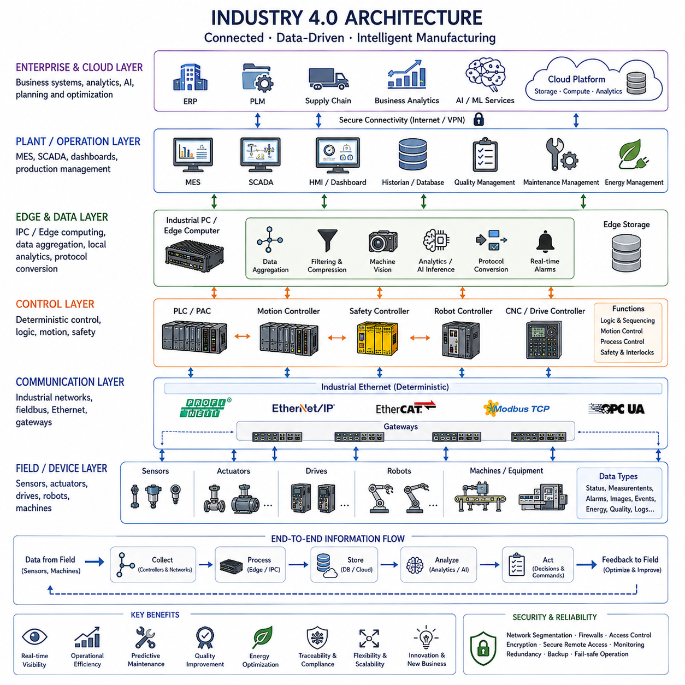
Industry 4.0 architecture represents the evolution of industrial automation from isolated control systems toward connected, data-driven, and increasingly intelligent production environments. It builds upon PLC-based control, fieldbus communication, standardized control software, and Industrial PC computing by connecting machines, sensors, controllers, information systems, and computing platforms across multiple operational layers.
Traditional automation architectures primarily focused on controlling individual machines or production lines. Industry 4.0 expands this perspective by treating equipment as part of a larger digital production system. Machine states, process variables, quality information, energy consumption, maintenance conditions, and production results can be collected and exchanged so that decisions are informed by data generated throughout the manufacturing environment.
At the physical layer, sensors, actuators, motors, drives, robots, machines, and production equipment interact directly with industrial processes. PLCs, motion controllers, embedded controllers, and safety systems execute deterministic control close to these physical assets. Industry 4.0 does not remove this machine-level architecture; instead, it connects these established control functions to broader information and computing layers.
Industrial communication provides the connectivity required for this integration. Fieldbus systems continue to support distributed devices, while Industrial Ethernet provides higher bandwidth and increasingly unified networking between controllers, drives, remote I/O, Industrial PCs, and supervisory systems. Gateways can connect legacy equipment to modern networks, allowing existing production assets to participate in a progressively connected factory architecture.
Industrial PCs and edge computers form an important computing layer between machine control and centralized information systems. They can aggregate data from PLCs, sensors, cameras, drives, and industrial networks while performing local visualization, protocol conversion, filtering, analytics, machine vision, optimization, or AI processing. Edge processing reduces the need to transmit every raw signal to centralized infrastructure and enables faster local responses.
The edge layer is especially valuable when industrial data is generated faster than higher-level systems can efficiently process it. High-frequency sensor measurements, images, vibration signals, and machine diagnostics can be filtered, compressed, summarized, or analyzed near the equipment. Only meaningful events, features, statistics, or selected records may then be forwarded to plant servers or cloud platforms, reducing network and storage requirements.
Supervisory systems provide visibility across machines and production areas. HMI and SCADA platforms present operating conditions, alarms, process values, equipment states, and historical information to operators and engineers. Industry 4.0 extends these functions by integrating supervisory information with production management, quality systems, maintenance platforms, databases, analytics services, and enterprise-level applications.
Manufacturing Execution Systems, commonly called MES, connect shop-floor operations with production management. MES applications can track work orders, production progress, equipment utilization, material movement, quality results, and traceability information. Data originating from machines can therefore contribute directly to production planning and operational analysis, while authorized recipes and production instructions can move downward toward control systems.
Data becomes a fundamental architectural resource in Industry 4.0. Rather than using sensor information only for immediate control decisions, industrial systems can retain operational histories for later analysis. Process values, alarms, equipment conditions, quality measurements, maintenance records, energy data, and production events can be stored in historians, databases, data platforms, or other repositories according to their operational purpose.
This accumulated information enables condition monitoring and predictive maintenance. Measurements such as vibration, temperature, current, pressure, cycle time, or error frequency can reveal changes in equipment behavior before complete failure occurs. Analytical software can compare current conditions with historical patterns and maintenance criteria, allowing maintenance activities to become increasingly condition-based rather than relying only on fixed schedules.
Digital representation is another important characteristic of Industry 4.0 architecture. Physical equipment can be associated with digital information describing configuration, status, operating history, engineering parameters, and relationships with other production assets. More advanced implementations may use digital twins that combine physical-system data with models, simulations, or lifecycle information to support engineering, monitoring, optimization, and operational decision-making.
Interoperability becomes essential as more devices and software platforms exchange information. PLCs, Industrial PCs, robots, drives, databases, MES platforms, engineering systems, and cloud services may originate from different vendors and use different data models. Standardized interfaces, communication protocols, information models, and middleware help these heterogeneous components exchange information without requiring every system to understand every proprietary implementation.
A layered architecture helps separate responsibilities. Fast deterministic control remains close to sensors and actuators, supervisory functions operate at machine or plant level, and computationally intensive analytics can execute on edge, on-premise, or cloud infrastructure. Different functions therefore operate at different time scales. A servo loop may execute extremely quickly while production analysis or business optimization may operate over seconds, minutes, hours, or longer periods.
Cloud computing can provide scalable storage, centralized analytics, fleet-level comparison, remote services, and computational resources beyond an individual factory. However, cloud connectivity does not imply that critical machine control should depend on continuous remote communication. Time-critical control and safety functions generally remain close to the physical process, while cloud systems perform functions that tolerate greater communication latency and temporary disconnection.
On-premise computing provides an intermediate alternative when organizations require centralized computational capacity while keeping industrial data within the facility or enterprise network. Local servers can support databases, AI inference, analytics, digital twins, engineering services, or production applications. Industry 4.0 architecture can therefore distribute computing dynamically across controllers, edge devices, Industrial PCs, on-premise servers, and cloud platforms.
Cybersecurity becomes a system-level requirement because connectivity creates pathways between previously isolated operational equipment and broader information networks. Network segmentation, firewalls, identity management, access control, encrypted communication, secure remote access, software updates, logging, monitoring, and backup strategies must be incorporated into the architecture. Security must protect connectivity without disrupting deterministic control and production availability.
Reliability and resilience remain fundamental even as the architecture becomes more software-driven. Communication failures, server outages, application faults, or loss of external connectivity should not automatically cause unsafe machine behavior. Local controllers require defined fallback states, edge systems may buffer data during network interruptions, and redundant networks or computing resources can be introduced where availability requirements justify them.
Artificial intelligence can be introduced as an additional computational capability within Industry 4.0 rather than as a replacement for deterministic automation. Machine vision, anomaly detection, quality prediction, process optimization, predictive maintenance, and production forecasting can use AI models while PLCs and dedicated controllers continue to enforce machine sequences, interlocks, safety conditions, and fast control loops.
The resulting architecture creates bidirectional information flow across the industrial system. Physical equipment produces operational data that moves upward through controllers, networks, edge systems, and information platforms. Higher layers transform this information into visualization, analysis, optimization, production planning, or learned models, while appropriate commands, parameters, recipes, and decisions can move downward toward the equipment under controlled interfaces.
Within the attached industrial electrical architecture sequence, Industry 4.0 represents the integration stage built upon the preceding technologies. PLC architecture establishes deterministic programmable control, fieldbus architecture distributes communication and I/O, IEC 61131 provides standardized control-software concepts, and Industrial PCs introduce flexible general-purpose computing. Industry 4.0 connects these foundations into a broader digital industrial system.
This progression also provides an important foundation for later robotics and Physical AI electrical architectures included in the broader volume structure. Connected sensors, distributed control, edge computing, high-bandwidth networking, data platforms, and heterogeneous computing allow industrial systems to evolve from isolated automated machines toward coordinated cyber-physical systems in which control, information, computation, and increasingly intelligent decision-making operate as parts of one integrated architecture.

