Volume 01. Electrical Architecture Fundamentals

Chapter 02. Automotive Electrical Architecture

02.01. ECU Network Topology
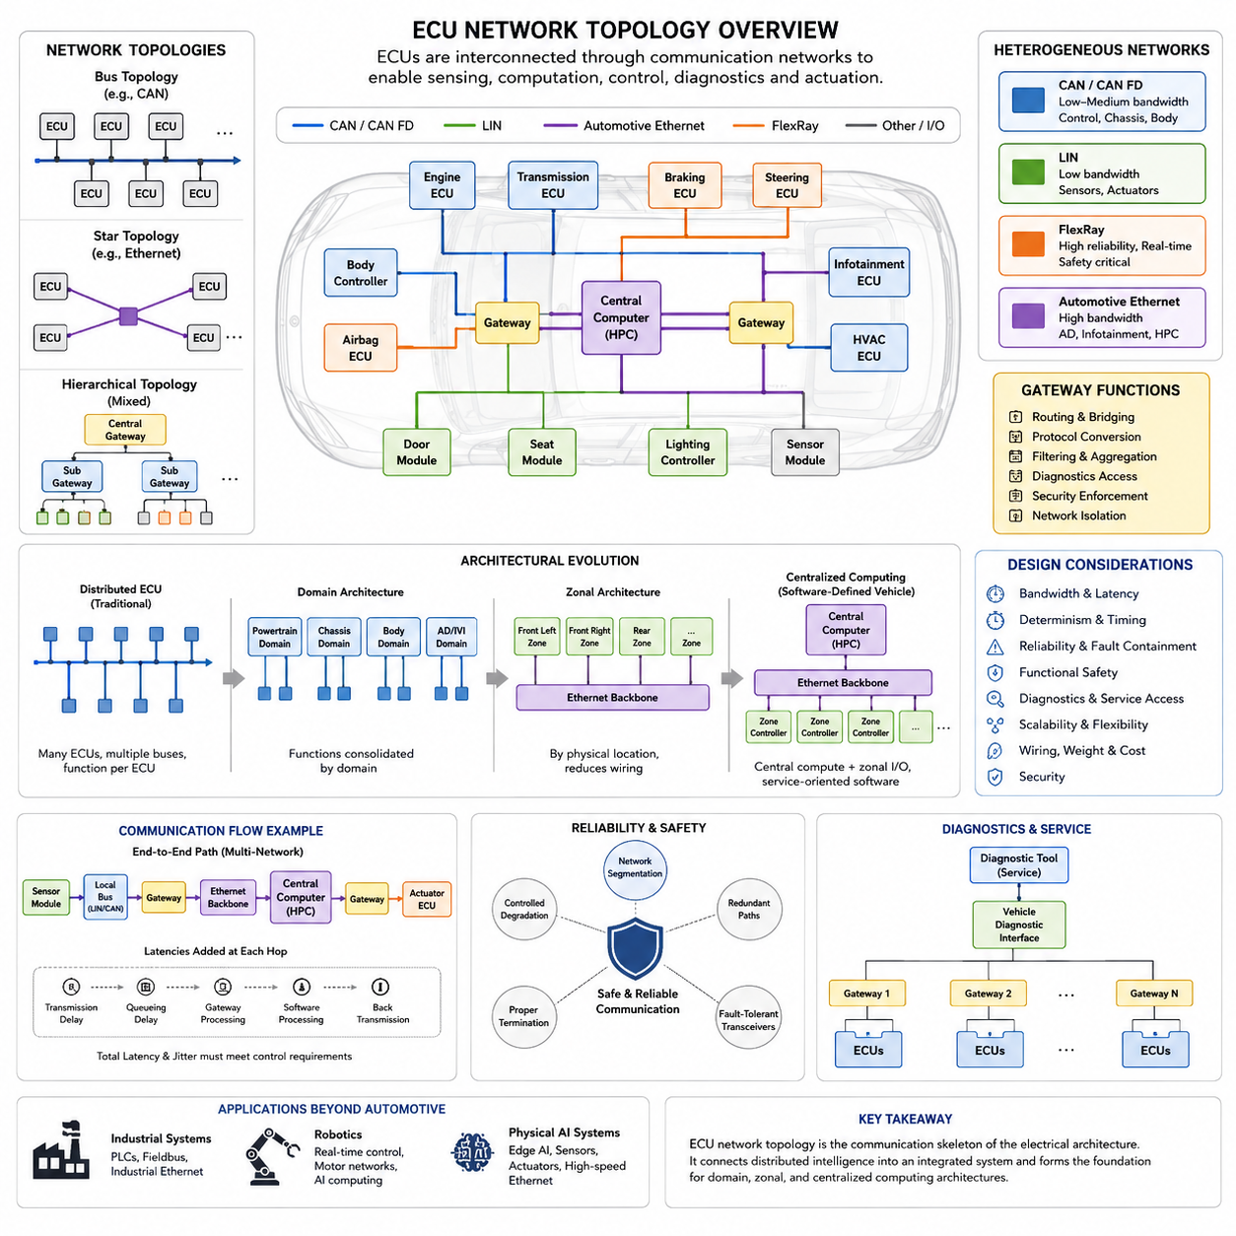
An ECU network topology defines how Electronic Control Units are physically and logically interconnected so that sensing, computation, control, diagnostics, and actuation can operate as one coordinated electrical system. Within the supplied structure, this topic forms the starting point of automotive electrical architecture before domain controllers, zonal architectures, AUTOSAR, software-defined vehicles, and high-performance computing are introduced.
Traditional vehicles commonly use a distributed ECU architecture in which individual controllers are assigned to relatively specific functions. An engine ECU, transmission controller, body controller, airbag controller, braking controller, steering controller, and numerous comfort controllers may operate independently while exchanging information through communication networks. The topology therefore becomes the structural framework that connects otherwise autonomous embedded control systems.
The simplest conceptual topology is a shared bus. Multiple ECUs connect to the same communication medium and exchange messages according to defined arbitration and addressing rules. CAN is a representative technology for this structure because many controllers can communicate over a common differential pair without requiring dedicated point-to-point wiring between every ECU. This dramatically reduces harness complexity compared with direct electrical connections between individual functions.
A bus topology is efficient, but every additional ECU increases network loading, message interactions, diagnostic complexity, and potential fault propagation. Engineers must therefore evaluate communication bandwidth, message frequency, latency, bus utilization, electrical termination, and failure behavior. Critical control messages must reach their destinations within predictable timing constraints even while diagnostic traffic, status information, and lower-priority messages share the same physical communication channel.
Automotive networks rarely consist of only one bus. Different subsystems have different requirements for bandwidth, determinism, cost, safety, and physical implementation. Low-cost devices may use LIN, conventional embedded controllers may communicate through CAN, higher-data-rate control networks may employ CAN FD, and cameras or advanced computing platforms may require Automotive Ethernet. The complete vehicle topology consequently becomes a heterogeneous network composed of several communication technologies.
Gateways connect these heterogeneous network segments and selectively transfer information between them. A gateway may receive a signal from one CAN network, interpret or route the corresponding information, and transmit it onto another network or Ethernet backbone. Besides routing, gateways can perform protocol conversion, filtering, diagnostics, security enforcement, traffic management, and network isolation, making their placement an important architectural decision rather than merely a wiring consideration.
Functional segmentation historically produced multiple networks such as powertrain, chassis, body, infotainment, and diagnostic buses. A braking ECU and steering ECU may exchange high-priority dynamic information on a chassis network, while door modules and lighting controllers operate on a body network with different performance requirements. This separation prevents every controller from competing for the same communication resources and allows network characteristics to be matched to functional requirements.
Physical topology and logical topology should be distinguished. Two ECUs may appear physically connected to the same wiring segment while software determines which messages they consume, transmit, or ignore. Conversely, controllers located on different physical buses can participate in the same vehicle function through gateway routing. Effective architecture therefore requires simultaneous consideration of wiring paths, communication protocols, message databases, software interfaces, and functional dependencies.
Network topology strongly influences wiring harness design. Distributed architectures can place ECUs near sensors and actuators, reducing some local wiring, but numerous controllers and communication branches may increase connectors, splices, harness routes, and installation complexity. Harness mass, packaging volume, connector count, electromagnetic compatibility, service accessibility, and manufacturing cost therefore become architectural variables rather than downstream implementation details.
Reliability must also be considered at the topology level. A shared communication segment can create common failure points if a short circuit, defective transceiver, wiring fault, or malfunctioning node disrupts communication for multiple controllers. Designers can reduce such risks through segmentation, redundant communication paths, protected gateways, fault-tolerant transceivers, appropriate termination, diagnostic monitoring, and controlled degradation strategies for functions that must remain available after failures.
Topology design is closely related to functional safety because communication failures can affect control functions even when individual ECUs remain operational. Safety analysis therefore examines lost messages, delayed messages, corrupted information, unintended transmission, network partitioning, and communication dependencies between controllers. Safety-related functions may require independent monitoring, redundant signals, dedicated channels, or defined fallback behavior when communication cannot be trusted.
Diagnostics add another logical layer to the network. Service tools must communicate with ECUs to read diagnostic trouble codes, observe parameters, execute tests, perform calibration-related operations, or update software. Diagnostic access may enter through a central interface and then traverse gateways toward individual controllers. Consequently, network topology determines not only normal operational communication but also how engineers, manufacturing systems, and service equipment access distributed electronic functions.
As vehicle functions become increasingly software-intensive, conventional distributed ECU networks encounter scalability limitations. Adding new features often introduces additional signal dependencies across several controllers, increasing integration effort and verification complexity. The architecture can eventually contain dozens or more ECUs connected through several buses and gateways, creating a network in which software functionality is distributed across hardware boundaries that were originally defined around individual components.
Domain architecture addresses part of this complexity by consolidating computation according to functional domains. Instead of assigning every function to a separate ECU, powerful domain controllers coordinate groups such as chassis, body, powertrain, or autonomous-driving systems. Traditional ECUs may remain at the edges, but the network becomes more hierarchical. This transition explains why ECU network topology naturally precedes domain controller architecture in the supplied chapter structure.
Zonal architecture reorganizes the topology according to physical location rather than primarily according to vehicle function. Front-left, front-right, rear, or other zone controllers aggregate nearby sensors and actuators and connect them to a high-speed backbone. This can reduce long point-to-point wiring runs and simplify harness organization. Functional software can then execute on centralized computing resources while zonal controllers provide local electrical and communication interfaces.
Automotive Ethernet increasingly serves as a backbone for these newer architectures because centralized perception, high-performance computing, software updates, and data-intensive sensors require substantially more bandwidth than traditional control buses can economically provide. CAN and LIN do not necessarily disappear; instead, they can remain as local networks connected through gateways or zonal controllers. The topology therefore evolves toward hierarchical combinations of Ethernet backbones and embedded field networks.
Time behavior becomes particularly important when several network technologies cooperate in one control path. A sensor measurement may travel through a local bus, pass a gateway, enter an Ethernet backbone, reach a central computer, and return as a control command through another network. Each transmission, queue, gateway, and software task contributes latency and jitter. Network topology must therefore be designed together with end-to-end control timing rather than evaluated solely by nominal bandwidth.
Modern ECU topology also provides the communication foundation for software-defined vehicles. Central computing, standardized interfaces, service-oriented communication, over-the-air updates, and software functions spanning multiple physical devices require a network capable of transporting information reliably across hardware boundaries. The electrical architecture progressively changes from a collection of interconnected controllers into a distributed computing platform whose communication infrastructure is a fundamental system resource.
For robotics and Physical AI systems, the same architectural principles remain relevant even though the components may be called motor controllers, safety controllers, sensor modules, edge computers, or AI computers rather than automotive ECUs. Low-level deterministic control can remain on local real-time networks while perception and AI computation use higher-bandwidth Ethernet connections. This relationship is consistent with the broader supplied library, which separates automotive, industrial, robotics, communication, compute, and Physical AI electrical architectures.
A well-designed ECU network topology therefore balances physical wiring, communication performance, computational distribution, fault containment, safety, diagnostics, scalability, and cost. It should not be viewed simply as a diagram showing which controllers are connected. It is the communication skeleton of the electrical architecture, defining how distributed electronic intelligence becomes an integrated system and establishing the foundation from which domain, zonal, and centralized computing architectures evolve.

02.02. Domain Controller Architecture
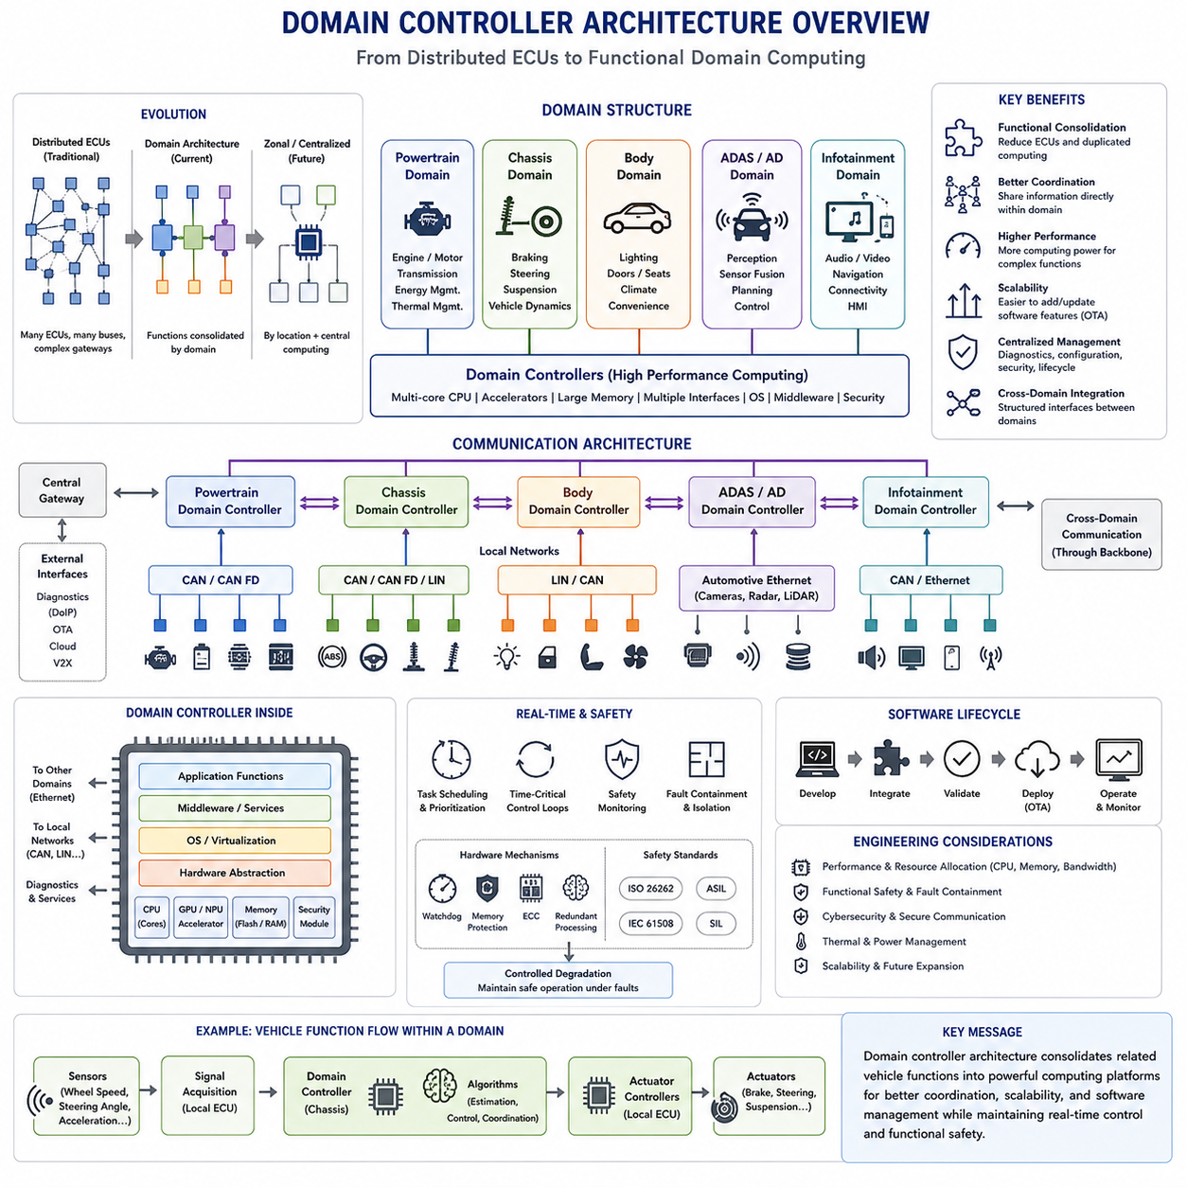
Domain controller architecture represents an important transition from highly distributed ECU networks toward consolidated vehicle computing. Instead of assigning nearly every function to a separate Electronic Control Unit, related functions are grouped into functional domains and coordinated by more powerful domain controllers. Typical domains include powertrain, chassis, body, infotainment, and advanced driver assistance, creating a hierarchical architecture between traditional distributed ECUs and later zonal or centralized designs.
In a traditional distributed architecture, individual ECUs are often designed around specific components or functions. An engine controller manages combustion, a transmission controller manages gear operation, a braking controller manages braking functions, and body controllers operate doors, lighting, seats, and other equipment. As vehicle functionality increases, this approach can produce dozens of controllers, multiple communication buses, complex gateways, duplicated computing resources, and increasingly complicated software dependencies.
Domain architecture changes the organizing principle from individual components toward functional groups. Controllers and software functions that share similar responsibilities are assigned to a common domain. A chassis domain, for example, can coordinate braking, steering, suspension, and vehicle dynamics functions, while a body domain can manage lighting, doors, seats, climate-related interfaces, and convenience systems. The domain controller becomes the primary computational and communication coordinator for its functional area.
A domain controller normally provides substantially greater processing capability than a conventional single-function ECU. It may contain multicore CPUs, hardware accelerators, larger memory resources, multiple communication interfaces, and sophisticated software platforms. This additional capability allows several previously independent functions to execute within one computing platform while supporting communication, diagnostics, security, monitoring, and coordination with other controllers throughout the vehicle.
Functional consolidation is one of the principal benefits of domain architecture. Several control algorithms that previously executed on separate ECUs can be moved into a domain controller, reducing duplicated processors and allowing information to be shared more directly. Some peripheral ECUs may remain because sensors, actuators, power electronics, or real-time interfaces still require local electronics, but their responsibilities can become simpler as higher-level computation migrates toward the domain controller.
The chassis domain demonstrates why consolidation can improve system coordination. Braking, steering, suspension, and traction functions all depend on vehicle motion and frequently require common information such as wheel speeds, acceleration, steering angle, and estimated vehicle state. When these functions are coordinated within a chassis domain controller, information can be exchanged through internal software interfaces rather than repeatedly crossing separate ECU and network boundaries.
A powertrain domain can similarly coordinate propulsion-related functions such as engine or electric motor control, transmission operation, energy management, regenerative braking interaction, and thermal management. In electrified vehicles, the relationships among battery systems, inverters, motors, charging equipment, and thermal systems create increasingly interconnected control requirements. Domain-level computation provides a location where these interactions can be coordinated while local controllers continue executing time-critical device control.
Body electronics form another natural functional domain because many body functions require modest computational performance but involve large numbers of distributed electrical devices. Door modules, lighting systems, seats, windows, wipers, climate interfaces, and access systems can communicate with a body domain controller. Consolidating supervisory logic can reduce fragmented software behavior and provide a more consistent interface for diagnostics, configuration, security, and vehicle-wide feature management.
Advanced Driver Assistance Systems and automated-driving functions create particularly demanding computational domains. Cameras, radar, LiDAR, ultrasonic sensors, localization systems, and vehicle-state information can generate large quantities of data that must be processed for perception, sensor fusion, prediction, planning, and control. An ADAS domain controller therefore often requires significantly higher computational performance and communication bandwidth than traditional automotive ECUs.
Communication architecture changes together with computation. Conventional CAN, LIN, and CAN FD networks may continue connecting local ECUs, sensors, and actuators, while domain controllers communicate through higher-bandwidth networks. Automotive Ethernet becomes increasingly important for transferring large datasets and connecting powerful computing platforms. Gateways can connect legacy buses with domain-level networks, producing a hierarchical communication structure rather than a collection of largely independent buses.
The domain controller may also perform gateway functions. Because it connects multiple local networks and exchanges information with other domains, it can route messages, translate protocols, filter traffic, enforce security policies, and isolate network faults. Combining computation and gateway functionality can simplify the architecture, although designers must carefully analyze the consequences because concentrating multiple responsibilities into one controller can increase the impact of a controller failure.
Real-time behavior remains essential even when functions are consolidated. A powerful processor does not automatically guarantee deterministic control. Software tasks with different periods, priorities, and safety requirements must coexist while communication latency and operating-system scheduling remain bounded. Time-critical loops may therefore remain on dedicated microcontrollers or local actuator controllers, while slower supervisory control, coordination, estimation, and planning functions execute on the domain controller.
Functional safety becomes more complex as consolidation increases. When several vehicle functions share a computing platform, a single hardware or software failure can potentially influence multiple functions. Domain controllers therefore require mechanisms such as memory protection, task isolation, watchdog supervision, safety monitoring, redundant processing, fault containment, and controlled degradation. Hardware and software architecture must ensure that failures cannot propagate uncontrollably between functions with different safety requirements.
Software architecture becomes increasingly important because domain controllers host multiple applications on shared hardware. Standardized middleware, operating systems, communication services, hardware abstraction, diagnostics, and application interfaces allow software functions to be separated from specific electronic components. This architectural direction naturally connects domain controllers with AUTOSAR Classic and AUTOSAR Adaptive, which appear later in the supplied automotive electrical architecture chapter.
Domain controllers also improve software lifecycle management. Instead of updating many independent ECUs individually, related software functions can increasingly be managed through a smaller number of powerful computing platforms. Centralized diagnostics, configuration management, secure boot, software authentication, logging, and over-the-air update mechanisms become easier to coordinate. However, larger software packages and greater functional integration also require rigorous version management, cybersecurity, validation, and rollback strategies.
Another advantage is improved cross-functional integration. Modern vehicle features rarely belong entirely to one traditional subsystem. Adaptive cruise control, stability control, energy optimization, automated parking, and autonomous driving may require information from several functional areas. Domain controllers can provide structured interfaces between these areas, allowing complex functions to combine vehicle-state information without requiring unrestricted communication among every individual ECU.
Nevertheless, domain architecture does not eliminate wiring complexity completely. Functional domains are logical groupings, whereas sensors and actuators are physically distributed throughout the vehicle. A front wheel sensor and a rear wheel sensor may belong to the same chassis domain but remain separated by several meters of harness. Consequently, domain consolidation can reduce computing fragmentation while still requiring long wiring paths between physically distributed devices and function-oriented controllers.
This limitation motivates the later transition toward zonal architecture. A zonal controller groups electrical interfaces according to physical location rather than functional responsibility. Nearby sensors and actuators connect to the nearest zone, while software functions execute on centralized or high-performance computers. Domain architecture can therefore be understood as an intermediate evolutionary stage: computation is consolidated according to function first, and subsequent architectures increasingly consolidate computation while reorganizing physical connectivity according to location.
Domain architecture also changes the engineering development process. Hardware, software, networking, diagnostics, safety, cybersecurity, and system engineering must be designed together because multiple functions now share common resources. Processor utilization, memory bandwidth, communication load, startup timing, thermal behavior, power consumption, and failure containment become system-level design variables. Resource allocation must therefore be planned across the complete domain rather than optimized independently for each ECU.
For robotics and Physical AI systems, a similar principle can be applied even when the term domain controller is not explicitly used. Motion control, perception, safety, manipulation, navigation, and AI computation can be organized into functional computing domains. Local motor controllers may maintain fast deterministic loops while stronger edge computers coordinate perception, planning, and system-level behavior. This reflects the broader electrical architecture structure in which robotics, communication, sensor, compute, and Physical AI architectures are treated as interconnected engineering layers.
Domain controller architecture therefore represents more than replacing several ECUs with a larger computer. It changes how vehicle functions are partitioned, how software is deployed, how communication is organized, and how shared computational resources are managed. By consolidating related functions while retaining appropriate local control, it creates a bridge from distributed ECU networks toward zonal architecture, high-performance computers, and ultimately software-defined vehicle architectures.

02.03. Zonal Architecture Design
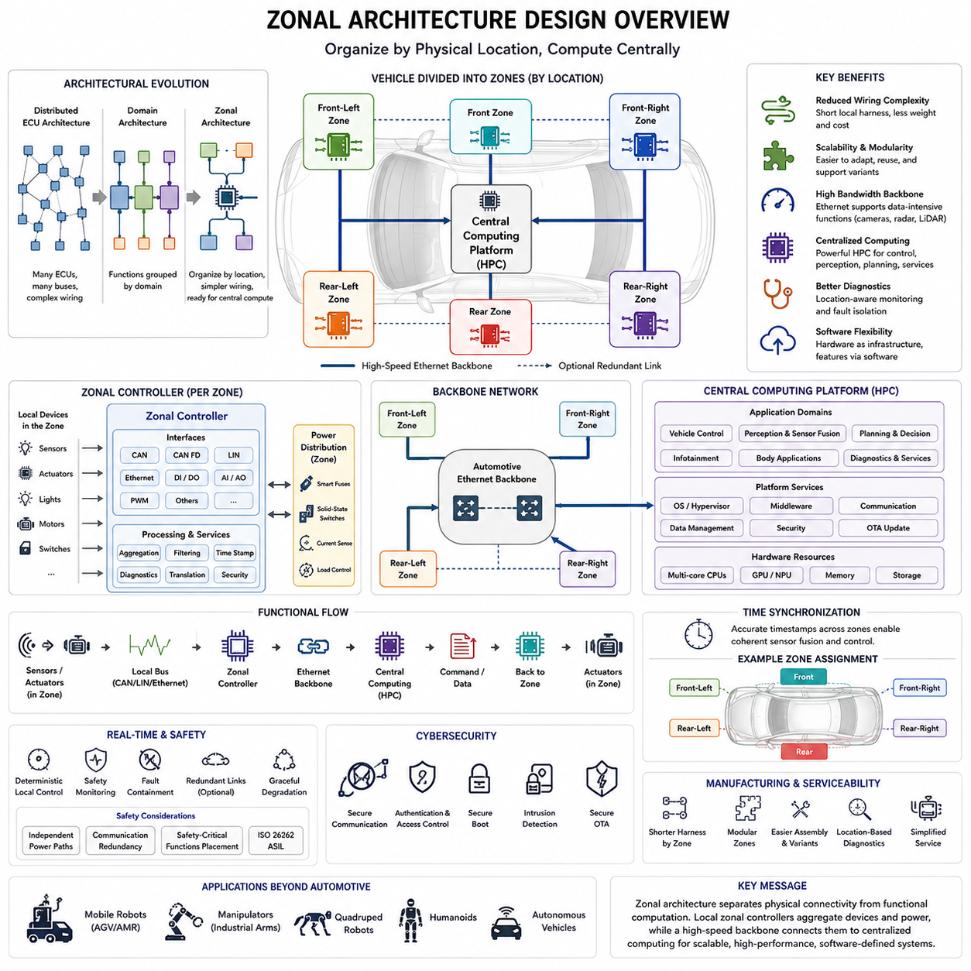
Zonal architecture design reorganizes vehicle electrical and electronic systems according to physical location rather than primarily according to functional responsibility. Instead of connecting sensors and actuators to distant domain-specific ECUs, devices are connected to nearby zonal controllers. These controllers aggregate local electrical interfaces and communicate with centralized computing resources through a high-speed backbone, forming an important architectural step toward software-defined vehicles and centralized high-performance computing.
Traditional distributed ECU architectures usually assign individual controllers to particular components or functions, while domain architectures consolidate related functions into powertrain, chassis, body, infotainment, or ADAS domains. Both approaches remain strongly influenced by functional organization. Zonal architecture introduces a different principle: physical location becomes a major factor in determining where sensors, actuators, communication interfaces, and electrical connections terminate.
A vehicle can conceptually be divided into zones such as front-left, front-right, rear-left, rear-right, front, rear, or cabin areas. The exact number and boundaries depend on vehicle size, packaging, electrical loads, safety requirements, and manufacturer strategy. A zonal controller located within each region provides nearby devices with communication, input/output, diagnostics, and sometimes power-distribution interfaces, reducing the need for long dedicated wiring paths across the vehicle.
The reduction of wiring complexity is one of the strongest motivations for zonal design. In function-oriented architectures, a sensor physically located at the rear of the vehicle may need wiring extending toward a controller associated with its functional domain. Under a zonal approach, the sensor can connect to the nearest zonal controller through a short local harness. Information is then transported digitally over the backbone to whichever computing function requires it.
This distinction separates physical connectivity from software functionality. A wheel-speed sensor, lighting unit, parking sensor, temperature sensor, and actuator located in the same physical area may connect to the same zonal controller even though they belong to completely different vehicle functions. The zonal controller provides physical access to these devices, while centralized software determines how their information is interpreted and which applications use it.
Zonal controllers therefore operate as intelligent aggregation points between edge devices and central computing. They may support CAN, CAN FD, LIN, Ethernet, discrete digital inputs, analog inputs, PWM interfaces, and other local connections. Information arriving from heterogeneous interfaces can be collected, filtered, timestamped, diagnosed, translated, or forwarded through the vehicle backbone. This allows legacy and low-cost interfaces to coexist with newer high-bandwidth networks.
Automotive Ethernet is particularly important in zonal architectures because the backbone must transport information between multiple zones and centralized computers. Rather than extending many independent CAN or LIN buses throughout the entire vehicle, local buses can terminate at zonal controllers and aggregated traffic can move through Ethernet. Higher backbone bandwidth also supports cameras, radar, LiDAR, diagnostics, software updates, and increasingly data-intensive vehicle functions.
The central computing platform performs functions that were previously distributed across many ECUs or domain controllers. Depending on the architecture, one or several High-Performance Computers can execute vehicle control, perception, sensor fusion, planning, infotainment, body applications, and supervisory functions. Zonal controllers remain responsible for local connectivity and selected real-time operations, while centralized computers increasingly determine higher-level vehicle behavior.
This division does not mean that every control loop should move into the central computer. Motor drives, braking interfaces, steering actuators, power electronics, and safety-related devices can require deterministic control at much higher frequencies than centralized applications. Fast local loops can remain inside dedicated microcontrollers or actuator controllers, while the zonal and central layers exchange commands, states, limits, and diagnostic information at appropriate rates.
Power distribution can also become closely associated with zonal architecture. A zonal controller may be combined with, or positioned near, intelligent power distribution electronics that supply nearby loads. Electronic fuses, solid-state switches, current measurement, load diagnostics, and programmable power control can reduce conventional relay and fuse complexity. Consequently, zonal design can reorganize both communication wiring and electrical power distribution around physical regions.
The backbone becomes a critical architectural resource because many functions depend on communication between zones and central computers. Engineers must evaluate bandwidth, latency, jitter, traffic prioritization, synchronization, congestion, and failure behavior. A high nominal data rate alone is insufficient. End-to-end timing must remain compatible with control requirements, particularly when information passes through sensors, local networks, zonal controllers, backbone switches, central software, and actuator interfaces.
Time synchronization becomes increasingly important when distributed sensors and controllers contribute to the same centralized computation. Camera frames, radar measurements, wheel speeds, inertial measurements, and actuator states may originate from different physical zones. Accurate timestamps allow the central computer to reconstruct a coherent vehicle state. Network timing and clock synchronization therefore become part of perception, sensor fusion, control, diagnostics, and system validation.
Functional safety must be considered carefully because consolidation changes failure propagation. A failed zonal controller could disconnect several unrelated devices located in the same physical region, while a backbone failure could affect communication across multiple zones. Designers therefore analyze redundant links, independent power paths, fault containment, safety monitoring, degraded operating modes, communication redundancy, and appropriate allocation of safety-critical functions between local and centralized controllers.
Cybersecurity also becomes increasingly important because zonal architecture creates highly interconnected computing systems. Compromise of a backbone interface or central computer could potentially provide access to multiple vehicle functions. Secure communication, authentication, secure boot, hardware security mechanisms, network segmentation, access control, intrusion monitoring, and protected software updates must therefore be integrated into the architecture rather than added after network design is completed.
Diagnostics can benefit substantially from this organization. Centralized diagnostic software can communicate through the backbone with zonal controllers and their attached devices, providing a structured view of electrical conditions throughout the vehicle. Zonal controllers can monitor local communication faults, disconnected sensors, short circuits, abnormal currents, voltage conditions, and device availability, allowing diagnostic information to be associated with both physical location and functional behavior.
Zonal architecture also improves manufacturing and serviceability when physical interfaces are organized consistently. Harness sections can be designed around vehicle regions, and modular zones can simplify assembly variants. When electrical loads or sensors change within a region, modifications may remain largely local rather than requiring extensive redesign of function-specific wiring paths across the vehicle. This modularity can support platform reuse and multiple vehicle configurations.
However, zonal architecture does not automatically reduce every form of complexity. Zonal controllers require many heterogeneous interfaces, substantial connector capacity, robust power management, sophisticated software, and careful thermal design. Central computers and Ethernet switches can become highly critical components. System complexity therefore moves away from large quantities of independent ECUs and long harness branches toward fewer but more capable computing, networking, and zonal devices.
Software abstraction is essential to obtaining the full benefit of this architecture. Applications should not need to know that a particular sensor is physically connected to a specific zone whenever such knowledge is unnecessary. Middleware and standardized interfaces can expose signals, services, or data objects independently of physical wiring. This allows software functionality to evolve without requiring every change in application logic to produce a corresponding change in electrical topology.
This separation between hardware location and software function is fundamental to the software-defined vehicle. Hardware resources can increasingly become reusable infrastructure, while vehicle behavior is implemented through software services running on centralized computers. Features can be updated, extended, or reconfigured without assigning a dedicated ECU to every new capability. Zonal architecture therefore provides an electrical and communication foundation for greater software flexibility.
The progression from distributed ECU architecture to domain architecture and then zonal architecture should not be interpreted as an instantaneous replacement process. Real vehicles can contain elements of all three approaches. Conventional ECUs may control individual devices, domain controllers may coordinate selected functional groups, zonal controllers may aggregate local interfaces, and centralized computers may execute advanced applications. Migration is therefore typically evolutionary and constrained by cost, safety, legacy systems, and product cycles.
For robotics and Physical AI systems, the zonal principle can also be applied to mobile robots, manipulators, quadrupeds, humanoids, and autonomous vehicles. Sensors, joint electronics, motor controllers, safety devices, and power interfaces can be grouped according to physical regions, while Ethernet connects these zones to edge AI computers. Local controllers maintain fast device-level operation, whereas centralized computing performs perception, planning, reasoning, and coordinated behavior. This relationship fits the broader robotics electrical architecture structure provided in the attached material.
Zonal architecture design therefore represents more than replacing several ECUs with zonal controllers. It reorganizes the relationship among wiring, communication, power distribution, computing, and software by separating physical device connectivity from functional computation. Through local aggregation, high-speed backbone communication, centralized processing, and appropriate retention of real-time edge control, it establishes a scalable foundation for high-performance computers and software-defined vehicle architectures.

02.04. AUTOSAR Classic and Adaptive
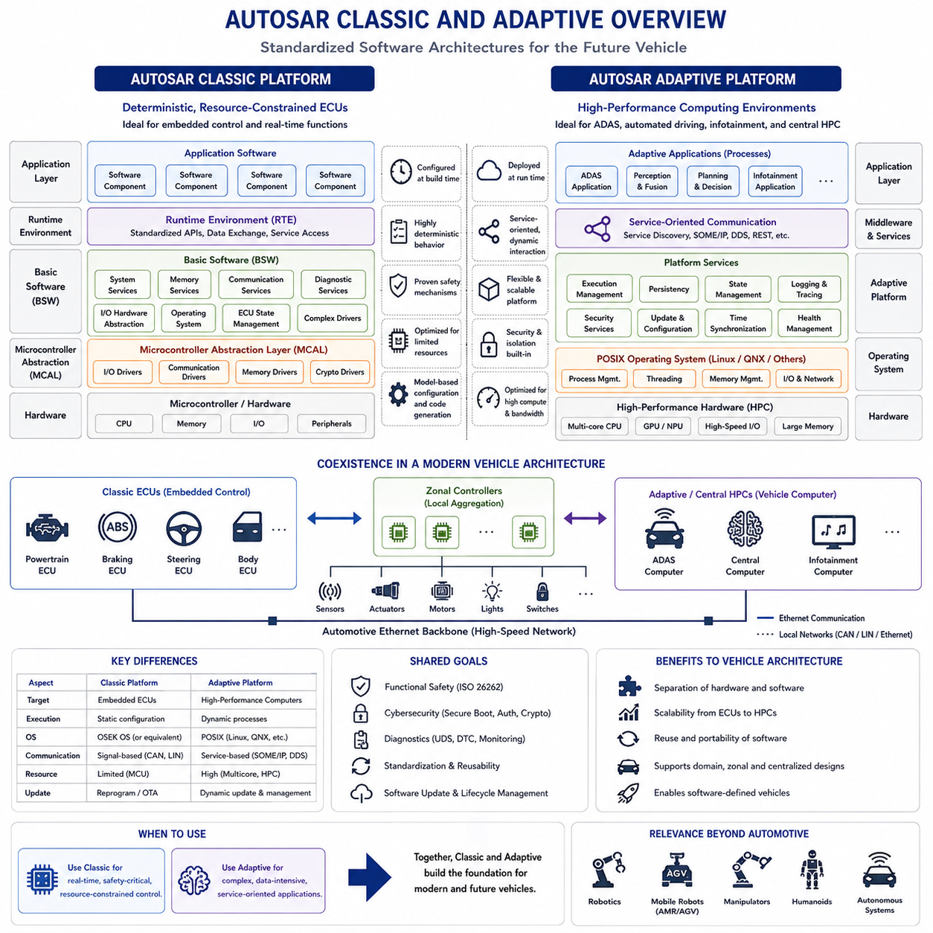
AUTOSAR provides a standardized software architecture for automotive Electronic Control Units, allowing vehicle software to be developed with clearer separation between application functions, communication services, operating-system functions, and hardware-specific implementation. Within automotive electrical architecture, AUTOSAR becomes increasingly important as vehicles evolve from distributed ECUs toward domain controllers, zonal systems, high-performance computers, and software-defined vehicles.
AUTOSAR is commonly divided into two major platforms: AUTOSAR Classic Platform and AUTOSAR Adaptive Platform. They address different classes of automotive computing rather than representing a simple older-versus-newer replacement relationship. Classic is primarily designed for deeply embedded, resource-constrained, deterministic control ECUs, while Adaptive targets high-performance computing environments that require dynamic software, service-oriented communication, and more flexible application execution.
AUTOSAR Classic Platform is closely associated with conventional microcontroller-based ECUs. These controllers often perform functions such as powertrain control, body electronics, braking interfaces, steering control, actuator management, and other embedded operations requiring predictable timing. Their software and hardware configurations are generally defined before deployment, allowing system behavior, communication, memory usage, and task scheduling to be engineered with strong determinism.
A central concept of Classic AUTOSAR is separation between application software and underlying hardware. Application functionality is implemented through Software Components, while standardized interfaces reduce direct dependency on specific microcontrollers, communication peripherals, or ECU hardware. This separation improves portability and reuse because application logic can be developed around defined interfaces rather than being tightly coupled to every low-level hardware implementation.
The Runtime Environment acts as an abstraction and communication layer between application Software Components and lower software layers. From the application perspective, the RTE provides standardized mechanisms for exchanging data and accessing services. This allows software components to interact without requiring each component to understand the detailed implementation of CAN communication, memory drivers, operating-system scheduling, or hardware registers.
Below the RTE, Basic Software provides standardized infrastructure required by the ECU. It includes services for communication, diagnostics, memory management, operating-system functions, ECU state management, and hardware-related interfaces. Basic Software is organized into layers so that application functionality can remain relatively independent from the underlying microcontroller and peripheral implementation while still accessing essential embedded-system capabilities.
The Microcontroller Abstraction Layer provides low-level interfaces to hardware resources such as digital I/O, analog conversion, timers, communication peripherals, and memory devices. Above this layer, ECU abstraction and service layers provide increasingly hardware-independent functionality. This layered structure allows Classic AUTOSAR to transform hardware-specific embedded software into a more standardized platform on which reusable automotive applications can be constructed.
Classic AUTOSAR is strongly configuration-oriented. ECU functions, communication relationships, software components, tasks, signals, and hardware resources are extensively defined during development, and generated configuration data is used to build the final software. This approach fits embedded controllers where resources are limited and predictable execution is important. The resulting system is relatively static, but that static structure supports deterministic behavior and detailed engineering analysis.
AUTOSAR Adaptive Platform addresses a different computing environment. Modern ADAS, automated driving, centralized vehicle computing, and other data-intensive functions require multicore processors, large memory, high-bandwidth networking, and complex operating systems. Applications may need to start, stop, update, or interact dynamically. Adaptive therefore uses architectural concepts more similar to modern distributed computing while preserving automotive requirements for reliability, safety, and lifecycle management.
Adaptive applications are commonly implemented as processes running on a POSIX-compatible operating environment rather than as statically configured embedded tasks in the Classic sense. This enables richer operating-system services, process isolation, dynamic application management, and more flexible deployment. Such capabilities are particularly appropriate for domain controllers and High-Performance Computers where many sophisticated software applications must share substantial computing resources.
Service-oriented communication is a major characteristic of Adaptive AUTOSAR. Instead of designing communication primarily around fixed signals exchanged between predetermined ECUs, applications can provide and consume services through standardized interfaces. Service discovery allows software to identify available services at runtime, supporting architectures in which applications interact through logical services rather than being permanently tied to specific physical controller locations.
Automotive Ethernet naturally complements this service-oriented architecture. High-performance computers may exchange perception results, vehicle states, diagnostics, maps, planning information, and other complex datasets that exceed the practical requirements of traditional signal-oriented networks. Technologies such as SOME/IP can support service-based communication over Ethernet, helping applications exchange structured information across domain, zonal, and centralized computing environments.
Classic and Adaptive AUTOSAR can coexist within the same vehicle. A motor controller, braking ECU, body controller, or other deeply embedded device may use Classic AUTOSAR, while an ADAS computer or central HPC uses Adaptive AUTOSAR. Communication gateways and standardized network technologies connect these environments. The resulting vehicle therefore combines deterministic embedded control with flexible high-performance computing rather than forcing every controller onto one software platform.
This coexistence reflects an important architectural principle: computing requirements should determine software-platform selection. A fast low-level control loop with limited memory and strict timing constraints has fundamentally different requirements from perception, planning, data processing, or service-oriented applications running on multicore processors. Classic and Adaptive provide complementary mechanisms for these different execution environments while supporting integration at the vehicle level.
Functional safety remains important in both environments, although the implementation strategies differ. Classic systems can rely on carefully configured tasks, memory protection, watchdogs, communication supervision, and deterministic execution. Adaptive systems require process isolation, application lifecycle supervision, platform health management, secure communication, and mechanisms for controlling failures within more complex computing environments. Safety architecture must therefore extend across both software and hardware boundaries.
Cybersecurity has also become fundamental because modern vehicle software communicates across increasingly connected networks. Secure boot, authentication, protected communication, access control, secure storage, software integrity, and controlled update mechanisms must protect both embedded ECUs and high-performance computers. As vehicles gain external connectivity and over-the-air software capabilities, cybersecurity becomes inseparable from software architecture and vehicle lifecycle management.
Diagnostics are integrated throughout the software architecture rather than treated only as an external service function. ECU software must detect faults, store diagnostic information, report operating states, and support service procedures. In increasingly centralized architectures, diagnostic information from Classic ECUs can be transported through gateways toward Adaptive or centralized computing platforms, where vehicle-wide monitoring and diagnostic applications can provide a more integrated system view.
Software updates highlight another difference between traditional embedded systems and newer vehicle computing. Classic ECUs generally operate with tightly controlled software images and configurations, although they can still support reprogramming and OTA mechanisms. Adaptive environments are designed for more dynamic software lifecycle management, making it practical to deploy, update, activate, deactivate, and manage complex applications on centralized computing platforms.
The relationship between AUTOSAR and zonal architecture is particularly significant. Zonal controllers may retain Classic-style embedded software when they provide deterministic local I/O, communication, power control, and actuator interfaces. Central HPCs can use Adaptive-style software for vehicle-level services, perception, planning, diagnostics, and application management. Ethernet then provides the communication backbone connecting physically distributed zones with logically centralized software functionality.
AUTOSAR also supports the broader transition toward software-defined vehicles by reducing direct coupling between vehicle functions and individual hardware devices. Standard interfaces, communication abstractions, middleware, service-oriented interaction, and lifecycle management allow software to become increasingly independent of physical ECU boundaries. This makes it easier to consolidate functions, reuse software, manage variants, and evolve vehicle capabilities without redesigning every electronic subsystem.
For robotics and Physical AI, the architectural concepts are relevant even when AUTOSAR itself is not used. A robot can similarly separate deterministic motor and safety control from high-level perception, planning, and AI computation. Microcontroller-based device controllers resemble the role addressed by Classic systems, while powerful edge computers resemble the Adaptive computing environment. Standardized interfaces and Ethernet communication can connect these layers while preserving different real-time requirements.
AUTOSAR Classic and Adaptive therefore should be understood as complementary software architecture platforms for different levels of automotive computation. Classic provides structured, deterministic, resource-efficient software for deeply embedded control, while Adaptive provides flexible, service-oriented execution for high-performance computing. Together they support the architectural progression from distributed ECUs through domain and zonal systems toward centralized, software-defined vehicle computing.

02.05. Software Defined Vehicle
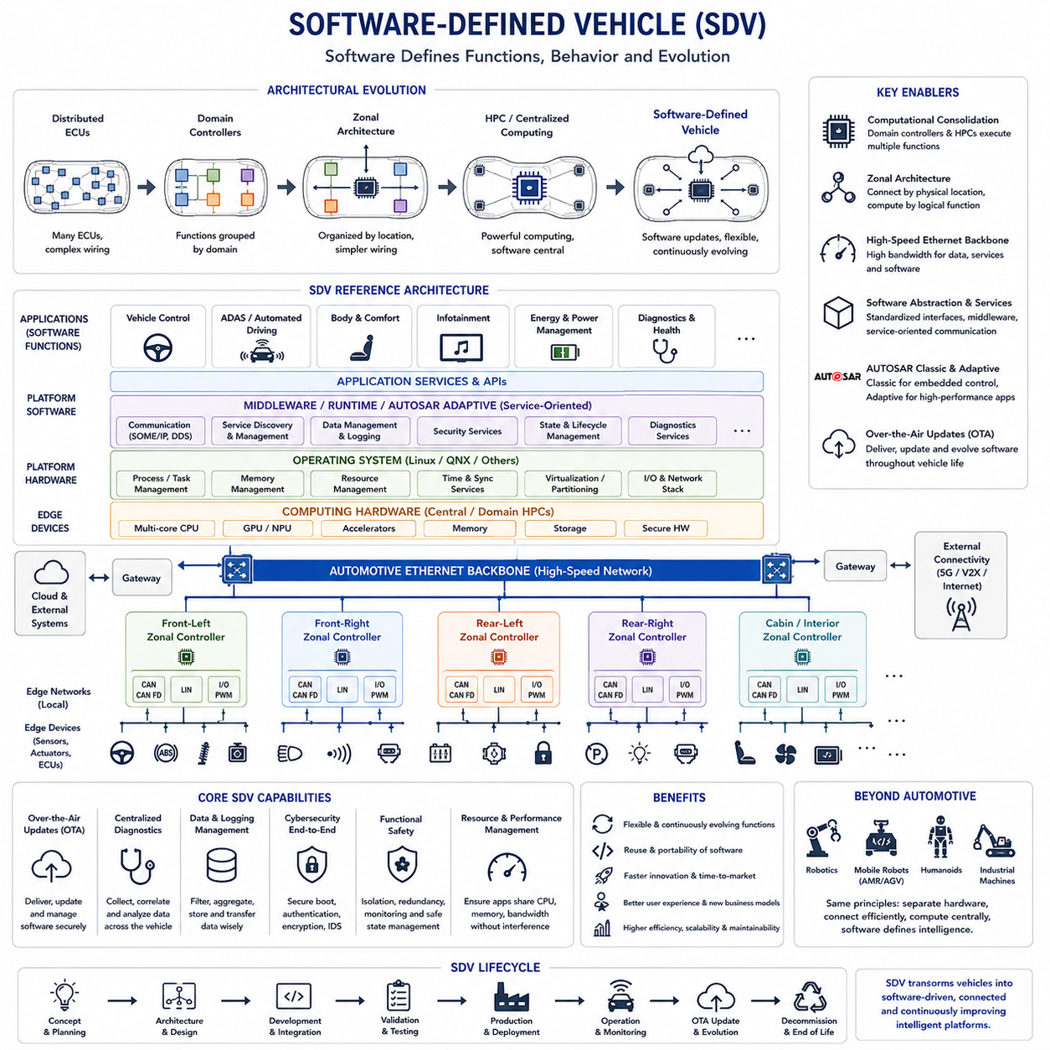
A Software-Defined Vehicle is an automotive architecture in which an increasing portion of vehicle functionality, behavior, configuration, and lifecycle evolution is determined by software rather than being permanently fixed by individual hardware controllers. Within the supplied structure, it follows ECU networks, domain controllers, zonal design, and AUTOSAR, and leads naturally toward High-Performance Computer architecture.
Traditional vehicles evolved by adding Electronic Control Units whenever new functions were introduced. Each ECU typically combined dedicated hardware, embedded software, communication interfaces, and specific vehicle functions. As the number of features increased, vehicles accumulated many controllers and complex dependencies. Software-Defined Vehicle architecture changes this relationship by treating computing, networking, and electrical hardware increasingly as reusable infrastructure on which software-defined functions execute.
This transition depends strongly on computational consolidation. Instead of distributing application logic across dozens of independent ECUs, domain controllers and centralized High-Performance Computers can execute multiple vehicle functions on shared computing platforms. Local controllers remain where deterministic control or direct electrical interfaces are required, but higher-level functions progressively migrate toward centralized computing resources that can be managed as common vehicle platforms.
Zonal architecture complements this approach by separating physical connectivity from functional computation. Sensors, actuators, switches, and electrical loads connect to nearby zonal controllers according to their physical location, while software functions execute on centralized computers according to logical requirements. Consequently, adding or modifying a software feature does not necessarily require adding another dedicated ECU or redesigning long function-specific wiring paths throughout the vehicle.
A high-speed communication backbone is essential because centralized software requires access to information distributed across the vehicle. Automotive Ethernet can connect zonal controllers, domain controllers, gateways, sensors, and High-Performance Computers while local CAN, CAN FD, or LIN networks continue serving appropriate embedded devices. The vehicle network therefore becomes a computing infrastructure that transports signals, services, sensor data, commands, diagnostics, and software-related information.
Software abstraction is a fundamental principle of the Software-Defined Vehicle. Applications should interact with standardized interfaces and services rather than depending directly on particular hardware registers, communication channels, or physical ECU locations. Middleware, operating systems, hardware abstraction layers, communication services, and standardized APIs create boundaries between application software and underlying electronics, improving portability, reuse, integration, and hardware independence.
Service-oriented architecture further reduces direct coupling between software functions. Instead of assuming that a specific ECU always provides a predefined signal at a fixed network location, applications can provide and consume logical services. Service discovery and standardized communication allow functions to interact through defined interfaces, making it easier to redistribute applications across computing platforms as vehicle hardware and software configurations evolve.
AUTOSAR Classic and AUTOSAR Adaptive illustrate how different software environments can coexist within this architecture. Classic AUTOSAR remains suitable for deterministic microcontroller-based control functions, while Adaptive AUTOSAR addresses high-performance, process-oriented, service-based applications. A Software-Defined Vehicle can therefore preserve reliable embedded control at the edge while introducing flexible software execution on domain controllers and central computing platforms.
The operating system and middleware become strategically important because many applications share common hardware resources. They must provide process or task management, communication, memory management, diagnostics, security, timing services, hardware abstraction, and resource isolation. In centralized computers, virtualization or partitioning can further separate applications with different performance, safety, and lifecycle requirements while allowing them to use the same physical computing platform.
Over-the-air updating is one of the most visible capabilities associated with Software-Defined Vehicles. Software can be delivered after manufacturing to correct defects, improve algorithms, update maps, modify interfaces, enhance diagnostics, or introduce supported functionality. OTA capability changes the vehicle from a product whose functionality is largely fixed at production into a system whose software can continue evolving throughout its operational lifecycle.
OTA updates, however, require much more than a wireless communication link. The architecture must support secure software distribution, package verification, compatibility checking, controlled installation, version management, rollback, recovery, and update status monitoring. Updates must not leave safety-critical controllers in inconsistent states. Vehicle software configuration therefore becomes a managed system-level asset rather than a collection of unrelated ECU firmware versions.
Centralized diagnostics provide another important capability. Traditional diagnostics often focus on individual ECUs and Diagnostic Trouble Codes, whereas software-defined architectures can combine information from controllers, networks, sensors, computing platforms, and software services. Central logging and health monitoring can provide a more complete view of system behavior, enabling fault correlation, software performance analysis, predictive maintenance, and improved service engineering.
Data management also becomes a major architectural responsibility. Cameras, radar, LiDAR, vehicle-state sensors, controllers, and software services can generate large volumes of operational information. Not all data should be stored or transmitted, so the vehicle requires mechanisms for filtering, aggregation, prioritization, logging, retention, and controlled external transfer. Data architecture must therefore be designed together with computing and communication architecture.
Cybersecurity is fundamental because a vehicle that can receive software and exchange data with external systems has a larger attack surface than an isolated embedded system. Secure boot, hardware roots of trust, cryptographic authentication, access control, encrypted communication, intrusion detection, software signing, protected storage, and secure update mechanisms must work together. Security must extend from cloud interfaces through central computers and networks to embedded controllers.
Functional safety remains equally important as software becomes more centralized and dynamic. Consolidating several functions on shared hardware can increase the consequences of processor, memory, operating-system, or communication failures. Isolation, redundancy, watchdogs, health monitoring, controlled degradation, independent safety mechanisms, and carefully defined fallback states are required so that software flexibility does not compromise safety-critical vehicle behavior.
Centralized computing also introduces resource-management challenges. Applications compete for CPU time, GPU or accelerator resources, memory capacity, memory bandwidth, storage, and network bandwidth. Vehicle architects must ensure that a computationally intensive perception or infotainment application cannot unexpectedly interfere with critical control or safety functions. Resource allocation and performance isolation therefore become important parts of both hardware and software architecture.
The Software-Defined Vehicle also changes the engineering organization. Electrical engineering, embedded software, cloud software, cybersecurity, functional safety, networking, data engineering, and application development become increasingly interdependent. Interfaces and system boundaries must be defined early because a feature may span sensors, zonal controllers, networks, central computers, software services, and external infrastructure rather than belonging to one traditional ECU development team.
Hardware and software lifecycles can also become increasingly decoupled. Vehicle hardware may remain in service for many years, while software can evolve much more frequently. Computing platforms therefore require performance headroom, standardized interfaces, storage capacity, communication bandwidth, and upgrade strategies that anticipate future applications. Architecture must support functions that may not have been fully defined when the original vehicle hardware was designed.
This transformation also enables new business and operational models. Features can potentially be activated through software configuration, vehicle behavior can be optimized after deployment, and fleet data can support continuous engineering improvements. However, technical capability must be accompanied by reliable configuration management, cybersecurity, regulatory compliance, user authorization, safety validation, and clear ownership of software throughout the vehicle lifecycle.
For robotics and Physical AI systems, the same architectural direction is highly relevant. A robot can use local motor and safety controllers for fast deterministic loops while centralized edge computers execute perception, world modeling, planning, reasoning, and AI applications. Ethernet can provide the high-speed backbone, and software services can abstract sensors and actuators from applications. The supplied broader structure similarly separates robotics communication, compute, sensing, and Physical AI electrical architecture into interconnected engineering areas.
A Software-Defined Vehicle therefore should not be understood simply as a vehicle containing more software or supporting OTA updates. It represents a deeper architectural shift in which computing platforms, communication networks, zonal interfaces, middleware, security, diagnostics, and lifecycle management form reusable infrastructure for continuously evolving software functions. This foundation leads directly toward centralized High-Performance Computer architectures capable of coordinating increasingly complex vehicle intelligence.

02.06. High Performance Computer (HPC)
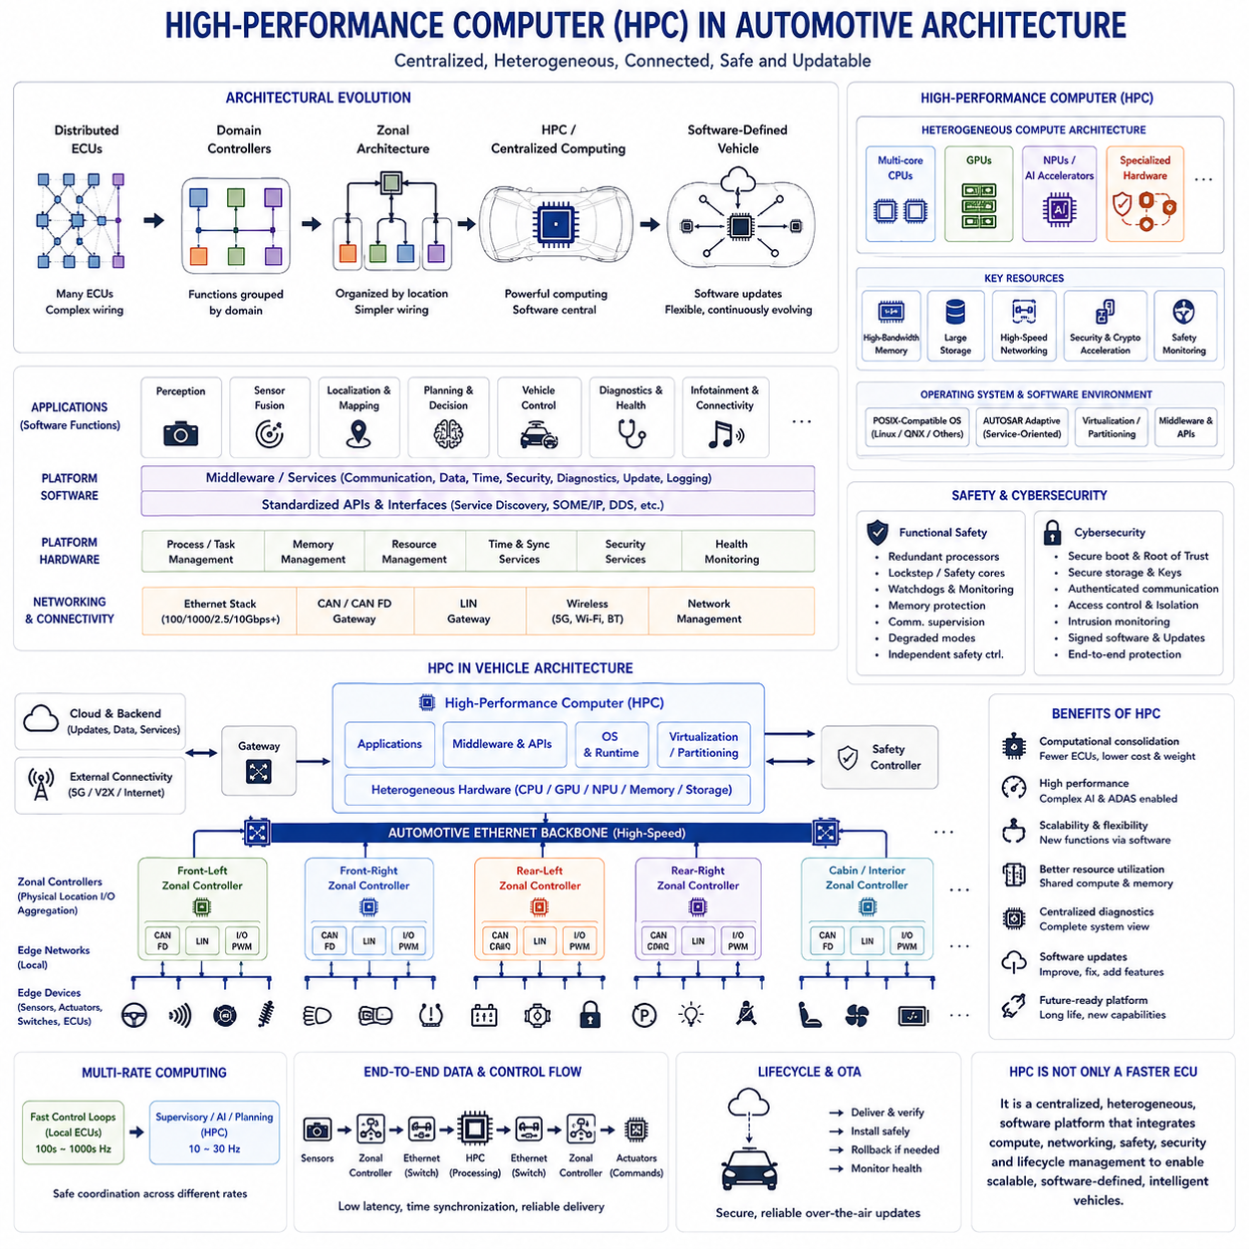
A High-Performance Computer, or HPC, represents the central computing layer that emerges as automotive electrical architecture evolves from distributed ECUs through domain and zonal architectures toward software-defined vehicles. Instead of assigning complex software functions to many independent controllers, an HPC consolidates substantial computation onto a smaller number of powerful platforms while maintaining connections to distributed sensors, actuators, zonal controllers, and safety-critical embedded systems.
Traditional automotive ECUs are optimized for relatively specific control functions and commonly use microcontrollers with tightly constrained memory, processing capability, and real-time behavior. An HPC addresses a different class of workloads. It must execute multiple sophisticated applications simultaneously, including perception, sensor fusion, vehicle-state estimation, automated-driving functions, planning, diagnostics, infotainment, connectivity, and software lifecycle services.
The computational architecture of an automotive HPC is therefore heterogeneous. Multicore CPUs provide general-purpose processing and system control, while GPUs can accelerate highly parallel workloads such as image processing and neural-network inference. NPUs or dedicated AI accelerators can execute machine-learning models efficiently, and specialized hardware may support signal processing, cryptography, networking, storage, or safety monitoring. These resources operate together as one integrated computing platform.
Computational consolidation reduces the need to duplicate processors, memory, storage, and software infrastructure across many independent ECUs. Several applications can share common hardware resources while communicating through standardized software interfaces. This can improve resource utilization and simplify functional integration, but it also creates stronger dependencies between applications because multiple vehicle functions now rely on the availability and correct operation of the same computing platform.
Memory architecture becomes particularly important as workloads grow. Camera processing, neural networks, sensor fusion, mapping, and automated-driving algorithms can move large quantities of data between processors and accelerators. High memory capacity alone is insufficient if bandwidth cannot sustain these transfers. HPC design must therefore consider memory bandwidth, latency, cache behavior, data movement, accelerator access, and contention among applications executing concurrently.
Storage requirements also expand beyond those of conventional ECUs. The platform may store operating-system images, application software, AI models, maps, configuration data, diagnostic logs, update packages, and temporary sensor information. High-capacity nonvolatile storage must provide appropriate performance, reliability, integrity, and security while supporting software updates and recovery mechanisms throughout the operational lifecycle of the vehicle.
The operating system forms a critical layer between computing hardware and vehicle applications. Unlike deeply embedded ECUs that often use compact real-time operating systems, HPC platforms may use POSIX-compatible operating environments capable of process management, memory protection, networking, file systems, and dynamic application execution. AUTOSAR Adaptive can operate within this class of environment and support service-oriented applications suited to centralized automotive computing.
Virtualization and partitioning allow different software environments to share one physical HPC while maintaining controlled separation. Vehicle control, ADAS, infotainment, diagnostics, and third-party applications can have different safety, security, timing, and lifecycle requirements. Hypervisors, process isolation, memory protection, and hardware virtualization mechanisms can prevent one software domain from unintentionally interfering with another while improving utilization of centralized hardware.
An HPC does not eliminate the need for real-time embedded controllers. Low-level motor control, braking actuation, steering interfaces, battery protection, power electronics, and other fast safety-related functions may remain on dedicated microcontrollers. These local controllers can execute deterministic loops independently, while the HPC provides slower supervisory commands, state estimation, planning, optimization, and coordinated vehicle-level behavior.
This creates a multi-rate computing architecture. A local actuator controller may operate at hundreds or thousands of control cycles per second, while perception, planning, or AI applications on the HPC operate at lower frequencies determined by sensor rates and computational complexity. The architecture must define how commands and states cross these rate boundaries so that slower centralized intelligence can safely supervise faster deterministic edge control.
High-speed networking is essential because centralized computing depends on data generated throughout the vehicle. Automotive Ethernet can provide the backbone connecting HPCs, zonal controllers, domain controllers, intelligent sensors, and gateways. CAN, CAN FD, and LIN can remain within local networks where their characteristics are appropriate. The HPC therefore sits at the center of a heterogeneous communication environment rather than replacing every existing automotive network.
Zonal architecture strengthens this relationship. Sensors and actuators connect to nearby zonal controllers, which aggregate local communication and electrical interfaces before exchanging information with the HPC through the backbone. This arrangement separates physical device connectivity from centralized computation. The HPC can execute software based on logical services and vehicle functions without requiring every application to directly manage the physical wiring location of each device.
End-to-end latency becomes a major design parameter. Sensor information may pass through a local interface, zonal controller, Ethernet switch, operating-system network stack, middleware, and application before producing a command that travels back toward an actuator. Each stage introduces processing delay and jitter. HPC performance must therefore be evaluated as part of the complete control and communication path rather than solely through processor benchmark results.
Time synchronization is similarly important for centralized perception and control. Cameras, radar, LiDAR, inertial sensors, wheel-speed sensors, and local controllers generate information at different locations and rates. Accurate timestamps and synchronized clocks allow the HPC to combine these observations into a coherent representation of vehicle state. Network synchronization consequently becomes an important part of sensor fusion, logging, diagnostics, and system validation.
Functional safety becomes more challenging when computation is consolidated because a single HPC failure can potentially influence several vehicle functions. Safety mechanisms may include redundant processors, lockstep or safety cores, watchdogs, health monitoring, memory protection, communication supervision, independent safety controllers, and degraded operating modes. The architecture must ensure that centralized computing failures do not produce uncontrolled behavior in safety-critical actuators.
Cybersecurity is equally fundamental because the HPC can connect internal vehicle networks with external communication and software-update infrastructure. Secure boot, hardware roots of trust, cryptographic acceleration, authenticated communication, access control, secure storage, intrusion monitoring, and signed software packages help protect the platform. Compromise of a central computer can have broad consequences, making security isolation a core architectural requirement.
Thermal and electrical design are significant constraints because high computational performance requires substantially more power than conventional microcontroller-based ECUs. CPUs, GPUs, NPUs, memory, storage, and networking devices generate heat that must be removed reliably under automotive environmental conditions. Power delivery, cooling, enclosure design, component placement, thermal throttling, startup behavior, and energy management therefore directly influence achievable computing performance.
Resource management is required when multiple applications share CPUs, accelerators, memory, and networks. Critical applications must receive sufficient computing resources even when other workloads become intensive. Scheduling policies, processor affinity, accelerator allocation, memory-bandwidth control, network prioritization, and performance monitoring can help maintain predictable behavior. Centralization therefore transforms hardware-resource allocation into a vehicle-level systems engineering problem.
HPC architecture is closely connected to the Software-Defined Vehicle because centralized computing provides a reusable platform on which software functions can evolve. Applications, middleware, AI models, diagnostics, and supported vehicle features can be updated without replacing dedicated hardware for every change. Combined with standardized interfaces and over-the-air update mechanisms, the HPC becomes a long-lived computational foundation for continuing software development after vehicle production.
The HPC also enables closer integration between conventional control software and AI-intensive functions. Perception networks can process camera or LiDAR data, world-state estimation can combine multiple sensor sources, planning algorithms can generate trajectories, and supervisory control can translate those trajectories into commands for lower-level controllers. This creates a hierarchical intelligence architecture in which high-level computation and low-level deterministic control cooperate rather than compete.
For robotics and Physical AI systems, the same architecture appears as a powerful edge computer connected to distributed device controllers. Motor controllers and safety devices maintain fast real-time loops, while CPUs, GPUs, or AI accelerators execute perception, localization, world models, planning, reasoning, and learned policies. High-speed Ethernet connects these computing layers, reflecting the broader separation of robotics control, communication, compute, sensing, and Physical AI architectures in the supplied structure.
A High-Performance Computer should therefore not be understood simply as a faster ECU. It represents a different architectural role in which heterogeneous computing, shared resources, high-speed networking, software abstraction, safety isolation, cybersecurity, and lifecycle management are combined into a centralized platform. Together with zonal connectivity and local deterministic controllers, the HPC provides the computational foundation for scalable Software-Defined Vehicles and increasingly intelligent automotive systems.

