Volume 01. Electrical Architecture Fundamentals

Chapter 09. Functional Safety Overview

09.01. ISO 26262 Introduction
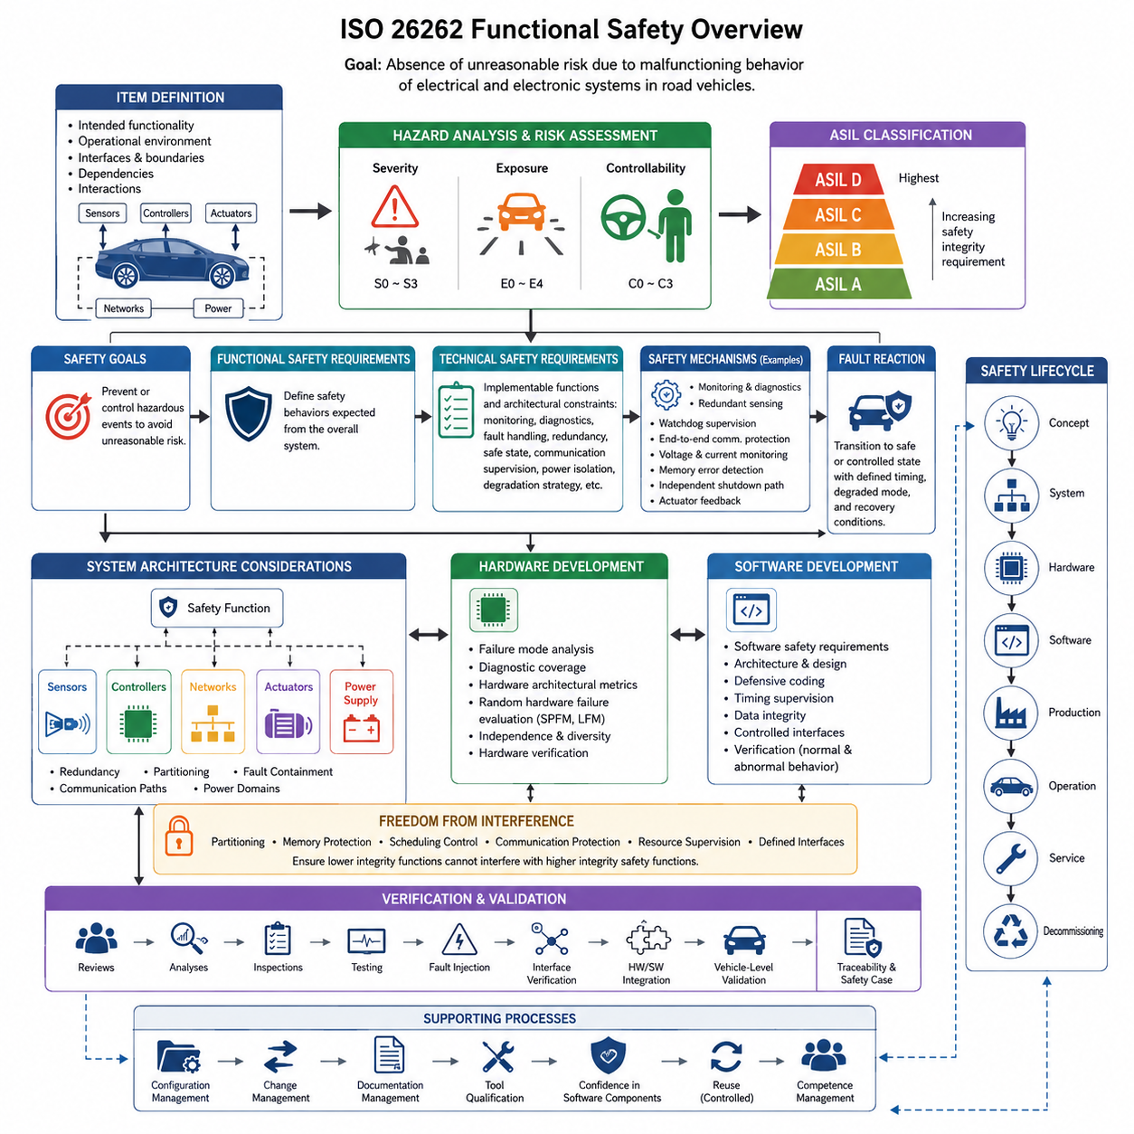
ISO 26262 is an international functional safety standard for electrical and electronic systems in road vehicles. It provides a systematic framework for reducing risks caused by malfunctioning behavior of safety-related systems. Rather than defining whether a particular component is inherently safe, the standard establishes engineering processes for identifying hazards, specifying safety requirements, developing appropriate controls, and demonstrating that residual risk has been reduced to an acceptable level.
The standard is based on the concept of functional safety, which concerns the absence of unreasonable risk resulting from hazards caused by malfunctioning electrical or electronic behavior. This distinguishes functional safety from general product reliability. A component may be highly reliable but still create an unacceptable hazard when a rare failure occurs, while another component may experience frequent noncritical faults without producing significant safety consequences. Safety engineering therefore considers both failure behavior and its effect on the complete system.
ISO 26262 applies a safety lifecycle that extends from early concept development through system, hardware, and software engineering and continues into production, operation, service, and decommissioning. Safety is therefore not treated as a verification activity performed only after the design is complete. Safety objectives, assumptions, requirements, analyses, verification activities, and supporting evidence are progressively developed and maintained throughout the lifecycle so that design decisions remain traceable to identified risks.
A fundamental starting point is the definition of an item, meaning the system or combination of systems being considered for functional safety analysis. Engineers define the intended functionality, operational environment, interfaces, boundaries, dependencies, and interactions of the item before evaluating hazardous behavior. Clear boundaries are particularly important in distributed electrical architectures because sensing, computation, communication, power distribution, and actuation may be implemented by different controllers while collectively supporting one vehicle-level function.
Hazard analysis and risk assessment examines situations in which malfunctioning behavior could create hazardous events. The assessment considers the severity of possible harm, the probability or frequency of exposure to the relevant operational situation, and the controllability available to people affected by the event. These factors support classification using Automotive Safety Integrity Levels, commonly expressed as ASIL A, ASIL B, ASIL C, and ASIL D, with ASIL D representing the most demanding integrity level within the classification framework.
The ASIL classification influences the rigor expected from subsequent development activities. Higher safety integrity generally requires stronger development discipline, greater independence in selected verification activities, more comprehensive analyses, and more robust evidence that systematic and random hardware faults are adequately controlled. The purpose is not simply to label a component with an ASIL, but to propagate safety objectives into concrete requirements and engineering mechanisms that can be implemented, verified, traced, and justified.
Safety goals are derived from hazardous events and represent high-level requirements intended to prevent or sufficiently control unacceptable consequences. These goals are refined into functional safety requirements that describe the safety behavior expected from the overall system. Technical safety requirements then translate this intent into implementable architectural constraints and functions, including monitoring, diagnostics, fault handling, redundancy, degradation strategies, communication supervision, power isolation, and transition to defined safe or controlled operating states.
At the system level, functional safety becomes closely connected with electrical and electronic architecture. Designers must determine how safety-related functions are distributed among sensors, controllers, communication networks, power supplies, actuators, and independent monitoring mechanisms. Architectural decisions concerning redundancy, partitioning, fault containment, communication paths, and power domains can determine whether a single fault remains localized or propagates into loss of a safety-critical function.
Hardware development addresses both systematic design concerns and failures associated with physical electronic components. Engineers analyze failure modes of processors, memories, power devices, communication interfaces, sensors, actuators, and supporting circuitry. Diagnostic coverage, fault detection mechanisms, hardware architectural metrics, and probabilistic evaluation of random hardware failures provide structured ways to assess whether the hardware architecture offers sufficient protection for the required safety integrity.
Software safety engineering complements the hardware process by controlling systematic faults introduced through requirements, architecture, implementation, integration, and verification. Software safety requirements are allocated to components and implemented using appropriate architectural principles, defensive programming practices, monitoring functions, timing supervision, data integrity mechanisms, and controlled interfaces. Verification must demonstrate not only nominal functionality but also correct behavior when abnormal conditions and detected faults occur.
Freedom from interference becomes important when software or hardware elements with different safety responsibilities share computing or communication resources. A lower-integrity function should not be able to corrupt the execution, memory, timing, communication, or data of a higher-integrity safety function. Partitioning, memory protection, scheduling controls, communication protection, resource supervision, and clearly defined interfaces are therefore important architectural mechanisms in increasingly centralized and high-performance computing platforms.
Safety mechanisms are engineering features specifically introduced to detect, tolerate, control, or mitigate faults. Examples include watchdog supervision, plausibility checking, redundant sensing, end-to-end communication protection, voltage monitoring, memory error detection, processor lockstep techniques, independent shutdown paths, and actuator feedback. Their effectiveness depends not merely on their existence but on diagnostic coverage, independence, reaction time, fault assumptions, and the system response following detection.
Fault reaction must be designed according to the physical consequences of the controlled function. Immediately removing power is not automatically the safest response for every system. Steering, braking, propulsion, robotic actuation, or automated motion functions may require controlled degradation or continued operation for a limited period before entering a safe state. Functional safety architecture therefore links fault detection with carefully defined reactions, timing requirements, degraded modes, and recovery conditions.
Verification and validation provide evidence that safety requirements have been correctly implemented and that the resulting system achieves its intended safety objectives. Reviews, analyses, inspections, testing, fault injection, interface verification, hardware and software integration testing, and vehicle-level validation can contribute to this evidence. Traceability connects identified hazards to safety goals, requirements, implementation elements, verification results, and unresolved issues, making the safety argument auditable rather than dependent on informal engineering judgment.
Supporting processes are also essential because functional safety depends on disciplined engineering management. Configuration management ensures that safety evidence corresponds to known versions of hardware, software, requirements, and calibration data. Change management evaluates whether modifications introduce new hazards or invalidate previous analyses. Documentation management, tool qualification where applicable, confidence in software components, and controlled reuse help preserve safety integrity as complex products evolve across multiple development iterations.
ISO 26262 is particularly relevant to modern architectures because increasing centralization, high-performance computing, Ethernet communication, electrified powertrains, and software-defined functionality create new dependencies between traditionally separate domains. A failure in a shared power rail, gateway, central computer, communication backbone, or synchronization service can influence several functions simultaneously. Functional safety analysis therefore needs to examine common-cause failures, dependent failures, shared resources, and architectural fault containment rather than considering individual ECUs in isolation.
For robotics and Physical AI systems, ISO 26262 is best understood within the attached material as part of a broader functional-safety foundation rather than as a universal robotics safety standard. The source structure deliberately places it alongside IEC 61508, ISO 3691-4, ASIL/SIL/PL concepts, and the safety lifecycle, while a later dedicated Safety Architecture volume expands these subjects independently. This organization supports comparison between automotive functional-safety principles and the different safety frameworks required by industrial and robotic applications.

09.02. IEC 61508 Introduction
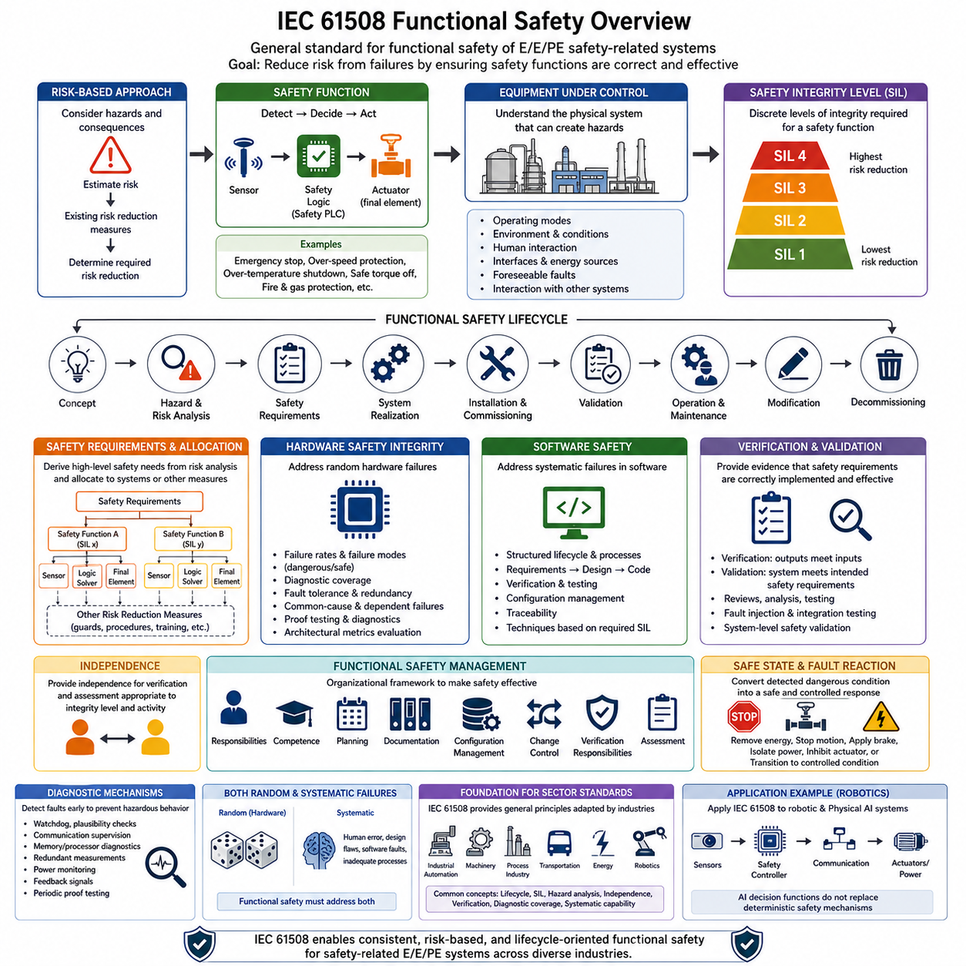
IEC 61508 is an international functional safety standard that establishes a general framework for electrical, electronic, and programmable electronic safety-related systems. Unlike standards developed for a single industry, it provides fundamental principles that can be adapted across industrial automation, machinery, process plants, transportation, energy, and other safety-critical applications. Within the attached structure, it complements ISO 26262 and provides an important foundation for understanding broader functional safety engineering.
The central objective of IEC 61508 is to reduce risks associated with failures of systems that perform safety functions. Functional safety is achieved when safety-related equipment correctly performs the required safety functions under specified conditions and responds appropriately when faults occur. The standard therefore considers not only whether equipment operates correctly during normal conditions, but also whether failures are detected, controlled, tolerated, or converted into defined safe behavior.
IEC 61508 uses a risk-based approach rather than assuming that every safety function requires the same level of engineering rigor. Engineers first consider hazardous events, their potential consequences, and the likelihood of occurrence. Existing risk reduction measures are then considered to determine how much additional risk reduction must be provided by safety-related systems. This approach connects engineering effort to the level of risk associated with the application.
A safety function is a function implemented to achieve or maintain a safe state for equipment under control when a potentially hazardous condition occurs. It may involve detecting an abnormal condition, evaluating the condition through safety logic, and commanding an output that reduces the associated risk. Typical implementations can therefore involve sensors, safety controllers or logic solvers, communication paths, and final elements such as contactors, brakes, valves, or controlled shutdown mechanisms.
The concept of the equipment under control is important because functional safety cannot be evaluated by examining a safety controller in isolation. Engineers must understand the machine, process, vehicle, robot, or other physical system whose behavior can create hazards. Operating modes, environmental conditions, human interaction, interfaces, energy sources, foreseeable faults, and interactions with external systems influence both the required safety functions and their performance requirements.
IEC 61508 organizes safety engineering around a functional safety lifecycle. The lifecycle provides a structured path from initial concept and hazard analysis through safety requirements, system realization, installation, commissioning, validation, operation, maintenance, modification, and eventual decommissioning. Safety is therefore treated as a continuous engineering responsibility rather than as a final inspection performed after hardware and software development has already been completed.
Safety requirements are progressively refined as development proceeds. High-level safety needs identified through hazard and risk analysis are translated into specific safety functions and associated integrity requirements. These requirements are then allocated to electrical, electronic, programmable electronic systems or other risk reduction measures. Clear allocation allows designers to determine which subsystem is responsible for detecting a hazardous condition, making the safety decision, and executing the required physical response.
A major concept introduced by IEC 61508 is the Safety Integrity Level, or SIL. SIL represents a discrete level associated with the integrity required from a safety function, ranging from SIL 1 through SIL 4. Higher SIL levels correspond to greater required risk reduction and increasingly demanding engineering measures. SIL should therefore be understood as a requirement associated with the performance of a safety function rather than simply as a general quality grade assigned to an entire product.
Safety integrity considers both random hardware failures and systematic failures. Random hardware failures arise from physical failure mechanisms that may occur probabilistically during operation, while systematic failures are related to causes such as incorrect requirements, design errors, software defects, implementation mistakes, or inadequate engineering processes. Effective functional safety must address both categories because increasing hardware reliability alone cannot eliminate systematic design errors.
Hardware safety integrity is evaluated using quantitative and architectural considerations appropriate to the safety function. Failure rates, dangerous and safe failure modes, diagnostic coverage, fault tolerance, and the effectiveness of diagnostic mechanisms influence the ability of an architecture to achieve the required integrity. Redundancy can improve fault tolerance, but redundant channels must also be analyzed for common-cause and dependent failures that could defeat multiple channels simultaneously.
Software requires a different safety approach because software does not normally fail through random physical wear mechanisms in the same way as electronic hardware. Software failures are primarily systematic and can originate in requirements, architecture, implementation, integration, configuration, or modification. IEC 61508 therefore emphasizes structured development processes, appropriate design methods, verification, testing, traceability, configuration control, and techniques selected according to the required safety integrity.
Verification and validation have distinct but complementary roles within the safety lifecycle. Verification evaluates whether the outputs of a development activity correctly satisfy its specified inputs and requirements. Validation evaluates whether the completed safety-related system satisfies the intended safety requirements in the actual or representative application context. Reviews, analyses, testing, fault injection, integration testing, and system-level safety validation can contribute evidence to these activities.
Independence is another important principle in functional safety assessment. Depending on the required integrity and the activity being performed, verification or assessment may require personnel with an appropriate degree of independence from those responsible for the original development. The purpose is to reduce the possibility that assumptions, implementation errors, or incomplete interpretations remain undetected because the same development perspective is repeatedly applied throughout the lifecycle.
Functional safety management provides the organizational framework needed to make technical safety activities effective. Responsibilities, competence, planning, documentation, configuration management, change control, verification responsibilities, and assessment activities must be defined and managed. A technically sophisticated safety architecture can still become unreliable if modifications are uncontrolled, requirements are inconsistent, evidence is lost, or responsibilities between organizations and engineering teams remain unclear.
Safe state and fault reaction concepts connect logical safety requirements with physical system behavior. When a dangerous condition is detected, the system may need to remove energy, stop motion, engage a brake, isolate a power source, inhibit an actuator, or transition into another controlled operating condition. The correct response depends on the physical process because immediate shutdown may itself introduce hazards in systems containing moving masses, stored energy, suspended loads, or continuously controlled processes.
Diagnostic mechanisms help detect faults before they combine into hazardous system behavior. Watchdogs, plausibility checks, communication supervision, memory protection, processor diagnostics, redundant measurements, power monitoring, feedback signals, and periodic proof testing can contribute to fault detection. Their effectiveness depends on detection coverage, response time, independence, test interval, and whether the detected condition can be converted into an appropriate system-level safety response.
IEC 61508 also provides an important conceptual foundation for sector-specific functional safety standards. Different industries have distinct operating environments, hazard models, terminology, regulatory requirements, and acceptable engineering practices, so general principles are often adapted into more specialized standards. This explains why functional safety engineering frequently contains related concepts such as safety lifecycles, integrity levels, hazard analysis, independence, verification, diagnostic coverage, and systematic capability across different domains.
For robotics and Physical AI, IEC 61508 is especially useful as a foundational reference for understanding safety-related electrical, electronic, and programmable control architectures. Sensors can identify hazardous conditions, safety controllers can evaluate them, communication systems can transport safety information, and actuators or power systems can execute protective responses. AI-based decision functions do not remove the need for deterministic safety mechanisms when hazardous physical motion or energy must remain controlled.
Within the attached book structure, IEC 61508 is intentionally introduced alongside ISO 26262, ISO 3691-4, ASIL/SIL/PL concepts, and the safety lifecycle before the material progresses to the dedicated Safety Architecture volume. This positioning establishes the relationship between general functional safety principles and their automotive, industrial, machinery, and robotics adaptations, while allowing later chapters to examine each framework and its implementation requirements in greater depth.

09.03. ISO 3691-4 Introduction
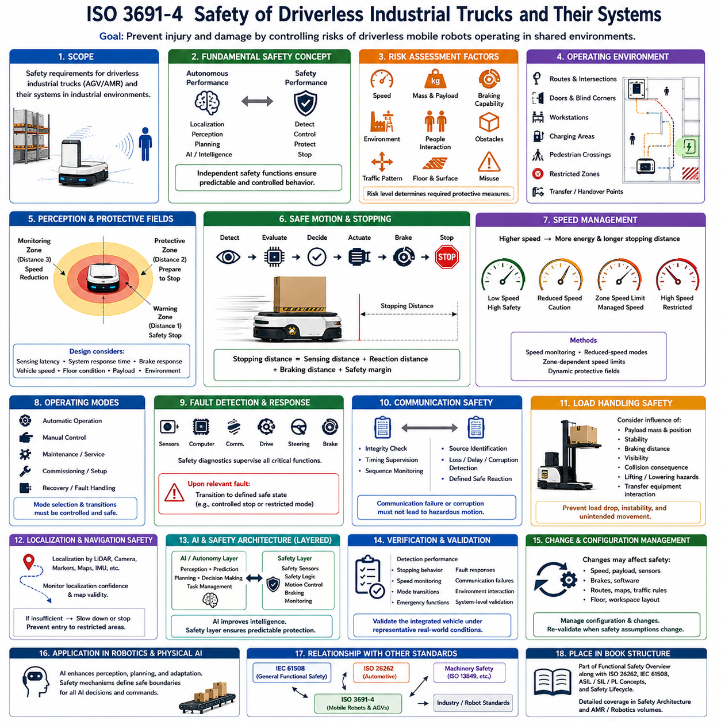
ISO 3691-4 is an international safety standard addressing driverless industrial trucks and their systems, including many automated guided vehicles and autonomous mobile robots used in industrial environments. It focuses on hazards created when mobile machines travel, maneuver, stop, and interact with people or equipment without a continuously present onboard driver. Within the attached structure, it provides the mobile-robot safety perspective alongside the automotive and general functional safety foundations introduced by ISO 26262 and IEC 61508.
The fundamental safety challenge addressed by ISO 3691-4 is that a driverless industrial truck can generate hazardous physical motion while operating in an environment shared with people, machinery, structures, and other vehicles. Safety therefore depends on more than reliable navigation. The complete system must control risks associated with travel, steering, braking, load handling, unexpected obstacles, failures, operating modes, and interactions within the intended operating environment.
A useful distinction is the difference between autonomous performance and safety performance. A robot may have sophisticated localization, perception, path planning, and AI capabilities while still requiring independent measures that prevent hazardous motion. Conversely, a safety system does not need to understand the environment with the same semantic richness as an autonomous navigation system. Its primary responsibility is to ensure that dangerous situations lead to sufficiently controlled and predictable machine behavior.
Risk assessment is essential because the required protective measures depend on the application. Engineers must consider the characteristics of the mobile platform, its speed, mass, braking capability, carried loads, operating space, foreseeable obstacles, pedestrian interaction, traffic patterns, environmental conditions, and possible misuse. A lightweight robot moving slowly through a restricted area presents a different risk profile from a heavy autonomous vehicle transporting material through a mixed human-machine workspace.
The operating environment is therefore part of the safety design rather than merely a background condition. Routes, intersections, doors, blind corners, workstations, charging areas, pedestrian crossings, restricted zones, and transfer locations can influence the hazards encountered by a mobile robot. Safety engineering must consider the relationship between the vehicle and its environment because changing the layout or traffic conditions can alter assumptions on which the original safety concept was based.
Personnel detection and protective sensing are central considerations for driverless mobile equipment operating near people. Safety-related sensors can monitor regions around the vehicle and detect objects or persons before hazardous contact occurs. Detection alone, however, is insufficient. The system must relate detection distance to vehicle speed, braking performance, system response time, environmental conditions, and the required separation needed to reduce or stop motion before unacceptable contact occurs.
Protective fields can be designed to support different responses as an obstacle or person approaches the vehicle. A wider monitoring region may initiate speed reduction, while a closer protective region may require a safety-related stop. Such behavior creates a relationship between perception distance and stopping capability. The design must therefore consider sensing latency, control reaction time, brake response, vehicle velocity, surface conditions, payload, and other factors that influence the actual stopping distance.
Speed is an important safety variable because kinetic energy and stopping distance increase as vehicle velocity rises. A mobile robot that is safe at one speed may not provide sufficient protection when operating faster under the same sensing configuration. Safety concepts can consequently use speed monitoring, reduced-speed modes, zone-dependent speed limits, or dynamically adapted protective regions to maintain an appropriate relationship between vehicle motion and available detection and stopping distance.
Braking and stopping behavior must be considered as physical safety functions rather than purely software commands. When a hazardous condition is detected, the system must achieve the intended motion response with sufficient reliability and within the required time. This requires coordination among safety sensing, control logic, communication, motor drives, brakes, and mechanical dynamics. The resulting stopping behavior should remain consistent with assumptions used when protective distances and operating limits were established.
Emergency stopping provides another layer of protection but should not be treated as the primary mechanism for normal obstacle avoidance. Emergency stop functions are intended to support rapid intervention or response to abnormal hazardous situations. Their placement, accessibility, reset behavior, and interaction with machine control must be designed so that activation produces an appropriate response and restarting does not automatically create a new hazardous movement.
Operating modes influence which safety functions are necessary and how the machine is permitted to move. Automatic operation, manual control, maintenance, commissioning, recovery, or other service conditions may expose people to different hazards. Mode selection and transitions therefore require controlled behavior. Functions that are acceptable during normal autonomous operation may need to be restricted when personnel are performing maintenance, manually moving the vehicle, or working inside normally protected areas.
Fault detection is particularly important because a mobile machine can remain physically dangerous after a sensing, computing, communication, steering, or drive fault. Safety-related diagnostics can supervise sensors, controllers, communication links, braking functions, speed information, steering behavior, and other critical signals. When a relevant fault is detected, the machine should transition to a defined response that prevents uncontrolled continuation of hazardous motion.
Communication can become part of the safety chain when safety information is distributed between sensors, controllers, drives, and other devices. Loss, corruption, delay, repetition, or incorrect sequencing of safety-related messages must not silently result in dangerous behavior. Safety communication mechanisms can therefore include integrity checking, timing supervision, sequence monitoring, source identification, and defined reactions when communication becomes unavailable or unreliable.
Load handling introduces additional hazards for mobile robots that transport, lift, tow, or manipulate materials. The safety assessment must consider how payload mass and position influence stability, braking distance, turning behavior, visibility, and collision consequences. Systems incorporating lifting mechanisms or attachments may require additional measures because hazardous conditions can result not only from vehicle travel but also from falling loads, unintended movement, instability, or interaction with transfer equipment.
Localization and navigation failures also require careful treatment. An autonomous robot may estimate its position using LiDAR, cameras, markers, maps, inertial sensors, or combinations of these technologies. Loss of localization accuracy can cause incorrect path execution or entry into restricted regions. The safety architecture should therefore determine which navigation assumptions are safety relevant and how the system responds when localization confidence or required environmental information becomes insufficient for continued operation.
For modern AMRs, conventional autonomous perception and safety-related protective sensing often coexist. General perception may identify objects, classify people, estimate free space, and optimize navigation, while safety-rated sensing provides independently justified protective functions. This separation is valuable because complex AI perception can improve operational intelligence without automatically becoming the sole barrier preventing hazardous physical contact. Safety-critical motion constraints can remain under mechanisms designed specifically for predictable protective behavior.
Verification and validation must demonstrate that protective functions operate correctly under representative conditions. Testing can include detection performance, stopping behavior, speed monitoring, operating-mode transitions, emergency functions, fault reactions, communication failures, and interactions with the intended environment. Validation should consider the integrated vehicle rather than isolated components because sensing range, latency, braking performance, payload, floor conditions, and configuration collectively determine the resulting safety behavior.
Changes to the robot or operating environment can affect previously validated safety assumptions. Modifying maximum speed, payload, sensor mounting, braking components, software, routes, floor conditions, traffic rules, or workspace geometry may alter the required protective measures. Configuration and change management are therefore important throughout operation, particularly for AMR deployments where maps, missions, traffic flows, and work areas can evolve after initial commissioning.
Within robotics and Physical AI architectures, ISO 3691-4 helps connect high-level autonomous intelligence with deterministic protection of physical motion. AI may improve perception, prediction, route selection, task planning, and adaptation, while safety mechanisms establish constraints within which those capabilities are allowed to command the machine. This creates a layered architecture in which intelligent behavior can evolve without assuming that every AI decision itself provides the required safety integrity.
The attached book structure positions ISO 3691-4 within the Functional Safety Overview together with ISO 26262, IEC 61508, ASIL/SIL/PL concepts, and the safety lifecycle. A later dedicated Safety Architecture volume includes ISO 3691-4 as its own chapter, while separate AMR and robotics volumes address practical electrical architectures. This organization establishes ISO 3691-4 as an introductory bridge between general functional safety principles and the specific safety challenges of autonomous mobile industrial equipment.

09.04. ASIL/SIL/PL Concepts
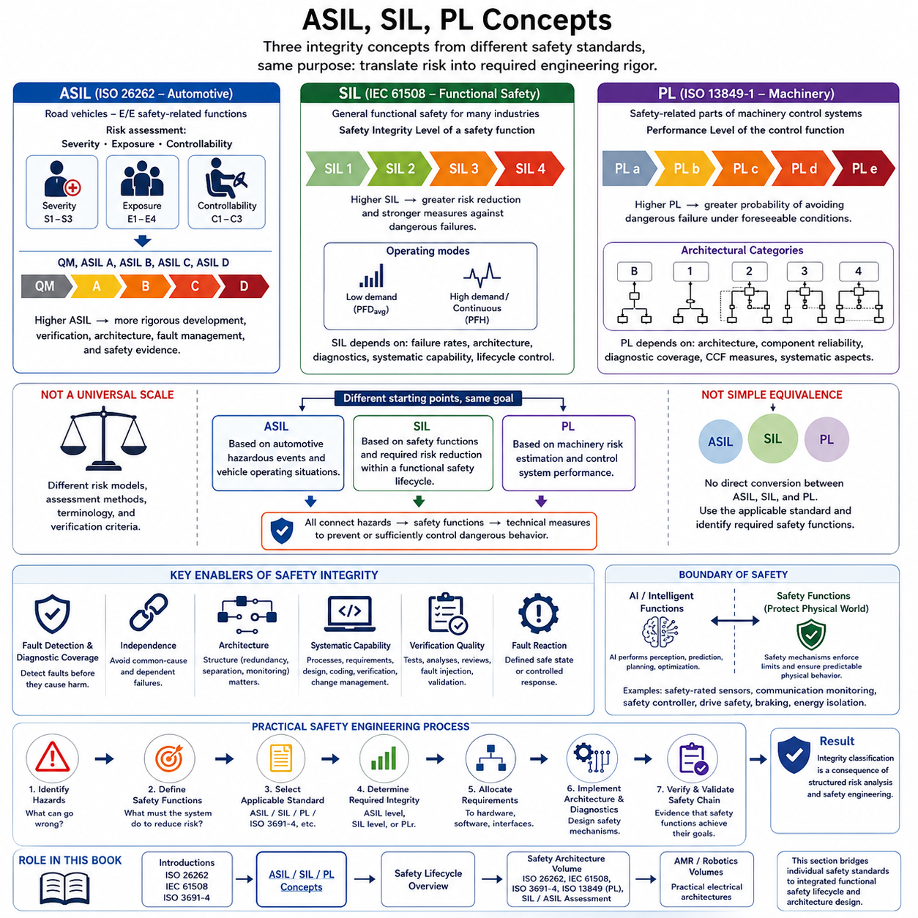
ASIL, SIL, and PL are safety integrity concepts used by different functional and machinery safety frameworks to express how rigorously safety-related functions must reduce risk. ASIL is associated primarily with ISO 26262 for road vehicles, SIL is central to IEC 61508 and related sector standards, and PL is used within machinery safety standards such as ISO 13849-1. In the attached structure, these concepts connect the preceding introductions to automotive, general functional, and mobile-robot safety.
Although ASIL, SIL, and PL are often shown together, they should not be interpreted as interchangeable labels on a single universal safety scale. Each belongs to a different assessment framework with its own scope, terminology, risk evaluation method, architectural requirements, and verification expectations. Their common purpose is to translate risk into engineering rigor, but the method used to determine and demonstrate the required integrity differs significantly among the standards.
Automotive Safety Integrity Level, or ASIL, is defined within ISO 26262 and is used for safety-related electrical and electronic functions in road vehicles. Hazard analysis and risk assessment evaluates hazardous events using severity, exposure, and controllability. The resulting classification can lead to QM or ASIL A through ASIL D, where increasing ASIL generally corresponds to increasingly demanding measures for development, verification, architecture, fault management, and safety evidence.
Severity describes the potential magnitude of harm associated with a hazardous event, while exposure considers how frequently the relevant operational situation can occur. Controllability evaluates the ability of affected persons to avoid or control the resulting harm. These dimensions are combined according to the ISO 26262 classification method. ASIL therefore represents the safety integrity requirement derived from a specific automotive hazardous-event context rather than simply the probability that an electronic component will fail.
Safety Integrity Level, or SIL, is a central concept of IEC 61508. SIL is associated with the integrity required from a safety function and ranges from SIL 1 to SIL 4. Higher SIL corresponds to greater required risk reduction and stronger measures against dangerous failures. Unlike the automotive ASIL method, SIL determination originates from a broader functional safety framework that can be adapted to industrial, process, machinery, energy, transportation, and other safety-related applications.
SIL assessment is closely connected to the required performance of a safety function. IEC 61508 distinguishes operating characteristics such as low-demand and high-demand or continuous modes when considering dangerous failure probabilities. Quantitative targets are combined with architectural constraints and systematic safety measures. Consequently, achieving a SIL cannot be demonstrated by a failure-rate number alone; hardware architecture, diagnostics, development processes, verification, competence, and lifecycle controls also matter.
Performance Level, or PL, is widely associated with ISO 13849-1 for safety-related parts of machinery control systems. Required Performance Level, commonly written PLr, is determined from machinery risk considerations, while achieved performance is expressed from PL a through PL e. Higher performance levels represent greater capability of the safety-related control function to provide the required risk reduction under foreseeable operating and fault conditions.
PL evaluation considers factors such as control architecture, component reliability, diagnostic coverage, common-cause failure measures, and systematic aspects. Architectural Categories such as B, 1, 2, 3, and 4 describe structural characteristics of safety-related control systems and interact with quantitative reliability and diagnostic parameters when determining achieved PL. This makes PL especially practical for machinery architectures using safety relays, safety PLCs, sensors, interlocks, drives, and protective devices.
The three concepts therefore approach a similar engineering problem from different domain perspectives. ASIL begins from automotive hazardous events and vehicle operating situations. SIL focuses on safety functions within a general functional safety lifecycle and required risk reduction. PL addresses safety-related machinery control functions through risk estimation and control-system performance. Each framework ultimately connects identified hazards to technical measures that prevent or sufficiently control dangerous behavior.
A higher integrity classification does not simply mean that more redundant hardware must be installed. Redundancy is only one possible mechanism. Safety integrity also depends on fault detection, diagnostic coverage, independence, architectural constraints, systematic development controls, verification quality, configuration management, and appropriate fault reactions. A redundant architecture containing common design errors or common-cause failures may provide much less safety improvement than its physical duplication appears to suggest.
Random hardware failures and systematic failures are also treated differently. Hardware components can fail through probabilistic physical mechanisms, allowing failure rates and diagnostic coverage to contribute to quantitative evaluation. Software defects and many design errors are systematic rather than random. Their control therefore relies heavily on lifecycle discipline, requirements quality, architecture, coding methods, verification, independence, traceability, change management, and other process-oriented measures.
Diagnostic coverage is important because safety architectures frequently depend on detecting dangerous faults before they can produce unacceptable consequences. Watchdogs, redundant measurements, plausibility checks, communication monitoring, memory protection, feedback signals, and drive diagnostics can detect different fault classes. However, the value of a diagnostic mechanism depends on which faults it detects, how quickly detection occurs, and whether the system can perform an appropriate safe reaction afterward.
Common-cause and dependent failures must be considered whenever multiple channels are used to improve safety. Two sensors, controllers, communication paths, or power supplies are not truly independent if the same environmental condition, design defect, software error, power source, connector, or communication dependency can disable both simultaneously. Functional safety analysis must therefore examine independence and shared dependencies rather than assuming that duplication automatically provides the intended integrity improvement.
The required safety integrity belongs primarily to a safety function and its implementation context, not automatically to every component within the complete machine or vehicle. A complex system may contain functions with different safety requirements and non-safety functions operating alongside them. Appropriate partitioning, interfaces, communication protection, and freedom from interference can allow these elements to coexist while preserving the integrity required by the safety-related functions.
ASIL, SIL, and PL should therefore not be converted through a simplistic equivalence table. Informal comparisons may be useful for understanding relative engineering rigor, but ASIL D cannot universally be declared equal to a particular SIL or PL, because their risk models and compliance criteria differ. When systems cross automotive, industrial, and robotics domains, engineers should identify the applicable safety functions and standards rather than assigning integrity levels through direct numerical substitution.
This distinction becomes especially important in autonomous mobile robots. An AMR may contain machinery safety functions governed by standards associated with PL, electrical or programmable safety functions influenced by SIL-based principles, and autonomous vehicle technologies conceptually similar to ASIL-oriented architectures. ISO 3691-4 provides application-specific requirements for driverless industrial trucks, while the underlying safety architecture may incorporate technologies and engineering principles originating from several safety frameworks.
For Physical AI systems, the integrity framework also establishes an important boundary between intelligent decision making and safety enforcement. AI can perform perception, prediction, planning, optimization, and adaptive control, but safety-related functions may require independently justified mechanisms with predictable failure responses. Safety-rated sensors, monitored communication, safety controllers, drive safety functions, braking mechanisms, and energy isolation can constrain physical actions when intelligent behavior becomes uncertain or unsafe.
A practical safety architecture therefore begins with hazards and required risk reduction rather than selecting ASIL, SIL, or PL as a product feature. Engineers identify hazardous behavior, define safety functions, determine the applicable standard, establish the required integrity, allocate requirements to hardware and software, implement appropriate architectures and diagnostics, and verify the complete safety chain. The integrity classification becomes a consequence of structured risk analysis and safety engineering.
Within the attached book structure, ASIL/SIL/PL concepts follow the introductory chapters on ISO 26262, IEC 61508, and ISO 3691-4 and precede the Safety Lifecycle Overview. The larger robotics electrical and hardware tree also assigns a dedicated Safety Architecture volume to ISO 26262, IEC 61508, ISO 3691-4, ISO 13849 PL, and SIL/ASIL assessment. This organization makes the present section a conceptual bridge from individual standards toward integrated functional safety lifecycle and architecture design.

09.05. Safety Lifecycle Overview
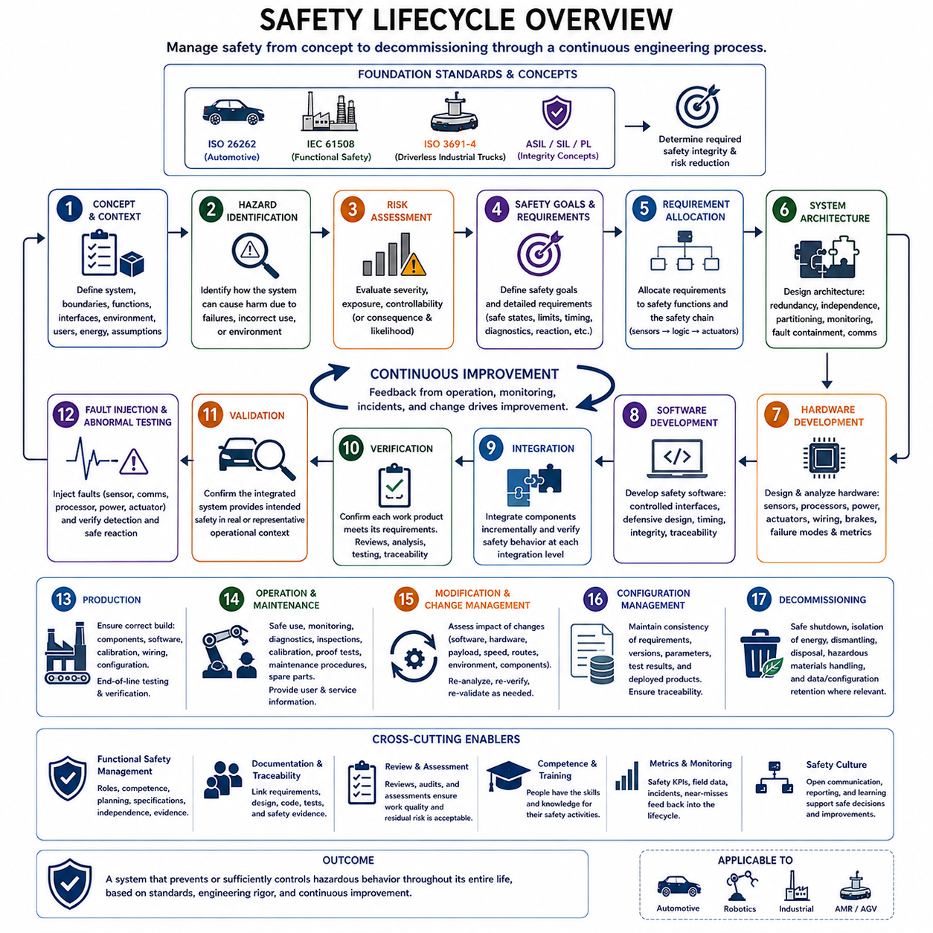
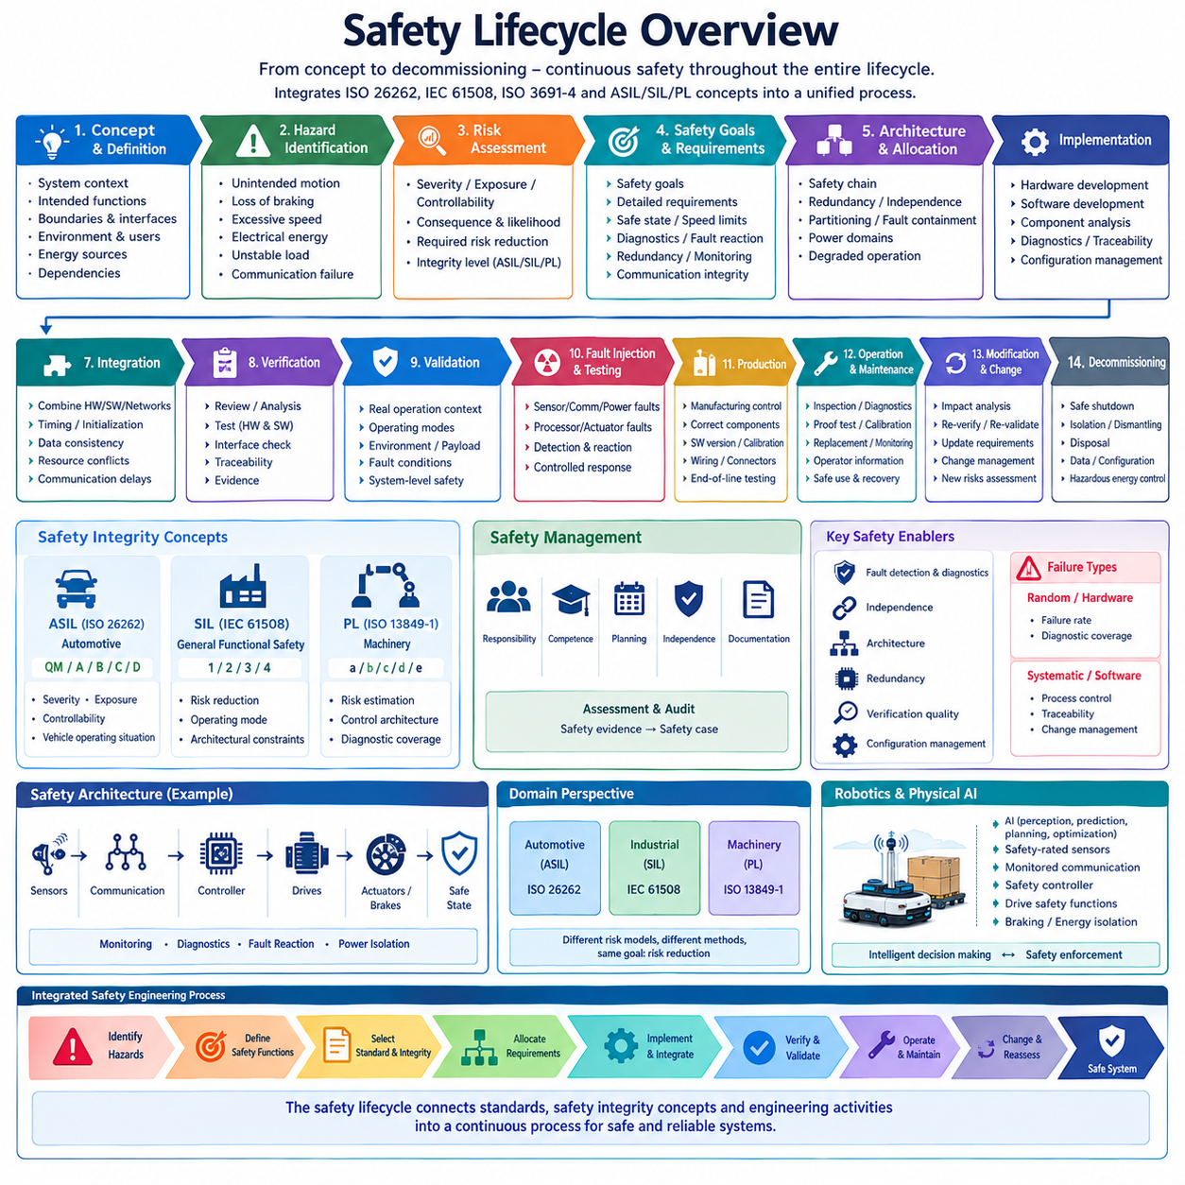
A safety lifecycle is a structured engineering framework used to manage safety from the earliest concept of a system through development, production, operation, maintenance, modification, and eventual decommissioning. Its purpose is to ensure that safety is continuously engineered rather than added after design completion. Within the attached structure, the lifecycle integrates the preceding ISO 26262, IEC 61508, ISO 3691-4, and ASIL/SIL/PL concepts into a common process perspective.
The lifecycle begins by establishing the system context and defining what is being developed. Engineers identify intended functions, system boundaries, interfaces, operating environments, users, energy sources, dependencies, and reasonably foreseeable operating conditions. A clear definition is essential because safety requirements depend on what the system can physically do and where it will operate. Incorrect boundaries can exclude important interactions and create gaps that remain hidden during later analysis.
Hazard identification examines how the system could cause harm when components fail, functions behave incorrectly, operators make foreseeable errors, or environmental conditions differ from expectations. Hazards may originate from unintended motion, loss of braking, excessive speed, electrical energy, unstable loads, communication failures, incorrect sensing, or loss of control. The objective is not merely to list component failures but to understand hazardous system behavior and its consequences.
Risk assessment evaluates identified hazardous situations to determine whether additional risk reduction is required. Different standards use different classification methods, such as severity, exposure, and controllability in automotive applications or other combinations of consequence and likelihood in industrial safety. The result provides the basis for determining the required safety integrity and selecting appropriate safety measures rather than applying identical protection to every function.
Safety goals and safety requirements transform risk-analysis results into explicit engineering obligations. A high-level safety goal describes what hazardous behavior must be prevented or controlled, while progressively refined requirements specify how the system must achieve that objective. Requirements can define safe states, speed limits, stopping performance, diagnostic behavior, fault reaction times, redundancy, monitoring, communication integrity, power isolation, or other constraints necessary to achieve acceptable risk.
Safety requirements are allocated across the system architecture so that responsibility for each protective function is clearly defined. A complete safety chain may include sensors that detect hazardous conditions, communication paths that transmit safety information, controllers that evaluate conditions, and actuators or power devices that execute protective actions. Allocation must also consider dependencies because the failure of a shared power supply, network, clock, processor, or software service can affect multiple safety functions simultaneously.
System architecture converts safety requirements into a realizable technical structure. Designers determine redundancy, independence, partitioning, fault containment, monitoring, communication protection, power domains, and degraded operating strategies. Architectural analysis asks whether individual faults or combinations of faults can violate safety requirements. It also evaluates whether safety mechanisms remain effective when parts of the normal control system become unavailable or behave incorrectly.
Hardware development addresses the physical implementation of safety-related functions. Engineers analyze sensors, processors, memories, power electronics, communication devices, wiring, brakes, actuators, and other components for relevant failure modes. Failure rates, diagnostic coverage, fault tolerance, common-cause failures, dependent failures, environmental effects, and architectural constraints are considered according to the applicable safety framework and required integrity.
Software development addresses systematic faults that can arise from requirements, architecture, implementation, integration, configuration, and modification. Safety-related software requires controlled interfaces, deterministic behavior where necessary, defensive design, timing supervision, data integrity, error handling, and traceability. Verification activities are performed throughout development so that defects are detected near the stage where they are introduced rather than only during final system testing.
Integration progressively combines hardware, software, communication networks, sensors, controllers, and actuators into larger functional assemblies. Safety behavior must be verified at each relevant integration level because components that operate correctly independently may interact incorrectly when connected. Timing, initialization, data consistency, resource conflicts, communication delays, power transitions, and fault propagation are typical integration concerns that can only become visible in the combined system.
Verification asks whether each engineering output correctly satisfies its specified input requirements. Requirements can be reviewed for completeness and consistency, architecture can be analyzed against safety requirements, software and hardware can be tested against their specifications, and interfaces can be checked for correct behavior. Traceability connects these activities so that engineers can demonstrate which evidence supports each safety requirement and identify requirements that remain insufficiently verified.
Validation addresses a different question: whether the completed system provides the intended safety behavior in its real or representative operational context. Validation therefore considers the integrated machine or vehicle, realistic operating modes, environmental conditions, users, payloads, speeds, fault conditions, and interactions with surrounding equipment. A function may satisfy its component specification yet still fail to provide sufficient safety when actual system dynamics and environmental conditions are considered.
Fault injection and abnormal-condition testing provide important evidence because many safety mechanisms are designed specifically for conditions that should rarely occur during normal operation. Engineers can deliberately introduce sensor faults, communication loss, corrupted information, processor failures, power disturbances, actuator faults, or diagnostic conditions to verify detection and reaction behavior. Testing should confirm not only that a fault is detected but that the resulting system response remains appropriately controlled.
Production introduces another lifecycle phase because a validated design can lose its intended safety characteristics if manufacturing and assembly are inconsistent. Production controls help ensure that correct components, software versions, calibration data, wiring, connectors, sensors, and safety configurations are installed. End-of-line testing and configuration verification can provide evidence that manufactured systems correspond to the safety-relevant design baseline established during development.
Operation and maintenance continue the safety lifecycle after deployment. Safety-related systems may require inspections, diagnostic checks, proof tests, calibration, replacement intervals, maintenance procedures, or monitoring of field failures. Operators and service personnel need appropriate information concerning safe use, fault indications, recovery procedures, and prohibited modifications. Safety therefore remains dependent on technical and organizational controls throughout the operational life of the system.
Modification requires particular attention because changes can invalidate earlier safety assumptions. Software updates, new sensors, changed payloads, higher speeds, altered routes, replacement components, communication changes, or revised operating environments may affect existing hazards and safety functions. Change management should determine which analyses, requirements, verification activities, and validation evidence must be repeated rather than assuming that previously demonstrated safety automatically remains valid.
Configuration management maintains consistency among safety requirements, hardware versions, software releases, calibration parameters, test results, analysis records, and deployed products. Without controlled configuration, safety evidence may refer to a different system version from the one actually operating. Traceability and configuration control therefore allow engineers to reconstruct why a safety decision was made, what implementation satisfies it, and which evidence demonstrates compliance.
Decommissioning is also part of the lifecycle because removing a system from service can introduce hazards associated with stored electrical energy, batteries, mechanical loads, hazardous materials, or unintended reactivation. Safe shutdown, isolation, dismantling, disposal, and data or configuration handling should therefore be considered where relevant. Including decommissioning reinforces the principle that safety responsibility extends beyond development and normal operation.
Functional safety management spans all lifecycle phases and coordinates responsibilities, competence, planning, independence, documentation, assessments, and safety evidence. Safety activities must have defined owners and completion criteria. Reviews and assessments provide checkpoints for determining whether the required work has been performed and whether unresolved issues remain acceptable. The resulting safety case or equivalent body of evidence supports a structured argument that the system achieves its safety objectives.
For robotics and Physical AI, the lifecycle provides a particularly important boundary between rapidly evolving intelligent functions and controlled physical safety. Perception, world models, planning, and AI policies may change through software development, while braking, speed limitation, protective sensing, energy isolation, and fault reaction must continue to satisfy established safety requirements. Every significant AI or system update should therefore be evaluated for its effect on assumptions governing physical safety.
Within the attached structure, Safety Lifecycle Overview concludes Chapter 09 after ISO 26262, IEC 61508, ISO 3691-4, and ASIL/SIL/PL concepts. The broader robotics electrical and hardware tree then provides a dedicated Safety Architecture volume covering these standards and their assessment methods in greater depth. This sequence makes the lifecycle the integrating framework that connects hazard identification, integrity classification, architecture, implementation, verification, operation, and change management into one continuous safety engineering process.

