Volume 01. Electrical Architecture Fundamentals

Chapter 07. LV/HV Architecture

07.01. 12V/24V/48V LV Systems
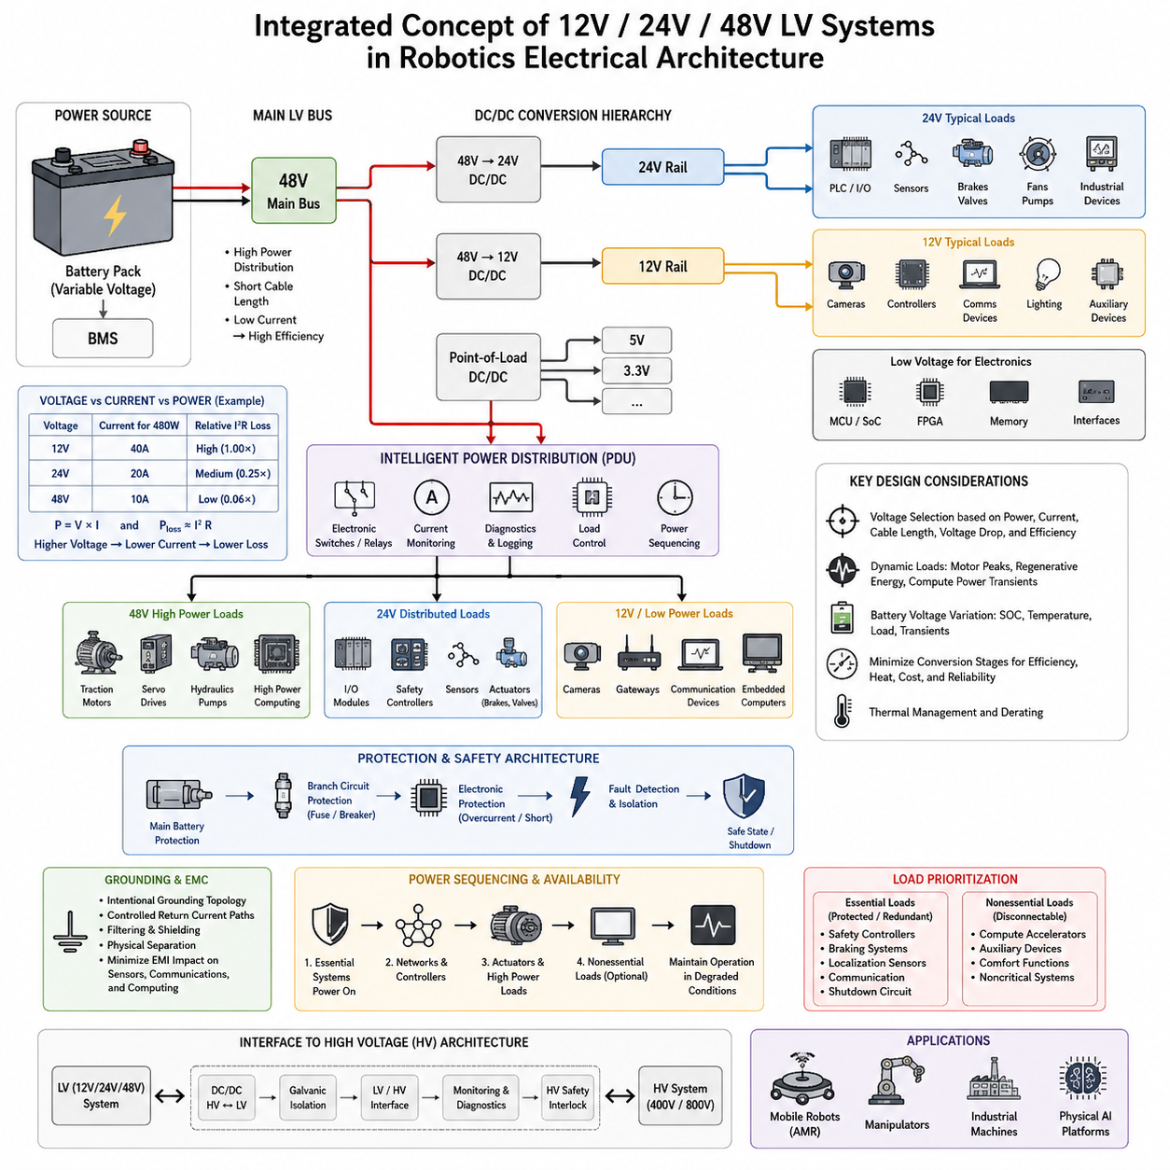
Low-voltage electrical systems based on 12 V, 24 V, and 48 V rails form the practical foundation for supplying controllers, sensors, communication devices, computing platforms, auxiliaries, and many actuator subsystems. Within the architecture structure, these LV systems sit between general power-distribution design and the higher-voltage domains addressed by the following sections on 400 V/800 V systems, galvanic isolation, LV/HV interfaces, and safety interlocks.
A 12 V system is widely suited to relatively low-power electronic loads such as control modules, sensors, cameras, communication interfaces, lighting, relays, and auxiliary devices. Its major advantage is the broad availability of components and mature protection technology. However, transmitting significant power at 12 V requires relatively high current, which increases conductor size, connector requirements, resistive losses, voltage drop, and thermal loading throughout the distribution network.
A 24 V architecture provides a useful middle ground between conventional 12 V electronics and higher-power 48 V distribution. It is especially common in industrial automation and robotics, where PLCs, I/O modules, sensors, communication devices, brakes, valves, and smaller actuators can share a standardized supply environment. For the same delivered power, doubling the voltage from 12 V to 24 V approximately halves the current, reducing conductor losses and simplifying power distribution.
The 48 V domain extends the LV concept toward substantially higher power while avoiding the much higher operating voltages associated with traction-class HV systems. It is attractive for mobile robots, AMRs, manipulators, and other electrically intensive machines because motors, servo drives, pumps, fans, computing equipment, and high-power auxiliaries can be supplied with lower current than equivalent 12 V or 24 V designs. This improves power density and can reduce harness mass and distribution losses.
The fundamental relationship among voltage, current, and power is expressed by P = V × I. A 480 W load theoretically draws 40 A at 12 V, 20 A at 24 V, and 10 A at 48 V before conversion and wiring losses are considered. Because conductor loss follows approximately P_loss = I²R, increasing distribution voltage can dramatically reduce resistive loss for the same delivered power. This relationship is one of the main engineering reasons for moving higher-power robotic subsystems toward 48 V architectures.
Voltage selection therefore cannot be based only on nominal load voltage. Engineers must consider continuous current, peak current, startup and inrush behavior, transient conditions, allowable voltage drop, wiring length, connector capability, fuse coordination, thermal environment, conversion efficiency, and fault behavior. These factors connect LV architecture directly with the broader engineering domains of wire sizing, circuit protection, grounding, EMC, battery design, and powertrain integration represented elsewhere in the robotics electrical hardware structure.
A practical robot may use several LV rails simultaneously rather than selecting one voltage for every device. For example, a 48 V battery or main bus can feed propulsion and actuator systems while isolated or non-isolated DC/DC converters generate 24 V and 12 V secondary rails. Additional point-of-load conversion may generate 5 V, 3.3 V, or lower semiconductor supply voltages inside electronic modules. This hierarchical approach separates high-power distribution from sensitive electronics while retaining a common system-level power architecture.
The 48 V rail is often positioned close to the energy source and high-power loads because this minimizes high-current cable length. A 24 V rail can support industrial control devices and distributed I/O, while 12 V may supply cameras, embedded computers, gateways, communication equipment, or automotive-derived modules. The exact partition depends on component availability and platform requirements, but unnecessary conversion stages should be avoided because every converter introduces efficiency loss, heat, cost, packaging requirements, and additional failure modes.
Battery voltage also changes continuously with state of charge, load, temperature, chemistry, and transient behavior, so a nominal 12 V, 24 V, or 48 V system must never be treated as an ideal fixed-voltage source. Electrical loads and converters must tolerate the defined operating range rather than only the nominal value. Designers must evaluate undervoltage, overvoltage, startup, regenerative energy, load dump behavior where applicable, and short-duration disturbances to ensure that controllers and safety functions remain predictable.
Dynamic loads are particularly important in robotics. Motors and servo amplifiers can demand sharp current peaks during acceleration, while regenerative braking can return energy to the DC bus during deceleration. At the same time, GPUs and high-performance computers may exhibit rapidly changing computational power demand. If these events occur simultaneously, the LV bus can experience significant voltage excursions, making source impedance, cable resistance, converter dynamics, local capacitance, and battery characteristics important architectural parameters.
Protection must be coordinated at multiple levels. Main battery protection limits catastrophic fault energy, branch protection isolates individual circuits, and electronic protection can provide faster detection of overload or short-circuit conditions. Fuse or breaker ratings must therefore be selected together with conductor ampacity and load characteristics rather than independently. A protection device that is too small causes nuisance interruptions, while an oversized device may allow cables, connectors, or electronic modules to experience damaging fault energy.
Ground and return-path design are equally important because high-current actuator circuits and sensitive sensor electronics may coexist on the same LV platform. Motor drives and switching converters can generate conducted and radiated interference that affects cameras, LiDAR, IMUs, communication networks, and computing systems. Intentional grounding topology, controlled return-current paths, filtering, shielding, physical separation, and appropriate DC/DC architecture help prevent power-distribution disturbances from becoming perception or communication failures.
Power sequencing becomes increasingly important as the number of LV domains grows. Some controllers must start before actuators are energized, communication networks may require stable power before dependent nodes initialize, and safety controllers must remain available during selected fault conditions. Intelligent PDUs can supervise branch currents, control electronic switches or relays, detect abnormal loads, and report diagnostic information, transforming LV distribution from passive wiring into an observable and controllable subsystem.
Availability requirements may also justify separating essential and nonessential LV loads. Safety controllers, braking functions, localization sensors, communication gateways, and shutdown circuitry can be assigned protected or redundant supplies, while computational accelerators or auxiliary equipment may be disconnected during degraded operation. Such prioritization allows a robot to transition toward a controlled safe state instead of losing all electrical functions simultaneously when battery capacity, converter capability, or distribution integrity becomes limited.
The boundary between 48 V LV distribution and higher-voltage architectures should be treated as an architectural interface rather than simply a difference in numerical voltage. Systems that combine LV electronics with 400 V or 800 V propulsion domains require deliberate conversion, isolation, grounding, monitoring, connector, and fault-containment strategies. This progression explains why the chapter structure places 12 V/24 V/48 V systems before HV systems, galvanic isolation, LV/HV interfaces, and HV safety interlocks.
For Physical AI and advanced robotic platforms, LV architecture ultimately becomes part of the compute-sense-actuate infrastructure. Sensors require electrically clean and stable rails, edge AI computers require high transient power capability, communication networks require dependable supply continuity, and actuators require efficient high-current delivery. A well-designed combination of 12 V, 24 V, and 48 V domains therefore provides not merely electrical compatibility, but the energy foundation for reliable perception, computation, communication, control, and physical action.

07.02. 400V/800V HV Systems
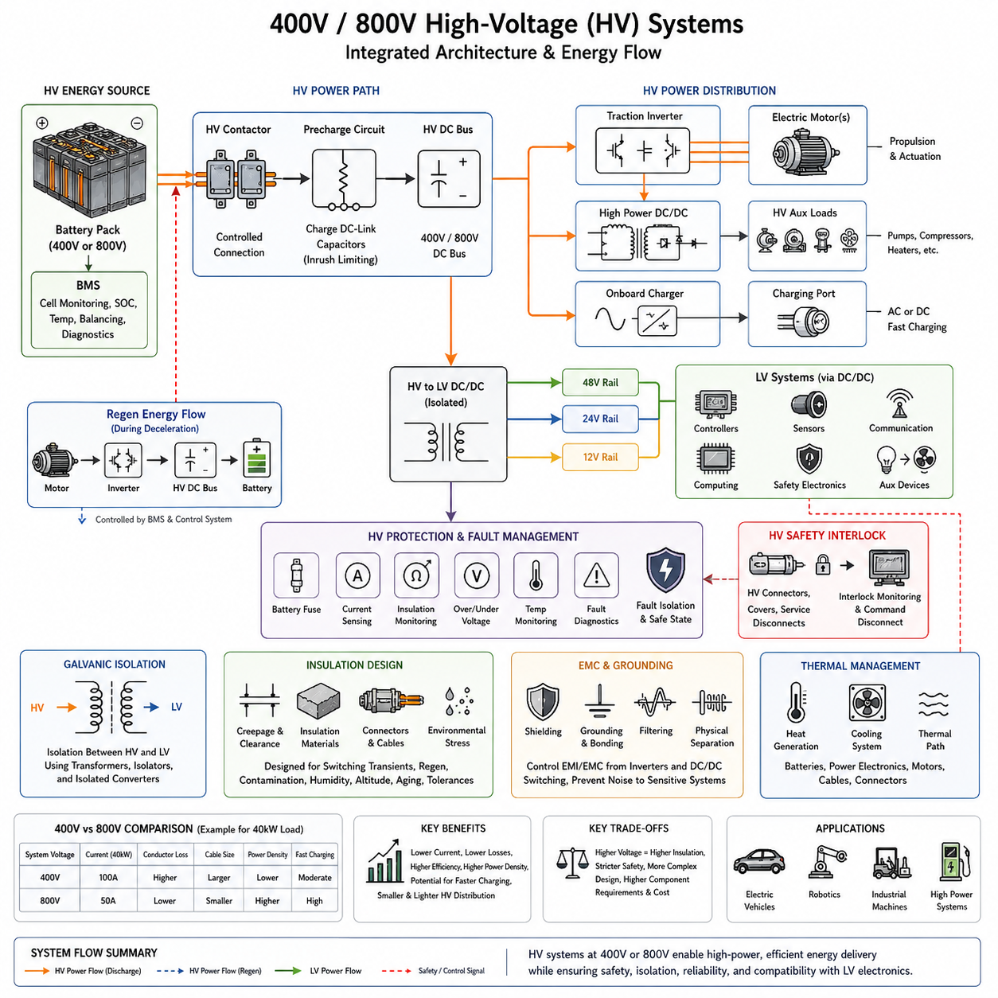
High-voltage electrical systems based on 400 V and 800 V architectures provide the energy backbone for platforms whose propulsion, actuation, charging, or auxiliary power requirements exceed the practical limits of 12 V, 24 V, and 48 V distribution. Within the LV/HV architecture, these systems extend the power hierarchy toward high-energy domains while requiring stronger isolation, protection, monitoring, and controlled interface mechanisms.
The primary reason for increasing system voltage is to transmit large amounts of power without requiring extremely high current. Because electrical power follows P = V × I, a 40 kW load theoretically requires 100 A at 400 V but only 50 A at 800 V. Since resistive conductor loss approximately follows P_loss = I²R, reducing current can significantly decrease cable losses, conductor heating, connector loading, and the cross-sectional area required for high-power distribution.
A 400 V architecture represents a widely applicable high-voltage level for electric propulsion and other power-intensive systems. It can supply traction inverters, high-power motor drives, pumps, compressors, heaters, charging systems, and DC/DC converters while maintaining substantially lower current than LV distribution. For robots, autonomous vehicles, heavy mobile platforms, and electrically driven machinery, this enables power levels that would become inefficient or mechanically difficult to distribute through a 48 V bus.
An 800 V architecture extends these advantages by approximately halving current for the same transmitted power compared with a 400 V system. Lower current can reduce cable mass and resistive losses while enabling higher power density in traction systems and potentially supporting faster high-power charging. However, the higher voltage increases requirements for insulation coordination, semiconductor blocking capability, creepage and clearance, connector construction, switching behavior, EMC control, and safe maintenance procedures.
The choice between 400 V and 800 V therefore cannot be reduced to efficiency alone. Engineers must evaluate required continuous and peak power, motor and inverter characteristics, battery configuration, charging requirements, cable length, packaging, thermal constraints, converter availability, component cost, insulation requirements, and safety objectives. A higher-voltage architecture is valuable only when its system-level benefits justify the additional electrical, mechanical, and safety complexity.
The battery pack typically forms the main HV energy source and consists of many cells connected in series and parallel to achieve the required voltage, energy capacity, and current capability. A battery management system monitors cell voltage, temperature, state of charge, and abnormal conditions, while contactors and associated protection devices control connection of the pack to the HV bus. The resulting architecture must manage both normal energy delivery and potentially dangerous stored fault energy.
HV contactors provide controlled electrical connection between the battery and downstream loads. Because traction inverters and other power electronics contain substantial DC-link capacitance, directly closing the main contactors can create severe inrush current. A precharge circuit therefore raises the DC-link voltage in a controlled manner before the primary power path is fully connected, reducing electrical stress on contactors, capacitors, connectors, and other components during system startup.
Once energized, the HV DC bus distributes energy to major loads such as traction inverters and high-power DC/DC converters. The inverter converts DC electrical energy into controlled multiphase power for electric motors and can reverse the energy flow during regenerative operation. During deceleration or negative mechanical work, motor-generated electrical energy can return through the inverter toward the HV bus and battery, requiring coordinated control of battery acceptance limits and bus voltage.
High-voltage DC/DC conversion provides an important bridge between the HV domain and lower-voltage electrical systems. A 400 V or 800 V battery may supply an isolated converter that generates 48 V, 24 V, or 12 V rails for controllers, sensors, communication equipment, computing platforms, safety electronics, and auxiliary devices. This allows high-power propulsion and low-voltage control electronics to coexist within a hierarchical power architecture without requiring every device to operate directly from the HV bus.
Galvanic isolation becomes a central architectural requirement when HV and LV domains interact. Isolation prevents an intentional direct conductive path between selected electrical domains while allowing energy or information to cross through appropriately designed converters, transformers, isolators, or communication interfaces. The following section of the chapter addresses galvanic isolation specifically, reflecting its importance as the engineering boundary between high-energy circuits and accessible low-voltage electronics.
Insulation design must consider more than the nominal 400 V or 800 V operating value. Switching transients, regenerative events, charging conditions, fault conditions, environmental contamination, humidity, altitude, aging, and manufacturing tolerances can influence dielectric stress. Creepage distance, clearance distance, insulation materials, connector geometry, cable construction, shielding, and enclosure design must therefore be coordinated with the maximum expected electrical and environmental stresses.
HV fault management requires rapid detection and controlled isolation because the available electrical energy can be substantial. Protection may include battery fuses, contactors, current sensing, insulation monitoring, overvoltage and undervoltage detection, temperature monitoring, and fault diagnostics. The architecture should prevent a localized failure from propagating across the complete power system and should transition the platform toward an appropriate safe state when continued HV operation is no longer acceptable.
The high-voltage safety interlock concept provides another layer of supervision by monitoring the integrity of HV connectors, covers, service disconnects, and other protected interfaces. If the interlock path indicates that part of the HV system has been opened or compromised, the control architecture can command the energy source to disconnect from the HV bus. This function is treated later in the chapter as a dedicated HV safety mechanism rather than merely a wiring feature.
Grounding and electromagnetic compatibility become increasingly important because high-voltage inverters and DC/DC converters switch large amounts of energy at high frequency. Rapid voltage and current transitions can create common-mode currents, conducted noise, and radiated emissions that interfere with sensors, communication networks, positioning systems, and AI computing hardware. HV cable shielding, controlled return paths, filtering, enclosure bonding, physical separation, and carefully designed grounding structures are therefore integral to the architecture.
Thermal management must also be considered at system level. Batteries, inverters, motors, DC/DC converters, contactors, connectors, and conductors all generate heat according to their operating current, switching losses, internal resistance, and environmental conditions. Increasing voltage can reduce distribution current, but it does not eliminate semiconductor or conversion losses. Cooling architecture and electrical architecture must consequently be developed together to maintain component lifetime, efficiency, and predictable performance.
For advanced robotics and Physical AI platforms, the 400 V or 800 V domain can provide concentrated energy for propulsion and high-power actuation while the LV domain supports perception, communication, real-time control, and AI computation. The resulting electrical system is therefore not a single voltage network but a coordinated hierarchy of energy domains connected through conversion, isolation, monitoring, and safety mechanisms. This structure provides the foundation for scalable high-power autonomous machines while preserving controlled interfaces to sensitive electronic systems.

07.03. Galvanic Isolation Design
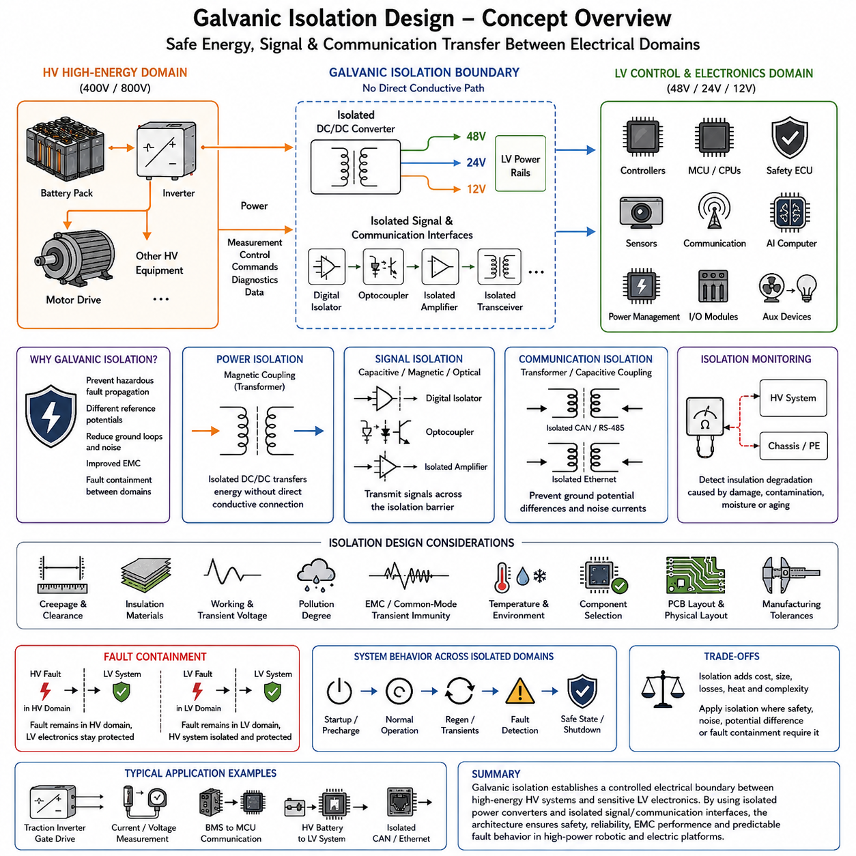
Galvanic isolation is the deliberate prevention of direct conductive current flow between two electrical domains while still allowing power, control signals, or communication data to pass across the boundary. In LV/HV architectures, it forms a critical interface between high-energy 400 V or 800 V circuits and lower-voltage 48 V, 24 V, or 12 V electronics, supporting controlled energy transfer while reducing the propagation of hazardous electrical faults.
The fundamental purpose of isolation is to ensure that two circuits do not share an unintended direct electrical path. Their reference potentials may therefore differ without forcing large equalization currents through signal grounds, chassis structures, communication cables, or sensitive electronics. Energy or information crosses the isolation barrier through mechanisms such as magnetic coupling, capacitive coupling, or optical transmission rather than through a continuous metallic conductor.
In a high-voltage robotic or electric vehicle architecture, the traction battery, inverter, motor drive, and other HV equipment can form one electrical domain, while controllers, sensors, communication devices, safety electronics, and AI computers operate in another. Galvanic isolation limits the possibility that an HV fault directly transfers dangerous voltage into accessible LV circuits and provides a defined electrical boundary between high-energy propulsion systems and low-voltage control infrastructure.
Isolated DC/DC converters are one of the most important components for transferring power across this boundary. A converter can receive energy from a 400 V or 800 V HV bus and generate a 48 V, 24 V, or 12 V output while maintaining electrical separation between input and output. Transformer-based conversion transfers energy magnetically across the isolation barrier, allowing the LV system to receive power without requiring a direct conductive connection to the HV bus.
Isolation is equally important for signal paths. Gate commands, current measurements, voltage measurements, diagnostic information, and control signals often need to cross boundaries between circuits operating at different electrical potentials. Digital isolators, optocouplers, isolated amplifiers, isolated ADC interfaces, and transformer-based communication interfaces can transmit the required information while maintaining the intended separation between electrical domains.
Motor inverters provide a representative example of this requirement. Power semiconductor switches operate directly within the HV domain, while their control algorithms may execute on lower-voltage microcontrollers or processors. Isolated gate-driver architecture allows switching commands to cross into the high-voltage power stage while helping prevent the switching-node voltage from appearing directly within the controller domain. Feedback paths may similarly require isolation for current, voltage, and fault information.
The isolation barrier itself must be engineered as a physical structure rather than treated as an abstract circuit symbol. PCB layout, transformer construction, package geometry, connector arrangement, insulation materials, cable routing, enclosure structure, and manufacturing tolerances determine whether electrical separation remains effective under actual operating conditions. Creepage and clearance therefore become essential parameters when establishing the physical distance between conductive regions at different potentials.
Clearance describes the shortest distance through air between conductive parts, while creepage describes the shortest distance along the surface of an insulating material. Their required values depend on factors such as working voltage, transient voltage, insulation category, material properties, pollution conditions, and environmental requirements. A design that appears isolated in the circuit schematic may therefore be inadequate if PCB spacing, connector geometry, or contamination creates an unintended breakdown path.
Isolation requirements must also consider transient conditions rather than only nominal bus voltage. Fast switching edges from inverters and DC/DC converters can generate large common-mode voltage transitions, while regenerative operation, charging, switching events, and faults can temporarily increase electrical stress. Isolation components must therefore tolerate both the required steady-state voltage and the transient behavior expected throughout the operating life of the platform.
Common-mode transient immunity is especially important for isolated signal interfaces located near fast-switching power electronics. Rapid changes in voltage can capacitively couple across an isolation barrier and disturb logic signals even when direct conduction is prevented. Appropriate isolator technology, PCB layout, parasitic-capacitance control, filtering, shielding, and grounding must therefore be considered together to preserve signal integrity during high-frequency switching events.
Galvanic isolation also contributes to grounding and EMC architecture. Separating selected domains can prevent uncontrolled ground-loop currents and reduce the propagation of conducted interference between high-power and sensitive electronic systems. However, isolation does not automatically eliminate electromagnetic coupling because parasitic capacitance, cable shields, chassis connections, and radiated fields can still transfer noise. Isolation strategy must therefore be coordinated with grounding, bonding, shielding, and filtering design.
Communication networks may also cross isolated electrical domains. CAN, CAN FD, RS-485, Ethernet, or other interfaces can require isolation when nodes operate at significantly different reference potentials or when fault containment is necessary. Isolation can prevent ground-potential differences from becoming damaging currents through communication wiring, while also helping separate failures between control domains. The exact approach depends on network topology, bandwidth, timing, EMC, and safety requirements.
Isolation monitoring provides a complementary function to galvanic isolation. While the isolation barrier is designed to prevent unwanted conductive paths, an insulation monitoring function can supervise the electrical relationship between an HV system and chassis or other reference structures. Degradation caused by damaged cables, contamination, moisture, connector faults, or insulation aging can then be detected before the condition develops into a more severe electrical or safety failure.
Fault containment is therefore one of the central architectural benefits of galvanic isolation. A failure in an HV inverter, battery circuit, or high-power converter should not automatically propagate into perception computers, communication controllers, safety processors, or other LV electronics. Conversely, a low-voltage ground fault should not create an uncontrolled current path through the HV system. Well-defined isolation boundaries divide the electrical architecture into domains whose failures can be detected and managed more predictably.
Isolation must nevertheless be applied selectively because every isolation boundary introduces engineering cost. Isolated converters and communication devices add components, conversion losses, thermal load, PCB area, qualification requirements, and potential failure modes. Excessive isolation can therefore make a system unnecessarily complex. System architecture should identify where differences in voltage, reference potential, safety exposure, noise environment, or fault-containment requirements justify a deliberate isolation boundary.
Startup, shutdown, and fault behavior must also be considered across isolated domains. An LV controller may remain powered after the HV bus has been disconnected, or an isolated converter may lose its input while downstream capacitors retain energy temporarily. Diagnostic signals can disappear at different times from power rails. Consequently, system state machines should distinguish between loss of communication, loss of isolated power, intentional HV shutdown, isolation failure, and actual controller malfunction.
For robotics and Physical AI systems, galvanic isolation protects the boundary between high-power physical actuation and sensitive computational intelligence. Motors, inverters, batteries, and power converters can operate in high-energy domains, while perception sensors, edge AI computers, communication networks, and safety controllers remain within controlled LV environments. This separation supports reliable sense-compute-actuate operation even when significant electrical noise and energy are present.
Galvanic isolation therefore connects the 400 V/800 V HV architecture to the subsequent LV/HV interface and HV safety-interlock concepts within the chapter structure. It establishes the controlled electrical boundary across which energy and information can pass while direct hazardous current paths remain restricted. Combined with insulation coordination, monitoring, grounding, protection, and fault management, isolation becomes a fundamental architectural mechanism for safe and reliable high-power robotic electrical systems.

07.04. LV/HV Interface
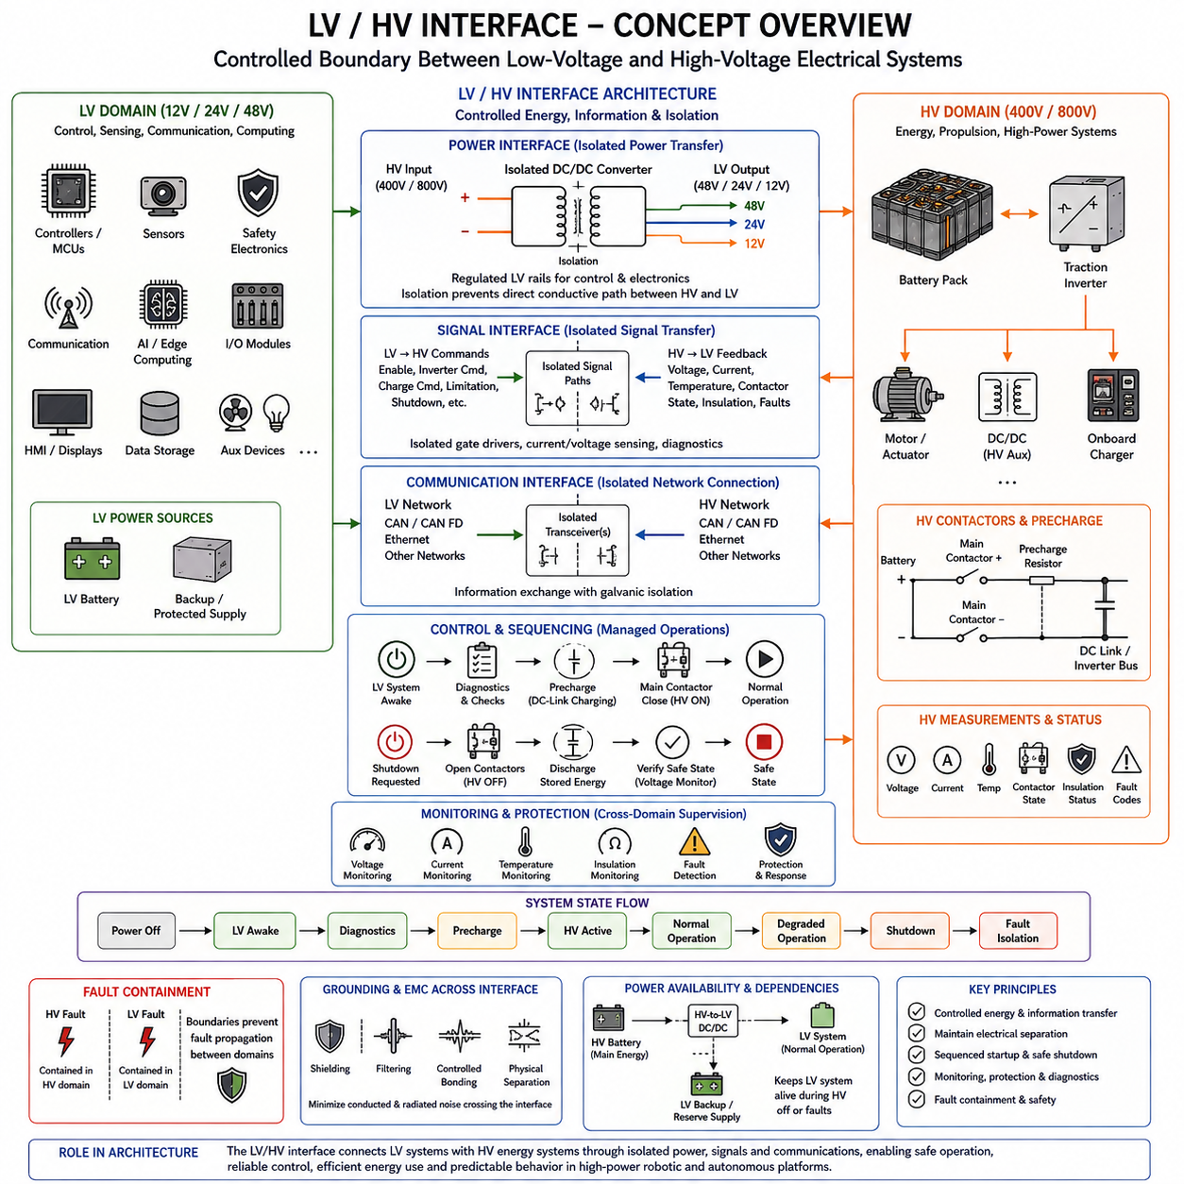
The LV/HV interface is the controlled architectural boundary between low-voltage electrical systems and high-voltage energy systems. In a robotic or autonomous platform, the LV domain may operate at 12 V, 24 V, or 48 V for controllers, sensors, communication, safety electronics, and computing, while the HV domain may operate at 400 V or 800 V for propulsion, high-power actuation, charging, and other energy-intensive functions.
The interface is not a single connector or converter but a coordinated collection of power, signal, communication, isolation, monitoring, and control functions. Its purpose is to allow the LV and HV domains to cooperate without losing their electrical separation or fault-containment properties. The interface therefore defines which quantities may cross the boundary, how they are transferred, and what happens when either side enters an abnormal operating condition.
Power commonly crosses the LV/HV boundary through an isolated DC/DC converter. Energy from a 400 V or 800 V battery bus can be converted into 48 V, 24 V, or 12 V rails that supply control and electronic equipment. The converter must regulate its LV output while tolerating variations and transients on the HV side, and its isolation barrier prevents the HV bus from becoming directly connected to accessible low-voltage circuits.
The relationship can also become bidirectional in architectures that require energy transfer in both directions. Although many auxiliary converters primarily transfer energy from HV to LV, advanced systems may use bidirectional DC/DC conversion for energy management, backup power, charging, or specialized storage architectures. The direction and magnitude of power flow must therefore be explicitly controlled rather than assumed to remain constant under all operating states.
Control information crosses the boundary in both directions. An LV controller may request HV activation, inverter operation, charging, power limitation, or shutdown, while the HV system returns measurements and status information such as voltage, current, temperature, contactor state, insulation condition, and fault codes. These exchanges create a logical control interface that operates together with, but remains distinct from, the physical power interface.
Communication networks can provide this logical connection. CAN, CAN FD, Ethernet, or other communication technologies may connect controllers associated with the two voltage domains, depending on bandwidth, determinism, safety, and system requirements. Where galvanic separation is required, isolated transceivers, transformers, or other isolation mechanisms are inserted so that information can cross the interface without creating an unintended conductive path between HV and LV references.
The LV domain often controls the sequence used to energize the HV domain. A low-voltage battery or protected LV rail can power the vehicle or robot controller, battery management system, safety controller, and communication network before the main HV bus becomes active. These controllers can perform diagnostics, verify operating conditions, and determine whether the system is permitted to proceed toward precharge and main-contactor closure.
Precharge is therefore closely connected to LV/HV interface control. Before the main HV contactors establish the full power path, the control system can activate a precharge circuit that gradually charges downstream DC-link capacitance. Voltage measurements are then evaluated to confirm that the expected bus voltage has been reached. Only after successful verification does the control logic command the main contactors to complete the HV connection.
Shutdown follows the reverse architectural principle but must also consider stored energy. When the LV control system requests HV shutdown, traction or actuator commands are disabled and the HV contactors can be opened to isolate the battery. However, capacitors within inverters and converters may remain charged after disconnection. Voltage monitoring and discharge mechanisms are therefore necessary to determine when the downstream HV bus has reached an acceptable state.
The interface must distinguish normal operational transitions from electrical faults. A communication timeout, converter fault, insulation degradation, overtemperature event, overcurrent condition, contactor malfunction, or abnormal bus voltage may each require a different response. Interface logic should identify the nature and severity of the event and select an appropriate reaction, ranging from diagnostic reporting and power derating to controlled shutdown or immediate HV isolation.
Galvanic isolation provides the physical foundation for many of these interface functions. Power converters, measurement circuits, gate-control paths, and communication links may all cross the LV/HV boundary while maintaining electrical separation. Isolation design must therefore be coordinated with the interface architecture rather than treated as an independent component-level feature. Creepage, clearance, transient immunity, insulation monitoring, and fault containment all influence the integrity of the complete boundary.
Measurement is another essential function because an LV controller frequently needs information about electrical quantities that physically exist inside the HV domain. Isolated voltage sensing and current sensing can provide these measurements without directly exposing the controller to HV potential. Accuracy, bandwidth, isolation rating, diagnostic coverage, and failure behavior must be selected according to whether the measurement supports energy management, control, protection, or safety functions.
Grounding and EMC design must also span the interface. Even when direct conductive paths are removed, switching noise can cross isolation barriers through parasitic capacitance or electromagnetic coupling. High dv/dt inverter nodes and high di/dt current paths can disturb LV sensors and computing systems if the interface is poorly designed. Shielding, filtering, controlled bonding, cable routing, isolation capacitance, and physical separation must therefore be developed as parts of one coordinated EMC strategy.
The LV/HV interface also establishes fault-containment boundaries. A fault in an HV inverter or battery circuit should not directly propagate dangerous voltage into a camera, communication gateway, AI computer, or safety controller. Likewise, a short circuit or ground fault in the LV system should not unintentionally energize or destabilize the HV domain. Protection and isolation mechanisms divide the architecture so that failures can be detected and contained within predictable regions.
Power availability creates another important dependency between the two domains. The LV system may depend on the HV battery through an HV-to-LV DC/DC converter during normal operation, yet the LV controllers are often required to remain operational when the HV system is disconnected. A separate LV battery, backup supply, or protected energy reserve may therefore be used to preserve communication, diagnostics, braking, shutdown control, and other essential functions during transitions or failures.
State management provides a useful way to coordinate these interactions. The electrical architecture may progress through states such as powered-off, LV awake, diagnostics, precharge, HV active, normal operation, degraded operation, shutdown, and fault isolation. Each state defines permitted contactor commands, converter operation, communication expectations, actuator authority, and diagnostic behavior. Explicit state transitions reduce ambiguity between software control and physical electrical behavior.
For Physical AI platforms, this interface separates the high-energy layer that produces physical motion from the low-voltage layer that performs perception, reasoning, communication, and supervisory control. Edge AI computers and sensors can remain within a protected LV environment while commanding motors and high-power actuators operating from the HV domain. The LV/HV interface therefore becomes a key link in the sense-compute-actuate chain rather than merely a power-conversion boundary.
Within the chapter structure, the LV/HV interface integrates the concepts introduced by 12 V/24 V/48 V LV systems, 400 V/800 V HV systems, and galvanic isolation, and leads naturally to the HV safety interlock that follows. Together, these mechanisms establish controlled energy transfer, information exchange, startup and shutdown sequencing, electrical separation, monitoring, and fault containment between the two major voltage domains of a high-power robotic electrical architecture.

07.05. HV Safety Interlock
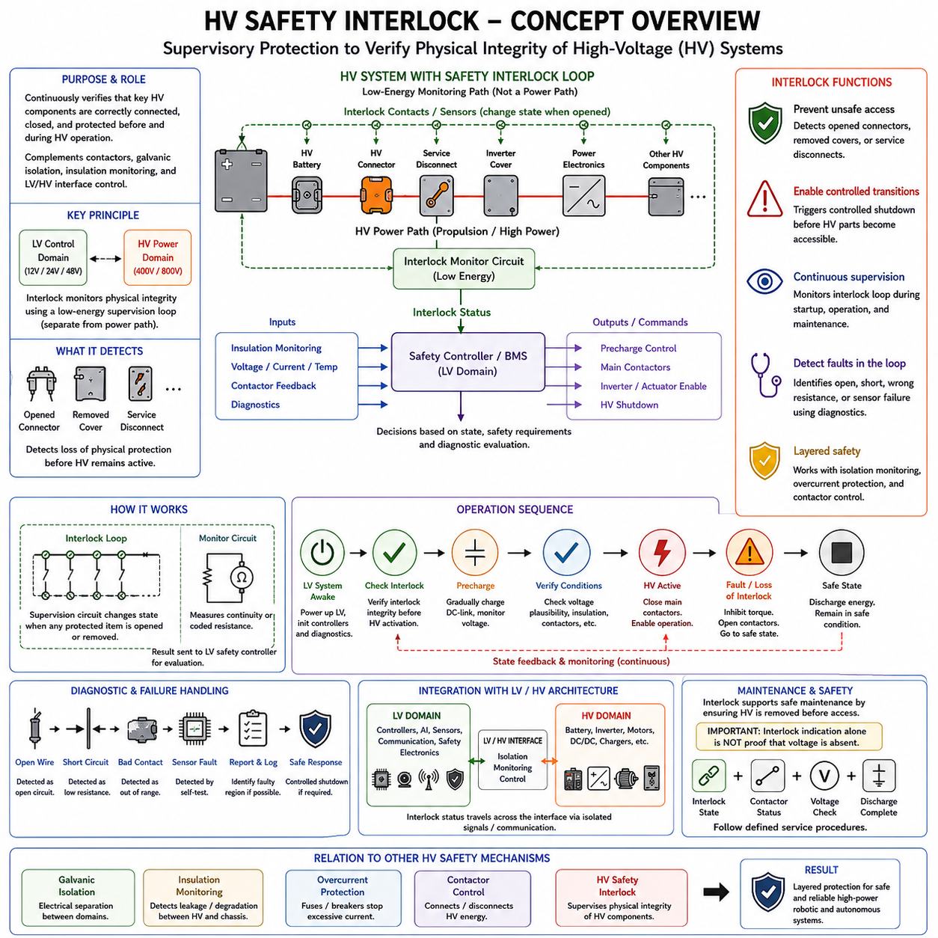
The high-voltage safety interlock is a supervisory protection mechanism used to verify that critical parts of an HV electrical system remain correctly connected, closed, and protected before high-voltage energy is permitted to remain active. In a 400 V or 800 V architecture, it complements contactors, galvanic isolation, insulation monitoring, and LV/HV interface control by providing continuous information about the physical integrity of the HV system.
A typical HV safety interlock uses a low-energy monitoring circuit that passes through selected high-voltage connectors, service disconnects, access covers, battery interfaces, power electronics, and other protected components. The monitoring circuit itself does not carry propulsion power. Instead, it forms a supervision loop whose electrical continuity or coded condition indicates whether the monitored HV components are correctly installed and mechanically secured.
This arrangement separates the detection function from the dangerous energy path. The HV battery may contain substantial stored energy, but the interlock can operate from a protected low-voltage control domain. A battery management system, safety controller, or dedicated monitoring circuit evaluates the interlock condition and determines whether HV contactors may close or remain closed. The LV control architecture can therefore supervise physical HV integrity without exposing its logic circuits directly to HV potential.
Connectors are important elements of the interlock architecture because opening an energized HV connector can create hazardous conditions. Interlock contacts are commonly arranged so that the monitoring path changes state before the main power contacts become physically accessible or fully separated. This provides the control system with an opportunity to remove HV energy through the main contactors before the power connection is completely opened.
A similar principle can be applied to service disconnects, battery covers, inverter covers, junction boxes, and other components that expose or interrupt high-voltage circuits during maintenance. Opening a protected interface changes the interlock state, which can trigger a controlled transition toward HV shutdown. The exact implementation depends on the platform, but the architectural objective remains to detect loss of physical protection before continued HV operation becomes unsafe.
The interlock signal must be interpreted as part of a state-management system rather than as a simple on/off input. During initial startup, the controller can verify interlock integrity before allowing precharge. If the loop is valid, other conditions such as insulation status, battery state, contactor diagnostics, and bus voltage can be checked. Only when all required conditions are satisfied should the architecture proceed toward main-contactor closure and HV-active operation.
During normal operation, the interlock is continuously or periodically supervised. If the monitored path unexpectedly opens, the controller must determine an appropriate response according to system safety requirements. Propulsion or actuator torque may first be inhibited, followed by controlled opening of the main contactors and transition to a safe state. The required timing depends on the hazard, stored energy, operating mode, and system-level safety concept.
HV shutdown does not immediately guarantee that every high-voltage node has become electrically safe. Inverters, DC/DC converters, and other power-electronic devices may contain DC-link capacitors that retain energy after the battery contactors open. The interlock response must therefore be coordinated with discharge circuits and voltage monitoring. A safe-state decision should consider both source disconnection and the residual voltage remaining in downstream components.
Interlock monitoring should also detect faults within the supervision circuit itself. A broken wire, damaged connector, short circuit, corroded contact, incorrect assembly, or failed sensing device can produce misleading information if the circuit is not designed diagnostically. Depending on the required integrity level, the architecture may use continuity checks, defined resistance ranges, redundant paths, plausibility checks, or other diagnostic mechanisms to distinguish valid states from monitoring faults.
The interlock should not be considered a replacement for galvanic isolation or insulation monitoring. Galvanic isolation controls conductive separation between electrical domains, while insulation monitoring evaluates unintended electrical leakage or degradation between the HV system and reference structures such as chassis. The safety interlock instead supervises the physical integrity and connection state of selected HV components. These mechanisms address different failure modes and work together within the overall safety architecture.
Likewise, the interlock does not replace overcurrent protection or battery fault protection. A fuse may interrupt severe fault current, a contactor may disconnect the energy source, an insulation monitor may detect degraded isolation, and the interlock may detect an opened connector or access cover. Effective HV protection is therefore layered, with each mechanism observing a different aspect of electrical integrity and contributing information to the overall fault-management strategy.
The LV/HV interface provides the control pathway through which interlock information influences high-voltage operation. The safety controller can receive the interlock state within the LV domain and use it together with voltage, current, temperature, insulation, and contactor feedback. It can then command precharge circuits, main contactors, inverters, and other HV devices according to the current operating state and the severity of any detected abnormal condition.
Startup sequencing illustrates this integration clearly. The LV system becomes active first and initializes controllers, diagnostics, communication, and safety monitoring. The interlock condition is verified before HV activation is authorized. Precharge can then raise the downstream DC-link voltage in a controlled manner, after which voltage plausibility and contactor conditions are checked. Only a valid sequence permits the system to enter the HV-active state.
Shutdown sequencing follows a coordinated reverse process. Torque-producing devices are commanded toward an appropriate state, energy transfer is reduced or stopped, and the main contactors disconnect the HV battery. Residual energy is discharged and monitored, while the LV system remains powered long enough to supervise the transition and record diagnostic information. The interlock thus participates in a controlled state transition rather than simply removing power instantaneously.
Mechanical design is closely related to interlock performance. Connector position, locking mechanisms, service covers, harness routing, vibration, shock, contamination, moisture, temperature cycling, and manufacturing tolerances can all affect the reliability of the monitored path. A robust interlock architecture must therefore be designed together with connectors, harnesses, enclosures, and service procedures rather than being added only as an electrical schematic feature.
Diagnostics are especially important for autonomous robots and high-power Physical AI platforms because an interlock event may occur far from an operator. The system should identify which monitored region has caused the interruption when the architecture supports such localization. Diagnostic information can then be reported to supervisory software or maintenance systems, helping distinguish an actual opened HV interface from wiring damage, connector degradation, or another interlock-circuit fault.
The interlock also contributes to maintenance safety by supporting controlled de-energization before technicians access HV components. However, an interlock indication alone should not be interpreted as proof that hazardous voltage is absent. Stored electrical energy and possible component faults remain relevant. The architecture therefore combines interlock state, contactor status, voltage measurement, discharge behavior, and defined service procedures when establishing whether an HV subsystem has reached a safe condition.
For robotics and Physical AI systems, the HV safety interlock helps protect the boundary between high-energy physical actuation and the lower-voltage intelligence layer. Batteries, inverters, motors, and high-power converters can be supervised through LV safety logic while perception computers, communication systems, and control processors remain electrically separated. A detected loss of HV integrity can therefore trigger coordinated limitation or shutdown before uncontrolled energy threatens the platform.
Within the chapter structure, the HV safety interlock completes the progression from 12 V/24 V/48 V LV systems through 400 V/800 V HV systems, galvanic isolation, and the LV/HV interface. Together, these concepts establish voltage-domain separation, controlled energy transfer, monitoring, sequencing, physical integrity supervision, and fault containment. They form the fundamental LV/HV architecture required for reliable high-power robotic and autonomous electrical systems.

