Volume 01. Electrical Architecture Fundamentals

Chapter 06. Power Distribution Architecture

06.01. Power Distribution Topology
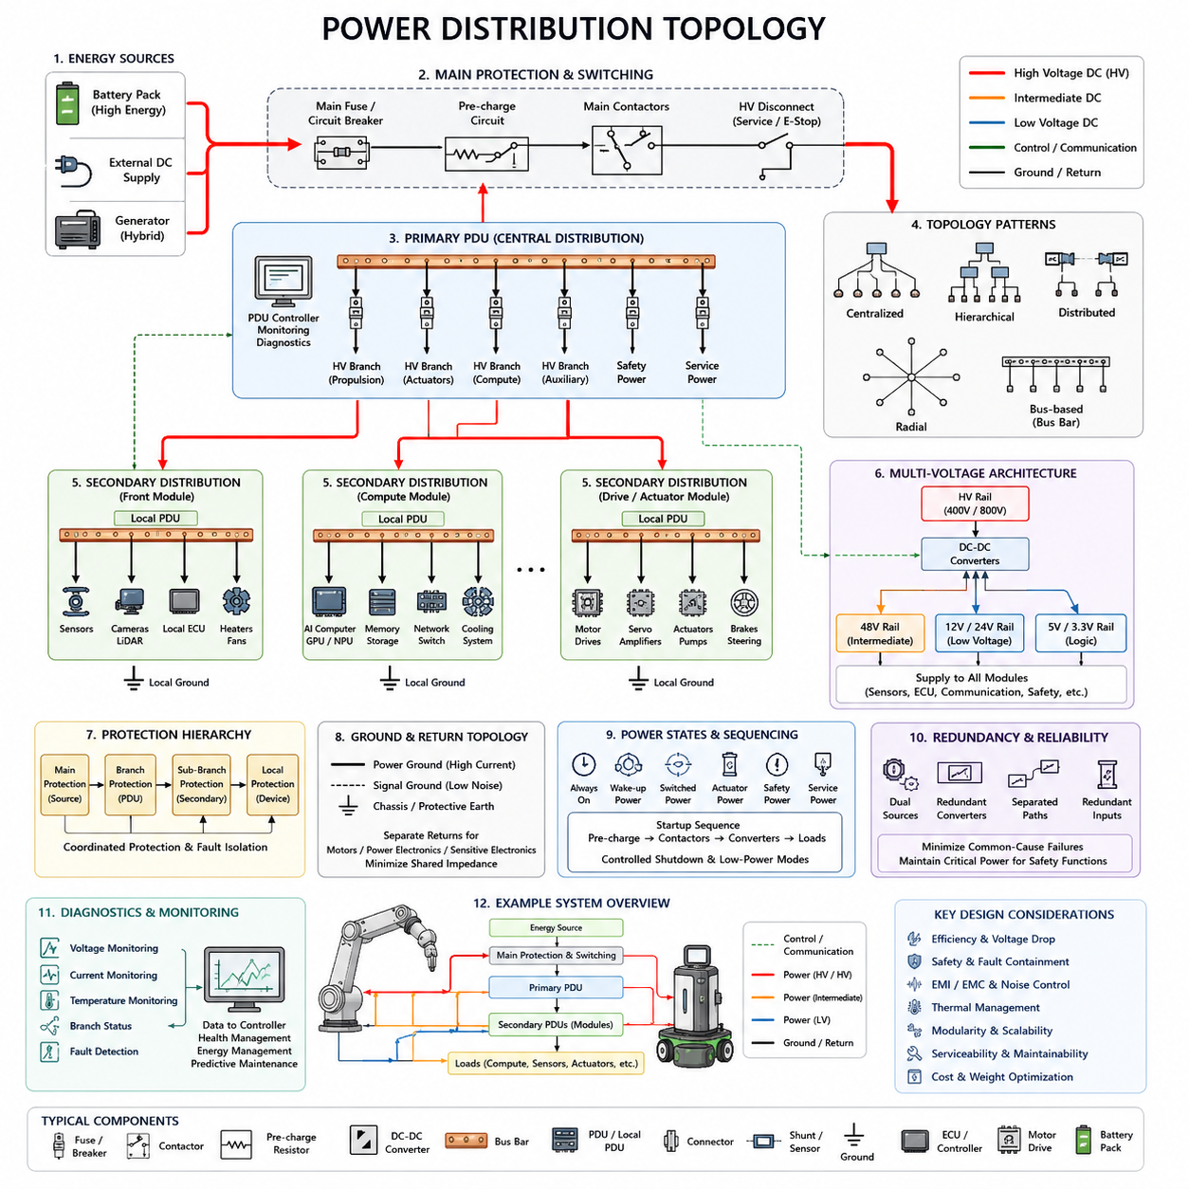
Power distribution topology defines how electrical energy is transferred from the primary energy source to every electrical and electronic load within a robot, vehicle, or Physical AI system. The topology determines current paths, voltage availability, protection boundaries, isolation behavior, and the consequences of individual failures. It therefore forms a structural foundation for the complete electrical architecture.
A typical architecture begins with a primary source such as a battery pack, external DC supply, generator, or hybrid energy system. Power passes through a main protection and switching stage before reaching downstream distribution networks. Contactors, circuit breakers, fuses, pre-charge circuits, and disconnect devices may be positioned near the source so abnormal currents or system faults can be isolated before they propagate.
The simplest topology is centralized power distribution, where most electrical loads receive power from a central Power Distribution Unit (PDU). The PDU contains switching and protection elements and provides individual branches for controllers, sensors, actuators, communication devices, and auxiliary equipment. Centralization simplifies monitoring and protection coordination, but long cable runs can increase harness mass and voltage drop.
Distributed power architectures place smaller distribution units closer to groups of loads. A mobile robot, for example, may use separate distribution nodes for the front sensor assembly, computing system, drive modules, manipulator, and auxiliary equipment. Local distribution reduces long high-current branches and can simplify modular assembly, although additional electronics, connectors, communication interfaces, and diagnostic functions are required.
A hierarchical topology combines centralized and distributed concepts. Main battery power is first delivered to a primary PDU, which supplies several secondary distribution units. Each secondary unit then feeds local loads. This creates clearly defined electrical domains and enables designers to coordinate protection from the battery level through intermediate branches to individual devices while preserving modularity and serviceability.
Radial distribution connects each major branch independently to a central distribution point. A failure in one branch can therefore be isolated without directly interrupting unrelated branches. This structure is common where fault containment is important. However, each independent branch requires dedicated conductors and protection devices, so increasing the number of loads can increase wiring complexity, connector count, and packaging requirements.
Bus-based distribution uses a common electrical path from which multiple loads or local distribution nodes receive power. Bus bars are particularly useful for carrying large currents with low resistance and compact packaging. They may connect batteries, contactors, converters, motor drives, and high-power computing systems. Detailed bus-bar geometry and implementation belong to the subsequent bus-bar architecture topic within the chapter structure.
Modern robots frequently require multiple voltage domains because propulsion, actuators, computing platforms, sensors, and control electronics have different electrical requirements. A high-energy battery rail may directly supply traction inverters or servo drives, while DC-DC converters generate intermediate and low-voltage rails. These rails can then supply computers, ECUs, communication equipment, cameras, LiDAR, safety controllers, and auxiliary electronics.
The placement of DC-DC converters strongly influences topology. A centralized converter can create one low-voltage rail for the complete platform, whereas distributed converters can generate required voltages close to individual load groups. Centralized conversion reduces converter count, while distributed conversion can reduce low-voltage current over long harnesses and improve modularity. Conversion efficiency, thermal behavior, fault isolation, and cost must be evaluated together.
Power topology must distinguish continuous loads from transient and highly dynamic loads. Sensors and controllers may have relatively stable consumption, while motors, servo amplifiers, pumps, compute accelerators, and communication equipment can create rapid changes in demand. If these loads share poorly designed paths, transient current can produce voltage sag, conducted noise, unwanted resets, or degraded sensor operation.
Protection topology should follow the physical distribution structure. Main protection limits faults close to the energy source, branch protection isolates distribution segments, and local protection protects individual loads or modules. Fuse and breaker ratings must therefore be coordinated with conductor capacity, expected operating current, inrush behavior, short-circuit conditions, and downstream protection so that faults are disconnected at an appropriate level.
Ground and return-current topology are equally important because electrical power requires both supply and return paths. High-current motor returns, switching converter currents, sensitive sensor references, and digital electronics should not be connected without considering shared impedance. Poor return-path design can transform load current variations into reference-voltage disturbances, creating communication errors, sensor noise, unstable measurements, and electromagnetic compatibility problems.
Power distribution also defines operating states. A system may contain always-on power, switched power, wake-up power, safety power, actuator power, compute power, and service power. Separating these domains allows selected subsystems to remain active while others are disconnected. This supports startup sequencing, controlled shutdown, charging, maintenance, emergency operation, low-power standby, and energy management without requiring the entire platform to remain energized.
Startup sequencing becomes particularly important when large capacitive loads are present. Motor drives, inverters, high-performance computers, and DC-link capacitors can generate substantial inrush current when directly connected. Pre-charge circuits, staged contactor operation, controlled converter enable signals, and sequential branch activation can limit these transients and prevent unnecessary fuse operation, connector stress, battery voltage collapse, or system resets.
For robotic systems, mechanical modularity should be reflected in electrical topology. A mobile base, manipulator, perception mast, battery module, compute enclosure, and end effector can each form an electrical subsystem with clearly defined power interfaces. Such partitioning improves manufacturing, replacement, diagnostics, and future upgrades because modules can evolve without requiring complete redesign of the primary distribution network.
Physical AI platforms introduce additional challenges because computing power can become a major dynamic electrical load. GPUs, AI accelerators, edge computers, cameras, LiDAR, networking devices, and cooling systems may consume significant power while motors simultaneously generate large transient demands. The distribution topology must prevent propulsion disturbances from degrading perception and AI computation while still maintaining efficient use of the shared energy source.
Safety-related loads require special consideration. Emergency-stop circuits, safety controllers, braking devices, steering functions, isolation monitoring, and essential sensing may require power paths that remain available when nonessential loads are disconnected. The topology should therefore support controlled de-energization rather than treating the entire machine as one undifferentiated electrical load, particularly where safe stopping requires temporary electrical energy.
Redundancy can be introduced through dual sources, independent converters, separated distribution paths, or redundant power inputs to critical controllers. However, redundancy is effective only when common-cause failures are minimized. Two nominally redundant branches that share the same upstream fuse, connector, converter, bus bar, or ground connection may still fail together. Power topology therefore defines the physical boundaries upon which later redundancy strategies are built.
Diagnostics increasingly become part of the distribution architecture itself. Intelligent PDUs and electronic switching devices can measure voltage, current, temperature, overload conditions, and branch status. These measurements allow controllers to identify abnormal consumption, disconnected loads, short circuits, deteriorating components, or unexpected energy demand. Power distribution can consequently become an observable and controllable subsystem rather than a passive wiring network.
A well-designed topology balances electrical efficiency, safety, fault containment, weight, packaging, cost, thermal performance, maintainability, and scalability. No single centralized, distributed, radial, or bus-based arrangement is optimal for every platform. Practical architectures commonly combine several patterns, assigning each according to current level, physical distance, criticality, modular boundaries, and expected operating conditions.
Power distribution topology ultimately provides the framework upon which bus-bar architecture, voltage-rail design, load analysis, and dynamic power management are developed. These topics appear sequentially within Chapter 06, indicating a progression from structural distribution toward detailed power implementation and active energy control. A robust topology therefore establishes the electrical pathways that make later optimization, protection, and intelligent power management possible.

06.02. Bus Bar Architecture
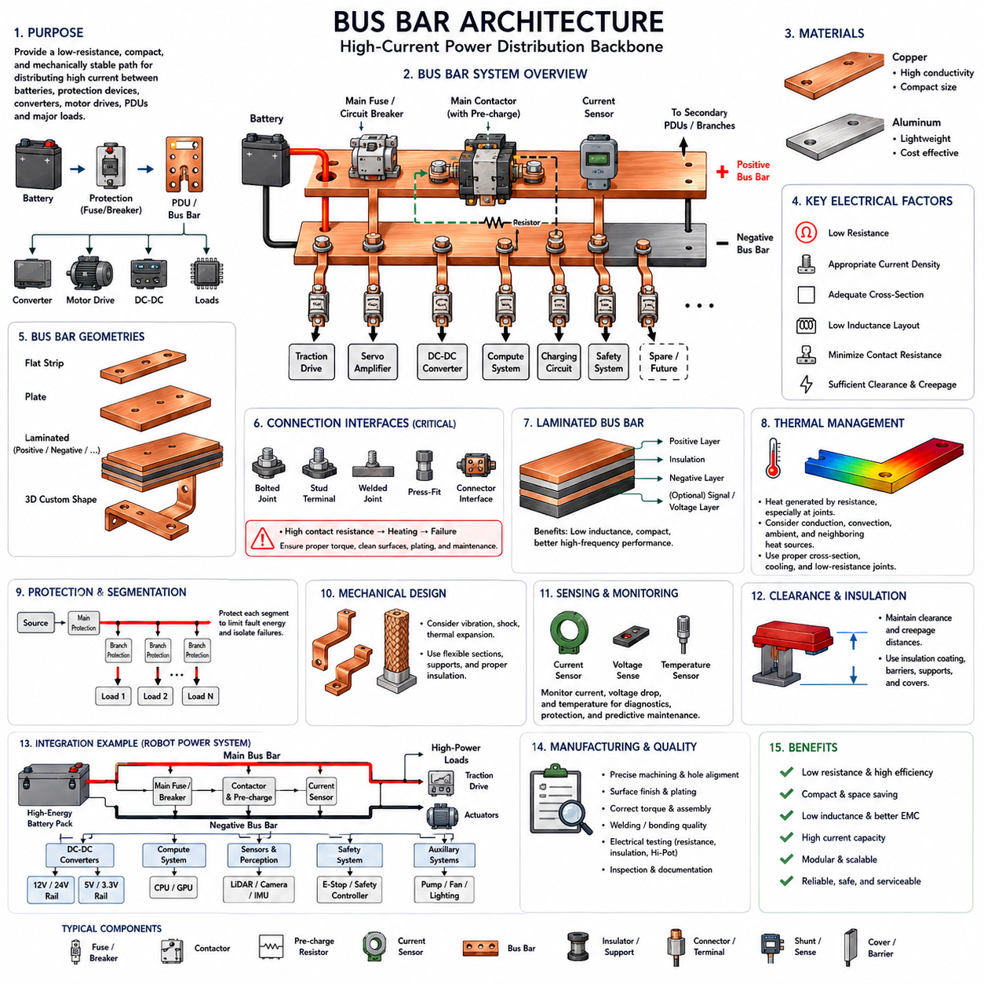
Bus bar architecture provides a structured method for distributing high electrical current between batteries, protection devices, contactors, converters, motor drives, Power Distribution Units, and other major loads. Instead of carrying all current through conventional wires, a bus bar uses a rigid or semi-rigid conductive element that provides a low-resistance, mechanically stable, and compact electrical path within the power distribution system.
Bus bars are commonly manufactured from copper or aluminum because both materials provide useful combinations of electrical conductivity, mechanical strength, weight, manufacturability, and cost. Copper offers high conductivity and allows compact conductor dimensions, while aluminum can significantly reduce mass. Material selection therefore depends on current level, available packaging space, thermal limits, mechanical requirements, and system-level weight targets.
The electrical behavior of a bus bar is fundamentally determined by its resistance, current density, geometry, and connection interfaces. Even a very small resistance becomes important when hundreds of amperes flow through the conductor because power loss increases with the square of current. Excessive resistance produces heat, reduces system efficiency, increases voltage drop, and can accelerate degradation of terminals, insulation, and nearby electronic components.
Bus bar cross-sectional area must be selected according to continuous current, peak current, allowable temperature rise, ambient temperature, cooling conditions, and expected operating duration. A conductor capable of carrying a short motor acceleration pulse may not safely carry the same current continuously. Consequently, bus bar sizing should distinguish steady-state loading from transient loading rather than relying only on the maximum instantaneous current.
Geometry provides an important design advantage over conventional round wires. A bus bar can be formed as a flat strip, plate, laminated structure, or custom three-dimensional shape that follows the available mechanical envelope. Wide and thin conductors can provide large conductive area while fitting into compact battery packs, PDUs, inverter assemblies, and robotic power modules where conventional cable routing would require additional volume.
A centralized bus bar can form the electrical backbone of a primary Power Distribution Unit. Battery power enters the main bus through a fuse, circuit breaker, contactor, or disconnect device and is then divided into protected branches. These branches can supply traction drives, servo amplifiers, DC-DC converters, computing systems, charging circuits, safety systems, and secondary PDUs according to the power distribution topology established at system level.
Positive and negative bus bars should be considered together because every supply current requires a corresponding return path. Their physical relationship influences resistance, inductance, electromagnetic emissions, and transient behavior. Closely arranged supply and return conductors can reduce loop area and associated magnetic fields, which becomes increasingly important when high-current switching devices such as inverters and motor drives operate at high switching frequencies.
Laminated bus bars place multiple conductive layers close together while separating them with dielectric insulation. Positive, negative, and sometimes additional voltage or signal-related layers can be integrated into one compact assembly. The reduced spacing between current paths decreases parasitic inductance and can improve high-frequency electrical performance, making laminated structures particularly useful around inverters, DC links, converters, and high-power switching electronics.
Connection interfaces are often more critical than the resistance of the bus bar itself. Bolted joints, studs, terminals, welded connections, press-fit structures, and connector interfaces introduce contact resistance that can increase because of insufficient clamping force, contamination, oxidation, surface deformation, or thermal cycling. A locally degraded connection can therefore become a thermal hotspot even when the main conductor is adequately sized.
Mechanical design must account for vibration, shock, thermal expansion, manufacturing tolerance, and assembly forces. A rigid conductor directly connecting components with different thermal expansion or mechanical movement can transfer unwanted stress into terminals and electronic assemblies. Flexible bus bars, braided conductors, compliant sections, or appropriately positioned mechanical supports can be introduced where relative movement must be accommodated without compromising electrical performance.
Thermal management is closely coupled with electrical design. Heat is generated by conductor resistance and especially by high-resistance interfaces, while surrounding components may also transfer heat into the bus structure. Designers must evaluate conduction into mounting structures, natural or forced convection, enclosure temperature, neighboring heat sources, and localized contact heating rather than considering only the nominal current rating of the conductor material.
Bus bars must also satisfy electrical clearance and creepage requirements, particularly when the architecture includes higher DC voltages. Conductive surfaces require sufficient physical separation from other potentials, chassis structures, and accessible components. Insulation coatings, molded barriers, insulating supports, covers, and laminated dielectric layers can prevent unintended contact while maintaining the required electrical separation throughout the expected operating environment.
Protection devices should be positioned so that faults on major bus segments can be interrupted before conductors or connected equipment are damaged. A main fuse may protect the source-side bus, while branch fuses or electronic protection devices protect individual outgoing circuits. The physical location of these elements is important because an unprotected conductor section between the energy source and protection device remains exposed to potentially severe short-circuit energy.
High-current switching components such as contactors are frequently integrated directly into the bus bar structure. This reduces cable length and the number of separate connection interfaces between the battery, protection devices, pre-charge circuit, and downstream distribution network. Compact integration can reduce resistance and packaging volume, but it also requires careful coordination of thermal paths, insulation distances, service access, and fault containment.
Pre-charge architecture is particularly important when a bus bar connects a battery to loads containing large DC-link capacitors. Direct connection can generate a very large inrush current. A pre-charge resistor and controlled switching path gradually raise the downstream voltage before the main contactor closes. The bus structure must therefore support both the normal high-current path and the temporary pre-charge path without creating unsafe bypass conditions.
Current measurement can be incorporated into the bus bar using shunt resistors, Hall-effect sensors, magnetic sensors, or dedicated current-sensing modules. Measuring current near the primary distribution point allows the system to estimate total consumption, detect abnormal loads, support battery management, and supervise power states. Additional branch measurements can provide more detailed information for diagnostics, predictive maintenance, and intelligent power management.
Voltage and temperature sensing can further transform a passive bus structure into an observable part of the electrical architecture. Sensors placed near major terminals, contactors, fuses, or high-current joints can detect abnormal voltage drop or thermal rise. Increasing resistance at a connection may then be identified before catastrophic failure occurs, allowing the supervisory controller to reduce load, isolate a branch, or generate a maintenance warning.
Robotic platforms benefit from modular bus bar architectures because battery, drive, compute, perception, and auxiliary modules often require different current levels. A main high-current bus can supply propulsion and actuator systems, while separate branches feed DC-DC converters that create lower-voltage rails for controllers, sensors, networking, and AI computers. This creates a clear transition from bulk energy distribution to localized voltage conversion.
Physical AI systems place additional demands on bus architecture because high-performance computing and electromechanical actuation operate simultaneously. GPU-based edge computers may create rapid variations in electrical consumption while motors and servo drives generate substantially larger transient currents. Low-impedance distribution and appropriate separation of sensitive compute branches from noisy actuator branches help maintain stable voltage for perception, communication, and AI processing.
Fault containment should influence the physical segmentation of the bus system. Rather than constructing one uninterrupted conductor network, designers can create defined electrical zones separated by protection and switching elements. A failure in an actuator branch, converter, compute module, or auxiliary subsystem can then be isolated while essential safety or control functions remain powered, provided the overall architecture supports the required degraded operating state.
Serviceability must be considered because bus bars are often located inside battery packs, PDUs, inverter enclosures, or tightly packaged robot structures. Technicians should be able to identify energized sections, safely isolate the source, access fastening points, and replace modules without disturbing unrelated circuits. Covers, interlocks, labeling, touch protection, and mechanically keyed interfaces contribute to safe assembly and maintenance.
Manufacturing quality directly affects electrical reliability. Surface finish, plating, flatness, hole position, joint torque, insulation placement, welding quality, and dimensional tolerance can influence contact resistance and mechanical integrity. Production inspection should therefore verify both mechanical characteristics and electrical performance, particularly at joints where small manufacturing variations can produce significant heating under high current.
Bus bar architecture ultimately connects the abstract power distribution topology with the physical implementation of high-current energy paths. It determines how energy moves efficiently and safely between sources, switching devices, protection elements, converters, and major loads. Within Chapter 06, this provides the physical distribution foundation required before defining detailed voltage rails, performing load analysis and power budgeting, and implementing dynamic power management.

06.03. Voltage Rail Design
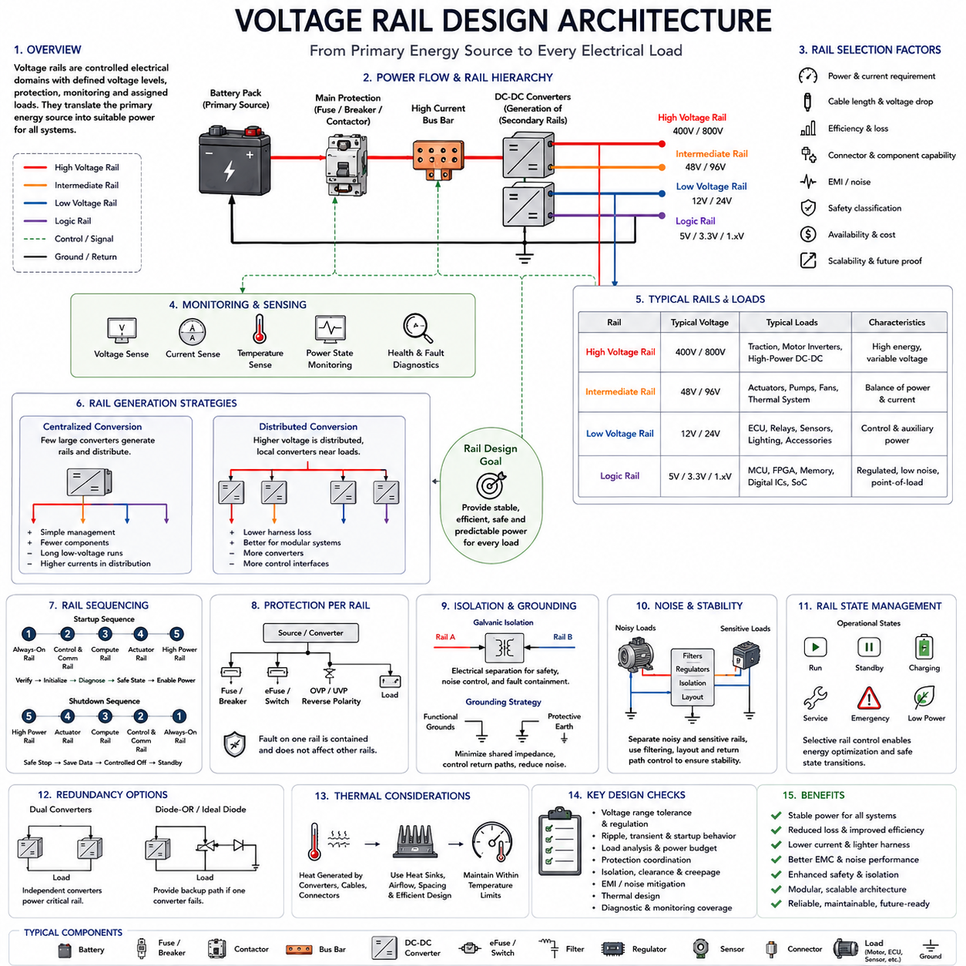
Voltage rail design defines how different voltage levels are created, distributed, protected, monitored, and assigned to electrical loads within a power distribution architecture. After the overall power topology and high-current bus structure have been established, voltage rails translate the primary energy source into electrical domains suitable for motors, controllers, sensors, communication devices, safety systems, and computing platforms.
A voltage rail represents a controlled electrical supply shared by one or more loads requiring compatible voltage characteristics. A robot may contain a high-energy battery rail for propulsion, an intermediate rail for actuators and industrial equipment, a low-voltage rail for controllers and accessories, and lower logic rails for processors and sensors. Each rail becomes a distinct electrical domain with its own performance and protection requirements.
The primary battery voltage usually forms the highest-energy rail available in the system. Depending on the platform, this rail may supply motor inverters, servo drives, traction systems, high-power DC-DC converters, or other major loads directly. Because battery voltage varies with state of charge, temperature, current demand, and chemistry, connected equipment must tolerate the complete expected operating voltage range rather than only the nominal value.
DC-DC converters create secondary voltage rails from the primary source. Step-down converters reduce a higher battery voltage to intermediate or low-voltage levels, while isolated converters can additionally provide galvanic separation between electrical domains. In specialized architectures, bidirectional converters may transfer energy in both directions, allowing regenerative energy, auxiliary storage, or controlled interaction between different power domains.
Rail selection should consider more than the nominal voltage required by individual components. Current demand, cable length, conductor size, conversion efficiency, connector capability, electrical noise, safety classification, component availability, and future scalability all influence the appropriate voltage. For the same power level, increasing distribution voltage reduces current, which can reduce conductor cross-section, resistive loss, voltage drop, and harness mass.
This relationship becomes especially important for high-power robotic actuators. Delivering several kilowatts through a low-voltage rail can require very large currents, heavy cables, large connectors, and substantial protection devices. Moving actuator power to a higher voltage can reduce these requirements, although higher voltage simultaneously increases insulation, isolation, clearance, creepage, switching, service, and personnel-protection requirements.
Intermediate voltage rails provide a practical compromise between high-energy propulsion buses and sensitive low-voltage electronics. A 48 V-class architecture, for example, can support motors, pumps, actuators, thermal systems, and other moderate-power equipment while reducing current compared with traditional lower-voltage distribution. The exact rail voltage, however, should follow system requirements rather than being selected solely from conventional voltage categories.
Low-voltage rails commonly supply ECUs, communication devices, relays, sensors, lighting, safety electronics, and auxiliary equipment. Depending on the platform, these may include 12 V or 24 V domains. Industrial robots often use 24 V for control equipment, while other robotic or vehicle architectures may retain 12 V-compatible devices because of component availability, legacy interfaces, or compatibility with existing electrical ecosystems.
Electronic computing systems require additional regulated rails. Edge computers, GPUs, network switches, cameras, LiDAR units, and embedded controllers may receive an intermediate supply and generate lower internal voltages through local point-of-load conversion. Processor cores, memory, interfaces, and digital logic may ultimately operate at voltages far below the platform-level rail, making voltage conversion a hierarchical process from battery energy to semiconductor-level power.
Centralized conversion uses a small number of large converters to generate rails that are distributed throughout the platform. This approach can simplify converter management and reduce component count, but long low-voltage distribution paths may carry high currents. Distributed conversion instead sends a higher voltage closer to the loads and performs local conversion, potentially reducing harness losses while increasing the number of converters and associated control interfaces.
Voltage regulation quality is critical for sensitive electronic loads. A nominal rail must remain within the operating limits of connected devices during startup, shutdown, motor acceleration, regenerative events, load switching, battery variation, and converter transients. Designers must therefore evaluate steady-state tolerance together with ripple, overshoot, undershoot, transient response, startup ramp behavior, and short-duration disturbances.
Dynamic loads can produce significant rail interaction. A motor drive may suddenly demand high current during acceleration, while a GPU can rapidly change power consumption according to computational workload. If both depend on insufficiently isolated or poorly regulated distribution paths, the resulting voltage disturbance can affect sensors, communication interfaces, controllers, or computing systems. Rail partitioning therefore contributes directly to system stability.
Sensitive loads and noisy loads should be separated where necessary. Motor drives, switching converters, pumps, solenoids, and high-current actuators can inject conducted disturbances into their supply rails, while cameras, IMUs, communication transceivers, analog sensors, and computing systems may require cleaner electrical conditions. Dedicated branches, filters, local regulators, grounding strategies, and controlled return paths can reduce coupling between these domains.
Rail sequencing determines the order in which electrical domains become active. An always-on rail may first power the battery management system, wake-up controller, or supervisory electronics. Control and communication rails can then initialize before compute systems and actuator power are enabled. Such sequencing allows the system to verify conditions, establish communication, perform diagnostics, and confirm safety states before energizing high-power loads.
Shutdown sequencing is equally important. Removing all rails simultaneously can prevent controllers from recording diagnostic information, placing actuators into safe states, or completing data storage. A controlled architecture may remove actuator power first while maintaining safety, control, and compute rails temporarily. Essential electronics can then execute controlled shutdown procedures before the remaining rails are disconnected or moved into low-power operation.
Safety power should be treated according to functional requirements rather than convenience. Emergency-stop monitoring, safety controllers, braking circuits, steering functions, isolation monitoring, and essential sensors may need power after ordinary actuator or compute rails have been disabled. A dedicated safety rail or protected safety branch can preserve the electrical functions required to transition the machine into a defined safe state.
Protection must be coordinated separately for each voltage rail. The source converter, conductor, connector, distribution branch, and connected load have different current limits and fault behavior. Fuses, circuit breakers, electronic switches, current limiting, overvoltage protection, reverse-polarity protection, and converter shutdown functions can therefore be combined to prevent a fault on one rail from damaging upstream equipment or propagating into other domains.
Galvanic isolation may be required between selected rails when electrical safety, noise control, measurement integrity, or fault containment demands separation. An isolated DC-DC converter transfers power without a direct conductive connection between input and output domains. Isolation boundaries must be coordinated with communication interfaces, grounding, shielding, chassis connections, and diagnostic circuits so unintended conductive paths do not defeat the intended separation.
Ground and return architecture must be designed together with the voltage rails. Multiple positive supply rails do not necessarily require identical return structures, particularly when high-current actuators and sensitive electronics coexist. Shared return impedance can convert current variations into reference-voltage errors. Designers therefore need to understand where rail currents return, where grounds are joined, and how chassis and protective-earth connections interact with functional grounds.
Voltage sensing provides direct visibility into rail health. Monitoring the primary battery rail and major secondary rails allows the supervisory controller to detect undervoltage, overvoltage, converter failure, abnormal voltage drop, or unstable operation. Combining voltage measurements with current and temperature information makes it possible to distinguish between excessive load, degraded wiring, poor connections, thermal problems, and converter-related faults.
Physical AI platforms make rail design increasingly important because computing and actuation create different but simultaneous power profiles. AI accelerators and GPUs require stable electrical power for perception and inference, while propulsion and manipulation systems can produce much larger current transients. Separating compute, perception, communication, actuator, and safety power domains helps prevent mechanical power events from disrupting the intelligence stack.
Rail architecture also supports power-state management and energy optimization. Nonessential sensors, auxiliary computers, communication modules, cooling equipment, or actuators can be disconnected when they are not required. Selective rail control allows the system to transition among operating, standby, charging, service, emergency, and low-power states while maintaining only the electrical domains necessary for each condition.
Redundant systems may use independent voltage generation paths for critical loads. Two DC-DC converters can supply separated or diode-ORed rails, or a safety controller can receive power from independent sources. Effective redundancy requires attention to shared upstream components, common grounds, connectors, protection devices, thermal dependencies, and control logic because duplicated outputs alone do not guarantee electrical independence.
Thermal design must accompany rail design because every conversion stage produces losses. High-current converters, regulators, protection devices, connectors, and conductors generate heat according to load and efficiency. Rail architecture therefore affects enclosure cooling, heat-sink placement, airflow, component spacing, and allowable continuous power. Conversion efficiency becomes especially important in battery-powered robots because electrical losses directly reduce operating time.
A robust voltage rail architecture consequently creates a controlled hierarchy from the primary energy source to every electrical load. The battery and bus-bar system provide bulk energy, converters establish appropriate voltage domains, protection devices contain faults, and monitoring functions supervise rail health. Within Chapter 06, this voltage structure provides the basis for the subsequent load analysis and power budget, followed by dynamic power management.

06.04. Load Analysis and Budget
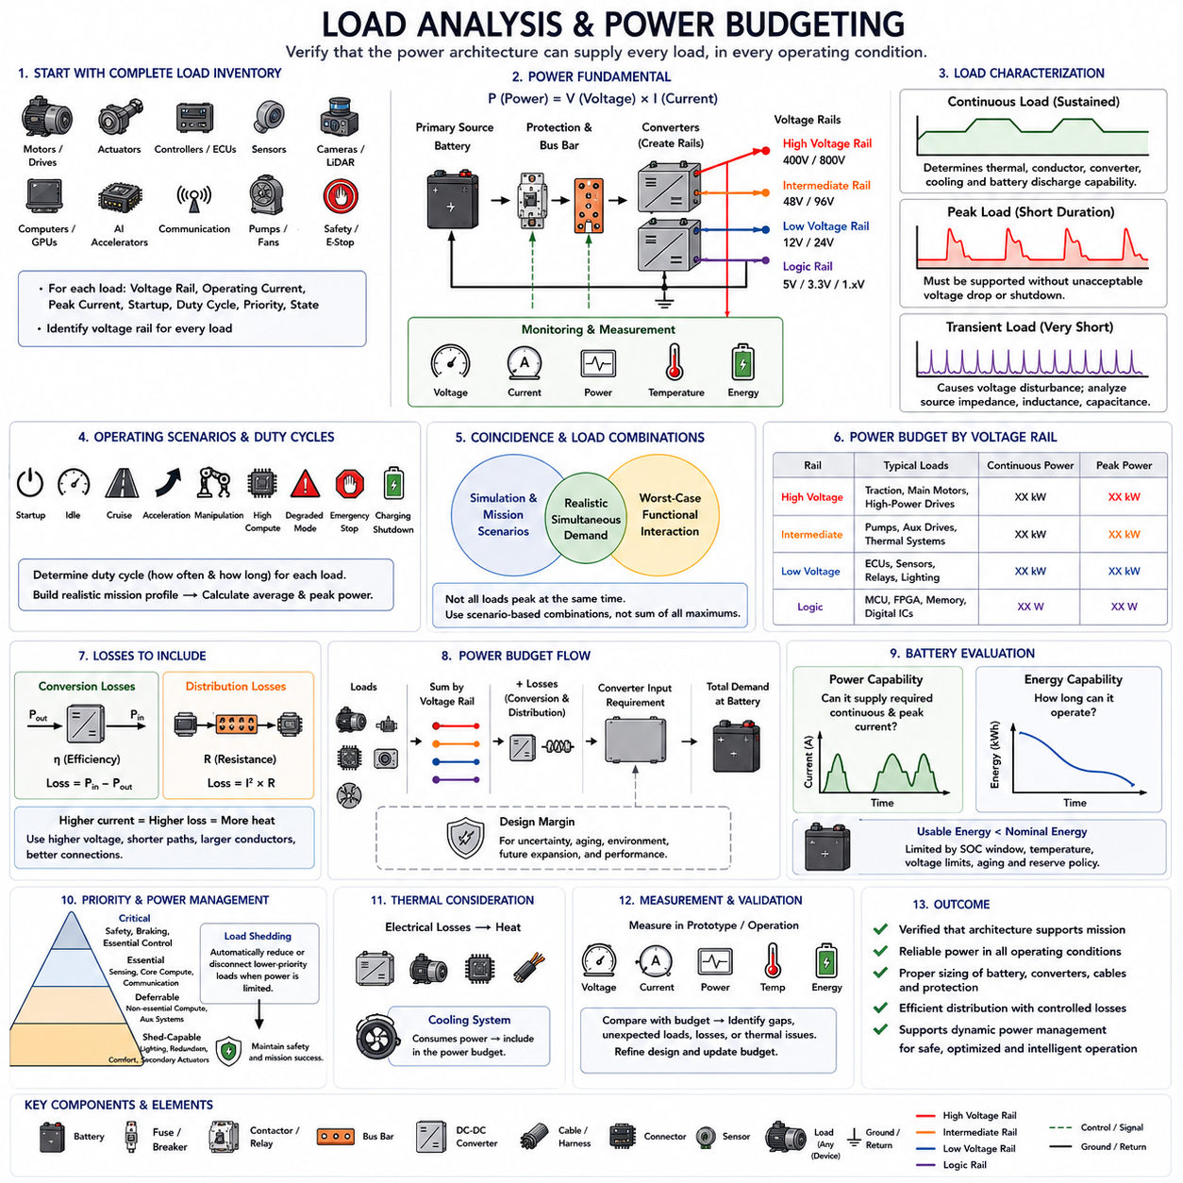
Load analysis and power budgeting determine whether an electrical architecture can supply every subsystem reliably across normal, peak, transient, startup, degraded, and emergency operating conditions. After power distribution topology, bus-bar architecture, and voltage rails are defined, load analysis quantifies how much electrical energy each device requires and how those demands combine at branch, rail, converter, battery, and complete-system levels.
The analysis begins with a complete electrical load inventory. Motors, servo drives, controllers, sensors, cameras, LiDAR, communication devices, safety equipment, pumps, fans, lighting, computers, GPUs, AI accelerators, and auxiliary equipment must be identified. Each load should be associated with its voltage rail, operating current, peak current, startup behavior, duty cycle, priority, and expected operating state.
Electrical power for a DC load is fundamentally related to voltage and current through P = V × I. This simple relationship becomes a system-level engineering tool when applied across hundreds of loads. Designers can calculate individual device power, aggregate loads connected to each voltage rail, estimate converter input requirements, and ultimately determine the total demand placed on the battery or other primary energy source.
Rated power should not automatically be interpreted as continuous operating power. Motors may reach rated or peak output only during acceleration or heavy loading, while cooling fans, pumps, sensors, and computers may operate continuously. AI computers can also vary significantly according to processing workload. Accurate budgeting therefore requires realistic operating profiles instead of simply adding every component's maximum rating.
Continuous load represents the power that must be supported for extended operation without exceeding thermal or electrical limits. This value influences conductor sizing, bus-bar temperature, converter rating, connector capability, cooling requirements, and battery discharge. The continuous system budget should represent credible sustained operation, including environmental conditions that may increase cooling or actuator demand.
Peak load represents the highest short-duration demand expected during operation. Simultaneous motor acceleration, steering, manipulation, braking control, cooling activation, and intensive AI processing can create a peak substantially above average consumption. The architecture must tolerate this condition without unacceptable voltage sag, converter shutdown, fuse operation, communication failure, or unintended reset of computing equipment.
Transient analysis addresses even shorter electrical events. Motor drives, capacitive electronics, DC-link circuits, solenoids, contactors, and large computers can create rapid current changes during switching or startup. Although these events may last only milliseconds or seconds, they can disturb shared voltage rails. Source impedance, bus resistance, converter response, capacitance, protection characteristics, and wiring inductance influence the resulting voltage behavior.
Startup load deserves separate analysis because many systems do not begin operation under steady-state conditions. Computers charge internal capacitors, converters initialize, pumps start, sensors activate, and actuator drives energize. If these loads are enabled simultaneously, accumulated inrush current can exceed normal operating demand. Controlled sequencing and pre-charge mechanisms can distribute startup demand over time and reduce stress on the electrical system.
Duty cycle describes how frequently and how long a load operates. A motor drawing 100 A for a few seconds does not impose the same thermal and energy requirement as a device continuously drawing 100 A. Mission profiles should therefore identify acceleration periods, cruising, manipulation, perception-intensive operation, idle periods, charging, standby, and other representative states to calculate realistic average and peak consumption.
Coincidence is another important factor because not every load reaches maximum demand simultaneously. Applying maximum ratings to all components can create an excessively conservative architecture with unnecessary battery capacity, conductor mass, converter size, and cost. However, assuming too little coincidence can produce an undersized system. Load combinations should therefore be derived from credible operating scenarios and worst-case functional interactions.
Power budgets should be organized by voltage rail and electrical domain. High-voltage or high-energy rails may primarily support traction and major actuators, intermediate rails may support pumps and auxiliary drives, and low-voltage rails may supply controllers, sensors, communication, and safety equipment. Logic and local regulated rails then support processors, memory, and semiconductor devices within individual electronic modules.
Converter efficiency must be included when transferring load requirements between voltage domains. A downstream load consuming 900 W does not require exactly 900 W from the upstream rail if the converter is less than 100 percent efficient. Conversion losses become heat and increase primary-source demand. Multiple conversion stages can accumulate significant losses, especially in systems containing numerous distributed converters and high-power computing equipment.
Distribution losses must also be incorporated into the budget. Current flowing through cables, bus bars, connectors, fuses, contactors, and PCB conductors produces resistive losses. These losses increase rapidly with current and can become significant in low-voltage, high-power systems. Increasing distribution voltage, shortening high-current paths, increasing conductor cross-section, and reducing contact resistance can improve overall power-delivery efficiency.
Thermal load is closely related to the electrical power budget. Electrical losses in converters, motor drives, computing equipment, conductors, and connections become heat that cooling systems must remove. Cooling equipment itself consumes electrical power, creating an interaction between electrical and thermal budgets. High ambient temperature can further increase fan or pump demand while reducing the allowable output of temperature-sensitive electrical components.
Design margin provides capacity for uncertainty, component variation, aging, environmental effects, and future expansion. A system designed exactly at its calculated continuous limit may have little tolerance for unexpected loads or degraded efficiency. Margin should nevertheless be assigned deliberately rather than by applying arbitrary excessive factors everywhere, because unnecessary margin increases battery size, converter capacity, weight, packaging volume, and cost.
The battery must be evaluated for both power and energy. Power determines whether the battery can provide the required instantaneous and continuous current, while energy determines how long the system can operate. A robot may have sufficient kilowatt-hours for a mission but still fail if the battery cannot support peak motor current. Conversely, high power capability does not guarantee adequate operating duration.
Usable battery energy is normally lower than nominal stored energy because operating limits, state-of-charge boundaries, temperature, aging, voltage requirements, and reserve policies restrict how much energy can actually be consumed. Mission energy calculations should therefore use the usable energy window rather than the theoretical battery capacity. Reserve energy may also be required for safe return, shutdown, communication, braking, or emergency functions.
Physical AI systems introduce a significant compute component into the load budget. GPUs, CPUs, AI accelerators, memory, storage, high-speed networking, cameras, LiDAR, and cooling can collectively consume substantial power. Unlike traditional control electronics, AI compute demand may vary with model complexity, sensor processing rate, inference workload, and operating mode, making computation an active variable in the electrical power budget.
Actuation and computation should also be analyzed together because their peaks can coincide. A robot navigating difficult terrain may simultaneously require high motor torque, intensive perception, localization, world-model processing, planning, and communication. Designing these domains independently can underestimate actual system demand. Mission-based load analysis captures such interactions and provides a more realistic basis for source and converter sizing.
Load priority becomes important when available power is temporarily lower than requested power. Safety controllers, braking systems, essential sensing, and minimum control functions normally receive higher priority than convenience loads or nonessential computing tasks. Defining critical, essential, deferrable, and shed-capable loads allows the architecture to maintain important functions during low battery conditions, converter limitations, thermal constraints, or faults.
Load shedding intentionally disconnects or reduces lower-priority loads when electrical capacity becomes constrained. Auxiliary lighting, redundant perception processing, nonessential communication, secondary computing, cooling margins, or selected actuators may be reduced depending on system requirements. Effective load shedding requires coordination between electrical hardware and supervisory software so that power reduction does not create unsafe system behavior.
A power budget should therefore be treated as a dynamic model rather than a single total wattage value. Different operating states produce different combinations of loads, and the dominant consumer can change throughout a mission. Startup, idle, cruise, acceleration, manipulation, high-compute operation, degraded mode, emergency stopping, charging, and shutdown should each be evaluated as distinct electrical scenarios.
Measurement is essential for validating analytical estimates. Voltage, current, temperature, converter efficiency, battery power, and branch consumption can be recorded during prototype testing. Comparing measured values with the design budget reveals incorrect assumptions, unexpected transient loads, excessive losses, or abnormal thermal behavior. Instrumented PDUs and intelligent power monitors can provide this information continuously during development and operation.
The resulting power budget becomes an engineering interface between electrical, mechanical, thermal, software, AI, and system teams. Electrical engineers use it to size conductors and converters, mechanical engineers use it for packaging and cooling, battery engineers use it for energy storage sizing, and software teams use it to define operating states and power-control policies. AI teams can additionally use the budget to understand allowable compute envelopes.
Load analysis and budgeting ultimately verify that the power distribution architecture can support the intended mission rather than merely connect all electrical components. Within Chapter 06, it converts the previously defined topology, bus bars, and voltage rails into quantitative operating requirements. These results then provide the foundation for dynamic power management, where electrical resources can be actively monitored, prioritized, and controlled during operation.

06.05. Dynamic Power Management
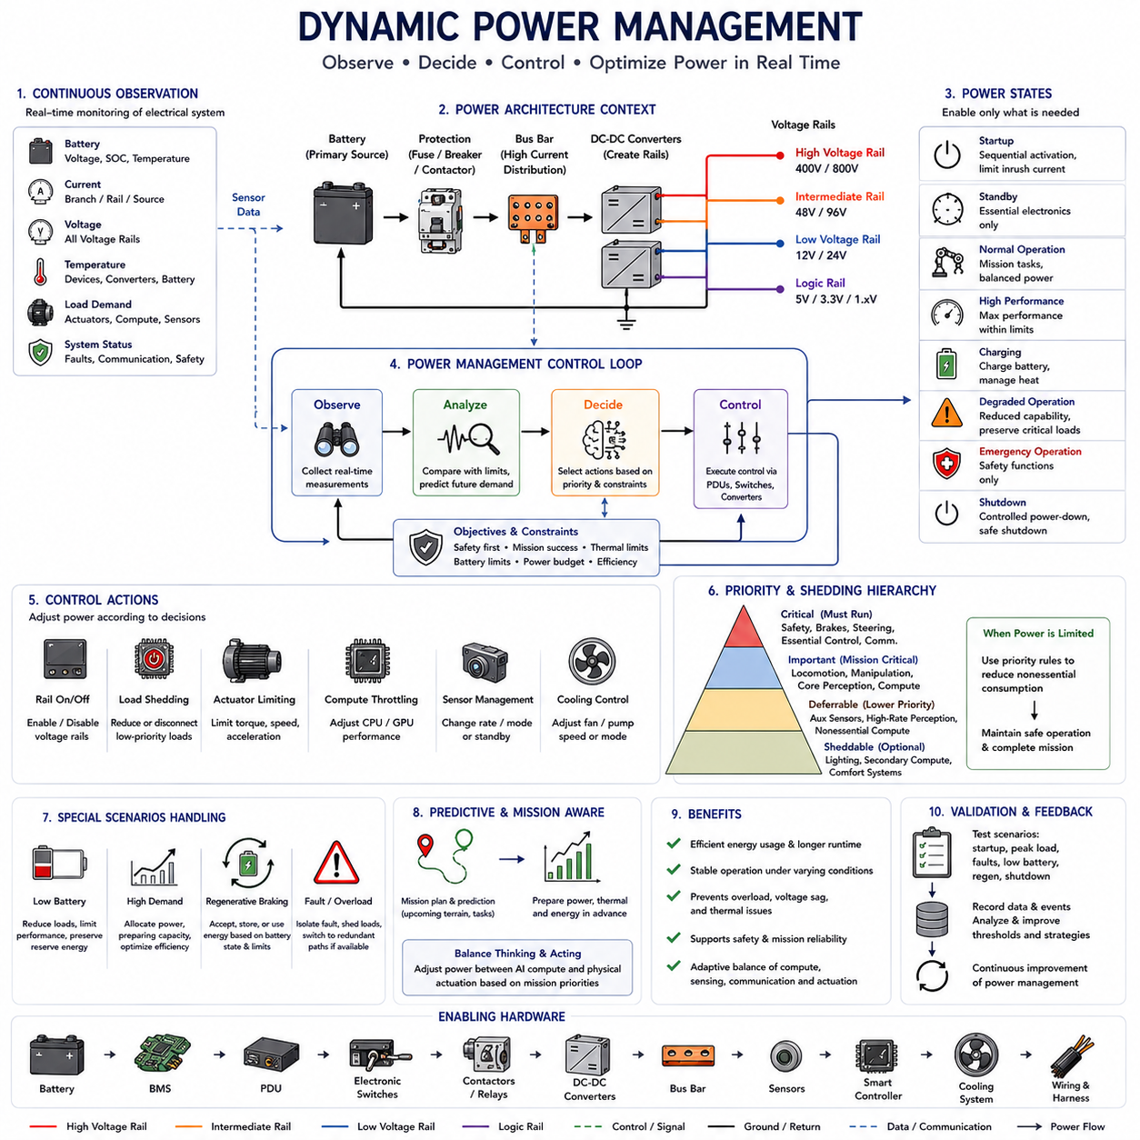
Dynamic power management extends the power distribution architecture from passive energy delivery into active control of electrical resources during operation. After topology, bus bars, voltage rails, and load budgets have been established, the system can continuously observe available energy and actual demand, then adjust power states according to mission requirements, safety priorities, thermal limits, battery condition, and changing computational or actuator workloads.
The fundamental objective is to supply sufficient power to every required function without unnecessarily energizing equipment that is not currently needed. A robot rarely requires all sensors, processors, actuators, communication devices, cooling systems, and auxiliary equipment at maximum capability simultaneously. Dynamic control allows electrical consumption to follow the actual operating state instead of remaining fixed at the worst-case design condition.
Power management begins with continuous observation of the electrical system. Battery voltage, state of charge, branch current, rail voltage, converter status, temperature, actuator demand, compute utilization, and fault information can be collected by the supervisory controller. These measurements create a real-time representation of electrical availability and consumption that can be compared with limits established during load analysis and power budgeting.
Power states define combinations of electrical domains appropriate for specific operating conditions. Typical states may include startup, standby, normal operation, high-performance operation, charging, service, degraded operation, emergency operation, and shutdown. Each state determines which voltage rails and loads remain active, which devices operate at reduced capability, and which equipment can be completely disconnected to conserve energy.
Startup management coordinates the activation of electrical loads so that the system does not create excessive simultaneous inrush current. Always-on controllers and battery management functions can initialize first, followed by communication, safety, perception, computing, and actuator domains. High-power loads can then be enabled only after voltage stability, communication status, thermal condition, and safety prerequisites have been confirmed.
During normal operation, the power-management controller can respond to changing mission demand. A mobile robot traveling through an uncomplicated environment may require moderate propulsion and perception power, while difficult terrain or manipulation may demand higher actuator output. Similarly, complex scenes can increase AI processing demand. Electrical resources can therefore be allocated according to the current combination of physical and computational workload.
Load prioritization provides the decision structure for allocating limited power. Safety functions, braking, steering, essential control, critical sensing, and communication required for safe operation generally receive the highest priority. Mission-critical computation and actuation follow according to platform requirements, while auxiliary devices and nonessential processing can receive lower priority. These classifications guide controlled responses when available power becomes constrained.
Load shedding reduces or disconnects lower-priority electrical consumption when total demand approaches system limits. Instead of allowing battery voltage to collapse or protection devices to trip, the supervisory system can disable optional equipment, reduce auxiliary loads, suspend secondary computation, or limit selected actuator functions. Load shedding should preserve predictable behavior and must never remove electrical functions required to maintain or reach a safe state.
Dynamic actuator power limiting can prevent mechanical loads from exceeding available electrical capability. Motor torque, acceleration, velocity, pump output, or manipulator performance can be temporarily constrained when battery current, converter capacity, thermal limits, or rail voltage approach defined thresholds. This creates a direct relationship between electrical resource availability and motion-control capability rather than allowing independent subsystems to compete uncontrolled for power.
Compute power can also be managed dynamically. CPUs, GPUs, and AI accelerators may support adjustable performance states, workload scheduling, clock control, or selective activation of processing resources. A Physical AI system can reduce nonessential inference workloads or processing rates when electrical capacity is limited, while preserving perception and decision functions required for navigation, safety, and minimum mission capability.
Sensor power management provides another opportunity for energy optimization. Cameras, LiDAR, radar, auxiliary sensors, lighting, and environmental sensing do not necessarily require identical operating rates in every mission state. Selected sensors can operate at reduced frequency or be placed into standby when environmental conditions and safety requirements permit, although sufficient sensing coverage must always be retained for safe operation.
Thermal management must be coordinated with electrical power management because electrical consumption and heat generation are strongly coupled. Increased motor, converter, or compute power generates additional heat, while fans and pumps consume additional electricity to remove that heat. The controller must therefore consider both electrical and thermal limits so that reducing one constraint does not unintentionally create another system-level limitation.
Battery condition directly influences available power. State of charge, temperature, cell voltage, aging, internal resistance, and battery-management limits can reduce the amount of current that can safely be delivered. Dynamic power management should therefore use available battery capability rather than assuming a constant nominal rating. The same robot may have different allowable acceleration or compute performance depending on battery and environmental conditions.
Regenerative power introduces the opposite problem because energy can flow back from motors during braking or controlled deceleration. The electrical architecture must determine whether this energy can be accepted by the battery, stored elsewhere, consumed by other loads, or limited by the drive system. Dynamic management can coordinate regenerative current with battery state, voltage limits, and simultaneous system consumption to prevent bus overvoltage.
Voltage rail control enables entire electrical domains to be activated or deactivated according to system state. Separate actuator, compute, perception, communication, auxiliary, and safety rails allow selective control without removing power from the complete platform. Intelligent PDUs, electronic switches, contactors, and converter enable interfaces can implement these transitions under command from supervisory control logic.
Rail transitions should follow controlled sequencing rules. Enabling a high-power rail may require verification of source voltage, insulation status, contactor state, converter readiness, communication, and downstream faults. Similarly, disabling a rail may require software notification, data storage, actuator stabilization, or transfer to another power source. Dynamic management therefore combines electrical switching with coordinated system-state transitions.
Fault conditions require rapid modification of the normal power strategy. An overloaded branch can be isolated, a failed converter can be disabled, and nonessential loads can be removed to preserve critical functions. Where redundant power paths exist, the controller may transfer selected loads to an alternate source or converter. The resulting degraded mode should provide a defined level of capability rather than allowing uncontrolled system behavior.
Power redundancy becomes more useful when combined with active supervision. Two sources or converters provide limited benefit if the system cannot detect their condition and determine when a transfer is required. Voltage, current, temperature, diagnostic status, and communication health can be used to identify deterioration before complete failure, allowing controlled switchover while sufficient electrical capacity remains available.
Predictive power management extends this concept by considering future demand rather than only current measurements. Mission planning may indicate an approaching slope, manipulation task, high-speed segment, or compute-intensive perception region. The system can preserve battery reserve, precondition thermal systems, reduce nonessential loads, or prepare additional power capacity before the predicted demand occurs.
Mission-level energy management connects instantaneous power decisions with operating duration. A robot that consumes excessive energy early in a mission may be unable to complete its task or return safely. Remaining battery energy can therefore be compared with predicted route, terrain, payload, computation, and reserve requirements. Mission planning and electrical management can then cooperate to modify speed, workload, route, or task execution.
Physical AI makes this coordination particularly important because intelligence itself becomes an adjustable electrical load. Perception models, world models, planning algorithms, and multimodal AI can consume substantial computing power while the same platform requires energy for physical motion. Dynamic power management provides a mechanism for balancing energy between thinking and acting according to current mission priorities.
For example, difficult terrain may justify allocating more power to locomotion while maintaining only essential AI processing, whereas a stationary inspection task may reduce actuator demand and allocate additional power to cameras, LiDAR, GPU inference, or detailed environmental analysis. This creates an adaptive relationship among sensing, computation, communication, and actuation rather than treating their power budgets as permanently independent.
Power-management decisions must nevertheless remain bounded by safety architecture. Energy optimization cannot override emergency-stop behavior, minimum braking capability, safety sensing, required communication, or other safety-related functions. Safety constraints therefore define non-negotiable power allocations, while optimization operates on the remaining controllable electrical capacity.
Diagnostics and historical data can improve power-management strategies over time. Recorded branch currents, battery behavior, converter efficiency, thermal conditions, mission profiles, and load-shedding events can reveal recurring bottlenecks or excessive design margins. These observations can support calibration of thresholds, maintenance planning, hardware redesign, and more accurate prediction of remaining operating time.
Validation should test transitions as well as steady operating states. Engineers must verify behavior during simultaneous peak loads, low battery conditions, thermal derating, converter faults, communication loss, regenerative events, startup, emergency stopping, and controlled shutdown. The objective is to demonstrate that power-management actions remain deterministic, stable, and compatible with the electrical and functional safety architecture.
Dynamic power management ultimately closes the loop of Chapter 06. Power distribution topology defines where energy flows, bus-bar architecture provides the high-current physical paths, voltage rail design establishes electrical domains, and load analysis quantifies demand. Dynamic power management then observes and controls these resources during operation, transforming the complete power architecture into an adaptive system capable of supporting efficient, reliable, and intelligent robotic operation.

