Volume 02. Wire Harness Engineering

Chapter 02. Current Capacity

02.01. Continuous vs Transient Current
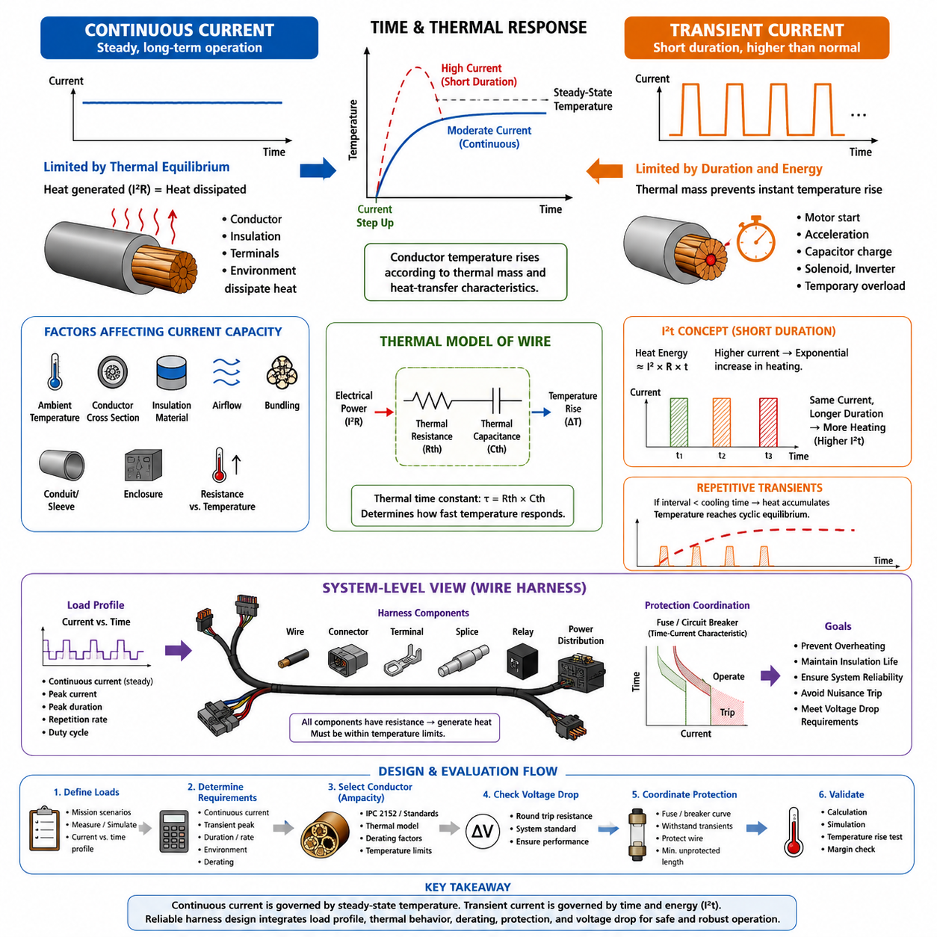
Continuous current is the electrical current that a wire or conductor must carry for an extended period while the system remains in a normal operating state. In wire-harness engineering, its allowable value is primarily limited by thermal equilibrium. Electrical resistance produces heat according to I²R loss, while the conductor, insulation, terminals, and surrounding environment continuously dissipate that heat.
When current remains approximately constant for sufficient time, the conductor temperature approaches a steady-state value at which generated heat and dissipated heat become balanced. The allowable continuous current must therefore keep the conductor and insulation below their specified temperature limits. Ambient temperature, conductor cross-sectional area, insulation material, airflow, bundling, and installation method all influence this equilibrium.
Transient current is a current that exceeds the normal continuous operating level for a limited duration. Examples include motor starting current, actuator acceleration current, capacitor charging current, solenoid energization, inverter transients, and temporary overloads. A wire can often tolerate a transient current considerably higher than its continuous rating because its thermal mass prevents the conductor temperature from rising instantaneously.
The distinction between continuous and transient current is fundamentally related to time. A conductor does not respond thermally to an electrical load with zero delay. When current suddenly increases, resistive heating increases immediately, but conductor temperature rises according to the thermal capacitance and heat-transfer characteristics of the wire assembly. Short pulses may therefore produce only a small temperature increase even when their peak current is high.
A simplified thermal interpretation treats the wire as a system having thermal resistance and thermal capacitance. Thermal resistance represents the difficulty of transferring heat from the conductor to the environment, while thermal capacitance represents the amount of thermal energy required to change its temperature. Together they create a thermal time constant that determines how quickly the wire approaches a new temperature after current changes.
For continuous loading, conductor selection is usually governed by the long-term temperature rise rather than by the instantaneous current peak. The designer must evaluate whether the expected steady current can be carried under the worst credible ambient and installation conditions. A wire installed individually in free air can dissipate heat more effectively than the same wire placed inside a dense harness bundle, conduit, protective sleeve, or enclosed compartment.
Transient loading requires evaluation of both current magnitude and duration. A very high current lasting only a few milliseconds can have a completely different thermal effect from the same current lasting several seconds. The relevant quantity is therefore not simply peak amperage. The energy deposited into the conductor depends strongly on the current-squared relationship, making high-current pulses increasingly significant as their duration or repetition rate increases.
The I²t concept provides a useful first-order method for understanding short-duration electrical heating. Because resistive power is proportional to current squared, doubling current produces approximately four times the instantaneous resistive heating when resistance is unchanged. For sufficiently short events, where heat dissipation during the pulse is limited, accumulated I²t can be related to the thermal energy absorbed by the conductor and nearby conductive elements.
Repeated transient currents require additional attention because individual pulses may not be thermally independent. If the interval between pulses is shorter than the cooling time of the wire, residual heat remains before the next event begins. The temperature can then progressively increase until a cyclic thermal equilibrium is reached. A load that appears safe when evaluated as one isolated pulse may therefore become unacceptable under frequent repetitive operation.
Robotic systems commonly exhibit this mixed current behavior. Drive motors may require elevated current during acceleration, steering actuators may produce short peaks during rapid corrections, manipulators may draw varying current with payload and motion, and computing systems may create dynamic power demands. Harness design should consequently characterize the load using continuous current, peak current, peak duration, repetition rate, and representative operating duty cycle.
Continuous and transient current limits must also be considered together with connectors, terminals, splices, relays, fuses, and power-distribution devices. The wire alone may tolerate a short current pulse, while a connector contact with higher localized resistance can experience excessive temperature rise. Conversely, a protective fuse selected too close to a repetitive transient peak may undergo cumulative heating and nuisance operation even though the harness itself remains thermally acceptable.
Current capacity must therefore be treated as a system-level thermal constraint rather than as a single fixed ampere value printed beside a wire gauge. Continuous current establishes the long-term thermal requirement, while transient current introduces time-dependent energy and peak-load requirements. Reliable harness engineering combines both perspectives so that normal operation, temporary overloads, repetitive duty cycles, and abnormal conditions remain within defined electrical and thermal limits.
Practical current profiling should be based on realistic operating scenarios rather than only nominal equipment ratings. Measurements or simulations should include startup, acceleration, braking, payload changes, actuator stalls, charging transitions, computing peaks, and simultaneous operation of multiple loads. The resulting current-versus-time profile provides a stronger basis for determining conductor size and thermal margin than a single maximum-current specification.
A useful engineering approach is to separate the electrical load profile into steady, periodic, and exceptional regions. The steady component determines the basic continuous ampacity requirement, periodic peaks are evaluated using thermal accumulation and duty cycle, and exceptional events are coordinated with protection devices. This separation prevents unnecessary wire oversizing while preserving adequate margin against overheating and insulation degradation.
Ambient conditions can significantly change both continuous and transient capability. Elevated surrounding temperature reduces the temperature margin between normal operation and the maximum allowable conductor or insulation temperature. Harness bundles also restrict heat transfer because neighboring conductors heat one another. Consequently, current capability established under room-temperature free-air conditions should not be directly applied to enclosed robotic installations without appropriate derating.
Wire resistance itself increases as conductor temperature rises, especially for common copper and aluminum conductors. This creates a coupled thermal-electrical effect: current generates resistive heat, temperature increases resistance, and the increased resistance produces additional loss at the same current. Under normal design conditions the system reaches a stable equilibrium, but insufficient thermal margin can cause substantially greater temperature rise than a room-temperature resistance calculation suggests.
Voltage-drop requirements may impose a conductor size larger than the thermal ampacity requirement, particularly in low-voltage high-current robotic systems. A wire might safely carry a transient motor current without exceeding its thermal limit yet produce enough temporary voltage drop to reset controllers, disturb sensors, reduce actuator torque, or trigger undervoltage protection. Current-capacity evaluation should therefore be coordinated with voltage-drop analysis rather than performed independently.
Protection coordination introduces another time-dependent relationship. Fuses and circuit breakers possess their own current-time characteristics and normally permit short overloads while interrupting sustained excessive current or severe faults. The conductor must remain thermally protected throughout this operating envelope. The objective is not merely to select a fuse above normal current, but to ensure that the protection characteristic remains compatible with conductor capability and legitimate transient loads.
For AMRs and other mobile robots, duty cycle can vary dramatically with mission profile. Continuous cruising on level floors, repeated stop-and-go operation, ramp climbing, heavy payload transport, docking, and emergency maneuvering can produce different thermal histories even when the hardware is unchanged. Current-capacity validation should therefore consider representative worst-case missions and not assume that average mission current adequately represents harness stress.
A robust harness specification should ultimately define more than one current number. It should identify expected continuous current, normal transient peak, maximum peak duration, repetition conditions, abnormal overload behavior, ambient-temperature range, bundling assumptions, and applicable derating factors. These parameters create a traceable connection between electrical load behavior and physical wire selection, enabling later validation through calculation, simulation, and temperature-rise testing.
Understanding continuous versus transient current provides the conceptual foundation for the remaining current-capacity engineering process. Once the load is represented as a function of magnitude and time, ampacity methods, thermal models, derating rules, and temperature measurements can be applied consistently. This time-aware perspective is especially important in robotic harnesses, where highly dynamic actuators coexist with continuously powered computing, sensing, communication, and safety systems.

02.02. IPC 2152 Ampacity Standard
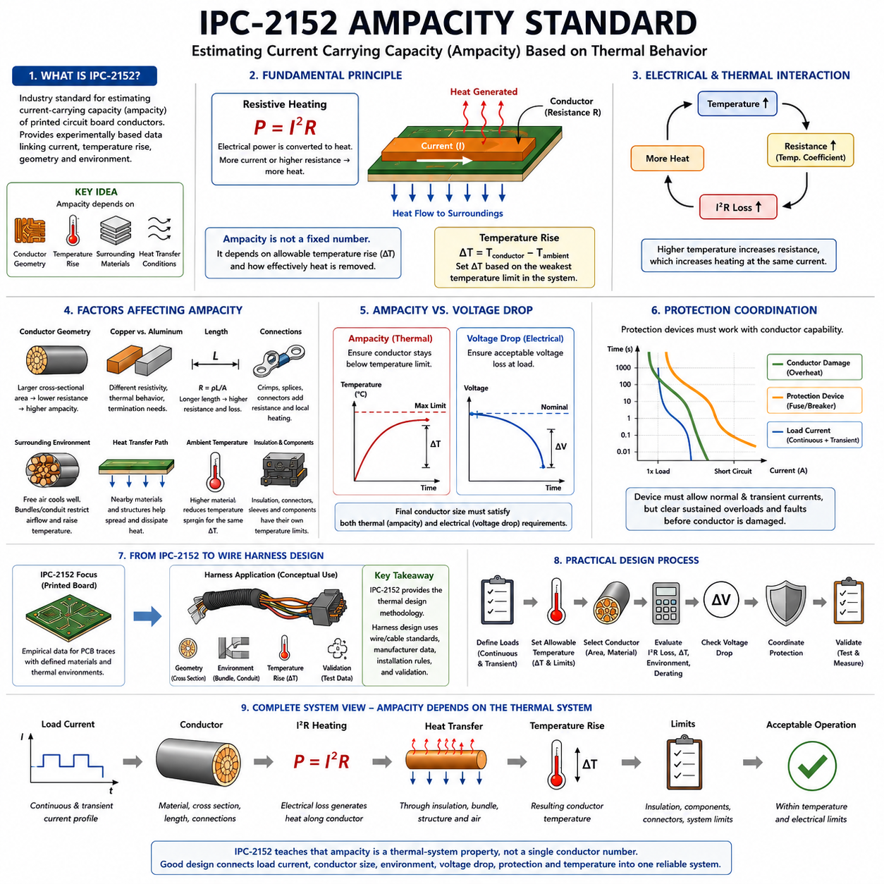
IPC-2152 is a widely referenced industry standard for estimating the current-carrying capacity, or ampacity, of conductive traces used in printed circuit boards. Within wire-harness engineering, its value is primarily conceptual and comparative rather than a direct wire-sizing rule. It demonstrates how allowable current depends on conductor geometry, temperature rise, surrounding materials, and heat-transfer conditions rather than on conductor cross section alone.
The standard was developed to provide a more experimentally grounded approach to current-versus-temperature-rise relationships for printed conductors. It improves upon older simplified relationships that tended to represent current capacity through generalized equations without adequately describing the surrounding thermal environment. IPC-2152 emphasizes measured thermal behavior and provides empirical information that designers can use to estimate conductor temperature rise under defined conditions.
Ampacity refers to the amount of electrical current that a conductor can carry while remaining within an acceptable temperature limit. This definition is important because a conductor does not possess one universal current rating. The acceptable current depends on how much temperature rise is permitted above ambient temperature and how effectively heat generated by electrical resistance can be transferred into surrounding materials and ultimately dissipated into the environment.
The basic physical mechanism remains resistive heating. When current I flows through a conductor having resistance R, electrical power is converted into heat approximately according to P = I²R. Increasing conductor cross-sectional area generally decreases resistance and therefore reduces heat generation for a given current. However, conductor temperature cannot be predicted from resistance alone because the final temperature also depends on the paths through which this heat leaves the conductor.
IPC-2152 therefore reinforces an important distinction between electrical capacity and thermal capacity. Electrical calculations determine resistance and I²R loss, while thermal conditions determine the resulting temperature rise. Two conductors having similar resistance can reach different operating temperatures if their surrounding structures provide different heat-transfer paths. This principle is equally important when reasoning about wires installed in robotic electrical systems.
Conductor geometry strongly influences ampacity. Wider or thicker conductive paths generally provide lower electrical resistance and greater current-carrying capability. In a wire harness, the analogous parameter is conductor cross-sectional area, commonly specified in square millimeters or AWG. Increasing conductor area reduces resistance per unit length, decreases voltage drop, and normally allows greater continuous current before a specified temperature limit is reached.
Temperature rise is commonly expressed as the difference between conductor temperature and ambient temperature, ΔT = Tconductor − Tambient. A current-capacity decision must therefore specify an acceptable ΔT rather than simply stating that a conductor can carry a certain number of amperes. A conductor operating in a 25°C environment with a 30°C rise experiences a substantially different absolute temperature from one operating with the same rise in a 70°C environment.
This distinction becomes especially important because insulation systems, connector housings, terminal plating, seals, protective sleeves, and nearby electronic components may each have their own temperature limitations. The allowable conductor temperature should therefore be established from the weakest relevant thermal constraint in the complete electrical assembly. Ampacity is useful only when it is associated with clearly defined ambient and maximum operating temperatures.
One of the major lessons associated with IPC-2152 is that surrounding material can act as an important heat-transfer mechanism. In printed circuit boards, dielectric material and nearby conductive structures participate in spreading heat away from a current-carrying trace. The corresponding harness principle is that installation conditions—including free air, bundle construction, conduit, protective sleeving, clamps, enclosure surfaces, and adjacent wires—can substantially alter thermal performance.
A conductor operating in free air can transfer heat through convection and radiation over much of its external surface. When the same conductor is placed within a tightly packed bundle, neighboring wires restrict airflow and may simultaneously generate their own heat. Interior wires can consequently operate at higher temperatures than isolated wires carrying equivalent current. This is why practical harness ampacity calculations require bundling and environmental derating.
Conductor length also affects electrical loss because total resistance increases with length. For a uniform conductor, resistance can be represented approximately by R = ρL/A, where ρ is material resistivity, L is conductor length, and A is cross-sectional area. The resulting I²R loss is distributed along the conductor, while connectors, crimps, splices, and terminals can introduce additional localized resistance and concentrated heating that must be evaluated separately.
The conductor material is another important parameter. Copper is commonly used because of its high electrical conductivity, mechanical properties, and established termination technologies. Aluminum provides lower mass but has different resistivity, thermal behavior, oxide characteristics, and termination requirements. Consequently, equal cross-sectional areas made from different conductor materials should not automatically be assumed to provide equivalent ampacity or equivalent system performance.
The temperature coefficient of resistance introduces further coupling between electrical and thermal behavior. As the temperature of common metallic conductors rises, their resistance generally increases. Increased resistance produces greater I²R loss at the same current, which can further increase temperature. Ampacity evaluation should therefore consider conductor resistance at realistic operating temperatures rather than relying exclusively on nominal resistance measured near room temperature.
For robotic harness design, IPC-2152 should not be interpreted as a replacement for wire-specific standards, manufacturer ampacity data, automotive conductor requirements, or experimentally validated harness rules. IPC-2152 primarily addresses printed-board conductors. Its strongest contribution to harness engineering is the thermal design methodology it illustrates: current capacity must be linked to geometry, allowable temperature rise, thermal environment, and empirical validation.
This distinction prevents a common engineering error in which a current value derived for one conductor configuration is transferred directly to another configuration. PCB copper traces, insulated stranded wires, busbars, flexible circuits, connector contacts, and cable assemblies have fundamentally different geometries and heat-transfer boundaries. A current rating is therefore meaningful only when the physical configuration and test conditions associated with that rating are understood.
In an AMR or mobile robot, the thermal environment can vary substantially across the electrical architecture. Battery cables, motor-phase conductors, DC power-distribution wiring, compute power lines, sensor branches, and charging circuits may experience different current profiles and installation conditions. Harness sections near motors, inverters, batteries, or enclosed power-distribution units may also experience higher local ambient temperatures than externally routed harness sections.
A practical design process begins by determining continuous and transient load currents and then identifying the allowable conductor temperature. The designer selects a preliminary conductor cross section and evaluates resistance, I²R heating, installation environment, ambient temperature, bundling, and applicable derating factors. Voltage drop and protection coordination are then checked because the conductor must satisfy electrical performance and fault-protection requirements in addition to thermal ampacity.
The relationship between ampacity and voltage drop is particularly important in 12 V, 24 V, and 48 V robotic power systems. A conductor may remain below its thermal limit yet still create unacceptable voltage loss during high-current operation. Conversely, a conductor selected primarily to satisfy stringent voltage-drop requirements may possess substantial thermal current margin. Final wire selection should therefore satisfy both constraints rather than treating ampacity as the only sizing criterion.
Protection devices must also be coordinated with conductor capability. A fuse or circuit breaker should allow legitimate operating currents and expected short-duration transients while protecting the downstream conductor against sustained overloads and fault currents. The relevant comparison is therefore time-dependent: load-current profiles, conductor thermal response, and protection-device time-current characteristics must remain compatible across normal and abnormal operating conditions.
Engineering margin is necessary because calculated or tabulated ampacity cannot perfectly represent every production installation. Manufacturing tolerances, conductor resistance variation, crimp resistance, bundle density, airflow changes, contamination, aging, enclosure temperature, and mission duty cycle can shift actual temperatures. Conservative derating and representative temperature-rise testing provide protection against these uncertainties without relying exclusively on theoretical calculations.
Temperature-rise validation should reproduce realistic installation conditions as closely as practical. The harness should be tested with representative conductor lengths, bundles, sleeves, connectors, terminals, ambient temperatures, and load profiles. Temperature measurements at conductor regions and electrical interfaces can identify thermal hot spots that may not be apparent from wire-gauge calculations alone, especially around crimps, splices, connectors, and power-distribution junctions.
The broader engineering lesson of IPC-2152 is that ampacity is a thermal-system property rather than an isolated conductor number. Current creates heat, conductor geometry determines electrical loss, surrounding structures determine heat transfer, and temperature limits define acceptable operation. This framework connects naturally with subsequent harness topics such as ampacity calculation, wire thermal modeling, temperature-rise measurement, gauge selection, and environmental derating.
For reliable robotic electrical architecture, IPC-2152 is therefore most useful as a reference for understanding current-capacity methodology while wire-specific design remains governed by appropriate cable standards, component specifications, installation rules, and validation data. Applying this disciplined approach prevents simplistic current-rating assumptions and supports a traceable relationship among load current, conductor size, thermal environment, voltage drop, protection, and operating temperature.

02.03. Ampacity Calculation Method
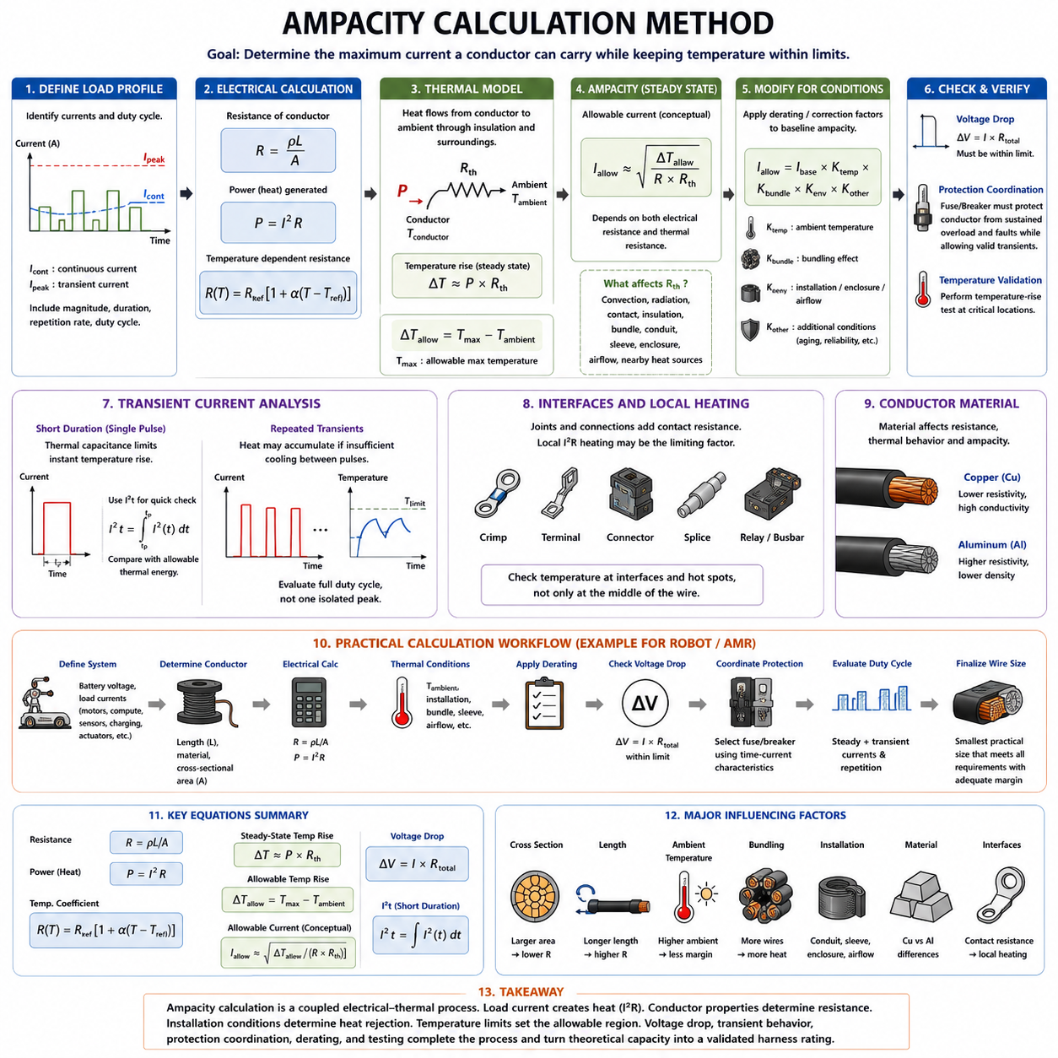
Ampacity calculation determines the maximum current a conductor can carry while maintaining its temperature within defined operating limits. In wire harness engineering, this value cannot be derived from conductor cross-sectional area alone. The calculation must connect electrical resistance, current-generated heat, ambient temperature, insulation limits, installation conditions, and the ability of the surrounding environment to remove heat from the conductor.
The calculation begins with the electrical load profile. Continuous current establishes the primary steady-state thermal requirement, while transient current introduces additional time-dependent heating. Motor startup, acceleration, actuator operation, charging, and temporary overloads may create currents much higher than the normal value. Their magnitude, duration, repetition rate, and duty cycle should therefore be identified before conductor ampacity is evaluated.
Electrical resistance provides the link between load current and heat generation. For a uniform conductor, resistance can be approximated by R = ρL/A, where ρ is conductor resistivity, L is conductor length, and A is conductor cross-sectional area. Electrical power converted into heat is then expressed as P = I²R. Increasing conductor area reduces resistance and generally reduces heat generation for the same current.
Resistance should be evaluated at the expected operating temperature rather than only at a nominal room-temperature condition. Metallic conductor resistance normally increases as temperature rises. A simplified relationship can be expressed as R(T) = Rref[1 + α(T − Tref)], where α is the temperature coefficient of resistance. This creates thermal-electrical coupling because increased temperature raises resistance and therefore increases I²R loss at constant current.
The generated heat must be transferred from the conductor through insulation and surrounding structures into the environment. A simplified steady-state thermal model represents temperature rise as ΔT ≈ P × Rth, where Rth is the effective thermal resistance between the conductor and ambient environment. Combining this relationship with P = I²R shows directly why allowable current depends on both electrical resistance and thermal resistance.
Using the simplified steady-state model, current may be conceptually estimated from I ≈ √[ΔT/(R × Rth)]. This relationship should be understood as an engineering model rather than a universal ampacity equation. Real harness installations involve distributed heat transfer, temperature-dependent properties, convection, radiation, contact interfaces, bundles, sleeves, enclosures, and nearby heat sources that cannot always be represented accurately by one thermal resistance value.
Allowable temperature rise must be defined before solving for allowable current. It can be expressed as ΔTallow = Tmax − Tambient, where Tmax is the selected maximum permissible operating temperature and Tambient is the applicable ambient temperature. Tmax should not automatically be set equal to the conductor material limit. Insulation, connectors, terminals, seals, sleeves, nearby components, and reliability requirements may impose lower temperature limits.
Ambient temperature is particularly important because it directly consumes part of the available thermal margin. A harness operating at 25°C ambient has substantially more temperature-rise margin than the same harness operating near a motor, inverter, battery, or enclosed power-distribution unit at 70°C. The current capacity should therefore be calculated for the worst credible local ambient condition rather than for a convenient laboratory room temperature.
Installation configuration modifies heat dissipation and must be incorporated through thermal modeling, correction factors, or empirical derating. A single wire in free air generally dissipates heat more effectively than a wire inside a tightly packed bundle. Conduit, corrugated tubing, braid, tape, protective sleeves, sealed enclosures, and restricted airflow can further reduce heat transfer and therefore reduce practical allowable current.
Bundle effects become significant because neighboring conductors can heat one another while simultaneously restricting airflow. The center of a large bundle may experience a considerably different thermal environment from its outer surface. Consequently, calculating each conductor as if it were isolated can overestimate harness current capacity. Bundle size, number of simultaneously loaded wires, spacing, routing, and surrounding material should therefore be included in the design assumptions.
A practical engineering method often begins with a baseline ampacity obtained from an applicable wire standard, manufacturer data, validated test data, or an accepted calculation model. Environmental correction factors are then applied to account for ambient temperature, bundling, enclosure, installation method, and other conditions. Conceptually, the allowable design current can be represented as Iallow = Ibase × Ktemp × Kbundle × Kenvironment × Kother.
Derating factors should not be treated as arbitrary safety multipliers. Each factor represents a physical or reliability-related condition that reduces the usable current capability from a reference condition. Temperature derating accounts for reduced thermal margin, bundle derating accounts for mutual heating, and installation derating accounts for restricted heat rejection. Applying factors without understanding their reference conditions can result in either unsafe design or unnecessary conductor oversizing.
Conductor material must also be included in the calculation. Copper and aluminum have different resistivity, density, temperature coefficients, thermal conductivity, and termination behavior. A conductor with the same geometric cross section does not necessarily provide the same electrical resistance or ampacity when its material changes. Material selection therefore affects both the initial electrical-loss calculation and the subsequent thermal response.
Ampacity calculation should include electrical interfaces because harness temperature is not always highest along the middle of a wire. Crimps, terminals, connectors, splices, busbar joints, relays, and power-distribution connections introduce contact resistance. Even a relatively small additional resistance can create concentrated I²R heating at high current. Local interface temperatures may therefore become the limiting condition before the bulk conductor reaches its thermal limit.
Transient currents require a time-dependent calculation rather than only the steady-state ampacity model. For sufficiently short events, thermal capacitance limits the immediate temperature rise because the conductor stores part of the generated thermal energy. I²t provides a useful first-order indicator of short-duration heating, while more detailed analysis uses conductor thermal mass, heat capacity, thermal resistance, pulse duration, and initial temperature to predict the transient response.
Repeated transients require consideration of thermal accumulation. If the conductor does not return close to its initial temperature between current pulses, each subsequent pulse begins from an elevated temperature. The design should therefore evaluate the complete duty cycle rather than one isolated peak. Drive motors and robotic actuators are typical examples where acceleration, braking, steering, and repeated motion can produce cyclic temperature behavior.
After a conductor satisfies the thermal ampacity requirement, voltage drop must be checked independently. The approximate voltage drop is ΔV = I × R for a single defined current path, with the complete supply-and-return resistance included where applicable. Low-voltage systems are particularly sensitive to this constraint. A thermally acceptable conductor may still cause excessive voltage reduction during motor acceleration or other high-current operation.
Protection coordination forms another mandatory check. Fuse or circuit-breaker characteristics should protect the selected conductor against sustained overload and fault conditions while allowing legitimate operating transients. The conductor thermal withstand, load-current profile, and protection-device time-current characteristic must therefore be compared across time. Selecting a fuse only from the nominal continuous current can produce either nuisance operation or insufficient wire protection.
An engineering margin is normally added because the calculation contains uncertainties. Actual conductor resistance, ambient temperature, bundle arrangement, airflow, crimp quality, contact aging, manufacturing tolerance, contamination, mission profile, and simultaneous load operation may differ from nominal assumptions. The margin should be traceable to defined design requirements rather than introduced as an unexplained percentage that hides uncertainty in the underlying model.
For an AMR, a representative calculation may begin with battery voltage and the current profile of each major load, including traction motors, steering, computing, sensors, communication equipment, actuators, and charging interfaces. The designer determines conductor length and material, estimates operating resistance and thermal conditions, applies appropriate derating, checks voltage drop, coordinates circuit protection, and then evaluates the combined mission duty cycle.
Calculation alone should not be regarded as final validation. Representative temperature-rise testing is needed for high-current or thermally critical harness sections. Testing should reproduce realistic conductor length, connectors, crimps, bundle configuration, protective coverings, ambient temperature, airflow, and load profile. Measurements at likely hot spots can reveal local thermal behavior that a simplified analytical model cannot accurately predict.
The final conductor size is therefore selected through an iterative process rather than from one equation. Increasing cross-sectional area reduces resistance and voltage drop while generally improving thermal margin, but it also increases mass, cost, stiffness, connector size, routing space, and minimum bend radius. The optimum wire gauge is the smallest practical conductor that satisfies thermal, electrical, protection, mechanical, environmental, and reliability requirements with adequate margin.
Ampacity calculation is consequently best understood as a coupled electrical-thermal design process. Load current determines heat generation, conductor properties determine resistance, installation conditions determine heat rejection, and component temperature limits establish the allowable operating region. Voltage-drop analysis, transient behavior, protection coordination, derating, and physical testing then complete the design process and convert a theoretical current capability into a validated harness rating.

02.04. Thermal Model of Wire
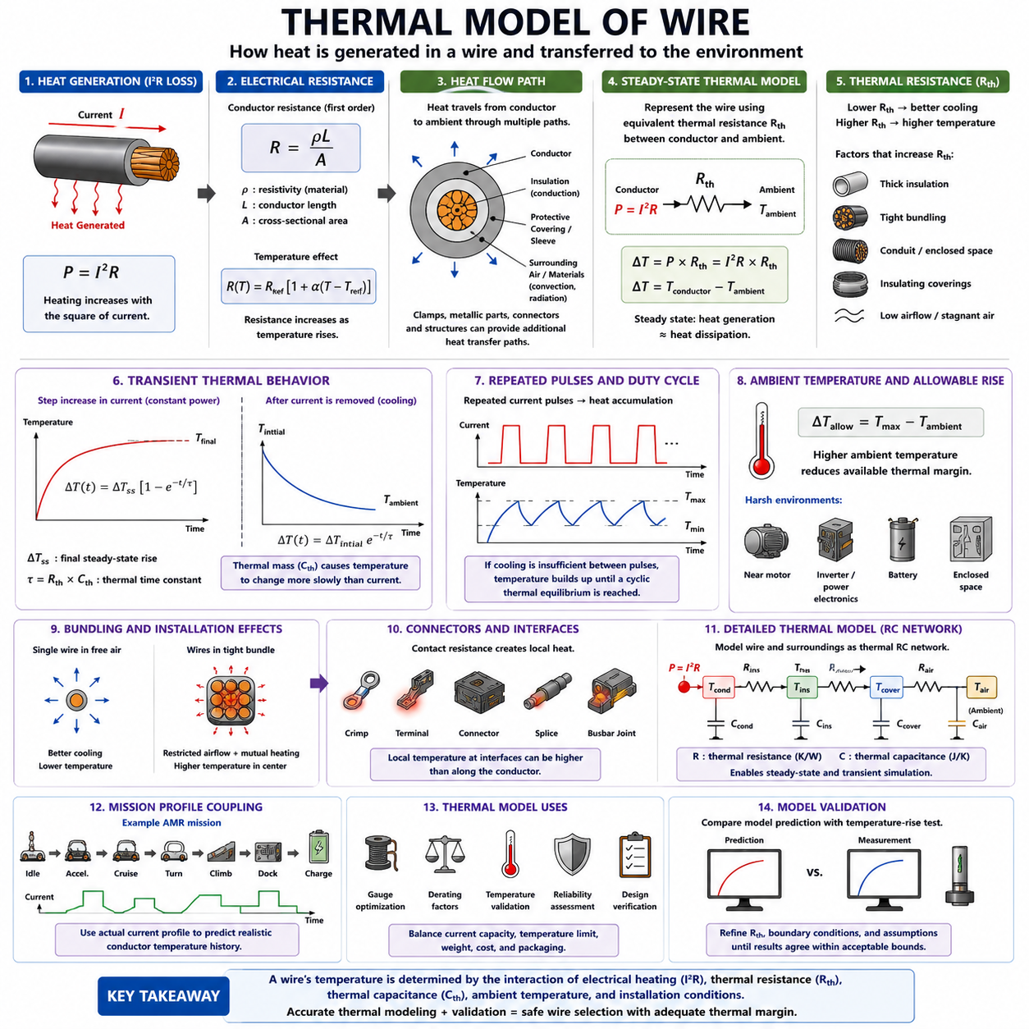
A wire thermal model describes how electrical energy converted into heat changes conductor temperature and how that heat is transferred to the surrounding environment. In current-capacity engineering, the model provides the physical connection between conductor current and allowable temperature. It explains why ampacity depends not only on wire gauge, but also on resistance, insulation, ambient temperature, installation geometry, airflow, bundling, and operating time.
The primary heat source in a current-carrying wire is resistive loss. When current I flows through a conductor with electrical resistance R, the generated power can be approximated as P = I²R. Because heating increases with the square of current, relatively small increases in current can produce much larger increases in thermal load. This nonlinear relationship is one of the fundamental reasons why current capacity requires careful thermal evaluation.
Conductor resistance is determined by material properties and geometry. For a uniform conductor, R = ρL/A provides a useful first-order relationship, where ρ is electrical resistivity, L is conductor length, and A is cross-sectional area. A larger conductor area reduces resistance and therefore decreases I²R heating for the same current, while increasing conductor length increases total resistance and the electrical energy converted into heat.
Resistance itself changes with temperature, creating coupling between the electrical and thermal domains. A simplified expression is R(T) = Rref[1 + α(T − Tref)], where α represents the temperature coefficient of resistance. As conductor temperature rises, resistance typically increases, causing greater power loss at constant current. Accurate thermal analysis therefore benefits from updating resistance according to the predicted operating temperature.
The heat generated inside the conductor must travel through several thermal paths before reaching the surrounding environment. Heat conducts radially through the insulation, transfers to adjacent materials or protective coverings, and is eventually rejected through convection and radiation. Clamps, metallic structures, connectors, terminals, and enclosure surfaces may provide additional conductive paths that either improve or locally modify heat dissipation.
A simple steady-state thermal model can represent the wire using an equivalent thermal resistance Rth between the conductor and ambient environment. The temperature rise can then be approximated by ΔT = P × Rth. Substituting the electrical heating relationship gives ΔT ≈ I²R × Rth. This equation illustrates the direct interaction among current, electrical resistance, thermal resistance, and conductor temperature.
Thermal resistance is analogous to electrical resistance, but it describes opposition to heat flow rather than electrical current. A low thermal resistance means heat can escape efficiently, producing a smaller temperature rise for a given power loss. A high thermal resistance indicates restricted heat transfer. Thick insulation, enclosed conduits, dense bundles, stagnant air, and thermally insulating coverings can increase the effective thermal resistance of a harness installation.
Steady-state analysis assumes that sufficient time has passed for conductor temperature to stop changing significantly. At this condition, heat generation is approximately balanced by heat dissipation. If ambient temperature is Tambient and the steady conductor temperature is Tconductor, the temperature rise is ΔT = Tconductor − Tambient. Continuous ampacity is fundamentally associated with maintaining this equilibrium below the allowable temperature limit.
Real robotic loads are rarely perfectly steady, so the thermal model must also describe transient behavior. A wire has thermal mass and therefore requires finite energy to change temperature. This behavior can be represented by thermal capacitance Cth. When current suddenly increases, electrical heating changes immediately, but conductor temperature responds more slowly because energy must accumulate in the conductor and surrounding materials.
Combining thermal resistance Rth and thermal capacitance Cth produces a first-order thermal time constant, commonly represented as τ = Rth × Cth. The time constant indicates how rapidly the conductor responds to a change in heating. A small time constant produces a relatively rapid temperature response, while a large thermal mass or strongly coupled thermal structure can make the temperature change more gradually.
For a simplified step in constant heating power, conductor temperature approaches its new steady-state value approximately exponentially. Conceptually, the temperature rise may be represented as ΔT(t) = ΔTss[1 − exp(−t/τ)], where ΔTss is the final steady-state temperature rise. This behavior explains why a conductor can tolerate short current peaks considerably above its continuous current without immediately reaching the corresponding steady-state temperature.
When the current pulse ends, stored thermal energy begins to leave the conductor and the temperature decays toward ambient conditions. Cooling can also be approximated using an exponential response in a simple lumped thermal model. The actual cooling rate depends on conductor mass, insulation, surrounding materials, airflow, mounting, bundle structure, and temperature difference between the harness and its environment.
Repeated current pulses create a more complicated thermal history. If each pulse occurs before the conductor has sufficiently cooled, residual heat accumulates and the minimum temperature between pulses progressively increases. Eventually the system may reach a cyclic thermal equilibrium. For drive motors, steering actuators, manipulators, pumps, and other repetitive robotic loads, this cyclic behavior can be more important than either a single transient or a simple continuous-current assumption.
The thermal model must also account for ambient temperature because the allowable temperature rise is determined by the difference between maximum permissible temperature and local ambient temperature. Conceptually, ΔTallow = Tmax − Tambient. Higher ambient temperature reduces available thermal margin even if electrical current remains unchanged. Harnesses routed near motors, batteries, inverters, brakes, power electronics, or sealed enclosures therefore require special attention.
Insulation affects the thermal model in two different ways. Its maximum temperature rating contributes to the allowable conductor-temperature limit, while its thermal properties influence heat transfer from the conductor. Insulation thickness, thermal conductivity, surface characteristics, and material type can therefore affect both the permissible temperature and the thermal resistance of the wire assembly.
Bundling introduces thermal interaction among multiple wires. Each loaded conductor becomes a heat source, while neighboring wires and coverings restrict convection and modify conductive heat paths. Wires near the center of a bundle may experience a higher effective ambient temperature and poorer cooling than wires on the outside. Bundle thermal behavior therefore cannot always be represented accurately by analyzing each conductor independently.
Protective components such as corrugated conduit, braid, tape, sleeves, and sealed coverings provide mechanical and environmental protection but can alter heat rejection. Their thermal effect depends on material, thickness, coverage, air gaps, and external airflow. A harness that performs safely in free air may therefore operate at a substantially higher temperature after being packaged inside protective structures.
Connectors, terminals, crimps, and splices require localized thermal modeling because their contact resistance can create concentrated heat sources. The highest temperature in a power circuit may occur at a termination rather than along the conductor itself. Mechanical relaxation, oxidation, contamination, poor crimping, or aging can increase contact resistance, making interface temperature an important reliability indicator in high-current harnesses.
A more detailed thermal model may divide the harness into multiple thermal nodes representing conductor, insulation, protective covering, surrounding air, connector interfaces, and nearby structures. Thermal resistances connect these nodes, while thermal capacitances represent stored energy. Such an RC thermal network allows engineers to simulate both steady-state and transient temperature behavior without requiring a full three-dimensional thermal simulation for every design iteration.
For highly critical designs, numerical methods such as finite-element analysis can represent spatial temperature gradients, complex geometry, local heat sources, and realistic boundary conditions in greater detail. However, increasing model complexity does not automatically improve accuracy. Reliable results still depend on realistic material properties, contact conditions, convection coefficients, ambient temperatures, electrical losses, and installation geometry.
The thermal model should be coupled with the actual mission current profile of the robot. An AMR may alternate among idle operation, acceleration, constant-speed travel, turning, ramp climbing, payload transport, docking, charging, and emergency maneuvers. Each state produces a different electrical load and therefore a different heating rate. Simulating this sequence provides a more realistic conductor temperature history than evaluating only nominal or peak current.
Thermal modeling also supports wire gauge optimization. Increasing conductor cross section lowers electrical resistance and normally reduces temperature rise, but larger wires increase mass, cost, stiffness, packaging volume, connector requirements, and bend radius. The model helps determine whether a smaller conductor can safely support a dynamic load profile or whether additional cross section is necessary to maintain thermal margin under continuous operation.
Model predictions should ultimately be verified by temperature-rise measurement. Representative harness samples should reproduce actual wire length, connectors, crimps, bundles, sleeves, routing, ambient conditions, and load profiles. Measurements at conductors and expected hot spots can then be compared with calculated results. Differences between prediction and measurement provide information for refining thermal resistance, boundary conditions, and derating assumptions.
The wire thermal model is therefore the central physical framework connecting continuous current, transient current, ampacity calculation, derating, and temperature-rise testing within current-capacity engineering. Electrical resistance determines heat generation, thermal resistance controls heat rejection, thermal capacitance governs temperature response over time, and component limits define acceptable temperature. Together these relationships provide a traceable basis for safe wire selection.

02.05. Temperature Rise Measurement
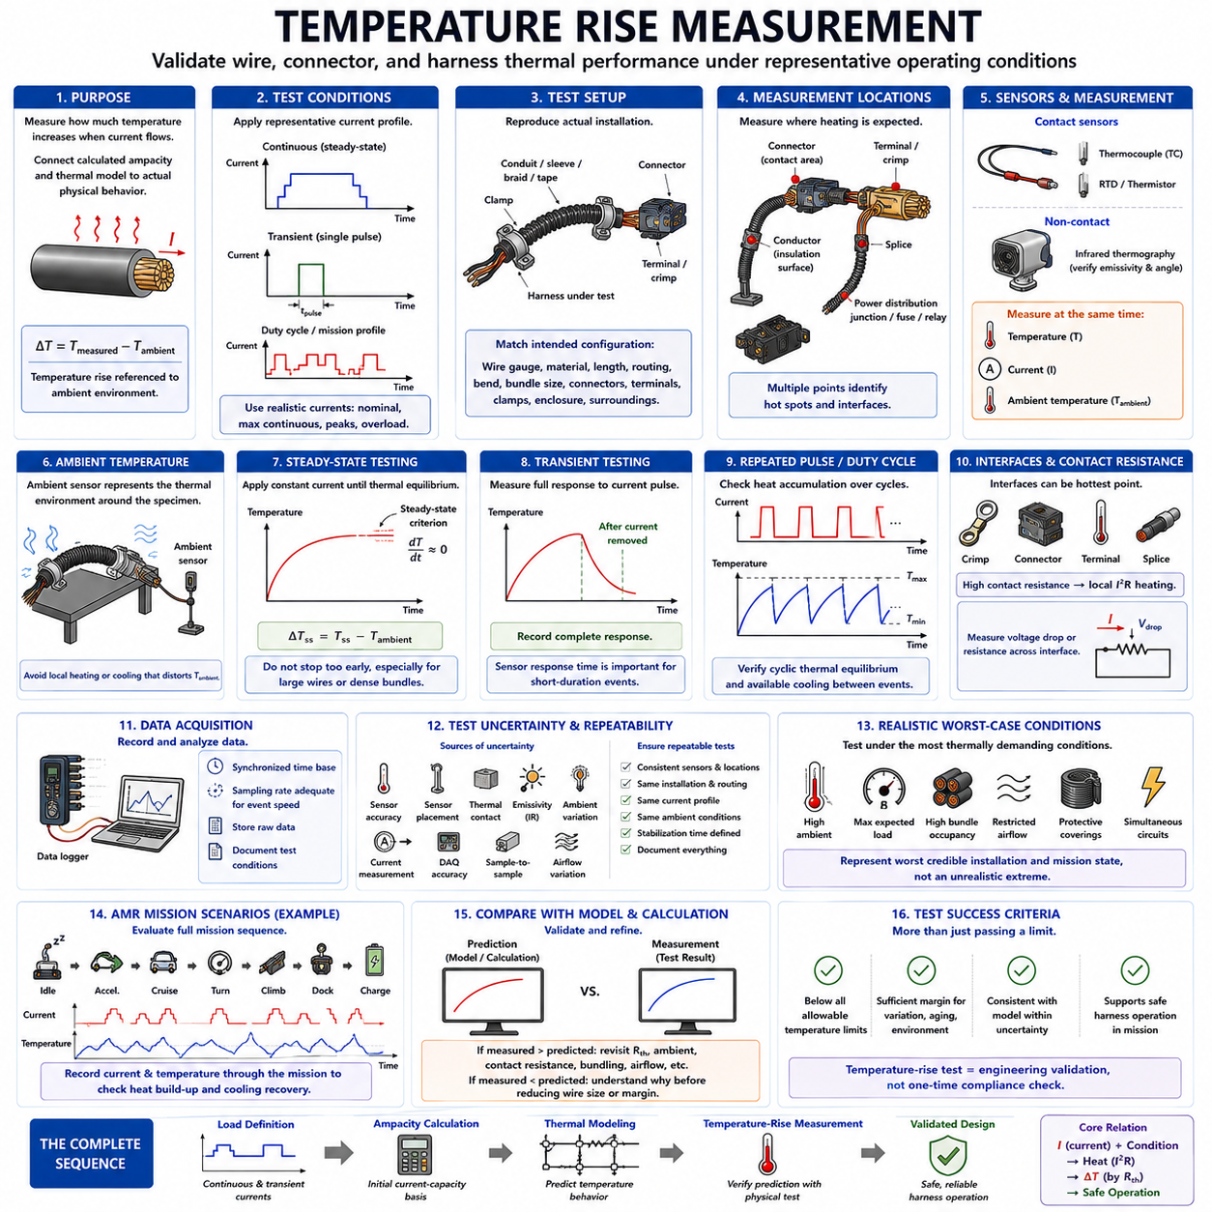
Temperature-rise measurement is the experimental process used to determine how much the temperature of a wire, terminal, connector, or harness assembly increases when electrical current is applied. Within the current-capacity chapter of wire-harness engineering, it provides the validation step that connects calculated ampacity and thermal models with actual physical behavior under representative operating conditions.
Temperature rise is normally defined as the difference between the measured component temperature and the relevant ambient temperature. It can be expressed as ΔT = Tmeasured − Tambient. This distinction is important because absolute component temperature changes with environmental conditions. A measured conductor temperature of 70°C represents very different thermal performance when the surrounding ambient is 25°C compared with an ambient of 60°C.
The primary purpose of measurement is to verify that the conductor and all associated components remain below their allowable temperature limits. These limits may be established by wire insulation, connector housing, terminal plating, seals, sleeves, nearby components, or system reliability requirements. Consequently, measuring only the middle of the conductor is insufficient when another electrical or mechanical interface may become the actual thermal limitation.
A representative test begins by defining the electrical load condition. Continuous-current testing evaluates the steady-state temperature reached during sustained operation, while transient testing examines the response to short-duration current peaks. Robotic systems may additionally require repeated duty-cycle testing because acceleration, steering, manipulation, braking, docking, and charging can create cyclic current profiles that repeatedly heat and cool the harness.
The test current should represent realistic system operation rather than an arbitrarily convenient laboratory value. Important conditions include nominal continuous current, maximum expected continuous current, normal transient peaks, peak duration, repetition rate, and abnormal overload conditions where appropriate. For an AMR, representative mission sequences can provide more meaningful thermal information than a single constant-current test.
Ambient temperature must be measured carefully because it forms the reference for the temperature-rise calculation. The ambient sensor should represent the thermal environment surrounding the test specimen without being significantly heated by the specimen itself or cooled by an unrelated airflow source. Incorrect ambient measurement can distort calculated ΔT even when the conductor temperature measurement itself is accurate.
The physical installation of the test sample should reproduce the intended harness configuration as closely as practical. Wire gauge, conductor material, insulation type, conductor length, bundle size, routing, bend geometry, conduit, braid, tape, sleeve, clamps, connectors, terminals, and enclosure conditions can all influence heat transfer. Testing a wire freely suspended in air may not represent the temperature of the same wire installed inside a dense robotic harness.
Measurement locations should be selected according to expected thermal behavior rather than convenience. Typical locations include the conductor, insulation surface, crimp region, terminal, connector contact area, splice, fuse interface, relay connection, and power-distribution junction. Areas near high-temperature equipment or restricted airflow may also require monitoring. Multiple measurement points help identify local hot spots that a single sensor could miss.
Thermocouples are commonly used because they are small, inexpensive, and capable of measuring temperature at localized points. Their installation requires care because the sensor and attachment method can influence the measured value. The thermocouple should maintain reliable thermal contact with the target while adding minimal thermal mass and avoiding unnecessary modification of airflow or heat conduction around the measurement location.
Resistance-based temperature detectors and thermistors can also provide accurate measurements when their size, range, response time, and mounting method are appropriate. These sensors may be useful for repeated laboratory testing or embedded monitoring. However, every contact sensor introduces some interaction with the measured object, so sensor placement and attachment should remain consistent when results from different conductors or design configurations are compared.
Infrared thermal imaging provides a useful non-contact method for observing temperature distribution over connectors, bundles, terminals, and surrounding structures. It can reveal unexpected hot spots and thermal gradients that point sensors may overlook. However, infrared measurement depends strongly on surface emissivity, viewing angle, reflections, accessibility, and calibration, so shiny metallic terminals can produce misleading apparent temperatures if these effects are ignored.
Electrical current should be measured simultaneously with temperature whenever possible. Actual current can differ from commanded or nominal current because of supply voltage, load variation, motor operation, controller behavior, or test-equipment tolerance. Recording current and temperature on a common time base allows engineers to relate heating and cooling behavior directly to the electrical load profile and improves comparison with thermal-model predictions.
For steady-state testing, current is applied until the temperature approaches thermal equilibrium. A practical steady-state criterion should be defined before the test, such as a sufficiently small temperature change over a specified observation period. The exact criterion depends on the applicable engineering procedure. Declaring equilibrium too early can underestimate the final temperature, especially for large conductors, dense bundles, or assemblies having long thermal time constants.
The temperature-versus-time curve contains information beyond the final steady-state value. The initial heating rate, curvature, time required to approach equilibrium, and cooling response after current removal provide insight into thermal resistance and thermal capacitance. These measured characteristics can be compared with an RC thermal model and used to refine parameters when the predicted response differs from the physical harness behavior.
Transient testing focuses on the maximum temperature reached during and after a current pulse. Because temperature may continue changing briefly after electrical conditions change, the complete response should be recorded rather than measuring only at the instant the current is removed. Sensor response time is especially important for short events because a slow sensor can underestimate rapid local temperature changes at small conductors or contact interfaces.
Repeated-pulse testing should continue long enough to determine whether heat accumulates over successive cycles. The temperature may initially increase from cycle to cycle before approaching a periodic steady condition. Both maximum and minimum cyclic temperatures are useful because they reveal the amount of cooling between events. This is particularly relevant to motors and actuators that repeatedly accelerate, stop, reverse, or operate under varying mechanical loads.
Connector and termination measurements deserve special attention because localized contact resistance can generate significant I²R heating. A conductor may remain well below its allowable temperature while a poor crimp or high-resistance contact becomes excessively hot. Measuring voltage drop or electrical resistance across critical interfaces together with temperature can help distinguish conductor heating from localized connection problems.
Test repeatability is necessary for meaningful comparison between design alternatives. Sensor type, sensor location, attachment method, ambient condition, current profile, sample preparation, airflow, stabilization time, and data-acquisition settings should be controlled and documented. Without consistent test conditions, an apparent improvement from a larger wire, different sleeve, new connector, or routing change may actually result from measurement variation.
Measurement uncertainty should also be considered. Sensor accuracy, data-acquisition accuracy, current measurement error, ambient-temperature variation, sensor positioning, thermal contact, emissivity assumptions, and sample-to-sample variation can all influence the result. When measured temperature is close to the allowable limit, uncertainty becomes especially important because a small measurement error may determine whether the design appears to pass or fail.
Temperature-rise testing is most valuable when it reproduces worst credible operating conditions. Elevated ambient temperature, maximum expected load, high bundle occupancy, restricted airflow, protective coverings, and simultaneous operation of nearby circuits may need to be combined. The objective is not to create an unrealistic extreme condition, but to represent the most thermally demanding installation and mission state that the system can reasonably encounter.
For AMR harness validation, test scenarios can correspond to actual mission states such as idle, acceleration, cruise, turning, ramp climbing, payload transport, docking, and charging. Recording current and temperature through the complete sequence reveals whether thermal energy accumulates during demanding portions of the mission and whether available cooling periods are sufficient to restore adequate thermal margin before the next high-load event.
Measured results should be compared with the predictions generated during ampacity calculation and thermal modeling. If measured temperatures are consistently higher than predicted, assumptions concerning thermal resistance, ambient temperature, contact resistance, bundling, or airflow may require revision. If measured temperatures are lower, the model may be conservative, but the reason should be understood before reducing conductor size or design margin.
A successful test should demonstrate more than a simple pass below one temperature limit. The measured thermal behavior should provide sufficient margin for manufacturing variation, component aging, environmental changes, mission variability, and measurement uncertainty. This converts temperature-rise testing from a one-time compliance activity into an engineering validation process that supports reliable conductor sizing and harness architecture.
Temperature-rise measurement therefore completes the current-capacity engineering sequence established in this chapter: continuous and transient current define the electrical loading, ampacity methods provide an initial current-capacity basis, thermal modeling predicts temperature behavior, and physical measurement verifies the prediction. Together, these methods establish a traceable relationship between load current, installation condition, conductor temperature, and safe harness operation.

