Volume 02. Wire Harness Engineering

Chapter 04. Wire Gauge Selection

04.01. AWG vs mm² Conversion
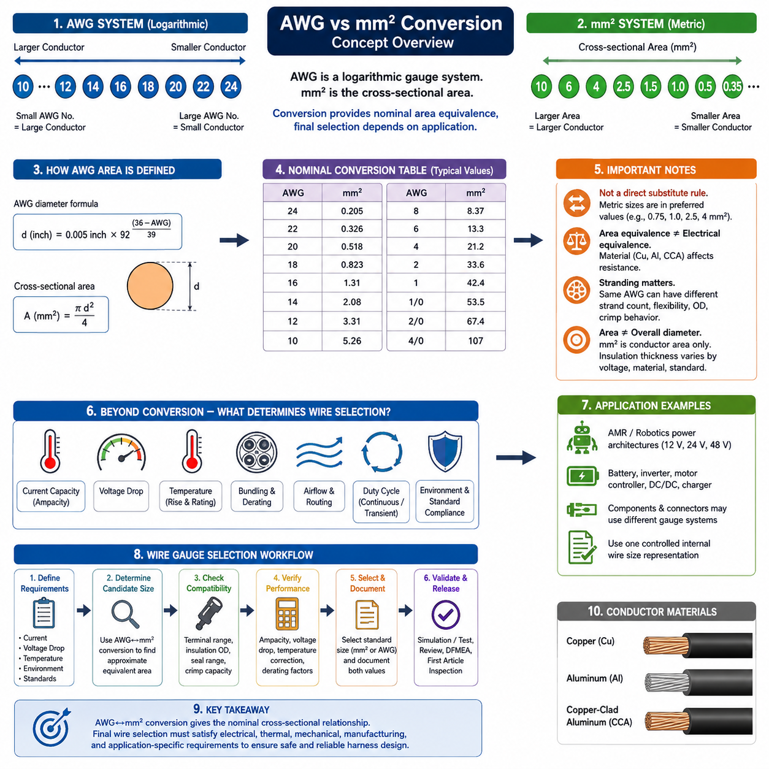
American Wire Gauge (AWG) and square millimeters (mm²) are two different systems used to describe conductor size. AWG is a logarithmic gauge system historically used in North America, while mm² directly represents conductor cross-sectional area. In wire harness engineering, conversion between them is essential because component datasheets, connectors, wires, and design standards may specify conductor sizes using different systems.
The AWG numbering system works inversely to conductor size. A smaller AWG number indicates a larger conductor, while a larger AWG number indicates a smaller conductor. For example, 10 AWG is substantially larger than 20 AWG. This convention can initially appear counterintuitive, particularly when engineers work simultaneously with metric wire specifications in which increasing cross-sectional area directly indicates increasing conductor size.
AWG dimensions follow a logarithmic progression rather than a linear sequence. The standard relationship is based on 36 AWG having a nominal diameter of approximately 0.127 mm and 0000 AWG having a diameter of approximately 11.684 mm. The diameter of an AWG conductor can therefore be calculated from its gauge number, and its nominal circular cross-sectional area can subsequently be obtained from the calculated diameter.
For a solid round conductor, the cross-sectional area is calculated from A = πd²/4, where A is area and d is conductor diameter. Combining this geometric relationship with the AWG diameter equation provides a mathematical conversion from AWG to mm². In engineering practice, however, standardized conversion tables are normally preferred because they reduce calculation effort and allow rapid comparison with commercially available metric conductor sizes.
Common nominal relationships illustrate the progression clearly. 24 AWG is approximately 0.205 mm², 22 AWG approximately 0.326 mm², 20 AWG approximately 0.518 mm², 18 AWG approximately 0.823 mm², 16 AWG approximately 1.31 mm², 14 AWG approximately 2.08 mm², 12 AWG approximately 3.31 mm², and 10 AWG approximately 5.26 mm². These values represent nominal conductor areas rather than insulation dimensions.
Larger power conductors continue the same relationship. 8 AWG corresponds to approximately 8.37 mm², 6 AWG to 13.3 mm², 4 AWG to 21.2 mm², 2 AWG to 33.6 mm², 1 AWG to 42.4 mm², 1/0 AWG to 53.5 mm², 2/0 AWG to 67.4 mm², and 4/0 AWG to approximately 107 mm². Such sizes are relevant to battery, inverter, charging, and high-current distribution circuits.
AWG-to-mm² conversion should not be interpreted as a direct commercial wire substitution rule. Metric conductor sizes are commonly manufactured in preferred values such as 0.35, 0.5, 0.75, 1.0, 1.5, 2.5, 4, 6, 10, 16, 25, 35, 50, 70, and 95 mm². Consequently, the calculated AWG equivalent frequently falls between available metric sizes, requiring an engineering decision rather than simple numerical replacement.
For example, 18 AWG has a nominal area of about 0.823 mm², but a metric harness may offer 0.75 mm² or 1.0 mm² conductors rather than an exact 0.823 mm² product. Similarly, 12 AWG at approximately 3.31 mm² does not directly correspond to the common 2.5 or 4 mm² sizes. Selection should therefore consider whether the smaller candidate remains adequate or whether the next larger standardized conductor is required.
Cross-sectional equivalence alone does not guarantee equivalent electrical performance. Conductor material strongly affects resistance because copper, aluminum, and copper-clad aluminum have different resistivities. Two wires with similar cross-sectional areas can consequently exhibit different voltage drops, losses, and temperature rises. Conversion should therefore preserve the distinction between dimensional equivalence and actual electrical equivalence.
Stranded conductors require additional care. AWG normally describes the effective conductor size represented by the combined metallic cross-sectional area, while individual strand diameter and strand count determine flexibility and construction. A finely stranded robotics cable and a conventional automotive cable may share the same nominal gauge but differ considerably in flexibility, outside diameter, termination behavior, fatigue resistance, and compatible crimp geometry.
The conductor cross-sectional area must also be distinguished from overall wire diameter. A specification such as 2.5 mm² refers to the metallic conductor area, not the external diameter of the insulated wire. Insulation thickness depends on voltage rating, material, temperature class, abrasion requirements, environmental protection, and applicable standards. Harness packaging calculations must therefore use actual finished-wire dimensions supplied by the wire manufacturer.
Reverse conversion from mm² to AWG is useful when a metric design must interface with connectors, terminals, or equipment specified in AWG. Because AWG values are discrete, the calculated equivalent should normally be treated as a reference point. The engineer must then select an available gauge that satisfies electrical requirements and lies within the conductor-size range approved for the associated terminal, seal, splice, and crimping process.
Terminal compatibility is particularly important during conversion. A connector contact may be qualified for a specific range such as 16–20 AWG, while a metric wire supplier specifies conductors in mm². The selected metric conductor must satisfy not only approximate AWG area equivalence but also conductor diameter, insulation diameter, strand construction, seal range, crimp barrel capacity, and the terminal manufacturer's validated application specification.
Current capacity should never be inferred solely from an AWG/mm² conversion table. Ampacity depends on conductor resistance, insulation temperature rating, ambient temperature, bundling, airflow, routing, duty cycle, and acceptable temperature rise. The wire-size conversion establishes conductor geometry, whereas current-based selection is a separate engineering step within the overall wire gauge selection process identified in the harness engineering structure.
Voltage-drop verification is likewise required after selecting the nominal equivalent size. Resistance is proportional to conductor resistivity and circuit length and inversely proportional to cross-sectional area. A long low-voltage power circuit can therefore require a substantially larger conductor than its thermal ampacity alone suggests. This is especially important in 12 V, 24 V, and 48 V robotic power architectures where small voltage losses can affect load performance.
For AMR and robotic harnesses, conversion frequently occurs when North American components are integrated with IEC-oriented or automotive metric wiring. Motor controllers, DC/DC converters, battery systems, breakers, connectors, and imported subsystems may use different gauge conventions. Establishing one controlled internal wire-size representation helps prevent mismatches between schematic design, harness drawings, purchasing specifications, manufacturing documentation, and service information.
A practical engineering database should therefore record both the specified conductor size and its nominal equivalent rather than repeatedly performing informal conversions. An entry might identify a conductor as 2.5 mm² with an approximate AWG reference while retaining 2.5 mm² as the controlling specification. This prevents the approximate conversion value from gradually becoming an unintended replacement specification as data passes between engineering and manufacturing teams.
The safest conversion philosophy is consequently to treat AWG and mm² as related descriptions rather than perfectly interchangeable standards. Mathematical conversion provides the nominal cross-sectional relationship, but final wire selection must return to the actual application requirements. Current capacity, voltage drop, temperature, conductor material, flexibility, terminal compatibility, insulation construction, environmental conditions, and standard compliance together determine whether the selected wire is truly equivalent.
Within the wire harness engineering workflow, AWG-versus-mm² conversion therefore serves as the dimensional foundation for subsequent gauge selection rather than the final selection criterion itself. After establishing the approximate equivalent conductor area, engineers should verify current capability, voltage-drop performance, temperature correction, and application-specific constraints before releasing the design. This sequence maintains consistency between electrical calculations and physical harness implementation.

04.02. Current Based Selection
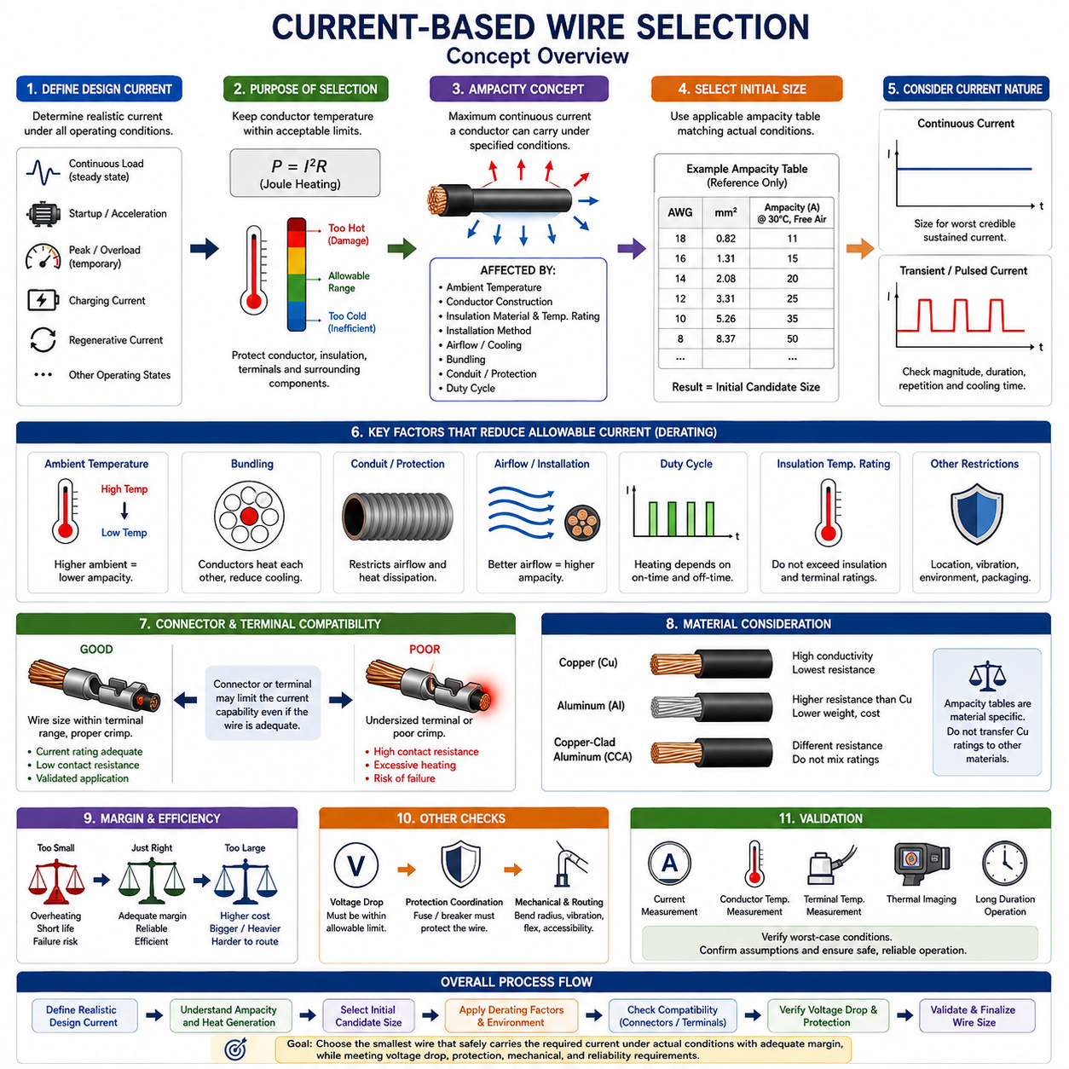
Current-based wire selection begins by determining the electrical current that the conductor must carry under realistic operating conditions. The design current is not simply the nominal current printed on a device label. It should represent the expected continuous load, temporary overloads, startup current, motor acceleration, actuator peaks, charging current, regenerative current, and other operating states that can produce conductor heating.
The fundamental purpose of current-based selection is to keep conductor temperature within an acceptable limit. Electrical current flowing through conductor resistance produces Joule heating according to P = I²R. Because heating increases with the square of current, even a moderate increase in current can significantly increase thermal stress. The selected conductor must therefore dissipate generated heat without exceeding the temperature limits of the conductor, insulation, terminals, or surrounding components.
Ampacity is the maximum current that a conductor can carry continuously under specified conditions while remaining within its permitted temperature range. It is not an absolute property determined only by AWG or conductor cross-sectional area. The same wire may have substantially different allowable currents depending on ambient temperature, insulation material, installation method, airflow, bundling, conduit use, duty cycle, and the temperature rating of connected terminals.
The first practical step is to establish the continuous current for each circuit. Continuous loads include controllers, computers, sensors, communication devices, lighting, pumps, fans, and other equipment that may remain energized for extended periods. For these circuits, conductor sizing should be based on the worst credible sustained operating current rather than short-term average consumption, because thermal equilibrium is eventually governed by sustained electrical losses.
Transient current requires separate consideration because many robotic loads are highly dynamic. Motors can draw several times their normal operating current during acceleration, stall, sudden direction changes, or high-torque operation. Solenoids, contactors, capacitive electronic loads, DC/DC converters, and inverters can also produce short-duration peaks. These currents may be acceptable when their duration is too short to raise conductor temperature beyond the allowable limit.
The relationship between current magnitude and duration is therefore important. A conductor possesses thermal mass and does not reach its final temperature instantaneously. Short pulses can sometimes exceed continuous ampacity without damaging the wire, whereas repeated pulses can accumulate heat and approach continuous-load behavior. Current-based selection should consequently consider the load profile, pulse duration, repetition rate, thermal time constant, and cooling period between high-current events.
For motor and actuator circuits, engineers should distinguish normal running current, expected operating peak current, stall current, and fault current. Normal and repeated peak currents influence conductor sizing, while fault current is primarily addressed through circuit protection and short-circuit withstand verification. Selecting a wire directly from motor stall current as though it were continuous can unnecessarily increase harness mass, cost, connector size, and routing difficulty.
A preliminary conductor size can be obtained from an applicable ampacity table after the design current has been established. The table must match the intended wire construction and application as closely as possible. An AWG or mm² value selected from a generic table should be treated as an initial candidate because actual harness conditions can differ significantly from the reference conditions under which the published current rating was established.
Ambient temperature is one of the most important corrections. A wire operating inside a cool electronics enclosure has greater thermal margin than the same wire routed near a motor, inverter, battery, brake, or other heat source. As ambient temperature approaches the insulation temperature rating, the conductor has less permissible temperature rise. High-temperature zones therefore generally require derating, improved routing, higher-temperature insulation, or increased conductor size.
Bundling also reduces allowable current because neighboring conductors heat one another and restrict heat transfer to the environment. A single wire in free air can dissipate heat more effectively than the same wire located in a tightly packed harness bundle. When several high-current circuits share a bundle, their simultaneous loading must be considered because thermal interaction can make an individually acceptable conductor unsuitable after installation.
Conduits, braided sleeves, tapes, protective tubes, and enclosed cable channels can further change thermal behavior. These protective elements are often necessary for abrasion resistance, environmental protection, mechanical organization, or serviceability, but they can restrict convection and heat dissipation. Current-based wire selection must therefore reflect the final physical harness configuration rather than evaluating an electrically isolated conductor independently of its packaging.
Insulation temperature rating establishes another important boundary. PVC, XLPE, PTFE, and other insulation systems can support different operating temperatures, but a higher insulation rating does not automatically mean that unlimited current can be carried. Increased conductor temperature also affects terminal interfaces, seals, connector housings, nearby wires, mechanical aging, and system reliability. The complete interconnection system must remain within its qualified thermal limits.
Connector and terminal ratings can become the limiting factor even when the conductor itself has adequate ampacity. A large conductor connected through an undersized terminal does not create a high-current connection. Contact resistance at crimps and mating interfaces generates additional localized heating. The selected wire gauge must therefore be compatible with terminal current capability, conductor range, crimp geometry, connector temperature rating, and validated application specifications.
Copper conductors are commonly used because of their high conductivity and established termination technology, but conductor material must always be identified when applying current tables. Aluminum or copper-clad aluminum conductors have different electrical resistance and thermal characteristics for the same cross-sectional area. A current rating associated with a copper conductor should not automatically be transferred to another material merely because its nominal AWG or mm² designation appears similar.
Design margin should account for uncertainties in actual current, manufacturing variation, ambient conditions, aging, and future system changes. However, arbitrary oversizing is not always desirable. Larger wires increase mass, cost, minimum bend radius, bundle diameter, connector requirements, assembly effort, and packaging demand. Good current-based selection seeks adequate thermal margin while maintaining an efficient harness rather than automatically selecting the largest practical conductor.
In AMR and robotic systems, current-based sizing is especially important for drive motors, steering actuators, manipulators, battery distribution, DC/DC converters, computing systems, charging circuits, pumps, and auxiliary power networks. Dynamic mission profiles can produce large differences between average and peak current, so measured or simulated current profiles often provide a more realistic basis than component nameplate values alone.
Current-based selection should also consider simultaneous operation. Individual loads may each appear acceptable, yet a shared feeder can carry the combined current of multiple downstream branches. The engineer must identify maximum credible concurrency and calculate feeder current accordingly. This is particularly important for battery-to-PDU connections, common return paths, power distribution branches, and circuits supplying several actuators or computing devices.
After a candidate conductor is selected from current requirements, the design must still be checked against voltage drop. A wire can remain thermally safe while producing excessive resistance-related voltage loss, particularly in long 12 V, 24 V, or 48 V circuits. In such cases, voltage-drop requirements may force selection of a larger conductor than ampacity alone requires. Current-based selection is therefore one constraint within a multi-criteria gauge-selection process.
Temperature correction and derating must then be applied using the actual installation environment. High ambient temperature, dense bundling, limited airflow, conduit routing, simultaneous loading, and other thermal restrictions reduce available current capacity. The resulting corrected ampacity should remain above the required design current with appropriate engineering margin. If it does not, conductor size, routing, packaging, or operating strategy must be changed.
Final validation should reproduce representative worst-case conditions whenever practical. Current measurement, conductor temperature measurement, terminal temperature measurement, thermal imaging, voltage-drop testing, and long-duration operation can confirm whether analytical assumptions remain valid in the assembled system. Particular attention should be given to connectors, splices, bends, enclosed bundles, and other locations where localized heating may exceed predictions based solely on conductor resistance.
Current-based wire selection is therefore a thermal-electrical design process rather than a simple lookup of current versus AWG or mm². The engineer establishes realistic continuous and transient currents, selects an initial conductor, applies environmental and installation corrections, verifies connector compatibility, and checks thermal performance. Voltage drop, protection coordination, packaging, mechanical durability, and validation then complete the final gauge-selection decision.

04.03. Voltage Drop Based Selection
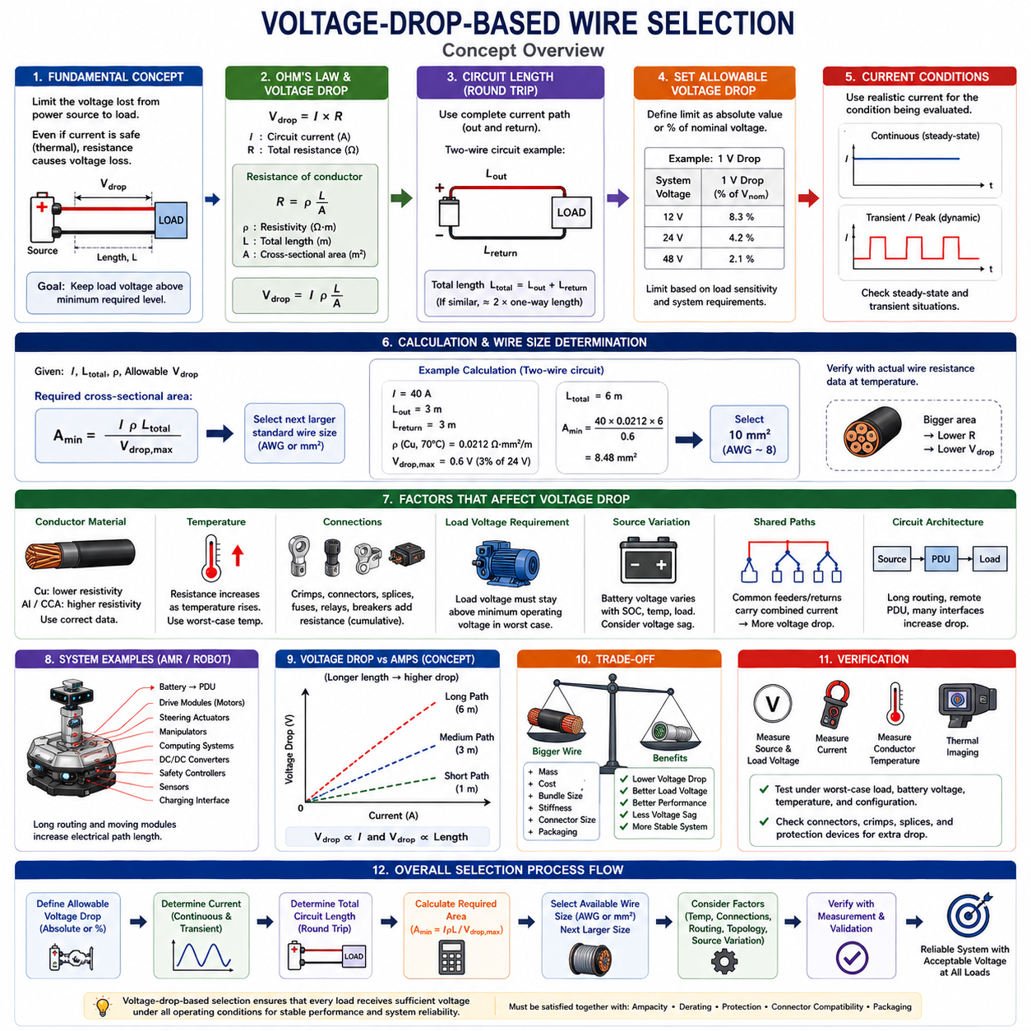
Voltage-drop-based wire selection determines conductor size by limiting the voltage lost between the power source and the electrical load. Even when a wire can safely carry the required current from a thermal perspective, its resistance can reduce the voltage available at the load. This is especially important in low-voltage robotic systems, where relatively small absolute voltage losses can represent a significant percentage of the supply voltage.
Voltage drop is fundamentally described by Ohm’s law, Vdrop = I × R, where I is the circuit current and R is the total resistance of the current path. Because conductor resistance increases with length and decreases with cross-sectional area, long circuits and high-current loads generally require larger conductors. Wire gauge selection must therefore consider electrical distance as well as current-carrying capability.
For a uniform conductor, resistance can be estimated from R = ρL/A, where ρ is conductor resistivity, L is conductor length, and A is conductor cross-sectional area. Combining this relationship with Ohm’s law gives Vdrop = IρL/A. This equation directly shows that increasing conductor area reduces voltage drop, while increasing current, resistivity, or circuit length increases the voltage lost along the conductor.
Circuit length must represent the complete current path rather than only the physical distance from the source to the load. In a conventional two-wire circuit, current travels through the positive conductor to the load and returns through the negative conductor. If both conductors have similar length and size, the effective resistance is approximately based on twice the one-way distance. Ignoring the return path can significantly underestimate actual voltage drop.
The first design step is to define the maximum allowable voltage drop. This limit may be specified as an absolute voltage, such as 0.5 V, or as a percentage of nominal system voltage. Percentage-based limits are useful when comparing different architectures because the same absolute loss has very different significance in 12 V, 24 V, and 48 V systems. The allowable limit should reflect the sensitivity and operating requirements of the connected load.
For example, a 1 V drop represents approximately 8.3% of a 12 V system, 4.2% of a 24 V system, and 2.1% of a 48 V system. This illustrates why conductor resistance becomes particularly critical in lower-voltage architectures. Increasing distribution voltage can reduce current for the same transmitted power and consequently reduce both I²R losses and voltage drop, although load voltage requirements and conversion architecture must also be considered.
The load voltage should remain above the minimum operating voltage required by the device under worst-case conditions. Motors may lose available torque or speed, electronic controllers may reset, sensors may become unstable, and communication equipment may malfunction if supply voltage falls below its operating range. Voltage-drop limits should therefore be derived from system-level functional requirements rather than selected only from a generic percentage guideline.
Current used in the calculation must correspond to the operating condition being evaluated. Continuous current determines sustained voltage loss, while startup, acceleration, steering, lifting, or other peak loads can produce temporary voltage sag. For robotic systems, evaluating only average current can conceal critical operating conditions. The designer should examine both steady-state voltage drop and transient voltage behavior where load dynamics are significant.
Motor circuits deserve particular attention because motor current changes with mechanical load and operating state. During acceleration or high-torque operation, increased current produces a proportionally larger voltage drop in the harness. The reduced motor terminal voltage can then affect torque and acceleration performance. In severe cases, this interaction can create a system that operates normally at light load but performs poorly during demanding maneuvers.
Battery-powered systems introduce additional voltage variation because source voltage itself changes with state of charge, temperature, load current, and battery internal resistance. The harness voltage drop must therefore be considered together with battery voltage sag. A circuit that appears acceptable at nominal battery voltage may become marginal when the battery is near its minimum operating voltage and the system simultaneously experiences a high-current event.
Conductor material directly affects voltage-drop performance through resistivity. Copper is commonly used because of its relatively low electrical resistance, while aluminum and copper-clad aluminum require different cross-sectional considerations. A conductor should not be treated as electrically equivalent merely because its nominal AWG or mm² size matches another material. Resistance data corresponding to the actual conductor construction should be used whenever available.
Temperature also changes conductor resistance. Copper resistance increases as conductor temperature rises, so a voltage-drop calculation performed only with room-temperature resistance can underestimate losses during hot operation. For circuits operating near motors, batteries, power electronics, or other heat sources, resistance should be evaluated at a representative worst-case conductor temperature rather than assuming constant resistance under all environmental conditions.
Connections add resistance beyond the wire itself. Crimp terminals, connectors, splices, fuse contacts, relays, contactors, circuit breakers, busbars, and distribution interfaces each contribute some resistance to the complete circuit. Their individual voltage drops may be small, but multiple interfaces can create a meaningful cumulative loss. A realistic voltage budget should therefore distinguish conductor voltage drop from total end-to-end distribution voltage drop.
A preliminary conductor size can be calculated by rearranging the voltage-drop relationship. For a simple conductor path, the required cross-sectional area is proportional to IρL/Vdrop,max. In a two-wire circuit, the complete outgoing and return length must be included. The resulting calculated area is normally converted to the next appropriate commercially available AWG or mm² size rather than specifying a nonstandard conductor area.
The calculated minimum size should not automatically be rounded downward to the nearest commercial wire size. If the calculated requirement lies between 1.5 mm² and 2.5 mm², for example, selecting 1.5 mm² may violate the voltage-drop target even though it is closer numerically. The candidate conductor should be verified using its actual resistance specification, manufacturing tolerance, temperature condition, and complete circuit length before the design is accepted.
Shared feeders and common return conductors require special attention. A feeder supplying several loads carries their combined current, and a common return path can produce voltage changes that affect multiple devices simultaneously. High-current motor loads sharing a return path with sensitive sensors or controllers can create undesirable supply disturbances. Distribution topology and grounding architecture therefore influence voltage-drop-based conductor sizing.
In an AMR, voltage-drop analysis is particularly important for battery-to-PDU feeders, drive modules, steering actuators, manipulators, computing systems, DC/DC converters, safety controllers, sensors, and charging interfaces. Long chassis routing can make electrical path length substantial even in a physically compact robot. Moving modules and service loops can further increase conductor length beyond the simple geometric distance between components.
Voltage-drop-based sizing should be coordinated with current-based sizing rather than treated as an independent alternative. The conductor must satisfy both thermal ampacity and voltage-drop requirements. A short high-current circuit may be dominated by ampacity, while a long moderate-current circuit may be dominated by voltage drop. The final conductor size is generally determined by whichever requirement produces the larger minimum cross-sectional area.
Increasing conductor size improves voltage-drop performance but introduces penalties in mass, cost, bundle diameter, flexibility, bend radius, connector size, and packaging space. This tradeoff is especially important in mobile robots, where harness mass and routing complexity affect mechanical design. Engineers should therefore optimize distribution voltage, circuit length, connector placement, PDU location, and load architecture before solving every voltage-drop problem simply by increasing wire size.
Final verification should evaluate the complete electrical path under representative worst-case conditions. Measurements should be taken with realistic load current, battery voltage, conductor temperature, connector configuration, and operating state. Measuring voltage directly at both source and load terminals provides an effective validation of the calculated distribution loss and can reveal unexpected resistance in crimps, connectors, splices, or protection devices.
Voltage-drop-based wire selection is therefore a system-level electrical design process. The engineer establishes the allowable load voltage loss, determines realistic current and complete circuit length, calculates conductor resistance, includes temperature and connection effects, selects an available AWG or mm² size, and verifies performance. The result must then be reconciled with ampacity, derating, protection, connector compatibility, packaging, and validation before the wire gauge is released for production.

04.04. Temperature Based Correction
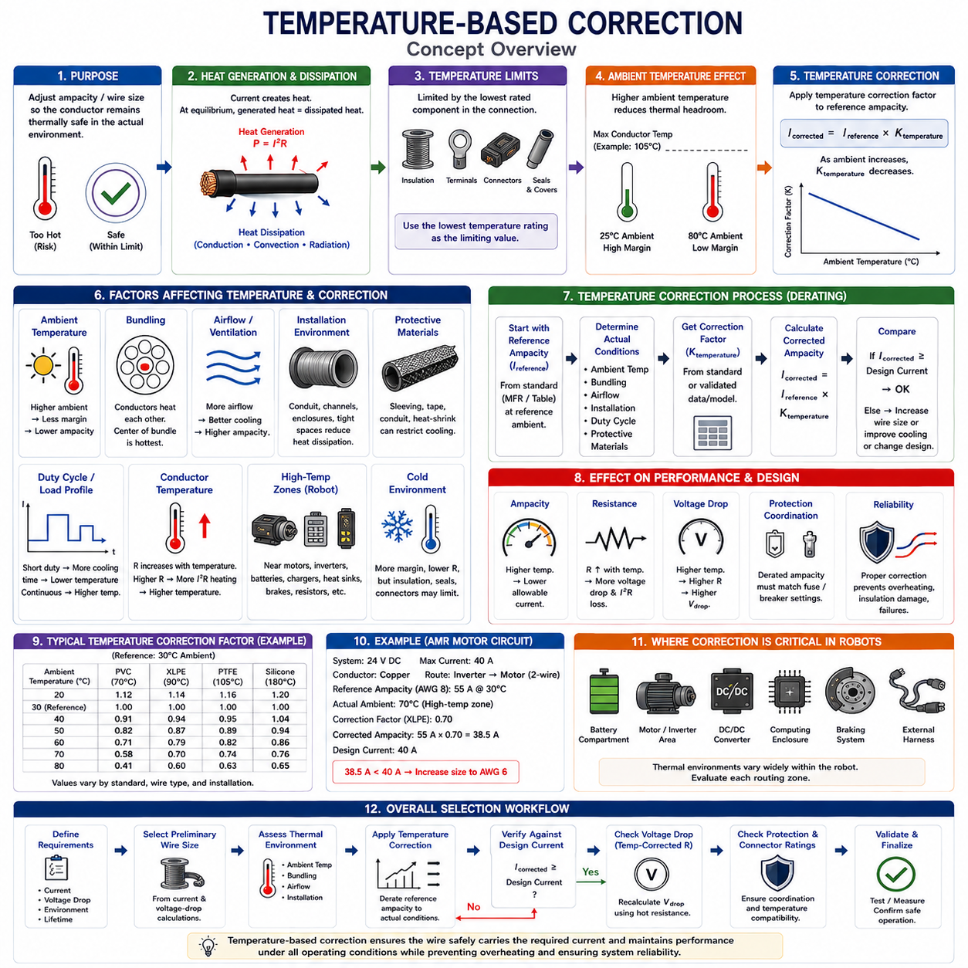
Temperature-based correction adjusts a preliminary wire size or ampacity rating so that the conductor remains thermally safe under the actual operating environment. A current rating established under a reference ambient temperature cannot automatically be applied to every installation. When ambient temperature rises, the available temperature margin between the conductor and its maximum permitted operating temperature decreases, requiring correction or derating.
Wire temperature is determined by the balance between internally generated heat and heat transferred to the surrounding environment. Current flowing through conductor resistance produces Joule heating according to P = I²R. At thermal equilibrium, this heat must be dissipated through conduction, convection, and radiation. If the environment prevents sufficient heat removal, conductor temperature rises until a new thermal equilibrium is reached or the allowable temperature limit is exceeded.
The allowable conductor temperature is normally constrained by the insulation system, terminal interfaces, connector materials, seals, protective coverings, and applicable standards. Insulation materials such as PVC, XLPE, and PTFE have different thermal capabilities, but the insulation rating alone does not define a safe operating temperature. The lowest qualified temperature limit within the complete electrical connection should normally govern the design.
Ambient temperature establishes the starting thermal condition from which current-generated temperature rise occurs. If a conductor is permitted to operate at a maximum temperature of 105°C, an environment at 25°C provides considerably more thermal headroom than an environment at 80°C. The same electrical current can therefore be acceptable in the cooler environment but unsuitable in the hotter location even though conductor size and insulation construction remain unchanged.
Temperature correction is commonly implemented by applying a correction factor to a reference ampacity. Conceptually, the corrected current capability can be represented as Icorrected = Ireference × Ktemperature, where Ktemperature is a temperature correction factor determined from the applicable standard, manufacturer data, or validated thermal model. As ambient temperature increases, this factor generally decreases and reduces the usable current capacity of the conductor.
The correction factor should not be treated as a universal constant because its value depends on the reference conditions and the wire system being evaluated. A table developed for building cable, automotive wire, aerospace wiring, or a specific manufacturer’s product may use different assumptions. Engineers should therefore identify the applicable conductor construction, insulation temperature rating, reference ambient temperature, installation condition, and governing standard before applying a factor.
Conductor resistance itself also increases with temperature. For copper, resistance can be approximated using R(T) = Rref[1 + α(T − Tref)], where α is the temperature coefficient of resistance. As the conductor becomes hotter, resistance increases, which increases I²R losses for the same current. This electrothermal interaction means that temperature affects both the permissible thermal margin and the electrical losses responsible for heating.
High-temperature zones within a robot require particular attention because local ambient conditions can differ substantially from the general enclosure temperature. Wires routed near motors, motor drivers, inverters, DC/DC converters, batteries, braking components, heat sinks, chargers, or power resistors can experience elevated local temperatures. Harness design should therefore use temperature conditions associated with the actual routing zone rather than a single robot-wide ambient value.
Low airflow can intensify temperature effects even when measured ambient temperature appears moderate. A wire inside a sealed enclosure, protective conduit, densely packed cable channel, or internal chassis cavity may dissipate heat less effectively than a wire exposed to moving air. Temperature-based correction must consequently be coordinated with installation-based derating because ambient temperature and heat-transfer conditions jointly determine the resulting conductor temperature.
Harness bundling creates another coupled thermal effect. Multiple energized conductors located together generate heat while simultaneously reducing the exposed surface area available for cooling. The center of a dense bundle can operate significantly hotter than its surroundings. Applying only an ambient-temperature correction while ignoring bundle heating can therefore overestimate actual ampacity, particularly when several high-current circuits operate simultaneously.
Protective materials can further influence thermal behavior. Corrugated conduit, braided sleeving, tapes, heat-shrink tubing, waterproof coverings, and abrasion protection may be necessary for mechanical or environmental durability, but they can also restrict convection and alter heat transfer. A temperature correction developed for a single wire in free air should not automatically be assumed valid for the same wire enclosed inside multiple protective layers.
Duty cycle must also be considered when temperature correction is applied to dynamic robotic loads. A continuously energized conductor approaches thermal equilibrium, while a conductor carrying short intermittent current may cool between operating events. Motors and actuators frequently exhibit acceleration peaks followed by lower steady currents. The relevant temperature condition therefore depends on current magnitude, duration, repetition rate, thermal time constant, and available cooling time.
Cold environments introduce a different set of considerations. Lower ambient temperature generally increases electrical thermal margin and reduces conductor resistance, but it does not automatically justify increasing current beyond validated ratings. Insulation flexibility, seal behavior, connector materials, mechanical stress, condensation, and low-temperature qualification may become limiting factors. Thermal design must therefore remain within the complete environmental specification rather than optimizing only conductor ampacity.
Temperature correction is particularly important for battery-powered AMRs because operating conditions can vary widely across charging, standby, acceleration, continuous travel, slope climbing, payload transport, and manipulation. Battery compartments, motor regions, computing enclosures, and external harness sections can each have different thermal environments. A single conductor size may therefore require different evaluation depending on where and how the circuit is routed.
For mobile manipulators and other high-degree-of-freedom robots, moving joints can combine electrical heating with restricted routing and mechanical constraints. Harnesses passing through arms, rotating joints, cable carriers, or compact actuator assemblies may have limited airflow and closely packed conductors. Increasing conductor size can reduce electrical resistance, but it can also reduce flexibility and increase bending stress, making thermal correction part of a broader electromechanical optimization.
A practical selection process begins with the conductor size obtained from current-based and voltage-drop-based calculations. Its reference ampacity is then corrected for the expected ambient temperature and installation environment. If the corrected ampacity falls below the required design current, the engineer may increase conductor size, improve routing, separate high-current circuits, increase airflow, change insulation technology, or modify the electrical architecture.
Temperature-based correction must also be coordinated with connector and terminal selection. Connector contacts and crimp interfaces can develop localized heating because of contact resistance, and connector housings may have lower temperature limits than the wire insulation. A conductor that remains below its own maximum temperature can still produce an unacceptable connection temperature. Thermal verification should therefore include both wire sections and electrical interfaces.
Voltage-drop calculations should be revisited after the expected conductor temperature has been established. Because resistance rises with temperature, a conductor selected using room-temperature resistance may produce greater voltage drop during hot operation. For long or high-current circuits, this difference can become significant. Temperature-corrected resistance therefore provides a more realistic basis for worst-case voltage-drop verification.
Protection coordination is similarly affected by thermal conditions. The wire must remain protected against overload and short-circuit conditions while the fuse or circuit breaker must tolerate legitimate operating currents. If high ambient temperature reduces conductor ampacity, a protection strategy based only on reference-temperature capability may no longer provide sufficient margin. Wire, protection device, terminal, and environmental limits should be evaluated as one coordinated system.
Analytical correction factors are useful during design, but physical validation remains important for thermally demanding circuits. Thermocouples, resistance-based temperature estimation, thermal cameras, current measurements, and environmental chamber testing can be used to examine conductor and terminal temperatures. Tests should reproduce representative current profiles, ambient temperatures, bundle configurations, protective coverings, airflow conditions, and operating duration.
Measurements should focus on thermal hot spots rather than only average harness temperature. Bundle centers, connector contacts, crimps, splices, bends near heat sources, sealed passages, and transitions into protective conduits can operate hotter than accessible wire surfaces. Temperature sensors should therefore be positioned at locations predicted to experience the greatest thermal stress, and sufficient test duration should be provided for slow thermal behavior to stabilize.
Temperature-based correction is therefore not simply the application of a numerical derating factor. It links conductor ampacity, ambient temperature, resistance variation, insulation capability, installation method, bundling, airflow, duty cycle, connector limits, and environmental conditions. The final wire gauge should satisfy current capacity and voltage-drop requirements at the expected worst-case temperature while maintaining adequate reliability, mechanical suitability, and protection coordination.

04.05. Gauge Selection Decision Matrix
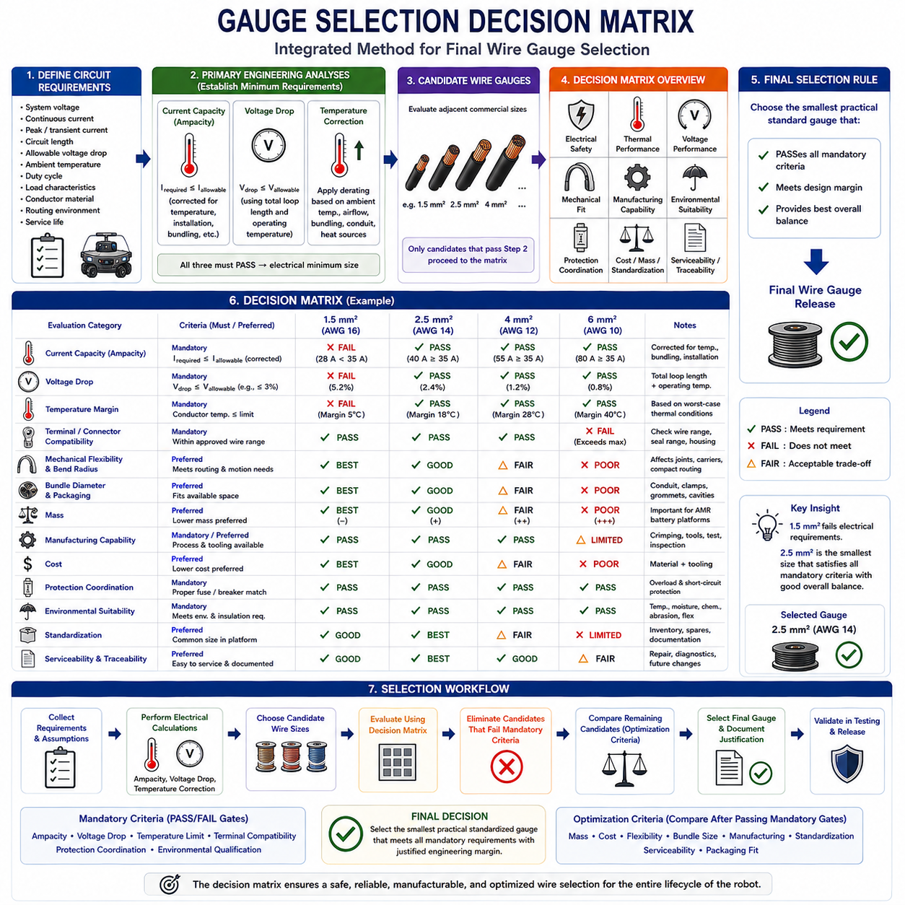
A wire gauge selection decision matrix provides a structured method for choosing the final conductor size after current capacity, voltage drop, temperature, and installation constraints have been evaluated. Rather than selecting AWG or mm² from a single criterion, the matrix combines electrical, thermal, mechanical, manufacturing, and environmental requirements so that the chosen wire remains suitable throughout the complete harness operating envelope.
The decision process begins by defining the circuit requirements. Important inputs include nominal system voltage, continuous current, transient or peak current, circuit length, allowable voltage drop, ambient temperature, duty cycle, load characteristics, conductor material, routing environment, and expected service life. These parameters establish the boundary conditions against which candidate conductor sizes can be compared consistently.
Current capacity establishes one minimum conductor requirement. The selected wire must carry the expected continuous current without exceeding its allowable temperature, while transient currents must be evaluated according to magnitude, duration, repetition rate, and thermal response. A conductor that cannot satisfy the corrected ampacity requirement is eliminated from consideration regardless of its advantages in mass, cost, flexibility, or packaging.
Voltage drop establishes another independent minimum requirement. For each candidate wire, the complete outgoing and return resistance should be evaluated using realistic conductor length and operating temperature. The resulting load voltage must remain within the acceptable range during relevant continuous and peak-current conditions. If voltage drop exceeds the defined limit, the candidate is rejected even when its thermal current capacity is adequate.
Temperature correction modifies the current capability and resistance assumptions used in the matrix. Ambient temperature, local heat sources, bundling, airflow, conduit, sleeving, and other installation conditions can increase conductor temperature and reduce usable ampacity. Resistance also rises with temperature, increasing voltage drop. Candidate sizes should therefore be compared using corrected operating conditions rather than only room-temperature catalog values.
A useful decision matrix treats current capacity, voltage drop, and temperature as mandatory pass-or-fail gates rather than optional preferences. If 1.5 mm² satisfies current capacity but fails voltage drop, while 2.5 mm² satisfies both, the larger conductor becomes the minimum viable electrical candidate. Likewise, a conductor that passes both calculations at room temperature may still require upsizing if temperature correction reduces its ampacity below the design current.
Connector and terminal compatibility forms another mandatory gate. Each candidate conductor must fall within the approved wire range of the selected terminal and must be compatible with the crimp barrel, conductor construction, insulation diameter, seal range, and connector housing. Increasing conductor size to improve voltage drop is ineffective if the resulting wire can no longer be properly terminated using the intended connector system.
Mechanical characteristics become increasingly important after the electrical minimum size has been established. Larger conductors generally have greater outside diameter, higher mass, larger minimum bend radius, and reduced flexibility. These effects can create problems in articulated joints, cable carriers, steering modules, manipulators, doors, moving sensor assemblies, or compact electronic enclosures. The electrically safest option is therefore not automatically the mechanically best option.
Harness packaging provides another decision dimension. Increasing conductor size enlarges bundle diameter and may require larger conduits, grommets, clamps, connector cavities, service loops, and routing channels. A wire that satisfies all electrical calculations can still be unsuitable if it cannot be routed without excessive bending, interference, compression, abrasion, or assembly difficulty. Packaging feasibility should therefore be verified before final gauge release.
Mass is especially significant in mobile robotics. Replacing several long circuits with oversized conductors can add meaningful harness weight, particularly when power circuits run throughout a large AMR, mobile manipulator, quadruped, or other battery-powered platform. Additional conductor mass can affect energy consumption, payload capacity, moving-joint inertia, and mechanical support requirements, making unnecessary electrical oversizing undesirable.
Manufacturing capability should also be represented in the matrix. The selected wire must be compatible with available cutting, stripping, crimping, splicing, welding, inspection, and test processes. A technically suitable conductor may introduce new tooling, applicators, terminals, seals, or quality-control requirements. Using standardized wire sizes already supported by the manufacturing process can reduce production complexity while improving repeatability and quality.
Standardization can therefore be used as a preference after mandatory engineering requirements are satisfied. If both 2.5 mm² and 4 mm² satisfy all electrical and environmental requirements, but 2.5 mm² is already widely used within the platform, the smaller standardized size may simplify inventory, documentation, tooling, repair kits, and service operations. However, standardization must never override a failed thermal or voltage-drop requirement.
Environmental conditions provide another selection gate. Moisture, chemicals, abrasion, vibration, repeated flexing, contamination, high temperature, low temperature, and outdoor exposure influence the required wire construction and insulation system. Gauge selection cannot be separated completely from wire type because two conductors with the same nominal cross-sectional area may have different insulation thickness, flexibility, strand construction, environmental durability, and finished outside diameter.
Protection coordination must be checked against every final candidate. The fuse or circuit breaker should protect the conductor against unacceptable overload and fault heating while allowing legitimate operating currents and transient events. Increasing conductor size may improve thermal margin and reduce resistance, but protection settings must still remain coordinated with the complete branch circuit, terminals, connectors, distribution devices, and expected fault conditions.
The matrix can distinguish mandatory criteria from optimization criteria. Ampacity, voltage drop, temperature limits, terminal compatibility, protection coordination, and required environmental qualification normally function as mandatory constraints. Mass, cost, flexibility, bundle size, manufacturing simplicity, standardization, and serviceability can then be used to compare the candidates that have already passed the mandatory engineering gates.
A practical comparison may begin with several adjacent commercial sizes rather than a single calculated result. For example, 1.5 mm², 2.5 mm², 4 mm², and 6 mm² can be evaluated side by side. Each size is checked for corrected ampacity, worst-case voltage drop, connector compatibility, thermal margin, routing feasibility, mass, manufacturing capability, and cost. Candidates that fail mandatory criteria are removed before optimization begins.
This approach prevents compensating one critical failure with several minor advantages. A conductor should not receive an acceptable overall score merely because it is inexpensive and lightweight when it fails voltage drop or temperature limits. Safety-related and functional requirements should therefore operate as hard gates. Weighted scoring becomes useful only among candidates that have already demonstrated compliance with all required limits.
For AMR drive circuits, the matrix often reveals competing requirements. Motor current favors a larger conductor for thermal margin, long routing favors a larger conductor for lower voltage drop, and repetitive movement favors a smaller and more flexible cable. Connector cavity size, chassis routing space, bundle diameter, and mass may impose additional limits. Final selection consequently represents a controlled compromise among multiple engineering domains.
Different circuit classes can use different decision priorities. Battery and PDU feeders generally emphasize current capacity, voltage drop, protection, and thermal performance. Motor and actuator circuits additionally emphasize transient current and mechanical flexibility. Sensor and communication power circuits may prioritize voltage stability, electromagnetic compatibility, compact routing, and connector constraints. Charging circuits may emphasize continuous current, temperature rise, connector heating, and durability.
Design margin should be included explicitly rather than created through arbitrary gauge increases. Margin can account for current uncertainty, temperature variation, resistance tolerance, aging, manufacturing variation, and future load growth. The purpose is to maintain adequate robustness under credible worst-case conditions. Excessive margin, however, can increase cost and mass without providing meaningful system benefit, so assumptions should be documented and technically justified.
The decision matrix should preserve traceability from system requirements to the released wire specification. The engineering record should identify the design current, peak-current profile, allowable voltage drop, total circuit length, temperature assumptions, derating factors, selected conductor material, terminal range, protection device, and final AWG or mm² size. This allows future design changes to be evaluated without repeating the entire selection process from undocumented assumptions.
Validation closes the matrix process. Representative circuits should be tested under worst-case current, temperature, routing, bundling, and operating conditions. Measurements of load voltage, conductor temperature, terminal temperature, current, and localized thermal hot spots can confirm the analytical decision. If validation reveals insufficient margin, the matrix should be revisited rather than treating the originally selected gauge as permanently fixed.
The final selection rule is therefore to choose the smallest practical standardized conductor that passes every mandatory electrical, thermal, environmental, protection, connector, and mechanical requirement with justified engineering margin. Current-based selection establishes thermal capacity, voltage-drop-based selection protects delivered voltage, and temperature correction adapts these calculations to actual conditions. The decision matrix integrates these results into one traceable final wire gauge decision.

