Volume 02. Wire Harness Engineering

Chapter 12. AMR Harness Design

12.01. Repetitive Flex Countermeasures
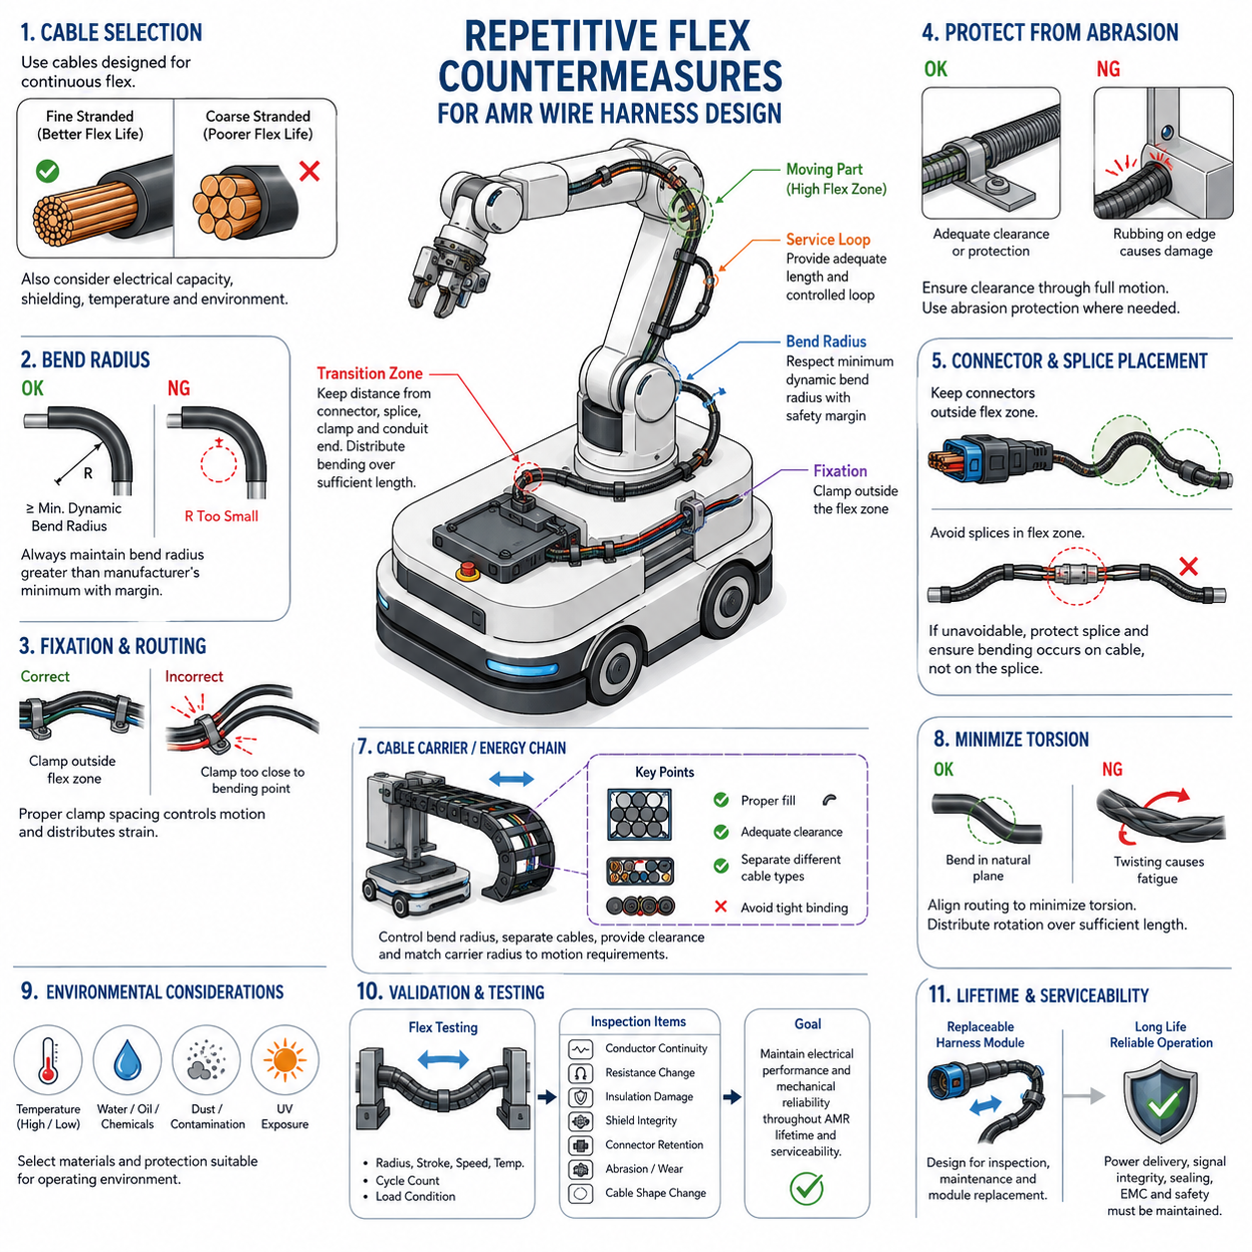
Repetitive flexing is one of the most demanding mechanical conditions for an AMR wire harness because conductors, insulation, shielding, and protective coverings experience thousands or millions of bending cycles during steering, suspension motion, lift operation, sensor movement, or service articulation. The harness must therefore be designed as a dynamic mechanical component rather than as a stationary electrical connection.
The first countermeasure is to identify every region where relative movement occurs between connected components. Typical locations include steering modules, independently moving drive units, articulated sensor mounts, suspension interfaces, lifting mechanisms, rotating assemblies, and movable access panels. The expected displacement, bending direction, angular range, cycle frequency, and required service life should be defined before the routing geometry is finalized.
Conductor construction strongly influences flex life. Fine-stranded conductors generally tolerate repeated bending better than conductors made from fewer, larger strands because deformation is distributed among many small elements. The selected cable should be explicitly suitable for dynamic or continuous-flex applications when high cycle counts are expected. Electrical current capacity alone is therefore insufficient as a selection criterion for moving AMR harnesses.
Bend radius is a fundamental design parameter because excessive curvature concentrates mechanical strain in the conductor and insulation. A harness should never be forced around a sharp edge or constrained into a radius below the cable manufacturer's specified dynamic bending limit. Where repeated motion occurs, the design radius should normally provide additional margin beyond the minimum value so manufacturing variation and vehicle motion do not create localized overstress.
The location of the bending zone is as important as the bend radius itself. Motion should be distributed over a controlled length rather than concentrated immediately behind a connector, splice, clamp, or rigid conduit termination. These transition points create stiffness discontinuities where conductor fatigue can accelerate. Adequate free length and gradual stiffness transitions allow the cable to form a predictable bending shape during each operating cycle.
Harness fixation must distinguish between stationary support points and dynamic flex regions. Clamps should stabilize the harness outside the moving zone while allowing the intended flexible section to move freely. Installing a clamp too close to the bending center can transfer strain into a short cable segment, whereas insufficient fixation may permit uncontrolled whipping, rubbing, or entanglement. Clamp spacing must therefore support both motion control and strain distribution.
A service loop can provide additional movement capacity when properly designed, but excessive slack is not automatically beneficial. Uncontrolled loops can strike surrounding structures, become trapped between moving components, or create reverse bending during motion. The loop geometry should guide the harness through a repeatable trajectory while maintaining clearance throughout the full mechanical envelope. Its shape should be verified at both motion extremes and intermediate positions.
Torsional loading should be minimized because a cable designed primarily for bending may not tolerate repeated twisting with equal durability. Routing should align the natural bending plane of the harness with the dominant mechanism motion whenever possible. If rotation cannot be avoided, the required angular displacement should be distributed over sufficient cable length, or a cable specifically rated for combined torsional and flexing service should be selected.
Protective sleeves and conduits require special consideration in repetitive-flex zones. A protective layer that is appropriate for stationary routing may become excessively stiff during continuous movement and transfer bending stress to its termination points. Flexible braid, dynamic cable protection, or appropriately selected moving conduits can provide abrasion resistance while preserving mobility. Protection should not significantly reduce the intended dynamic bend radius.
Cable carriers or energy chains are effective where the motion path is linear, repetitive, and sufficiently predictable. The carrier controls bending radius, separates cables, and prevents uncontrolled loops while guiding power, communication, and sensor wiring through repeated travel. Cable fill, internal clearance, cable arrangement, carrier radius, acceleration, travel distance, and relative cable movement must all be considered rather than treating the carrier merely as mechanical protection.
Internal cable arrangement inside a moving carrier also affects lifetime. Cables should have enough space to move naturally without being tightly compressed against neighboring cables or carrier surfaces. Different cable diameters and stiffness levels may produce unequal motion, so separators can be useful where necessary. Cables should not be tied together so rigidly that they behave as one inflexible bundle throughout a region intended for continuous movement.
Connectors should normally be positioned outside the principal repetitive-flex zone. When this is impossible, strain relief must prevent cyclic bending loads from being transmitted directly into terminals, seals, backshells, or conductor crimp interfaces. Connector orientation should also avoid forcing the cable into an immediate sharp bend. The mechanical load path should pass through suitable harness support features rather than through electrically critical termination interfaces.
Splices require similar protection. A splice changes local diameter, stiffness, and mass and can therefore become a fatigue initiation point when located inside a dynamic bending region. Whenever practical, splices should be moved into mechanically stable harness sections. If a splice must remain near a moving interface, routing and support should ensure that the repetitive curvature occurs in flexible conductor sections rather than directly across the splice transition.
Abrasion becomes increasingly important as cycle count increases. Even small contact forces can eventually damage insulation when a cable repeatedly slides against brackets, frame members, fasteners, covers, or other harnesses. Dynamic clearance should therefore be evaluated over the complete motion envelope. Where contact cannot be eliminated, suitable abrasion-resistant protection and controlled contact surfaces should be introduced without creating new stiffness concentrations.
Environmental conditions can accelerate flex-related degradation. Low temperatures may increase insulation stiffness, elevated temperatures can reduce material strength, and water, oils, cleaning chemicals, or outdoor contamination may alter protective materials. An AMR intended for warehouses, outdoor operation, inspection, or industrial environments should therefore evaluate repetitive-flex durability under representative temperature and contamination conditions rather than only under room-temperature laboratory conditions.
Electrical characteristics can also change as mechanical damage accumulates. Broken conductor strands increase local resistance, while shield degradation can reduce EMC performance and intermittent contact can create communication faults that appear only during motion. Power, signal, Ethernet, CAN, encoder, sensor, and safety circuits should consequently be assessed according to their electrical sensitivity as well as their mechanical flex requirements when selecting cable and routing strategies.
Shielded cables need particular attention because shields, drain wires, and foil structures may have different fatigue behavior from the main conductors. A cable that remains electrically continuous may still suffer progressive shielding deterioration under repeated bending. For high-flex communication or sensor interfaces, shield construction should therefore be compatible with the required dynamic duty, and shield termination should not create an excessively rigid boundary at the beginning of the flex zone.
Design verification should reproduce the actual motion profile as closely as practical. Flex testing should consider representative bend radius, stroke, speed, acceleration, temperature, cable loading, and number of cycles. Inspection should monitor conductor continuity, resistance variation, insulation damage, shield integrity, connector retention, protective sleeve wear, and changes in cable geometry. Testing only a few manual bending cycles cannot demonstrate long-term AMR durability.
Accelerated testing can be useful, but increasing speed or reducing bend radius indiscriminately may introduce failure mechanisms that do not represent field operation. Test acceleration should preserve the dominant mechanical stresses of the real application. The required cycle count should be related to expected AMR operating frequency and design lifetime so that qualification represents actual accumulated movement rather than an arbitrary laboratory endurance target.
Repetitive-flex countermeasures should ultimately be integrated with serviceability and lifetime design. The volume structure places lifetime flex-cycle design within serviceability engineering and repetitive-flex countermeasures within AMR harness design, emphasizing that dynamic durability must be considered across both lifecycle and vehicle-level architecture. Replaceable moving harness modules can reduce maintenance cost when flexing components have predictable wear limits.
A robust AMR harness therefore combines suitable continuous-flex cable, generous controlled bend radius, carefully located fixation, protected transitions, adequate moving length, abrasion prevention, and realistic lifecycle validation. The objective is not simply to prevent immediate wire breakage, but to maintain power delivery, signal integrity, sealing, EMC performance, and connector reliability throughout repeated robot motion while keeping eventual inspection and replacement practical.

12.02. Moving Part Harness Design
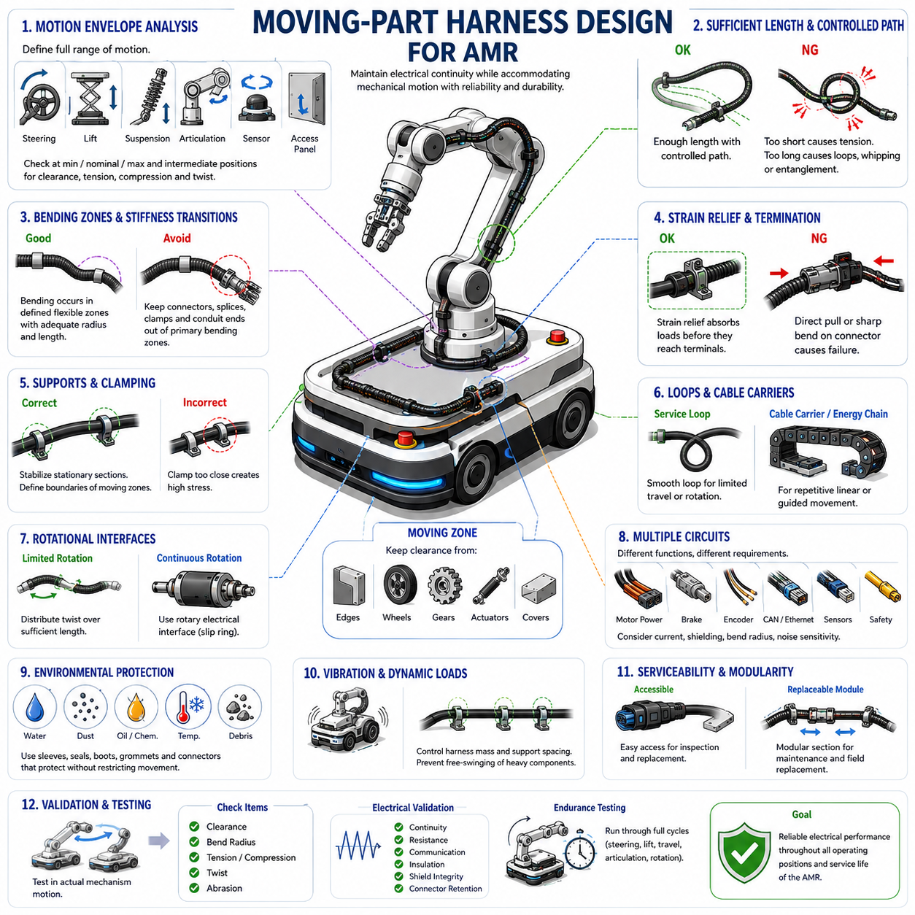
Moving-part harness design addresses electrical wiring that crosses interfaces where components translate, rotate, steer, articulate, lift, or otherwise change position during AMR operation. Unlike stationary routing, these harness sections must preserve electrical continuity while accommodating predictable mechanical motion. Their design must therefore integrate cable flexibility, routing geometry, strain control, clearance, protection, and lifecycle durability as one coordinated system.
The design process begins by defining the complete mechanical motion envelope of every moving interface. Steering angle, suspension displacement, wheel-module movement, lift stroke, actuator travel, sensor rotation, access-panel motion, and service positions can all alter harness geometry. Routing should be evaluated at minimum, nominal, and maximum positions, including intermediate configurations where unexpected interference, tension, compression, or reverse bending may occur.
A moving harness requires sufficient effective length to accommodate displacement without transferring tensile loads into connectors or terminals. However, excessive cable length can produce uncontrolled loops, whipping, entanglement, or contact with nearby structures. The required length should therefore be determined from actual kinematics rather than arbitrary slack allowance, providing enough freedom for motion while maintaining a controlled and repeatable cable trajectory throughout the operating range.
Bending should occur within intentionally defined flexible zones rather than randomly along the harness. These zones should provide adequate bend radius and sufficient free cable length to distribute strain over a broad region. Connectors, splices, clamps, branch points, conduit ends, and other stiffness transitions should normally remain outside the primary bending area because repeated curvature around these discontinuities can accelerate conductor, insulation, or termination fatigue.
Routing geometry should follow the natural motion of the mechanism. A harness crossing a rotating joint should approach the joint in a direction that minimizes unnecessary twisting, while wiring attached to a translating assembly should follow a path compatible with its travel direction. Poor alignment can convert simple mechanical displacement into combined bending, torsion, and tension, significantly increasing cable stress even when the total movement appears relatively small.
Strain relief is essential wherever a flexible harness transitions into a connector, enclosure, motor, sensor, controller, or other rigid component. Mechanical loads generated by motion should be absorbed by dedicated support features before reaching terminals and conductor crimps. The strain-relief arrangement should prevent both direct pulling and concentrated bending immediately behind the termination while remaining compatible with required sealing, service access, and connector disengagement.
Clamps and supports define how mechanical motion is distributed through the harness. Fixed points should stabilize stationary sections and establish clear boundaries around moving zones without restricting the intended cable movement. A clamp positioned too close to a joint can create a short, highly stressed bending section, while excessive spacing can allow uncontrolled movement. Support positions should therefore be determined together with mechanism geometry and cable flexibility.
Service loops can accommodate limited translation or rotation where cable carriers are unnecessary or impractical. A properly designed loop changes shape smoothly as the mechanism moves and returns without folding, twisting, or contacting surrounding components. Loop orientation, diameter, free length, and attachment points should be chosen according to the actual direction of motion, and the loop should remain controlled during acceleration, braking, vibration, and emergency movement.
Cable carriers or energy chains provide a more controlled solution for mechanisms with repetitive linear or guided movement. They establish a predictable bending radius and protect cables from uncontrolled motion while allowing power and communication lines to travel together. Carrier selection should consider travel length, acceleration, bending radius, internal dimensions, cable quantity, cable diameter, separation requirements, and the space available around the moving mechanism.
Cables installed inside an energy chain should retain enough internal freedom to move without being tightly compressed or bound together. Different cable types may have different diameters, stiffness, and dynamic characteristics, making separators useful where relative movement could cause rubbing or interference. Harness ties intended for stationary bundles should not be applied in ways that prevent cables from naturally repositioning as the carrier bends and straightens.
Rotational interfaces require particular attention because continuous or large-angle rotation can accumulate torsion that ordinary harness slack cannot safely absorb. Limited rotation may be accommodated by distributing twist over sufficient cable length, but the resulting torsional strain must remain within cable capability. Mechanisms requiring repeated unlimited rotation may require a dedicated rotary electrical interface rather than attempting to solve the problem solely through conventional flexible harness routing.
Abrasion protection must be coordinated with dynamic movement. A moving harness should maintain clearance from sharp edges, fasteners, frame members, wheels, gears, actuators, covers, and other moving assemblies over its complete trajectory. Where occasional contact cannot be eliminated, flexible abrasion-resistant protection can be applied. Protective sleeves or conduits must not introduce excessive stiffness that shifts bending stress to their ends and creates new fatigue locations.
Moving-part harnesses often contain several electrical functions with different mechanical requirements. Motor power cables, brake wiring, encoder signals, CAN communication, Ethernet, safety circuits, and sensor cables may share the same moving mechanism but should not automatically follow identical routing. Cable diameter, shielding, minimum bend radius, noise sensitivity, current level, and flex rating should be considered when deciding whether circuits can be bundled or require separate controlled paths.
Shielded communication and sensor cables require particular care because dynamic motion can affect both conductor continuity and electromagnetic compatibility. Shield braid, foil, drain conductors, and shield terminations may experience repeated mechanical stress even when the main conductors remain functional. Cable construction should therefore support the intended moving application, and rigid shield terminations should be positioned so that they do not become concentrated fatigue boundaries.
Environmental protection remains necessary even within moving sections. Outdoor or industrial AMRs may expose articulated harnesses to water, dust, oils, cleaning chemicals, temperature extremes, and debris while the cables are continuously moving. Sleeves, seals, boots, grommets, and connectors should maintain the required protection without restricting movement. Material flexibility at the lowest expected operating temperature is particularly important because otherwise acceptable routing can become excessively stiff.
Moving harness design must also account for vibration and dynamic acceleration. Rapid steering changes, wheel impacts, lift operation, emergency braking, or travel over uneven surfaces can produce inertial forces that cause unsupported cable sections to oscillate. Harness mass should therefore be controlled through appropriate support spacing and routing. Heavy connectors, splice packages, or protective components should not be allowed to move freely where their inertia can repeatedly load nearby conductors.
Installation tolerances must be included because production harnesses rarely reproduce nominal CAD geometry exactly. Cable length tolerance, clamp position, connector orientation, bundle diameter, protective covering thickness, and assembly variation can reduce intended clearances or bend-radius margins. Moving-part designs should therefore include sufficient mechanical margin so that acceptable manufacturing variation does not transform a nominally safe routing path into an interference or fatigue condition.
Serviceability should be considered from the beginning because moving harness sections can experience greater wear than stationary wiring. Connectors and attachment points should remain accessible where practical, and replacement should not require unnecessary disassembly of unrelated AMR systems. Where a moving harness has a predictable finite service life, a modular replaceable section can provide a practical method for scheduled inspection, maintenance, and field replacement.
Validation should reproduce the actual mechanism motion rather than testing the cable independently under unrelated conditions. The assembled harness should be exercised through representative steering, lifting, translation, articulation, or rotation cycles while monitoring clearance, bend radius, tension, twisting, abrasion, and support behavior. Electrical continuity, resistance, communication stability, insulation condition, shield integrity, connector retention, and visible mechanical wear should be evaluated throughout endurance testing.
The final moving-part harness should behave predictably through every operational and service position of the AMR. Successful design does not merely provide enough cable for a component to move; it deliberately controls where and how the cable bends, twists, translates, and transfers mechanical load. Integrating motion-envelope analysis, flexible routing, strain relief, abrasion protection, environmental durability, validation, and replaceability produces a harness capable of maintaining reliable electrical performance throughout robot operation.

12.03. IP Rating Harness Design
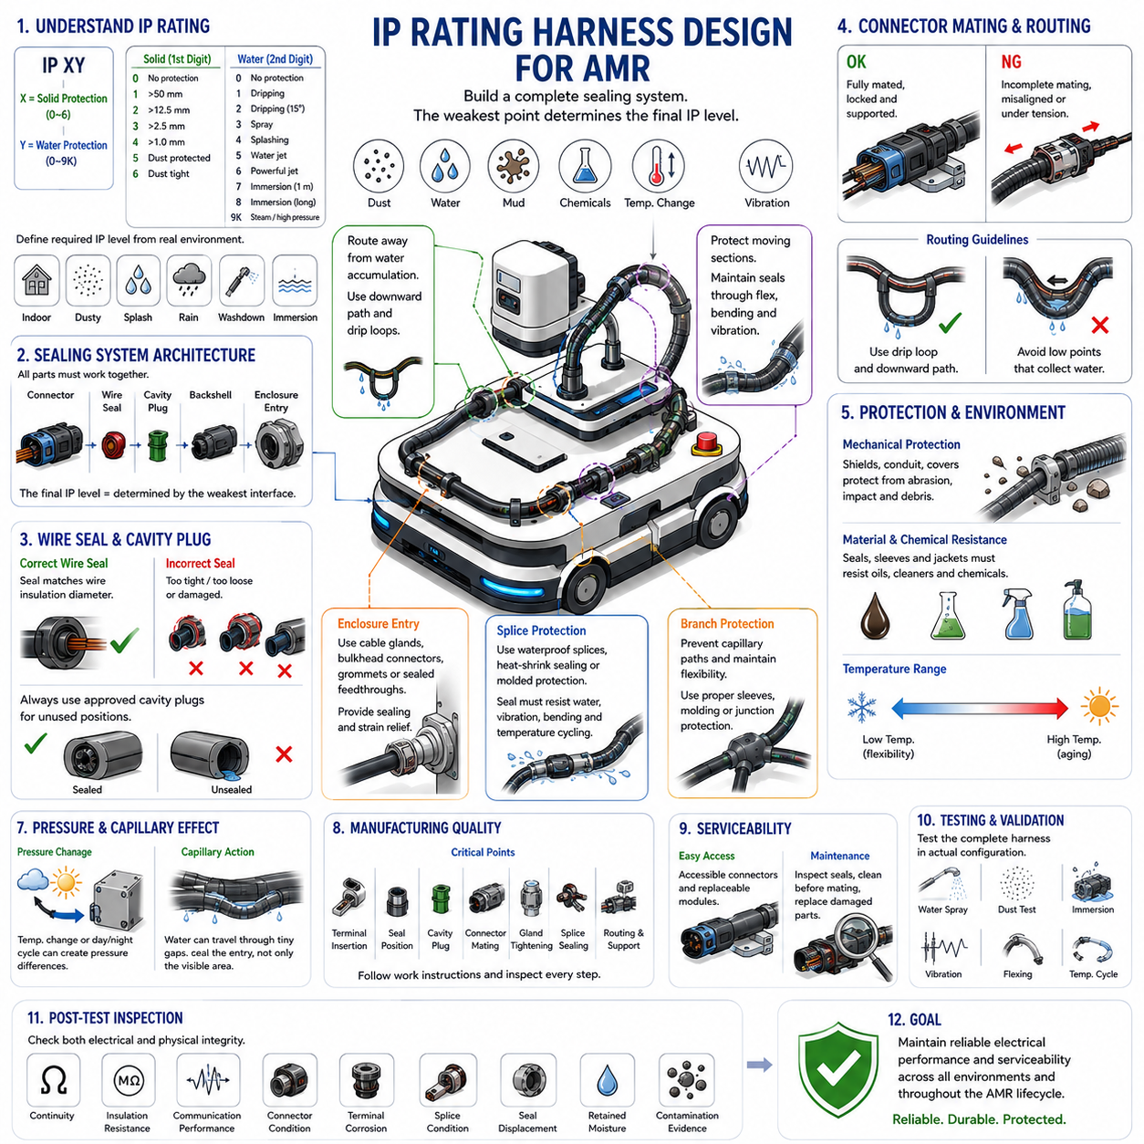
IP rating harness design for an AMR ensures that electrical conductors, connectors, splices, branch points, and enclosure interfaces remain protected against solid particles and water throughout the robot’s operating life. Because AMRs may operate near dust, rain, splashing water, cleaning processes, or outdoor contamination, environmental sealing must be treated as a system-level harness requirement rather than only a connector specification.
The required ingress protection level should be defined from the actual operating environment before selecting harness components. The first IP digit represents protection against solid-particle ingress, while the second represents protection against water. A design intended for a controlled indoor warehouse may require different protection from an outdoor inspection AMR exposed to rain, mud, washdown, standing water, or repeated transitions between wet and dry environments.
Selecting an IP-rated connector does not automatically make the complete harness assembly compliant with the same rating. Connector housings, terminals, wire seals, cavity plugs, backshells, cable glands, mating interfaces, and enclosure penetrations must function together as a sealing system. The final protection level is determined by the weakest interface, so every potential ingress path should be identified during harness architecture and packaging design.
Wire seals must match the actual conductor insulation diameter rather than only the nominal wire gauge. A seal designed for an incorrect cable diameter may be excessively compressed, insufficiently compressed, or mechanically damaged during terminal insertion. Wire insulation surface condition is also important because cuts, scratches, contamination, or deformation near the sealing region can create small leakage paths that become significant during prolonged exposure to water or pressure.
Unused connector cavities require dedicated sealing because an empty terminal position can provide a direct path for moisture and contamination. Approved cavity plugs or sealing pins should be installed according to the connector system specification. Improvised fillers, adhesives, or uncontrolled sealants should not replace designed sealing components because their performance can vary with temperature, vibration, chemical exposure, aging, and maintenance activity.
Connector mating must achieve the intended mechanical lock and seal compression. Partial engagement may provide electrical contact while leaving the sealing interface insufficiently compressed. Connector position assurance and secondary locking features should therefore be verified during assembly and inspection. Harness routing should also avoid mechanical loads that pull on the connector and gradually reduce engagement or distort the sealing geometry during vehicle operation.
Cable entry into an electrical enclosure requires particular attention because the enclosure may have a high IP rating while an improperly designed harness penetration compromises the entire assembly. Cable glands, bulkhead connectors, grommets, or sealed feedthroughs should be selected according to cable diameter, environmental exposure, and enclosure requirements. The penetration must provide sealing while also controlling cable strain and preventing movement from damaging the sealing interface.
Harness routing should prevent water from being naturally guided toward connectors and enclosure entries. Where possible, cable paths should include suitable downward routing or drip-loop geometry so water drains away from sensitive interfaces instead of accumulating at them. Vertical cable runs entering an enclosure from above deserve particular attention because water can travel along the cable surface and reach the sealing interface repeatedly during rain or wash exposure.
Low points in harness routing can collect water, mud, or cleaning fluid if protective sleeves and conduits are not appropriately designed. Corrugated conduit can protect wiring mechanically but may also retain moisture when water enters through an opening. Drainage strategy should therefore be considered together with sealing strategy. A partially sealed conduit that traps water can create a more severe long-term environment than an intentionally drained protective system.
Splices located in wet or contaminated zones require waterproof construction appropriate to the expected exposure. The conductor joint must provide electrical integrity while the external sealing system prevents water from reaching exposed conductor strands. Heat-shrink sealing, molded protection, waterproof splice systems, or other qualified methods may be used according to the harness architecture, but the sealed region must also tolerate vibration, bending, temperature cycling, and installation variation.
Branch points are another potential ingress location because multiple wires or conduits converge and create irregular geometries that are difficult to seal consistently. Branch protection should prevent capillary water paths while maintaining mechanical support and appropriate flexibility. Tape alone should not automatically be assumed to provide waterproofing unless the complete wrapping process and material system have been validated for the intended environmental exposure.
Capillary action can transport moisture through very small gaps between conductor strands, insulation interfaces, braided shields, or poorly sealed transitions. Water entering at one point may therefore migrate beyond the visibly wet region. Harness sealing should prevent initial ingress rather than relying only on local external protection. Particular attention is required where stripped conductors, shield terminations, splices, or cable transitions expose internal pathways.
Pressure differences can also drive moisture through small sealing defects. Temperature changes between daytime and nighttime operation, movement between indoor and outdoor environments, or heating and cooling of electrical equipment can change internal air pressure. Repeated pressure cycling may gradually draw humid air or water through marginal seals, making long-term sealing performance dependent on both environmental exposure and thermal behavior.
Dynamic harness sections create additional challenges because repeated bending can degrade seals, boots, glands, and protective coverings even when their initial IP performance is satisfactory. A sealing system near steering, lifting, suspension, or articulated mechanisms must maintain compression and geometry throughout movement. Flexing should not repeatedly pull on sealed interfaces, and rigid sealing components should normally remain outside primary repetitive-flex zones whenever practical.
Abrasion and impact can indirectly reduce IP performance by damaging cable insulation, protective sleeves, connector housings, or sealing surfaces. Outdoor AMRs may encounter gravel, vegetation, debris, tools, pallet edges, or other objects capable of striking exposed harnesses. Environmental protection therefore depends on mechanical packaging as well as sealing, and vulnerable harness sections may require guards, conduits, covers, or relocation to protected structural zones.
Temperature influences sealing materials and should be included in component selection. Elastomeric seals may harden at low temperature, soften at elevated temperature, or lose compression after long-term aging. Cable insulation and connector materials also expand and contract differently during thermal cycling. The required IP performance should therefore be maintained across the AMR’s specified temperature range rather than demonstrated only under nominal room-temperature conditions.
Chemical compatibility is particularly important for industrial AMRs exposed to oils, greases, coolants, detergents, disinfectants, or cleaning agents. A sealing material that performs well against water may swell, crack, soften, or lose elasticity after chemical exposure. Connector seals, boots, grommets, glands, sleeves, and cable jackets should consequently be selected according to both the required ingress protection and the substances expected in the operating environment.
Serviceability must be balanced with sealing performance. Connectors that are frequently disconnected for maintenance can accumulate dirt, damage seals, or lose lubrication required by the connector system. Service procedures should protect open interfaces from contamination and require inspection of seals before reconnection. Damaged seals, cavity plugs, locking features, or backshell components should be replaced rather than reused when their environmental performance can no longer be assured.
Manufacturing quality has a direct effect on final IP performance. Correct terminal insertion, seal position, cavity plugging, connector mating, gland tightening, boot installation, splice sealing, and routing must be controlled through work instructions and inspection. Even a well-designed sealing architecture can fail when assembly variation leaves a seal folded, a terminal incompletely seated, a gland incorrectly tightened, or a cable surface contaminated.
Validation should evaluate the completed harness in a configuration representative of the installed AMR. Water spray, dust exposure, immersion where applicable, temperature cycling, vibration, flexing, and mechanical loading may need to be combined because field failures often result from interactions between environmental and mechanical stresses. Testing individual components alone cannot fully demonstrate the protection provided by the assembled routing and sealing system.
Post-test inspection should examine both electrical and physical integrity. Continuity, insulation resistance, communication performance, connector condition, terminal corrosion, splice condition, seal displacement, retained moisture, and evidence of contamination should be checked after environmental exposure. Where safety-related or high-current circuits are involved, small amounts of moisture that do not immediately cause failure should still be treated as significant evidence of sealing weakness.
A robust AMR IP-rated harness therefore combines appropriate component ratings with controlled routing, waterproof transitions, drainage, strain relief, mechanical protection, manufacturing discipline, and representative environmental validation. The objective is not simply to attach an IP-rated connector to a cable, but to create a complete environmental protection system that maintains electrical reliability and serviceability across stationary and moving sections throughout the robot lifecycle.

12.04. Drive Module Harness
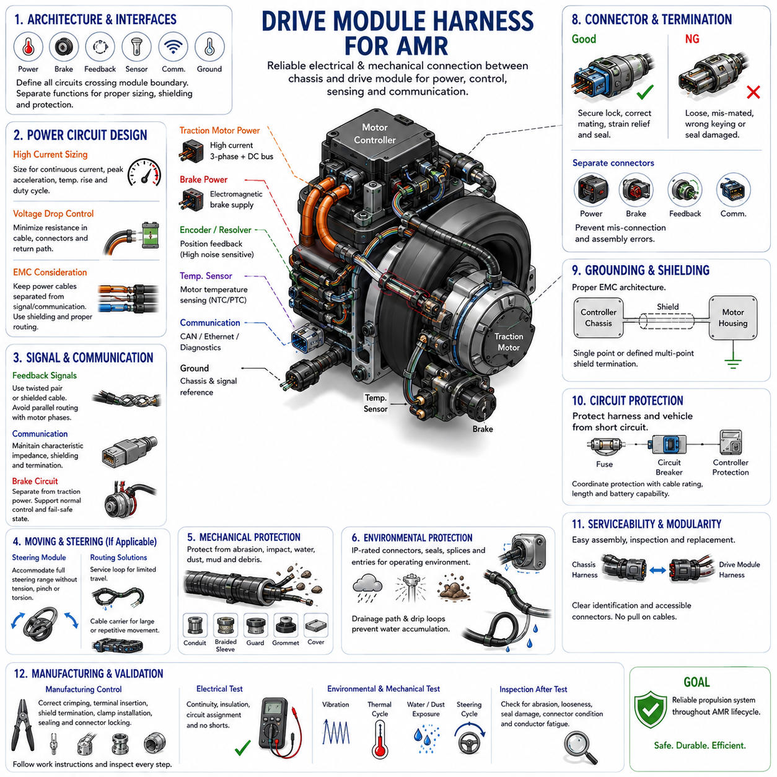
The drive module harness forms the electrical interface between the AMR power distribution system, motor controller, traction motor, brake, encoder, temperature sensors, and local communication devices. Because the drive module combines high current, vibration, repetitive motion, electromagnetic noise, and safety-critical functions in a compact area, its harness must be engineered as an integrated electromechanical subsystem rather than a simple collection of cables.
Drive module architecture should begin with a clear definition of every electrical interface crossing the module boundary. Typical circuits include traction-motor power, electromagnetic brake supply, encoder or resolver feedback, motor-temperature sensing, controller communication, grounding, and diagnostic signals. Separating these functions at the architecture stage helps establish appropriate wire gauge, shielding, connector type, routing, protection, and service requirements.
Traction-motor conductors normally represent the highest-current circuits within the drive harness and should be sized according to continuous current, transient acceleration current, allowable voltage drop, ambient temperature, bundle conditions, and protective-device coordination. Motor startup, acceleration, hill climbing, and wheel obstruction can produce current substantially above normal cruising demand, so conductor selection should reflect the complete electrical and thermal duty cycle.
Voltage drop is particularly important because the drive harness lies directly in the energy path between the battery or power distribution unit and the traction system. Excessive resistance reduces voltage available to the motor controller and converts useful electrical energy into harness heat. Conductor cross-section, route length, connector resistance, terminal interfaces, and return-path resistance should therefore be included when establishing the drive-module voltage-drop budget.
Motor power cables should be routed with attention to electromagnetic compatibility because switching motor controllers generate high-frequency voltage and current transitions. Power conductors should be kept appropriately separated from encoder, communication, sensor, and other noise-sensitive circuits wherever packaging permits. Where separation cannot be maintained, shielding, controlled cable geometry, filtering, grounding strategy, or localized protective routing may be required to preserve signal integrity.
Motor phase wiring requires consistent routing and termination because phase conductors carry rapidly changing currents generated by the inverter or motor drive. The conductors should normally follow similar paths and lengths so that unnecessary loop area and electromagnetic imbalance are minimized. Mechanical separation between phase cables should not create excessive loop geometry, while bundling should still respect thermal derating and cable manufacturer requirements.
Encoder, resolver, Hall sensor, and other motor-position feedback circuits require greater protection from electrical noise than ordinary power wiring. These signals directly influence commutation, velocity estimation, position control, and fault detection. Appropriate twisted-pair or shielded cable construction should be selected according to the sensor interface, and routing should avoid prolonged parallel exposure to motor phases, brake switching lines, or other high-noise conductors.
Communication wiring such as CAN or industrial network connections may connect the drive controller to the AMR control architecture. These cables should maintain the characteristic wiring geometry, shielding, termination, and connector practices required by the communication system. Mechanical routing should also prevent repetitive deformation from altering conductor spacing or shield integrity, particularly where communication cables cross the boundary between the chassis and a moving drive assembly.
The electromagnetic brake circuit should be treated separately from the traction power circuit even when both terminate within the same drive module. Brake coils can generate inductive transients during switching, while safety architecture may require defined brake behavior following power loss or emergency stop. Wire sizing, suppression devices, connector allocation, routing, and circuit protection should therefore support both normal brake control and the required fail-safe operating state.
Drive modules commonly experience substantial vibration and shock from wheel-road interaction, acceleration, braking, floor joints, obstacles, and structural resonance. Harness mass must be adequately supported so these loads are not transferred directly into connector terminals or motor interfaces. Clamp locations, strain relief, connector orientation, bundle mass, and unsupported cable length should be designed to prevent fretting, conductor fatigue, terminal movement, and progressive loosening.
Steering drive modules introduce an additional moving-harness requirement because the wheel assembly may rotate relative to the main chassis. Harness length and routing must accommodate the complete steering range without tension, pinching, excessive bending, or accumulated torsion. Flexible zones should be intentionally defined, while connectors, splices, rigid conduits, and heavy branch points should remain outside the dominant bending region whenever packaging allows.
For limited steering angles, a controlled service loop can absorb movement when sufficient space is available. The loop should change geometry predictably through the full steering range and should not contact the tire, suspension, frame, steering linkage, or nearby harnesses. For larger or highly repetitive movement, cable carriers or other guided-routing methods may provide better control of bend radius and cable trajectory.
Drive harnesses located close to wheels are particularly vulnerable to abrasion, impact, water, dust, mud, and debris. Routing should maximize separation from tires, rotating shafts, gears, sharp structural edges, and exposed fasteners. Corrugated conduit, braided protection, guards, grommets, or local covers can provide additional mechanical protection, but these components should not create rigid transitions that concentrate vibration or bending stress.
Environmental sealing should reflect the actual AMR operating environment. Outdoor or washdown-capable platforms may require sealed motor connectors, waterproof splices, protected branch points, sealed enclosure entries, and suitable cable jackets. Water should not be allowed to collect at connectors or inside protective conduits, and routing should promote drainage through downward paths or appropriate drip geometry while preserving the required ingress-protection performance.
Thermal exposure must be evaluated because the drive module combines conductor heating with heat generated by motors, brakes, bearings, and motor controllers. Harness sections routed close to these components may experience temperatures significantly above the general AMR ambient condition. Wire insulation, connector materials, protective sleeves, seals, and clamp components should therefore be selected for the actual local temperature while conductor ampacity is appropriately derated.
Connector selection should reflect both electrical load and mechanical environment. High-current motor connections require suitable current capability, contact resistance, temperature performance, retention, and protection against incorrect mating. Signal connectors require reliable low-level contact performance and shielding where applicable. Where practical, power, brake, feedback, and communication interfaces should be arranged so assembly errors and cross-connection during manufacturing or service are minimized.
Grounding and shielding within the drive module should follow a defined EMC architecture rather than being added after interference problems appear. Motor housings, controller chassis, cable shields, protective earth or chassis references, and signal grounds can serve different functions. Shield termination should provide the intended high-frequency path while avoiding mechanically fragile arrangements, and grounding conductors should be protected against loosening, corrosion, and vibration.
Circuit protection must coordinate with the drive-harness conductor capability and expected fault current. A short circuit in a traction circuit can release substantial energy from the AMR battery, so fuses or other protective devices should interrupt faults before the wire insulation or terminals reach damaging conditions. Protection strategy should consider conductor size, cable length, connector ratings, controller behavior, battery capability, and the maximum unprotected section of wiring.
Packaging should allow the drive module to be assembled and removed without damaging the harness. Connectors should remain accessible, identification should be clear, and disconnect procedures should not require pulling directly on cables. A modular interface between the chassis harness and drive-module harness can simplify production, diagnostics, and field replacement while reducing the amount of vehicle wiring disturbed when a motor, controller, brake, or complete wheel module requires service.
Manufacturing controls are essential because incorrect crimping, terminal insertion, phase connection, shield termination, clamp installation, or connector locking can produce failures that appear only after the AMR enters service. Work instructions should define routing, fixation, connector mating, torque where applicable, sealing, identification, and inspection requirements. Electrical testing should verify continuity, isolation, circuit assignment, and absence of unintended shorts before vehicle operation.
Validation should combine electrical loading with representative mechanical and environmental conditions. The assembled drive harness should be evaluated during acceleration, regenerative braking where applicable, steering, repeated start-stop operation, vibration, thermal cycling, and exposure to expected contaminants. Measurements can include voltage drop, conductor temperature, connector temperature, communication stability, insulation condition, resistance changes, and mechanical movement of the installed harness.
Inspection after endurance testing should focus on areas where electrical and mechanical stresses interact. Connector backshells, strain-relief points, steering loops, clamps, conduit ends, motor terminals, shield terminations, and chassis transitions should be examined for abrasion, fretting, looseness, cracking, seal displacement, or conductor fatigue. Stable electrical measurements alone should not be considered sufficient if physical deterioration indicates that reliability margin is being consumed.
A robust drive module harness ultimately provides a controlled electrical and mechanical bridge between the AMR chassis and its propulsion hardware. Successful design combines current capacity, voltage-drop control, EMC separation, feedback-signal integrity, braking requirements, vibration resistance, moving-part routing, environmental sealing, circuit protection, manufacturing quality, and serviceability so that propulsion remains reliable throughout the expected robot operating lifecycle.

12.05. Charging Interface Harness
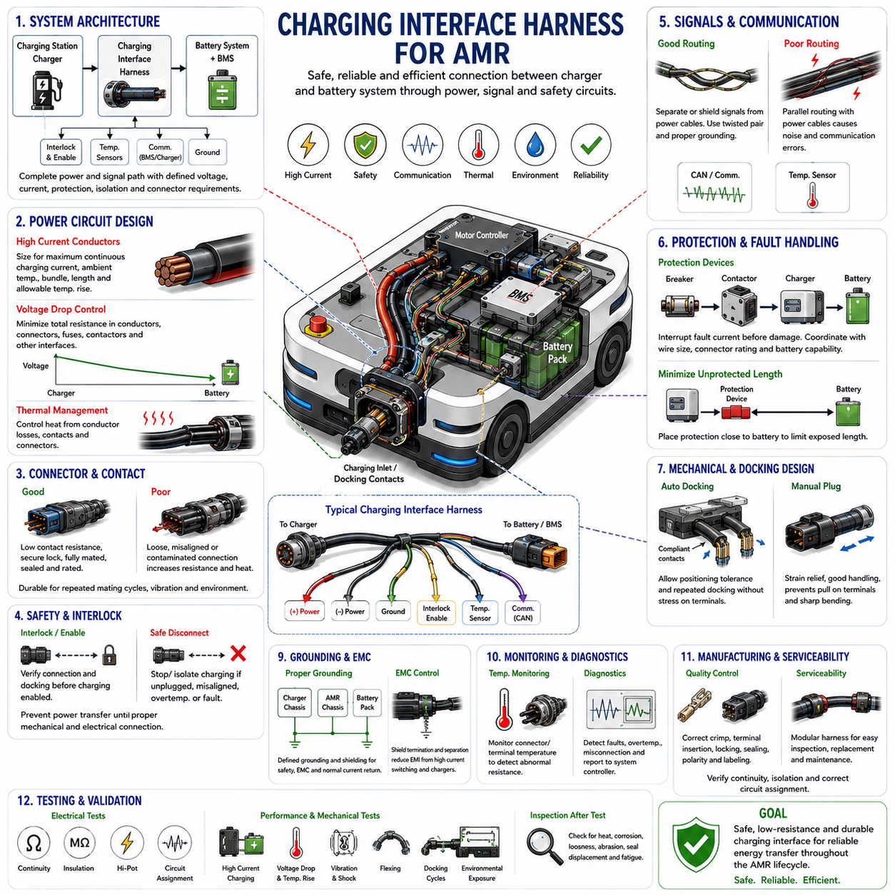
The charging interface harness forms the electrical connection between the AMR battery system, charging inlet or contact assembly, charger, battery management system, and associated control and safety circuits. Unlike ordinary power wiring, this interface experiences repeated charging cycles, connector engagement, high current, environmental exposure, and possible operator interaction, so electrical, thermal, mechanical, and safety requirements must be considered together.
Charging architecture should begin by defining the complete power and signal path from the external charging source to the battery. Depending on the AMR design, the interface may include positive and negative charging conductors, protective grounding, charger-enable signals, interlock circuits, temperature sensing, communication with the charger, and battery-management communication. Each circuit should have clearly defined voltage, current, protection, isolation, and connector requirements.
The charging conductors must be sized for the maximum continuous charging current rather than only the normal operating value. Conductor resistance generates heat during charging, and this heat is added to losses at terminals, connectors, contactors, and other interfaces. Wire gauge selection should therefore consider charging current, charging duration, ambient temperature, bundle conditions, allowable temperature rise, cable length, and the thermal limits of surrounding components.
Voltage drop should be controlled because excessive resistance between the charger and battery reduces charging efficiency and increases thermal stress. The complete charging path should include conductor resistance, connector contact resistance, fuse or protection-device resistance, contactor resistance, and other series interfaces. Voltage-drop limits should be established so that the charger and battery management system can operate correctly across the intended battery voltage and charging-current range.
Charging connectors and contacts require sufficient current capability with low and stable contact resistance. Repeated mating cycles, contamination, mechanical wear, oxidation, and reduced contact force can progressively increase resistance and generate localized heating. Connector selection should therefore consider rated current, temperature rise, mating-cycle durability, retention, environmental sealing, terminal construction, touch protection, and resistance to incorrect or incomplete engagement.
The charging interface should prevent power transfer before proper mechanical and electrical connection has been established. Interlock or charger-enable circuits can be used to confirm connector engagement, docking condition, or other required states before charging current is applied. Similarly, the system should stop or isolate charging when the interface is disconnected, misaligned, overheated, or otherwise outside its permitted operating conditions.
Battery management system integration is essential because charging must remain within battery voltage, current, temperature, and state-of-charge limits. The charging harness may therefore carry communication or control signals between the battery management system and charger in addition to the main charging current. These low-level circuits should be routed and protected so switching noise and high charging currents do not compromise communication or sensing accuracy.
Where communication wiring shares the charging interface, power and signal circuits should be separated or appropriately shielded according to their electrical characteristics. High-current switching, contactor operation, charger power electronics, and DC/DC conversion can introduce electromagnetic disturbances. Twisted pairs, shielded cables, controlled grounding, suitable connector pin allocation, and physical separation can help maintain communication integrity throughout the charging process.
Charging circuit protection must coordinate with conductor size, connector capability, battery fault current, and charger characteristics. A short circuit in the charging path can release substantial energy, particularly when the battery remains connected to the affected conductors. Fuses, circuit breakers, contactors, or other protective devices should interrupt abnormal current before cables, terminals, or connectors reach damaging thermal conditions.
The length of unprotected charging wiring should be minimized, particularly near the battery connection. Protection devices should be positioned so that a short circuit along the charging harness does not leave a long conductor segment directly exposed to battery fault energy. Routing and packaging should also protect these high-energy conductors from crushing, sharp edges, moving mechanisms, and service activities that could damage insulation.
Automatic charging introduces different mechanical requirements from manually connected charging. An AMR using docking contacts must repeatedly align with a charging station, making contact geometry, compliance, positioning tolerance, contact force, and surface contamination important. The harness behind the charging contacts should accommodate any permitted movement without transferring docking impact or repetitive displacement directly into electrical terminals.
Spring-loaded contacts or compliant charging assemblies can compensate for small docking errors, but their wiring requires controlled flexible routing. Sufficient cable length should permit the contact assembly to move through its complete compliance range without tension, sharp bending, or interference. Flexible sections should be separated from rigid connector or splice transitions so repeated docking cycles do not create concentrated conductor fatigue.
For manually connected charging, the inlet and cable interface should withstand repeated insertion, removal, pulling, and handling. Strain relief should prevent external cable forces from being transmitted directly to terminals or enclosure penetrations. Connector orientation and mounting should support natural handling while minimizing the possibility of sharp cable bending, accidental disconnection, incomplete mating, or damage caused by vehicle movement during charging.
Charging interfaces are often located near the exterior of the AMR and can therefore be exposed to water, dust, cleaning agents, debris, and accidental impact. Appropriate ingress protection should be selected for the actual operating environment. Sealed connectors, boots, grommets, cable glands, protective covers, and drainage features may be required to prevent contamination from degrading insulation or increasing contact resistance.
Water accumulation around charging contacts requires particular attention because conductive contamination can reduce insulation performance and promote corrosion. The interface should be oriented or protected so water drains away rather than remaining inside the connector or contact cavity. Protective covers may be used when the interface is not engaged, while drainage paths should avoid directing water toward battery enclosures, electronics, or other sensitive components.
Temperature monitoring can provide additional protection for high-current charging interfaces. Abnormal connector resistance can produce localized heating that may not be detected from battery temperature alone. Where charging power or environmental conditions justify it, temperature sensing near critical contacts, terminals, or cable interfaces can support current reduction, charging interruption, diagnostics, and preventive maintenance before severe degradation occurs.
Harness routing should separate charging cables from sensitive communication and sensor wiring where practical while also maintaining adequate clearance from hot components and moving mechanisms. High-current cables should be securely supported to prevent their mass from loading connectors during vibration. Clamp spacing and strain relief should control movement without creating sharp stiffness transitions that concentrate bending stress near the charging inlet or battery interface.
Grounding and bonding requirements depend on charger architecture, vehicle voltage, enclosure construction, and charging method. Protective grounding, chassis bonding, cable shielding, and DC return conductors should not be treated as interchangeable functions. Their connections should follow a defined electrical architecture so fault-current paths, EMC behavior, personnel protection, and normal charging-current return paths remain controlled and predictable.
Connector keying, polarity control, and identification are important because reverse connection or incorrect mating can cause severe electrical damage. Positive, negative, communication, interlock, and grounding interfaces should be clearly differentiated through connector design, pin assignment, physical keying, labeling, or other controlled methods. Manufacturing and service procedures should verify polarity before energizing the charging system.
Serviceability should allow charging components to be inspected and replaced without disturbing unnecessary portions of the AMR harness. Charging contacts, connectors, protective covers, and flexible docking sections can experience higher wear than stationary wiring and may require periodic maintenance. A modular charging-interface harness can simplify replacement while preserving the integrity of the battery and main vehicle harness.
Manufacturing quality directly affects charging reliability because high-current interfaces are sensitive to crimp resistance and terminal installation. Crimp geometry, conductor insertion, terminal seating, connector locking, seal installation, cable support, polarity, and fastening torque where applicable should be controlled. Electrical inspection should verify continuity, isolation, correct circuit assignment, and absence of unintended shorts before charging power is applied.
Validation should represent the actual charging method and expected lifecycle. Testing can include repeated docking or connector mating, continuous high-current charging, temperature measurement, voltage-drop monitoring, vibration, flexing, environmental exposure, and fault-condition evaluation. Automatic docking systems should additionally be tested across realistic positional tolerances so charging remains reliable without excessive mechanical loading of contacts or harnesses.
Post-test inspection should examine terminals, connector bodies, docking contacts, strain-relief points, flexible sections, seals, protective covers, clamps, and battery-side connections. Evidence of discoloration, corrosion, abrasion, looseness, seal movement, insulation damage, increased contact resistance, or conductor fatigue should be treated as degradation even when charging remains functional at the end of the test.
A robust charging interface harness ultimately provides a safe, low-resistance, mechanically controlled, and environmentally protected energy-transfer path between the AMR and its charging infrastructure. Integrating conductor sizing, voltage-drop control, connector durability, BMS coordination, interlocks, protection, EMC, docking mechanics, sealing, thermal monitoring, manufacturing control, serviceability, and lifecycle validation enables reliable charging throughout the robot’s intended operating life.

