Volume 02. Wire Harness Engineering

Chapter 07. Splice Engineering

07.01. Crimp Splice Technology
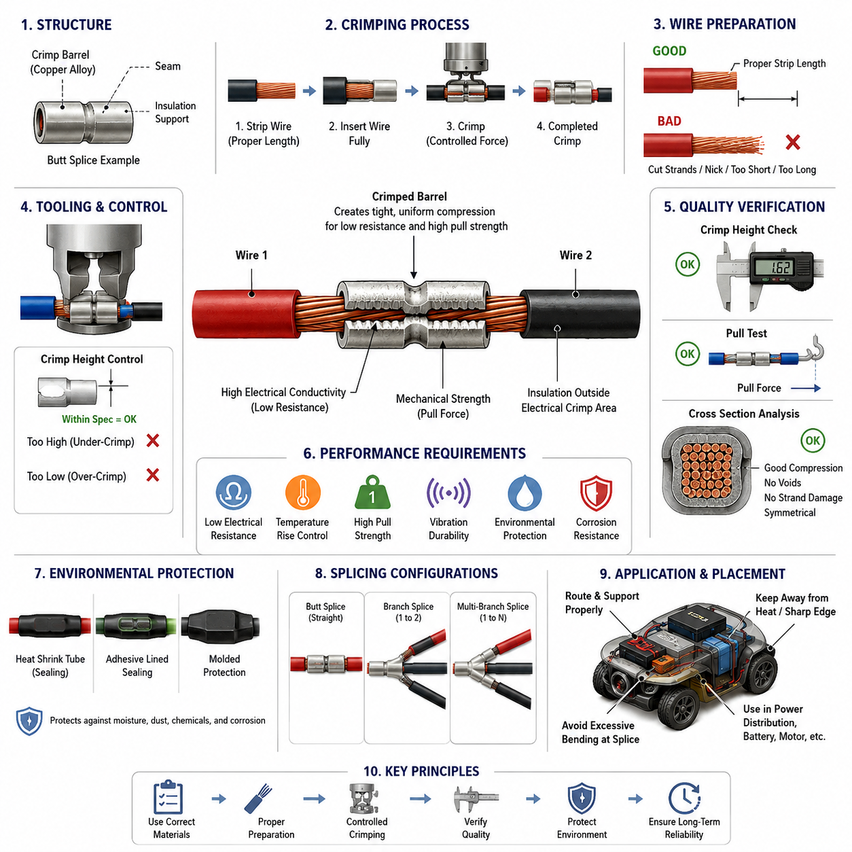
Crimp splicing is a mechanical and electrical joining method used to connect two or more conductors by permanently deforming a metallic splice barrel around the stripped wire strands. Within wire-harness engineering, the splice becomes part of the current path and must provide low electrical resistance, adequate mechanical retention, stable thermal behavior, and long-term reliability under vibration and environmental exposure.
A typical crimp splice consists of a conductive barrel, prepared wire ends, and an optional insulation-support or sealing system. Copper or copper-alloy splice materials are commonly selected to maintain conductivity and compatibility with copper conductors. During crimping, controlled compression forces the conductor strands into intimate contact with one another and with the barrel, producing a dense metallic interface without requiring solder.
The electrical performance of a crimp splice depends primarily on the quality of contact established during deformation. As the barrel compresses the conductor bundle, surface films are disrupted and numerous microscopic contact points are formed. Sufficient compression increases the effective contact area and reduces interface resistance, while excessive or insufficient compression can damage strands or leave unstable contact regions that increase resistance over time.
Wire preparation is therefore a critical part of the process. Insulation must be stripped to the specified length without cutting, nicking, scraping, or excessively separating the conductor strands. The stripped conductor should enter the splice barrel completely while insulation remains outside the electrical crimp region unless the splice design specifically provides insulation support. Poor stripping can reduce effective conductor area and create a localized mechanical weak point.
The relationship among conductor cross-sectional area, splice-barrel size, and tooling geometry must be controlled as an integrated system. A barrel that is too large may not achieve adequate compression, whereas an undersized barrel may produce excessive deformation, strand extrusion, or mechanical damage. When several wires are combined in one splice, their total conductor area and individual strand construction must both be considered when defining the approved splice configuration.
Crimp tooling determines how mechanical force is translated into barrel deformation. Production equipment may use dedicated applicators, presses, or qualified hand tools depending on manufacturing volume and service requirements. The crimp profile, closing height, tooling alignment, and applied force must remain within controlled limits. Worn tooling can gradually change the resulting geometry even when the wire and splice components themselves remain unchanged.
Crimp height is one of the most useful process-control parameters because it provides an indirect indication of conductor compression. A specified crimp-height window is normally established for each combination of wire size, splice barrel, and tooling configuration. A height above the acceptable range can indicate under-compression, while an excessively low value can indicate over-compression, strand damage, or abnormal material displacement.
Mechanical integrity is commonly evaluated through pull-force testing. The test applies an axial load to the terminated conductor until a specified force is reached or the joint fails. Pull force does not directly measure electrical performance, but it is valuable for identifying weak compression, incomplete conductor insertion, damaged strands, incorrect components, or tooling problems. Electrical and mechanical evaluations should therefore be treated as complementary controls.
Cross-sectional analysis provides deeper insight into the internal condition of a crimp. A prepared section through the crimped barrel can reveal conductor distribution, compression uniformity, voids, strand damage, barrel deformation, and symmetry. This method is especially useful during process qualification, tooling setup, engineering validation, and investigation of production defects because external appearance alone cannot confirm the internal contact structure.
Electrical resistance across the splice should remain very low relative to the resistance of the connected wire segment. Excessive splice resistance produces localized I²R heating, which can accelerate oxidation, insulation aging, and mechanical degradation. This issue becomes increasingly important in high-current circuits such as battery feeds, motor power distribution, charging circuits, heaters, and other loads where even a small additional resistance can generate significant heat.
Thermal performance must be considered together with current capacity. A splice may carry the required current under laboratory conditions but experience greater temperature rise when installed inside a dense harness bundle, protective sleeve, conduit, or poorly ventilated enclosure. The splice design should therefore be evaluated under representative current, ambient temperature, bundling, duty-cycle, and neighboring-circuit conditions rather than solely by nominal conductor rating.
Branch splices introduce additional design considerations because one incoming conductor may distribute current to several outgoing circuits. The upstream conductor and splice must accommodate the combined current, while each branch must remain coordinated with its conductor size and circuit protection. The physical arrangement of conductors inside the splice should also avoid severe imbalance that could produce nonuniform compression or concentrate mechanical stress on individual wires.
Environmental protection becomes necessary when a splice is located where moisture, condensation, dust, chemicals, or corrosive contaminants may reach the conductor interface. Depending on the harness environment, the crimp may be combined with heat-shrink tubing, adhesive-lined sealing material, molded protection, or another qualified sealing method. The sealing system should protect the electrical joint without transferring excessive stiffness or stress into the adjacent flexible wire.
Splice placement is closely related to mechanical reliability. A well-manufactured crimp can still fail if positioned at a severe bend, repetitive-flex location, unsupported harness transition, or high-vibration zone. The splice creates a local change in stiffness and mass, so routing and support should prevent repeated bending directly at the barrel or conductor exit. Appropriate strain relief allows mechanical loads to be distributed into the surrounding harness structure.
For mobile robots and AMRs, crimp splices may experience continuous vibration, acceleration, shock, steering motion, and repeated thermal cycling. Splices near drive modules, batteries, power distribution units, and moving assemblies therefore require particular attention to support and routing. A design suitable for a stationary control cabinet cannot automatically be assumed to provide equivalent reliability in a continuously moving robotic platform.
Crimp splicing should ultimately be treated as a qualified manufacturing process rather than a simple wire-joining operation. Reliable production requires defined materials, approved wire combinations, controlled stripping, validated tooling, crimp-height limits, mechanical testing, visual inspection, and periodic process verification. Traceable process control ensures that the electrical and mechanical characteristics demonstrated during qualification are reproduced consistently throughout harness manufacturing.

07.02. Ultrasonic Weld Splice
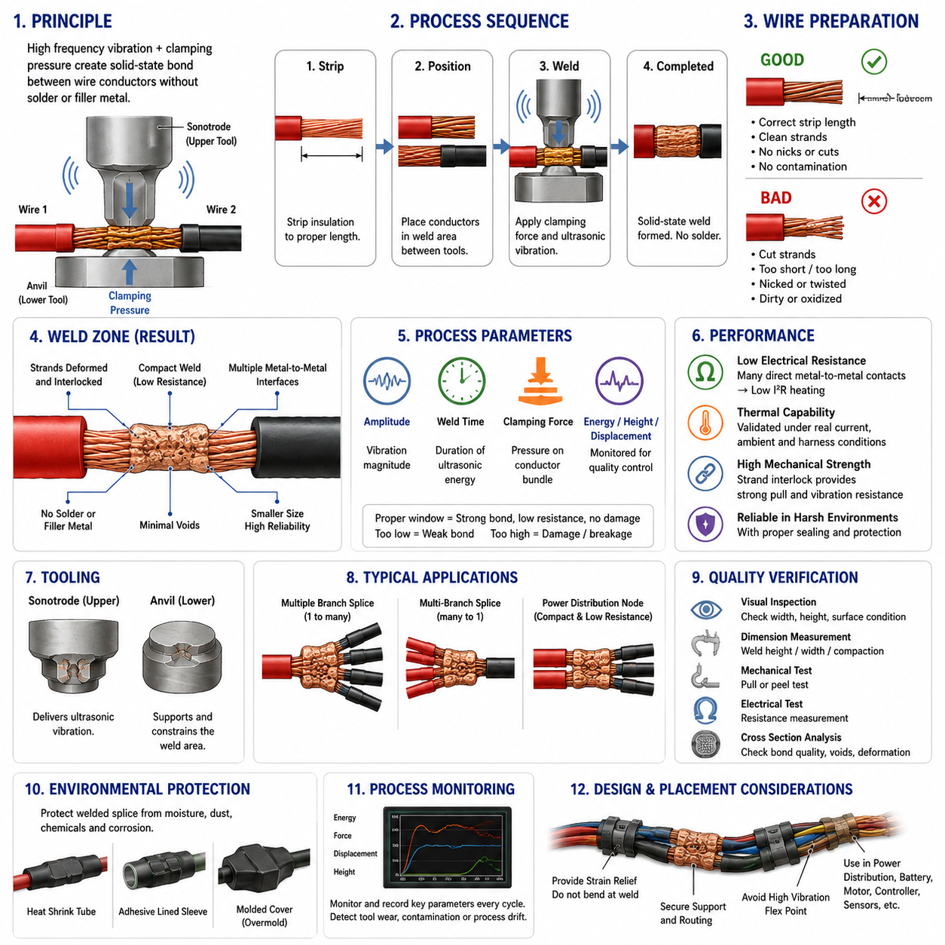
Ultrasonic weld splicing is a solid-state joining process used to create permanent electrical connections between multiple wire conductors without solder, filler metal, or a separate crimp barrel. Within wire harness engineering, it is particularly valuable when several copper conductors must be consolidated into a compact, low-resistance junction capable of supporting demanding electrical, thermal, and mechanical operating conditions.
The process uses high-frequency mechanical vibration combined with controlled clamping pressure. Stripped conductor ends are positioned between an ultrasonic sonotrode and an anvil, after which the tooling applies pressure while ultrasonic vibration acts parallel to the joining interface. The resulting microscopic relative motion disrupts surface oxides and contaminants and promotes direct metal-to-metal contact between adjacent conductor strands.
Unlike fusion welding, ultrasonic welding does not intentionally melt the bulk conductor material. Bond formation occurs primarily through frictional interaction, plastic deformation, and localized metallurgical bonding at the contacting surfaces. Because the process remains below the bulk melting temperature of the conductor, thermal damage to nearby insulation can be limited while a dense and mechanically integrated conductor joint is produced.
Wire preparation strongly influences weld quality. Insulation must be removed to the specified length without cutting, nicking, excessively twisting, or contaminating the exposed strands. Oil, moisture, oxidation, processing residue, or foreign particles on the conductor surface can interfere with energy transfer and bonding. The stripped wire ends must also be positioned consistently within the defined welding area before the welding cycle begins.
The conductor bundle is compressed into a compact weld geometry during processing. Individual strands deform and become mechanically interlocked while clean metallic surfaces are brought into intimate contact. Properly controlled deformation reduces voids within the splice and establishes many parallel conductive paths. The resulting junction can therefore provide very low electrical resistance while occupying less volume than some conventional multi-wire connection methods.
Several process parameters interact to determine weld quality. Ultrasonic amplitude defines the magnitude of tool vibration, weld time determines how long ultrasonic energy is applied, and clamping force controls mechanical pressure on the conductor bundle. Depending on the welding equipment, energy, final weld height, displacement, or other derived variables may also be monitored to determine whether each production cycle remains within an approved process window.
Too little ultrasonic energy can leave conductor strands insufficiently bonded, resulting in weak mechanical retention and unstable electrical contact. Excessive energy can cause severe strand deformation, material thinning, strand breakage, or damage near the transition between the welded region and the flexible conductor. Process development therefore seeks sufficient metallurgical bonding without unnecessarily reducing the mechanical integrity of the original wire.
The total conductor cross-sectional area is a fundamental parameter when defining an ultrasonic splice. A welding system and its tooling normally support a specified range of combined conductor areas rather than arbitrary wire combinations. Differences in wire gauge, strand count, strand diameter, conductor plating, and bundle arrangement can change the way ultrasonic energy propagates through the splice and should therefore be considered during process qualification.
Tooling geometry is equally important. The sonotrode transfers ultrasonic vibration into the conductor bundle while the anvil supports and constrains the opposite surface. Tool patterns may improve mechanical coupling and prevent conductor movement during welding. Wear, contamination, alignment error, or surface damage on these tools can alter energy transmission and weld geometry, making periodic inspection and maintenance important elements of production control.
Electrical performance is one of the principal advantages of a properly produced ultrasonic splice. The welded conductor mass contains numerous direct metal-to-metal interfaces and eliminates the additional electrical interface associated with a separate splice barrel. Low junction resistance reduces localized I²R heating, which is particularly beneficial in battery distribution, motor power circuits, charging systems, power distribution units, and other high-current harness branches.
Thermal behavior must nevertheless be validated under actual harness operating conditions. Current flowing through the splice generates heat according to its effective resistance, while neighboring wires, harness bundling, sleeves, conduits, ambient temperature, and airflow influence heat dissipation. Qualification should therefore confirm that splice temperature rise remains acceptable at representative continuous and transient currents rather than relying only on nominal conductor capacity.
Mechanical performance requires attention to the transition between the rigid welded mass and the flexible wire. The welded region is relatively stiff, so repeated bending immediately adjacent to it can concentrate strain in a small number of conductor strands. Harness routing, strain relief, clamps, and protective coverings should prevent the weld from becoming a flex point, especially in robotic systems exposed to vibration, steering movement, acceleration, and repetitive mechanical motion.
Branch connections are a common application because ultrasonic welding can join several conductors into a single electrically continuous node. One supply conductor may be connected to multiple outgoing branches, or several conductors may converge at a distribution point. Electrical design must ensure that the upstream conductor and welded junction support the combined current while downstream branches remain appropriately coordinated with their wire gauges and circuit protection.
Quality verification can combine visual inspection, dimensional measurement, mechanical testing, electrical measurement, and destructive analysis. Weld width, height, compaction, conductor position, and surface condition provide useful indicators of process stability. Pull or peel testing can evaluate mechanical integrity, while resistance measurements help confirm electrical continuity. Cross-sectional analysis can reveal internal bonding, strand deformation, voids, and abnormal material flow.
Modern ultrasonic welding equipment can also provide valuable process-monitoring data for every production cycle. Parameters such as delivered energy, weld time, displacement, final height, force, and equipment-specific quality indicators can be compared against qualified limits. Statistical monitoring of these values allows gradual tooling wear, conductor variation, contamination, or process drift to be detected before they develop into significant harness quality problems.
Environmental protection is normally added after welding when the splice will encounter moisture, condensation, dust, chemicals, or corrosive contamination. Heat-shrink tubing, adhesive-lined sealing components, molded covers, or equivalent protection can isolate the welded conductor from the environment. The selected protection must also provide appropriate mechanical support without creating an abrupt stiffness transition that transfers bending stress directly to the conductor exit.
In AMRs and other mobile robotic platforms, ultrasonic weld splices are especially useful for compact power-distribution nodes where battery power must be divided among drive modules, computing systems, sensors, controllers, and auxiliary loads. Their low resistance and compact geometry can reduce harness volume and voltage loss, but installation must account for vibration, thermal cycling, service accessibility, environmental sealing, and the repetitive motion characteristic of mobile equipment.
Ultrasonic weld splicing should therefore be treated as a controlled manufacturing technology rather than simply an alternative to crimping. Reliable implementation requires qualified conductor combinations, controlled stripping and positioning, validated welding parameters, maintained tooling, defined acceptance limits, and periodic verification. When these factors are managed systematically, ultrasonic welding can provide compact, low-resistance, mechanically robust, and repeatable multi-wire connections for advanced robotic wire harnesses.

07.03. Waterproof Splice Design
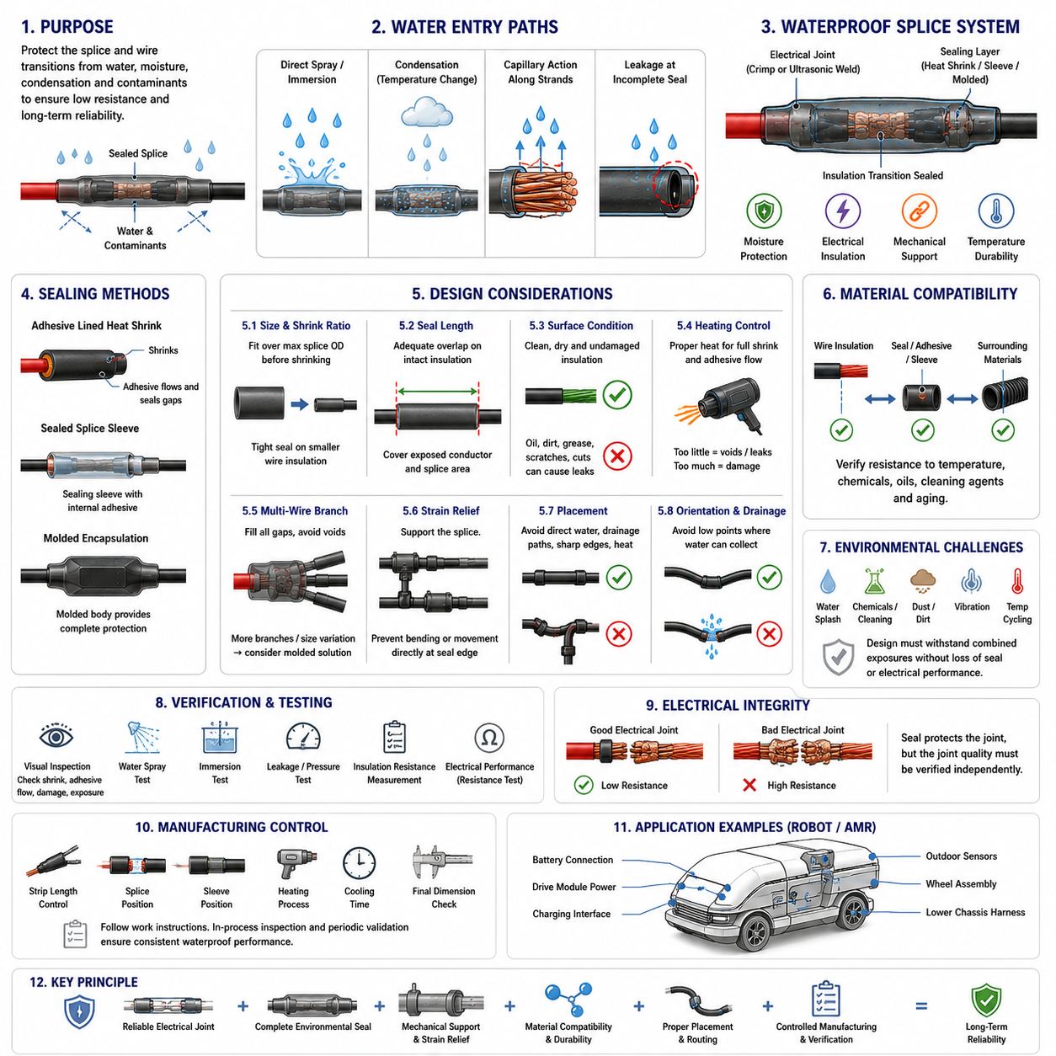
Waterproof splice design extends the electrical and mechanical function of a wire splice by preventing water, humidity, condensation, and contaminants from reaching the exposed conductor interface. Within wire harness engineering, sealing must be treated as part of the splice system rather than as an accessory added afterward, because moisture intrusion can increase resistance, accelerate corrosion, damage insulation, and eventually cause intermittent or permanent circuit failure.
A waterproof splice normally combines a reliable electrical joint with a dedicated environmental barrier. The internal connection may be produced by crimp splicing or ultrasonic welding, while the external protection can use adhesive-lined heat-shrink tubing, sealed splice sleeves, molded encapsulation, or equivalent technologies. The sealing structure must isolate both the conductor joint and the transitions where individual insulated wires enter the protected region.
Water can enter a splice through several mechanisms. Direct spray or immersion can penetrate openings in an incomplete seal, while condensation can form when temperature changes occur inside enclosed harness regions. Moisture may also migrate along conductor strands through capillary action, allowing water to travel beneath insulation from a remote entry point. Waterproof design must therefore consider both external penetration and longitudinal moisture migration.
Adhesive-lined heat-shrink tubing is widely used because it provides electrical insulation, environmental sealing, and mechanical support in a relatively compact package. During heating, the outer polymer tube contracts around the splice while the internal adhesive softens and flows into gaps around the wire insulation. After cooling, the adhesive forms a continuous barrier that reduces possible leakage paths between the splice and surrounding environment.
The dimensions of the sealing component must match the complete splice geometry. Before shrinking, the sleeve must be large enough to pass over the maximum diameter of the splice, yet after shrinking it must tightly conform to the smaller wire insulation at both ends. An unsuitable shrink ratio can leave gaps around small wires or generate excessive mechanical compression, making component selection dependent on both splice diameter and individual wire sizes.
Seal length is equally important because environmental protection depends on sufficient overlap with intact wire insulation. The protective sleeve should extend beyond the exposed conductor and splice region so that sealing occurs on clean, undamaged insulation surfaces. If the sealed overlap is too short, vibration, bending, dimensional tolerance, or adhesive displacement may create a leakage path close to the electrical connection.
Surface condition strongly affects sealing reliability. Wire insulation should be clean and free from oil, grease, dust, release agents, and processing residue before the sealing operation. Contamination can prevent adhesive from wetting and bonding to the insulation surface. The insulation itself must also remain undamaged because cuts, scratches, or deformation beneath the seal can become channels for water penetration or locations for mechanical failure.
Heating must be controlled when heat-shrink sealing is used. Insufficient temperature or heating time can prevent complete shrinking and adhesive flow, leaving internal voids or incomplete sealing around the wire. Excessive heating can damage insulation, deform the splice protection, degrade adhesive, or produce excessive material flow. A qualified heating process should therefore define temperature, exposure time, equipment, and acceptable finished appearance.
Multi-wire branch splices are more difficult to waterproof than simple one-to-one joints. Several wires leaving the same end of a splice create valleys and irregular spaces between adjacent insulation surfaces. Adhesive or sealing material must fill these geometries completely without trapping voids. As the number and diameter variation of branch wires increase, molded or specially designed sealing components may become preferable to conventional heat-shrink tubing.
Mechanical strain relief and waterproofing should be designed together. A sealed splice typically becomes stiffer and heavier than the surrounding wires, creating transition regions where bending stress can concentrate. The harness should therefore be supported so that repeated movement does not occur directly at the edge of the sealing material. Clamps, routing geometry, service loops, and protective coverings can distribute mechanical loads away from the sealed connection.
Environmental sealing does not eliminate the need for proper splice placement. Whenever possible, a splice should be located away from direct water jets, drainage paths, wheel splash, standing water, chemical exposure, sharp edges, and severe temperature sources. Routing the harness so that water does not naturally collect around the splice reduces the burden placed on the sealing system and improves long-term reliability.
The orientation of a sealed splice can influence water accumulation and drainage. Harness geometry should avoid creating low points or pockets where liquid remains around the splice for extended periods. Where unavoidable exposure exists, the protective design should tolerate repeated wetting and drying cycles without loss of adhesion or cracking. Drainage and harness routing are therefore complementary elements of waterproof electrical design.
Material compatibility must be verified between wire insulation, sealing adhesive, heat-shrink material, protective sleeves, and any surrounding harness components. Different polymers respond differently to temperature, chemicals, oils, cleaning agents, and long-term aging. A sealing material that adheres effectively to one insulation family may provide weaker bonding to another, so material combinations should be qualified as a complete system.
Temperature cycling creates another challenge because conductors, insulation, adhesive, and protective polymers have different thermal expansion characteristics. Repeated heating and cooling can generate internal stress at bonded interfaces and gradually create microscopic separation paths. Waterproof splice qualification should therefore evaluate not only initial sealing performance but also sealing integrity after representative thermal cycling and mechanical aging.
For mobile robots and AMRs, waterproof splices may be required near batteries, drive modules, charging interfaces, outdoor sensors, wheel assemblies, and lower chassis harnesses. These locations can experience water splash, cleaning fluids, dust, vibration, thermal cycling, and mechanical shock simultaneously. The splice protection must therefore provide environmental sealing without compromising harness flexibility, routing, serviceability, or electrical performance.
Verification of waterproof splice quality should include inspection of the finished seal and testing appropriate to the intended environment. Visual checks can identify incomplete shrinking, insufficient adhesive flow, damaged tubing, exposed conductor, or abnormal deformation. Depending on system requirements, validation can also include water spray, immersion, pressure-related leakage testing, insulation resistance measurement, and post-exposure electrical evaluation.
Electrical resistance should be measured independently of sealing performance because a waterproof exterior cannot compensate for a defective internal splice. The conductor connection must first satisfy its electrical and mechanical requirements, after which the environmental protection must preserve those characteristics throughout service life. This separation of functions helps prevent a visually acceptable sealed assembly from masking an electrically weak connection.
Manufacturing control is particularly important because many waterproofing defects originate from process variation rather than component design. Strip length, splice position, sleeve location, heating conditions, adhesive flow, cooling time, and final dimensions should be defined in work instructions. Production inspection and periodic validation should confirm that the sealing process consistently reproduces the condition established during engineering qualification.
Waterproof splice design should ultimately be approached as an integrated combination of electrical connection, environmental sealing, mechanical support, material compatibility, routing, and manufacturing control. A robust design prevents moisture from reaching the conductor while maintaining low resistance and mechanical integrity under vibration and thermal cycling. This system-level approach is essential for reliable wire harnesses used in outdoor and mobile robotic platforms.

07.04. Splice Location Rules
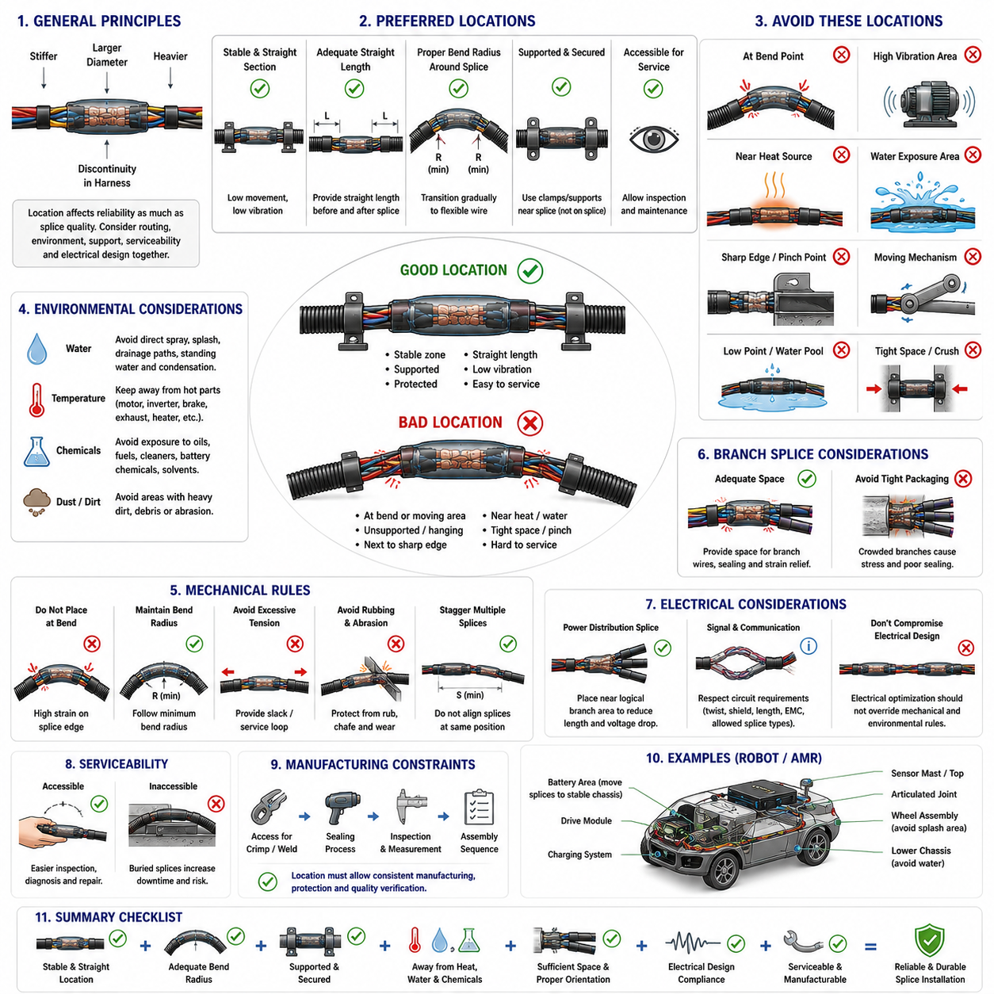
Splice location is a fundamental harness-design decision because a mechanically and electrically sound splice can still fail when installed in an unsuitable environment. The splice creates a local discontinuity in stiffness, diameter, mass, and flexibility compared with the surrounding wire. Its position must therefore be selected together with routing, environmental protection, mechanical support, serviceability, and electrical architecture.
A preferred splice location is generally a stable section of the harness where movement, bending, vibration, heat, moisture, and mechanical loading are relatively low. The surrounding harness should provide enough straight length to support the splice and its protective covering without forcing the conductor into an abrupt bend. Selecting a mechanically quiet region reduces stress on both the conductor joint and the insulation transition.
Splices should not normally be placed directly at bend points. A crimped, welded, or environmentally sealed splice is considerably stiffer than an ordinary wire section, and repeated bending near its edge concentrates strain where the flexible conductor enters the rigid joint. Over many operating cycles, this localized strain can cause strand fatigue, insulation cracking, increased electrical resistance, or eventual conductor failure.
Minimum bend radius requirements should therefore be considered around every splice. The harness should transition gradually from the relatively rigid splice region into the flexible wire rather than immediately changing direction. Additional routing space may be required to achieve this geometry, especially when a splice includes heat-shrink tubing, molded protection, or several branch wires that increase the effective diameter and stiffness of the assembly.
High-vibration zones should also be avoided whenever practical. Locations near motors, gearboxes, wheel assemblies, pumps, compressors, actuators, and structural interfaces can transmit continuous vibration into the harness. If a splice must be installed in such an area, mechanical support should prevent the splice mass from moving independently and transferring cyclic loads into the conductor exits.
Harness clamps and supports must be positioned with the splice in mind. A clamp can stabilize the harness near a splice, but placing the clamp directly over the electrical joint may produce excessive compression or interfere with environmental protection. The support arrangement should restrain harness movement while allowing the splice and its sealing components to remain mechanically undamaged and free from unintended concentrated loads.
Splices should be kept away from sharp edges, pinch points, moving mechanisms, and locations where adjacent structures can rub against the harness. The increased diameter of a splice can reduce clearance that was adequate for the original wire bundle. Packaging analysis must therefore consider the maximum splice envelope, protective sleeve, manufacturing tolerances, harness movement, and neighboring components rather than only the nominal wire diameter.
High-temperature regions require particular attention because additional splice resistance can generate localized heat while external heat sources simultaneously increase conductor temperature. Splices should preferably be separated from motors, inverters, braking components, heaters, exhaust-related surfaces, and other hot structures. Where separation is limited, thermal shielding, higher-temperature materials, or relocation of the splice may be necessary.
Water exposure is another major location criterion. Even when waterproof splice technology is used, the joint should preferably remain away from direct spray, wheel splash, drainage paths, standing water, condensation collection points, and frequently washed areas. Environmental sealing should provide a defense against unavoidable exposure rather than justify positioning a splice at the most severe water-entry location.
Harness orientation should prevent the splice from becoming a natural collection point for liquids. Low sections of a routing path can retain water, while vertical wire sections may guide liquid toward a splice through surface flow or capillary mechanisms. Where possible, routing should promote drainage away from the connection and avoid geometries that repeatedly expose sealing transitions to accumulated moisture.
Chemical exposure should also influence location selection. Cleaning agents, hydraulic fluids, lubricants, battery-related chemicals, fuels, and industrial contaminants may degrade insulation, adhesives, heat-shrink materials, or molded protection. A splice located near such sources requires verified material compatibility and environmental protection, but physical separation from the contamination source remains the preferred first design measure.
Branch splices require sufficient packaging space because multiple outgoing wires create a larger and less flexible local structure. The branch geometry should allow each conductor to leave the splice without severe bending, crossing, or tensile loading. Adequate space is also necessary for sealing materials and strain relief. Compressing a multi-wire branch into a narrow routing channel can undermine an otherwise properly manufactured joint.
Splice locations should be coordinated with harness breakout points. A splice positioned immediately at a breakout can create a combination of stiffness transition, wire separation, bending, and tensile loading in the same small region. Providing appropriate distance between the electrical joint and the mechanical breakout allows loads to be distributed gradually and makes the harness easier to manufacture, inspect, protect, and install.
Electrical architecture can also affect splice placement. Power-distribution splices should be positioned so that conductor lengths, voltage drop, current loading, fuse coordination, and downstream branch routing remain consistent with the intended circuit design. Locating a distribution splice close to the logical branching region can reduce unnecessary conductor length, but electrical optimization should not override mechanical or environmental restrictions.
Signal and communication circuits require additional consideration because splice geometry can alter electrical characteristics. Sensitive sensor lines, differential communication pairs, shielded cables, and high-speed networks may have specific restrictions on allowable splices or on the distance over which twisting and shielding can be interrupted. Splice placement must therefore respect the electrical requirements of the particular circuit rather than applying power-wire rules universally.
Serviceability should be considered when determining whether a splice should remain accessible. A splice buried deep inside a large harness bundle, inaccessible chassis cavity, or permanently enclosed structure can make fault diagnosis and repair difficult. However, accessibility should not result in placement within an exposed or mechanically vulnerable area. The design must balance protection, packaging, inspection, and realistic maintenance requirements.
Manufacturing constraints also influence acceptable splice locations. The harness assembly process must provide enough access for crimping, ultrasonic welding, sealing, inspection, and dimensional verification. A theoretically ideal vehicle or robot location may create manufacturing difficulty if the splice cannot be produced or protected consistently. Harness-board layout and assembly sequence should therefore be reviewed together with the final installed routing.
Multiple splices should generally not be concentrated at exactly the same longitudinal position within a harness bundle. Stacking several joints can create a large local increase in diameter and stiffness, making routing and protective covering difficult. Staggering splice positions distributes the packaging volume and mechanical discontinuities along the harness, while the required separation should be defined according to the harness construction and installation constraints.
For mobile robots and AMRs, splice-location engineering is particularly important around drive modules, steering assemblies, suspension interfaces, batteries, charging systems, sensor masts, and articulated mechanisms. These regions can combine vibration, repeated motion, water exposure, heat, and restricted packaging. Splices should preferably be transferred into stable chassis regions and connected to moving equipment through appropriately supported flexible harness sections.
The final splice location should therefore be validated as part of the complete harness installation rather than from a two-dimensional wiring diagram alone. Engineers should evaluate the actual routing path, bend radius, clearance, vibration source, temperature, water exposure, support points, service access, and assembly sequence. A robust location is one where the splice remains electrically stable, mechanically protected, environmentally controlled, manufacturable, and serviceable throughout the robot's operating life.

07.05. Splice Quality Inspection
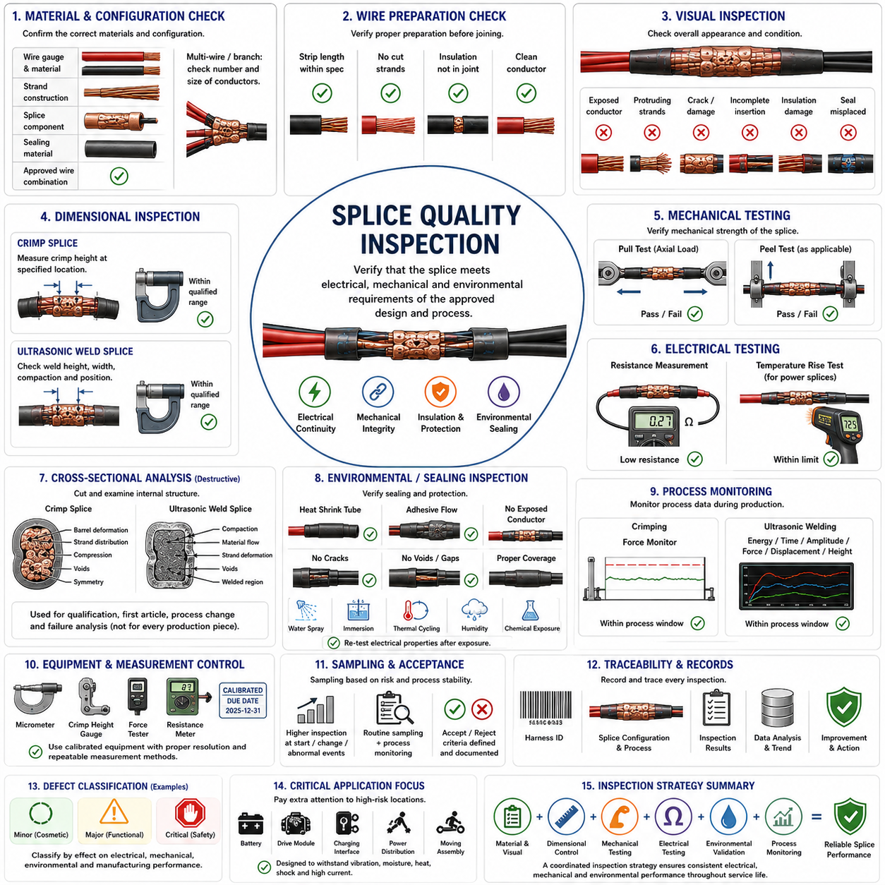
Splice quality inspection is the systematic process used to verify that an electrical splice has been manufactured according to its approved design and process requirements. Because a splice becomes a permanent part of the wire harness current path, inspection must evaluate electrical continuity, mechanical integrity, conductor condition, geometry, insulation protection, and environmental sealing rather than relying on external appearance alone.
Inspection begins with confirmation that the correct materials and configuration have been used. Wire gauge, conductor material, strand construction, splice component, sealing material, and approved wire combination should match the applicable engineering specification. For multi-wire and branch splices, inspectors must also confirm that the number and sizes of conductors correspond to the qualified configuration rather than merely fitting physically inside the joint.
Wire preparation should be examined because many splice defects originate before the actual joining operation. Strip length must remain within specification, conductor strands should not be cut or excessively nicked, and insulation should not extend into an unintended electrical joining region. Exposed strands should also remain free from contamination, severe oxidation, excessive separation, or deformation that could compromise subsequent crimping or ultrasonic welding.
Visual inspection provides the first practical indication of process quality. The finished splice should have the expected shape, alignment, conductor insertion, insulation position, and protective coverage. Inspectors should look for exposed conductor, protruding strands, cracked components, abnormal deformation, incomplete insertion, damaged insulation, displaced sealing materials, or evidence that the joint was produced outside the intended tooling position.
For crimp splices, crimp height is a critical dimensional characteristic because it reflects the amount of compression applied to the conductor bundle. Measurements should be taken using the specified method and calibrated equipment at the defined location on the crimp. A value above the qualified range may indicate insufficient compression, while an excessively low value can indicate over-compression, strand damage, or abnormal barrel deformation.
Crimp width, symmetry, barrel closure, conductor position, and other dimensional characteristics may also be inspected when required by the process specification. Dimensional inspection is most meaningful when limits are established for the exact combination of splice component, conductor size, and tooling. Generic dimensional acceptance criteria should not replace the validated limits established during engineering and manufacturing qualification.
Ultrasonic weld splices require different geometric indicators because no separate metal barrel surrounds the conductor bundle. Weld height, width, compaction, conductor position, and surface condition can be monitored to determine whether the ultrasonic process produced the intended joint geometry. Abnormal thinning, excessive flash, strand separation, incomplete compaction, or visible conductor damage can indicate unsuitable energy, force, positioning, or tooling conditions.
Mechanical testing evaluates whether the splice can withstand loads expected during manufacturing, installation, and service. Pull-force testing applies an axial load to the wire and splice, while peel testing may be appropriate for certain welded or branch configurations. The test result should be compared with qualified acceptance criteria, and the location and mode of failure should be recorded because failure behavior can reveal important information beyond the maximum measured force.
Electrical resistance measurement verifies that the splice provides a low-resistance current path. A mechanically strong connection can still contain poor electrical interfaces, contamination, insufficient compression, or incomplete bonding. Resistance measurements are especially important for high-current battery, motor, charging, and power-distribution circuits because a small increase in splice resistance can produce significant localized I²R heating during operation.
Temperature-rise testing can provide additional validation for power splices. Representative current is passed through the connection while splice temperature and surrounding conductor temperature are monitored. Excessive localized heating may indicate abnormal electrical resistance or insufficient conductor contact. Testing should reproduce realistic current, ambient temperature, bundling, enclosure, and airflow conditions when thermal performance is critical to the application.
Cross-sectional analysis is one of the most informative destructive inspection methods. A splice sample is sectioned, prepared, and examined to reveal the internal conductor arrangement and joint structure. For crimped connections, the section can show strand distribution, barrel deformation, compression, voids, and symmetry. For ultrasonic welds, it can reveal compaction, material flow, internal voids, strand deformation, and the quality of the bonded region.
Cross-section results are particularly valuable during initial process qualification, tooling setup, first-article inspection, process changes, and failure investigation. They can reveal internal defects that cannot be detected from the exterior. However, because sectioning destroys the inspected sample, cross-sectional analysis is normally applied according to a sampling or qualification plan rather than being used as a production inspection method for every splice.
Waterproof splices require inspection of the environmental protection in addition to the internal electrical joint. Heat-shrink tubing should be fully recovered and correctly positioned, adhesive flow should provide evidence of complete sealing, and no exposed conductor or obvious leakage path should remain. Molded or sleeved protection should be examined for cracks, voids, incomplete coverage, deformation, or damage near wire-entry transitions.
Environmental validation can extend beyond visual inspection when the splice is intended for wet or contaminated locations. Water spray, immersion, thermal cycling, humidity exposure, chemical exposure, or other application-specific tests may be performed according to the qualification plan. Electrical resistance and insulation condition should be evaluated after exposure to confirm that environmental protection preserves rather than merely covers the electrical connection.
Process monitoring provides another layer of quality assurance by detecting manufacturing variation before defective splices reach final inspection. Crimping equipment may monitor force or related process characteristics, while ultrasonic welders can record energy, weld time, amplitude, displacement, force, and final height. Comparing these values with qualified process windows helps identify missing conductors, incorrect positioning, tooling wear, contamination, and gradual process drift.
Inspection equipment itself must remain controlled. Micrometers, crimp-height gauges, force testers, resistance measurement equipment, and other instruments should have suitable resolution and calibration for the characteristics being measured. An inspection result is only meaningful when the measurement method is repeatable and traceable, so calibration status, measurement location, test setup, and operator method should be defined within the quality system.
Sampling plans should reflect the risk and stability of the splice process. Initial production, tooling changes, new conductor combinations, maintenance events, or abnormal process-monitoring results may justify increased inspection frequency. Once process capability has been demonstrated, production inspection can combine appropriate sampling with automated monitoring. Safety-critical or high-current connections may require more stringent verification than low-risk auxiliary circuits.
Defects should be classified according to their effect on electrical, mechanical, environmental, and manufacturing performance. A cosmetic variation that does not affect function should not automatically be treated the same as strand damage, high resistance, inadequate weld bonding, or incomplete waterproof sealing. Clear acceptance and rejection criteria reduce subjective decisions and allow inspectors, manufacturing engineers, and design engineers to evaluate splices consistently.
Traceability is essential when splice quality affects robot reliability or safety. Inspection records should identify the relevant harness, splice configuration, production process, tooling or equipment where required, inspection results, and disposition of nonconforming parts. Process data can then be correlated with field failures or production trends, allowing recurring defects and gradual deterioration to be identified systematically.
For mobile robots and AMRs, splice inspection should reflect the severe combination of vibration, repeated motion, thermal cycling, moisture, shock, and high-current operation that may occur in service. Splices associated with batteries, drive modules, charging interfaces, power distribution, and moving assemblies deserve particular attention because degradation at these locations can cause voltage loss, intermittent faults, overheating, or complete loss of function.
Effective splice quality inspection therefore combines material verification, visual examination, dimensional control, mechanical testing, electrical measurement, destructive analysis, environmental validation, process monitoring, and traceability. No single inspection method can demonstrate every aspect of splice quality. A coordinated inspection strategy ensures that the manufactured joint reproduces the electrical, mechanical, and environmental performance established during engineering qualification.

