Volume 02. Wire Harness Engineering

Chapter 08. Routing Engineering

08.01. Routing Path Principles
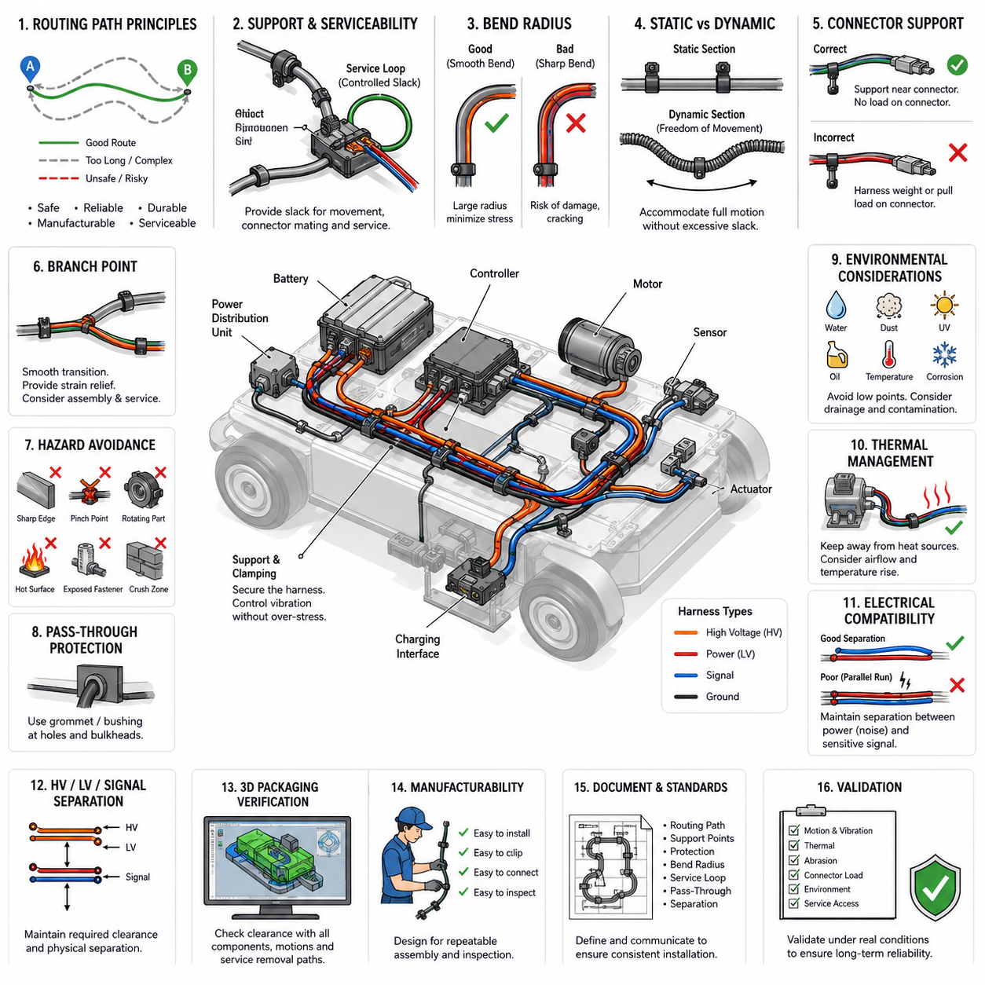
Routing a wire harness begins with defining a path that supports electrical performance, mechanical durability, manufacturability, and serviceability throughout the product life cycle. The shortest geometric route is not automatically the best route. A practical path must avoid hazards, respect packaging constraints, accommodate assembly variation, and maintain sufficient clearance from structures that can damage the harness.
The routing process should begin from fixed electrical interfaces such as batteries, power distribution units, controllers, sensors, actuators, motors, and charging components. These interfaces establish the principal endpoints, while intermediate routing points are selected according to mechanical structure and available packaging corridors. The resulting path should be predictable, mechanically supported, and compatible with installation and removal procedures.
Harness routing should preferably follow stable structural members rather than crossing open spaces without support. Frames, chassis rails, panels, brackets, and dedicated cable channels can provide natural routing references. Using these structures reduces uncontrolled movement and makes clamp placement more systematic. However, contact with structural edges must be controlled because repeated vibration against even a moderately sharp surface can gradually damage insulation.
A fundamental routing principle is to minimize unnecessary changes in direction. Excessive bends increase harness length, installation complexity, friction during assembly, and mechanical stress near attachment points. Smooth transitions with sufficiently large bend radii are preferable to abrupt corners. The minimum allowable bend radius depends on conductor construction, cable diameter, insulation material, shielding, temperature, and whether the cable is static or repeatedly flexed.
Routing must distinguish between static sections and dynamic sections. A harness attached to a rigid frame can normally be constrained relatively firmly, while wiring connected to steering assemblies, suspension elements, articulated joints, movable sensors, or serviceable modules requires controlled freedom of movement. Dynamic sections must provide enough length for the full motion envelope without creating excessive slack that can become trapped or abraded.
Service loops and controlled slack should therefore be introduced intentionally rather than appearing as accidental excess wire. Proper slack accommodates connector mating, manufacturing tolerances, component movement, and maintenance access. Too little slack transfers tensile force directly into terminals and connectors, while excessive slack can create uncontrolled loops that contact rotating parts, hot surfaces, sharp structures, or other harness branches.
Harness support points should control mass and vibration without concentrating stress. Clamps, clips, ties, channels, and brackets maintain the intended route and prevent the cable bundle from developing large vibration amplitudes. Support spacing should reflect harness mass, bundle stiffness, orientation, vibration environment, and local acceleration. Heavy connectors or branch points may require additional support because their concentrated mass increases dynamic loading.
Connectors should not normally be used as mechanical supports for the harness. The routing arrangement should prevent harness weight, vibration, or pulling force from being continuously transferred into connector terminals or mating interfaces. Where practical, a support point should be located near a connector while preserving sufficient free length for mating and service. This approach improves terminal stability and reduces fretting-related electrical problems.
Branch points require particular attention because they change bundle geometry and redistribute mechanical loads. A branch should leave the main trunk through a smooth transition rather than a sharp fold. The routing direction should match the natural destination of the branch, and adequate strain relief should be provided. Branch locations should also remain compatible with harness-board manufacturing, vehicle or robot assembly sequence, inspection, and field replacement.
The route must avoid predictable mechanical hazards such as sharp edges, pinch points, crushing zones, exposed fastener threads, rotating shafts, gears, fans, wheels, belts, chains, and moving linkages. When complete avoidance is impossible, additional protection such as sleeves, conduits, edge guards, grommets, or rigid channels may be required. Protective materials supplement good routing practice but should not be treated as substitutes for eliminating hazards.
Routing through holes, bulkheads, panels, or structural partitions requires protection against edge contact and relative movement. Grommets, bushings, sealed pass-through devices, or suitable conduit interfaces can isolate the harness from the penetration boundary. The design should consider not only the nominal installed position but also manufacturing tolerance, vibration displacement, connector manipulation, and possible movement during maintenance operations.
Environmental exposure must be considered along the entire routing path. Water, dust, mud, oil, hydraulic fluid, cleaning chemicals, salt, ultraviolet radiation, and condensation can affect insulation, protection materials, connectors, and attachment devices. Low points where water can collect should be minimized, and routing near exposed exterior regions should account for splash direction, drainage, pressure washing, and contamination accumulation.
Temperature is another major path-selection constraint. Harnesses should be routed away from motors, inverters, braking components, heaters, exhaust systems, power electronics, and other heat sources whenever practical. Local temperature can be substantially higher than the general ambient temperature. Routing decisions must therefore consider radiant heating, conductive contact, restricted airflow, operating duty cycle, and temporary thermal peaks rather than ambient temperature alone.
Electrical compatibility also influences the physical route. Power conductors, motor phase cables, switching power electronics, communication lines, encoder wiring, and low-level sensor signals can have different electromagnetic characteristics. Routing should create a physical architecture that enables the required separation and shielding strategy. Parallel runs between noisy power circuits and sensitive signal circuits should be controlled, especially when long common routing distances are involved.
High-voltage and low-voltage harnesses should be treated as distinct routing systems where required by the electrical architecture. Their paths must support identification, protection, maintenance safety, and suitable physical separation. High-voltage routing should also consider possible crash, impact, abrasion, and service hazards. The path should avoid locations where ordinary maintenance operations could unintentionally damage or disturb energized high-voltage wiring.
In an AMR, routing must reflect the machine's continuous exposure to vibration, repeated acceleration, steering motion, wheel disturbances, and frequent maintenance. Harnesses near drive modules, casters, suspension mechanisms, lift mechanisms, and charging interfaces require particular attention. The route must remain safe across the robot's complete operating configuration rather than only when the robot is stationary in its nominal assembly position.
Three-dimensional packaging verification is essential because a harness that appears acceptable in a two-dimensional drawing may interfere with surrounding hardware after installation. Routing should be evaluated against component envelopes, fastener access, tool paths, covers, moving mechanisms, cooling ducts, and service removal trajectories. Digital mock-up can identify many conflicts, but physical prototype inspection remains valuable for detecting installation behavior that CAD geometry does not represent.
Manufacturing feasibility should be incorporated before the route is frozen. Assemblers must be able to position the harness, install clips, mate connectors, verify locking features, and perform inspection without excessive force or complicated manipulation. Routing that requires severe twisting or precise threading through inaccessible spaces increases assembly time and defect probability. Good routing therefore balances packaging efficiency with repeatable human or automated installation.
The routing definition should include sufficient design information to reproduce the intended installation. Important characteristics include routing corridors, attachment locations, branch orientation, protected zones, bend conditions, service loops, pass-through points, and interfaces with moving structures. Critical restrictions should be reflected in drawings, CAD data, harness-board information, work instructions, or engineering standards so that the designed path is preserved during production.
Final validation should examine the harness in realistic operating conditions rather than judging routing only by visual appearance. Inspection should consider full mechanism motion, vibration, thermal expansion, connector loading, abrasion potential, service access, and environmental exposure. Evidence of rubbing, tension, uncontrolled movement, excessive bending, or contact with hazardous components indicates that the route or its supporting protection requires modification.
A robust routing path is ultimately a controlled mechanical system for electrical conductors. It coordinates geometry, support, motion, environment, electrical separation, assembly, and maintenance so that wires remain within their intended operating conditions throughout the machine's life. Establishing these principles at the beginning of routing engineering provides the foundation for later detailed rules concerning separation distance, thermal zones, vibration zones, and LV/HV/signal segregation.

08.02. Separation Distance Rules
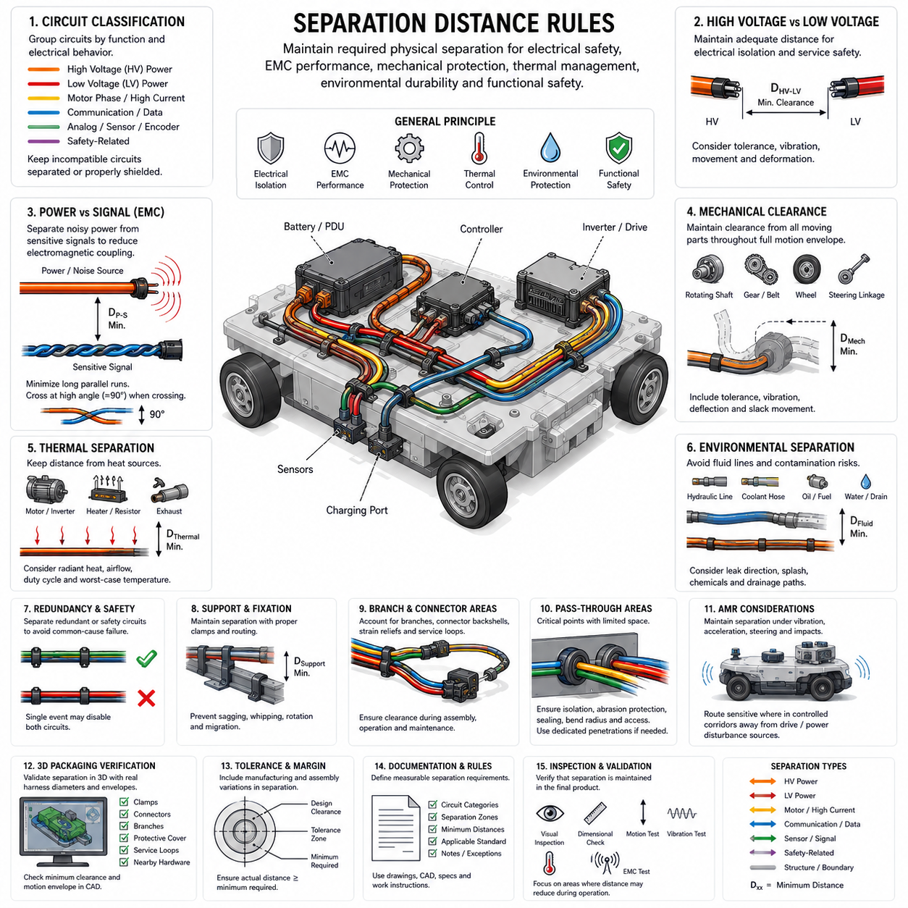
Separation distance in wire harness routing is the controlled physical spacing maintained between electrical circuits, mechanical structures, heat sources, moving components, and other potential hazards. The required distance is not a single universal value. It depends on voltage level, current, signal sensitivity, electromagnetic environment, insulation system, mechanical motion, temperature, contamination, and the consequences of possible contact or interference.
Electrical separation begins by classifying circuits according to their function and electrical behavior. High-voltage power, low-voltage power, motor phases, switched loads, communication networks, analog sensors, encoders, and safety-related signals can require different routing treatment. Circuits with similar characteristics may share routing corridors, while electrically incompatible circuits should be separated or provided with appropriate shielding and protective measures.
High-voltage (HV) and low-voltage (LV) wiring should normally maintain deliberate physical separation when the system architecture requires electrical isolation and service safety. The distance must account for normal manufacturing tolerance, vibration, harness movement, connector manipulation, and possible deformation during operation. A nominal CAD clearance is insufficient if the actual installed harness can move enough to eliminate that clearance.
Separation between power wiring and sensitive signal wiring is important for electromagnetic compatibility (EMC). Motor phase cables, inverter outputs, switching power supplies, contactor circuits, and other rapidly changing currents can generate electromagnetic fields that couple into nearby sensor or communication wiring. Increasing physical distance reduces coupling and is therefore one of the most fundamental noise-control techniques available to the harness designer.
Long parallel routing between noisy and sensitive circuits should be minimized whenever practical. Electromagnetic coupling generally becomes more significant when conductors remain close and parallel over a long distance. When different circuit classes must cross, a short crossing with a large crossing angle, preferably approaching 90 degrees where packaging allows, can reduce the effective coupling length compared with extended parallel routing.
Distance requirements should be evaluated together with shielding rather than treating the two methods as independent solutions. A shielded cable may tolerate routing conditions that would be unacceptable for an unshielded signal, but shielding does not automatically eliminate the need for separation. Shield termination quality, grounding architecture, cable construction, frequency range, and common-mode current paths determine how effective the shielding actually becomes.
Communication cables such as CAN, CAN FD, Ethernet, encoder links, and other differential interfaces benefit from maintaining their intended cable geometry while being separated from strong noise sources. Twisted-pair construction improves immunity to common electromagnetic disturbances, but routing directly beside inverter outputs or high-current switching conductors can still degrade signal integrity. Physical separation provides an additional layer of robustness.
Mechanical separation is equally important. Harnesses must maintain clearance from rotating shafts, gears, belts, chains, wheels, fans, linkages, steering mechanisms, and other moving components throughout their complete motion envelope. Clearance should be based on worst-case relative position rather than the nominal static condition. Tolerance accumulation, vibration amplitude, structural deflection, wear, and unexpected slack movement should be included in the assessment.
Clearance from sharp edges and abrasive surfaces must prevent insulation contact during both normal operation and foreseeable movement. A harness that appears separated from an edge when stationary may repeatedly strike that edge under vibration. Where adequate distance cannot be maintained, protective measures such as edge guards, sleeves, conduits, grommets, or additional clamps can be introduced to prevent direct mechanical damage.
Thermal separation is required around motors, inverters, braking components, heaters, power resistors, exhaust-related components, and other high-temperature sources. The relevant parameter is the temperature experienced by the harness, not simply the geometric distance from the heat source. Radiant heat, airflow, conductive paths, enclosure temperature, operating duration, and component duty cycle can significantly change the thermal environment.
Increasing distance from a heat source is generally preferable because it reduces thermal exposure without adding material complexity. When packaging limitations prevent sufficient separation, thermal barriers, reflective protection, high-temperature sleeves, or higher-rated insulation may be required. These measures should be validated under realistic worst-case operation because localized temperature peaks may occur only during high-load or abnormal operating conditions.
Harnesses should also be separated from fluid lines and regions where leakage can create electrical or material degradation. Hydraulic lines, coolant hoses, lubrication systems, battery fluids, cleaning chemicals, and water drainage paths can introduce contamination risks. Routing should consider not only normal separation but also the direction in which a leaking or ruptured line could discharge fluid onto nearby electrical components.
Physical separation between redundant or safety-related circuits can prevent a single mechanical event from disabling multiple functions simultaneously. If two redundant power feeds, communication channels, sensor paths, or safety circuits are routed together through the same vulnerable location, one abrasion event, impact, thermal incident, or crushing condition could defeat both channels. Separation can therefore contribute directly to fault independence and system-level reliability.
Attachment points play an important role in preserving designed separation distances. Clamps and clips should maintain the intended relationship between adjacent harnesses and surrounding structures despite vibration and acceleration. A clearance that depends only on the natural stiffness of the cable bundle may disappear during operation. Support locations should therefore be selected to prevent uncontrolled sagging, whipping, rotation, or migration.
Branch points and connector regions require additional consideration because local harness geometry becomes less predictable. Multiple branches may converge near controllers, power distribution units, sensors, or actuators, creating congestion that reduces separation. Connector backshells, strain reliefs, service loops, and mating movements should be included in the packaging envelope so that required clearances remain available during assembly and maintenance.
Pass-through regions can create concentrated separation problems. When several circuit classes pass through a bulkhead, panel opening, cable gland, or conduit, the available routing space may force them closer together. The designer must consider electrical isolation, abrasion protection, environmental sealing, bend radius, and service access simultaneously. Dedicated penetrations may be preferable when incompatible circuits cannot be safely combined.
In an Autonomous Mobile Robot (AMR), separation distances must remain valid under acceleration, braking, steering, wheel impact, chassis vibration, payload changes, and maintenance activity. Drive modules and power electronics create particularly demanding combinations of current, switching noise, heat, and mechanical movement. Sensitive sensor and communication harnesses should therefore be routed through controlled corridors that remain separated from these disturbance sources.
Three-dimensional packaging analysis should verify separation using realistic harness diameters and movement envelopes rather than idealized centerlines. CAD models should include clamps, connectors, branches, protective coverings, service loops, and nearby hardware. Minimum-clearance checks can identify potential interference, but engineering judgment is still necessary because flexible harnesses do not remain perfectly fixed in the geometric position represented by the nominal model.
Manufacturing tolerances must be incorporated into every separation rule. Wire cutting tolerance, branch position tolerance, clip installation variation, connector location variation, structural dimensional variation, and assembly technique can shift the installed harness from its nominal position. The specified design clearance should therefore contain sufficient margin so that production variation does not routinely reduce the actual distance below the acceptable limit.
Separation rules should be documented as measurable engineering requirements rather than subjective instructions such as “keep away” or “route separately.” Drawings, CAD models, harness specifications, and work instructions should identify critical separation zones and the applicable circuit categories. Where a numerical minimum is required, the value should come from the relevant product standard, safety requirement, EMC validation, component specification, or approved internal engineering rule.
Inspection and validation should confirm that the intended separation is preserved in the manufactured product. Visual inspection, dimensional checks, motion tests, vibration tests, thermal measurements, and EMC testing can reveal different failure mechanisms. Particular attention should be given to locations where harnesses move toward each other, approach hot components, contact structures, or change position after repeated operation.
Separation distance is therefore a multidimensional design control rather than simply empty space between wires. It provides electrical isolation, reduces electromagnetic coupling, prevents mechanical interference, limits thermal exposure, supports environmental protection, and can preserve redundancy against common-cause failures. Applied together with routing, shielding, clamping, protective covering, and validation, separation rules form a fundamental part of reliable wire harness engineering.

08.03. High Temperature Zone Countermeasures
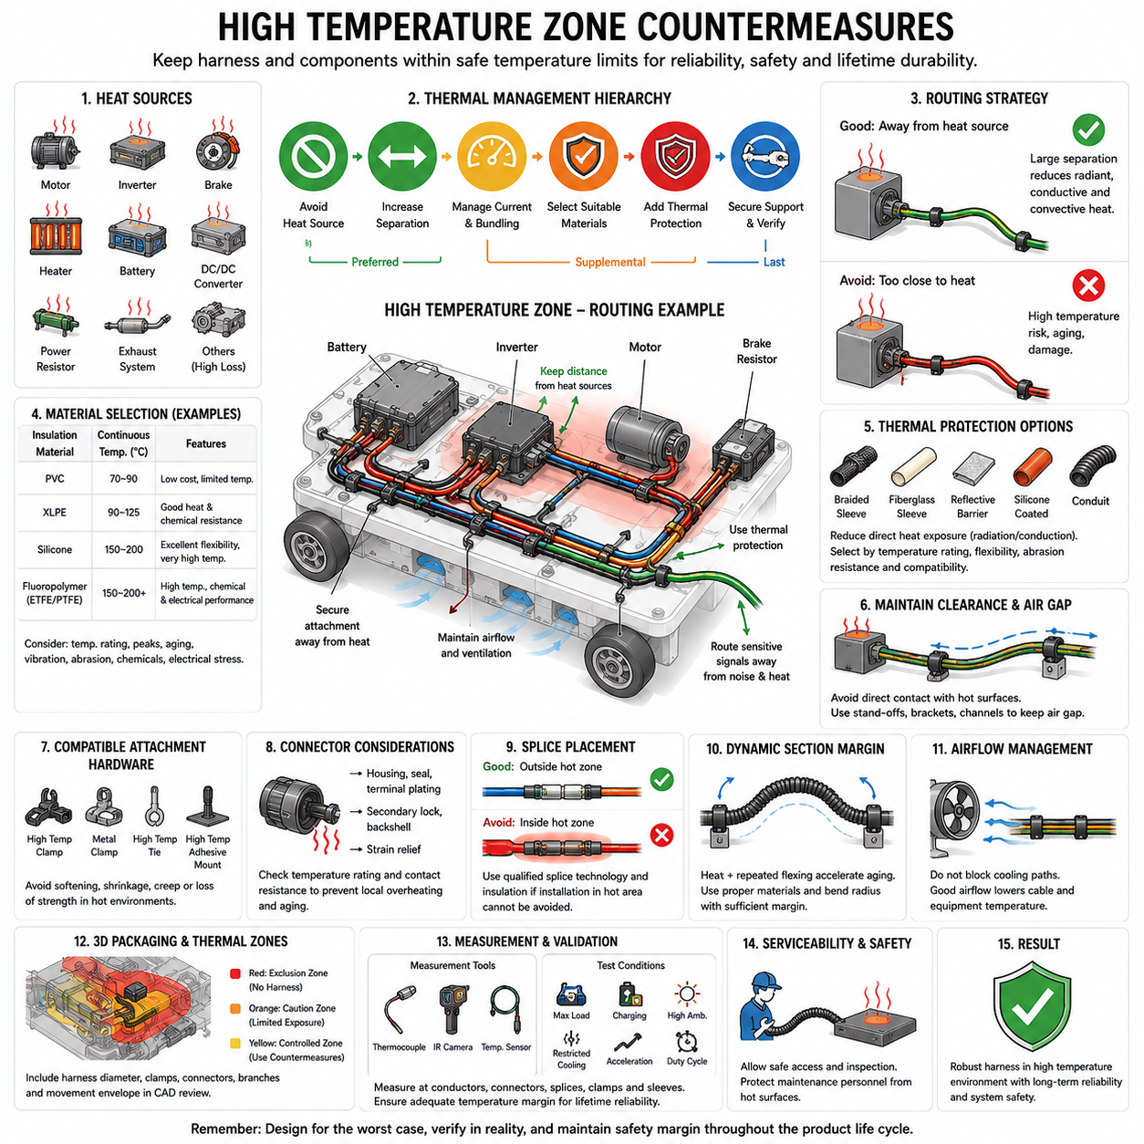
High-temperature zones in a wire harness system are locations where conductors, insulation, connectors, protective coverings, and attachment components may experience temperatures significantly above the general ambient condition. Typical sources include motors, inverters, braking components, power resistors, heaters, batteries, DC/DC converters, exhaust-related equipment, and other high-loss electrical or mechanical devices.
The first countermeasure is avoidance. Whenever packaging permits, the harness should be routed away from the heat source rather than relying immediately on heat-resistant materials. Increasing physical separation reduces radiant, conductive, and convective heat transfer simultaneously. A slightly longer routing path can therefore provide greater lifetime reliability than a short path passing directly through a severe thermal environment.
Thermal routing must be based on the actual temperature experienced by the harness rather than only the rated temperature of the nearby component. Surface temperature, radiant heat, enclosure temperature, airflow, operating duration, duty cycle, load condition, and neighboring heat sources can combine to create localized hot spots. Measurements or validated thermal models should therefore represent realistic worst-case operating conditions.
Wire insulation must be selected according to the maximum expected conductor and environmental temperature. PVC, XLPE, fluoropolymer, silicone, and other insulation systems provide different thermal capabilities and mechanical characteristics. The selected material must tolerate continuous operating temperature, temporary thermal peaks, aging, vibration, abrasion, chemical exposure, and the electrical stress associated with the circuit.
Current loading and external temperature must be considered together because conductor self-heating adds to environmental heating. A cable that operates safely at normal ambient temperature may exceed its allowable temperature when routed near a motor or inverter. High-temperature routing can therefore require current derating, increased conductor cross-sectional area, reduced bundle density, or improved heat dissipation in addition to higher-temperature insulation.
Harness bundling can further increase temperature because neighboring conductors heat one another while restricting airflow. A large bundle routed through a hot zone may experience substantially different thermal behavior from an individual cable exposed to the same ambient temperature. Bundle size, conductor loading diversity, protective sleeves, conduits, and local ventilation should therefore be included in the thermal assessment.
Thermal sleeves and protective coverings provide an additional countermeasure where routing distance alone is insufficient. High-temperature braid, fiberglass-based sleeves, silicone-coated materials, reflective coverings, or other suitable protective systems can reduce direct thermal exposure. Their selection should consider continuous temperature capability, flexibility, abrasion resistance, installation method, contamination, and compatibility with the underlying cable insulation.
Reflective thermal barriers are particularly useful when radiant heat is the dominant mechanism. A barrier positioned between the heat source and harness can reduce radiation without requiring major changes to the electrical architecture. However, a reflective surface may become ineffective if it becomes heavily contaminated or physically damaged, so installation environment, maintenance conditions, orientation, and long-term cleanliness should be considered.
Direct contact with hot structures should be prevented even when the cable insulation has a relatively high temperature rating. Contact creates a concentrated conductive heat-transfer path and can produce local temperatures much higher than the surrounding air. Clamps, stand-offs, brackets, channels, and routing guides can maintain a controlled air gap between the harness and motors, heat sinks, housings, pipes, or other heated surfaces.
Attachment hardware within a high-temperature zone must also be thermally suitable. Plastic clips, cable ties, adhesive mounts, tapes, grommets, and corrugated conduits can lose strength, soften, shrink, become brittle, or creep under sustained temperature. A harness protected by high-temperature insulation can still fail mechanically if its attachment system deteriorates and allows the bundle to move toward a heat source or abrasive structure.
Connectors require special attention because their temperature limits can differ from those of the attached wire. Connector housings, seals, terminal plating, secondary locks, backshells, and strain-relief components may age rapidly under elevated temperature. Contact resistance can also generate additional local heating, creating a feedback mechanism in which poor electrical contact increases temperature and elevated temperature accelerates further degradation.
Splices should preferably be positioned outside severe thermal zones whenever practical. A splice introduces additional conductor interfaces, insulation transitions, and protective materials whose thermal behavior may differ from the continuous wire. If a splice must remain in a hot region, the splice technology, insulation system, sealing material, strain relief, and current-carrying capability should all be qualified for the expected temperature profile.
Routing near motors and inverters requires simultaneous thermal and electromagnetic consideration. Moving a signal harness away from an inverter can reduce both temperature exposure and electromagnetic coupling, while relocating a high-current cable may change voltage drop or packaging requirements. Effective routing therefore requires a system-level compromise among thermal management, EMC, electrical performance, mechanical protection, and serviceability.
Dynamic harness sections require additional margin because repeated flexing can accelerate insulation aging at elevated temperature. Steering assemblies, articulated mechanisms, lift systems, movable sensors, and drive modules may expose cables to heat and mechanical cycling simultaneously. Materials and bend radii that are acceptable in a static hot environment may not provide adequate lifetime performance under continuous flexing.
In an Autonomous Mobile Robot (AMR), drive motors, motor controllers, braking resistors, battery systems, charging interfaces, and onboard computing equipment can create distributed high-temperature zones. The thermal condition also changes with payload, acceleration, floor resistance, operating speed, charging state, and mission duration. Harness design should therefore consider the complete robot duty profile rather than a single steady operating point.
Airflow should be treated as part of the routing environment. A harness positioned in a ventilated region can operate at a lower temperature than an identical harness located inside a stagnant enclosure. Conversely, routing that blocks cooling paths can increase both cable and equipment temperature. Harness packaging should preserve intended ventilation around power electronics, motors, batteries, and thermal management components.
Serviceability must remain practical after thermal protection is added. Sleeves, shields, barriers, and conduits should not prevent connector inspection, harness removal, or fault diagnosis. Maintenance personnel must also be protected from hot surfaces. The routing arrangement should allow safe access while ensuring that thermal protection cannot easily be omitted, displaced, or incorrectly reinstalled during service.
Three-dimensional packaging analysis should identify heat sources and define thermal exclusion or caution zones around them. Harness centerlines alone are insufficient because the complete bundle diameter, protective covering, clamps, connectors, branches, and movement envelope occupy additional space. Thermal zones can be incorporated into CAD reviews so that routing violations are detected before prototype construction.
Thermal simulation can support routing decisions when the environment is complex, but simulation assumptions must reflect realistic heat generation, airflow, contact conditions, and operating duty. Analytical calculations and digital models are most useful when correlated with physical measurements. Thermocouples, temperature sensors, thermal imaging, and instrumented prototypes can reveal local hot spots that simplified models may overlook.
Validation should reproduce demanding operating conditions such as maximum continuous load, repeated acceleration, charging, restricted cooling, elevated ambient temperature, or combinations of these conditions. Temperature should be measured at representative conductors, connectors, splices, clamps, and protective coverings. The objective is not merely to remain below an immediate failure temperature but to preserve adequate margin for aging and production variation.
Thermal aging must be considered because insulation and polymeric components can degrade gradually even when no visible damage occurs during initial testing. Long-term exposure can reduce flexibility, mechanical strength, sealing performance, and dielectric integrity. Temperature margin is therefore an important reliability parameter, and designs operating continuously near material limits should be treated cautiously even if short-duration validation is successful.
High-temperature-zone countermeasures ultimately follow a hierarchy: avoid the heat source where possible, increase separation, control current and bundling, select suitable materials, introduce thermal protection, maintain secure mechanical support, and verify the resulting design under realistic conditions. Combining these measures prevents thermal routing from becoming dependent on a single protective component and creates a more robust wire harness throughout the machine lifetime.

08.04. High Vibration Zone Routing
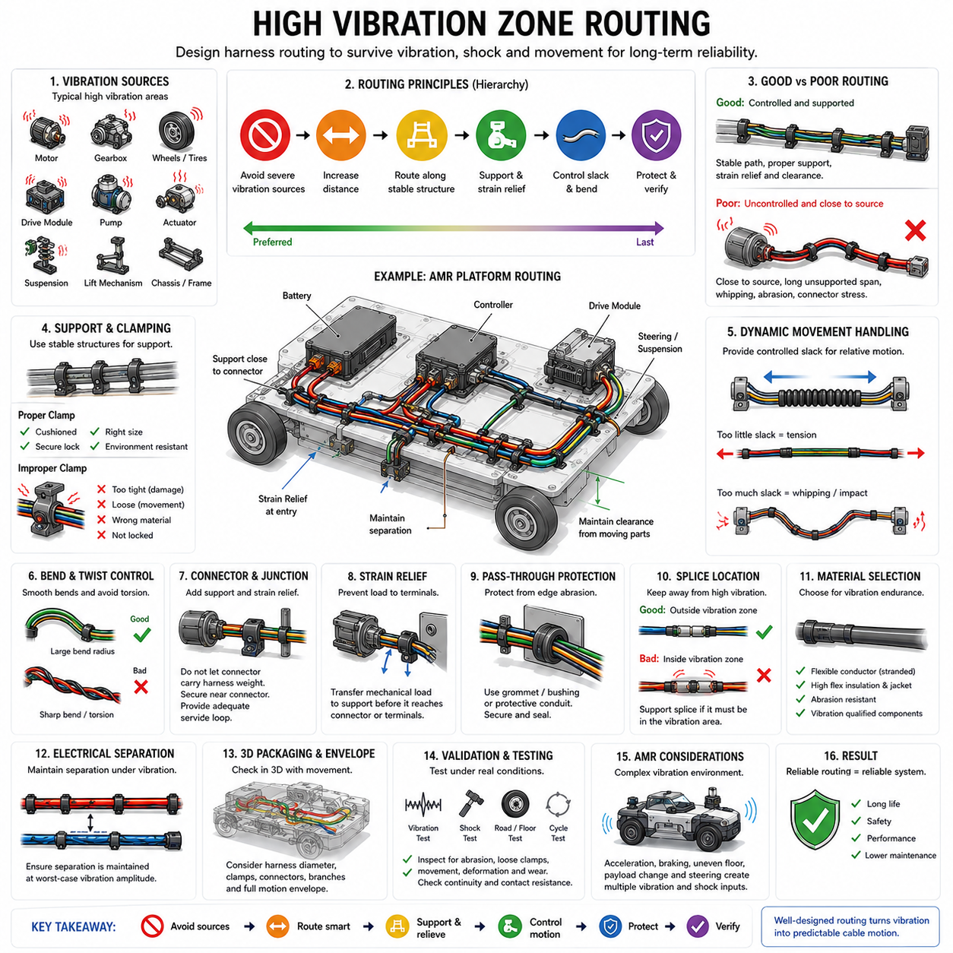
High-vibration zones are regions where a wire harness is repeatedly subjected to oscillation, shock, acceleration, structural movement, or vibration transmitted from motors, wheels, gearboxes, pumps, actuators, and other dynamic equipment. In these locations, routing must prevent relative motion from producing conductor fatigue, insulation abrasion, connector damage, terminal fretting, or progressive loosening of attachment hardware.
The first routing principle is to avoid severe vibration sources whenever practical. Increasing the distance between the harness and a vibrating assembly reduces direct mechanical excitation and simplifies protection. A slightly longer path along a stable chassis or structural member is often preferable to a short path across a motor, gearbox, drive module, suspension element, or other component generating continuous vibration.
Vibration severity should be evaluated from the actual operating environment rather than inferred only from the component type. Frequency, amplitude, acceleration, shock level, operating speed, structural resonance, mounting stiffness, payload, and road or floor conditions can significantly change harness loading. Measurements using accelerometers or validated dynamic models can help identify locations where additional routing controls are necessary.
A harness should normally be supported by stable structural members so that vibration does not create uncontrolled movement. Frames, chassis rails, rigid brackets, and dedicated routing channels provide predictable reference points for clamps and clips. Support should constrain the bundle sufficiently to prevent whipping and impact while avoiding excessive restriction that transfers concentrated bending loads into the conductors.
Clamp spacing is an important parameter in vibration-resistant routing. Excessive distance between supports allows the harness to develop larger vibration amplitudes, while supports positioned too closely can create unnecessary stiffness and local stress concentration. Appropriate spacing depends on bundle mass, cable stiffness, routing orientation, vibration spectrum, attachment strength, connector mass, and the presence of branches or protective coverings.
Clamps should secure the harness without crushing insulation or restricting necessary movement. Cushion clamps, appropriately designed clips, and vibration-resistant brackets can distribute mechanical loads over a larger area. The selected attachment device must remain locked under repeated acceleration and should be compatible with temperature, chemicals, moisture, dust, and other environmental conditions encountered during the product lifetime.
Heavy connectors, junctions, splices, and branch points require additional support because concentrated mass increases inertial loading during vibration. A connector should not carry the dynamic weight of an unsupported harness. Where practical, the bundle should be secured close to the connector while retaining sufficient free length for mating, tolerance, and service. This reduces terminal loading and helps prevent fretting at electrical contacts.
Strain relief is essential where the harness enters connectors, enclosures, sensors, motors, and other components. The routing arrangement should transfer mechanical loads into suitable supports before those loads reach terminals or conductor-to-terminal interfaces. Without effective strain relief, repeated small movements can gradually fatigue conductor strands or weaken crimps even when the external insulation appears undamaged.
Bend geometry should remain smooth in high-vibration regions. Sharp bends concentrate cyclic strain in a small section of conductor and insulation, accelerating fatigue. Bend radius should therefore include margin beyond the minimum static installation requirement when repeated motion is expected. The cable should also be prevented from bending repeatedly at exactly the same point immediately adjacent to a rigid clamp or connector.
Controlled slack is required when relative motion exists between two structures. Too little slack places the harness under tension as components move, while excessive slack allows whipping, impact, entanglement, and abrasion. The objective is a defined motion profile in which the cable flexes gradually through an intended region rather than moving unpredictably throughout the installation.
Dynamic sections should be designed differently from static sections. Wiring connected to steering mechanisms, suspension systems, articulated joints, lift mechanisms, movable sensors, or drive modules must accommodate repeated displacement throughout the full motion envelope. The harness should be routed so that bending, twisting, and extension remain controlled under every expected operating position, including mechanical tolerance and structural deflection.
Torsional loading should be minimized because repeated twisting can damage conductors even when the cable maintains an acceptable bend radius. When two connected components rotate relative to each other, the routing geometry should distribute rotation over sufficient cable length or use an appropriate flexible cable-management solution. The design should avoid forcing all angular displacement into a short section near a connector.
Abrasion protection becomes particularly important when vibration can bring the harness close to surrounding structures. Sleeves, braided protection, conduits, edge guards, grommets, and protective channels can provide additional resistance to rubbing. However, protection should complement proper clearance and fixation rather than justify continuous contact between the harness and an abrasive or sharp surface.
Pass-through locations require careful treatment because vibration can cause repeated rubbing against hole edges, bulkheads, and panels. Grommets, bushings, sealed pass-through devices, or suitable protective conduits should isolate the cable from structural edges. The protection itself must remain securely positioned, because a displaced grommet can expose the harness to concentrated abrasion at precisely the location where movement is greatest.
Harness materials should be selected for combined electrical and mechanical endurance. Conductor strand construction, insulation flexibility, jacket material, shielding, braid structure, and protective coverings influence fatigue resistance. A cable suitable for a static installation may not provide adequate life under continuous vibration or flexing, even when its voltage, current, and temperature ratings appear sufficient.
Splices should preferably be located away from the most severe vibration regions. A splice can create a locally stiff section where conductor geometry and protective covering differ from the surrounding cable. If installation in a vibrating area cannot be avoided, the splice should be properly supported and strain relieved so that cyclic bending does not concentrate directly at the electrical joint or insulation transition.
Electrical separation must remain valid under vibration. Power cables, motor phases, communication lines, and sensitive sensor wiring that are properly separated in the nominal installation may move toward one another during operation. Clamp positions and routing corridors should therefore preserve required separation under worst-case vibration amplitude, preventing both electromagnetic compatibility problems and physical contact between adjacent harnesses.
In an Autonomous Mobile Robot (AMR), drive modules, wheels, casters, suspension elements, lift mechanisms, motors, and payload structures can generate complex vibration environments. Floor joints, thresholds, uneven surfaces, rapid acceleration, emergency braking, and payload variation can introduce transient shocks beyond normal steady vibration. Harness routing should therefore consider both repetitive vibration and occasional high-energy mechanical events.
Drive-module harnesses are particularly demanding because they can experience vibration, steering motion, motor-generated heat, electromagnetic noise, and repeated mechanical displacement simultaneously. Power, communication, encoder, and safety wiring must remain mechanically controlled throughout the steering and suspension envelope. Routing should prevent contact with wheels, rotating shafts, gears, and other moving components under all allowable configurations.
Three-dimensional packaging analysis should include realistic movement envelopes rather than evaluating only nominal harness geometry. CAD reviews should represent bundle diameter, clamps, connectors, branches, service loops, surrounding hardware, and expected component motion. Areas where a flexible harness approaches a structural edge or moving component require additional margin because vibration can consume apparently adequate static clearance.
Prototype validation should reproduce realistic vibration and shock conditions while the harness is installed in its production-intent configuration. Inspection should look for abrasion marks, clamp migration, connector movement, insulation deformation, loose attachments, excessive whipping, and localized bending. Electrical continuity and contact resistance can also be monitored because mechanical degradation may develop before obvious external damage becomes visible.
Validation should consider accumulated life rather than only short-duration survival. Repeated low-amplitude vibration can cause fatigue, fretting, and wear over thousands or millions of cycles even when individual events appear harmless. Accelerated vibration testing, motion cycling, road or floor testing, and post-test inspection can help determine whether the routing maintains adequate mechanical and electrical integrity throughout the intended service life.
High-vibration-zone routing therefore depends on controlling where and how the harness is allowed to move. The preferred hierarchy is to avoid severe vibration sources, route along stable structures, provide suitable support and strain relief, control slack and bend geometry, protect against abrasion, and validate the complete installation dynamically. These measures transform uncontrolled vibration into predictable cable motion and improve long-term harness reliability.

08.05. LV/HV Signal Separation
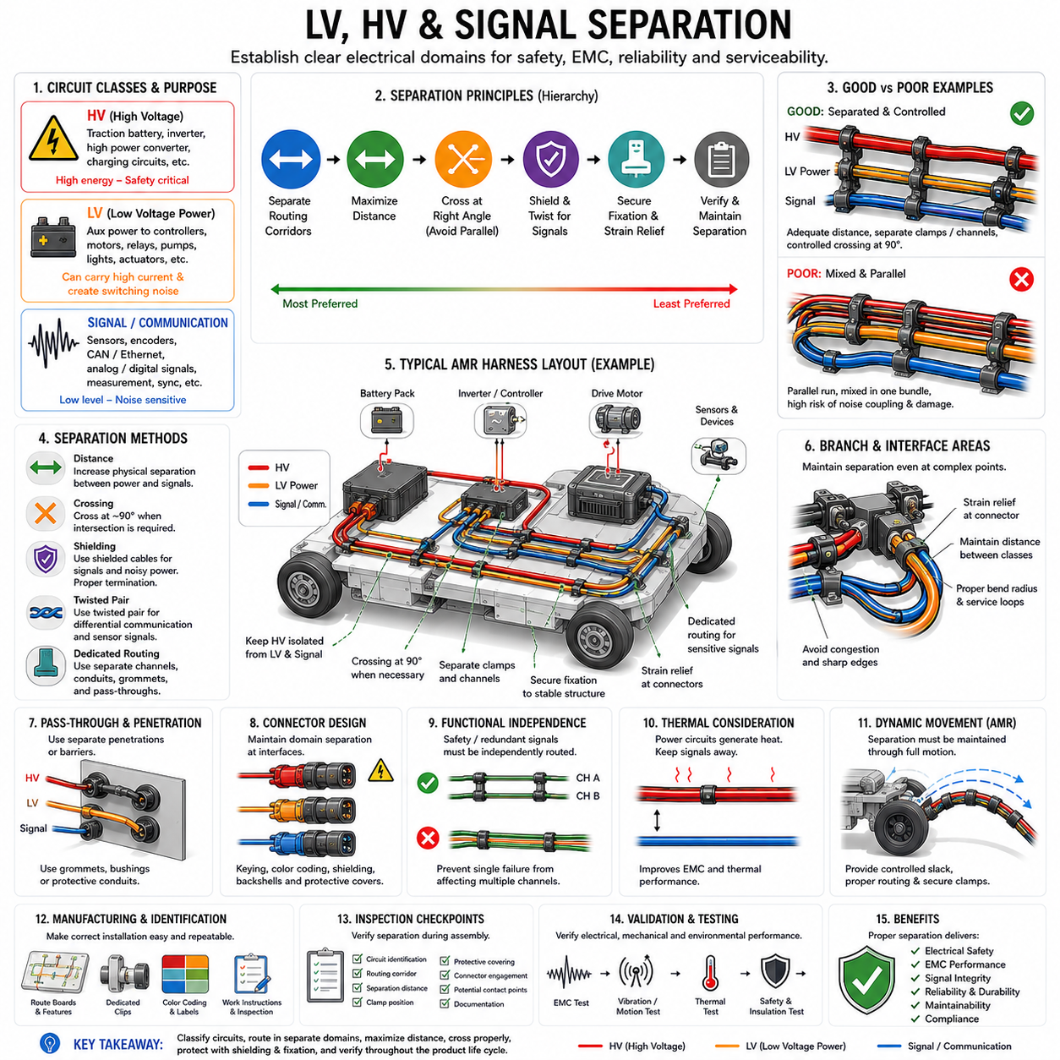
Low-voltage (LV), high-voltage (HV), and signal circuits should be treated as distinct electrical routing classes because they perform different functions and create different safety, electromagnetic, and reliability requirements. Separation is therefore not merely a packaging preference. It establishes controlled electrical domains within the harness architecture and reduces the probability that one circuit class will adversely affect another.
LV circuits commonly distribute auxiliary power to controllers, sensors, actuators, relays, communication devices, lighting, and other electronic equipment. Although their voltage is relatively low, these circuits can still carry substantial current and generate switching transients. LV power wiring should therefore be distinguished from low-level signal wiring, particularly when supplying motors, solenoids, contactors, pumps, or other rapidly switched loads.
HV circuits require more restrictive routing because their consequences of insulation failure, accidental contact, or mechanical damage can be severe. Battery traction lines, inverter feeds, high-power converters, charging circuits, and similar conductors should follow clearly defined routing corridors. Their placement must support electrical isolation, mechanical protection, identification, inspection, service safety, and prevention of unintended interaction with LV and signal circuits.
Signal circuits include analog sensors, encoders, communication networks, measurement channels, synchronization lines, and other information-carrying conductors. Many operate with relatively small voltage or current levels and can therefore be sensitive to electromagnetic disturbances. Signal integrity depends not only on cable construction and communication protocol but also on the physical relationship between signal wiring and surrounding power circuits.
The basic separation principle is to avoid routing HV, noisy LV power, and sensitive signal wiring as one uncontrolled bundle. When packaging permits, separate routing corridors should be established according to circuit class. Dedicated clamps, channels, conduits, pass-throughs, and branch locations can preserve this separation throughout assembly and operation rather than relying on the natural position of flexible cables.
Physical distance is one of the most effective methods for reducing electromagnetic coupling. High-current conductors and rapidly switched circuits generate electric and magnetic fields that decrease in influence as separation increases. Increasing the distance between power and signal cables can therefore improve electromagnetic compatibility (EMC) without changing the electrical circuit itself, making routing geometry an important part of EMC design.
Motor phase cables and inverter outputs deserve particular attention because rapid voltage and current transitions can create strong electromagnetic disturbances. Sensitive analog signals, encoder wiring, communication cables, and low-level measurement circuits should not normally follow these conductors over long parallel distances. The routing architecture should reduce both proximity and common parallel length whenever packaging permits.
When power and signal cables must cross, a short crossing at a relatively large angle is preferable to a long parallel run. A crossing angle approaching 90 degrees can reduce the length over which electromagnetic coupling occurs. This rule does not eliminate the need for appropriate cable construction or shielding, but it provides a useful geometric countermeasure when different electrical domains must intersect within a constrained packaging region.
Shielding and separation should be designed together. Shielded signal cables can improve immunity to external electromagnetic fields, while shielded power cables can reduce emitted disturbances. However, shielding effectiveness depends on cable construction, shield coverage, grounding strategy, termination quality, connector design, and operating frequency. A shield should therefore not be used as an automatic justification for eliminating physical separation.
Twisted-pair wiring provides another important defense for differential communication and sensing circuits. CAN, CAN FD, Ethernet, encoder interfaces, and similar differential links benefit from controlled conductor geometry that reduces susceptibility to common electromagnetic interference. Even with twisted pairs, however, unnecessary proximity to inverter outputs, motor phases, switching converters, or high-current LV conductors should be avoided.
HV and LV separation also serves electrical safety rather than EMC alone. Mechanical damage that simultaneously affects HV and LV wiring can potentially transfer hazardous voltage into circuits that are not designed to withstand it. Maintaining independent routing paths, suitable barriers, and protected pass-through regions can reduce the probability of cross-domain faults caused by abrasion, crushing, impact, contamination, or connector damage.
Mechanical fixation is essential for preserving separation. A CAD model may show adequate clearance between HV, LV, and signal harnesses, but flexible bundles can sag, rotate, whip, or migrate during operation. Clamps and clips should therefore maintain the intended spatial relationship under vibration, acceleration, thermal expansion, service manipulation, and manufacturing variation rather than allowing separation to depend only on cable stiffness.
Branch points require careful planning because different circuit classes often converge near controllers, power distribution units, inverters, motors, sensors, and charging interfaces. Separation that is easy to maintain along the main routing corridor can disappear near these interfaces. Branch geometry, connector backshells, strain reliefs, bend radii, service loops, and installation access should therefore be included in the local separation design.
Pass-through regions such as bulkheads, panels, cable glands, and structural openings can become critical concentration points. If HV, LV, and signal circuits are forced through the same restricted opening, electrical separation and mechanical protection may be compromised. Separate penetrations, internal barriers, protective conduits, or controlled cable positioning should be considered when the required isolation cannot be reliably maintained.
Connectors should preserve the same electrical-domain philosophy used in the harness routing. HV interfaces should be clearly distinguishable and protected from unintended access or incorrect mating. LV power and signal interfaces should also be arranged to reduce routing congestion and accidental cross-connection. Connector placement can therefore influence separation quality well beyond the immediate mating interface.
Redundant and safety-related signals may require additional independence even from other signal wiring. Two channels intended to provide fault tolerance should not automatically be routed together if one abrasion event, thermal incident, connector failure, or mechanical impact could disable both. Separation strategy should therefore consider functional independence as well as the basic HV, LV, and signal classification.
Thermal effects must be considered together with electrical separation. HV cables and high-current LV conductors can generate heat through conductor resistance, while inverters, converters, motors, and power distribution components create external thermal loads. Sensitive signal wiring routed away from these components can gain both EMC and thermal benefits, demonstrating that a well-designed separation strategy can solve multiple engineering problems simultaneously.
In an Autonomous Mobile Robot (AMR), the drive system creates a particularly demanding separation environment. Battery power, motor phases, motor-controller connections, encoder signals, CAN or Ethernet communication, safety circuits, and sensor wiring may all occupy a compact chassis. Controlled routing corridors are therefore necessary to prevent packaging pressure from gradually collapsing the intended electrical-domain separation.
Moving drive modules add another complication because separation must remain valid throughout steering, suspension, or articulation motion. A signal cable that is adequately separated from motor power wiring in the nominal position may approach it during full steering travel. The complete motion envelope should therefore be evaluated, including controlled slack, bend behavior, vibration, structural tolerance, and worst-case cable displacement.
Three-dimensional packaging analysis should model actual bundle diameters, protective coverings, connectors, branches, clamps, service loops, and surrounding structures. Checking only nominal harness centerlines can overestimate available clearance. Minimum-distance analysis should also account for manufacturing tolerance and expected movement so that the required separation remains available in the physical product rather than only in the CAD definition.
Manufacturing instructions must preserve the intended separation architecture. If assembly operators can install an HV harness on either side of a signal bundle or attach different circuit classes to the same clip without restriction, the design intent may be lost during production. Harness boards, drawings, labels, dedicated clips, keyed routing features, and work instructions should make the correct installation repeatable and easy to inspect.
Inspection should verify circuit identification, routing corridor, clamp location, separation distance, protective covering, connector engagement, and potential contact points. Particular attention should be given to congested regions around batteries, inverters, power distribution units, motor controllers, drive modules, and charging interfaces. Production inspection should confirm that manufacturing variation has not reduced the intended separation below the approved requirement.
Validation should combine electrical and mechanical testing. EMC testing can determine whether power circuits disturb communication or sensing functions, while vibration and motion testing can confirm that separation remains mechanically stable. Thermal testing can identify additional interactions caused by high-current circuits. The complete harness should therefore be evaluated as an integrated physical and electrical system rather than as independent wires.
LV, HV, and signal separation ultimately creates a disciplined electrical architecture inside the physical harness. Effective design combines circuit classification, dedicated routing corridors, physical distance, shielding, controlled crossing geometry, secure fixation, mechanical protection, manufacturing controls, and system-level validation. When these measures are applied together, electrical safety, signal integrity, EMC performance, maintainability, and long-term reliability can be improved simultaneously.

