Volume 02. Wire Harness Engineering

Chapter 03. Voltage Drop

03.01. Allowable Voltage Drop Criteria
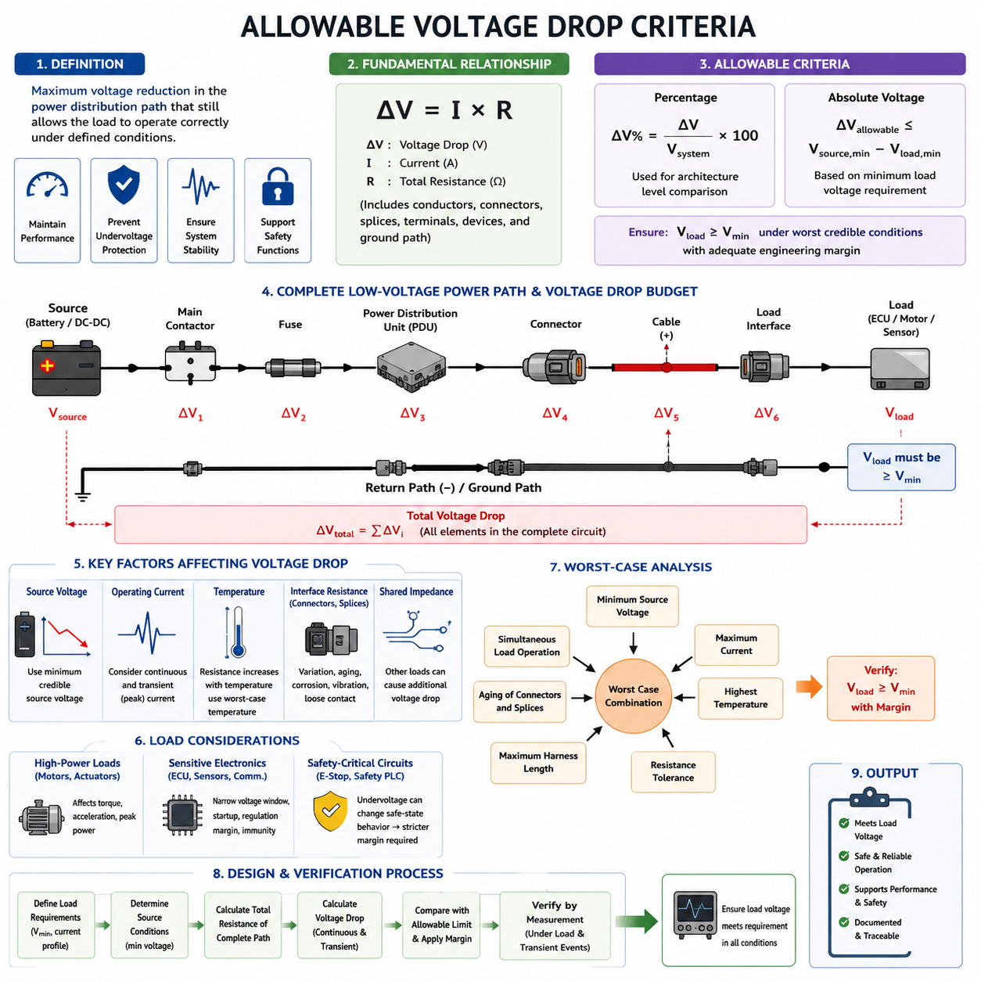
Allowable voltage drop is the maximum reduction in electrical potential that a power distribution path may introduce while still allowing the connected load to operate correctly under defined conditions. It is not merely a wiring efficiency target. In a robot or vehicle, excessive drop can reduce actuator torque, disturb electronic control units, trigger undervoltage protection, and create unstable behavior during high-current events.
Voltage drop criteria should therefore be established from the requirements of the load rather than from wire current capacity alone. A conductor may safely carry the required current without overheating while still producing an unacceptable voltage loss. Harness engineering must simultaneously satisfy ampacity, thermal limits, voltage requirements, mechanical constraints, protection coordination, and system-level power distribution objectives.
The fundamental relationship is ΔV = I × R, where ΔV is the voltage drop, I is the current flowing through the circuit, and R is the total resistance of the relevant current path. For practical harness design, resistance includes not only the conductor but also terminals, connectors, splices, distribution devices, fuse interfaces, contactors, grounding paths, and other electrical junctions located between the source and the load.
Allowable drop is commonly expressed either as an absolute voltage or as a percentage of nominal system voltage. The percentage representation is ΔV% = (ΔV / Vsystem) × 100. Percentage limits are useful for architecture-level comparison, while absolute voltage limits are often more meaningful when evaluating a particular ECU, sensor, motor controller, or converter whose minimum operating voltage is explicitly specified.
The most important criterion is the minimum voltage required at the load terminals. If a device requires at least Vmin for guaranteed operation, the distribution network must satisfy Vload ≥ Vmin under the worst credible operating condition. Consequently, the available voltage-drop budget can be expressed as ΔVallowable ≤ Vsource,min − Vload,min, with additional engineering margin where uncertainty or transient behavior must be accommodated.
Source voltage must not automatically be treated as the nominal battery voltage. Batteries change voltage with state of charge, temperature, aging, internal resistance, and instantaneous current demand. DC/DC converters also have tolerance and regulation characteristics. Voltage-drop assessment should therefore begin from the minimum credible source voltage at the distribution point rather than from an idealized 12 V, 24 V, or 48 V nominal value.
Operating current must likewise represent realistic system behavior. Continuous current is important for steady-state voltage loss, but many robotic loads produce much larger transient currents. Motor acceleration, steering actuation, brake release, pumps, fans, heaters, compute startup, capacitive charging, and simultaneous subsystem activation can temporarily produce voltage drops substantially greater than those predicted from average current consumption.
A useful design distinction is therefore made between continuous and transient allowable voltage drop. Continuous criteria protect normal operating performance and efficiency, whereas transient criteria determine whether short-duration disturbances remain above device reset, dropout, or protection thresholds. A short voltage excursion may be thermally harmless to the wire yet functionally unacceptable if it resets an ECU or interrupts a safety-related sensor.
The voltage-drop budget should be allocated across the complete electrical path rather than assigned entirely to the cable. A source-to-load path may contain battery terminals, a main contactor, fuse, power distribution unit, connectors, splices, positive conductor, load interface, return conductor, and chassis or ground connections. Each element consumes part of the available budget, making interface resistance an important system-level design parameter.
Return-path resistance must be included whenever current returns through a dedicated conductor or through multiple grounding interfaces. Evaluating only the positive wire underestimates the actual circuit drop. For a simple two-wire circuit, the relevant resistance is approximately the sum of supply and return resistances, while more complex grounded architectures require analysis of the actual current return topology and shared impedance.
Temperature is another essential criterion because conductor resistance increases as copper temperature rises. A harness that meets its voltage-drop target at room temperature can exceed the allowable limit after prolonged high-current operation or exposure to a hot environment. Resistance calculations should therefore use the expected operating conductor temperature or a defined worst-case temperature rather than relying exclusively on nominal resistance at 20°C.
Connector and splice resistance also changes during service life. Contact wear, contamination, corrosion, vibration, relaxation of contact force, imperfect crimping, and repeated mating cycles can increase interface resistance. A robust allowable-drop criterion should consequently contain sufficient margin for manufacturing variation and aging instead of assuming that every connection will permanently retain its initial laboratory resistance.
For motors and other high-power loads, allowable voltage drop directly influences available electrical and mechanical performance. Reduced motor-controller input voltage can limit achievable phase voltage, acceleration, torque, and peak power. In an AMR, simultaneous traction and steering demand can therefore expose voltage-drop weaknesses that remain invisible during stationary measurements or low-load functional testing.
Sensitive electronic loads require a different interpretation. Cameras, LiDARs, radar modules, communication gateways, embedded computers, and safety controllers may draw less current than traction equipment, but their allowable voltage window can be narrower. Their criteria should emphasize uninterrupted operation, power-supply regulation margin, startup behavior, and immunity to disturbances generated by other branches of the power network.
Safety-related circuits should be evaluated according to the consequence of undervoltage rather than by applying a generic harness percentage. Emergency-stop circuits, braking controllers, safety PLCs, safety sensors, and power-disconnection devices may require stricter margins because loss of supply can alter the intended safe-state behavior. Functional requirements must therefore take precedence over a universal voltage-drop percentage.
The allowable criterion must also account for shared distribution impedance. When several loads share a feeder, connector, fuse block, ground return, or PDU bus, current demanded by one branch can reduce the voltage available to another. This coupling is particularly important when motors and sensitive electronics are supplied through common upstream paths. Branch-level calculations alone may therefore miss significant system interactions.
Worst-case analysis should combine credible unfavorable conditions rather than evaluating parameters independently at nominal values. Typical considerations include minimum source voltage, maximum expected current, elevated conductor temperature, maximum permitted harness length, resistance tolerance, connector aging, and simultaneous load operation. The resulting case establishes whether sufficient voltage margin remains at the load under realistic boundary conditions.
Engineering margins should be explicit rather than hidden inside arbitrary wire oversizing. The calculated voltage drop can be compared with a defined design limit and a reserved margin for uncertainty, aging, or future load growth. This makes the design traceable and allows later changes in cable length, connector count, load power, or architecture to be evaluated without reconstructing the original assumptions.
Voltage-drop acceptance should finally be confirmed by measurement on representative hardware. Measurements are most meaningful when taken directly between the source distribution point and load terminals while the intended current is flowing. Testing should include steady operation and important transient events, with minimum load voltage captured using instrumentation fast enough to observe short disturbances that ordinary handheld meters may miss.
A well-defined allowable voltage-drop criterion therefore connects electrical physics with functional performance. It defines how much of the available source voltage may be consumed by the complete distribution network while preserving required load voltage across temperature, current, manufacturing, aging, and transient conditions. This criterion becomes the foundation for subsequent round-trip resistance calculation, system-voltage rules, simulation, wire-gauge selection, and AMR voltage-drop budgeting within the harness design process.

03.02. Round Trip Resistance Calculation
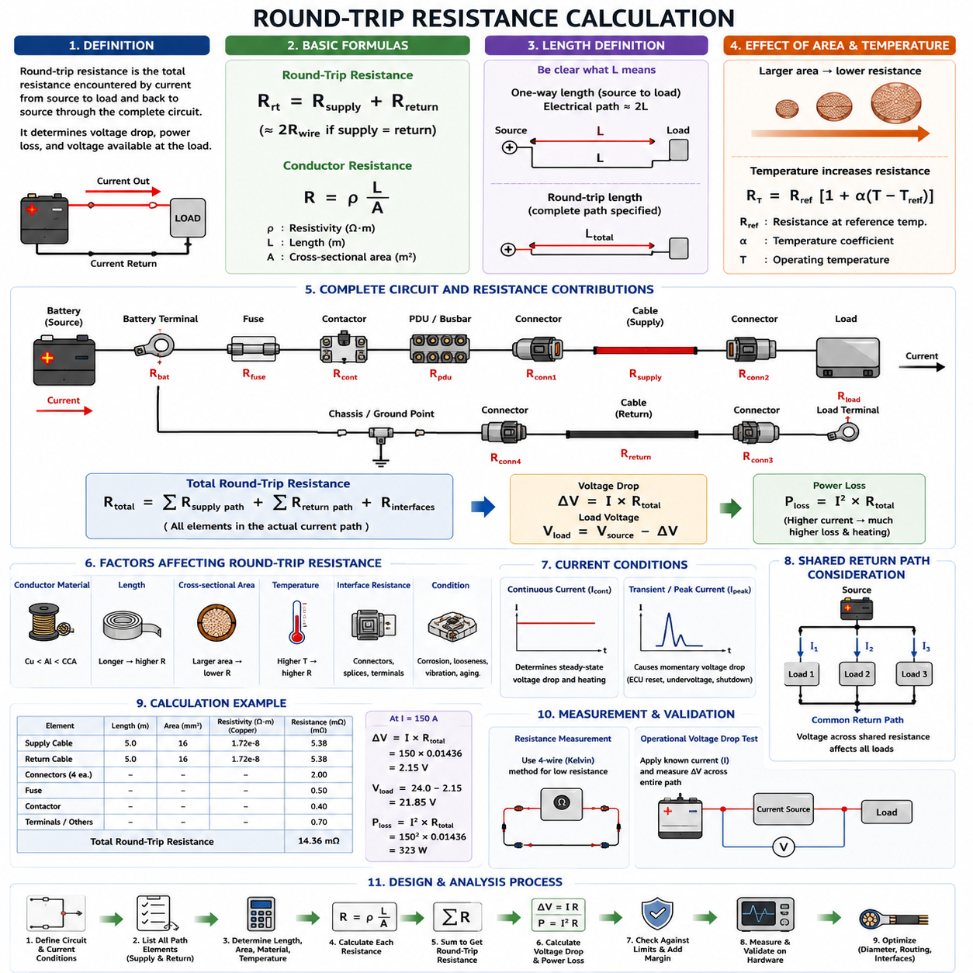
Round-trip resistance is the total electrical resistance encountered by current as it travels from the power source to a load and returns to the source through the complete circuit. In wire-harness engineering, calculating only the supply conductor resistance is insufficient because the same current must complete a return path. The combined resistance determines the actual voltage drop, power loss, and voltage available at the load.
For a simple two-wire DC circuit, the round-trip resistance can be expressed as Rround-trip = Rsupply + Rreturn. If the supply and return conductors use the same material, cross-sectional area, length, and temperature, their resistances are approximately equal. The calculation can then be simplified to Rround-trip ≈ 2Rwire, which explains why conductor length must often be doubled when calculating circuit voltage drop.
The resistance of an individual conductor follows R = ρL/A, where R is resistance, ρ is the electrical resistivity of the conductor material, L is conductor length, and A is conductor cross-sectional area. For equal supply and return conductors, the relationship becomes Rround-trip = 2ρL/A. This equation provides the basic physical relationship between harness length, conductor size, material properties, and total circuit resistance.
Length must be defined carefully because inconsistent interpretation can produce a factor-of-two calculation error. If L represents the one-way physical distance from the source to the load, the electrical path for an equal two-wire circuit is approximately 2L. If the specified length already represents the complete supply-and-return path, it must not be doubled again. Harness calculations should therefore explicitly identify whether a stated length is one-way or round-trip length.
The conductor cross-sectional area has an inverse relationship with resistance. Increasing wire area reduces round-trip resistance and consequently reduces voltage drop and resistive heating. This is one reason larger wire gauges may be required even when a smaller conductor can safely carry the current thermally. Wire sizing must therefore consider voltage-drop requirements together with ampacity, temperature, packaging, mass, flexibility, and cost.
Conductor material must also be included because resistivity differs between copper, aluminum, copper-clad aluminum, and other materials. Copper is widely used because of its relatively low resistivity and favorable electrical characteristics, but alternative conductors may be selected to reduce mass or cost. When materials differ between the supply and return paths, each conductor resistance should be calculated independently rather than applying a simple doubling assumption.
Temperature significantly influences round-trip resistance. For metallic conductors such as copper, resistance increases as conductor temperature rises. A temperature-adjusted approximation can be written as RT = Rref[1 + α(T − Tref)], where Rref is resistance at the reference temperature and α is the temperature coefficient of resistance. Voltage-drop calculations should therefore reflect realistic operating temperature rather than relying exclusively on room-temperature resistance.
This temperature effect creates an important interaction between current capacity and voltage-drop design. Higher current produces greater I²R heating, which increases conductor temperature and resistance. The increased resistance then produces additional voltage drop and heat. Although a properly designed harness reaches thermal equilibrium rather than increasing indefinitely, this coupling means that worst-case round-trip resistance should be evaluated at an appropriate stabilized conductor temperature.
Real harness resistance includes more than the bulk resistance of the wires. The complete path may contain battery terminals, fuses, contactors, power distribution units, connector contacts, crimp joints, splices, busbars, grounding interfaces, and load terminals. A practical expression is therefore Rtotal = Rsupply-wire + Rinterfaces + Rreturn-path, where Rinterfaces represents the cumulative resistance of electrical connections and distribution components.
Connector and splice resistance may appear very small individually, but multiple interfaces can become significant in low-voltage, high-current circuits. Contact resistance can also increase because of manufacturing variation, inadequate crimping, contamination, corrosion, fretting, vibration, thermal cycling, or aging. Engineering calculations should distinguish conductor resistance from interface resistance so that excessive losses can be traced to their actual physical source.
When the return path uses a dedicated negative conductor, calculation is relatively straightforward because both supply and return wire geometries are known. However, some electrical architectures use chassis, frame, structural metal, or distributed grounding networks as part of the return path. In such systems, return resistance cannot automatically be assumed equal to supply resistance and should instead be determined from the actual grounding topology and connection interfaces.
Shared return paths require additional attention because currents from several loads may flow through a common conductor or grounding segment. The voltage developed across this shared resistance is proportional to the combined current and can shift the local ground potential seen by other devices. Consequently, a round-trip resistance model may need to represent individual branches and shared segments rather than treating each load as an electrically independent two-wire circuit.
Once round-trip resistance is known, circuit voltage drop is calculated using ΔV = I × Rround-trip for the relevant current condition. If additional interface resistance is modeled separately, ΔV = I × Rtotal should be used. The resulting load voltage can then be estimated as Vload = Vsource − ΔV, allowing the calculated value to be compared directly with the minimum operating voltage requirement of the connected equipment.
Power dissipated in the resistive path is related to the same calculation through Ploss = I²Rtotal. This relationship shows why apparently small resistance values become important in high-current circuits. Doubling current doubles voltage drop but increases resistive power loss by a factor of four. Traction motors, steering actuators, high-power computers, heaters, pumps, and charging circuits therefore require particularly careful resistance budgeting.
Transient current should be evaluated in addition to continuous current. Motor startup, rapid acceleration, steering corrections, brake operation, capacitive charging, and simultaneous activation of multiple loads can produce short-duration current peaks. Although these events may not substantially increase average conductor temperature, their instantaneous voltage drop can cause motor-controller undervoltage, ECU reset, sensor interruption, or DC/DC converter shutdown.
Round-trip resistance calculations should therefore be performed for several relevant operating states rather than for a single nominal current. Continuous operation establishes steady-state voltage loss and heating, while peak-current cases reveal transient voltage margin. Minimum source voltage, elevated conductor temperature, maximum harness length, connector resistance, and simultaneous load operation can then be combined to establish a credible worst-case circuit condition.
Manufacturing tolerance should also be considered. Actual conductor cross-sectional area, strand construction, cable length, crimp resistance, terminal contact resistance, and connector performance vary within production limits. A design that satisfies the voltage requirement only with ideal nominal resistance may fail when assembled components approach their tolerance limits. Appropriate resistance margin should therefore be included before the allowable voltage-drop budget is considered fully consumed.
A useful engineering method is to construct a resistance budget for the entire source-to-load loop. Each conductor segment and interface is assigned an estimated or measured resistance, and the values are summed according to the actual current path. This makes it possible to identify dominant contributors, compare alternative routing or wire gauges, evaluate connector changes, and determine whether improvements should target conductors, interfaces, grounding, or distribution architecture.
For example, a long cable segment may dominate resistance in a low-current branch, while connector and contactor resistance may become proportionally important in a short high-current path. Increasing wire gauge provides limited benefit if most of the voltage loss occurs across degraded contacts or shared grounding interfaces. Round-trip analysis therefore prevents wire sizing from being treated as the only solution to voltage-drop problems.
Measurement provides an important validation of the calculated resistance. Direct resistance measurements can be difficult at milliohm levels because test-lead and contact resistance may be comparable to the harness resistance itself. Four-wire Kelvin measurement techniques are therefore useful for precise low-resistance characterization, while operational voltage-drop measurements under known current can provide an effective system-level verification of the complete assembled circuit.
During operational testing, voltage should preferably be measured across the complete source-to-load and return path while representative current flows. The effective resistance can then be estimated from R = ΔV/I. Measurements at intermediate nodes can further isolate losses across cables, connectors, fuses, contactors, splices, or grounding points, allowing calculated resistance budgets to be correlated with physical hardware behavior.
Round-trip resistance calculation ultimately provides the quantitative bridge between wire properties and system-level voltage performance. By accounting for supply and return conductors, temperature, interfaces, shared paths, operating current, tolerances, and aging, the engineer can predict the actual voltage delivered to each load. The resulting resistance model becomes a foundation for voltage-drop analysis, wire-gauge selection, protection coordination, and AMR power-distribution design.

03.03. System Specific Standards (12V/24V/48V)
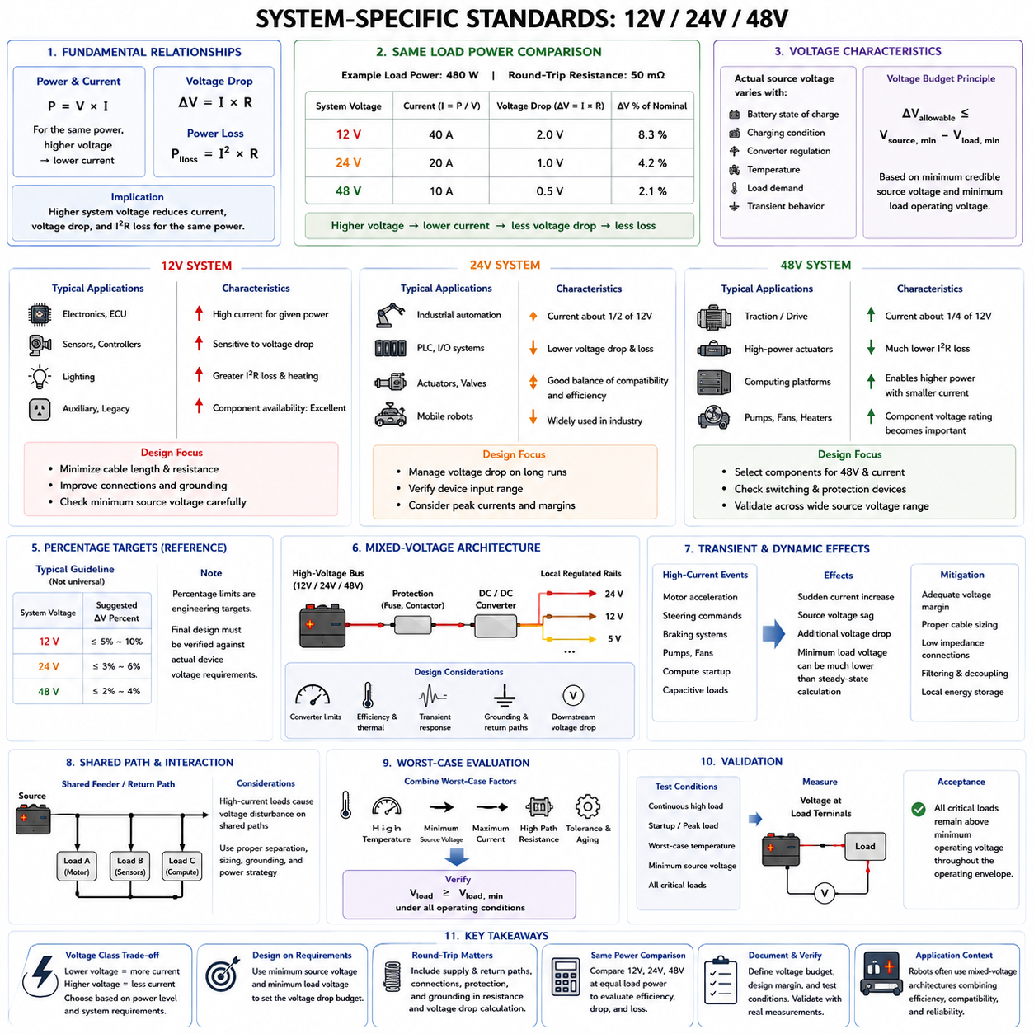
A 12 V, 24 V, or 48 V electrical system cannot be evaluated using nominal voltage alone. Each voltage class has a different relationship between load power, current, conductor resistance, voltage drop, and equipment operating limits. The nominal value primarily identifies the architecture; actual source voltage varies with battery state, charging condition, converter regulation, temperature, load demand, and transient behavior.
For a load requiring electrical power P, current is approximately I = P/V when conversion losses and dynamic effects are neglected. Consequently, increasing distribution voltage reduces the current required to deliver the same power. A 480 W load theoretically requires 40 A at 12 V, 20 A at 24 V, and 10 A at 48 V, illustrating why higher-voltage architectures become attractive as robotic power demand increases.
Voltage drop follows ΔV = I × R, so the reduction in current obtained at higher system voltage directly decreases conductor voltage drop for the same resistance and delivered power. If the same 480 W load is supplied through a 50 mΩ round-trip path, the approximate drops are 2.0 V at 12 V, 1.0 V at 24 V, and 0.5 V at 48 V before other operating effects are considered.
The percentage impact becomes even more significant. A 1 V drop represents approximately 8.3% of a 12 V nominal system, 4.2% of a 24 V system, and 2.1% of a 48 V system. This demonstrates why low-voltage architectures are especially sensitive to cable length and connection resistance. However, percentage limits should be treated as engineering criteria rather than universal standards applicable to every device.
A 12 V architecture is commonly appropriate for relatively low-power electronics, sensors, controllers, lighting, auxiliary equipment, and legacy automotive-compatible devices. Its major advantage is the broad availability of components and power accessories. Its principal electrical limitation is that moderate power quickly produces high current, making conductor resistance, connector resistance, fuse interfaces, and grounding quality increasingly important.
In a 12 V system, source voltage can move significantly relative to the minimum operating voltage of connected electronics. Battery discharge, startup current, long cable runs, or simultaneous load activation may therefore consume a large portion of the available voltage margin. Sensitive devices should be checked using minimum credible source voltage and maximum path resistance rather than assuming that 12.0 V is continuously available at the load.
High-current 12 V branches require particular attention because resistive power loss follows Ploss = I²R. Delivering several hundred watts through a low-voltage network can produce substantial cable heating and connector losses even when the calculated voltage drop initially appears manageable. Increasing conductor area, shortening routing distance, improving interfaces, or supplying high-power loads from a higher-voltage bus may become necessary.
A 24 V architecture provides a useful compromise between low-voltage component compatibility and improved power-distribution efficiency. For the same load power, current is approximately half that of a 12 V system. This reduces voltage drop, I²R losses, required conductor cross-sectional area for some applications, and electrical stress on connectors and distribution interfaces caused by high continuous current.
Industrial automation equipment, PLC-based systems, actuators, sensors, and mobile robots frequently use equipment designed around 24 V power. Nevertheless, a 24 V label does not guarantee that every device shares the same permissible input range. Each load must still be evaluated against its specified minimum and maximum operating voltages, startup requirements, transient tolerance, and protection thresholds.
For mobile robots, a 24 V distribution system can support moderate propulsion and auxiliary loads while maintaining manageable harness dimensions. The voltage-drop budget should still include battery variation, contactors, fuses, PDU paths, connectors, supply conductors, and return conductors. Long harness runs or high peak motor currents can consume substantial voltage margin even though performance is generally more favorable than an equivalent 12 V network.
A 48 V architecture becomes increasingly attractive when power demand reaches levels at which 12 V or 24 V distribution would require excessive current. Traction systems, mobile robots, high-power actuators, computing platforms, pumps, and other demanding loads can benefit from reduced current. For the same power, a 48 V bus theoretically carries one-quarter of the current required by a 12 V bus.
The reduced current of a 48 V system can substantially lower conductor losses because power loss depends on the square of current. For identical delivered power and path resistance, reducing current to one-quarter reduces I²R loss to one-sixteenth. In practical systems, designers may use this advantage to improve efficiency, reduce cable mass, increase available power, or balance conductor size against allowable voltage drop.
Higher distribution voltage does not eliminate voltage-drop engineering. A 48 V system may carry much greater total power than a 12 V system, and individual branches can still experience significant current. Connectors, contactors, fuses, cables, and protection devices must be selected for the actual voltage and current conditions. Component voltage ratings and switching behavior also become increasingly important as bus voltage rises.
The term “48 V system” should not be interpreted as a fixed 48.0 V operating condition. Battery-based systems can operate over a substantial voltage range determined by cell chemistry, series cell count, state of charge, charging voltage, and load current. Regulated 48 V buses have different behavior. Harness criteria must therefore be derived from the actual source-voltage envelope rather than from the nominal architecture name.
Comparison among 12 V, 24 V, and 48 V systems should therefore be performed at equal load power whenever architecture efficiency is being evaluated. Comparing only current ratings can be misleading because the voltage classes may serve different power levels. The fundamental architecture relationship is P ≈ VI, while harness consequences emerge through ΔV = IR and Ploss = I²R.
Allowable voltage drop should ultimately be defined from load requirements. If Vsource,min is the minimum credible voltage at the distribution source and Vload,min is the minimum voltage required by the equipment, the available path budget is bounded by ΔVallowable ≤ Vsource,min − Vload,min. This principle applies equally to 12 V, 24 V, and 48 V systems and is more reliable than assigning one universal percentage limit.
Percentage-based targets remain useful during preliminary architecture design because they provide a convenient way to allocate voltage-drop budgets among feeders, branches, connectors, and return paths. However, the final design should convert those targets into actual volts and verify them against device specifications. A percentage that is acceptable for a motor may be unacceptable for an ECU or safety controller connected to the same nominal bus.
Mixed-voltage architectures are frequently advantageous in robots. A higher-voltage bus can distribute energy efficiently to traction or high-power equipment, while DC/DC converters generate 24 V, 12 V, 5 V, or other regulated rails near the loads. This approach can reduce high-current cable length, but converter input limits, output regulation, conversion efficiency, transient response, grounding, and downstream voltage drop must all be included.
In such architectures, voltage-drop budgeting becomes hierarchical. The engineer first verifies the main battery or distribution bus, then the input voltage available to each DC/DC converter, and finally the regulated output path from the converter to its downstream loads. A satisfactory 48 V main-bus calculation does not guarantee that a remote 12 V sensor or computer receives sufficient voltage after conversion and secondary harness losses.
Transient behavior is particularly important across all three voltage classes. Motor acceleration, steering commands, braking systems, pumps, fans, compute startup, and capacitive loads can create sudden current demand. The resulting source sag and harness voltage drop occur simultaneously, meaning that the minimum load voltage can be considerably lower than a calculation based only on nominal source voltage and steady-state current.
Shared feeders and return paths must also be evaluated. A traction motor connected to a common distribution path can create a voltage disturbance observed by sensors, communication equipment, or computing devices. Higher bus voltage can reduce the magnitude of some distribution effects, but correct architecture still requires appropriate branch separation, conductor sizing, grounding, filtering, local energy storage, and power-conversion strategy.
Temperature and aging remain relevant regardless of voltage class. Elevated conductor temperature increases resistance, while connector wear, corrosion, vibration, and contact degradation can increase interface resistance over time. Worst-case evaluation should therefore combine the minimum credible source voltage with maximum expected current, elevated path resistance, manufacturing tolerance, aging allowance, and simultaneous operating conditions.
System-specific acceptance criteria should be documented as an engineering voltage budget rather than simply stating “12 V,” “24 V,” or “48 V.” The budget should identify the source-voltage range, load operating range, continuous and transient current conditions, allowable path resistance, interface contributions, required design margin, and validation conditions. This makes wire-harness decisions traceable to actual electrical requirements.
Validation should reproduce representative operating conditions and measure voltage at the load terminals rather than only at the battery or PDU. Continuous high-load operation establishes steady-state performance, while startup and peak-load tests reveal transient behavior. Measurements should confirm that every critical load remains above its required minimum voltage throughout the expected operating envelope.
The selection of 12 V, 24 V, or 48 V is therefore both a system-architecture and wire-harness decision. Lower voltages offer compatibility and simplicity but require greater current for a given power, while higher voltages improve distribution efficiency and enable higher power with reduced current. Correct design combines the chosen voltage class with round-trip resistance, load limits, thermal behavior, transient conditions, and an explicit voltage-drop budget.

03.04. Voltage Drop Simulation Tools
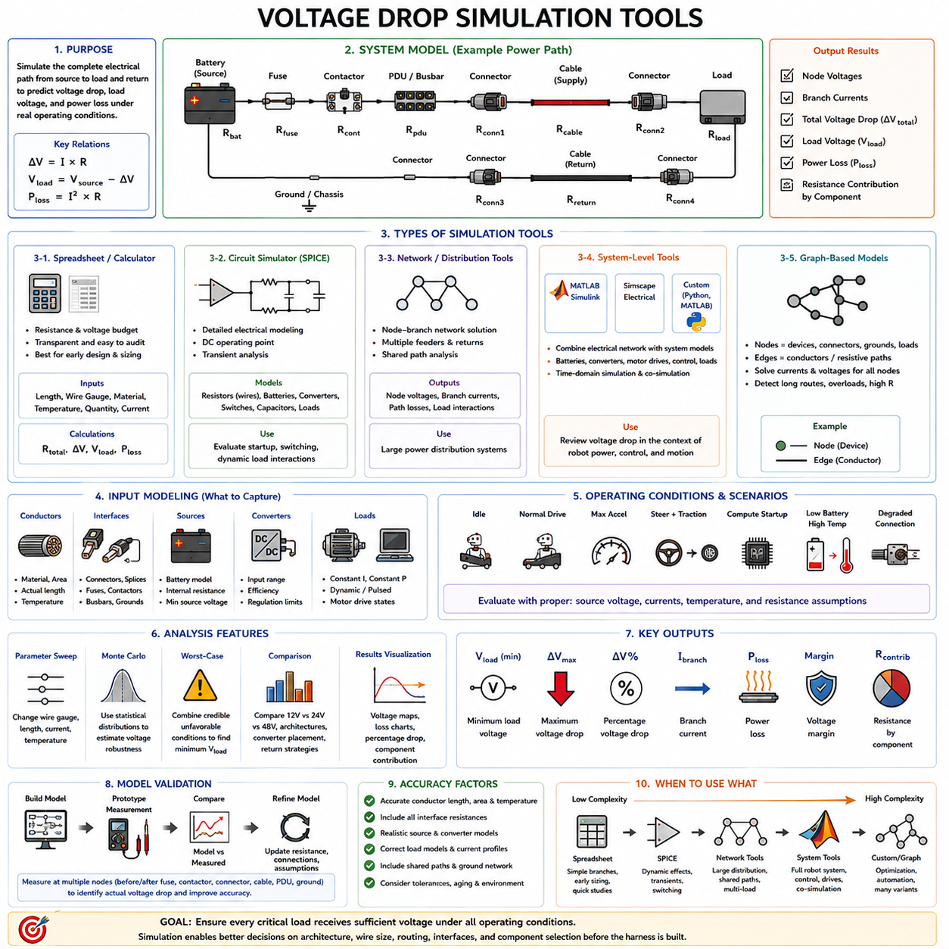
Voltage-drop simulation tools extend basic calculations into system-level analysis by representing the complete electrical path from source to load and return. Instead of evaluating only ΔV = I × R for one conductor, a simulation can include batteries, DC/DC converters, fuses, contactors, PDU paths, connectors, splices, cables, grounding networks, and multiple interacting loads within the wire-harness architecture.
The simplest simulation method is a spreadsheet-based resistance and voltage budget. Each electrical element is represented by its resistance, current, temperature correction, and connection to the circuit. The tool calculates cumulative resistance, voltage drop, load-terminal voltage, and power loss. This approach is transparent, easy to audit, and especially useful during early harness sizing and architecture development.
Spreadsheet models can also compare wire gauges, cable lengths, conductor materials, connector quantities, and operating currents through parameterized equations. By changing one design variable, the engineer can immediately observe its influence on voltage margin and power loss. Such models are valuable for design trade studies because assumptions remain visible and calculation results can be traced directly to their source parameters.
Circuit simulators such as SPICE provide a more detailed electrical representation. Harness conductors can be modeled as resistors, while batteries, converters, switches, capacitors, and loads can be represented using appropriate electrical models. DC operating-point analysis determines steady-state node voltages and branch currents, while transient analysis evaluates voltage behavior during startup, switching, or rapidly changing load conditions.
SPICE-based analysis becomes particularly useful when voltage drop interacts with source impedance and dynamic loads. A motor controller or computing device may suddenly demand current, causing battery or converter voltage sag while the harness simultaneously produces an I × R drop. Transient simulation can represent these effects together and reveal a minimum load voltage that would not appear in a nominal steady-state calculation.
For large electrical distribution systems, network-oriented tools provide another level of analysis. The power architecture can be represented as nodes connected by resistive branches, with loads distributed across multiple feeders and return paths. Solving the network simultaneously reveals node voltages, branch currents, shared-path losses, and interactions among loads that would be difficult to identify through independent branch calculations.
Commercial electrical-system tools such as MATLAB/Simulink and Simscape Electrical can combine electrical networks with dynamic system models. Battery behavior, DC/DC converters, motor drives, control logic, switching events, and load profiles can be integrated into one simulation environment. This is useful when harness voltage drop must be evaluated as part of a robot's overall power, control, and motion behavior rather than as an isolated wiring calculation.
General mathematical environments such as MATLAB or Python can also be used to build custom voltage-drop solvers. The harness can be represented using resistance matrices, node equations, or graph-based network models. Custom tools are particularly useful when many harness configurations, operating scenarios, wire-gauge alternatives, or automatically generated architectures must be evaluated repeatedly during design optimization.
A graph-based representation is well suited to complex robotic harnesses. Electrical nodes can represent batteries, PDUs, connectors, splices, converters, grounding points, and loads, while edges represent conductors or other resistive paths. Network equations can then calculate current flow and voltage at every node. This approach also supports automated checks for long routes, overloaded shared paths, or excessive accumulated resistance.
Regardless of software, simulation accuracy depends primarily on the quality of the input model. Conductor resistance should reflect material, cross-sectional area, actual routed length, and operating temperature. Connector, splice, fuse, contactor, busbar, and grounding resistance should also be represented when their contribution is significant. An elaborate simulation using unrealistic nominal resistance values can be less useful than a simple model built from credible data.
Temperature-dependent resistance should be included when evaluating high-current or high-temperature circuits. A simulation may calculate resistance from RT = Rref[1 + α(T − Tref)] or use temperature-specific resistance data. More advanced electrothermal models can couple I²R losses with thermal behavior so that current increases temperature, temperature increases resistance, and the resulting resistance modifies voltage drop and heat generation.
Source modeling is equally important. A battery should not always be represented as an ideal fixed-voltage source because terminal voltage changes with state of charge, temperature, internal resistance, and load current. Depending on the required fidelity, the model may use a minimum source voltage, a voltage source with series resistance, or a dynamic battery model that reproduces voltage sag during high-current events.
DC/DC converters require different assumptions. A regulated converter can maintain its output voltage within a defined input and load range, but regulation is lost if input voltage falls below the converter's operating threshold. Simulation should therefore evaluate both the voltage drop before the converter and the downstream drop after conversion. This is especially important in mixed 48 V, 24 V, 12 V, and 5 V robot architectures.
Load models can range from simple constant-current representations to more realistic constant-power, resistive, pulsed, or dynamic models. Constant-power loads deserve special attention because current increases when supply voltage decreases. This behavior can amplify voltage drop and potentially create a feedback condition in which reduced voltage causes increased current, which produces still greater distribution loss.
Motor loads require operating-state-dependent modeling. Current during idle, steady motion, acceleration, stall, steering correction, or regenerative operation can differ substantially. A voltage-drop simulation should therefore include representative drive cycles or current profiles rather than relying on one average current value. The objective is to determine whether adequate voltage remains available during the most demanding credible operating event.
Computing and perception equipment also produces dynamic loads. Edge computers, GPUs, LiDARs, cameras, communication modules, and other electronics can exhibit startup surges or rapidly changing consumption. Their current profiles may overlap with motor demand. Time-domain simulation allows these events to be combined and can reveal short undervoltage conditions that average-power calculations cannot identify.
Scenario-based simulation is therefore a practical method for robotic systems. Typical scenarios can represent idle operation, normal driving, maximum acceleration, simultaneous steering and traction, compute startup, charging, low battery, high ambient temperature, or degraded connector resistance. Each scenario uses appropriate source voltage, load currents, temperatures, and resistance assumptions to calculate the resulting voltage margin.
Worst-case simulation should combine credible unfavorable parameters rather than simply applying unrealistic maximum values to every variable. Important cases may include minimum source voltage, maximum harness length, elevated conductor temperature, peak current, high connector resistance, simultaneous loads, and aging allowance. The resulting minimum load voltage can then be compared with the equipment's specified operating threshold.
Monte Carlo analysis can extend deterministic simulation when manufacturing variation and uncertainty are important. Instead of assigning one resistance value to each component, statistical distributions can represent cable length, conductor resistance, terminal resistance, connector contact resistance, source voltage, and load current. Repeated simulations estimate the distribution of load voltage and help quantify design robustness rather than producing only one nominal result.
Parameter sweeps are useful for wire-gauge selection. A simulation can automatically evaluate several conductor cross-sectional areas across combinations of length, current, and temperature. The results can identify the smallest practical conductor that satisfies voltage-drop, thermal, and design-margin requirements. This provides a more systematic approach than repeatedly calculating individual wire sizes by hand.
Simulation can also support architecture comparison. A designer can compare a long 12 V feeder with a 24 V alternative, a centralized DC/DC converter with distributed converters, or dedicated return conductors with shared grounding paths. Because each architecture can be evaluated using the same load and boundary conditions, voltage efficiency and harness consequences become quantitatively comparable.
Results should be presented in engineering quantities that directly support decisions. Useful outputs include minimum load voltage, maximum voltage drop, percentage voltage drop, branch current, conductor loss, total distribution loss, voltage margin, and resistance contribution by component. Node-voltage maps can also identify where voltage is being lost along a complex power-distribution path.
Simulation should not replace physical validation. Model parameters contain tolerances and assumptions, and real assemblies introduce contact behavior, routing variation, temperature gradients, aging, and dynamic effects that may not be perfectly represented. Prototype measurements should therefore be used to correlate the model, and measured resistance or voltage-drop data should be fed back into subsequent simulation revisions.
Correlation is especially valuable when measurements are taken at several nodes. Voltage measurements before and after a fuse, contactor, connector, cable, PDU, or grounding point can identify the actual contribution of each element. Differences between simulation and measurement can then reveal inaccurate resistance assumptions, unexpected shared currents, poor connections, or omitted electrical paths.
A mature voltage-drop workflow therefore progresses from analytical equations to parameterized calculation, network or transient simulation, worst-case scenario analysis, and hardware validation. The required tool complexity should match the electrical problem. Simple branches may need only a spreadsheet, while mixed-voltage robotic platforms with batteries, converters, motors, computing loads, and shared paths can justify dynamic network simulation.
Voltage-drop simulation ultimately provides a virtual representation of the power-distribution behavior before the complete harness is manufactured. When supported by realistic source, conductor, interface, load, temperature, and transient models, it allows engineers to predict weak points, compare architectures, optimize wire gauges, allocate voltage budgets, and verify that critical loads remain above their required operating voltage throughout the robot's expected operating envelope.

03.05. AMR Voltage Drop Budget
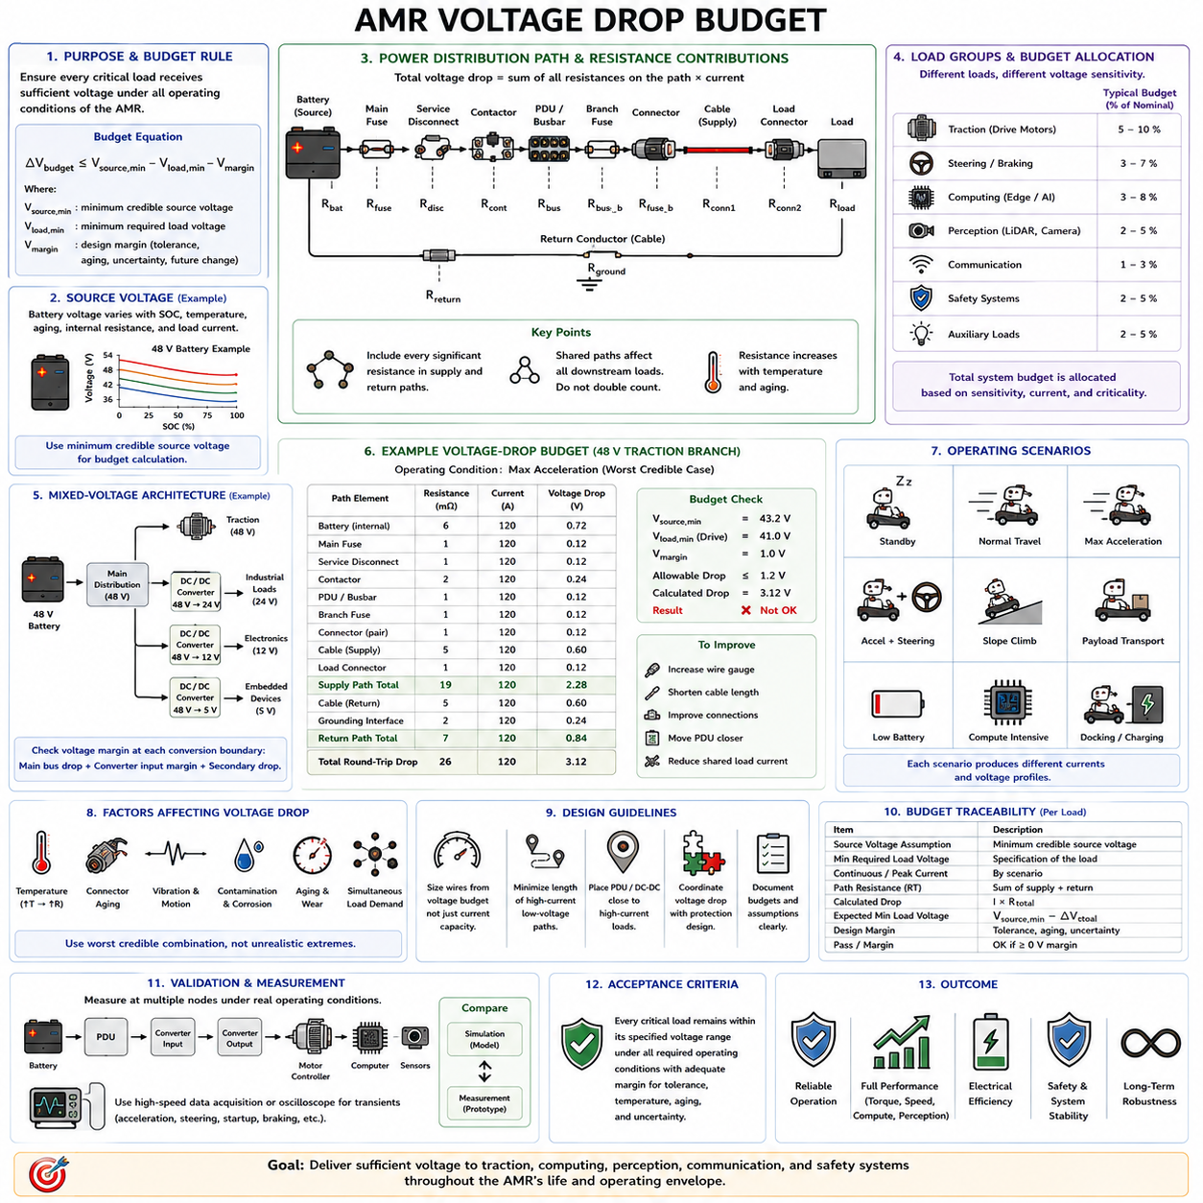
An AMR voltage-drop budget defines how much electrical voltage may be lost between the energy source and each critical load while preserving reliable operation throughout the robot’s operating envelope. The budget converts general voltage-drop principles into an architecture-level design constraint covering batteries, protection devices, distribution units, harnesses, connectors, return paths, converters, drive modules, computing equipment, and sensors.
The starting point is the minimum credible source voltage rather than the nominal battery rating. Battery terminal voltage changes with state of charge, temperature, aging, internal resistance, and instantaneous current demand. An AMR described as a 24 V or 48 V platform therefore operates across a voltage range, and the lowest credible source voltage establishes the boundary from which the available distribution margin must be calculated.
For each load, the fundamental requirement is Vload ≥ Vload,min under the defined operating conditions. The maximum allowable distribution drop can therefore be expressed as ΔVbudget ≤ Vsource,min − Vload,min − Vmargin. Here, Vmargin represents engineering reserve for uncertainty, manufacturing tolerance, aging, unmodeled resistance, and future changes that should not consume the entire theoretical voltage difference.
An AMR should not normally use one identical voltage-drop limit for every electrical branch. Traction motors, steering actuators, safety controllers, edge computers, LiDARs, cameras, communication devices, and auxiliary loads have different operating characteristics. The total system budget should therefore be decomposed into load-specific or functional-domain budgets according to voltage sensitivity, current demand, criticality, and transient behavior.
The traction domain usually represents one of the largest electrical loads. Drive motors can demand substantial current during acceleration, slope climbing, obstacle traversal, rapid direction changes, or high rolling resistance. Voltage drop at the motor controller reduces the voltage available for generating motor phase voltage and can limit torque, acceleration, and peak mechanical power even before an undervoltage protection threshold is reached.
Steering and braking loads must be considered together with traction when they can operate simultaneously. An AMR may accelerate while steering, apply an electrically released brake, or perform rapid corrections during navigation. The voltage-drop budget must therefore represent realistic concurrent demand rather than calculating each actuator independently and assuming that only one high-current branch operates at a time.
Computing equipment creates a different requirement. Edge computers, GPUs, industrial PCs, embedded controllers, and AI accelerators may consume less peak current than traction motors but can be sensitive to short input-voltage disturbances. A temporary voltage reduction that produces little mechanical effect may reset a computer, interrupt perception, corrupt communication, or force the autonomous system into a recovery state.
Perception loads such as LiDARs, cameras, radar, GNSS receivers, and IMUs should also receive an explicit voltage budget. Their current consumption is often modest, but interruption of sensor power can degrade localization, obstacle detection, mapping, or navigation. Sensor branches are therefore frequently better evaluated from minimum operating voltage and continuity requirements than from a generic percentage-drop rule.
Safety-related equipment requires particular attention. Emergency-stop circuits, safety PLCs, safety LiDARs, brake controllers, contactor control circuits, and other safety functions must remain within their specified electrical operating range whenever their operation is required. Their voltage-drop allocation should be derived from the intended safe behavior and component specifications rather than from convenience or general harness practice.
The complete voltage budget must include every significant resistance between source and load. A typical path may contain battery terminals, a main fuse, service disconnect, contactor, PDU busbar, branch fuse, connectors, splices, supply cable, load connector, return conductor, and grounding interfaces. The total voltage drop is the sum of the drops across these elements according to the actual current flowing through each path.
This creates a hierarchical budget structure. Part of the available voltage margin is consumed by the common upstream distribution path, and the remaining margin is available to individual branches. If several loads share a battery connection, contactor, fuse, busbar, or ground return, the voltage drop across that shared section affects all downstream devices and should not be independently counted as though each branch had a separate source.
A practical AMR model therefore separates common-path resistance from branch resistance. The shared path carries the combined current of active loads, while each branch carries its own load current. During high-demand operation, a relatively small resistance in the common feeder can create a substantial voltage reduction because the current through that section may equal the combined traction, steering, computing, sensor, and auxiliary demand.
Mixed-voltage AMRs require multiple linked budgets. A 48 V battery may supply traction directly while DC/DC converters generate 24 V for industrial equipment, 12 V for electronics, and lower regulated rails for embedded devices. The voltage available at a downstream load depends on the main-bus drop, converter input requirement, converter regulation, and secondary harness drop, so each conversion boundary must be evaluated explicitly.
The input voltage at a DC/DC converter is particularly important. A downstream 24 V or 12 V rail may remain well regulated while the converter input stays within its specified range, but regulation can collapse when upstream voltage falls below the required threshold. Consequently, the main-bus voltage-drop budget must protect converter input margin in addition to protecting directly connected loads.
Continuous and transient budgets should be distinguished. Continuous operation determines steady-state conductor heating, distribution efficiency, and sustained load voltage. Transient conditions determine whether short current peaks cause unacceptable voltage excursions. Motor acceleration, steering corrections, brake activation, compute startup, capacitive charging, pumps, fans, and contactor operation can create transient combinations that must be evaluated separately.
An AMR operating scenario provides a useful basis for allocating these budgets. Representative conditions may include standby, normal travel, maximum acceleration, simultaneous acceleration and steering, slope climbing, payload transport, low-battery operation, compute-intensive perception, docking, and charging. Each condition produces a different current distribution and therefore a different voltage profile throughout the electrical architecture.
The worst electrical condition is not necessarily the condition with the highest total power. Minimum battery voltage may occur near a low state of charge, while maximum conductor resistance may occur after the harness has heated. High traction current can then coincide with elevated connector resistance and active computing loads. Credible combinations of these factors should define the design corner used for final voltage-margin assessment.
Temperature must be incorporated because AMR harness resistance changes during operation. Continuous traction current can heat supply and return conductors, while enclosed routing, protective sleeves, nearby electronics, motors, or environmental temperature can further raise conductor temperature. The resulting resistance increase consumes additional voltage budget and should be included when determining worst-case path resistance.
Connector and splice aging should also be represented. Mobile robots experience vibration, repetitive motion, thermal cycling, contamination, and repeated service operations that can alter contact resistance. A voltage-drop budget based entirely on new-component resistance may therefore provide insufficient lifetime margin. Interface resistance should include appropriate tolerance or aging allowance according to the application and reliability objective.
Wire-gauge selection can then be treated as a budget-allocation problem. Once the maximum resistance permitted for a branch is known, conductor area can be selected so that the round-trip cable resistance, temperature correction, and interface resistance remain within that allocation. This approach connects wire sizing directly to the electrical requirement instead of choosing gauge from current capacity alone.
Routing decisions also affect the budget because conductor resistance increases with length. Locating a PDU or DC/DC converter closer to high-current loads can reduce cable resistance more effectively than increasing wire size over a long route. Distributed power conversion may similarly reduce low-voltage high-current cable length, although the additional converters, connectors, protection devices, and thermal constraints must also be considered.
Voltage-drop budgeting should be coordinated with fuse and protection design. A larger conductor may improve voltage performance and reduce normal operating resistance, but protection devices must still protect the downstream wire under fault conditions. Conversely, fuse, breaker, contactor, and PDU resistance contributes to normal voltage loss. Protection coordination and voltage-drop optimization therefore cannot be treated as completely independent activities.
Simulation can evaluate the complete AMR budget before harness manufacture. A network model can assign resistance to common feeders, branches, connectors, converters, and return paths while applying current profiles for different operating scenarios. Parameter sweeps can compare wire gauges and routing alternatives, while transient analysis can identify short undervoltage events that steady-state calculations may overlook.
The engineering budget should remain traceable. Each critical load should have a documented source-voltage assumption, minimum required load voltage, continuous current, peak current, path resistance, calculated voltage drop, expected minimum terminal voltage, and remaining design margin. Shared-path assumptions and simultaneous-load conditions should also be recorded so that later changes to the robot can be evaluated consistently.
Prototype validation should reproduce the operating cases used in the calculation. Voltage measurements at the battery, PDU, converter inputs, converter outputs, motor controllers, computers, and critical sensors can show how the available voltage is actually distributed. Measuring multiple nodes also helps identify whether unexpected loss originates in a conductor, connector, fuse, contactor, grounding point, or shared distribution path.
Dynamic measurements are particularly important because a conventional multimeter may not capture short voltage minima. Oscilloscopes or sufficiently fast data-acquisition systems can record source voltage, load voltage, and current during acceleration, steering, startup, or other demanding events. These measurements allow the predicted transient voltage budget to be correlated with actual AMR behavior.
The final acceptance criterion is not simply that total percentage voltage drop remains below an arbitrary number. Every critical load must remain within its specified voltage range during all required operating conditions, with appropriate margin for tolerance, temperature, aging, and uncertainty. The allowable percentage can differ between branches because functional requirements and electrical characteristics differ across the robot.
An effective AMR voltage-drop budget therefore connects battery characteristics, power-distribution architecture, round-trip resistance, wire sizing, connectors, protection devices, DC/DC conversion, load behavior, thermal conditions, and validation into one coordinated engineering process. It ensures that electrical power reaches traction, computing, perception, communication, and safety functions with sufficient voltage margin throughout the intended life and operating envelope of the AMR.

