Volume 02. Wire Harness Engineering

Chapter 11. Serviceability Design

11.01. Service Loop Design
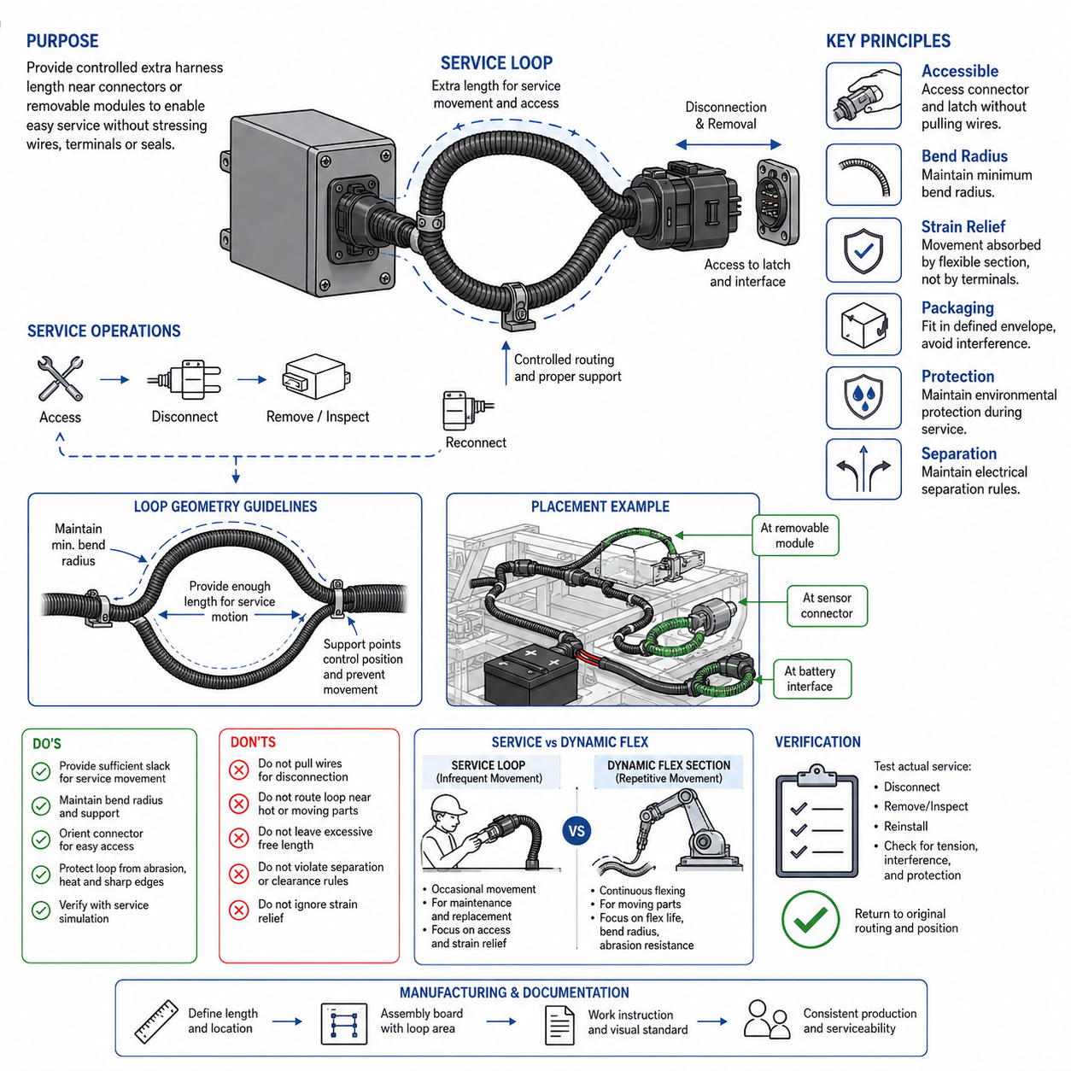
Service loop design provides intentional extra harness length near connectors, removable modules, or service points so technicians can disconnect, inspect, reposition, and reconnect electrical interfaces without placing excessive tensile load on wires or terminals. The loop is not simply unused wire. It is a controlled geometric feature that preserves accessibility while maintaining electrical, mechanical, and packaging requirements throughout the product lifetime.
The required loop length should be derived from the expected service motion rather than selected as an arbitrary allowance. Engineers should consider the distance needed to withdraw a component, expose a connector locking mechanism, rotate a module for inspection, or reach the interface with normal service tools. The available length must support these operations without pulling the harness tight or transferring service loads into terminals, seals, splices, or connector backshells.
A properly designed service loop must remain controlled during normal operation. Excessive free length can move under vibration, contact neighboring structures, become trapped between covers, or create abrasion against sharp edges. The loop should therefore be positioned within a defined envelope and supported by suitable clamps, clips, guides, sleeves, or tie points while retaining enough freedom for the intended service movement. Routing must remain predictable after repeated maintenance operations.
Bend radius is a fundamental constraint because additional harness length is useful only when the conductors can move without excessive bending stress. The loop geometry should maintain the minimum allowable bend radius for the wire, cable, shielding system, conduit, and outer protection. Tight folding near connector exits should be avoided because it concentrates strain where conductor strands, insulation, crimp interfaces, and environmental seals may be particularly vulnerable to mechanical damage.
Connector orientation strongly influences service-loop effectiveness. A technician should be able to release the connector position assurance feature, latch, threaded coupling, or secondary lock without using the wires as a pulling handle. Sufficient slack should permit the connector body to be grasped directly. After reconnection, the loop should naturally return to its intended routing region rather than forcing the connector sideways or producing persistent bending at the wire-entry point.
Service loops must also account for strain relief. Harness movement during maintenance should be absorbed progressively by the flexible wire section instead of being concentrated at a crimped terminal or splice. A nearby support point can isolate the fixed harness from service movement, but its location must not make the remaining free section too short. The relationship among connector position, free length, first clamp location, and allowable movement should therefore be evaluated as one mechanical system.
Packaging space places practical limits on service-loop size. In compact robots, AMRs, battery compartments, control cabinets, and actuator modules, additional wire can interfere with cooling paths, moving mechanisms, covers, sensors, or other harness branches. Serviceability must therefore be considered during packaging development rather than added after routing is finalized. Three-dimensional CAD reviews can verify both the normal stored position and the temporary extended position required during maintenance.
Service-loop geometry should reflect the mechanical characteristics of the circuit. Small signal wires can usually tolerate compact routing more easily than large power cables, shielded communication cables, or high-current battery conductors. Large conductors require greater bend radii and can transmit significant restoring force to connectors. Shielded cables may additionally require controlled geometry to prevent shield damage, impedance disturbance, or excessive stress at shield termination points during servicing.
Environmental protection must remain effective throughout service movement. A loop located near water, dust, chemicals, hot surfaces, or exposed chassis areas should use suitable insulation, conduit, braid, tape, or other protective covering. Its extended service position should also be evaluated because a harness that is protected when stored may temporarily approach hazardous edges or surfaces when a module is removed. Protection strategy should therefore consider both operational and maintenance configurations.
The loop should not compromise electrical separation rules established elsewhere in the harness architecture. Additional length must not allow low-voltage power, high-voltage circuits, communication cables, or sensitive signal lines to migrate into prohibited routing zones. When multiple harnesses occupy the same service region, clips or dedicated routing features can preserve separation even after maintenance personnel have disconnected and repositioned components during troubleshooting or replacement activities.
Service loops become particularly important where replaceable modules are expected during field operation. Controllers, sensors, motor drives, batteries, communication devices, and charging components may require replacement without removing the complete harness assembly. Providing controlled local slack can reduce disassembly time and prevent technicians from disturbing unrelated branches. This supports the broader serviceability architecture in which accessible connectors and modular harness sections enable efficient component-level maintenance.
The design should distinguish a service loop from a dynamic flex section. A service loop normally experiences occasional movement during inspection or replacement, whereas a dynamic harness may flex continuously during steering, suspension travel, manipulator motion, or other repetitive operation. If the same section performs both functions, its conductor construction, bend radius, support arrangement, abrasion protection, and expected flex life must satisfy the more demanding repetitive-motion requirements.
Manufacturing controls are necessary to ensure that the designed service allowance is actually produced. Harness drawings and assembly boards should define branch length, loop location, clamp position, orientation, and acceptable routing envelope sufficiently clearly that operators do not remove intentional slack during installation. Visual standards or reference dimensions can help distinguish the required service loop from accidental excess length and maintain consistent serviceability across production units.
Verification should include physical service simulations using production-representative harnesses and components. Technicians should demonstrate connector disconnection, module removal, inspection access, and reinstallation without abnormal wire tension, excessive bending, interference, or damage to protective coverings. The harness should then return to its intended installed condition with appropriate clearance and support. Repeating representative service operations can reveal progressive twisting, clamp migration, abrasion, or strain that may not appear during a single trial.
For AMRs and other mobile robotic platforms, service-loop design contributes directly to maintainability and operational availability. Frequently replaced sensors, wheel-drive modules, batteries, computing units, safety devices, and charging interfaces should be serviceable without extensive harness removal. A controlled service loop combines adequate access, bend-radius management, strain relief, environmental protection, routing discipline, and repeatable installation so that maintenance can be performed efficiently without sacrificing long-term electrical reliability.

11.02. Connector Accessible Design
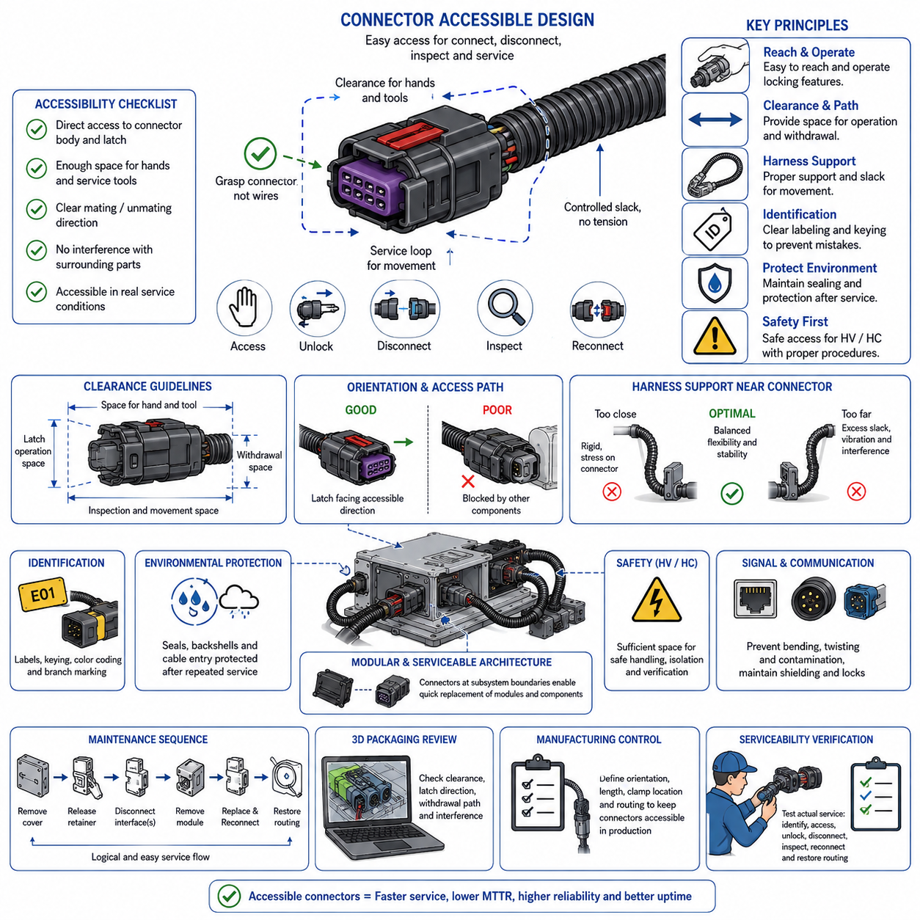
Connector accessible design ensures that electrical connectors can be reached, identified, disconnected, inspected, and reconnected during assembly and field maintenance without unnecessary removal of surrounding components. Accessibility must be treated as a design requirement rather than a convenience added after packaging. Connector location, orientation, surrounding clearance, harness slack, locking mechanism, and tool access should be considered together as part of the overall serviceability strategy.
A connector should be positioned so that a technician can directly grasp its housing rather than pulling on the attached wires. The surrounding package must provide enough space for fingers, gloves, or appropriate service tools to operate the latch, coupling ring, secondary lock, or connector position assurance feature. Access should remain practical under realistic maintenance conditions, including restricted visibility and confined equipment compartments.
Connector orientation has a major influence on service efficiency. Locking features should face an accessible direction whenever packaging permits, while connector mating and unmating motion should not be blocked by frames, covers, brackets, batteries, controllers, or neighboring harnesses. An apparently accessible connector may become difficult to remove if its required withdrawal direction intersects another component, so both access and extraction paths must be evaluated.
Clearance around the connector should accommodate more than the physical connector dimensions. Space is required for hand movement, latch displacement, coupling rotation, inspection, and the initial movement needed to separate mating halves. Large power connectors and sealed industrial connectors may require considerably more operating space than small signal connectors because their locking mechanisms, sealing forces, and cable stiffness can increase the force and motion needed for disconnection.
Harness routing must support connector accessibility rather than restrict it. The branch approaching the connector should provide sufficient controlled slack to allow normal mating and unmating while avoiding excessive free wire that can interfere with nearby structures. Service loops may be introduced where necessary to permit a module or connector to move into a convenient maintenance position without transmitting tensile load into terminals, seals, splices, or upstream harness branches.
The first harness support point near a connector requires careful placement. If the clamp is too close, the harness may become too rigid to disconnect comfortably or may impose bending stress on the connector exit. If it is too far away, excessive unsupported length can vibrate, abrade, or interfere with neighboring components. The support arrangement should therefore provide both operational stability and sufficient flexibility for the expected service movement.
Connector accessibility must also consider the complete maintenance sequence rather than only the disconnected state. A technician may need to remove a cover, release a retaining clip, disconnect several interfaces, withdraw a module, perform replacement, and then restore the harness to its original routing. The connector architecture should support this sequence logically so that unrelated electrical interfaces do not need to be disturbed simply to access one serviceable component.
Identification is an important part of accessible design, particularly where multiple similar connectors are located close together. Labels, connector identifiers, keying, color coding where appropriate, branch markings, and clear physical differentiation can reduce incorrect reconnection. Identification should remain visible or discoverable during servicing and should correspond consistently with electrical drawings, wiring diagrams, diagnostic documentation, and work instructions.
Accessibility must not compromise environmental protection. Waterproof or dust-resistant connectors require seals, locking mechanisms, backshells, and cable-entry regions to remain correctly positioned after repeated maintenance. Connector placement should allow technicians to inspect sealing surfaces and confirm complete engagement. Designs that force connectors against surrounding structures can make proper locking difficult and may hide partially seated conditions that later cause intermittent electrical faults.
High-current and high-voltage connectors require additional consideration because cable stiffness, connector mass, touch protection, and required safety procedures can significantly affect service access. The technician must have enough room to manipulate the connector without sharply bending the cable or placing side loads on terminals. Where hazardous voltage is present, accessibility should be coordinated with isolation, interlock, discharge, verification, and protection requirements defined by the electrical safety architecture.
Signal and communication connectors may have different accessibility concerns. Ethernet, camera, LiDAR, encoder, and other data interfaces can use relatively delicate contacts, shielding arrangements, or locking features. Service access should prevent twisting, excessive bending, contamination, and repeated loading of cable terminations. Where connectors are densely packaged around computing or perception modules, clear routing and identification are especially important for preventing incorrect connections during replacement.
Modular harness architecture benefits directly from accessible connector placement. When subsystem boundaries are located at practical service interfaces, a sensor module, drive unit, controller, battery assembly, or other replaceable component can be removed without dismantling large portions of the main harness. Accessible connectors therefore support modularity by creating defined electrical separation points between serviceable assemblies and the fixed vehicle or robot infrastructure.
Packaging reviews should evaluate connector accessibility using realistic three-dimensional geometry. CAD models can identify blocked latch directions, insufficient withdrawal distance, collisions with covers, and interference between the connector and surrounding harnesses. However, geometric clearance alone does not guarantee practical serviceability. Physical mockups or representative hardware should be used when necessary to confirm that a technician can actually reach and operate the interface.
Manufacturing requirements should preserve the intended accessibility established during design. Harness drawings, installation instructions, clamp locations, branch lengths, connector orientations, and routing references should prevent production variation from moving connectors into inaccessible positions. A connector that is serviceable in the nominal CAD model may become difficult to reach if harness slack, clip orientation, or mounting position varies significantly between assembled units.
Serviceability verification should reproduce representative maintenance tasks using production-intent components. Technicians should demonstrate identification, access, unlocking, disconnection, inspection, reconnection, and routing restoration without pulling wires, damaging seals, applying abnormal bending, or removing unrelated assemblies unnecessarily. Repeated service trials can reveal problems such as difficult latch operation, hidden connectors, insufficient hand clearance, excessive insertion force, or gradual harness displacement.
For AMRs and mobile robotic platforms, connector accessible design can significantly reduce mean time to repair and improve operational availability. Drive modules, sensors, safety devices, batteries, computing units, communication equipment, and charging interfaces are common service points. Designing their connectors for direct access, controlled harness movement, reliable identification, environmental protection, and repeatable reconnection allows field maintenance to be performed efficiently while preserving electrical and mechanical integrity throughout the robot lifecycle.

11.03. Modular Harness Architecture
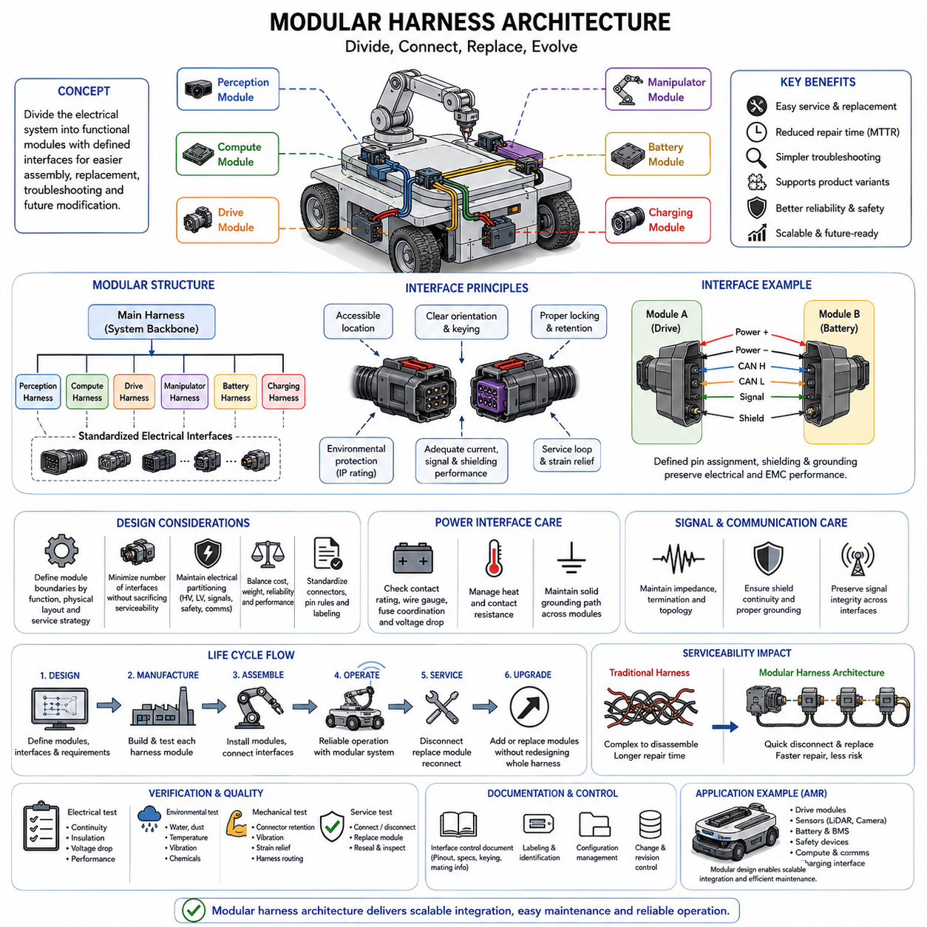
Modular harness architecture divides a large electrical wiring system into clearly defined harness modules that correspond to functional, physical, or serviceable subsystems. Instead of constructing one continuous harness across the entire robot or machine, the architecture establishes controlled electrical interfaces between modules. This approach supports easier assembly, replacement, troubleshooting, configuration management, and future system modification while preserving electrical integrity.
The boundaries of each harness module should reflect meaningful subsystem divisions. Typical boundaries may correspond to drive modules, sensor assemblies, battery systems, computing units, manipulators, safety devices, charging interfaces, or removable body structures. A good boundary allows one subsystem to be disconnected without disturbing unrelated wiring, while avoiding unnecessary intermediate connectors that increase resistance, cost, weight, packaging complexity, and potential failure points.
Connector placement is fundamental to modular architecture because connectors form the electrical interfaces between harness sections. Interface connectors should be located where technicians can reach, identify, disconnect, and reconnect them during assembly or service. Their orientation, locking method, environmental rating, current capability, signal integrity, pin allocation, and mechanical retention must satisfy the requirements of all circuits crossing the modular boundary.
The architecture should distinguish between a main harness and local subsystem harnesses where appropriate. The main harness can provide common power distribution, communication networks, grounding paths, and system-level interfaces, while local harnesses distribute these resources within individual modules. This hierarchical arrangement can reduce routing complexity and allows local harness designs to evolve without requiring complete redesign of the system-level wiring architecture.
Electrical partitioning must be coordinated with physical partitioning. A mechanically removable module provides limited service benefit if its harness remains permanently integrated with distant components. Conversely, excessive electrical segmentation can introduce many connectors and discontinuities. Mechanical assembly boundaries, maintenance strategy, electrical functions, packaging constraints, and expected replacement frequency should therefore be evaluated together when selecting modular harness interfaces.
Power circuits require careful treatment at module boundaries. Connector contacts, wire gauges, fuse coordination, voltage drop, transient current capability, thermal limits, and grounding paths must remain suitable after the circuit is divided into multiple harness sections. High-current interfaces can add significant contact resistance and heat, so modularity should not be introduced simply for convenience when a continuous connection provides substantially better electrical or reliability performance.
Communication and signal circuits also require interface discipline. CAN, CAN FD, Ethernet, sensor signals, encoder lines, and other communication channels may depend on controlled impedance, shielding, termination, topology, or pair geometry. Modular connectors and intermediate harness sections must preserve these characteristics. Shield continuity and grounding strategy should be explicitly defined so that serviceable interfaces do not unintentionally create electromagnetic compatibility or communication reliability problems.
Modular architecture should maintain separation among circuits with different electrical and safety characteristics. High-voltage, low-voltage power, safety-related circuits, communication networks, and sensitive sensor signals may require different connectors, routing regions, shielding, or physical separation. A modular interface should preserve these design rules rather than combining unrelated circuits solely to reduce connector count or simplify packaging.
Standardization can significantly increase the value of modular harness design. Reusing defined connector families, interface conventions, pin-assignment rules, labeling methods, mounting features, and branch construction practices reduces engineering variation and simplifies manufacturing and field support. However, standardization should not permit incompatible modules to be accidentally connected, so mechanical keying, coding, polarization, and clear identification remain essential.
Modularity also supports product variants and configurable robotic platforms. Different sensors, computing devices, drive systems, payload modules, or optional equipment can be connected through predefined electrical interfaces without redesigning the complete harness. A common base harness can therefore support multiple product configurations while variant-specific harness modules provide the required local connections. This can reduce design duplication and improve configuration control across a product family.
Serviceability is one of the strongest reasons for adopting modular harness architecture. A failed subsystem should ideally be replaceable by disconnecting a limited number of accessible interfaces and removing only the associated local harness or module. Service loops, accessible connectors, logical interface locations, and clear identification work together with modular architecture to reduce unnecessary disassembly and prevent maintenance activities from disturbing healthy portions of the electrical system.
Fault isolation can also improve when electrical boundaries correspond to functional subsystems. Technicians can inspect connectors, measure power and signals at defined interfaces, substitute known-good modules, or isolate sections of the harness during diagnosis. Clearly documented interface points make electrical troubleshooting more systematic because measurements can progress from the system-level distribution network toward the suspected local subsystem without opening the entire harness.
Environmental protection must be maintained at every modular interface. Connectors located in exposed robot structures may require protection against water, dust, chemicals, vibration, temperature variation, and mechanical impact. Frequent service interfaces must retain their sealing performance after repeated mating cycles. Connector location should also prevent contamination during module removal and allow technicians to inspect seals, contacts, locking features, and protective components before reconnection.
Mechanical loads at modular interfaces should be controlled through appropriate harness support and strain relief. Connector bodies should not carry the weight of long cable sections or experience continuous side loads caused by poor routing. Clamps and supports should stabilize each harness module while preserving enough controlled movement for connection and service. The interface should return to a repeatable installed geometry after a module has been removed and replaced.
Manufacturing can benefit from modular harnesses because individual sections may be fabricated, inspected, and electrically tested before final system assembly. Subsystem harnesses can be installed with their associated mechanical modules and later connected through defined interfaces during final integration. Harness drawings, connector tables, labels, interface definitions, and configuration records must clearly identify each module so that manufacturing variations do not create incompatible or incorrectly routed assemblies.
Verification should evaluate both individual harness modules and the integrated architecture. Tests should confirm continuity, insulation, voltage drop, communication performance, grounding, shielding, connector engagement, environmental protection, and mechanical routing as applicable. Service trials should additionally demonstrate that modules can be disconnected, replaced, and reconnected without damaging terminals, seals, wires, adjacent harnesses, or surrounding components.
For AMRs and other robotic platforms, modular harness architecture provides a practical foundation for scalable electrical integration. Drive units, batteries, perception sensors, safety devices, computing systems, communication equipment, manipulators, and charging systems can be organized as serviceable electrical modules connected through controlled interfaces. When electrical partitioning, connector accessibility, protection, standardization, diagnostics, and configuration management are designed together, modularity can reduce maintenance effort and support efficient platform evolution.

11.04. Lifetime Flex Cycle Design
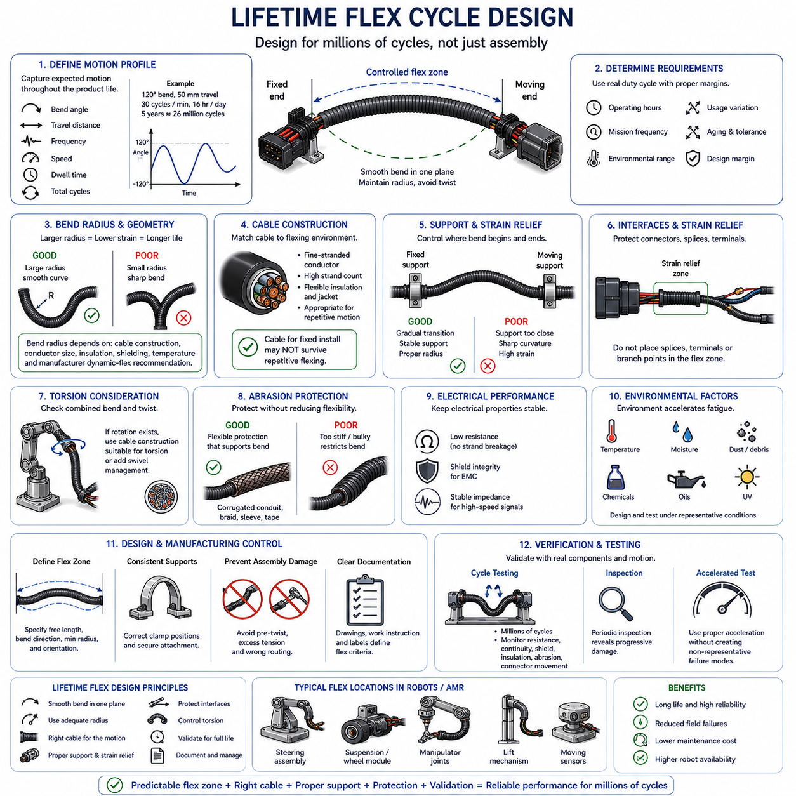
Lifetime flex cycle design ensures that harness sections exposed to repeated motion can survive the required operational life without conductor fatigue, insulation cracking, shielding degradation, or terminal damage. Unlike a service loop that moves occasionally during maintenance, a lifetime flex section experiences repetitive bending during normal operation. Its geometry, materials, support, and expected motion must therefore be engineered as a fatigue-critical system.
The design process begins by defining the expected motion profile over the complete product lifetime. Engineers should identify bending angle, travel distance, motion frequency, operating speed, dwell conditions, and the number of expected cycles. A harness moving once per minute for several years may accumulate millions of cycles, so seemingly moderate movement can become a major durability requirement when evaluated over the full operating life.
Flex cycle requirements should be derived from realistic duty cycles rather than arbitrary laboratory targets. Robot operating hours, mission frequency, steering activity, manipulator movements, suspension travel, door or cover operation, and maintenance actions may contribute differently to harness motion. Appropriate design margins should account for usage variation, accelerated aging, manufacturing tolerances, and operating conditions that may exceed the nominal mission profile.
Bend radius is one of the most important parameters affecting flex life. Repeated bending over a small radius produces high strain in conductor strands and insulation, accelerating fatigue damage. Increasing the dynamic bend radius generally reduces mechanical strain and improves durability. The required radius should reflect cable construction, conductor size, insulation material, shielding, temperature range, and the manufacturer's dynamic-flex recommendations rather than only static routing limits.
The conductor construction should match the expected flexing environment. Fine-stranded conductors generally distribute bending strain more effectively than conductors with fewer, larger strands and are therefore often preferred for repetitive-motion applications. Strand count, strand diameter, lay construction, conductor material, and overall cable geometry influence fatigue performance. A wire suitable for fixed installation may not provide acceptable life when continuously flexed.
Insulation and jacket materials also influence lifetime performance because they must repeatedly deform without cracking, hardening, tearing, or separating from the conductor system. Material flexibility can change significantly with temperature, chemical exposure, ultraviolet radiation, oils, cleaning agents, and aging. The selected material should retain sufficient mechanical flexibility throughout the environmental range expected during the complete service life of the robot or machine.
Dynamic harness routing should create controlled bending rather than random deformation. The moving section should preferably bend in a predictable plane and over a defined radius instead of twisting, folding, or forming sharp localized bends. Routing geometry should guide motion naturally so that the same region does not experience uncontrolled stress concentration. Adequate free length must be provided without creating excessive slack that can whip, snag, or contact surrounding structures.
Support points determine where bending begins and ends and therefore strongly influence fatigue life. Clamps located too close to a moving joint can create abrupt curvature and concentrate strain near the restraint. Supports located too far away can permit uncontrolled movement and abrasion. The fixed and moving ends should be positioned so that the harness transitions gradually between stationary and dynamic regions while maintaining the intended bend geometry throughout motion.
Strain relief is especially important near connectors, splices, terminals, and branch transitions. These interfaces should not become the primary flex points because repeated bending can transfer loads directly into crimps, seals, solder joints, shield terminations, or connector backshells. The dynamic section should absorb motion within a designated flexible region while nearby interfaces remain mechanically stabilized and protected from repetitive tensile, torsional, and bending loads.
Torsion should be evaluated separately from bending because many robotic mechanisms generate combined motion. Steering modules, rotating sensors, articulated joints, manipulators, and cable routing around pivots may twist the harness while simultaneously bending it. Cables intended primarily for linear flexing may perform poorly under repeated torsion. Where rotational motion cannot be eliminated, cable construction and routing should be selected specifically for the required torsional cycle.
Abrasion protection must not unintentionally reduce flexibility. Corrugated conduit, braid, tape, sleeves, and protective jackets can prevent contact damage, but they also change stiffness and bend behavior. A protection system that is appropriate for a static harness may restrict a dynamic section and move the bending stress toward an unprotected boundary. Protective materials should therefore be selected and terminated so that they support rather than interfere with controlled flexing.
Electrical performance must remain stable throughout flex life. Progressive strand breakage can increase conductor resistance before complete open-circuit failure occurs, while shield damage can degrade electromagnetic compatibility. Twisted pairs or high-speed communication cables may experience geometry changes that affect impedance and signal quality. Flex validation should therefore monitor relevant electrical characteristics in addition to visible mechanical damage.
Environmental conditions can substantially accelerate flex fatigue. Low temperatures may increase insulation stiffness, high temperatures can accelerate material aging, and contamination can change friction between the harness and surrounding guides. Water, dust, oils, chemicals, and debris may also enter moving interfaces. Flex cycle qualification should reproduce representative environmental conditions when these factors can interact with repetitive mechanical movement during actual operation.
Manufacturing consistency is critical because small differences in branch length, clamp position, cable orientation, or installed twist can significantly change dynamic behavior. Harness drawings and work instructions should define the flexible zone, support locations, free length, bend direction, minimum radius, and installation orientation. Assembly processes should prevent technicians from introducing pre-twist, excessive tension, or routing variations that invalidate the intended fatigue design.
Lifetime verification should use representative production cables, connectors, protection materials, supports, and installation geometry. Cycle testing should reproduce the required movement while monitoring for conductor resistance change, intermittent continuity, insulation damage, shield degradation, connector movement, abrasion, and abnormal heating. Periodic inspection during testing can reveal progressive failure mechanisms and help determine whether the design margin is adequate.
Accelerated flex testing can reduce validation time, but acceleration must preserve the relevant failure mechanisms. Simply increasing motion speed may introduce heating, inertia, or dynamic effects that do not represent actual operation. Test frequency, displacement, bend radius, environmental conditions, and load should therefore be selected carefully. The objective is to accumulate representative fatigue damage without creating artificial failure modes unrelated to field operation.
For AMRs and robotic platforms, lifetime flex cycle design is particularly important around steering assemblies, suspension systems, wheel modules, manipulators, moving sensors, lift mechanisms, and other articulated structures. These locations can accumulate very large numbers of cycles during normal missions. Designing predictable flex zones with appropriate cable construction, bend radius, strain relief, protection, and validated cycle life prevents harness fatigue from becoming a hidden limitation on robot durability and availability.

11.05. Field Repair Kit Design
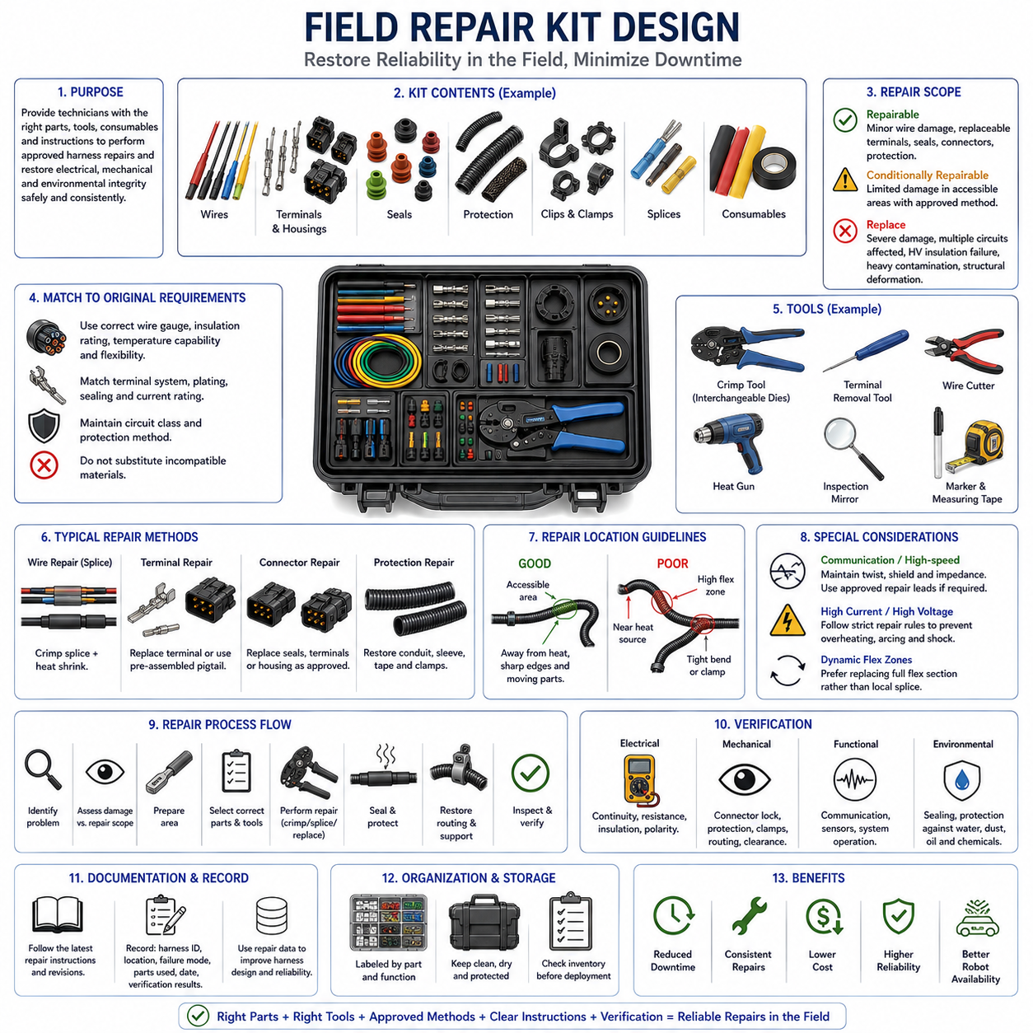
Field repair kit design provides technicians with a controlled set of parts, tools, consumables, and instructions required to restore damaged wire harnesses under field conditions. The objective is not to reproduce every factory manufacturing process outside the plant, but to enable approved repairs that recover electrical continuity, mechanical integrity, environmental protection, and serviceability while minimizing robot downtime and uncontrolled repair practices.
The kit contents should be derived from the actual harness architecture and expected field failure modes. Typical repair needs include damaged wires, terminals, connector housings, seals, protective sleeves, clips, clamps, and localized branch sections. Components should correspond to the connector families, wire gauges, insulation types, circuit classes, and protection methods used on the platform so technicians are not forced to substitute electrically or mechanically incompatible materials.
Repair scope must be clearly defined because not every harness defect should be repaired in the field. Minor conductor damage or replaceable connector components may be suitable for controlled repair, while extensive thermal damage, multiple damaged circuits, high-voltage insulation failure, severe contamination, or structural harness deformation may require complete harness replacement. Repair instructions should establish clear limits between repairable, conditionally repairable, and replacement-required conditions.
Wire repair materials should match the original electrical and environmental requirements as closely as practical. Replacement wire must have appropriate conductor cross-section, current capacity, insulation rating, temperature capability, flexibility, and environmental resistance. Using an incorrect wire simply because it fits physically can alter voltage drop, thermal performance, mechanical durability, or circuit protection coordination and may create a latent reliability problem.
Terminal and connector repair requires compatible service components and controlled installation methods. Replacement terminals should match the connector system, conductor range, plating, sealing configuration, and current requirement. Where individual terminals or seals are not approved for field replacement, the repair strategy may instead use a preassembled connector pigtail or replaceable harness module. This reduces dependence on complex terminal extraction and precision crimping in uncontrolled environments.
Crimp repair tools should be selected according to the terminals and splice systems included in the kit. Proper crimp geometry depends on conductor size, terminal construction, tooling profile, and applied compression, so generic pliers are not an acceptable substitute for controlled crimp tooling. Where several terminal families are used, interchangeable dies or dedicated service tools should be clearly identified to prevent technicians from using an incorrect combination.
Splice repair should use predefined and validated methods. Depending on the harness architecture and environmental requirements, an approved repair may use crimp splices, sealed splice systems, heat-shrink components, or preconfigured repair leads. The repaired section should restore conductor capacity while avoiding excessive stiffness, large local diameter changes, or stress concentrations that can create new fatigue points near the repaired area.
Environmental sealing is particularly important when field repairs occur on AMRs or robots operating around water, dust, oils, chemicals, or outdoor contamination. Repair kits should include the specified seals, heat-shrink materials, sleeves, tapes, or other protection components required by the approved repair process. A repair that restores electrical continuity but leaves the conductor exposed to moisture or contamination should not be considered complete.
Mechanical protection must also be restored after electrical repair. Corrugated conduit, braid, protective sleeve, tape wrapping, grommets, clamps, and clips may need replacement if they were damaged during the original failure or during access to the repair location. The completed harness should return to its intended routing and support condition so that the repaired area is not exposed to abrasion, excessive vibration, sharp edges, heat, or uncontrolled movement.
Repair location influences the appropriate repair method. Repairs should generally avoid regions experiencing severe vibration, repetitive flexing, tight bending, high temperature, or direct environmental exposure when a safer location can be selected. Splices should not be positioned where they become primary bending points or interfere with clamps and connectors. In dynamic harness sections, replacement of the complete flexible segment may provide better durability than a localized splice repair.
Communication and sensitive signal circuits require additional caution. Twisted pairs, shielded cables, Ethernet lines, sensor interfaces, and other high-speed circuits depend on cable geometry and shielding characteristics that may be difficult to restore with a simple conductor splice. Repair procedures should specify whether such circuits can be repaired, require specialized components, or must be replaced as complete cable or harness sections to preserve signal integrity and electromagnetic compatibility.
High-current and high-voltage circuits should have more restrictive field repair rules because an inadequate repair can create overheating, arcing, insulation breakdown, or electric shock hazards. Approved repair procedures must preserve conductor capacity, insulation coordination, sealing, touch protection, and mechanical retention. Where these characteristics cannot be reliably reproduced with field equipment, replacement of the affected cable or modular harness assembly should be the required service action.
Organization of the field repair kit is as important as its contents. Parts should be separated by connector family, wire size, seal type, or repair function and clearly labeled with service part numbers. Visual identification can reduce selection errors when repairs are performed under time pressure. Consumables should have controlled quantities and storage requirements, while tools should have dedicated positions so missing equipment can be detected before deployment.
Documentation should provide concise but technically controlled repair instructions. Each procedure should identify the applicable circuit or harness type, permitted damage, required components, tooling, preparation dimensions, crimp or splice method, sealing process, routing restoration, and final inspection criteria. Photographs or diagrams may be used in the actual service documentation, while revision control should ensure that field kits remain aligned with the current production harness configuration.
Post-repair verification is necessary before the robot returns to operation. Depending on the circuit, technicians may need to confirm continuity, resistance, insulation, polarity, connector engagement, sealing, communication performance, or functional operation. Visual inspection should confirm that no conductor is exposed, protection is restored, clamps are correctly positioned, and the repaired harness maintains appropriate clearance from moving parts, hot surfaces, and sharp structures.
Repair records should be integrated with maintenance and configuration management. The technician should identify the affected harness, circuit, repair location, failure mode, parts used, date, and verification result. Repeated repairs at similar locations can reveal systematic problems in routing, protection, flex design, connector selection, or manufacturing. Field repair data therefore provides valuable feedback for improving future harness designs rather than serving only as a maintenance record.
For AMRs and robotic platforms, a well-designed field repair kit can significantly reduce mean time to repair and prevent minor harness damage from causing extended system downtime. Standardized wires, connectors, splices, protection materials, controlled tooling, documented repair limits, and verification procedures allow technicians to restore approved faults consistently. Combined with modular harness architecture, accessible connectors, and serviceable routing, the repair kit becomes part of a complete lifecycle serviceability strategy.

