Volume 02. Wire Harness Engineering

Chapter 01. Wire Physics

01.01. Resistivity and Temperature Coefficient
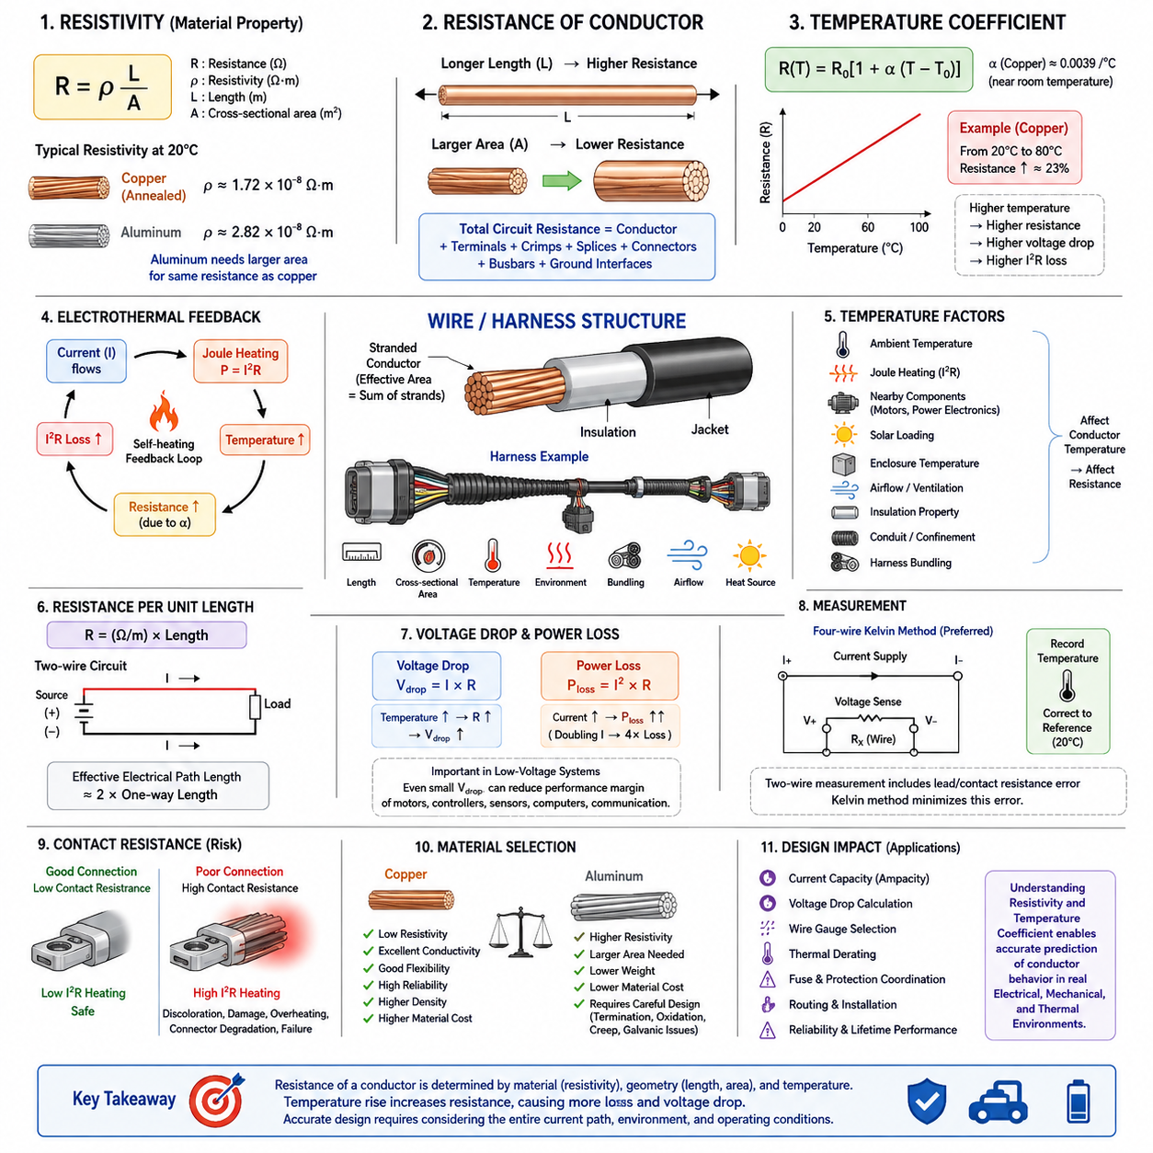
Electrical resistivity describes the intrinsic opposition of a conductor material to the movement of electric charge. Unlike resistance, which depends on the physical dimensions of a wire, resistivity is primarily a material property. For a uniform conductor, resistance is expressed as R = ρL/A, where ρ is resistivity, L is conductor length, and A is cross-sectional area.
This relationship is fundamental to wire-harness engineering because every conductor introduces electrical loss between the power source and the connected load. Increasing conductor length increases resistance proportionally, while increasing conductor cross-sectional area reduces resistance. Therefore, long harness branches or high-current circuits generally require larger conductors to maintain acceptable voltage drop and thermal performance.
Copper is widely used for electrical harnesses because it combines relatively low resistivity with good mechanical flexibility, manufacturability, and connection reliability. At approximately 20°C, annealed copper has a resistivity near 1.72 × 10⁻⁸ Ω·m. Aluminum has higher resistivity, so a larger aluminum cross section is normally required to obtain electrical resistance comparable to that of a copper conductor.
Resistance calculations must distinguish between conductor resistivity and the resistance of the actual wire assembly. A conductor may have excellent bulk resistivity, yet the complete circuit can contain additional resistance from terminals, crimps, splices, connectors, busbars, and grounding interfaces. Harness analysis therefore begins with conductor resistance but eventually considers the entire current path from source to load and return.
Temperature significantly affects conductor resistance. In common metallic conductors such as copper and aluminum, resistance normally increases as temperature rises because increased lattice vibration interferes with electron transport. Over a moderate temperature range, this behavior can be approximated by R(T) = R₀[1 + α(T − T₀)], where α represents the temperature coefficient of resistance.
For copper near room temperature, the temperature coefficient is approximately 0.0039/°C. This means that a copper conductor operating substantially above its reference temperature can have noticeably greater resistance than indicated by a room-temperature calculation. A harness designed only with nominal 20°C resistance can therefore underestimate actual voltage drop and conductor power loss during high-temperature operation.
The temperature coefficient creates an important electrothermal feedback mechanism. Current flowing through a conductor produces Joule heating according to P = I²R. As conductor temperature rises, its resistance increases, which can increase I²R losses when current remains approximately constant. The final operating temperature is consequently determined by both electrical heat generation and the ability of the wire to transfer heat into its surroundings.
Ambient temperature is only one component of conductor temperature. Internal Joule heating, nearby motors or power electronics, solar loading, enclosure temperature, airflow, insulation properties, conduit installation, and harness bundling can all influence thermal conditions. A wire routed through a hot compartment can therefore operate at a substantially different resistance from an identical wire exposed to cooler, freely ventilated conditions.
For stranded conductors, the electrical cross-sectional area is approximately the combined metallic area of the individual strands rather than the outside diameter of the insulated wire. Strand construction strongly influences flexibility and fatigue behavior, while total conductive area largely determines DC resistance. Manufacturing tolerances, strand diameter, material purity, and conductor processing can also cause measured resistance to differ from an ideal theoretical value.
Wire resistance is commonly specified in ohms per unit length, such as Ω/km or mΩ/m. This representation is convenient for harness design because circuit resistance can be estimated directly from routing length. In a two-wire power circuit, both supply and return conductors normally contribute to the voltage drop, so the effective electrical path length may be approximately twice the one-way physical distance between the source and load.
Voltage drop follows directly from Ohm's law, Vdrop = IR. Because conductor resistance increases with temperature, voltage drop also becomes temperature dependent. This is particularly important in low-voltage systems, where even a relatively small absolute voltage loss can represent a significant percentage of the available supply voltage and may reduce the operating margin of motors, controllers, sensors, computers, or communication equipment.
Resistive power dissipation is calculated using P = I²R, making current especially important in harness thermal design. Doubling current produces approximately four times the resistive heating when resistance remains constant. Consequently, conductor selection cannot be based only on whether a wire can physically carry a specified current; voltage-drop limits, insulation temperature capability, installation environment, and expected duty cycle must also be considered.
In mobile robots and AMRs, conductor temperature can vary considerably between operating states. High propulsion current during acceleration, climbing, turning, payload transport, or wheel stall can temporarily increase cable heating, while idle periods permit cooling. Battery voltage, motor-controller current demand, cable length, and conductor temperature therefore interact dynamically rather than behaving as independent design parameters.
Temperature correction becomes particularly important when estimating worst-case circuit performance. A practical calculation can first determine resistance at the reference temperature from resistivity, length, and area, then correct that resistance to the expected operating temperature. The corrected value can subsequently be used for voltage-drop and I²R-loss calculations, providing a more realistic representation of the installed harness.
For example, a copper conductor that rises from 20°C to 80°C experiences an approximate resistance increase of about 23 percent when the linear temperature-coefficient approximation is applied. A circuit that appears acceptable at room temperature may therefore approach a voltage-drop or thermal limit under sustained high-current operation. This illustrates why room-temperature resistance alone is insufficient for robust harness sizing.
The linear temperature model is useful for engineering calculations but should not be interpreted as universally exact. Temperature coefficients vary with material composition, reference temperature, purity, and operating range. For wide temperature excursions or high-accuracy analysis, manufacturer resistance data, standardized conductor specifications, or experimentally measured resistance-versus-temperature characteristics should be preferred over a simple constant-coefficient approximation.
Measurement provides an important link between theoretical resistivity and actual harness performance. Because power-wire resistance can be only a few milliohms, ordinary two-wire resistance measurements may include significant lead and contact errors. Four-wire Kelvin measurement is preferred for precise low-resistance characterization because separate current and voltage paths reduce the influence of test-lead and probe-contact resistance on the measured conductor value.
Resistance measurements should also record conductor temperature. Comparing a resistance measured on a cold wire with a specification referenced to 20°C can produce an apparent discrepancy even when the conductor is completely normal. Correcting measurements to a common reference temperature enables meaningful comparison among production samples, supplier specifications, prototypes, and field-return harnesses.
Contact resistance must be separated conceptually from bulk conductor resistance. A long wire may accumulate resistance through its material and geometry, while a poorly crimped terminal can introduce localized resistance within a very short distance. Such concentrated resistance is particularly dangerous because I²R heating occurs in a small region, potentially producing terminal discoloration, insulation damage, connector degradation, or progressive thermal failure.
Material selection therefore involves more than comparing nominal resistivity values. Copper provides excellent conductivity but has relatively high density and material cost, whereas aluminum can reduce mass but requires greater cross-sectional area and careful attention to termination technology, oxidation, creep, and galvanic compatibility. These tradeoffs become increasingly significant as harness current, length, and total vehicle cable mass increase.
Resistivity and temperature coefficient ultimately form the physical foundation for later harness-engineering decisions involving current capacity, voltage drop, wire-gauge selection, thermal derating, fuse coordination, routing, and protection. Understanding these properties allows the designer to predict how a conductor behaves not merely under nominal laboratory conditions, but across the electrical, mechanical, and thermal environments encountered throughout system operation.

01.02. Skin Effect and Proximity Effect
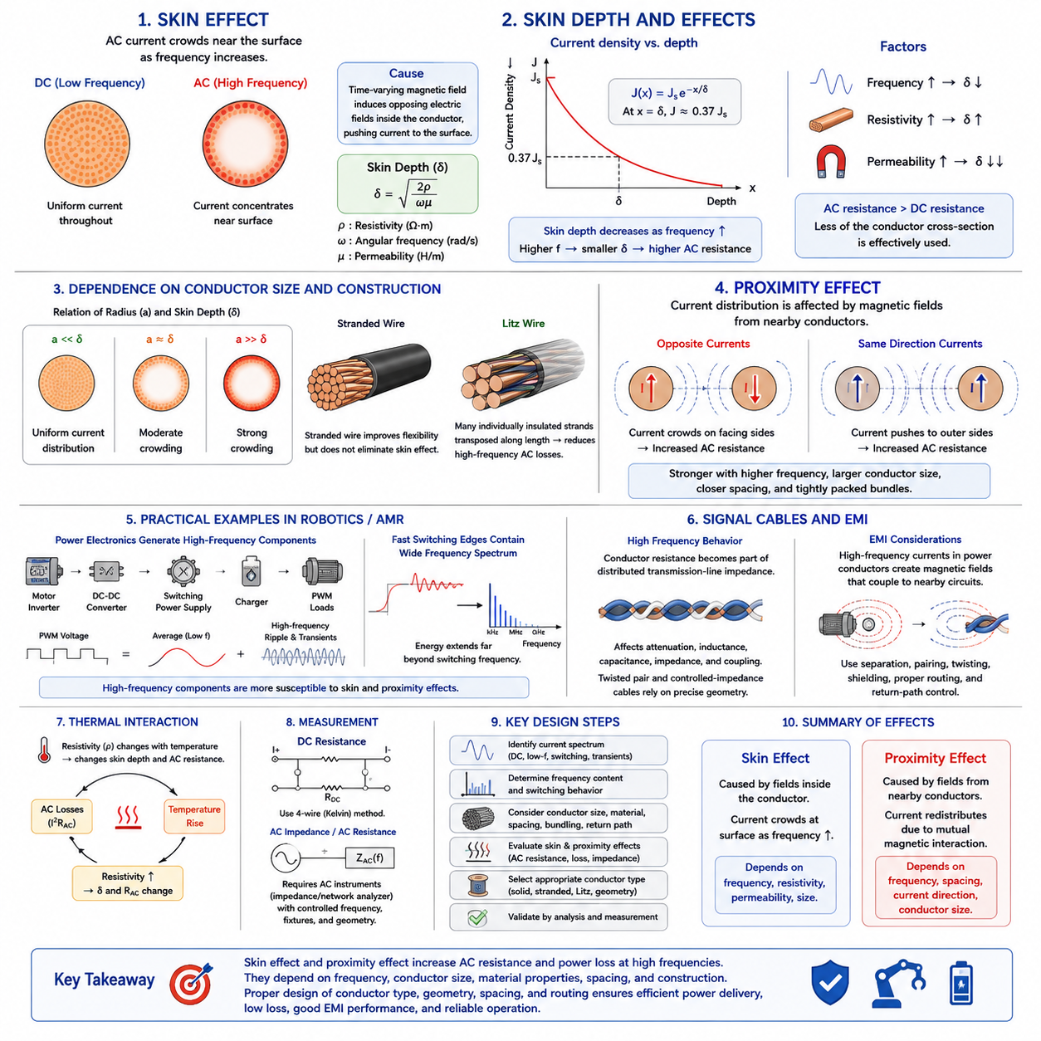
Skin effect is the tendency of alternating current to concentrate progressively toward the outer surface of a conductor as frequency increases. With direct current, current density is approximately uniform throughout the conductor cross section under ordinary conditions. With alternating current, however, time-varying magnetic fields induce internal electromagnetic effects that redistribute current and reduce utilization of the conductor core.
The physical origin of skin effect is electromagnetic induction within the conductor. Alternating current produces a changing magnetic field, which in turn creates induced electric fields that oppose changes in current distribution according to electromagnetic principles. The opposing effect is stronger toward the interior of the conductor, causing a greater proportion of the total current to flow near its surface as frequency rises.
Skin depth provides a convenient measure of how deeply alternating current penetrates into a conductor. It is commonly represented by δ and can be approximated by δ = √(2ρ/ωμ), where ρ is resistivity, ω is angular frequency, and μ is magnetic permeability. Current density decreases approximately exponentially with depth, reaching about 37 percent of its surface value at one skin depth.
The skin-depth relationship shows that frequency, material resistivity, and magnetic permeability determine the severity of skin effect. Increasing frequency decreases skin depth, while increasing resistivity tends to increase it. Materials with high magnetic permeability can exhibit much smaller skin depths. Consequently, conductor behavior at high frequency cannot be evaluated solely from the DC resistance and geometric cross-sectional area.
For copper, skin depth is relatively large at low frequencies and becomes progressively smaller as frequency increases. At conventional DC power distribution or very low-frequency operation, the effect is usually negligible for ordinary harness wire sizes. At kilohertz and especially megahertz frequencies, however, current can become increasingly concentrated near the conductor surface, raising effective AC resistance above its DC value.
The increase in AC resistance occurs because the entire physical cross section is no longer used equally for current conduction. Although the conductor contains the same amount of metal, much of the central region carries less current than the outer region. The effective conducting area therefore decreases, increasing resistive loss. This distinction between DC resistance and frequency-dependent AC resistance becomes important in high-frequency power and signal applications.
Conductor diameter strongly influences the practical significance of skin effect. When the conductor radius is much smaller than the skin depth, current distribution remains relatively uniform. When conductor dimensions become comparable to or larger than the skin depth, current crowding becomes significant. Large conductors carrying high-frequency current can therefore experience substantial AC resistance even when their DC resistance is very low.
Stranded wire improves mechanical flexibility but does not automatically eliminate skin effect. If ordinary strands are electrically connected together along their length, the complete bundle can still behave electromagnetically like a larger conductor. Specialized Litz wire addresses this problem by using many individually insulated strands that are arranged so each strand occupies different positions within the overall bundle along its length.
Litz-wire construction can reduce high-frequency losses by dividing the conductor into strands whose individual diameters are selected relative to skin depth. Transposition of the strands helps equalize their exposure to magnetic fields and reduces unequal current distribution. Such construction is valuable in transformers, inductors, wireless-power systems, high-frequency converters, and other applications where ordinary stranded conductors would experience excessive AC losses.
Proximity effect is related to skin effect but results primarily from magnetic fields produced by nearby conductors. When alternating currents flow through conductors located close together, the magnetic field from one conductor influences current distribution in another. Instead of current being distributed symmetrically around each conductor surface, it can become concentrated in particular regions depending on conductor spacing and current direction.
For two nearby conductors carrying currents in opposite directions, as commonly occurs in supply and return paths, electromagnetic interaction can crowd current toward particular facing regions. For conductors carrying current in the same direction, the redistribution pattern differs. In both cases, nonuniform current density reduces the effective conducting area and increases AC resistance beyond the value predicted using DC resistance alone.
Proximity effect becomes stronger as frequency increases because the magnetic fields vary more rapidly and induce stronger redistribution of current. It also becomes more significant when conductors are positioned close together, when conductor dimensions are large relative to skin depth, or when many current-carrying conductors are tightly packed. Harness geometry can therefore influence high-frequency electrical loss even when every wire uses identical conductor material and gauge.
Bundled conductors provide an important practical example. A tightly packed bundle may experience electromagnetic interaction among neighboring wires in addition to ordinary thermal derating caused by restricted heat dissipation. These are different physical mechanisms: thermal bundling affects conductor temperature and resistance through heat transfer, while proximity effect directly changes AC current distribution through electromagnetic coupling.
In robotics and AMR harnesses, most battery and low-frequency power circuits are dominated by DC resistance, voltage drop, thermal loading, and transient current requirements rather than severe skin effect. Nevertheless, modern power electronics introduce switching components at much higher frequencies. Motor inverters, DC-DC converters, switching power supplies, chargers, and PWM-controlled loads can place significant high-frequency current components on otherwise low-frequency power conductors.
Pulse-width modulation creates a particularly important distinction between fundamental electrical operation and high-frequency current content. A motor may rotate slowly while its inverter switches at several kilohertz or higher. The harness can therefore carry DC or low-frequency average current together with switching ripple and fast transient components. These higher-frequency components are more susceptible to skin and proximity effects than the average current.
Fast switching edges contain frequency components extending far above the nominal switching frequency. Consequently, conductor behavior relevant to electromagnetic compatibility may involve frequencies much higher than those suggested by motor speed or PWM frequency alone. Skin and proximity effects can influence conductor impedance, power loss, common-mode and differential-mode current paths, and the effectiveness of grounding and shielding arrangements.
Signal cables require a somewhat different interpretation. At high frequencies, conductor resistance becomes part of a distributed transmission-line impedance rather than merely producing a simple DC voltage drop. Skin effect contributes to frequency-dependent attenuation, while conductor geometry and proximity influence inductance, capacitance, impedance, and coupling. Twisted pairs and controlled-impedance cables therefore rely on carefully defined conductor geometry.
The relationship between proximity effect and electromagnetic interference is especially relevant when power and signal wiring share limited packaging space. High-frequency currents in motor phases or switching-power conductors generate changing magnetic fields that can couple into nearby circuits. Separation distance, conductor pairing, twisting, shielding, routing, and return-path control are therefore important not only for signal integrity but also for controlling electromagnetic interactions.
Temperature remains important because resistivity appears directly in the skin-depth equation. As conductor temperature changes, material resistivity changes, which slightly modifies skin depth and AC resistance. At the same time, AC losses themselves generate additional heat. Practical high-frequency conductor analysis can therefore require an electrothermal view in which frequency-dependent resistance and temperature-dependent material properties interact.
Measurement of high-frequency conductor behavior differs from simple DC resistance measurement. A four-wire Kelvin method is effective for low DC resistance, but AC impedance requires instruments and test arrangements capable of controlling frequency, fixture parasitics, contact impedance, and conductor geometry. Impedance analyzers, network analyzers, or specialized AC resistance measurements may be used when frequency-dependent conductor performance must be characterized accurately.
Engineering analysis should therefore begin by identifying the actual current spectrum rather than simply labeling a circuit as DC or AC. A battery cable may carry substantial switching ripple, while a motor phase conductor may contain a complex PWM waveform. Determining conductor dimensions, frequency content, material properties, spacing, bundling, and return-path geometry allows the designer to judge whether DC resistance remains sufficient or AC effects require consideration.
Skin effect and proximity effect ultimately extend basic wire physics from static resistance into frequency-dependent conductor behavior. Skin effect redistributes current because of fields generated within the conductor, while proximity effect modifies that distribution because of fields from neighboring conductors. Together they explain why conductor geometry, spacing, frequency, and electromagnetic environment become increasingly important as harness systems incorporate faster power electronics and communication interfaces.

01.03. Conductor Materials (Cu, Al, CCA)
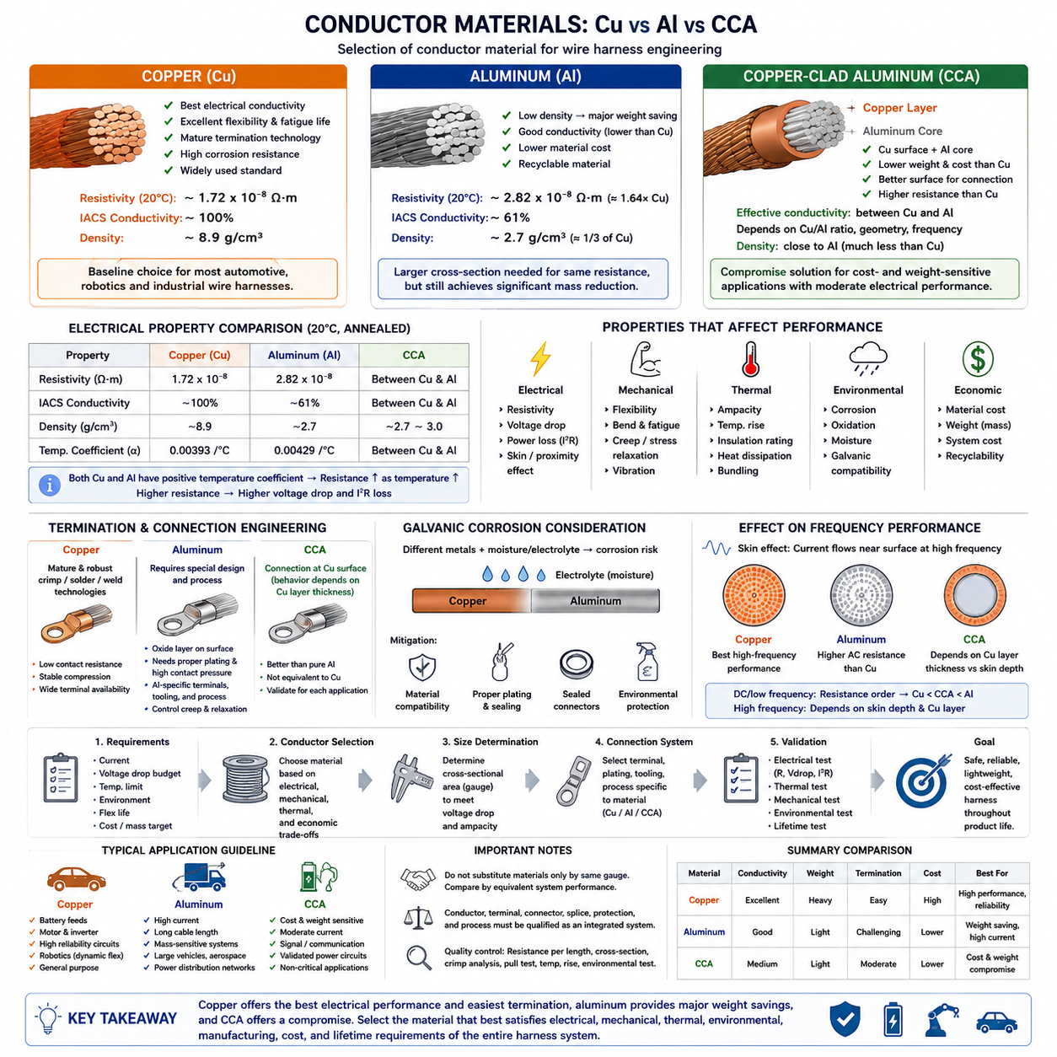
Copper is the dominant conductor material in wire-harness engineering because it provides an effective balance of electrical conductivity, mechanical flexibility, termination reliability, corrosion resistance, and manufacturing maturity. Aluminum offers substantial mass reduction at the cost of higher electrical resistivity and more demanding connection engineering, while copper-clad aluminum combines characteristics of both materials for selected applications.
Copper has a resistivity of approximately 1.72 × 10⁻⁸ Ω·m at 20°C for annealed material, making it one of the most conductive metals practical for large-scale electrical wiring. Its high conductivity allows a required current to be transmitted with relatively small conductor cross-sectional area, reducing voltage drop and resistive heating while simplifying packaging in dense harness assemblies.
Electrical conductivity is often expressed relative to the International Annealed Copper Standard, or IACS. Annealed copper represents approximately 100% IACS conductivity, although specific copper alloys and processing conditions can produce different values. This reference provides a convenient basis for comparing conductor materials because lower conductivity directly influences resistance, voltage drop, heat generation, and the cross-sectional area required for a circuit.
Copper also performs well mechanically in flexible harness applications. Fine-stranded copper conductors can tolerate repeated bending significantly better than rigid solid conductors when strand construction, bend radius, and routing are properly designed. This characteristic is particularly valuable in robots, AMRs, manipulators, steering modules, articulated joints, service loops, and other systems where harness sections experience vibration or repetitive movement.
Termination technology is another major advantage of copper. Automotive and industrial crimp systems have been optimized over decades for copper conductors, producing stable mechanical compression and low electrical contact resistance when appropriate terminals, tooling, and process controls are used. Copper is also compatible with numerous soldering, welding, ultrasonic joining, busbar, and connector technologies used throughout electrical systems.
Copper nevertheless has disadvantages. Its density is approximately 8.9 g/cm³, making large copper harnesses a significant contributor to vehicle or robot mass. Copper prices can also represent an important portion of harness cost. As power levels and cable lengths increase, designers may therefore investigate lighter conductor technologies, particularly in large vehicles, battery systems, aerospace platforms, and high-current power distribution networks.
Aluminum has a density of approximately 2.7 g/cm³, only about one-third that of copper, which creates a strong opportunity for harness mass reduction. Its electrical resistivity, however, is approximately 2.82 × 10⁻⁸ Ω·m at 20°C, substantially higher than that of copper. An aluminum conductor therefore requires a larger cross-sectional area than copper to achieve approximately the same electrical resistance.
The larger required aluminum cross section does not eliminate its mass advantage because aluminum is much less dense. Consequently, properly designed aluminum conductors can provide substantial weight savings while maintaining acceptable electrical resistance. The tradeoff is increased conductor diameter, which can affect harness packaging, connector dimensions, bend radius, routing space, conduit size, and minimum separation from surrounding structures.
Aluminum termination requires more careful engineering than conventional copper termination. Aluminum naturally forms a thin oxide layer whose electrical characteristics differ from those of the underlying metal. Reliable joints therefore depend on terminal materials, plating, contact pressure, crimp geometry, surface preparation, and joining processes designed specifically for aluminum conductors rather than simply applying a copper termination process unchanged.
Mechanical behavior must also be considered. Aluminum is generally more sensitive than copper to creep, stress relaxation, and certain fatigue mechanisms at electrical interfaces. A connection that initially provides sufficient contact pressure can deteriorate if the termination design does not account for material behavior over temperature cycling and service life. This makes validated aluminum-specific terminals and controlled manufacturing processes essential.
Galvanic corrosion is another important concern when aluminum is electrically connected to dissimilar metals in the presence of moisture or electrolytes. Copper-aluminum interfaces require careful material compatibility, plating, sealing, and environmental protection. In outdoor robots, charging interfaces, battery compartments, or wet environments, connector sealing and corrosion-control strategies become particularly important for long-term resistance stability.
Copper-clad aluminum, commonly abbreviated CCA, consists of an aluminum core covered by an outer copper layer. The concept seeks to combine the low density and lower material cost of aluminum with some surface-related advantages of copper. Because electrical contacts occur at the conductor surface, the copper exterior can improve compatibility with certain connection processes while the aluminum core reduces overall conductor mass.
CCA should not be treated as electrically equivalent to solid copper of the same nominal cross-sectional area. Its effective conductivity depends on the copper-to-aluminum ratio, manufacturing process, conductor geometry, and operating frequency. For DC and low-frequency power circuits, a CCA conductor generally has higher resistance than an equal-area copper conductor and may therefore require a larger gauge to meet the same voltage-drop and thermal requirements.
At higher frequencies, current increasingly concentrates toward the conductor surface because of skin effect. Since CCA places the higher-conductivity copper material around the outside of the aluminum core, its high-frequency behavior can differ from what would be expected from a homogeneous aluminum conductor. However, actual performance depends strongly on copper-layer thickness relative to skin depth and cannot be assumed from the CCA designation alone.
CCA can provide useful compromises in applications where mass and cost are important but maximum copper conductivity is unnecessary. It has been used in communication cables, selected signal wiring, and some power applications. For safety-critical, high-current, repetitive-flex, or harsh-environment robotic circuits, however, conductor construction must be validated against electrical, mechanical, thermal, termination, and lifetime requirements rather than selected solely for weight or price.
Conductor material also affects temperature-dependent resistance. Copper and aluminum both have positive temperature coefficients, meaning their resistance increases as operating temperature rises. Consequently, material comparisons should be performed at realistic operating temperatures rather than only at the nominal 20°C reference condition. Higher resistance increases voltage drop and I²R loss and can influence the thermal equilibrium of the complete harness.
Current capacity cannot be determined from conductivity alone. Ampacity depends on conductor area, insulation temperature rating, ambient temperature, bundling, routing, airflow, conduit or sleeve installation, duty cycle, and allowable temperature rise. A larger aluminum or CCA conductor may achieve an acceptable resistance, but its different diameter and thermal environment can produce installation behavior that differs from an equivalent copper circuit.
Mechanical flexibility is similarly dependent on more than the base material. Strand count, individual strand diameter, conductor lay, insulation construction, bend radius, tensile loading, vibration, and repetitive-flex requirements all contribute to harness durability. Fine-stranded copper remains attractive for highly dynamic robotic wiring, while alternative conductor constructions require application-specific flex and fatigue validation before deployment in moving harness sections.
Material choice also propagates into connector engineering. A change from copper to aluminum or CCA may require different terminal barrels, crimp dimensions, plating systems, sealing methods, strain relief, inspection criteria, and process parameters. The conductor cannot therefore be substituted independently from the rest of the harness. Wire, terminal, connector, splice, protection, and manufacturing process should be qualified as an integrated connection system.
Quality control is especially important because conductor appearance alone may not reliably identify electrical performance. Resistance-per-unit-length measurement, conductor cross-section inspection, material verification, crimp cross-section analysis, pull-force testing, temperature-rise testing, and environmental validation can be used to confirm that the manufactured harness satisfies its intended requirements. Supplier specifications should clearly identify conductor material rather than relying only on nominal gauge.
In AMR power distribution, copper is generally the straightforward reference choice for battery feeds, motor-controller circuits, computing power, sensors, and communication wiring because of its predictable electrical and connection characteristics. Aluminum becomes more attractive as current, cable length, and total harness mass increase, while CCA may be considered selectively where its electrical and mechanical limitations are compatible with the circuit requirements.
For larger robotic platforms, autonomous vehicles, mobile manipulators, and future high-power systems, conductor selection increasingly becomes a system-level optimization problem. Copper minimizes conductor resistance and simplifies termination, aluminum minimizes mass, and CCA can occupy an intermediate design space. The preferred material therefore depends on current, length, voltage-drop budget, thermal environment, packaging volume, motion, lifetime, cost, and service conditions.
Copper, aluminum, and copper-clad aluminum should ultimately be compared by equivalent system performance rather than equal nominal gauge. The correct question is not simply which material has the lowest resistivity, but what conductor size and connection system can satisfy electrical, thermal, mechanical, environmental, manufacturing, reliability, and mass requirements throughout the product lifetime. This approach establishes a sound basis for subsequent current-capacity and wire-gauge selection.

01.04. Insulation Materials (PVC, XLPE, PTFE)
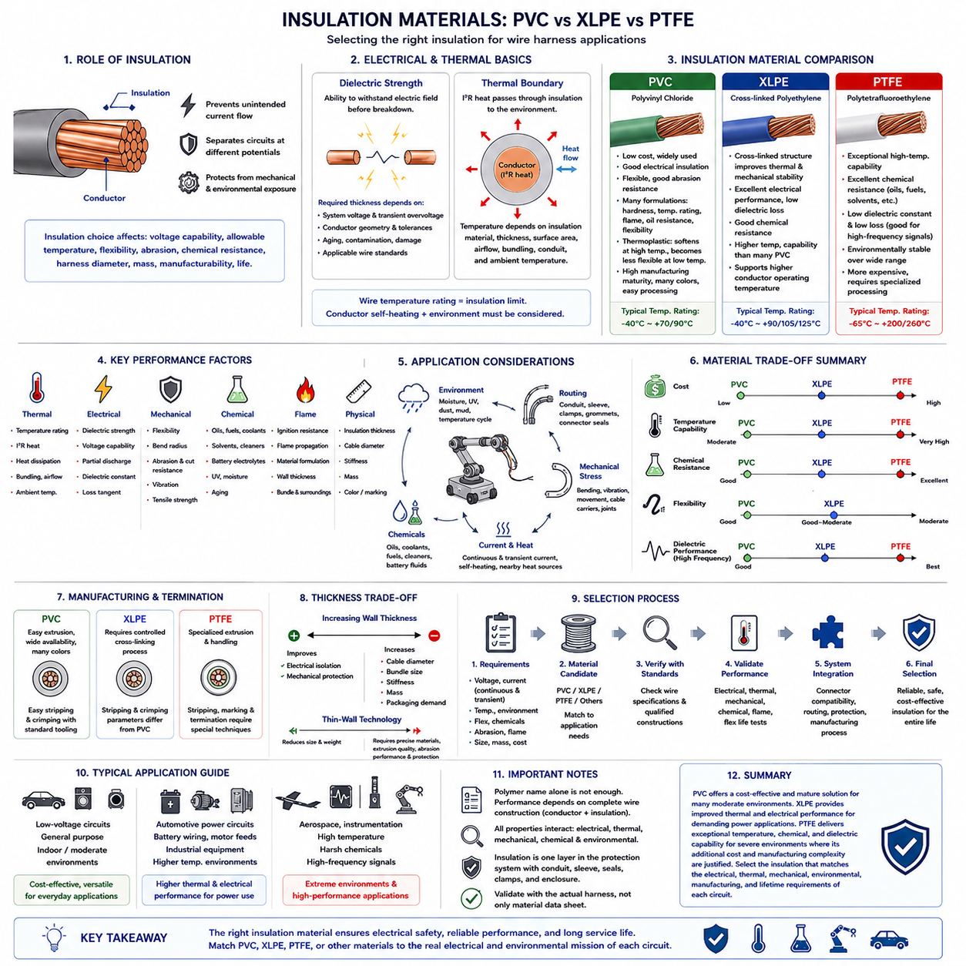
Electrical insulation is the material surrounding a conductor that prevents unintended current flow, separates circuits at different electrical potentials, and protects the conductor from mechanical and environmental exposure. In wire-harness engineering, insulation selection directly influences voltage capability, allowable conductor temperature, flexibility, abrasion resistance, chemical durability, harness diameter, mass, manufacturability, and service life.
An insulation system must maintain sufficient dielectric strength throughout the intended operating environment. Dielectric strength describes the electric-field level that a material can withstand before electrical breakdown occurs. The required insulation thickness therefore depends not only on nominal system voltage but also on transient overvoltage, conductor geometry, manufacturing tolerances, aging, contamination, mechanical damage, and applicable wire standards.
Insulation also establishes an important thermal boundary around the conductor. Current flowing through the conductor generates I²R heat, which must pass through the insulation before reaching the surrounding environment. The insulation material, thickness, surface area, airflow, bundling condition, conduit, and ambient temperature consequently influence conductor temperature and determine how much continuous current a wire can safely carry.
The temperature rating of a wire should not be interpreted simply as the surrounding ambient-temperature limit. It normally represents a maximum permitted material or conductor operating condition defined by the applicable wire construction and standard. Conductor self-heating must therefore be added to environmental thermal loading when evaluating whether the insulation remains within its allowable operating range during continuous and transient current conditions.
Polyvinyl chloride, commonly abbreviated PVC, is one of the most widely used insulation materials because it combines relatively low cost with practical electrical insulation, flexibility, abrasion resistance, and straightforward manufacturing. Different formulations can modify hardness, temperature capability, flame behavior, oil resistance, and flexibility, making PVC suitable for many low-voltage automotive, industrial, appliance, and general-purpose harness applications.
PVC is a thermoplastic material, meaning that its mechanical characteristics change as temperature rises and the material can soften under sufficiently high thermal exposure. This behavior must be considered near motors, power electronics, batteries, heaters, and other hot components. Prolonged elevated temperature can accelerate aging and reduce mechanical performance, while very low temperatures may reduce flexibility depending on the particular compound.
A major advantage of PVC is its manufacturing maturity. It can be extruded efficiently around copper conductors and produced in many colors, wall thicknesses, and formulations. This supports high-volume harness production, circuit identification, stripping, crimping, and automated processing. However, the exact performance of PVC wire depends strongly on the compound formulation, so the generic material name alone is insufficient to define engineering capability.
Cross-linked polyethylene, or XLPE, begins from a polyethylene-based polymer whose molecular structure is cross-linked to improve thermal and mechanical stability. Cross-linking restricts polymer-chain movement and enables the insulation to retain useful properties at temperatures where ordinary thermoplastic polyethylene would soften more significantly. XLPE is therefore widely used where higher thermal capability and robust electrical performance are required.
XLPE generally provides excellent electrical insulation characteristics, relatively low dielectric loss, good chemical resistance, and higher temperature capability than many conventional PVC formulations. These properties make it attractive for automotive power circuits, battery wiring, motor feeds, industrial equipment, and other applications where conductors may experience sustained current loading or elevated environmental temperature.
The improved thermal performance of XLPE can support higher conductor operating temperatures, but this does not automatically mean that the same wire gauge can safely carry any desired increase in current. Ampacity still depends on heat generation and heat dissipation. Bundling, ambient temperature, routing, enclosure conditions, adjacent heat sources, conductor size, and connector limitations must all be evaluated together with the insulation temperature rating.
Cross-linking also changes manufacturing and recycling behavior. Unlike ordinary thermoplastics that can be repeatedly softened and remelted, cross-linked materials form a network structure that does not simply return to a conventional melt state. Processing, stripping, termination, repair, and end-of-life considerations may therefore differ from PVC. Manufacturing parameters must be matched to the specific XLPE wire construction.
Polytetrafluoroethylene, commonly known as PTFE, is a fluoropolymer insulation material valued for exceptional temperature capability, chemical resistance, dielectric performance, and environmental stability. PTFE can operate in conditions that would be unsuitable for many conventional polymer insulations, making it particularly attractive for aerospace, high-temperature industrial equipment, instrumentation, specialized robotics, and demanding electrical systems.
PTFE has very high resistance to many chemicals, oils, fuels, solvents, and environmental contaminants. This chemical inertness is advantageous when harnesses pass through areas exposed to aggressive fluids or uncertain contamination. PTFE also maintains useful electrical characteristics across a broad temperature range, supporting applications where stable insulation performance is required under severe environmental variation.
Another important characteristic of PTFE is its low dielectric constant and low dielectric loss compared with many common insulation materials. These properties can be beneficial in high-frequency signal and communication cables because the insulation participates directly in cable capacitance, characteristic impedance, propagation behavior, and dielectric loss. Insulation selection therefore becomes part of signal-integrity design rather than merely electrical isolation.
PTFE nevertheless presents practical tradeoffs. It is generally more expensive than common PVC and many XLPE constructions, and its processing characteristics require specialized manufacturing techniques. Its mechanical surface characteristics can also affect stripping, termination, marking, clamping, and harness assembly. Selecting PTFE for every circuit would therefore add cost and manufacturing complexity without necessarily providing useful system-level benefit.
Mechanical properties are as important as dielectric characteristics in robotic harnesses. Insulation must survive bending, vibration, abrasion, clamping pressure, contact with edges, installation forces, and maintenance operations without exposing the conductor. A material with excellent temperature capability may still be unsuitable for a moving harness if the complete wire construction cannot withstand the required repetitive-flex cycle and minimum bend radius.
Insulation thickness creates another system-level tradeoff. Increasing wall thickness can improve mechanical protection and electrical isolation, but it also increases cable diameter, bundle size, stiffness, mass, and packaging demand. Thin-wall wire technology reduces harness volume and weight, but requires carefully controlled materials, extrusion quality, abrasion performance, manufacturing tolerances, and protection against mechanical damage.
Chemical compatibility should be evaluated against the actual operating environment rather than a generic description such as oil resistant. Robot harnesses may encounter lubricants, hydraulic fluids, cleaning chemicals, battery electrolytes, coolants, adhesives, paints, fuels, or outdoor contaminants. Temperature and mechanical stress can accelerate chemical degradation, so combined environmental exposure may be more severe than an individual laboratory test suggests.
Flame behavior is also a critical insulation property. Electrical faults, overloaded conductors, poor terminals, and nearby hot components can expose insulation to abnormal thermal conditions. Depending on the application and standard, insulation may be required to resist ignition or limit flame propagation. Material formulation, wall thickness, bundle configuration, surrounding components, and protective sleeves all influence the resulting fire behavior.
In outdoor AMRs and mobile robots, insulation can additionally face moisture, ultraviolet radiation, temperature cycling, dust, mud, road contaminants, and repeated mechanical vibration. The wire insulation should therefore be considered together with corrugated conduit, braided sleeve, tape, grommets, clamps, connector seals, and enclosure protection. Insulation is one layer within a broader harness protection architecture rather than the only environmental barrier.
Dynamic robotic applications impose particularly demanding requirements near steering assemblies, suspension movement, manipulators, joints, cable carriers, and moving drive modules. Fine-stranded conductors improve conductor flexibility, while the insulation must accommodate repeated deformation without cracking, excessive hardening, or separation from the conductor. Flex-life performance should therefore be validated using the complete wire construction rather than inferred solely from polymer type.
PVC, XLPE, and PTFE should consequently not be ranked using a single scale from inferior to superior. PVC provides a cost-effective and mature solution for many moderate environments. XLPE offers improved thermal and electrical performance for demanding power applications, while PTFE provides exceptional temperature, chemical, and dielectric capability where severe environments justify its additional cost and manufacturing complexity.
The final insulation decision should begin with system voltage, continuous and transient current, expected conductor temperature, ambient temperature, routing environment, flex requirement, chemical exposure, abrasion risk, flame requirement, cable diameter, mass, manufacturing process, connector compatibility, lifetime, and cost. Applicable wire specifications then define qualified constructions rather than relying on polymer names alone.
Insulation material ultimately forms part of the electrothermal, mechanical, and environmental design of the complete harness. The conductor determines fundamental electrical resistance, while insulation strongly influences heat transfer, dielectric isolation, physical protection, and lifetime durability. Selecting PVC, XLPE, PTFE, or another material therefore requires matching the complete wire construction to the actual electrical and environmental mission of each circuit.

01.05. Wire Standards (ISO 6722, SAE J1128)
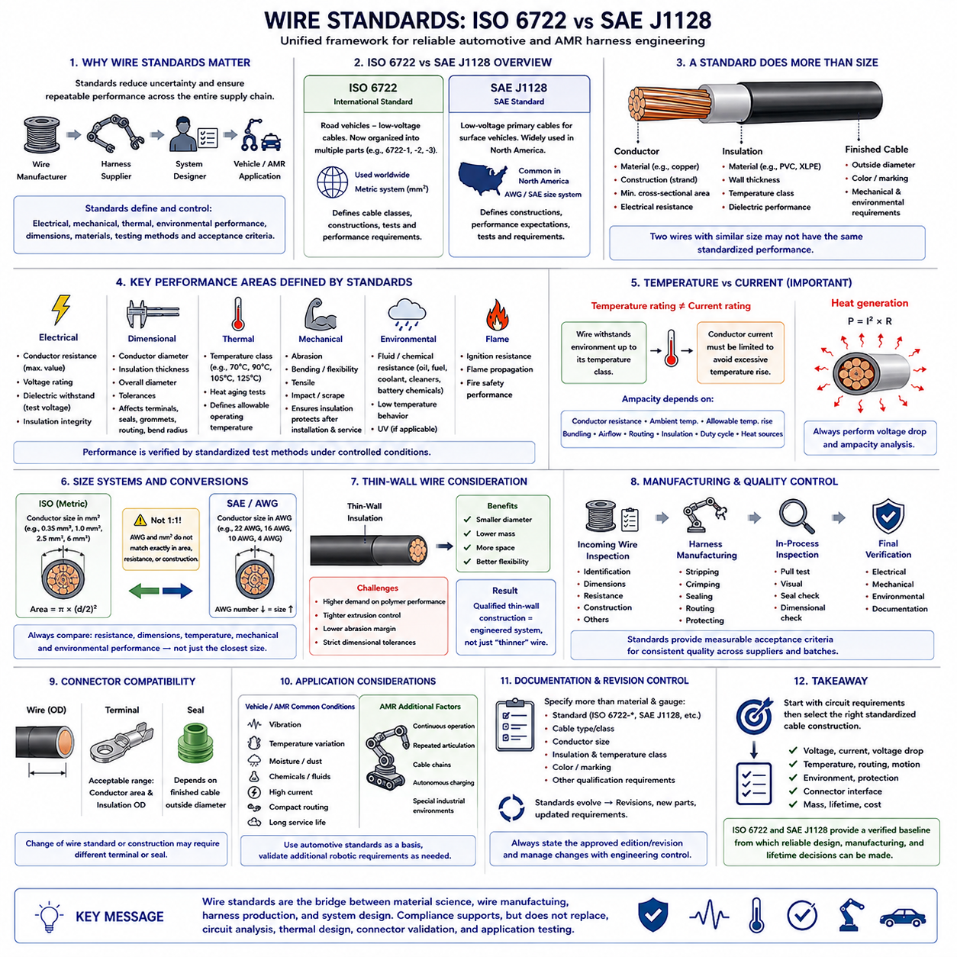
Wire standards provide a controlled engineering framework for specifying conductor construction, insulation performance, dimensional limits, environmental durability, and verification methods. In automotive and mobile robotic harnesses, standards reduce uncertainty between wire manufacturers, harness suppliers, and system designers by defining repeatable requirements rather than relying only on generic descriptions such as copper wire or PVC-insulated cable.
ISO 6722 is historically one of the most important international references for low-voltage road-vehicle cables. It establishes requirements and test methods intended to ensure that automotive wires maintain acceptable electrical, mechanical, thermal, and environmental performance. Modern ISO cable requirements have evolved into multiple parts and related standards, so engineers must always identify the exact document, part, revision, and cable class applicable to a project.
SAE J1128 provides another widely recognized framework for low-voltage primary cables used in surface vehicles. It has traditionally been important in North American automotive engineering and defines cable constructions and performance expectations appropriate to vehicle wiring. ISO and SAE specifications therefore represent related engineering objectives, although their classifications, dimensions, terminology, and qualification details should not be assumed to be interchangeable.
A wire standard does considerably more than specify conductor size. It can define conductor material and construction, nominal or minimum cross-sectional area, strand configuration, insulation dimensions, outside diameter, electrical resistance, temperature capability, mechanical performance, and required test conditions. Consequently, two wires described commercially as having similar size may not necessarily provide identical standardized performance.
Conductor resistance is a particularly important controlled parameter because it directly influences voltage drop and I²R heating. Standards may specify maximum resistance values under defined reference conditions, allowing designers to verify actual electrical performance rather than relying solely on nominal conductor area. This becomes important when comparing different strand constructions, conductor tolerances, material processing, and supplier manufacturing methods.
Dimensional requirements are equally important for harness integration. Conductor diameter, insulation wall thickness, and finished cable outside diameter affect terminal selection, wire seals, connector cavities, grommets, conduit fill, bundle diameter, minimum bend radius, and routing space. A wire substitution that appears electrically equivalent may therefore create mechanical or manufacturing problems if its dimensional envelope differs from the qualified construction.
Temperature classification is another central element of automotive wire specifications. Different cable constructions are designed for different operating-temperature ranges, reflecting the capabilities of insulation materials and complete wire construction. Higher temperature capability can be necessary near motors, inverters, batteries, power converters, braking systems, or other heat sources, but the specified temperature class must be interpreted according to the exact applicable standard.
Temperature rating alone does not determine allowable current. A standardized wire may survive a specified thermal environment while still becoming excessively hot if conductor current is too high for the installation. Current capacity must therefore be determined using conductor resistance, ambient temperature, allowable temperature rise, bundling, airflow, routing, insulation capability, duty cycle, and neighboring heat sources rather than reading a current rating directly from the material name.
Mechanical testing helps ensure that insulation continues to protect the conductor after manufacturing, installation, and service exposure. Depending on the applicable specification and wire construction, tests can evaluate abrasion, bending, flexibility, tensile behavior, impact, scraping, or other forms of mechanical stress. Such tests are particularly relevant to vehicle and robotic harnesses exposed to vibration, assembly forces, clamps, edges, and repeated maintenance.
Thermal aging tests evaluate whether a wire retains acceptable properties after controlled exposure to elevated temperature. Polymer insulation can harden, soften, shrink, crack, discolor, or lose mechanical strength as it ages. Accelerated thermal testing provides a standardized method for assessing these effects, although successful qualification does not eliminate the need to consider the actual temperature profile and lifetime of the installed harness.
Low-temperature behavior is also important because insulation that performs well at room temperature may become significantly stiffer or more brittle in cold environments. Standardized cold tests can evaluate whether the cable remains mechanically suitable after exposure to low temperatures. Outdoor AMRs, autonomous vehicles, industrial mobile robots, and equipment stored or operated in winter conditions require particular attention to this behavior.
Chemical and fluid resistance can become critical in automotive and robotic installations. Harnesses may encounter oils, fuels, lubricants, coolants, cleaning agents, battery-related chemicals, and other contaminants. Applicable wire standards can provide controlled exposure and evaluation methods, enabling engineers to select constructions whose insulation remains functional rather than assuming that a generic polymer designation guarantees compatibility with every fluid.
Flame performance is another characteristic commonly addressed within vehicle cable qualification frameworks. An electrical fault or external heat source can expose a harness to ignition conditions, making resistance to flame propagation important. Standardized flame tests provide repeatable comparison conditions, but they should not be interpreted as proof that an entire installed harness or vehicle assembly is fireproof under every possible fault condition.
Electrical withstand testing verifies the integrity of the insulation barrier. Depending on the wire specification, test methods can apply defined voltages or other electrical conditions to detect insulation defects or insufficient dielectric performance. Electrical qualification complements dimensional and mechanical testing because an insulation layer may appear physically acceptable while still failing to provide the required electrical isolation under specified conditions.
ISO and SAE wire families can use different conventions for identifying conductor size and cable construction. ISO-oriented engineering commonly works with metric conductor cross-sectional areas expressed in mm², while North American practices frequently use AWG or SAE cable designations. Direct conversion must be performed carefully because nominal AWG and metric sizes do not always correspond exactly in conductor area, resistance, or standardized construction.
This difference becomes important when replacing a wire originally specified under one standards system with a product qualified under another. Selecting the numerically closest AWG or mm² size does not prove equivalence. The engineer should compare conductor resistance, usable temperature range, insulation thickness, outside diameter, mechanical tests, environmental performance, terminal compatibility, and all project-specific qualification requirements before approving substitution.
Thin-wall automotive wire demonstrates why standards and construction details matter. Reducing insulation thickness can decrease harness diameter, mass, and packaging volume, which is valuable in densely packaged vehicles and robots. However, thinner insulation places greater demands on polymer performance, extrusion control, abrasion resistance, dimensional tolerances, and manufacturing quality. A qualified thin-wall construction should therefore be treated as an engineered system rather than simply a thinner version of conventional wire.
Standards also support manufacturing quality control by providing measurable acceptance criteria. Incoming wire can be checked for identification, dimensions, conductor resistance, construction, and other specified properties. Harness manufacturers can then establish controlled stripping, crimping, sealing, routing, and inspection processes around a known cable construction, improving consistency between prototypes, production batches, replacement parts, and multiple suppliers.
Connector compatibility must be evaluated together with the selected standardized wire. Terminals typically accept defined conductor-area and insulation-diameter ranges, while cable seals depend strongly on finished outside diameter. Changing from one wire family to another can therefore require a different terminal or seal even when electrical conductor size appears similar. The complete wire-terminal-seal combination should be validated rather than qualifying each component independently.
For robotic systems, automotive cable standards can provide a valuable starting point because AMRs experience many vehicle-like conditions, including vibration, temperature variation, compact routing, high-current power distribution, and long service periods. Nevertheless, an AMR may introduce additional requirements such as continuous indoor operation, repetitive articulation, cable-chain motion, unusual chemicals, autonomous charging, or specialized industrial environments not fully represented by conventional vehicle qualification.
Dynamic sections of a robot harness require particular caution. A cable that satisfies an automotive wire specification is not automatically a continuous-flex robotic cable. Steering mechanisms, manipulators, suspension systems, rotating modules, and cable carriers may impose millions of repetitive bending cycles. Application-specific flex testing, bend-radius control, strain relief, and specialized conductor construction may therefore be necessary in addition to baseline wire-standard compliance.
Wire specification should consequently be documented using more than a material and gauge description. Engineering drawings and bills of materials should identify the applicable standard, cable type or class, conductor size, insulation construction, temperature requirement, color, and other necessary qualification information. Supplier part numbers can then be linked to this controlled technical definition rather than becoming the only source of performance requirements.
Revision control is essential because international and industry standards evolve. Requirements can be reorganized, superseded, divided into new parts, or updated as materials and vehicle technologies change. Engineers should therefore avoid treating references such as ISO 6722 or SAE J1128 as timeless fixed specifications. Procurement and design documentation should identify the approved edition or revision and manage changes through formal engineering control.
For AMR harness engineering, the most effective approach is to begin with circuit requirements and then select an appropriate standardized cable construction. Voltage, current, voltage-drop budget, temperature, routing, motion, environment, connector interface, protection, mass, and lifetime should first be established. The relevant ISO, SAE, or other industrial specification can then provide a qualification framework for selecting and validating the actual wire.
ISO 6722 and SAE J1128 ultimately illustrate the role of standards as engineering interfaces between material science, wire manufacturing, harness production, and system design. Compliance does not replace circuit analysis, thermal design, connector validation, or application testing. Instead, a correctly selected standard establishes a verified baseline from which reliable voltage-drop, ampacity, routing, manufacturing, and lifetime decisions can be developed.

