Volume 03. Connector Engineering

Chapter 09. High Voltage Connectors

09.01. HV Interlock (HVIL) Design
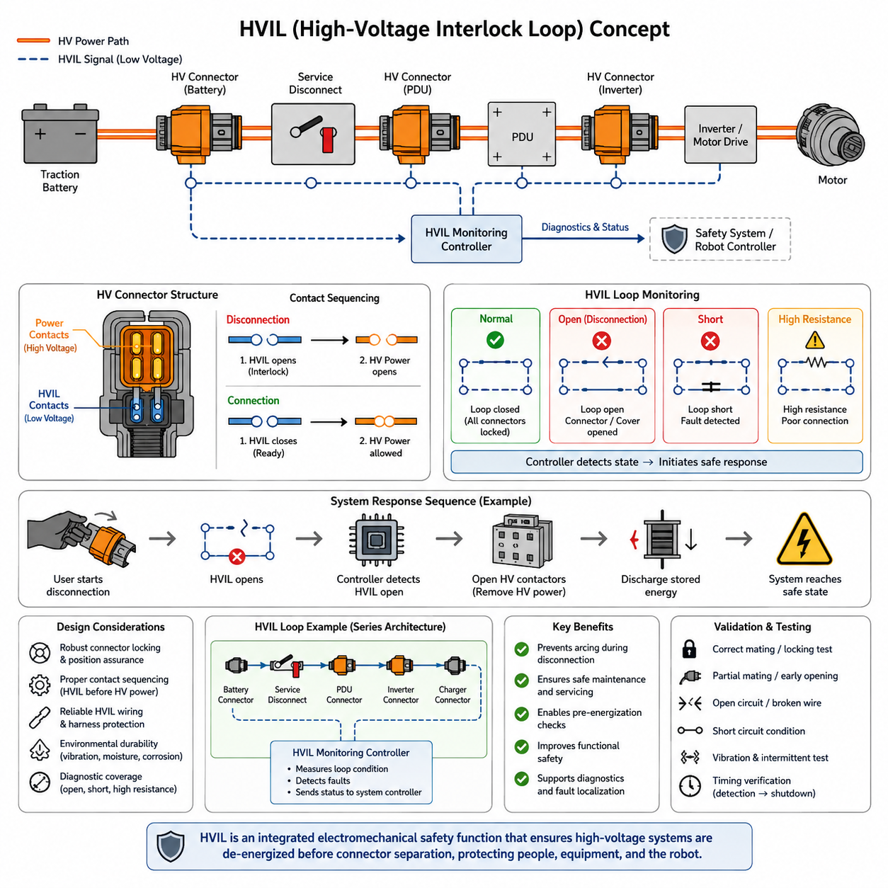
A high-voltage interlock loop, commonly called HVIL, is a low-voltage monitoring circuit integrated into a high-voltage connector system to detect whether connectors, service disconnects, covers, or other protected interfaces are correctly assembled. Within the connector architecture, HVIL provides an electrical indication of mechanical connection integrity rather than carrying traction or propulsion power itself.
The fundamental principle is to route a dedicated low-energy circuit through the high-voltage connection path. When every monitored connector is fully seated and locked, the HVIL circuit forms the expected electrical loop. If a connector becomes partially disengaged, a service cover is opened, or a monitored component is removed, the loop changes state. The supervisory controller interprets this condition and initiates the appropriate high-voltage shutdown sequence.
HVIL is especially important because the mechanical separation of a high-voltage connector should not occur while substantial current is flowing through its power contacts. Opening energized contacts can generate an electrical arc, damage contact surfaces, increase local temperature, and expose personnel to hazardous voltage. The interlock therefore supports a coordinated transition from an energized system to a controlled electrically safe condition before complete connector separation occurs.
A typical HV connector consequently contains two distinct electrical functions. Large power terminals carry the high-voltage positive and negative conductors, while smaller auxiliary terminals provide the HVIL connection. These auxiliary contacts are intentionally associated with the connector mating mechanism so that their electrical state represents connector engagement. Their geometry, contact sequence, terminal retention, and mechanical tolerances therefore become functional elements of the overall safety concept.
Contact sequencing is one of the most important aspects of HVIL connector design. During disconnection, the interlock contacts should change state before the main high-voltage contacts physically separate enough to create an uncontrolled energized opening. During connection, the power interface must be mechanically established before the system is permitted to energize it. This behavior is commonly implemented through staged contact lengths, connector position assurance mechanisms, or secondary locking structures.
The resulting sequence can be understood as a controlled chain of events. A user begins releasing the connector, the HVIL circuit opens, the controller detects the interruption, and the high-voltage control system commands contactors or equivalent switching devices to remove energy from the downstream circuit. Only afterward should mechanical movement permit complete separation of the power terminals. The required timing must account for detection, controller response, switching delay, and residual-energy discharge.
An HVIL system should not be treated simply as a continuity wire. Robust implementations supervise the electrical characteristics of the loop so that normal connection, open circuit, short circuit, and certain wiring faults can be distinguished. Depending on the architecture, the controller may evaluate resistance, voltage, current, or encoded electrical states. Diagnostic coverage is particularly important because an undetected short across the interlock could falsely indicate that every protected connector remains correctly connected.
Series-connected HVIL architectures are common because multiple high-voltage interfaces can be monitored through one continuous loop. The circuit may pass through the battery enclosure, power distribution unit, inverter, charger, DC-DC converter, service disconnect, and other HV connectors before returning to the monitoring controller. Opening any monitored interface interrupts the chain. The disadvantage is that identifying the exact location of an interruption may require additional diagnostics or segmented monitoring.
Connector locking architecture and HVIL behavior must therefore be developed together. A primary latch provides basic mechanical retention, while a secondary lock or connector position assurance feature can verify that the connector has reached its intended mating position. In high-integrity designs, the HVIL terminals should not report a valid connection merely because the housings have touched. Their state should correspond to sufficient engagement for reliable power-contact geometry, sealing, retention, and electrical performance.
The high-voltage system response following an HVIL fault depends on the system architecture. Detection normally causes the supervisory controller to inhibit energization or request opening of the main high-voltage contactors. Stored energy in DC-link capacitors and other downstream components must also be considered because opening the battery contactors does not instantaneously eliminate voltage everywhere. Discharge circuits and voltage monitoring therefore complement HVIL rather than being replaced by it.
HVIL wiring itself requires engineering discipline comparable to other safety-related signal circuits. Wire routing, terminal retention, crimp quality, vibration resistance, abrasion protection, connector sealing, and resistance stability can influence diagnostic reliability. A damaged interlock conductor can create unnecessary high-voltage shutdowns, while an unintended bypass can defeat the intended protection. Harness design must therefore consider both safe fault detection and avoidance of nuisance interruptions during normal robot operation.
Environmental effects become especially significant in mobile robotics. Vibration, mechanical shock, moisture, contamination, thermal cycling, cable motion, and repeated maintenance can gradually alter auxiliary contact behavior. Fretting, terminal relaxation, corrosion, or incomplete locking may create intermittent HVIL signals even while the power terminals remain connected. Such transient events must be considered when defining electrical thresholds, diagnostic filtering, fault persistence criteria, and maintenance procedures.
Filtering requires a careful balance. An extremely sensitive controller can interpret short disturbances caused by vibration or switching noise as genuine connector separation and repeatedly shut down the robot. Excessive filtering, however, can delay recognition of a real disconnect event. The HVIL detection strategy should therefore be derived from the physical connector opening sequence, expected electrical noise environment, controller sampling characteristics, contactor response, and maximum allowable energized separation time.
HVIL also provides valuable information during startup. Before closing the main contactors, the system can verify that the monitored loop is in its expected state. If a service disconnect is removed, a battery connector is incompletely seated, or an enclosure interlock remains open, high-voltage activation can be inhibited. This converts the interlock from a purely reactive shutdown mechanism into part of the system's pre-energization permissive logic and diagnostic architecture.
Serviceability strongly influences practical HVIL design. Maintenance personnel may intentionally open battery compartments, disconnect propulsion components, or replace high-voltage modules. The interlock architecture should cause these actions to move the system toward a de-energized condition rather than depending exclusively on procedural compliance. Nevertheless, HVIL indication alone must never be interpreted as proof of zero voltage; appropriate voltage verification and high-voltage service procedures remain necessary.
For AMRs and other battery-powered robots, HVIL becomes increasingly relevant as propulsion voltage and stored energy increase. The robot may contain a traction battery, high-power motor drives, charging interfaces, DC-DC conversion, and power distribution hardware distributed across a compact chassis. Integrating interlock monitoring into these connection points allows the electrical architecture to detect unintended access or separation while coordinating the battery management and power-control systems.
The connector chapter structure places HVIL at the beginning of high-voltage connector engineering, followed by high-voltage cable identification, connector selection, charging interfaces, and UAV applications. This positioning reflects an important engineering principle: high-voltage connector selection is not only a matter of current rating, voltage rating, sealing, and packaging. The connection system must also support controlled energization, safe disconnection, fault detection, and maintainable system integration.
A complete HVIL design should ultimately be validated at connector, harness, controller, and system levels. Testing should include correct mating, partial mating, intentional disconnection, broken interlock wiring, relevant short-circuit conditions, vibration-induced intermittency, contact resistance variation, and shutdown timing. Validation should confirm not merely that a fault is detected, but that detection occurs early enough for the high-voltage switching and discharge architecture to establish the intended safe state.
The most effective design philosophy is therefore to regard HVIL as an integrated electromechanical safety function. Connector geometry determines when the interlock changes state, the harness transports that information, diagnostic electronics determine whether the signal is credible, and the power-control architecture performs the required response. Reliable high-voltage disconnection emerges only when these mechanical, electrical, diagnostic, and control functions are engineered and verified as one coordinated system.

09.02. Orange Cable Safety Standard
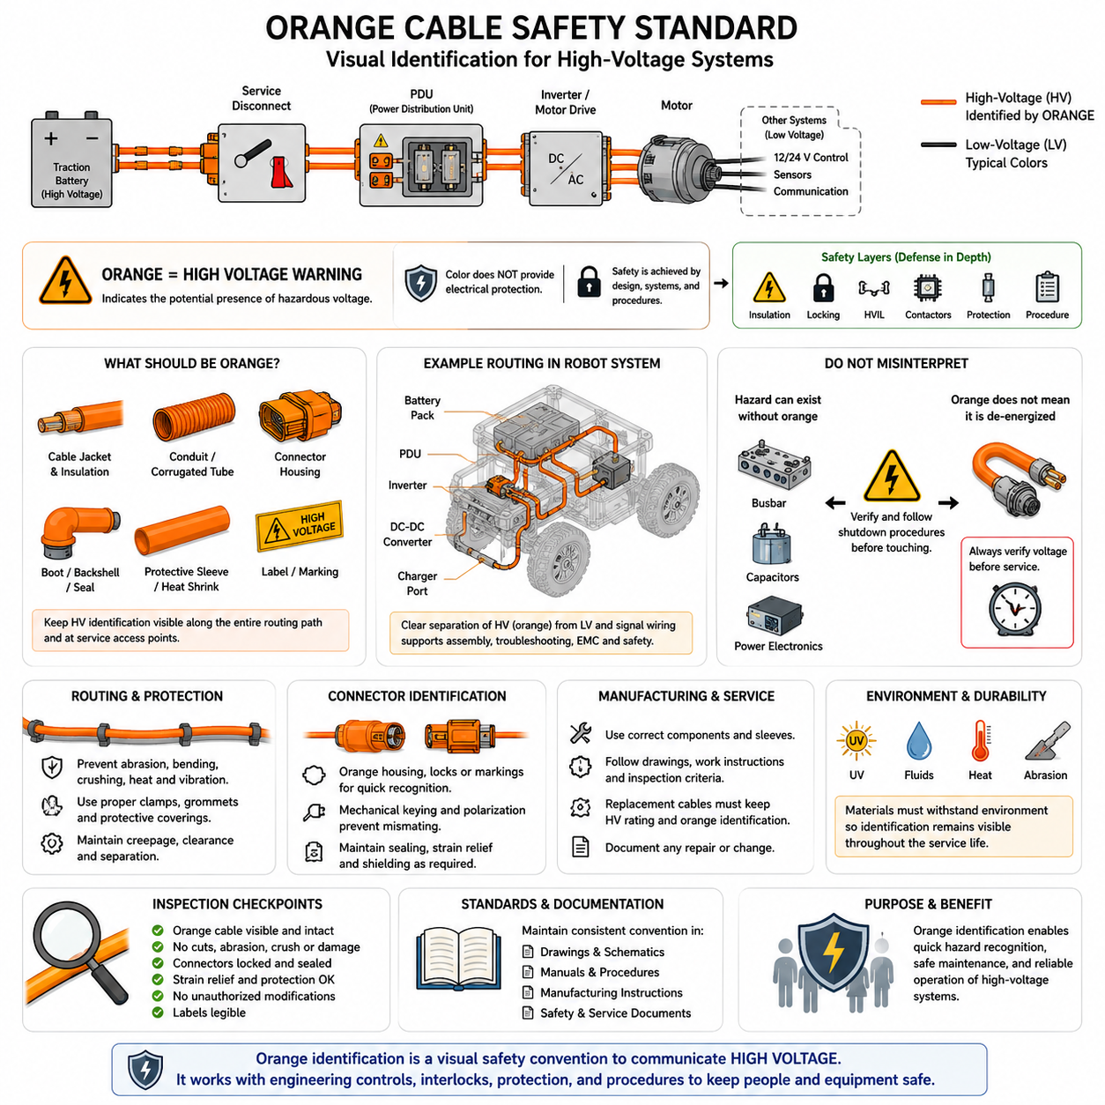
Orange insulation and jacket identification is a fundamental visual safety convention for high-voltage electrical systems. In automotive, mobile robotics, industrial vehicles, and other electrified platforms, orange-colored cables, conduits, connector components, and protective coverings provide an immediate indication that the associated circuit may contain hazardous high voltage. This visual distinction helps separate HV circuits from conventional low-voltage wiring.
The orange identification convention becomes increasingly important as electrical architectures combine multiple voltage domains within the same machine. A robot may contain 12 V or 24 V control electronics, 48 V auxiliary equipment, communication networks, and substantially higher-voltage propulsion or charging circuits. Without clear visual differentiation, maintenance personnel could incorrectly treat a high-energy conductor as an ordinary low-voltage harness during inspection, troubleshooting, assembly, or repair.
Orange coloration should therefore be understood as a hazard-identification mechanism rather than an electrical protection device. The color itself does not provide insulation, prevent electric shock, interrupt fault current, or guarantee that a circuit has been de-energized. Its purpose is to communicate the presence of a high-voltage electrical domain quickly and consistently. Actual protection must still be provided through insulation systems, enclosures, interlocks, circuit protection, grounding concepts, and controlled service procedures.
The identification philosophy should extend beyond the cable conductor insulation when necessary. High-voltage harness assemblies may use orange outer jackets, corrugated tubes, heat-shrink materials, connector housings, boots, protective sleeves, or labels so that the HV nature of the circuit remains recognizable after installation. The exact implementation depends on the harness architecture, environmental protection strategy, connector system, mechanical packaging, and applicable industry requirements.
Consistency is critical because the effectiveness of visual identification depends on predictable interpretation. If orange is used for unrelated low-voltage circuits, pneumatic lines, decorative components, or ordinary signal harnesses, its safety meaning becomes diluted. Electrical architecture rules should therefore reserve the selected high-voltage identification scheme for HV-related components wherever practical and document the convention in harness drawings, electrical schematics, service manuals, manufacturing instructions, and system safety documentation.
High-voltage cable identification must remain visible throughout the installed routing path as far as practical. Harness sections passing through battery compartments, power distribution areas, motor-drive assemblies, charging systems, or service-access zones should remain recognizable without requiring extensive disassembly. Where the cable is enclosed by additional mechanical protection, the external covering should preserve or reproduce the intended HV identification so personnel can recognize the electrical hazard before accessing the conductor itself.
Cable routing and orange identification work together but serve different purposes. Routing engineering prevents excessive bending, abrasion, crushing, thermal exposure, vibration damage, and interference with moving mechanisms, while orange identification communicates electrical hazard. A correctly colored cable that is poorly routed can still suffer insulation failure, and a mechanically protected HV cable without adequate identification can still create service risk. Both requirements must therefore be considered simultaneously.
High-voltage connectors should also support rapid differentiation from low-voltage interfaces. Orange housings, secondary locks, backshells, cable seals, or nearby markings can reinforce the HV designation, particularly where multiple connector families are installed in a compact enclosure. Mechanical keying and polarization remain essential because color alone cannot prevent incorrect mating, but consistent visual coding improves assembly recognition and reduces the probability of inappropriate service actions.
The identification system is particularly useful during emergency response and maintenance. When an enclosure is opened or damaged equipment is inspected, orange components provide a rapid visual cue that additional electrical precautions may be required. Personnel can recognize that disconnect procedures, personal protective equipment, isolation verification, or specialized service instructions may apply before touching or removing the associated components.
However, visible orange wiring must never be interpreted as the only location where hazardous voltage can exist. Conductive busbars, internal battery connections, inverter DC links, capacitors, terminals, and enclosed power electronics may retain hazardous electrical energy even when no orange cable is visible. Similarly, an orange cable should be considered potentially hazardous until the electrical state has been established through the appropriate system shutdown and verification procedure.
Service disconnects and high-voltage interlock loop(HVIL) systems complement orange identification. Orange coloration warns personnel that they are approaching an HV circuit, while a service disconnect provides a means of intentionally interrupting the energy path. HVIL can detect opening or incomplete connection of monitored interfaces and request system shutdown. These mechanisms form different layers of protection and should not be treated as interchangeable safety functions.
The cable construction itself must satisfy the electrical and environmental requirements of the application independently of its color. Conductor cross-sectional area must support operating current, insulation must withstand the maximum system voltage, and materials must tolerate expected temperature, vibration, fluids, moisture, abrasion, and mechanical stress. Shielding may also be required between inverter and motor systems where rapidly switched currents create significant electromagnetic interference(EMI).
Shielded HV cables introduce additional identification considerations because the electrical construction may include a central conductor, primary insulation, shielding layer, and external protective jacket. The outermost visible layer normally provides the practical visual identification, while shielding termination is handled through appropriate connector and grounding architecture. The orange jacket must therefore coexist with EMC requirements without compromising shield continuity, sealing, strain relief, or connector termination quality.
Manufacturing processes should preserve the identification convention from cable preparation through final vehicle or robot assembly. Incorrect sleeves, replacement cables, locally sourced components, or undocumented repairs can create sections that no longer follow the intended visual scheme. Harness bills of materials(BOM), drawings, work instructions, inspection criteria, and approved component lists should consequently define the required HV cable appearance as part of configuration control.
Maintenance and field repair require the same discipline. Replacing an orange HV cable with an electrically equivalent but visually unmarked cable can reduce system-level safety even if its conductor and insulation ratings are technically adequate. Replacement parts should preserve electrical rating, environmental capability, connector compatibility, shielding requirements, mechanical protection, and high-voltage identification so the repaired system retains the original safety communication strategy.
Environmental aging must also be considered because color identification has value only while it remains recognizable. Heat, ultraviolet exposure, chemicals, oils, cleaning agents, abrasion, and contamination can discolor or obscure cable surfaces. Outdoor AMRs, inspection robots, mining vehicles, agricultural machines, and UAV power systems may experience particularly severe exposure. Material selection and validation should therefore confirm that identification remains sufficiently distinguishable throughout the intended service life.
Inspection programs can use orange HV identification as part of routine visual assessment. Technicians can follow the HV routing path and check for abrasion, cuts, crushed conduit, loose connectors, contamination, damaged strain relief, missing protective coverings, or unauthorized modifications. The visual convention therefore supports not only immediate hazard recognition but also efficient maintenance and systematic verification of high-voltage harness integrity.
For robotics platforms, packaging density makes disciplined identification especially valuable. Batteries, motor controllers, DC-DC converters, chargers, computers, sensors, and communication equipment may occupy the same chassis volume. Clear separation between HV power, low-voltage power, and signal networks simplifies assembly and troubleshooting while helping engineers maintain appropriate creepage, clearance, routing separation, EMC control, and service accessibility within constrained mechanical spaces.
Validation should examine the complete installed HV harness rather than only individual orange cables. Reviews should confirm that HV circuits are consistently recognizable, identification is not hidden at critical service locations, protective coverings maintain the convention, replacement components follow the same rules, and labels remain legible. Electrical, mechanical, environmental, manufacturing, and service requirements must be evaluated together because high-voltage safety depends on their combined effectiveness.
Within the connector engineering structure, orange cable identification follows HV interlock design and precedes detailed HV connector selection, charging interfaces, and UAV-specific high-voltage connectors. This sequence emphasizes that high-voltage connector engineering begins with hazard recognition and controlled access before progressing to component selection. The broader electrical architecture also treats connector engineering as a dedicated discipline alongside harness, power, grounding, safety, and validation engineering.
Ultimately, orange cable identification should be regarded as one layer within a defense-in-depth high-voltage safety architecture. Visual identification warns people, insulation prevents unintended electrical contact, connector locking controls mechanical separation, HVIL detects interface state, contactors isolate energy, circuit protection responds to electrical faults, and service procedures establish controlled human interaction. Effective HV engineering coordinates all of these mechanisms rather than relying on any single safety feature.

09.03. HV Connector Selection Criteria
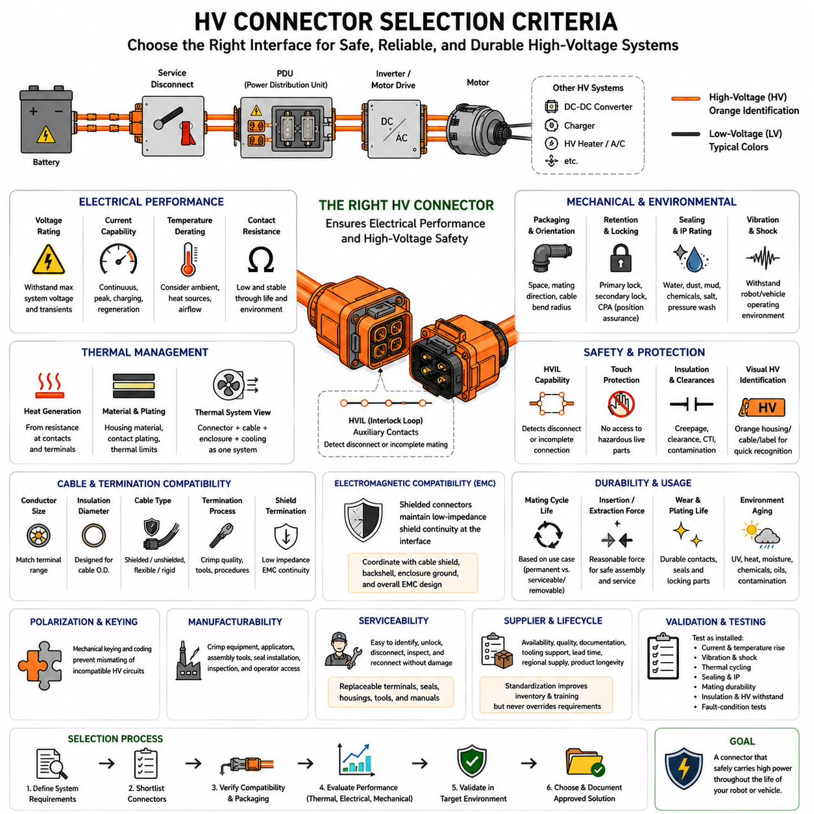
High-voltage connector selection begins with the electrical architecture of the system rather than with connector size or appearance. The selected interface must support the maximum operating voltage, continuous current, transient current, insulation requirements, environmental conditions, and expected service life of the circuit. In robotics, these requirements must be evaluated together because propulsion, charging, battery, and auxiliary HV circuits can experience very different operating profiles.
Voltage rating establishes the first fundamental selection boundary. A connector must provide adequate insulation performance for the highest voltage that can appear during normal operation, charging, regeneration, fault conditions, and relevant electrical transients. The nominal battery voltage alone is therefore insufficient. Connector insulation geometry, dielectric materials, creepage distance, clearance distance, contamination level, and environmental exposure must remain compatible with the actual maximum system voltage.
Current capability must be evaluated under realistic operating conditions rather than from a catalog rating alone. High-voltage connectors generate heat primarily through conductor and contact resistance, and temperature rise increases with current and resistance. Continuous propulsion loads, acceleration peaks, charging currents, regenerative braking, and auxiliary power demands can create different thermal profiles. Selection should therefore consider both steady-state current and representative transient duty cycles.
Temperature derating is particularly important because connector current capability normally decreases as ambient temperature increases. A connector installed near an inverter, motor, battery, or enclosed power distribution unit may operate at temperatures substantially higher than laboratory reference conditions. Cable size, terminal resistance, contact plating, housing material, airflow, neighboring heat sources, and enclosure temperature must consequently be evaluated as one thermal system rather than as independent specifications.
Contact resistance provides another critical selection criterion. Even small resistance increases can generate significant localized heating when high current passes through a connector. Terminal geometry, contact normal force, plating material, crimp quality, mating condition, contamination, and aging influence resistance stability. The preferred connector is therefore not merely one with low initial resistance, but one capable of maintaining sufficiently stable electrical contact throughout the required environmental and mating life.
Cable compatibility must be verified simultaneously with connector selection. HV terminals are normally designed for defined conductor cross-sectional areas, insulation diameters, cable constructions, and termination processes. Selecting a connector without confirming compatibility with the intended cable can result in inadequate crimping, sealing, strain relief, or current capability. Shielded motor cables may impose additional requirements for shield termination, backshell geometry, and electromagnetic compatibility.
Mechanical packaging strongly influences practical connector selection in robots and autonomous vehicles. Available space, connector orientation, mating direction, cable bend radius, service access, neighboring structures, and harness routing determine whether a theoretically suitable connector can actually be integrated. Straight and right-angle configurations can produce significantly different packaging results, while high-current cables require sufficient space behind the connector to avoid excessive bending and mechanical loading.
Connector retention must withstand the mechanical environment throughout operation. Mobile robots can expose HV interfaces to continuous vibration, repeated shock, chassis deformation, cable movement, and occasional impacts. Primary locking mechanisms should maintain reliable engagement, while secondary locking or connector position assurance features can reduce the probability of incomplete mating. Terminal position assurance may also be required to ensure that individual contacts remain correctly retained within the housing.
Environmental sealing requirements depend on installation location. Connectors located inside protected electrical enclosures may face relatively moderate contamination, while externally mounted connectors can encounter water, dust, mud, oils, cleaning agents, salt, and pressure washing. Appropriate ingress protection, interface seals, wire seals, cavity protection, and housing materials must therefore be selected according to the real installation environment rather than applying the highest available IP rating without system justification.
High-voltage interlock loop functionality should be considered when connectors can be serviced, disconnected, or accessed while hazardous energy may be present. An HVIL-compatible connector provides auxiliary contacts that allow the system to detect connector release or incomplete engagement. Proper contact sequencing enables the interlock state to change before dangerous separation of energized power contacts, giving the controller time to command contactor opening and transition the electrical system toward a safe state.
Touch protection is another important consideration for serviceable HV interfaces. Connector construction should minimize the possibility that personnel can contact hazardous conductive elements during normal handling, mating, or unmating. Recessed contacts, protective housing geometry, terminal barriers, locking structures, and controlled mating sequences contribute to this objective. The required protection should be evaluated for both fully connected and intentionally disconnected connector states.
Visual high-voltage identification complements the electrical and mechanical selection criteria. Orange housings, cable jackets, backshells, or markings can distinguish HV circuits from low-voltage power and signal connections. However, orange identification is only a visual safety convention and cannot replace electrical protection. The connector must independently satisfy voltage withstand, insulation, touch protection, locking, sealing, interlock, and environmental requirements.
Electromagnetic compatibility becomes significant when connectors are used between batteries, inverters, motor drives, DC-DC converters, and electric motors. Rapid switching can produce substantial conducted and radiated electromagnetic noise. Shielded cable systems therefore require connectors capable of maintaining suitable shield continuity with low-impedance termination around the interface. Shield architecture must be coordinated with cable construction, connector backshells, enclosure grounding, and the overall EMC strategy.
Mating-cycle requirements should reflect the intended use case. A permanently installed battery-to-inverter connector may experience very few intentional mating cycles, whereas removable batteries, charging interfaces, interchangeable modules, and service connectors may be operated repeatedly. Contact wear, plating durability, sealing surfaces, locking components, and insertion and extraction forces must remain acceptable throughout the specified cycle life rather than being evaluated only when new.
Insertion and extraction forces also affect assembly and serviceability. Large multi-contact or high-current connectors can require considerable mating force, particularly when robust seals are incorporated. Excessive force increases the probability of incomplete mating, housing damage, cable loading, or incorrect service practices. Lever mechanisms, sliding locks, guided interfaces, and positive position indicators can improve usability while providing controlled mechanical engagement of the electrical contacts.
Connector polarization and mechanical keying are essential where multiple similar HV interfaces exist within the same system. Mechanical coding should prevent incompatible circuits from being accidentally connected even when housings have similar dimensions. Color coding and labels can assist personnel, but physical incompatibility provides stronger protection against mismating. This becomes especially valuable in dense robot power architectures containing batteries, chargers, converters, inverters, and multiple traction drives.
Manufacturability must be included in the selection process because connector performance depends heavily on termination quality. Required crimping equipment, applicators, assembly tools, seal installation processes, terminal insertion procedures, inspection methods, and operator accessibility should be understood before production release. A technically advanced connector can become unsuitable if reliable manufacturing requires tooling, process control, or supplier support that cannot realistically be maintained.
Serviceability and replacement strategy should also influence component choice. Technicians must be able to identify, unlock, disconnect, inspect, and reconnect HV interfaces using controlled procedures without damaging terminals, seals, cables, or locking mechanisms. Availability of replacement terminals, seals, housings, extraction tools, repair instructions, and approved cable assemblies can determine whether the connector remains maintainable over the full operational life of the robot or vehicle.
Supplier capability and lifecycle availability become increasingly important for production platforms. Connector families should be evaluated for component availability, quality consistency, technical documentation, tooling support, regional supply, lead time, and expected product longevity. Using a standardized connector family across several HV subsystems can reduce inventory and training complexity, but standardization should never override electrical, thermal, environmental, mechanical, or safety requirements.
Validation must reproduce the combined stresses expected in the final installation. Electrical current and temperature-rise testing should be complemented by vibration, mechanical shock, thermal cycling, sealing, mating durability, retention, insulation, and relevant fault-condition evaluations. Harness-level testing is especially valuable because cable routing, crimping, strain relief, shielding, and connector mounting can create failure mechanisms that are not apparent when an isolated connector is tested independently.
Within the provided connector-engineering structure, HV connector selection follows HVIL design and orange-cable safety identification, and precedes charging-port and UAV-specific connector applications. This organization establishes a progression from safe disconnection and hazard recognition toward component selection and application-specific integration, while the broader robotics electrical structure treats connector engineering as part of an integrated electrical, harness, power, safety, and validation architecture.
The final selection decision should therefore be based on a balanced engineering assessment rather than a single catalog parameter. Voltage margin, current and thermal performance, contact resistance, cable compatibility, sealing, vibration resistance, HVIL, touch protection, EMC, locking, packaging, serviceability, manufacturing capability, supplier support, and validation evidence must converge on one solution. A suitable HV connector is ultimately an engineered system interface that preserves electrical performance and high-voltage safety throughout the complete product lifecycle.

09.04. Charge Port Connector (CCS, CHAdeMO)
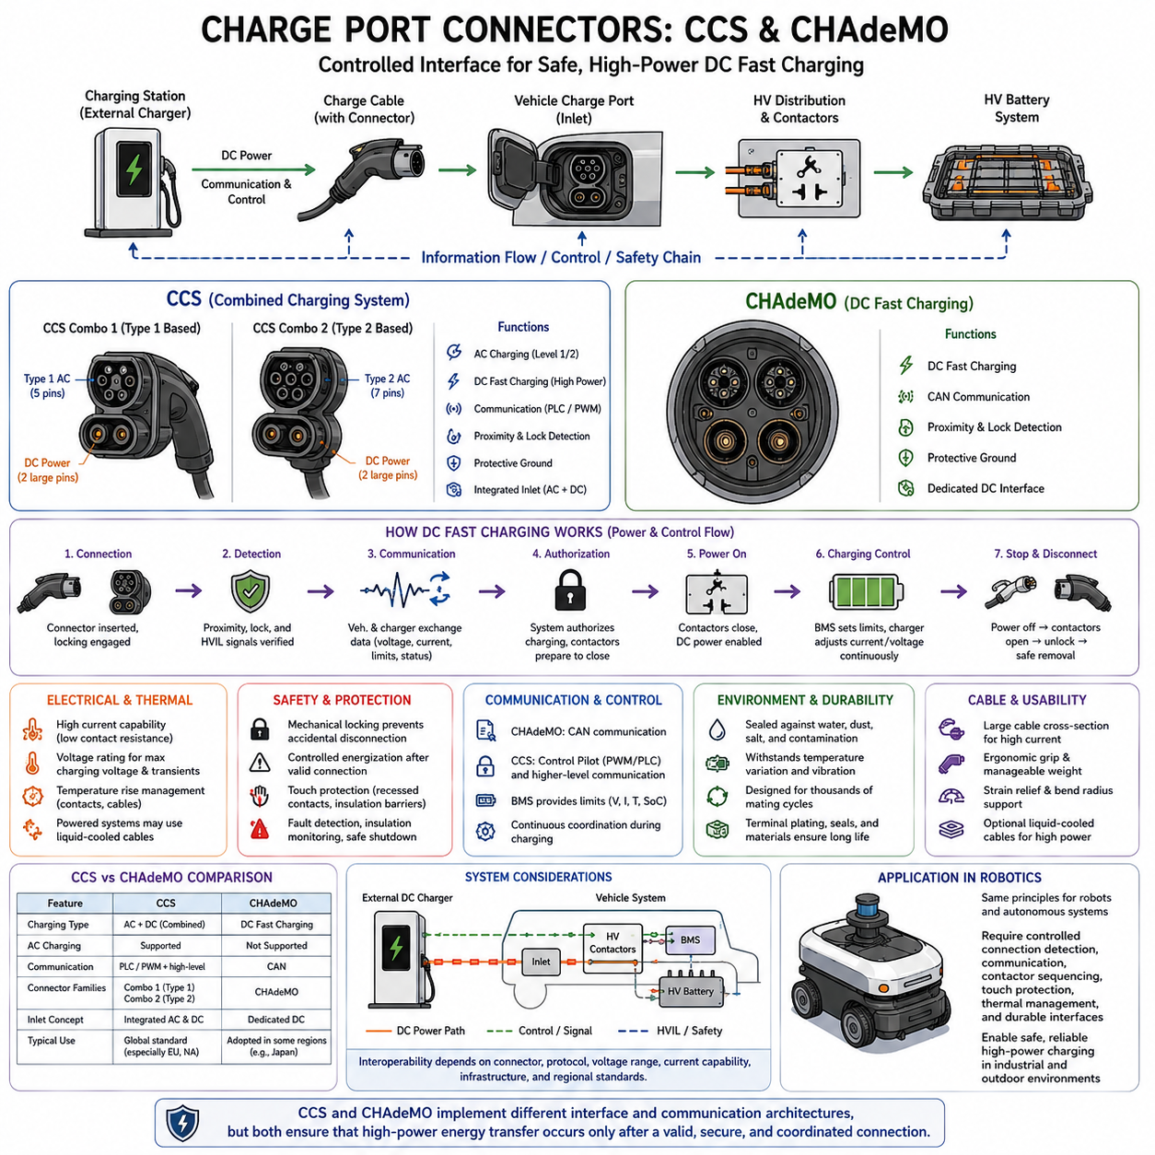
Charge-port connectors form the controlled electrical and communication interface between an external charging system and a high-voltage battery system. Within high-voltage connector engineering, charging interfaces require more than sufficient voltage and current capability because they are repeatedly handled by users and exposed to environmental conditions. CCS and CHAdeMO illustrate two major approaches developed for conductive electric-vehicle charging.
The Combined Charging System, commonly called CCS, integrates charging functions into a standardized vehicle-side interface intended to support both conventional AC charging and high-power DC charging within a coordinated connector architecture. The fundamental concept is to reduce the need for completely separate charging inlets while providing dedicated power contacts, communication functions, protective mechanisms, and mechanical features appropriate to different charging modes.
CCS implementations are commonly associated with two physical families. Combo 1 extends the Type 1 AC interface with additional DC power contacts, while Combo 2 extends the Type 2 interface. In both cases, the large DC contacts provide the high-current path required for rapid battery charging. Smaller contacts support functions such as charging control, connection detection, protective signaling, and communication between the vehicle and charging equipment.
CHAdeMO was developed around a dedicated DC fast-charging interface rather than the combined AC/DC connector philosophy represented by CCS. The charging connector provides large DC power contacts together with auxiliary signal and communication connections. Its architecture coordinates the external charger and vehicle so that charging current can be controlled according to battery conditions, allowable limits, system status, and safety requirements throughout the charging session.
The electrical power path of a DC charging system differs from ordinary onboard AC charging. In AC charging, external AC power enters the vehicle and an onboard charger converts it into controlled DC power for the battery. During DC fast charging, conversion is primarily performed by external charging equipment, and controlled DC power is delivered toward the battery through the charge port and vehicle high-voltage distribution architecture.
This difference places demanding requirements on the DC charging connector. Contacts must carry substantial current while maintaining acceptably low contact resistance and temperature rise. Connector performance therefore depends on terminal geometry, contact force, conductive materials, plating, cable size, crimp or termination quality, and thermal conditions. Increasing charging power makes the connector, cable, and thermal-management architecture increasingly interdependent.
Voltage rating must be selected against the complete charging architecture rather than only the nominal battery voltage. The interface must maintain appropriate insulation performance at the maximum charging voltage and relevant transient conditions. Creepage distance, clearance distance, dielectric materials, contamination, moisture, connector geometry, and environmental exposure consequently become important parts of charge-port design, particularly as battery-system voltages increase.
High charging current produces resistive heating in contacts, terminals, and cables. Because power loss increases strongly with current, small increases in connection resistance can create significant localized temperature rise. Charging systems may therefore monitor temperature near critical contacts or terminals and reduce charging current when thermal limits are approached. High-power implementations can additionally employ actively cooled charging cables or other thermal-management techniques.
Mechanical locking is fundamental because the charging interface should not be unintentionally disconnected while hazardous power is being transferred. The charging system coordinates connector presence detection, locking state, electrical authorization, and power switching before significant charging current is permitted. During disconnection, power transfer should be terminated before the connector reaches a state in which energized high-voltage contacts could be exposed or separated unsafely.
This behavior follows the same safety philosophy introduced by high-voltage interlock design. Signal and auxiliary functions establish whether the interface is correctly connected, while power-control devices determine whether high voltage may be applied. The connector therefore participates in a controlled state sequence rather than acting as a passive pair of conductors. Mechanical position, communication status, electrical authorization, and power state must remain coordinated.
Communication represents an important architectural difference between CCS and CHAdeMO. CHAdeMO traditionally uses CAN-based communication between the vehicle and charger for charging control. CCS employs charging-control signaling together with higher-level communication mechanisms associated with the CCS charging architecture. Despite different implementations, both approaches require the charger and vehicle to exchange information before and during high-power energy transfer.
The battery management system plays a central role in this interaction. Battery voltage, temperature, state of charge, allowable charging current, fault conditions, and other constraints influence how much charging power can safely be accepted. The external charger cannot simply apply its maximum available current. Charging power must remain bounded by the vehicle and battery limits, with communication and control continuously coordinating the requested and permitted operating conditions.
Protective architecture extends beyond communication. Charging systems require mechanisms for electrical isolation, contactor control, fault detection, connection verification, and safe shutdown. Depending on system design, insulation monitoring and other electrical diagnostics may also be incorporated. The charge connector must therefore be considered as one element within a safety chain extending from the charging equipment through the vehicle inlet and HV distribution system to the battery.
Touch protection is particularly important because charging connectors are routinely manipulated by users rather than only by trained HV technicians. Conductive HV elements should remain inaccessible during normal handling and expected connection states. Recessed terminals, insulating barriers, connector geometry, locking mechanisms, controlled energization, and protective caps can work together to minimize the possibility of accidental contact with hazardous conductive components.
Environmental sealing is another major selection criterion. Charge ports are often mounted on external surfaces where they can encounter rain, dust, condensation, road contamination, salt, temperature variation, and repeated handling. Interface seals, drainage strategy, housing materials, terminal protection, and inlet covers must therefore preserve electrical performance under realistic environmental conditions rather than relying solely on nominal connector ratings.
Repeated mating creates durability requirements that differ from many permanently installed HV connectors. Charging interfaces may experience thousands of connection and disconnection events during product life. Contact wear, plating degradation, contamination, seal wear, latch deterioration, insertion force, extraction force, and mechanical alignment must remain within acceptable limits. Damaged or contaminated contacts can increase resistance and consequently increase heating during high-current charging.
Cable handling also affects practical charging-system design. High-current conductors require large cross-sectional areas, making cables heavier and less flexible. Users must nevertheless be able to position and mate the connector without excessive force. Strain relief, bend radius, cable support, connector grip geometry, and potentially liquid-cooled cable construction therefore influence usability as charging power increases.
CCS and CHAdeMO should not be evaluated only by connector geometry because the physical interface is one component of a larger charging ecosystem. Vehicle compatibility depends on charging protocol, communication implementation, voltage range, current capability, inlet architecture, charging infrastructure, regional deployment, and system-level certification requirements. A mechanically adaptable connector alone cannot provide interoperability when the associated electrical and communication architectures are incompatible.
For robotics and autonomous mobile systems, conventional passenger-vehicle charging interfaces may be directly useful in some large platforms, but their engineering principles have broader value even when proprietary robot charging connectors are used. High-power AMRs, outdoor autonomous vehicles, and industrial robots still require controlled connection detection, power authorization, communication, contactor sequencing, touch protection, thermal management, and durable mechanical interfaces.
Automated charging introduces additional mechanical requirements because a robot rather than a person may align the charging interface. Positional tolerance, guided engagement, compliance, contact wiping, docking repeatability, foreign-object tolerance, and misalignment detection can become as important as electrical ratings. Nevertheless, the underlying safety objective remains the same: high-power energy transfer should occur only after a valid, mechanically stable, and electrically verified connection has been established.
Within the provided connector-engineering structure, the CCS and CHAdeMO charge-port topic follows HVIL design, orange-cable safety identification, and general HV connector selection criteria, while preceding the UAV-specific HV connector application. This progression moves from fundamental HV safety mechanisms toward selection methodology and then into application-specific interfaces within the broader robotics electrical architecture.
A robust charge-port design therefore integrates electrical rating, thermal behavior, contact resistance, mechanical locking, connection detection, communication, battery control, environmental sealing, touch protection, mating durability, cable handling, and system-level validation. CCS and CHAdeMO implement these functions through different interface and communication architectures, but both demonstrate the central principle that safe fast charging requires coordinated management of mechanical connection, information exchange, and high-voltage power transfer.

09.05. HV Connector for UAV
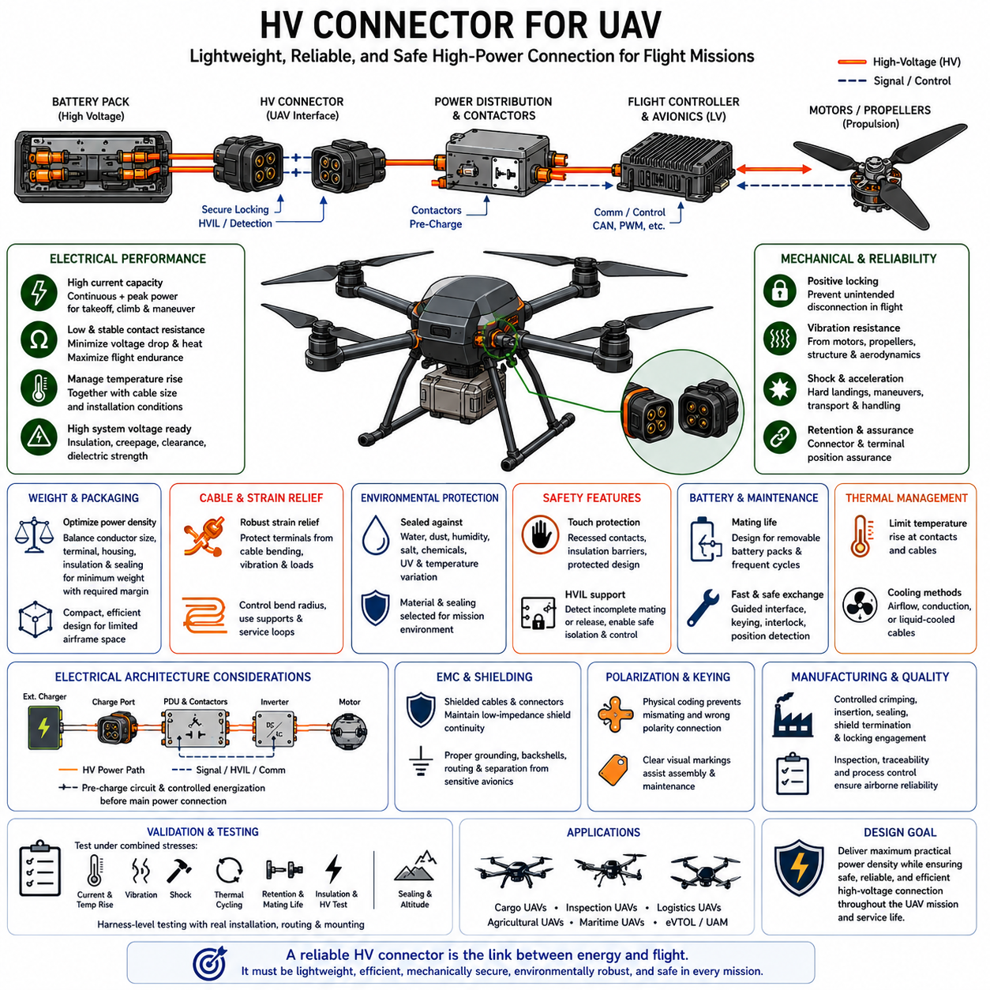
High-voltage connectors for unmanned aerial vehicles must satisfy a combination of electrical performance, mass efficiency, mechanical reliability, and environmental durability that is more demanding than many stationary applications. In UAV power architectures, every gram influences payload and endurance, while connector failure can immediately affect propulsion or flight safety. The connector must therefore provide high power density without sacrificing secure electrical and mechanical performance.
The definition of high voltage in a UAV must be considered relative to the complete propulsion architecture rather than only the battery nominal voltage. Large cargo UAVs and electrically propelled aircraft can use series-connected battery modules to reduce current for a required power level. As system voltage increases, however, connector insulation, creepage distance, clearance distance, dielectric strength, touch protection, and controlled disconnection become progressively more important.
Current capability remains equally critical because propulsion motors can demand substantial continuous power and considerably higher transient power during takeoff, climb, maneuvering, or disturbance recovery. Connector selection must therefore account for continuous current, peak current magnitude, peak duration, and duty cycle. A connector that performs adequately during cruise may still overheat or experience excessive voltage drop during repeated high-power flight phases.
Electrical losses have direct consequences for UAV efficiency. Contact resistance creates voltage drop and converts electrical energy into heat rather than useful propulsion power. Because battery energy is limited, unnecessary connector losses reduce available flight endurance while increasing thermal stress. Low and stable contact resistance throughout the connector lifecycle is therefore both an electrical-efficiency requirement and a reliability requirement for airborne power distribution.
Temperature rise must be evaluated together with conductor size and installation conditions. A lightweight UAV naturally encourages smaller cables and connectors, but aggressive downsizing increases current density and thermal loading. Connector terminals, cable conductors, crimps, housings, and surrounding structures form a coupled thermal system. The selected interface must remain within allowable temperature limits during representative ground operation, takeoff, climb, cruise, landing, and charging conditions.
Mass optimization requires system-level tradeoffs rather than simply selecting the smallest connector. An undersized interface can increase resistance, temperature, mechanical stress, and failure probability, while an excessively large connector adds unnecessary mass and packaging volume. The preferred design balances conductor cross-section, terminal dimensions, housing structure, locking mechanism, insulation distance, environmental sealing, and required safety margin to achieve suitable power density.
Vibration resistance is especially important because UAV connectors can be exposed to continuous excitation from motors, propellers, rotors, gearboxes, aerodynamic loading, and structural modes. Repeated vibration can promote terminal fretting, contact resistance variation, latch wear, wire fatigue, and connector movement. Secure retention, adequate contact normal force, strain relief, cable support, and suitable mounting therefore become essential parts of connector reliability.
Mechanical shock and acceleration loads must also be considered. Hard landings, emergency maneuvers, payload handling, transportation, and localized structural impacts can impose loads significantly different from steady vibration. Connector housings, terminal retention systems, locking features, and harness attachments should prevent momentary separation or terminal displacement. Even a very brief interruption in a propulsion power path may have consequences that are unacceptable for a flight-critical system.
Positive locking is therefore a fundamental requirement for propulsion and battery interfaces. Friction alone should not be assumed to provide adequate retention where unintended separation can interrupt flight power. Depending on the architecture, primary locks, secondary locks, connector position assurance, terminal position assurance, or tool-controlled release mechanisms can be used. The locking concept must remain secure while still supporting controlled manufacturing and maintenance operations.
Cable strain relief deserves particular attention because high-power UAV cables can be relatively stiff compared with lightweight airframe structures. Cable bending or vibration can transfer force directly into connector terminals when adequate support is absent. Proper backshell geometry, clamps, service loops, bend-radius control, and harness attachment points should redirect mechanical loads away from electrical contacts and prevent conductor fatigue near the termination.
Environmental requirements vary considerably among UAV applications. A small indoor aircraft may operate in a relatively controlled environment, while an outdoor inspection, logistics, agricultural, maritime, or cargo UAV may encounter rain, dust, humidity, salt, chemicals, ultraviolet exposure, and wide temperature changes. Connector sealing and material selection must therefore reflect the actual mission profile rather than applying one environmental specification to every UAV.
Altitude introduces an additional consideration for electrical insulation. Reduced air density can influence the insulation behavior of exposed electrical gaps, making appropriate clearance design increasingly important as operating altitude and system voltage increase. Connector selection should consequently consider the intended altitude envelope together with voltage, contamination, enclosure design, insulation materials, and the degree to which conductive elements are protected inside sealed connector structures.
High-voltage identification remains useful in larger UAV electrical systems because batteries, propulsion inverters, chargers, low-voltage electronics, avionics, sensors, and communication networks may coexist within a compact airframe. Orange cable jackets, connector components, or appropriate markings can distinguish HV power circuits from lower-voltage wiring. Visual identification assists assembly and maintenance but does not replace insulation, locking, protection, or electrical verification.
High-voltage interlock loop functionality can be appropriate for serviceable battery packs, removable power modules, power distribution units, or other interfaces where disconnection may occur while hazardous voltage is available. An HVIL circuit can indicate incomplete mating or connector release and allow the power-control system to inhibit energization or command isolation. The benefit increases as UAV voltage, stored energy, and maintenance complexity increase.
Battery replacement architecture strongly affects connector requirements. UAVs designed around removable battery packs may experience substantially more mating cycles than platforms with permanently installed batteries. Repeated insertion and extraction introduce wear of contacts, plating, seals, and locking components. Connector cycle-life requirements should therefore be based on expected battery replacement and maintenance frequency rather than assuming the low mating count typical of fixed propulsion wiring.
Fast battery exchange can create a conflict between operational speed and electrical safety. Operators may want to remove a depleted battery and install a charged pack rapidly, but high-power connectors require controlled alignment, complete mating, secure locking, and verification before power is enabled. Guided interfaces, keyed housings, pre-charge arrangements, interlocks, and position detection can reduce the probability of arcing, incomplete connection, or incorrect assembly during repeated battery changes.
Pre-charge behavior can be important when a battery connector energizes equipment containing substantial DC-link capacitance. Direct connection can produce a large inrush current as capacitors charge, potentially damaging contacts or creating arcing. The electrical architecture may therefore use a pre-charge circuit or controlled connection sequence before the main power path is established. Connector selection must remain compatible with the intended system-level energization strategy.
Electromagnetic compatibility is another important consideration because UAV propulsion inverters and motors generate rapidly switching currents close to sensitive avionics, GNSS receivers, communication systems, flight controllers, and sensors. Where shielded HV cables are required, connectors should support effective shield termination and low-impedance continuity. Shielding, grounding, connector backshells, cable routing, and separation from sensitive wiring must be designed as one EMC architecture.
Connector polarization and keying reduce the risk of incorrect assembly in UAVs containing multiple batteries, motor drives, charging ports, or modular payload power interfaces. Similar-looking connectors carrying different voltage levels or polarity should not be mechanically interchangeable when mismating could create hazardous conditions. Physical coding provides stronger protection than labels alone, while clear visual markings remain useful for manufacturing inspection and field maintenance.
Manufacturing quality has a direct effect on airborne connector reliability. Crimp height, conductor preparation, terminal insertion, seal installation, shield termination, strain relief, and locking engagement must be controlled and inspectable. Lightweight components can be particularly sensitive to improper assembly because reduced material margins leave less tolerance for damage. Production processes should therefore include appropriate tooling, work instructions, inspection criteria, and traceability.
Validation should reproduce the combined electrical, mechanical, thermal, and environmental stresses expected during UAV operation. Current and temperature-rise testing should be combined with vibration, shock, thermal cycling, retention, mating durability, insulation, sealing, and relevant altitude conditions. Harness-level testing is especially important because cable mass, routing, mounting points, structural vibration, and connector orientation can alter loads compared with isolated component testing.
The provided connector-engineering structure places UAV high-voltage connectors after HVIL design, orange-cable safety identification, general HV connector selection, and CCS/CHAdeMO charging interfaces. This makes the UAV topic an application-focused conclusion to the high-voltage connector chapter, while the broader robotics electrical architecture separately includes a dedicated cargo-UAV volume covering avionics, flight control, cargo systems, hybrid power, and large UAV classes.
A suitable UAV HV connector is therefore not simply the lightest component that meets nominal voltage and current ratings. It must balance electrical efficiency, thermal margin, insulation, altitude capability, vibration and shock resistance, locking, cable strain relief, environmental protection, mating life, HVIL compatibility, EMC, manufacturing quality, and maintainability. The final objective is maximum practical power density while preserving dependable power delivery throughout the aircraft mission and service lifecycle.

