Volume 03. Connector Engineering

Chapter 07. Industrial Connectors

07.01. Harting Han Series
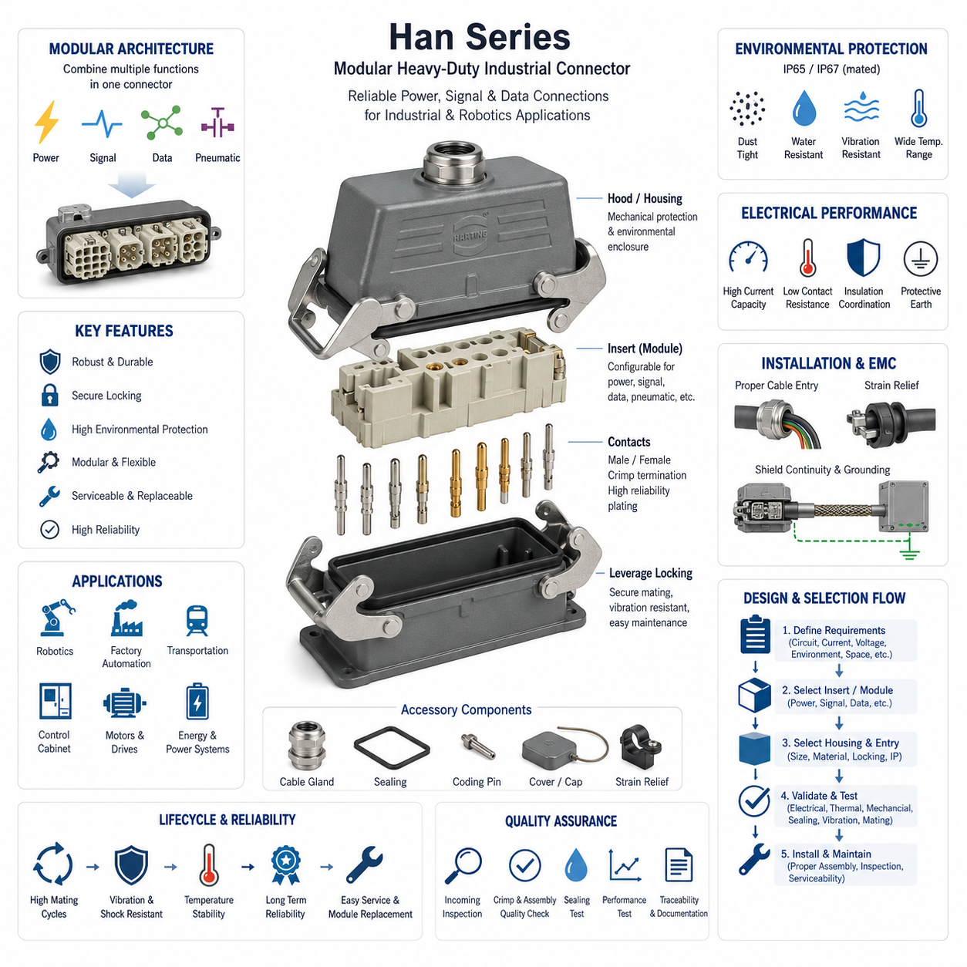
The Harting Han series represents one of the most established families of rectangular industrial connectors used in machinery, factory automation, transportation equipment, robotics, and distributed electrical systems. Within an industrial connector architecture, Han connectors are primarily intended to provide mechanically robust, serviceable interfaces between cables, equipment modules, control cabinets, motors, actuators, and field devices. Their importance lies not in a single connector specification but in a modular platform concept that allows the electrical interface to be adapted to different power, signal, communication, and environmental requirements.
A typical Han connector assembly is constructed from several coordinated elements rather than a single molded component. The interface generally combines a hood or housing, one or more inserts, male and female contacts, cable-entry hardware, sealing components, and a locking mechanism. This separation allows engineers to select the enclosure according to installation conditions while choosing inserts and contacts according to electrical requirements. As a result, mechanical packaging and electrical configuration can be optimized independently within the limits of the selected connector family.
The rectangular metal or polymer housing provides mechanical protection and establishes the physical mating interface. Industrial environments commonly expose connectors to vibration, impact, dust, moisture, oils, handling loads, and repeated maintenance operations, making enclosure design particularly important. Lever-operated locking arrangements are widely associated with heavy-duty rectangular connectors because they provide controlled mechanical retention while allowing technicians to disconnect equipment without complex tooling. Correct locking also helps maintain sealing compression and stable contact engagement during operation.
Han inserts determine how electrical circuits are organized inside the connector. Depending on the selected configuration, an insert can accommodate power conductors, control signals, instrumentation circuits, communication interfaces, or combinations of these functions. This makes the series fundamentally different from a connector selected only by pin count. Engineers must evaluate conductor size, rated current, voltage, contact arrangement, insulation coordination, temperature, pollution conditions, and applicable standards before selecting an insert. Connector capacity must therefore be treated as an engineered operating envelope rather than a nominal catalog value.
A particularly important characteristic of the Han concept is modularity. Modular connector architectures can combine different functional interfaces within one rectangular enclosure, reducing the number of separate connectors required at a machine boundary. Power contacts, signal contacts, pneumatic interfaces, and data-oriented modules can potentially occupy a common modular frame when compatible components are selected. For robotics, this approach can simplify detachable subsystem interfaces because several services between a robot base, manipulator, tool module, battery subsystem, or auxiliary equipment can be consolidated into a controlled connection point.
Contact technology must be selected with the same attention given to the housing. Contact resistance, normal force, conductor termination, plating, mating cycles, contamination, and vibration influence long-term electrical reliability. Crimp termination is particularly useful where production consistency and vibration resistance are important, while other termination technologies may be appropriate for installation-oriented applications. A connector that satisfies current requirements when new can still become a thermal risk if termination quality deteriorates, contact surfaces become contaminated, or mechanical loads reduce effective contact integrity over time.
Current rating should never be interpreted independently of thermal conditions. Electrical current flowing through contact and termination resistance generates heat, while the connector housing and surrounding environment determine how effectively that heat can dissipate. High ambient temperature, densely populated inserts, large numbers of simultaneously loaded contacts, enclosed installation spaces, and neighboring heat sources can reduce practical current capability. Consequently, temperature-rise verification and appropriate derating are essential when Han connectors carry substantial power in continuously operating industrial or robotic equipment.
Environmental protection depends on the complete assembled interface. Selecting a housing associated with a particular ingress-protection capability does not automatically guarantee that the installed connector will achieve that performance. Correct mating, locking, cable-gland selection, seal condition, cable diameter, unused-entry treatment, mounting geometry, and installation workmanship all contribute to the final result. This principle connects industrial connector selection directly with the environmental-rating and waterproofing engineering topics established earlier in the connector engineering structure.
Mechanical installation deserves similar attention because cable forces can be transferred directly into terminals if strain relief is inadequate. Cable glands and related entry components should provide appropriate retention, sealing, and bend management while avoiding excessive compression of the cable jacket. Harness routing should prevent persistent lateral loading at the connector exit and provide sufficient service length for maintenance. On moving robotic equipment, connector placement should also minimize exposure to collision, repeated flexing, uncontrolled cable motion, and locations where maintenance personnel may inadvertently use the cable as a handling point.
Industrial connectors also participate in electromagnetic compatibility strategy. Conductive housings can support shield continuity when the connector, cable shield, gland, enclosure, and grounding concept are designed as one system. Merely using a metal connector housing does not guarantee effective EMC performance. High-frequency interference can exploit discontinuities created by poor shield termination, long grounding paths, inadequate enclosure bonding, or unsuitable cable-entry hardware. Motor drives, inverters, switching power supplies, Ethernet links, encoders, and sensitive sensor signals therefore require coordinated connector and shielding design.
For robotics applications, the Han family is especially relevant at subsystem boundaries where reliability, modular replacement, and serviceability are more important than extreme miniaturization. An AMR or industrial robot may use heavy-duty rectangular connectors between power distribution assemblies, motor-drive compartments, battery-related modules, external charging equipment, manipulators, or detachable auxiliary systems. Such interfaces allow large assemblies to be manufactured and tested separately before final integration, while field maintenance can replace a module without individually disconnecting numerous internal conductors.
The principal tradeoff is packaging. Heavy-duty industrial rectangular connectors provide strong mechanical protection and extensive configuration flexibility, but they can occupy considerably more space and mass than compact automotive or board-oriented connector families. They may therefore be unsuitable for small joints, lightweight end effectors, compact sensor heads, or densely packaged electronics. Connector selection should follow the physical location and functional boundary: heavy-duty modular interfaces are valuable at major equipment partitions, while smaller connector technologies remain preferable within compact robotic assemblies.
Serviceability is one of the strongest architectural reasons to adopt this connector class. A well-designed interface creates an explicit electrical boundary between replaceable modules and allows technicians to disconnect a subsystem without opening numerous terminals or disturbing unrelated wiring. Keying, coding, labeling, contact-position control, and documented pin assignments should be used to prevent incorrect reconnection. Protective earth conductors and safety-related circuits require particular attention because connector replacement must never compromise bonding, isolation, or the intended safety architecture.
Selection therefore begins with system requirements rather than with a preferred Han housing size. Engineers should first define every circuit crossing the interface, including voltage, maximum and continuous current, conductor size, signal type, communication requirements, protective earth, shielding, environmental exposure, mating frequency, available installation volume, and service expectations. These requirements determine whether a fixed insert or modular architecture is appropriate and provide the basis for evaluating contacts, termination methods, enclosure material, cable entry, locking configuration, and environmental protection.
Validation should reproduce the conditions expected in the actual machine. Electrical continuity, insulation performance, protective-earth integrity, temperature rise, contact resistance, mechanical retention, vibration behavior, sealing, and repeated mating may all require verification according to application severity. Testing is particularly important when multiple high-current circuits are concentrated within one enclosure or when the connector is mounted close to motors, inverters, batteries, or other thermal sources. Production inspection must additionally verify crimp quality, contact insertion, sealing components, coding, and locking operation.
Within the broader connector engineering structure, the Harting Han series provides an industrial counterpart to the automotive connector families examined in the preceding chapter and establishes a foundation for comparison with Phoenix Contact, Anderson Powerpole/SB, M12/M8 circular connectors, and DIN-rail terminal technologies that follow. The key engineering lesson is that a Han interface should be treated as a configurable electromechanical subsystem whose electrical, mechanical, environmental, EMC, manufacturing, and service characteristics must be designed together rather than as an interchangeable cable accessory.

07.02. Phoenix Contact Series
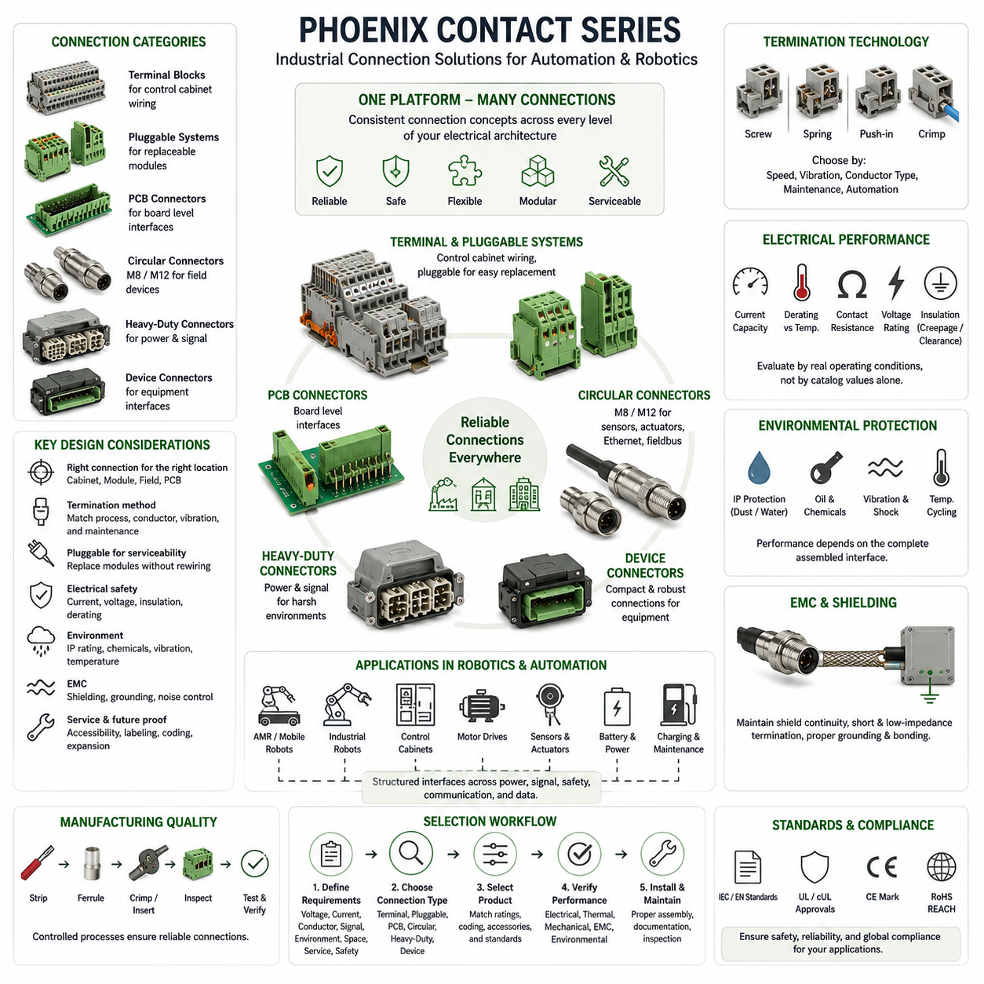
Phoenix Contact connector technologies represent a broad industrial interconnection platform used throughout control cabinets, machinery, factory automation, robotics, energy systems, and distributed I/O architectures. Within industrial connector engineering, the Phoenix Contact approach is particularly relevant because it spans field wiring, device connections, PCB interfaces, pluggable terminal systems, and industrial circular connectors. This breadth allows engineers to maintain consistent connection concepts across multiple levels of an electrical architecture rather than treating every interface as an unrelated connector problem.
Unlike a single connector family defined by one housing geometry, Phoenix Contact solutions cover several interconnection categories optimized for different installation boundaries. These include terminal-oriented connectors, pluggable connection systems, PCB terminal blocks, industrial circular connectors, heavy-duty interfaces, and device connection technologies. The engineering value therefore comes from selecting an appropriate connection principle according to where the interface exists: inside a control cabinet, between equipment modules, at a sensor or actuator, on a PCB, or at a serviceable field connection.
A fundamental design consideration is the termination technology used to connect the conductor to the contact system. Screw, spring, push-in, crimp, and related connection methods provide different balances among installation speed, vibration resistance, conductor preparation, serviceability, and manufacturing automation. Push-in technology is especially useful in industrial wiring because appropriately prepared conductors can be inserted directly without repeatedly tightening screws. However, conductor type, ferrule usage, cross-sectional range, stripping length, and installation procedure must remain compatible with the selected terminal specification.
Spring-based connection principles maintain contact force through an elastic mechanism rather than depending entirely on a manually applied screw torque. This can provide advantages in environments containing vibration or temperature cycling because the terminal can accommodate small dimensional changes while maintaining conductor pressure. Screw connections remain valuable where conventional field practices, broad technician familiarity, or particular conductor arrangements make them appropriate. Neither method is universally superior; termination technology should be selected according to manufacturing processes, maintenance strategy, vibration exposure, conductor characteristics, and required inspection procedures.
Pluggable terminal systems provide an important bridge between permanent wiring and replaceable electronic modules. Instead of disconnecting individual conductors when a controller, power supply, I/O module, or subsystem requires replacement, a plug can separate the wiring harness from the equipment. This architecture can significantly reduce maintenance time and wiring errors while preserving field wiring during device replacement. Coding and polarization should be incorporated when similar connectors are positioned near one another so that technicians cannot accidentally reconnect a plug to an electrically incompatible interface.
PCB connection technology extends the same architectural principle to electronic assemblies. Board-mounted headers and terminal interfaces allow external wiring to connect directly to controllers, power electronics, communication devices, sensor interfaces, and distributed control modules. Selection must account for PCB current paths, pin spacing, creepage and clearance, conductor size, mechanical loading, and insertion forces. A high-current connector cannot compensate for an undersized PCB copper path, making connector rating and circuit-board thermal design inseparable when substantial power crosses the board boundary.
Industrial circular connectors provide another major interface category, particularly for sensors, actuators, Ethernet, fieldbus, and distributed I/O. M8 and M12 formats are widely associated with compact machine-level connectivity because standardized mechanical interfaces simplify replacement and equipment integration. Different coding arrangements distinguish power and communication functions and help prevent incompatible connections. In robotic equipment, circular connectors are particularly useful around sensor clusters, motor feedback systems, distributed I/O devices, safety components, and machine peripherals where compactness and robust field installation are required.
Electrical performance must be evaluated using actual operating conditions rather than catalog ratings alone. Continuous current, conductor cross section, number of simultaneously loaded positions, contact resistance, ambient temperature, enclosure conditions, and neighboring heat sources determine practical thermal performance. Dense control cabinets can create significantly different conditions from open laboratory testing. Appropriate derating is therefore necessary, particularly for power distribution connectors, motor circuits, DC power interfaces, and compact multi-position connectors operating continuously near their maximum rated current.
Voltage selection requires similar discipline. Rated voltage is related not only to insulating material but also to contact spacing, creepage distance, clearance distance, pollution degree, installation environment, and applicable standards. Industrial equipment can experience contamination, condensation, conductive dust, or transient overvoltage that changes the effective insulation requirement. Engineers should therefore establish the electrical environment before selecting a connector and avoid assuming that physically similar connectors provide equivalent insulation performance simply because their conductor capacity or external dimensions appear comparable.
Environmental protection becomes increasingly important when Phoenix Contact interfaces move outside protected cabinets and into machine or robot environments. Dust, water, oils, coolants, cleaning chemicals, vibration, mechanical impact, and temperature cycling can affect both electrical and mechanical reliability. The ingress protection of an interface depends on the complete assembled system, including mating components, seals, cable glands, cable diameter, mounting surfaces, and unused ports. A nominally sealed connector can lose its protection if installation details fail to preserve the intended sealing geometry.
Mechanical reliability also depends strongly on cable management. Connector contacts should not function as strain-relief devices, and external cable loads should be controlled before forces reach the termination region. Proper routing, clamping, bend radius, service loops, and cable-entry hardware prevent vibration or maintenance activity from producing repeated loads at conductor terminations. This becomes especially important on mobile robots and manipulators, where acceleration, chassis vibration, joint movement, and repeated servicing can create loading conditions that stationary industrial installations may not experience.
Electromagnetic compatibility must be considered when connectors carry high-speed communication or operate near motors, inverters, DC/DC converters, switching power supplies, and other noise sources. Shielded connector systems can maintain cable-shield continuity across equipment boundaries, but effective performance depends on the complete grounding and bonding architecture. Short, low-impedance shield termination is generally preferable to long pigtail arrangements at high frequencies. Connector selection should therefore be coordinated with cable construction, enclosure bonding, protective earth, signal grounding, and EMC zoning.
For robotic systems, Phoenix Contact technologies can support several distinct architectural layers. Control-cabinet terminal systems can organize internal power and I/O distribution, pluggable interfaces can create replaceable controller or power modules, and circular connectors can connect field-mounted sensors and actuators. This division allows the connector technology to follow the physical hierarchy of the robot. An AMR, for example, may require serviceable interfaces among the battery, power distribution unit, motor drives, edge computer, safety devices, perception sensors, and external charging or maintenance equipment.
Serviceability should be designed into these interfaces rather than added after the electrical architecture is complete. Connectors intended for maintenance should be accessible, clearly labeled, mechanically distinguishable where necessary, and documented with stable pin assignments. Coding can prevent cross-mating, while modular plugs allow assemblies to be replaced without disturbing permanent wiring. Spare positions and future expansion should be considered carefully because unnecessary oversizing increases packaging requirements, whereas insufficient capacity can force costly connector redesign when additional sensors or functions are introduced.
Manufacturing quality is equally important because reliable connector hardware cannot compensate for poor assembly processes. Conductor stripping, ferrule installation, crimping, insertion depth, screw torque where applicable, wire identification, and pull-force verification should be controlled through defined production procedures. Automated or semi-automated wiring can improve consistency when equipment volume justifies it. Inspection criteria should focus not only on visual appearance but also on electrical continuity, retention, insulation, polarity, coding, and the traceability of critical assembly operations.
The selection process should therefore begin by identifying the interface boundary and its functional requirements. Engineers should define circuit voltage, continuous and peak current, conductor range, signal or communication type, shielding, environmental exposure, vibration, mating frequency, available space, assembly method, service requirements, and applicable safety constraints. Only after these conditions are understood should a terminal block, pluggable connector, PCB interface, circular connector, or other Phoenix Contact solution be selected. This prevents connector choice from being driven primarily by familiarity or physical appearance.
Within the industrial connector chapter of the broader Connector Engineering volume, Phoenix Contact follows the Harting Han series and precedes Anderson Powerpole/SB, M12/M8 circular connectors, and DIN-rail terminal blocks. This structure places it within a comparison of industrial connection philosophies rather than presenting it as a single interchangeable product family. The central engineering lesson is to view Phoenix Contact technologies as building blocks for structured electrical interfaces whose termination, current capacity, insulation, environment, EMC behavior, manufacturing process, and service strategy must be coordinated at system level.

07.03. Anderson Powerpole / SB
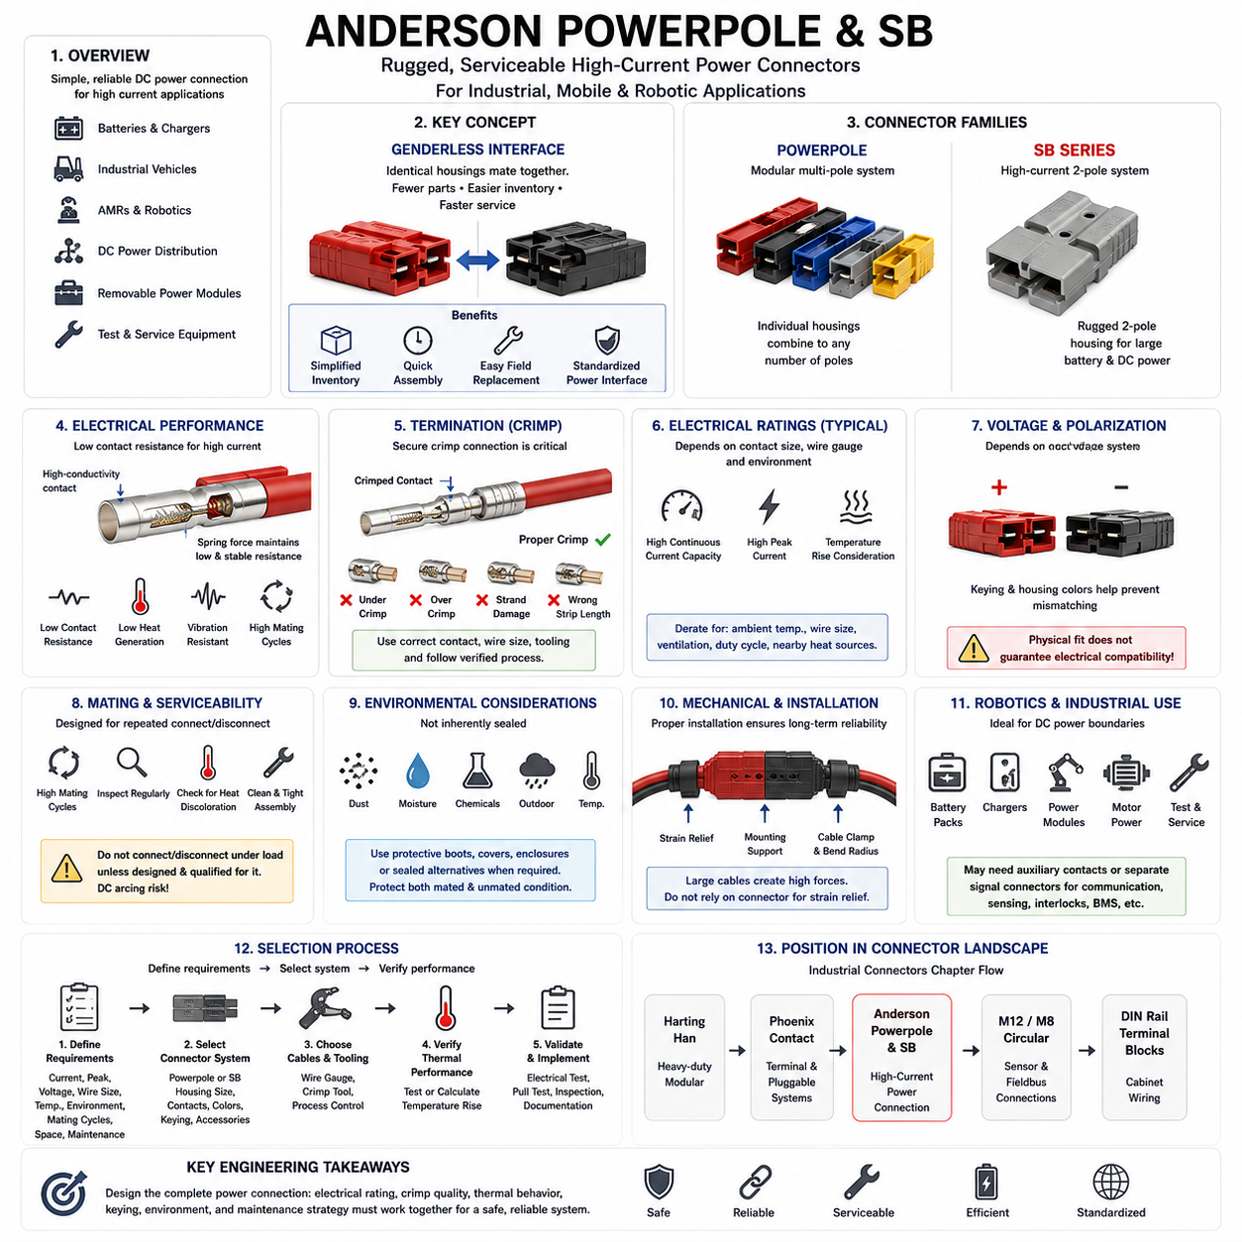
Anderson Powerpole and SB connectors are widely used industrial power interconnection systems designed for applications requiring reliable transfer of relatively high electrical current through simple, rugged, and serviceable interfaces. Within industrial connector engineering, these connectors are particularly relevant to batteries, chargers, DC power distribution, material-handling equipment, mobile robots, industrial vehicles, and removable electrical modules. Their architecture emphasizes low-resistance power contacts and practical field connection rather than dense signal integration.
A distinctive characteristic of many Anderson connector designs is the use of genderless or hermaphroditic mating interfaces. Instead of maintaining separate conventional male and female connector housings, compatible housings can mate with identical counterparts when their mechanical configuration and electrical ratings match. This simplifies inventory management, cable assembly, maintenance, and field replacement because fewer connector variants need to be controlled. The concept is especially valuable in battery-powered equipment where chargers, battery packs, and vehicles may require standardized interchangeable power interfaces.
Powerpole connectors use individual modular housings that can be mechanically combined to create multi-pole arrangements. This allows designers to construct power interfaces according to circuit requirements while maintaining a relatively simple connector architecture. Housing configuration and color can assist circuit identification and polarization, although color alone should never replace documented wiring definitions. Correct mechanical assembly is important because inappropriate housing orientation or incompatible components can defeat the intended keying strategy and increase the possibility of incorrect field connection.
The SB family follows a different packaging concept and is commonly associated with larger two-pole battery and DC power connections. The molded housing integrates the primary power positions into a mechanically robust interface suitable for repeated connection and disconnection. Different housing sizes and configurations support different current and conductor requirements, so the designation SB should not be interpreted as representing one universal electrical rating. Engineers must select the specific connector size, contact, conductor range, and accessory configuration according to the actual application.
The electrical performance of Powerpole and SB systems depends strongly on the contact interface. High-current connectors require low and stable contact resistance because even a small resistance produces significant heat as current increases. Contact geometry, spring force, conductive material, plating, surface condition, and mating quality determine the effective electrical interface. A properly designed contact system maintains sufficient normal force during operation while limiting resistance growth caused by vibration, repeated mating, contamination, or mechanical wear.
Crimp termination is commonly used to connect conductors to high-current contacts. Reliable crimping requires the contact, conductor cross section, insulation preparation, and tooling to be treated as one qualified system. An incorrect crimp can create excessive resistance even when the connector itself is correctly rated. Poor conductor insertion, unsuitable tooling, under-crimping, over-crimping, damaged strands, or incorrect stripping can reduce mechanical retention and increase localized heating. Production processes should therefore include controlled tooling and appropriate inspection or pull-force verification.
Current rating must be interpreted together with conductor size and thermal environment. Connector catalog values are normally associated with defined test conditions and cannot automatically represent every installed configuration. Ambient temperature, cable gauge, contact resistance, enclosure ventilation, duty cycle, neighboring heat sources, and continuous versus intermittent loading influence actual temperature rise. Battery-powered robots and industrial vehicles can impose long-duration currents as well as short acceleration peaks, making both steady-state and transient electrical loading important during connector selection.
Voltage capability is also an engineering constraint even when the primary application is high-current DC distribution. Contact spacing, insulation geometry, contamination, installation environment, and applicable safety requirements determine whether a connector is suitable for a particular voltage system. Designers should clearly distinguish extra-low-voltage robotic power networks from higher-voltage battery architectures. Physical compatibility must never be interpreted as electrical compatibility, particularly where similar connector formats could otherwise permit equipment operating at different voltages to be connected.
Connector polarization and keying are essential when several battery or power circuits exist within the same facility. Mechanical configurations should prevent incompatible voltages, battery chemistries, charging circuits, or functional buses from being accidentally interconnected. Housing color can provide useful visual identification, but mechanical incompatibility and documented interface control provide stronger protection. Robotics fleets especially benefit from standardized connector definitions because batteries, chargers, service equipment, and replacement modules may be handled by many operators over the equipment lifetime.
Repeated mating is a significant consideration in applications where batteries are manually exchanged or charging equipment is connected frequently. Every mating cycle produces some mechanical wear at the contact surfaces and housing interface. Contact wear, contamination, reduced spring force, damaged housings, or foreign material can gradually increase resistance. Maintenance programs should therefore inspect high-cycle power connectors for discoloration, deformation, looseness, pitting, overheating evidence, and abnormal insertion or extraction behavior before these conditions develop into operational failures.
Power connectors should not be disconnected casually while substantial current is flowing unless the complete interface is specifically designed and qualified for that operating condition. Interrupting DC current can generate an electrical arc, and DC arcs can be more difficult to extinguish than comparable AC arcs because there is no natural current zero crossing each cycle. System architecture should therefore coordinate connectors with contactors, precharge circuits, charging controls, interlocks, or operating procedures when energized connection and disconnection could otherwise occur.
Environmental exposure must be considered separately from current capability. A rugged high-current connector is not automatically a sealed connector. Dust, moisture, conductive contamination, corrosion, industrial chemicals, and outdoor exposure can affect contact surfaces and insulation performance. Where robots or vehicles operate in harsh environments, protective boots, covers, enclosures, appropriate mounting orientation, or alternative sealed connector technologies may be required. Environmental protection should be evaluated for both the mated operating condition and the unmated service condition.
Mechanical mounting and cable routing strongly influence long-term reliability. Large-gauge power cables can generate substantial forces because of their stiffness and mass, particularly when routed through mobile equipment. These forces should not be continuously transferred into the connector contacts or housing. Proper strain relief, cable clamps, bend-radius control, service loops, and mounting support reduce mechanical stress. On AMRs, forklifts, mobile platforms, and battery carts, designers must additionally consider chassis vibration, repeated battery movement, impact, and operator handling.
The simple two-conductor architecture of many SB applications makes these connectors particularly suitable for battery interfaces. A removable robot battery can use a standardized high-current connector between the battery pack and vehicle power distribution system, while compatible infrastructure can support charging or service operations. However, modern battery systems frequently require additional communication, temperature sensing, identification, interlock, or battery-management signals. These functions may require auxiliary contacts or a separate signal connector depending on the selected system architecture.
In robotics, Anderson-style power connectors are therefore most useful where the electrical boundary is dominated by DC energy transfer rather than high-density sensing or communication. They can support battery packs, charging stations, removable power modules, motor-power distribution, test equipment, and temporary service connections. They are generally less suitable as a complete interface for sensor-rich modules requiring Ethernet, CAN, safety signals, shielding, and numerous low-current circuits. Such boundaries may require a hybrid architecture or separate dedicated signal connectors.
Selection should begin with continuous current, peak current, system voltage, conductor cross section, expected temperature, mating frequency, environmental exposure, available packaging space, and maintenance method. Engineers should then select compatible housings, contacts, cable sizes, accessories, and tooling as an integrated connection system. Thermal verification is advisable when operation approaches the practical current limit, particularly in enclosed battery compartments or high-duty-cycle mobile robots where elevated ambient temperature and limited airflow can significantly influence connector temperature.
Within the Industrial Connectors chapter, Anderson Powerpole and SB follow the Harting Han and Phoenix Contact sections and precede the dedicated discussion of M12/M8 circular connectors and DIN-rail terminal blocks. This placement highlights a different industrial connection philosophy: rather than maximizing mixed-function modularity or cabinet-level wiring flexibility, Powerpole and SB systems emphasize robust, low-resistance, serviceable power transfer. Their engineering value is greatest when electrical rating, crimp quality, thermal behavior, keying, environmental protection, and maintenance strategy are designed together as part of the complete power architecture.

07.04. M12/M8 Circular Connectors
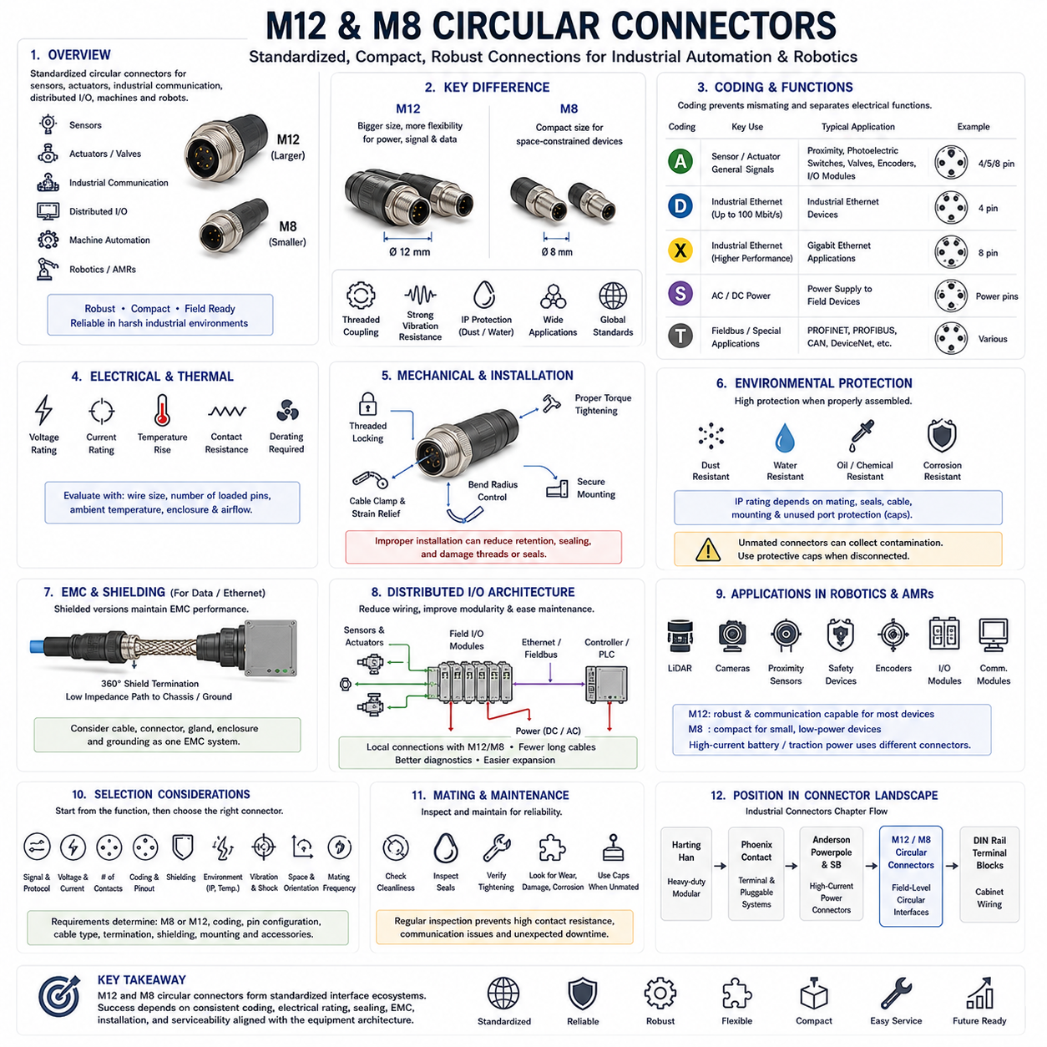
M12 and M8 circular connectors are standardized industrial connection systems widely used for sensors, actuators, industrial communication, distributed I/O, machine automation, and robotics. Their compact circular form, defined mating geometry, and robust mechanical construction make them suitable for field-level electrical interfaces where conventional cabinet connectors would be too large or insufficiently protected. Within industrial connector engineering, they provide an important bridge between control equipment and distributed devices installed directly on machines or mobile robotic platforms.
The fundamental difference between M12 and M8 connectors is their physical scale and the applications enabled by that scale. M12 connectors use a larger threaded interface and generally provide greater flexibility for power, signal, and industrial communication connections. M8 connectors are smaller and are commonly selected for compact sensors, miniature actuators, and space-constrained equipment. Connector diameter alone, however, does not define electrical capability; contact arrangement, coding, conductor size, voltage, current, and environmental rating must also be evaluated.
A major advantage of these connector families is standardization. Standardized mechanical interfaces allow compatible devices, cables, sensors, and I/O modules from different equipment ecosystems to be integrated without creating a unique connector architecture for every machine. This supports modular equipment design and simplifies replacement in industrial environments. Nevertheless, sharing the same nominal M12 or M8 format does not guarantee compatibility because pin count, coding, electrical function, communication protocol, shielding, and connector gender can differ significantly between implementations.
Coding is one of the most important concepts in M12 connector engineering. Different mechanical coding arrangements are used to separate electrical functions and reduce the possibility of incorrect mating. Depending on the connector system, coding can distinguish conventional sensor and actuator wiring from Ethernet, fieldbus, or power applications. The coding system therefore acts as both a mechanical compatibility mechanism and an architectural classification method. Engineers must verify coding together with pin assignment rather than identifying a connector only by its external circular appearance.
A-coded M12 connectors are strongly associated with conventional sensor and actuator interfaces and general-purpose industrial signals. They are commonly encountered in automation equipment where proximity sensors, photoelectric sensors, switches, valves, encoders, and distributed I/O devices must connect to control systems. Pin assignments must still be verified for each application because the presence of a familiar connector does not guarantee an identical circuit definition. Standardized wiring practices become especially valuable when large machines or robotic fleets contain hundreds of field devices.
Industrial Ethernet introduced additional M12 coding arrangements optimized for data communication. D-coded connectors have historically been associated with industrial Ethernet implementations, while X-coded M12 connectors provide separated contact groups suitable for higher-performance Ethernet connections. Other coding systems support additional industrial communication architectures. In these applications, connector selection must consider impedance behavior, pair arrangement, shielding, cable category, bandwidth, and EMC performance in addition to basic continuity and environmental protection.
Power-oriented M12 variants extend the circular connector concept beyond low-current sensing and communication. Power coding arrangements provide mechanically differentiated interfaces intended for DC or AC power distribution within defined electrical limits. This allows distributed equipment such as I/O modules, small drives, actuators, controllers, and machine subsystems to receive power through compact standardized connectors. Designers must verify the specific coding, contact rating, conductor size, voltage, and applicable standard because different power-coded variants are not interchangeable.
M8 connectors serve a particularly important role where packaging density is a primary constraint. Compact sensors and actuators can often be connected with significantly less installation volume than would be required by larger industrial connectors. This is useful for robot end effectors, compact manipulators, sensor arrays, conveyor equipment, machine tooling, and distributed automation. The reduced size also means that cable routing, connector accessibility, tightening, and mechanical protection require careful consideration, especially where technicians must work in confined spaces.
Mechanical locking commonly uses threaded coupling, although specific product families may provide alternative quick-locking mechanisms. Proper coupling creates the mechanical retention required to resist vibration and helps establish the intended environmental seal. Under-tightening can reduce retention or sealing performance, while inappropriate installation practices can damage threads, seals, or connector bodies. Where tightening torque is specified, assembly processes should control it appropriately rather than relying entirely on subjective hand tightening, particularly in production environments requiring repeatable quality.
Ingress protection is one of the reasons M12 and M8 connectors are widely deployed outside control cabinets. Properly selected and assembled connector systems can provide strong resistance to dust and water, allowing field devices to operate close to machinery or process equipment. The stated IP performance applies to defined assembly conditions and normally depends on correct mating, intact seals, appropriate cable construction, correct mounting, and properly protected unused ports. Environmental rating must therefore be evaluated at system level rather than assigned automatically from the connector name.
Unmated connectors deserve particular attention because their environmental protection can differ substantially from the mated condition. During equipment assembly, maintenance, transportation, or module replacement, open connector interfaces can collect dust, moisture, oils, metal particles, or other contaminants. Protective caps should be considered where connectors may remain disconnected. This is especially important on mobile robots operating near floors, outdoor equipment, manufacturing processes, or maintenance areas where exposed contacts can encounter contamination before reconnection.
Vibration and mechanical shock influence both connector retention and contact reliability. Circular threaded connectors are well suited to many industrial environments, but the complete installation must prevent excessive cable movement from loading the connector interface. Cable clamps, appropriate bend radius, strain relief, and controlled routing should be incorporated into the harness design. On robots, dynamic motion can create repeated cable forces that are not present in stationary machinery, so a robust connector does not eliminate the need for proper moving-cable engineering.
Electrical current capability must be evaluated together with temperature rise and conductor size. Small connectors can experience significant heating when multiple contacts carry substantial current, particularly in high ambient temperatures or enclosed spaces. Contact resistance, wire gauge, number of loaded contacts, connector materials, and airflow affect the resulting temperature. Designers should apply manufacturer derating information and verify thermal behavior when operating near rated limits instead of assuming that the maximum catalog current is suitable for continuous operation.
EMC and shielding become critical when M12 connectors carry Ethernet, high-speed data, encoder signals, or sensitive measurement signals near motors and power electronics. Shielded connector versions can provide a controlled transition between the cable shield and equipment enclosure, but the effectiveness depends on shield termination and bonding geometry. A continuous low-impedance shielding path is preferable for high-frequency interference control. Connector, cable, gland, enclosure, and grounding strategy should therefore be engineered as one EMC interface.
Distributed I/O architectures demonstrate the system-level value of M12 and M8 connectivity. Instead of routing every sensor cable back to a central cabinet, field I/O modules can be mounted close to sensors and actuators, with standardized circular connectors providing local device connections. Communication and power can then be concentrated into fewer trunk connections toward the controller. This reduces long point-to-point harnesses, improves modularity, simplifies machine installation, and can make fault isolation easier when connector and channel identification are consistently documented.
In AMRs and other mobile robots, M12 and M8 connectors can support LiDAR interfaces, cameras, proximity sensors, safety devices, encoders, distributed I/O, communication modules, and auxiliary equipment depending on their electrical requirements. M12 is particularly useful where mechanical robustness and communication capability are important, while M8 can serve compact low-power devices where installation space is limited. High-current battery and traction-power boundaries generally require connector technologies designed specifically for substantially larger power transfer.
Selection should begin with the function of the interface rather than connector diameter. Engineers should define signal type, communication protocol, voltage, continuous current, conductor size, number of contacts, shielding, environmental exposure, vibration, available space, mating frequency, cable orientation, and maintenance requirements. These requirements determine whether M8 or M12 is appropriate and which coding, pin configuration, termination, cable type, shielding arrangement, and mounting method should be selected for the complete connection.
Within the Industrial Connectors chapter, M12 and M8 circular connectors follow the Harting Han, Phoenix Contact, and Anderson Powerpole/SB discussions and precede DIN-rail terminal blocks. This progression distinguishes heavy-duty modular interfaces, broad industrial connection platforms, high-current DC power connectors, compact field-level circular interfaces, and cabinet wiring technologies. The central engineering lesson is that M12 and M8 should be treated as standardized interface ecosystems whose coding, electrical rating, communication function, sealing, EMC, installation, and serviceability must all remain consistent with the equipment architecture.

07.05. DIN Rail Terminal Blocks
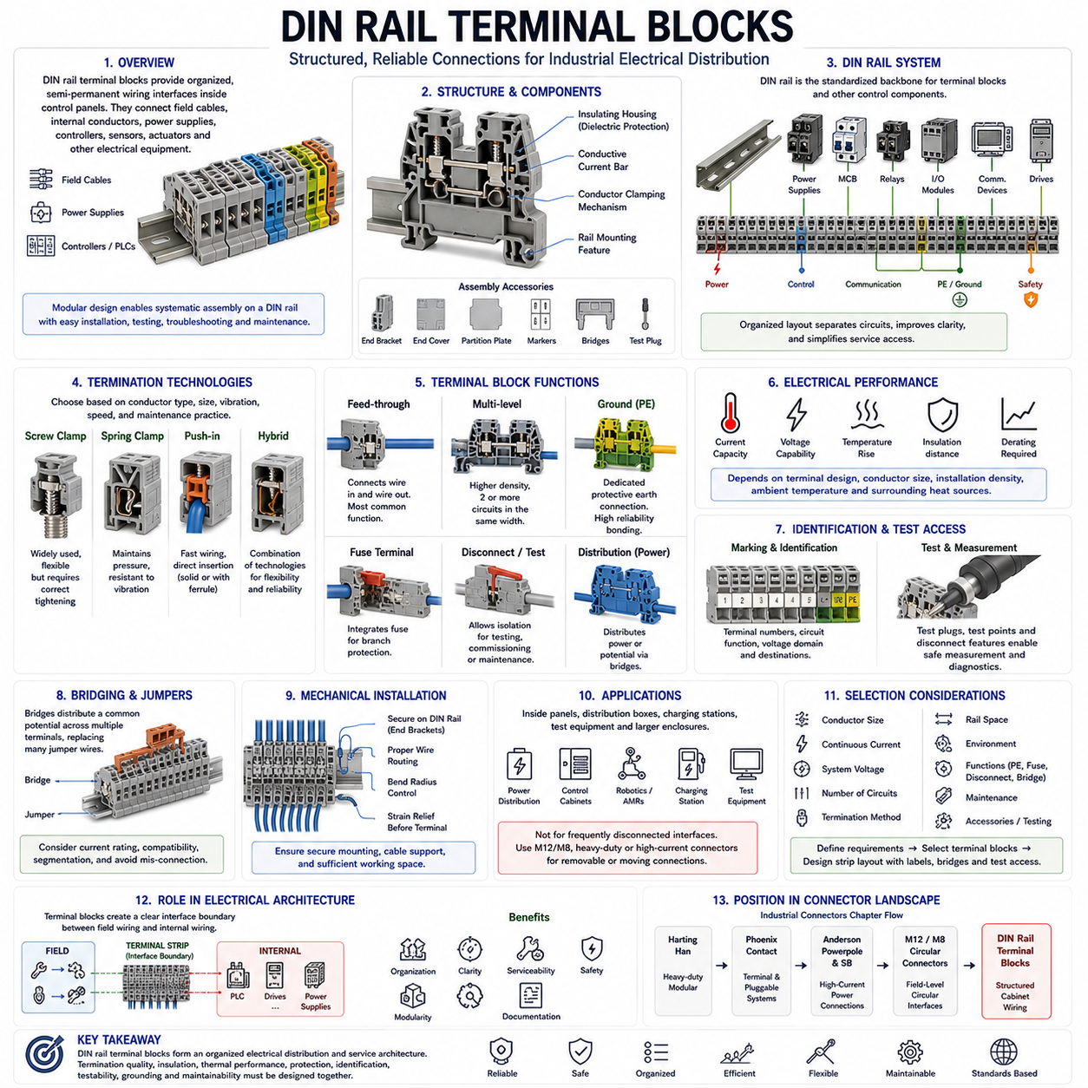
DIN rail terminal blocks are fundamental components of industrial electrical distribution and control-panel wiring, providing structured connection points between field cables, internal conductors, power supplies, controllers, sensors, actuators, and other electrical equipment. Unlike detachable cable connectors, terminal blocks normally create organized semi-permanent wiring interfaces inside protected enclosures. Their modular construction allows electrical circuits to be assembled systematically along a standardized DIN rail while maintaining accessibility for installation, testing, troubleshooting, modification, and maintenance.
A typical DIN rail terminal block consists of an insulating housing, conductive current bar, conductor clamping mechanism, and mechanical feature that attaches the block to the rail. Individual blocks are installed side by side to create terminal assemblies containing the required number of circuits. End brackets, end covers, partition plates, markers, bridges, and test accessories complete the assembly. This modular approach allows designers to configure terminal strips according to the exact electrical architecture rather than requiring a dedicated multi-position connector for every cabinet configuration.
The DIN rail provides a standardized mechanical backbone for mounting terminal blocks and many other industrial control components. Power supplies, circuit breakers, relays, contactors, interface modules, communication devices, and distributed I/O equipment can often share the same cabinet mounting concept. Terminal blocks therefore become part of the physical organization of the control system rather than merely individual wire joints. Careful rail layout can separate power, control, communication, protective earth, and safety circuits while improving wiring clarity and service access.
Several conductor termination technologies are available, including screw-clamp, spring-clamp, push-in, and related connection mechanisms. Screw terminals remain widely understood and can accommodate many industrial wiring practices, but their installation quality depends on correct conductor preparation and tightening. Spring and push-in technologies maintain conductor pressure through an elastic mechanism and can reduce assembly time. Selection should consider conductor type, cross-sectional area, ferrule requirements, vibration, installation speed, maintenance practices, tooling, and the production environment.
Push-in terminal technology is particularly useful for high-volume cabinet assembly because properly prepared solid conductors or conductors fitted with suitable ferrules can often be inserted directly into the terminal. This reduces repetitive tightening operations and supports consistent wiring processes. However, fast installation does not eliminate engineering controls. Stripping length, conductor size, ferrule geometry, insertion depth, and release procedures must comply with the selected terminal specification to ensure both electrical continuity and mechanical retention throughout the equipment lifetime.
Electrical current capability depends on the conductive path through the terminal, contact resistance, conductor size, ambient temperature, installation density, and neighboring heat sources. Terminal blocks installed closely together can influence one another thermally, especially when many circuits simultaneously carry substantial current. Power-distribution terminals therefore require careful consideration of continuous load rather than selection based solely on conductor acceptance. Temperature-rise evaluation and appropriate derating become increasingly important in compact cabinets containing power electronics, motor drives, converters, and high-current DC distribution.
Voltage capability is governed by insulation coordination as well as conductor separation. Creepage distance, clearance distance, insulating material, pollution degree, overvoltage conditions, and applicable standards determine the safe operating envelope. Adjacent terminal positions carrying different voltage domains may require additional spacing, partition plates, or physical segregation. Engineers should avoid assuming that all terminals mounted on the same rail can safely carry any combination of circuits merely because their conductor sizes are compatible.
Feed-through terminal blocks provide the simplest and most common function by electrically connecting a conductor entering one side to another conductor leaving the opposite side. They create organized transition points between field wiring and internal cabinet wiring and make circuits easier to identify and troubleshoot. Instead of joining wires directly inside a harness, the terminal strip establishes a documented interface boundary. This is particularly useful where machines are assembled from modules or where field cables must be disconnected without disturbing internal equipment wiring.
Multi-level terminal blocks increase wiring density by providing two or more electrically distinct connection levels within approximately the same rail width. They are useful in compact control cabinets where large numbers of sensor, actuator, and I/O circuits must be terminated. Increased density, however, can reduce visual accessibility and make probing or maintenance more difficult if the layout is poorly planned. Terminal numbering, marker visibility, wiring routes, and test access therefore become increasingly important as terminal architecture becomes vertically layered.
Protective-earth terminal blocks provide dedicated connections between equipment protective conductors and the grounding system. Their mechanical and electrical relationship with the DIN rail can differ from ordinary feed-through terminals because protective bonding must remain reliable under fault conditions. Grounding terminals should be clearly identifiable and applied according to the intended protective-earth architecture. Protective earth must not be treated as an ordinary signal return, and its current-carrying and bonding requirements should remain distinct from functional grounding or electronic reference connections.
Fuse terminal blocks integrate circuit protection with the wiring interface, allowing individual branches to be protected without requiring separate fuse holders elsewhere in the cabinet. Disconnect and knife-disconnect terminals similarly allow circuits to be intentionally opened for testing, commissioning, isolation, or maintenance. These functions demonstrate that a terminal strip can become more than a passive wiring boundary. With appropriate components, it can support distribution, isolation, protection, measurement, and diagnostics while preserving a structured physical wiring architecture.
Bridging and jumper systems allow one electrical potential to be distributed efficiently across multiple terminal positions. This is useful for common DC supply rails, control voltages, sensor power, or return circuits. A properly designed bridge can replace numerous individual jumper wires and improve cabinet organization. However, bridge current capacity, terminal compatibility, segmentation, and accidental cross-connection must be considered carefully. Distribution topology should remain visible in electrical documentation because physical bridges can otherwise make circuit relationships difficult to understand during maintenance.
Marking and identification are critical parts of terminal-block engineering. Every terminal position should correspond consistently to electrical drawings, harness documentation, I/O definitions, and service information. Printed or machine-generated markers can identify terminal numbers, circuit functions, voltage domains, and destinations. Clear identification reduces commissioning errors and troubleshooting time. In complex robotic systems, terminal documentation can also establish the physical boundary between the robot harness, control cabinet, external infrastructure, charging system, and service equipment.
Testing access is another major advantage of organized terminal systems. Test points, disconnect features, and measurement accessories allow technicians to verify voltage, continuity, current paths, and field-device behavior without dismantling large portions of the wiring. This is particularly valuable during commissioning and fault diagnosis. Test procedures should nevertheless consider electrical safety because exposed measurement points can create hazards when cabinets contain hazardous voltage or high-energy DC circuits. Accessibility must therefore be balanced with appropriate protection.
Mechanical installation requires attention to rail retention, end brackets, conductor routing, bend radius, and wire strain. Terminal blocks should remain securely positioned when conductors are inserted, removed, or serviced. Large conductors can exert substantial mechanical force and may require additional cable support before reaching the terminal strip. Wiring ducts and routing channels should guide conductors without creating excessive bending or obstructing terminal identification. Sufficient working space should also be preserved for tools, probes, and future maintenance.
In robotics and AMR systems, DIN rail terminal blocks are most useful inside power-distribution boxes, control cabinets, charging stations, test equipment, and larger electrical enclosures. They can organize connections among batteries, power supplies, contactors, motor drives, safety controllers, PLCs, distributed I/O, chargers, and external infrastructure. They are generally not intended for frequently disconnected moving interfaces. M12/M8, heavy-duty rectangular, or dedicated high-current connectors are more appropriate where equipment modules must be repeatedly connected and removed.
Terminal selection should begin with conductor size, continuous current, system voltage, number of circuits, available rail space, termination method, environmental conditions, maintenance requirements, and required functions such as grounding, fusing, disconnecting, or distribution. Engineers should then define terminal grouping, spacing, markers, bridges, accessories, and test access as one complete terminal-strip architecture. Designing individual blocks independently can produce a functional circuit while still creating an inefficient or difficult-to-maintain cabinet.
Within the Industrial Connectors chapter, DIN rail terminal blocks follow Harting Han, Phoenix Contact, Anderson Powerpole/SB, and M12/M8 circular connectors. This sequence completes the chapter by moving from detachable heavy-duty interfaces and high-current power connections through compact field connectors to structured cabinet wiring. The central engineering lesson is that DIN rail terminals should be treated as an organized electrical distribution and service architecture in which termination quality, insulation, thermal performance, protection, identification, testability, grounding, and maintainability are designed together.

