Volume 03. Connector Engineering

Chapter 10. Selection Guidelines

10.01. Connector Selection Matrix
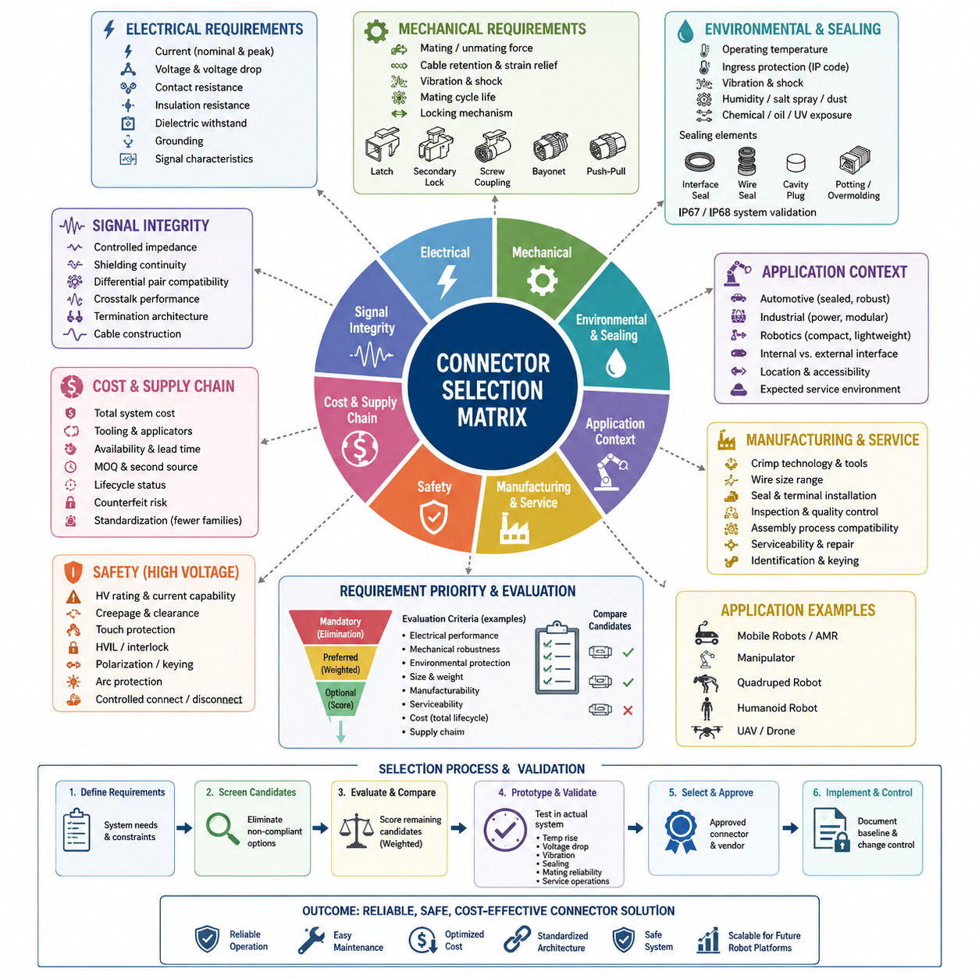
Connector selection is a system-level engineering decision rather than a simple choice based on pin count or current rating. A practical selection matrix converts electrical, mechanical, environmental, manufacturing, safety, service, and cost requirements into comparable criteria. Within the connector engineering structure, this matrix consolidates the principles developed across contact physics, derating, environmental protection, waterproofing, automotive, industrial, robotics, and high-voltage connector domains.
The first dimension of the matrix should describe electrical requirements. Engineers define nominal and peak current per contact, operating voltage, allowable voltage drop, contact resistance, insulation resistance, dielectric withstand capability, grounding needs, and signal characteristics. Power, low-level analog signals, digital communication, high-speed Ethernet, and safety circuits impose different contact and shielding requirements, so identical pin counts do not imply interchangeable connector solutions.
Current capability must be evaluated under realistic operating conditions rather than by relying only on catalog current ratings. Ambient temperature, wire gauge, number of simultaneously loaded contacts, enclosure temperature, airflow, terminal resistance, and neighboring heat sources influence connector temperature rise. The selection matrix should therefore distinguish nominal catalog rating from application-specific derated current and provide sufficient margin for abnormal loads, aging, contamination, and production variation.
Mechanical requirements form another major selection axis. The connector must tolerate mating and unmating forces, cable loads, vibration, shock, repeated motion, and the required mating-cycle life. Locking mechanisms should be selected according to the consequences of unintended disconnection. Positive latches, secondary locks, screw coupling, bayonet coupling, push-pull mechanisms, or specialized retention systems may be appropriate depending on whether the interface is internal, serviceable, mobile, or exposed to severe dynamic loading.
Environmental criteria determine whether an electrically adequate connector can survive the intended operating location. The matrix should include operating temperature, ingress protection, vibration and shock resistance, humidity, salt spray, chemical exposure, dust, oil, cleaning agents, and ultraviolet exposure where applicable. The connector structure provided for this volume explicitly separates environmental rating and waterproofing design, indicating that sealing performance must be evaluated as an engineered interface rather than as a single catalog attribute.
For sealed interfaces, the matrix should examine connector interface seals, individual wire seals, unused-cavity plugs, cable entry geometry, and possible potting or overmolding requirements. An IP67 or IP68 designation alone does not guarantee system-level waterproofing if an incorrect wire diameter, damaged seal, missing cavity plug, poor harness routing, or incomplete mating condition creates a leakage path. Selection therefore needs to consider both the connector specification and the complete installed configuration.
Application environment strongly influences connector family selection. Automotive-style connectors are well suited to many mobile robot interfaces because they combine positive locking, vibration resistance, sealed configurations, established crimp technology, and high-volume availability. Industrial connectors may provide higher power capacity, modularity, field wiring convenience, or standardized machine interfaces. Compact robotics connectors are advantageous where packaging density, low mass, frequent service, or small electronic modules dominate the design requirements.
The matrix should also separate internal and external interfaces. Internal PCB-to-wire connections may prioritize compactness, low mass, assembly efficiency, and adequate retention, while external robot connections generally require stronger housings, improved strain relief, environmental sealing, keyed mating, and protection against operator misuse. Connectors located near wheels, suspension components, manipulators, or exposed sensor assemblies may require substantially greater mechanical robustness than connectors protected inside an electronics enclosure.
Signal integrity becomes increasingly important for cameras, LiDARs, high-speed computing modules, Ethernet networks, and other perception interfaces. Selection criteria may therefore include controlled impedance, shielding continuity, differential-pair compatibility, crosstalk performance, termination architecture, and cable construction. A mechanically strong power connector should not automatically be used for high-speed data simply because sufficient contacts are available; electrical interface behavior must remain compatible with the communication technology.
Manufacturing considerations should be incorporated before a connector becomes part of the standard design. Terminal crimp technology, applicator availability, hand-tool requirements, automated processing compatibility, wire-size range, seal installation, terminal insertion procedures, secondary locking, inspection accessibility, and repair methods influence production quality. A technically excellent connector may become unsuitable when specialized tooling, difficult assembly operations, or poorly controlled terminal installation introduces excessive manufacturing risk.
Serviceability adds another dimension because robots are maintained throughout their operating life. Connectors requiring field replacement should be accessible, identifiable, difficult to mis-mate, and sufficiently durable for expected service cycles. Polarization, keying, coding, labeling, connector position, finger clearance, and harness slack affect maintenance quality. A selection matrix should consequently evaluate not only initial assembly but also diagnostic access, replacement time, technician error probability, and recovery after field damage.
High-voltage connections require additional safety criteria beyond ordinary power-interface selection. The connector engineering structure identifies HV interlock design, orange-cable safety conventions, dedicated HV selection criteria, charging interfaces, and UAV high-voltage applications as separate subjects. A selection matrix for these systems should therefore account for touch protection, creepage and clearance, voltage rating, current capacity, interlocking strategy, polarization, arc-related risks, and controlled connection or disconnection behavior.
Connector size and mass must be balanced against robustness. Small connectors improve packaging efficiency but can reduce contact size, mechanical strength, sealing space, and service accessibility. Large industrial connectors may provide excellent durability but impose unacceptable mass and volume on compact robots, manipulators, quadrupeds, humanoids, or UAV systems. The optimum solution is therefore the smallest connector that satisfies electrical, environmental, mechanical, safety, manufacturing, and lifecycle requirements with appropriate engineering margin.
Cost evaluation should extend beyond connector purchase price. The real system cost includes terminals, seals, backshells, cavity plugs, strain relief, crimp tooling, applicators, assembly labor, inspection, inventory, procurement effort, field replacement, and failure consequences. This is consistent with the chapter structure in which the selection matrix precedes standard connector lists, cost-versus-performance tradeoffs, the Approved Vendor List, and connector change control. Selection therefore establishes the technical baseline before commercial optimization and standardization.
Supply-chain criteria should include manufacturer stability, distributor availability, lead time, minimum order quantity, second-source possibilities, lifecycle status, regional availability, and counterfeit risk. Using too many connector families increases terminal inventories, tooling requirements, technician training, documentation complexity, and procurement burden. Standardization should therefore favor a controlled set of connector families wherever requirements overlap, while permitting specialized connectors when environmental, electrical, safety, or packaging constraints genuinely justify them.
A useful matrix can classify requirements as mandatory, preferred, and optional rather than treating every parameter equally. Mandatory criteria function as elimination gates: insufficient voltage rating, inadequate derated current, unacceptable environmental protection, missing safety features, or incompatible signal characteristics immediately disqualify a candidate. Remaining alternatives can then be compared using weighted criteria such as size, mass, serviceability, manufacturing complexity, availability, standardization value, and total lifecycle cost.
Selection should ultimately be verified at the installed-system level. Datasheet compliance provides the starting point, but representative harnesses should be evaluated for temperature rise, voltage drop, retention, vibration behavior, sealing, mating reliability, routing loads, assembly repeatability, and service operations when these factors are relevant. This approach connects connector selection directly with the wider robotics electrical architecture, which places connector engineering alongside harness, protection, grounding, communication, safety, AMR, manipulator, quadruped, humanoid, and validation disciplines.
The final matrix should therefore operate as a traceable engineering decision mechanism rather than a catalog comparison table. Each selected connector should be linked to defined application requirements, rejection criteria, validation evidence, approved sourcing, and controlled replacement rules. When implemented consistently, the matrix reduces unnecessary connector diversity while preventing inappropriate standardization, creating a reusable interface architecture that supports reliable design, manufacturing, maintenance, and future robotics platform development.

10.02. Hills Robotics Standard Connector List
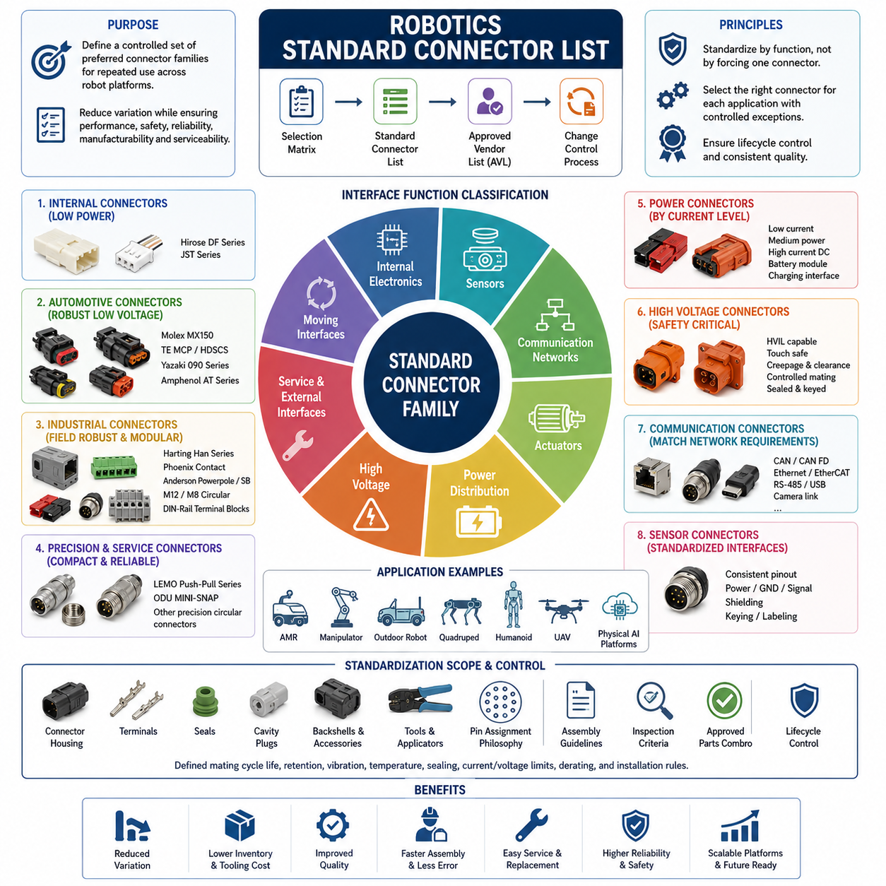
A robotics standard connector list establishes a controlled set of preferred connector families for repeated use across robot platforms. Its purpose is not to force every electrical interface into one connector type, but to reduce unnecessary variation while preserving appropriate solutions for power, communication, sensors, actuators, service interfaces, and high-voltage systems. Within the connector engineering structure, the standard list follows the connector selection matrix and precedes cost, vendor approval, and change-control activities.
Standardization begins by classifying interfaces according to their engineering function. Low-power internal electronics, sensor signals, communication networks, actuator power, battery distribution, external service connections, environmental interfaces, and high-voltage circuits have fundamentally different requirements. A connector should therefore enter the standard list only after its intended application domain, electrical limits, environmental capability, mechanical characteristics, assembly method, and service conditions have been clearly defined.
Internal PCB-to-wire connections generally require compact size, low mass, high packaging density, reliable polarization, and efficient manufacturing. Connector families such as Hirose DF and appropriate JST series can serve many internal robotics applications where currents and environmental exposure remain within their qualified limits. These connectors are particularly useful for controller boards, embedded computers, internal sensors, low-power modules, and short harness interfaces protected inside robot enclosures.
Internal connector selection must nevertheless consider vibration and cable loading. A small connector suitable for stationary electronics may become unreliable when installed near motors, gearboxes, mobile joints, or repeatedly moving harnesses. Positive retention, proper strain relief, suitable wire gauge, controlled harness routing, and adequate mating-cycle capability remain necessary. Standardization should therefore specify not only a connector family but also the permitted application environment and installation constraints.
For robust low-voltage interfaces exposed to mobile-platform vibration, automotive connector families provide an important standard category. Molex MX150, TE MCP or HDSCS, Yazaki 090, and Amphenol AT-type solutions represent the automotive connector technologies addressed earlier in the connector engineering structure. Their sealed housings, locking mechanisms, crimp terminals, and vibration-resistant construction make this class useful for AMRs, outdoor robots, vehicle-like platforms, and exposed electrical modules.
Industrial robotics requires another standardized category because machine interfaces often emphasize field serviceability, modular installation, durable housings, and compatibility with industrial automation infrastructure. Harting Han, Phoenix Contact solutions, Anderson Powerpole or SB families, M12/M8 circular connectors, and DIN-rail terminal blocks represent different industrial interface approaches included in the engineering structure. They should not be treated as equivalent products, but assigned to specific roles according to power, signal, installation, and environmental requirements.
M12 and M8 circular interfaces are especially useful as standardized external sensor and industrial communication connections where established pin arrangements and rugged field installation are desirable. Depending on the specific coding and implementation, these interfaces can support sensors, actuators, industrial Ethernet, and other communication links. The standard connector list should control coding, pin assignment, male-female orientation, shielding practice, cable construction, and device-side conventions to prevent physically similar interfaces from being incorrectly interconnected.
High-quality circular connectors such as LEMO push-pull and ODU MINI-SNAP families can occupy a different role in robotics standardization. They are appropriate where compact circular construction, reliable mating, repeated connection, precise mechanical interfaces, or service accessibility are important. These connector classes can be valuable for instrumentation, removable sensor assemblies, research robots, mobile manipulators, and specialized modules, although their cost and sourcing characteristics must be justified against less expensive alternatives.
Power distribution requires connector categories based on current level rather than a single universal power connector. Low-current electronics, medium-power actuators, high-current DC distribution, removable battery modules, charging interfaces, and high-voltage propulsion systems should have clearly separated standards. This prevents a connector qualified for one power class from being reused incorrectly at another level and makes wire gauge, terminal size, temperature-rise limits, derating requirements, and protection coordination easier to control.
Anderson Powerpole and SB-type connectors can be useful where robust DC power connection, modularity, or relatively high-current handling is required. However, the standard list should define acceptable voltage and current ranges for each selected configuration rather than relying on the family name alone. Actual capability depends on contact size, wire gauge, housing configuration, ambient temperature, duty cycle, and installation conditions, so application-specific derating remains mandatory even for standardized components.
High-voltage connectors require an independent controlled category. These interfaces may need high-voltage interlock loops, touch-safe construction, adequate creepage and clearance, secure polarization, controlled mating behavior, environmental sealing, and clear identification. The connector engineering structure separately addresses HVIL design, orange-cable safety practices, high-voltage selection criteria, charging connectors, and UAV high-voltage interfaces, demonstrating that high-voltage standardization requires additional safety governance beyond ordinary low-voltage connector selection.
Communication connectors should be standardized together with the electrical network architecture. CAN, CAN FD, Ethernet, EtherCAT, RS-485, USB, camera links, and other communication technologies can impose different requirements for shielding, impedance, differential-pair routing, termination, and grounding. A connector may be mechanically compatible while being electrically inappropriate for a particular network. The standard list should consequently associate approved connector configurations with defined communication interfaces instead of identifying them merely as generic signal connectors.
Sensor interfaces benefit greatly from standardization because robots may contain many cameras, LiDARs, proximity sensors, encoders, IMUs, safety devices, and environmental sensors. Repeated connector conventions reduce harness design effort and simplify module replacement. Where possible, sensor classes should use consistent power pins, ground strategy, communication pins, shielding rules, keying, and labeling while maintaining sufficient differentiation to prevent accidental connection of electrically incompatible devices.
Actuator interfaces require particular attention because motors, brakes, encoders, temperature sensors, and communication channels may coexist within the same joint or drive module. Small manipulators may use compact multi-pin connectors, while high-power mobile bases or humanoid joints may require separate power and signal interfaces. Standardization should define whether combined or separated architectures are permitted and establish current, shielding, grounding, retention, vibration, and service requirements for each approach.
Moving interfaces require specialized treatment. Rotary joints, tool changers, hot-swap modules, removable batteries, and frequently exchanged end effectors experience mechanical conditions that conventional static connectors may not tolerate. The connector engineering structure therefore identifies rotary and hot-swap connectors as a dedicated robotics topic. These applications should use explicitly approved interfaces with defined mating-cycle life, sequencing behavior, retention, wear limits, and inspection or replacement criteria.
A useful standard connector list should define preferred, conditional, and special-use components. Preferred connectors become the default choices for recurring interfaces and should have validated tooling, documented assembly processes, reliable sourcing, and known field performance. Conditional connectors may be used when environmental, packaging, electrical, or customer requirements justify them. Special-use connectors should require engineering review because they increase inventory, tooling, documentation, qualification, and lifecycle-management complexity.
Standardization must extend to terminals, seals, cavity plugs, backshells, accessories, and tooling. Approving only the housing family is insufficient because incorrect terminal plating, wire-size combinations, seal ranges, crimp tooling, or cavity accessories can compromise the complete interface. Each approved configuration should therefore define compatible part combinations and manufacturing requirements, allowing production engineering and quality control to reproduce the validated connector assembly consistently.
The standard list should also establish common pin-assignment philosophy where practical. Power, ground, communication, shield, wake-up, interlock, and reserved pins should follow controlled conventions within defined interface classes. Such consistency reduces wiring errors and simplifies schematics, harness documentation, diagnostics, manufacturing inspection, and service training. However, identical physical connectors should not be reused for incompatible voltage classes unless robust keying or coding prevents dangerous cross-connection.
A connector becomes truly standardized only when its complete lifecycle is controlled. Engineering selection, qualification evidence, manufacturer information, approved distributors, tooling, assembly instructions, inspection criteria, replacement parts, and obsolescence status should remain traceable. The subsequent Approved Vendor List and connector change-control process in the chapter structure therefore complement the standard connector list by controlling where approved components originate and how substitutions or design changes are introduced.
The resulting robotics connector standard should function as a reusable interface architecture across AMRs, manipulators, outdoor vehicles, quadrupeds, humanoids, UAVs, and future Physical AI platforms. Standard families reduce design repetition, inventory diversity, tooling cost, assembly errors, and service complexity, while controlled exceptions preserve engineering flexibility. The objective is not minimum connector diversity at any cost, but the smallest practical set of validated interfaces capable of supporting electrical performance, environmental robustness, safety, manufacturability, serviceability, and platform scalability.

10.03. Cost vs Performance Tradeoff
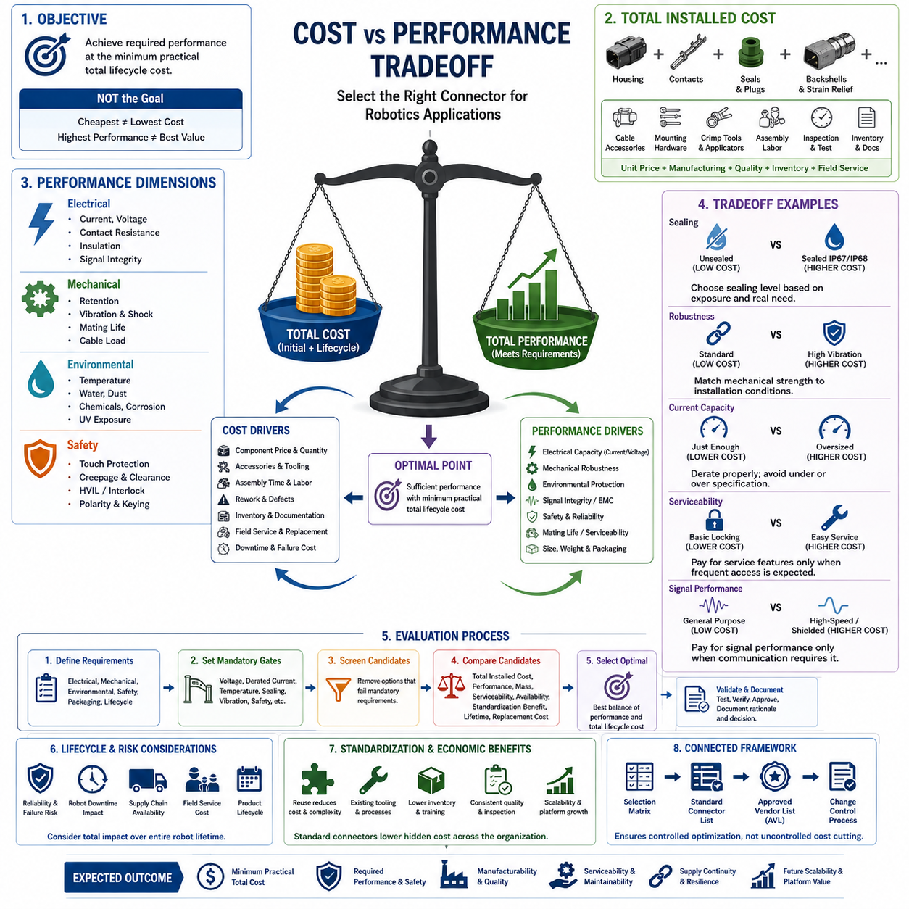
Cost-versus-performance tradeoff analysis determines how much connector capability is justified by the actual requirements of a robotics system. The lowest-priced connector is rarely the lowest-cost engineering solution, while the highest-performance connector may provide capabilities that the application never uses. The objective is therefore to select sufficient electrical, mechanical, environmental, safety, and lifecycle performance at a total cost appropriate to the interface and its failure consequences.
Connector cost should be evaluated as total installed cost rather than housing purchase price alone. The complete interface may include contacts, seals, cavity plugs, backshells, strain relief, cable accessories, mounting hardware, crimp tooling, applicators, assembly labor, inspection, qualification, inventory, and documentation. A connector with a low unit price can consequently become expensive if it requires difficult assembly, specialized tooling, extensive rework, or frequent field replacement.
Performance must likewise be defined as a multidimensional engineering quantity. Electrical capability includes current, voltage, contact resistance, insulation, and signal behavior, while mechanical performance includes retention, vibration resistance, mating life, and cable-load tolerance. Environmental performance adds temperature, water, dust, chemicals, corrosion, and UV exposure. These requirements reflect the preceding connector-engineering topics covering contact physics, derating, environmental rating, and waterproofing.
The most important tradeoff is between required performance and unnecessary margin. Engineering margin is necessary because catalog ratings do not exactly represent installed robot conditions, but excessive over-specification increases size, mass, price, and sourcing complexity. A connector designed for extreme temperature, severe vibration, thousands of mating cycles, and full environmental sealing may offer little additional value when permanently installed inside a protected electronics enclosure.
Under-specification creates the opposite problem. A cheaper connector may initially satisfy nominal voltage and current requirements but fail because of temperature rise, vibration, fretting, insufficient retention, contamination, or repeated maintenance. The resulting cost can include troubleshooting, harness replacement, robot downtime, damaged electronics, field-service labor, and customer dissatisfaction. Connector economics should therefore account for the expected cost of failure as well as the initial component cost.
Environmental protection illustrates this tradeoff clearly. Sealed connectors require additional housing features, seals, plugs, assembly controls, and often larger packaging volume. These costs are justified for outdoor robots, exposed wheel modules, wet environments, mobile equipment, or interfaces subject to dust and cleaning processes. Inside a controlled enclosure, however, an unsealed connector may deliver equivalent system reliability at substantially lower cost and complexity.
Mechanical robustness should also match installation conditions. Automotive-style connectors can provide secure locking, vibration resistance, sealing, and established crimp systems, while industrial connectors can provide strong housings, modularity, and convenient field installation. Compact robotics connectors prioritize packaging density and mass, whereas precision push-pull systems can emphasize repeated mating and serviceability. The volume structure intentionally treats automotive, industrial, and robotics connector families separately because their performance-cost profiles address different application conditions.
Current capability introduces both direct and indirect cost effects. Larger contacts and housings generally increase component size and price, but operating contacts too close to their thermal limits can reduce reliability. Current rating must therefore be evaluated together with wire gauge, ambient temperature, loaded-contact count, contact resistance, duty cycle, and thermal environment. Appropriate derating often provides better lifecycle economics than either selecting the smallest possible connector or dramatically oversizing the interface.
Signal connectors require a different performance calculation. Low-speed discrete signals may need little more than reliable contact and retention, whereas Ethernet, camera links, differential communication, or other high-speed interfaces can require controlled impedance, shielding continuity, suitable pair geometry, and EMC performance. Paying for high-speed capability where it is unnecessary wastes cost, but using a generic low-cost connector where signal integrity is critical can produce intermittent failures that are difficult and expensive to diagnose.
Weight and packaging become economic variables in mobile robotics. Large rugged connectors can simplify reliability engineering but consume enclosure space and increase harness mass. This is particularly important for manipulators, quadrupeds, humanoids, and UAVs, where additional mass can affect joint loads, energy consumption, payload, and operating time. Connector cost optimization must therefore consider the system-level value of reduced size and weight rather than comparing only component prices.
Serviceability can justify a more expensive connector when an interface is frequently accessed. Positive locking, clear keying, easy handling, high mating-cycle capability, and replaceable contacts may reduce technician time and prevent incorrect connections. Conversely, paying for sophisticated service features on a connection that is assembled once and remains inaccessible throughout the product life may provide little economic benefit. Expected maintenance frequency should consequently be included in the tradeoff assessment.
Manufacturing volume strongly changes the economics of connector selection. At low prototype volumes, inexpensive hand tooling and readily available connectors may dominate the decision. At higher production volumes, connector price, terminal cost, automated crimp compatibility, assembly time, defect rate, and applicator investment become increasingly important. A small reduction in per-unit cost can create significant savings at scale, but only if the lower-cost solution maintains adequate process capability and field reliability.
Standardization changes the tradeoff further because a connector already used elsewhere on the robot may have hidden economic advantages. Existing tooling, trained operators, stocked terminals, validated assembly procedures, supplier relationships, inspection methods, and service parts reduce the effective cost of reuse. Introducing a technically superior connector family for a small performance improvement can therefore increase total organizational cost through additional inventory, tooling, documentation, and qualification requirements.
Supply-chain resilience should be treated as part of performance rather than purely as procurement cost. A very inexpensive connector with unstable availability, long lead times, single-source dependence, or uncertain lifecycle status can create production interruptions that greatly exceed component savings. Conversely, paying a moderate premium for a widely supported connector family with predictable availability and approved alternatives may reduce operational and business risk over the product lifecycle.
High-voltage and safety-related interfaces require a different economic threshold because failure consequences can be severe. HV connectors may require touch protection, creepage and clearance control, secure polarization, environmental sealing, and HVIL functionality. The connector engineering structure accordingly separates HV interlock, orange-cable safety, HV selection, charging interfaces, and UAV high-voltage connectors. Cost reduction must never remove features required to maintain the defined electrical and safety architecture.
A practical evaluation can first establish mandatory performance gates and then optimize cost among candidates that pass them. Voltage, derated current, temperature, sealing, vibration, signal integrity, safety, and packaging limits should eliminate unsuitable candidates before price comparison begins. Remaining connectors can then be compared using total installed cost, mass, serviceability, manufacturing effort, availability, standardization benefit, expected lifetime, and replacement cost.
The economic optimum is therefore not necessarily the cheapest surviving candidate. One connector may cost more per unit but reduce assembly time, eliminate an accessory, use existing tooling, improve field replacement, or lower expected failure rates. Another may provide excellent technical performance but require expensive proprietary tooling and long procurement lead times. Tradeoff analysis converts these effects into a system decision instead of allowing component price to dominate engineering judgment.
Lifecycle cost becomes especially important for commercial robot fleets because connector failures can remove an entire machine from service. The value of reliability increases with robot utilization, service travel cost, customer dependence, and difficulty of accessing the failed interface. A modest connector cost increase can be economically rational when it meaningfully reduces downtime probability, whereas the same premium may be unnecessary for a noncritical internal interface that can be replaced quickly.
Cost-versus-performance decisions should finally remain traceable to the connector selection matrix, robotics standard connector list, Approved Vendor List, and connector change-control process that form Chapter 10 of the connector engineering structure. Together these mechanisms ensure that optimization does not become uncontrolled cost cutting. The desired outcome is a standardized connector architecture that achieves required performance and safety with minimum practical total lifecycle cost while preserving manufacturability, serviceability, supply continuity, and future platform scalability.

10.04. Approved Vendor List (AVL)
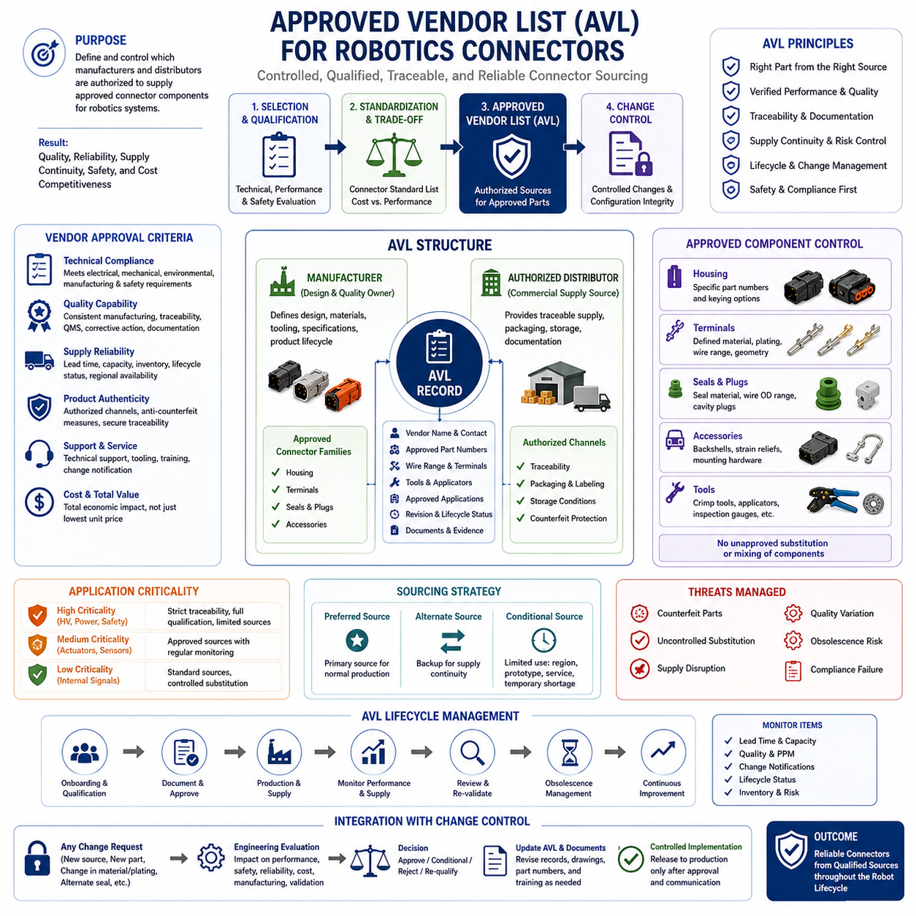
An Approved Vendor List, or AVL, establishes which manufacturers, distributors, and specific connector sources are authorized for use in a robotics electrical architecture. It converts connector selection from an individual purchasing decision into a controlled engineering and supply-chain process. Within the selection-guideline structure, the AVL follows technical selection, connector standardization, and cost-versus-performance evaluation, and provides the sourcing baseline before formal connector change control.
AVL approval should distinguish between the connector manufacturer and the purchasing source. The manufacturer controls the original component design, materials, tooling, specifications, and product lifecycle, while authorized distributors provide traceable commercial supply. A connector family may therefore be technically approved while purchasing remains restricted to specific channels that provide acceptable traceability, packaging, storage conditions, documentation, and counterfeit protection.
A vendor should not enter the AVL solely because it offers the lowest quotation. Approval begins with confirmation that the proposed components satisfy the electrical, mechanical, environmental, manufacturing, and safety requirements established during connector selection. Current and voltage capability, temperature range, vibration resistance, sealing, mating life, terminal technology, signal characteristics, and applicable high-voltage requirements must remain consistent with the qualified application.
The AVL should identify components at a sufficiently detailed level to prevent unintended substitutions. Manufacturer name, connector family, housing part number, terminal part number, seal and cavity-plug references, backshell or accessory information, approved wire range, and applicable tooling may all be required. Recording only a generic family name can allow visually similar but technically different contacts, plating options, seals, or housing variants to enter production without engineering evaluation.
Terminal control is especially important because connector performance depends heavily on the contact system. Different terminal materials, plating finishes, wire ranges, and contact geometries can change resistance, temperature rise, corrosion behavior, mating durability, and crimp quality. An approved housing should therefore not imply automatic approval of every compatible terminal. The AVL should preserve the validated relationship between housing, contact, wire, seal, and assembly process.
Supplier quality capability should be considered together with component performance. Relevant factors include manufacturing consistency, lot traceability, quality-management processes, corrective-action responsiveness, change-notification practices, and the ability to provide technical documentation. For critical robotics interfaces, stable production quality may be more valuable than a small unit-price advantage because connector defects can propagate into harness failures, intermittent faults, field downtime, and difficult diagnostic problems.
Supply continuity is another fundamental AVL criterion. Lead time, minimum order quantity, regional availability, production capacity, distributor inventory, lifecycle status, and expected product longevity influence whether a technically suitable connector can support commercial robot production. A component that performs well during prototype development may become unsuitable for a production platform if availability is unstable or future supply depends on a single vulnerable source.
Second-source strategy should be managed carefully because connector interchangeability is often less complete than it appears. Two connectors may have similar dimensions or electrical ratings but differ in terminal geometry, sealing, locking behavior, material, plating, tooling, or qualification history. A second source should therefore be treated as an independently evaluated configuration rather than automatically accepted because it is described as compatible or equivalent.
Counterfeit and unauthorized components create significant risk for connector systems. Differences in resin composition, terminal plating thickness, spring properties, dimensional tolerances, or sealing materials may not be visually obvious but can significantly reduce reliability. Purchasing through traceable manufacturer-authorized channels can therefore be an important part of the AVL strategy, particularly for safety-related, high-current, environmentally exposed, or high-voltage interfaces.
The AVL should also differentiate approval according to application criticality. A supplier acceptable for a noncritical internal signal connector may not automatically be appropriate for battery power, emergency-stop circuits, propulsion interfaces, safety sensors, or high-voltage connections. Higher-consequence interfaces can require stronger traceability, tighter configuration control, additional qualification evidence, and more restrictive sourcing rules than ordinary internal electronics.
Cost remains relevant, but AVL decisions should use total economic impact rather than component price alone. A vendor offering slightly higher prices may provide shorter lead times, better technical support, reliable stock, approved tooling, superior traceability, or faster corrective action. These capabilities can reduce inventory buffers, engineering effort, production interruptions, quality escapes, and field-service costs, producing a lower total lifecycle cost despite a higher purchase price.
For production planning, the AVL can classify sources according to their role. A preferred source can support normal production, while an alternate approved source provides resilience when the primary channel is constrained. Conditional sources may be permitted only for specific regions, prototypes, service parts, or temporary shortages. Such classification prevents emergency procurement from silently becoming a permanent engineering substitution without appropriate technical review.
Documentation is essential because approval must remain traceable over the robot lifecycle. The AVL should connect approved sources with technical drawings, datasheets, qualification evidence, applicable connector standards, internal part numbers, approved applications, and revision status. Procurement and manufacturing teams then receive an unambiguous definition of what may be purchased, while engineering retains the evidence explaining why the component and source were approved.
Vendor approval should extend to manufacturing support where connector assembly depends on specialized processes. Availability of validated crimp tools, applicators, extraction tools, inspection gauges, assembly instructions, and training can significantly influence production quality. A connector source that cannot support the required termination process may create manufacturing risk even when the connector itself meets all electrical and environmental requirements.
High-voltage connector sourcing requires particularly strict control. HVIL functionality, touch protection, creepage and clearance, polarization, sealing, contact materials, and high-current performance can all be safety significant. Unauthorized substitution of terminals, housings, seals, or accessories may invalidate the qualified configuration. High-voltage AVL entries should therefore preserve complete part combinations and clearly identify which substitutions are prohibited without engineering approval.
Periodic AVL review is necessary because supplier conditions change after initial approval. Manufacturers may revise materials, relocate production, modify tooling, change plating processes, discontinue products, or issue product-change notifications. Distributors may also change authorization status or regional support. The AVL should therefore be treated as a maintained engineering record rather than a static purchasing spreadsheet created once at the beginning of a program.
Product change notifications should trigger assessment proportional to their technical significance. Changes affecting contact materials, plating, housing resin, sealing compounds, terminal geometry, manufacturing location, or critical dimensions may require engineering review or requalification. Administrative changes with no effect on form, fit, function, manufacturing, or reliability may require only documentation updates. This prevents unnecessary testing while maintaining configuration integrity.
Obsolescence management should be incorporated into AVL governance before a component becomes unavailable. Lifecycle monitoring allows engineering teams to identify end-of-life notices, last-time-buy opportunities, declining distributor inventory, and emerging lead-time problems early enough to qualify alternatives. This is especially important for robot platforms expected to remain in production or field service for many years after their initial design release.
The AVL must remain connected to the robotics standard connector list rather than becoming an independent procurement catalog. The standard connector list defines which connector architectures are preferred for recurring interfaces, while the AVL defines which manufacturers, part configurations, and purchasing sources are approved for those architectures. This separation allows engineering standardization and commercial sourcing control to reinforce each other without confusing their responsibilities.
The final governance link is the connector change-control process, which follows the AVL within the chapter structure. A new supplier, alternate terminal, changed plating, replacement seal, modified housing, or supposedly equivalent connector should not enter production merely because purchasing can obtain it. Any deviation from the approved configuration should be evaluated for its effect on electrical performance, environmental protection, manufacturing, serviceability, safety, cost, and existing validation evidence.
A well-managed AVL therefore becomes part of the technical configuration of the robot rather than merely a purchasing convenience. It provides traceability from engineering requirements through standardized connector selection to qualified components and controlled supply sources. Combined with lifecycle monitoring and change control, it reduces counterfeit risk, uncontrolled substitution, production interruption, quality variation, and field failures while preserving cost competitiveness and supply-chain resilience across scalable robotics platforms.

10.05. Connector Change Control Process
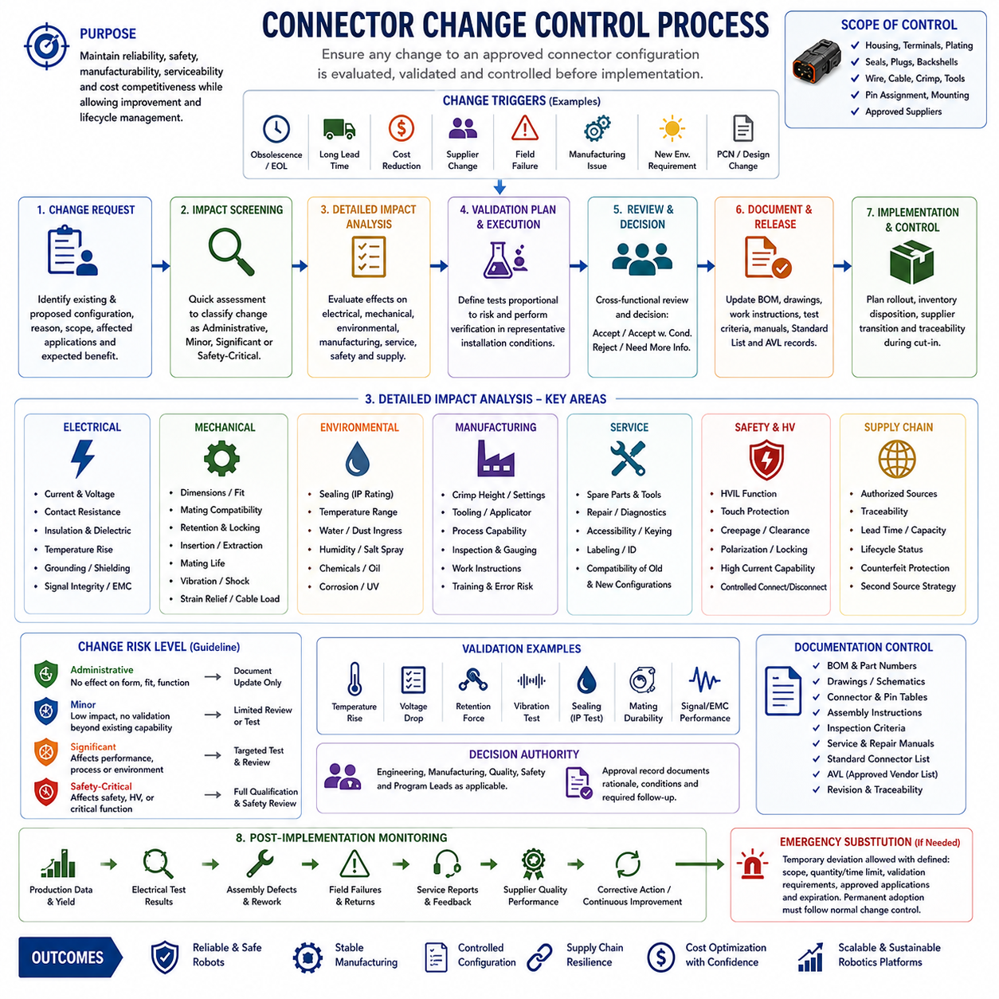
Connector change control is the formal process used to ensure that any modification to an approved connector configuration is evaluated before it enters production or field service. A change may appear minor at component level yet affect electrical performance, sealing, vibration resistance, manufacturability, safety, or serviceability. Within the selection-guideline structure, change control completes the sequence established by connector selection, standardization, cost-performance evaluation, and approved sourcing.
A controlled configuration includes more than the connector housing. It can include terminals, contact plating, seals, cavity plugs, backshells, strain relief, wire size, cable construction, crimp parameters, tooling, pin assignments, mounting provisions, and approved suppliers. Changing any of these elements can alter the behavior of the assembled interface. The change process should therefore control the complete validated connection rather than only the visible connector part number.
Change requests can originate from engineering, manufacturing, quality, procurement, service, suppliers, or product lifecycle management. Typical triggers include component obsolescence, long lead times, cost reduction, supplier changes, field failures, manufacturing difficulties, new environmental requirements, packaging modifications, and product-change notifications. Regardless of origin, the request should identify the existing configuration, proposed configuration, reason for change, affected applications, and expected benefit.
The first engineering activity is impact screening. The proposed modification should be examined for possible effects on form, fit, function, reliability, manufacturing, service, and safety. A replacement that appears mechanically interchangeable may use different contact materials, terminal geometry, plating thickness, housing resin, seal compounds, or locking characteristics. The purpose of screening is to determine whether the change is administrative, minor, significant, or safety critical.
Electrical impact assessment should consider current capacity, voltage rating, contact resistance, insulation resistance, dielectric performance, temperature rise, grounding, shielding, and signal integrity. Changes to terminals, plating, wire size, or crimp geometry can affect resistance and thermal behavior even when the connector housing remains unchanged. Communication interfaces may additionally require verification of impedance, differential-pair geometry, shielding continuity, crosstalk, and EMC-related characteristics.
Mechanical assessment examines dimensions, mating compatibility, retention force, locking mechanisms, insertion and extraction forces, mating-cycle capability, strain relief, vibration, shock, and cable loading. Small dimensional differences can affect packaging or prevent complete mating, while changes to latch geometry or contact normal force can influence long-term reliability. Moving joints, manipulators, mobile platforms, and exposed modules generally require greater scrutiny because dynamic loads accelerate connector degradation.
Environmental impact must be evaluated whenever housing, seal, wire, backshell, cable entry, or material changes occur. An interface previously validated for IP67 or IP68 conditions may no longer retain that capability after seemingly minor substitutions. Temperature range, humidity, water ingress, dust, salt spray, chemicals, oil, cleaning agents, corrosion, and UV exposure should be reassessed according to the actual installation environment and the technical significance of the proposed change.
Manufacturing impact analysis determines whether the existing production process remains valid. A new terminal may require different crimp height, applicator settings, insertion procedures, extraction tools, inspection criteria, or operator training. Even when a supplier describes a replacement as compatible, existing tooling should not automatically be assumed suitable. Process capability, assembly error risk, inspection accessibility, work instructions, and required production documentation should therefore be reviewed.
Service impact is equally important because field technicians depend on stable interface conventions. A changed connector can affect spare parts, repair tools, diagnostic procedures, mating accessibility, labeling, keying, and replacement instructions. Compatibility between existing robots and newly produced service components should be explicitly determined. If old and new configurations cannot be safely mixed, configuration identification and service documentation must clearly separate the applicable versions.
Safety-related and high-voltage changes require the highest level of control. HVIL functionality, touch protection, creepage and clearance, polarization, locking, sealing, high-current performance, and controlled connection or disconnection may all be safety significant. A lower-cost or more available component should not be accepted if it weakens the validated safety architecture. Changes affecting emergency-stop, propulsion, battery, charging, or other critical interfaces may similarly require enhanced review.
Supply-chain evaluation should accompany technical assessment when the change introduces a new manufacturer or distributor. Authorization status, traceability, manufacturing location, quality capability, lead time, production capacity, lifecycle status, counterfeit protection, and second-source strategy can influence the decision. Because the Approved Vendor List precedes change control in the chapter structure, a sourcing change should update the controlled AVL rather than bypass it through an informal procurement substitution.
Cost-reduction proposals should be evaluated using the same discipline as performance-driven changes. Unit-price savings can disappear if a replacement requires new tooling, additional inspection, qualification testing, inventory duplication, operator training, documentation updates, or increased field failures. The relevant comparison is therefore the total lifecycle impact of the old and new configurations, consistent with the preceding cost-versus-performance stage of the selection guideline.
The depth of validation should be proportional to change risk. Administrative corrections or source-document updates may require only document review, while changes affecting materials, contacts, seals, tooling, electrical loading, or environmental capability may require targeted testing. Major configuration changes can justify broader qualification involving temperature rise, voltage drop, retention, vibration, sealing, mating durability, signal performance, or other application-specific validation.
Validation should reproduce representative installation conditions whenever practical. Testing an isolated connector may fail to reveal problems caused by actual wire gauge, harness routing, enclosure temperature, cable loads, mounting geometry, contamination, or repeated service operations. The objective is not simply to demonstrate that the replacement component works, but to establish that the changed interface continues to satisfy the requirements previously assigned to the robot system.
Decision authority should correspond to the significance of the change. Low-risk documentation changes may be handled through simplified approval, while functional modifications should involve responsible electrical, mechanical, manufacturing, quality, or system engineers as appropriate. Safety-critical changes may require additional safety authority. The approval record should state whether the proposal is accepted, conditionally accepted, rejected, or requires additional evidence before implementation.
Approved changes require coordinated documentation updates before release. Schematics, harness drawings, bills of materials, internal part numbers, connector tables, pin assignments, assembly instructions, inspection criteria, service manuals, standard connector lists, and AVL records may all be affected. Revision control should establish exactly which product configuration uses the new interface and prevent manufacturing from combining obsolete and revised information.
Implementation timing must also be controlled. Existing inventory may be consumed, reworked, returned, segregated, or scrapped depending on compatibility and risk. Production cut-in dates, serial-number boundaries, software or diagnostic implications, service stock, and supplier deliveries may need coordination. Where old and new configurations coexist temporarily, traceability should make it possible to determine which connector configuration is installed on each affected robot.
Emergency substitutions require discipline even when production is threatened by shortages. A temporary deviation can be useful when an approved component becomes unavailable, but urgency should not eliminate technical assessment. The temporary configuration should define scope, quantity or time limits, validation requirements, approved applications, and expiration conditions. Permanent adoption should subsequently pass through the normal change-control process rather than continuing indefinitely as an undocumented exception.
Post-implementation monitoring closes the engineering loop. Early production data, assembly defects, electrical test results, field failures, service reports, supplier quality information, and connector-related diagnostic events can reveal issues that qualification testing did not expose. Significant unexpected behavior should trigger corrective action and, when necessary, rollback to the previous configuration or initiation of another controlled engineering change.
Change control should preserve traceability from the original requirement through connector selection, the robotics standard connector list, cost-performance assessment, AVL approval, validation evidence, and the final released configuration. These elements form a connected governance sequence within Chapter 10 rather than independent administrative documents. Each approved change should therefore explain not only what changed, but why the new configuration remains acceptable.
A mature connector change-control process prevents uncontrolled substitution while still allowing engineering improvement, cost optimization, supply-chain adaptation, and lifecycle management. Its purpose is not to make connector changes difficult, but to ensure that their consequences are understood before implementation. By combining risk-based assessment, proportionate validation, configuration management, documentation, and post-release monitoring, robotics platforms can evolve without sacrificing reliability, safety, manufacturability, serviceability, or interface standardization.

