Volume 03. Connector Engineering

Chapter 02. Contact Physics

02.01. Contact Resistance Theory
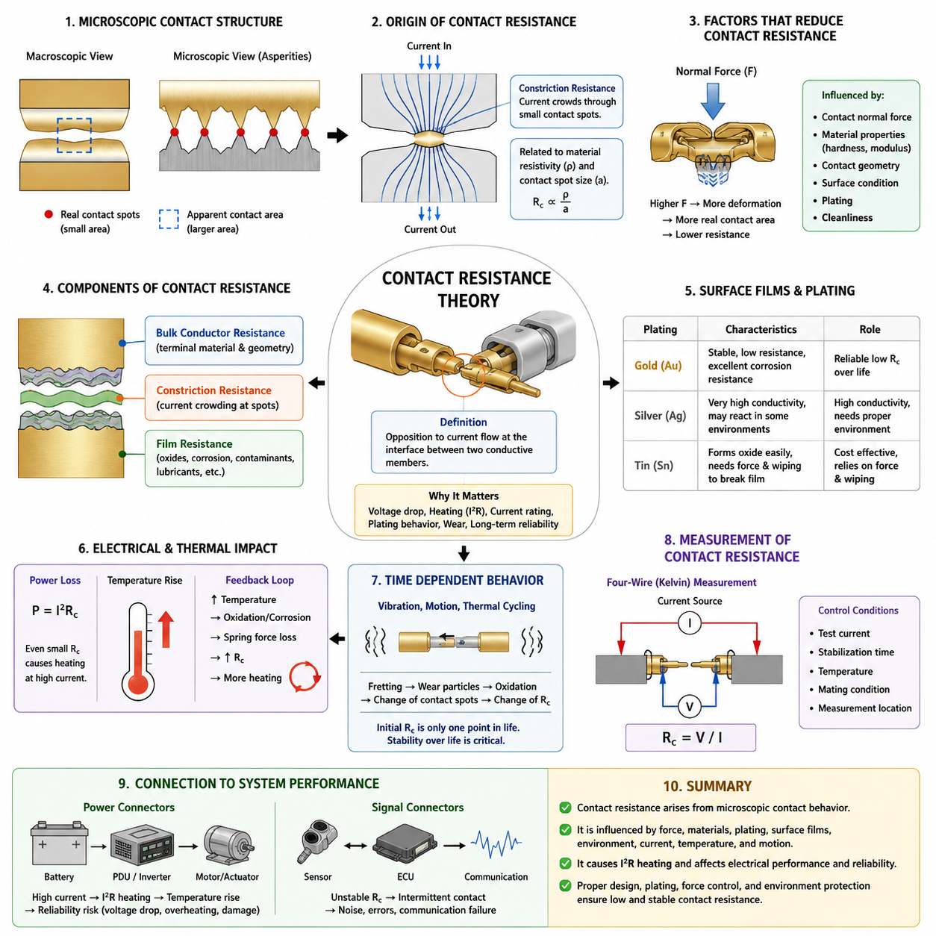
Electrical contact resistance is the opposition to current flow that appears at the interface between two conductive members even when the bulk materials themselves have very low resistivity. In connector engineering, this resistance is concentrated around the microscopic regions where the mating contacts physically touch. The subject therefore belongs fundamentally to contact physics and provides the theoretical basis for understanding connector heating, voltage drop, current rating, plating behavior, wear, and long-term electrical reliability.
A connector contact that appears smooth at the macroscopic scale is actually composed of microscopic peaks and valleys called asperities. When two contacts are mated, only a small fraction of their apparent geometric area forms true metal-to-metal contact. Electrical current is therefore forced to pass through a collection of discrete microscopic contact spots rather than uniformly across the complete nominal surface. This difference between apparent contact area and real contact area is central to contact resistance theory.
As current approaches each microscopic contact spot, its flow lines converge from the relatively large conductor cross-section into a much smaller conducting region and then diverge again after crossing the interface. This phenomenon produces constriction resistance. For a simplified circular contact spot, the resistance is related to the electrical resistivity of the contact material and inversely related to the characteristic size of the conducting spot. Larger and more numerous contact spots consequently provide lower interface resistance.
The real contact area depends strongly on contact normal force and the mechanical properties of the mating materials. Increasing normal force causes asperities to deform elastically and, at sufficiently high local stress, plastically. This deformation enlarges existing conductive spots and creates additional ones, reducing constriction resistance. Connector terminals therefore use spring beams, cantilever structures, tuning forks, sockets, or similar mechanisms to maintain a controlled normal force throughout the intended service life.
A useful engineering approximation separates contact resistance into contributions from bulk conductor resistance, constriction resistance, and resistance associated with surface films. The bulk contribution arises from the terminal material and geometry, while constriction resistance originates from current crowding around microscopic contact regions. Film resistance is produced by oxides, corrosion products, contamination, lubricants, or other layers located between the conductive surfaces. In practical connectors, changes in the latter two components often dominate aging behavior.
Surface films are particularly important because metallic surfaces exposed to the environment rarely remain perfectly clean. Tin, copper, silver, and other contact materials can develop oxide, sulfide, or corrosion layers depending on temperature, humidity, atmospheric contaminants, and surrounding chemicals. Some films remain sufficiently conductive, while others significantly increase interface resistance. Reliable contact design must therefore establish conditions under which films are penetrated, displaced, controlled, or prevented from becoming electrically disruptive.
Contact plating provides an engineered interface between the base terminal material and the environment. Tin, silver, and gold systems behave differently because their electrical, mechanical, chemical, and tribological characteristics differ. Gold is valued for stable low-resistance interfaces and excellent corrosion resistance, whereas tin commonly depends on sufficient normal force and wiping action to disrupt surface oxide. Silver provides high conductivity but requires appropriate consideration of environmental exposure and surface reactions.
The resistance measured across a connector is normally very small, often in the milliohm range, but even such small values become important when substantial current flows through the contact. Contact power dissipation follows P = I²R, meaning that heating increases with the square of current. A resistance that appears negligible at signal-level current can therefore become a significant thermal source in a battery, motor, actuator, inverter, charging, or power-distribution connection carrying tens or hundreds of amperes.
This electrical heating creates an important feedback mechanism. Higher contact resistance generates additional heat, which raises terminal temperature. Increased temperature can alter material resistivity, accelerate oxidation and corrosion, reduce spring stress through relaxation, affect polymer housings, and modify plating behavior. These changes may further increase contact resistance. Connector engineering must prevent this progressive electro-thermal degradation from developing into excessive voltage drop, localized overheating, terminal damage, or loss of electrical continuity.
Contact resistance is consequently not a fixed material property comparable to bulk resistivity. It is a system-level interface characteristic influenced by terminal geometry, contact force, surface finish, plating thickness, material hardness, contamination, mating history, temperature, vibration, and environmental exposure. Two contacts manufactured from identical conductive alloys may exhibit different resistance behavior if their normal force, surface condition, contact geometry, or mechanical stability differs during operation.
Mechanical motion can cause contact resistance to become time dependent. Small relative movements produced by vibration, thermal expansion, cable loading, or dimensional tolerance may repeatedly disturb the contact interface. Such motion can remove protective surface layers, expose base material, generate wear particles, and promote oxidation. The resulting fretting process can progressively change the population and quality of conductive asperities, connecting contact resistance theory directly to wear and fretting corrosion within the Contact Physics chapter structure.
The initial resistance of a newly assembled connector therefore represents only one point in its electrical life. Engineering evaluation must also consider resistance stability after repeated mating cycles, vibration, thermal cycling, humidity exposure, contamination, and aging. A connector with slightly higher but stable resistance may provide greater practical reliability than one with exceptionally low initial resistance that increases rapidly under environmental or mechanical stress. Resistance change over life is thus often as important as the initial absolute value.
Accurate measurement of low contact resistance requires careful test methodology because lead and fixture resistance can be comparable to the resistance being evaluated. Four-wire, or Kelvin, measurement is commonly used to separate the current-carrying path from the voltage-sensing path. A controlled test current is passed through the contact while voltage is measured independently across the desired interface. Resistance is then obtained from R = V/I without substantially including the resistance of measurement leads.
Measurement conditions must be defined because the applied current itself can influence the observed interface. Low-level measurements are useful when evaluating the intrinsic condition of a contact without intentionally disrupting surface films, while higher test currents may produce localized heating or electrical breakdown of weak films. Connector qualification therefore requires consistent current, stabilization time, temperature, mating condition, measurement location, and instrumentation so that resistance values can be meaningfully compared.
Contact resistance also establishes a direct bridge between microscopic contact physics and connector current-rating engineering. As the Volume 03 structure indicates, Contact Physics precedes Current Rating and Derating, including current-rating test methods and temperature rise at the contact. The microscopic interface determines resistance, resistance produces I²R loss, and that loss contributes to terminal temperature rise. Current capability therefore cannot be evaluated independently of contact-interface behavior.
For robotics and AMR electrical systems, stable contact resistance is especially important because connectors may simultaneously experience continuous vibration, repeated acceleration, temperature variation, dust, moisture, maintenance cycles, and high actuator currents. Battery, PDU, motor-drive, charging, and grounding interfaces can become system-level reliability constraints if contact resistance increases. Connector selection must therefore address not only nominal voltage and current ratings but also mechanical retention, environmental protection, plating, normal force, and lifecycle stability.
Signal connectors are also affected even when thermal dissipation is insignificant. An unstable microscopic interface can introduce intermittent continuity, fluctuating voltage levels, additional noise, or communication errors. Low-current sensor and communication circuits may be particularly sensitive to contamination or surface-film behavior because their operating current may not provide enough electrical or thermal energy to disrupt resistive films. Stable interface chemistry and mechanical contact integrity are therefore essential for both power and signal connections.
Contact resistance theory ultimately explains why connector reliability cannot be reduced to selecting a sufficiently conductive metal. Electrical performance emerges from the interaction of microscopic surface geometry, mechanical force, material properties, plating, environmental chemistry, current, temperature, and motion. Understanding these relationships provides the foundation for the following Contact Physics topics—wear and fretting corrosion, plating selection, contact normal force, and contact failure modes—and supports the broader connector engineering hierarchy defined in the electrical engineering architecture.

02.02. Wear and Fretting Corrosion
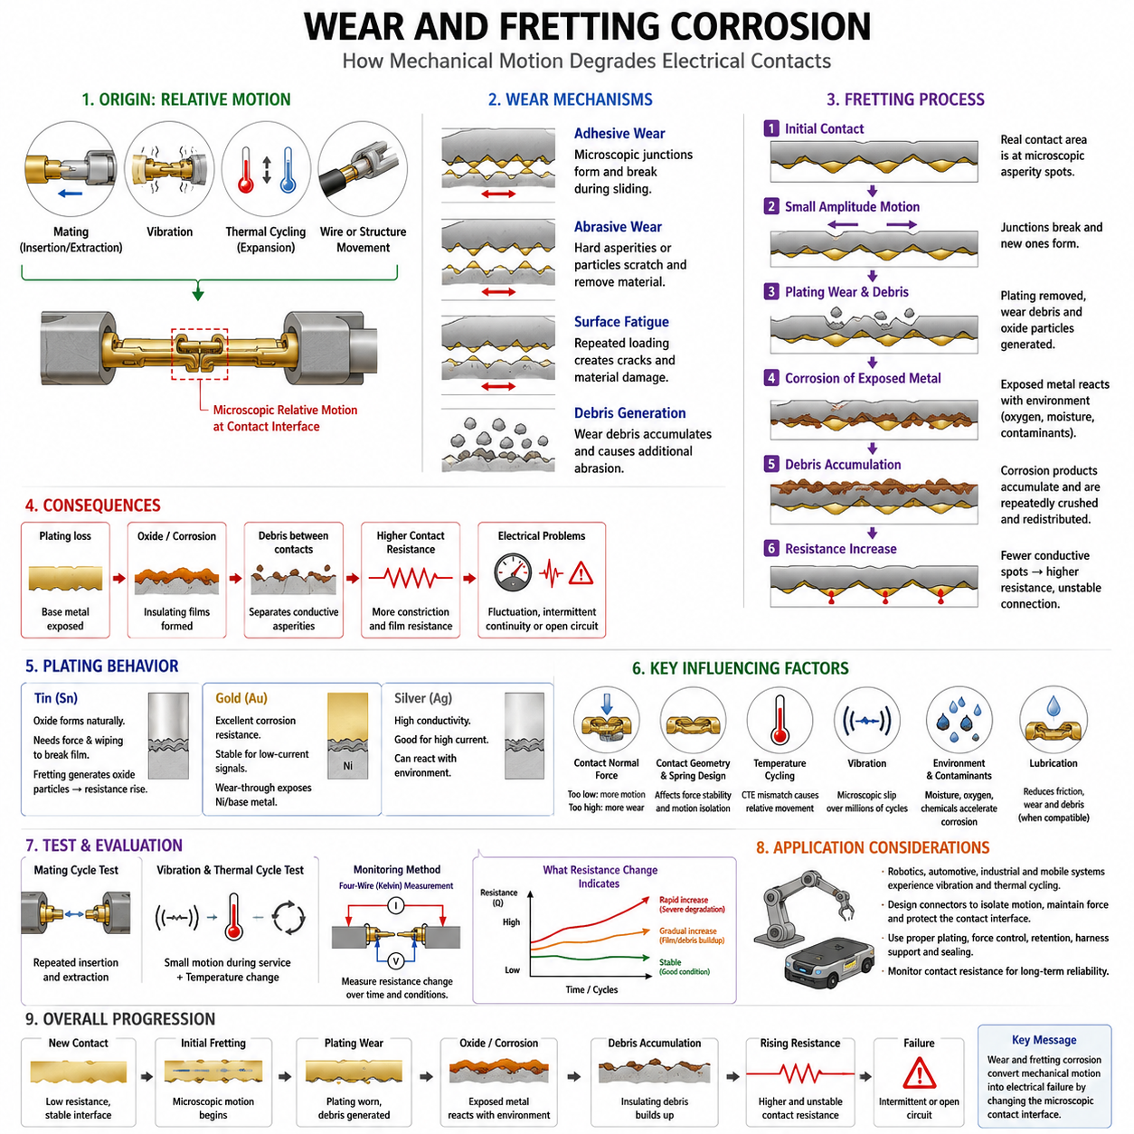
Wear and fretting corrosion are progressive degradation mechanisms that occur when mating electrical contacts experience relative mechanical motion. In connector systems, the contact interface must simultaneously maintain electrical continuity and mechanical stability. Repeated sliding, vibration, thermal expansion, cable movement, or mating cycles can alter the microscopic contact regions, gradually increasing contact resistance and reducing the reliability of both power and signal connections.
Wear describes the removal, displacement, or deformation of material from contacting surfaces as a result of mechanical interaction. Connector contacts may experience wear during insertion and extraction because mating surfaces slide against each other under normal force. Additional microscopic movement can continue after mating. The severity of wear depends on contact geometry, normal force, surface hardness, plating material, plating thickness, lubrication, surface roughness, and the magnitude of relative displacement.
Several wear mechanisms can occur at an electrical interface. Adhesive wear develops when microscopic contact junctions temporarily bond and are subsequently fractured by sliding. Abrasive wear occurs when hard asperities or particles scratch and remove softer material. Surface fatigue may develop after repeated mechanical loading, while accumulated debris can create additional abrasion. In plated contacts, these mechanisms are especially important because excessive wear can penetrate the protective plating and expose the underlying material.
Fretting is a particular form of contact degradation associated with repeated small-amplitude relative motion between surfaces that remain nominally mated. Unlike the relatively large sliding displacement produced during connector insertion or removal, fretting motion can occur over microscopic distances. Vibration, thermal cycling, structural deflection, wire movement, tolerance variation, and mechanical loading can all produce such displacement even when the connector housing remains completely locked.
The electrical consequence of fretting originates from repeated disturbance of the conductive contact spots. During one movement cycle, existing asperity junctions may be broken while new junctions are formed nearby. Repeated motion changes the real contact area and redistributes current paths across the interface. Initially, this action may temporarily reduce resistance by disrupting surface films, but continued movement can remove plating, generate debris, expose reactive material, and eventually create unstable or highly resistive contact regions.
Fretting corrosion occurs when mechanical fretting and chemical surface reactions act together. Wear removes or damages protective surface layers and exposes fresh metallic material to oxygen, moisture, and environmental contaminants. The exposed material can oxidize or corrode, and subsequent motion breaks the resulting corrosion products into particles. These particles accumulate around the contact zone and may be repeatedly crushed, displaced, and redistributed between the mating surfaces.
The resulting debris is often electrically less conductive than the original contact material. As corrosion products accumulate, they can separate conductive asperities and reduce the effective metal-to-metal contact area. Current is then forced through fewer remaining conductive spots, increasing constriction and film resistance. The connector may therefore progress from a stable low-resistance interface to fluctuating resistance, intermittent continuity, and eventually a persistent high-resistance or open-circuit condition.
Tin-plated contacts are particularly associated with fretting considerations because tin surfaces naturally develop oxide films. Properly designed tin contacts use sufficient contact normal force and wiping action to penetrate or displace these films during mating. However, repeated microscopic motion can continuously generate fresh wear debris and oxide particles. If these products accumulate within the contact zone, resistance may rise significantly even though the connector remains mechanically assembled and appears externally undamaged.
Gold-plated contacts behave differently because gold provides excellent corrosion resistance and maintains a stable electrical surface. This makes gold attractive for low-current signals and interfaces requiring very stable resistance. Nevertheless, gold plating is not immune to mechanical wear. If repeated motion removes or penetrates the gold layer, the nickel underplate or base material can become exposed, allowing corrosion products to develop and compromise the original benefit of the noble-metal surface.
Silver-plated contacts provide high electrical and thermal conductivity and are frequently useful for higher-current applications. Their wear behavior depends on contact force, surface finish, environmental conditions, and mechanical movement. Silver surfaces can also react with environmental contaminants, so plating selection cannot be based on conductivity alone. The complete contact system must consider electrical load, expected motion, chemical exposure, temperature, mating frequency, and required service life.
Contact normal force strongly influences both wear and fretting behavior. Adequate force creates stable conductive contact spots and helps prevent small disturbances from causing electrical discontinuity. Excessive force, however, can increase friction, insertion force, and mechanical wear. Insufficient force can allow greater relative movement and reduce the ability of the interface to penetrate films. Connector design therefore requires a controlled force range rather than simply maximizing contact pressure.
Contact geometry also affects susceptibility to fretting. Spring beams and similar compliant structures must accommodate dimensional tolerances while maintaining force during vibration and thermal expansion. The position of the contact point, spring stiffness, mating alignment, terminal retention, and wire support influence how external motion reaches the electrical interface. A well-designed housing and terminal system isolates the microscopic contact zone from cable vibration and structural movement as much as practical.
Temperature cycling can produce fretting even without an obvious external vibration source. Different connector materials, wires, housings, terminals, and mounting structures have different coefficients of thermal expansion. Repeated heating and cooling therefore create small dimensional changes that can generate relative motion at the contact interface. High-current connectors are particularly relevant because electrical I²R heating can add local temperature cycles to those imposed by the external operating environment.
Vibration creates another important pathway for fretting degradation in robotics, automotive systems, industrial machinery, and mobile platforms. Motors, gearboxes, wheels, pumps, cooling fans, manipulators, and vehicle motion can continuously excite connector assemblies. If terminal retention, harness support, or connector mounting allows this vibration to reach the contact interface, microscopic slip can occur over millions of cycles and gradually transform mechanical movement into electrical instability.
Lubrication can be used in some contact systems to reduce friction, limit wear, restrict oxygen access, and reduce the generation or transport of debris. Its effectiveness depends on compatibility with the contact material, plating, polymers, temperature range, electrical requirements, and environmental conditions. Lubricant should therefore be treated as part of an engineered contact system rather than as a universal corrective measure for an inadequately designed mechanical interface.
Wear evaluation must consider both the initial surface condition and the cumulative number of mechanical events. Mating-cycle testing evaluates the damage associated with repeated insertion and extraction, while vibration and thermal-cycle testing address smaller movements occurring during service. Resistance should be monitored before, during, and after environmental exposure because visual inspection alone may not reveal degradation occurring within microscopic contact regions.
Four-wire Kelvin measurement is useful for tracking small changes in contact resistance during these tests. A stable connector should maintain resistance within an acceptable range rather than merely satisfy a low initial value. Sudden resistance spikes can indicate momentary loss of conductive asperities, while a progressive increase can indicate film buildup, plating wear, corrosion, loss of normal force, or debris accumulation. Resistance history therefore provides valuable information about the evolution of the contact interface.
In robotics and autonomous mobile robots, fretting risk deserves particular attention because electrical connectors operate in a mechanically dynamic environment. Battery packs, PDUs, motor drives, wheel modules, steering actuators, sensors, compute units, and charging interfaces can experience different combinations of vibration and thermal cycling. Harness routing and strain relief must therefore work together with connector locking, terminal retention, plating, and normal force to protect electrical contact stability.
Wear and fretting corrosion ultimately demonstrate that connector reliability is governed by interactions between mechanical motion, surface chemistry, and electrical conduction. Microscopic movement changes contact spots; wear modifies or removes plating; exposed surfaces react with the environment; debris accumulates; and contact resistance becomes unstable. Understanding this progression provides the necessary foundation for plating selection, contact normal force design, and analysis of contact failure modes within the broader Contact Physics framework.

02.03. Plating Selection (Sn, Ag, Au)
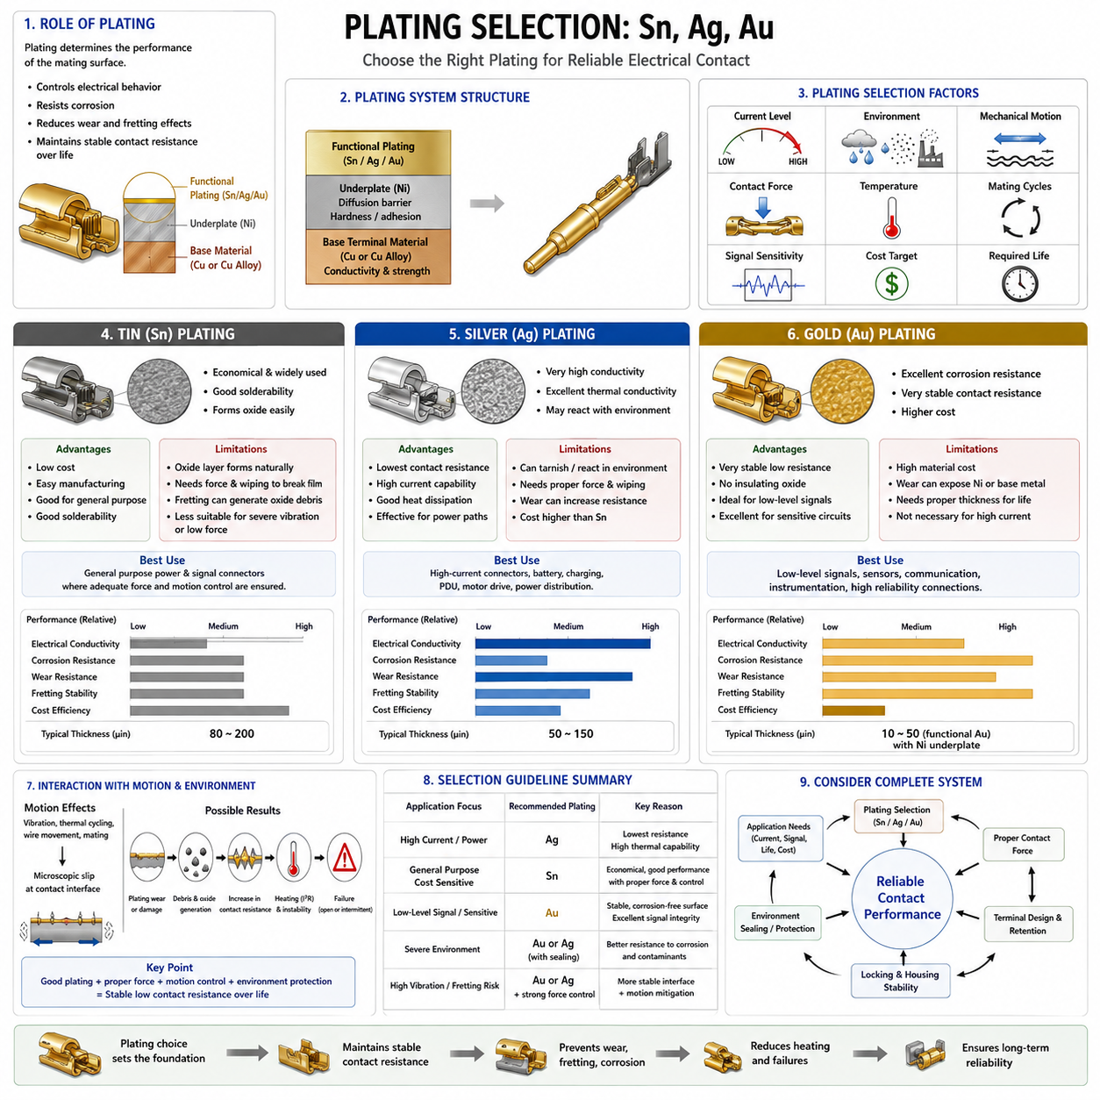
Contact plating is a critical interface technology used to control the electrical, mechanical, and environmental behavior of connector contacts. Although the terminal body provides structural strength and bulk conductivity, the plating determines many characteristics of the actual mating surface. Tin (Sn), silver (Ag), and gold (Au) are widely used because each offers a different balance of conductivity, corrosion resistance, wear behavior, contact stability, current capability, and cost.
Plating selection cannot be based only on the electrical conductivity of the coating material. The contact interface experiences normal force, sliding during mating, microscopic motion during service, temperature changes, humidity, contaminants, and repeated mating cycles. These conditions interact with surface chemistry and mechanical wear. A suitable plating must therefore maintain sufficiently low and stable contact resistance throughout the intended operating life rather than merely provide good conductivity when the connector is new.
The plating system normally consists of a base terminal material, an optional underplate, and the functional surface coating. Copper or copper alloys are commonly used for the terminal because they combine electrical conductivity with mechanical properties suitable for spring contacts. Nickel may be introduced as an underplate to provide a diffusion barrier, improve surface hardness, or support the performance of the outer coating. The complete layered structure should be considered as one engineered contact system.
Tin (Sn) is extensively used for general-purpose electrical connectors because it provides a practical combination of cost, manufacturability, solderability, and acceptable electrical performance. Tin is particularly attractive for applications where connector quantity is high and economic efficiency is important. However, tin readily forms a surface oxide. Reliable electrical contact therefore depends on contact force and mechanical wiping that penetrate or displace the oxide layer and establish conductive metal-to-metal contact regions.
The mechanical behavior of tin must be considered carefully. Tin-plated mating surfaces should generally have sufficient normal force to maintain stable contact spots and enough wiping action during mating to disturb surface films. Excessive microscopic movement after mating can become problematic because fretting repeatedly damages the interface. Wear particles and newly exposed tin can oxidize, producing debris that accumulates between the contacts and progressively increases contact resistance.
Tin is consequently most effective when the connector mechanical design restricts relative motion after mating. Terminal retention, housing stiffness, connector locking, harness support, and strain relief all contribute to plating performance by reducing movement at the electrical interface. A tin-plated connector used in a stable environment may provide excellent service, while the same surface system can experience resistance instability when subjected to severe vibration or repeated microscopic displacement.
Silver (Ag) offers very high electrical and thermal conductivity, making it particularly attractive for contacts carrying substantial current. Low electrical resistance reduces I²R losses at the interface, while high thermal conductivity assists heat spreading from localized contact regions. These properties make silver relevant to power connectors, battery connections, charging interfaces, power distribution equipment, and other applications where current capability and thermal performance are major design considerations.
Silver nevertheless requires consideration of environmental chemistry. Its surface can react with contaminants in the surrounding atmosphere, and the resulting compounds may alter interface behavior. The significance of these reactions depends on contact pressure, temperature, environmental exposure, current level, and mechanical wiping. Therefore, the high conductivity of silver does not automatically guarantee reliable performance under every condition. Environmental qualification remains an essential part of silver-plated connector design.
Mechanical loading is also important for silver-plated contacts. Appropriate contact force maintains a sufficiently large real contact area and reduces constriction resistance. Surface finish, plating thickness, mating geometry, and expected cycle life influence the rate at which the coating changes during service. In high-current applications, degradation that increases resistance can produce additional heating, so electrical, mechanical, and thermal design requirements must be evaluated together.
Gold (Au) is widely selected when stable low contact resistance and strong resistance to environmental corrosion are more important than minimum material cost. Gold is a noble metal and does not readily form the insulating oxide films associated with many base metals. This characteristic allows a clean and electrically stable contact interface to be maintained, making gold particularly useful for low-level signals, sensors, communication circuits, instrumentation, and other sensitive electrical connections.
The advantages of gold become especially important at low current and low voltage. Such circuits may not provide sufficient electrical or thermal energy to break down resistive surface films. A corrosion-resistant gold interface can therefore maintain reliable conductivity without depending heavily on current-assisted film disruption. For communication and sensor systems, this stability can reduce intermittent connections, signal fluctuations, noise, and errors caused by changing interface resistance.
Gold plating must still be protected against mechanical wear. Because gold is expensive, connector contacts generally use a controlled coating thickness rather than a solid gold contact structure. Repeated mating or fretting can progressively wear through the functional gold layer. Once the coating is penetrated, the nickel underplate or base material may become exposed. The exposed material can then react with the environment and generate corrosion products that compromise electrical stability.
For this reason, gold-plated contact design requires coordination between plating thickness and expected mechanical life. A connector intended for many mating cycles or significant wiping displacement may require a more robust plating system than a connector that remains permanently mated. Contact geometry, surface hardness, lubrication where applicable, normal force, and mating alignment all affect wear rate. Gold should therefore be treated as part of a complete tribological and electrical system rather than simply as a premium coating.
Direct comparison among tin, silver, and gold reveals that no single plating is universally superior. Tin provides economical performance where adequate force and mechanical stability can be maintained. Silver offers excellent electrical and thermal characteristics that are valuable for high-current interfaces. Gold provides exceptional surface stability and corrosion resistance for sensitive and low-level electrical connections. Selection must match the dominant failure mechanisms and performance requirements of the application.
Current level is one of the major selection parameters. High-current contacts require low interface resistance because even a small resistance increase can produce significant I²R heating. Silver can therefore be attractive where current and temperature rise dominate the design. Signal-level contacts place greater emphasis on stable continuity and resistance over time, often favoring gold. Tin remains highly useful across many moderate-cost applications when the mechanical interface is appropriately controlled.
Environmental conditions provide another important selection dimension. Humidity, oxygen, industrial contaminants, salt exposure, dust, temperature, and chemical agents can influence surface reactions. The connector housing and sealing system reduce exposure but do not eliminate the need to consider plating behavior. A plating system should therefore be selected together with environmental protection requirements rather than assuming that an IP-rated housing alone guarantees long-term electrical contact stability.
Vibration and fretting requirements must also influence plating selection because the coating operates directly at the moving microscopic interface. Small relative displacement can wear the surface and generate debris even when the connector remains fully locked. Tin can generate oxidized fretting debris, while gold can lose its corrosion-resistant advantage if wear exposes underlying material. Plating choice must consequently be coordinated with contact force, terminal retention, locking mechanisms, and harness strain relief.
Manufacturing and lifecycle economics should be considered alongside technical performance. Using gold on every connection would unnecessarily increase cost, while choosing tin solely because it is economical can create reliability problems in applications requiring extremely stable low-level signals. Silver may offer an effective solution for demanding power paths but may not be necessary for every circuit. Connector engineering therefore assigns plating according to electrical function, environmental severity, mechanical duty, and reliability target.
For robotics and autonomous mobile robots, different plating technologies may coexist within the same electrical architecture. Battery, charging, motor-drive, and power-distribution connections emphasize current capacity and thermal stability, while cameras, sensors, communication networks, and control electronics emphasize signal integrity and resistance stability. Connectors exposed to continuous vibration additionally require careful coordination between plating, normal force, terminal retention, housing design, and harness support.
Plating selection ultimately converts the principles of contact resistance and fretting corrosion into a practical connector design decision. Tin (Sn), silver (Ag), and gold (Au) each manage the contact interface differently, and their performance depends on current, contact force, motion, environment, temperature, and lifecycle requirements. Selecting the appropriate system establishes the foundation for controlling contact normal force and preventing the contact failure modes addressed in the following sections of Contact Physics.

02.04. Contact Normal Force
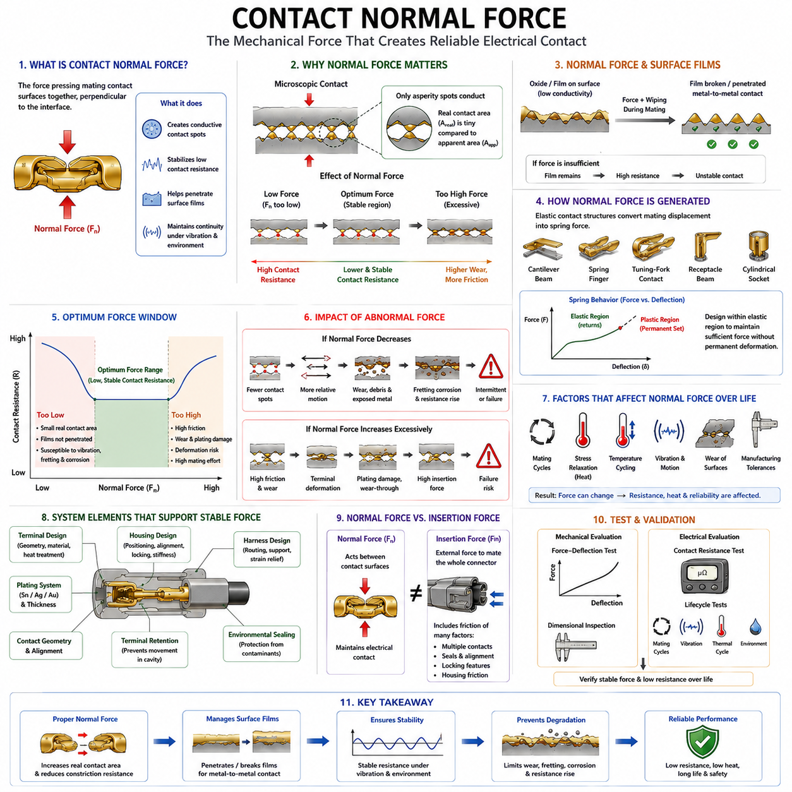
Contact normal force is the mechanical force pressing two mating electrical contact surfaces together in a direction approximately perpendicular to their interface. It is one of the fundamental variables governing connector performance because electrical conduction occurs only through microscopic contact spots. Proper normal force creates and maintains these conductive regions, stabilizes contact resistance, supports film penetration, and helps preserve electrical continuity under vibration and environmental loading.
Although connector contacts appear to touch across a relatively large geometric area, their surfaces contain microscopic asperities. Actual electrical conduction occurs only where opposing asperities physically meet. Applying normal force produces high localized pressure at these points, causing elastic and sometimes plastic deformation. The deformation enlarges existing conductive spots and creates additional ones, increasing the real contact area while reducing constriction resistance at the interface.
The relationship between normal force and contact resistance is therefore strongly connected to contact resistance theory. At very low force, only a limited number of asperities carry current, producing small effective contact area and relatively high resistance. As force increases, more asperities participate and existing contact spots become larger. Resistance generally decreases toward a stable region, although the exact relationship depends on contact geometry, material hardness, surface condition, and plating.
Normal force also performs an important role in managing surface films. Metals such as tin can develop oxide layers that are substantially less conductive than the underlying material. During mating, contact pressure combined with wiping motion can fracture, penetrate, or displace these films and expose conductive regions. Insufficient force may leave resistive films between mating surfaces, resulting in unstable resistance even when the connector appears mechanically engaged.
Connector terminals generate normal force through elastic contact structures rather than through the housing alone. Cantilever beams, spring fingers, tuning-fork contacts, receptacle beams, and cylindrical socket structures are examples of mechanisms that deflect during mating. Their geometry and material properties convert mating displacement into spring force. The terminal must remain within an appropriate mechanical operating range so that sufficient force is maintained without permanent deformation.
Spring behavior is therefore central to normal-force design. Within the elastic region, a contact beam approximately returns to its original shape after the mating load is removed. If deflection or stress exceeds the material capability, permanent set may occur. The contact can then lose part of its designed force during subsequent mating. Terminal geometry, beam length, thickness, material modulus, yield strength, heat treatment, and forming process must consequently be coordinated.
Higher normal force is not automatically better. Increasing force can improve electrical contact stability, but it also increases friction between mating surfaces. Higher friction produces greater insertion and extraction forces and can accelerate plating wear during sliding. Excessive force can deform terminals, damage coatings, increase connector mating effort, or overload housing features. Engineering design therefore seeks an optimum force window rather than the maximum achievable force.
Insufficient normal force creates a different set of risks. Small contact pressure can reduce the real metal-to-metal contact area and increase constriction resistance. Surface films may not be adequately penetrated, while vibration can more easily disturb the remaining conductive asperities. The interface can then become susceptible to resistance fluctuations, intermittent continuity, fretting, and corrosion. Low normal force can therefore convert relatively small mechanical disturbances into electrical failures.
Normal force and fretting corrosion are closely linked. A properly loaded interface tends to maintain stable conductive regions and restrict uncontrolled microscopic movement. If force decreases, relative motion can occur more readily at the contact interface. Repeated micro-motion disrupts contact spots, wears plating, produces debris, and exposes reactive material. Oxidized wear particles may then accumulate between the contacts, causing progressive increases in resistance and further electrical instability.
The required normal force depends partly on the selected plating system. Tin-plated contacts commonly require sufficient force and wiping action to manage oxide films. Gold-plated contacts benefit from a chemically stable surface but still require adequate mechanical force to maintain reliable conductive spots. Silver-plated power contacts require controlled force to establish low-resistance interfaces capable of carrying substantial current. Plating and force must therefore be designed as interacting parameters.
Plating thickness and surface hardness further modify the mechanical interaction. A thin functional coating can be damaged if local pressure or sliding wear becomes excessive, while an interface with inadequate pressure may fail to establish stable conductive regions. Underplates such as nickel can influence hardness and wear characteristics. Consequently, the complete combination of terminal material, underplate, functional plating, contact geometry, and normal force determines the resulting interface behavior.
Normal force can change throughout connector life even when the original terminal design is correct. Repeated mating cycles can modify contact geometry and wear the surface. Sustained mechanical stress at elevated temperature can cause stress relaxation, gradually reducing spring force. Thermal cycling can repeatedly change terminal and housing dimensions. Manufacturing tolerances can also shift the actual contact deflection away from its nominal design value.
Stress relaxation is especially important in connectors operating near heat-generating components or carrying substantial current. Contact resistance produces I²R heating, which raises terminal temperature. Elevated temperature can accelerate relaxation of the spring material and reduce normal force. Lower force may then increase contact resistance, generating still more heat. This electro-thermo-mechanical feedback mechanism can produce progressive degradation if adequate thermal and mechanical margins are not established.
Housing design contributes indirectly but critically to normal-force stability. The housing positions the mating terminals, controls alignment, limits unwanted displacement, and supports terminal retention. Poor alignment can concentrate force on an unintended region or cause abnormal terminal deformation. Weak retention may permit the terminal to move inside the cavity. Connector position assurance, terminal position assurance, locking features, and dimensional control therefore support the designed contact-force condition.
Harness design also affects the force experienced by the contact interface. Wire tension, bending loads, insufficient strain relief, or poorly supported harness mass can transfer external mechanical forces into the terminal. On moving machinery, these loads can vary continuously with vibration and motion. Proper routing, clipping, service loops, bend control, and strain relief help prevent harness forces from disturbing the small spring structures responsible for maintaining electrical contact.
Insertion force is related to normal force but should not be treated as the same parameter. Normal force acts between the contact surfaces, whereas connector insertion force is the external force required to mate the complete connector. Insertion force includes friction from multiple terminals, seals, alignment features, and mechanical locking structures. A multi-pin connector can therefore require substantial mating force even when the normal force of each individual contact is relatively modest.
Normal-force validation requires both mechanical and electrical evaluation. Force-deflection measurements can determine how terminal force changes with mating displacement, while dimensional inspection verifies the geometry controlling that displacement. Contact resistance measurements determine whether the resulting interface provides stable electrical conduction. Mating-cycle, vibration, thermal-cycle, and environmental tests then determine whether the designed force remains effective after representative lifecycle exposure.
In high-current connectors, normal force contributes directly to thermal performance because insufficient real contact area increases resistance and I²R heating. Battery, PDU, inverter, motor-drive, and charging connections therefore require mechanically stable contact interfaces in addition to adequate conductor cross-section. A connector with large terminals can still overheat if contact force deteriorates, demonstrating that bulk conductor capacity alone does not determine power-connection reliability.
For low-current signal connections, normal force is equally important for a different reason. Sensors, communication networks, control electronics, and measurement circuits may operate with insufficient electrical energy to overcome unstable surface films. Maintaining clean and consistent conductive contact spots becomes essential. Stable normal force combined with suitable plating can prevent intermittent signals, resistance fluctuations, noise, and communication faults caused by microscopic interface instability.
Robotics and autonomous mobile robots impose demanding conditions because connectors experience vibration, acceleration, thermal cycling, cable motion, and repeated maintenance. Battery systems and actuators require low-resistance power contacts, while cameras, LiDAR, sensors, and communication systems require stable signal interfaces. Terminal spring design, plating, locking, retention, harness support, and environmental sealing must therefore work together to preserve normal force throughout vehicle operation.
Contact normal force ultimately connects mechanical connector design with microscopic electrical contact physics. Adequate force increases real contact area, reduces constriction resistance, helps manage surface films, and stabilizes conduction. Too little force promotes resistance instability and fretting, while excessive force increases mating effort, wear, and mechanical stress. Establishing and preserving the correct force window is therefore a fundamental requirement for preventing the contact failure modes addressed next in Contact Physics.

02.05. Contact Failure Modes
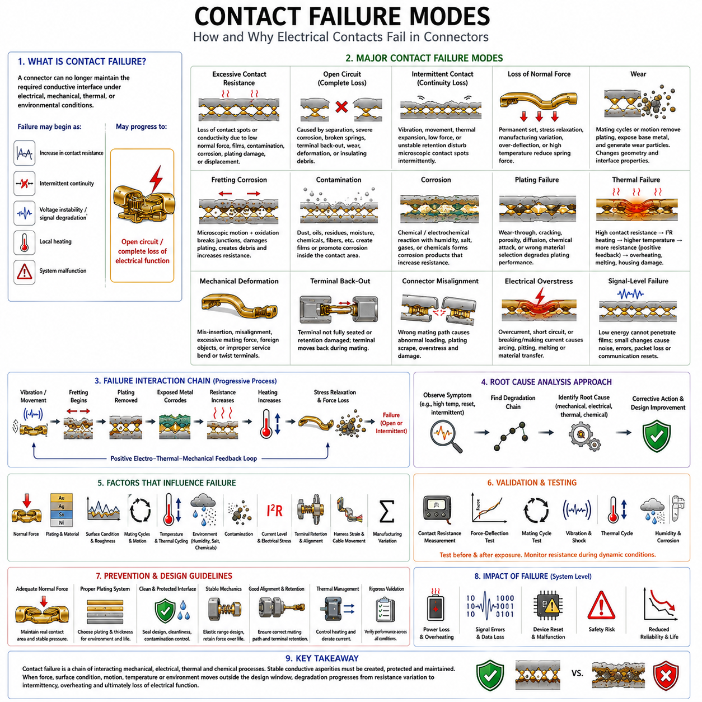
Electrical contact failure occurs when a connector can no longer maintain the required conductive interface under its electrical, mechanical, thermal, or environmental operating conditions. Failure does not always appear as a complete open circuit. It may begin as a small increase in contact resistance, intermittent continuity, voltage instability, local heating, or signal degradation and progressively develop into a system-level malfunction.
A fundamental failure mode is excessive contact resistance. Current normally passes through microscopic asperity contact spots, so any reduction in their number, size, or conductivity can increase resistance. Loss of contact normal force, contamination, surface films, corrosion, plating damage, or mechanical displacement can all alter these conductive regions. The resulting resistance increase affects both power transmission and low-level signal integrity.
Open-circuit failure represents the extreme condition in which a continuous conductive path is lost. It may result from terminal separation, severe corrosion, broken spring structures, terminal back-out, excessive wear, deformation, or accumulated insulating debris. Some open circuits are permanent, while others appear intermittently during vibration or movement. Intermittent opens are particularly difficult to diagnose because static inspection may show apparently normal continuity.
Intermittent contact failure occurs when the electrical interface repeatedly transitions between acceptable and unacceptable resistance. Vibration, cable movement, thermal expansion, insufficient normal force, or unstable terminal retention can disturb microscopic conductive spots. The circuit may operate correctly when stationary but generate brief interruptions during motion. In sensor, communication, and control circuits, even very short disturbances can produce corrupted data, resets, or communication faults.
Loss of contact normal force is an important mechanical origin of many electrical failures. Contact beams are designed to operate within a controlled elastic range, but permanent deformation, stress relaxation, manufacturing variation, excessive mating deflection, or elevated temperature can reduce spring force. Lower force decreases real contact area and makes the interface more vulnerable to surface films, vibration, fretting, and resistance instability.
Wear-related failure develops as mating cycles or service motion remove or redistribute surface material. Repeated sliding can thin the functional plating, expose the underplate or base material, and generate wear particles. Once protective plating has been penetrated, the exposed material may react more readily with the environment. Wear therefore changes not only mechanical geometry but also the chemical and electrical characteristics of the contact interface.
Fretting corrosion combines microscopic relative motion with oxidation or other chemical reactions. Small movements repeatedly break contact junctions and damage the surface coating. Freshly exposed material reacts with oxygen, moisture, or contaminants, while subsequent movement converts corrosion products into debris. As these particles accumulate between mating surfaces, conductive asperities become isolated and contact resistance may become progressively higher and less stable.
Contamination provides another pathway to contact failure. Dust, oils, manufacturing residues, moisture, chemicals, fibers, and other foreign materials can enter or remain within the contact region. Some contaminants create electrically resistive films, while others promote corrosion or retain moisture. Even sealed connectors can experience contamination if sealing surfaces, wire seals, cavity plugs, assembly processes, or maintenance practices are inadequate.
Corrosion failure occurs when contact or terminal materials react chemically or electrochemically with their environment. Humidity, salt, industrial gases, condensation, and chemical exposure can accelerate surface degradation. Corrosion products may increase interface resistance, damage plating, weaken terminal material, or spread along exposed surfaces. Material compatibility and environmental sealing therefore contribute directly to maintaining electrical contact integrity.
Plating failure can occur through wear-through, cracking, porosity, diffusion, chemical attack, or inappropriate material selection. Tin, silver, and gold each provide different interface characteristics and failure sensitivities. A plating system that performs well in one environment may be unsuitable in another. Functional coating thickness, underplate design, surface hardness, mating motion, normal force, temperature, and expected lifecycle must be considered together.
Thermal failure is closely coupled to electrical resistance. Power dissipated at a contact follows P = I²R, so a resistance increase can produce substantial localized heating at high current. Higher temperature increases conductor resistance and can accelerate oxidation, stress relaxation, polymer degradation, and plating deterioration. These effects can further increase resistance, creating a positive electro-thermal feedback loop that may progress toward severe overheating.
In extreme cases, thermal degradation can discolor terminals, soften or deform connector housings, damage seals, carbonize surrounding materials, or destroy the contact interface. A connector may therefore fail even when the bulk terminal cross-section appears adequate for the nominal current. Current rating must account for interface resistance, ambient temperature, adjacent loaded contacts, conductor size, airflow, housing materials, and lifecycle degradation.
Mechanical deformation is another major failure mechanism. Incorrect insertion, misalignment, excessive mating force, foreign objects, damaged housings, or improper service procedures can bend or twist terminals. A deformed contact may still mate physically while producing an incorrect contact position or reduced normal force. Such hidden damage can create elevated resistance or intermittent behavior without an obvious external indication of failure.
Terminal back-out occurs when a terminal is not correctly retained within its connector cavity or when the retention mechanism becomes damaged. During mating, the terminal can move backward instead of fully engaging the opposing contact. The connector housing may appear completely mated and locked while the electrical contact remains partial or absent. Terminal Position Assurance mechanisms are commonly used to reduce this assembly-related failure risk.
Connector misalignment can produce abnormal contact loading and damage. If mating terminals do not enter along the intended path, contact beams can be overstressed, plating can be scraped, and local forces can exceed the designed elastic range. Misalignment may originate from housing tolerances, damaged polarization features, poor mounting, cable loads, or forced assembly. Mechanical guidance is therefore part of electrical reliability.
Electrical overstress can damage contacts when current exceeds the intended capability or when abnormal events create high localized energy. Overcurrent increases contact heating, while short circuits can expose interfaces to severe thermal stress. Making or breaking current under unsuitable conditions can also produce electrical arcing. Arc energy may melt, pit, oxidize, or transfer contact material, permanently altering the mating surface and increasing resistance.
Signal-level contacts can fail without visible thermal damage. Low-current circuits may not possess sufficient energy to penetrate oxide or contamination films, making them sensitive to small changes in interface condition. Contact resistance fluctuations can produce voltage errors, noise, intermittent sensor signals, packet loss, or communication resets. For these applications, surface stability and corrosion-resistant plating can be more important than high-current capability.
Failure mechanisms rarely operate independently. Vibration may initiate fretting, fretting may remove plating, exposed material may corrode, corrosion products may increase resistance, and increased resistance may generate additional heat. Elevated temperature can then accelerate stress relaxation, reducing normal force and increasing movement at the interface. Connector failure is therefore often a progressive chain of interacting mechanical, chemical, electrical, and thermal processes.
Failure analysis should identify the degradation chain rather than only the final symptom. A burned terminal, for example, may indicate excessive current, but it can also be the final result of reduced normal force followed by increasing contact resistance and localized I²R heating. Similarly, communication errors may originate from software symptoms while the underlying cause is an intermittent connector interface. Root-cause analysis must therefore examine the complete contact system.
Validation should reproduce the stresses expected throughout connector life. Contact resistance measurement, force-deflection evaluation, dimensional inspection, mating-cycle testing, vibration, mechanical shock, thermal cycling, humidity, contamination, and corrosion exposure can reveal different failure mechanisms. Measurements before and after testing are useful, but monitoring resistance during dynamic testing can reveal transient discontinuities that would otherwise remain undetected.
Robotics and autonomous mobile robots combine many conditions that accelerate connector degradation. Continuous vibration from wheels, motors, gearboxes, manipulators, and cooling systems can coexist with thermal cycling, outdoor contamination, charging cycles, and maintenance activity. Power connectors may develop resistance-related heating, while sensor and network connectors can produce intermittent faults capable of disrupting perception, localization, control, or communication.
Preventing contact failure therefore requires coordinated design rather than dependence on a single connector specification. Contact geometry, normal force, plating, terminal retention, locking, sealing, harness routing, strain relief, current derating, thermal management, manufacturing control, and validation must operate as one system. A connector is reliable only when the microscopic electrical interface remains stable within the mechanical and environmental architecture surrounding it.
Contact failure modes complete the Contact Physics framework by integrating contact resistance, wear and fretting corrosion, plating selection, and contact normal force into a common reliability model. Stable conductive asperities must be created, protected, and maintained throughout service life. When force, surface condition, motion, temperature, or environment moves outside the intended design window, degradation can progress from resistance variation to intermittency, overheating, and ultimately loss of electrical function.

