Volume 03. Connector Engineering

Chapter 03. Current Rating and Derating

03.01. Current Rating Test Method
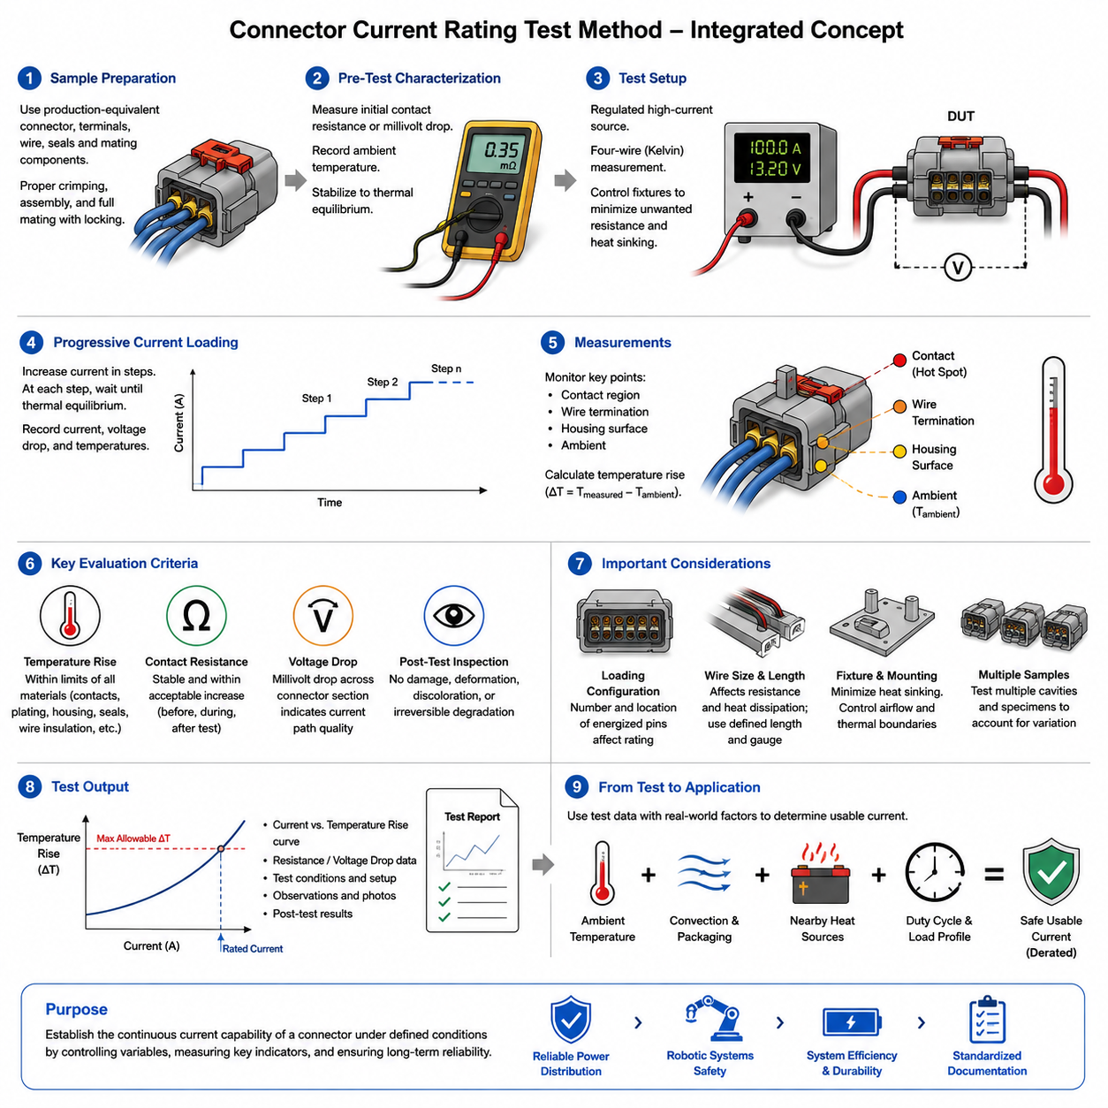
Current rating testing determines the continuous electrical current that a connector can carry while maintaining acceptable thermal and electrical performance. The rating is not simply the maximum current that can physically pass through a contact. It is established under defined test conditions by observing temperature rise, voltage drop, contact stability, and evidence of material degradation as current is applied.
A typical test begins with representative connector samples assembled using the specified terminals, conductor sizes, insulation types, seals, and mating components. Production-equivalent crimping and assembly processes should be used because conductor termination resistance can contribute significantly to measured heating. Samples must also be fully mated and locked so that contact normal force and interface geometry represent actual service conditions.
Before electrical loading, the test configuration is characterized at ambient conditions. Initial contact resistance or millivolt drop measurements establish a baseline for detecting changes during and after the thermal test. Ambient temperature is measured near the specimen without allowing the sensor to be strongly influenced by connector heating. The complete setup should reach thermal equilibrium before meaningful current-rating measurements begin.
Current is normally supplied from a regulated high-current source through conductors selected to represent the intended application or the applicable qualification procedure. The electrical path must be arranged so that unwanted resistance in fixtures, bus bars, clamps, and measurement leads does not distort connector performance. Four-wire Kelvin measurement is particularly useful when resistance or millivolt drop must be measured accurately across low-resistance contact interfaces.
Rather than immediately applying the expected rated current, testing commonly uses progressive current steps. Current is increased in controlled increments and maintained at each level until the connector approaches thermal equilibrium. Temperature, current, voltage drop, and relevant environmental conditions are recorded throughout the test. This procedure produces a relationship between applied current and connector temperature rise rather than only a single pass-or-fail observation.
Temperature rise is one of the primary criteria because electrical losses are converted into heat approximately according to the relationship P = I²R. Even a small increase in contact or termination resistance can therefore produce substantial additional heating at high current. Temperature sensors are placed at thermally significant locations such as contact regions, conductor terminations, housing surfaces, or other points specified by the applicable test procedure.
The reported temperature rise is generally evaluated relative to the measured ambient temperature rather than using connector temperature alone. If the surrounding air is at 25 °C and the measured connector location reaches 55 °C, the temperature rise is 30 °C. This distinction is important because the same electrical loading can produce different absolute temperatures when the connector operates in a cold laboratory, a warm enclosure, or a hot robot compartment.
Thermal equilibrium must be defined consistently because connector temperature usually increases rapidly after current application and then approaches a steady condition gradually. A measurement taken too early can underestimate the true operating temperature. Test procedures therefore establish a stabilization criterion based on a sufficiently small temperature change over a defined period, ensuring that current-rating decisions represent approximately steady-state thermal behavior.
The allowable current is constrained by more than contact temperature alone. Contact plating, spring material, terminal base metal, plastic housing, seals, wire insulation, and nearby components each have temperature limitations. Excessive heating may relax contact springs, accelerate oxidation, soften polymer structures, degrade sealing materials, or damage insulation. Consequently, the lowest relevant thermal limit can determine the practical continuous-current capability of the connector assembly.
Contact resistance should be monitored because temperature rise and electrical resistance are strongly coupled. A connector may initially satisfy the thermal requirement but develop increasing resistance because of poor crimping, contamination, insufficient contact force, surface degradation, or unstable interfaces. Comparing resistance before, during, and after current loading helps distinguish predictable conductor heating from abnormal localized heating associated with the electrical connection itself.
Voltage-drop measurement provides another practical indicator of current-path quality. Measuring the millivolt drop across a defined connector section allows its effective resistance to be calculated using R = V/I. When test boundaries are carefully controlled, this measurement can reveal abnormal terminals or cavities that may not be obvious from housing-surface temperature measurements. Localized electrical defects can otherwise remain hidden inside a multi-position connector.
Multi-pin connectors require special attention because current rating depends strongly on the number and location of simultaneously energized contacts. A single energized contact can dissipate heat into surrounding unused cavities more effectively than a densely loaded connector. When many adjacent terminals carry current, their thermal fields interact and the internal housing temperature rises. Current ratings must therefore identify the applicable loading configuration rather than treating every pin independently.
Wire size also affects the result. A larger conductor generally reduces wire resistance and can conduct heat away from the terminal more effectively, while a smaller conductor may generate additional heat close to the crimp region. Consequently, a current rating obtained with one wire gauge cannot automatically be transferred to every permitted conductor size. Test documentation should associate electrical loading with the actual wire and termination configuration used.
The length of wire attached to the specimen must also be controlled because conductors function as both electrical elements and thermal paths. Very short heavy-gauge leads may remove heat from a terminal more aggressively than an actual harness, producing an unrealistically favorable result. Conversely, an unsuitable laboratory lead arrangement may introduce additional heating. Standardized conductor lengths and routing improve repeatability between samples and laboratories.
Test fixtures must minimize unintended heat sinking. Metallic mounting plates, large clamps, or massive bus structures located close to the connector can conduct heat away from the specimen and artificially increase the apparent current capability. The connector should therefore be mounted according to the defined procedure, with surrounding airflow and thermal boundaries controlled. Natural convection and forced airflow must not be mixed without explicitly documenting the condition.
Several samples are normally desirable because current capability can vary with manufacturing tolerances. Contact normal force, plating thickness, crimp geometry, conductor strand distribution, and assembly position introduce small variations that can become important at high current. Testing multiple cavities and specimens helps identify whether the measured performance represents a robust design characteristic or merely the favorable behavior of one particular connector sample.
After the current-loading sequence, the specimen should be allowed to cool and then inspected and electrically remeasured. Permanent resistance increase, discoloration, housing deformation, terminal movement, seal damage, loss of contact force, or evidence of insulation deterioration indicates that the electrical loading may have exceeded a sustainable operating condition. A connector that survives temporarily but experiences irreversible degradation should not be considered adequately rated.
Current rating and current derating should remain conceptually separate. The rating test establishes connector behavior under specified laboratory conditions, whereas derating translates that capability into a usable design limit for real applications. The chapter structure places the test method before contact temperature rise, parallel-pin current sharing, ambient-temperature derating, and high-voltage connector rating, reflecting this progression from measurement to engineering application.
Ambient temperature is especially important when interpreting results because the available thermal margin decreases as environmental temperature rises. A connector demonstrating acceptable temperature rise in room-temperature testing may exceed housing, terminal, seal, or wire limits inside a warm electrical enclosure. The current-rating test therefore provides fundamental thermal data, while application engineering must combine those data with expected ambient conditions and component temperature limits.
For robotic systems, installation conditions can differ substantially from laboratory environments. Connectors may be located near batteries, motor drivers, DC-DC converters, brakes, actuators, or enclosed power distribution assemblies. Harness bundles may restrict convection, and continuous propulsion loads can maintain elevated temperatures for long periods. Connector current capability should therefore be validated against realistic operating duty, packaging, and surrounding heat sources.
AMRs and other mobile robots also experience rapidly changing load profiles. Motor acceleration can create high transient current, while cruising produces lower sustained current and charging interfaces may experience long periods of relatively constant high current. Continuous-current testing primarily establishes steady-state capability; transient overload behavior requires separate consideration of thermal time constants, contact mass, conductor heating, and protection-system response.
A technically complete current-rating report should preserve enough information for another engineer to reproduce and interpret the test. Important information includes connector identification, terminal and plating configuration, conductor size and type, crimping method, energized cavity pattern, ambient condition, mounting arrangement, current steps, stabilization criterion, measurement locations, resistance or voltage-drop data, temperature results, and post-test inspection findings.
The final engineering value of the test is therefore not merely a catalog ampere number. It establishes an experimentally supported relationship among current, resistance, temperature rise, connector construction, conductor configuration, and thermal environment. When these variables are controlled and documented, current-rating testing becomes the foundation for subsequent derating, harness sizing, protection coordination, connector selection, and reliable power-distribution design in robotic electrical architectures.

03.02. Temperature Rise at Contact
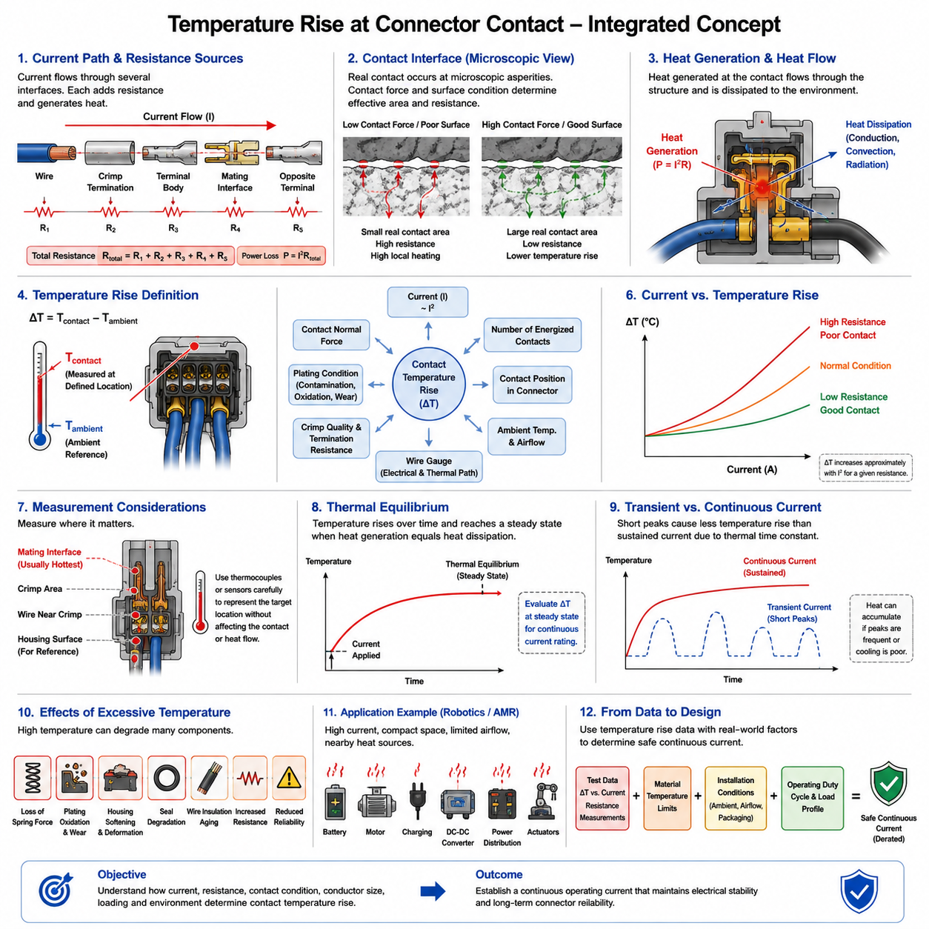
Temperature rise at a connector contact is the increase in local temperature produced when electrical current passes through the resistance of the contact system. Although connector resistance is normally very small, the resulting power loss follows approximately P = I²R. Because heating increases with the square of current, relatively small increases in current or resistance can create significant thermal stress in high-current connector applications.
A connector contact is not an ideal continuous conductor. Electrical current passes through a sequence of interfaces including the wire, crimp termination, terminal body, mating contact surfaces, and the corresponding terminal on the opposite side. Each region contributes resistance to the current path. Localized resistance at the mating interface and termination region can concentrate heat, producing temperatures substantially higher than those measured on the external connector housing.
The microscopic nature of electrical contact strongly influences this heating process. Two apparently smooth metallic surfaces actually touch through a limited number of microscopic asperities. Current is constricted through these small conductive regions, creating constriction resistance. Contact normal force, surface roughness, plating condition, contamination, oxidation, and wear determine the effective conductive area and therefore influence both contact resistance and local temperature generation.
Contact temperature rise can be represented conceptually as the balance between internally generated electrical heat and heat transferred into the surrounding structure. Heat generated at the contact travels through the terminal, conductor, housing, and adjacent contacts before being dissipated through conduction, convection, and radiation. The resulting temperature therefore depends not only on electrical resistance and current but also on the complete thermal path surrounding the contact.
The basic temperature-rise quantity is normally expressed as ΔT = Tcontact − Tambient, where Tcontact represents the measured or estimated temperature at a defined connector location and Tambient represents the surrounding reference temperature. This relative value is particularly useful because it separates connector-generated heating from the environmental temperature. The absolute operating temperature remains important because material limits apply to the total temperature experienced by the component.
Current has a dominant influence on temperature rise because Joule heating increases approximately with I². If resistance remained constant, doubling the current would theoretically produce four times the electrical power loss. Actual connector behavior is more complex because electrical resistance, thermal conductivity, convection, and material properties can change with temperature. Consequently, measured current-versus-temperature-rise curves are generally more useful for engineering decisions than simple linear extrapolation.
Resistance and temperature can also create a reinforcing thermal relationship. As metallic conductors become hotter, their electrical resistivity generally increases. Increased resistance produces additional I²R heating, which can further increase temperature. A properly designed connector reaches a stable thermal equilibrium where generated heat equals dissipated heat. If heat generation becomes excessive or thermal dissipation is inadequate, operating temperature can approach damaging material limits.
Contact normal force is especially important because it influences the real conductive area between mating surfaces. Adequate normal force helps maintain stable asperity contact and low electrical resistance. If force decreases because of poor design, mechanical deformation, wear, vibration, or thermal stress relaxation, contact resistance may rise. The resulting localized heating can accelerate further degradation, creating a progressive mechanism that eventually produces an electrically unstable connection.
Plating materials influence thermal behavior indirectly through their electrical and surface characteristics. Tin, silver, and gold contact systems exhibit different resistance, oxidation, wear, and environmental behavior. A plating system that becomes contaminated, oxidized, fretted, or mechanically damaged can develop higher interface resistance even when the bulk terminal remains conductive. This explains why contact condition must be considered together with nominal terminal current capacity.
The crimp termination must also be included when investigating connector heating. A poorly formed crimp can create excessive resistance between conductor strands and the terminal barrel, producing a hot spot near the rear of the contact rather than directly at the mating interface. Measuring only one location may therefore lead to an incorrect diagnosis. Temperature measurements should cover the regions most likely to contain electrical and thermal bottlenecks.
Wire gauge affects connector temperature because the attached conductor participates in both electrical conduction and heat transfer. A larger conductor normally has lower electrical resistance and can provide a more effective thermal path away from the terminal. A smaller conductor can generate additional wire heating and may transfer heat toward the connector. Connector temperature-rise data must therefore be interpreted together with the conductor size used during testing.
The number of simultaneously energized contacts is another major variable. When only one terminal carries current, surrounding terminals and housing material can help absorb and distribute its heat. When many adjacent contacts are energized, each contact becomes a heat source and their thermal fields overlap. The internal connector temperature can therefore become considerably higher even when the current through each individual terminal remains unchanged.
Contact position can consequently affect thermal performance within a multi-pin connector. A terminal located near an outer edge may dissipate heat differently from one surrounded by energized contacts near the center. Dense connector arrangements can create internal thermal hot spots that are not predicted by a single-contact test. Current capability should therefore consider cavity position, energized-contact pattern, connector geometry, and simultaneous loading conditions.
Ambient temperature determines the remaining thermal margin available to the connector. For example, the same 35 °C temperature rise produces an absolute temperature of 60 °C in a 25 °C environment but 95 °C in a 60 °C environment. The electrical behavior may initially appear similar, yet the second condition places much greater stress on the housing, seals, plating, spring materials, and wire insulation.
Airflow and installation geometry also influence the observed temperature. A connector operating in open air may dissipate heat effectively through natural or forced convection, whereas the same connector inside a sealed enclosure can retain considerably more heat. Harness bundles, protective sleeves, covers, nearby electronics, batteries, motor controllers, and structural components can modify the thermal environment and change the relationship between current and contact temperature.
Accurate measurement of contact temperature can be challenging because the hottest region may be located inside the connector and inaccessible after mating. Thermocouples or other temperature sensors must be positioned carefully so that they represent the desired location without significantly changing contact force, housing geometry, or heat flow. External housing temperature alone should not automatically be assumed to represent the maximum internal contact temperature.
Temperature measurements should be recorded together with current, ambient temperature, voltage drop, and contact resistance whenever practical. Correlating these quantities helps identify the physical origin of abnormal heating. A contact exhibiting both elevated resistance and elevated temperature suggests an electrical interface problem, while similar heating across multiple contacts may indicate system-level thermal loading, insufficient conductor size, restricted cooling, or excessive simultaneous current demand.
Thermal equilibrium is essential when evaluating continuous-current performance. Immediately after current is applied, electrical heating begins faster than the connector reaches its final temperature. The measured temperature then rises according to the thermal mass and heat-transfer characteristics of the assembly. A stable value is reached when heat generation and heat dissipation become approximately balanced, providing the appropriate basis for continuous-current temperature-rise assessment.
Transient current must be distinguished from continuous current because connector thermal response has a finite time constant. Short acceleration peaks in motors or actuators may produce currents substantially above the continuous rating without immediately creating the same temperature reached under sustained loading. However, repeated peaks, long acceleration periods, high duty cycles, or insufficient cooling can accumulate heat, making the average and time-dependent load profile important.
Excessive temperature can damage more than the electrical interface itself. High temperature may reduce spring force, accelerate plating oxidation, soften polymer housings, deform terminal retention features, degrade seals, age wire insulation, and increase nearby component temperatures. These effects can permanently increase resistance or reduce mechanical integrity. Thermal performance must therefore be evaluated against the temperature limits of the entire connector assembly rather than the contact metal alone.
For robotic platforms such as AMRs, connector heating is especially important in battery, motor, charging, DC-DC converter, power-distribution, and actuator circuits. These systems can combine sustained current, frequent acceleration peaks, compact packaging, limited airflow, and nearby heat-generating electronics. A connector that performs adequately in an isolated laboratory configuration may therefore require substantial application derating when installed inside the robot.
Temperature-rise characterization ultimately provides the physical basis for connector current rating and subsequent derating. The objective is not merely to identify the current at which a connector becomes hot, but to understand how current, resistance, contact condition, conductor size, simultaneous pin loading, ambient temperature, and heat dissipation interact. This relationship allows engineers to establish a continuous operating current that preserves electrical stability and long-term connector reliability.
A robust connector design therefore treats temperature rise as a system-level electrical and thermal parameter rather than an isolated contact property. Current-rating test data, resistance measurements, material temperature limits, installation conditions, and real operating duty cycles must be evaluated together. This approach provides the engineering foundation for reliable connector selection, current derating, harness integration, protection coordination, and power-distribution design in robotic electrical architectures.

03.03. Parallel Pin Current Sharing
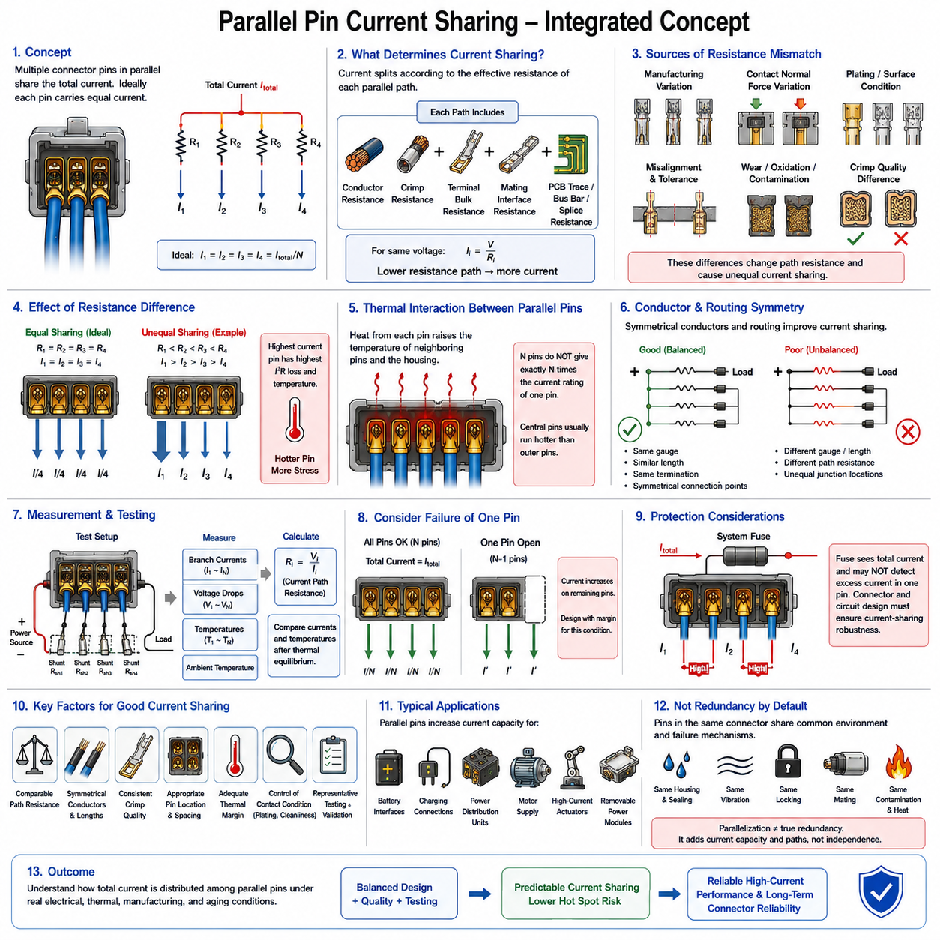
When several connector pins are connected electrically in parallel, the total circuit current is divided among multiple contact paths rather than being carried by a single terminal. Ideally, identical parallel contacts would carry equal current, so N identical pins carrying a total current Itotal would each conduct approximately Itotal/N. Real connectors, however, contain small electrical and thermal differences that prevent perfectly uniform current sharing.
Each parallel current path includes more than the resistance of the mating contact itself. The complete path contains conductor resistance, crimp resistance, terminal bulk resistance, mating-interface resistance, and resistance associated with PCB traces, bus bars, splices, or other interconnections. Small differences anywhere along these paths can alter current distribution because current preferentially flows through paths having lower total electrical resistance.
For parallel paths exposed to the same voltage, branch current follows the basic relationship Ii = V/Ri. A branch with lower resistance therefore carries more current than a branch with higher resistance. The total current is the sum of all individual branch currents. This means that current-sharing analysis should use the complete effective resistance of each parallel branch rather than assuming that identical connector terminal part numbers automatically produce identical currents.
Manufacturing variation is one source of resistance mismatch. Crimp dimensions, conductor strand distribution, terminal alignment, contact normal force, plating thickness, surface condition, and dimensional tolerances can differ slightly between cavities. These differences may appear insignificant when terminals are evaluated individually, but in parallel operation they can determine which contact receives a larger fraction of the total current and therefore experiences greater electrical and thermal stress.
Contact resistance can also change during service. Vibration, fretting, oxidation, contamination, repeated mating cycles, corrosion, mechanical relaxation, and wear may increase the resistance of one contact relative to neighboring contacts. Current then redistributes toward the lower-resistance paths. The remaining contacts may consequently carry more current than originally intended even though the total system current has not changed.
Temperature introduces an additional coupling between resistance and current sharing. As a terminal and its conductor become hotter, their metallic resistance generally increases. This resistance increase can shift some current toward cooler parallel paths, providing a degree of natural balancing. However, contact interfaces affected by degradation may behave less predictably, and localized heating can accelerate oxidation, stress relaxation, or surface damage that further changes the resistance distribution.
Parallel pins also interact thermally. If several adjacent contacts carry current simultaneously, each generates I²R losses and transfers heat into the same connector housing. The resulting thermal fields overlap, reducing the ability of individual terminals to dissipate heat. Consequently, four parallel contacts normally cannot be assumed to provide exactly four times the usable continuous-current capability of one isolated contact.
Pin location within the connector influences this thermal interaction. Contacts near the center of a densely populated connector may be surrounded by other energized terminals and can operate at higher temperatures than contacts near the housing perimeter. For this reason, parallel-pin capability depends on the selected cavity arrangement as well as the number of pins. Separating high-current contacts can sometimes improve heat distribution when connector architecture permits it.
External conductor geometry is equally important. If one parallel terminal is connected through a shorter wire, larger conductor, wider PCB trace, or lower-resistance bus path, that branch may attract more current. Symmetrical routing therefore improves current sharing. Parallel conductors should preferably have comparable gauge, length, termination construction, and electrical path geometry from the common source node to the common load node.
The electrical junction points should also be considered carefully. If parallel branches are joined at physically different locations along a bus bar or PCB copper region, resistance in the common conductor can create unequal branch voltages. A geometrically symmetric connection or balanced star-like arrangement can reduce this effect. The objective is to make the impedance seen by each parallel connector path as similar as practical.
Crimp quality becomes especially significant because a parallel system can temporarily hide a defective termination. If one crimp develops excessive resistance, neighboring branches may continue carrying the load and the system may remain electrically functional. This apparent redundancy can conceal progressive degradation while increasing current in the healthy contacts. Diagnostic strategies should therefore detect abnormal resistance or temperature before redistribution produces secondary overload.
A simple example illustrates the principle. If four nominally identical pins carry 80 A, ideal sharing would produce 20 A per pin. If one branch develops greater resistance, its current may fall while the other three branches rise above 20 A. The exact distribution depends on branch resistance values. Engineering evaluation must therefore consider the maximum probable current in an individual contact rather than relying only on the arithmetic average.
Connector manufacturers may specify current capability for one contact, multiple energized contacts, or particular loading patterns. These conditions must not be treated as interchangeable. A single-pin laboratory rating often benefits from relatively effective heat dissipation, whereas a fully populated connector creates substantially greater internal heating. Parallel-pin design should therefore be based on applicable multi-contact data whenever such characterization is available.
Testing provides the most reliable method for evaluating a critical parallel-pin configuration. Representative samples should use production-equivalent terminals, wire gauges, crimps, seals, housings, and cavity locations. The intended total current is applied while individual branch currents, voltage drops, and temperatures are measured where practical. Testing should continue until thermal equilibrium is reached so that steady-state current distribution and temperature rise can be evaluated together.
Individual branch current can be measured using suitable low-resistance shunts, calibrated current sensors, or other instrumentation that does not significantly disturb the original circuit impedance. Measurement methods must be selected carefully because adding unequal shunt resistance or excessive lead resistance can itself change the current distribution being investigated. Instrumentation should therefore preserve electrical symmetry as closely as possible.
Voltage-drop measurements provide another useful indication of parallel-path condition. Measurements across corresponding sections of each branch can reveal resistance differences caused by crimps, terminals, mating interfaces, or conductors. When combined with measured branch current, effective resistance can be estimated using R = V/I. Trending these values during thermal stabilization can reveal whether current distribution remains stable as connector temperature increases.
Temperature should be monitored at several parallel contacts because equal current does not necessarily guarantee equal thermal conditions. Differences in cavity position, nearby energized contacts, airflow, conductor heat transfer, and housing geometry can create different contact temperatures. The hottest contact or termination, rather than the average connector temperature, usually represents the most important thermal constraint for continuous operation.
Failure of one branch must be considered when parallel contacts perform a critical power function. If one of N parallel paths becomes open circuit, its current is redistributed among the remaining N−1 paths. A design operating close to the normal capability of every contact may therefore overload the remaining terminals immediately after a single-contact failure. Whether this condition must be tolerated depends on system safety goals and required fault behavior.
Fuse and protection coordination can become complicated when multiple pins form one power path. A system-level fuse primarily responds to total current and may not detect excessive current concentrated in one connector contact while the overall circuit remains below the protection threshold. Connector thermal protection therefore cannot rely exclusively on the upstream fuse. Current-sharing robustness must be established through connector, conductor, and circuit design.
For AMRs and other robotic platforms, parallel contacts may be attractive in battery interfaces, removable power modules, charging connections, power distribution units, motor supply circuits, and high-current actuator connections. They can increase practical current capacity without immediately requiring a physically larger single contact, but they also introduce additional dependence on assembly quality, balanced routing, thermal management, and long-term contact stability.
Parallel pins should not automatically be interpreted as electrical redundancy. If all pins are housed in the same connector, exposed to the same contamination, vibration, thermal environment, locking mechanism, and mating event, they may share common-cause failure mechanisms. Parallelization primarily provides additional conductive paths and potentially greater current capability; true redundancy requires a separate analysis of independence, fault containment, and system architecture.
Design margin is therefore essential. The intended total current should be distributed using conservative assumptions about current imbalance, simultaneous contact heating, ambient temperature, manufacturing variation, aging, and possible branch degradation. Applying a simple multiplication factor to the single-contact current rating can overestimate usable capacity. Derating should reflect the actual connector configuration and its expected operating environment.
The relationship between parallel-pin current sharing and temperature rise is particularly important within connector engineering. Unequal resistance produces unequal current, unequal current changes I²R heating, and shared thermal paths determine the resulting temperatures. Temperature can then alter branch resistance and redistribute current again. Electrical and thermal behavior are therefore coupled and should be analyzed as one interacting system rather than as independent calculations.
A robust parallel-pin design ultimately seeks predictable current distribution rather than mathematically perfect equality. Comparable branch resistance, symmetrical conductors, consistent crimping, suitable cavity selection, controlled contact condition, adequate thermal margin, and representative testing reduce the probability that one terminal becomes disproportionately loaded. These principles allow multiple connector contacts to carry high current while maintaining stable electrical performance and long-term reliability.
Parallel-pin current sharing therefore forms an important bridge between individual contact rating and practical connector-level current capacity. The engineering objective is to determine how the total load is actually distributed across contacts under realistic electrical, thermal, manufacturing, and aging conditions. This understanding provides the basis for connector derating, fault assessment, harness design, protection coordination, and reliable high-current power distribution in robotic electrical systems.

03.04. Derating by Ambient Temperature
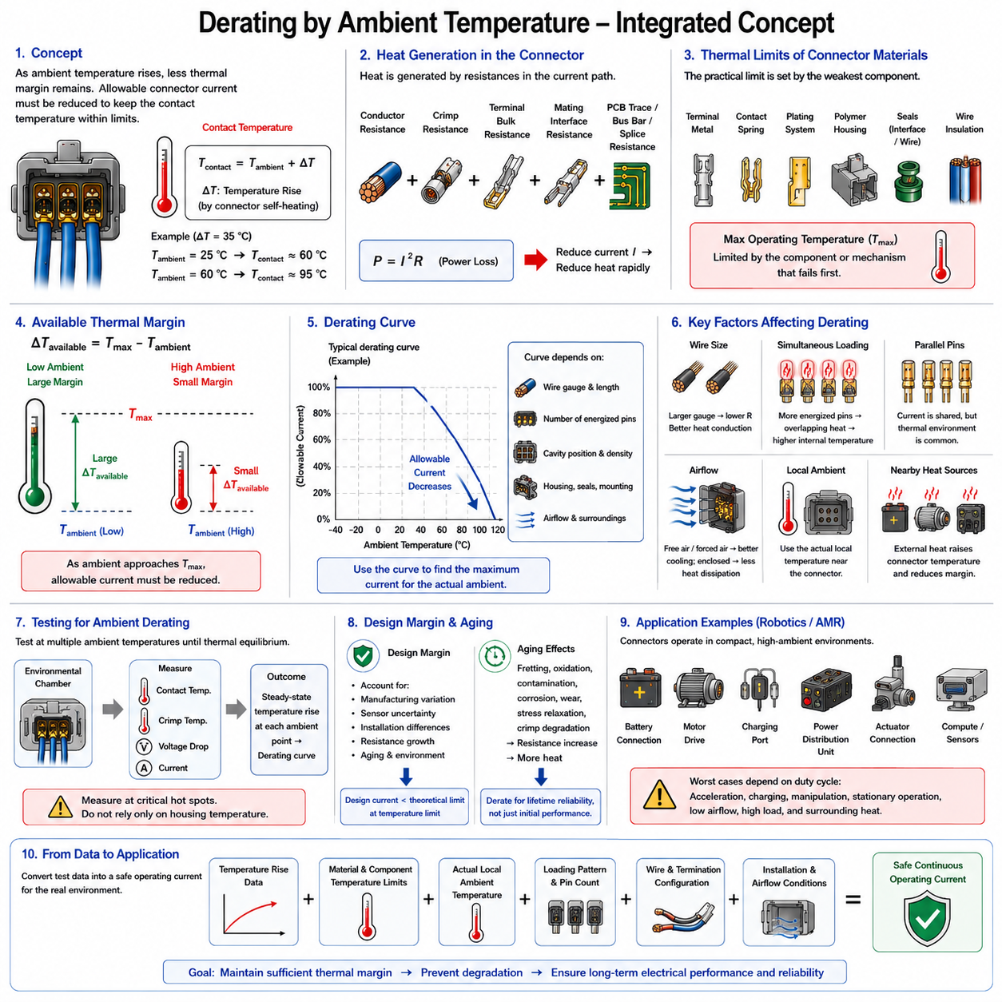
Ambient-temperature derating is the process of reducing the allowable connector current as the surrounding environmental temperature increases. A connector generates heat internally through conductor, crimp, terminal, and contact resistance, while the environment establishes the starting temperature from which this self-heating occurs. As ambient temperature rises, less thermal margin remains before connector materials reach their allowable temperature limits.
The fundamental relationship can be understood through the absolute operating temperature of the connector. If a contact produces a temperature rise ΔT above ambient, its approximate operating temperature becomes Tcontact = Tambient + ΔT. A connector producing a 35 °C rise at 25 °C ambient therefore reaches approximately 60 °C, while the same rise at 60 °C ambient would produce approximately 95 °C.
Every connector contains materials with finite temperature capability. Terminal base metals, contact springs, plating systems, polymer housings, interface seals, wire seals, and conductor insulation may have different maximum operating temperatures. The practical thermal limit of the assembly is governed by the component or degradation mechanism that becomes unacceptable first, rather than by the temperature capability of the metallic contact alone.
Current-generated heating is strongly related to electrical resistance through approximately P = I²R. Reducing current therefore reduces internal heat generation rapidly because current appears as a squared term. Ambient-temperature derating takes advantage of this relationship by lowering allowable current when environmental temperature increases, thereby limiting self-generated heat and keeping the resulting connector temperature within the permitted thermal envelope.
A simple thermal interpretation considers the maximum available temperature rise as ΔTavailable = Tmax − Tambient. When ambient temperature is low, a relatively large temperature rise may be available before reaching the component temperature limit. As ambient temperature approaches Tmax, the available rise becomes progressively smaller. At sufficiently high ambient temperature, continuous electrical loading may need to be severely restricted regardless of the connector's room-temperature current rating.
Derating curves express this relationship in a practical engineering form. The horizontal axis typically represents ambient temperature, while the vertical axis represents allowable current or a percentage of rated current. The curve generally decreases as ambient temperature increases. Such a curve converts thermal characterization into a usable design rule, allowing engineers to determine an appropriate current limit for a specified operating environment.
A derating curve should not be interpreted as a universal property independent of test configuration. Connector temperature rise depends on wire gauge, conductor length, number of energized contacts, cavity position, housing configuration, seals, mounting arrangement, airflow, and surrounding structures. A curve generated under one configuration may therefore produce inaccurate results if applied directly to a substantially different connector installation.
The reference current rating is especially important. If a manufacturer specifies a current rating under a defined ambient temperature and contact-loading condition, that value provides a starting point rather than an unconditional operating limit. Engineers must identify the associated test conditions before applying the rating. Using a catalog current value without understanding its thermal assumptions can result in insufficient design margin.
Wire size affects ambient derating because conductors serve simultaneously as electrical paths and thermal paths. Larger conductors generally have lower electrical resistance and can conduct more heat away from the terminal, whereas smaller conductors can generate additional I²R heating. Consequently, allowable connector current at elevated ambient temperature may depend strongly on the wire gauge and termination configuration used in the actual harness.
Simultaneous contact loading also changes the required derating. A single energized contact may transfer heat into unused terminals and surrounding housing regions, while many energized contacts generate overlapping thermal fields. Dense loading reduces effective heat dissipation and increases internal connector temperature. Therefore, elevated ambient temperature combined with high pin utilization can require substantially greater current reduction than either condition considered independently.
Parallel pins require similar caution. Dividing total current among several contacts can reduce the electrical load per contact, but the contacts still share the same thermal environment. Their combined heat raises the temperature of the connector housing and neighboring terminals. Unequal current sharing may also cause one contact to run hotter than expected, so ambient derating should consider both current distribution and simultaneous thermal interaction.
Airflow is another major factor. A connector operating in free air can dissipate heat through natural convection, while forced airflow may improve cooling further. In contrast, a connector inside a sealed enclosure, cable cover, protective sleeve, or tightly packed electrical compartment may retain heat. Ambient temperature measured outside such an enclosure may not accurately represent the local thermal environment experienced by the connector.
The correct ambient reference should therefore represent the temperature surrounding the connector during operation rather than a convenient remote measurement. In robotic systems, internal electrical compartments may become substantially warmer than the external atmosphere because of batteries, motor drivers, DC-DC converters, computers, charging electronics, and power distribution equipment. Local ambient temperature is the relevant quantity for connector derating.
Heat from neighboring components can further reduce thermal margin. A connector mounted near an inverter, motor controller, battery module, resistor, contactor, or high-power converter may receive heat through air, wiring, or structural conduction. In this situation, connector temperature results from both its own electrical losses and external thermal sources. Derating based only on nominal vehicle or room ambient temperature can therefore underestimate actual thermal stress.
Transient operating conditions should be distinguished from continuous ambient-temperature derating. Short current peaks may be tolerated because the connector possesses thermal mass and does not reach steady-state temperature immediately. However, repeated acceleration events, frequent actuator operation, charging cycles, or high-duty motor loads can accumulate heat. The relevant design condition depends on both current magnitude and the duration and repetition of the load.
Thermal equilibrium remains the principal reference for continuous-current derating. During testing, current should be maintained long enough for the connector temperature to stabilize under each relevant ambient condition. Measurements taken before stabilization can underestimate the eventual temperature rise. The resulting steady-state data can then be used to establish the relationship among ambient temperature, current, and maximum connector temperature.
Environmental chambers provide a controlled method for characterizing this relationship. Representative connector assemblies can be operated at several ambient temperatures while current is applied and temperatures are monitored at critical contacts, crimps, conductors, and housing locations. Testing multiple ambient points allows the allowable-current boundary to be established experimentally rather than relying solely on theoretical thermal assumptions.
The maximum measured temperature should be compared with the applicable material and component limits. Particular attention should be given to internal hot spots because external housing temperature may remain significantly lower than contact or crimp temperature. Temperature sensors must therefore be located where they can represent the critical thermal regions without significantly disturbing contact geometry, contact force, or normal heat transfer.
A useful derating method combines measured temperature-rise data with the maximum permissible operating temperature and an engineering safety margin. The safety margin accounts for manufacturing variation, sensor uncertainty, aging, resistance growth, installation differences, and environmental uncertainty. The resulting design current should therefore normally be lower than the theoretical current that would place the hottest connector location exactly at its temperature limit.
Aging is important because connector resistance may not remain at its initial value throughout service life. Fretting, oxidation, contamination, corrosion, plating wear, contact-force relaxation, and crimp degradation can increase resistance. Since additional resistance produces additional I²R heating, a connector operating with little thermal margin when new may become thermally unacceptable after extended use. Derating should therefore support lifetime reliability rather than only initial performance.
High ambient temperature can itself accelerate these aging mechanisms. Elevated temperature may increase oxidation rates, promote polymer aging, reduce spring-force retention, degrade seals, and accelerate insulation deterioration. This creates an important reliability interaction: high ambient temperature reduces immediate thermal margin while also potentially increasing the rate at which the connector's electrical and mechanical properties degrade over time.
For AMRs and other robotic platforms, ambient derating is particularly relevant because connectors frequently operate inside compact enclosed structures. Battery compartments, motor-drive enclosures, charging modules, power distribution units, and actuator assemblies can experience temperatures considerably above room conditions. Low-speed operation or stationary charging may also reduce airflow even when electrical loading remains high.
Robotic duty cycles can create location-specific worst cases. A traction connector may experience maximum heating during repeated acceleration, while a charging connector may experience its highest continuous temperature when the robot is stationary. An actuator connector may be stressed during repetitive manipulation, and a power-distribution connector may carry simultaneous loads from compute, sensing, motors, and auxiliary equipment. Derating should reflect these realistic operating states.
Temperature monitoring can also be incorporated into advanced power systems when thermal conditions vary widely. Sensors located near critical connectors or within power-distribution assemblies can provide information for diagnostics, current limiting, charging control, or protective shutdown. Such monitoring does not replace proper connector derating, but it can provide an additional layer of protection against abnormal cooling conditions, unexpected resistance growth, or unusual system loads.
Ambient-temperature derating ultimately converts laboratory current-rating and temperature-rise information into a practical application limit. The process connects contact heating, material temperature capability, local environment, simultaneous pin loading, conductor configuration, installation geometry, and operating duty. Its purpose is not simply to reduce current conservatively, but to establish a defensible current level that maintains sufficient thermal margin.
A robust connector design therefore evaluates current rating, temperature rise, parallel-pin behavior, and ambient-temperature derating as related parts of the same electrical-thermal problem. The usable current is the value that remains acceptable under realistic worst-case conditions rather than the highest value demonstrated under favorable laboratory conditions. This approach provides the basis for reliable connector selection, harness integration, protection coordination, and power distribution in robotic electrical architectures.

03.05. HV Connector Current Rating
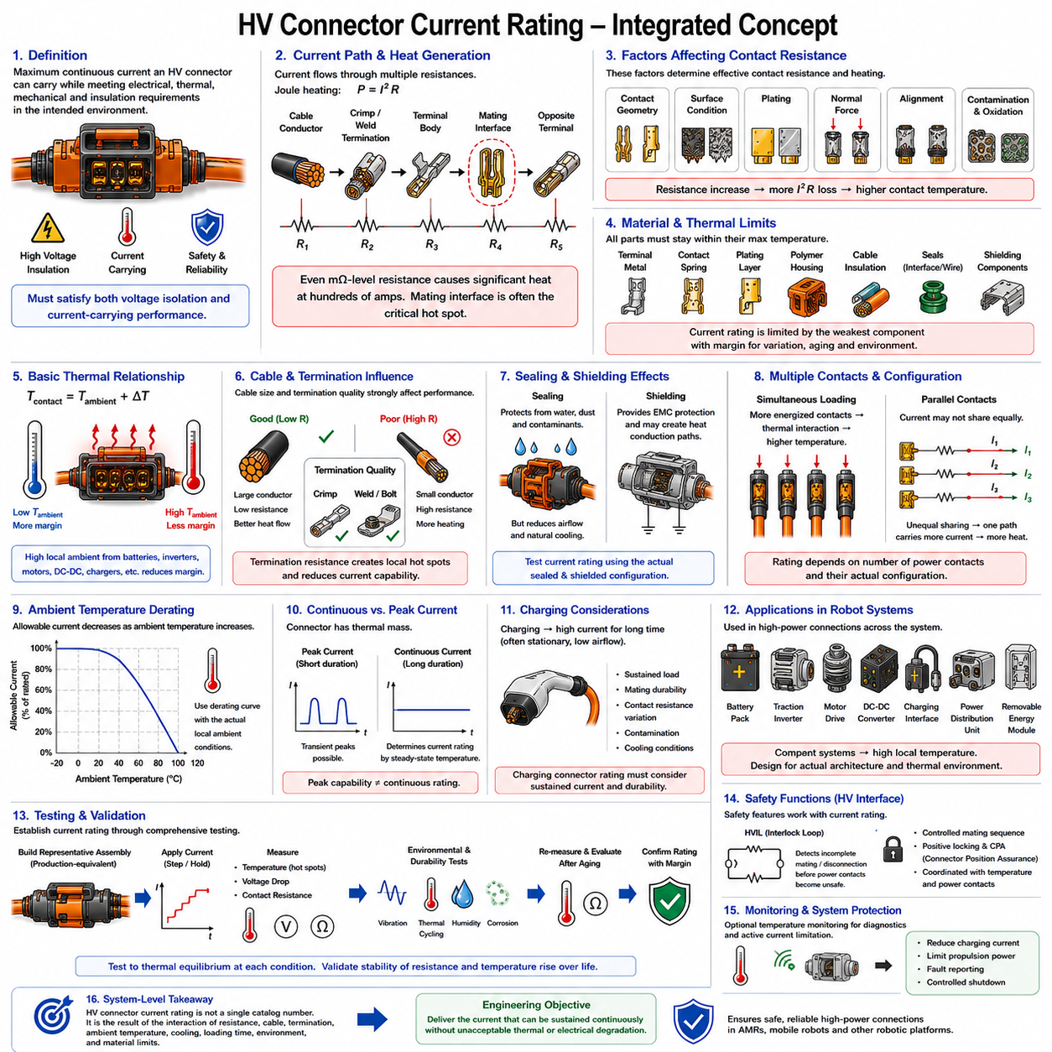
High-voltage connector current rating defines the continuous current that an HV connector can carry while maintaining acceptable electrical, thermal, mechanical, and insulation performance. Although voltage determines insulation and clearance requirements, current determines conductor and contact heating. An HV connector must therefore satisfy both voltage isolation and current-carrying requirements simultaneously under the intended operating environment.
The basic thermal mechanism remains Joule heating, approximately described by P = I²R. Current passes through the cable conductor, crimp or welded termination, terminal body, mating interface, and corresponding terminal on the opposite side. Each portion contributes resistance. Because current can reach hundreds of amperes in high-power systems, even milliohm-level resistance becomes important and can generate substantial localized heat.
The mating interface is often a critical thermal region because current flows through microscopic contact areas maintained by mechanical normal force. Contact geometry, surface condition, plating, terminal alignment, and contact force determine the effective interface resistance. If resistance increases because of contamination, wear, oxidation, mechanical relaxation, or improper mating, I²R losses increase and the contact temperature can rise significantly.
HV connector current capability must therefore be established from temperature-rise behavior rather than from conductor cross-sectional area alone. A large terminal may possess substantial bulk conductivity while the mating interface or cable termination becomes the actual thermal bottleneck. Testing should evaluate the complete connector assembly, including terminals, cable, seals, housing, shielding structures, and the production-equivalent termination process.
The operating temperature can be represented approximately as Tcontact = Tambient + ΔT, where ΔT is the connector-generated temperature rise. This relationship becomes especially important in HV systems because connectors may be located close to batteries, inverters, motor drives, DC-DC converters, charging electronics, or other heat-generating equipment. High local ambient temperature directly reduces the remaining thermal margin available for current-induced heating.
Material limits constrain the usable current rating. HV connectors contain terminal metals, contact springs, plating layers, polymer housings, cable insulation, interface seals, wire seals, shielding components, and sometimes internal interlock elements. The allowable continuous current must keep all relevant components within their specified thermal capability, including sufficient margin for manufacturing variation, aging, and abnormal environmental conditions.
Cable size strongly influences HV connector thermal performance. Large HV conductors reduce electrical resistance and can conduct heat away from the terminal, while undersized cables generate additional heat near the termination. The cable is therefore part of the connector's thermal system rather than merely an external load connection. A current rating established with one cable cross-section should not automatically be applied to a substantially different cable configuration.
Termination quality is equally important. High-current HV terminals may use crimped, welded, bolted, or other engineered conductor interfaces depending on the connector architecture. Excessive termination resistance creates localized heating that can propagate into the contact and housing. Production tooling, process control, conductor preparation, dimensional inspection, and electrical resistance verification are therefore closely related to the achievable current capability.
HV connectors frequently incorporate environmental sealing, but sealing can affect thermal performance. Sealed housings reduce exposure to water and contamination while also restricting natural airflow around internal terminals. Cable seals, interface seals, covers, backshells, and protective structures can modify heat-transfer paths. Consequently, current-rating tests should reproduce the sealed configuration intended for the actual application whenever practical.
Shielding structures can also influence heat transfer. Many HV connectors use metallic shells, shielding rings, cable braids, or conductive interfaces to provide electromagnetic compatibility. These components may create additional thermal conduction paths, but their effect depends on geometry and installation. Current capability should therefore be validated using the complete shielded connector configuration rather than assuming that shielding always improves or worsens cooling.
HV connectors may contain two or more high-current contacts located close together. Simultaneous loading causes their thermal fields to interact, raising the internal housing temperature compared with isolated-contact operation. The rated current must therefore correspond to the actual number of energized power contacts and their configuration. Single-contact test results cannot automatically represent a complete multi-pole HV connector operating under full load.
Parallel high-current contacts require additional consideration because current may not divide equally. Small differences in contact resistance, termination resistance, cable length, or conductor geometry can cause one branch to carry more current than another. The higher-current path experiences greater I²R heating. Parallelization can increase total current capability, but the resulting rating must account for current imbalance and shared thermal conditions.
Current rating also depends on ambient-temperature derating. A connector that safely carries a specified current at 25 °C may require a lower continuous current at 60 °C or 80 °C because less thermal margin remains before material limits are reached. HV connector specifications should therefore be interpreted together with applicable derating curves rather than treating the room-temperature current value as universally available.
The local ambient temperature is more relevant than the external vehicle or room temperature. An HV connector installed inside a battery enclosure or power electronics compartment can experience an environment substantially hotter than the surrounding atmosphere. Heat transferred from bus bars, battery cells, inverters, contactors, converters, or nearby cables can further increase connector temperature even without an increase in connector current.
Continuous current and peak current must be distinguished carefully. Traction motors and high-power actuators can produce short current peaks during acceleration, while charging and sustained propulsion may create long-duration loads. A connector can tolerate some transient overload because its thermal mass delays temperature rise, but repeated peaks or high duty cycles can accumulate heat. Peak-current capability therefore cannot replace continuous-current thermal qualification.
Charging applications present a particularly demanding continuous-current condition. During charging, high current may be maintained for extended periods while the robot or vehicle remains stationary, potentially reducing airflow. Contact resistance at the charging interface can also change through repeated mating cycles and environmental exposure. Charging connector current rating should therefore consider sustained load, mating durability, contamination, and realistic cooling conditions.
For mobile robots and AMRs, HV connectors may be used between battery packs, power distribution units, traction inverters, motor drives, high-power DC-DC converters, charging interfaces, and removable energy modules. Compact packaging can place several heat-generating devices in the same enclosure. Connector selection must therefore reflect the actual electrical architecture and thermal environment rather than only the nominal battery current.
HV systems also introduce safety functions that interact with connector design. A high-voltage interlock loop, commonly called HVIL, may detect incomplete mating or disconnection before the main power contacts become unsafe. The interlock does not determine the current rating itself, but it supports safe connection management. Power-contact temperature, mating sequence, locking integrity, and interlock behavior should remain coordinated within the complete HV interface design.
Connector mating condition is particularly important at high current. Partial engagement can reduce effective contact area or normal force and create severe localized resistance. Mechanical keying, positive locking, connector position assurance, and appropriate mating-sequence features help ensure that the electrical interface reaches its intended geometry. Current-rating performance assumes correct assembly and should not be interpreted as tolerance for incomplete mating.
Contact resistance measurement provides an important indicator of HV connector condition. Four-wire Kelvin measurement can be used to characterize low resistance across defined portions of the current path. Initial measurements establish a baseline, while measurements during qualification or after environmental exposure can identify degradation. Increasing resistance is important because relatively small changes can produce significant additional heating at high current.
Temperature-rise testing should use representative HV connector assemblies and production-equivalent cable terminations. Current is applied in controlled steps while temperatures are measured at critical locations such as mating contacts, termination regions, cable conductors, and housing areas. Voltage drop and resistance should also be recorded where practical. Testing continues until thermal equilibrium is reached at each relevant condition.
Environmental testing should be connected with current-rating validation because vibration, mechanical shock, thermal cycling, humidity, contamination, and corrosion can alter contact resistance over service life. A connector that meets its current requirement when new may perform differently after environmental aging. Repeating resistance and temperature-rise measurements after relevant durability tests provides evidence that the current capability remains stable.
Thermal cycling deserves particular attention because HV connectors combine metals, polymers, seals, cables, and contact springs having different thermal expansion characteristics. Repeated heating and cooling can influence terminal position, contact force, sealing compression, and termination integrity. Current-rating validation should therefore consider whether the connector maintains acceptable resistance and temperature rise after representative thermal and mechanical aging.
Protection devices cannot completely protect a connector from every thermal failure. A fuse or circuit breaker responds primarily to circuit current, while a damaged contact can develop excessive local resistance and overheat even when total current remains below the protection threshold. Proper connector current rating, installation control, temperature margin, and resistance stability are therefore necessary independently of upstream overcurrent protection.
Some high-power systems use temperature sensing near HV connectors to provide additional diagnostics or active current limitation. A measured temperature approaching a defined threshold can trigger reduced charging current, propulsion limitation, fault reporting, or controlled shutdown. Such monitoring can improve system robustness, but it should supplement rather than replace appropriate passive current rating and ambient-temperature derating.
A reliable HV connector rating must therefore combine current-rating test data, contact temperature rise, cable and termination configuration, simultaneous contact loading, ambient-temperature derating, environmental aging, and application duty cycle. The engineering objective is not to identify the highest current that can briefly pass through the connector, but the current that can be sustained without unacceptable thermal or electrical degradation.
Within robotic electrical architecture, this rating becomes an input to cable sizing, fuse and contactor coordination, power distribution design, charging strategy, thermal management, packaging, and service procedures. Maintaining sufficient margin between expected operating current and validated connector capability reduces resistance growth, thermal aging, insulation damage, and unexpected power-path failures throughout the system lifetime.
HV connector current rating should ultimately be treated as a system-level electrical-thermal qualification rather than a single catalog number. The usable current emerges from the interaction of contact resistance, conductor size, termination quality, ambient temperature, cooling, loading duration, environmental exposure, and material limits. Evaluating these factors together provides the foundation for safe and reliable high-power connections in AMRs, mobile robots, and other robotic platforms.

