Volume 03. Connector Engineering

Chapter 05. Waterproofing Design

05.01. Interface Seal Design
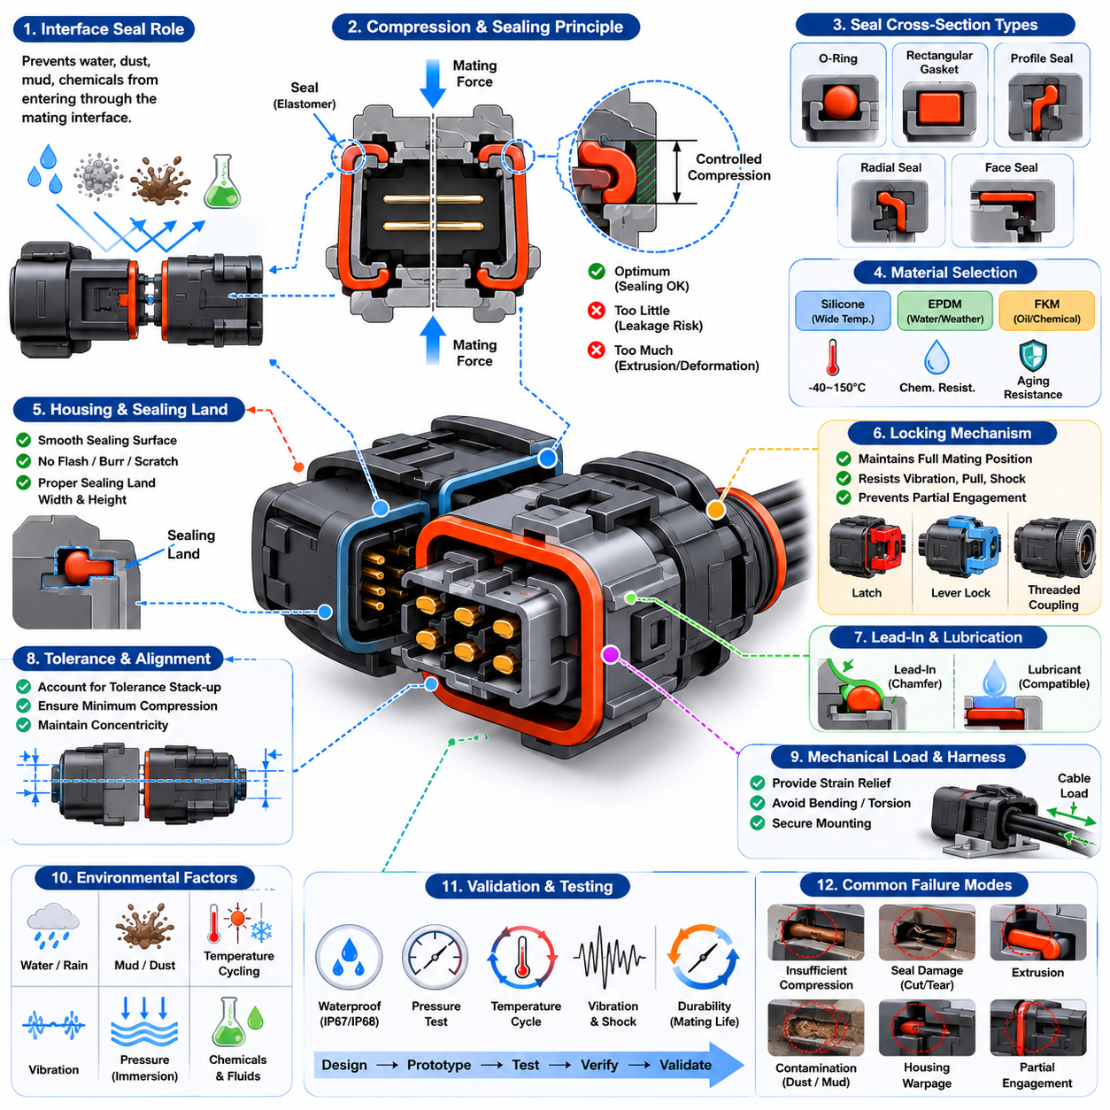
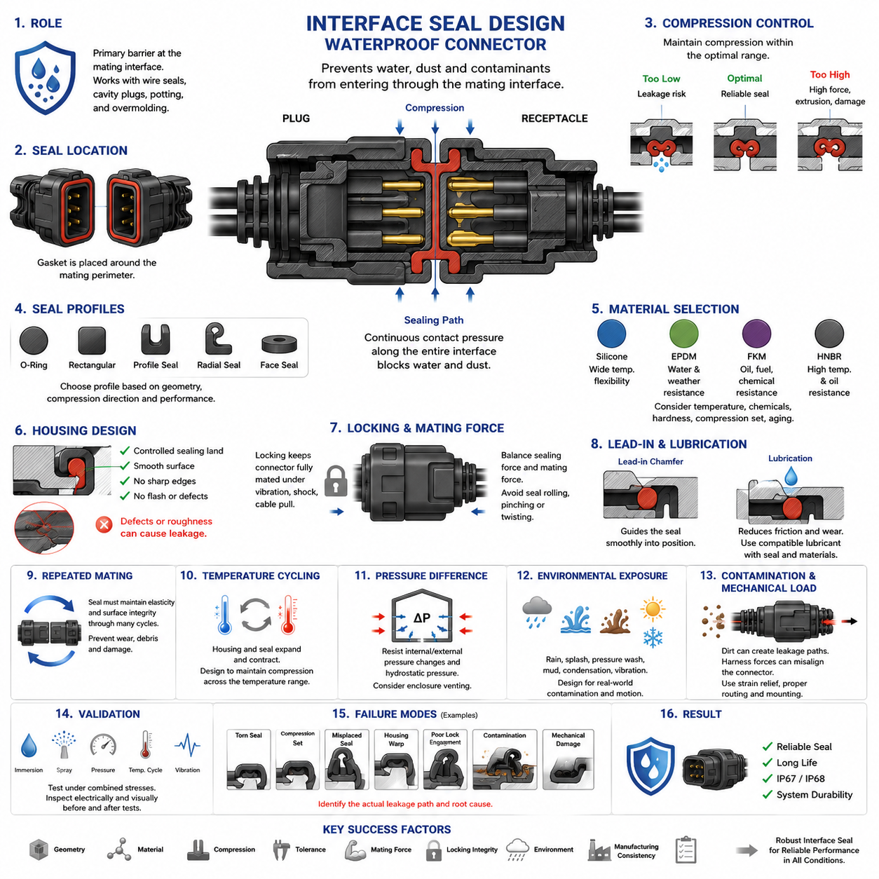
Interface seal design is the primary barrier that prevents water, dust, mud, cleaning fluids, and other contaminants from entering a connector through the mating boundary between two housings. Within waterproof connector engineering, it complements wire seals, cavity plugs, potting, and overmolding, but specifically addresses the perimeter where connector halves meet.
A typical interface seal is formed from an elastomeric gasket positioned around the connector mating perimeter. When the plug and receptacle are fully engaged, housing geometry compresses the gasket and creates continuous contact pressure along the sealing path. Effective sealing therefore depends not simply on the presence of rubber, but on controlled deformation across the complete interface.
Seal compression must remain within a designed operating range. Insufficient compression can leave microscopic leakage paths caused by dimensional tolerance, surface irregularity, vibration, or housing distortion. Excessive compression can create high mating force, permanent set, extrusion, tearing, or accelerated material aging. The housing and seal must therefore be designed together as a mechanical sealing system.
The seal cross-section strongly influences its deformation behavior. O-rings, rectangular gaskets, molded profile seals, radial seals, and axial face seals distribute contact pressure differently. Connector geometry determines whether compression occurs mainly along the mating axis or radially against a surrounding wall. The selected profile must maintain sealing pressure while tolerating manufacturing variation and repeated mating cycles.
Elastomer selection is governed by the environmental conditions expected during the connector lifetime. Silicone rubber provides useful flexibility over broad temperature ranges, while EPDM can offer strong resistance to water and weathering. Fluoroelastomers may be selected where oils, fuels, or aggressive chemicals are important. Material selection must consider temperature, chemical exposure, hardness, compression set, and aging simultaneously.
Seal hardness affects both mechanical robustness and the force required to obtain adequate deformation. A softer material can conform effectively to housing imperfections but may be more susceptible to extrusion, damage, or excessive deformation. A harder material can provide dimensional stability but requires greater force to establish sealing contact. Appropriate hardness is therefore linked directly to connector geometry and allowable mating force.
Housing geometry must provide a controlled sealing land that supports the gasket without creating sharp edges or discontinuities. Parting lines, ejector marks, gate remnants, flash, scratches, and excessive surface roughness can become leakage paths when located within the active sealing region. Mold design and dimensional control are consequently important parts of waterproof connector performance rather than merely manufacturing concerns.
Tolerance stack-up is particularly critical because connector housings, seals, terminals, locking mechanisms, and mounting features all contribute to the final mating position. The design should preserve adequate seal compression at the worst combination of dimensional limits rather than only at nominal dimensions. Statistical tolerance analysis can additionally reveal production conditions that may produce marginal compression before leakage appears in field service.
The locking mechanism performs an important sealing function by maintaining the connector at its intended fully mated position. Latches, lever locks, threaded couplings, or secondary locking structures must resist forces that could partially separate the housings. Even a small loss of engagement can reduce gasket compression, particularly during vibration, cable loading, thermal cycling, or accidental pulling of the harness.
Connector mating force should therefore be evaluated together with sealing force. Increasing gasket compression may improve initial resistance to water intrusion, but it can also raise insertion force beyond acceptable ergonomic or mechanical limits. Lever-assisted connectors and other mechanical mating systems can provide additional force, although their geometry must still prevent seal rolling, pinching, twisting, or uneven compression during engagement.
Lead-in features help guide the interface seal into its operating position without cutting or displacing it. Chamfers and smooth transition surfaces are commonly used so that the gasket progressively deforms rather than encountering an abrupt edge. Poor lead-in geometry can cause localized stretching, seal shaving, folding, or rolling, producing defects that may remain visually hidden after the connector is fully assembled.
Lubrication may be used to reduce friction during assembly and protect the seal from abrasion, but lubricant compatibility must be established with both the elastomer and surrounding connector materials. An incompatible lubricant can cause swelling, softening, cracking, or changes in friction over time. Lubrication should consequently be treated as a controlled engineering and manufacturing parameter rather than an informal assembly aid.
Repeated mating introduces another design challenge because the interface seal experiences friction and cyclic deformation whenever the connector is disconnected and reconnected. The sealing system must retain adequate elasticity and surface integrity throughout the specified mating life. Wear debris, contamination, accidental tool contact, or improper handling can progressively damage the sealing surface even when electrical contacts remain functional.
Temperature cycling produces dimensional changes in both polymer housings and elastomer seals. Differences in thermal expansion can alter compression as the connector moves between cold and hot conditions. At low temperature the seal may become less compliant, while prolonged high-temperature exposure can increase compression set and aging. Robust designs maintain useful contact pressure throughout the specified operating temperature range.
Pressure differences can challenge an apparently well-sealed interface. Rapid temperature changes may produce pressure variation inside an enclosure or connector cavity, while immersion creates external hydrostatic pressure. The interface seal must resist these differential pressures without opening a leakage path. For demanding applications, enclosure venting and connector sealing should be considered together rather than as independent design problems.
Water intrusion is not determined solely by static immersion. Outdoor robots and vehicles may experience rain, splash, wheel spray, pressure washing, mud, condensation, and repeated wet-dry cycles. Dynamic water can attack the seal from changing directions while vibration simultaneously moves the connector. Interface seal design should therefore reflect the real contamination mechanisms of the application instead of relying only on nominal ingress ratings.
Contamination on the gasket or sealing land can defeat an otherwise correct design. Sand grains, metal particles, fibers, grease deposits, or dried mud may prevent continuous surface contact and create capillary leakage paths. Connector placement, protective covers, assembly cleanliness, maintenance procedures, and inspection requirements consequently influence the practical reliability of the interface seal throughout service life.
Mechanical loading from the harness must also be controlled. Cable bending, tension, torsion, or poorly supported harness mass can transmit forces into the connector housing and distort the mating interface. In mobile robots, repeated acceleration and vibration may amplify these loads. Proper strain relief, harness clipping, connector mounting, and routing help preserve the alignment required for uniform seal compression.
Validation should reproduce the combined stresses expected in service. Waterproof performance may be checked through immersion, spray, pressure, thermal cycling, vibration, and environmental exposure, with electrical and visual inspection performed before and after testing. The broader connector structure places interface sealing within waterproofing design and later IP67/IP68 validation, emphasizing that design and verification form a continuous engineering process.
Failure analysis should distinguish between seal-material failure and system-level sealing failure. Leakage may result from torn elastomer, compression set, incorrect seal installation, housing warpage, insufficient latch engagement, tolerance accumulation, contamination, or mechanical damage. Identifying the actual leakage path is essential because simply replacing the gasket may not correct a geometric or assembly-related root cause.
For robotic and AMR applications, interface sealing has direct implications for reliability because connectors are distributed near batteries, motors, sensors, compute modules, and communication devices throughout the machine. The broader electrical architecture includes connector engineering as a dedicated discipline and environmental testing as part of system validation, making sealing performance an important contributor to overall platform durability.
A robust interface seal is ultimately achieved by balancing geometry, material properties, compression, tolerance, mating force, locking integrity, environmental exposure, and manufacturing consistency. Waterproof performance should not be regarded as a property of the gasket alone. It emerges from the interaction of the seal, connector housing, locking mechanism, assembly process, harness installation, and validation strategy across the product lifetime.

05.02. Wire Seal Selection
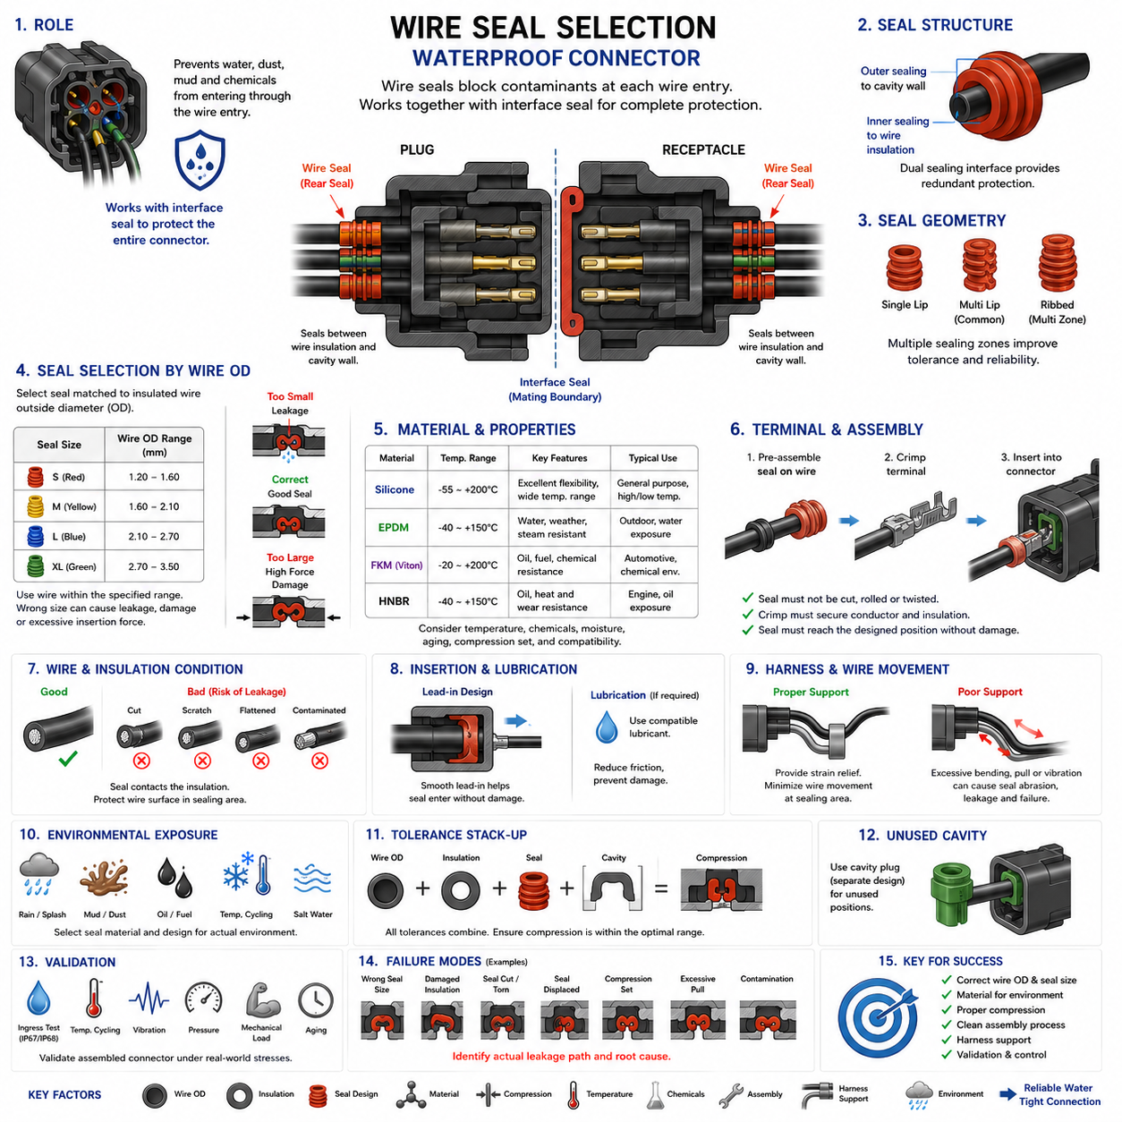
Wire seals prevent environmental contaminants from entering a connector through the individual conductor passages at the rear of the housing. While an interface seal protects the mating boundary between connector halves, wire seals close the annular space between each insulated wire and its corresponding cavity. The waterproofing structure therefore depends on both sealing locations working together as complementary barriers.
A typical wire seal is an elastomeric component installed around the insulated conductor before the terminal is inserted into the connector housing. As the wire and terminal assembly enters the cavity, the seal is positioned within a defined sealing region. Its outer surface contacts the cavity wall while its inner surface compresses around the wire insulation, producing two simultaneous sealing interfaces.
Seal selection begins with the outside diameter of the insulated wire rather than conductor cross-sectional area alone. Two wires having the same copper area can have different insulation thicknesses and therefore different overall diameters. The selected seal must provide sufficient radial interference around the actual insulation diameter while remaining compatible with the dimensions of the connector cavity.
Wire seals are commonly specified for a defined insulation diameter range. A wire near the lower limit requires the seal to deform sufficiently inward to maintain contact pressure, while a wire near the upper limit produces greater expansion and assembly force. Selecting a wire outside the specified range can cause leakage, excessive insertion force, seal damage, or permanent deformation during service.
The outer diameter and geometry of the seal must also match the connector cavity. When the terminal and wire are fully installed, the housing geometry constrains the seal and establishes radial compression against its exterior surface. Incorrect cavity compatibility can leave an external leakage path even when the inner diameter appears to fit the wire correctly, making both interfaces equally important.
Seal geometry often incorporates multiple flexible ribs or sealing lips rather than relying on one broad contact surface. These features create several localized barriers along the wire and cavity surfaces. Multiple sealing zones can improve tolerance accommodation and provide redundancy against small surface imperfections, although their dimensions must still remain within the intended compression and deformation range.
Elastomer hardness affects conformity, insertion force, mechanical stability, and long-term sealing pressure. Softer compounds can conform readily to variations in wire insulation but may be vulnerable to excessive deformation or damage. Harder compounds provide greater structural stability but can increase assembly force and may accommodate dimensional variation less effectively. Hardness must therefore be matched to seal geometry and application conditions.
Material selection must consider the complete environmental exposure of the connector. Silicone-based materials are useful where broad temperature flexibility is required, while other elastomers may provide improved resistance to water, oils, fuels, cleaning chemicals, or weathering. Chemical compatibility must include both external contaminants and substances that may already exist on the wire insulation or during manufacturing.
Compatibility between the wire seal and insulation material is especially important. PVC, XLPE, TPE, silicone, and other insulation systems have different hardness, surface friction, chemical behavior, and temperature characteristics. A sealing material that performs correctly against one insulation type may exhibit different friction, compression, adhesion, swelling, or long-term interaction when used with another.
The condition of the wire insulation directly influences sealing performance because the seal contacts the insulation rather than the conductor. Cuts, scratches, flattened regions, extrusion defects, contamination, or excessive surface irregularity can create leakage paths beneath the seal. Wire preparation and handling must therefore protect the insulation within the region that will become the active sealing surface.
Terminal crimping must be coordinated with seal placement. In sealed terminal systems, the wire seal is normally positioned before the terminal crimping process, and the terminal may include dedicated features for supporting or retaining the seal. The crimp operation must secure the conductor and insulation correctly without crushing, cutting, displacing, or excessively deforming the sealing element.
The seal must also survive terminal insertion into the connector housing. Excessive friction between the elastomer and cavity wall can cause the seal to roll, stretch, tear, or remain outside its intended position. Appropriate lead-in geometry, controlled insertion alignment, and compatible lubrication can reduce these risks while helping the seal reach its final position without mechanical damage.
Lubrication requires careful control because it affects insertion force and long-term material behavior. A suitable lubricant can reduce friction between the seal, wire insulation, and housing, but an incompatible substance may cause swelling, softening, cracking, or altered sealing pressure. Manufacturing processes should therefore define lubricant type, quantity, application location, and material compatibility where lubrication is required.
Wire movement after assembly presents another challenge. Harness vibration, bending, pulling, and torsional loads can cause the conductor to move relative to the seal. Repeated motion at the sealing interface may produce abrasion or progressively reduce sealing effectiveness. Proper strain relief and harness support are therefore necessary to prevent external cable loads from being transferred directly into the sealed cavity.
The wire should enter the connector cavity with appropriate alignment. Severe bending immediately behind the connector can push the wire against one side of the seal, creating asymmetric compression and potentially opening a leakage path on the opposite side. Harness routing should provide sufficient straight length near the connector and avoid mechanical configurations that continuously side-load the wire seal.
Temperature cycling affects both the elastomer and wire insulation. Their different coefficients of thermal expansion can change the radial interference between the two materials as temperature varies. At low temperatures the seal may become less compliant, while prolonged high-temperature exposure can increase compression set or aging. Selection must preserve sealing pressure across the specified operating temperature range.
Environmental exposure can involve considerably more than clean water. Automotive, industrial, outdoor robotic, and AMR connectors may encounter rain, splash, mud, dust, detergents, oils, coolants, salt-containing water, and repeated wet-dry cycles. The wire seal material and geometry should therefore be evaluated against the actual environmental profile rather than selected solely from a nominal waterproof classification.
Manufacturing tolerance must be considered across the wire, insulation, seal, terminal, and housing cavity. Each component may individually satisfy its drawing while their combined dimensional extremes produce insufficient or excessive compression. Worst-case tolerance analysis helps establish whether adequate sealing remains available across the complete production range rather than only in nominal prototype assemblies.
Connector families frequently use different seal sizes or identification colors to accommodate several wire diameter ranges within similar cavities. Correct part selection becomes a manufacturing-control issue because visually similar seals may not be interchangeable. Assembly documentation, part-number control, color coding, inspection, and error-proofing methods can reduce the risk of installing a seal intended for another wire size.
Unused connector cavities require different treatment because no insulated wire is present for a normal wire seal to compress against. These locations are typically addressed with dedicated cavity plugs, which are treated separately within the waterproofing design structure. Wire seal selection should therefore be coordinated with cavity population so that every rear-entry path has an appropriate sealing solution.
Validation should examine assembled connectors rather than evaluating seal material independently. Water ingress testing can be combined with temperature cycling, vibration, pressure exposure, mechanical loading, and aging to determine whether sealing remains effective after realistic stresses. Subsequent IP67/IP68 validation provides system-level evidence that the complete connector sealing architecture satisfies its intended environmental requirement.
Failure analysis should identify whether leakage occurs between the seal and wire, between the seal and cavity, or through damage to the sealing element itself. Typical causes include incorrect wire diameter, wrong seal selection, damaged insulation, torn sealing lips, incomplete terminal insertion, seal displacement, contamination, compression set, or excessive harness loading. Locating the actual leakage path is essential for determining the root cause.
For robotic electrical systems, reliable wire sealing protects distributed power, communication, sensing, and control connections from environmental degradation. Mobile platforms can expose harnesses to vibration, repeated motion, water, dust, and large temperature changes, making wire-to-connector transitions particularly vulnerable. The broader robotics electrical architecture consequently treats connector engineering as a dedicated discipline supporting overall system reliability.
Effective wire seal selection ultimately requires coordinated control of wire insulation diameter, cavity geometry, seal dimensions, elastomer properties, terminal compatibility, compression, temperature, chemical resistance, assembly processes, and harness loading. A waterproof connector is therefore not achieved merely by adding a seal; reliable performance emerges when every wire entry is engineered as a controlled mechanical and environmental interface.

05.03. Cavity Plug Application
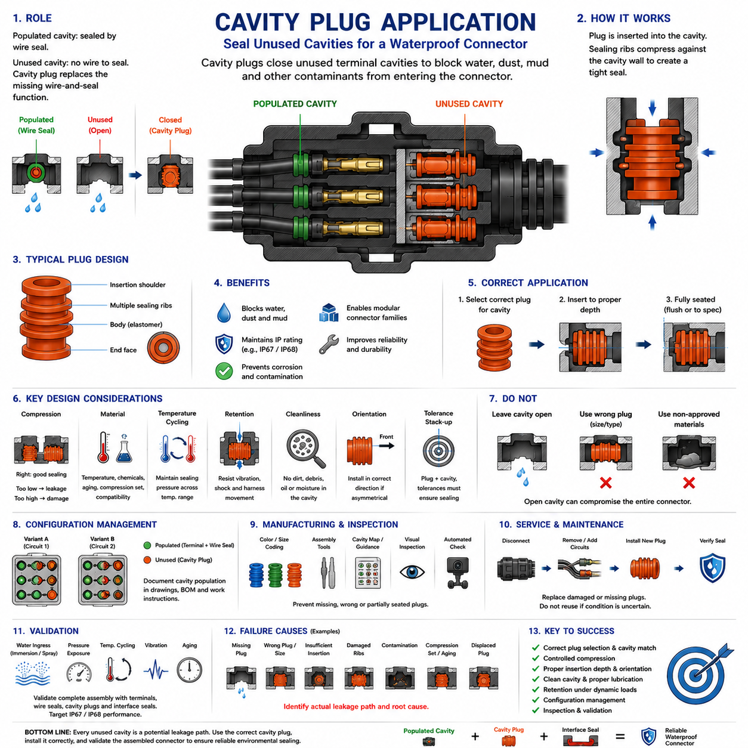
Cavity plugs are sealing components used to close unused terminal cavities in environmentally sealed connectors. A populated cavity is normally protected by the wire seal surrounding its insulated conductor, but an unused cavity contains no wire to complete that sealing interface. The cavity plug replaces the missing wire-and-seal function and prevents water, dust, mud, and other contaminants from entering through the open rear passage.
The need for cavity plugs results directly from modular connector architecture. A connector housing may provide more terminal positions than a particular harness configuration requires, allowing one housing family to support multiple electrical variants. Every unpopulated position, however, represents a potential environmental leakage path unless it is intentionally sealed. Waterproofing design must therefore account for both populated and unused cavities.
A cavity plug typically consists of an elastomeric or elastomer-compatible molded component dimensioned to fit the same sealing region used by the wire-entry system. When inserted correctly, its external sealing surfaces contact the cavity wall and generate controlled radial compression. Unlike a wire seal, the plug does not require an insulated conductor through its center because the component itself forms a complete barrier across the unused passage.
Plug geometry must correspond to the specific connector cavity rather than merely approximate its diameter. Sealing ribs, insertion depth, shoulder position, retention features, and contact surfaces are designed around the housing geometry. A plug that appears physically capable of entering a cavity may still provide insufficient compression or incorrect axial positioning, so connector-manufacturer compatibility and specified part numbers should be respected.
Multiple sealing ribs are commonly useful because they create successive barriers between the environment and connector interior. Each rib deforms against the cavity wall and contributes localized contact pressure. This arrangement can tolerate small dimensional variations and surface irregularities better than a single narrow sealing line, provided that the plug is inserted to the intended depth and the ribs remain undamaged.
Compression is fundamental to cavity plug performance. Insufficient interference between the plug and cavity can leave microscopic leakage paths, especially under vibration, pressure changes, or temperature cycling. Excessive interference can increase insertion force, damage sealing ribs, deform the plug, or make correct installation difficult. Plug and cavity dimensions must therefore establish a controlled sealing range throughout production tolerances.
Material properties should be compatible with the connector's environmental specification. The plug may experience water, humidity, dust, oils, cleaning agents, salt-containing moisture, temperature extremes, and long-term aging. Elastomer hardness, chemical resistance, compression set, thermal behavior, and compatibility with the connector housing should therefore be considered together rather than selecting the component only by physical dimensions.
Temperature cycling can alter sealing pressure because the plug and connector housing may expand and contract differently. At low temperatures an elastomer can lose flexibility, while prolonged high-temperature exposure can increase aging and compression set. A suitable cavity plug must retain enough elastic recovery and contact pressure to preserve sealing performance across the connector's specified operating temperature range.
Insertion depth is particularly important. A plug installed too shallow may not position its sealing ribs within the designed cavity sealing region, while excessive insertion can move it beyond the intended contact surfaces or interfere with internal structures. Assembly specifications should therefore define the final seating position clearly enough that production personnel and inspection systems can distinguish correct installation from partial insertion.
Insertion orientation must also be controlled when the cavity plug has directional geometry. Some plug designs may include different leading and trailing profiles, shoulders, tapered surfaces, or retention features. Installing such a component backward can increase insertion force or prevent correct sealing engagement. Assembly instructions should identify orientation wherever the component is not mechanically symmetrical.
Lead-in geometry within the connector housing helps the cavity plug enter without cutting, folding, or shaving its sealing ribs. The plug should move smoothly through the entry region and reach its sealing position without excessive friction. Sharp edges, molding defects, burrs, contamination, or damaged cavity surfaces can compromise the plug even when the selected component is otherwise dimensionally correct.
Lubrication may be used when specified by the connector system to reduce insertion friction and protect elastomeric surfaces. Any lubricant must be compatible with the plug material, housing polymer, neighboring wire seals, and expected environmental conditions. Excessive or inappropriate lubricant can change material properties or complicate contamination control, so its application should be treated as a defined manufacturing process.
Cavity cleanliness is critical before plug installation. Dust, metal particles, wire fragments, grease, moisture, or molding debris trapped between the sealing ribs and cavity wall can create a leakage path. Because contamination may become hidden after insertion, prevention is more effective than later inspection. Connector storage, handling, assembly-area cleanliness, and component protection therefore contribute directly to sealing reliability.
Cavity plugs should be installed in every unused position required by the connector sealing specification. Leaving even one open cavity can compromise the environmental protection of the complete connector because water entering through that passage may reach neighboring terminals and conductive surfaces. Waterproof performance must therefore be evaluated at connector level rather than assuming that individually sealed populated wires are sufficient.
Harness configuration management becomes important when different product variants use different cavity populations. A cavity that is populated in one robot configuration may remain unused in another, requiring a plug only in the second variant. Harness drawings, connector tables, bills of materials, assembly instructions, and configuration records should identify populated and plugged positions consistently to prevent production errors.
Changes to circuit allocation can also affect sealing requirements. If a terminal is removed during a design revision, the newly unused cavity must not simply be left open. Conversely, when a previously unused position becomes populated, its cavity plug must be removed and replaced by the correct terminal and wire-sealing arrangement. Electrical change control should therefore include an explicit review of connector sealing configuration.
Manufacturing error-proofing can significantly improve cavity plug reliability. Plug color, size differentiation, insertion tools, cavity maps, visual standards, and automated inspection may help operators identify missing, incorrect, or partially seated plugs. This is particularly valuable for connectors containing many positions, where a single omitted plug may be difficult to detect after the harness has been installed in the equipment.
Retention during vibration and mechanical shock must also be considered. A plug that gradually backs out of its sealing position can lose compression even though it was installed correctly during manufacturing. Connector geometry and plug design should provide sufficient retention for expected dynamic loads, while nearby harness movement or service operations should not repeatedly disturb the plugged cavities.
Service procedures require similar control. When technicians disconnect connectors, add circuits, remove terminals, or repair harnesses, cavity plugs may be lost, damaged, contaminated, or installed incorrectly during reassembly. Service documentation should specify replacement requirements and discourage reuse when plug condition cannot be assured. Environmental sealing must be restored before the connector returns to operation.
Unused cavities should not be improvised with unrelated materials such as generic rubber pieces, adhesives, tape, or sealant unless the connector system explicitly specifies such a method. These substitutes may not provide controlled compression, material compatibility, retention, or serviceability. A dedicated cavity plug provides a predictable mechanical interface that can be validated together with the connector housing.
Validation should be performed on the complete assembled connector containing the intended combination of populated terminals, wire seals, cavity plugs, and interface seals. Water ingress, immersion, spray, pressure, temperature cycling, vibration, and aging can expose weaknesses that are not apparent during visual inspection. The chapter structure subsequently addresses IP67/IP68 validation as the system-level confirmation of waterproof connector performance.
Failure analysis should determine whether leakage resulted from a missing plug, incorrect plug type, insufficient insertion, damaged sealing ribs, contamination, dimensional mismatch, compression set, housing damage, or plug displacement. Identifying the actual leakage path prevents corrective actions from focusing only on the visible component when the underlying problem may originate from assembly control or cavity geometry.
In robotic and AMR electrical systems, cavity plugs are small components with potentially system-level consequences. Connectors located near motors, batteries, sensors, communication equipment, and compute hardware can experience vibration, water, dust, and repeated maintenance. An unsealed unused cavity can therefore undermine the environmental protection of otherwise correctly designed electrical connections throughout the platform.
Reliable cavity plug application ultimately depends on treating every unused connector position as an engineered sealing interface. Correct plug selection, cavity compatibility, controlled compression, insertion depth, material resistance, cleanliness, retention, configuration management, inspection, and environmental validation must operate together. In a waterproof connector, an unused electrical position is not an unused mechanical path; it must remain deliberately and reliably sealed.

05.04. Potting and Overmolding
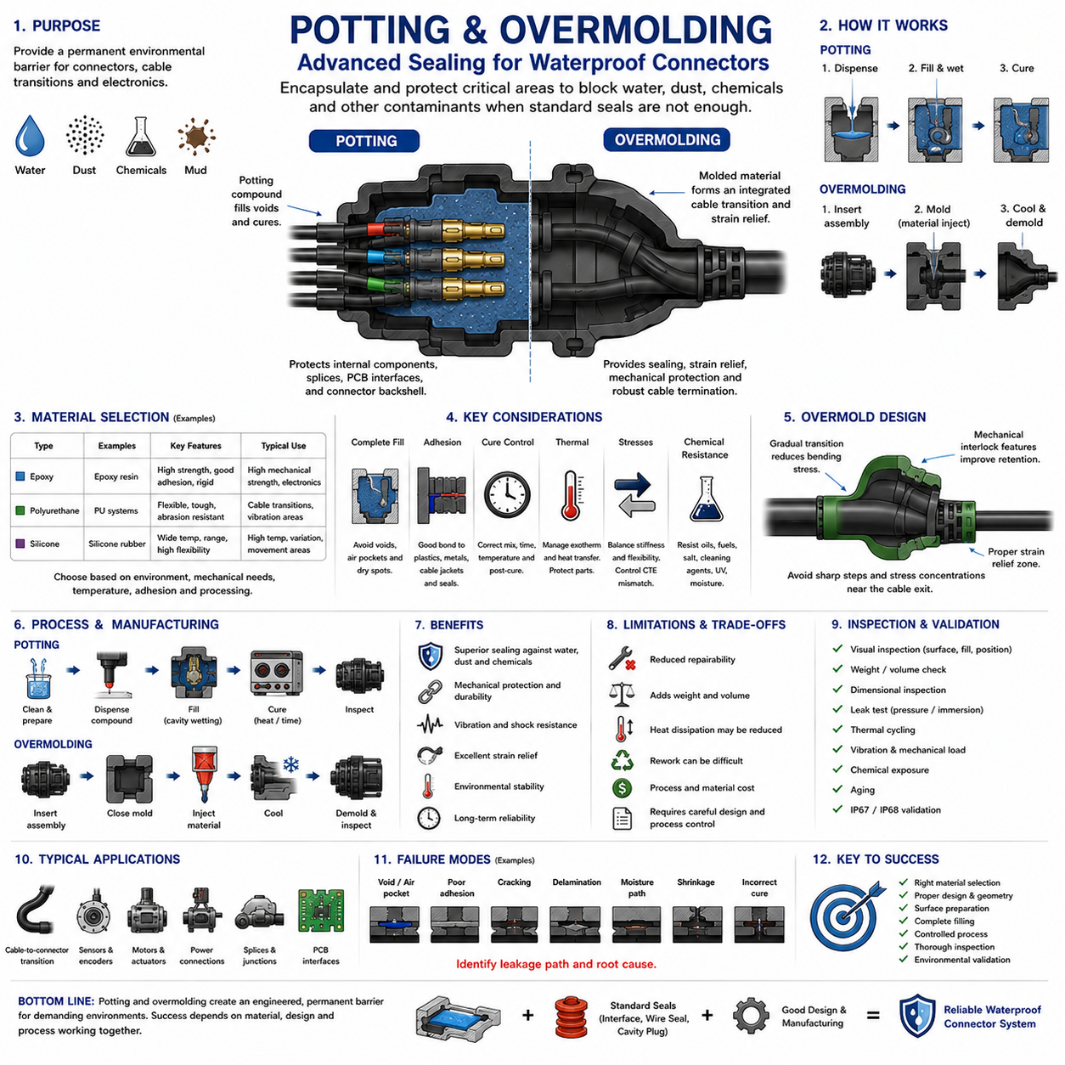
Potting and overmolding are sealing techniques used when conventional interface seals, wire seals, and cavity plugs are insufficient or when a more permanent environmental barrier is required. Within waterproof connector design, these methods encapsulate conductors, terminals, cable transitions, or connector backshell regions to restrict paths through which water, dust, chemicals, and other contaminants can migrate.
Potting generally involves introducing a liquid or semi-liquid compound into a cavity surrounding electrical components and allowing it to cure into a solid or resilient mass. The cured material fills internal voids that might otherwise become leakage paths. Depending on the application, potting can protect terminal regions, cable entries, splices, printed circuit interfaces, or the rear portion of a connector assembly.
The effectiveness of potting depends strongly on complete material filling. Air pockets, incomplete wetting, narrow gaps, and trapped contamination can create discontinuities through which moisture may eventually migrate. Potting geometry should therefore allow the compound to flow around wires and components without trapping significant voids, while the manufacturing process must provide controlled dispensing, filling, and curing conditions.
Potting compounds are commonly based on epoxy, polyurethane, or silicone chemistries, each offering different mechanical and environmental characteristics. Epoxy systems can provide high strength and strong adhesion, polyurethane can provide useful flexibility and environmental resistance, and silicone systems can accommodate substantial temperature variation and movement. Selection must reflect the specific connector and operating environment.
Material stiffness is particularly important because wires, housings, terminals, and potting compounds expand, contract, and move differently. A very rigid compound can transfer mechanical or thermal stress into conductors and termination points, while an excessively soft material may provide insufficient support. The selected material should balance sealing, adhesion, mechanical reinforcement, flexibility, and thermal expansion behavior.
Adhesion between the potting compound and surrounding surfaces determines whether a continuous environmental barrier is maintained. Connector polymers, cable jackets, wire insulation, metals, and existing elastomer seals may present very different surface energies. A compound that bonds well to one material may separate from another, creating an interfacial leakage path even though the bulk potting material remains undamaged.
Surface preparation therefore has a major influence on reliability. Oil, mold release agent, dust, moisture, fingerprints, oxidation, or processing residue can reduce adhesion. Depending on the material system, cleaning, drying, surface activation, primer application, or other controlled preparation may be necessary. The production process should define these requirements rather than relying on visually clean surfaces alone.
Cure behavior must also be controlled. Potting materials may depend on time, temperature, humidity, mixing ratio, or chemical reaction to achieve their specified properties. Incorrect mixing or incomplete curing can produce soft regions, poor adhesion, internal stress, or reduced chemical resistance. Manufacturing controls should consequently address dispensing ratio, mixing quality, cure temperature, cure duration, and post-cure requirements.
Exothermic heat generated during curing can become important when relatively large volumes of reactive material are used. Excessive internal temperature may damage connector polymers, wire insulation, electronic components, or neighboring seals. Potting volume, material chemistry, cure schedule, and thermal dissipation should therefore be considered together, especially where sensitive electronics are located close to the encapsulated region.
Overmolding differs from conventional potting because a material is molded directly around a cable, connector, terminal assembly, or other component to create an integrated external structure. The process can simultaneously provide environmental sealing, strain relief, mechanical protection, and a controlled transition between cable and connector. It is frequently used where a robust and repeatable cable termination is desired.
An overmolded cable-to-connector transition can reduce the number of exposed interfaces through which contaminants can enter. Instead of relying only on separate boots, seals, or mechanical clamps, the molded material surrounds the transition region and can become part of the finished cable assembly. Successful sealing still depends on adhesion, geometric interlock, material compatibility, and controlled molding conditions.
Overmolding materials must be compatible with the cable jacket and connector housing. Thermoplastic elastomers, polyurethane-based systems, and other moldable materials can provide different combinations of flexibility, abrasion resistance, chemical resistance, and processability. Processing temperature is also important because the molding operation must not thermally damage insulation, housings, seals, terminals, or embedded electronics.
Mechanical interlocking features can improve retention when chemical adhesion alone is insufficient. Grooves, undercuts, ribs, holes, and shaped surfaces can allow the potting or overmolding material to mechanically engage the surrounding structure. These features can improve resistance to pulling and separation, but they should avoid sharp stress concentrations and should not create new voids or difficult-to-fill regions.
Strain relief is an important advantage of properly designed overmolding. Cable bending loads should transition gradually from the flexible cable into the relatively rigid connector rather than concentrating at one location. The overmold geometry can provide a controlled stiffness gradient, reducing repeated bending at the conductor termination and improving resistance to vibration, pulling, torsion, and handling loads.
However, excessive stiffness near the cable exit can move the bending concentration rather than eliminate it. If the overmold becomes abruptly rigid, cyclic cable motion may concentrate immediately beyond its edge and eventually damage the jacket or conductor. Transition length, wall thickness, material hardness, and cable flexibility should therefore be designed together to manage mechanical fatigue.
Potting and overmolding can also influence thermal behavior. Encapsulation changes the pathways through which heat leaves conductors, terminals, electronics, and connector contacts. A material that protects against water may simultaneously reduce convection or alter conduction. For current-carrying or heat-generating assemblies, thermal effects should be evaluated so that environmental protection does not unintentionally increase operating temperature.
Electrical properties can become important when potting material surrounds exposed conductive regions. Dielectric strength, volume resistivity, moisture absorption, and tracking resistance may influence insulation performance. High-voltage assemblies require particular attention to voids because trapped air or poorly bonded regions can produce locally different electric-field conditions compared with a continuous dielectric encapsulation.
Pressure and moisture migration require consideration even when the encapsulated region appears completely filled. Water can travel along interfaces between cable jackets, insulation, conductors, and encapsulant if adhesion is inadequate. Capillary migration may allow moisture to bypass a substantial length of material. Effective sealing therefore requires interruption of interfacial leakage paths rather than simply maximizing encapsulation thickness.
Environmental compatibility should reflect actual service exposure. Outdoor robots, AMRs, industrial equipment, and vehicles may encounter rain, immersion, mud, salt-containing water, oils, coolants, cleaning agents, UV exposure, vibration, and temperature cycling. A material suitable for indoor moisture protection may not remain stable under combined chemical, thermal, and mechanical stresses encountered in field operation.
Repairability represents an important tradeoff. Conventional sealed connectors can often be depinned, serviced, and resealed, whereas heavily potted or overmolded assemblies may become effectively non-serviceable. Removing cured material can damage wires, terminals, or housings and may not restore the original sealing condition. Designers should therefore decide whether environmental robustness or field repairability has higher priority for the application.
Manufacturing repeatability is critical because potting and overmolding performance depends heavily on process control. Material batch condition, mixing ratio, dispensing volume, mold temperature, injection parameters, component positioning, cure conditions, and cleanliness can all affect the finished seal. Production validation should therefore evaluate the process window and not only the performance of a small number of ideal prototypes.
Inspection methods depend on the structure being produced. External overmolding defects such as incomplete fill, flash, cracks, surface voids, or poor cable positioning may be visible, while internal potting voids and interfacial separation can remain hidden. Weight checks, dimensional inspection, process monitoring, section analysis, leak testing, or other validation methods may be required according to the reliability level of the application.
Validation should evaluate the complete assembly after environmental and mechanical stress. Water ingress or immersion testing can be combined with temperature cycling, vibration, mechanical loading, chemical exposure, and aging. The waterproofing chapter subsequently addresses IP67/IP68 validation, emphasizing that potting or overmolding is only one element of the complete connector environmental protection strategy.
Failure modes include incomplete filling, trapped air, poor adhesion, cracking, material shrinkage, delamination, incorrect curing, chemical degradation, cable separation, and fatigue near the overmold transition. Leakage analysis should determine whether moisture passed through the bulk material, an internal void, or an interface between different materials. This distinction is necessary for effective root-cause correction.
For robotic electrical architectures, potting and overmolding can provide valuable protection at exposed cable transitions, sensors, motors, power connections, and permanently assembled modules. These systems frequently experience vibration, cable movement, water, dust, and repeated temperature changes. The broader robotics electrical structure places connector engineering within the platform-level electrical architecture, making durable environmental sealing an important reliability function.
Reliable potting and overmolding ultimately require coordinated control of material chemistry, adhesion, geometry, surface preparation, filling, curing, molding parameters, mechanical flexibility, thermal behavior, environmental resistance, inspection, and validation. These techniques should not be treated simply as adding material around a connector; they are engineered encapsulation processes whose performance depends on both product design and manufacturing discipline.

05.05. IP67/IP68 Validation Test
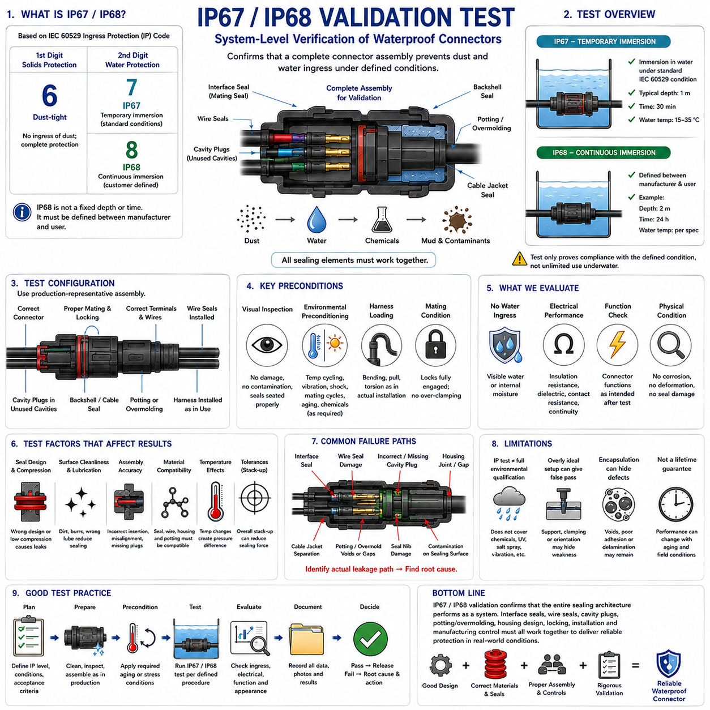
IP67 and IP68 validation testing verifies whether a completed connector assembly provides the intended level of protection against solid particles and water ingress. Within the connector engineering structure, this validation follows interface seal design, wire seal selection, cavity plug application, and potting or overmolding, making it the system-level confirmation of the waterproofing design rather than an evaluation of one sealing component alone.
The IP designation is based on the ingress protection classification defined by IEC 60529. The first characteristic numeral identifies protection against access and solid foreign objects, while the second identifies protection against water. For IP67 and IP68 connectors, the first numeral 6 represents the highest dust-protection category, requiring a dust-tight enclosure under the applicable test conditions.
The second numeral distinguishes the water protection requirement. IP67 addresses protection against temporary immersion in water under standardized conditions, whereas IP68 addresses protection during continuous or more severe immersion conditions agreed between the manufacturer and user. Consequently, IP68 should not be interpreted simply as a universally fixed deeper-water version of IP67 without reviewing the specified test conditions.
Validation must begin with a clearly defined test configuration. Connector type, mating condition, terminal population, wire sizes, wire seals, unused cavity plugs, interface seals, backshells, cable exits, potting, and overmolding should represent the intended production assembly. Testing an idealized connector configuration that differs from the released harness may fail to represent the actual environmental sealing performance.
The connector should normally be tested in the condition relevant to its intended environmental rating. A mated connector relies on the interface seal between the two housings, while rear-entry protection depends on wire seals, cavity plugs, and any additional encapsulation. If unmated protection is required, that condition requires its own sealing strategy because the normal mating-interface barrier may no longer be present.
Dust protection evaluates whether fine particles can enter the enclosure through sealing interfaces or assembly gaps. The effectiveness of the interface seal, wire entries, plugged cavities, housing joints, and other potential paths must be considered together. Dust intrusion is particularly important because deposited particles can later retain moisture, contaminate electrical contacts, interfere with locking structures, or accelerate mechanical wear.
Water immersion testing introduces hydrostatic pressure against the connector sealing system. Even relatively modest immersion depth creates a pressure difference between the surrounding water and internal cavity. Water can exploit small discontinuities that may not be apparent during visual inspection, including damaged sealing lips, insufficient compression, housing distortion, contaminated surfaces, incomplete engagement, or interfacial paths around wires.
IP67 validation commonly involves temporary immersion according to the applicable IEC 60529 conditions. The exact specimen arrangement, water level, duration, and other procedural details should follow the relevant standard and product specification rather than being improvised. Passing the test demonstrates compliance with the defined test condition; it does not imply unlimited underwater operating capability.
IP68 validation requires particularly careful specification because immersion conditions are not represented by one universal depth and duration for every product. The applicable requirement should define the intended water depth or pressure, exposure duration, temperature conditions, and acceptance criteria. Connector drawings and validation documents should therefore record the actual IP68 test severity instead of stating only the IP code.
Water temperature and specimen temperature can influence test severity. Temperature differences may produce pressure changes inside sealed cavities, and subsequent cooling can create a tendency to draw external moisture inward through marginal sealing paths. For applications exposed to rapid thermal changes, immersion testing combined with temperature conditioning can provide a more representative assessment than a simple room-temperature water test.
Preconditioning is useful because newly manufactured seals may perform differently from components that have experienced realistic aging. Temperature cycling, vibration, mechanical shock, mating cycles, cable movement, chemical exposure, or thermal aging can be applied before ingress testing when required by the product validation plan. This approach determines whether sealing remains effective after degradation mechanisms have acted on the connector.
Vibration is particularly relevant to automotive, industrial, and robotic connectors because it can alter terminal position, harness loading, latch engagement, and sealing interfaces. A connector that passes immersion when new and stationary may leak after repeated dynamic loading. Sequential environmental validation can therefore reveal interactions between mechanical durability and waterproof performance that isolated tests may overlook.
Harness loading should also be represented where appropriate. Pulling, bending, torsion, or side loading of cables can distort wire seals or connector housings and reduce local sealing compression. Test fixtures should avoid unrealistic support conditions that make the specimen artificially robust. The objective is to reproduce the mechanical boundary conditions expected when the connector is installed in the actual equipment.
Connector mating condition must be controlled before testing. Primary locks, lever locks, threaded couplings, connector position assurance features, and secondary locking devices should be fully engaged according to the product design. Partial mating can reduce interface-seal compression and create leakage paths, while excessive external clamping during testing can artificially improve performance by applying forces not present in normal service.
Inspection before testing establishes the initial condition of the specimen. Seals should be checked for cuts, rolling, displacement, contamination, or incorrect installation, while housings should be examined for cracks, flash, deformation, and sealing-surface damage. Wire insulation and cavity plugs should also be verified because defects in these areas can create rear-entry leakage independent of the mating interface.
Acceptance criteria should be established before the test begins. Depending on the connector and system requirement, evaluation may include visible water ingress, internal moisture, insulation resistance, dielectric performance, contact resistance, electrical continuity, corrosion evidence, or functional operation. A connector should not be declared successful solely because water is not immediately visible externally after removal from the test chamber.
Electrical measurements before and after environmental exposure provide evidence of whether ingress or mechanical stress has affected connector function. Contact resistance can reveal degradation at conductive interfaces, while insulation resistance or dielectric testing can detect moisture-related loss of electrical isolation. Functional circuits may additionally be monitored when the connector forms part of a larger validated assembly.
Leakage-path analysis is important when a specimen fails. Water found inside a connector does not by itself identify the defective component. The path may originate at the interface seal, a wire seal, an unused cavity, a housing joint, a cable interface, or a potted region. Controlled disassembly and inspection should therefore preserve evidence so that the actual entry route can be identified.
Failure analysis should distinguish design weakness from manufacturing variation. Incorrect seal dimensions, inadequate compression, poor housing geometry, or insufficient retention indicate potential design problems, whereas damaged seals, missing cavity plugs, incomplete terminal insertion, contamination, or incorrect assembly may indicate process-control failures. Both categories must be addressed because production connectors must tolerate realistic manufacturing variation.
Repeated failures near dimensional limits may indicate a tolerance-stack problem rather than an isolated defective component. Housing cavity dimensions, seal dimensions, wire outside diameter, plug size, mating position, and molding variation can combine to reduce sealing pressure. Validation specimens should therefore represent relevant tolerance conditions whenever the reliability target requires confidence beyond nominal assemblies.
Potting and overmolding require similar scrutiny during ingress validation. External encapsulation may appear continuous while internal voids, poor adhesion, delamination, or capillary paths remain hidden. Environmental cycling can open interfaces between encapsulant, cable jackets, wires, and housings, allowing moisture migration. Waterproof validation should consequently evaluate the complete encapsulated transition rather than only its visible surface.
IP testing should be distinguished from broader environmental qualification. An IP67 or IP68 result addresses defined ingress-protection conditions but does not by itself establish resistance to salt spray, fuels, oils, detergents, ultraviolet exposure, vibration, thermal aging, or every field environment. The connector engineering structure separately treats chemical resistance, vibration, temperature, corrosion, and waterproofing because these stresses require complementary validation.
For outdoor robots and AMRs, field exposure can combine water, dust, mud, vibration, cable movement, temperature changes, and pressure washing in ways that are more complex than a single laboratory immersion test. IP validation provides an essential standardized baseline, but product qualification should also reproduce the installation orientation, harness routing, mechanical loading, and environmental combinations expected on the robot.
Test documentation should provide traceability from the specimen to the final engineering decision. Connector part numbers, seal and plug specifications, wire sizes, assembly configuration, sample condition, preconditioning, test parameters, acceptance criteria, measured results, photographs, failure observations, and disposition should be recorded. This information allows later design or manufacturing changes to be evaluated against the validated baseline.
Design changes that affect sealing should trigger review of existing validation evidence. Changing housing material, wire diameter, seal compound, cavity plug, lubricant, terminal configuration, cable jacket, potting material, overmold geometry, or supplier can alter the sealing system even when the connector interface appears unchanged. Change control should determine whether analysis, partial revalidation, or complete ingress testing is required.
For robotic electrical architectures, waterproof connector validation protects distributed power, sensing, communication, control, and computing interfaces from environmental degradation. The broader electrical architecture places connector engineering within a system containing batteries, motors, sensors, compute hardware, and communication networks, so connector ingress failures can propagate beyond a single electrical connection into platform-level reliability problems.
Successful IP67/IP68 validation ultimately demonstrates the performance of an integrated sealing architecture. Interface seals, wire seals, cavity plugs, potting or overmolding, housing geometry, locking, harness installation, manufacturing controls, and environmental durability must function together. The objective is not merely to pass an immersion event, but to establish repeatable evidence that the production connector maintains its required environmental protection throughout its intended service conditions.

