Volume 04. Fuse, Relay, and Power Distribution Unit

Chapter 10. Robot Power Protection

10.01. AMR Power Protection Pattern
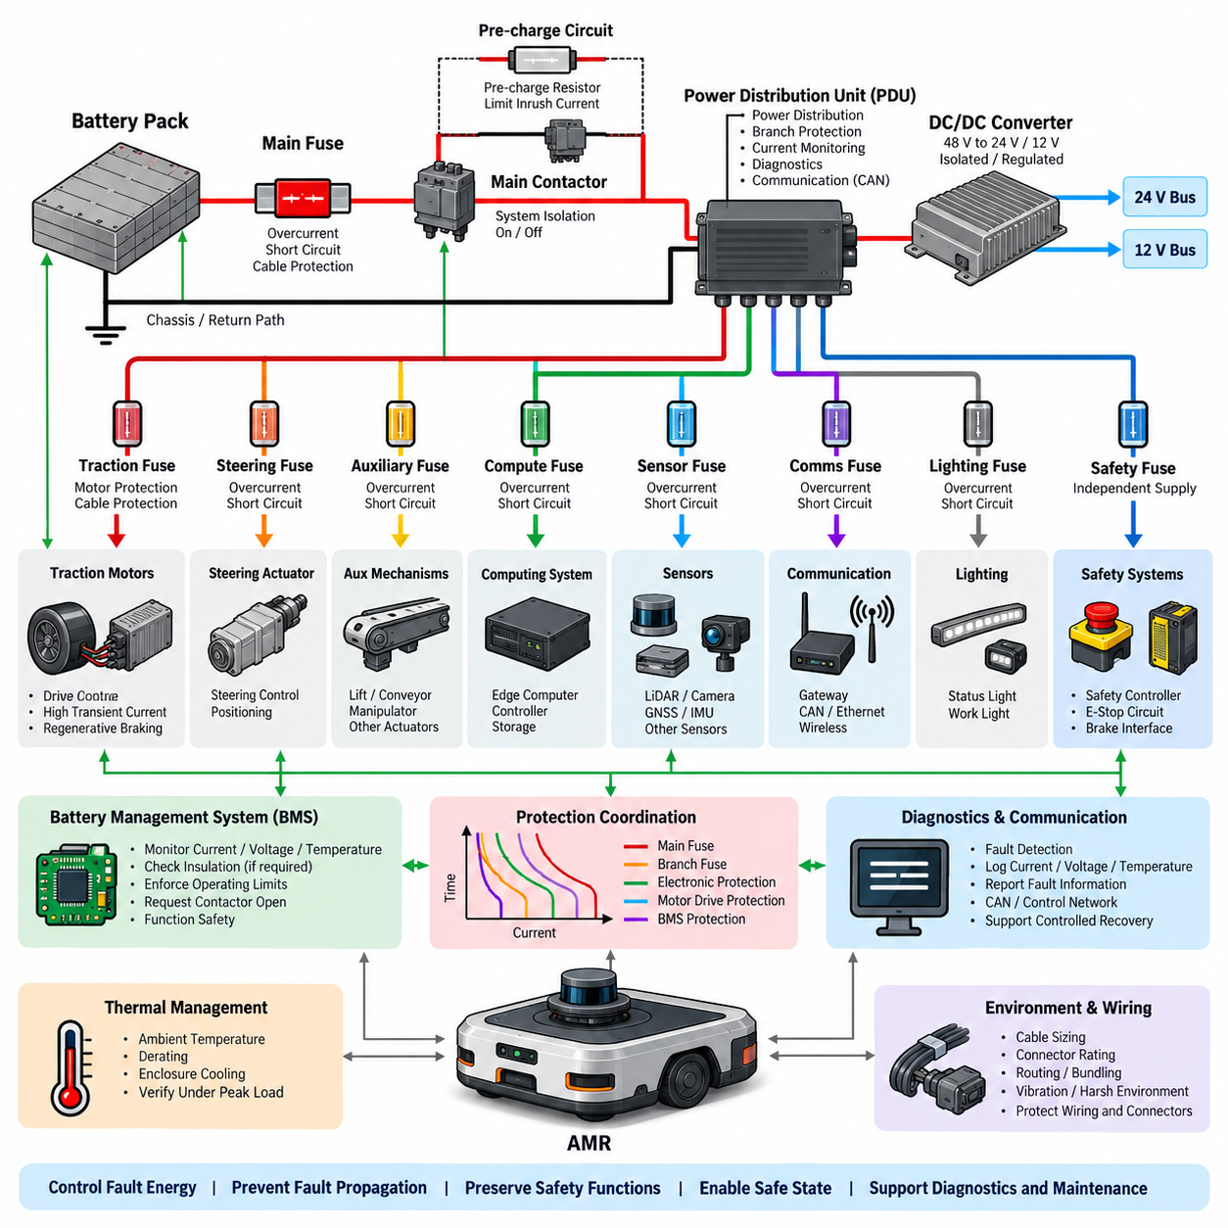
An AMR power protection pattern should be designed as a coordinated system rather than as a collection of independent fuses. The electrical architecture typically begins at the battery and progresses through primary isolation, main overcurrent protection, pre-charge or controlled connection, power distribution, branch protection, and individual loads. This layered structure limits fault energy while preserving unaffected functions whenever possible.
The battery interface forms the first protection boundary because it is connected to the system’s largest available fault current. A main fuse should therefore be positioned electrically close to the battery positive terminal, with its current rating and interrupting capability selected for the battery chemistry, maximum short-circuit current, cable capacity, and downstream contactor arrangement. Protection of the return path may also be required depending on grounding architecture.
A typical AMR uses a main contactor or equivalent high-current switching device to isolate propulsion and auxiliary power from the battery. The contactor is not normally intended to interrupt severe short-circuit current by itself, so coordination with the main fuse is essential. During startup, a pre-charge path can limit charging current into DC-link capacitors of motor drives and converters before the main contactor closes, reducing contact erosion and nuisance protection events.
Downstream of the main switching stage, the power distribution unit provides the central protection boundary for individual electrical domains. Separate protected branches can supply traction motor drives, steering actuators, DC/DC converters, computing systems, sensors, communication equipment, lighting, and auxiliary mechanisms. This organization corresponds directly to the broader AMR electrical architecture in which power, sensing, computing, communication, and actuation functions coexist.
Traction branches usually require special consideration because motor drives can draw high transient current during acceleration, obstacle negotiation, steering, and regenerative operation. A traction fuse must tolerate legitimate peak current without unnecessary opening while still protecting cables and downstream hardware against sustained overloads and short circuits. Its time-current characteristic should therefore be coordinated with motor-driver electronic protection rather than selected only from nominal motor current.
Electronic motor drives provide a faster local protection layer than conventional thermal fuses for many semiconductor faults. Current sensing can detect phase overcurrent, DC-bus overcurrent, locked-rotor conditions, or abnormal torque demand and command rapid switching shutdown. The upstream fuse remains necessary as an independent energy-limiting device for catastrophic failures such as shorted power semiconductors, damaged busbars, cable faults, or faults that prevent electronic shutdown.
Low-voltage electronic loads require a different protection pattern because their current levels and availability requirements differ from traction loads. A DC/DC converter may generate 24 V, 12 V, or other regulated rails from the main battery bus, after which each critical load group should receive appropriately sized branch protection. Edge computers, controllers, LiDARs, cameras, GNSS receivers, communication gateways, and safety devices should not unnecessarily share one protective element.
Selective protection is particularly important for autonomous operation. A fault in a nonessential accessory should ideally disconnect only that branch rather than removing localization, communication, braking, or safety-control power. Protection zones can therefore be aligned with functional criticality. Safety controllers, emergency-stop circuits, braking interfaces, and essential communication devices may require independently protected supplies so that an auxiliary short circuit does not produce an uncontrolled vehicle state.
Smart PDU technology extends this pattern by combining switching, current measurement, diagnostics, and communication at each protected channel. Electronic load switches or MOSFET stages can detect abnormal current, disconnect individual loads, report fault information through CAN or another control network, and support controlled recovery. Conventional fuses can remain as backup protection for conditions exceeding the electronic switching device’s safe operating capability.
Protection coordination must account for the relationship between the main fuse, branch fuses, electronic switches, motor-drive protection, converter protection, and battery management system. For a downstream fault, the device nearest the fault should normally operate first. The upstream device should remain intact unless fault magnitude or duration exceeds the downstream device’s clearing capability. Time-current curves and expected fault-current ranges provide the basis for verifying this selectivity.
The battery management system adds another supervisory protection layer by monitoring pack current, cell voltage, temperature, insulation-related conditions where applicable, and battery operating limits. It may request contactor opening when operating conditions become unsafe, while hardware fuses provide protection against fault currents that are too rapid or severe for software-controlled isolation. The resulting architecture deliberately combines electronic supervision with independent passive protection.
Emergency-stop behavior must be considered separately from ordinary electrical fault protection. An emergency stop may command removal of propulsion torque while maintaining power to safety controllers, brakes, communication, and diagnostic functions required to reach or maintain a safe state. Consequently, simply placing all robot loads behind one contactor can create undesirable behavior. The protected power architecture should distinguish energy isolation from safety-related power retention.
Regenerative braking introduces bidirectional energy flow into the protection design. During deceleration, motor drives can return energy to the DC bus and battery, causing bus voltage and current conditions that differ from normal propulsion. Fuse selection, contactor sequencing, DC-link design, BMS limits, and overvoltage handling must therefore be evaluated for both motoring and regeneration. Protection must remain valid across the full operating envelope rather than only during discharge.
Cable and connector protection remains one of the fundamental purposes of the AMR protection system. Fuse ratings should not exceed the safe current capability of the protected conductors after considering ambient temperature, bundling, routing, connector contact resistance, enclosure heating, and duty cycle. A fuse sized only according to load current can leave wiring insufficiently protected, while excessive conservatism can cause nuisance opening during legitimate transient operation.
Thermal behavior should also be evaluated at system level because AMRs often concentrate batteries, PDUs, converters, motor drivers, computers, and harness junctions within compact enclosures. High ambient temperature reduces available current margin and can alter fuse clearing behavior, semiconductor limits, connector temperature rise, and cable ampacity. Protection design should therefore be coordinated with thermal management and verified under representative continuous and peak-load operating conditions.
Fault diagnostics should identify not only that protection has operated but also which electrical domain failed and under what conditions. Current, voltage, temperature, contactor state, branch-switch status, and BMS information can be logged before and after a protection event. Such information enables service personnel to distinguish between genuine short circuits, overloads, inrush problems, degraded connectors, intermittent harness faults, and incorrect protection calibration.
A robust AMR pattern ultimately forms a hierarchy of battery protection, primary isolation, centralized distribution, selective branch protection, intelligent local shutdown, and supervisory diagnostics. The design objective is not merely to prevent component damage but to control fault energy, prevent fault propagation, preserve safety-critical functions, support deterministic transition to a safe state, and provide sufficient diagnostic information for rapid recovery and maintenance.

10.02. Manipulator Power Protection
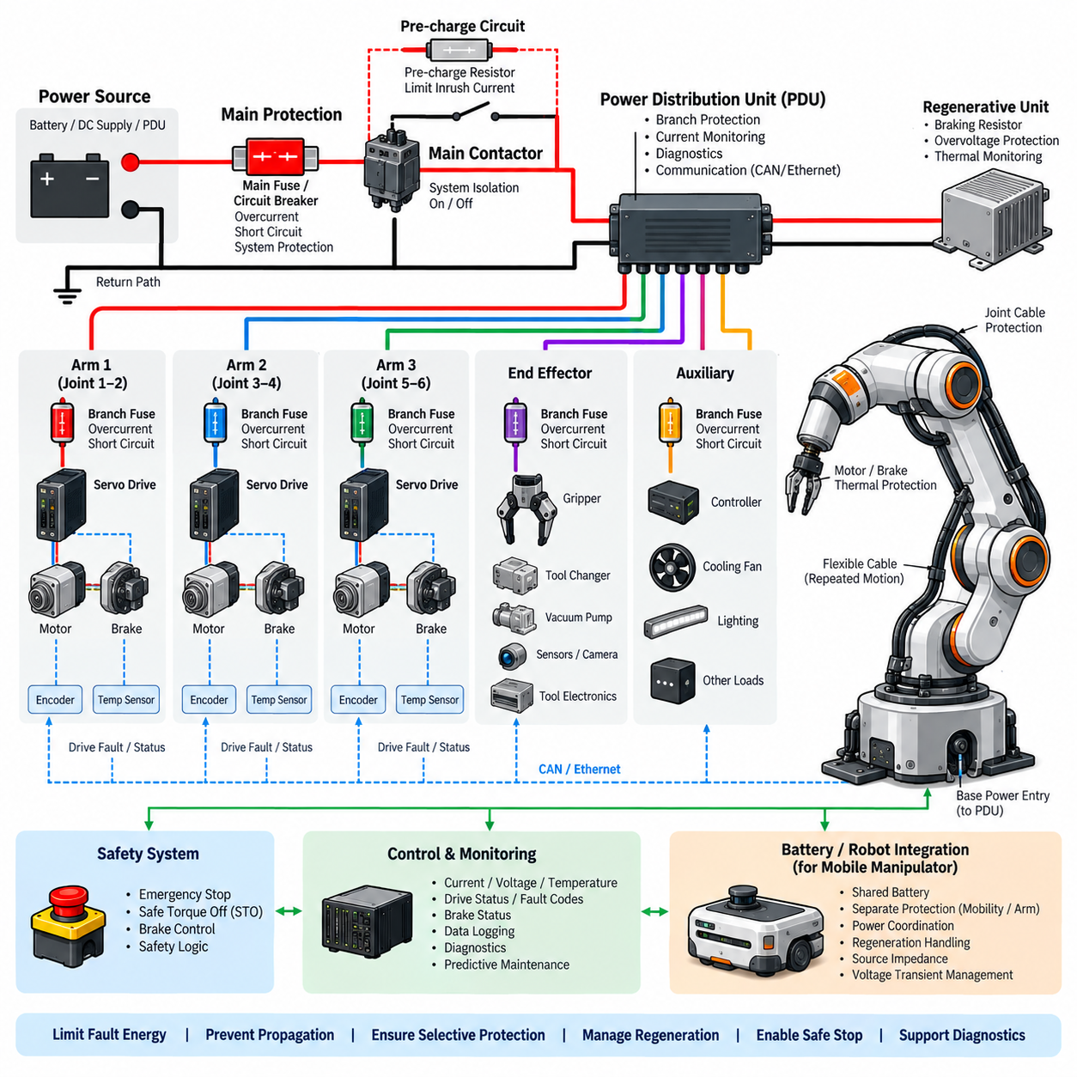
Manipulator power protection must account for a load profile that differs significantly from a mobile base. Multiple servo drives can accelerate, decelerate, hold gravity loads, and reverse direction within milliseconds, creating rapidly changing current demand on a shared DC bus. Protection therefore has to distinguish normal dynamic peaks from genuine overloads while preventing a single joint or drive failure from propagating through the complete manipulator power system.
The power path normally begins with a protected source such as a battery bus, DC supply, or power distribution unit and continues through main isolation, branch protection, servo drives, motors, brakes, and auxiliary loads. The protection hierarchy should match these electrical boundaries. A main protective device limits system-level fault energy, while downstream devices isolate faults associated with individual arms, joint groups, drives, or auxiliary mechanisms.
A manipulator main fuse or circuit breaker must be selected from the maximum continuous operating current, expected simultaneous joint activity, transient servo demand, conductor capacity, and available short-circuit current. Selecting the device simply from the sum of motor nameplate currents can produce excessive protection ratings because joints rarely operate at their individual worst-case values simultaneously. Conversely, aggressive undersizing can cause nuisance interruption during coordinated high-load motion.
Servo drives provide the first fast electronic protection layer for many actuator faults. Their current sensing and control electronics can detect phase overcurrent, DC-bus overcurrent, motor stall, excessive torque, abnormal acceleration, or power-stage faults and disable switching rapidly. This local response protects semiconductor devices and motors much faster than conventional fuses, but it does not eliminate the requirement for upstream hardware protection against catastrophic drive or wiring failures.
Branch protection is particularly valuable in multi-axis manipulators. Instead of supplying every servo drive through a single protected feeder, electrical domains can be separated by arm, joint group, actuator module, or drive cluster. A short circuit in one branch can then be isolated without exposing the entire power distribution network to prolonged fault current. The appropriate segmentation depends on manipulator topology, required availability, wiring architecture, and maintenance strategy.
Time-current coordination between branch fuses and the main protective device determines whether this segmentation actually provides selective protection. A downstream fault should normally clear the corresponding branch device before the main device opens. The coordination study must consider both overload duration and prospective short-circuit current because two devices that appear selective at moderate current may operate nearly simultaneously during a severe low-impedance fault.
Regenerative energy is a major characteristic of manipulator power systems. When a joint decelerates or a gravity-loaded axis moves downward, the servo drive can return electrical energy to the common DC bus. Other drives may consume this energy, but if instantaneous regenerated power exceeds system demand, the DC-bus voltage can rise. Protection must therefore coordinate drive overvoltage limits, regenerative resistors, braking units, energy storage, and source acceptance capability.
A braking resistor or regenerative unit requires its own protection considerations. Repeated high-energy deceleration can thermally overload the resistor even when instantaneous current remains within an acceptable range. Temperature monitoring, thermal switches, drive calculations, and duty-cycle limits can prevent overheating. A failed braking circuit must also be detected because loss of regenerative energy dissipation can lead to DC-bus overvoltage and subsequent drive shutdown.
Electromechanical holding brakes used on vertical or gravity-loaded joints introduce another protected power domain. Brake release power should be designed so that electrical faults do not unintentionally release a load or prevent the manipulator from reaching a safe condition. Brake coils, suppression devices, switching circuits, connectors, and wiring require suitable protection, while the safety architecture determines when power removal should engage the mechanical brake.
Emergency-stop behavior requires coordination between electrical isolation and controlled mechanical stopping. Immediately removing all electrical power may not always provide the safest response because servo control can be required during controlled deceleration before torque is removed. Safety functions such as Safe Torque Off can disable torque generation independently of ordinary branch protection. Power architecture must therefore distinguish fault protection, operational shutdown, emergency stopping, and safety-related torque removal.
Inrush current must also be considered because servo drives contain substantial DC-link capacitance. Simultaneously connecting several drives can generate a charging pulse large enough to stress contactors, connectors, fuses, and power supplies. A pre-charge circuit, sequential drive enable strategy, current-limited supply, or controlled contactor sequence can reduce this stress. Protection devices should tolerate the verified startup profile without sacrificing short-circuit protection.
Manipulator cabling presents additional challenges because conductors repeatedly bend, twist, and move through joints, cable carriers, and hollow shafts. Mechanical fatigue can eventually damage insulation or conductors and produce intermittent shorts, increased resistance, or ground faults. Protection ratings must therefore be coordinated with conductor gauge, connector capability, routing, flex life, ambient temperature, and local thermal conditions rather than being based solely on actuator electrical ratings.
Joint modules may integrate a motor, encoder, brake, temperature sensor, servo electronics, and local controller within a compact enclosure. Such integration creates high local power density and makes thermal protection important. Motor winding temperature, power-semiconductor temperature, brake temperature, and enclosure temperature can supplement electrical overcurrent protection. Derating or controlled shutdown may be preferable to abrupt power removal when temperature rises gradually.
Auxiliary devices such as grippers, tool changers, vacuum pumps, solenoids, force-torque sensors, cameras, and end-effector electronics should normally be separated from high-power servo branches. Tool interfaces are especially exposed to wiring errors, connector damage, and externally attached equipment of uncertain condition. Dedicated fusing or electronic current limiting at the tool interface prevents an end-effector fault from disabling the manipulator’s main control and safety functions.
A mobile manipulator introduces an additional coordination problem because the arm and mobile base can share the same battery and PDU. High arm acceleration may coincide with traction demand, while regenerative energy from either subsystem can affect the common DC bus. Separate protected feeders for mobility and manipulation help contain faults, but their combined peak current, source impedance, battery limits, and voltage transients must still be evaluated at the shared power boundary.
Smart power distribution can improve manipulator diagnostics by measuring current independently for servo groups and auxiliary branches. Abnormal current signatures can reveal overloaded joints, damaged cables, stalled mechanisms, degraded brakes, or defective tools before a hard protective trip occurs. Electronic switches can disconnect selected auxiliary loads and report their status, while conventional fuses remain useful as independent protection against high-energy faults.
Protection diagnostics should preserve the sequence of events surrounding a shutdown. Useful records include DC-bus voltage, source current, branch current, joint torque demand, drive fault codes, motor temperature, brake status, contactor state, and emergency-stop status. Time-correlated information makes it possible to distinguish an electrical short circuit from mechanical overload, excessive regeneration, thermal derating, cable degradation, or an incorrect motion command.
The complete manipulator protection architecture therefore combines source protection, main isolation, selective branch protection, servo-drive electronic protection, regenerative energy management, brake protection, thermal monitoring, and safety-related shutdown functions. Its purpose is not simply to disconnect power during a fault, but to limit fault energy, prevent propagation between axes, maintain controlled stopping capability, protect personnel and equipment, and provide deterministic recovery after the fault has been identified.

10.03. UAV Power Protection
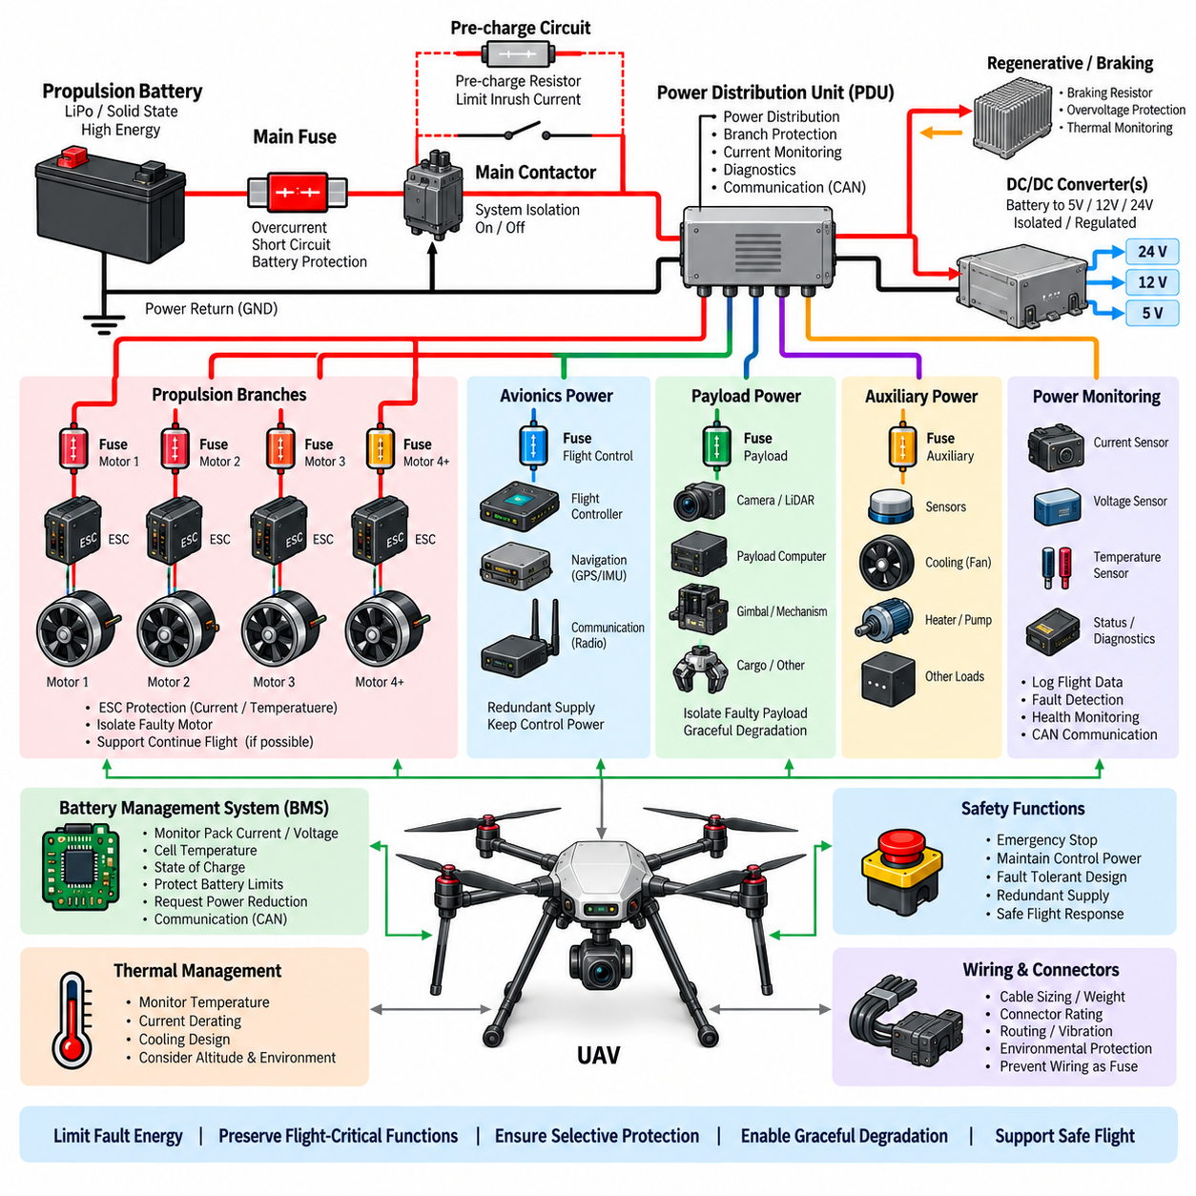
UAV power protection must address a power system in which propulsion reliability, low mass, rapid current transients, and flight safety are tightly coupled. Unlike ground robots, a complete loss of electrical power can immediately remove thrust and flight-control capability. Protection must therefore isolate electrical faults without unnecessarily disconnecting healthy propulsion, avionics, navigation, communication, and safety functions.
The primary power path normally begins at the propulsion battery or energy-storage system and continues through main overcurrent protection, isolation devices, power distribution, electronic speed controllers, and propulsion motors. Separate regulated power paths typically supply flight computers, sensors, communication equipment, payload controllers, and auxiliary systems. This separation establishes protection zones with different current levels and availability requirements.
The battery represents the highest-energy electrical source and therefore requires protection close to its terminals. Main fuse selection should consider maximum continuous discharge current, propulsion peak demand, battery short-circuit capability, cable ampacity, connector ratings, and expected environmental temperature. The protective device must tolerate legitimate takeoff and maneuvering currents while interrupting dangerous fault current before conductors or downstream equipment suffer severe damage.
Multirotor propulsion produces highly dynamic electrical loading because several motors can change torque almost simultaneously in response to attitude-control commands. Takeoff, gust rejection, aggressive maneuvering, and payload stabilization may produce short-duration current peaks well above steady cruise values. Protection characteristics must distinguish these normal transient demands from sustained overloads so that protective devices do not create a propulsion failure during otherwise valid flight operation.
Individual propulsion branches can be protected separately so that a fault in one electronic speed controller or motor does not directly expose every propulsion channel to the same fault path. The feasibility of continued flight after branch isolation depends on aircraft configuration, control authority, and redundancy. Protection architecture should therefore be coordinated with propulsion topology rather than assuming that electrical isolation alone guarantees safe flight.
Electronic speed controllers provide a fast local protection layer through current sensing, semiconductor protection, temperature monitoring, and control logic. They can respond to motor phase faults, excessive current, stalled or damaged motors, and abnormal power-stage conditions more rapidly than conventional fuses. Upstream hardware protection remains necessary because catastrophic semiconductor shorts, damaged wiring, or connector failures can create fault paths that electronic control cannot reliably interrupt.
Power distribution should separate high-current propulsion from low-voltage avionics wherever practical. DC/DC converters or regulated power modules may generate dedicated rails for the flight controller, navigation sensors, communication modules, payload computers, cameras, and other electronics. A propulsion branch fault should not collapse the avionics rail, while an auxiliary payload short circuit should not remove the electrical power required to stabilize and control the aircraft.
Flight-control power deserves special treatment because continued computation and sensing may be required even when another electrical domain fails. Redundant regulated supplies, independent branch protection, diode or ideal-diode isolation, and separated wiring paths can reduce common-cause failures. The exact level of redundancy depends on UAV size and mission criticality, but protection should preserve essential control functions long enough to execute an appropriate safe-flight response.
Voltage-drop management is closely related to protection design. High propulsion current flowing through batteries, connectors, cables, contactors, and distribution conductors produces temporary bus-voltage reduction. If undervoltage protection thresholds are poorly coordinated, a valid propulsion transient can reset flight computers or communication equipment. Energy-source impedance, conductor resistance, converter hold-up capability, and undervoltage thresholds should therefore be evaluated together.
Short-circuit protection must account for the extremely low impedance of modern high-power battery packs. A severe fault can release very large current before software or supervisory controllers can react. Hardware fuses and appropriately rated switching devices provide an independent protection path. Their interrupting capability must be sufficient for the prospective fault current, while physical placement should minimize the length of unprotected high-energy conductors.
Contactors or high-current electronic switches may be used for battery isolation in larger UAV power systems. These devices must be coordinated with fuses because a contactor is not necessarily capable of safely interrupting the maximum battery short-circuit current. Pre-charge may also be required when large motor controllers, inverters, or DC-link capacitors are connected, limiting inrush current and reducing contact wear during system energization.
Regenerative energy must be considered when the propulsion architecture permits bidirectional power flow. Rapid motor deceleration or certain electric propulsion controllers can return energy toward the DC bus, potentially increasing bus voltage. Battery charge acceptance, controller overvoltage limits, energy absorption, and protection thresholds must be coordinated so that normal dynamic operation does not trigger unnecessary shutdown or damage sensitive power electronics.
Thermal protection is especially important because UAV electrical equipment operates under strict mass and cooling constraints. Batteries, ESCs, converters, connectors, and cables can experience substantial temperature rise during sustained high-power flight. Temperature monitoring and current derating can reduce loading before critical limits are reached. Protection settings should consider altitude, airflow, enclosure design, ambient temperature, and mission duration rather than relying solely on room-temperature ratings.
Wiring protection requires careful coordination with weight optimization. Reducing conductor size lowers aircraft mass but decreases thermal margin and increases voltage drop. Fuse ratings must remain compatible with the actual conductor ampacity after considering bundling, routing, connector resistance, insulation temperature limits, and environmental conditions. Protection should prevent lightweight wiring from becoming the unintended fusible element during an electrical fault.
Payload power should normally be treated as a separate electrical domain. Cameras, LiDARs, communication payloads, computing modules, cargo mechanisms, pumps, heaters, or mission-specific equipment can introduce unpredictable load behavior. Dedicated branch protection or electronically controlled power channels allow a faulty payload to be disconnected while preserving propulsion and flight-control functions, enabling graceful degradation instead of complete vehicle power loss.
Battery management systems can provide supervisory protection by monitoring pack current, cell voltage, temperature, state of charge, and other battery limits. The BMS may request power reduction or isolation when unsafe conditions develop, but flight consequences must be considered before abrupt disconnection. Hardware protection, BMS logic, propulsion control, and flight-control responses should therefore form a coordinated strategy rather than independent shutdown mechanisms.
Protection diagnostics are valuable because electrical faults during flight may be transient and difficult to reproduce after landing. Logging battery voltage, pack current, branch current, ESC status, motor demand, converter voltage, temperature, fuse or switch state, and flight-control events provides a time-correlated fault history. Such records help distinguish genuine electrical faults from overload, thermal limitation, connector degradation, voltage sag, or abnormal propulsion commands.
Larger cargo UAVs require increasingly rigorous protection coordination because battery energy, propulsion power, conductor size, and available fault current increase substantially with vehicle scale. Distributed propulsion may involve multiple battery strings, high-power buses, independent propulsion zones, and redundant avionics supplies. Electrical segmentation should limit the amount of stored energy that any single fault can release while preventing one damaged zone from propagating failure across the aircraft.
The complete UAV power protection architecture therefore combines source protection, selective distribution, propulsion-branch protection, ESC electronic protection, regulated avionics power, thermal supervision, battery management, isolation, and fault diagnostics. Its fundamental objective is to control fault energy while preserving flight-critical electrical functions, preventing cascading failures, enabling graceful degradation, and supporting a predictable transition toward the safest achievable flight state.

10.04. Motor Driver Overcurrent Protection
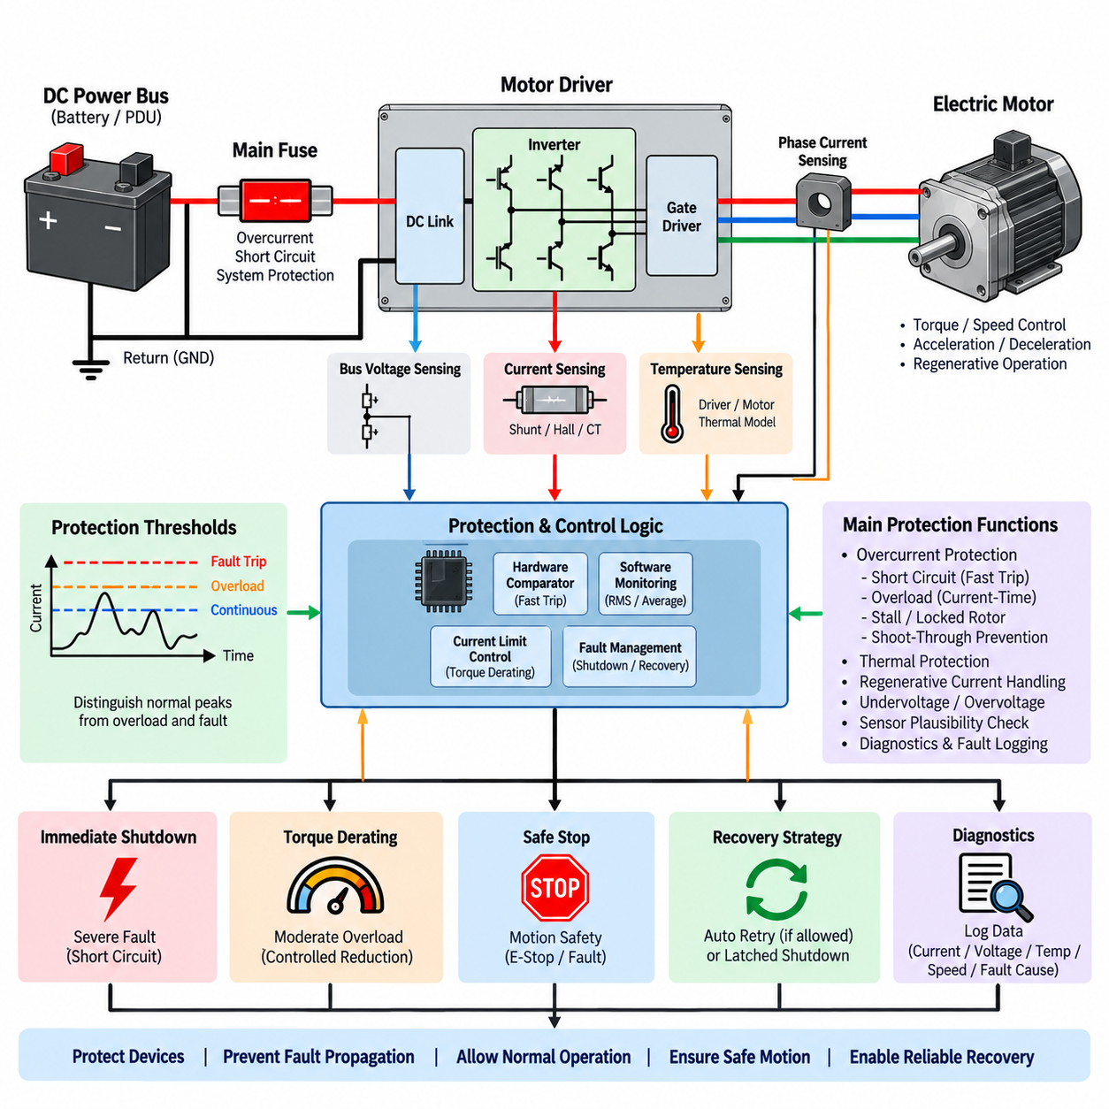
Motor driver overcurrent protection is a coordinated set of functions that prevents excessive electrical current from damaging power semiconductors, motors, cables, connectors, and the upstream power network. In robotic systems, normal acceleration and transient torque demand can produce currents far above continuous operating values, so protection must distinguish legitimate short-duration peaks from sustained overloads and destructive fault currents.
The motor driver is typically positioned between a DC power bus and an electric motor, using MOSFETs, IGBTs, or other switching devices to regulate phase current and motor torque. Because semiconductor junctions can be damaged within microseconds under severe overcurrent, driver-level protection must operate much faster than conventional upstream fuses. The fuse provides energy isolation, while electronic protection limits semiconductor stress during rapidly developing faults.
Current measurement is therefore a fundamental element of motor driver protection. Shunt resistors, Hall-effect sensors, current transformers, or integrated semiconductor current-sensing techniques can measure DC-bus or motor-phase current. The sensing method must provide sufficient bandwidth, accuracy, isolation, and dynamic range to detect dangerous current while remaining stable in an electrically noisy switching environment.
Protection thresholds should reflect the difference between continuous current, temporary overload current, and instantaneous fault current. Continuous limits protect the thermal capability of the motor and driver, while higher short-duration thresholds permit acceleration and peak torque. A separate fast-trip threshold can respond to severe short circuits. This multi-level strategy prevents nuisance shutdown while maintaining rapid protection against destructive events.
Hardware overcurrent comparators are commonly used when response time must be independent of processor execution. The sensed current is compared directly with a predefined threshold, and exceeding that threshold can disable PWM switching or gate-drive outputs immediately. This hardware path remains effective even if control software is delayed, overloaded, or malfunctioning, providing an independent protection mechanism for the power stage.
Software protection complements the fast hardware path by evaluating current over longer time intervals. The motor controller can monitor RMS current, average current, torque demand, operating duration, speed, and temperature to identify sustained overload conditions. Instead of immediately disabling the drive, software may first reduce torque or current commands, allowing controlled derating before a protective shutdown becomes necessary.
The power semiconductor safe operating area must be considered when defining protection limits. MOSFET and IGBT current capability depends on junction temperature, bus voltage, switching state, pulse duration, and cooling conditions. A current level that is acceptable for a very short pulse may become destructive when sustained. Protection settings should therefore reflect semiconductor transient capability rather than relying only on nominal device current ratings.
Short-circuit faults require the fastest protection response because current can rise rapidly through a low-impedance path. Possible faults include phase-to-phase shorts, phase-to-ground shorts, damaged motor windings, failed cables, connector faults, and shorted switching devices. The driver should interrupt gate commands before semiconductor energy limits are exceeded, while upstream fuses provide backup isolation if the electronic switching stage cannot clear the fault.
Shoot-through is a particularly severe inverter fault in which the high-side and low-side switching devices of the same bridge leg conduct simultaneously. This creates a very low-impedance path across the DC bus and can destroy power semiconductors rapidly. Gate-driver interlocking, dead-time control, undervoltage lockout, desaturation or current detection, and immediate gate shutdown are important measures for preventing or limiting shoot-through events.
Motor stall and locked-rotor conditions differ from direct short circuits because the current may remain high for a relatively long period without reaching an instantaneous fault threshold. At low or zero speed, reduced back electromotive force allows substantial current to flow while motor cooling may also deteriorate. Current-time monitoring, winding-temperature estimation, and torque limitation are therefore required to prevent gradual thermal damage.
Thermal protection and overcurrent protection are closely related. Conduction losses increase approximately with current squared in resistive elements, while switching and motor losses also rise with operating load. Driver temperature sensors, motor winding sensors, or thermal models can estimate accumulated thermal stress. Current limits may be dynamically reduced as temperature rises, creating thermal derating before a critical shutdown threshold is reached.
Regenerative operation must also be included in the protection strategy because current direction reverses when mechanical energy returns through the motor driver to the DC bus. The current-sensing circuit and protection algorithm should correctly interpret both motoring and regenerative current. Excessive regeneration can create high current or bus overvoltage, requiring coordination among motor control, battery acceptance limits, braking circuits, and DC-bus protection.
The upstream fuse should not be expected to protect semiconductor devices against every overcurrent event. Fuse clearing time is generally too slow for many inverter semiconductor faults, especially at current levels that are dangerous to silicon but insufficient to clear the fuse immediately. Instead, the motor driver handles fast electronic protection, while the fuse protects wiring and isolates catastrophic faults that remain after the electronic protection has operated or failed.
Protection coordination becomes especially important when several motor drivers share a common PDU or battery bus. A fault in one drive should ideally cause that branch to shut down without collapsing healthy motor channels. Separate branch fuses, electronic switches, or contactors can improve fault containment. Their ratings and trip characteristics should coordinate with the main protective device so that downstream protection normally operates first.
Robotic motion safety must be considered when deciding how the driver reacts to overcurrent. Immediate torque removal may be appropriate for a destructive electrical fault, but a moderate overload may allow controlled deceleration or torque reduction before shutdown. Mobile robots, manipulators, and other robotic platforms can have different safe-state requirements, so electrical protection behavior should be integrated with braking, emergency-stop, and safety-control functions.
Current-limit recovery also requires deliberate design. Automatically restarting a motor after every trip can repeatedly energize a short circuit or stalled mechanism and create additional thermal stress. Some transient events may permit controlled retry after a delay, while severe short-circuit or semiconductor faults should require a latched shutdown and diagnostic reset. Recovery policy should therefore depend on fault classification rather than using one restart strategy.
Diagnostic information should capture the electrical and operating conditions that existed when overcurrent protection activated. Useful data include peak current, RMS current, DC-bus voltage, motor speed, torque command, PWM duty, semiconductor temperature, motor temperature, fault source, and trip duration. Time-stamped records help distinguish a genuine electrical fault from mechanical jamming, excessive payload, aggressive control commands, thermal limitation, or degraded wiring.
Sensor plausibility is also important because incorrect current measurements can cause either nuisance shutdown or loss of protection. Offset drift, saturation, open sensing connections, amplifier faults, and calibration errors should be detected where practical. Comparing phase currents, DC-bus current, commanded torque, and motor behavior can provide additional diagnostic confidence and prevent a single faulty measurement channel from silently compromising protection.
A robust motor driver overcurrent architecture therefore combines fast current sensing, hardware trip logic, software current limiting, thermal supervision, semiconductor protection, upstream fusing, selective branch isolation, and fault diagnostics. The objective is to interrupt destructive faults within the required time while allowing legitimate transient torque, preventing fault propagation, preserving healthy electrical domains, and supporting predictable safe recovery of the robotic system.

10.05. Inrush Current Management
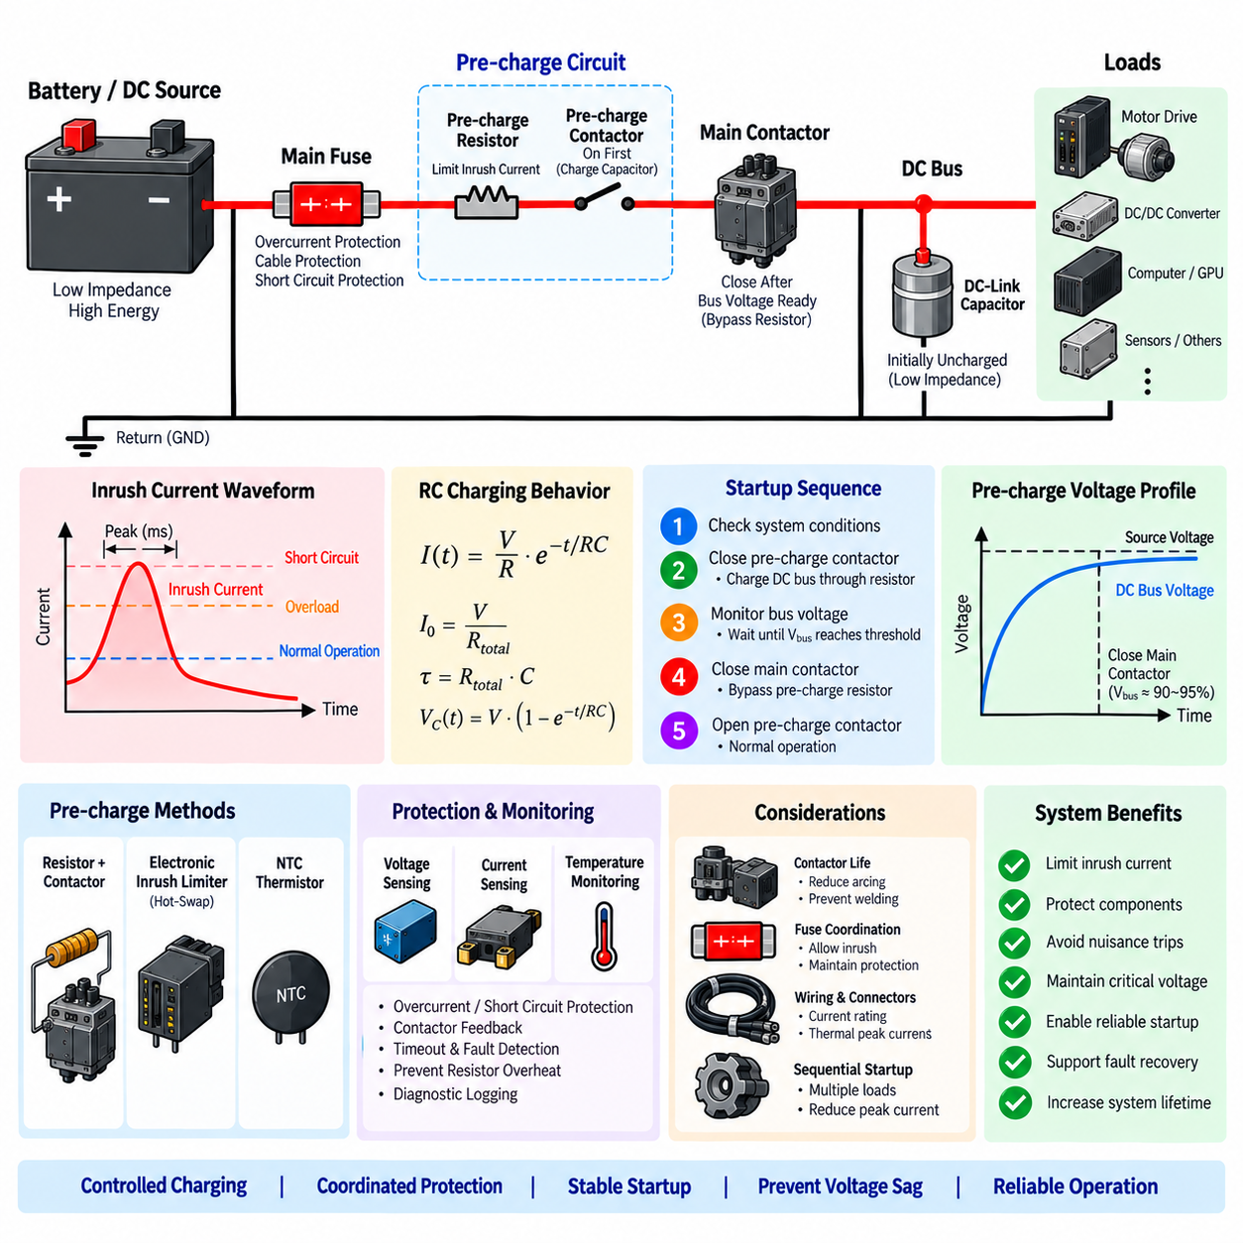
Inrush current is the short-duration current surge that occurs when an electrical system is first connected to its power source. In robots, AMRs, manipulators, and UAVs, large DC-link capacitors inside motor drives, inverters, DC/DC converters, and computing power supplies initially behave almost like a low-impedance load. Without management, the resulting current pulse can stress batteries, connectors, contactors, fuses, and distribution conductors.
The magnitude of inrush current depends primarily on source voltage, source impedance, wiring resistance, connector resistance, and the effective capacitance connected to the bus. An uncharged capacitor initially has nearly zero terminal voltage, so connecting it directly to a stiff battery can create a very large charging current. The peak may last only milliseconds, but its electrical and thermal effects can still exceed component limits.
A basic approximation treats the startup path as a resistor-capacitor network. Immediately after connection, current is approximately determined by the source voltage divided by total series resistance, while capacitor voltage rises exponentially toward the supply voltage. The time constant is defined by resistance multiplied by capacitance. These relationships provide a useful starting point for estimating peak current, charging time, and pre-charge requirements.
Inrush current must be distinguished from overload and short-circuit current because each condition requires a different protection response. A valid startup surge is expected and temporary, an overload persists because operating demand exceeds design capability, and a short circuit represents an abnormal low-impedance fault. If protection cannot distinguish these conditions, a correctly operating robot may repeatedly trip its fuse or circuit breaker during startup.
Pre-charge is one of the most widely used methods for controlling inrush current in high-power DC systems. A resistor is temporarily inserted between the source and the downstream DC bus before the main contactor closes. The resistor limits capacitor charging current while the DC-link voltage gradually rises. Once the voltage difference across the main contactor becomes sufficiently small, the main contactor closes and bypasses the pre-charge path.
The pre-charge resistor must be selected for resistance, pulse energy, peak power, temperature rise, and repetition rate. Higher resistance reduces peak current but increases charging time, while lower resistance charges the bus faster at the cost of higher current and greater instantaneous stress. The resistor must also tolerate the energy transferred into the downstream capacitance without exceeding its short-duration thermal capability.
Pre-charge timing should not rely solely on a fixed delay when system conditions can vary significantly. Measuring source voltage and downstream DC-bus voltage provides a more robust method. The controller can close the main contactor when the bus reaches a defined percentage of source voltage or when the voltage difference falls below an acceptable threshold. This approach compensates for changes in capacitance, battery voltage, temperature, and load configuration.
A typical startup sequence first verifies system conditions, closes the pre-charge switch or contactor, monitors DC-bus voltage, confirms successful charging, closes the main contactor, and then opens the pre-charge path. If the bus voltage fails to rise as expected, the controller should stop the sequence. Such behavior can indicate a downstream short circuit, excessive connected load, failed resistor, damaged contactor, or incorrect wiring.
Pre-charge circuits require protection against abnormal operating states. If the main contactor fails to close, the resistor may remain continuously connected and overheat. If the pre-charge contactor welds, the resistor can remain electrically active during later switching events. Temperature monitoring, timeout logic, contactor feedback, voltage plausibility checks, and fault latching can prevent a temporary current-limiting element from becoming a new failure source.
Contactors are strongly affected by uncontrolled inrush current. Closing a contactor onto a large uncharged capacitor can create contact bounce, arcing, local heating, erosion, and eventually contact welding. A correctly designed pre-charge sequence substantially reduces the current present when the main contacts close. This improves contactor electrical life and makes switching behavior more predictable over repeated robot power cycles.
Fuses and circuit breakers must also be coordinated with startup current. A protective device selected only from steady-state load current may operate unnecessarily during repeated charging pulses, while excessive oversizing can weaken cable and fault protection. The inrush waveform, pulse duration, repetition frequency, fuse time-current characteristic, and I²t withstand should therefore be considered together when selecting upstream protection.
Electronic inrush limiting provides an alternative to resistor-and-contactor pre-charge. MOSFET-based hot-swap controllers or electronic load switches can regulate current while downstream capacitance charges. These devices can provide programmable current limits, voltage monitoring, fault timers, and controlled turn-on behavior. However, semiconductor safe operating area and thermal dissipation must be verified because substantial energy can be absorbed during startup.
NTC thermistors provide a simpler passive method of limiting startup current. Their resistance is relatively high when cold and decreases as current heats the device, allowing normal operation with lower resistance after startup. This method can be useful for suitable power levels, but rapid power cycling can be problematic because a warm thermistor may not recover enough resistance to limit the next inrush event effectively.
Sequential startup can reduce inrush when multiple high-capacitance loads share one PDU. Instead of energizing every motor driver, converter, computer, and sensor supply simultaneously, the controller enables branches in a defined order. The peak current seen by the battery and main distribution path is thereby reduced. Smart PDU channels can combine sequencing with current monitoring and fault isolation for more controlled power-up behavior.
Motor drives and servo systems are major contributors to robotic inrush because their DC-link capacitors may be relatively large. Multiple drives connected to a common bus can produce a substantial combined charging pulse. Pre-charging the common DC bus before enabling individual drives, or sequentially connecting drive groups, reduces stress on the main contactor, branch protection, connectors, and battery.
Computing systems can also generate significant startup current. Edge computers, GPU systems, communication equipment, and sensor power supplies contain input capacitors and switching regulators that may start simultaneously when auxiliary power is enabled. Although each device may have moderate steady-state consumption, their combined startup surge can cause temporary voltage sag, converter current limiting, or controller resets if the distribution system is not designed for the transient.
Voltage sag is an important secondary effect of inrush current. Source impedance converts a large charging pulse into a temporary reduction in bus voltage, which can disturb already energized electronics. Safety controllers, flight computers, communication devices, and other critical loads may reset even though no protective device trips. Separating critical power rails, sequencing loads, and providing adequate hold-up capacitance can improve immunity to these startup disturbances.
Inrush management should also consider repeated switching and fault recovery. A system that shuts down and immediately retries may repeatedly charge partially discharged capacitors, generating multiple high-energy pulses in a short period. Retry delays, discharge-state monitoring, thermal limits, and controlled restart logic can prevent excessive stress on resistors, switches, fuses, contactors, and the battery during repeated recovery attempts.
Diagnostic monitoring can make startup faults easier to identify. Recording source voltage, DC-bus voltage, charging current, pre-charge duration, contactor states, branch status, and fault codes provides evidence of whether the power-up sequence behaved correctly. Trends such as increasing charging time or abnormal voltage difference may reveal degrading contacts, increased resistance, damaged capacitors, or changes in connected electrical loads.
A robust inrush current management architecture therefore combines controlled charging, correctly coordinated protection, voltage and current monitoring, contactor sequencing, thermal supervision, fault detection, and diagnostic logging. Its objective is to energize high-capacitance robotic loads without damaging components, causing nuisance trips, collapsing critical voltage rails, or creating uncontrolled switching events, while still preserving effective protection against genuine overloads and short circuits.

