Volume 04. Fuse, Relay, and Power Distribution Unit

Chapter 08. HV Protection

08.01. Insulation Monitoring Device (IMD)
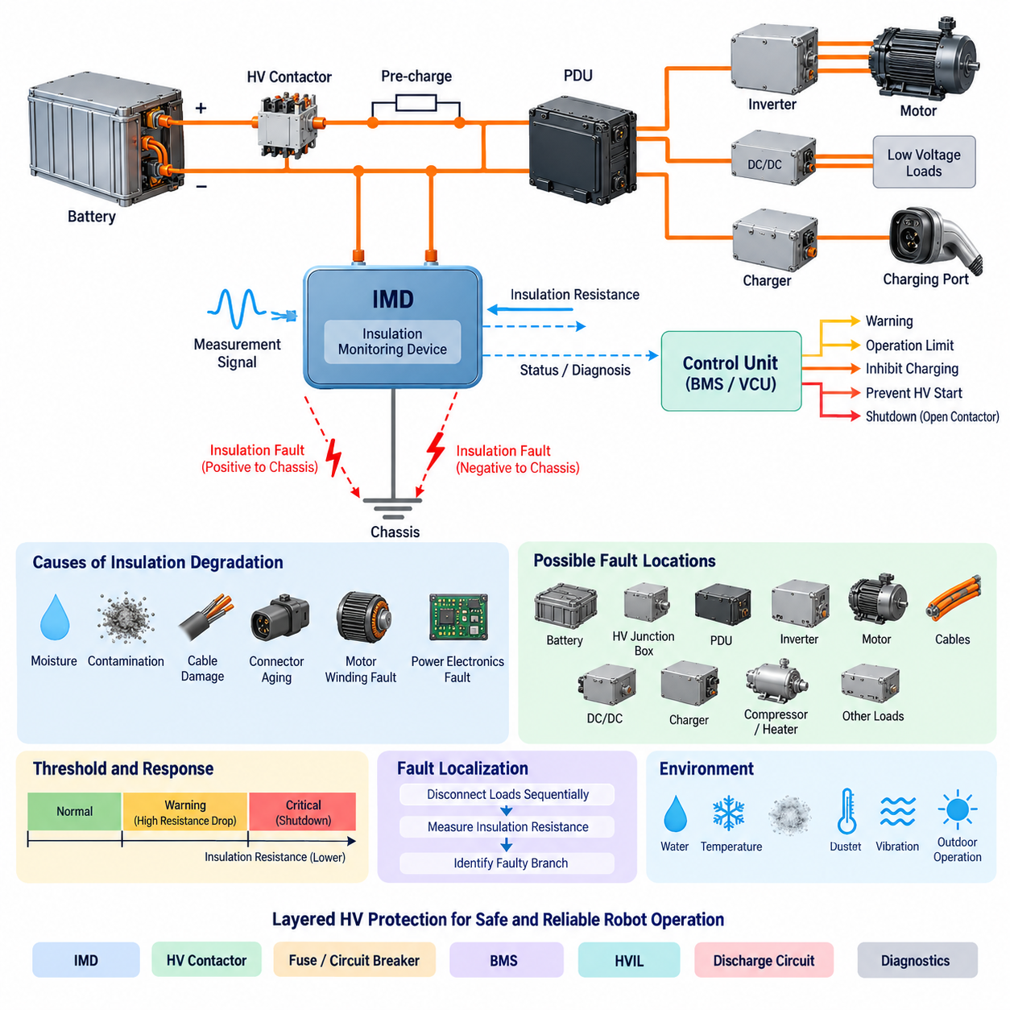
An Insulation Monitoring Device (IMD) is a protective monitoring component used in unearthed or high-resistance-grounded electrical systems to continuously evaluate the insulation condition between energized conductors and the chassis, protective earth, or other accessible conductive structures. In robotic high-voltage architectures, the IMD provides early detection of insulation degradation before a fault develops into hazardous leakage current, electric shock risk, or a secondary short circuit.
Unlike an overcurrent fuse or circuit breaker, an IMD does not primarily detect excessive load current. Instead, it evaluates the effective insulation resistance of the energized power network relative to the conductive structure surrounding it. A healthy isolated electrical system normally exhibits very high resistance to chassis. Contamination, damaged cable insulation, moisture ingress, connector degradation, motor winding defects, or internal power-electronic failures can progressively reduce this resistance.
The fundamental monitoring quantity is insulation resistance, commonly expressed as resistance from the isolated DC bus to chassis or protective earth. In a floating HV system, both the positive and negative conductors are intentionally isolated from the chassis. The IMD supervises this isolation continuously and identifies abnormal resistance reduction on either side of the bus. This makes insulation monitoring particularly important where conventional ground-fault protection cannot reliably detect the first insulation fault.
Practical IMDs typically inject or superimpose a controlled measurement signal between the monitored electrical network and chassis. By observing the resulting electrical response, the device estimates insulation resistance while the system remains energized. The measurement technique must tolerate DC voltage, switching ripple, distributed capacitance, inverter activity, DC/DC converters, motor drives, and electromagnetic noise without interpreting normal operating behavior as an insulation failure.
System capacitance to chassis strongly influences IMD behavior. Long cables, EMI capacitors, motor windings, battery packs, inverter assemblies, and distributed power electronics can create substantial parasitic capacitance. The monitoring algorithm therefore has to distinguish resistive leakage from capacitive current. Excessive network capacitance can increase measurement settling time and complicate fault localization, so IMD selection must consider both nominal system voltage and expected system leakage capacitance.
An insulation fault does not always require immediate removal of power. In an isolated power architecture, a single insulation fault may establish one unintended connection between the energized circuit and chassis without producing a large fault current. Nevertheless, the system has lost an important layer of electrical isolation. A second fault on the opposite potential can then create a dangerous current path through the chassis, making early detection of the first fault a central objective of insulation monitoring.
The IMD should therefore be integrated with the overall HV protection strategy rather than treated as an independent alarm sensor. Its status may be transmitted to a battery management system, vehicle control unit, safety controller, or power distribution controller. Depending on fault severity and operating state, the supervisory controller can generate a warning, restrict operation, inhibit charging, prevent HV startup, request controlled shutdown, or command the main contactors to disconnect the battery from the HV bus.
Threshold definition requires coordination with system voltage, electrical safety requirements, insulation design targets, measurement tolerance, and expected environmental degradation. A single fixed threshold may be insufficient for complex robotic platforms. Designs can use warning and critical thresholds so that gradual insulation deterioration is identified before reaching a shutdown condition. Hysteresis and time qualification are also useful for preventing repeated state transitions caused by noise or temporary environmental effects.
Startup monitoring is especially important because an insulation defect may exist before the HV contactors are closed. A protection architecture can perform insulation verification during initialization and permit energization only when the measured condition satisfies the required criteria. After HV activation, continuous monitoring detects faults that develop during operation. This combination provides protection against both pre-existing insulation failures and dynamic failures caused by vibration, motion, temperature, or component damage.
Fault response should consider whether the detected condition is transient, persistent, localized, or progressively deteriorating. Moisture inside a connector, for example, may gradually reduce insulation resistance, while cable abrasion against a metallic frame may create intermittent faults dependent on vibration. Logging insulation resistance over time therefore provides valuable diagnostic information. Trend analysis can reveal degradation before the resistance reaches a critical protection threshold and supports predictive maintenance.
In battery-powered robots, possible insulation-fault locations include the battery enclosure, HV junction box, PDU, traction inverter, motor cables, DC/DC converter, charger interface, electric compressor, heater, and other high-energy loads. Because these devices share the same isolated bus, a single IMD may observe the combined insulation condition of the entire energized network. Detection therefore indicates that a problem exists, but it does not necessarily identify the exact defective component.
Fault localization can be improved through sectional isolation and diagnostic sequencing. Loads or branches can be disconnected individually while insulation resistance is re-evaluated, allowing the controller or service technician to determine which branch causes the abnormal condition. Smart PDUs and controllable contactors can support this process. However, diagnostic switching must be carefully coordinated so that fault localization does not unintentionally energize unsafe circuits or disrupt required safety functions.
The IMD also interacts with HV contactors, the pre-charge circuit, and the HV Interlock Loop. These mechanisms perform different functions. Contactors provide electrical isolation, pre-charge limits capacitor charging current, HVIL detects interrupted or improperly connected HV interfaces, and the IMD detects deterioration of electrical insulation to chassis. Combining these mechanisms creates layered protection because no single device can detect every hazardous failure mode in a high-voltage robotic system.
Environmental robustness is critical in mobile robots and autonomous vehicles. Water, conductive dust, coolant, salt contamination, condensation, mechanical vibration, connector movement, and cable abrasion can alter insulation characteristics during field operation. Outdoor AMRs and UAVs can experience wider temperature and humidity ranges than indoor industrial equipment. The IMD and its measurement strategy must therefore remain stable under realistic environmental and electromagnetic conditions while maintaining adequate diagnostic coverage.
IMD diagnostics should distinguish device failure from genuine insulation degradation. Internal self-tests, supply monitoring, communication supervision, measurement plausibility checks, and fault-status outputs can help a supervisory controller determine whether insulation information remains trustworthy. A communication failure should not automatically be interpreted as healthy insulation. Safety-oriented architectures normally define a deterministic fallback state when the monitoring function becomes unavailable or its measurement validity cannot be confirmed.
For AMRs, mobile manipulators, heavy autonomous vehicles, and electrically powered UAVs, insulation monitoring becomes increasingly important as battery voltage and stored energy increase. The IMD acts as a continuous observer of the electrical boundary separating hazardous energy from the mechanical structure. When coordinated with contactors, fuses, circuit breakers, BMS functions, HVIL, discharge circuits, and supervisory diagnostics, it forms a fundamental element of layered HV protection and safe power-system operation.

08.02. HV Interlock Loop (HVIL)
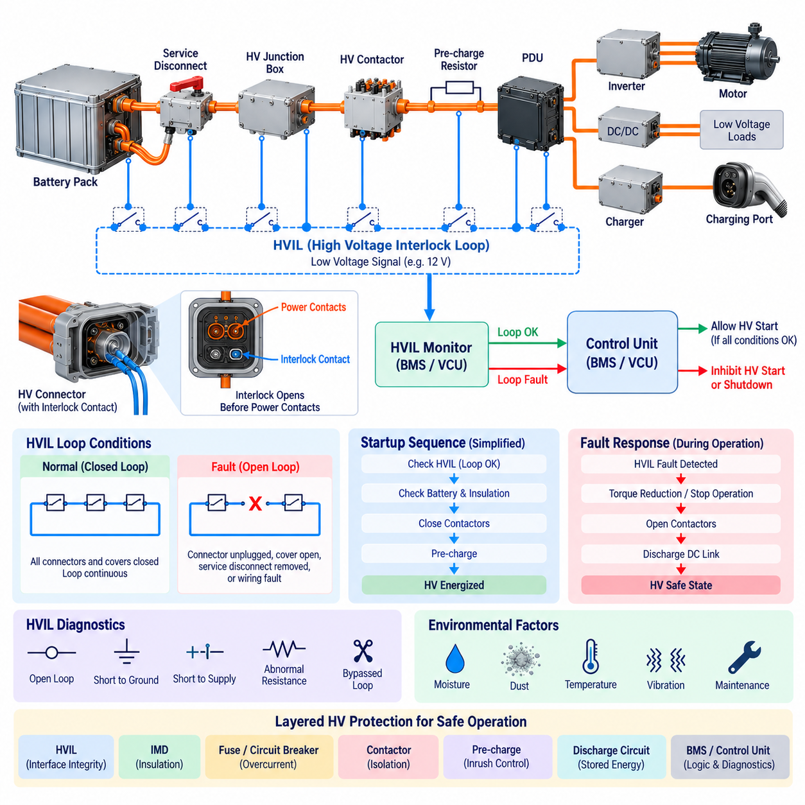
A High Voltage Interlock Loop (HVIL) is a low-voltage supervisory circuit used to verify that high-voltage connectors, covers, service disconnects, and other accessible interfaces remain correctly installed and mechanically secured. In robotic high-voltage systems, the HVIL provides an independent indication that the physical containment of hazardous electrical energy has not been compromised before or during operation.
The fundamental concept of HVIL is to route a dedicated low-energy electrical loop through selected high-voltage components and interfaces. When every monitored connector and enclosure is properly assembled, the loop remains electrically continuous and the supervisory controller recognizes a valid condition. If a connector is unplugged, a cover is opened, a service disconnect is removed, or the interlock wiring is damaged, continuity changes and an HVIL fault is detected.
HVIL is different from insulation monitoring, overcurrent protection, and voltage monitoring because it primarily supervises the physical integrity of the HV connection path rather than the electrical quality of the power circuit itself. An insulation monitoring device detects degraded isolation to chassis, while a fuse detects excessive current. The HVIL instead determines whether components intended to contain or connect hazardous voltage remain correctly engaged.
A typical HVIL architecture contains a low-voltage signal source, interlock wiring, interlock contacts integrated into HV connectors or covers, and a monitoring input in the Battery Management System (BMS), Vehicle Control Unit (VCU), or dedicated safety controller. These elements form a continuous series loop. Because multiple devices can be connected in series, one monitoring channel can supervise several HV interfaces distributed throughout the robot.
High-voltage connectors commonly use dedicated interlock contacts that are mechanically coordinated with the main power contacts. Their geometry can be designed so that the HVIL state changes before the high-current terminals become accessible during disconnection. During connection, the main terminals can be mechanically engaged before the interlock circuit confirms complete connector seating. This sequencing supports controlled energization and de-energization of the HV system.
The concept is often described through first-mate-last-break or last-mate-first-break contact behavior, depending on the connector architecture and reference convention. The essential engineering objective is that the supervisory system receives sufficient indication of connector movement before hazardous exposure occurs. Contact sequencing must therefore be evaluated together with contactor opening time, stored electrical energy, discharge behavior, and connector separation mechanics.
When the HVIL loop is healthy, the supervisory controller may permit the HV system to proceed through its normal startup sequence. This can include checking battery conditions, insulation status, contactor diagnostics, pre-charge operation, and DC bus voltage before closing the main contactors. HVIL validity is therefore generally one prerequisite for HV activation rather than the sole condition determining whether the power system can be energized.
If an HVIL fault is detected before startup, the controller should normally inhibit HV activation and prevent the main contactors from closing. This prevents hazardous voltage from being intentionally applied to a system whose connector or enclosure integrity cannot be confirmed. Diagnostic information can identify the HVIL as the reason for the startup inhibition and support service personnel in locating an improperly connected component.
An HVIL interruption during operation requires a carefully defined response strategy. The system can immediately request torque removal or load reduction, stop high-power operation, open the main contactors, and initiate controlled discharge of the DC link. The exact sequence depends on system architecture and safety requirements because uncontrolled removal of propulsion or actuator power can itself create mechanical hazards in mobile robots, manipulators, or autonomous vehicles.
The response time must consider the complete energy-removal chain rather than only HVIL detection latency. After an interlock fault is detected, software processing, communication, contactor actuation, inverter shutdown, and capacitor discharge all require finite time. Consequently, the safety analysis should determine how quickly accessible conductors can become exposed and ensure that hazardous voltage is reduced appropriately before physical access becomes possible.
Stored energy is particularly important because opening the battery contactors does not immediately guarantee that every downstream conductor is safe. Inverters, DC/DC converters, motor drives, filters, and other power-electronic devices can contain large DC-link capacitors. A discharge circuit is therefore commonly coordinated with HVIL operation so that residual bus voltage falls to an acceptable level after the primary energy source has been disconnected.
The HVIL circuit itself must also be diagnosed because simple continuity monitoring can confuse a genuine connector opening with wiring faults or electrical shorts. More sophisticated implementations can supervise expected voltage or resistance ranges rather than using only binary open-versus-closed detection. This enables the controller to identify conditions such as an open loop, short to ground, short to supply, abnormal loop resistance, or potentially bypassed interlock circuitry.
Series-connected HVIL loops provide architectural simplicity but can make fault localization difficult. If several connectors, access covers, and service disconnects share one loop, an interruption indicates that at least one monitored interface is invalid without necessarily identifying which one. Systems requiring better service diagnostics can divide the HVIL into multiple monitored zones or combine loop monitoring with component-specific status information.
HVIL wiring should be routed and protected with the same attention given to other safety-related signals. Connector vibration, harness abrasion, water ingress, corrosion, contamination, poor terminal retention, and repeated maintenance cycles can cause intermittent continuity changes. In mobile robots, these transient faults may appear only during acceleration, steering, vibration, or chassis deformation, making event logging and timestamped diagnostic information valuable for root-cause analysis.
The HVIL should not be used as a substitute for a dedicated emergency-stop circuit, functional safety controller, or electrical isolation system. An emergency stop addresses hazardous machine behavior, while HVIL supervises selected physical interfaces in the high-voltage system. Similarly, HVIL does not measure insulation resistance or directly determine whether residual voltage remains present. These functions must be provided by coordinated protection mechanisms.
Integration with the main contactors creates an important protection relationship. The HVIL reports whether the monitored HV interfaces are intact, while the contactors physically connect or disconnect the battery from the HV bus. A valid HVIL can be included among the permissive conditions for contactor closure, whereas an invalid HVIL can generate an opening request. Contactor feedback should then confirm whether the commanded isolation actually occurred.
The pre-charge circuit must also be coordinated with HVIL status. During startup, an invalid interlock should normally prevent initiation or completion of pre-charge because charging downstream DC-link capacitors would establish hazardous voltage in a system with uncertain physical integrity. If the interlock opens during pre-charge, the sequence should be aborted and the accumulated energy safely discharged before another startup attempt is permitted.
In robotic platforms, HVIL monitoring can cover the battery pack, HV junction box, PDU, traction inverter, motor controller, DC/DC converter, charger, service disconnect, and removable high-voltage modules. The exact coverage depends on where human access, maintenance operations, removable connectors, and hazardous voltage exposure can occur. Interfaces that can be opened during service deserve particular attention because maintenance activity creates foreseeable opportunities for accidental HV exposure.
Outdoor AMRs, heavy autonomous vehicles, mobile manipulators, and high-power UAVs introduce additional requirements because vibration, shock, moisture, dust, thermal cycling, and frequent connector servicing can affect interlock reliability. Mechanical connector retention and electrical HVIL diagnostics should therefore be considered together. A robust design must avoid nuisance shutdowns while still detecting genuine loss of connector engagement before the condition develops into an electrical safety hazard.
HVIL becomes most effective when incorporated into a layered high-voltage protection architecture. The HVIL supervises physical connection integrity, the insulation monitoring device supervises isolation to chassis, fuses and circuit breakers protect against excessive current, contactors provide controlled electrical separation, pre-charge manages inrush current, and discharge circuits remove stored energy. The BMS or supervisory controller coordinates these functions into a consistent HV state machine.
For high-energy robotic systems, the HVIL should ultimately be regarded as part of the transition logic between safe, de-energized, pre-charge, energized, fault, and discharge states. Its value is not merely detecting an unplugged connector but ensuring that mechanical access to the HV network is linked to electrical energy control. Properly coordinated with diagnostics and power switching, HVIL provides a fundamental layer of protection against unintended exposure to hazardous voltage.

08.03. Discharge Circuit Design
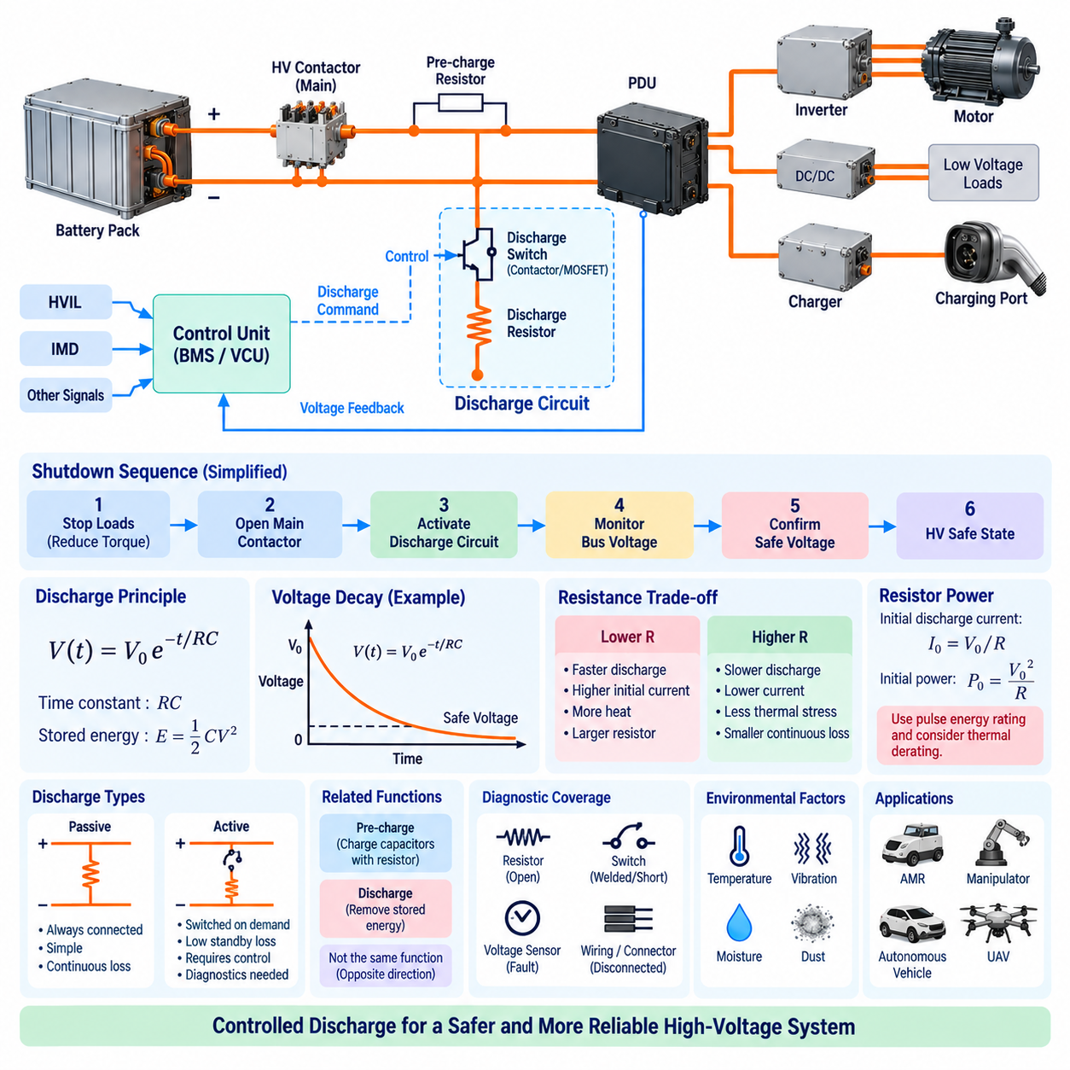
A discharge circuit is a protective function used to remove electrical energy stored in high-voltage DC buses and power-electronic capacitors after the primary power source has been disconnected. In robotic HV architectures, opening the battery contactors does not immediately make every downstream conductor safe because inverter, converter, and filter capacitors may remain charged. The discharge circuit reduces this residual voltage in a controlled and predictable manner.
The principal energy source requiring discharge is usually the DC-link capacitance distributed across traction inverters, motor drives, DC/DC converters, chargers, and other high-power electronic modules. The energy stored in a capacitor follows E = 1/2 CV², meaning that stored energy increases with capacitance and with the square of voltage. Consequently, even moderate capacitance can retain significant hazardous energy when the HV bus operates at several hundred volts.
The simplest discharge architecture places a resistor across the HV DC bus so that stored capacitor energy is converted into heat after power removal. If resistance R is connected across capacitance C, the ideal voltage decay follows an exponential relationship, V(t) = V₀e^(-t/RC). The product RC is the electrical time constant, and it provides the fundamental relationship between discharge resistance, system capacitance, initial voltage, and the time required to reach a safe voltage.
A lower discharge resistance produces faster voltage reduction but creates higher initial current and greater resistor power dissipation. A higher resistance reduces current and thermal stress but extends the time during which hazardous voltage remains present. Discharge circuit design therefore requires a compromise between safe-voltage timing requirements, resistor size, peak power, energy capability, thermal limits, packaging, reliability, and the electrical loading permitted during normal operation.
Passive discharge uses a resistor that remains permanently connected across the DC bus. This architecture is simple and inherently available without requiring a control command, but it continuously consumes power whenever the HV bus is energized. The resulting losses may be undesirable in battery-powered robots. The resistor must also tolerate continuous voltage and thermal loading, making passive discharge less attractive when high efficiency or long operating duration is important.
Active discharge connects the discharge resistor only when energy removal is required. A relay, contactor, MOSFET, IGBT, or other switching element can establish the discharge path after the main HV source has been isolated. Because the resistor is disconnected during normal operation, continuous power loss can be greatly reduced. However, active discharge introduces additional switching, control, diagnostics, and failure modes that must be considered in the protection architecture.
The discharge resistor is selected from both resistance and energy requirements. Its resistance determines the initial discharge current according to I₀ = V₀/R and strongly influences the decay time. At the instant discharge begins, resistor power is approximately P₀ = V₀²/R, which can be much higher than its normal continuous power rating. Therefore, pulse-energy capability, transient thermal impedance, operating temperature, and repetitive discharge duty are often more important than the continuous wattage value alone.
For example, a system with a large DC-link capacitance can produce a short but intense thermal pulse each time the HV system shuts down. Repeated startup and shutdown cycles may prevent the discharge resistor from cooling completely between events. Thermal accumulation must therefore be evaluated using the expected duty cycle rather than assuming each discharge begins at ambient temperature. Enclosure temperature and cooling conditions should also be included in resistor derating.
The discharge switching device must be rated for the maximum bus voltage, discharge current, transient conditions, and expected switching life. In an active design, the switch is normally commanded only after the main contactors have opened or the energy source has otherwise been isolated. Incorrect sequencing can connect the discharge resistor directly across an energized battery, potentially producing excessive continuous current and severe thermal stress or damaging the discharge components.
Coordination between the main contactors and discharge circuit is therefore fundamental. During normal HV operation, the discharge path should remain inactive unless the architecture intentionally uses permanent passive discharge. When shutdown begins, torque-producing loads are first brought to an appropriate state, the main energy source is disconnected, and the discharge path is activated. The controller then monitors bus voltage until the electrical system reaches the defined safe state.
Voltage feedback provides confirmation that discharge has actually occurred. A voltage sensing circuit can measure the HV bus after the contactors open and verify that voltage decreases according to the expected profile. If the voltage remains unexpectedly high, the controller can identify a discharge failure. Conversely, an unusually rapid or abnormal voltage collapse may indicate an unexpected load, short circuit, measurement problem, or another condition requiring diagnostic investigation.
Discharge timing should be based on measured voltage rather than relying exclusively on a fixed delay. Component tolerances, temperature, bus capacitance, connected loads, and aging can change the actual decay rate. A timer can provide supervision, but voltage feedback confirms the physical result. A robust state machine can therefore require both sufficient elapsed time and measured bus voltage below the defined threshold before declaring the HV network safe.
The discharge function is closely related to the High Voltage Interlock Loop (HVIL). If an HV connector is unplugged, an access cover is opened, or a service disconnect changes state, the HVIL can request removal of high-voltage energy. Opening the main contactors isolates the battery, while the discharge circuit removes energy remaining in downstream capacitors. This coordination reduces the possibility that accessible HV terminals remain energized after physical containment has been compromised.
Insulation monitoring provides another complementary function. The Insulation Monitoring Device (IMD) evaluates isolation between the energized HV network and chassis, whereas the discharge circuit removes stored energy after shutdown. An insulation fault may initiate a controlled HV shutdown, after which the contactors isolate the source and the discharge circuit lowers residual voltage. These functions therefore operate as different layers within the same HV protection architecture.
The discharge circuit must also be distinguished from the pre-charge circuit. Both commonly use resistive components, but their energy-flow directions and purposes differ. Pre-charge limits inrush current while charging downstream DC-link capacitors before the main contactors fully connect the battery. Discharge performs the opposite transition by removing energy from those capacitors after isolation. Some architectures may share components, but independent functional analysis is necessary before combining these functions.
Diagnostic coverage should include the discharge resistor, switching element, command path, voltage sensor, wiring, and connectors. Possible faults include an open resistor, welded relay, shorted semiconductor, failed control output, disconnected harness, or incorrect voltage measurement. A system that commands discharge without verifying the resulting voltage reduction cannot reliably determine whether the stored electrical energy has actually been removed.
A welded or permanently closed discharge switch represents a different hazard from an open discharge path. An open path prevents energy removal, while a permanently active path may continuously load the HV bus and overheat the resistor. Diagnostic logic can compare commanded discharge state, measured bus voltage, expected decay rate, current behavior, and thermal information to distinguish these conditions and select an appropriate fault response.
Physical placement influences both safety and performance. The discharge path should be electrically connected where it can remove energy from the hazardous capacitance that remains isolated from the battery after contactor opening. Placing the resistor on the wrong side of the main contactor may discharge the battery-side circuit while leaving downstream DC-link capacitors charged. System-level schematics must therefore identify all capacitances and switching boundaries that can trap hazardous energy.
In AMRs, mobile manipulators, heavy autonomous vehicles, and high-power UAVs, several distributed power converters may each contain local capacitors. A centralized discharge circuit may not remove energy trapped behind internal switches or converters. Local discharge elements may therefore be required inside individual inverter or converter modules. The overall HV architecture should verify that every service-accessible hazardous node reaches its intended safe-voltage condition.
Environmental conditions also affect discharge design. High ambient temperature reduces resistor thermal margin, while vibration and shock can damage large power resistors, terminals, or mounting structures. Moisture, conductive contamination, and inadequate creepage or clearance can create unintended leakage paths around HV components. Mechanical mounting, insulation materials, enclosure design, thermal management, and electrical spacing must therefore be considered together.
A complete shutdown sequence can be represented as a controlled transition from energized operation to an electrically safe condition. The system reduces or disables active loads, opens the main contactors, activates discharge, measures the falling DC bus voltage, detects abnormal behavior, and confirms that the safe-voltage criterion has been reached. Only after this confirmation should the supervisory logic consider the downstream HV network de-energized for the intended operating or service state.
Discharge circuit design is therefore not simply the selection of a resistor across a capacitor. It is a coordinated safety function involving stored-energy calculation, RC decay behavior, switching devices, contactor sequencing, voltage measurement, thermal design, diagnostics, HVIL interaction, insulation monitoring, and system state management. Proper integration ensures that disconnecting the energy source results not merely in an open circuit, but in a verified reduction of hazardous stored electrical energy.

08.04. Arc-Flash Protection
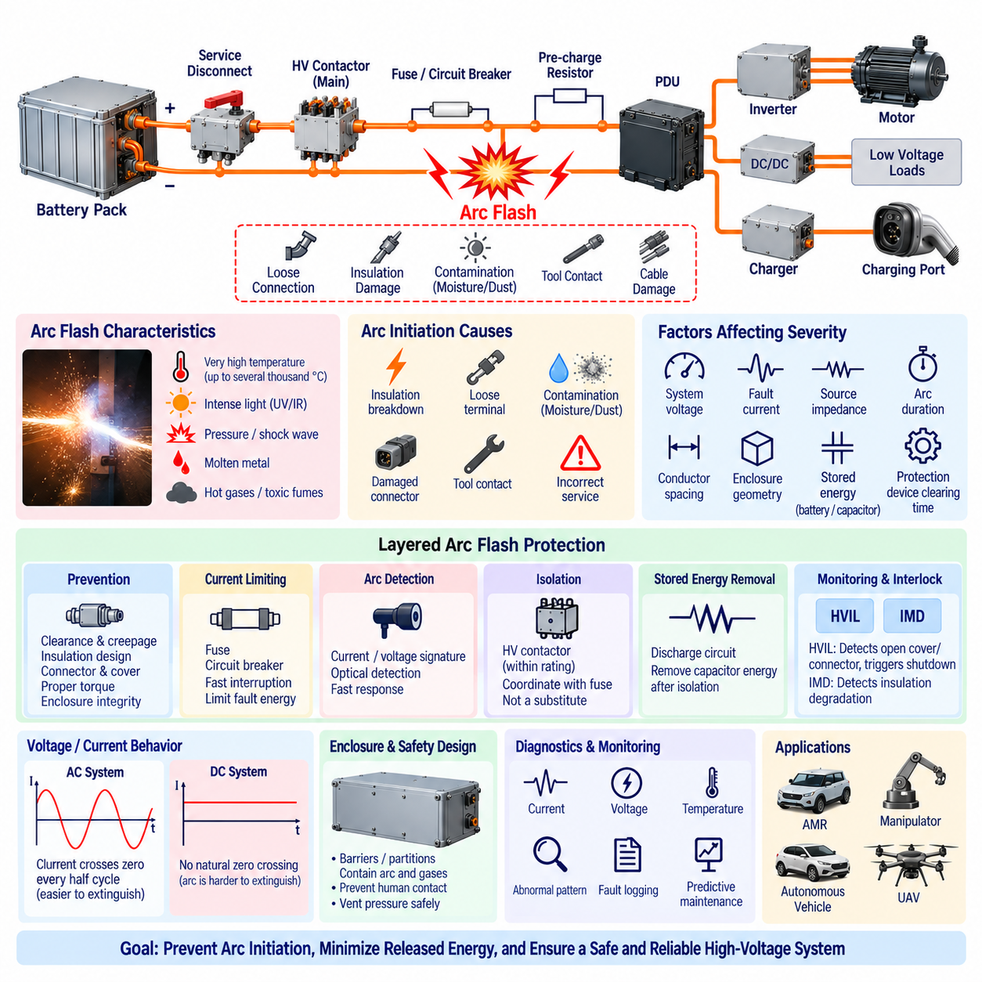
Arc flash is a hazardous release of thermal and electromagnetic energy produced when electrical current flows through an ionized path between conductors or between a conductor and ground. The resulting plasma can reach extremely high temperatures and generate intense light, pressure, molten metal, and hot gases. In high-energy robotic power systems, arc-flash protection is therefore an important consideration wherever fault energy can be released rapidly.
An arc can begin when insulation breaks down across an air gap or when conductive material bridges normally isolated electrical potentials. Loose terminals, damaged connectors, contamination, moisture, conductive debris, incorrect service procedures, insulation deterioration, or accidental tool contact can initiate the event. Once the air becomes ionized, the arc may continue even after the original physical contact has disappeared, provided sufficient electrical energy remains available.
Arc-flash severity depends strongly on system voltage, available fault current, source impedance, arc duration, conductor spacing, enclosure geometry, and the protective device clearing time. Stored energy in batteries and DC-link capacitors can also contribute to the event. Consequently, protection cannot be based only on nominal voltage. A relatively compact battery system may still present substantial hazard if it can deliver very high current into a low-impedance fault.
DC systems require particular attention because direct current does not naturally cross zero every half cycle as AC current does. An established DC arc can therefore be difficult to extinguish if the circuit continues supplying sufficient voltage and current. High-voltage battery systems used in robots, autonomous vehicles, mobile manipulators, and UAVs should use switching and protection devices specifically capable of interrupting the expected DC fault conditions.
The first protection principle is to prevent an arc from being initiated. Adequate electrical clearance, creepage distance, insulation coordination, connector design, terminal covers, barriers, enclosure integrity, cable protection, and proper torque control reduce the probability of unintended conductive paths. Mechanical design is equally important because vibration, shock, harness movement, connector loosening, and foreign-object intrusion can gradually create conditions from which an electrical arc develops.
Current-limiting protection reduces the energy available during a fault. Properly selected fuses, circuit breakers, and other interruption devices should disconnect the affected circuit before excessive thermal and mechanical energy accumulates. The clearing characteristic of the protective device must be coordinated with the prospective fault current. A device with an adequate current rating but excessively slow interruption can permit significantly greater arc energy than the surrounding components can tolerate.
Fuse selection for arc-flash protection therefore involves more than preventing conductor overheating. The fuse interrupting rating must exceed the maximum prospective fault current, and its time-current and current-limiting characteristics should be evaluated against the energy available from the battery and connected capacitances. High-speed fuses can substantially reduce fault energy in suitable applications, although coordination with inrush, motor acceleration, regenerative current, and normal transient loads remains necessary.
Circuit breakers and electronically controlled protection can provide additional flexibility. Electronic current measurement allows abnormal current to be detected independently of purely thermal mechanisms, while configurable trip logic can respond differently to overloads and severe short circuits. In smart PDUs, current sensors and semiconductor switches can isolate individual branches rapidly, potentially preventing a local wiring or load fault from propagating into a larger system-level event.
The main HV contactors provide another layer of isolation, but they should not automatically be considered substitutes for dedicated short-circuit protection. Contactors have finite interruption capability and may not safely clear every prospective fault current. Severe current can weld or damage their contacts. Fuses or appropriately rated circuit breakers are therefore commonly coordinated with contactors so that each device operates within its intended electrical and mechanical capability.
Arc detection can supplement conventional overcurrent protection in systems where an arc may not produce current high enough for rapid short-circuit protection. Electrical arc signatures can include rapid current fluctuations, voltage disturbances, broadband electrical noise, or optical emission. Specialized detection methods can combine current, voltage, or light information to distinguish an abnormal arc from normal switching behavior, although nuisance detection must be carefully controlled.
Detection speed is important because incident energy increases as the arc continues. A protection system should minimize the time between fault initiation, detection, decision, and energy interruption. This total response includes sensor delay, processing time, communication latency, switching command generation, contactor or breaker opening time, and any remaining energy supplied by downstream capacitors. System-level analysis must therefore consider the complete fault-clearing chain.
Stored electrical energy remains relevant even after the battery has been disconnected. Inverters, motor drives, DC/DC converters, chargers, and filters can contain charged capacitors capable of feeding an existing arc for a short period. A coordinated discharge circuit helps remove this residual energy after source isolation. However, discharge circuitry must itself be positioned and protected so that it does not introduce an additional unintended high-energy fault path.
The High Voltage Interlock Loop (HVIL) provides complementary protection by detecting when monitored HV connectors, covers, or service disconnects are opened. If access to an energized region is attempted, HVIL can initiate controlled power removal before conductive parts become accessible. HVIL does not directly detect an arc, but it reduces exposure opportunities by linking mechanical access to electrical isolation, contactor control, and subsequent discharge of stored energy.
The Insulation Monitoring Device (IMD) provides another preventive layer by detecting deterioration of insulation between the isolated HV network and chassis. Progressive contamination, damaged cables, moisture, or component degradation may lower insulation resistance before a severe fault develops. Detecting these conditions early allows maintenance or controlled shutdown before a second insulation fault or conductive path creates conditions favorable to a high-energy electrical event.
Enclosure design influences both arc prevention and the consequences of an internal failure. Barriers and partitions can limit propagation between adjacent conductors or branches, while appropriately designed covers reduce accidental human contact. The designer should also consider pressure and hot-gas behavior if an internal arc occurs. A mechanically strong enclosure that traps rapidly expanding gases without appropriate consideration can create a different mechanical hazard.
Maintenance state is particularly important because many electrical incidents occur when protective covers are removed or equipment is being inspected, measured, or repaired. Service procedures should minimize energized work and require verification that the HV source is isolated and residual voltage has fallen to the defined safe level. Service disconnects, lockout provisions, voltage measurement points, warning labels, and clear maintenance instructions support controlled access to HV components.
Protection architecture should also consider faults created by incorrect assembly. A partially seated connector, loose busbar, improperly tightened terminal, damaged insulating washer, or forgotten conductive tool may operate normally at first but later generate localized heating and arcing. Manufacturing inspection, torque verification, connector-position assurance, end-of-line electrical testing, and maintenance diagnostics therefore contribute directly to arc-flash risk reduction.
Thermal monitoring can provide useful early warning in high-current joints. Abnormal contact resistance at a loose or degraded connection generates localized heating before catastrophic failure occurs. Temperature sensors placed near busbars, contactors, connectors, or fuse terminals can reveal developing problems. Current and temperature trends can be combined with diagnostic thresholds to identify connections whose behavior is inconsistent with the expected electrical load.
Robotic platforms introduce mechanical conditions that stationary electrical cabinets may not experience. Repeated acceleration, impacts, steering loads, manipulator motion, vibration, and chassis flex can stress HV cables and terminals. Outdoor AMRs additionally encounter water, dust, salt, temperature cycling, and contamination. Arc-flash prevention must therefore integrate electrical protection with harness routing, connector retention, strain relief, sealing, and environmental qualification.
Fault containment can be improved by segmenting the power distribution architecture. Instead of exposing the entire HV bus to every downstream failure, branch fuses, controllable contactors, circuit breakers, or smart PDU channels can isolate affected loads. Selective protection limits the portion of the system that remains connected to the fault and can reduce fault propagation while preserving diagnostic information needed to determine the origin of the event.
A complete arc-flash protection strategy combines prevention, rapid detection, current limitation, electrical isolation, stored-energy removal, and controlled service access. Fuses and breakers interrupt excessive current, contactors isolate the source, HVIL supervises physical access, IMD monitors insulation integrity, discharge circuits remove residual energy, and diagnostics identify abnormal electrical or thermal behavior. These functions should be coordinated rather than designed as independent protective features.
For AMRs, mobile manipulators, autonomous vehicles, and high-power UAVs, increasing battery voltage and stored energy make this coordinated approach increasingly important. Arc-flash protection is not a single component but a system-level engineering discipline involving electrical architecture, component ratings, mechanical packaging, environmental robustness, fault detection, protection coordination, and maintenance procedures. The objective is to prevent arc initiation wherever possible and minimize released energy when prevention fails.

08.05. HV Protection for UAV
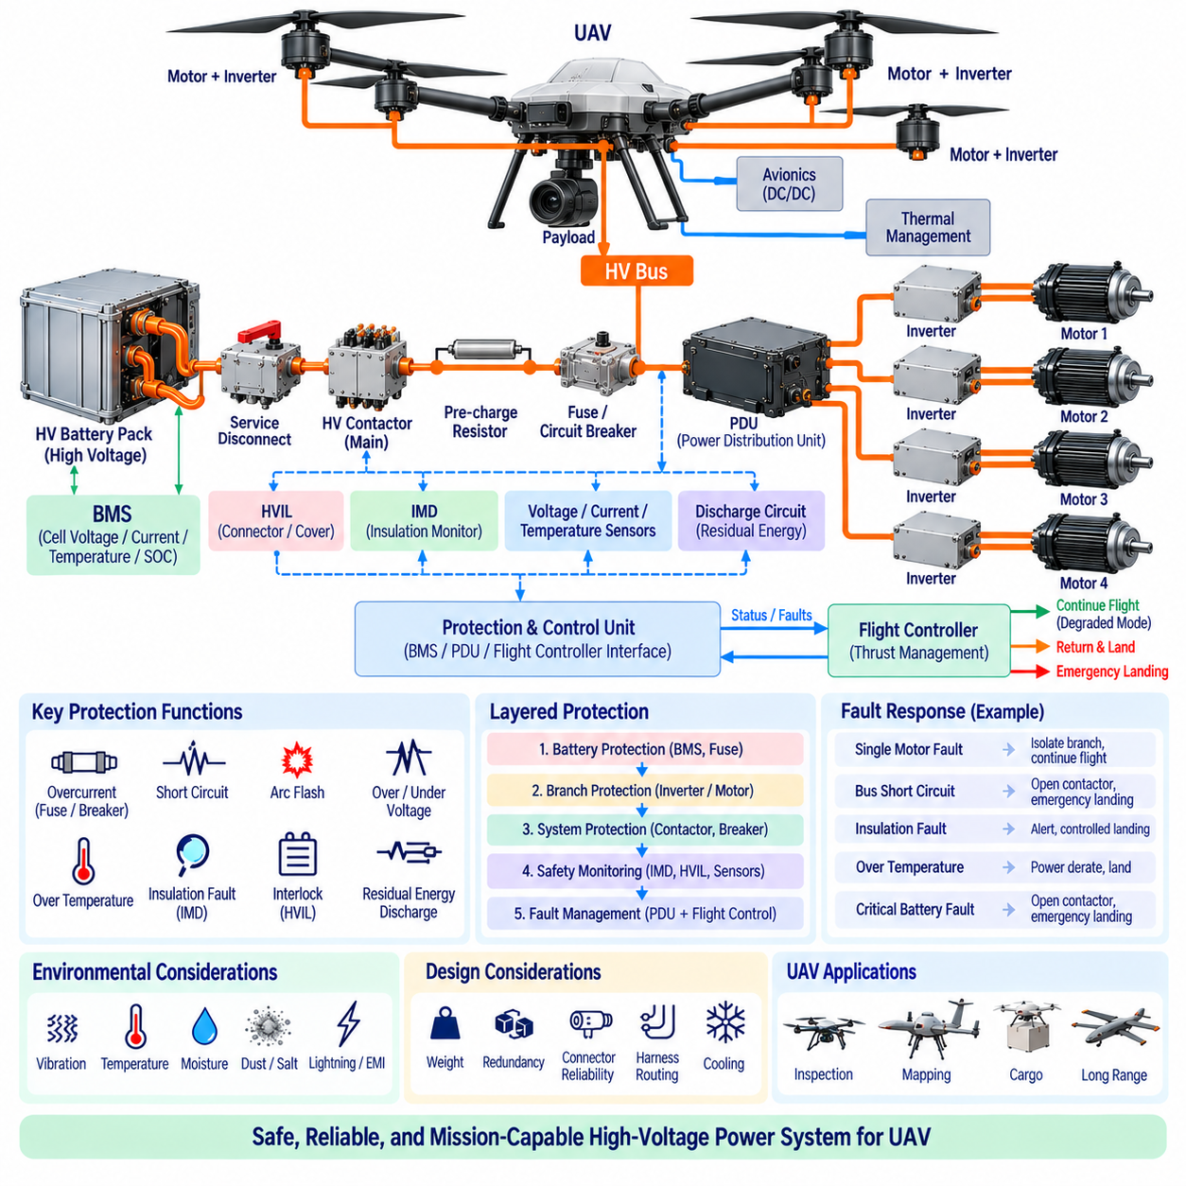
High-voltage protection for an Unmanned Aerial Vehicle (UAV) must manage electrical hazards while preserving the power availability required for controlled flight. Unlike stationary equipment, an airborne platform cannot always respond to an electrical fault by immediately disconnecting all propulsion energy. The protection architecture must therefore coordinate fault isolation, battery protection, propulsion continuity, diagnostics, and emergency landing behavior according to fault severity.
As UAV payload, range, and propulsion power increase, battery voltage generally increases to reduce current for a given power level. Higher voltage can reduce conductor mass and resistive losses, but it introduces greater requirements for insulation, connector spacing, switching devices, maintenance safety, and fault interruption. Large cargo UAVs may contain substantial stored electrical energy, making HV protection a system-level architectural function rather than a collection of individual protective components.
The HV architecture commonly begins with one or more battery packs connected through pack-level protection, contactors, current sensing, and a power distribution stage. The resulting HV bus supplies propulsion inverters, motors, DC/DC converters, avionics supplies, thermal-management equipment, and other high-power loads. Protection boundaries should be defined so that a fault in one propulsion branch does not unnecessarily remove electrical power from every remaining propulsion channel.
Battery protection forms the first major layer. The Battery Management System (BMS) supervises cell voltage, pack current, temperature, state of charge, and other battery conditions while coordinating contactor operation. Pack fuses or other high-current interruption devices provide protection against severe short circuits beyond the intended capability of electronic control. The BMS and passive protection devices should therefore be coordinated rather than treated as interchangeable protection mechanisms.
Branch protection is especially important in multi-motor UAV architectures. Each propulsion inverter or motor branch can be protected independently using appropriately rated fuses, circuit breakers, contactors, or electronic switching devices. Selective isolation allows a failed propulsion channel to be disconnected while healthy channels remain energized when the aircraft architecture can tolerate the resulting asymmetric thrust. This requires close coordination between electrical protection and flight-control logic.
Protection selectivity must consider both electrical and flight consequences. A branch device should ideally clear a local fault before upstream battery protection disconnects the entire HV bus. However, the remaining propulsion system must be capable of maintaining controllability after that branch is isolated. Electrical protection coordination therefore becomes linked to thrust allocation, motor redundancy, vehicle dynamics, aircraft mass, mission phase, and emergency flight-control strategies.
The main HV contactors provide controlled connection and isolation between the battery and the downstream power network. During startup, contactor operation is normally coordinated with system diagnostics and pre-charge. During a critical fault, contactors can isolate the battery from the HV bus, but complete battery disconnection should occur only when required by the safety strategy because opening the main source during flight can remove propulsion power from otherwise healthy motors.
Pre-charge is required where propulsion inverters and converters contain significant DC-link capacitance. Directly connecting a high-voltage battery to discharged capacitors can generate large inrush current, damaging contactors, connectors, fuses, and capacitors. A pre-charge resistor limits this current while the downstream bus voltage rises. The controller verifies successful pre-charge before closing the main current path and should detect incomplete, excessively slow, or abnormal charging behavior.
Stored energy must also be considered after the HV source is disconnected. Inverter and converter DC-link capacitors can retain hazardous voltage even after battery contactors open. A discharge circuit removes this energy in a controlled manner and voltage sensing confirms that the bus has reached the defined safe condition. For UAVs, discharge is particularly relevant during maintenance, post-flight servicing, emergency shutdown, and recovery after an accident or hard landing.
An Insulation Monitoring Device (IMD) can continuously supervise the isolation between a floating HV network and the aircraft structure. Cable damage, moisture, contamination, inverter defects, motor winding deterioration, or mechanical abrasion can reduce insulation resistance. The first insulation fault may not immediately produce a large current in an isolated system, but detecting it early is important because a second fault can establish a hazardous current path through conductive structures.
The High Voltage Interlock Loop (HVIL) can supervise removable battery connectors, service disconnects, access covers, and other HV interfaces. If an interlocked connection is not correctly seated, HV activation can be inhibited before takeoff. During maintenance, opening an interlocked interface can request electrical isolation and subsequent discharge. In-flight HVIL responses require careful design because a mechanically intermittent signal should not automatically cause an uncontrolled total propulsion shutdown.
Arc and short-circuit protection require particular attention because UAV batteries can supply very high fault current. Damaged cables, loose terminals, connector separation, contamination, or insulation breakdown can initiate high-energy faults. DC arcs can be difficult to extinguish because direct current lacks the natural zero crossings of AC systems. Fuses, breakers, contactors, and semiconductor switches must therefore have suitable DC voltage and interruption capability for the prospective fault conditions.
Electrical harness design is directly connected to HV protection. UAV cables experience vibration, airframe movement, repeated maintenance, temperature changes, and potentially severe mechanical loads during takeoff and landing. Routing should prevent abrasion, crushing, excessive bending, and contact with sharp structures. Strain relief, connector retention, insulation protection, and physical separation between redundant power channels reduce the probability that one mechanical event disables multiple electrical paths.
Weight creates a distinctive design constraint for airborne HV protection. Increasing conductor size, adding contactors, installing duplicate batteries, or using heavy protective enclosures improves certain safety margins but reduces payload and endurance. Protection architecture must therefore achieve fault tolerance without uncontrolled mass growth. Strategic redundancy and selective branch isolation are generally more effective than simply duplicating every electrical component throughout the aircraft.
Thermal design is equally important because fuses, contactors, busbars, cables, inverters, and batteries generate heat while operating at high power. Reduced cooling performance, high ambient temperature, solar heating, or repeated high-thrust operation can reduce electrical component margins. Temperature sensing near batteries, connectors, power distribution components, and propulsion electronics allows the controller to detect abnormal thermal behavior before insulation or connection damage progresses into a severe electrical fault.
Environmental exposure can significantly affect UAV HV insulation. Moisture, condensation, conductive dust, salt, and rapid temperature changes can reduce surface insulation resistance and accelerate connector degradation. Creepage distance, clearance, sealing, drainage, conformal protection, and material selection should reflect the expected operating environment. Outdoor and cargo UAVs require particular attention because their electrical systems may be exposed to harsher conditions than indoor robotic equipment.
Lightning, electrostatic charging, and electromagnetic disturbances introduce additional aircraft-specific considerations. These effects should be controlled through appropriate bonding, shielding, grounding strategy, surge protection, and physical routing without compromising the intended isolation of the HV network. Protection design must distinguish the structural current paths required for electromagnetic control from unintended HV leakage paths monitored by the insulation protection system.
Fault detection should combine current, voltage, temperature, insulation, contactor feedback, and communication information rather than depending on a single measurement. A propulsion branch drawing abnormal current while its inverter reports a fault should be treated differently from a system-wide bus-voltage collapse. Correlated diagnostics improve fault classification and allow the controller to determine whether the appropriate response is warning, power derating, branch isolation, mission termination, or complete HV shutdown.
The protection controller and flight controller therefore require a clearly defined interface. Electrical faults should be translated into operational states that the flight-control system can understand. A degraded propulsion channel may require thrust redistribution and immediate landing, whereas a battery thermal emergency may require more aggressive mission termination. This relationship connects electrical fault management with vehicle-level functional safety rather than leaving protection decisions entirely inside the PDU or BMS.
Redundant battery architectures can further improve availability. Independent battery strings, contactors, distribution paths, or propulsion groups can prevent a single electrical failure from eliminating all thrust. However, redundancy is useful only when common-cause failures are controlled. Shared connectors, busbars, cooling systems, software, structural routing, or protection devices can create hidden single points of failure even when multiple battery packs or motors are installed.
Ground maintenance requires a different protection state from flight. HV activation should be prevented when service conditions are not satisfied, and maintenance personnel should have a reliable method to isolate battery energy. Service disconnects, HVIL, contactor status, bus-voltage measurement, discharge verification, warning indicators, and controlled startup procedures together establish a safer transition between energized operation and maintenance access.
After a crash, hard landing, water exposure, or structural damage, the HV system may require an emergency isolation strategy. Damaged batteries or cables can remain energized even when normal control electronics are unavailable. Physical battery segmentation, appropriately positioned protection devices, robust enclosures, and clearly defined emergency-disconnect mechanisms can limit the amount of electrical energy available at damaged sections and support safer recovery operations.
A robust UAV HV protection architecture therefore combines BMS supervision, fuses or breakers, selective branch protection, HV contactors, pre-charge, discharge, insulation monitoring, HVIL, thermal monitoring, diagnostics, and flight-control coordination. These mechanisms should form a layered system in which local faults are contained whenever possible, critical faults lead to controlled vehicle-level responses, and hazardous stored energy is managed during both operation and maintenance.
For high-power and cargo UAVs, the central engineering objective is not simply to disconnect electricity whenever a fault occurs. The protection system must distinguish faults that require immediate isolation from faults that permit degraded flight long enough to reach a safer condition. Effective HV protection therefore balances electrical safety, propulsion availability, fault containment, mass, redundancy, environmental robustness, and controlled emergency behavior as one integrated aircraft-level design problem.

