Volume 04. Fuse, Relay, and Power Distribution Unit

Chapter 02. Fuse Types and Selection

02.01. Blade Fuse (Mini, Regular, Maxi)
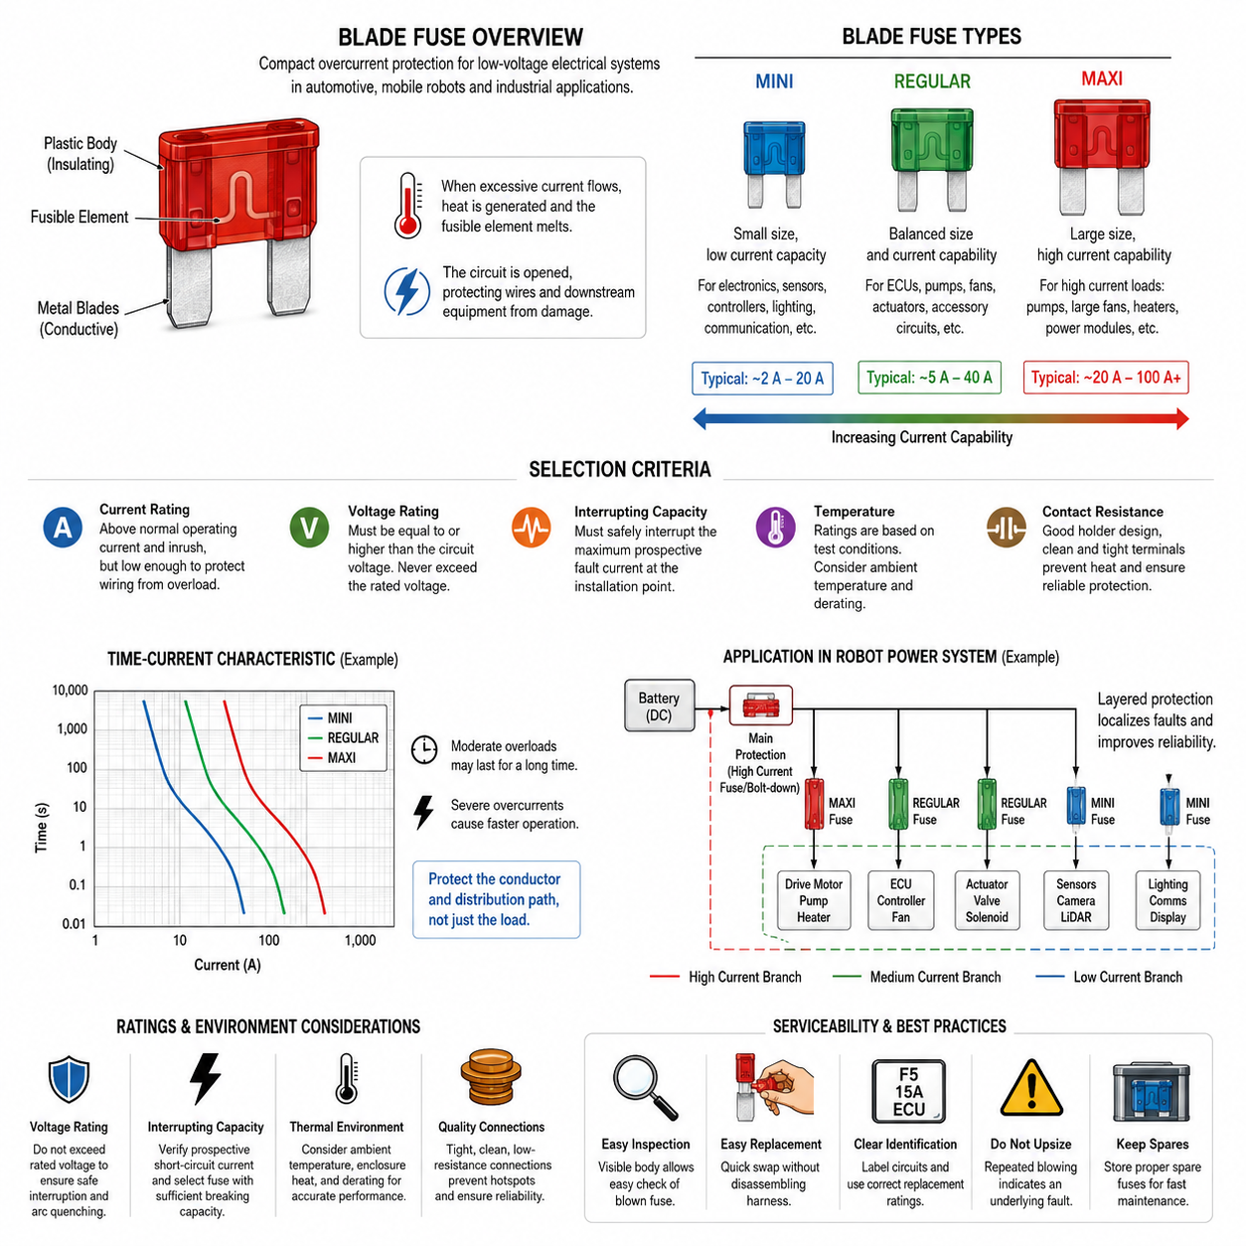
Blade fuses are compact overcurrent protection devices widely used in automotive, mobile robot, AMR, and low-voltage electrical systems. They consist of a calibrated fusible element enclosed in an insulating plastic body with two exposed metal blades. When excessive current produces sufficient thermal energy, the element melts and interrupts the circuit, protecting wiring and downstream equipment from overheating or damage.
The blade format provides several practical advantages for distributed electrical architectures. A fuse can be inserted directly into a standardized holder or power distribution unit without threaded fasteners, making assembly and replacement relatively simple. The visible plastic body also supports rapid identification during maintenance. However, physical compatibility alone does not guarantee electrical suitability, because voltage rating, current rating, interrupting capability, and time-current behavior must all match the circuit.
Mini blade fuses are intended for circuits where packaging space and moderate current capacity are important. Their smaller body allows many protected branches to be concentrated within a compact fuse box or PDU. In robots, they are suitable for auxiliary electronics, controllers, sensors, lighting, communication devices, and other relatively low-current loads. Their compact dimensions are valuable where enclosure volume and harness packaging are tightly constrained.
Regular blade fuses, often called standard blade fuses, provide a useful balance between physical size, current capability, thermal performance, and serviceability. They are commonly applied to medium-current branches supplying ECUs, pumps, fans, actuators, accessory circuits, and similar loads. Because of their widespread use, regular blade fuses are convenient when designing electrical systems that require easily obtainable replacement components and straightforward field maintenance.
Maxi blade fuses extend the blade-fuse concept toward substantially higher-current circuits. Their larger conductive blades and fusible structure provide greater current-carrying capability than Mini or Regular types. They are therefore useful near major distribution points or for loads such as electric pumps, large fans, heaters, auxiliary power modules, and selected motor circuits. Nevertheless, very high battery or traction currents may require bolt-down or specialized high-current fuse technologies instead.
The choice among Mini, Regular, and Maxi types should therefore be considered as part of a current hierarchy rather than simply as a packaging decision. Mini fuses generally serve smaller branch loads, Regular fuses cover many conventional medium-current circuits, and Maxi fuses protect larger branches. The exact usable range depends on the particular fuse family and manufacturer, so the engineer should verify the datasheet rather than assuming that fuse body size alone defines allowable current.
Current rating indicates the nominal current classification of a fuse, but it should not be interpreted as a precise current at which the fuse immediately opens. A blade fuse is a thermal protection device with a time-current characteristic. Moderate overloads may persist for a significant period, while severe overcurrents produce much faster operation. Consequently, fuse selection must consider both steady-state load current and transient conditions such as motor starting, capacitor charging, actuator acceleration, and other inrush events.
The fuse must primarily protect the conductor and electrical distribution path rather than merely match the nominal current consumption of the connected device. The selected fuse rating should normally remain above expected operating current, including acceptable temporary peaks, while remaining sufficiently low to prevent the protected wire from reaching an unsafe thermal condition during overload or short-circuit events. This relationship connects blade-fuse selection directly with wire gauge, derating, ambient temperature, and harness design.
Voltage rating is equally important because opening the fusible element does not automatically guarantee safe circuit interruption. After melting, the fuse must withstand the electrical stress across the resulting gap and suppress continued conduction or arcing. A fuse must therefore never be applied above its specified voltage rating. This requirement becomes increasingly important as robotic platforms move from conventional low-voltage auxiliary networks toward 48 V and other higher-voltage DC power architectures.
Interrupting or breaking capacity defines the maximum prospective fault current that the fuse can safely interrupt under specified conditions. A battery can deliver fault current far greater than the normal operating current of the protected load, especially when wiring resistance between the battery and fault location is low. Engineers must therefore evaluate the available short-circuit current at the fuse location and confirm that the selected blade fuse can safely clear that fault without destructive rupture.
Contact resistance is another important consideration in blade-fuse applications. Current passes through the fuse blades, holder terminals, crimps, busbars, and associated conductors, and each interface contributes resistance and heat generation. A loose, contaminated, oxidized, or poorly tensioned terminal can become a localized thermal hotspot even when the fuse element itself is correctly rated. Reliable fuse protection therefore depends on the mechanical and electrical quality of the holder as well as the fuse.
Thermal environment strongly affects blade-fuse behavior. Fuse ratings and time-current curves are established under defined test conditions, whereas actual installations may place the fuse inside a sealed PDU near relays, MOSFET switches, DC/DC converters, batteries, or other heat-producing components. Closely packed high-current fuses can also heat one another. Ambient-temperature correction and enclosure-level thermal analysis should therefore accompany nominal current calculations in demanding robot power systems.
In an AMR or mobile robot, blade fuses can form a layered protection structure. A higher-current device may protect the main low-voltage distribution branch, while Regular and Mini blade fuses protect progressively smaller downstream loads. This arrangement localizes faults and reduces the probability that failure of a sensor, controller, fan, or auxiliary actuator disables the entire platform. Protection coordination should ensure that the fuse closest to the fault operates before unnecessary upstream protection is triggered.
Serviceability is one of the strongest advantages of blade fuses. A technician can usually inspect, remove, and replace a failed device without disturbing the surrounding harness. For effective diagnostics, however, the electrical design should provide clear circuit identification, accessible fuse locations, correct spare ratings, and protection against installing an inappropriate replacement. Repeated fuse operation should always be treated as evidence of an underlying electrical fault rather than solved by installing a higher-rated fuse.
Mini, Regular, and Maxi blade fuses therefore represent different physical and electrical scales within the same fundamental protection concept. Correct selection requires coordinated evaluation of normal current, transient current, wire ampacity, voltage, fault-current capability, thermal environment, packaging, holder performance, and maintenance requirements. Within the broader fuse architecture, blade fuses are especially effective for accessible low-voltage branch protection, while other fuse technologies address higher-current and specialized protection requirements.

02.02. Bolt-Down Fuse (MIDI, MEGA)
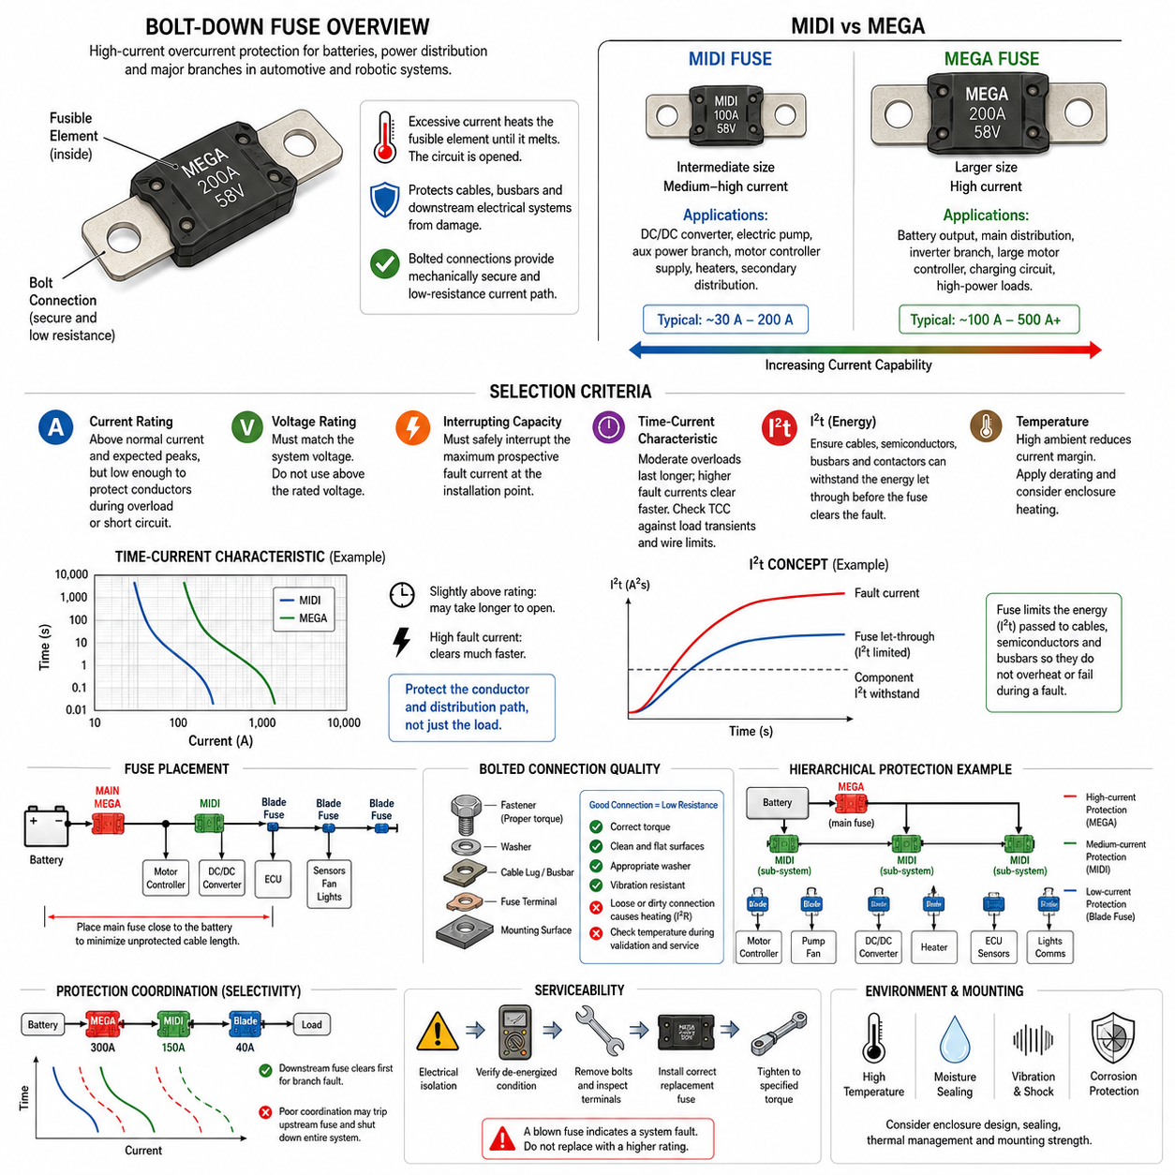
Bolt-down fuses are high-current overcurrent protection devices designed for circuits where conventional plug-in blade fuses are no longer sufficient. Instead of relying on spring-contact terminals, they use bolted electrical connections that clamp the fuse directly between busbars, cable lugs, or power distribution terminals. This construction provides a mechanically secure, low-resistance current path suitable for batteries, high-power loads, and major distribution branches.
The two common bolt-down fuse families considered in low-voltage automotive and robotic power systems are MIDI and MEGA fuses. Both use a fusible element integrated into a compact body with mounting holes or terminal sections at each end. Their fundamental operating principle remains thermal: excessive current heats the calibrated element until it melts and opens the circuit, preventing the protected conductor and downstream distribution network from experiencing damaging thermal stress.
MIDI fuses provide an intermediate protection level between smaller blade fuses and larger high-current devices. Their relatively compact construction makes them useful where substantial current must be protected without consuming excessive PDU space. Typical applications include medium-to-high-current DC/DC converter feeds, electric pumps, auxiliary power branches, motor-controller supplies, heaters, and secondary distribution circuits in mobile robots and automotive electrical architectures.
MEGA fuses are intended for higher-current power paths and are physically larger than MIDI devices. Their robust terminals and larger fusible structure make them suitable for battery outputs, high-current power distribution, inverter branches, major motor-controller feeds, charging circuits, and other substantial electrical loads. In an AMR, MEGA fuses may be positioned close to the battery or main PDU to provide primary protection before power is divided into smaller downstream branches.
The distinction between MIDI and MEGA should not be treated simply as a difference in physical dimensions. Fuse selection must reflect the required current range, available fault current, voltage, thermal environment, mounting arrangement, and coordination with downstream protection. A MIDI fuse may be appropriate for a substantial auxiliary branch, while a MEGA fuse may protect the main distribution path. Exact electrical ratings must always be verified using the specific manufacturer's datasheet.
A bolt-down fuse should primarily be selected to protect the cable, busbar, and distribution path rather than merely matching the nominal rating of the connected equipment. Normal continuous current, expected overloads, motor acceleration, converter startup, capacitor charging, regenerative conditions, and other transient currents must be evaluated. The fuse must tolerate legitimate operating peaks while opening rapidly enough to prevent excessive conductor heating during sustained overload or short-circuit conditions.
Time-current behavior is therefore fundamental to MIDI and MEGA fuse engineering. A current slightly above the nominal rating does not necessarily cause immediate opening, because the fuse element requires sufficient accumulated thermal energy to melt. As fault current increases, clearing time generally decreases significantly. Engineers should compare the fuse time-current curve with load transients and conductor thermal limits rather than selecting protection solely from a single nominal ampere value.
The I²t characteristic is especially important when evaluating high-current bolt-down fuses. It represents the thermal energy associated with current flow during the fuse operating process and helps determine whether cables, semiconductor power devices, busbars, contactors, or other downstream components can withstand the energy passed before interruption. Protection design therefore requires coordination between fuse clearing behavior and the short-duration thermal capability of the protected electrical components.
Voltage rating must also match the electrical architecture. When the fusible element melts, the fuse must interrupt current and withstand the voltage appearing across the opened element without maintaining a destructive arc. A fuse rated for a particular DC voltage should not be assumed suitable for a higher-voltage network merely because its current rating is adequate. This becomes particularly significant in 48 V robot architectures and other battery systems with elevated DC bus voltages.
Interrupting capacity becomes critical because batteries can supply extremely high short-circuit current. The prospective fault current near a battery may be many times greater than normal operating current because battery internal resistance, cable resistance, and connection resistance can be very low. The selected MIDI or MEGA fuse must therefore possess sufficient breaking capability to interrupt the maximum credible fault current at its installation point without uncontrolled rupture or continued arcing.
Fuse location strongly influences the amount of wiring that is actually protected. A main battery fuse should normally be positioned electrically close to the battery source so that the length of unprotected conductor is minimized. If a fuse is installed far downstream, the cable between the battery and fuse remains exposed to short-circuit risk. Mechanical packaging, service access, environmental sealing, and crash or impact considerations must therefore be coordinated with electrical protection requirements.
Bolted joints are a defining engineering consideration for MIDI and MEGA fuses. The fuse terminal, busbar or cable lug, washer arrangement, fastener, and mounting surface form part of the current path. Insufficient tightening can increase contact resistance and create localized heating, while excessive tightening can damage terminals or the fuse body. Specified tightening torque and assembly procedures should therefore be treated as electrical reliability requirements rather than merely mechanical instructions.
Contact resistance becomes increasingly significant as current rises because connection heating is proportional to I²R. Even a small additional resistance at a loose or contaminated bolted interface can produce substantial heat under high current. Surface condition, terminal flatness, material compatibility, fastener retention, vibration resistance, and corrosion protection must consequently be considered. Thermal inspection can also help identify abnormal connection heating during prototype validation and field maintenance.
Ambient temperature and enclosure heating affect the operating margin of bolt-down fuses. A fuse mounted inside a compact PDU may be exposed to heat from contactors, relays, MOSFETs, DC/DC converters, busbars, or neighboring fuses. High ambient temperature can reduce available current margin, while tightly grouped conductors can further increase local temperature. Appropriate temperature derating and PDU-level thermal analysis are therefore necessary for reliable continuous operation.
MIDI and MEGA fuses can be combined with blade fuses to establish hierarchical protection within a robot power architecture. A MEGA fuse may protect the main battery distribution path, MIDI fuses may protect major subsystem branches, and Mini or Regular blade fuses may protect individual controllers, sensors, fans, and auxiliary devices. Such a hierarchy helps isolate faults and allows a localized electrical failure to be cleared without unnecessarily removing power from unrelated robot functions.
Protection coordination becomes particularly important when several fuse levels are connected in series. A downstream branch fault should ideally operate the nearest appropriate fuse before the upstream main fuse clears. Achieving this behavior requires comparison of time-current curves and energy characteristics rather than simply assigning progressively larger current ratings upstream. Poor coordination can cause a minor branch fault to disconnect the entire robot, reducing availability and complicating fault diagnosis.
Serviceability differs from plug-in blade fuses because MIDI and MEGA devices require tools and controlled fastener assembly for replacement. Maintenance procedures should therefore include electrical isolation, verification of a de-energized state, inspection of terminals and mounting surfaces, installation of the correct replacement rating, and tightening to the specified torque. A repeatedly opened fuse must be investigated as a system fault and should never be replaced with a higher rating merely to prevent recurrence.
MIDI and MEGA bolt-down fuses therefore provide robust protection for the high-current layers of automotive, AMR, mobile robot, and battery-based electrical systems. MIDI devices are well suited to substantial subsystem branches, while MEGA devices extend protection toward main battery and major distribution paths. Their successful application depends on coordinated evaluation of current, voltage, I²t, fault level, conductor capacity, thermal environment, connection resistance, mechanical fastening, protection selectivity, and service requirements.

02.03. JCASE and High-Current Fuse
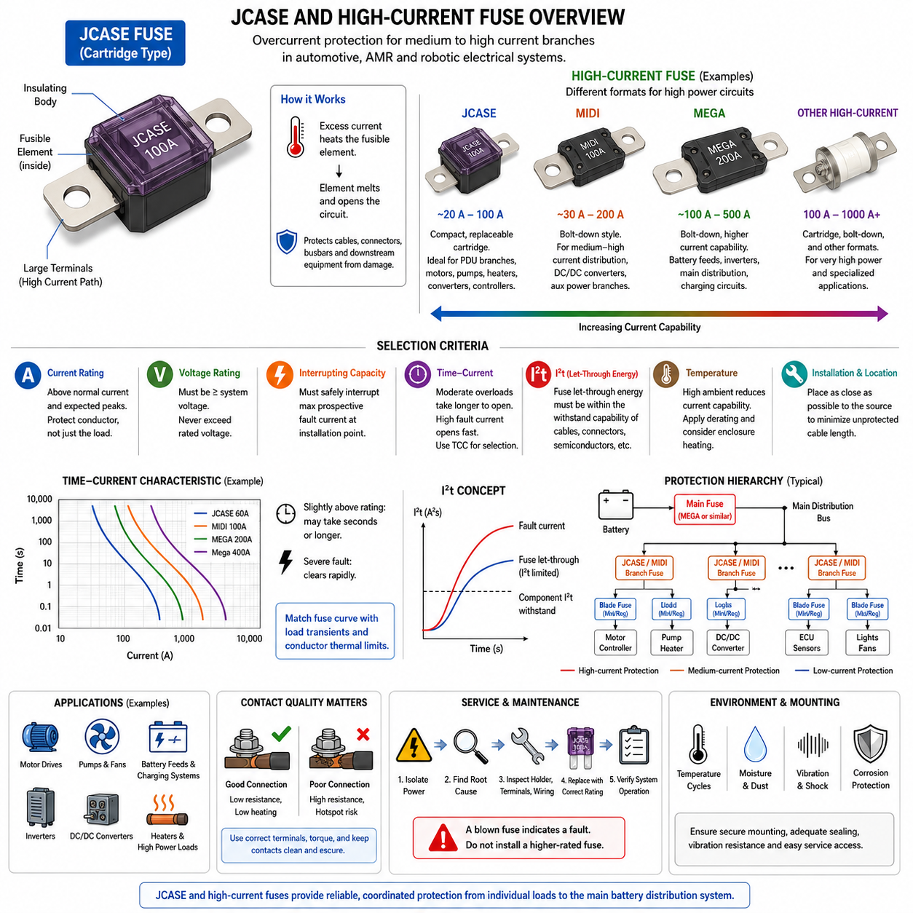
JCASE fuses are cartridge-style overcurrent protection devices developed for circuits that require higher current capability than conventional Mini or Regular blade fuses while retaining compact packaging and convenient serviceability. They are commonly used in automotive and mobile electrical systems to protect substantial branch loads such as motors, pumps, heaters, power converters, controllers, and other equipment connected to low-voltage DC distribution networks.
The JCASE construction combines a calibrated fusible element with relatively large conductive terminals enclosed by an insulating body. Unlike small blade fuses intended primarily for lower-current branches, the larger current path allows JCASE devices to operate in more demanding power circuits. Depending on the specific product family, the fuse may use cartridge, plug-in, or related mounting arrangements designed to provide secure electrical contact within a fuse block or PDU.
The fundamental operating principle remains based on thermal response to current. During normal operation, current passes through the fusible element with acceptable temperature rise. When sustained overload or severe short-circuit current occurs, I²R heating increases the temperature of the element until it melts. The resulting electrical separation interrupts the fault current and prevents excessive thermal energy from damaging wiring, connectors, busbars, or downstream equipment.
JCASE fuses occupy an important position between conventional blade fuses and larger bolt-down protection devices. They provide a practical solution when a circuit requires more current capability than Mini or Regular blade formats can conveniently support but does not necessarily require a MIDI, MEGA, or larger bolted fuse. This intermediate role makes JCASE technology useful for compact power distribution units where several medium-to-high-current branches must be protected independently.
High-current fuse is a broader engineering category rather than a single mechanical format. It includes devices intended to safely protect battery feeds, high-power distribution branches, motor drives, inverters, DC/DC converters, heaters, charging systems, and similar loads. Depending on required current, voltage, fault level, packaging, and service requirements, the appropriate device may be a JCASE, bolt-down fuse, cartridge fuse, or another specialized high-current protection technology.
Fuse current rating must be selected in relation to both the load and the protected conductor. A high-current circuit may experience substantial temporary peaks during motor acceleration, actuator startup, capacitor charging, converter energization, or other transient events. The fuse must tolerate these legitimate conditions without nuisance opening while remaining capable of interrupting abnormal current before the cable, busbar, connector, or distribution structure exceeds its allowable thermal limit.
The time-current characteristic is therefore essential when selecting a JCASE or other high-current fuse. Fuse operation is not determined by a single instantaneous current threshold. Moderate overload current may require seconds or considerably longer to produce melting, whereas severe fault current can cause rapid interruption. Engineers should compare the manufacturer's time-current curve with expected load profiles, conductor thermal capability, and required protection response.
I²t provides another important method for evaluating high-current protection. The parameter represents the accumulated current-squared energy associated with fuse operation and indicates how much fault energy can pass before the circuit is fully interrupted. The fuse let-through energy should remain compatible with the short-duration withstand capability of cables, connectors, semiconductor devices, contactors, busbars, and other protected components located downstream.
Voltage rating must be considered independently from current rating. After the fusible element melts, the fuse must establish sufficient electrical separation to extinguish the arc and withstand the system voltage. A device with adequate ampere capacity may still be unsuitable if its voltage rating is lower than the maximum operating voltage of the circuit. This requirement becomes increasingly significant in 48 V robotic platforms and other elevated low-voltage DC architectures.
Interrupting capacity is particularly important in high-current battery systems. A battery pack may deliver extremely large short-circuit current because its internal impedance and the resistance of nearby cables and busbars can be very low. The fuse must safely interrupt the maximum prospective fault current at its installation location. Selecting a fuse solely from continuous load current without evaluating available fault current can therefore produce an unsafe protection design.
The installation position determines how much of the electrical path receives short-circuit protection. Main or high-current source protection should generally be located as close as practical to the battery or power source. This minimizes the length of conductor existing upstream of the fuse. A cable segment between the source and remotely located fuse remains effectively unprotected, so routing, mechanical protection, insulation, and fuse placement must be considered together.
JCASE fuses can be particularly useful inside modular PDUs because they combine relatively high current capability with replaceability. Several subsystem branches can be individually fused without requiring a bolted connection for every protected load. In an AMR, for example, separate JCASE devices may protect motor-control auxiliaries, steering systems, DC/DC converters, pumps, fans, heaters, or other significant loads while smaller blade fuses protect sensors and electronic accessories.
Contact quality remains important even when the fuse itself is correctly sized. High current passing through a poor terminal interface can generate significant I²R heating. Insufficient contact force, oxidation, contamination, terminal deformation, or vibration-induced loosening may create a hotspot that damages the fuse holder or surrounding PDU before the fuse element operates. Fuse holders must therefore be rated for the intended current and environmental conditions.
Thermal environment can substantially modify fuse operating margin. A JCASE or high-current fuse installed near relays, contactors, MOSFET switches, converters, or other high-current fuses may operate at an ambient temperature significantly above room temperature. Enclosure heating and limited airflow can further increase temperature. Appropriate temperature derating and thermal validation are consequently required when determining continuous current capability in a compact robotic PDU.
Protection coordination allows JCASE and high-current fuses to operate as part of a layered electrical protection architecture. A main battery fuse can protect the source and primary distribution path, JCASE or similar devices can protect major subsystem branches, and smaller blade fuses can protect individual electronic loads. Proper selectivity should cause the protection device nearest the fault to operate first whenever practical, preserving power to unaffected parts of the robot.
This hierarchical approach is particularly valuable for autonomous systems because unnecessary loss of the main power bus may immediately stop propulsion, perception, computing, communication, and safety-related functions. A fault in an auxiliary heater or pump should ideally be isolated to that branch rather than opening the main battery fuse. Time-current curves, I²t characteristics, branch ratings, and fault-current levels should therefore be evaluated together when designing coordinated protection.
Mechanical packaging and environmental resistance are also significant considerations. Mobile robots can expose fuse assemblies to vibration, shock, dust, moisture, temperature cycling, and contamination. The fuse body, terminal interface, holder, enclosure, and wiring attachment must maintain stable electrical contact throughout these conditions. High-current fuse locations should also permit inspection and replacement without creating unnecessary risk to nearby energized conductors or sensitive electronics.
Maintenance should treat an opened JCASE or high-current fuse as an indication that the electrical system requires investigation. The technician should isolate the power source, verify a safe de-energized condition, identify the fault, inspect the fuse holder and terminals, and install a replacement with the specified current, voltage, and interrupting ratings. Installing a larger fuse to prevent repeated opening can remove the intended protection margin and expose wiring to dangerous overheating.
JCASE and other high-current fuses therefore extend fuse protection from ordinary branch circuits into the higher-power layers of automotive, AMR, and robotic electrical architectures. Their correct application requires coordinated consideration of continuous and transient current, time-current response, I²t, voltage rating, interrupting capacity, conductor capability, thermal environment, contact quality, installation position, and protection selectivity. Together with blade and bolt-down fuses, they enable a structured hierarchy of protection from individual loads to the main battery distribution system.

02.04. Fast-Blow vs. Slow-Blow
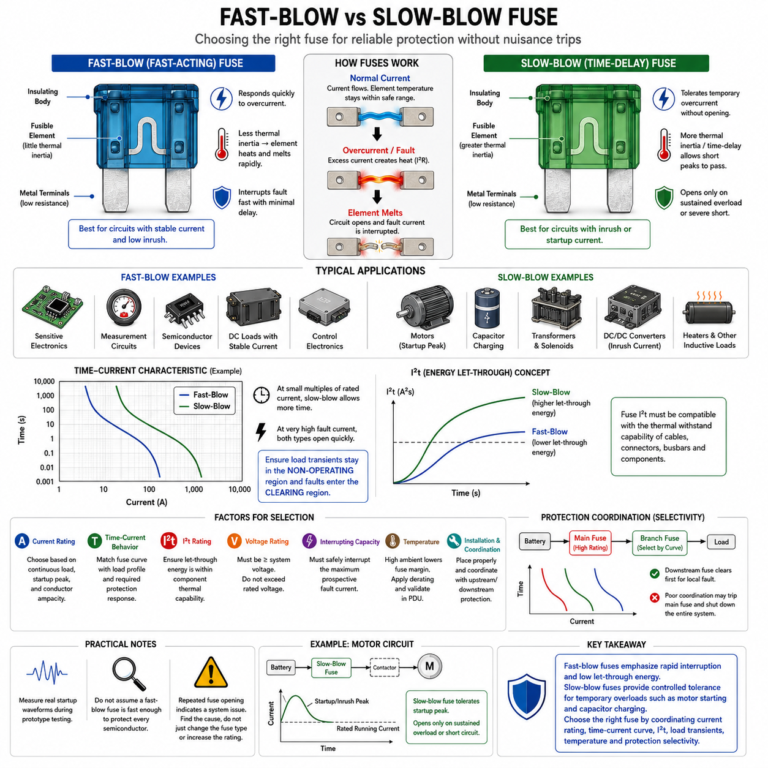
Fast-blow and slow-blow fuses are distinguished primarily by how quickly their fusible elements respond to overcurrent. Both devices protect conductors and electrical equipment by converting excessive current into heat until the element melts and opens the circuit. The difference lies in their intentional thermal response: fast-blow fuses react rapidly to excessive current, while slow-blow fuses tolerate temporary overloads before interrupting the circuit.
A fast-blow fuse, also called a fast-acting fuse, is designed to interrupt abnormal current with relatively little intentional delay. Its fusible element typically has limited thermal inertia, allowing temperature to rise rapidly when current exceeds the intended operating range. This behavior is useful when downstream components have limited ability to withstand overcurrent energy and therefore require rapid isolation from a fault.
Fast-blow protection is particularly appropriate for circuits whose normal operating current remains relatively stable and does not contain large startup or inrush peaks. Sensitive electronic modules, measurement circuits, control electronics, semiconductor-based loads, and selected low-inertia electrical devices can benefit from rapid protection. In such applications, unnecessary delay may allow damaging energy to reach components before the fuse completes interruption.
The main limitation of a fast-blow fuse appears when the protected load naturally produces short-duration current peaks. Motors, solenoids, transformers, capacitive inputs, heaters, and power converters may temporarily draw current considerably above their steady-state value during startup or switching. A fast-acting fuse selected too close to normal operating current may interpret these legitimate transients as faults and open unnecessarily, producing nuisance fuse operation.
A slow-blow fuse, commonly called a time-delay fuse, is intentionally designed to tolerate temporary overcurrent without immediately opening. Its element construction provides greater thermal inertia or a controlled time-delay characteristic. Short-duration current peaks can therefore pass without melting the element, while sustained overloads and severe short circuits still generate sufficient thermal energy to operate the fuse and disconnect the protected circuit.
Slow-blow behavior is valuable for loads with predictable startup or inrush characteristics. Electric motors may draw several times their normal running current during acceleration, while DC/DC converters and electronic power supplies can produce high charging current when input capacitors are energized. Solenoids and other inductive actuators may also generate temporary current peaks. Time-delay protection allows these normal events while maintaining protection against persistent abnormal current.
The terms fast-blow and slow-blow should not be interpreted as two exact universal operating speeds. Fuse behavior is defined more accurately by the manufacturer's time-current characteristic. Two devices with the same nominal current rating can have substantially different opening times at the same overload current. Engineers should therefore use published time-current curves rather than relying only on descriptive labels when selecting protection for a specific circuit.
A time-current curve expresses the relationship between fault-current magnitude and fuse operating time. At relatively small multiples of rated current, a slow-blow fuse generally remains closed longer than a comparable fast-blow device. As fault current becomes very large, both types can operate rapidly. The engineering objective is to ensure that legitimate load transients remain inside the fuse's non-operating region while damaging faults enter the required clearing region.
The I²t characteristic provides an additional way to compare fuse response because it represents the current-squared energy associated with the operating process. A fast-blow fuse generally aims to limit the energy passed into a vulnerable circuit, while a slow-blow device intentionally accepts greater short-duration energy to accommodate normal transient loads. The allowable fuse I²t must therefore remain compatible with the thermal withstand capability of protected conductors and components.
Fuse speed cannot be selected independently from current rating. Increasing the ampere rating of a fast-blow fuse merely to survive startup current can weaken overload protection for the conductor. Conversely, selecting an appropriately characterized slow-blow fuse may tolerate the required startup pulse while maintaining a lower continuous current rating. The correct approach is to coordinate current rating, time-current behavior, transient duration, and conductor thermal limits together.
For motor circuits, the distinction is particularly important. A traction motor, steering actuator, cooling fan, pump, or manipulator actuator may demand elevated current during acceleration or mechanical loading. If the protection responds too rapidly, normal operation may repeatedly open the fuse. If it responds too slowly or has excessive current capacity, however, wiring and motor-control equipment may experience damaging energy during a stalled motor or genuine short circuit.
Power electronic circuits introduce similar considerations. DC/DC converters, inverters, motor drives, and computing power supplies may contain substantial input capacitance. At power-on, capacitor charging can create a brief but high inrush pulse even though steady-state current is much lower. Fuse selection should compare the magnitude and duration of this pulse with the fuse time-current and I²t characteristics to distinguish normal energization from a persistent fault.
Fast-blow devices can be advantageous when semiconductor protection dominates the design requirement. MOSFETs, diodes, control electronics, and other electronic components may possess limited short-circuit energy withstand capability. Nevertheless, a conventional fuse should not automatically be assumed fast enough to protect every semiconductor junction. The fuse clearing characteristic must be compared with component limits, and electronic current limiting or dedicated semiconductor protection may also be necessary.
Ambient temperature influences both fast- and slow-blow fuse operation because fuse behavior depends on thermal accumulation. A fuse located inside a warm PDU requires less additional heating to reach its melting condition than the same device operating in a cooler environment. Nearby relays, contactors, converters, busbars, and other fuses can further raise local temperature, making manufacturer-specified temperature correction and practical thermal validation important.
Protection coordination becomes more complex when fast- and slow-blow devices are used at different levels of a distribution network. A branch fuse should ideally isolate its local fault before an upstream main fuse removes power from the complete system. Achieving this selectivity requires comparison of time-current curves over the expected fault-current range. Nominal current ratings alone cannot demonstrate that the downstream fuse will always operate first.
In an AMR power architecture, different fuse responses may therefore coexist. Sensitive auxiliary electronics can use relatively fast protection where transient current is limited, while motor, pump, actuator, or converter branches may require time-delay behavior to tolerate startup peaks. Higher-level battery and PDU protection must then be coordinated with these branch devices so that normal transient operation is tolerated without sacrificing system-level fault isolation.
Selecting between fast-blow and slow-blow protection begins with understanding the actual load-current profile. Continuous current, startup peak, peak duration, repetitive pulses, stalled-load current, short-circuit current, conductor ampacity, and downstream component withstand capability should all be considered. Measurement of real startup waveforms during prototype testing is often more reliable than assuming that the nominal load current adequately represents the electrical stress.
Repeated fuse opening should not be corrected automatically by changing from fast-blow to slow-blow protection. The event may indicate excessive load current, abnormal mechanical resistance, damaged wiring, a failing motor, incorrect fuse sizing, unexpected inrush, or another system problem. Changing fuse characteristics without identifying the cause can conceal a fault and increase thermal risk elsewhere in the electrical distribution system.
Fast-blow and slow-blow fuses therefore represent different strategies for managing the relationship between fault protection and legitimate transient current. Fast-blow devices emphasize rapid interruption and reduced let-through energy, whereas slow-blow devices provide controlled tolerance for temporary overloads such as motor starting and capacitor charging. Correct selection requires coordinated evaluation of current rating, time-current curves, I²t, load transients, conductor limits, temperature, and protection selectivity.

02.05. PTC Resettable Fuse
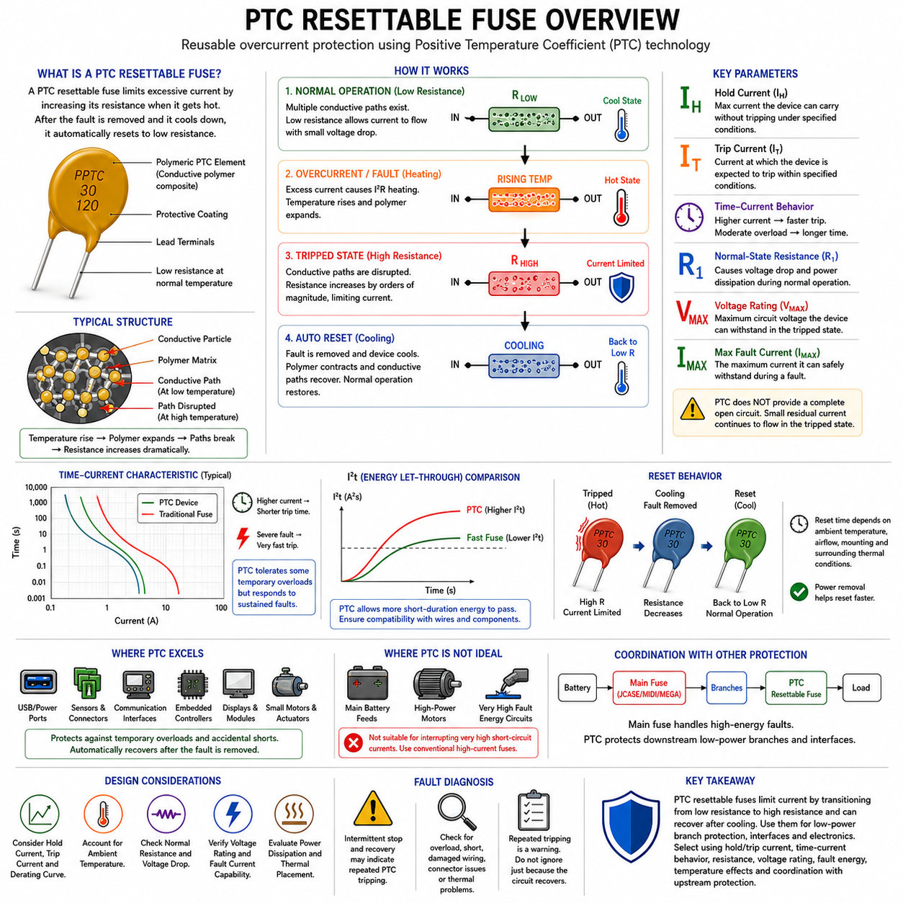
A PTC resettable fuse is a reusable overcurrent protection device based on a positive temperature coefficient material whose electrical resistance increases sharply when excessive current causes self-heating. Unlike a conventional fuse that permanently melts its fusible element, the PTC device enters a high-resistance state that limits current. After the fault is removed and the device cools, its resistance decreases and normal circuit operation can usually resume.
The most common resettable protection device is the polymeric positive temperature coefficient device, often called a PPTC or resettable fuse. It typically contains a conductive polymer composite in which conductive particles form numerous electrical paths at normal temperature. The resulting resistance is relatively low, allowing normal load current to pass while producing only limited voltage drop and self-heating.
When current rises beyond an appropriate level for sufficient time, I²R heating raises the temperature of the PTC material. Thermal expansion of the polymer structure disrupts many conductive paths, causing resistance to increase by several orders of magnitude. This rapid resistance transition substantially reduces circuit current. The device therefore does not create a completely open circuit like a melted fuse, but instead maintains the faulted branch in a strongly current-limited state.
Two important parameters are hold current and trip current. Hold current represents the maximum specified current that the device can carry under defined conditions without transitioning into its high-resistance state. Trip current represents a higher current level at which the device is expected to transition within specified conditions. These values depend strongly on ambient temperature, so they should never be interpreted independently from the manufacturer's thermal specifications.
A PTC resettable fuse has a time-current response rather than an ideal instantaneous trip threshold. A severe overcurrent generates heat rapidly and produces a relatively fast transition, whereas a moderate overload may require considerably more time. This thermal behavior allows the device to tolerate some temporary current variations while responding to sustained abnormal conditions. Selection should therefore consider both current magnitude and duration rather than only nominal load current.
After tripping, the PTC device remains electrically connected and continues to pass a small residual current. This current produces enough heating to help maintain the high-resistance state while the fault remains present. Consequently, the circuit downstream of a tripped PTC should not automatically be regarded as completely de-energized. This characteristic is fundamentally different from a conventional fuse that produces a physical open circuit after successful clearing.
Reset occurs after the abnormal condition is removed and the device is allowed to cool sufficiently. As its temperature falls, the polymer structure contracts and conductive paths are progressively restored, reducing resistance toward its normal value. In many applications, removing power assists the reset process because continued voltage can maintain residual heating. Reset time therefore depends on device construction, ambient temperature, airflow, mounting, and surrounding thermal conditions.
One major advantage of resettable protection is reduced maintenance after temporary faults. Conventional fuses require physical replacement after operation, whereas a PTC can recover without replacing a component. This characteristic is useful in electronic assemblies, inaccessible modules, distributed sensors, communication interfaces, auxiliary robot circuits, and other applications where occasional recoverable faults may occur and manual service would be undesirable.
However, resettable does not mean unlimited life or identical performance after every trip. Repeated thermal cycling can alter device resistance and electrical characteristics, particularly after severe or prolonged fault conditions. The post-trip resistance may remain higher than the initial resistance for some period, and cumulative stress should be considered in reliability analysis. A PTC should therefore not be treated as a maintenance-free substitute for every conventional fuse application.
Normal-state resistance is an important design consideration because a PTC is always present in series with the protected circuit. Its resistance creates voltage drop and power dissipation according to the load current. In low-voltage electronics, even a relatively small additional resistance may affect voltage margin. The designer should therefore evaluate initial resistance, maximum resistance, operating current, voltage drop, and resulting thermal dissipation under worst-case normal conditions.
Ambient temperature has a particularly strong influence on PTC behavior. At elevated temperature, less additional self-heating is required to reach the transition region, so the effective current-carrying capability decreases. At low temperature, the device may tolerate more current before tripping. Manufacturer derating curves are therefore essential when selecting a PTC for robot electronics located near processors, converters, motor drivers, batteries, or other heat-producing equipment.
Voltage rating defines the maximum circuit voltage for which the PTC is designed during a fault condition. After transition to the high-resistance state, substantial voltage may appear across the device while residual current continues to flow. The selected component must therefore be rated for the maximum possible system voltage, including relevant operating tolerances. Current capability alone cannot establish whether a PTC is electrically suitable for a particular circuit.
The maximum fault-current capability must also be respected. A PTC is not automatically suitable for interrupting the extremely high short-circuit currents available directly from large batteries. Excessive fault current can thermally or mechanically damage the device before it reaches a safe limiting state. For high-energy battery distribution, conventional high-current fuses such as JCASE, MIDI, MEGA, or specialized battery fuses are generally more appropriate as primary protection.
This distinction makes PTC devices especially suitable for lower-power branch protection rather than main battery protection. In a robotic electrical architecture, a conventional fuse may protect the main distribution path while resettable devices protect individual electronic modules, sensor supplies, communication interfaces, peripheral ports, small actuators, or auxiliary branches. Combining technologies allows each protection layer to use the operating principle best suited to its fault energy.
PTC devices are useful for protecting interfaces that may experience temporary overload or accidental short circuits during connection. USB-like power ports, sensor connectors, communication accessories, embedded controllers, display modules, and low-power peripheral supplies are typical examples. If an external cable or peripheral creates an overload, the PTC can limit current and later recover after the defective connection is removed, reducing the need for service access.
Protection coordination must still be considered when a PTC is installed downstream of a conventional fuse. A local overload should ideally cause the PTC to enter its limiting state without opening an upstream fuse that supplies multiple functions. A severe short circuit, however, may require the upstream fuse to provide higher-energy fault interruption. Coordination therefore involves comparing PTC trip behavior, upstream fuse characteristics, wiring limits, and available fault current.
Thermal placement is important because the PTC operates through temperature-dependent resistance. Mounting the device near a hot converter, power resistor, motor driver, or heat sink can cause premature operation, while strong cooling may delay its response. PCB copper area and neighboring components can also influence heat transfer. Component selection and physical layout should therefore be validated together under realistic enclosure temperature and airflow conditions.
Fault diagnosis requires awareness of the device's automatic recovery behavior. A circuit that temporarily stops operating and later recovers may indicate that a PTC has repeatedly entered and exited its high-resistance state. Such behavior should not be dismissed merely because no permanent fuse has opened. Repeated trips can indicate excessive load, intermittent short circuits, damaged wiring, connector contamination, thermal problems, or incorrect protection sizing.
A PTC resettable fuse therefore provides a different protection philosophy from one-time blade, JCASE, MIDI, or MEGA fuses. It limits abnormal current by transitioning from low resistance to high resistance and can recover after the fault and thermal stress are removed. Its effective use requires coordinated evaluation of hold current, trip current, time-current behavior, resistance, voltage, fault energy, ambient temperature, reset behavior, thermal placement, and upstream protection.

