Volume 04. Fuse, Relay, and Power Distribution Unit

Chapter 04. Contactor Design

04.01. High-Current Contactor Basics
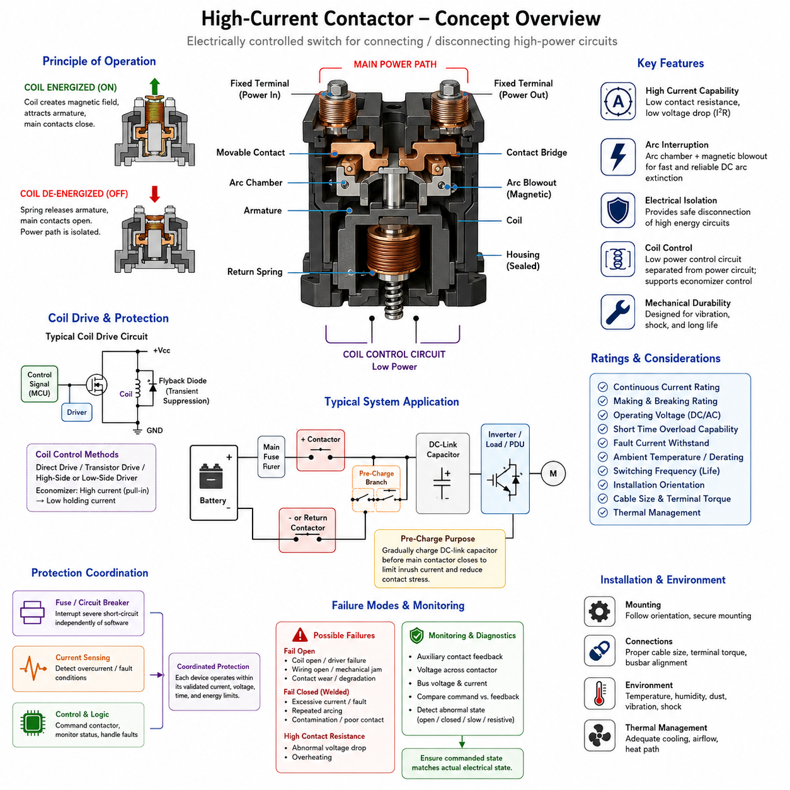
A high-current contactor is an electrically controlled switching device designed to connect or disconnect power circuits carrying currents far beyond the practical range of ordinary signal relays. In robotics electrical architecture, contactors are commonly placed between batteries and major loads such as traction inverters, motor drives, DC/DC converters, charging circuits, or high-power distribution units. They provide a controllable physical isolation point in the main power path.
Although a contactor operates according to the same electromagnetic principle as a conventional electromechanical relay, its mechanical and electrical construction is optimized for substantially greater current, fault energy, and switching stress. An energized coil creates magnetic force that moves an armature and closes the main contacts. Removing coil power releases the mechanism, normally allowing a spring to return the contacts to their defined de-energized state.
The main current path typically consists of large fixed terminals, movable contacts, conductive bridges, and low-resistance internal connections. Because hundreds of amperes may pass through this path, even a very small contact resistance can generate significant heat according to P = I²R. Contact materials, contact pressure, terminal geometry, conductor cross-section, and thermal paths must therefore be engineered together to maintain acceptable voltage drop and temperature rise.
A contactor normally contains two electrically distinct circuits: the high-current power circuit and the low-power coil control circuit. This separation allows a battery management system, vehicle control unit, safety controller, or power distribution controller to command a large electrical load using relatively modest control power. Depending on the system architecture, the coil may be driven directly, through a transistor stage, or through an intelligent high-side or low-side driver.
Contactor ratings must not be interpreted simply as the maximum current printed on the device. Continuous current rating describes the current that can normally be carried under specified thermal conditions, while making and breaking ratings describe the current that can safely be switched. Short-duration overload capability, fault-current withstand, operating voltage, switching cycles, ambient temperature, mounting orientation, conductor size, and cooling conditions can all influence practical capability.
Opening a contactor carrying current is more difficult than merely separating two conductors. As the contacts move apart, current may continue flowing through an electrical arc formed across the increasing gap. The arc produces intense local heating, erodes contact surfaces, and can potentially prevent successful interruption. The problem becomes particularly important in DC systems because current does not naturally pass through zero every half-cycle as it does in an AC waveform.
High-current DC contactors therefore employ design features intended to extinguish arcs rapidly. These may include increased contact separation, magnetic blowout structures, arc chambers, specially shaped contacts, controlled opening speed, and sealed internal environments. Some contactors use permanent magnets to force the arc away from the primary contact region, while sealed designs may use controlled gas environments to improve interruption performance and reduce oxidation.
Polarity can become important when magnetic arc suppression is incorporated into a DC contactor. A device marked with defined positive and negative power terminals should therefore not automatically be treated as bidirectional. Reversing current direction may change the direction in which the magnetic field moves the arc and can reduce interruption capability. Regenerative robotic powertrains require particular attention because normal energy flow can reverse during regenerative braking or controlled deceleration.
The contactor coil also presents an inductive load to its control electronics. When coil current is interrupted, the collapsing magnetic field generates a voltage transient that must be managed by an appropriate suppression method. A diode, TVS device, Zener arrangement, or other clamp network may be used depending on the required release speed and driver architecture. Excessive suppression can slow contact opening, while insufficient suppression can overstress the switching electronics.
Many modern contactors reduce steady-state coil power by using economizer control. A relatively high initial current is applied to create sufficient magnetic force for rapid pull-in, after which the coil current is reduced to a lower holding level. This decreases continuous power consumption and coil heating. Such behavior is especially useful in battery-powered robots, AMRs, electric vehicles, and UAV power systems where parasitic electrical consumption and enclosure temperature are important constraints.
Contact bounce occurs when mechanical contacts briefly separate and reconnect after initial impact. In a high-current circuit, bouncing can produce repeated arcs, local heating, electromagnetic interference, and accelerated surface damage. Contact geometry, spring force, armature dynamics, damping, and material selection are therefore designed to minimize unstable transitions. The actual switching behavior must also be considered when sequencing multiple contactors or coordinating pre-charge operations.
A contactor should not be regarded as the primary device for interrupting every possible short-circuit condition. Fuses, circuit breakers, current sensing, battery protection electronics, and contactors normally perform complementary functions. A fuse can interrupt severe fault energy independently of software, while a contactor provides commanded connection and isolation. Proper protection coordination ensures that each component operates within its validated current, voltage, time, and energy limits.
In battery-powered systems, a typical power path may include a battery, main fuse, positive contactor, negative or return-path contactor, pre-charge branch, DC-link capacitor, and inverter or PDU. Closing the main contactor directly into a discharged DC-link capacitor can create extremely high inrush current. A pre-charge circuit is therefore commonly used to raise the downstream voltage gradually before the main current path is completed, reducing contact erosion and welding risk.
Contact welding is one of the most important failure modes in high-current switching. Excessive making current, short-circuit current, repeated arcing, inadequate contact pressure, contamination, or operation outside specified ratings can locally melt the contact surfaces and cause them to bond together. A welded contactor may remain electrically closed even after coil power has been removed, meaning that commanded OFF status alone cannot guarantee actual power isolation.
For this reason, safety-oriented systems frequently monitor contactor state rather than assuming that the electrical state follows the command. Auxiliary contacts can provide mechanical position information, while voltage measurements across the contactor or downstream bus can provide electrical evidence of successful opening or closing. More advanced diagnostic logic compares coil command, auxiliary feedback, battery voltage, DC-link voltage, current flow, and timing to detect abnormal operation.
Failure behavior must be considered at system level. A contactor may fail open because of coil damage, driver failure, broken wiring, mechanical obstruction, or degraded contacts. It may fail closed because of welding or mechanical sticking. It can also develop excessive contact resistance without completely failing, producing abnormal voltage drop and heating. Diagnostic strategies should therefore distinguish loss of actuation, incorrect state, slow operation, and progressive electrical degradation.
Thermal design is particularly important because contactor capability depends strongly on the installation environment. High ambient temperature, enclosed PDUs, neighboring power electronics, undersized cables, poor terminal interfaces, and repeated high-current operation can raise internal temperatures significantly. Engineers should evaluate steady-state current together with duty cycle, terminal temperature, cable heating, enclosure airflow, and manufacturer derating information rather than selecting solely from nominal current.
Mechanical integration also affects reliability. Mobile robots expose electrical components to vibration, shock, dust, moisture, repeated acceleration, and changing orientation. Contactors should be mounted according to their specified orientation and mechanical limits, with power cables supported so that cable mass and vibration do not impose excessive loads on the terminals. Terminal torque, busbar alignment, insulation clearance, environmental sealing, and service accessibility should be controlled during installation.
The distinction between a relay and a contactor is therefore primarily one of application scale and switching engineering rather than a completely different operating principle. Relays are widely used for relatively moderate electrical loads, while contactors are engineered around high-current power switching, arc interruption, thermal management, fault exposure, and long-term mechanical endurance. This makes the contactor a fundamental element of controlled power distribution in high-energy robotic systems.
For AMRs and other Physical AI platforms, contactor operation forms an important boundary between software-controlled intelligence and physical electrical energy. A supervisory controller may request power activation, but safe energization depends on electrical prerequisites such as acceptable battery state, absence of critical faults, correct pre-charge behavior, valid isolation conditions, and confirmed contactor feedback. Power-state transitions should therefore be treated as controlled sequences rather than simple digital commands.
A robust contactor design ultimately combines electrical ratings, arc behavior, thermal performance, coil-drive characteristics, mechanical endurance, diagnostics, protection coordination, and system-level failure handling. Correct selection requires engineers to consider not only how much current the device can carry, but also what current it must make or break, under which voltage and fault conditions, how frequently it operates, and what the complete robot must do if the contactor does not behave as commanded.

04.02. HV Contactor for Battery System
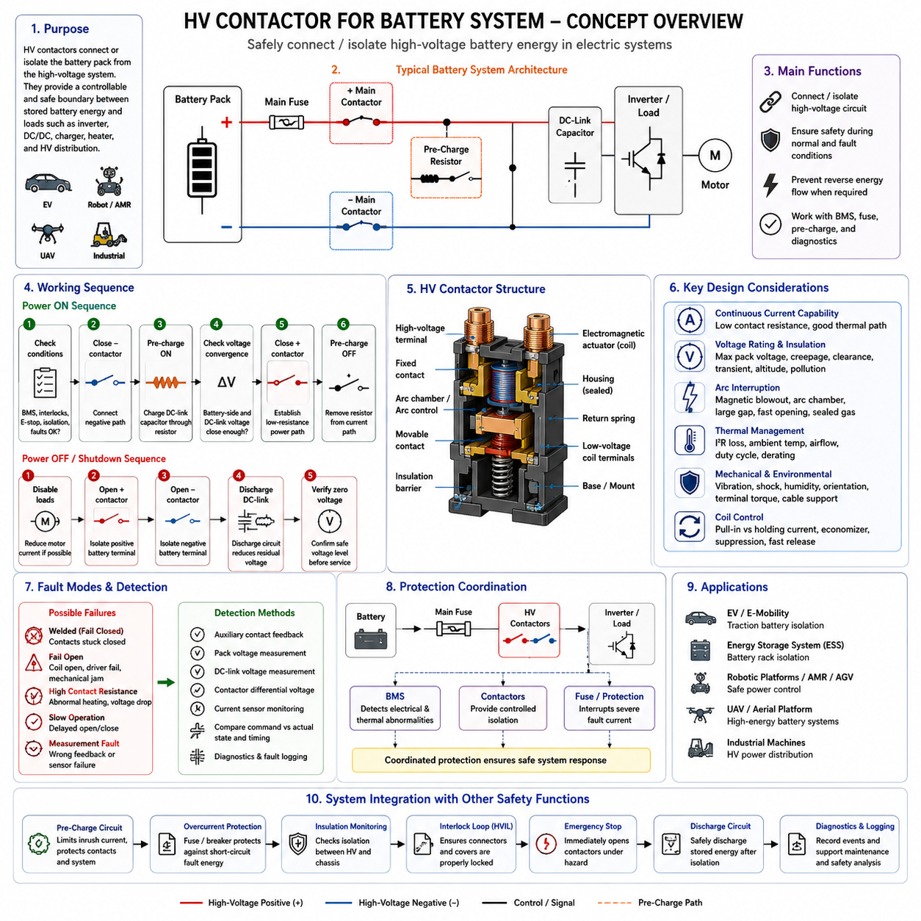
An HV contactor is a high-voltage electromechanical switching device used to connect or isolate a battery pack from the downstream electrical system. In battery-powered robots, electric vehicles, industrial mobile platforms, and other high-energy systems, it forms a controllable boundary between stored battery energy and loads such as traction inverters, DC/DC converters, chargers, heaters, and high-voltage power distribution units.
Unlike a conventional low-voltage relay, an HV contactor must safely carry substantial continuous current while maintaining insulation and interruption capability at elevated DC voltage. Its design combines large conductive terminals, low-resistance main contacts, an electromagnetic actuator, insulation barriers, an arc-control structure, and often a sealed housing. These elements must operate together under normal switching, overload, vibration, thermal cycling, and abnormal electrical conditions.
A typical battery system contains at least a positive main contactor and a negative main contactor, allowing both sides of the high-voltage battery connection to be isolated. Depending on the architecture, additional contactors may control charging paths, auxiliary high-voltage loads, or redundant isolation functions. This arrangement allows the battery management system and supervisory controller to establish or remove the high-voltage connection according to operating state and detected faults.
The contactor coil belongs to a low-voltage control domain even though the main contacts switch the high-voltage power domain. A battery management system (BMS), vehicle control unit, safety controller, or dedicated contactor driver commands the coil through appropriate driver electronics. Galvanic and physical separation between the control circuitry and HV conductors is essential so that high-voltage faults cannot propagate into low-voltage electronics or communication networks.
Closing the main contactors requires more than simply applying power to their coils. Downstream equipment commonly contains large DC-link capacitors that initially appear as a very low impedance when discharged. Connecting the battery directly to these capacitors can generate severe inrush current, producing contact arcing, electromagnetic disturbance, connector stress, fuse loading, and possible contact welding. Battery systems therefore normally coordinate main contactors with a pre-charge circuit.
During pre-charge, a resistor limits current while the downstream DC-link capacitor is gradually charged toward battery voltage. The controller monitors battery-side and load-side voltage and determines whether the voltage difference has decreased sufficiently. Only after acceptable pre-charge conditions are confirmed is the main contactor closed to establish the low-resistance power path. The pre-charge branch can then be removed from continuous conduction.
The shutdown sequence is equally important. When normal operation ends or a safety fault occurs, the system commands the appropriate contactors to open and verifies that high-voltage energy has been disconnected. Stored energy may remain in DC-link capacitors after the battery is isolated, so discharge circuitry can be required to reduce residual voltage to a defined safe level. Contactor opening and downstream discharge are therefore separate but coordinated functions.
Interrupting high-voltage DC current creates severe electrical stress because an arc can remain established as the contacts separate. Unlike AC current, DC current does not periodically cross zero, so the contactor must actively promote arc extinction. HV contactors may use magnetic blowout mechanisms, arc chambers, enlarged contact gaps, high-speed opening mechanisms, specialized contact materials, or sealed gas environments to prevent a sustained conductive plasma path.
Magnetic arc-control structures can make contactor polarity significant. If a manufacturer specifies battery-side and load-side terminal polarity, the installation must follow that requirement unless bidirectional interruption capability is explicitly provided. This becomes especially important in systems with regenerative braking, bidirectional charging, or energy recovery because current direction may differ between operating modes even though the battery voltage polarity remains unchanged.
Continuous-current capability is determined largely by contact resistance and thermal performance. Because conduction loss follows I²R, milliohm-level resistance becomes important when hundreds of amperes flow through the contactor. Terminal interfaces, cable or busbar sizing, contact pressure, ambient temperature, enclosure airflow, duty cycle, and neighboring heat sources influence operating temperature. Consequently, nominal current rating must be evaluated together with manufacturer-defined thermal and derating conditions.
Voltage rating is also more complex than nominal battery voltage. A battery pack reaches its maximum voltage when fully charged, and switching transients can temporarily impose additional electrical stress. The contactor must maintain adequate insulation, creepage, clearance, and interruption performance throughout the system operating envelope. Selection should therefore consider maximum pack voltage, expected transients, altitude effects, contamination, environmental conditions, and applicable insulation requirements.
One critical failure mode is contact welding. Excessive inrush current, short-circuit current, repeated high-energy switching, insufficient pre-charge, or operation beyond the specified making capability can locally melt the contact surfaces. A welded contactor remains electrically closed even when its coil is de-energized. For this reason, removing the contactor command cannot by itself be considered proof that the high-voltage battery has actually been isolated.
Battery systems therefore use feedback and electrical measurements to determine actual contactor state. Auxiliary contacts may indicate mechanical position, while pack voltage, DC-link voltage, contactor differential voltage, and current sensors provide electrical evidence. Diagnostic software compares the commanded state with observed behavior and timing. Unexpected voltage after an opening command, for example, can indicate welding, leakage, an alternate current path, or a measurement-system fault.
Failure can also occur in the opposite direction. A damaged coil, open harness, failed driver, insufficient coil voltage, mechanical obstruction, or degraded contact mechanism may prevent the contactor from closing. Excessive contact resistance can create another failure mode in which the contactor operates mechanically but develops abnormal heating and voltage drop. Robust diagnostics should therefore detect fail-open, fail-closed, slow transition, implausible feedback, and progressive resistance degradation.
The contactor is only one element of battery protection. A main fuse or other overcurrent protection device is generally required because a contactor cannot necessarily interrupt the maximum prospective short-circuit current safely. The BMS detects abnormal electrical and thermal conditions, the contactors provide commanded isolation, and the fuse provides independent protection against severe fault energy. Effective protection depends on coordination among these devices rather than reliance on a single component.
Emergency shutdown logic must account for the contactor's physical switching limitations. Opening under normal low-current conditions is very different from interrupting a large motor current or short-circuit current. The system should reduce or disable active loads when possible before opening the HV path, while genuine hazardous faults may require immediate isolation. The control strategy must therefore balance rapid hazard removal against the electrical interruption capability and expected lifetime of the contactor.
HV contactors are exposed to demanding mechanical and environmental conditions in mobile platforms. Vibration, shock, humidity, dust, temperature cycling, cable forces, and installation orientation can affect both electrical and mechanical reliability. Heavy HV cables and busbars should be mechanically supported so their loads are not transferred directly into contactor terminals. Correct terminal torque and low-resistance interfaces are particularly important because poor joints can become significant localized heat sources.
Low-voltage coil behavior must also be considered during battery-system design. Pull-in generally requires greater electromagnetic force than holding the closed state, so some contactors or drivers use economizer control that applies higher initial coil current followed by reduced holding current. Coil suppression must also control inductive voltage when the driver switches off while preserving sufficiently rapid contact release for the required safety response.
A typical HV battery activation sequence therefore behaves as a controlled state machine rather than a simple ON command. The controller checks battery condition, isolation status, emergency-stop state, interlocks, and relevant diagnostic conditions before initiating contactor operation. It then performs the defined negative or positive contactor sequencing, executes pre-charge, evaluates voltage convergence, closes the remaining main path, and verifies that the resulting electrical state agrees with the commanded state.
The HV contactor consequently acts as both a power component and an important safety actuator. Its operation links battery management, pre-charge, overcurrent protection, insulation monitoring, emergency shutdown, diagnostics, and high-voltage distribution into one coordinated architecture. This role places HV contactor engineering naturally within the broader contactor-design structure alongside pre-charge circuits, return-path contactors, and contactor welding detection.
For robotics and Physical AI platforms, reliable HV contactor control ensures that computational commands ultimately result in a predictable physical energy state. Software may request propulsion or actuator power, but actual energization should occur only after electrical prerequisites have been validated. Safe design therefore treats high-voltage activation, operation, fault isolation, and shutdown as monitored electrical state transitions whose success must be verified rather than assumed.

04.03. Pre-Charge Circuit Design
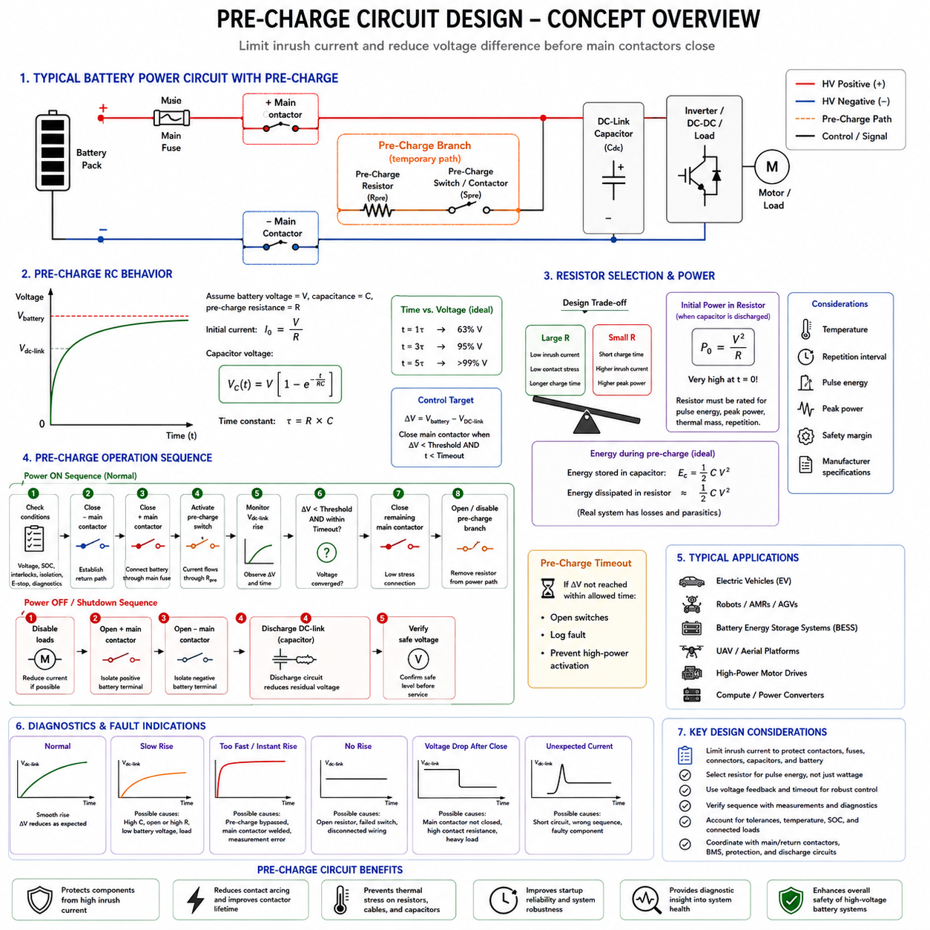
A pre-charge circuit is used to limit the initial inrush current that occurs when a battery is connected to a power electronic load containing large DC-link capacitors. In robotic platforms, electric vehicles, battery energy systems, and high-power motor drives, these capacitors may initially behave almost like a short circuit. Without controlled charging, the resulting current can stress contactors, fuses, connectors, busbars, capacitors, and the battery itself.
The fundamental purpose of pre-charge is to reduce the voltage difference across the main contactor before its contacts close. Instead of connecting the battery directly to a discharged DC-link capacitor, the system first routes current through a pre-charge resistor. The resistor limits current while the capacitor voltage gradually rises toward the battery voltage. Once an acceptable voltage relationship is reached, the main contactor can close under much lower electrical stress.
A typical battery power path includes a main fuse, positive and negative or return-path contactors, a pre-charge resistor, a pre-charge switching device, and the downstream DC-link capacitance. The pre-charge branch is normally connected in parallel with one of the main contactors. During normal high-current operation the branch is bypassed, because the resistor is intended only for temporary charging and cannot normally carry the continuous traction or actuator current.
The charging behavior can be approximated as a resistor-capacitor, or RC, circuit. If the battery is represented by voltage V and the downstream capacitance by C, the initial current is approximately I₀ = V/R, where R is the total pre-charge resistance. Capacitor voltage then rises exponentially according to Vc(t) = V[1 − exp(−t/RC)] for an idealized circuit. The product RC therefore defines the basic charging time constant.
After one time constant, the capacitor reaches approximately 63 percent of the applied voltage; after three time constants it reaches about 95 percent, and after five it exceeds 99 percent in the ideal model. Practical systems do not necessarily wait five time constants. Instead, the controller usually determines whether the downstream voltage has reached a defined fraction of pack voltage or whether the differential voltage across the main contactor has fallen below an acceptable threshold.
Resistor selection requires a compromise between current limitation and charging time. A larger resistance reduces initial current and contact stress but increases the time required to charge the DC-link capacitor. A smaller resistance shortens pre-charge time but produces greater current and higher instantaneous power. The selected resistance must therefore satisfy the allowable inrush current of the battery, switching device, fuse, wiring, capacitor, and downstream electronics while meeting system startup-time requirements.
The pre-charge resistor experiences substantial transient power even though it normally operates only briefly. At the instant pre-charge begins, its power can approach P₀ = V²/R in the simplified case of a discharged capacitor. This initial value can be much greater than the resistor's continuous power rating. Consequently, resistor selection must consider pulse energy, peak power, thermal mass, allowable surface temperature, repetition interval, and manufacturer-defined overload characteristics rather than continuous wattage alone.
For an ideal capacitor charged through a resistor from a constant-voltage source, the energy ultimately stored in the capacitor is ½CV², while approximately the same amount of energy is dissipated in the resistor during charging. This relationship provides a useful first estimate of required pulse-energy capability. Real systems additionally contain cable resistance, capacitor equivalent series resistance, semiconductor losses, auxiliary loads, leakage paths, and battery impedance that modify actual current and energy distribution.
The switching element in the pre-charge branch may be a dedicated contactor, relay, or suitable semiconductor device depending on voltage, current, architecture, and safety requirements. It must tolerate the initial charging current and system voltage while providing the required isolation when inactive. Its making capability is important because it initiates current into the discharged DC-link network, even though the pre-charge resistor limits the magnitude of that current.
A common activation sequence begins by checking battery voltage, interlocks, isolation status, emergency-stop conditions, and relevant diagnostic states. One main contactor is then closed, followed by activation of the pre-charge branch. The controller observes the downstream DC-link voltage as it rises. When the required voltage convergence is achieved within the permitted time, the remaining main contactor closes and the pre-charge branch is subsequently opened or disabled.
Voltage convergence is more informative than relying only on a fixed timer. A timer assumes that capacitance, resistance, battery voltage, temperature, and connected loads remain predictable. Measuring both battery-side and DC-link voltage allows the controller to determine whether charging is actually progressing. A useful control quantity is the voltage difference ΔV = Vbattery − VDC-link, because this difference directly relates to the electrical stress present when the main contactor closes.
If the DC-link voltage rises too slowly, the system may have excessive capacitance, an unintended load, a damaged resistor, excessive resistance, low battery voltage, or another abnormal current path. If the voltage rises almost instantly when a substantial capacitance should be present, the pre-charge contactor may be bypassed, a main contactor may already be welded closed, or voltage sensing may be incorrect. Pre-charge behavior can therefore provide valuable diagnostic information beyond simple inrush limitation.
A pre-charge timeout is normally required so that the resistor is not energized indefinitely when the expected voltage cannot be reached. Continuous current through a resistor designed for short pulses can rapidly produce excessive temperature and possible damage. When the timeout expires, the controller should terminate the sequence, open the relevant switching devices, record an appropriate fault, and prevent normal high-power activation until the abnormal condition has been evaluated.
The main contactor should close only after the differential voltage has been reduced sufficiently. If it closes too early, the remaining voltage difference can still create a large current step and contact arc, defeating the purpose of pre-charge. Conversely, excessively long pre-charge unnecessarily delays system startup and increases resistor heating. The threshold and timing requirements should therefore be derived from contactor capability, capacitance, allowable current, battery voltage, and system safety objectives.
After the main contactor closes, the pre-charge switch is normally opened so that the resistor is removed from the active power path. The controller may verify that the DC-link voltage remains close to battery voltage after the branch is disabled. A significant voltage collapse can indicate that the main contactor failed to close, has excessive resistance, or that an unexpected downstream load exists. Sequence verification therefore continues beyond the instant of main contactor closure.
Shutdown requires separate consideration because pre-charge is primarily an energization function. When the battery is disconnected, DC-link capacitors can retain hazardous energy after the main contactors open. A discharge circuit may therefore be used to reduce the remaining voltage within a specified time. The pre-charge resistor and discharge resistor may appear conceptually similar, but their electrical functions, switching sequences, energy requirements, and safety objectives should not automatically be treated as identical.
Pre-charge design must also consider repeated startup attempts. If a system repeatedly cycles between OFF and ON, the resistor may not have enough time to cool between pulses. A component that safely handles one pre-charge event may overheat under rapid retries. Control software can therefore impose retry limits or cooling delays, while hardware selection should evaluate the worst credible sequence of pre-charge events rather than only a single nominal startup.
Component tolerances and environmental conditions affect the actual RC response. Resistance changes with tolerance and temperature, capacitance can vary with manufacturing tolerance and operating condition, and battery voltage changes with state of charge. Downstream devices may also begin consuming current before pre-charge is complete. Design verification should therefore evaluate minimum and maximum charging times across the expected electrical and environmental operating envelope rather than relying solely on nominal calculations.
Fault analysis should include an open pre-charge resistor, shorted resistor, welded pre-charge contactor, failed-open switch, welded main contactor, incorrect voltage measurement, wiring faults, and unexpected downstream loading. Each condition can produce a different voltage-time signature during startup. Comparing commanded switching states with measured battery voltage, DC-link voltage, current, and auxiliary contact feedback enables the controller to identify many of these faults before full battery power is applied.
In mobile robots and Physical AI systems, pre-charge is particularly important because high-power motor drives, compute power converters, actuator electronics, and auxiliary power modules can create substantial aggregate input capacitance. A controlled pre-charge sequence prevents these electronics from being exposed to uncontrolled energization while protecting the battery switching architecture from repetitive inrush stress. This improves contactor life, startup reliability, and overall power-system robustness.
Pre-charge should therefore be treated as part of the battery power-state machine rather than as an isolated resistor calculation. Its operation must coordinate with the main and return-path contactors, battery management system, fuse protection, voltage sensing, interlocks, diagnostics, and shutdown strategy. Within the contactor-design structure, it forms the functional bridge between HV battery contactor operation and subsequent return-path control and welding detection.

04.04. Return Path Contactor
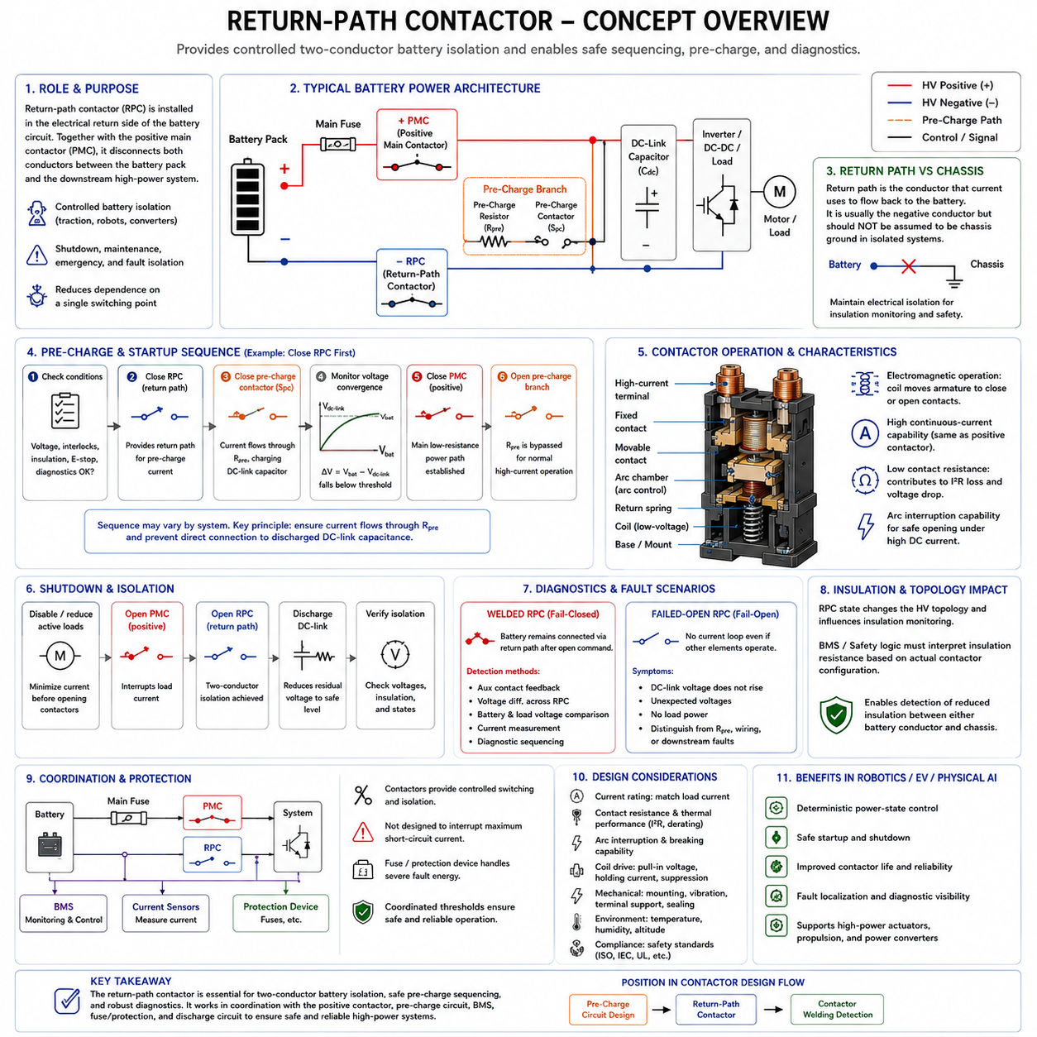
A return-path contactor is a high-current switching device installed in the electrical return side of a battery power circuit. In a floating or isolated DC architecture, it is commonly used together with a positive main contactor so that both conductors between the battery pack and the downstream high-power system can be disconnected. This dual-contactor arrangement provides controlled battery isolation for traction, robotic actuators, power converters, and other high-energy loads.
The term return path describes the conductor through which current returns from the load toward the battery. In many battery systems this corresponds to the negative conductor, but the concept should not automatically be equated with chassis ground. High-voltage and safety-oriented DC systems frequently maintain electrical isolation between battery conductors and the chassis, allowing insulation monitoring and preventing normal operating current from intentionally flowing through the mechanical structure.
When both positive and return-path contactors are open, the battery is disconnected from the downstream system on both sides of its power interface. This architecture reduces dependence on a single switching point and supports controlled isolation during shutdown, maintenance, emergency conditions, and detected electrical faults. The actual degree of isolation nevertheless depends on auxiliary circuits, charging paths, filters, measurement networks, and other possible connections across the system boundary.
The return-path contactor normally uses the same basic electromagnetic operating principle as the positive contactor. A low-voltage coil produces magnetic force that moves an armature and closes large conductive contacts capable of carrying substantial DC current. When coil excitation is removed, a spring mechanism opens the contacts. Because the return conductor carries essentially the same load current as the positive conductor, its continuous-current capability must be selected accordingly.
Contact resistance is especially important because both main contactors contribute series resistance to the battery power path. If each contactor has resistance R, conduction losses occur according to I²R in each device, and their combined voltage drop affects the voltage delivered to the load. Terminal resistance, cable joints, busbars, contact pressure, temperature, and aging must therefore be included when evaluating total power-path loss and thermal performance.
The return-path contactor also experiences electrical stress during opening and closing. High DC current can generate an arc when the contacts separate, requiring adequate breaking capability and arc-control design. If the contactor incorporates magnetic arc blowout, installation polarity and permitted current direction must be verified from its specifications. This consideration becomes particularly important when regenerative loads can reverse current through the battery power path.
Return-path control is closely related to the pre-charge sequence. A common strategy closes one main contactor first, often the return-path contactor, and then energizes the pre-charge branch on the opposite side. Current flows through the pre-charge resistor and gradually charges the downstream DC-link capacitor. After the voltage difference has fallen below the specified threshold, the remaining main contactor closes and establishes the normal low-resistance power path.
This sequence is not universal. Some systems close the positive-side contactor first and perform pre-charge through the return side, while others use different switching arrangements according to packaging, diagnostics, charging topology, or safety requirements. The important design principle is that the sequence must create a known current path through the pre-charge resistor and must prevent an uncontrolled direct connection between the battery and discharged DC-link capacitance.
During startup, the controller should therefore evaluate more than individual contactor commands. Battery voltage, downstream bus voltage, auxiliary contact feedback, pre-charge state, interlock status, insulation condition, and current measurements can be combined to determine whether the expected electrical topology actually exists. A valid command sequence without corresponding electrical behavior should be treated as a diagnostic condition rather than assumed to represent successful energization.
The return-path contactor becomes particularly important during shutdown because opening both main conductors provides a clearly defined battery isolation strategy. Under normal shutdown, active loads can first be disabled or reduced, after which the main contactors are opened in the specified order. Downstream DC-link capacitors may remain charged after isolation, so a separate discharge circuit can then reduce residual voltage to a safe level within the required time.
Opening order can influence diagnostic capability and electrical stress. If one contactor opens while the other remains closed temporarily, voltage measurements can be used to evaluate the state of the open device or determine whether an unexpected conductive path exists. The sequencing strategy should nevertheless avoid creating hazardous intermediate states. Timing requirements must consider contactor opening delay, bounce, load current, arc interruption, and voltage measurement response.
A welded return-path contactor represents a significant failure because the battery remains connected to the downstream system through one conductor even after an opening command. Although opening the positive contactor may interrupt normal load current, the system no longer has the intended two-pole isolation. Depending on architecture, this condition can affect maintenance safety, insulation diagnostics, fault response, charging behavior, and subsequent power-up sequences.
Welding detection therefore should not be limited to the positive contactor. Auxiliary contact feedback can indicate mechanical state, while electrical measurements can reveal whether the return path remains conductive. The controller may compare battery voltage, load-side voltage, contactor differential voltage, and current before and after switching commands. Diagnostic sequencing can intentionally create known states that make an otherwise ambiguous welded-contact condition easier to identify.
A fail-open return-path contactor creates a different behavior. The positive contactor and pre-charge components may operate correctly, but no complete current loop can be established if the return path remains open. The DC-link voltage may fail to rise as expected, or measured voltages may appear unusual depending on leakage and measurement circuits. Combining electrical measurements with auxiliary feedback helps distinguish a failed contactor from a failed resistor, wiring fault, or downstream problem.
The relationship between the return path and chassis requires careful architectural definition. In an isolated battery system, the battery negative conductor should not casually be connected to chassis simply because it is called the return path. Intentional or accidental connections can alter insulation-monitoring behavior and create unexpected current paths. Grounding, bonding, shielding, protective earth, signal reference, and high-power battery return should therefore be treated as distinct electrical functions.
Insulation monitoring can use the floating nature of the HV bus to detect reduced resistance between either battery conductor and chassis. Because the return-path contactor changes the topology of the battery network, its open or closed state can influence how insulation measurements are interpreted. Battery management and safety logic should therefore understand the actual contactor configuration when evaluating isolation faults rather than treating insulation resistance as independent of switching state.
The return-path contactor must also be coordinated with the main fuse and other protection devices. It provides commanded switching and isolation but is not necessarily capable of safely interrupting the maximum battery short-circuit current. Severe fault energy may require a fuse or dedicated protection device. Contactors, current sensing, the BMS, and overcurrent protection consequently form a coordinated protection architecture with different operating thresholds and response mechanisms.
Coil-drive design affects return-path contactor performance in the same way as other electromagnetic contactors. Adequate pull-in voltage must be available under low-voltage supply variation, while holding current and coil temperature must remain within limits during extended operation. Economizer control can reduce holding power, and suitable transient suppression protects the driver when the coil is de-energized without excessively delaying contact release during a safety shutdown.
Mechanical and thermal integration are equally important. High-current cables or busbars connected to the return-path contactor should be supported so that vibration and cable mass do not impose excessive mechanical forces on its terminals. Correct mounting orientation, terminal torque, insulation spacing, environmental sealing, ambient-temperature derating, and heat dissipation must be considered because degradation of either main contactor can compromise the complete battery power path.
In mobile robots, AMRs, electric vehicles, and other Physical AI platforms, the return-path contactor contributes to a deterministic power-state architecture. The supervisory controller does not merely request battery ON or OFF; it coordinates two main switching paths, pre-charge, voltage sensing, interlocks, protection, and diagnostic feedback. This allows software commands to be verified against the actual electrical state before high-power actuators or propulsion systems are enabled.
Return-path contactor design should therefore be considered as part of a complete battery isolation and sequencing strategy rather than as a duplicate of the positive contactor. Its value comes from controlled two-conductor isolation, coordinated pre-charge operation, fault localization, and diagnostic observability. Within the contactor-design structure, these functions connect the preceding pre-charge design topic directly to the subsequent problem of contactor welding detection.

04.05. Contactor Welding Detection
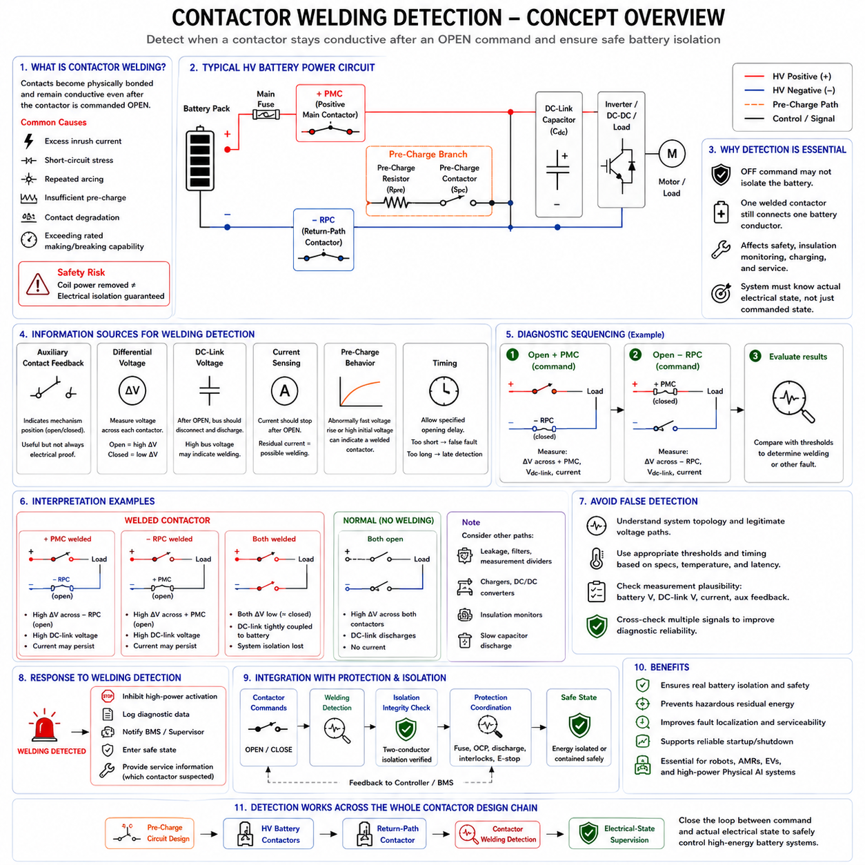
Contactor welding is a failure condition in which the main electrical contacts become physically bonded and remain conductive after the contactor has been commanded to open. In high-current battery systems, this can result from excessive inrush current, short-circuit stress, repeated arcing, insufficient pre-charge, contact degradation, or operation beyond the specified making and breaking capability. A welded contactor defeats the expected relationship between coil command and actual power state.
The fundamental safety problem is that removing coil power does not guarantee electrical isolation. A controller may command the battery system OFF while a welded positive or return-path contactor continues connecting one battery conductor to the downstream high-voltage bus. The system must therefore determine the actual electrical state rather than relying solely on the commanded state, making welding detection an essential diagnostic function in high-energy battery architectures.
Contact welding commonly occurs when very high current flows at the instant the contacts close. If a discharged DC-link capacitor is connected directly to the battery, the resulting inrush current can create an intense arc and localized heating at the contact interface. The surfaces can partially melt and then solidify together under contact pressure. Proper pre-charge design substantially reduces this risk by minimizing the voltage difference before the main contactor closes.
Welding can also develop during contact opening. When a contactor interrupts high DC current, an arc forms between the separating contacts and can produce extreme local temperatures. Repeated interruption near or beyond the device rating progressively erodes and damages the contact surfaces. Eventually, material transfer, roughness, contamination, or localized melting can increase the probability that the contacts stick or weld during a subsequent switching operation.
A battery system usually contains at least a positive main contactor and a negative or return-path contactor. Welding detection should address both devices because either can remain conductive after an opening command. If only one contactor is welded, opening the other may interrupt normal load current, but the intended two-conductor isolation is lost. This condition can still affect maintenance safety, insulation monitoring, charging behavior, and later startup sequences.
The simplest diagnostic concept compares the commanded contactor state with feedback from an auxiliary contact. An auxiliary contact is mechanically linked to the main switching mechanism and indicates whether the contactor appears open or closed. If the controller commands OFF but the auxiliary feedback remains closed beyond the permitted release time, a welded or mechanically stuck contactor can be suspected. This method provides useful mechanical-state information but should not always be treated as complete electrical proof.
An auxiliary contact may indicate armature position without directly measuring conductivity through the high-current contact interface. Mechanical linkage faults, auxiliary contact faults, wiring problems, or unusual contact damage can therefore produce ambiguous information. For safety-oriented diagnosis, auxiliary feedback is more powerful when combined with electrical measurements such as battery voltage, DC-link voltage, differential voltage across each contactor, and current sensing.
Differential-voltage measurement provides direct information about the electrical state of a contactor. When a contactor is closed and carrying current normally, the voltage across it should be very small, approximately equal to current multiplied by contact resistance. When it is open and separating two energized nodes, a substantial voltage may appear across it. Comparing measured differential voltage with the commanded switching state can therefore reveal whether the contactor behaves electrically as expected.
The interpretation of differential voltage depends on the surrounding circuit topology. An open contactor does not necessarily have a large voltage across it if both sides happen to be at similar potential because of another conductive path, leakage, pre-charge components, or discharged capacitors. Welding detection must therefore evaluate the complete switching configuration rather than applying a single voltage threshold independently to every operating condition.
A useful diagnostic strategy deliberately creates known contactor states during startup or shutdown. For example, one main contactor can remain closed while the other is commanded open, allowing voltage measurements to determine whether the supposedly open device still provides a conductive path. The sequence can then be changed to evaluate the second contactor. Such diagnostic sequencing improves observability because each switching state creates expected voltage relationships that can be compared with measurements.
DC-link voltage is particularly useful during shutdown diagnostics. After the battery contactors are commanded open, the downstream bus should become electrically separated from the battery and may then discharge through a controlled discharge circuit. If the DC-link voltage remains strongly coupled to battery voltage when it should be isolated, a welded contactor or another unintended conductive path may exist. The diagnosis must distinguish this behavior from slow capacitor discharge or measurement error.
Current sensing provides another diagnostic dimension. If measurable current continues flowing through a path after the corresponding contactor has been commanded open, the electrical state is inconsistent with the command. However, zero current alone cannot prove successful opening because a welded contactor can remain closed while the connected load happens to draw no current. Current measurement is therefore complementary to voltage and position feedback rather than a complete welding-detection method by itself.
Timing is important because electromechanical contactors do not change state instantaneously. Coil de-energization, magnetic release, armature travel, contact separation, bounce, and arc extinction require finite time. Diagnostic logic must allow the specified opening delay before declaring a welding fault. Conversely, an excessively long diagnostic delay can postpone recognition of a hazardous condition. Thresholds should therefore incorporate contactor specifications, temperature effects, supply conditions, and measurement latency.
The pre-charge circuit also contributes valuable information for welding diagnosis. Before startup, an unexpectedly high DC-link voltage may indicate that a main contactor is already conductive when it should be open. During pre-charge, voltage that rises much faster than predicted can suggest that the pre-charge resistor has been bypassed by a welded main contactor. Thus, the voltage-time behavior originally used to control inrush current can simultaneously serve as a diagnostic signature.
A welded positive contactor and a welded return-path contactor can produce different voltage patterns depending on system topology. Diagnostic software should therefore identify which switching device is inconsistent rather than merely reporting a generic high-voltage fault. Fault localization helps determine whether startup must be inhibited, whether service procedures require special precautions, and which hardware should be inspected or replaced.
The system must also avoid false welding diagnoses. Capacitor charge, leakage resistance, EMI filters, measurement-divider networks, insulation-monitoring devices, chargers, DC/DC converters, and auxiliary high-voltage loads can maintain unexpected voltages after contactors open. Diagnostic thresholds and timing should account for these legitimate electrical paths. A residual voltage by itself does not prove contact welding unless its magnitude and behavior are inconsistent with the known circuit model.
Measurement plausibility is therefore part of welding detection. If battery voltage, DC-link voltage, current sensors, and auxiliary contacts produce mutually inconsistent information, the controller should consider a sensor or wiring fault as well as a contactor fault. Cross-checking multiple measurements prevents a single failed sensor from creating an incorrect conclusion about the high-voltage switching state and supports more robust fault classification.
Once welding is detected or strongly suspected, normal high-power activation should generally be inhibited. Repeatedly commanding a damaged contactor can worsen the failure or create unpredictable electrical states. The system should transition to a defined safe response, record diagnostic information, communicate the fault to the supervisory controller or BMS, and preserve enough state information to support service analysis and identification of the failed switching element.
Welding detection should also interact with insulation monitoring and emergency shutdown logic. A system with one welded contactor may still interrupt load current using the remaining healthy contactor, but its isolation topology is degraded. Safety logic should recognize this distinction between current interruption and complete battery isolation. The appropriate response depends on the electrical architecture, fault containment strategy, and required safe state of the robot or vehicle.
Diagnostic coverage can be improved by testing contactor behavior during controlled power-state transitions rather than waiting for a hazardous operating event. Startup and shutdown naturally provide opportunities to compare commands, auxiliary feedback, bus voltages, current, and timing. Repeated observations can also reveal progressive changes such as increasing contact resistance, slower mechanical operation, or abnormal pre-charge behavior before complete welding occurs.
In mobile robots, AMRs, electric vehicles, and Physical AI platforms, contactor welding detection closes the loop between software command and physical energy control. The controller must know not only what state it requested but whether the battery power network actually reached that state. This principle is essential when propulsion, manipulators, high-power compute systems, or other actuators depend on a high-energy battery bus.
Contactor welding detection should therefore be implemented as a coordinated diagnostic function involving main and return-path contactors, pre-charge behavior, voltage sensing, current sensing, auxiliary feedback, timing, and protection logic. Within the contactor-design structure, it completes the progression from basic high-current switching through HV battery contactors, pre-charge control, and return-path isolation to verified electrical-state supervision.

