Volume 04. Fuse, Relay, and Power Distribution Unit

Chapter 06. Protection Coordination

06.01. Time-Current Curve (TCC)
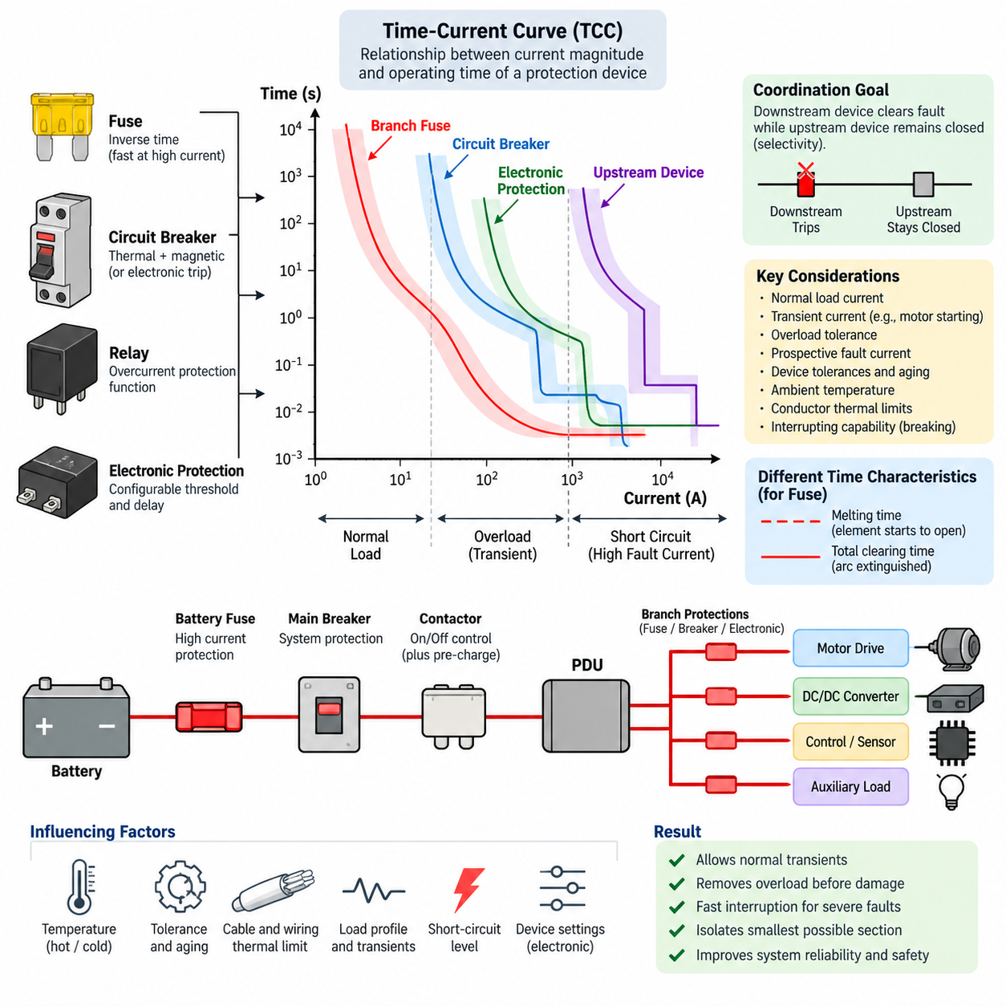
A Time-Current Curve (TCC) describes the operating relationship between the magnitude of current flowing through an overcurrent protection device and the time required for that device to interrupt the circuit. It is a fundamental engineering representation used when coordinating fuses, circuit breakers, relays, and electronic protection devices. The curve allows designers to evaluate whether abnormal current will be tolerated temporarily or cleared before conductors and equipment reach damaging thermal or electrical limits.
The horizontal axis of a TCC normally represents current, while the vertical axis represents operating or clearing time. Both axes are commonly plotted on logarithmic scales because protection systems must cover extremely wide ranges of current and time. Current may range from normal load levels to many times rated current, while operating time can extend from milliseconds during severe short circuits to seconds or minutes during moderate overload conditions.
A protection device does not generally operate at one exact current and one exact time. Instead, its behavior is represented by a curve or band defining the expected operating region. Manufacturing tolerances, ambient temperature, initial thermal state, device construction, and current waveform can influence actual clearing time. Consequently, TCC analysis should treat the published characteristic as an operating envelope rather than assuming that every device will trip at a single deterministic point.
The shape of a TCC reflects the physical operating principle of the protection device. A fuse responds primarily to heating produced by current and therefore exhibits an inverse time characteristic: relatively small overloads require longer melting times, whereas large fault currents cause rapid operation. Thermal circuit breakers behave similarly in their overload region, while magnetic or electronic trip mechanisms can provide much faster operation when current exceeds a defined threshold.
An inverse-time characteristic is particularly useful because electrical conductors, terminals, windings, and semiconductor components also accumulate thermal stress over time. Moderate overload current can often be tolerated briefly without damage, whereas sustained overload must eventually be disconnected. At much higher fault current, the available thermal margin becomes extremely small. The TCC therefore provides a convenient way to compare protection-device response against the thermal withstand characteristics of protected equipment.
For fuses, several time characteristics may appear in the manufacturer's TCC information. The melting characteristic indicates the time required for the fuse element to begin opening, while the total clearing characteristic includes the additional time needed to extinguish the arc and fully interrupt current. Protection coordination normally requires careful attention to which characteristic is being compared, especially at high prospective fault currents where the difference between melting and total clearing can become significant.
Circuit-breaker TCCs may contain several distinct operating regions. The thermal region covers sustained overload conditions and normally shows an inverse relationship between current and trip time. A magnetic instantaneous region responds to severe overcurrent with little intentional delay. Electronic-trip breakers may provide additional long-time, short-time, instantaneous, and sometimes ground-fault functions whose thresholds and delays can be adjusted to obtain the required coordination behavior.
The most important application of TCC analysis is protection coordination between upstream and downstream devices. When a fault occurs in a branch circuit, the protection device closest to the fault should normally interrupt the current while upstream devices remain closed. On a TCC plot, this objective is examined by comparing the operating bands of successive devices and verifying sufficient separation throughout the relevant current range. This concept forms the basis for subsequent selectivity and cascade protection design.
For example, a branch fuse protecting a motor controller should generally clear a branch short circuit before the main distribution breaker operates. However, the branch fuse must also tolerate legitimate transient currents such as motor starting current or capacitor charging current. The engineer therefore evaluates normal load current, expected transient envelopes, overload conditions, and prospective short-circuit current together rather than selecting protection solely from the continuous current rating.
Motor loads illustrate why time is as important as current. A traction motor, pump, fan, or robotic actuator may temporarily draw several times its normal operating current during acceleration or sudden mechanical loading. If the protection curve intersects the expected transient-current envelope, nuisance interruption can occur. Conversely, selecting an excessively slow protective device merely to avoid nuisance trips can expose cables, connectors, motor drivers, or windings to unacceptable fault energy.
Cable and wire protection can also be evaluated using TCC relationships. The protective device should interrupt abnormal current before conductor temperature exceeds allowable insulation or material limits. This requires coordination between the device characteristic and the conductor's short-time thermal withstand capability. Wire gauge, conductor material, insulation temperature rating, harness bundling, ambient temperature, installation method, and connection resistance can all influence the practical protection margin.
Short-circuit analysis defines another important boundary of the TCC study. The prospective fault current depends on source voltage, battery or supply impedance, cable resistance, connection impedance, and fault location. A fault near a low-impedance battery can produce extremely high current, while a distant fault through long wiring may produce substantially less current. Both conditions must be considered because the same protection device can operate in completely different regions of its TCC.
The TCC must therefore be interpreted together with interrupting capability. Fast operation alone does not prove that a protective device can safely clear a fault. The device must also possess an interrupting rating appropriate for the maximum prospective fault current at its installation point. This distinction becomes especially important in battery systems, industrial DC distribution, high-power robots, and other low-impedance power architectures where short-circuit current can become very large.
TCC coordination becomes more complex when several protection technologies are connected in series. A battery fuse, main circuit breaker, PDU branch protection device, electronic motor-driver protection, and internal semiconductor current limiting may all respond to the same abnormal event. Their thresholds, delays, thermal memories, and interruption mechanisms must be considered as one coordinated protection chain rather than as independent components selected only according to their individual current ratings.
Electronic protection introduces additional flexibility because current thresholds and timing functions can be implemented in software or dedicated trip electronics. A smart PDU may detect overload current, apply a configurable delay, disconnect a channel through a semiconductor switch, and report the event through a communication network. Nevertheless, its electronic trip characteristic should still be evaluated against conventional fuse and breaker curves whenever multiple protection layers share the same current path.
Temperature is another important consideration because many protection devices depend on thermal mechanisms. Elevated ambient temperature can reduce the current required to operate a thermal breaker or fuse, while low temperature can increase operating time. Components installed inside enclosed PDUs, battery compartments, or densely packaged robot electronics may therefore behave differently from laboratory conditions. Manufacturer correction factors and worst-case thermal conditions should be incorporated into coordination studies.
Tolerance and aging should also be included in engineering margins. Contact resistance can increase over service life, fuse characteristics can vary within specified manufacturing limits, and thermal conditions can change as ventilation becomes restricted or equipment is modified. Reliable coordination should therefore avoid designs in which two protective characteristics barely avoid intersection under nominal assumptions. Adequate separation provides robustness against realistic variations across production and operating conditions.
In an AMR or mobile robot, TCC analysis can be applied hierarchically from the battery toward individual loads. A high-current battery fuse provides protection against catastrophic distribution faults, a main breaker or contactor protection stage protects the principal power path, and branch devices protect traction drives, steering actuators, computing equipment, sensors, auxiliary converters, and charging circuits. Each level should isolate faults without unnecessarily removing power from unaffected subsystems.
Regenerative and bidirectional power systems require additional attention because current may flow differently during propulsion, braking, charging, and fault conditions. Protection coordination must account for the maximum current magnitude and duration associated with each operating mode. DC systems also present interruption challenges because current does not naturally pass through zero as AC current does, making the device's DC voltage rating, arc-extinguishing capability, polarity restrictions, and interrupting rating essential parts of TCC-based selection.
A complete TCC study therefore combines load profiles, transient-current envelopes, device operating bands, conductor withstand limits, equipment damage curves, and minimum and maximum prospective fault currents on a common engineering basis. The objective is not simply to make every protection device operate quickly. It is to establish controlled timing so that normal transients pass safely, overloads are removed before thermal damage occurs, severe faults are interrupted rapidly, and the smallest practical portion of the electrical system is disconnected.
When correctly applied, the Time-Current Curve becomes more than a component-selection graph. It provides a system-level language for reasoning about fault energy, interruption timing, protection hierarchy, and service continuity. In robotics power architectures containing batteries, PDUs, motor drives, DC/DC converters, computing systems, and safety circuits, TCC analysis provides the foundation from which selectivity, cascade protection, simulation-based coordination, and complete AMR protection strategies can subsequently be developed.

06.02. Selectivity Design
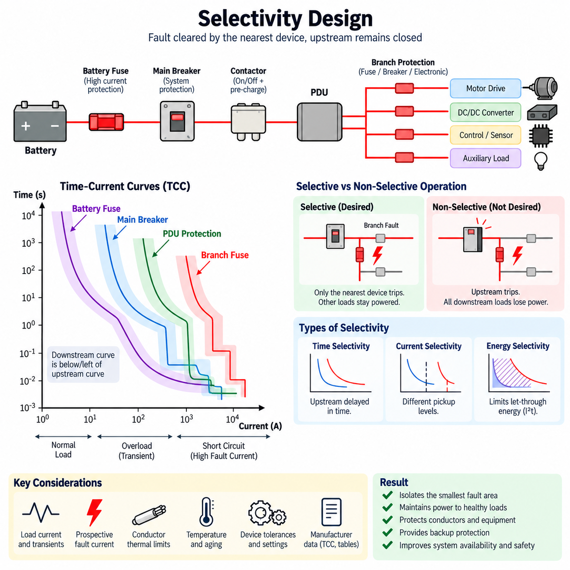
Selectivity design is the engineering process of arranging multiple overcurrent protection devices so that a fault is interrupted by the protective device closest to the fault while upstream devices remain energized. In a coordinated electrical distribution system, this behavior limits the affected area, maintains power to healthy loads, and prevents a localized electrical failure from unnecessarily shutting down the complete machine or robot.
Selectivity is closely related to protection coordination but emphasizes the sequence in which protective devices operate. A distribution architecture may contain a battery fuse, main circuit breaker, PDU protection, branch fuses, electronic switches, and motor-drive protection. When an abnormal condition occurs, these devices may all detect the same current. Selective design ensures that their operating thresholds and times establish a predictable protection hierarchy.
The simplest example is a main protective device supplying several independently protected branches. If a short circuit occurs in one branch, its branch protection should clear the fault before the main device operates. The remaining branches can therefore continue operating. If the main device trips first, every downstream load loses power even though most circuits are healthy, demonstrating poor selectivity and unnecessarily reducing system availability.
Selectivity can be evaluated using Time-Current Curves (TCCs), which compare current magnitude with protection operating time. The downstream device characteristic should generally lie below or to the left of the upstream characteristic throughout the fault-current range requiring coordination. Sufficient separation between the curves is necessary because manufacturing tolerances, temperature, aging, initial thermal conditions, and measurement uncertainty can shift actual operating behavior.
Time selectivity is achieved by intentionally delaying the upstream protective device relative to the downstream device. A downstream breaker may operate immediately for a branch fault while the upstream breaker waits for a defined interval before opening. If the downstream device successfully clears the fault, the upstream device remains closed. This method provides clear coordination but increases the duration of fault current experienced by upstream conductors and equipment.
Current selectivity uses different pickup thresholds rather than primarily relying on time delays. The downstream device is configured to respond at a lower current level, while the upstream device requires a larger current before entering its rapid trip region. This approach can provide fast fault clearing without long intentional delays, although selectivity may disappear when fault current becomes sufficiently high to activate the instantaneous functions of both devices.
Energy selectivity considers the amount of fault energy passed through protective devices during interruption. Current-limiting fuses and fast circuit breakers can significantly restrict peak current and let-through energy before an upstream device reaches its operating condition. The I²t characteristic is therefore important when coordinating fuses or other current-limiting devices, particularly where fault duration is extremely short and conventional time separation alone does not fully describe device interaction.
Complete selectivity means that the downstream device operates first throughout the entire expected fault-current range up to the maximum prospective short-circuit current. Partial selectivity exists when coordination is guaranteed only below a specified current value. Partial selectivity can still be acceptable when the calculated maximum fault current at the downstream installation point remains below the manufacturer-defined or analytically verified selectivity limit.
Prospective fault current must therefore be calculated at relevant locations in the distribution system. A fault near a battery or low-impedance DC bus may produce much greater current than a fault at the end of a long cable. Cable resistance, connector resistance, battery internal resistance, converter impedance, contactor resistance, and distribution topology influence the available fault current and determine which regions of the protective-device characteristics must be coordinated.
Protection settings cannot be selected solely from fault current. Normal operating behavior must also remain outside the trip region. Motors can generate starting and acceleration currents, DC/DC converters can exhibit input inrush, capacitive loads can create short charging pulses, and robotic actuators can experience temporary current peaks during dynamic motion. Selective protection must distinguish these legitimate transients from sustained overloads and actual short circuits.
The conductor and equipment damage limits provide another boundary for selectivity design. Delaying an upstream breaker may improve coordination, but the additional delay cannot allow cables, connectors, busbars, semiconductor switches, motor windings, or battery components to exceed their thermal withstand capability. Selectivity is therefore constrained by equipment protection: maintaining service continuity must never take priority over preventing unsafe thermal or electrical damage.
Fuse-to-fuse coordination often depends on the relationship between the ratings and I²t characteristics of the downstream and upstream fuses. The downstream fuse should melt and clear the fault without delivering sufficient energy to cause the upstream fuse to operate. Simple current-rating ratios may provide preliminary guidance, but final coordination should use manufacturer data because fuse construction, speed class, temperature behavior, and current-limiting performance differ between product families.
Breaker-to-breaker coordination requires consideration of thermal, short-time, magnetic, and instantaneous trip regions. Adjustable electronic-trip breakers offer greater flexibility because pickup current and delay can be configured independently. However, overlapping instantaneous regions can eliminate selectivity during severe faults. Manufacturer selectivity tables, tested device combinations, and TCC analysis are therefore important when determining whether coordination remains valid at high short-circuit currents.
Fuse-to-breaker coordination combines devices with different operating mechanisms and must be analyzed carefully. A downstream fuse may clear severe faults extremely quickly while an upstream breaker provides slower overload and backup protection. Conversely, a downstream breaker may protect a serviceable branch while an upstream fuse protects the main power path. Their curves, total clearing times, current-limiting behavior, and maximum fault levels must be evaluated together.
Electronic protection in a smart PDU introduces programmable selectivity. Each output channel can have an individual continuous-current limit, overload threshold, short-circuit threshold, and trip delay. Software can distinguish short transient peaks from persistent faults and disconnect only the affected channel. Nevertheless, electronic protection must still coordinate with upstream physical fuses or breakers because semiconductor failure or loss of control electronics can require independent backup interruption.
Selectivity must also account for backup protection. The downstream device is expected to clear a local fault first, but the upstream device must operate if the downstream device fails to interrupt it. Consequently, the coordination interval cannot be unlimited. The upstream protection should remain slow enough to permit normal downstream clearing while still operating within a safe time if the primary protection mechanism fails or the fault persists.
DC power systems require special attention because interruption behavior differs from AC systems. Batteries can supply high short-circuit current with limited source impedance, and DC arcs do not benefit from periodic natural current zero crossings. Protective devices must therefore have appropriate DC voltage and interrupting ratings in addition to suitable selectivity characteristics. A device coordinated correctly by timing can still be unsafe if it cannot physically interrupt the available DC fault current.
In an AMR electrical architecture, selectivity can be implemented as a hierarchy beginning with battery protection and progressing toward individual loads. A battery fuse protects against catastrophic high-current faults, a main breaker protects the principal distribution path, and PDU branch devices protect traction drives, steering systems, computing equipment, sensors, communication modules, and auxiliary loads. Local electronic protection may provide an additional layer inside individual subsystems.
This hierarchy is particularly valuable for robotic systems because different loads have different operational importance. A fault in an auxiliary lighting circuit should not normally remove propulsion, computing, localization, or safety power. Similarly, a failed sensor branch should preferably be isolated without collapsing the entire DC bus. Selectivity therefore contributes not only to electrical protection but also to fault containment, graceful degradation, serviceability, and overall system availability.
Safety-related circuits require additional engineering judgment. Selectivity should not preserve power merely for availability when system safety requires coordinated shutdown. Emergency-stop circuits, safety controllers, brake systems, contactors, and battery isolation functions may intentionally disconnect larger portions of the system after particular faults. Electrical selectivity must therefore be integrated with the machine-level safety architecture rather than treated as an independent optimization objective.
A practical selectivity study begins by establishing the power-distribution topology, load currents, transient profiles, conductor ratings, and prospective fault currents at major nodes. Protection characteristics are then compared across successive hierarchy levels. TCC separation, I²t behavior, interrupting capability, thermal limits, environmental derating, and manufacturer coordination data are evaluated together to determine whether each fault is cleared by the intended device.
The final design should be verified under minimum and maximum operating conditions because protection behavior can change with battery state, supply impedance, temperature, cable length, and component tolerance. A low fault current must still be large enough to trigger protection within a safe period, while the highest prospective fault current must remain within interrupting ratings and the verified selective range. Both boundaries are necessary for a robust protection architecture.
Effective selectivity design therefore balances four objectives: rapid fault interruption, protection of conductors and equipment, isolation of the smallest practical fault region, and continuity of unaffected electrical functions. When these objectives are coordinated across fuses, breakers, electronic protection, PDUs, and subsystem-level devices, the resulting architecture can tolerate localized failures without converting them into system-wide power losses.
For robots, AMRs, battery systems, and industrial automation equipment, selectivity ultimately transforms individual protection components into a coordinated protection system. Time-current behavior defines when each device should respond, fault-current analysis determines the conditions it must handle, and the protection hierarchy determines which device should act first. This coordinated foundation enables the subsequent development of cascade protection, simulation-based coordination, and complete robot power-protection architectures.

06.03. Cascade Protection
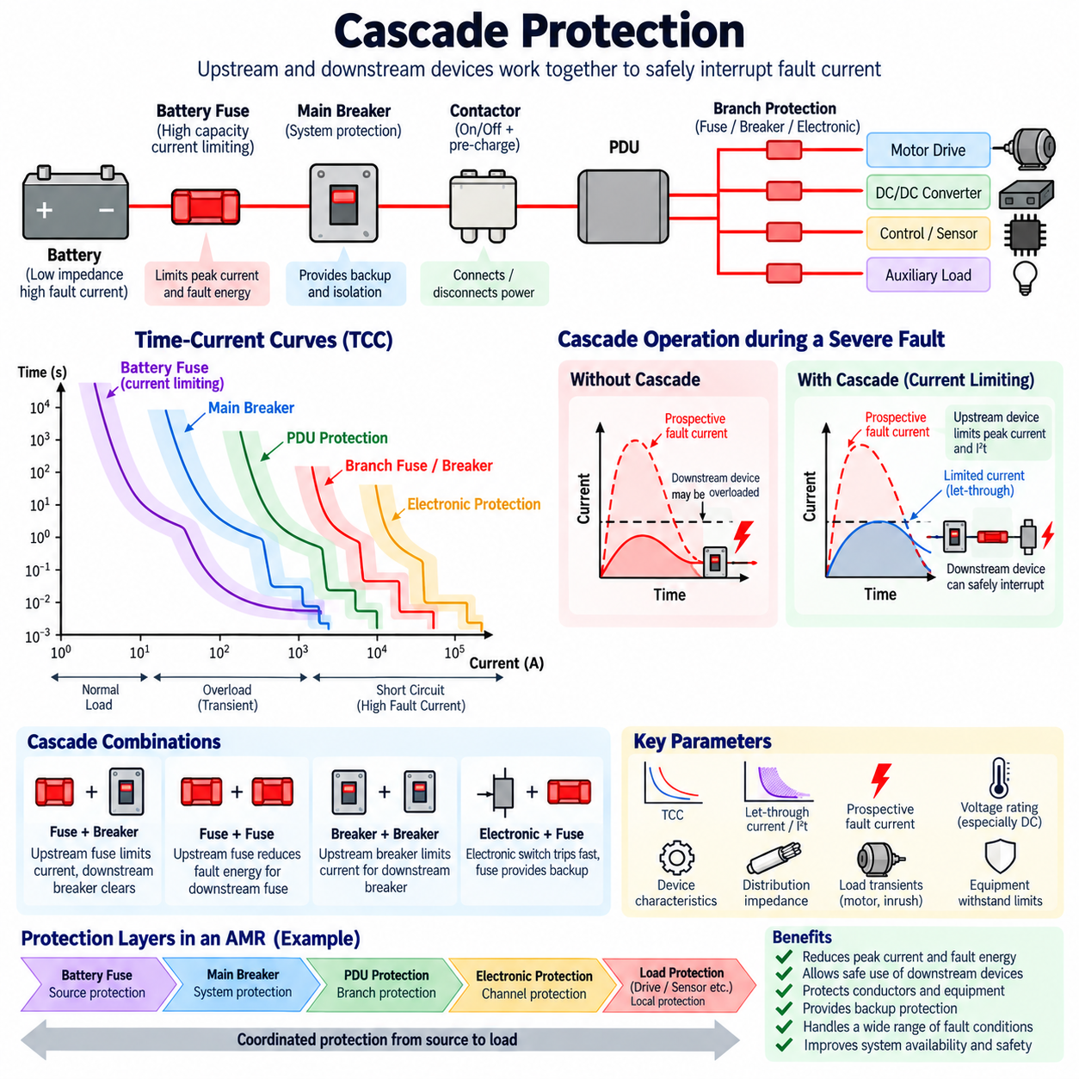
Cascade protection is a coordinated protection strategy in which upstream and downstream protective devices operate as a system to safely interrupt fault current. The upstream device can limit or interrupt fault energy in a manner that reduces the electrical stress imposed on downstream equipment. This approach is especially useful in multi-level power distribution architectures containing main protection, PDU protection, branch protection, and local electronic protection.
Unlike selectivity, whose primary objective is to ensure that the protective device nearest the fault operates while upstream devices remain closed, cascade protection focuses on the combined protective performance of devices connected in series. The upstream device may actively contribute to fault interruption. Therefore, cascade protection and selectivity are related concepts but do not represent the same design objective within protection coordination.
A typical cascade begins with a high-capacity protective device installed near the power source. Downstream devices protect progressively smaller distribution branches and individual loads. During a severe short circuit, the upstream device may limit the peak current and let-through energy before downstream equipment experiences the full prospective fault current. The resulting protection performance depends on the interaction between both devices rather than on either device considered independently.
The principle becomes important when the prospective short-circuit current at a distribution point exceeds the standalone interrupting capability of a downstream protective device. Under specifically verified combinations, an upstream current-limiting device can reduce the fault stress sufficiently for the downstream device to participate safely in interruption. Such an arrangement must be based on validated device combinations and must never be assumed merely because two protection devices are connected in series.
Current limiting is one of the fundamental mechanisms behind effective cascade protection. A current-limiting fuse or breaker can begin interrupting a severe fault before the prospective current reaches its unrestricted peak value. By restricting the actual peak current, the device reduces electrodynamic forces on conductors, busbars, terminals, and contacts while also reducing the thermal energy transferred into downstream components during the fault.
The I²t characteristic provides an important measure of this thermal stress. Because heating effects are strongly related to the square of current integrated over time, a rapid reduction in fault current can significantly decrease the energy passing through the circuit. Cascade analysis therefore considers not only the RMS or prospective fault current but also peak current, pre-arcing or melting energy, total clearing energy, and the withstand capability of downstream devices.
Time-Current Curves remain useful for understanding cascade behavior, particularly in the overload and moderate fault-current regions. The curves show when upstream and downstream devices begin operating and whether their characteristics overlap. However, very high current-limiting fault conditions may occur so rapidly that conventional TCC comparison alone is insufficient. Manufacturer let-through curves, I²t data, peak-current limitation data, and tested coordination tables may also be required.
Cascade protection can involve several combinations of protective technologies. A high-current battery fuse may operate with a downstream circuit breaker, a main molded-case circuit breaker may support smaller branch breakers, or a physical fuse may provide backup protection for semiconductor-based PDU channels. Each combination has different dynamic behavior, and the engineering analysis must reflect the actual operating principles and interruption capabilities of the selected devices.
Fuse-based cascading can provide very rapid limitation of severe fault currents. When a high-performance upstream fuse enters its current-limiting region, it can restrict both the magnitude and duration of current delivered downstream. A downstream fuse or breaker may consequently experience much less fault energy than the prospective system fault level would suggest. The exact coordination nevertheless depends on fuse class, rating, voltage, I²t characteristics, and manufacturer-validated combinations.
Breaker-based cascade protection can use the current-limiting characteristics of an upstream breaker to reduce stress on downstream breakers. This arrangement can be attractive in industrial distribution systems containing multiple protection levels. However, the combined short-circuit rating cannot be inferred from the individual breaker ratings. The manufacturer must establish whether the particular upstream and downstream combination has been tested or otherwise approved for the required fault level.
Electronic protection introduces another cascade layer in modern robotic systems. A smart PDU may detect excessive branch current and rapidly turn off a semiconductor switch before a physical fuse operates. If the semiconductor cannot interrupt the fault because of device failure, excessive short-circuit current, or loss of control, a branch fuse or upstream breaker provides secondary protection. A higher-level battery fuse then protects against faults that exceed the capability of lower protection layers.
This layered arrangement illustrates an important distinction between normal protection and backup protection. The fastest local device should normally handle faults within its designed operating range. The next protection layer responds when the local mechanism cannot clear the event, and higher layers address increasingly severe or persistent faults. Cascade design therefore establishes overlapping protection capability without requiring every device to perform the same protection function.
The interrupting rating of each device remains a critical requirement. Cascade protection must not be interpreted as permission to install arbitrarily underrated downstream devices. Any enhanced or conditional short-circuit capability must be supported by applicable manufacturer data, tested series combinations, and relevant equipment requirements. Without such evidence, each device should be treated according to its independently specified interrupting capability.
Voltage rating is equally important, especially in DC systems. A device capable of interrupting a given AC fault current may not provide equivalent performance on a DC bus because DC arcs do not naturally pass through periodic current zero crossings. Battery-powered robots and AMRs therefore require protective devices with suitable DC voltage ratings, polarity characteristics where applicable, arc-extinguishing capability, and verified interruption performance.
The physical distribution impedance influences cascade behavior throughout the system. Battery internal resistance, cable length, conductor cross-section, busbar resistance, connector interfaces, contactors, and DC/DC converters can change the prospective fault current available at each node. Consequently, a fault near the battery may activate strong current-limiting behavior, while a distant branch fault may produce lower current and remain in a slower overload or short-time protection region.
Cascade protection must also remain compatible with normal transient operation. Motor acceleration, regenerative braking, capacitor charging, DC/DC converter startup, and actuator peak loads can generate substantial temporary currents. Protection thresholds and delays must allow these legitimate events without nuisance interruption while still providing sufficiently rapid response to persistent overloads and short circuits. Load profiles therefore form an essential input to cascade design.
Thermal coordination with conductors and equipment provides another design constraint. Even when protective devices can successfully interrupt a fault, the let-through energy must remain below the withstand capability of cables, connectors, PCB traces, busbars, motor windings, semiconductor switches, and other components in the fault path. The protection chain is only effective when the weakest protected component remains within its allowable thermal and electrodynamic limits.
Cascade protection and selectivity may sometimes create competing requirements. Selectivity attempts to keep upstream devices closed during downstream faults, whereas cascading may intentionally rely on upstream current limitation or operation to support downstream interruption. The designer must therefore determine whether service continuity or enhanced short-circuit protection is the dominant requirement for each fault region and verify the resulting device interaction accordingly.
In an AMR, a practical cascade may begin with a battery fuse capable of interrupting the maximum battery short-circuit current. A main breaker or contactor protection stage forms the next level, followed by PDU branch fuses or electronic protection. Motor drives, computing systems, sensors, communication modules, and auxiliary equipment can then contain additional local protection. Each successive layer addresses a more localized portion of the electrical architecture.
For traction branches, cascade protection is particularly important because motor drives can draw high normal peak currents while also being connected to a low-impedance battery source. Semiconductor protection may react first to moderate overcurrent, a branch fuse may clear severe drive or cable faults, and the battery fuse provides final protection against catastrophic high-energy faults. Correct coordination prevents a single protection mechanism from carrying responsibility for every possible fault condition.
A practical cascade study begins by calculating minimum and maximum prospective fault currents at important distribution nodes. Engineers then identify the operating region of each protection layer and compare TCC characteristics, I²t limits, peak-current limitation, interrupting ratings, conductor withstand limits, and manufacturer coordination data. Faults should be evaluated at multiple locations because protection behavior changes significantly with distribution impedance and fault position.
Verification should include tolerance, temperature, aging, battery state, cable configuration, and worst-case source impedance. The minimum fault current must still cause a protective response within an acceptable time, while the maximum fault current must remain within the verified capability of the complete protection chain. Particular attention is required when a design depends on current limitation from one device to protect another device with lower standalone capability.
Effective cascade protection therefore creates a layered defense against electrical faults. Local devices handle routine overloads and branch faults, intermediate devices provide additional interruption and backup capability, and source-level protection addresses the highest-energy events. When these layers are coordinated with TCC behavior, I²t characteristics, fault-current calculations, and equipment withstand limits, the distribution architecture can manage a much wider range of abnormal conditions.
For robots, AMRs, battery systems, and industrial equipment, cascade protection transforms multiple independent protective components into a structured fault-energy management system. Combined with Time-Current Curve analysis and selectivity design, it establishes when protection should operate, which layer should respond, and how fault energy should be constrained. This provides the foundation for coordination simulation and complete robot power-protection design.

06.04. Coordination Simulation Tools
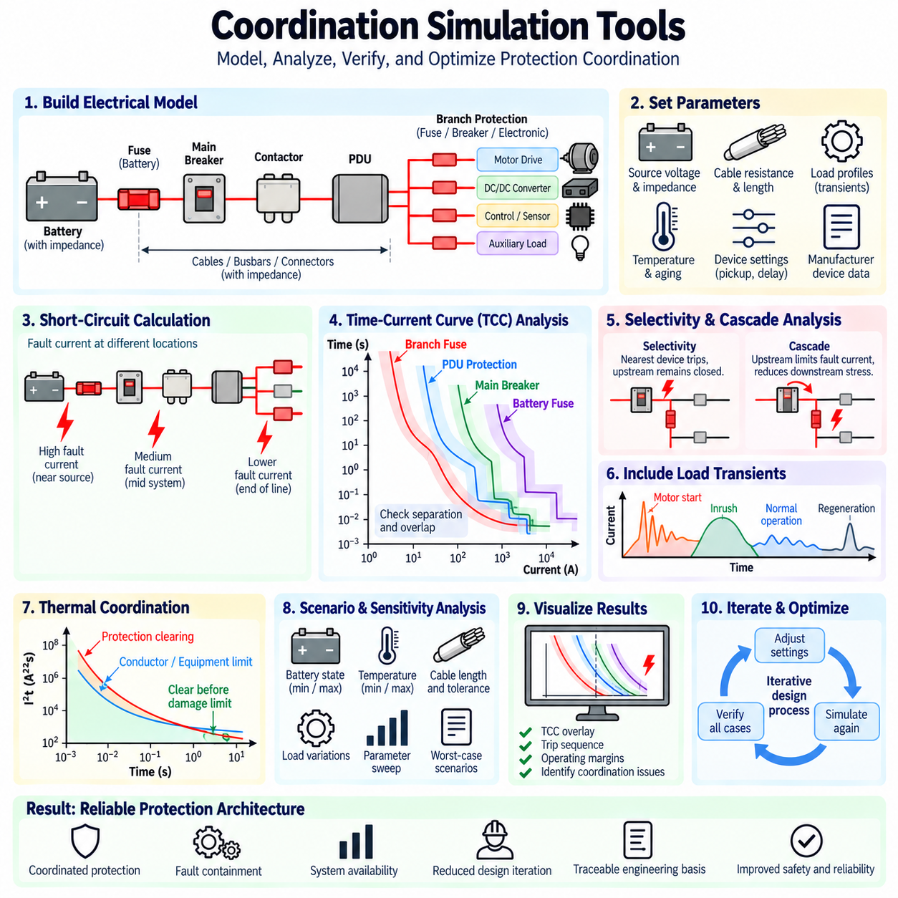
Protection coordination simulation tools provide an engineering environment for analyzing how fuses, circuit breakers, electronic protection devices, relays, and other protective elements interact during overload and short-circuit conditions. Instead of evaluating each device independently, simulation allows the complete protection hierarchy to be studied from the power source through distribution nodes to individual loads, supporting systematic verification of coordinated operation.
The foundation of a coordination study is an accurate electrical network model. The engineer represents batteries or power supplies, cables, busbars, connectors, contactors, PDUs, converters, motors, and protection devices together with their relevant electrical parameters. Source impedance and distribution resistance are especially important because they determine the prospective fault current available at different locations and therefore influence which protection characteristic becomes active.
Short-circuit calculation is one of the primary functions of coordination software. The simulation estimates minimum and maximum fault currents at selected nodes by considering source voltage, internal source impedance, conductor impedance, connection resistance, and network topology. Fault location must be varied because a short circuit close to a battery may produce extremely high current, while the same fault at the end of a long cable may generate substantially lower current.
Time-Current Curve analysis is another central capability. Protection-device characteristics can be placed on common logarithmic current-versus-time axes so that engineers can compare their operating regions directly. A branch fuse, PDU protection device, main breaker, and battery fuse can therefore be evaluated as one coordinated chain. Curve overlap, insufficient separation, or unexpected upstream operation can be identified before hardware testing.
Modern coordination tools commonly use manufacturer device libraries containing published protection characteristics. These libraries may include fuse melting and total-clearing curves, breaker thermal and magnetic trip characteristics, electronic-trip settings, interrupting ratings, and current-limiting information. Using actual device data reduces the uncertainty associated with simplified generic curves, although the engineer must still verify that the selected model corresponds to the exact device and operating conditions.
Selectivity analysis evaluates whether the protection device nearest a fault operates before upstream devices. Simulation can place faults at multiple branches and determine the expected sequence of protective actions. Complete selectivity may be demonstrated across the entire expected fault-current range, while partial selectivity may be identified when coordination is maintained only below a particular current. This information supports fault containment and service continuity decisions.
Cascade protection analysis requires additional information beyond basic TCC comparison. When an upstream current-limiting device reduces the stress applied to downstream protection, the simulation may need peak-current limitation, let-through energy, and I²t characteristics. Manufacturer-tested cascade or series combinations remain particularly important because high-current interruption involves dynamic device interactions that cannot always be predicted accurately from independent TCC curves alone.
Load behavior must be included so that normal operating transients are not incorrectly interpreted as faults. Motor starting, acceleration, regenerative braking, capacitor charging, converter startup, and actuator peak torque can generate temporary currents substantially above continuous operating levels. By overlaying these load-current envelopes with protection characteristics, engineers can identify settings that avoid nuisance trips while retaining adequate overload and short-circuit protection.
Thermal withstand characteristics can also be compared with protection operation. Cable and conductor limits, busbar capability, connector heating, motor winding limits, and semiconductor protection boundaries may be represented as damage or withstand curves. The protection device should clear abnormal current before the protected component crosses its allowable thermal boundary. This approach connects protection coordination directly with wire sizing, derating, and equipment thermal design.
Scenario analysis is particularly valuable because a protection architecture must operate correctly under more than one nominal condition. Simulation cases can represent different battery states, source voltages, ambient temperatures, cable lengths, load combinations, and fault locations. Minimum fault-current scenarios verify that protection still operates rapidly enough, while maximum fault-current scenarios confirm interrupting capability and fault-energy containment under the most severe conditions.
Sensitivity analysis extends this process by varying uncertain parameters within realistic limits. Battery internal resistance may change with state of charge, temperature, aging, and cell chemistry, while cable and connector resistance can vary with temperature and manufacturing tolerance. Protective devices also contain operating tolerances. Exploring these variations helps identify coordination designs that appear acceptable nominally but lose selectivity or thermal margin under worst-case conditions.
Simulation tools are also useful for adjustable electronic protection. An electronic-trip breaker or smart PDU may provide configurable current thresholds, delay times, short-circuit limits, and channel-specific protection parameters. Engineers can modify these settings in the model and immediately examine their influence on TCC separation and fault-clearing sequence. This capability supports systematic calibration instead of relying primarily on trial-and-error hardware adjustment.
For smart robotic power systems, protection behavior may combine physical devices and software-controlled functions. A semiconductor load switch can respond within microseconds or milliseconds, while a branch fuse, main breaker, or battery fuse provides progressively higher-level backup protection. Coordination analysis should therefore represent both electronic and electromechanical layers so that local software-controlled protection does not unintentionally conflict with physical backup devices.
A useful simulation model should distinguish between device trip initiation and complete current interruption. For a fuse, melting time and total clearing time are different quantities. For a breaker, sensing, mechanical opening, and arc interruption introduce additional timing. This distinction becomes increasingly important at high fault currents because the energy delivered during the final interruption interval may determine whether downstream semiconductor devices or conductors survive.
Visualization is one of the major advantages of coordination software. Engineers can inspect TCC overlays, fault-current levels, trip points, operating margins, and protection sequences in a common environment. A graphical representation makes it easier to identify cases in which a downstream curve approaches an upstream curve too closely or a normal transient enters a trip region. Visualization therefore supports both detailed analysis and engineering design reviews.
Commercial power-system analysis platforms often combine protection coordination with short-circuit, load-flow, arc-flash, cable, and equipment studies. In large industrial systems, this integration allows changes in network configuration to propagate through multiple analyses. Robotics applications may use a smaller model, but the underlying engineering principle remains the same: protection settings should be derived from the electrical system rather than selected independently from component datasheets.
General circuit simulation environments can complement dedicated coordination software when detailed transient behavior is important. SPICE-type models can represent battery impedance, capacitors, semiconductor switches, parasitic inductance, contact resistance, and converter input behavior. Such simulations are particularly useful for studying fast current transients and inrush phenomena, although they do not automatically replace manufacturer-certified protection coordination information.
Model accuracy is limited by the quality of input data. A sophisticated simulation cannot compensate for an unrealistic battery short-circuit model, incorrect cable resistance, missing contact impedance, or an inaccurate protection curve. Engineers should therefore establish traceable input parameters from component datasheets, measured values, manufacturer libraries, and validated system models. Assumptions should be explicitly documented when reliable data are unavailable.
Simulation results should not be interpreted as automatic proof of compliance or safety. Protection devices have manufacturing tolerances, environmental dependencies, aging effects, and interruption phenomena that may not be completely represented by analytical models. Manufacturer coordination tables, applicable standards, component qualification data, and physical fault testing remain necessary where required. Simulation is most effective as a design and verification tool within a broader validation process.
An AMR coordination model can begin with the battery and its internal impedance, followed by the battery fuse, main breaker or contactor stage, power cables, PDU, branch protection, and individual loads. Traction drives, steering actuators, computers, sensors, communication equipment, and auxiliary loads can each be represented by appropriate steady-state and transient current profiles. Faults can then be inserted systematically at each distribution level.
For a traction-drive branch, simulation can examine normal acceleration current, temporary overload, motor-controller short circuit, cable short circuit, and semiconductor failure. The model can determine whether local electronic protection reacts first, whether the branch fuse provides appropriate backup, and whether the battery fuse remains coordinated. The resulting sequence can then be compared with conductor thermal limits and the maximum fault energy allowed by the drive electronics.
The engineering workflow is iterative rather than a single calculation. Initial protection ratings and settings are selected, the network is simulated, coordination conflicts are identified, and device ratings or settings are adjusted. The analysis is then repeated across relevant operating and fault scenarios. This cycle continues until normal transients, overload protection, short-circuit interruption, selectivity, cascade behavior, and equipment withstand requirements are simultaneously satisfied.
Simulation models should also be maintained as the electrical architecture evolves. Changing battery capacity, cable gauge, PDU architecture, motor-drive rating, or branch layout can alter fault-current levels and invalidate previously established coordination. Maintaining the coordination model as an engineering artifact allows protection performance to be reassessed systematically whenever the power architecture changes, rather than assuming that previous protection settings remain valid.
Protection coordination simulation therefore connects analytical design with physical implementation. TCC analysis explains when protective devices operate, short-circuit calculations determine the currents they must interrupt, selectivity analysis determines the preferred operating sequence, and cascade analysis evaluates interaction between protection layers. Thermal and transient simulations add the equipment constraints necessary to transform these individual calculations into a complete protection strategy.
For robots, AMRs, battery systems, and industrial automation equipment, coordination simulation tools provide a practical method for developing and validating a layered protection architecture before destructive fault testing. When accurate system models, manufacturer characteristics, worst-case scenarios, and physical verification are combined, simulation can reduce design iteration, expose hidden coordination conflicts, and provide a traceable technical basis for reliable robot power protection.

06.05. AMR Protection Coordination Example
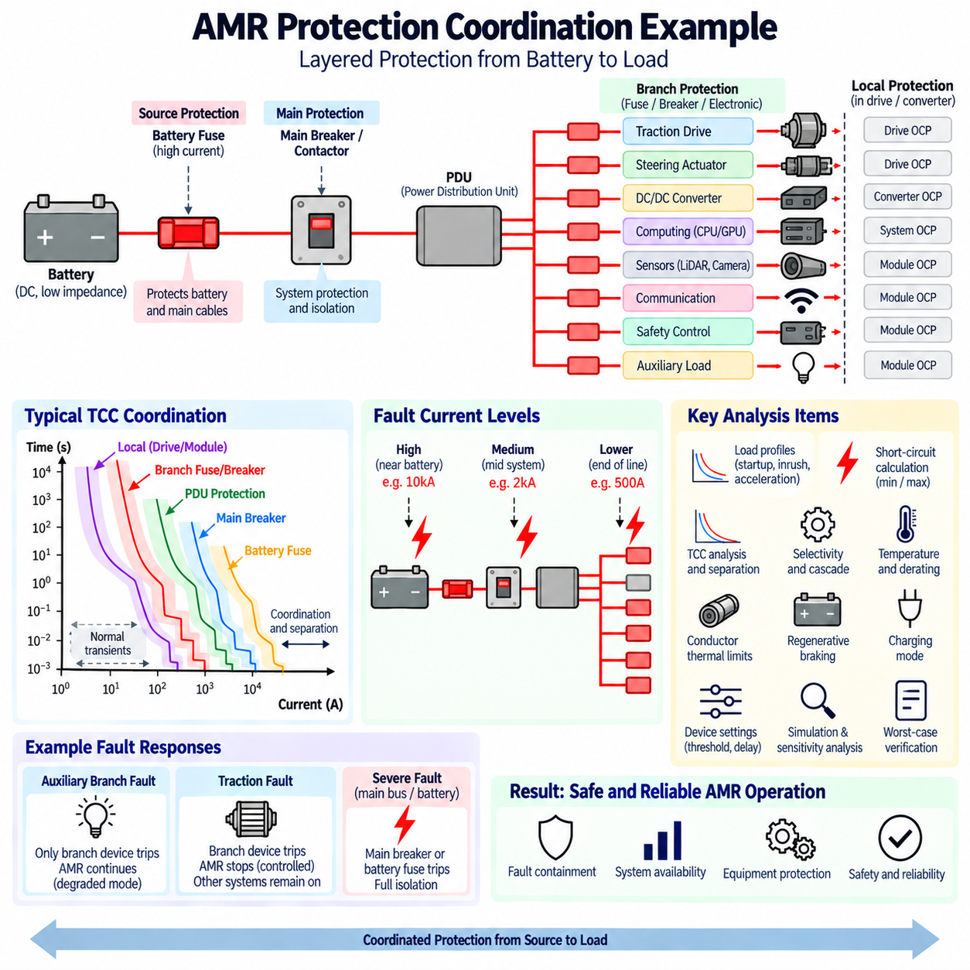
An AMR protection coordination example can be developed by treating the robot as a layered DC power distribution system rather than as a collection of independently protected loads. A practical architecture begins at the battery, continues through source-level protection and switching, enters the PDU, and then divides into protected branches supplying traction drives, steering actuators, computers, sensors, communication equipment, converters, and auxiliary loads.
Consider a representative battery-powered AMR in which the battery is connected first to a high-current fuse and then to a main breaker or contactor stage. The main power path feeds a PDU that distributes energy to several branches. Each branch contains a fuse, breaker, or electronic protection channel selected according to its load characteristics. Local protection inside motor drives or converters may provide an additional layer closest to the actual electrical load.
The battery fuse represents the highest-energy protection layer. Its primary responsibility is to protect the battery cables and main distribution path against catastrophic short circuits that could release very large fault energy. Because the battery can behave as a low-impedance source, the fuse must have an appropriate DC voltage rating and interrupting capability for the maximum prospective battery fault current rather than being selected only from the AMR continuous operating current.
The main breaker provides system-level protection and convenient electrical isolation. Its continuous current rating must support simultaneous operation of the required AMR loads, while its thermal and instantaneous characteristics must coordinate with the battery fuse. During ordinary downstream faults, the main breaker should preferably remain closed if branch protection can isolate the affected circuit, but it must still provide backup protection when a branch device cannot clear a persistent fault.
The PDU forms the transition from system-level protection to branch-level protection. Separate outputs may supply the traction system, steering system, DC/DC converters, onboard computing, perception sensors, communication equipment, safety electronics, and auxiliary devices. This architecture allows protection settings to reflect the characteristics and criticality of each load rather than applying one common protection threshold to every electrical subsystem.
The traction branch normally requires special attention because it may carry the largest dynamic current. During acceleration, slope climbing, obstacle negotiation, or rapid speed changes, motor drives can temporarily draw currents substantially higher than their steady-state values. Branch protection must tolerate these legitimate peaks while responding to prolonged overload, motor-controller failure, cable short circuit, or other abnormal conditions before conductors and power electronics are damaged.
A traction-drive protection chain may consist of electronic overcurrent protection inside the drive, followed by a branch fuse or breaker and then the upstream main and battery protection. Moderate overload should normally be handled by the drive electronics. A severe branch short circuit should cause the branch device to operate rapidly, while the battery fuse remains available as the final protection layer for extremely high-energy faults or failure of downstream interruption.
Computing and sensor branches have very different current profiles. An edge computer, GPU module, or DC/DC converter can generate substantial startup inrush because of input capacitance, even though its steady-state current is considerably lower. Cameras, LiDARs, communication modules, and control electronics generally consume smaller currents. Separate branch protection prevents a fault in one low-power subsystem from unnecessarily disabling traction or the entire AMR.
The first coordination check is therefore based on normal and transient load profiles. Continuous current, startup current, acceleration peaks, regenerative events, converter inrush, and temporary actuator overloads are characterized for each branch. These current-versus-time envelopes are compared with the protection characteristics so that normal AMR operation remains outside the trip region while sustained abnormal current enters a region where protection operates predictably.
The second step is to calculate prospective fault current at multiple positions. A short circuit directly after the battery fuse can produce a much higher current than a short circuit near a sensor at the end of a long harness. Battery internal resistance, cable length, conductor cross-section, connector resistance, contactor resistance, and PDU distribution impedance determine the available current. Protection must operate correctly at both the minimum and maximum credible fault levels.
Time-Current Curve analysis can then place the protection layers on a common current-versus-time diagram. Ideally, the local or branch protection characteristic operates first, followed by PDU or main protection and finally the battery fuse as fault severity increases. The curves must also remain clear of legitimate transient-current envelopes. Adequate separation is required because temperature, manufacturing tolerance, aging, and initial thermal conditions can shift actual operating behavior.
For a fault in an auxiliary branch, selectivity requires the auxiliary branch device to disconnect that circuit without removing power from the traction, computing, and safety branches. The robot may report the failure and continue in a degraded operating state when permitted by the system safety concept. This demonstrates why electrical protection coordination contributes directly to fault containment and system availability rather than merely preventing component damage.
A traction fault may require a different response. Because propulsion is functionally important and potentially safety relevant, loss of a traction branch may require the control system to stop the vehicle even when electrical selectivity successfully preserves power to other branches. Computing, communication, safety control, and diagnostic functions can remain energized to perform controlled stopping, record fault information, communicate status, and support recovery.
This distinction illustrates that electrical selectivity and functional system response are not identical. Protection coordination determines which electrical circuit is disconnected, while the safety and control architecture determines what the AMR should do after that event. A selectively isolated branch fault may therefore cause continued operation, reduced capability, controlled stopping, or complete shutdown depending on the function that has been lost.
Cascade protection becomes relevant for severe faults. The battery fuse or another upstream current-limiting device may restrict peak fault current and I²t energy before downstream equipment experiences the unrestricted prospective fault level. This can reduce thermal and electrodynamic stress on cables, PDU conductors, connectors, and branch devices. Any cascade relationship used to justify protection capability must nevertheless be supported by appropriate device data or validated combinations.
Conductor protection must be checked together with device coordination. The clearing characteristic of each branch device should remain below the thermal damage boundary of its cable and connectors. The same principle applies to PDU busbars, PCB conductors, motor windings, and semiconductor switches. A protection sequence is not acceptable merely because the correct fuse trips first if excessive let-through energy can damage another component before interruption is completed.
Temperature introduces an important practical margin in an AMR because electrical components may operate inside compact enclosures close to batteries, motor drives, computers, and converters. Fuse and breaker characteristics can shift with ambient temperature, while cable current capability decreases as thermal conditions become more severe. Protection coordination should therefore be verified at representative minimum and maximum operating temperatures rather than only under room-temperature laboratory conditions.
Regenerative braking must also be considered in traction-system coordination. During deceleration, energy can flow from the motor drive back toward the DC bus or battery, producing current conditions different from propulsion. Protection devices, contactors, busbars, and electronic switches must be suitable for the possible current direction and magnitude. A unidirectional assumption can create unexpected behavior in a power architecture containing regenerative loads.
The charging path introduces another operating condition. When the AMR docks to a charger, the battery, BMS, charging interface, contactors, and protection devices form a different power-flow configuration from normal driving. Charging faults should be isolated without exposing the vehicle harness or battery to excessive energy. Protection settings must therefore consider both autonomous operation and charging when the same electrical distribution components participate in both modes.
A smart PDU can improve coordination by monitoring current individually on each branch. Electronic thresholds and delays can be configured according to load type, allowing a motor branch to tolerate short acceleration peaks while a sensitive electronics branch uses a lower protection threshold. Fault status can also be communicated to the robot controller, enabling diagnostics and controlled recovery while independent fuses or breakers remain available as physical backup protection.
A representative fault study should include branch overload, branch short circuit, main-bus short circuit, failed motor drive, failed converter, and protection-device failure. For each event, the engineer determines the expected current path, first protection device to operate, backup device, maximum clearing time, and equipment exposed to fault energy. This establishes whether the intended protection hierarchy remains valid across realistic failure conditions.
Simulation can then verify the architecture before destructive testing. The AMR electrical network is modeled using battery impedance, cable resistance, PDU distribution paths, protection characteristics, and load profiles. Faults are inserted at selected nodes, and the resulting current levels and trip sequence are compared with TCC curves, I²t limits, conductor withstand capability, and interrupting ratings.
Worst-case analysis should vary battery state, temperature, cable tolerance, source impedance, and load conditions. A fully charged battery at favorable temperature may produce the maximum short-circuit current, while another operating condition may produce a much lower fault current that takes longer to activate protection. Both extremes matter: high current challenges interruption capability, whereas low fault current can challenge the ability to detect and clear the fault quickly enough.
The final AMR protection architecture therefore operates as a coordinated hierarchy from source to load. Battery protection manages catastrophic source-level faults, main protection protects the principal distribution path, PDU devices isolate individual branches, and local electronic protection responds closest to sensitive loads. This layered organization is consistent with the broader AMR electrical architecture in which battery, power distribution, sensing, computing, communication, and safety functions operate as an integrated system.
A successful coordination example is not defined simply by whether every fault eventually opens a fuse or breaker. Normal transients must pass without nuisance trips, localized faults should be isolated where appropriate, conductors and equipment must remain below damage limits, severe faults must receive reliable backup protection, and safety-related responses must remain consistent with vehicle behavior. Protection coordination therefore becomes part of overall AMR fault-management architecture.
When TCC analysis, selectivity, cascade protection, fault-current calculation, thermal limits, simulation, and physical verification are combined, an AMR can achieve both electrical safety and operational resilience. The resulting design confines faults to the smallest appropriate region, preserves healthy electrical functions when possible, provides backup for severe failures, and creates a traceable engineering basis for reliable battery-to-load power protection.

