Volume 04. Fuse, Relay, and Power Distribution Unit

Chapter 07. PDU Design

07.01. PDU Architecture Types
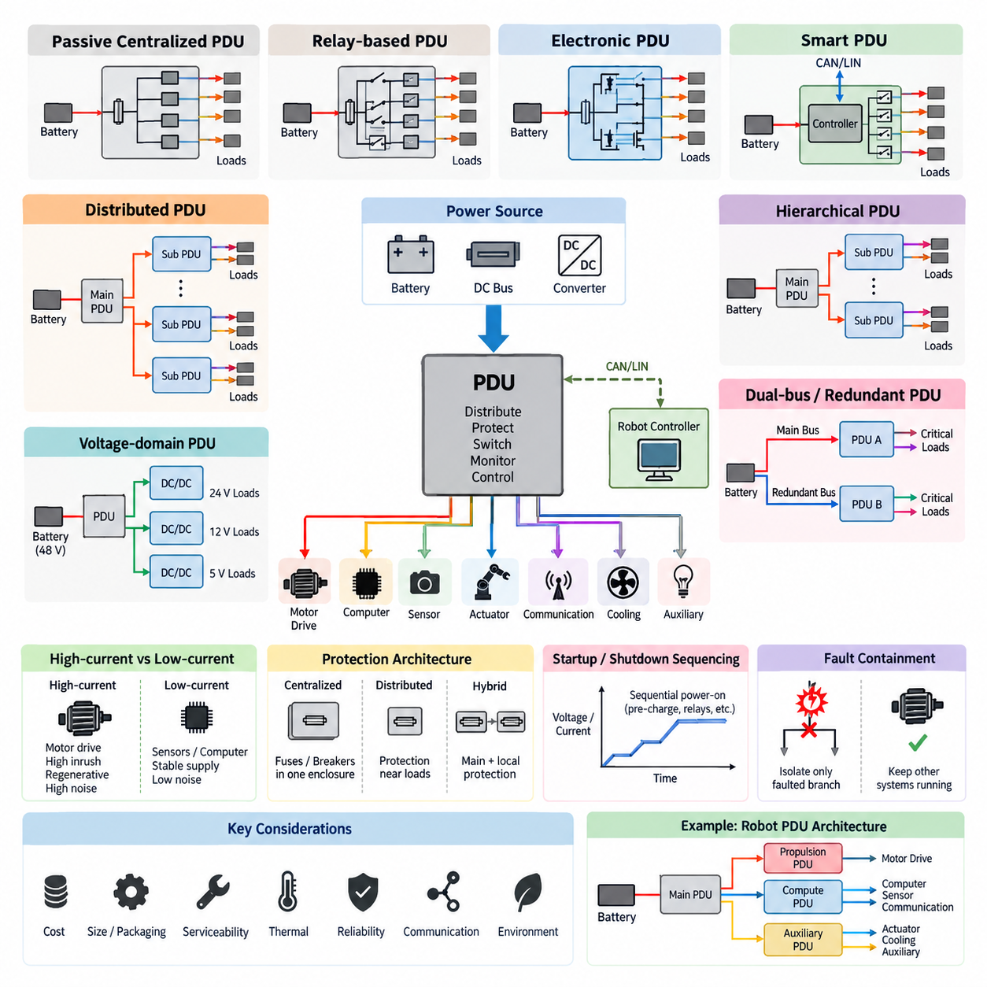
A Power Distribution Unit (PDU) is the central electrical node that receives power from a battery, DC bus, or upstream converter and distributes it to multiple protected loads. In robotics, the PDU sits between the primary energy source and subsystems such as motor drives, computers, sensors, actuators, communication equipment, cooling devices, and auxiliary electronics. Its architecture determines how power branches are organized, protected, isolated, monitored, and serviced.
The simplest PDU architecture is a passive centralized distribution structure. Battery power enters a single enclosure containing busbars, fuses, relays, terminals, and connectors, and individual protected branches leave the enclosure for each load group. This architecture is inexpensive, mechanically straightforward, and easy to inspect. It is especially suitable for small robots whose electrical loads are relatively stable and where sophisticated channel-level diagnostics are unnecessary.
A centralized relay-based PDU extends passive distribution by adding electromechanical relays or contactors to selected branches. Loads can therefore be switched according to operating modes such as startup, shutdown, charging, emergency stop, or maintenance. High-current propulsion branches may use contactors while lower-current auxiliary circuits use conventional relays. This structure provides physical galvanic switching and clear fault isolation, although relay lifetime, coil power, contact wear, and enclosure size must be considered.
Electronic PDUs replace many mechanical switching elements with semiconductor devices such as power MOSFETs or intelligent high-side switches. Electronic switching enables rapid control, high switching-cycle endurance, compact packaging, and sophisticated protection functions. Depending on the device, each output can incorporate overcurrent limitation, short-circuit shutdown, overtemperature protection, open-load detection, and diagnostic feedback. This architecture becomes particularly attractive when robot operating modes require frequent power sequencing.
A smart PDU combines electronic or electromechanical switching with an embedded controller and communication interface. The controller measures electrical conditions, interprets commands, executes protection logic, records faults, and reports PDU status to a vehicle controller or robot computer. CAN, LIN, or other embedded communication networks may be used according to system requirements. The architecture transforms the PDU from a passive electrical junction into an actively managed power subsystem.
Distributed PDU architecture separates power distribution into several physical nodes located near major load groups. Instead of routing every branch from one central enclosure, a primary PDU supplies secondary distribution modules positioned near propulsion, perception, computing, manipulation, or auxiliary equipment. This approach can reduce harness length, conductor mass, connector concentration, and packaging congestion, particularly in large mobile robots where loads are physically separated across the platform.
A hierarchical architecture combines centralized and distributed concepts. A main PDU performs battery-level isolation and high-current distribution, while subordinate PDUs handle local branch protection and switching. For example, a mobile robot may use one primary battery distribution module feeding propulsion, compute, sensor, and auxiliary zones. Each zone can then contain secondary protection appropriate to its load characteristics, creating several coordinated protection layers between the battery and final devices.
High-current and low-current loads are frequently separated architecturally because their electrical behavior differs substantially. Motor drives can produce large startup currents, regenerative currents, switching noise, and transient disturbances, whereas sensors and computing electronics require comparatively stable and low-noise supplies. Separate bus sections, dedicated protection devices, filtering, grounding arrangements, or DC-DC conversion stages help prevent propulsion disturbances from degrading perception, communication, or AI computing reliability.
Dual-bus and redundant PDU architectures are used when continued operation or controlled shutdown is important after a single electrical failure. Critical controllers, braking systems, localization sensors, communication modules, or safety circuits may receive power through independent branches or separate supply buses. Redundancy does not simply mean duplicating wires; common failure points such as connectors, busbars, switching devices, grounding paths, and upstream protection must also be evaluated to achieve meaningful fault tolerance.
Voltage-domain architecture becomes important when a robot contains several operating voltages. A battery bus such as 48 V may directly supply propulsion equipment while DC-DC converters generate 24 V, 12 V, or lower-voltage domains for controllers and sensors. Distribution can occur before or after conversion depending on current demand, conversion efficiency, wiring requirements, fault containment, and packaging. Clear domain boundaries also simplify protection coordination and prevent inappropriate loads from being connected to higher-energy buses.
A PDU can additionally be classified according to whether protection is centralized or distributed. Centralized protection places most fuses, breakers, and switches inside one serviceable enclosure, simplifying inspection and replacement. Distributed protection places protective devices closer to loads, potentially reducing the length of unprotected conductors. In practical robot designs, hybrid protection is common: major feeders are protected centrally while downstream branches receive additional local protection matched to conductor size and equipment characteristics.
Serviceability strongly influences architecture selection. A centralized PDU provides technicians with one identifiable location for fuse inspection, voltage measurement, connector isolation, and branch troubleshooting. Distributed modules can improve local accessibility but increase the number of service locations. Modular PDUs with replaceable fuse blocks, relay modules, electronic channel boards, or connectorized subassemblies can balance these requirements and allow damaged sections to be repaired without replacing the entire distribution assembly.
Thermal behavior also differentiates PDU architectures. High-current busbars, fuse terminals, relays, contactors, MOSFETs, connectors, and PCB copper all generate heat through conduction losses. Concentrating these elements in one enclosure can create thermal hot spots, whereas distributed architectures spread heat across the platform. Electronic PDUs require particular attention because semiconductor resistance increases losses as current rises, making thermal design directly related to allowable channel current and protection performance.
Fault containment should be considered at the architectural level rather than only through individual fuse ratings. A short circuit in an auxiliary sensor should not disable propulsion, while a propulsion fault should not unnecessarily remove power from safety-critical control electronics. Separating loads into functional domains and assigning independent protective branches limits fault propagation. The resulting architecture should support selective disconnection so that the smallest practical electrical region is isolated when a fault occurs.
Startup and shutdown sequencing can further determine the preferred PDU type. Large capacitive loads such as motor inverters, edge computers, GPU systems, and DC-link circuits may create significant inrush current when connected simultaneously. Controlled relays, contactors, pre-charge circuits, or semiconductor load switches allow branches to be energized in sequence. A managed architecture can therefore reduce battery voltage sag, nuisance fuse operation, connector stress, and transient disturbances during robot initialization.
For an autonomous mobile robot, a practical architecture often combines several PDU types rather than relying on a single topology. A battery-side primary PDU can provide main isolation and high-current protection, a propulsion section can feed motor drives, and electronically controlled secondary sections can supply compute and perception equipment. Safety circuits can remain independently protected so that emergency functions do not depend entirely on the software-controlled distribution layer.
Architecture selection should ultimately follow the robot's electrical energy, physical size, fault-tolerance requirements, load distribution, service strategy, communication architecture, and expected operating environment. Small indoor robots may justify a compact centralized PDU, while large outdoor AMRs, mobile manipulators, quadrupeds, humanoids, or cargo platforms increasingly benefit from hierarchical and distributed structures. The PDU therefore becomes a system-level architectural element connecting power distribution, protection, diagnostics, thermal design, harness engineering, and functional safety.

07.02. Smart PDU with CAN/LIN
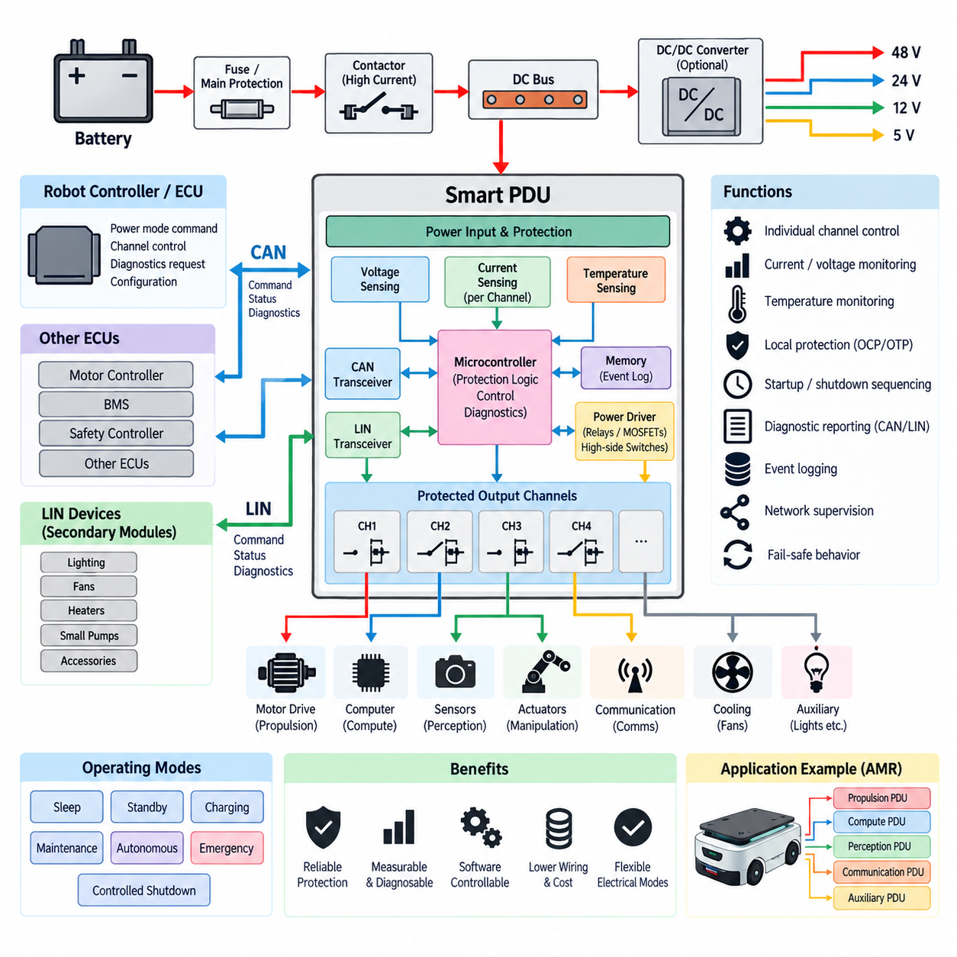
A Smart Power Distribution Unit (Smart PDU) extends conventional power distribution by combining protected electrical switching with embedded sensing, control, diagnostics, and network communication. Instead of simply routing battery power through fuses and relays, the Smart PDU becomes an intelligent electrical node capable of controlling individual loads and reporting their operating condition to the robot controller through communication interfaces such as CAN or LIN.
The internal architecture typically contains a power input stage, protection devices, switching elements, current and voltage sensing circuits, an embedded microcontroller, communication transceivers, and multiple protected output channels. Mechanical relays may still be used for high-current or isolation-critical branches, while MOSFETs or intelligent high-side switches can control frequently operated loads. The microcontroller coordinates these elements according to commands, local protection logic, and measured electrical conditions.
Controller Area Network (CAN) is particularly suitable for Smart PDU integration when reliable communication among multiple electronic controllers is required. A CAN-connected PDU can operate as a network node alongside motor controllers, battery management systems, safety controllers, and other ECUs. The robot controller can transmit commands for channel activation or shutdown, while the PDU periodically transmits voltage, current, temperature, switch status, and diagnostic information.
CAN communication also enables the electrical architecture to separate high-level power-management decisions from low-level protection execution. A central controller may determine that perception equipment should be activated, but the Smart PDU performs the actual switching and verifies whether the resulting electrical behavior is normal. If excessive current or abnormal temperature is detected, local protection can react immediately without waiting for a higher-level software decision or communication response.
Local Interconnect Network (LIN) provides a lower-cost communication alternative for simpler or less time-critical distributed electrical functions. A LIN-based PDU or secondary power module can control auxiliary loads that do not require the bandwidth or multi-master characteristics associated with more capable networks. Examples can include lighting, fans, heaters, small pumps, accessory electronics, and other relatively low-speed devices where deterministic command and diagnostic exchange is sufficient.
CAN and LIN can therefore coexist within a hierarchical Smart PDU architecture. A main PDU may communicate with the primary robot controller through CAN while secondary modules or local intelligent switches use LIN for lower-priority loads. This arrangement can reduce wiring and communication hardware cost while preserving robust CAN connectivity for critical power-management functions. Network selection should follow required bandwidth, fault tolerance, topology, diagnostic capability, and system criticality.
A major advantage of the Smart PDU is channel-level control. Each protected output can be represented as an individually controllable electrical resource rather than a permanently energized branch. Software can switch sensor groups, computers, communication equipment, cooling fans, actuators, and auxiliary devices according to robot operating state. This capability enables electrical operating modes such as sleep, standby, charging, maintenance, autonomous operation, emergency response, and controlled shutdown.
Channel-level current monitoring adds another layer of intelligence. A current sensor or integrated semiconductor measurement circuit can determine how much current each branch consumes during startup and steady-state operation. The controller can compare measurements with expected ranges and detect abnormal behavior such as overload, short circuit, stalled equipment, excessive inrush current, or unexpectedly low consumption that may indicate an open circuit or disconnected load.
Voltage monitoring is equally important because branch voltage provides information that cannot always be obtained from current measurement alone. The PDU can monitor battery input voltage and, where required, selected output voltages to identify undervoltage, overvoltage, excessive voltage drop, or switching failure. Combining voltage and current information allows the controller to distinguish between upstream supply problems, local switching faults, wiring resistance, disconnected loads, and abnormal downstream equipment behavior.
Temperature monitoring protects the PDU itself from excessive thermal stress. Sensors can be placed near high-current switching devices, busbars, connectors, PCB power paths, or other expected thermal hot spots. When temperature approaches a defined limit, the controller can issue a warning, reduce allowable current, disconnect noncritical loads, or shut down an affected channel. Such thermal supervision is particularly valuable in sealed robot enclosures with limited airflow.
Smart switching also enables controlled startup sequencing. Rather than energizing all loads simultaneously, the PDU can activate branches in a predefined order. Low-power controllers may start first, followed by sensors, communication systems, edge computers, cooling equipment, and finally high-current propulsion devices. Sequential activation reduces simultaneous inrush current and battery voltage sag while providing an opportunity to verify each electrical domain before the next stage is energized.
Controlled shutdown can be equally important. When a robot receives a shutdown request, some loads may need to remain powered temporarily so that data can be stored, computers can terminate software safely, communication messages can be transmitted, actuators can reach a safe state, or cooling can continue after a high-power device stops. A Smart PDU can implement these timed dependencies while maintaining local protection throughout the shutdown process.
Diagnostic communication transforms electrical faults into information that can be used by higher-level robot software. Instead of indicating only that a fuse has opened, the PDU can report which channel failed, when the event occurred, what current or voltage existed near the event, and whether the switch was commanded on or off. Diagnostic trouble information can be stored locally or transmitted through CAN or LIN to maintenance, fleet-management, or service tools.
Fault handling should remain layered so that communication loss does not eliminate basic electrical protection. Hardware fuses, circuit breakers, semiconductor protection, or other independent protective mechanisms should continue to protect conductors and equipment even if the embedded controller or network becomes unavailable. Local firmware can additionally define fail-safe output states so that communication timeout, invalid commands, controller reset, or network faults lead each channel toward an appropriate predetermined condition.
Network supervision is therefore an important Smart PDU function. The controller can monitor message timing, communication errors, command validity, and network availability. A CAN-based system may use periodic status messages and timeout supervision to determine whether the controlling ECU remains operational. LIN-based secondary modules can similarly detect missing master communication. The response should depend on load criticality rather than applying the same shutdown behavior to every electrical branch.
For an autonomous mobile robot, the Smart PDU can become the interface between the battery system and software-defined operating modes. Propulsion, compute, perception, communication, cooling, and auxiliary domains can be separately switched and monitored while the main controller coordinates their operation through CAN. Lower-priority devices may be grouped behind LIN-controlled modules. This creates an electrical architecture that can adapt its active power configuration to the robot's current mission and state.
The Smart PDU should nevertheless be designed as an electrical protection system rather than merely as another networked computer. Fuse coordination, conductor current capacity, switching-device ratings, short-circuit capability, connector limits, thermal derating, grounding, electromagnetic compatibility, and safe failure behavior remain fundamental requirements. Communication and software add observability and controllability, but they should complement rather than replace correctly engineered hardware protection.
When properly integrated, a CAN/LIN Smart PDU provides a bridge between traditional electrical distribution and intelligent robotic control. It allows electrical branches to become measurable, diagnosable, and software-controllable resources while retaining dedicated protection at the hardware level. This capability is especially valuable for increasingly complex AMRs and other robotic platforms where propulsion, computing, sensing, communication, and auxiliary systems must operate as coordinated electrical domains.

07.03. Load-Switch MOSFET Design
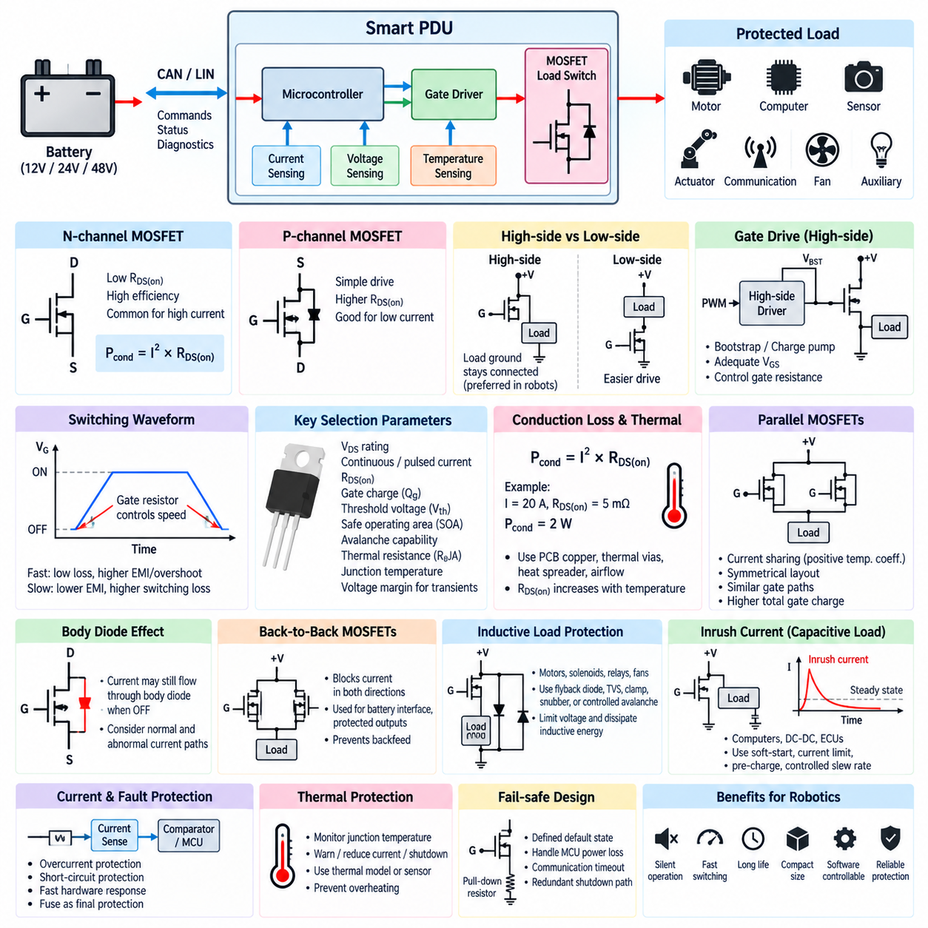
A load switch based on a power MOSFET provides electronically controlled connection and disconnection between a power source and an electrical load. In a Power Distribution Unit (PDU), this approach can replace conventional mechanical relays for many low- and medium-power branches. The absence of moving contacts enables silent operation, rapid switching, high cycle life, compact packaging, and direct control from embedded electronics.
The N-channel MOSFET is widely used as a load-switching element because its low on-state resistance can provide efficient conduction at substantial current. When the MOSFET is fully enhanced, the drain-to-source resistance, RDS(on), determines much of the conduction loss. The approximate loss can be expressed as Pcond = I² × RDS(on), showing why even a small resistance becomes important as channel current increases.
A P-channel MOSFET can simplify high-side switching because its gate can often be driven without a dedicated voltage-boost circuit. However, comparable P-channel devices generally exhibit higher RDS(on) than N-channel devices, resulting in greater conduction loss for a given silicon size. Consequently, P-channel solutions are attractive for simpler or lower-current channels, while high-current PDU designs commonly favor N-channel MOSFETs with appropriate gate-drive circuitry.
High-side and low-side switching represent two fundamental circuit arrangements. A high-side switch is placed between the positive supply and the load, allowing the load ground to remain continuously connected to the system ground. A low-side switch is placed between the load and ground and is usually easier to drive. Robotics PDUs frequently prefer high-side switching because disconnected loads retain a defined ground reference for communication, sensing, and diagnostic interfaces.
Driving an N-channel MOSFET on the high side requires the gate voltage to rise sufficiently above the MOSFET source voltage. Dedicated high-side gate drivers, charge pumps, or bootstrap circuits may therefore be required. The gate driver must provide adequate gate-to-source voltage while respecting the maximum VGS rating. Insufficient gate voltage leaves the device partially enhanced, increasing RDS(on), power dissipation, and junction temperature.
The MOSFET gate behaves primarily as a capacitive load, so switching speed depends on how rapidly the gate charge can be supplied or removed. Gate resistance can be used to control the transition rate and limit peak gate current. Very fast transitions reduce switching loss but may increase electromagnetic interference, voltage overshoot, and ringing. Slower transitions can improve electromagnetic behavior but increase the energy dissipated during switching.
MOSFET selection must consider more than nominal load current. Important electrical parameters include drain-to-source voltage rating, continuous and pulsed drain current, RDS(on), gate charge, threshold voltage, safe operating area, avalanche capability, package thermal resistance, and junction-temperature limits. Appropriate voltage margin is particularly important in robotic systems because motors, inductive wiring, converters, and switching devices can produce supply transients above the nominal battery voltage.
Conduction loss directly influences the thermal design of the load switch. For example, a MOSFET carrying 20 A with an effective RDS(on) of 5 mΩ dissipates approximately 2 W through conduction alone. PCB copper, thermal vias, heat spreaders, enclosure conduction, and airflow must remove this heat while keeping the junction below its allowable temperature. RDS(on) also normally increases with junction temperature, creating additional loss as the device becomes hotter.
Parallel MOSFETs can be used when a single device cannot efficiently carry the required current. Because MOSFET on-resistance generally increases with temperature, current sharing can be more favorable than with devices exhibiting negative temperature coefficients. Nevertheless, symmetrical PCB routing, similar gate paths, matched thermal environments, and suitable device selection remain important. Paralleling devices also increases total gate charge and places greater demand on the gate driver.
The intrinsic body diode of a power MOSFET significantly affects load-switch behavior. With a single MOSFET, current may still flow in one direction through the body diode even when the transistor is commanded off. This can be undesirable when complete electrical isolation, reverse-current blocking, or prevention of backfeed is required. The body-diode orientation must therefore be evaluated according to normal current flow and possible abnormal operating conditions.
Back-to-back MOSFETs provide a common solution when bidirectional blocking is required. Two MOSFETs are arranged so that their body diodes oppose each other, preventing uncontrolled current flow in either direction when the switches are off. When both MOSFETs are turned on, the channel conducts normally. This topology is useful for battery interfaces, protected outputs, redundant supplies, and branches where downstream energy storage could otherwise feed power back into the PDU.
Inductive loads require additional protection because interrupting current through motors, solenoids, relays, fans, pumps, or long harnesses can generate substantial voltage transients. Depending on circuit requirements, suppression may use freewheel diodes, transient-voltage-suppression devices, clamps, snubbers, or controlled MOSFET avalanche. The protection network should constrain the MOSFET drain-to-source voltage while dissipating the stored inductive energy safely.
Inrush current is another major concern when switching capacitive loads such as computers, motor controllers, DC-DC converters, and electronic control units. A discharged input capacitor can initially appear as a very low impedance and produce current far above the steady-state load. Controlled gate slew rate, current limiting, soft-start control, pre-charge circuits, or intelligent high-side switches can reduce this stress and prevent nuisance operation of upstream protection.
Current sensing can be integrated with the MOSFET channel to provide intelligent protection. A shunt resistor, Hall-effect sensor, or current-sense function embedded in a smart switch can provide feedback to the PDU controller. Firmware or hardware comparators can then detect overload and short-circuit conditions. Fast hardware protection is particularly important because severe short circuits may exceed the MOSFET safe operating area before normal software can respond.
Short-circuit protection must consider both current magnitude and response time. Simply turning off a MOSFET after detecting excessive current may not be sufficient if detection, filtering, computation, and gate discharge take too long. Intelligent switches can integrate rapid current limiting and thermal shutdown, while discrete designs may require dedicated comparators and gate-control circuits. A conventional fuse can remain as an independent final protection layer against catastrophic failures.
Thermal protection complements current protection because moderate overloads may not trigger an immediate short-circuit response yet can progressively overheat the semiconductor. Junction temperature may be estimated from current and thermal models or monitored using integrated temperature sensing. A Smart PDU can issue warnings, reduce current, disconnect a channel, or implement retry logic when thermal limits are approached, depending on the safety requirements of the connected load.
Fail-safe behavior must also be defined for loss of microcontroller power, gate-driver failure, communication timeout, or software reset. Gate pull-down or pull-up resistors establish a known default state so that the MOSFET does not float unpredictably. Critical channels may require independent hardware enable signals or redundant shutdown paths. The intended default state depends on whether maintaining power or removing power represents the safer condition for the particular robotic subsystem.
A well-designed MOSFET load switch therefore combines semiconductor selection, gate-drive design, transient suppression, current monitoring, thermal management, short-circuit protection, and fail-safe control. Within a Smart PDU, these circuits allow individual robot loads to become software-controlled electrical channels while retaining fast local hardware protection. This makes MOSFET switching particularly valuable for modern AMRs and robotic platforms requiring frequent power sequencing, diagnostics, compact packaging, and high switching-cycle reliability.

07.04. Current Monitoring per Channel
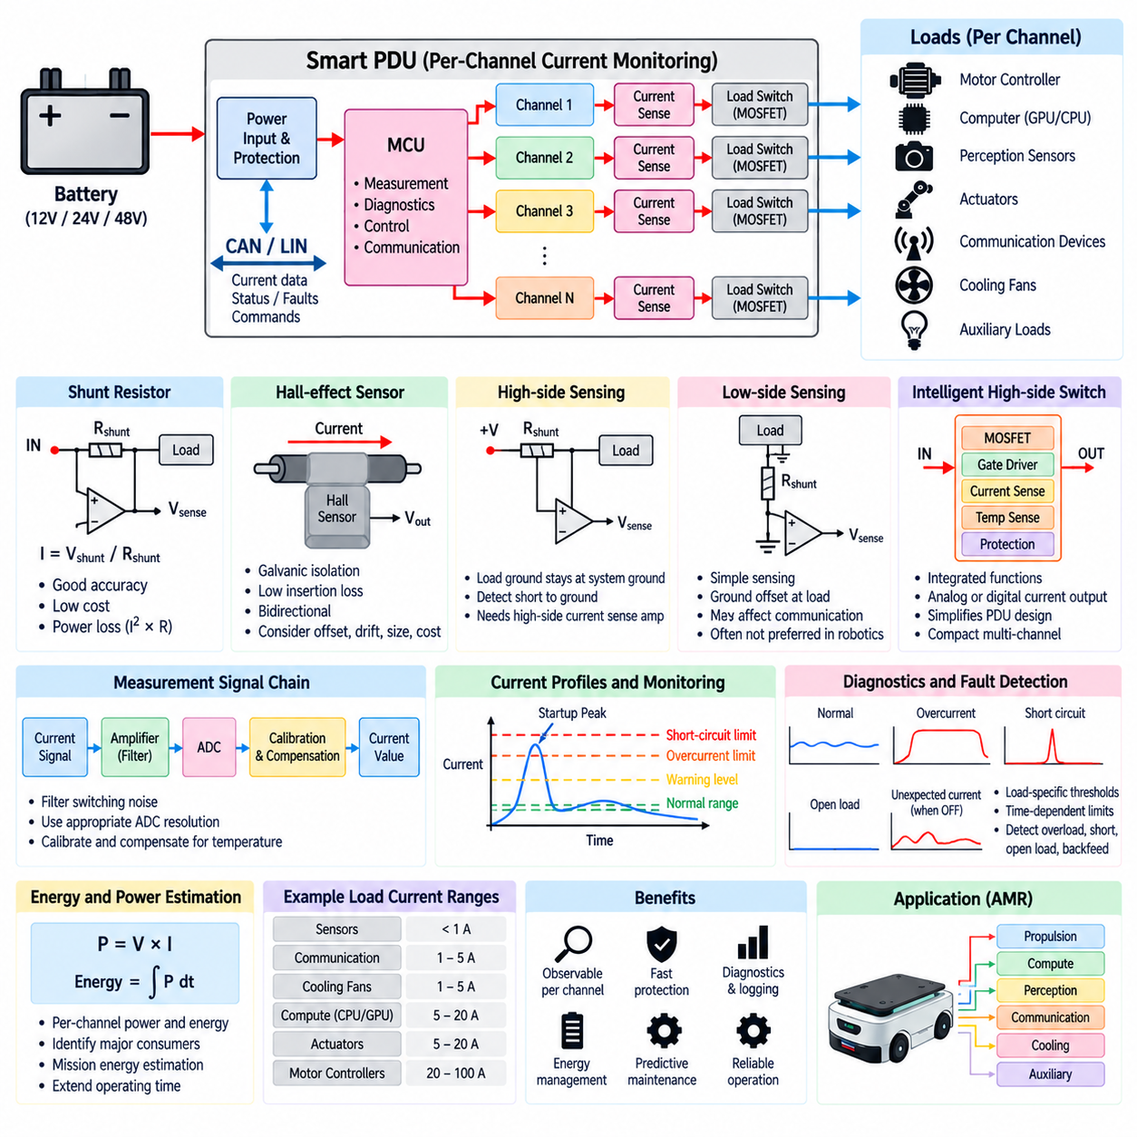
Per-channel current monitoring allows a Power Distribution Unit (PDU) to measure the electrical current flowing through each protected output independently. Instead of observing only total battery current, the PDU can determine how much power is being consumed by individual loads such as motor controllers, computers, sensors, actuators, communication devices, cooling fans, and auxiliary equipment. This transforms each branch into an observable electrical channel.
The basic measurement principle is to convert branch current into an electrical signal that can be interpreted by the PDU controller. Common approaches include shunt resistors, Hall-effect sensors, magnetic current sensors, and current-sense functions integrated into intelligent high-side switches. The appropriate technology depends on channel current, required accuracy, isolation requirements, allowable power loss, cost, packaging, bandwidth, and expected fault conditions.
A shunt-based measurement circuit places a precisely known low-value resistor in the current path and measures the voltage developed across it. According to Ohm's law, the current can be calculated as I = Vshunt / Rshunt. Because the resistance is intentionally very small, the resulting voltage is typically measured using a current-sense amplifier. This method provides good accuracy and relatively low cost but introduces power dissipation proportional to I² × Rshunt.
High-side current sensing places the shunt or sensing element between the positive supply and the load. This arrangement allows the load ground to remain directly connected to system ground and makes it possible to detect certain short circuits to ground. However, the measurement circuit must tolerate a common-mode voltage close to the supply voltage. Dedicated high-side current-sense amplifiers are therefore commonly used to extract the small differential voltage across the shunt.
Low-side current sensing places the measurement resistor between the load and ground. The sensing electronics can be simpler because the measured voltage remains close to ground potential. However, the shunt introduces a voltage offset between the load ground and system ground, which can interfere with communication, analog sensing, or other ground-referenced interfaces. For this reason, high-side sensing is often preferred in intelligent robotic power distribution systems.
Hall-effect current sensors measure the magnetic field produced by current rather than inserting a significant resistive element into the power path. They can provide galvanic isolation between the high-current conductor and measurement electronics and are useful for higher-current branches. Their advantages include low insertion loss and bidirectional measurement capability, although offset, temperature drift, bandwidth, physical size, and cost must be considered when selecting the sensor.
Intelligent high-side switches can integrate the power MOSFET, gate driver, current sensing, temperature monitoring, and protection functions into one semiconductor device. Some devices provide an analog current-sense output proportional to load current, while others expose diagnostic information through digital interfaces. This approach can significantly simplify Smart PDU hardware and enables compact multi-channel designs where switching, monitoring, and protection must operate together.
Measurement range should be matched to the expected operating behavior of each channel. A perception sensor drawing less than one ampere requires different measurement resolution from a motor controller carrying tens of amperes. Designing every channel for the highest possible current can reduce useful resolution at low currents. Smart PDUs may therefore use different sensor ranges, amplifier gains, or channel classes for compute, sensor, actuator, auxiliary, and propulsion loads.
Sampling rate is determined by what the monitoring system is intended to observe. Slow sampling may be sufficient for energy estimation and steady-state load monitoring, while faster sampling is required to capture startup current, short transients, motor-related variations, and developing faults. Extremely fast short-circuit protection should generally not depend entirely on normal software sampling because damaging current can rise much faster than the embedded control loop can respond.
Filtering is necessary because robotic electrical systems contain substantial switching noise. Motor inverters, DC-DC converters, PWM-controlled loads, relays, communication equipment, and long harnesses can introduce high-frequency disturbances into current measurements. Analog filtering can reduce unwanted components before analog-to-digital conversion, while digital filtering can stabilize reported values. Excessive filtering, however, can delay detection of genuine overcurrent events.
Analog-to-digital converter (ADC) resolution influences the smallest current change that can be distinguished. The usable resolution depends not only on ADC bit depth but also on sensor gain, reference voltage, noise, offset, and measurement range. A carefully designed current-monitoring channel should use enough of the ADC input range to achieve useful resolution while maintaining sufficient headroom for startup peaks and abnormal operating conditions.
Calibration improves measurement accuracy by compensating for resistor tolerance, amplifier offset, sensor gain variation, PCB resistance, and manufacturing variation. Calibration values can be stored in nonvolatile memory and applied by the PDU firmware. Temperature compensation may also be required because shunt resistance, amplifier characteristics, and magnetic sensor offsets change with temperature. Production calibration can therefore improve consistency among PDU channels and between manufactured units.
Per-channel monitoring enables load-specific diagnostic thresholds. Instead of using one universal overcurrent limit, each branch can have limits based on its normal electrical behavior. A fan, sensor, GPU computer, communication modem, actuator, and motor controller exhibit very different current profiles. Thresholds can include normal operating ranges, startup allowances, warning levels, overload limits, short-circuit limits, and time-dependent conditions to distinguish legitimate transients from persistent faults.
Current signatures can provide useful diagnostic information even before a protection threshold is exceeded. Increasing fan current may indicate bearing degradation or obstruction, while unexpectedly low current may indicate a disconnected load. A motorized actuator that draws current without expected movement may be stalled. Repeated changes in computer or sensor consumption can also reveal abnormal startup behavior. Current monitoring therefore supports condition monitoring as well as immediate electrical protection.
Energy and power consumption can also be estimated from channel measurements. When current is combined with measured bus voltage, instantaneous electrical power can be approximated as P = V × I. Integrating power over time provides energy consumption for individual subsystems. A robot can use this information to identify dominant consumers, estimate mission energy requirements, manage low-battery operation, or selectively disable nonessential loads to extend remaining operating time.
Fault detection should distinguish overload, short circuit, open load, and unexpected current flow. Excessive current while a channel is commanded on may indicate overload or a downstream short circuit. Near-zero current can indicate an open circuit or disconnected device. Current detected while a channel is commanded off may indicate MOSFET leakage, body-diode conduction, welded relay contacts, backfeed, or an unintended alternative power path. Combining command state and measured current greatly improves diagnostic resolution.
Protection logic commonly uses both magnitude and time because acceptable current depends on duration. A motor controller or computer may legitimately draw a large current during startup but should not maintain that level indefinitely. The PDU can therefore apply time-dependent thresholds similar in concept to protection coordination. Severe faults trigger rapid shutdown, whereas moderate overloads may be tolerated briefly before warning, current limitation, or channel disconnection occurs.
Per-channel data becomes particularly valuable when transmitted through a Smart PDU network interface. Current values, peak measurements, accumulated energy, warning states, and fault events can be reported through CAN or LIN to the robot controller. The information may also be recorded in diagnostic logs and forwarded to maintenance or fleet-management systems. This allows electrical behavior to become part of the robot's overall health-monitoring and service strategy.
For an autonomous mobile robot (AMR), current monitoring can separate propulsion, compute, perception, communication, cooling, and auxiliary power behavior. The controller can identify which domain is responsible for unexpected battery consumption and isolate abnormal branches without unnecessarily disabling the entire robot. Combined with controllable MOSFET load switches, monitoring creates a closed electrical management loop in which each channel can be measured, diagnosed, protected, and switched independently.
A robust per-channel current-monitoring design therefore combines appropriate sensing technology, measurement range, sampling, filtering, ADC design, calibration, thermal compensation, diagnostic thresholds, and fast independent protection. Its purpose is not merely to display current values, but to convert electrical distribution into observable system information. Within a Smart PDU, this capability provides the foundation for channel-level diagnostics, energy management, predictive maintenance, and coordinated robot power protection.

07.05. PDU Thermal Management
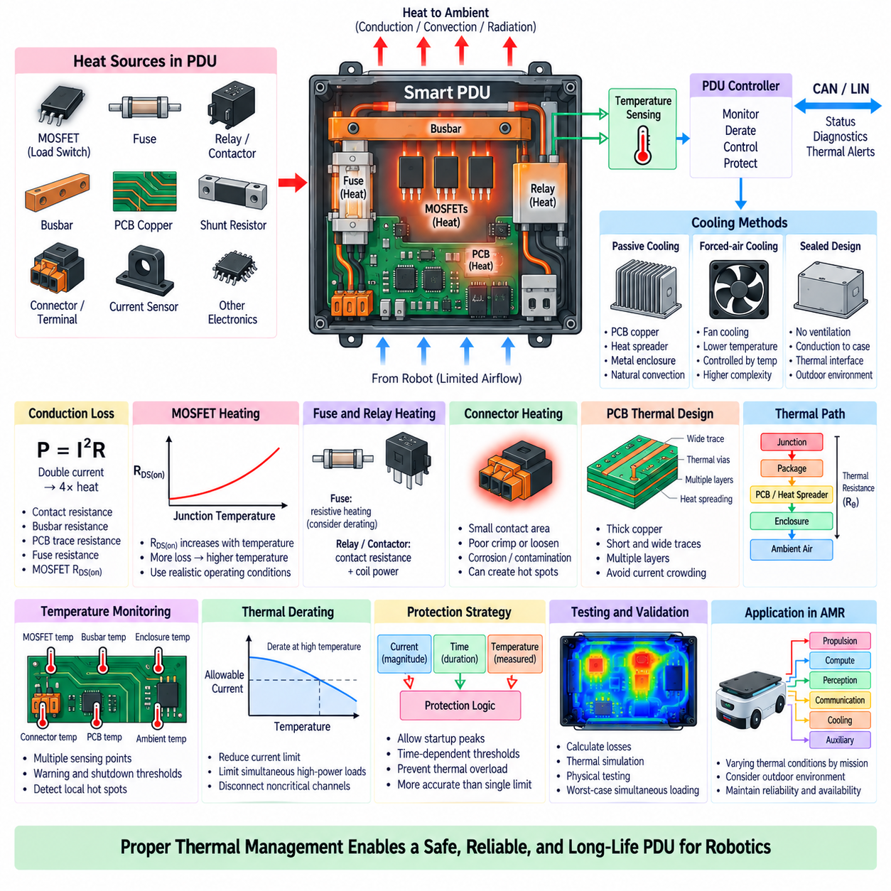
Thermal management in a Power Distribution Unit (PDU) is essential because every current-carrying component generates heat through electrical resistance. Busbars, PCB copper, fuses, relays, contactors, MOSFETs, shunt resistors, connectors, and terminals all contribute to internal temperature rise. As robot power demand increases, thermal performance becomes directly related to current capacity, protection accuracy, component lifetime, and overall electrical reliability.
The fundamental heat source in a PDU is conduction loss, which can be approximated by P = I²R. Because power dissipation increases with the square of current, doubling branch current produces approximately four times the resistive heating for the same resistance. Very small resistances therefore become significant in high-current paths. Contact resistance, busbar resistance, PCB trace resistance, fuse resistance, and MOSFET RDS(on) must all be included in thermal evaluation.
MOSFET-based load switches require particular attention because their on-state resistance changes with junction temperature. As a MOSFET becomes hotter, RDS(on) generally increases, producing additional conduction loss and further temperature rise. This electrothermal interaction means that room-temperature resistance alone is insufficient for design. Loss calculations should use realistic operating current and resistance values corresponding to the expected junction temperature rather than only nominal datasheet conditions.
Fuses also generate heat during normal operation because the fuse element has finite electrical resistance. A fuse operating continuously near its nominal rating may become substantially warmer than the surrounding environment, particularly inside a sealed PDU. Ambient temperature affects fuse behavior and available current capacity, so fuse derating and thermal interaction with neighboring components must be considered. Closely packed high-current fuses can mutually increase their local operating temperatures.
Relays and contactors produce heat through both contact resistance and coil power. High-current contacts may develop significant localized heating, especially if contact resistance increases through aging, contamination, oxidation, or mechanical degradation. Coil heating adds another thermal source whenever the device remains energized. Placement should therefore prevent relay or contactor heat from excessively warming temperature-sensitive electronics, current sensors, communication transceivers, or neighboring protection devices.
Connectors and terminals are critical thermal locations because relatively small contact areas carry the entire branch current. Poor crimping, insufficient terminal engagement, contamination, corrosion, loosening, or connector wear can increase contact resistance and create localized hot spots. Since P = I²R, even a modest resistance increase can generate substantial heat at high current. Thermal design should therefore include connector interfaces rather than treating only PCB and semiconductor losses.
Busbars are commonly used in high-current PDUs because their large conductive cross-section provides low resistance and good thermal spreading. Material, thickness, width, length, plating, joint design, and connection pressure influence both electrical and thermal performance. Although increasing conductor area reduces resistive loss, packaging and mass constraints limit practical dimensions. Busbars can also transfer heat toward the enclosure, making mechanical attachment part of the overall thermal path.
PCB-based PDUs depend strongly on copper thickness, trace width, layer arrangement, thermal vias, and current distribution. High-current traces should minimize unnecessary length and constrictions that increase resistance and local current density. Multiple copper layers can be connected in parallel where appropriate, while thermal vias can transfer heat between layers or toward a heat-spreading structure. Current crowding around pads, vias, and narrow transitions should be evaluated because these regions may become local hot spots.
The thermal path from a semiconductor junction to ambient air can be represented using a thermal-resistance network. Heat flows from the junction through the package, PCB or heat spreader, enclosure, and finally into the surrounding environment. The approximate temperature rise can be related to dissipated power and total thermal resistance. Reducing any major thermal resistance along this path improves the ability of the PDU to maintain acceptable component temperatures.
Passive cooling is generally preferred when PDU losses are moderate because it improves simplicity and reliability. Heat can be conducted through PCB copper, thermal interface materials, heat spreaders, metal mounting plates, or the PDU enclosure. Natural convection and radiation then transfer energy to the surrounding environment. A metal enclosure can function as both mechanical protection and a heat sink when power devices are thermally coupled to it through an appropriate insulated thermal path.
Forced-air cooling may be required for high-power electronic PDUs, particularly when multiple MOSFET channels, converters, or other heat-generating electronics are concentrated in a compact enclosure. Fans can significantly reduce thermal resistance but introduce moving components, acoustic noise, power consumption, contamination paths, and additional failure modes. Fan operation can therefore be controlled according to measured temperature rather than running continuously at maximum speed.
Sealed PDUs present a more difficult thermal problem because environmental protection restricts airflow. Outdoor AMRs may require resistance to water, dust, mud, and other contaminants, making ventilation undesirable. In these systems, heat must primarily leave through conduction from internal components to the enclosure and from the enclosure to ambient air or the robot chassis. Thermal interface materials and mechanically controlled contact pressure become important parts of the heat-transfer design.
Component placement strongly influences temperature distribution. High-loss devices should not be clustered unnecessarily, and heat-sensitive components should be separated from major heat sources. MOSFETs, shunts, fuses, relays, contactors, and high-current connectors should be positioned with adequate thermal spreading and measurement access. Temperature sensors should be placed near expected hot spots rather than only where PCB layout is convenient, because average board temperature may not represent the most stressed component.
Temperature monitoring enables the Smart PDU to respond dynamically to thermal conditions. Sensors may monitor MOSFET regions, busbars, fuse banks, connectors, PCB hot spots, or enclosure temperature. The controller can compare these measurements with warning and shutdown thresholds. Multiple sensing locations are useful in larger PDUs because a single enclosure temperature sensor may fail to detect localized heating caused by a degraded connection or overloaded channel.
Thermal derating reduces allowable electrical load as temperature rises. A channel capable of carrying a specified current at moderate ambient temperature may require a lower current limit in a hot enclosure or outdoor environment. Smart PDUs can implement dynamic derating by reducing permitted current, restricting simultaneous high-power loads, or disconnecting noncritical channels. This approach allows thermal capability to be treated as an actively managed system resource rather than a fixed limit.
Protection thresholds should account for thermal behavior because electrical and thermal limits are closely related. A moderate overload may be electrically tolerable for a short period but thermally unacceptable if sustained. Conversely, a short startup peak may generate little total thermal energy. Combining current magnitude, duration, and measured temperature enables more accurate protection decisions than using a single instantaneous current threshold for all operating conditions.
Thermal simulation and physical testing are complementary parts of PDU development. Early calculations can estimate conduction losses and identify major heat sources, while detailed simulation can evaluate temperature distribution and heat-transfer paths. Prototype testing should then measure actual temperatures under representative current loads, ambient temperatures, enclosure configurations, and operating modes. Particular attention should be given to worst-case simultaneous loading rather than only individual channel tests.
For an autonomous mobile robot (AMR), PDU thermal conditions vary significantly with mission state. Propulsion, computing, perception, communication, cooling, and auxiliary loads may operate simultaneously during autonomous driving, while charging or standby creates different heat distributions. Outdoor ambient temperature, solar heating, enclosure location, and reduced airflow can further change thermal margins. Thermal design should therefore consider complete robot operating scenarios rather than a single laboratory condition.
A robust PDU thermal-management strategy integrates electrical loss reduction, conductor sizing, component placement, heat spreading, enclosure design, temperature sensing, current monitoring, and dynamic derating. Thermal management is not an isolated mechanical task but part of protection coordination and electrical architecture. Proper control of temperature enables the PDU to deliver required current safely while maintaining semiconductor reliability, connector integrity, protection performance, and long-term robot availability.

