Volume 04. Fuse, Relay, and Power Distribution Unit

Chapter 01. Fuse Theory

01.01. I²t Characteristic
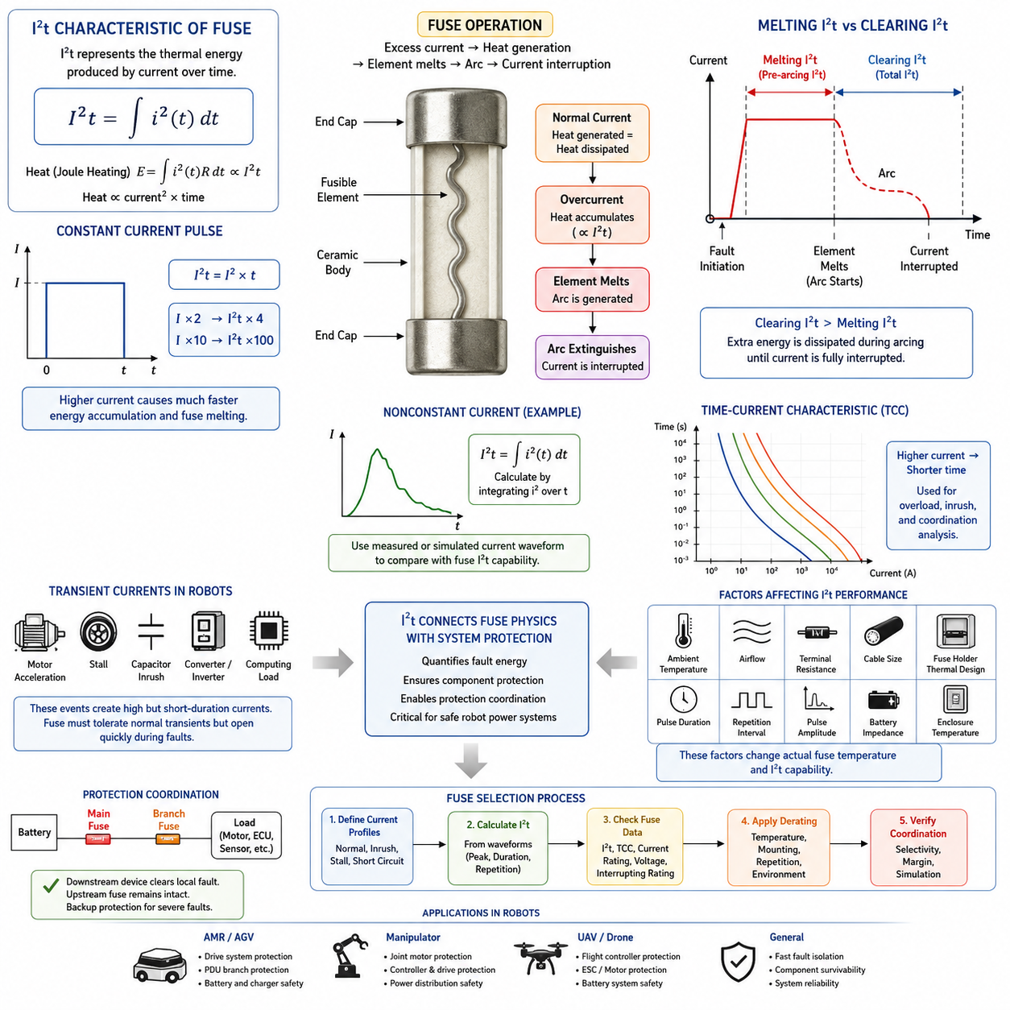
The I²t characteristic describes the thermal energy imposed on a fuse by an overcurrent and is one of the fundamental parameters used to understand fuse operation. The term represents the integral of current squared over time, expressed mathematically as I²t = ∫i²(t)dt. Because resistive heating is proportional to the square of current, even a relatively short high-current pulse can generate substantial thermal energy within the fuse element.
A fuse protects an electrical circuit by converting excessive electrical current into heat within a deliberately designed fusible element. Under normal operating conditions, the generated heat is balanced by heat dissipation into the fuse body, terminals, wiring, and surrounding environment. When current becomes sufficiently high, heat accumulates faster than it can be dissipated, causing the element temperature to rise toward its melting point and eventually interrupt the circuit.
The physical basis of I²t can be related to Joule heating. For a resistance R carrying current i(t), the generated thermal energy is approximately E = ∫i²(t)Rdt. If the fuse resistance is treated as approximately constant over a short interval, the energy is proportional to I²t. Actual fuse resistance changes significantly as the element heats, however, so I²t should be regarded as a practical protection parameter rather than a complete thermodynamic model of the fuse.
For a constant current pulse, the relationship simplifies to I²t = I² × t. This immediately illustrates why current magnitude has such a strong effect on fuse behavior. Doubling the current produces four times the I²t accumulation during the same interval, while increasing the current by a factor of ten produces one hundred times the accumulation. Consequently, severe short circuits can melt fuse elements extremely rapidly even though their duration is only milliseconds.
Fuse specifications commonly distinguish between melting I²t and clearing I²t. Melting I²t, sometimes called pre-arcing I²t, represents the current-squared-time integral accumulated from the beginning of the fault until the fuse element melts and an arc begins to form. Clearing I²t represents the total integral from fault initiation until current has been completely interrupted. The difference reflects the additional energy transferred during the arcing and interruption process.
This distinction is important because melting of the element does not mean that current immediately becomes zero. After the conductive element separates, an electrical arc may persist across the opening gap, particularly in high-current or high-voltage circuits. The fuse must extinguish this arc before interruption is complete. Therefore, total clearing I²t is normally greater than melting I²t, and both values may be relevant when evaluating the thermal stress imposed on protected components.
The I²t rating must be interpreted together with the fuse time-current characteristic rather than as an isolated number. A time-current curve indicates how rapidly a fuse operates at different multiples of rated current, whereas I²t provides an energy-oriented representation of the fault event. The time-current curve is particularly useful for overload behavior, while I²t becomes especially valuable when analyzing short-duration surges, semiconductor protection, short circuits, and coordination between protective devices.
A correctly selected fuse must tolerate legitimate transient currents without unnecessary operation. Motors, DC/DC converters, capacitive loads, inverters, computing systems, and actuator drives can produce temporary currents substantially higher than their normal steady-state values. If the transient I²t approaches or exceeds the fuse's allowable pulse capability, repeated startup events may weaken the element or cause nuisance opening even though the steady operating current remains within the nominal fuse rating.
This consideration is particularly important in robotic power systems because motor drives can experience acceleration peaks, wheel stall events, regenerative transitions, and rapid torque changes. At the same time, DC-link capacitors and electronic loads may create significant inrush current when the system is energized. Fuse selection therefore requires evaluation of the actual current waveform rather than simply comparing the fuse ampere rating with the average current consumed by the robot.
For a nonconstant transient waveform, I²t should be determined by integrating the squared instantaneous current. In engineering calculations, measured current samples can be approximated numerically by summing i²Δt over sufficiently small time intervals. This allows startup measurements, motor-current logs, or simulated fault waveforms to be converted into an energy-related quantity that can be compared with appropriate manufacturer fuse data under the specified operating conditions.
Repeated pulses require additional consideration because the fuse may not return completely to its initial thermal state between events. A single pulse below the relevant I²t limit does not automatically guarantee unlimited repetitive operation. Pulse amplitude, pulse duration, repetition interval, ambient temperature, airflow, terminal resistance, conductor size, and fuse-holder thermal behavior influence the actual element temperature. Repetitive-duty applications therefore require suitable thermal and pulse derating.
Ambient temperature also changes the practical relationship between current and fuse operation. A fuse operating in a hot enclosure begins closer to the thermal condition required for melting, while a fuse in a cooler environment may dissipate heat more effectively. Power distribution units installed near batteries, motor controllers, converters, or enclosed electronics can experience temperatures substantially different from room-temperature laboratory conditions, making manufacturer temperature-derating information essential.
I²t is also useful for protection coordination. An upstream fuse should normally remain intact when a downstream protective device can safely isolate a local fault, while still providing backup protection for more severe conditions. Comparing time-current behavior and applicable I²t characteristics helps engineers determine whether protection layers are sufficiently selective. This becomes increasingly important in PDUs containing separate branches for traction, computing, sensing, communication, and auxiliary equipment.
Protection of semiconductor devices presents an especially demanding I²t application because power semiconductors can tolerate extreme overcurrent for only a very short period. MOSFETs, IGBTs, rectifiers, and related devices may suffer junction or interconnect damage before a conventional fuse clears the fault. The protective-device clearing behavior must therefore be compared with the semiconductor's permitted transient stress, while recognizing that semiconductor limits may be specified using parameters other than fuse I²t alone.
In battery-powered robots, prospective short-circuit current can be very high because lithium battery packs have relatively low internal impedance. The resulting current depends on battery impedance, busbars, cables, connectors, contactors, and fault location. A fuse must not only respond with appropriate I²t behavior but must also possess adequate voltage and interrupting capability. A fuse that melts quickly but cannot safely extinguish the resulting arc does not provide adequate protection.
The I²t concept consequently connects fuse physics with system-level electrical engineering. It provides a common framework for examining fault energy, transient survivability, component protection, and coordination, but it does not replace detailed fuse selection. Rated current, voltage rating, interrupting rating, time-current behavior, ambient-temperature derating, installation conditions, aging, mechanical environment, and manufacturer-specific characteristics must all be evaluated together.
For an AMR or other Physical AI platform, this means that fuse engineering should begin with realistic electrical operating profiles. Normal current, acceleration current, motor stall current, capacitor charging current, regenerative behavior, repetitive mission cycles, and credible short-circuit currents should be characterized. Their magnitude and duration can then be related to fuse time-current and I²t data to establish sufficient operating margin while maintaining rapid isolation of dangerous faults.
Ultimately, the I²t characteristic expresses a simple but powerful protection principle: electrical damage depends not only on how much current flows, but also on how long that current persists. Squaring the current emphasizes the destructive influence of severe overcurrent, while integration over time captures its duration. Understanding this relationship provides the foundation for the subsequent analysis of fuse melting, clearing time, fuse selection, derating, and coordinated robot power protection.

01.02. Melting and Clearing Time
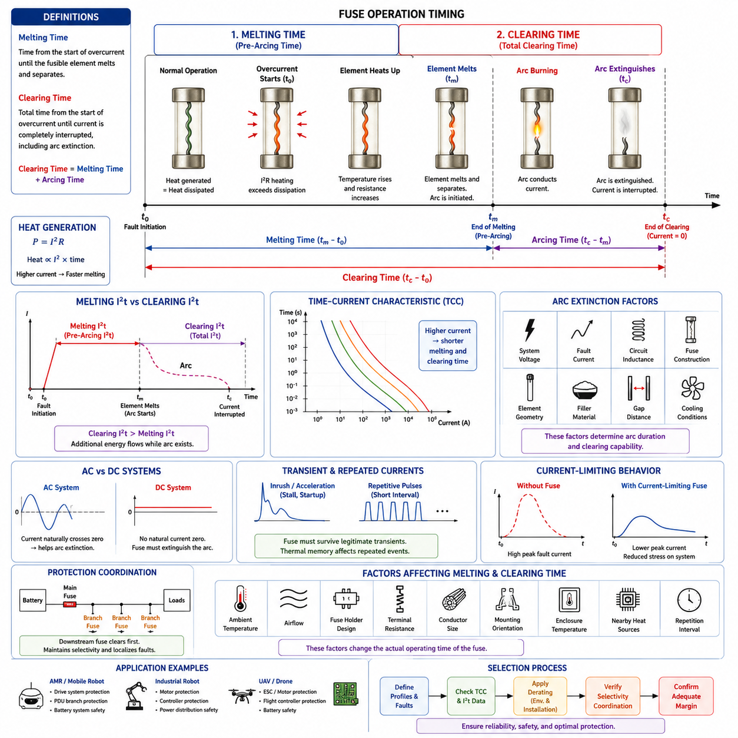
Melting time and clearing time describe two successive stages of fuse operation during an overcurrent or short-circuit event. Melting time is the interval from the initiation of excessive current until the fusible element physically melts and separates. Clearing time extends beyond this point and represents the total interval required for the fuse to interrupt current completely, including the additional period needed to extinguish the electrical arc.
When excessive current flows through a fuse element, electrical resistance produces Joule heating according to the approximate relationship P = I²R. Under normal current, this heat is transferred into the fuse body, terminals, conductors, and surrounding environment without reaching the melting temperature. During an overload, heat generation exceeds heat dissipation, causing the element temperature to increase progressively until its material reaches the condition required for melting.
The melting process is therefore not triggered at one universal current value. Its timing depends strongly on the magnitude and duration of the applied current. A moderate overload may require seconds or even longer to produce sufficient thermal accumulation, while a severe short circuit can generate enough energy to melt the element within milliseconds. This inverse relationship between fault-current magnitude and operating time forms the physical basis of the fuse time-current characteristic.
Melting time is also called pre-arcing time because it ends at approximately the point where the fuse element separates and an electrical arc begins to develop. During this period, current continues to flow through the metallic element while its temperature and resistance increase. The accumulated energy up to this transition can be characterized by melting I²t, or pre-arcing I²t, which links the melting process directly to the thermal-energy concept used in fuse engineering.
Physical separation of the fusible element does not immediately guarantee interruption of the circuit. As the element melts and separates, the voltage across the newly formed gap can sustain ionized material and produce an electrical arc. This arc remains electrically conductive and allows current to continue flowing temporarily even though the original metallic current path has been broken. The fuse must therefore perform an additional arc-extinction process before the fault is fully cleared.
Clearing time, sometimes called total clearing time, includes both the melting time and the subsequent arcing time. It can therefore be expressed conceptually as total clearing time = melting time + arcing time. The corresponding total clearing I²t includes energy accumulated during both stages. Consequently, clearing I²t is normally greater than melting I²t because additional fault energy passes through the circuit while the arc exists.
Arc duration depends on several electrical and physical conditions. System voltage, available fault current, circuit inductance, fuse construction, element geometry, filler material, and the distance created between melting sections all influence how quickly the arc can be extinguished. In high-energy fuses, materials such as silica-based fillers may absorb heat and assist arc quenching, enabling the fuse to interrupt large prospective short-circuit currents safely.
Direct-current systems require particular attention because DC current has no natural periodic zero crossing. In an AC circuit, current passes through zero during every electrical cycle, which can assist arc extinction. In a DC battery system, however, the fuse itself must create conditions that force the arc to extinguish. This makes adequate DC voltage rating, fuse geometry, arc-quenching capability, and interrupting rating particularly important for battery-powered robots and mobile platforms.
The difference between melting and clearing becomes especially significant when protecting sensitive electronic components. A semiconductor may survive until the fuse element melts but still be damaged by the energy delivered during the subsequent arcing interval. Protection assessment must therefore consider the complete clearing behavior rather than assuming that protection is achieved at the instant of element melting. Total clearing time and clearing I²t are often the more relevant quantities for evaluating downstream component stress.
Time-current characteristic curves provide a practical way to visualize fuse operating behavior. These curves normally plot current, often expressed as amperes or multiples of rated current, against operating time using logarithmic scales. At relatively small overloads, fuse operation may take a long time, whereas increasing fault current rapidly decreases melting and clearing times. The characteristic is generally represented as a band because manufacturing tolerances and thermal conditions produce a range rather than one exact operating point.
This operating band is important when coordinating a fuse with normal transient loads. Electric motors can draw high acceleration or stall currents, while DC-link capacitors, converters, computers, and motor controllers may generate substantial inrush current during startup. The fuse must remain intact through legitimate short-duration events while still clearing abnormal sustained overloads and short circuits rapidly enough to protect wiring, connectors, power electronics, and other components.
Fuse response is influenced by the thermal state that exists before the fault occurs. A fuse carrying significant continuous current is already warmer than an unloaded fuse and therefore requires less additional energy to reach its melting condition. Ambient temperature, airflow, fuse-holder construction, terminal resistance, conductor cross-section, mounting orientation, enclosure temperature, and neighboring heat-producing components can consequently alter the actual melting time observed in a real installation.
Repeated transient currents introduce another important effect. If successive pulses occur before the fuse element has cooled completely, residual heat from earlier events changes the starting condition for the next pulse. The resulting melting behavior may differ considerably from that predicted by treating every pulse independently. Robot applications with repetitive acceleration, braking, lifting, steering, or actuator cycles therefore require consideration of thermal recovery and repetitive pulse capability.
Prospective fault current must also be distinguished from the current actually allowed to pass during fuse operation. A high-performance current-limiting fuse can begin melting and develop arc voltage rapidly enough to restrict the peak fault current below the value that the unfused circuit would otherwise reach. This behavior can reduce thermal and electrodynamic stress on busbars, cables, connectors, contactors, semiconductor devices, and battery interconnections during severe short circuits.
Protection coordination depends heavily on differences in melting and clearing behavior between protective devices. For a fault occurring on a downstream branch, the branch fuse should ideally clear the fault before the upstream main fuse reaches its operating condition. Achieving this selectivity requires comparison of time-current curves and, for high-current faults, relevant I²t characteristics so that interruption remains localized without unnecessarily shutting down the complete electrical system.
In an AMR power distribution architecture, for example, a main battery fuse may protect the overall power bus while individual branch fuses protect traction drives, steering actuators, computing equipment, sensors, communication devices, and auxiliary loads. A traction-drive fault should preferably be cleared by its local branch protection before the main battery fuse operates, provided that the resulting fault energy remains within the safe limits of the branch conductors and components.
Motor circuits present a particularly challenging selection problem because normal and abnormal current profiles can overlap. High torque demand can produce temporary current peaks that resemble an overload, while a locked rotor or mechanical stall may produce sustained high current requiring interruption. Fuse melting and clearing characteristics must therefore be coordinated with motor-controller protection, current limiting, thermal models, and wiring capability rather than being selected solely from the motor's nominal current.
Battery short circuits represent the opposite extreme, where extremely large current can develop rapidly because battery packs and distribution conductors may have very low impedance. Under these conditions, the fuse must melt quickly, control the resulting arc, and completely interrupt the fault without rupture or restrike. The required fuse must therefore combine suitable melting behavior with adequate total clearing performance, voltage rating, and interrupting capacity for the maximum credible fault condition.
Engineering evaluation of melting and clearing time should consequently begin with realistic current profiles and fault scenarios. Normal continuous current, startup inrush, acceleration peaks, repetitive pulses, overload conditions, stall current, and prospective short-circuit current should be compared with manufacturer time-current curves and I²t data. Environmental and installation derating must then be applied before confirming that both nuisance-operation margin and protection performance are adequate.
Melting time and clearing time ultimately describe different boundaries in one continuous interruption process. Melting time identifies when the fusible element loses its metallic conduction path, while clearing time identifies when electrical current has actually ceased. Understanding the interval between these events is essential because a fuse is not merely a component that melts; it is an engineered interruption device that must safely absorb, control, and extinguish fault energy before the protected circuit can be considered electrically isolated.

01.03. Fuse Selection Principles
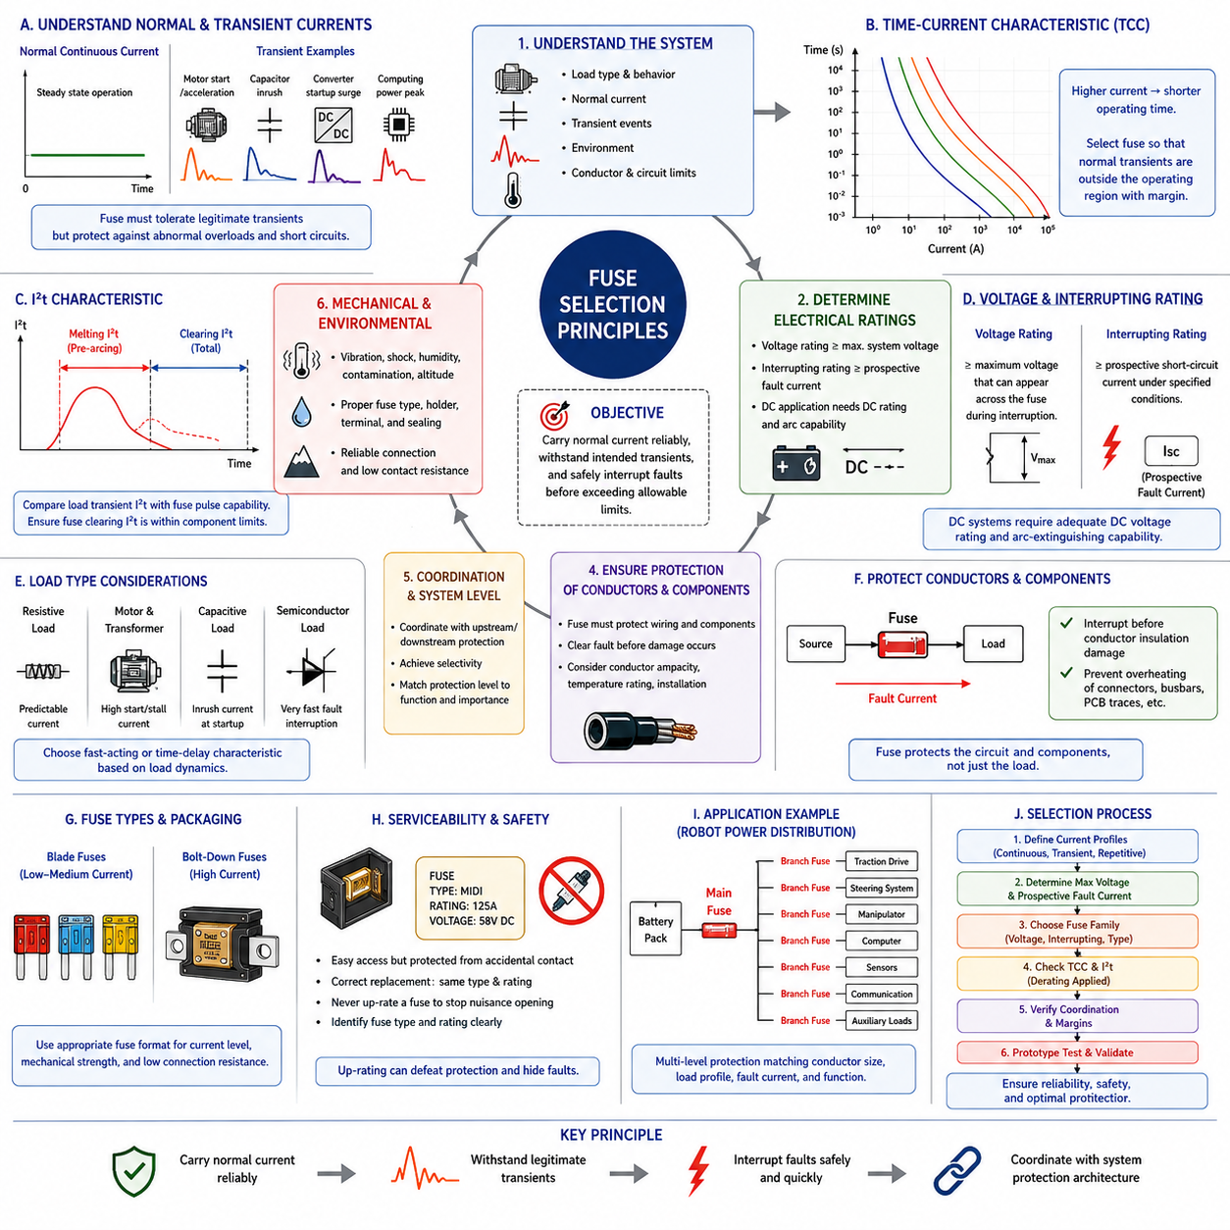
Fuse selection is a system-level protection decision rather than a simple comparison between load current and fuse current rating. A properly selected fuse must carry normal operating current reliably, tolerate legitimate transient events, and interrupt abnormal current before wiring or protected components exceed their safe limits. The selection process therefore combines electrical ratings, thermal behavior, fault conditions, load characteristics, and installation environment.
The first consideration is the normal continuous current of the protected circuit. The fuse rated current should provide sufficient margin above the expected steady-state load so that ordinary operation does not cause excessive heating or nuisance opening. However, simply selecting the next rating above the measured load current is insufficient because fuse current ratings are defined under specified test conditions that may differ substantially from the actual operating environment.
Continuous-current margin must account for fuse derating and the thermal characteristics of the installation. Ambient temperature, enclosure temperature, airflow, fuse-holder resistance, conductor size, terminal quality, neighboring heat sources, and mounting arrangement can alter fuse temperature. A fuse carrying current safely in laboratory conditions may operate significantly closer to its melting threshold when installed inside a compact PDU near batteries, converters, motor controllers, or other heat-generating devices.
System voltage is another fundamental selection parameter. The fuse voltage rating must be equal to or greater than the maximum voltage that can appear across the fuse during interruption. Voltage rating is primarily related to the fuse's ability to extinguish and contain the arc after its element melts. Using a fuse above its voltage capability can allow sustained arcing, restrike, insulation failure, or destructive rupture even when its current rating appears appropriate.
DC applications require particular attention because direct current does not naturally cross zero as AC current does. Battery-powered robots can therefore sustain an arc after the fuse element separates. A fuse intended for a 48 V, 72 V, or higher-voltage DC architecture must have an appropriate DC voltage rating and arc-extinguishing capability. An AC rating should never automatically be assumed to provide an equivalent safe DC interruption capability.
Interrupting rating, also called breaking capacity, defines the maximum prospective fault current that a fuse can safely interrupt under specified conditions. This parameter is distinct from the fuse's rated current. A 20 A fuse, for example, may normally carry approximately that level of current but may need to interrupt a short-circuit current of hundreds or thousands of amperes. The expected fault current must therefore be calculated or measured before the interrupting capability is selected.
Prospective short-circuit current depends on the complete source and distribution impedance. In a battery system, important contributors include battery internal resistance, cell and module interconnections, busbars, cables, connectors, contactors, PDU conductors, and fault location. High-capacity lithium battery packs can produce extremely large short-circuit currents, making adequate breaking capacity essential for AMRs, mobile manipulators, UAV power systems, and other battery-powered robotic platforms.
The load's transient current profile must also be characterized before selecting the fuse. Motors may draw large acceleration or stall currents, capacitors can generate charging inrush, converters may exhibit startup surges, and computing systems can produce short power-demand peaks. These events can exceed normal continuous current without representing faults. The fuse must tolerate legitimate transients while still responding rapidly enough to abnormal sustained overloads and short circuits.
Time-current characteristic curves are therefore central to fuse selection. They show how operating time changes as current increases above the fuse rating. A small overload may be tolerated for a relatively long period, while a severe fault produces rapid operation. The expected load-current waveform should be compared with the fuse characteristic so that startup, acceleration, and normal peak events remain outside the unwanted operating region with sufficient engineering margin.
I²t characteristics provide another important selection criterion, particularly for short-duration high-current events. The load transient I²t can be estimated from the current waveform and compared with appropriate fuse pulse capability, while the fuse melting and clearing I²t can be evaluated against the withstand capability of protected components. This energy-based comparison is especially useful for power semiconductors, motor drives, battery circuits, and other components sensitive to short fault-energy pulses.
The fuse must primarily protect the conductor and circuit rather than merely match the nominal rating of the connected load. During an overload or short circuit, the fuse should interrupt current before cable insulation, connector contacts, busbars, PCB traces, or other current-carrying structures reach damaging thermal conditions. Conductor ampacity, temperature rating, cross-sectional area, installation method, and allowable short-circuit energy must therefore be considered together with fuse behavior.
Load type strongly influences the appropriate fuse characteristic. Resistive loads generally have relatively predictable current behavior, while motors and transformers can require significant startup tolerance. Capacitive electronic loads may produce sharp inrush pulses, and semiconductor circuits may require extremely rapid fault interruption. Consequently, fast-acting and time-delay fuse characteristics serve different purposes, and selection must reflect the actual electrical dynamics of the protected branch.
Protection coordination becomes necessary when several fuses or protective devices are connected hierarchically. A fault in a downstream branch should ideally operate the local protective device while leaving the upstream main protection intact. Achieving this selectivity requires comparison of time-current curves and, where relevant, melting and clearing I²t values. Simply choosing a larger upstream ampere rating does not automatically guarantee selective operation under all fault-current conditions.
Mechanical and environmental requirements are also part of fuse selection in robotic systems. Vibration, shock, humidity, contamination, altitude, thermal cycling, and service conditions can influence the reliability of the fuse and its connections. Fuse construction, mounting method, terminal style, holder retention, and environmental sealing should match the application. Mobile robots often experience mechanical conditions that differ substantially from stationary electrical equipment.
Fuse packaging and connection resistance become increasingly important as current rises. Blade fuses may be suitable for many low-to-medium-current branches, while bolt-down fuse formats can provide stronger mechanical retention and lower-resistance connections for high-current battery and traction circuits. The fuse interface must support the required current without excessive terminal heating, because connection losses can change the thermal condition of both the fuse and surrounding distribution hardware.
Serviceability must be balanced against protection integrity. A replaceable fuse should be accessible enough for maintenance while being protected against accidental contact, incorrect replacement, contamination, and mechanical damage. Fuse identification should clearly indicate required type and rating. Replacing a fuse with a higher current rating to prevent repeated operation can defeat conductor protection and conceal an underlying electrical or mechanical fault rather than solving the actual problem.
For robot power distribution, protection is often divided into multiple levels. A main battery fuse protects the primary distribution path, while branch fuses protect traction drives, steering systems, manipulators, computers, sensors, communication devices, lighting, and auxiliary loads. Each protection level should correspond to the conductor size, expected load profile, fault current, and functional importance of its branch while remaining coordinated with upstream protection.
Motor-drive branches deserve special analysis because electronic current limiting and fuse protection perform different functions. A motor controller may detect overcurrent and reduce or disable output rapidly during many operating faults, but it cannot always protect against internal semiconductor failure, cable short circuits, connector faults, or faults upstream of its switching stage. The fuse therefore provides independent hardware protection for fault conditions that electronic control may not safely interrupt.
A robust selection process begins by defining maximum continuous current, normal transient waveforms, repetitive pulses, environmental temperature, and conductor capability. The engineer then determines maximum system voltage and prospective fault current, selects an appropriate fuse family, and compares time-current and I²t characteristics. Voltage rating, interrupting capacity, derating, mechanical requirements, and coordination with adjacent protection devices are then verified before final approval.
Prototype and system testing should confirm assumptions used during design. Actual startup current, motor acceleration, stall behavior, capacitor inrush, repetitive mission cycles, fuse-terminal temperature, and worst-case enclosure temperature can differ from analytical estimates. Testing under representative operating conditions helps reveal nuisance-opening risks, excessive thermal margin consumption, unexpected current peaks, or inadequate coordination before the protection architecture is released for production.
Ultimately, correct fuse selection establishes a controlled boundary between normal electrical stress and dangerous fault energy. The objective is neither to choose the smallest fuse that survives operation nor the largest fuse that avoids nuisance opening. The appropriate fuse is the device that reliably carries legitimate current, withstands intended transients, and safely interrupts faults before the protected conductors and components exceed their allowable electrical and thermal limits.

01.04. Fuse Derating by Temperature
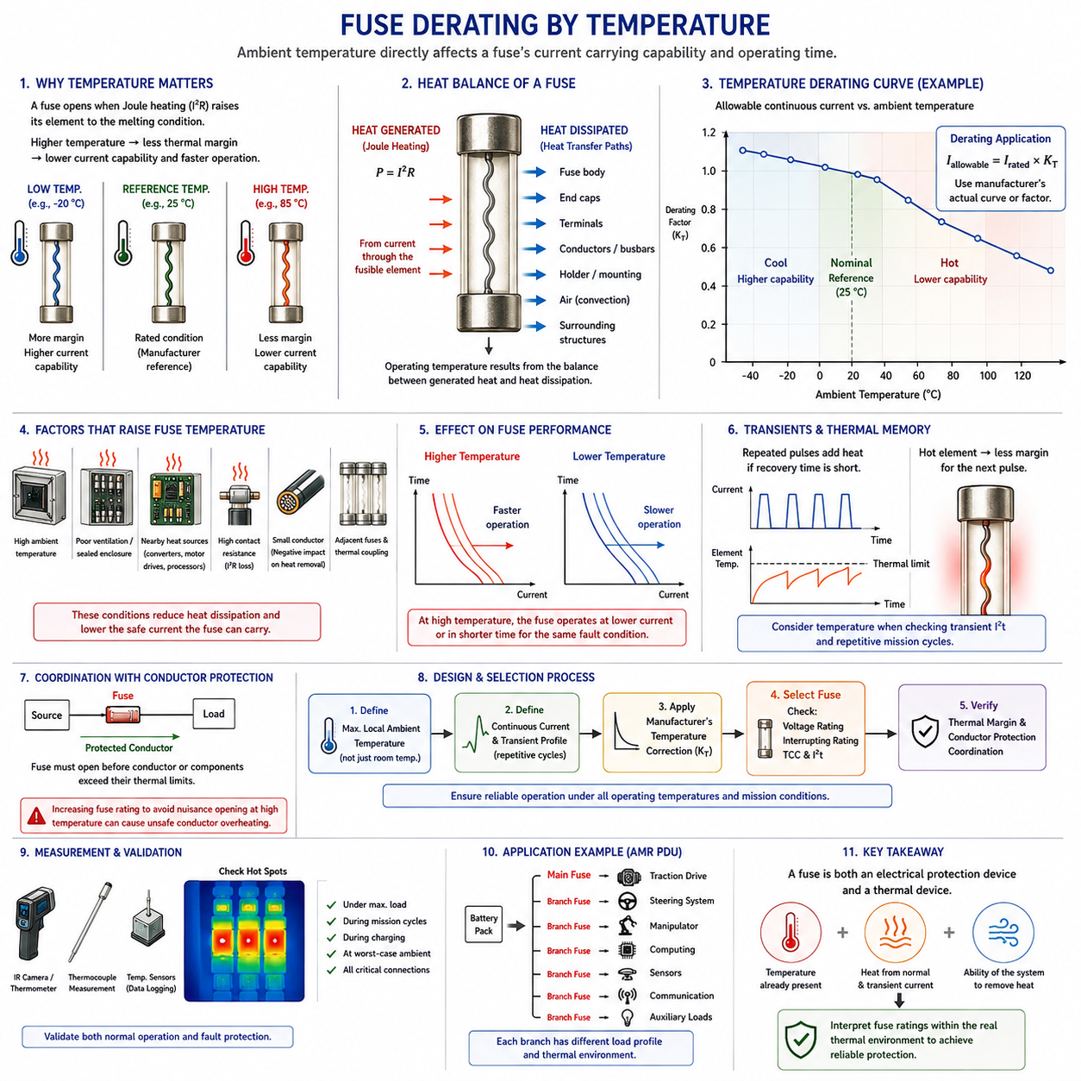
Temperature derating is the adjustment of a fuse’s usable current capability according to the thermal environment in which it operates. A fuse is fundamentally a temperature-sensitive protection device because its element opens when electrical heating raises the material to its melting condition. Consequently, the same fuse carrying the same current can behave differently at low, nominal, and elevated ambient temperatures.
Fuse current ratings are established under defined reference conditions specified by the manufacturer or applicable standard. These conditions normally represent a controlled thermal environment and cannot automatically represent every installation. When a fuse is installed inside a sealed PDU, battery enclosure, motor-controller compartment, or densely populated electrical cabinet, its actual surrounding temperature may be substantially higher than the reference temperature used for rating.
The thermal condition of a fuse results from both ambient temperature and internally generated heat. Current flowing through the fusible element produces Joule heating approximately proportional to I²R. At thermal equilibrium, this generated heat is balanced by heat transferred through the fuse body, terminals, conductors, holder, surrounding air, and nearby structures. Any condition that reduces heat dissipation increases the operating temperature of the element.
At elevated ambient temperature, the fuse element begins operation closer to its melting temperature. Less additional electrical energy is therefore required to reach the melting condition, meaning that the fuse may operate at a lower current or in a shorter time than it would under cooler reference conditions. Temperature derating compensates for this reduced thermal margin by lowering the continuous current that the fuse is expected to carry reliably.
At lower ambient temperatures, the opposite tendency can occur because the fuse can dissipate heat more effectively and begins farther from its melting condition. Its apparent current-carrying capability may therefore increase. This does not mean that engineers should arbitrarily increase fuse size or loading at low temperature, because conductor capability, protected-component limits, transient behavior, manufacturer specifications, and fault-protection requirements still define the permissible operating range.
A practical temperature derating method uses manufacturer-provided correction curves or factors. If a fuse has a nominal current rating I_rated and the applicable temperature correction factor is K_T, the allowable current may be represented conceptually as I_allowable = I_rated × K_T. The actual factor depends on fuse construction, material, package, mounting arrangement, and manufacturer data rather than on one universal derating percentage.
The distinction between ambient temperature and local fuse temperature is particularly important. Ambient temperature measured outside an enclosure may not represent the thermal environment experienced by the fuse. Internal heat from contactors, relays, DC/DC converters, motor drives, busbars, processors, or neighboring fuses can create localized hot regions. Fuse selection should therefore use a realistic local temperature near the installed protective device.
Fuse-holder and terminal resistance can significantly influence thermal behavior. Even a small additional contact resistance generates I²R losses at high current, producing heat directly near the fuse terminals. Loose fasteners, oxidized contacts, insufficient contact pressure, poor crimping, undersized terminals, or degraded holders can therefore raise local temperature and effectively reduce the fuse's current-carrying margin even when ambient temperature remains acceptable.
Conductor size also affects fuse temperature because connected wires or busbars provide important thermal paths. Large conductors can remove heat from the fuse terminals more effectively, while smaller conductors may operate at higher temperatures and transfer additional heat toward the fuse. Manufacturer test conditions may specify conductor sizes for this reason, and using substantially different wiring can change the thermal behavior observed in the actual application.
Enclosure design introduces another layer of thermal interaction. A sealed enclosure provides environmental protection but may restrict natural convection, while compact packaging can place several heat-producing devices close together. Solar loading, battery heating, motor-controller losses, and limited airflow can further increase internal temperature. The resulting worst-case thermal condition should be considered when determining the fuse rating and required derating margin.
Robotic systems experience dynamic thermal environments that can differ significantly from stationary electrical installations. An AMR may begin operation in a cool charging area and later operate outdoors under high solar exposure, while traction motors and power electronics progressively warm the electrical compartment. A fuse that has sufficient margin during startup may therefore experience a substantially different thermal condition after several hours of continuous mission operation.
Temperature also interacts with transient current capability. A motor acceleration pulse or capacitor inrush that is safely tolerated when the fuse is cool may consume a larger portion of the available thermal margin when the element is already hot. Repeated current pulses can further accumulate heat if the interval between events is too short for complete thermal recovery. Temperature derating and transient I²t evaluation should therefore not be treated as independent design activities.
This interaction is particularly relevant for traction and actuator circuits. Repeated acceleration, steering corrections, lifting operations, braking events, or wheel-stall conditions can produce recurring current peaks. The fuse must tolerate these legitimate events across the full expected temperature range without nuisance opening, while still providing sufficiently rapid protection during a genuine overload or short circuit. Mission-cycle thermal behavior should therefore be included in fuse verification.
Temperature derating must also remain coordinated with conductor protection. Increasing the fuse rating to avoid nuisance opening at high temperature can create an unsafe condition if the resulting protection level exceeds the thermal capability of cables, connectors, busbars, PCB traces, or other components. The correct solution is to evaluate the complete thermal and electrical architecture rather than compensating for an overheated fuse simply by selecting a larger current rating.
Multiple fuses installed close together can influence one another through thermal coupling. A heavily loaded branch may warm adjacent fuse positions, causing their local temperature to rise even when those branches carry moderate current. Smart PDUs and high-density distribution modules should therefore consider spacing, copper distribution, airflow, enclosure conduction, and simultaneous loading when establishing allowable branch currents and selecting fuse ratings.
Altitude and airflow may further influence heat dissipation in applications where environmental conditions vary widely. Reduced convective cooling can increase component temperature, while forced airflow can improve heat removal if it is reliable throughout operation. Because fuse thermal behavior depends on its installation, environmental qualification should represent the actual operating configuration rather than relying only on component-level data obtained under ideal laboratory conditions.
A useful design process begins by defining the maximum expected local ambient temperature rather than only the nominal room temperature. The continuous branch current and repetitive transient profile are then established, after which the appropriate manufacturer temperature correction data are applied. The selected fuse should retain adequate operating margin while satisfying voltage rating, interrupting rating, time-current behavior, I²t capability, and conductor-protection requirements.
Thermal simulation and measurement can improve confidence in high-current or densely packaged designs. Temperature sensors, thermocouples, infrared measurements, or thermal models can identify hot spots around fuse terminals, holders, busbars, and neighboring power devices. Measurements should be performed under representative continuous load, repetitive mission cycles, charging conditions, and worst-case enclosure temperatures rather than only during short bench tests.
Prototype validation should examine both normal operation and protection performance. Engineers should confirm that fuse temperature stabilizes within an acceptable range during maximum legitimate loading and that expected transients do not cause nuisance operation. At the same time, the selected fuse must still interrupt credible overload and short-circuit conditions before protected conductors and components exceed their allowable thermal or electrical limits.
For an AMR PDU, temperature-aware fuse engineering can be applied separately to the main battery path and branches supplying traction drives, steering, computing, sensors, communication, and auxiliary equipment. Each branch can have a different load profile and local thermal environment. A fuse positioned near a high-power motor controller may therefore require different thermal consideration from an identically rated fuse supplying electronics in a cooler region.
Temperature derating ultimately recognizes that a fuse is both an electrical protection device and a thermal device. Its operating margin depends on the temperature already present before abnormal current begins, the heat produced by normal and transient current, and the ability of the installation to remove that heat. Reliable protection therefore requires fuse ratings to be interpreted within the real thermal environment rather than treated as fixed current values independent of temperature.

01.05. Fuse Standards (ISO 8820)
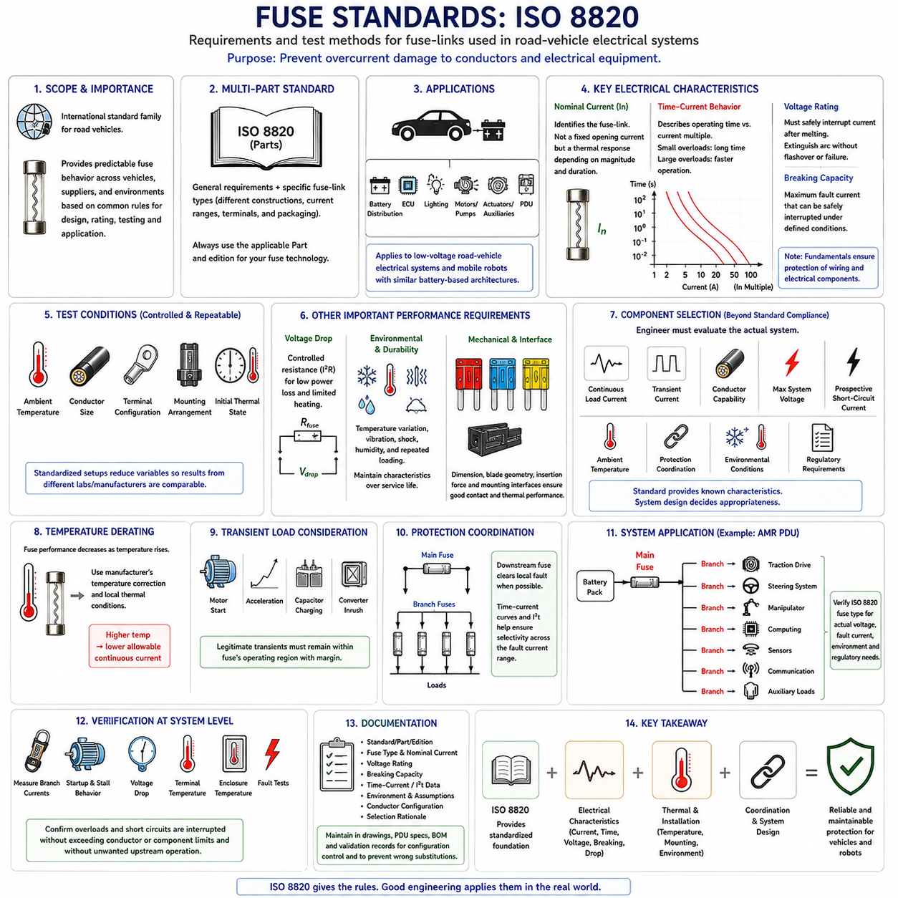
ISO 8820 is a family of international standards that defines requirements and test methods for fuse-links used in road-vehicle electrical systems. Within the structure of fuse engineering, it provides a standardized basis for evaluating protective devices that interrupt excessive current before conductors or electrical equipment experience unacceptable damage. It therefore connects fuse design, rating, testing, and application within automotive electrical architectures.
The importance of ISO 8820 arises from the need for predictable fuse behavior across different vehicles, suppliers, and electrical environments. A fuse identified by a nominal current rating must exhibit controlled electrical and thermal characteristics rather than merely carrying that current under arbitrary conditions. Standardized dimensions, test conditions, operating characteristics, and performance requirements allow engineers to compare compatible fuse technologies using a common technical framework.
ISO 8820 is organized as a multipart standard because road-vehicle fuse applications include different fuse constructions, current ranges, terminal configurations, and packaging concepts. The individual parts address general requirements and particular fuse-link categories. Engineers should therefore identify the applicable part and edition for the fuse technology being used instead of treating ISO 8820 as one universal specification covering every fuse design with identical requirements.
The standard is closely associated with low-voltage road-vehicle electrical systems, where fuses protect wiring and connected equipment against overcurrent conditions. Typical applications include battery distribution, electronic control units, lighting, motors, pumps, actuators, auxiliary systems, and power distribution modules. The same engineering principles are also highly relevant to mobile robots whose battery-based electrical architectures resemble automotive low-voltage power distribution.
Nominal current is one of the fundamental characteristics used to identify a fuse-link, but it should not be interpreted as an exact current at which the fuse immediately opens. A fuse is a thermally operated device whose response depends on current magnitude and duration. Standardized current-time behavior is therefore essential for distinguishing normal current carrying from overload conditions and for establishing predictable protection of wiring and electrical components.
Time-current behavior specifies how a fuse responds when current exceeds its nominal value. At relatively small multiples of rated current, the fuse may remain intact for a significant period, while larger overcurrents must produce progressively faster operation. These requirements establish an operating envelope that allows temporary legitimate loads while ensuring that sufficiently severe overloads cause the fuse element to melt and ultimately interrupt the circuit.
Fuse testing requires controlled reference conditions because temperature strongly influences fuse behavior. Ambient temperature, conductor size, terminal configuration, mounting arrangement, and initial thermal state can affect the time required for the element to melt. Standardized test arrangements reduce these variables so that performance measured by different laboratories or manufacturers can be meaningfully compared. Actual vehicle installation conditions must still be considered separately during application engineering.
Voltage rating is another essential characteristic because a fuse must safely interrupt current after its element melts. The resulting gap can develop an electrical arc, and the fuse construction must extinguish that arc without unsafe flashover, sustained conduction, or structural failure. The specified voltage capability must therefore be appropriate for the electrical system in which the fuse is installed, particularly when applying automotive fuse concepts to higher-energy battery systems.
Breaking capacity, or interrupting capability, addresses the maximum fault current that a fuse can safely interrupt under defined conditions. This requirement is fundamentally different from nominal current. A fuse that normally carries tens of amperes may be exposed to a short-circuit current many times greater. Safe protection therefore requires both correct continuous-current behavior and sufficient capability to contain and interrupt the maximum credible fault energy.
Voltage-drop characteristics are also relevant because every fuse introduces electrical resistance into the protected circuit. Excessive resistance causes power loss and local heating according to I²R, reducing system efficiency and influencing the thermal state of the fuse and its terminals. Controlled voltage-drop performance is especially important in high-current branches where even small additional resistance can generate significant heat and reduce available voltage at the connected load.
Environmental and durability testing supports reliable operation throughout the expected service life of a road vehicle. Automotive electrical components can experience temperature variation, vibration, mechanical shock, humidity, and repeated electrical loading. Fuse-links must maintain their required electrical and mechanical characteristics after appropriate environmental exposure so that normal vehicle operation does not progressively change their protective behavior beyond acceptable limits.
Mechanical dimensions and interface characteristics are important because fuse interchangeability depends on more than electrical rating. Blade geometry, terminal dimensions, body configuration, insertion characteristics, and associated mounting interfaces influence contact quality and thermal performance. Standardized dimensional requirements help prevent incompatible combinations and support repeatable connection behavior when suitable fuse-links are installed in corresponding holders or power distribution assemblies.
Fuse identification is necessary to reduce the risk of incorrect replacement during manufacturing or service. Current rating and other required markings allow technicians to distinguish fuse-links with similar physical dimensions but different electrical characteristics. Depending on the fuse type, visual identification methods can supplement printed or molded markings. Clear identification is particularly important because installing a higher-rated replacement can compromise conductor protection without producing an immediately visible malfunction.
ISO-based fuse selection does not eliminate the need for application-specific engineering. The engineer must still determine continuous load current, transient current, conductor capability, maximum system voltage, prospective short-circuit current, ambient temperature, and required protection coordination. Standard compliance establishes known component characteristics, while system design determines whether those characteristics are appropriate for the particular circuit and operating environment.
Temperature derating remains important even when a fuse satisfies standardized tests. A fuse installed near a motor controller, converter, battery, contactor, or other heat source can operate at a significantly higher temperature than under reference test conditions. The designer must therefore combine standardized fuse characteristics with manufacturer temperature-correction information and measured or simulated local thermal conditions to establish a reliable continuous-current margin.
Transient loads must similarly be evaluated against the standardized and manufacturer-specified operating characteristics. Motor startup, acceleration, solenoid operation, capacitor charging, and converter inrush can temporarily exceed the nominal branch current. These events should remain within the fuse's acceptable operating region with suitable margin, while sustained overloads and short circuits must enter the operating region that causes timely interruption.
Protection coordination extends the application of standardized fuse characteristics to complete power distribution systems. A main fuse and downstream branch fuses should be selected so that a local branch fault is isolated by the appropriate downstream protection whenever practical. Time-current curves and applicable I²t information help determine whether the desired selectivity exists across the expected fault-current range rather than only at one operating point.
For an AMR, automotive-style fuse engineering can provide a useful framework for organizing low-voltage battery protection. A main battery fuse may protect the primary power path, while separate branch fuses protect traction drives, steering, computing, sensors, communication equipment, and auxiliary loads. The applicability of a particular ISO 8820 fuse type must nevertheless be confirmed against the robot's actual voltage, fault current, environmental conditions, and regulatory requirements.
Robot applications may impose operating conditions that differ from conventional passenger vehicles. Continuous low-speed traction, frequent acceleration, repeated steering corrections, long mission duration, enclosed electronics, outdoor solar heating, and autonomous charging can produce distinctive electrical and thermal duty cycles. Compliance with a component standard should therefore be considered the starting point for protection design rather than evidence that the complete robotic electrical system is automatically protected.
Verification at system level remains necessary after the fuse type and rating have been selected. Engineers should measure representative branch currents, startup and stall behavior, voltage drop, terminal temperature, and enclosure temperature under realistic mission conditions. Fault analysis should confirm that credible overloads and short circuits are interrupted without exceeding conductor or component limits and without causing unacceptable operation of unrelated upstream protection.
Documentation should record the applicable fuse standard and part, fuse type, nominal current, voltage capability, breaking capacity, time-current information, environmental assumptions, conductor configuration, and selection rationale. Maintaining this information in electrical drawings, PDU specifications, bills of material, and validation records improves configuration control and helps prevent unauthorized substitutions that could alter the intended protection characteristics.
Ultimately, ISO 8820 provides a standardized foundation for designing and evaluating road-vehicle fuse protection, but safe application depends on integrating the standard with real system conditions. Nominal current, operating time, voltage capability, interrupting performance, temperature, installation, and coordination must be considered together. This approach is equally valuable when automotive fuse technologies are adapted to AMRs and other battery-powered robotic platforms requiring predictable and maintainable electrical protection.

