Volume 05. Grounding and EMC

Chapter 08. LiDAR EMI

08.01. LiDAR Power Noise Sensitivity
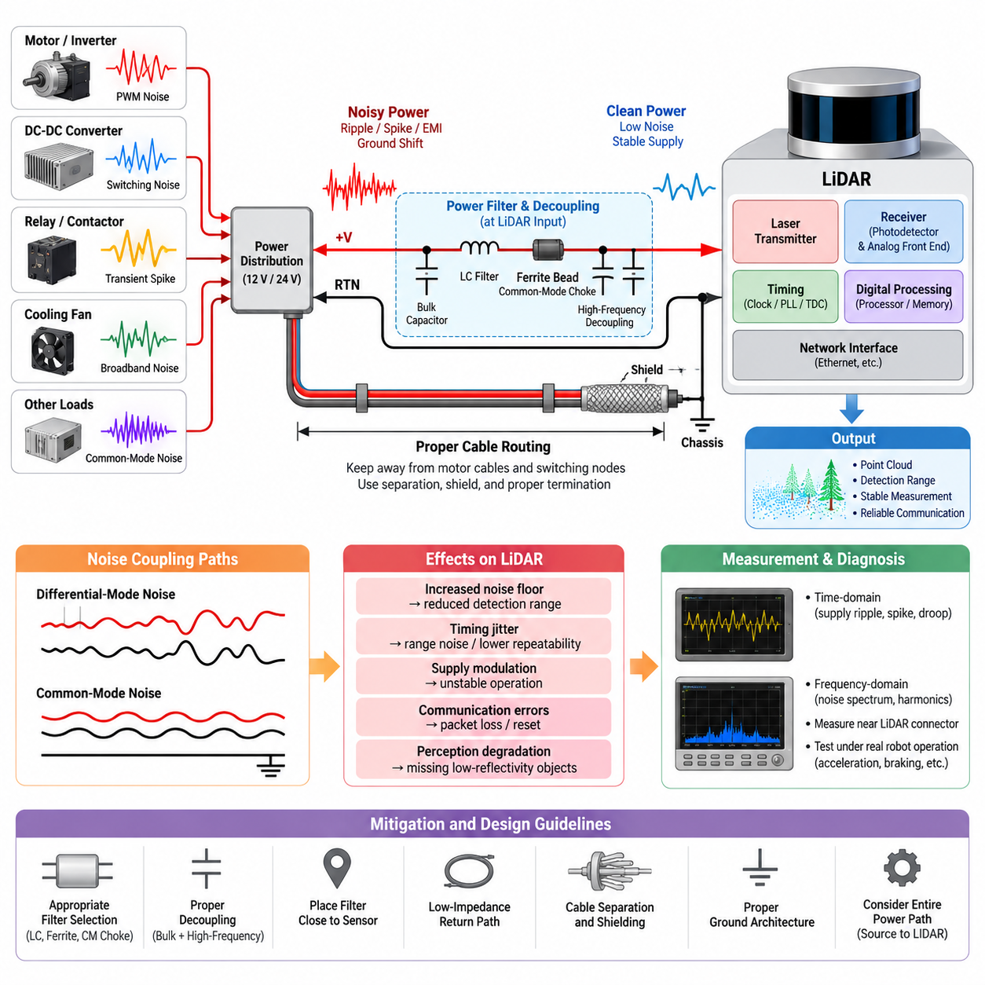
LiDAR systems combine precision analog sensing, high-speed digital processing, laser pulse generation, timing circuits, and network interfaces within a compact enclosure. This architecture makes the sensor sensitive not only to external electromagnetic interference but also to disturbances entering through its power supply. Power noise can alter receiver thresholds, timing references, internal clock stability, and signal-processing behavior, producing degradation that may appear as a perception problem rather than an electrical problem.
The power input of a LiDAR should therefore be treated as an EMC interface rather than simply as a DC supply connection. A nominal 12 V, 24 V, or other supply rail may contain switching ripple, transient spikes, common-mode disturbances, ground shifts, and broadband noise generated elsewhere in the robot. Motor inverters, DC-DC converters, relays, contactors, cooling fans, and high-current loads can inject disturbances into a shared power distribution network and propagate them toward the sensor.
Conducted noise reaches the LiDAR primarily through its positive supply conductor and return path. Differential-mode noise appears as a voltage disturbance between the supply and return conductors, while common-mode noise moves both conductors relative to the chassis or surrounding structure. These two mechanisms require different mitigation approaches because a filter that effectively attenuates differential ripple may provide little suppression of common-mode current flowing through cable capacitance, chassis coupling, or connector structures.
A LiDAR receiver must detect optical returns that may vary dramatically with target distance, reflectivity, incidence angle, weather, and ambient illumination. Weak returns can approach the sensitivity limit of the photodetector and analog front end. If supply noise couples into amplification, threshold, bias, or conversion circuits, the effective noise floor can increase. The resulting loss of signal-to-noise ratio may reduce detection range, increase measurement variance, or cause intermittent loss of low-reflectivity objects.
Timing stability is equally important because LiDAR distance measurement depends on precise estimation of optical propagation time or related phase and frequency information. Noise affecting oscillators, phase-locked loops, clock distribution, time-to-digital converters, or reference voltages can introduce timing uncertainty. Even when the disturbance does not reset the sensor or generate an obvious fault, increased timing jitter can appear as range noise, unstable point positions, or reduced repeatability in the resulting point cloud.
Power disturbances can also affect the laser transmitter section. Pulsed LiDAR architectures require rapid delivery of controlled energy to the laser source, creating substantial instantaneous current transitions inside the sensor. If the external supply impedance is excessive or local energy storage is inadequate, these current pulses can modulate the internal supply voltage. The LiDAR can consequently become both an EMI victim and an EMI source, with internally generated pulse currents propagating back into the robot power network.
This bidirectional behavior makes source impedance an important design parameter. A laboratory supply with short cables may produce excellent LiDAR performance, while the same sensor installed on an AMR can experience several meters of harness impedance, connector resistance, fuse resistance, PDU paths, and shared return conductors. The DC voltage may remain within specification while high-frequency impedance is unacceptable. EMC evaluation must therefore consider the frequency-dependent impedance of the complete installed power path.
Motor-driven robots present particularly severe conditions because PWM switching produces fast voltage and current transitions with wide spectral content. Motor phase cables, inverter DC buses, braking circuits, and DC-DC converters can couple noise conductively and radiatively into LiDAR wiring. When the LiDAR supply shares a distribution branch or return path with these loads, switching current can generate local ground bounce and supply modulation. Symptoms may correlate with acceleration, steering, braking, or specific motor operating points.
The physical routing of LiDAR power wiring is therefore part of the noise-control strategy. Power and signal cables should be kept away from inverter outputs, motor phase conductors, switching nodes, and other high-dV/dt or high-dI/dt structures wherever practical. Parallel routing over long distances increases coupling opportunities, whereas physical separation and controlled crossings reduce them. Shielding may further reduce coupling, but its effectiveness depends strongly on termination quality and chassis integration.
Filtering at the LiDAR power interface should be selected according to the measured disturbance mechanism rather than added indiscriminately. Input capacitors provide local high-frequency energy storage, while LC or multi-stage networks can attenuate differential disturbances. Ferrite components may add useful high-frequency loss, and common-mode structures can suppress currents that conventional differential filters cannot address. Component impedance, resonance, saturation, DC resistance, and sensor current demand must all be considered together.
Filter placement is as important as filter selection. A suppression network located far from the LiDAR leaves a section of cable exposed between the filter and the sensor, allowing noise to couple back onto the supposedly filtered conductors. Locating the final filtering stage close to the sensor power entry generally minimizes this vulnerable loop. The physical layout should also separate the noisy side and clean side of the filter so that capacitive or magnetic coupling does not bypass the intended attenuation path.
Decoupling must cover multiple frequency regions because no single capacitor behaves ideally across the complete disturbance spectrum. Bulk capacitance supports slower load variations and laser-related energy demand, while smaller low-inductance capacitors address faster components. Parasitic inductance in capacitor leads, PCB traces, connector pins, and harness segments limits high-frequency effectiveness. Consequently, a theoretically adequate capacitance value may perform poorly if current must travel through a large physical loop before reaching the decoupling element.
Ground architecture requires similar attention. Connecting the LiDAR return directly into a noisy motor return path can transform load current into sensor ground disturbance through shared impedance. Conversely, uncontrolled multiple grounding points can create common-mode current paths and ground loops. The appropriate architecture depends on sensor construction, chassis bonding, communication interface, shielding, and power topology, so the LiDAR power return must be considered together with the overall grounding and EMC structure of the robot.
Communication errors may sometimes be secondary symptoms of power integrity problems. Ethernet PHYs, serializers, processors, and internal switching regulators operate from rails derived from the LiDAR input supply. A transient entering the power interface can therefore disturb packet transmission, clock recovery, processor execution, or internal reset logic. Observed packet loss should not automatically be attributed to the communication cable; correlation with power-rail disturbances can reveal a common electrical origin.
Diagnosis should combine time-domain and frequency-domain measurements. An oscilloscope can capture supply droop, transient spikes, periodic ripple, and disturbances synchronized with motor switching or laser operation. A spectrum analyzer or suitable EMI measurement system can identify dominant frequency components and harmonics. Measurements should be taken near the LiDAR connector because observations made only at the battery or PDU can miss voltage disturbances created by local harness impedance and shared return paths.
Testing should reproduce realistic robot operating states rather than evaluate the LiDAR only under stationary conditions. Motor acceleration, regenerative braking, steering actuation, payload changes, DC-DC converter transitions, network activity, and simultaneous sensor operation can produce combinations of disturbances that are absent during bench testing. Point-cloud quality, detection range, packet statistics, sensor diagnostics, and power waveforms should therefore be recorded together so electrical events can be correlated with perception degradation.
A robust LiDAR installation ultimately depends on controlling the complete noise path from source to victim. Clean power distribution, low-impedance returns, appropriate filtering, local decoupling, cable separation, shielding, chassis bonding, and disciplined connector design work as a coordinated system. Treating power-noise sensitivity at the architecture stage prevents intermittent point-cloud faults from becoming difficult field problems and provides a stable electrical foundation for reliable perception in AMRs and other Physical AI platforms.

08.02. Isolated Power Supply Design
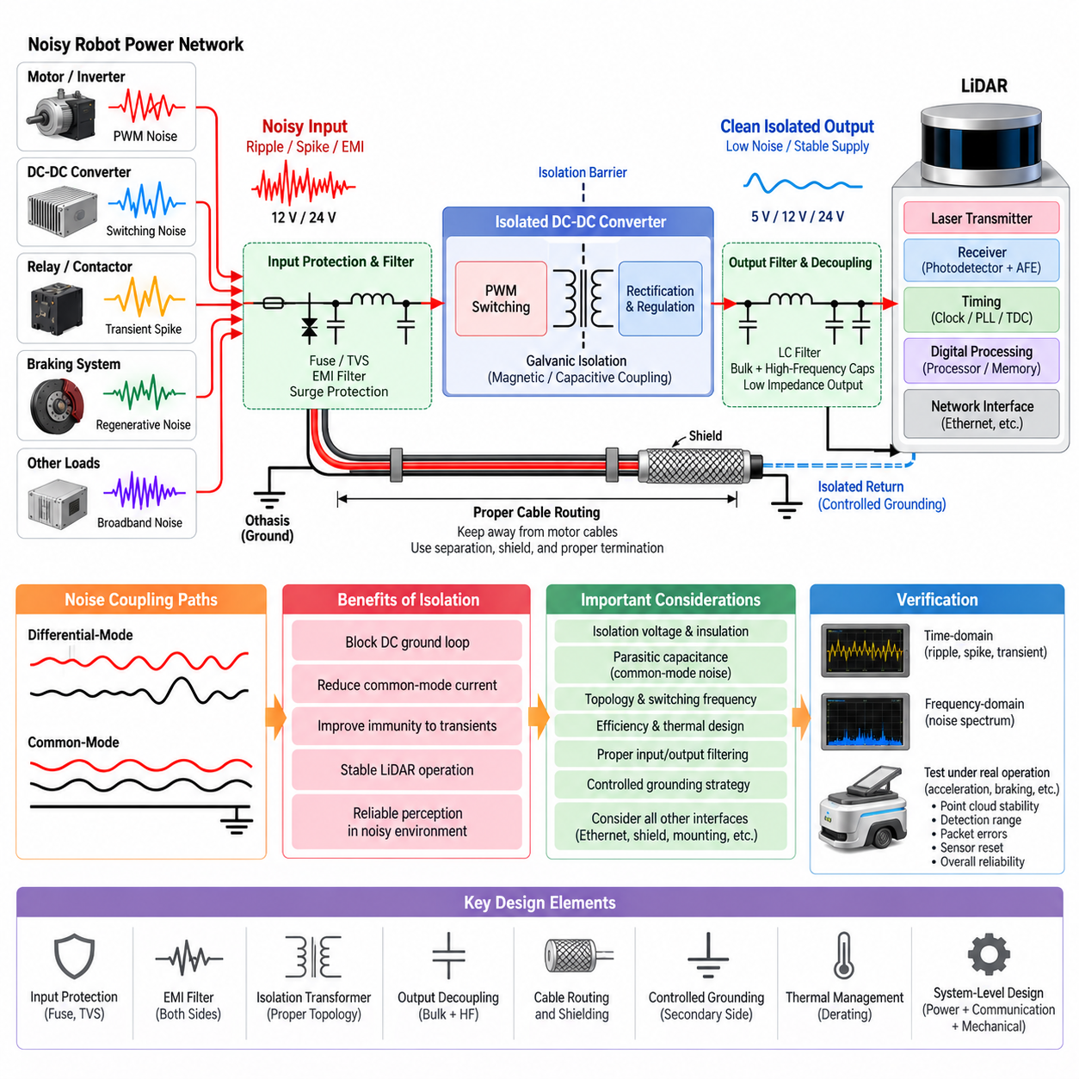
Electrical isolation in a LiDAR power supply is used to interrupt unwanted conductive paths between the sensor and the robot’s noisy power network. In an AMR, the LiDAR may share the vehicle with motor inverters, DC-DC converters, braking circuits, contactors, and high-current actuators. An isolated supply creates a galvanic barrier that prevents direct DC current flow across the boundary while transferring the required electrical power through magnetic or capacitive coupling.
The primary objective of isolation is not simply to produce a clean output voltage. It is to control the paths through which common-mode current, ground potential differences, and transient disturbances can reach sensitive LiDAR electronics. A conventional non-isolated converter maintains a direct relationship between input and output grounds, whereas an isolated DC-DC converter allows the sensor-side return to be electrically separated from the noisy source-side return under controlled conditions.
This separation is particularly useful when the LiDAR is mounted far from the central power distribution unit. Long harnesses introduce resistance, inductance, parasitic capacitance, and coupling to nearby cables or metallic structures. Motor currents flowing through shared conductors can create voltage differences between remote ground points. Without isolation, these differences can drive unwanted current through the LiDAR power return, communication shield, chassis connection, or other available conductive paths.
An isolated power architecture normally consists of an input protection and filtering stage, an isolated DC-DC conversion stage, secondary-side rectification or regulation, and local output filtering near the LiDAR. The input stage limits disturbances arriving from the robot power bus, while the isolation transformer provides galvanic separation. The secondary stage then establishes a locally referenced supply that can be filtered and decoupled according to the sensor’s current demand and noise sensitivity.
Selecting the isolated converter requires more than matching nominal input and output voltages. The designer must consider continuous power rating, peak current, conversion efficiency, allowable input range, output ripple, transient response, isolation voltage, insulation construction, switching frequency, thermal behavior, and electromagnetic emissions. LiDAR current consumption may also vary with laser operation, internal processing, heaters, network activity, or startup sequences, making adequate transient margin important.
Isolation does not automatically eliminate high-frequency noise because every practical isolation barrier contains parasitic capacitance. Fast switching voltage transitions inside the converter can drive displacement current through transformer interwinding capacitance and other parasitic paths. This current may appear on the isolated output as common-mode noise. Consequently, a converter with a high isolation-voltage rating can still exhibit poor EMC behavior if its common-mode coupling characteristics are unsuitable for the LiDAR installation.
Transformer design and switching topology therefore influence both conversion performance and EMC behavior. Flyback, forward, push-pull, half-bridge, and other isolated converter structures produce different switching waveforms, current loops, component stresses, and noise spectra. For a LiDAR supply, the preferred topology is not determined only by efficiency. The magnitude of switching edges, transformer parasitic capacitance, physical layout, operating frequency, and required filtering must also be evaluated.
The primary-side switching loop should be physically compact because high-dI/dt current loops generate magnetic fields and conducted disturbances. Likewise, high-dV/dt switching nodes should occupy minimal copper area to reduce capacitive coupling. The isolation transformer should be positioned so that noisy primary structures do not capacitively couple around the isolation barrier into clean secondary circuitry. PCB layout is therefore an essential part of isolation performance rather than a secondary packaging consideration.
Filtering should normally be applied on both sides of the isolation stage according to the measured noise paths. The primary input filter prevents converter switching noise from propagating back toward the robot power bus and attenuates disturbances arriving from other loads. Secondary filtering reduces residual differential ripple and switching components before they reach the LiDAR. Filter sections must be arranged so that noisy and clean conductors do not run closely together and bypass the intended attenuation.
Local decoupling near the LiDAR remains necessary even when an isolated converter is used. Bulk capacitance supplies energy during slower load changes, while smaller low-inductance capacitors provide lower impedance at higher frequencies. The wiring between the isolated supply and the sensor should be kept appropriately short and low impedance because a long secondary harness can recreate susceptibility to coupled noise and voltage transients after the isolation and filtering stages.
The isolated output return requires deliberate treatment. Leaving the secondary completely floating can reduce certain ground-loop currents, but an uncontrolled floating network can develop unpredictable common-mode voltage through parasitic capacitance. In other installations, the secondary may be referenced to chassis through a controlled high-frequency path or another defined network. The correct strategy depends on the LiDAR enclosure, connector structure, communication interface, cable shield, and overall robot grounding architecture.
Communication interfaces must be considered together with power isolation because a supposedly isolated LiDAR can be unintentionally reconnected to the robot ground through Ethernet circuitry, cable shields, mounting hardware, diagnostic interfaces, or chassis contact. If another low-impedance conductive path crosses the isolation boundary, the expected benefit may be reduced or eliminated. System-level isolation therefore requires identification of every electrical and mechanical connection between the sensor and the rest of the robot.
Shield termination requires particular care. A cable shield is primarily intended to control electromagnetic fields and common-mode currents, not to serve as a normal power return conductor. Depending on the architecture, the shield may be bonded to chassis near the connector using a low-inductance connection while the isolated power return remains separate. Poor termination, long pigtails, or accidental shield-to-signal-ground connections can create high-frequency current paths that bypass the intended isolation strategy.
Isolation can also improve immunity to transient events produced by contactors, relays, regenerative braking, and rapidly changing motor loads. However, the isolated converter itself must survive the input disturbances expected on the robot power bus. Reverse polarity protection, surge suppression, transient voltage suppression, current limiting, and suitable input capacitance may therefore be required before the isolation stage. Isolation should complement input protection rather than be treated as a substitute for it.
Thermal design is important because isolated conversion introduces additional losses in switching devices, magnetic components, rectifiers, and control circuitry. A converter installed inside a sealed sensor enclosure or compact electrical box may operate at significantly higher temperature than during laboratory testing. Efficiency should therefore be evaluated at realistic input voltage, LiDAR load, ambient temperature, and airflow conditions, with sufficient derating to maintain reliable operation over the required environmental range.
Verification should measure both electrical integrity and LiDAR performance. Input and output ripple, startup behavior, load-step response, common-mode voltage, transient susceptibility, and conducted emissions should be examined while the robot operates its motors and other major loads. Oscilloscope measurements should use appropriate probing techniques because long probe ground leads can exaggerate high-frequency noise. Measurements near the converter and directly at the LiDAR connector provide complementary information.
The final validation should correlate electrical measurements with perception behavior. Point-cloud stability, detection range, measurement variance, packet errors, sensor resets, diagnostic events, and startup reliability should be observed while acceleration, braking, steering, converter load changes, and other worst-case operating conditions are reproduced. This approach confirms whether isolation improves the actual sensor system rather than merely producing an acceptable voltage waveform during simplified bench testing.
A successful isolated LiDAR power design therefore combines galvanic separation with controlled grounding, filtering, decoupling, cable routing, shielding, transient protection, thermal management, and careful PCB layout. Isolation is most effective when it is treated as part of the complete source-path-victim EMC architecture. When every path crossing the isolation boundary is deliberately controlled, the LiDAR can maintain stable power and reliable perception even within the electrically noisy environment of an AMR or other Physical AI platform.

08.03. LiDAR Cable Routing
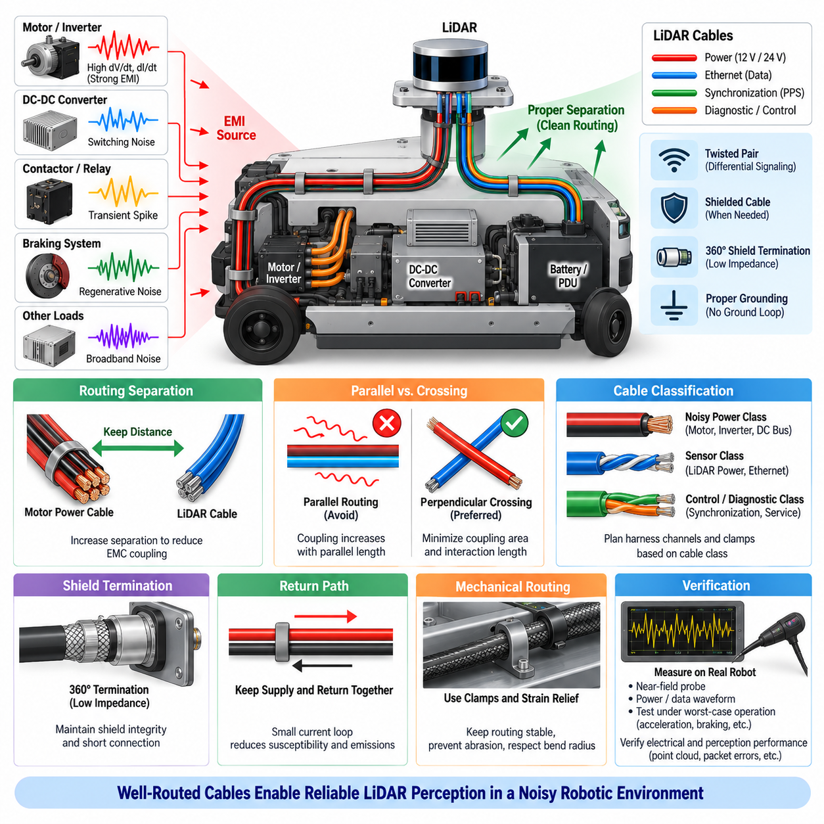
LiDAR cable routing is a critical part of electromagnetic compatibility because the cable harness forms both a conductive path for interference and an antenna structure that can receive or radiate electromagnetic energy. A LiDAR installation may include power, Ethernet, synchronization, and diagnostic connections, each with different susceptibility characteristics. Routing must therefore be designed as part of the complete sensor electrical architecture rather than treated as a mechanical packaging task.
In an AMR, the most significant routing concern is separation between LiDAR cables and high-energy switching circuits. Motor phase conductors, inverter outputs, braking circuits, contactor wiring, and high-current DC buses generate rapidly changing electric and magnetic fields. When LiDAR wiring runs parallel to these conductors, capacitive and inductive coupling can transfer switching noise into sensor power or communication circuits, potentially degrading point-cloud stability or network reliability.
Physical separation is one of the simplest and most effective countermeasures. Increasing the distance between sensitive LiDAR wiring and noisy power cables reduces both electric-field and magnetic-field coupling. The exact separation required depends on current magnitude, switching slew rate, cable construction, shielding, routing length, and installation geometry. For this reason, a fixed distance alone should not be regarded as a universal EMC solution; the complete coupling environment must be evaluated.
Parallel routing should be minimized because electromagnetic coupling accumulates over the shared routing length. If a LiDAR cable must cross a motor cable or another noisy harness, a near-perpendicular crossing is generally preferable to a long parallel path. The objective is to minimize the effective coupling area and interaction length. Short unavoidable crossings usually create less interference than routing sensitive and noisy cables together through the same channel for a significant distance.
Cable classification helps maintain routing discipline throughout robot development. High-current motor and inverter wiring can be treated as a noisy power class, while LiDAR power and communication wiring belong to more sensitive sensor classes. Harness channels, clamps, conduits, and connector locations can then be planned according to these classifications. This approach prevents later mechanical changes from unintentionally placing a sensitive sensor cable beside a strong EMI source.
LiDAR power and communication cables also require consideration relative to each other. A noisy power conductor routed directly beside an unshielded communication pair may inject disturbances into the data interface. Where practical, power wiring should have controlled return geometry, while Ethernet or other differential communication links should maintain their specified pair construction and impedance. Twisting and differential signaling reduce susceptibility by minimizing loop area and rejecting noise coupled similarly onto both conductors.
The return path is equally important because current always flows through a complete loop. Routing only the positive supply conductor carefully while allowing the return conductor to take a distant or shared path can create a large loop area that increases magnetic coupling. LiDAR supply and return conductors should therefore remain physically associated along the routing path. A compact current loop reduces both susceptibility to external magnetic fields and electromagnetic emissions generated by sensor current transitions.
Shielded cable can provide additional protection where routing separation alone is insufficient. The shield intercepts electric-field coupling and provides a controlled path for high-frequency common-mode current. Its effectiveness, however, depends strongly on shield coverage, transfer impedance, connector construction, and termination method. A high-quality cable shield can perform poorly when connected through a long pigtail because the additional inductance increases shield impedance at high frequencies.
For this reason, 360-degree shield termination is generally preferred at EMC-critical connector interfaces when the connector and system architecture support it. The cable shield should transition to the connector shell with minimal discontinuity, and the connector shell should have a low-impedance relationship to the appropriate chassis or enclosure structure. This creates a more continuous electromagnetic boundary and reduces the tendency for high-frequency common-mode current to enter internal sensor electronics.
Shielding strategy must nevertheless remain consistent with the grounding architecture. Connecting shields, signal returns, power returns, and chassis together without a defined plan can create unwanted current paths or ground loops. Conversely, leaving a shield floating at inappropriate locations may reduce its high-frequency effectiveness. LiDAR cable routing should therefore be designed together with chassis bonding, power isolation, connector termination, and communication-interface requirements rather than as an independent EMC measure.
Mechanical structures can influence cable EMC behavior as well. Routing a cable close to a bonded metallic chassis can sometimes provide a more controlled electromagnetic environment and reduce loop area, while routing it across openings, isolated panels, or poorly bonded structures can change common-mode behavior. Metallic conduits or cable trays may provide useful shielding when properly bonded, but discontinuities between sections can reduce effectiveness and create unexpected current concentration points.
Routing near switching power converters requires particular attention. DC-DC converters contain high-dV/dt switching nodes, magnetic components, and high-dI/dt loops that can produce localized electromagnetic fields. A LiDAR cable routed directly above or beside such circuitry can receive noise even when the converter meets general conducted-emission requirements. Sensitive harnesses should therefore be kept away from converter switching regions and from cables carrying rapidly pulsed converter currents.
Connector placement should support the intended cable-routing strategy. Locating the LiDAR connector toward the noisy motor harness may force sensitive wiring through an unfavorable region before separation becomes possible. Electrical and mechanical designers should therefore coordinate sensor orientation, connector direction, bracket design, and harness entry points early in development. Good connector placement can reduce cable length, eliminate unnecessary crossings, and simplify implementation of shielding and grounding requirements.
Excess cable length should also be avoided. Large service loops and loosely bundled excess wiring increase loop area and may create resonant structures that behave as efficient receiving or transmitting antennas at particular frequencies. Where serviceability requires additional length, the cable should be managed in a controlled manner without creating large open loops. Coiling excess sensor cable beside an inverter or motor controller can significantly undermine an otherwise well-designed EMC installation.
Cable fixation is important because routing geometry should remain stable during operation. Vibration, steering movement, suspension travel, rotating LiDAR mechanisms, maintenance, and repeated service can move cables toward noise sources or damage shield connections. Clamps and strain relief should preserve the intended separation while respecting cable bend-radius limits. Mechanical abrasion must also be prevented because shield damage can gradually change EMC behavior without producing an immediate electrical open circuit.
Moving robotic platforms introduce additional challenges where cables pass through joints, articulated structures, or moving sensor mounts. Flexible cable sections must maintain conductor geometry and shield continuity throughout repeated bending cycles. Routing should prevent tensile loading on connectors and avoid locations where repeated motion changes the distance between sensitive cables and motor conductors. EMC performance must therefore remain valid across the complete mechanical operating envelope, not only in one static configuration.
Verification should be performed on the actual installed harness whenever possible. Near-field probes can identify strong electromagnetic regions around motors, converters, and cable bundles, while oscilloscope measurements can reveal disturbances on LiDAR power or communication interfaces. Comparing sensor behavior with motors disabled and enabled, or temporarily rerouting a suspect cable, can provide strong evidence that a routing path is responsible for an observed interference problem.
Testing should include representative worst-case robot operating conditions such as maximum acceleration, steering activity, regenerative braking, high network traffic, simultaneous sensor operation, and heavy electrical loading. Point-cloud stability, detection range, packet errors, sensor resets, and diagnostic information should be monitored while cable-related disturbances are measured. A routing design that succeeds during idle operation may fail when inverter current and switching activity reach their maximum values.
Effective LiDAR cable routing ultimately follows the source-path-victim principle of EMC engineering. Noise sources should be physically separated from sensitive wiring, coupling paths should be minimized through compact return geometry, controlled crossings, shielding, and proper termination, and the LiDAR should receive clean power and communication signals at its connector. When routing, grounding, shielding, filtering, and mechanical packaging are developed together, reliable LiDAR perception can be maintained in the electrically demanding environment of an AMR or other Physical AI system.

08.04. Laser Pulse EMI
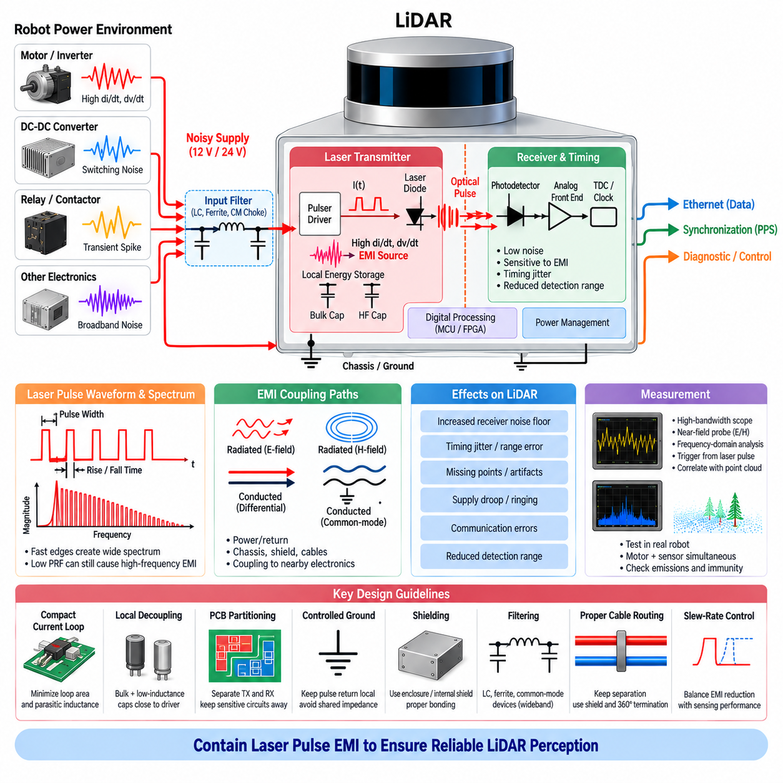
A pulsed LiDAR generates extremely short optical pulses by switching substantial electrical current through a laser diode or laser-driver circuit. Although the emitted optical energy is the intended output, the associated electrical current transitions contain very high-frequency components. Fast pulse edges create large dI/dt and dV/dt values, making the transmitter section a significant local electromagnetic interference source inside the LiDAR and potentially throughout the robot electrical system.
The electromagnetic spectrum produced by a laser pulse is determined not only by the pulse repetition frequency but also by the rise time, fall time, pulse width, driver topology, and current-loop geometry. A relatively low pulse repetition rate can still generate substantial high-frequency energy when the electrical edges are extremely fast. Therefore, EMC analysis must consider the complete transient waveform rather than focusing only on the nominal laser firing frequency or scanning rate.
The laser-driver current loop is one of the most critical EMI structures within a pulsed LiDAR. Energy-storage capacitors, switching devices, laser diodes, and return conductors form a rapidly changing current path during each pulse. Parasitic inductance in this loop produces voltage overshoot and ringing according to the current transition rate. Keeping the loop physically compact reduces magnetic-field radiation, switching-node voltage excursions, and coupling into nearby sensitive circuitry.
High-dV/dt switching nodes create a complementary electric-field coupling mechanism. Rapid voltage transitions can capacitively couple through PCB traces, component packages, heatsinks, enclosures, cables, and parasitic capacitances. These displacement currents may enter receiver grounds, communication interfaces, chassis structures, or external wiring. Minimizing switching-node area and maintaining adequate physical separation between transmitter switching circuits and sensitive receiver electronics are therefore fundamental layout practices.
Laser pulse generation can disturb the LiDAR’s own power rails because the transmitter demands energy in short bursts. If the local energy-storage network is inadequate, pulse current may be drawn directly through the external power harness, creating repetitive voltage disturbances at the LiDAR connector. Harness inductance can amplify these effects, causing supply droop, overshoot, or ringing that propagates toward the robot power distribution unit and other connected electronic modules.
Local decoupling is therefore essential for containing pulse energy near the laser driver. Bulk capacitors provide energy for lower-frequency variations, while low-inductance capacitors positioned close to the switching stage support the fastest current transitions. The effectiveness of these components depends strongly on placement and interconnection impedance. A capacitor with sufficient nominal capacitance may contribute little at high frequency if long PCB traces or vias introduce excessive parasitic inductance.
Pulse-related conducted emissions can propagate along both supply and return conductors. Differential-mode current appears between the LiDAR supply and return, while common-mode current may flow through chassis capacitance, cable shields, mounting structures, or communication interfaces. These mechanisms must be distinguished during diagnosis because a differential input filter cannot necessarily suppress common-mode current, and common-mode countermeasures may have little effect on disturbances confined to the local supply loop.
The LiDAR receiver is particularly vulnerable because it must detect weak optical returns shortly after transmitting a powerful laser pulse. Electrical interference coupled from the transmitter can temporarily increase the receiver noise floor, disturb photodetector bias, affect the analog front end, or alter threshold behavior. This internal coupling can reduce sensitivity to weak targets and may appear as missing points, unstable range measurements, reduced detection distance, or artifacts synchronized with laser firing.
Timing electronics represent another sensitive victim. Time-of-flight LiDAR depends on precise timing between transmitted and received optical events, so interference affecting clocks, phase-locked loops, time-to-digital converters, comparators, or reference voltages can directly influence range accuracy. Pulse-synchronous ground bounce or supply modulation may introduce timing jitter even when the sensor continues operating normally, producing increased range variance rather than an obvious electronic failure.
PCB partitioning helps control these interactions by separating the high-energy transmitter region from sensitive receiver and timing circuits. The laser driver, switching devices, pulse capacitors, and associated return paths should form a compact functional region. Receiver analog circuitry should be positioned away from high-field switching structures, while digital processing and communication interfaces should be arranged so that transmitter return currents do not flow through their reference paths.
Ground design is particularly important because an apparently continuous ground plane can still carry significant pulse-induced voltage gradients. If laser current and receiver current share the same high-frequency return impedance, the transmitter pulse can modulate the receiver reference potential. The objective is not necessarily to split every ground plane, but to control current flow so high-energy pulse return currents remain localized and do not traverse sensitive analog, timing, or communication reference regions.
Shielding can reduce radiated coupling when source containment through layout alone is insufficient. Conductive enclosures, internal shields, and properly bonded chassis structures can intercept electric fields and provide controlled paths for high-frequency currents. Shield effectiveness depends on continuity, aperture size, bonding impedance, and frequency. Small gaps, poorly bonded covers, long grounding straps, and connector discontinuities can allow high-frequency fields to escape even from an otherwise metallic enclosure.
External LiDAR cables can become secondary radiators when pulse-generated common-mode current reaches the sensor connector. A cable several meters long can radiate far more effectively than the compact internal laser-driver loop. Preventing common-mode current from reaching external wiring is therefore often more effective than attempting to shield the entire cable afterward. Connector bonding, common-mode filtering, controlled grounding, and suitable cable shielding can help contain these currents.
Cable routing remains important because pulse-generated emissions may couple into nearby camera, Ethernet, GNSS, IMU, or other sensor wiring. LiDAR cables should be separated from sensitive harnesses where practical, particularly near the sensor and its power interface. Shielded cables and 360-degree shield termination can provide additional high-frequency control when required, but shielding should remain consistent with the overall chassis and grounding architecture of the robot.
Filtering must account for the broad spectral content created by fast laser pulses. Input capacitors, LC networks, ferrite components, and common-mode suppression devices may be combined according to the identified noise mechanism. Filter components should be evaluated using their impedance over the relevant frequency range rather than only nominal values. Parasitic resonances can otherwise create frequencies at which a theoretically beneficial filter amplifies rather than attenuates disturbances.
Reducing edge speed can sometimes lower EMI because slower current and voltage transitions contain less high-frequency energy. However, laser pulse shape is closely related to optical performance, timing resolution, measurement range, and transmitter efficiency. Slew-rate control therefore cannot be applied blindly. Any modification to the laser-driver switching behavior must be evaluated against both EMC improvement and the resulting impact on LiDAR sensing performance.
Measurement of laser pulse EMI requires instrumentation capable of observing fast transient phenomena. High-bandwidth oscilloscopes with appropriate probes can examine switching-node voltage, pulse current, supply disturbances, and ground bounce. Near-field electric and magnetic probes can locate strong emission regions on the PCB or enclosure. Frequency-domain measurements can then identify dominant spectral components and determine whether energy is coupling into external power or communication cables.
Triggering measurements from the laser pulse or a related synchronization signal can be especially useful. Pulse-synchronous averaging and time correlation help distinguish laser-generated interference from motor PWM noise, converter switching, network activity, or unrelated background disturbances. Correlating electrical measurements with point-cloud artifacts, range variance, packet errors, or receiver diagnostics can demonstrate whether observed perception degradation is directly associated with transmitter activity.
Validation should be performed with the LiDAR integrated into the complete robot because mounting, cable length, chassis bonding, power distribution, and nearby electronics can substantially change EMI behavior. Tests should include simultaneous operation of motors, DC-DC converters, cameras, communication networks, and other sensors. Both emissions from the LiDAR and immunity of surrounding equipment should be evaluated under representative and worst-case operating conditions.
Effective laser pulse EMI control ultimately depends on containing high-frequency energy close to its source. Compact laser-current loops, low-inductance decoupling, controlled return paths, minimized switching-node area, functional PCB partitioning, shielding, filtering, connector bonding, and disciplined cable routing work together to prevent pulse energy from spreading through the robot. Applying these principles enables a LiDAR to maintain precise ranging while coexisting reliably with the dense electronics of an AMR or other Physical AI platform.

08.05. LiDAR Ground Isolation
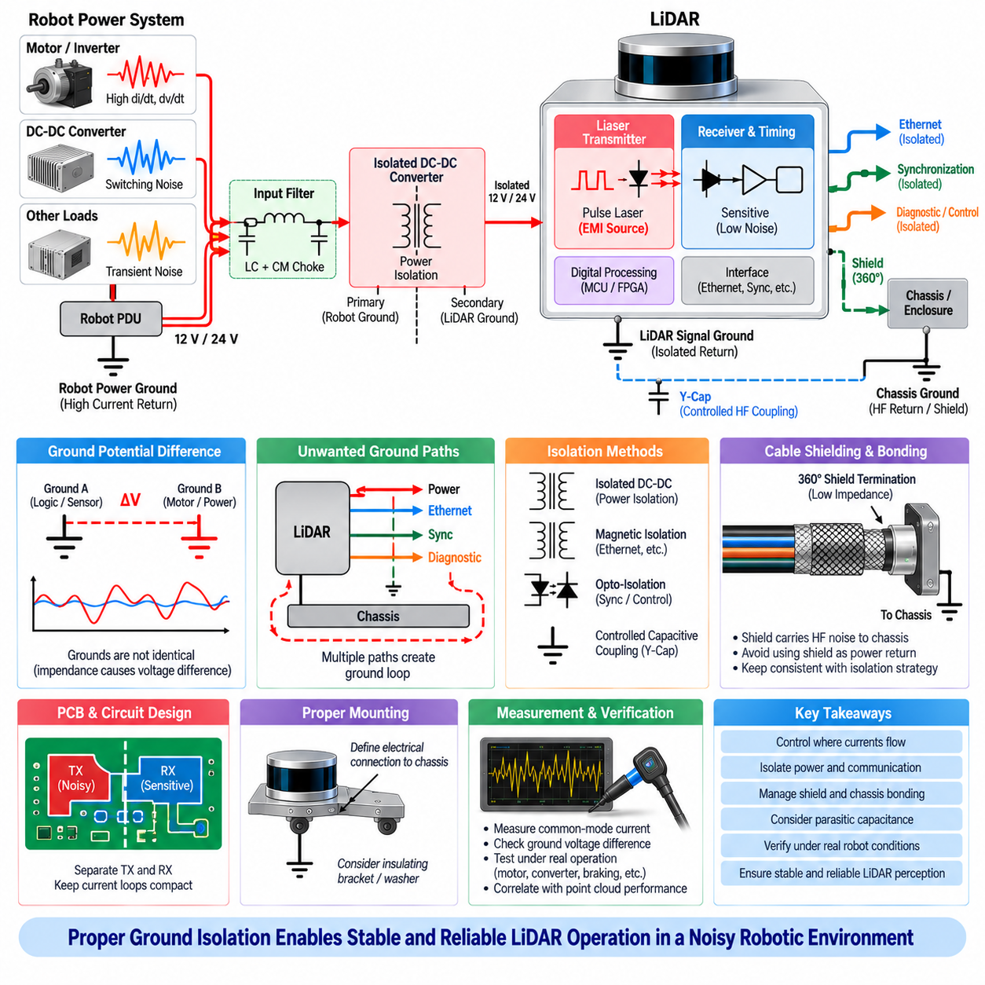
Ground isolation in a LiDAR installation is intended to control unwanted current flow between the sensor, power distribution system, communication interfaces, chassis, and other electronic modules. A robot may contain several electrical reference structures that are nominally called ground but are not electrically identical at all frequencies. Motor currents, converter switching, cable impedance, and transient events can create voltage differences between these reference points and disturb sensitive LiDAR electronics.
A ground connection should therefore be understood as an impedance rather than an ideal zero-volt node. Every wire, PCB trace, connector contact, chassis joint, and bonding strap contains resistance and inductance. When rapidly changing current flows through this impedance, a voltage is generated between different ground locations. Even a small impedance can produce significant disturbance when motor inverter currents or fast switching transients contain large dI/dt components.
LiDAR ground problems commonly arise when sensor return current shares a conductor with high-current loads. If motor, actuator, heater, or converter current flows through part of the same return path used by the LiDAR, the resulting voltage drop modulates the sensor reference potential. This shared-impedance coupling may affect the LiDAR power input, analog receiver, timing circuitry, Ethernet interface, or internal regulators without producing an obvious wiring failure.
Ground isolation interrupts selected conductive paths so that unwanted current cannot circulate through sensitive sensor circuits. An isolated DC-DC converter can separate the LiDAR power return from the primary robot power return, while transformer-isolated communication interfaces can prevent data connections from recreating a direct ground path. The objective is not to eliminate every electrical reference but to define deliberately where low-frequency and high-frequency currents are allowed to flow.
A completely floating LiDAR supply may appear to provide ideal isolation, but practical systems always contain parasitic capacitance between isolated circuits, cable shields, enclosures, mounting structures, and chassis. At high frequencies, displacement current can cross these capacitances even though there is no direct DC connection. Ground-isolation design must therefore consider both galvanic paths and frequency-dependent parasitic paths rather than evaluating isolation only with a resistance measurement.
Common-mode noise is particularly important because it can drive the entire LiDAR electrical system relative to the robot chassis. Fast switching edges from motor inverters and DC-DC converters may couple through parasitic capacitance and cause common-mode current to flow through the sensor enclosure, cable shield, communication cable, or mounting hardware. If this current enters internal signal ground before reaching chassis, it can disturb receiver, timing, and digital circuits.
The mechanical mounting of the LiDAR must therefore be included in the electrical ground model. A metallic sensor enclosure attached directly to a conductive robot frame can create a chassis connection even when the power supply is isolated. Painted surfaces, anodized brackets, insulating washers, bearings, and mounting fasteners can further create uncertain or frequency-dependent connections. The intended relationship between enclosure, signal ground, isolated return, and chassis should be explicitly defined.
Chassis ground and signal ground serve different purposes and should not be treated as interchangeable conductors. Chassis structures can provide a low-impedance path for high-frequency common-mode and shield currents, while signal ground provides the electrical reference required by internal electronics. Allowing large shield or chassis currents to flow through signal-ground conductors can convert common-mode interference into differential disturbances that directly affect sensitive circuits.
Cable shields require particular attention because they often cross the boundary between isolated and non-isolated regions. A shield should primarily carry high-frequency interference current toward the chassis rather than act as the normal LiDAR power return. Where appropriate, a 360-degree shield termination at the connector provides much lower high-frequency impedance than a long pigtail. Shield termination must nevertheless remain consistent with the overall isolation and chassis-bonding strategy.
Communication interfaces can unintentionally defeat power-ground isolation. A LiDAR powered from an isolated DC-DC converter may become galvanically connected to the robot again through Ethernet circuitry, synchronization wiring, USB diagnostics, serial interfaces, or another sensor connection. Each interface crossing the isolation boundary must therefore be examined independently. System isolation is only as effective as the lowest-impedance unintended path connecting the two reference domains.
Ethernet can provide useful separation when its physical interface uses appropriate transformer coupling, but cable shields and connector shells still require careful treatment. High-frequency common-mode current may flow through shield structures even when the data pairs are galvanically isolated. Connector-shell bonding should provide a controlled path to chassis so that interference current does not travel through PCB signal ground before reaching the enclosure or robot structure.
Synchronization signals such as pulse-per-second or external trigger connections also require evaluation. A single-ended synchronization line can reconnect isolated ground domains through its reference conductor and create a new ground loop. Differential signaling, galvanically isolated interfaces, or carefully controlled reference connections may be more suitable where significant ground potential differences exist. The required timing accuracy and interface delay must also be considered when isolation components are introduced.
Ground loops occur when multiple conductive connections create a closed path through which unintended current can circulate. A LiDAR may be connected to the robot through power return, cable shield, Ethernet connector, mounting bracket, and diagnostic equipment simultaneously. Differences in potential or electromagnetic induction can drive current around this loop. Breaking or controlling selected paths can reduce interference, but indiscriminately disconnecting grounds may create new EMC or safety problems.
High-frequency grounding differs from low-frequency grounding because inductance increasingly dominates conductor impedance as frequency rises. A long grounding wire that appears adequate with a multimeter may behave as a substantial impedance to fast laser pulses or inverter switching components. Short, wide bonding structures and direct chassis connections are generally more effective for high-frequency currents. Physical geometry is therefore as important as DC resistance when implementing ground isolation.
Controlled capacitive coupling can sometimes be used across an isolation boundary to provide a defined high-frequency return while preserving DC isolation. A suitable capacitor can prevent the isolated domain from floating unpredictably at high frequencies and redirect common-mode current away from sensitive circuitry. However, its capacitance, voltage rating, safety requirements, leakage current, resonance, and connection location must be selected according to the complete system architecture.
Filtering and ground isolation should be designed together because filter capacitors determine where high-frequency current returns. A capacitor connected from the LiDAR supply to an inappropriate ground can unintentionally bridge the isolation boundary or inject noise into signal ground. Common-mode filters also depend on a controlled relationship among cable conductors, shields, and chassis. Filter schematics must therefore be evaluated together with the physical current paths created by the PCB and harness.
Verification should begin by identifying every possible connection between the LiDAR and robot ground domains. Resistance measurements can reveal unintended DC paths, while impedance and oscilloscope measurements provide information about dynamic behavior. Common-mode voltage and current should be observed during motor acceleration, inverter switching, regenerative braking, converter operation, and other high-noise conditions rather than only when the robot is electrically idle.
Current probes and differential voltage probes are especially useful for ground-isolation diagnosis. A current probe around the LiDAR cable bundle or shield can reveal unexpected common-mode current, while a differential probe can measure voltage between the isolated sensor reference and chassis without forcing the two nodes together. Measurement equipment itself must be connected carefully because an oscilloscope protective-earth connection can unintentionally create the very ground path being investigated.
The final evaluation should correlate grounding behavior with actual perception performance. Point-cloud instability, missing detections, range variation, packet errors, sensor resets, and synchronization faults should be monitored while ground currents and reference voltages are measured. Temporarily modifying a suspected bonding or isolation path during controlled testing can help identify the dominant coupling mechanism, but the final configuration must satisfy EMC, electrical safety, mechanical, and service requirements.
Effective LiDAR ground isolation is therefore not equivalent to simply disconnecting the sensor ground from the chassis. It is a system-level strategy that deliberately controls power returns, signal references, communication isolation, cable shields, enclosure bonding, mounting paths, parasitic capacitance, and high-frequency current flow. When these elements are coordinated, ground-related interference can be contained while maintaining stable power, reliable communication, accurate timing, and dependable LiDAR perception in an AMR or other Physical AI platform.

