Volume 05. Grounding and EMC

Chapter 10. Robot EMC Case Studies

10.01. AMR Motor Noise Case
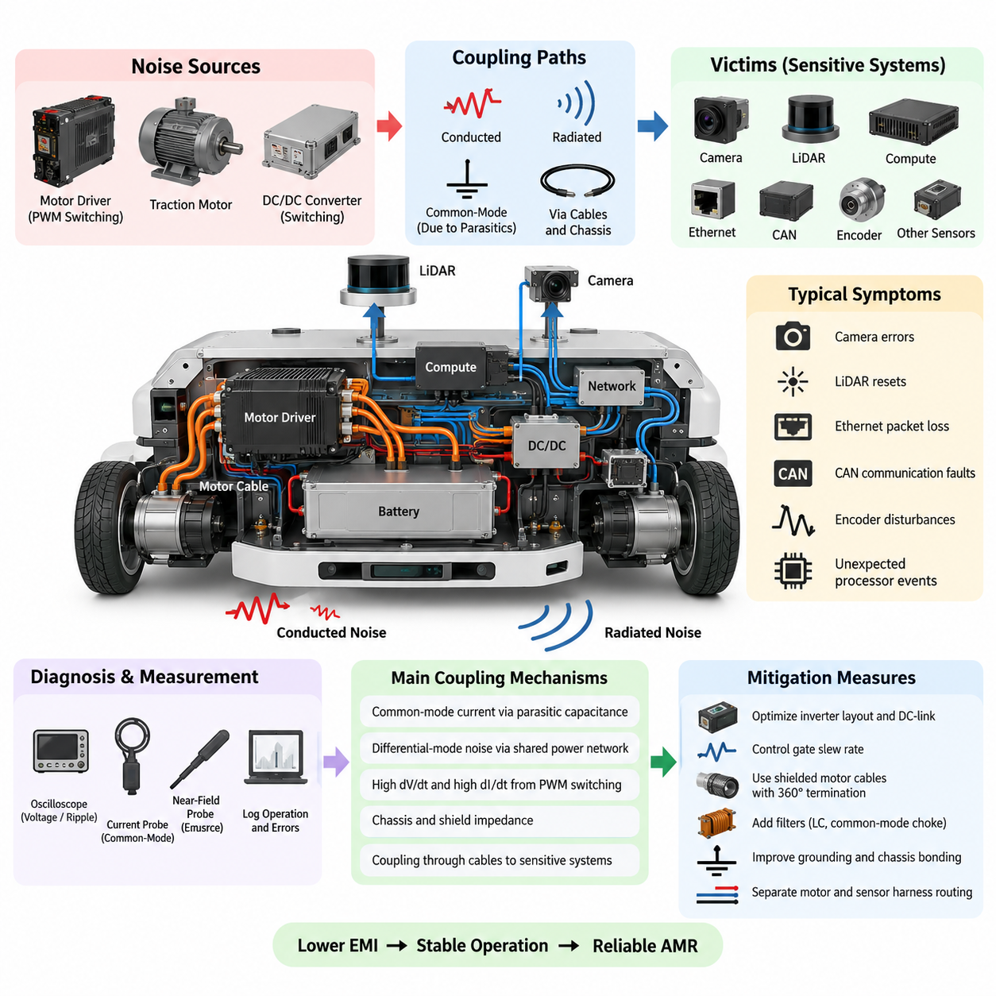
An autonomous mobile robot often combines high-current traction motors, PWM motor drivers, switching power converters, sensitive perception sensors, communication networks, and high-performance computing within a compact mechanical platform. This concentration makes motor-related electromagnetic noise one of the most common system-level EMC problems. The motor itself, inverter switching, long motor cables, and chassis coupling can collectively disturb electronics that appear electrically unrelated to the drive system.
A representative AMR noise case begins when the traction motor driver switches battery voltage through MOSFETs at a high PWM frequency. Although the fundamental PWM frequency may be only several kilohertz or tens of kilohertz, fast switching edges contain harmonic energy extending far into the megahertz region. High dV/dt generates capacitive displacement current, while high dI/dt produces magnetic fields and voltage transients across parasitic inductance in the DC bus, motor phases, connectors, cables, and grounding structure.
The first symptom may not appear at the motor controller itself. During acceleration, regenerative braking, rapid direction changes, or operation under heavy load, the AMR may experience intermittent camera errors, LiDAR resets, Ethernet packet loss, CAN communication faults, encoder disturbances, or unexpected processor events. Because these failures correlate with motor operation rather than with a permanent electrical defect, engineers should initially suspect conducted or radiated coupling from the traction power system.
Diagnosis should begin by reproducing the failure under controlled operating conditions. Motor speed, torque command, acceleration profile, PWM state, battery voltage, and payload should be recorded together with communication errors and sensor faults. Comparing operation with the wheels unloaded, loaded, and mechanically restrained can help separate switching-related interference from vibration or mechanical effects. Oscilloscope measurements should examine DC-bus ripple, motor phase transitions, ground potential differences, and power rails near affected devices.
Near-field probing provides another useful method for locating dominant emission regions. Strong fields are frequently detected around inverter switching nodes, DC-link capacitors, phase terminals, motor cables, and poorly terminated shield connections. A current probe around power or signal cables can reveal common-mode current that was not obvious from conventional voltage measurements. The purpose is not simply to find the largest waveform, but to identify the coupling path connecting the motor noise source to the susceptible subsystem.
One common AMR failure mechanism involves common-mode current flowing through parasitic capacitance between motor windings, motor housing, chassis, inverter heat sink, and electrical ground. Fast phase-voltage transitions drive these currents even when the intended motor current path is correctly wired. If the chassis connection has excessive impedance or the motor cable shield is terminated with a long pigtail, high-frequency current may seek alternative return paths through sensor shields, communication cables, or computing equipment.
Differential-mode noise creates a different path. Rapid changes in motor current produce voltage disturbances across the impedance of the battery harness and shared power-distribution network. When the motor driver and sensitive electronics receive power from a common branch without adequate filtering or physical separation, these disturbances can propagate into DC/DC converters and sensor supplies. A system may therefore have correct nominal voltage while still suffering short high-frequency transients capable of disturbing digital electronics or communication interfaces.
Corrective action should first reduce noise at its source. The inverter DC-link capacitor should be located close to the switching power stage so that the high-frequency current loop remains physically small. Bus-bar and PCB layouts should minimize loop inductance, and gate-drive resistance or programmable slew-rate control can reduce excessive switching edge speed. This introduces a tradeoff because slower transitions generally decrease EMI but increase switching loss and semiconductor heating, requiring thermal and efficiency verification.
Motor-cable treatment is equally important. Shielded motor cables should provide low-impedance high-frequency containment, with the shield bonded through a short, wide, preferably 360-degree termination rather than a long drain-wire connection. The shield connection should transition cleanly into the conductive enclosure or chassis structure. Motor phase cables should also be routed away from camera, LiDAR, Ethernet, encoder, GNSS, and other low-level signal harnesses, especially over long parallel distances.
Filtering can be introduced after the dominant noise mode has been identified. Differential-mode disturbances may be reduced with appropriate LC filtering, local decoupling, and improved DC-link capacitance, while common-mode currents may require common-mode chokes, ferrite components, improved chassis bonding, or a dV/dt filter at the inverter output. Filter components must be selected according to the actual interference spectrum because a component effective at one frequency range may provide little benefit elsewhere.
Grounding improvements frequently determine whether the final AMR solution is robust. Motor-driver power return, sensitive electronic ground, cable shields, and chassis connections should not be treated as interchangeable conductors. High-current switching return paths should be prevented from sharing unnecessary impedance with sensor and communication returns. At high frequencies, connection inductance becomes critical, so short and wide chassis bonds generally outperform long wires even when their measured DC resistance appears almost identical.
Suppose an AMR exhibits LiDAR resets and Ethernet packet errors whenever both traction motors accelerate rapidly. Measurements reveal large common-mode current on the motor cables and high-frequency voltage between the motor-driver enclosure and chassis. Replacing temporary pigtail shield connections with 360-degree terminations, improving enclosure bonding, separating motor and sensor harness routing, and controlling inverter slew rate can significantly reduce the coupled disturbance without changing the robot's functional architecture.
A second verification should repeat exactly the operating conditions that originally produced the failure. Testing only at constant low speed is insufficient because worst-case EMI may occur during startup, maximum torque, regenerative braking, rapid PWM transitions, or simultaneous operation of multiple motors. The AMR should therefore be exercised across representative battery states, payloads, speeds, acceleration commands, steering conditions, and charging or auxiliary-power configurations while sensor and communication health is continuously monitored.
Engineering validation should also distinguish between symptom removal and genuine EMC margin. A robot that stops resetting after one cable is moved may still possess a marginal architecture that fails after manufacturing variation, cable replacement, payload modification, or installation of additional sensors. Measurements of conducted disturbance, radiated emission, common-mode current, power integrity, and communication error rate provide quantitative evidence that corrective actions have reduced the underlying coupling mechanism rather than merely changing its manifestation.
The case demonstrates why AMR motor noise must be treated as a system-level interaction among source, coupling path, and victim. PWM switching establishes the source, parasitic capacitance, shared impedance, cables, and chassis create coupling paths, and sensors or communication electronics become victims. Effective troubleshooting therefore follows this chain instead of replacing components randomly, allowing each countermeasure to be associated with a measurable physical mechanism and verified improvement.
A mature AMR EMC design incorporates these lessons before prototype testing. Motor-driver layout, gate slew rate, DC-link design, cable shielding, 360-degree termination, chassis bonding, harness separation, filtering, and sensor power distribution should be considered together during electrical architecture development. When these measures are designed into the platform rather than added after failures appear, motor-induced interference becomes substantially easier to control as the robot evolves toward higher power and greater sensor complexity.

10.02. Manipulator Servo EMI Case
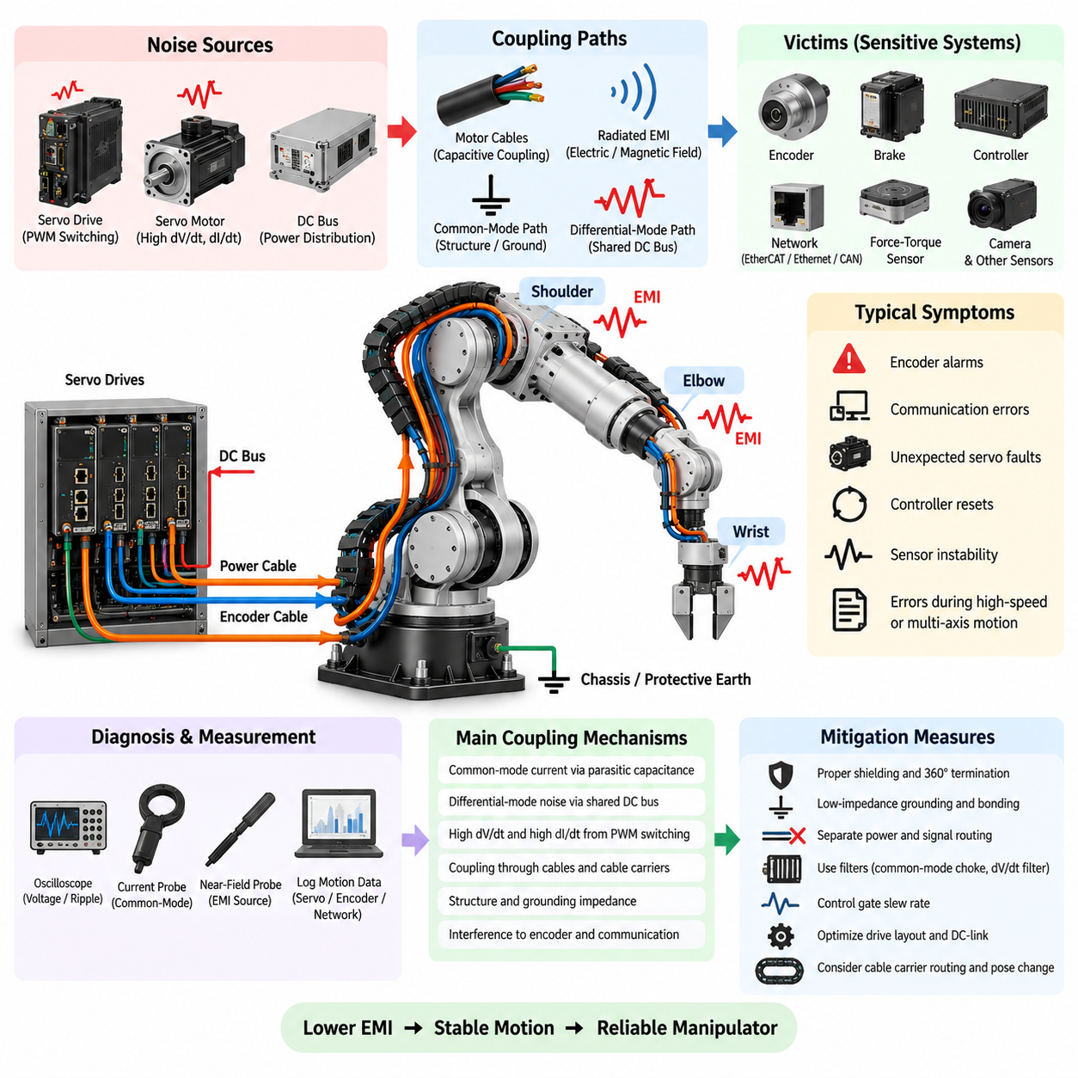
Industrial manipulators concentrate multiple high-power servo drives, motors, encoders, brakes, communication interfaces, and control electronics within a mechanically compact structure. Each joint repeatedly accelerates and decelerates while the servo inverter generates high-frequency PWM switching. As a result, a manipulator can become a complex electromagnetic environment in which noise generated at one joint propagates through power cables, motor frames, shields, grounding conductors, and the robot structure.
A typical servo EMI case appears during rapid multi-axis motion rather than during stationary operation. The manipulator may operate normally at low speed but exhibit encoder alarms, communication errors, unexpected servo faults, sensor instability, or controller resets when several joints accelerate simultaneously. These symptoms often become more frequent during high-torque motion, abrupt direction reversal, regenerative braking, or operation near the mechanical limits where servo current changes rapidly.
The primary EMI source is usually the servo inverter switching the DC bus through high-speed semiconductor devices. PWM voltage transitions create high dV/dt at the motor terminals, while rapidly changing phase currents generate high dI/dt. Although the commanded mechanical motion occurs at relatively low frequencies, the switching edges contain harmonic components extending into much higher frequency ranges. These components can couple into encoder, brake, communication, force-torque sensor, and auxiliary signal circuits.
Servo motor cables create an important propagation path because they normally carry both substantial motor current and rapidly changing PWM voltage. Cable capacitance between phase conductors, shields, motor housings, and surrounding structures allows common-mode current to flow during every switching transition. Long manipulator cable routes can increase this effect, particularly when cables pass through the base, shoulder, arm, wrist, and moving cable carriers before reaching individual servo motors.
Common-mode interference is especially significant when the servo motor frame, drive enclosure, cable shield, robot body, and protective earth do not form a sufficiently low-impedance high-frequency return structure. Fast displacement current may then seek unintended paths through encoder shields, communication cable shields, bearings, sensor grounds, or mechanical joints. A grounding connection that appears satisfactory when measured with a DC resistance meter can still exhibit substantial impedance at high frequencies because of conductor inductance.
Differential-mode interference can simultaneously propagate through the servo power distribution network. Rapid motor-current transitions generate voltage disturbances across the resistance and inductance of DC-bus conductors, connectors, and shared power paths. When several servo drives operate from a common DC source, disturbances from one axis may affect another axis. Regenerative energy and abrupt current changes can further modify the bus voltage, creating conditions in which switching noise and power-integrity problems appear together.
Encoder circuits are particularly important victims because precise servo control depends directly on reliable position and velocity feedback. Incremental encoders, absolute encoders, serial encoder interfaces, and resolver-related electronics may operate near powerful motor conductors inside the same moving structure. Noise coupled into encoder signals can produce position errors, invalid frames, checksum faults, or loss-of-synchronization events that the servo controller may interpret as a genuine motion-control failure.
Communication networks can provide another coupling path and another visible symptom. EtherCAT, industrial Ethernet, CAN-based networks, or proprietary servo links may pass close to motor cables through the robot base and cable carriers. Poor separation, inadequate shielding, incorrect connector termination, or excessive common-mode voltage can reduce communication margin. Intermittent packet or frame errors may therefore occur only during particular joint movements, making the problem appear software-related even when the root cause is electromagnetic.
Effective diagnosis requires correlation between electromagnetic events and manipulator operating states. Joint position, velocity, acceleration, torque command, motor current, DC-bus voltage, servo alarms, encoder errors, and network statistics should be recorded simultaneously where possible. Repeating the same trajectory at different speeds and loads helps determine whether the disturbance is related to switching activity, motor current, cable orientation, mechanical position, or simultaneous operation of several axes.
Oscilloscope measurements can examine DC-bus disturbances, motor phase switching, encoder power rails, signal integrity, and voltage differences between servo-drive ground and robot chassis. Current probes are useful for identifying common-mode current flowing on motor cables, shields, and grounding conductors. Near-field probes can locate strong electric or magnetic fields around servo drives, connectors, cable transitions, and control electronics, allowing engineers to trace the interference path rather than replacing suspected components blindly.
Cable routing should be investigated carefully because manipulator harness geometry changes with joint position. A motor cable and encoder cable that are adequately separated in one pose may approach each other or run parallel inside a cable carrier in another pose. High-power servo cables should therefore be separated from encoder, communication, force-torque sensor, camera, and other sensitive signal wiring wherever practical. Crossings are generally preferable to long parallel routes when physical separation cannot be maintained.
Shield termination strongly affects high-frequency performance. Servo motor cable shields should normally connect to the appropriate conductive enclosure or chassis using low-impedance connections, preferably through broad 360-degree termination rather than long pigtail wires. Connector backshells, cable glands, servo-drive enclosures, motor housings, and robot structural members should provide a controlled high-frequency return path. Discontinuities between these elements can convert the shield from an effective containment structure into part of the coupling problem.
Noise reduction at the servo drive itself may involve optimizing DC-link layout, reducing switching-loop inductance, controlling gate-drive slew rate, and applying suitable filtering. Slowing excessively fast switching edges can reduce dV/dt and associated common-mode current, although increased switching loss and semiconductor temperature must be evaluated. Depending on the measured spectrum and coupling mechanism, common-mode chokes, ferrites, line filters, output reactors, or dV/dt filters may provide additional attenuation.
Consider a manipulator that repeatedly reports encoder communication faults on a wrist joint whenever the shoulder and elbow axes accelerate together. Measurements may show that common-mode current generated by the larger servo drives travels along the robot structure and cable shields, while the wrist encoder cable runs parallel to a motor cable through part of the cable carrier. The wrist axis is therefore the visible victim even though the dominant noise source originates elsewhere in the manipulator.
Corrective actions in such a case can combine improved motor-shield termination, lower-impedance chassis bonding, increased separation between motor and encoder wiring, and adjustment of servo-drive switching characteristics. Local filtering or improved encoder power decoupling may increase immunity at the victim, but source and coupling-path improvements should remain the priority. Applying only a filter at the failing encoder may suppress one symptom while leaving excessive electromagnetic energy circulating through the overall robot structure.
Verification should reproduce the original worst-case trajectory and then extend testing beyond it. Multiple axes should operate simultaneously under representative payload, speed, acceleration, braking, and regenerative conditions. The robot should also be tested through different poses because harness geometry and structural current paths vary with joint position. Encoder error counters, communication statistics, servo alarms, controller health, and sensor behavior should be monitored continuously rather than relying only on successful completion of the commanded motion.
A robust solution requires measurable EMC margin rather than the simple disappearance of a fault. Manufacturing variation, replacement cables, different payloads, additional end-effectors, longer harnesses, or future sensor upgrades can change coupling conditions. Measurements of common-mode current, transient voltage, signal quality, power integrity, and communication error rate provide evidence that the underlying interference mechanism has been reduced sufficiently for realistic product variation and long-term operation.
The manipulator servo EMI case demonstrates the same fundamental source-path-victim relationship found throughout robot EMC engineering. Servo inverters and motors generate electromagnetic energy, cables and structural elements provide coupling paths, and encoders, networks, sensors, and controllers become potential victims. Designing servo power distribution, grounding, shielding, cable routing, filtering, and communication architecture as one integrated EMC system is therefore essential for stable and repeatable robotic motion.

10.03. LiDAR Interference Case
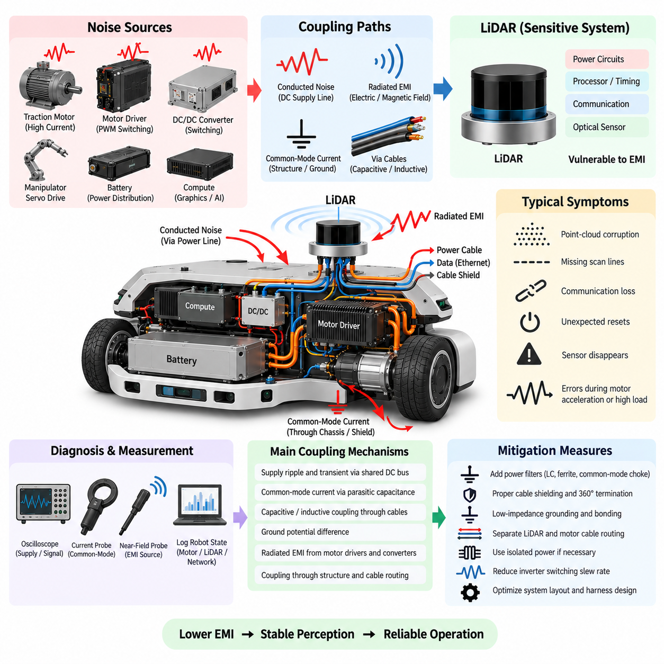
A LiDAR installed on an autonomous mobile robot operates as part of a tightly integrated electrical system containing traction motors, motor drivers, DC/DC converters, computing devices, communication networks, cameras, and other sensors. Although LiDAR is designed for accurate optical ranging, its power, processing, timing, and communication electronics remain vulnerable to electromagnetic interference. A disturbance originating elsewhere in the robot can therefore appear as a perception failure rather than an obvious electrical problem.
A typical LiDAR interference case may first appear as intermittent point-cloud corruption, missing scan lines, communication loss, unexpected resets, or temporary disappearance of the sensor from the perception system. The problem may occur only when traction motors accelerate, a manipulator moves, a high-power converter changes operating state, or another electrical load switches. Such correlation strongly suggests that the LiDAR fault should be investigated as a system-level EMC problem rather than only as a sensor defect.
One important coupling path is the LiDAR power supply. Switching noise from motor drivers or DC/DC converters can propagate through a shared DC distribution network and reach the LiDAR input. High-frequency ripple and short voltage transients may pass through wiring impedance and insufficient filtering even when the average supply voltage remains within specification. Sensitive internal regulators, processors, timing circuits, or communication transceivers may then become unstable without producing an obvious long-duration supply-voltage failure.
Common-mode current can create another interference mechanism. Fast inverter switching produces high dV/dt and drives displacement current through parasitic capacitances between power electronics, motor windings, chassis, cable shields, and structural components. If the robot does not provide a controlled low-impedance high-frequency return path, part of this current may flow through the LiDAR cable shield, sensor housing, communication connection, or local ground, disturbing the electrical reference used by the sensor.
Cable routing can significantly influence the severity of the problem. A LiDAR power or communication cable routed parallel to a motor phase cable, inverter output cable, or high-current battery conductor can receive capacitive and inductive coupling. Long parallel runs are particularly undesirable because they increase the effective coupling region. Maintaining physical separation and minimizing shared routing between noisy power wiring and sensitive LiDAR wiring can therefore provide substantial improvement without changing the sensor itself.
The LiDAR ground connection must also be examined carefully. A sensor may be connected simultaneously through its power return, communication interface, cable shield, and conductive mounting structure. These multiple connections can create unintended high-frequency current paths or ground-potential differences. In some architectures, deliberate ground isolation or isolated power can prevent motor-related current from entering the sensor domain, but isolation must be designed as part of the complete signal, shield, and chassis strategy rather than applied independently.
Diagnosis should begin by reproducing the interference under controlled robot operating conditions. Engineers should record LiDAR status, packet loss, point-cloud validity, sensor resets, motor current, inverter activity, DC-bus voltage, and robot operating state at the same time. Comparing stationary operation with acceleration, constant-speed motion, regenerative braking, and maximum-load operation helps identify whether the disturbance follows motor switching, current magnitude, mechanical motion, or another electrical event.
An oscilloscope can be used to examine the LiDAR input supply, local ground, chassis potential, and communication signals during the fault. Measurements should focus not only on low-frequency voltage variation but also on short high-frequency transients that may coincide with sensor errors. A current probe placed around the LiDAR cable or shield can reveal unexpected common-mode current, while a near-field probe can identify strong electromagnetic fields around motor drivers, converters, cable bundles, and connectors.
A useful isolation test is to temporarily operate the LiDAR from an electrically cleaner or isolated power source while maintaining the required communication path. If the interference disappears, the power or ground path becomes a strong suspect. Conversely, if the problem remains, cable coupling, shield current, communication susceptibility, or radiated interference should receive greater attention. Similar controlled substitutions help separate the source, coupling path, and victim without relying on random component replacement.
Power filtering should be placed close to the LiDAR when conducted noise is identified as a major contributor. Appropriate combinations of capacitors, ferrite components, LC filters, or common-mode chokes can attenuate disturbances before they enter the sensor. Filter selection must consider the measured noise spectrum, LiDAR current demand, startup behavior, cable impedance, and possible resonances. A filter chosen only by nominal current rating may provide little attenuation at the frequencies responsible for the actual failure.
Cable shielding and termination are equally important for high-frequency interference control. A shield should provide a low-impedance path for unwanted electromagnetic current and should be terminated according to the intended EMC architecture. Long pigtail connections can introduce substantial inductance and reduce shielding effectiveness at high frequencies. Where appropriate, short and broad or 360-degree shield termination provides better high-frequency behavior and prevents the shield from becoming an unintended antenna or coupling conductor.
Consider an AMR in which the front LiDAR occasionally resets whenever the traction motors produce maximum acceleration. Measurements reveal high-frequency common-mode current on the motor cables and corresponding transients on the LiDAR supply return. The LiDAR cable also shares a long harness route with motor wiring. In this case, the visible failure occurs at the LiDAR, but the root cause is the interaction between inverter switching, chassis current, shared power impedance, and cable routing.
Corrective actions can combine improved motor-cable shielding, lower-impedance chassis bonding, separation of LiDAR and motor harnesses, and additional filtering near the LiDAR power input. If necessary, isolated power can be considered to break an undesirable conducted path. Reducing excessive inverter switching slew rate may further lower the generated common-mode energy. The most effective solution normally addresses the noise source and coupling path before relying exclusively on increased immunity at the LiDAR.
LiDAR interference should also be distinguished from optical interference. Electromagnetic disturbance affects power, grounding, communication, or internal electronics, whereas optical interference originates from unwanted light or laser energy entering the sensing process. Both can produce abnormal point-cloud behavior, but their countermeasures are fundamentally different. Correlating errors with electrical switching and measuring conducted or radiated disturbances helps prevent an EMC problem from being misdiagnosed as an optical sensing problem.
Final verification should repeat the original worst-case condition and extend testing across representative robot states. Different motor speeds, acceleration levels, payloads, battery conditions, steering commands, converter loads, and simultaneous sensor operation should be included. LiDAR packet statistics, reset counters, point-cloud quality, communication health, and power integrity should be monitored continuously so that improvement is demonstrated quantitatively rather than inferred from a short period of apparently normal operation.
A robust design must retain sufficient EMC margin for production variation and future system changes. Cable length, connector condition, sensor mounting, replacement components, additional computing equipment, or higher-power motors can alter electromagnetic coupling. Measuring common-mode current, supply transients, communication quality, and LiDAR error rates provides evidence that the underlying mechanism has been reduced rather than merely shifted to an operating condition that was not included in the test.
The LiDAR interference case demonstrates that perception reliability depends on electrical architecture as well as sensing algorithms. Motor and converter switching form potential noise sources, power networks, grounds, chassis, shields, and cables establish coupling paths, and LiDAR electronics become the victim. Coordinated design of power filtering, isolation, grounding, cable routing, shielding, and source suppression is therefore essential for maintaining stable LiDAR operation in electrically complex robotic platforms.

10.04. Ethernet Noise Case
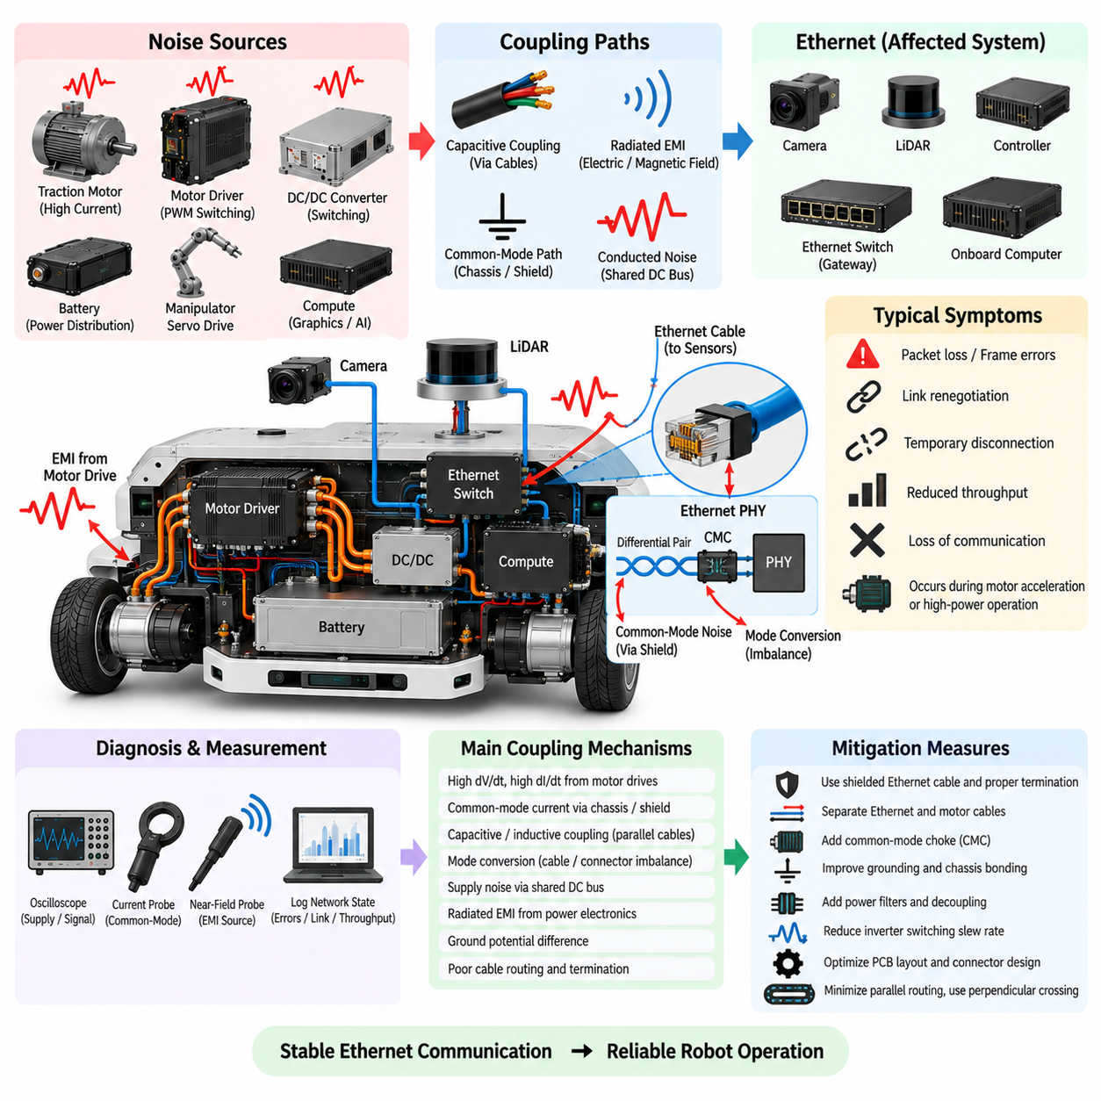
Ethernet communication in an autonomous mobile robot connects high-performance computers, LiDARs, cameras, gateways, controllers, and other intelligent devices while operating close to motors, inverters, DC/DC converters, and high-current power wiring. This combination creates a demanding electromagnetic environment. A network that performs reliably on a laboratory bench can therefore develop intermittent communication problems after installation inside the complete robot.
A typical Ethernet noise case may appear as packet loss, increased frame errors, link renegotiation, temporary disconnection, reduced throughput, or complete loss of communication with a sensor or controller. These symptoms often occur only during motor acceleration, regenerative braking, switching of a high-power load, or simultaneous operation of several actuators. Because the Ethernet link may automatically recover, the failure can initially be mistaken for software, driver, or network congestion problems.
The disturbance frequently originates from PWM motor drivers, servo inverters, switching converters, relays, or other fast-switching power circuits. High dV/dt produces strong electric-field coupling and common-mode displacement current, while high dI/dt generates magnetic fields and transient voltages across parasitic inductance. The resulting spectral energy can extend far beyond the fundamental switching frequency and overlap frequency ranges in which Ethernet cables, connectors, PHY circuits, and chassis structures remain susceptible.
Ethernet uses differential signaling to provide substantial immunity against external noise. Ideally, electromagnetic interference couples equally into both conductors of a differential pair and is rejected by the receiver. Real robot installations, however, contain cable imbalance, connector discontinuities, imperfect termination, asymmetric parasitic capacitance, and unequal PCB routing. These imperfections convert part of the common-mode disturbance into differential-mode voltage that directly reduces the signal margin available to the Ethernet PHY.
Common-mode current is therefore an important mechanism in practical Ethernet EMC failures. Motor and inverter switching can drive high-frequency current through the chassis, cable shields, equipment housings, and grounding structures. If an Ethernet shield becomes part of this unintended return path, substantial current may flow along the network cable. Voltage developed across shield and connector impedance can then couple into the twisted pairs or disturb the local electrical reference of the PHY and associated circuitry.
Cable routing often determines whether this mechanism becomes severe enough to produce communication errors. Ethernet cables routed parallel to motor phase cables, battery conductors, inverter outputs, or switching-power wiring can experience capacitive and inductive coupling over the shared distance. Long parallel routes are particularly undesirable. Maintaining separation, minimizing parallel exposure, and crossing noisy power cables approximately perpendicular where unavoidable can substantially reduce electromagnetic coupling.
Shielded Ethernet cables can improve EMC performance, but only when the shield and connector system are designed correctly. A shield should provide a controlled low-impedance high-frequency path rather than an arbitrary connection between equipment grounds. Shielded connectors, conductive backshells, and appropriate chassis termination should preserve shielding continuity through the interface. Long pigtail connections increase inductance and can significantly reduce shielding effectiveness at high frequencies.
The Ethernet PHY layout is another critical part of the interference path. Differential pairs should maintain controlled impedance, symmetry, and short routing between the PHY, magnetics or coupling network, connector, and protection components. Stubs, excessive vias, unnecessary layer transitions, poor reference-plane continuity, and asymmetric routing can increase mode conversion and reduce noise immunity. EMC performance therefore depends not only on the external cable but also on the PCB implementation at both ends of the link.
Common-mode chokes are frequently used near Ethernet interfaces to suppress unwanted common-mode energy while allowing differential data signals to pass. Their effectiveness depends on impedance versus frequency, parasitic characteristics, differential insertion loss, and compatibility with the specific Ethernet interface. A choke selected without considering the measured disturbance spectrum may provide limited improvement, while an inappropriate component can degrade signal integrity even if its nominal current or impedance appears suitable.
Diagnosis should correlate network errors with robot operating conditions. Ethernet CRC errors, dropped packets, link status, retransmissions where applicable, throughput, sensor timestamps, motor current, inverter switching state, DC-bus voltage, and robot motion should be recorded together. Repeating the same trajectory at different acceleration levels and payloads can reveal whether failures correlate with motor current, switching transitions, cable position, or simultaneous operation of multiple electrical subsystems.
Oscilloscope measurements can examine supply noise at the PHY, common-mode voltage, differential signal quality, and transient disturbances occurring during link errors. A current probe around an Ethernet cable can reveal high-frequency common-mode current flowing through the cable or shield. Near-field probes can identify strong emission regions around motor drivers, DC/DC converters, connectors, and cable bundles, helping engineers distinguish radiated coupling from conducted or chassis-related mechanisms.
A practical isolation experiment is to temporarily reroute the Ethernet cable away from high-power wiring while keeping all network settings unchanged. If communication errors decrease significantly, cable coupling becomes a strong suspect. Similar tests can compare shielded and correctly terminated cable configurations, alternative power sources for the affected device, or different chassis-bonding arrangements. Controlled changes are more informative than replacing several network components simultaneously.
Consider an AMR whose LiDAR Ethernet link occasionally disconnects whenever both traction motors accelerate rapidly. Network logs show increased frame errors immediately before link loss, while measurements reveal high-frequency common-mode current on the Ethernet shield. Inspection also shows that the Ethernet cable and motor phase cables share a long parallel harness route. The apparent LiDAR communication failure is therefore the visible result of a wider motor-to-network EMC coupling problem.
Corrective action should address the complete source-path-victim chain. Separating Ethernet and motor wiring reduces coupling, while improved motor-cable shielding and chassis bonding reduce the electromagnetic energy entering the robot structure. Proper Ethernet shield termination provides a controlled high-frequency return path, and suitable common-mode filtering can improve interface immunity. Source suppression through inverter layout optimization or slew-rate control can further reduce the disturbance before it reaches the network.
Power integrity should also be verified because an apparent Ethernet noise problem may involve the supply of the PHY, switch, sensor, or gateway. A transient entering through the shared DC network can momentarily disturb the Ethernet electronics even when the cable itself has excellent signal integrity. Local filtering, decoupling, improved power distribution, or isolation may therefore be required when measurements show that network errors correlate with supply disturbances rather than direct cable coupling.
Final verification should reproduce the original worst-case operating condition and then expand testing across motor speed, acceleration, payload, battery state, regenerative braking, sensor activity, and simultaneous network traffic. Error counters and link status should be monitored continuously. Successful data transfer for a short period is insufficient because an EMC-sensitive link may recover automatically after each disturbance while still producing unacceptable intermittent failures during long-term robot operation.
A robust Ethernet design requires sufficient margin for manufacturing variation, cable replacement, additional sensors, higher network speeds, and future powertrain changes. Measurements of common-mode current, PHY supply integrity, frame-error rate, link stability, and signal quality provide quantitative evidence of improvement. This prevents a temporary routing adjustment from being accepted as a permanent solution when the underlying electromagnetic coupling remains close to the failure threshold.
The Ethernet noise case demonstrates that reliable robot networking depends on the interaction of power electronics, grounding, shielding, cable routing, connector design, filtering, and PHY implementation. The network cannot be treated as an isolated digital subsystem. By identifying the noise source, tracing its coupling path, evaluating the Ethernet interface as the victim, and validating corrective actions under worst-case robot operation, stable communication can be maintained throughout the complete robotic platform.

10.05. UAV Avionics EMC Case
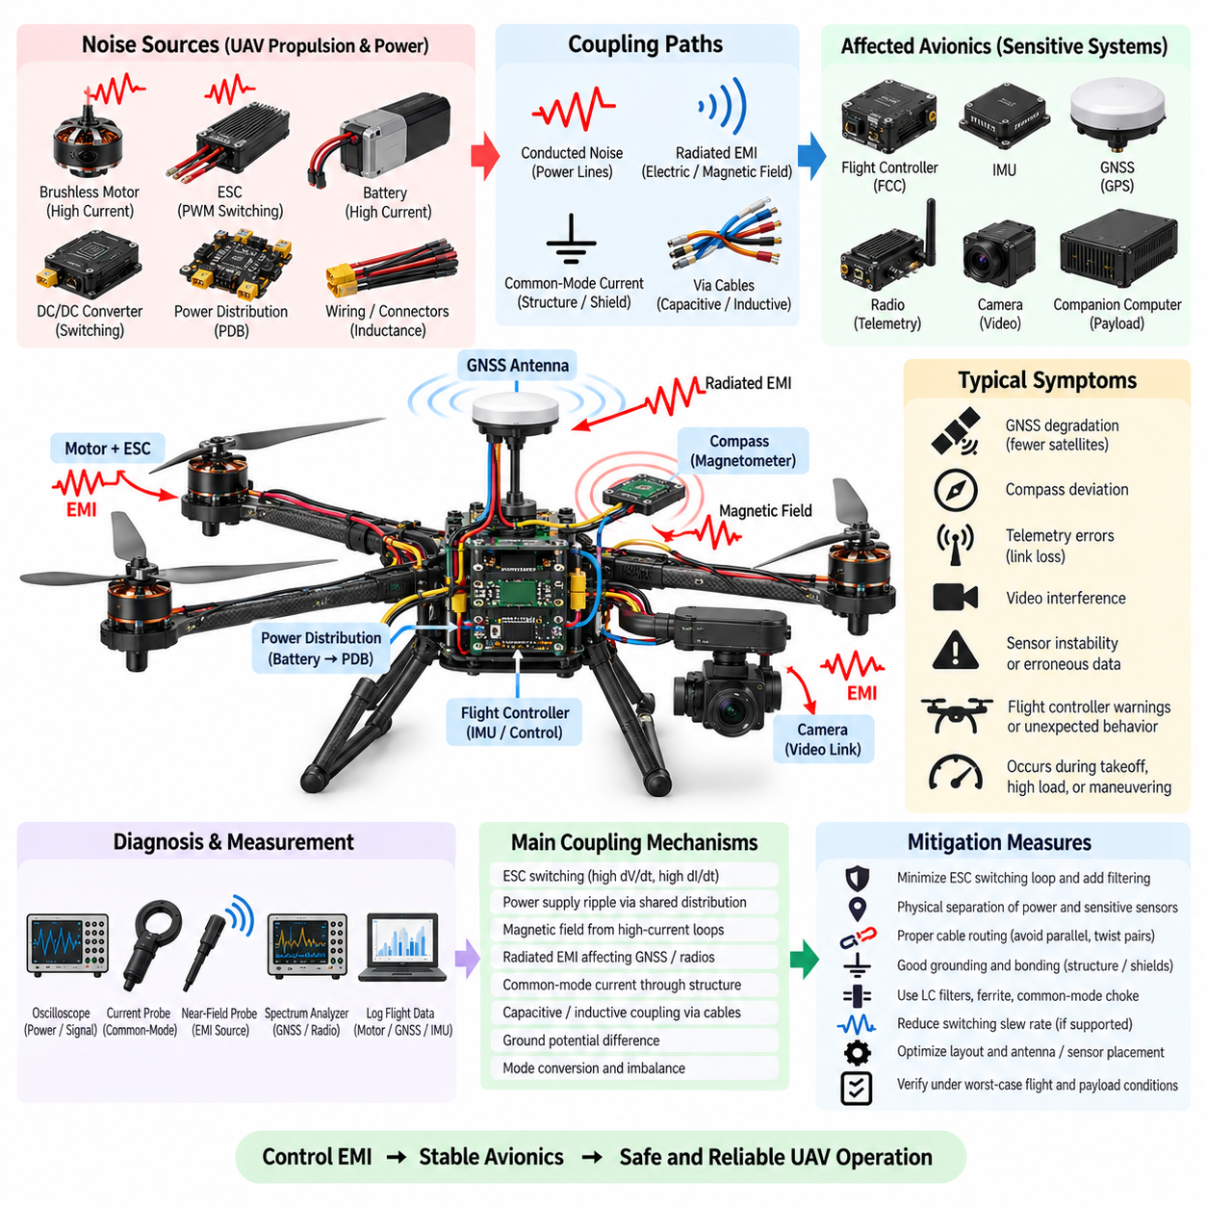
Unmanned aerial vehicles integrate propulsion, flight control, navigation, communication, sensing, and payload electronics within a compact airframe where weight and space are tightly constrained. High-current motors and electronic speed controllers operate close to sensitive avionics such as flight controllers, IMUs, GNSS receivers, radios, cameras, and navigation computers. This combination makes electromagnetic compatibility a system-level requirement directly related to flight stability and mission reliability.
A representative UAV avionics EMC problem may appear only after the propulsion system reaches high power. During takeoff, rapid climb, aggressive maneuvering, or operation with a heavy payload, the vehicle may experience GNSS degradation, compass deviation, telemetry errors, video interference, sensor instability, or unexpected flight-controller warnings. Because these symptoms correlate with motor thrust and electrical load, propulsion-related electromagnetic interference should be considered early in the investigation.
The propulsion system is normally one of the strongest electrical noise sources. Electronic speed controllers switch battery power rapidly through MOSFETs to control brushless motors, producing high dV/dt and high dI/dt waveforms. Fast voltage transitions generate capacitive displacement currents, while rapidly changing phase currents create magnetic fields and voltage transients across wiring inductance. Harmonic energy from these switching events can extend far beyond the fundamental PWM frequency.
Battery and power-distribution wiring provides another important path. Several motors can draw large and rapidly varying currents simultaneously, causing voltage ripple and transient disturbances across cable, connector, and distribution-board impedance. If avionics equipment shares these power paths without sufficient separation, filtering, or local energy storage, disturbances can propagate into flight-controller, navigation, communication, and sensor supplies even when the average battery voltage remains within the expected operating range.
Magnetic interference is particularly important for UAVs using magnetometers as part of their heading estimation. Motor phase currents, battery cables, power-distribution conductors, and high-current loops generate magnetic fields that can distort compass measurements. The problem often changes with throttle because propulsion current changes with thrust demand. Locating the magnetometer away from high-current wiring and minimizing power-loop area are therefore fundamental considerations in the physical avionics architecture.
GNSS systems present a different susceptibility problem because satellite signals arriving at the antenna are extremely weak. Broadband emissions or harmonics from switching converters, processors, digital interfaces, radios, or motor-control electronics can raise the local noise floor near GNSS frequencies. Noise can reach the receiver through radiation, antenna coupling, power lines, or cable shields, resulting in reduced satellite count, degraded signal quality, slower positioning, or intermittent loss of navigation performance.
Common-mode current can spread propulsion noise beyond the immediate motor and ESC region. Parasitic capacitance between switching nodes, motor windings, heat sinks, cable shields, conductive structures, and avionics grounds provides high-frequency current paths. In conductive airframes, these currents may distribute through structural members. In composite airframes, dedicated grounding and bonding paths become more important because the structure itself may not provide predictable high-frequency current return behavior.
Cable routing therefore has a major influence on UAV EMC performance. Motor phase wiring and battery conductors should be kept away from GNSS antenna cables, magnetometer wiring, flight-control signals, camera interfaces, and communication harnesses whenever practical. High-current conductor pairs should be routed closely together to minimize loop area, while sensitive cables should avoid long parallel runs with propulsion wiring. Separation is often more effective and lighter than adding extensive filtering after integration.
Shielding must be applied selectively because UAV design is strongly constrained by mass. Shielded cables may be justified for particularly sensitive communication, video, or sensor interfaces, but shielding is effective only when termination and grounding are properly designed. A poorly terminated shield can add weight without providing meaningful high-frequency attenuation. Short, low-inductance connections and appropriate chassis or enclosure bonding are therefore more important than simply adding conductive material around every cable.
Diagnosis should correlate avionics behavior with propulsion operating state. Motor speed, ESC command, battery current, bus voltage, flight-controller warnings, GNSS satellite statistics, IMU status, compass measurements, communication errors, and payload activity should be logged together where possible. Ground testing with propellers removed or with an appropriate controlled propulsion setup can help identify electrical interference, although the final configuration must also be tested because current, mechanical geometry, and operating conditions change in flight.
Oscilloscope measurements can examine avionics power rails, battery-bus ripple, ESC switching transients, and voltage differences between electrical reference points. Current probes can identify common-mode currents on power or signal cables, while near-field probes can locate strong emissions around ESCs, DC/DC converters, processors, and harness transitions. A spectrum analyzer can be particularly useful when interference with GNSS, radio, or telemetry systems is suspected because frequency-domain measurements can reveal harmonics near vulnerable receiver bands.
Controlled substitution is useful for separating coupling paths. Temporarily powering sensitive avionics from a cleaner isolated supply can indicate whether conducted noise enters through the power network. Moving a GNSS antenna or magnetometer farther from propulsion wiring can reveal radiated or magnetic coupling. Rerouting a communication cable can expose harness-related interference. Each experiment should change one major variable so that the source-path-victim relationship remains identifiable.
Consider a UAV that maintains stable GNSS reception with motors stopped but loses satellite signal quality when throttle exceeds a certain level. Measurements may reveal increased broadband noise from an ESC or DC/DC converter, while inspection shows the GNSS antenna cable routed close to propulsion wiring. The apparent navigation problem is therefore not necessarily a GNSS receiver defect but a system interaction involving switching emissions, cable coupling, antenna susceptibility, and power-distribution noise.
Corrective action can begin by reducing interference at the source. ESC switching loops should be physically compact, DC-link capacitors should be positioned close to switching devices, and unnecessary wiring inductance should be minimized. Appropriate slew-rate control may reduce excessive switching-edge energy when supported by the ESC design. Ferrites, LC filters, common-mode chokes, or local decoupling can then be applied according to the measured disturbance mechanism and frequency range.
Physical architecture improvements can be equally important. Increasing separation between propulsion electronics and navigation sensors, relocating the GNSS antenna, reducing high-current loop area, twisting or closely pairing power conductors, improving grounding and bonding, and separating noisy and sensitive harnesses can provide large EMC improvements with limited mass penalty. For UAVs, these geometric solutions are particularly valuable because they avoid the weight and thermal penalties associated with excessive shielding and filtering.
Verification must include representative worst-case propulsion and payload conditions. Low-throttle bench operation alone is insufficient because maximum interference may occur during takeoff, high-current climb, rapid motor-command transitions, regenerative or braking behavior where applicable, simultaneous payload operation, or communication transmission. Navigation quality, sensor stability, flight-controller status, telemetry performance, and power integrity should be monitored continuously while operating across the intended electrical envelope.
A robust UAV EMC solution must also account for configuration changes. Different propellers, motors, ESC firmware, battery types, payloads, radios, antennas, cable lengths, or computing modules can change current demand and electromagnetic coupling. Quantitative measurements of supply transients, magnetic disturbance, common-mode current, receiver signal quality, communication errors, and avionics health provide evidence that sufficient EMC margin exists beyond one successful prototype configuration.
The UAV avionics EMC case demonstrates that electromagnetic compatibility is closely connected to flight integrity. Propulsion electronics and converters form major noise sources, power wiring, structures, grounds, and electromagnetic fields establish coupling paths, and navigation, sensing, communication, and flight-control electronics become potential victims. Integrating source suppression, power filtering, grounding, bonding, cable routing, shielding, and physical separation from the beginning is therefore essential for dependable UAV operation.

