Volume 05. Grounding and EMC

Chapter 01. Grounding Theory

01.01. Single Point Ground
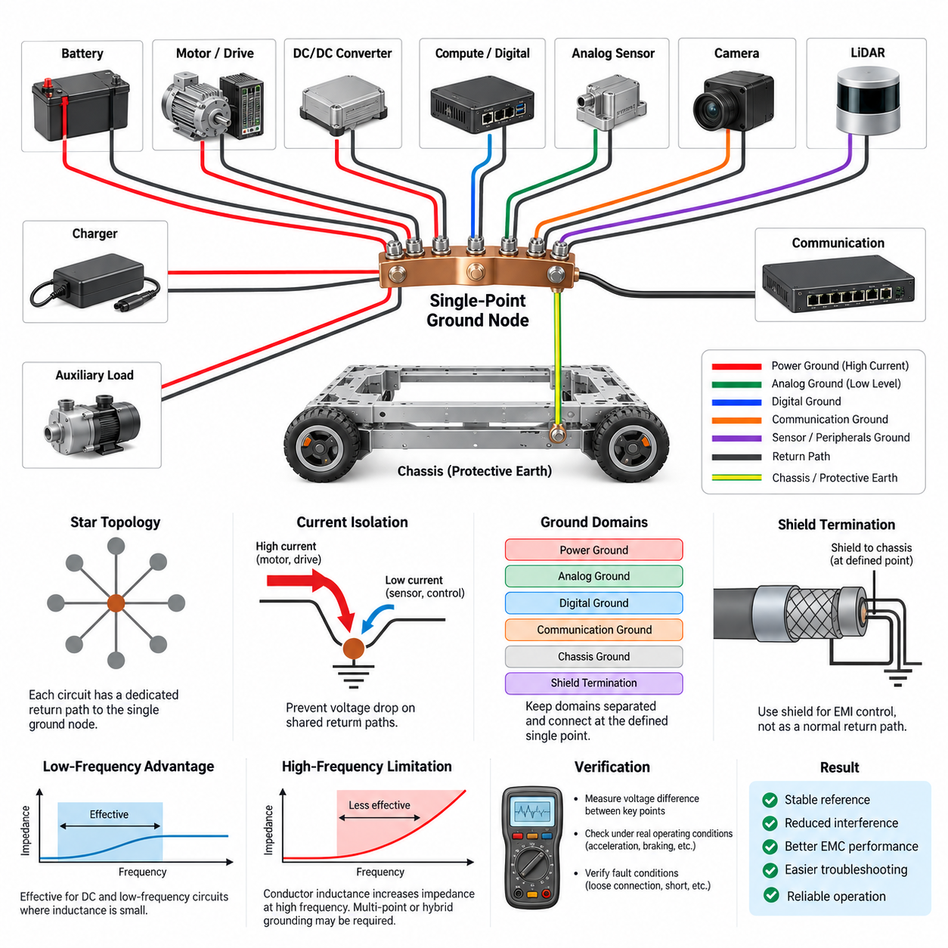
A single-point ground architecture connects the reference returns of multiple electrical and electronic subsystems to one intentionally defined grounding node. Instead of allowing return currents to flow through arbitrary chassis paths or several interconnected ground points, the architecture establishes a controlled reference location where power, control, sensing, and communication grounds are coordinated. This method is especially useful when predictable low-frequency behavior is more important than minimizing high-frequency impedance.
The fundamental objective is to prevent shared return paths from converting load current into unwanted signal voltage. Every conductor has resistance and inductance, so a current flowing through a common ground conductor produces a voltage difference according to its impedance. If a motor, relay, processor, and analog sensor share the same uncontrolled return path, large transient currents can disturb the reference voltage used by sensitive electronics. A single-point structure separates these paths until they reach the designated common node.
A practical single-point ground is often visualized as a star topology. Individual circuits or functional domains receive dedicated return conductors that converge at a central grounding point rather than being connected sequentially from one device to another. High-current loads should therefore not return through conductors used by low-level sensors or communication electronics. The star arrangement makes current paths easier to understand, calculate, measure, and troubleshoot because each branch has a relatively explicit electrical function.
Ground location is a system-level design decision rather than simply a convenient mechanical connection. The selected point should normally have a low and stable impedance to the intended reference, sufficient current capability, reliable mechanical construction, and controlled relationships with battery return and chassis. In a robot, the grounding node may be located near the power distribution unit, battery return junction, or another intentionally designed distribution structure depending on the overall electrical architecture and safety requirements.
Single-point grounding is particularly effective for DC and relatively low-frequency circuits because conductor inductance has limited influence in that frequency range. Analog sensors, low-frequency measurement circuits, reference supplies, and sensitive control electronics can benefit from clearly separated return paths. The technique reduces common impedance coupling and helps prevent variations in propulsion or actuator current from directly shifting the electrical reference used by low-level measurement circuits.
The architecture does not imply that every ground in a complex robot should be electrically identical. Designers commonly distinguish power ground, analog ground, digital ground, communication reference, chassis ground, shield termination, and protective bonding according to their functions. These domains can remain physically or functionally separated over portions of the system and meet only at deliberately selected locations. The important principle is that connections between domains must be engineered rather than created accidentally through mounting hardware or cable shields.
Power-ground branches require special attention because traction motors, servo drives, pumps, heaters, DC/DC converters, and other high-current loads can produce substantial steady-state and transient currents. Their return conductors should follow controlled low-impedance routes toward the main grounding node. Sensitive electronics should use separate branches so that voltage drops produced by high-current loads do not appear directly in sensor or processor references. This separation is essential in mobile robots where load currents change rapidly during acceleration and braking.
Analog grounding requires additional care because sensor outputs may represent millivolt-level information while nearby power electronics switch tens of amperes. A dedicated analog return path can reduce interference caused by shared impedance, but the connection between analog and digital domains must still be defined carefully. If an ADC or mixed-signal device transfers information between the two domains, the grounding strategy should support the actual current flow around that interface rather than relying only on schematic ground labels.
Digital systems can also generate substantial ground noise because processors, memory devices, communication controllers, and switching regulators draw rapidly changing currents. Local decoupling capacitors provide short high-frequency current loops close to devices, while the system grounding network establishes the larger reference structure. Consequently, single-point grounding should not be interpreted as forcing every transient current to travel physically to the central node. Local current loops and system-level reference management perform different but complementary functions.
Chassis ground must be distinguished from ordinary signal return. The conductive robot frame can provide shielding, fault-current control, electrostatic discharge paths, and electromagnetic compatibility functions, but uncontrolled chassis connections may also create unintended parallel return paths. If electronic ground is bonded to chassis at a defined point, additional bonds through mounting screws, connector shells, sensor housings, or cable shields must be reviewed carefully. Otherwise, the intended single-point topology can silently become a multi-point network.
Cable shields require similar consideration. A shield is primarily intended to control electromagnetic fields and common-mode interference rather than serve as a normal operating-current return conductor. Connecting a shield to signal ground at arbitrary locations can introduce noise into the reference network or create an unintended ground loop. Shield termination therefore has to be coordinated with grounding architecture, connector construction, frequency range, chassis design, and EMC objectives rather than treated as an independent wiring detail.
The major limitation of single-point grounding appears as operating frequency increases. Long conductors possess inductance, and their impedance rises with frequency, so a physically remote star point may no longer behave as an equipotential reference for fast switching edges or RF currents. High-frequency interference often requires short chassis bonds, low-inductance planes, distributed capacitive coupling, or multi-point grounding techniques. For this reason, sophisticated robotic systems frequently evolve toward hybrid grounding architectures instead of applying a pure single-point method everywhere.
Physical implementation determines whether the theoretical architecture actually works. Ground conductors should be sized for expected current and transient conditions, while connection resistance should remain low throughout vibration, temperature cycling, humidity, oxidation, and service life. Crimp joints, studs, busbars, PCB connections, and chassis bonds should be designed so their electrical function remains reproducible. A beautifully drawn star-ground schematic provides little benefit if several branches share an undersized harness segment before reaching the actual grounding node.
Ground-voltage measurements are useful during validation. Engineers can measure voltage differences between battery negative, the central ground node, controller ground, sensor ground, chassis, and high-current load returns while operating the robot under realistic conditions. Acceleration, regenerative braking, steering actuation, manipulator motion, charger operation, and communication activity can reveal disturbances that are invisible during static testing. Both steady voltage drop and transient behavior should be evaluated because different mechanisms dominate at different frequencies.
Grounding verification should also include fault conditions. A loose return terminal, damaged conductor, corroded chassis bond, short circuit, or disconnected sensor ground can force current through unexpected secondary paths. These paths may include communication cables, shields, mechanical structures, or interface electronics that were never intended to carry substantial current. Understanding these possibilities during design helps prevent connector damage, intermittent communication failures, sensor offsets, controller resets, and difficult field failures.
In an AMR, a useful implementation may place the battery and power distribution system near the principal DC reference while propulsion drives, steering controllers, compute units, sensors, and auxiliary loads use controlled return branches. High-current propulsion returns can be kept electrically distinct from LiDAR, camera, IMU, GNSS, and compute references until the intended convergence point. This organization supports both EMC performance and systematic troubleshooting as the robot architecture becomes more complex.
Single-point grounding should therefore be treated as a current-path management strategy rather than merely a rule stating that all grounds must meet at one location. Its effectiveness depends on identifying where operating currents, transient currents, fault currents, common-mode currents, and shield currents actually flow. When those paths are intentionally separated and reunited according to their electrical functions, the architecture provides a stable reference foundation for reliable sensing, computation, communication, and power control.
A successful design ultimately balances grounding topology with frequency, physical dimensions, current magnitude, EMC requirements, safety, and mechanical packaging. Single-point grounding offers a strong foundation for understanding and controlling low-frequency return currents, while its limitations naturally lead to multi-point and hybrid techniques addressed elsewhere in the grounding architecture. This makes it an essential starting concept for designing predictable electrical behavior in AMRs, manipulators, autonomous vehicles, and other Physical AI systems.

01.02. Multi Point Ground
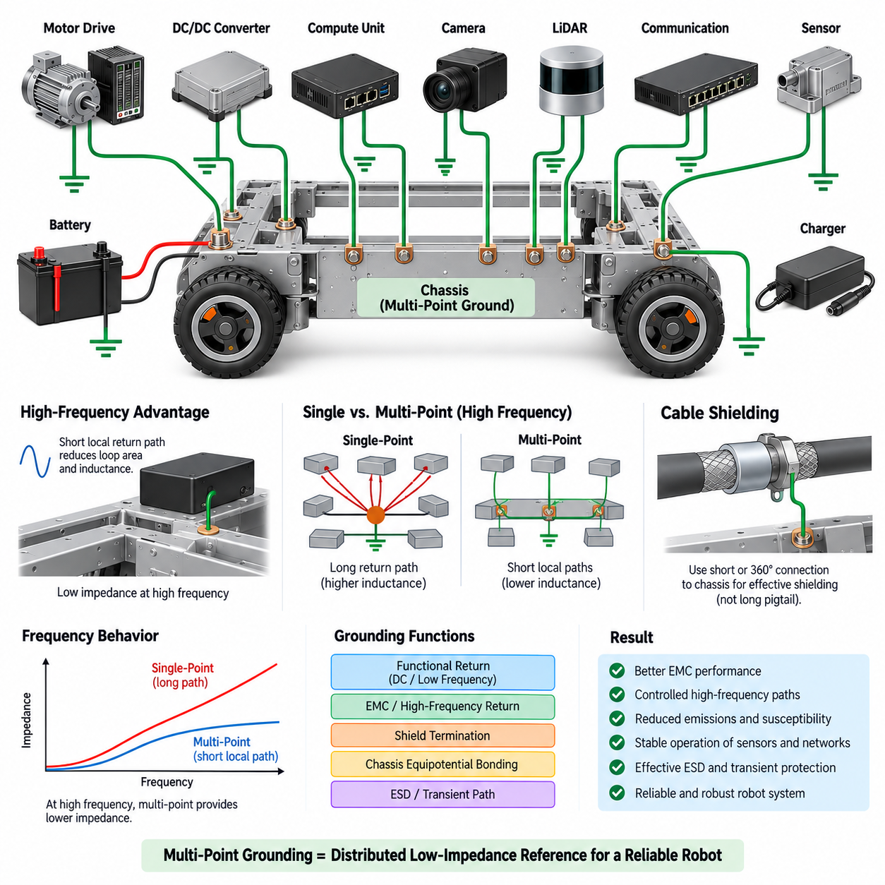
Multi-point grounding connects circuit references, equipment enclosures, shields, and chassis structures at multiple locations rather than forcing all return paths to converge at one central node. The objective is to create a distributed, low-impedance reference network, particularly for high-frequency currents whose behavior is strongly influenced by conductor inductance. In complex robotic systems, this approach can provide more effective electromagnetic control than a physically long single-point return structure.
The fundamental reason for using multi-point grounding is that a conductor does not behave as an ideal zero-impedance connection at high frequency. As frequency increases, parasitic inductance becomes increasingly important, and even a relatively short wire can develop significant impedance. A remote single grounding point may therefore cease to provide a common electrical reference for fast switching edges, RF currents, digital interfaces, and electromagnetic interference generated by modern power electronics.
In a multi-point architecture, equipment grounds are connected to a conductive reference structure at several strategically selected locations. This reference may be a chassis, enclosure, ground plane, structural frame, or another intentionally designed conductive network. Because high-frequency currents can reach the reference through short connections, their loop area and associated inductance can be reduced. The resulting structure provides many parallel paths rather than one long return path extending across the complete system.
The effectiveness of multi-point grounding depends heavily on connection impedance. A physically short and wide connection generally provides lower high-frequency inductance than a long, narrow wire. Bonding straps, conductive mounting surfaces, PCB ground planes, enclosure walls, and carefully designed chassis interfaces can therefore perform important grounding functions. At high frequency, connection geometry may be as important as DC resistance because inductive impedance can dominate the behavior of the current path.
Chassis structures are especially useful in multi-point grounding when they are intentionally designed as electromagnetic reference structures. A conductive robot frame can connect multiple electronic modules, motor-drive enclosures, power converters, communication interfaces, and cable shields through short local bonds. This does not mean that the chassis should automatically carry normal DC load current. Functional return currents and high-frequency common-mode currents should be distinguished so that the chassis performs its intended EMC and protective functions.
Multi-point grounding is particularly relevant to switching power systems. Motor inverters, servo drives, DC/DC converters, switching regulators, and high-speed processors generate current components extending far beyond their nominal operating frequencies. Fast voltage transitions create displacement currents through parasitic capacitances between circuits, heat sinks, motor windings, cables, and chassis structures. Providing controlled local high-frequency return paths can prevent these currents from traveling through sensitive signal circuits or long harness paths.
Motor-drive systems illustrate this principle clearly. PWM switching produces rapid voltage transitions that can couple through motor cables and parasitic capacitances into the mechanical structure. If the motor-drive enclosure, cable shield, motor housing, and chassis have low-impedance high-frequency connections, common-mode current can follow a controlled path. Poor bonding can instead force this current through bearings, sensor wiring, communication cables, or other unintended routes, increasing both emissions and susceptibility problems.
Cable shielding also benefits from multi-point grounding at sufficiently high frequencies. A shield intended to suppress electromagnetic coupling performs best when its termination provides a low-impedance continuation into the surrounding conductive structure. Long pigtail connections introduce inductance and can significantly reduce shielding effectiveness. For high-frequency applications, short or 360-degree shield terminations to connector shells or chassis structures are often more effective than routing the shield through a long wire to a distant ground node.
Digital communication networks introduce another important application. Ethernet, high-speed serial interfaces, cameras, LiDARs, processors, and distributed controllers contain rapidly changing signals that can generate common-mode noise. Their signal integrity depends primarily on properly controlled differential paths, but unwanted common-mode energy still requires a suitable return structure. Local chassis bonding, connector shielding, and distributed grounding can reduce the high-frequency voltage differences that otherwise develop between physically separated modules.
A multi-point network must not be interpreted as permission to connect every ground indiscriminately. Uncontrolled connections can create circulating currents, unexpected coupling, and low-frequency ground-loop problems. Each bond should have a defined purpose, such as RF return, shield termination, chassis equipotential bonding, ESD control, or fault-current management. The designer must understand which current components are expected to use each path and which currents should remain confined to dedicated power or signal-return conductors.
Frequency therefore becomes a central design parameter. At low frequency and DC, multiple conductive paths between separated nodes can permit unwanted circulating currents when small potential differences exist. At higher frequencies, however, the inductance of long single-point connections can make distributed local bonding preferable. This frequency-dependent behavior explains why multi-point grounding is not simply the opposite of single-point grounding; each architecture addresses different dominant physical mechanisms.
Ground planes provide a compact example of multi-point grounding. On a PCB, numerous components may connect directly to a continuous conductive plane through short traces and vias. The plane offers many parallel current paths and minimizes return-loop area for high-speed signals. Similar reasoning can be extended to equipment-level structures, although a robot chassis is electrically and geometrically more complicated than a PCB plane and must therefore be characterized with greater attention to joints, dimensions, coatings, and discontinuities.
Mechanical interfaces can strongly influence grounding performance. Painted surfaces, anodized aluminum, corrosion, loose fasteners, bearings, hinges, and structural joints may have acceptable mechanical characteristics while presenting unpredictable electrical impedance. Where a chassis connection is required for EMC, the bonding interface should be intentionally engineered. Conductive surfaces, suitable fasteners, bonding straps, controlled contact pressure, and corrosion protection help maintain predictable electrical behavior throughout the robot's service life.
Distributed grounding also interacts with electrostatic discharge and transient immunity. When an ESD event reaches a robot enclosure or external connector, the resulting current contains very fast components and naturally seeks low-inductance paths. A well-bonded conductive structure can distribute this energy around sensitive electronics rather than through them. Poorly connected panels or isolated structural sections can develop substantial transient voltage differences, increasing the possibility of processor resets, communication errors, or component damage.
Validation should examine the grounding network under realistic operating conditions rather than relying solely on DC continuity measurements. A low resistance measured with a multimeter does not guarantee low impedance at several megahertz. Engineers may evaluate bonding impedance, common-mode current, conducted emissions, radiated emissions, transient behavior, and voltage differences between chassis locations while motors, converters, processors, sensors, and communication systems operate simultaneously.
Current probes, oscilloscopes, spectrum analyzers, impedance measurement techniques, and near-field probes can help identify unexpected high-frequency paths. Measurements should be performed during operating states that generate strong electrical disturbances, including motor acceleration, PWM switching, regenerative braking, DC/DC load transitions, communication activity, and actuator operation. The objective is to determine whether noise currents remain within the intended grounding and shielding network or migrate into sensitive interfaces.
For an AMR or other Physical AI platform, multi-point grounding can connect motor-drive enclosures, compute housings, shielded connectors, sensor housings, and selected chassis locations into a distributed electromagnetic reference. Cameras, LiDARs, Ethernet interfaces, high-performance edge computers, and propulsion electronics can then use short local high-frequency connections while their functional DC returns remain deliberately controlled. This separation between functional current paths and EMC current paths is critical to robust system integration.
Multi-point grounding is therefore best understood as a distributed impedance-management strategy. Its purpose is not merely to increase the number of physical ground connections, but to provide short, predictable paths for high-frequency and common-mode currents while preventing those currents from interfering with sensitive electronics. Effective implementation requires coordinated design of chassis bonding, PCB grounding, connector shells, cable shields, enclosures, harness routing, and power-electronic interfaces.
In practical robotics, neither pure single-point nor pure multi-point grounding is universally optimal. Low-frequency sensor and power-return requirements may favor controlled single-point relationships, while high-frequency EMC requirements favor local multi-point bonding. Understanding this distinction provides the foundation for hybrid grounding architectures, where different grounding mechanisms coexist according to frequency and function. Such an approach is increasingly important as robots combine high-power actuators, fast switching converters, high-speed networks, precision sensors, and powerful edge computing within a compact conductive structure.

01.03. Hybrid Ground Architecture
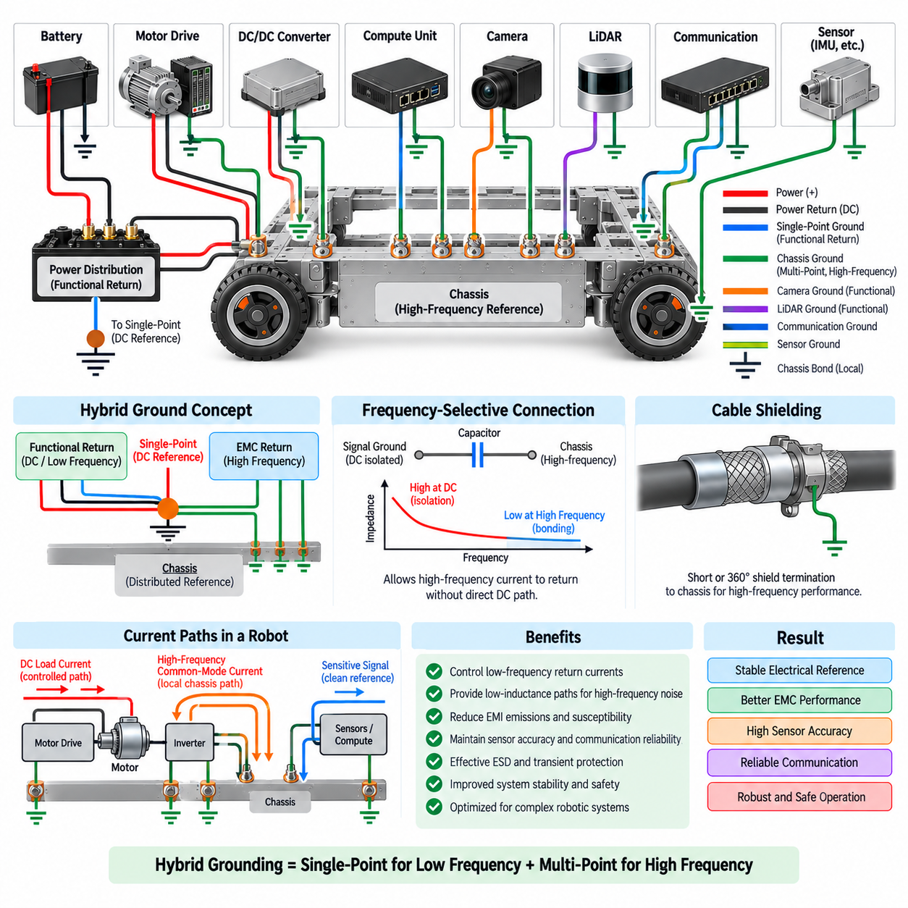
Hybrid grounding architecture combines single-point and multi-point grounding principles so that different current components can follow paths appropriate to their frequency, function, and electromagnetic behavior. Low-frequency functional returns may converge through controlled single-point connections, while high-frequency noise and common-mode currents use short distributed bonds to chassis or other reference structures. This allows one system to satisfy requirements that neither pure grounding method can address efficiently by itself.
The need for a hybrid architecture arises because grounding behavior changes with frequency. At DC and low frequencies, conductor resistance and shared return voltage drops are important, making controlled single-point paths useful for preventing unwanted coupling between power and sensitive circuits. At higher frequencies, conductor inductance becomes increasingly significant, so long wires leading to a remote star point may present excessive impedance and prevent noise currents from returning through the intended path.
A hybrid system therefore separates the concepts of functional current return and electromagnetic current return. Functional DC currents from controllers, sensors, processors, and power loads are routed through intentionally defined conductors toward the appropriate power reference. High-frequency common-mode currents, ESD transients, switching noise, and shield currents may instead be coupled or bonded locally to chassis. The two networks interact at controlled locations but are not assumed to perform identical electrical functions.
A typical robotic implementation may use battery negative as the principal DC power reference while a conductive chassis acts as a distributed high-frequency reference. Motor drives, DC/DC converters, compute units, sensors, and communication devices receive dedicated or carefully grouped functional return conductors. At the same time, their conductive housings, connector shells, and cable shields may be bonded locally to chassis through short, low-inductance connections, creating an effective multi-point structure for electromagnetic interference.
The connection between electrical ground and chassis is one of the most important decisions in a hybrid architecture. A deliberate DC bond may be established at a selected location to control static potential and fault behavior, while additional high-frequency connections can be implemented through capacitors, shield terminations, or low-inductance enclosure bonds where appropriate. Each connection should have a defined electrical purpose because accidental bonds can change current distribution and undermine the intended architecture.
Frequency-selective connections are particularly useful when low-frequency isolation and high-frequency bonding are both required. A capacitor can present high impedance at DC while providing progressively lower impedance as frequency increases. This allows certain noise components to return to chassis without creating a direct low-frequency conductive path. However, capacitor voltage rating, capacitance, parasitic inductance, placement, safety requirements, and expected transient energy must all be considered before such a connection is adopted.
Power electronics represent a major driver for hybrid grounding. Motor inverters, servo amplifiers, switching regulators, and DC/DC converters produce rapid voltage and current transitions that generate both differential-mode and common-mode interference. Their normal load currents should remain within controlled power-return loops, while high-frequency common-mode currents often require short paths through enclosures, heat sinks, cable shields, or chassis. Mixing these mechanisms into one long ground conductor can increase emissions and disturb sensitive electronics.
Motor and inverter integration demonstrates the importance of this separation. Battery and motor-drive DC currents may follow dedicated positive and negative conductors, avoiding the use of the chassis as a normal load return. Meanwhile, the inverter enclosure, motor housing, and motor-cable shield can be connected to the chassis with low-inductance bonds. This arrangement allows high-frequency switching currents to circulate locally while minimizing their tendency to flow through sensor references, communication wiring, or computing equipment.
Sensitive sensor circuits generally benefit from controlled low-frequency references. Analog sensors, IMUs, measurement circuits, and precision converters can experience errors when high-current voltage drops appear in their reference paths. A hybrid architecture can preserve dedicated sensor or analog returns while still providing high-frequency coupling to chassis where required for EMC. The challenge is to maintain a clean functional reference without leaving the sensor assembly electrically uncontrolled at frequencies where long wires become inductive.
Digital electronics require a similar but frequency-aware approach. Edge computers, MCUs, GPUs, memory systems, Ethernet controllers, and high-speed interfaces generate rapidly changing local currents that should primarily circulate through PCB ground planes and nearby decoupling structures. Equipment-level grounding then manages lower-frequency reference relationships and external common-mode currents. Chassis bonding of conductive enclosures and connector shells can provide an additional high-frequency path without forcing normal processor supply current through the robot frame.
Cable shields form an important bridge between single-point and multi-point concepts. Low-frequency instrumentation systems sometimes use a shield connection at one end to avoid circulating shield current, while high-frequency interfaces often benefit from bonding at both ends because shield inductance and electromagnetic coupling dominate. Hybrid designs select termination according to frequency, cable function, interface type, and chassis configuration rather than applying one universal rule to every cable in the robot.
High-speed communication links such as Ethernet require particular attention to common-mode behavior. Differential signaling provides strong rejection of many disturbances, but imbalance, parasitic capacitance, connector geometry, and cable coupling can still create common-mode currents. Shielded connectors and local chassis termination can provide short high-frequency paths, while signal references remain controlled according to the transceiver architecture. This prevents communication grounding from becoming an unintended path for propulsion or power-converter currents.
Mechanical construction becomes part of the electrical design because the chassis serves as a distributed high-frequency reference. Painted panels, anodized surfaces, hinges, bearings, removable covers, and bolted joints can introduce substantial and variable impedance. Bonding straps or controlled conductive interfaces may therefore be required across mechanical discontinuities. The objective is not necessarily to make every structural component an ideal conductor, but to establish predictable paths wherever EMC currents are expected to flow.
A hybrid architecture must also address fault currents separately from normal and EMC currents. Protective bonding should provide safe paths for electrical faults without relying on small signal conductors, communication shields, or sensitive electronic interfaces. The grounding design should therefore distinguish functional return, protective bonding, chassis reference, shield current, and common-mode noise paths. Although these networks may connect at selected points, their conductor sizing and physical implementation are determined by different electrical requirements.
Ground loops remain possible in hybrid systems if multiple conductive connections create low-frequency circulating paths. For this reason, every additional chassis bond should be evaluated according to its impedance across the relevant frequency range rather than simply classified as connected or disconnected. A path that is undesirable at DC may be valuable at tens of megahertz. Hybrid grounding intentionally exploits this frequency-dependent behavior while preventing uncontrolled current circulation in the frequency ranges where it would cause errors.
Physical layout is critical because a theoretically correct hybrid schematic can perform poorly when implemented with long wires or poorly located bonds. High-frequency connections should generally be short and have low inductance, while sensitive functional returns should avoid sharing conductors with noisy loads. Cable routing, connector placement, enclosure bonding, ground planes, power distribution, and chassis geometry must therefore be developed together. Grounding is an architectural property of the physical system rather than only a schematic convention.
Validation should examine both low-frequency voltage differences and high-frequency electromagnetic behavior. Measurements can include voltage drop between functional ground nodes, current flowing through chassis bonds and cable shields, common-mode noise, conducted emissions, radiated emissions, and transient response. Tests should be performed while propulsion drives, steering systems, manipulators, DC/DC converters, computers, cameras, LiDARs, and communication networks operate under realistic combinations of load and switching activity.
For an AMR, the resulting architecture may maintain a controlled battery-negative and power-return network for propulsion, auxiliary loads, compute equipment, and sensors while using the metal chassis as a distributed EMC reference. Motor-drive housings, shielded motor cables, compute enclosures, Ethernet connector shells, and selected sensor housings can be locally bonded to chassis. Carefully defined connections between DC ground and chassis then establish system potential without allowing the frame to become an uncontrolled normal-current return.
Hybrid grounding is therefore not a compromise between two competing grounding methods, but a deliberate frequency- and function-dependent architecture. Single-point principles control low-frequency reference relationships and shared return currents, while multi-point principles provide low-inductance paths for high-frequency interference, shielding, and transient energy. When these mechanisms are coordinated, the robot gains a more stable electrical reference without sacrificing the EMC advantages of distributed chassis bonding.
Modern Physical AI platforms make this approach increasingly important because high-current actuators, precision sensors, high-speed Ethernet, cameras, LiDARs, GPU computers, switching converters, and wireless systems operate within the same compact structure. A well-engineered hybrid grounding architecture manages the different current paths according to their physical behavior, supporting signal integrity, EMC compliance, sensor accuracy, communication reliability, transient immunity, and robust operation across the complete robotic system.

01.04. Ground Impedance Measurement
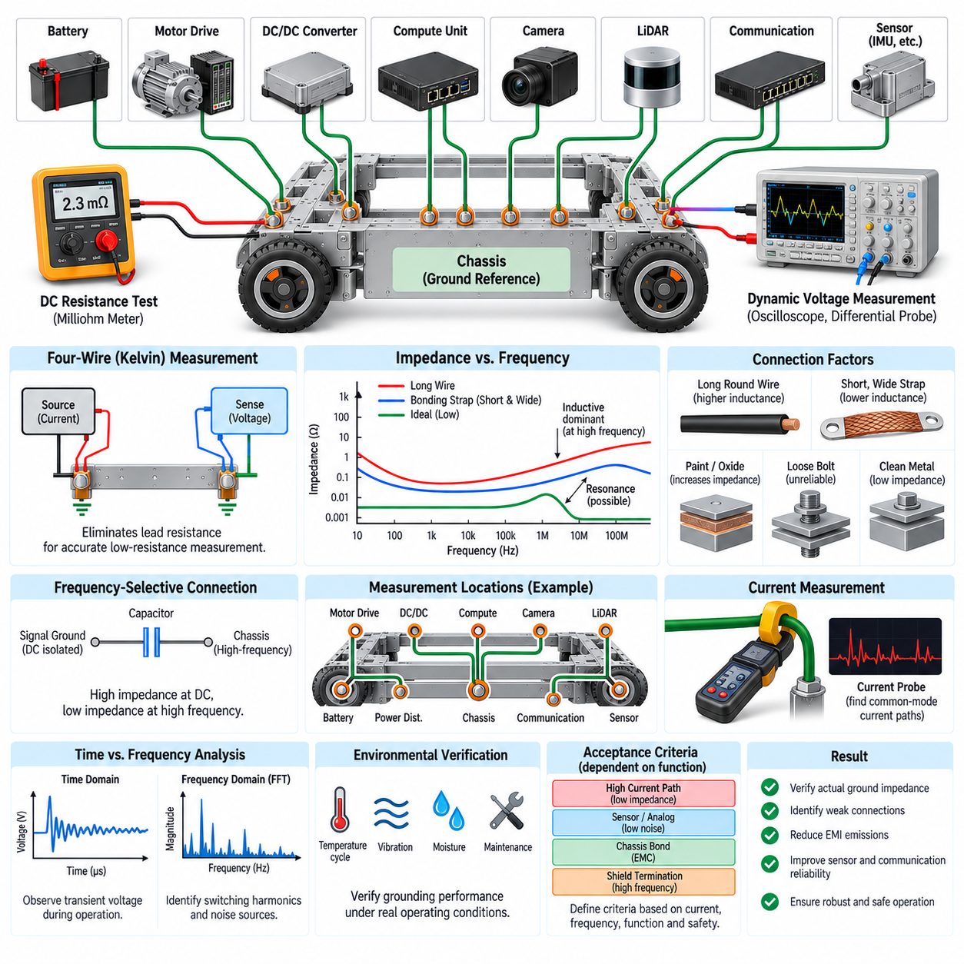
Ground impedance measurement determines how effectively a grounding path maintains a common electrical reference when current changes with frequency. Unlike a simple resistance measurement, impedance measurement considers resistance, inductance, capacitance, connection geometry, and frequency-dependent effects. This distinction is essential in robotic systems because a ground connection that appears excellent at DC can become a significant impedance at the frequencies produced by switching converters, motor drives, processors, and high-speed communication interfaces.
The electrical behavior of a grounding path can be represented by the complex impedance Z, which includes both resistive and reactive components. At low frequency, conductor and contact resistance may dominate, while at higher frequency the inductive reactance of wires, straps, joints, and structural paths becomes increasingly important. Parasitic capacitance can also create additional return paths. Consequently, grounding performance must be evaluated across the frequency range relevant to the actual equipment rather than represented by a single resistance value.
A basic DC resistance test remains useful because it can identify loose connections, corrosion, undersized conductors, poor crimps, and inadequate chassis bonds. A precision milliohm meter or suitable four-wire measurement method can measure very small resistance values while reducing errors caused by test-lead resistance. However, DC continuity alone cannot demonstrate EMC performance. A bond measuring only a few milliohms may still present substantial impedance to fast transient or radio-frequency current because of its physical inductance.
The four-wire, or Kelvin, measurement technique is particularly valuable for low-resistance grounding paths. Two conductors inject the test current while two separate sense conductors measure the voltage directly across the connection under evaluation. Because very little current flows through the sense leads, their resistance contributes minimally to the result. This technique is useful for evaluating busbars, battery-return joints, bonding straps, ground studs, connector interfaces, and other low-resistance structures where ordinary two-wire measurements can be misleading.
Frequency-dependent measurements require an AC stimulus or an instrument capable of characterizing impedance over frequency. An impedance analyzer, LCR meter, vector network analyzer, or specialized measurement arrangement can be used depending on the frequency range and required accuracy. The objective is to determine how the magnitude and phase of the grounding impedance change with frequency. This information reveals where a connection transitions from predominantly resistive behavior to inductive or resonant behavior.
Ground-path inductance is strongly influenced by geometry. A long round wire can have low DC resistance but relatively high inductance, while a short, wide bonding strap can provide much lower high-frequency impedance even when their DC resistances are similar. Loop area is also important because current must always complete a return path. Measurements should therefore represent the actual installed geometry rather than evaluating isolated conductors in arrangements that do not resemble their final application.
Chassis bonding measurements should be performed across the actual mechanical interfaces used by the robot. Paint, anodization, oxide layers, sealants, contamination, fastener pressure, surface roughness, and corrosion can significantly alter connection impedance. A mechanically strong joint is not automatically a reliable electrical bond. Measurements across bolted frames, removable panels, equipment mounting points, bonding straps, and enclosure interfaces help determine whether the chassis provides the intended electrical reference throughout the physical structure.
Measurement location is equally important. Engineers should identify the nodes whose voltage difference could affect system operation, such as battery negative, power distribution return, motor-drive ground, compute ground, sensor ground, communication ground, and chassis. Measuring between these points provides a map of the actual grounding network. In a distributed robotic architecture, several measurements may be required because one apparently good connection cannot guarantee low impedance across the entire platform.
Dynamic voltage measurements provide another practical way to evaluate ground behavior during operation. An oscilloscope can measure the voltage difference between selected ground nodes while motors accelerate, brakes regenerate energy, converters change load, or processors and communication interfaces become active. Since ground voltage may contain both slow variations and fast transients, appropriate bandwidth, probe configuration, and measurement technique are necessary to avoid confusing measurement artifacts with actual system behavior.
Differential probing is often preferable when measuring voltage between two ground points that may both move relative to the oscilloscope reference. A suitable differential probe can observe the actual potential difference without unintentionally connecting one point to protective earth through the instrument. Incorrect oscilloscope grounding can alter the circuit under test, create an unintended ground loop, or in some systems cause damaging current. Instrument grounding and isolation requirements must therefore be understood before connecting measurement equipment.
Probe leads can themselves introduce significant inductance at high frequency. A long ground clip may create a loop that picks up radiated noise or produces ringing that does not accurately represent the grounding structure. Short connections, low-inductance probe accessories, differential probes, coaxial arrangements, or carefully designed fixtures are preferred for high-frequency measurements. The measurement setup should have substantially better electrical behavior than the path being characterized whenever practical.
Current measurement can complement voltage and impedance measurements. A current probe placed around a bonding conductor, cable shield, power return, or selected harness section can reveal where common-mode or transient current actually flows. This is especially useful when validating hybrid or multi-point grounding because unexpected current may use chassis bonds or shields that were intended only for EMC purposes. Correlating current waveforms with ground-voltage disturbances helps identify the physical source and propagation path of interference.
Frequency-domain analysis can reveal disturbances that are difficult to interpret in the time domain. A spectrum analyzer or oscilloscope FFT can show switching fundamentals, harmonics, clock-related components, and broadband noise appearing between grounding points. When these spectral components correspond to motor PWM, DC/DC switching, processor activity, or communication traffic, engineers can trace the relationship between the noise source and the grounding network. This makes grounding measurement an important part of systematic EMC diagnosis.
For high-frequency chassis and bonding analysis, the measurement fixture must be carefully controlled. Test cables, adapters, connectors, and fixtures possess their own impedance and can dominate the result if they are not compensated or characterized. Calibration or de-embedding techniques may be necessary when precise measurements are required. The goal is to separate the electrical behavior of the grounding structure from the behavior introduced by the measurement system itself.
Ground impedance should also be evaluated under environmental and mechanical stress. Vibration can loosen fasteners, thermal cycling can change contact pressure, moisture can promote corrosion, and repeated maintenance can alter bonding surfaces. Measurements performed before and after environmental testing help determine whether the grounding architecture remains stable over the product life cycle. This is particularly important for outdoor AMRs, industrial robots, mobile manipulators, and other platforms exposed to vibration, contamination, and weather.
Acceptance criteria should be linked to function rather than relying on one universal impedance limit. A battery-return connection carrying hundreds of amperes, an analog sensor reference, a chassis bonding strap, and a high-frequency shield termination perform different tasks and therefore require different evaluation criteria. The relevant current magnitude, frequency range, allowable voltage disturbance, safety requirement, and EMC objective should determine what constitutes an acceptable grounding path.
In an AMR, measurements can begin with the main battery return and power distribution network and then extend to propulsion drives, steering controllers, DC/DC converters, edge computers, LiDARs, cameras, IMUs, communication equipment, and chassis bonds. Testing under simultaneous propulsion, computation, sensing, and communication activity is particularly valuable because interactions between subsystems may only appear when the complete robot is operating. Grounding problems that remain invisible on an individual bench can become significant after system integration.
Ground impedance measurement is therefore not merely a continuity inspection but a method for validating the electrical reference architecture across frequency, load, and operating condition. Combining low-resistance measurements, frequency-dependent impedance characterization, dynamic voltage measurements, and current-path analysis provides a more complete understanding of grounding behavior. The results can guide improvements in conductor geometry, bonding locations, chassis interfaces, cable shields, return routing, and separation of sensitive and noisy circuits.
A robust grounding design ultimately requires correlation between measurement and system behavior. If motor switching produces sensor errors, Ethernet faults, processor resets, or excessive emissions, measurements should identify the impedance and current paths that allow the disturbance to propagate. By treating ground as a real frequency-dependent electrical network rather than an ideal zero-volt symbol, engineers can verify single-point, multi-point, and hybrid grounding architectures and establish a reliable foundation for EMC performance in complex Physical AI systems.

01.05. Chassis Ground Design
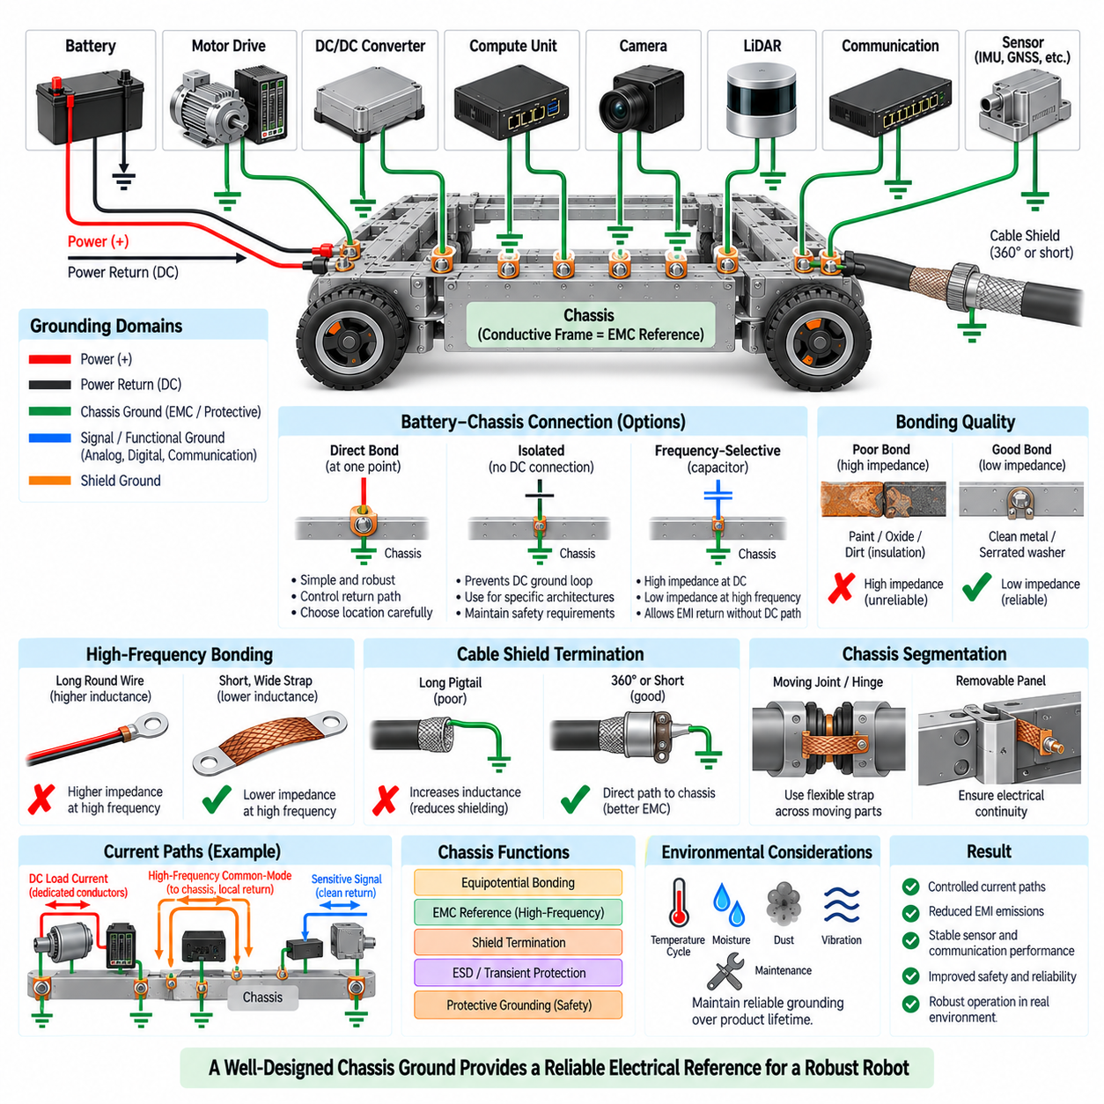
Chassis ground design defines how the conductive frame, enclosure, structural members, and equipment housings of a robot participate in the electrical reference and electromagnetic compatibility system. The chassis should not be treated as an accidental collection of metal parts. Its electrical role must be intentionally defined so that fault currents, high-frequency interference, electrostatic discharge, and shield currents follow controlled paths without disturbing functional power and signal returns.
A fundamental distinction must be maintained between chassis ground and functional electrical return. Battery negative, power return, analog ground, digital ground, and communication references carry currents required for normal circuit operation, whereas the chassis primarily supports equipotential bonding, EMC control, shielding, transient-current management, and protective functions. Connecting these domains without understanding their current paths can allow propulsion or converter currents to circulate through the mechanical structure.
The relationship between battery negative and chassis is therefore a system-level architectural decision. Some robotic systems establish a deliberate conductive bond at one controlled location, while others use isolation or frequency-selective coupling depending on safety, EMC, power architecture, and interface requirements. When a direct connection is used, its location should be chosen so that normal return currents remain within designated conductors and do not use the chassis as an unintended parallel path.
A conductive chassis can provide an effective distributed reference for high-frequency currents because its large surface area generally offers lower inductance than long grounding wires. Motor-drive enclosures, DC/DC converter housings, compute enclosures, connector shells, and sensor housings can be bonded locally to this structure where appropriate. Short connections reduce loop area and help high-frequency common-mode currents return close to their source instead of propagating through sensitive harnesses.
Bonding quality determines whether the chassis actually behaves as a useful electrical reference. Mechanical contact alone does not guarantee a low-impedance electrical connection. Paint, powder coating, anodization, oxide layers, adhesives, sealants, dirt, corrosion, and insufficient contact pressure can electrically isolate two structural parts that appear mechanically connected. Grounding interfaces must therefore specify conductive contact areas and reliable joining methods rather than assuming every bolted assembly provides adequate bonding.
Where electrical continuity across a mechanical joint is required, conductive surface preparation, appropriate fasteners, serrated washers, bonding straps, conductive gaskets, or other controlled interfaces may be used. The selected method must remain effective under vibration, thermal cycling, moisture, contamination, and repeated maintenance. Corrosion compatibility between different metals is also important because galvanic effects can progressively increase contact resistance and degrade chassis performance over the product lifetime.
Bonding conductors intended for high-frequency currents should generally be short and wide. A long round wire may have sufficiently low DC resistance while still presenting substantial inductive impedance at high frequency. Braided straps, wide conductive links, short enclosure contacts, and direct metal-to-metal interfaces can provide better high-frequency behavior. The geometry of the complete current loop is important because minimizing loop area reduces inductance and electromagnetic coupling.
Motor and inverter systems require particular attention because PWM switching produces rapid voltage transitions and common-mode currents. The inverter enclosure, motor housing, cable shield, and chassis can form a controlled high-frequency return structure when appropriately bonded. The normal motor-drive DC current should remain in dedicated power conductors, while switching-related common-mode current is given a short EMC path. This separation reduces the likelihood that noise will flow through sensors or communication equipment.
Cable shields should be integrated into chassis ground design rather than connected arbitrarily to signal ground. For high-frequency interfaces, a short or 360-degree shield termination at a conductive connector shell can transfer interference current directly to the enclosure or chassis. A long pigtail adds inductance and can significantly reduce shielding effectiveness. The shield should normally control electromagnetic coupling rather than become a substitute conductor for normal functional return current.
High-speed communication interfaces also depend on proper chassis integration. Ethernet and other differential links reject many disturbances through balanced signaling, but parasitic coupling and imbalance can still generate common-mode energy. Shielded connectors, enclosure bonds, and controlled chassis interfaces can provide paths for this energy without contaminating the digital reference. Communication cable shields should not unintentionally become return paths for motor, battery, or converter currents.
Sensor installation requires careful consideration because many sensors are mechanically mounted directly to conductive robot structures. A camera, LiDAR, IMU, GNSS receiver, or other sensor may obtain an unintended chassis connection through its housing, bracket, connector shell, or mounting fasteners. Designers should determine whether this connection is required, permitted, capacitively coupled, or intentionally isolated. Otherwise, an apparently isolated sensor ground can become part of an uncontrolled multi-point network after mechanical assembly.
Compute equipment presents similar issues. Edge computers, GPUs, embedded controllers, and network switches often contain conductive enclosures connected internally to connector shields or power references in ways that may not be obvious from an external wiring diagram. Their mounting points should therefore be evaluated electrically as well as mechanically. Understanding internal chassis-to-circuit connections helps prevent duplicate bonds, unexpected ground loops, and common-mode current paths during system integration.
Chassis segmentation can become important in large or articulated robots. Hinges, bearings, suspension elements, rotating joints, removable panels, and modular frames may interrupt electrical continuity even when the mechanical structure appears continuous. Flexible bonding straps may be required across moving or removable interfaces where a predictable high-frequency reference must be maintained. Bearings and mechanical joints should not be assumed to provide reliable long-term electrical bonding unless they are specifically designed for that purpose.
Electrostatic discharge places additional requirements on chassis design. When a person, tool, payload, or external object transfers an ESD pulse to the robot, the current contains extremely fast components and seeks a low-inductance path. A well-bonded conductive enclosure can distribute the transient around sensitive electronics. Poor chassis continuity can instead create large local voltage differences, allowing discharge current to pass through processors, sensor interfaces, communication ports, or other vulnerable circuitry.
Protective grounding and fault-current management must be considered independently from ordinary EMC optimization. If the system can be connected to external mains-powered equipment, chargers, industrial machinery, or grounded infrastructure, fault conditions may create hazardous currents or potential differences. Protective bonding conductors and connections must therefore be designed according to applicable safety requirements rather than relying solely on thin EMC straps, cable shields, or signal-ground conductors.
The physical placement of chassis bonds should follow expected current paths. High-frequency bonds are most effective when located close to the source or entry point of interference, such as a motor drive, converter, shielded connector, or external cable interface. Routing a noise current across a long internal path before connecting it to chassis increases loop area and coupling opportunities. Grounding, enclosure design, connector placement, cable routing, and power distribution should consequently be developed as one coordinated architecture.
Verification begins with inspection and low-resistance measurements but should extend to impedance and dynamic behavior. Engineers can measure continuity and resistance across frame joints, equipment bonds, enclosure interfaces, and designated battery-to-chassis connections. High-frequency impedance, common-mode current, transient voltage, conducted emissions, and radiated emissions provide additional evidence of whether the chassis performs its intended EMC function under realistic operating conditions.
Validation should be performed while the complete robot is operating. Motor acceleration, regenerative braking, steering, manipulator motion, DC/DC converter load changes, GPU computation, Ethernet traffic, camera operation, and LiDAR activity can produce combinations of interference that are absent during component-level tests. Measuring chassis voltage differences and bond currents under these conditions can reveal unintended paths and structural discontinuities that only become important after full system integration.
Environmental durability is essential because chassis grounding must remain reliable throughout the service life. Outdoor AMRs and other mobile platforms experience vibration, shock, water, dust, temperature cycling, corrosion, and maintenance activity. Ground interfaces should therefore be accessible for inspection where practical, protected against environmental degradation, and documented so that coatings or replacement hardware do not accidentally remove required electrical contact during manufacturing or service.
For an AMR, a practical chassis ground design can maintain dedicated battery and power-return conductors while using the metal frame as a distributed EMC reference. Motor drives, converter housings, compute enclosures, shielded connectors, and selected sensor housings can be bonded locally according to their electromagnetic requirements. A deliberately controlled relationship between chassis and functional ground then prevents the mechanical frame from becoming an uncontrolled normal-current return network.
Chassis ground design is therefore an integration discipline connecting electrical architecture, mechanical structure, power electronics, harness engineering, shielding, EMC, and safety. A successful chassis is not simply conductive; it provides predictable impedance and intentional current paths over the required frequency range. When its bonds, interfaces, shields, and functional-ground relationships are systematically engineered, the chassis becomes an important part of reliable electrical operation in AMRs and other Physical AI systems.

