Volume 05. Grounding and EMC

Chapter 07. Ethernet EMI

07.01. 100BASE-T1 EMC Design
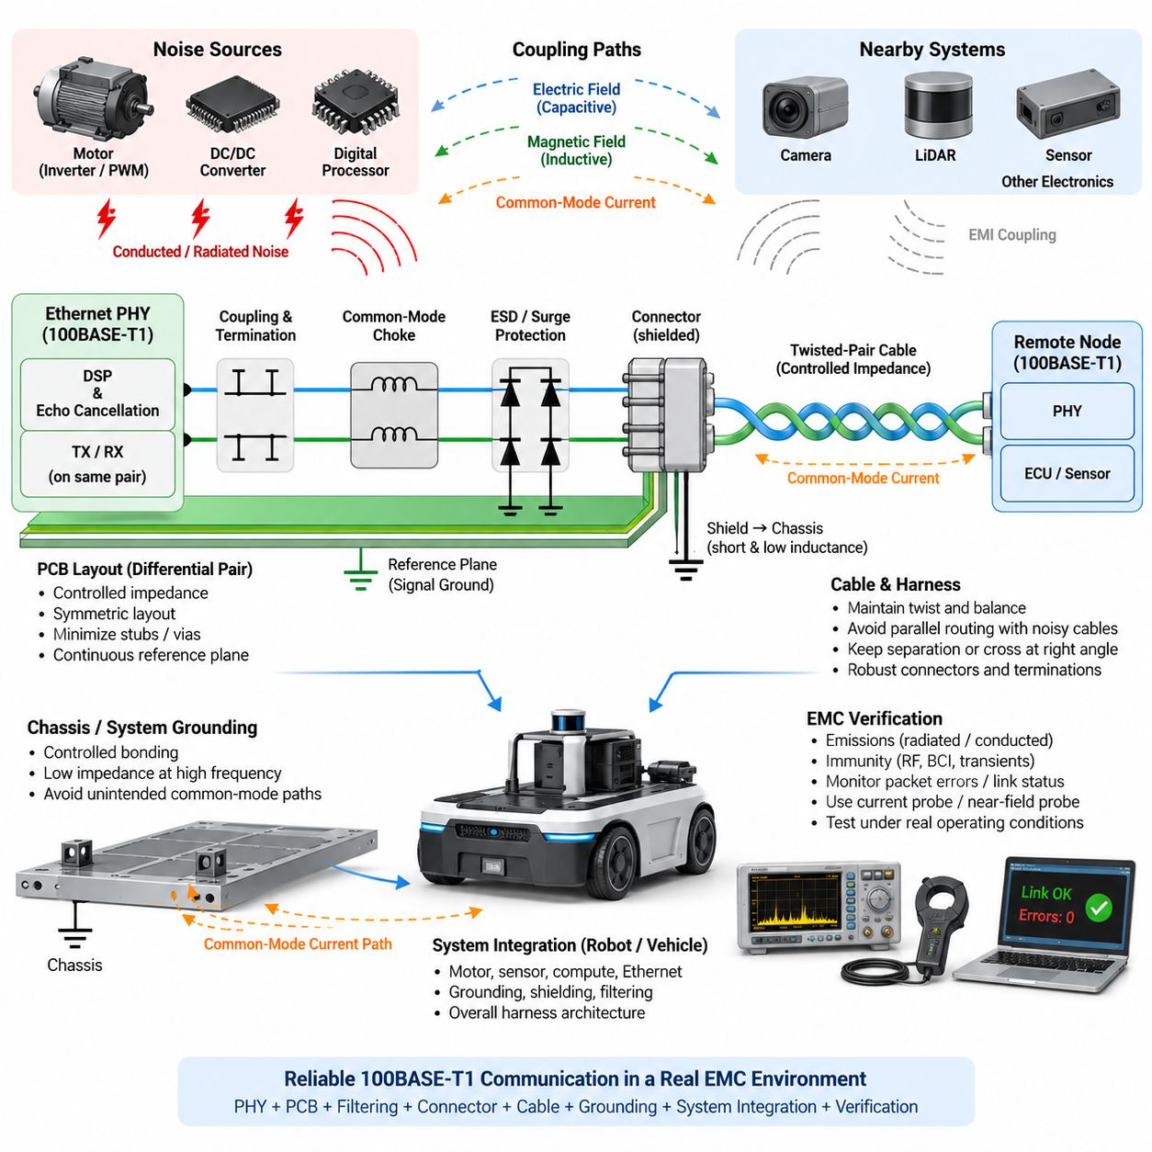
100BASE-T1 is a single-pair Ethernet technology designed for 100 Mbit/s communication over a balanced twisted pair, making it attractive for robots, vehicles, and distributed sensor systems where cable weight and packaging are important. EMC design must preserve the differential nature of the link while preventing common-mode energy from coupling into the cable, chassis, connectors, or nearby electronic systems.
Unlike conventional multi-pair Ethernet, 100BASE-T1 uses one bidirectional twisted pair for simultaneous transmit and receive communication. The PHY employs signal processing and echo cancellation to separate local transmission from received information. Because both directions share the same physical conductors, impedance discontinuities, imbalance, parasitic capacitance, connector asymmetry, and PCB layout errors can directly degrade both signal integrity and electromagnetic compatibility.
The fundamental EMC objective is to maintain electrical symmetry from the PHY pins through the PCB traces, coupling network, connector, twisted-pair cable, and remote node. Ideally, equal and opposite differential currents produce electromagnetic fields that largely cancel. Any asymmetry converts part of the differential signal into common-mode voltage or current, creating an efficient mechanism for cable radiation and susceptibility to external electromagnetic fields.
Differential impedance control is therefore a central design requirement. PCB traces associated with the MDI should be routed as a tightly coupled differential pair with consistent geometry, spacing, reference environment, and electrical length. Stubs, unnecessary vias, abrupt layer transitions, test pads, and asymmetric component placement should be minimized because each discontinuity can introduce reflections or differential-to-common-mode conversion that increases emissions.
The reference plane beneath the Ethernet signal path should remain continuous wherever the selected PHY and board architecture permit it. Routing across plane splits, chassis boundaries, or discontinuities changes return-current geometry and can increase mode conversion. Although the Ethernet pair carries differential signaling, high-frequency parasitic currents still interact with nearby reference structures, so the complete electromagnetic return path must be considered rather than treating the pair as an isolated two-wire circuit.
The coupling and termination network recommended for the selected 100BASE-T1 PHY should be implemented with careful symmetry. Component values, package sizes, trace lengths, and parasitic characteristics on both conductors should be closely matched. Even small differences between the positive and negative paths can reduce common-mode rejection. Components should therefore be positioned compactly and symmetrically instead of being distributed around the connector area according to routing convenience.
A common-mode choke may be introduced when required by the PHY reference design and EMC target. Its purpose is to present relatively high impedance to common-mode current while allowing the intended differential Ethernet signal to pass with limited distortion. Choke selection must consider common-mode impedance, differential insertion loss, parasitic capacitance, current capability, frequency behavior, and compatibility with the specific PHY rather than simply selecting the component with the highest impedance rating.
Common-mode choke placement is equally important. The component is generally most effective when incorporated into a compact and controlled MDI path near the cable interface according to the PHY vendor's recommended topology. Long traces between protection, choke, termination, and connector components can create additional coupling structures. The physical implementation must therefore be treated as part of the filter rather than assuming that the schematic alone determines EMC performance.
Connector design strongly affects the EMC behavior of the complete link. The two signal contacts should preserve symmetry and minimize unnecessary conductor separation through the transition from PCB to cable. If a shielded connector or shielded cable architecture is used, the shield termination must provide a short, low-inductance high-frequency connection to the intended chassis reference. Long pigtail connections can significantly reduce shielding effectiveness at high frequencies.
Cable selection should maintain controlled differential impedance and high longitudinal balance throughout the required harness length. Twist consistency, conductor geometry, insulation, connector termination, and manufacturing tolerances influence mode conversion. Routing should avoid extended parallel runs beside motor phase cables, inverter outputs, DC/DC converter switching nodes, contactor wiring, and other high-dV/dt or high-dI/dt conductors that can inject common-mode disturbances into the Ethernet channel.
Cable separation is particularly important in mobile robots because Ethernet wiring frequently shares limited harness space with battery, motor, brake, actuator, and sensor circuits. Increasing physical separation generally reduces capacitive and inductive coupling. Where noisy and sensitive harnesses must cross, approximately perpendicular crossing is preferable to long parallel routing. Harness architecture should therefore classify Ethernet as a noise-sensitive communication path and define routing zones accordingly.
Protection against electrostatic discharge and electrical transients must be implemented without destroying the balance of the Ethernet interface. Protection devices connected to the two MDI conductors should exhibit closely matched capacitance and dynamic characteristics. Excessive or asymmetric parasitic capacitance can increase differential insertion loss and common-mode conversion. Devices specifically characterized for high-speed differential communication interfaces are therefore preferable to generic protection components.
The relationship between signal ground and chassis ground requires deliberate high-frequency design. Uncontrolled capacitive coupling between digital ground, PHY circuitry, connector shield, chassis, and external cable can establish unintended common-mode current paths. Conversely, excessively isolating these structures without understanding parasitic coupling can also produce high RF impedance. EMC performance depends on controlling where high-frequency current flows rather than attempting to eliminate every possible connection.
Power integrity around the Ethernet PHY also influences emissions and immunity. Switching regulator ripple, digital processor noise, or motor-related disturbances entering the PHY supply can modulate the transmitter or disturb receiver thresholds. Local decoupling, appropriate power filtering, short current loops, and separation from high-current switching circuits help maintain PHY stability. The power-distribution network should therefore be included in Ethernet EMC analysis instead of focusing exclusively on the MDI pair.
PCB placement should establish a clear functional progression between the PHY, interface components, protection devices, and connector. The MDI traces should be short and isolated from clocks, switching nodes, high-current gate-drive loops, memory buses, and other strong noise sources. Routing the Ethernet pair around the PCB perimeter or through congested digital regions merely to simplify placement can increase coupling and should be avoided when a more direct interface path is possible.
Robotic platforms present additional challenges because motor drives can generate broadband conducted and radiated interference through PWM switching. Fast inverter edges may couple into the Ethernet cable through electric fields, magnetic fields, shared chassis impedance, or common power wiring. Good 100BASE-T1 performance therefore depends not only on the Ethernet PCB but also on motor cable shielding, inverter layout, chassis bonding, grounding, filtering, and overall harness segregation.
EMC verification should distinguish communication performance from electromagnetic performance. A link that successfully transfers packets on a laboratory bench may still produce excessive radiated emissions or fail when exposed to RF fields, bulk-current injection, transient disturbances, or motor switching. Testing should therefore observe packet errors, link interruptions, PHY diagnostic information, emissions, and immunity behavior under representative operating conditions rather than relying only on nominal link establishment.
Debugging is most effective when common-mode behavior is measured directly. Current probes, near-field probes, oscilloscopes, spectrum analyzers, and network-analysis techniques can help identify frequencies and physical locations associated with unwanted coupling. Comparing measurements before and after changes to cable routing, choke configuration, shield termination, grounding, or component placement allows engineers to distinguish the actual coupling mechanism from modifications that merely change symptoms.
Pre-compliance testing should be performed with representative cable lengths, connectors, enclosure structures, grounding arrangements, motor operation, DC/DC converters, and computational loads. A short laboratory cable attached to an open development board may behave very differently from the production harness installed through a metallic robot chassis. The cable itself can become an effective antenna, making system-level configuration essential for meaningful EMC assessment.
Design margins should account for production variation. Cable balance, connector contact geometry, choke characteristics, protection-device capacitance, PCB fabrication tolerance, and chassis bonding impedance all vary between units. An interface that passes EMC testing only with a particular prototype configuration may fail after manufacturing variation. Robust design therefore seeks sufficient margin through symmetry, controlled routing, predictable grounding, and carefully characterized interface components.
For an AMR or Physical AI platform, 100BASE-T1 EMC should ultimately be treated as a system architecture problem rather than a PHY-only problem. Reliable communication emerges from coordinated PHY selection, balanced PCB layout, controlled impedance, suitable filtering, connector design, cable routing, chassis bonding, power integrity, and verification under motor operation. This system-level approach connects Ethernet EMI design with the broader grounding, shielding, filtering, and motor-driver EMC structure of the volume.

07.02. 1000BASE-T1 EMC Design
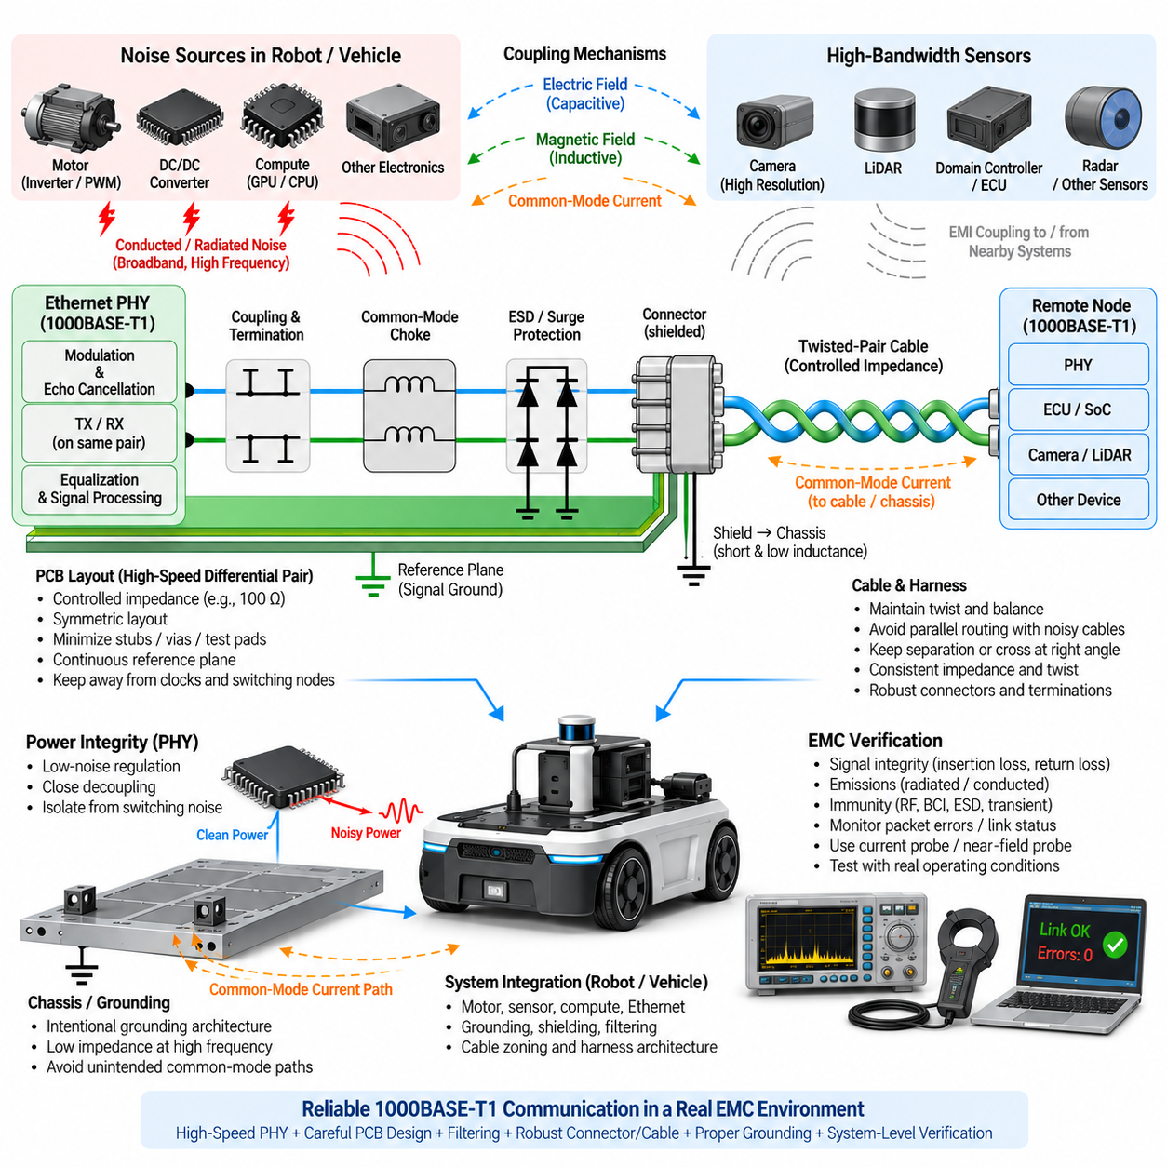
1000BASE-T1 extends single-pair Ethernet to 1 Gbit/s communication over one balanced twisted pair, providing the bandwidth required by high-resolution cameras, LiDAR systems, domain controllers, edge computers, and advanced robotic sensors. Within the Ethernet EMI structure of this volume, its EMC design follows the same system-level principles as 100BASE-T1 but requires tighter control because higher signaling bandwidth increases sensitivity to imbalance, discontinuities, and parasitic coupling.
The physical interface simultaneously supports bidirectional communication over the same pair, so the PHY relies on sophisticated modulation, echo cancellation, equalization, and signal processing to recover received information while transmitting. Consequently, noise introduced anywhere between the PHY and remote node can affect receiver margin. EMC engineering must therefore consider signal integrity, common-mode behavior, power integrity, cable characteristics, and electromagnetic coupling as interconnected design problems.
Electrical balance is one of the most important conditions for low-emission 1000BASE-T1 operation. Ideally, the currents flowing through the two conductors are equal in magnitude and opposite in direction, allowing their electromagnetic fields to cancel. PCB asymmetry, unequal component parasitics, connector geometry, cable imbalance, or reference-plane discontinuities can convert differential energy into common-mode energy, allowing the attached cable to behave as an efficient radiating structure.
Controlled differential impedance must be maintained from the PHY interface through the MDI routing and connector transition. Trace width, spacing, dielectric geometry, reference-plane distance, vias, component pads, and connector footprints all contribute to the impedance profile. Abrupt discontinuities cause reflections and mode conversion, so the routing should remain short, symmetric, and geometrically consistent while unnecessary stubs, test pads, vias, and layer changes are minimized.
Because 1000BASE-T1 operates with substantially greater signal bandwidth than 100BASE-T1, apparently small PCB structures can become electromagnetically significant. A short stub, mismatched pad, asymmetric via transition, or poorly located protection device may introduce measurable insertion loss or mode conversion. Layout review should therefore evaluate the complete high-frequency transmission path rather than verifying only nominal trace impedance or checking whether the differential pair lengths are approximately equal.
A continuous and predictable reference environment should be maintained around the MDI traces. Routing the pair across reference-plane splits, board cutouts, connector-ground discontinuities, or transitions between poorly coupled reference structures can change parasitic capacitance and common-mode current distribution. Differential signaling does not eliminate interaction with surrounding conductors; at high frequencies, the geometry of the complete electromagnetic field and its return paths strongly influences both signal integrity and EMC behavior.
Termination and coupling components should be placed according to the selected PHY manufacturer's reference architecture and implemented with strong symmetry. Matching resistor values alone is insufficient because package parasitics, pad geometry, trace lengths, and neighboring copper also influence balance. Both sides of the differential path should experience nearly equivalent electrical environments so that the interface maintains high common-mode rejection across the operating frequency range.
A common-mode choke can suppress unwanted common-mode current flowing toward the external cable, but it must be selected specifically for high-speed automotive Ethernet. High common-mode impedance alone does not guarantee good performance. Differential insertion loss, return loss, parasitic capacitance, mode conversion, resonance behavior, and compatibility with the PHY must also be considered because an unsuitable choke can improve emissions at one frequency while degrading communication margin elsewhere.
Placement of the common-mode choke and associated interface components should minimize the physical area in which uncontrolled RF current can circulate. Long traces between the PHY-side network, choke, ESD protection, and connector add parasitic inductance and capacitance and may create unintended resonant structures. The interface should therefore be designed as one compact high-frequency network rather than as several independent schematic blocks connected by convenient PCB routing.
Transient and ESD protection becomes challenging because protection devices introduce capacitance directly into a high-speed communication path. Devices should provide sufficient robustness while maintaining low and well-matched capacitance on both conductors. Asymmetric protection layouts can convert differential signals into common-mode components. Protection placement, grounding path, pad geometry, and device characteristics should consequently be evaluated together instead of treating ESD protection as an isolated reliability function.
Connector transitions must preserve the symmetry established on the PCB. Unequal pin lengths, excessive separation of the pair, asymmetric shield geometry, or poorly controlled transitions between PCB traces and twisted-pair conductors can produce local impedance discontinuities. When shielded connectors are used, the shield should normally transition to the intended chassis structure through a short, wide, low-inductance connection capable of carrying high-frequency common-mode current without forcing it through sensitive digital ground paths.
Cable construction is another major EMC variable. The twisted pair should maintain consistent geometry, impedance, twist characteristics, and longitudinal balance over its full length. Mechanical deformation, poorly controlled untwisting near connectors, inconsistent termination, or harness manufacturing variation can reduce balance. At gigabit rates, connector and cable quality should therefore be considered part of the electrical channel rather than passive mechanical components selected only according to packaging and durability requirements.
Harness routing should separate 1000BASE-T1 cables from strong electromagnetic noise sources such as inverter outputs, motor phase conductors, high-current battery paths, switching power converters, contactors, and PWM-controlled actuators. Long parallel routing increases capacitive and inductive coupling. Where separation is limited, crossing noisy conductors approximately perpendicular to the Ethernet cable and maintaining physical distance can significantly reduce the accumulated coupling into the communication channel.
Robotic platforms create particularly demanding conditions because Ethernet traffic may operate beside motor drives, high-performance GPU computers, DC/DC converters, LiDAR units, cameras, and multiple switching regulators. These subsystems generate different spectral components and coupling mechanisms. Successful Ethernet EMC design therefore requires coordinated cable zoning, grounding, shielding, filtering, enclosure bonding, and power-distribution design rather than attempting to solve every interference problem at the Ethernet connector.
PHY power supplies require low-noise local regulation and effective decoupling because supply disturbances can influence transmitter quality, clock behavior, receiver sensitivity, and internal analog circuitry. Decoupling capacitors should be placed close to the relevant supply pins with short current loops. Noisy switching regulators should be positioned and filtered so that their switching currents do not share sensitive return paths with the Ethernet PHY or inject broadband disturbances into the communication interface.
Clock and digital circuitry near the PHY can also become important emission sources. High-frequency clocks, memory interfaces, processor buses, and switching nodes should not be routed close to the MDI pair or connector region. Coupling from internal digital activity into the Ethernet pair may subsequently convert into common-mode cable current. Functional partitioning of the PCB should therefore establish a relatively quiet Ethernet interface zone between the PHY and external connector.
Ground and chassis architecture should provide intentional high-frequency current paths. Connector shields, enclosure metal, PCB reference planes, and signal ground must not be connected arbitrarily. High-frequency bonding should minimize inductance while preventing noisy chassis currents from flowing through sensitive circuit references. The objective is not simply to connect or isolate grounds, but to control the impedance and physical path through which common-mode energy returns to its source.
Shielding decisions should be based on the complete installation. A shielded cable can reduce field coupling, but its effectiveness depends strongly on termination quality at both ends and integration with the chassis. A shield connected through a long wire or pigtail presents significant high-frequency inductance. Where shielding is required, mechanically compact circumferential or otherwise low-inductance termination is preferable for maintaining shielding effectiveness over the relevant EMC frequency range.
Signal-integrity measurements and EMC measurements should be interpreted together. Excessive insertion loss, return loss, mode conversion, or channel imbalance may appear first as reduced communication margin and later as EMC failure. Conversely, a link can operate normally while generating unacceptable emissions. Verification should therefore combine channel characterization, PHY diagnostics, packet-error monitoring, emission measurements, and immunity testing to understand both communication robustness and electromagnetic behavior.
Immunity testing is especially important because external RF energy can couple onto the cable as common-mode voltage and then convert into differential disturbance at asymmetries in the channel. Bulk-current injection, radiated immunity, ESD, transient testing, and representative system disturbances can reveal weaknesses that ordinary packet-transfer testing cannot detect. Link recovery behavior should also be evaluated because temporary communication interruption may have system-level consequences in autonomous machines.
Pre-compliance testing should reproduce the production configuration as closely as practical, including representative cable lengths, connectors, chassis structures, motor operation, switching converters, sensor activity, processor loads, and grounding conditions. Testing only an isolated evaluation board can hide coupling mechanisms that emerge after installation. For robots and autonomous vehicles, worst-case operating states often occur when traction motors, compute systems, sensors, and communication networks are simultaneously active.
Debugging should focus on identifying the actual coupling path. Current probes can reveal common-mode cable currents, while near-field probes can locate strong PCB or enclosure emission regions. Spectrum analysis can correlate Ethernet-related peaks with motor PWM, converter switching, processor clocks, or PHY activity. Controlled modifications to cable position, shield termination, choke selection, grounding, and power filtering can then determine whether the dominant mechanism is conducted, radiated, capacitive, inductive, or common-mode coupling.
Production robustness requires sufficient margin for component and manufacturing variation. Common-mode choke characteristics, protection-device capacitance, resistor tolerance, PCB geometry, connector construction, cable balance, shield contact resistance, and chassis bonding can vary between units. A design that barely passes with a carefully assembled prototype is therefore insufficient. EMC performance should remain stable across realistic tolerances, temperature conditions, cable configurations, and expected service-life degradation.
For AMRs and Physical AI systems, 1000BASE-T1 EMC design is ultimately a coordinated system-engineering activity. PHY layout, controlled impedance, balanced termination, common-mode filtering, transient protection, connector design, cable routing, shielding, chassis bonding, power integrity, and validation must operate as one architecture. This approach places 1000BASE-T1 naturally within the volume's broader progression from grounding and shielding through noise analysis, filtering, motor-driver EMI, and Ethernet-specific EMC engineering.

07.03. Shielded Connector Design
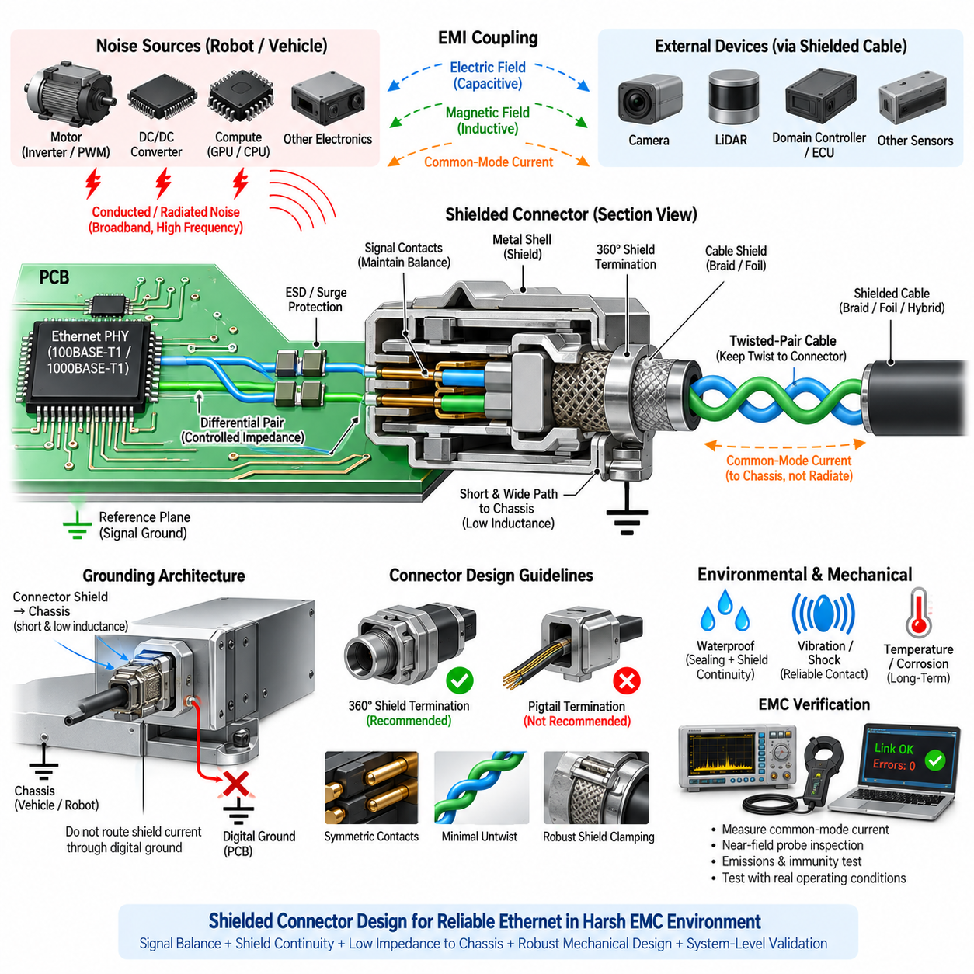
Shielded connector design is a critical part of Ethernet EMC engineering because the connector forms the electromagnetic transition between the PCB, enclosure, cable shield, and external wiring environment. In 100BASE-T1 and 1000BASE-T1 networks, a well-designed connector must preserve differential signal balance while providing a controlled low-impedance path for unwanted high-frequency common-mode current.
The primary EMC function of a shielded connector is not simply to surround signal contacts with conductive material. It must maintain shielding continuity between the cable shield and the equipment chassis while preventing external electromagnetic fields from coupling into sensitive Ethernet conductors. At the same time, internally generated common-mode energy should be directed toward the chassis rather than allowed to propagate along the cable and radiate into the surrounding environment.
High-frequency shield current behaves differently from low-frequency current because connection inductance becomes increasingly important as frequency rises. A shield connection that appears electrically adequate at DC may exhibit significant impedance at RF frequencies. For this reason, the connector shield should be bonded to the chassis through the shortest and widest practical conductive path, minimizing loop area and connection inductance between the connector shell and chassis structure.
A circumferential or 360-degree shield termination is generally more effective than a long pigtail connection. A pigtail introduces series inductance and concentrates shield current through a narrow conductor, reducing shielding effectiveness at higher frequencies. A connector that provides broad metallic contact around the cable shield allows RF current to spread across a larger surface and creates a more continuous electromagnetic boundary between the cable and enclosure.
Shield termination should be considered from the cable entry point through the connector shell and into the chassis. Any discontinuity in this path can create local voltage differences that drive common-mode current into unintended structures. Paint, anodized surfaces, coatings, corrosion, mechanical gaps, or poorly controlled contact pressure can increase bonding impedance. Mechanical connector design is therefore inseparable from EMC performance and must remain effective throughout the product lifetime.
The signal contacts inside the connector must preserve the electrical symmetry of the Ethernet differential pair. Excessive conductor separation, unequal contact lengths, asymmetric pin geometry, or different parasitic capacitances to the connector shell can convert differential energy into common-mode energy. For high-speed Ethernet, the connector should therefore be treated as part of the transmission channel rather than as a simple mechanical interface between PCB traces and cable conductors.
Impedance continuity through the connector transition is especially important for 1000BASE-T1 because higher signaling bandwidth makes the link more sensitive to geometric discontinuities. The PCB footprint, connector pins, terminal structure, cable termination, and initial untwisted section of the pair collectively determine the local impedance profile. Excessive discontinuity can increase reflections, insertion loss, return loss, and mode conversion even when the nominal cable impedance is correct.
The twisted pair should remain twisted as close as practical to the connector termination. Excessive untwisting increases loop area and changes the mutual coupling between conductors, reducing longitudinal balance and increasing susceptibility to electromagnetic fields. Harness manufacturing specifications should therefore define allowable untwist length and termination geometry so that prototype EMC performance is maintained consistently during production.
Connector shield and signal ground should not automatically be treated as the same electrical node. The shield primarily provides a high-frequency electromagnetic boundary and common-mode return path, while signal ground supports internal circuit operation. Directly routing shield current through PCB digital ground can inject external noise into sensitive electronics. The intended relationship between connector shell, chassis, signal ground, and PCB reference planes must therefore be explicitly defined.
Where the connector is mounted directly to a metallic enclosure, a low-inductance chassis bond can often be achieved through conductive mounting surfaces, spring fingers, conductive gaskets, or dedicated shell contacts. The design should provide sufficient contact area and stable mechanical pressure. Small contact points or long PCB traces between the connector shield and chassis may introduce enough inductance to reduce the effectiveness of an otherwise well-shielded cable.
When a connector is mounted on a PCB inside a nonconductive enclosure, shield-current management becomes more difficult because a natural chassis termination may not exist at the cable entry. Designers must deliberately provide an RF reference structure or controlled path to the available chassis or enclosure ground. Allowing shield current to travel deeply across the PCB before reaching its return path can increase emissions and expose internal circuits to common-mode disturbances.
The shield termination architecture at both ends of the cable should be considered as one system. Connecting only one end may help avoid certain low-frequency ground-current problems, but it can reduce high-frequency shielding effectiveness. Connecting both ends generally provides a better RF path but may allow low-frequency current when chassis potentials differ. The appropriate strategy depends on system grounding, cable length, operating environment, and frequency range of concern.
Capacitive coupling between shield and circuit reference may sometimes be intentionally used to provide a high-frequency return path while limiting low-frequency current. Such arrangements require careful component selection and layout because capacitor value, voltage rating, parasitic inductance, and placement determine their RF behavior. They should not be introduced as universal remedies for ground loops without understanding the complete common-mode current path.
Protection devices near the connector must also preserve the symmetry of the Ethernet interface. ESD and transient currents should be diverted toward a robust reference through short, low-inductance paths before they can propagate into the PHY region. Protection components with mismatched parasitic capacitance can disturb differential balance, so both their electrical characteristics and physical placement should be considered together with connector and shield design.
The connector region should be partitioned from noisy internal circuits whenever practical. Switching regulators, motor-control circuits, high-current traces, processor clocks, memory buses, and gate-drive loops should not be placed immediately beside the Ethernet cable entry. A connector shield cannot compensate for poor internal PCB partitioning if strong electromagnetic fields are coupled directly into signal contacts or MDI traces after the shield boundary.
Mechanical robustness is particularly important in mobile robots because vibration, shock, repeated mating, contamination, humidity, and corrosion can degrade shield contact over time. A connector that performs well during initial EMC testing may develop increased contact impedance after prolonged field operation. Shield contact materials, plating, retention mechanisms, environmental sealing, and mating-cycle capability should therefore be included in EMC reliability considerations.
Waterproofing and shielding requirements must also be coordinated. Seals, gaskets, plastic inserts, and environmental barriers can interrupt conductive paths if they are added without considering shield continuity. In outdoor AMRs, industrial robots, and autonomous vehicles, the connector must simultaneously provide environmental protection and a stable RF bond. Mechanical sealing architecture should therefore preserve conductive shell contact without compromising ingress protection.
Cable shield construction must be compatible with the connector termination method. Braided shields generally provide strong mechanical durability and useful high-frequency performance, while foil shields can provide excellent coverage but require appropriate drain or termination structures. Hybrid braid-and-foil constructions may combine advantages. Regardless of shield type, the connector should capture the shield uniformly and avoid excessive exposed length between the shield termination and signal contacts.
The physical location of the connector on the enclosure influences EMC performance. Locating the connector near a suitable chassis bonding point minimizes shield-current path length. If the connector is separated from chassis metal by long brackets, wires, or PCB paths, RF impedance can increase significantly. Cable entry, connector placement, chassis structure, and PCB position should therefore be planned together during mechanical and electrical architecture development.
Multiple shielded connectors installed on the same robot can interact through the chassis. Ethernet, camera, LiDAR, motor, and power cable shields may all inject common-mode currents into shared metallic structures. Poor bonding can create voltage differences between connector locations and cause current to redistribute through unexpected cables. Chassis bonding should therefore provide a sufficiently low and predictable high-frequency impedance across the complete platform.
Shield effectiveness should be verified under representative cable and enclosure configurations rather than inferred only from connector specifications. Current probes can measure common-mode cable current, while near-field probes can identify leakage around connector transitions. Radiated-emission testing can determine whether changes in shield bonding reduce antenna-like cable behavior, and immunity testing can reveal whether external fields are entering through the connector or another coupling path.
Testing should include mechanical variations that may occur in production, such as connector mating tolerance, shield contact pressure, cable orientation, harness movement, and enclosure assembly variation. Measurements should also consider motor operation, DC/DC converter switching, processor loading, and other realistic noise sources. EMC qualification performed only with quiet electronics can fail to reveal weaknesses in connector shield architecture that appear during actual robot operation.
For AMR and Physical AI platforms, shielded connector design must therefore be integrated with grounding, shielding, filtering, cable routing, chassis bonding, and Ethernet PHY layout rather than treated as an isolated component-selection task. The connector becomes the controlled electromagnetic boundary between internal electronics and the external harness, allowing differential communication to cross the enclosure while common-mode noise is returned through a deliberate low-impedance chassis path.

07.04. Common Mode Choke for Ethernet
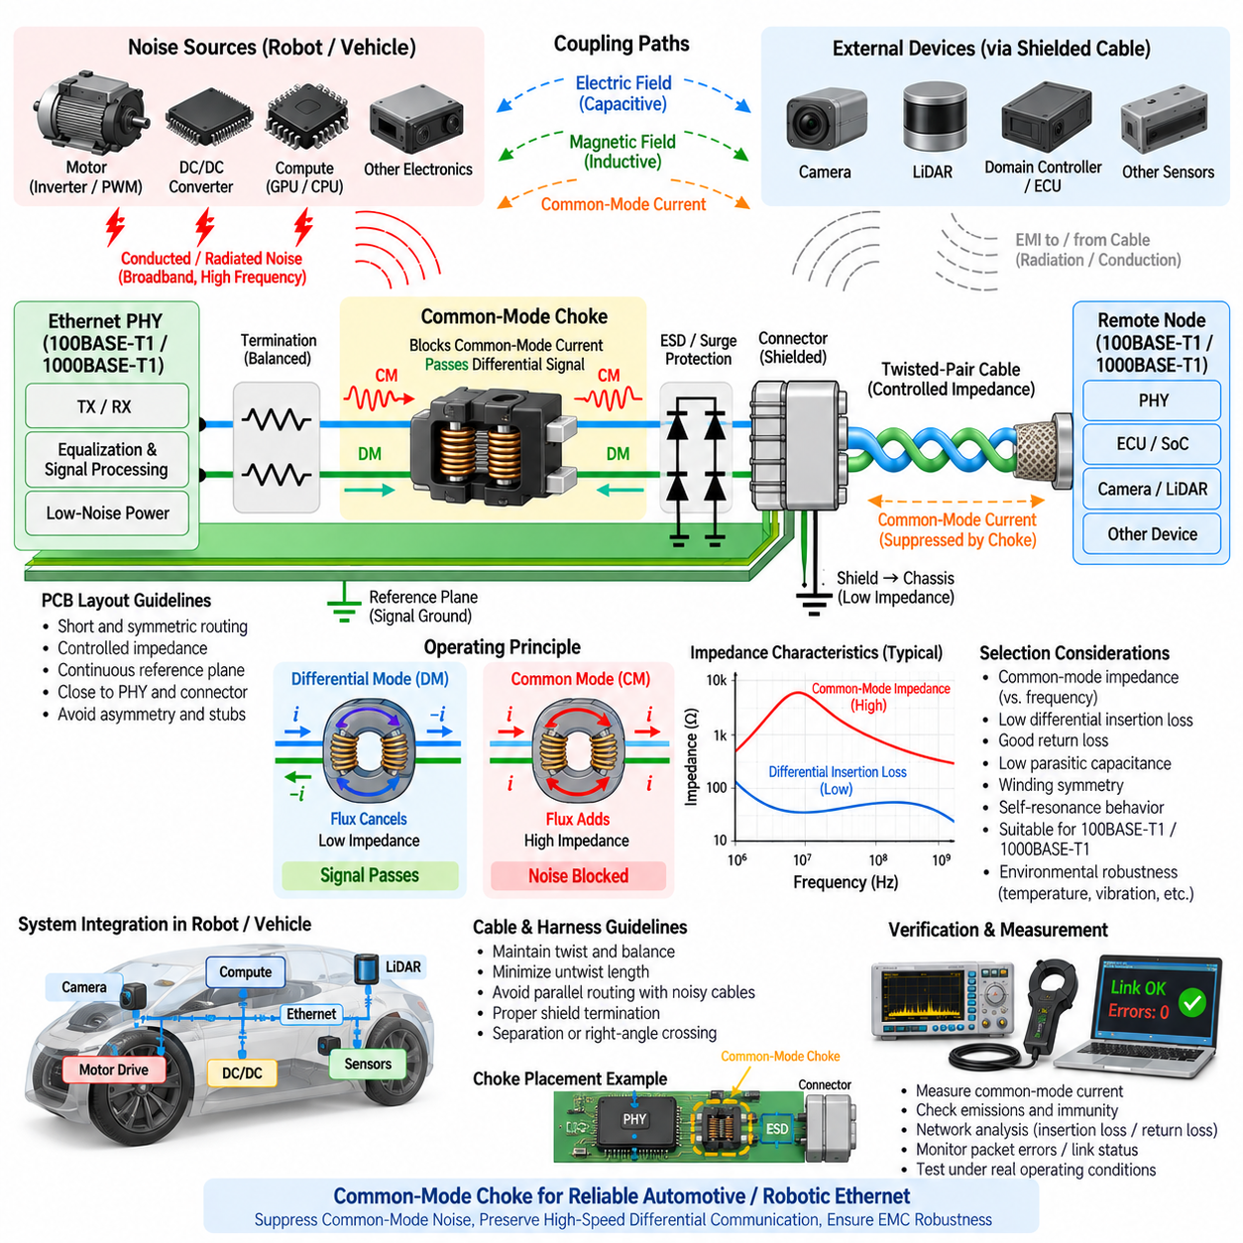
A common-mode choke is an important EMC component in Ethernet interfaces because it suppresses unwanted common-mode current while allowing the intended differential communication signal to pass with minimal disturbance. In 100BASE-T1 and 1000BASE-T1 systems, the choke is commonly located in the media-dependent interface between the Ethernet PHY and cable, where it helps prevent high-frequency noise from propagating between the PCB and external harness.
The operating principle is based on the magnetic relationship between two windings placed on a shared magnetic core. During normal differential signaling, currents in the two conductors flow in opposite directions, producing magnetic flux that largely cancels inside the core. The resulting differential impedance remains relatively low, allowing the Ethernet waveform to propagate without excessive attenuation or distortion when the choke is correctly designed.
Common-mode current behaves differently because approximately equal currents flow in the same direction through both conductors. Their magnetic flux then adds inside the core rather than cancelling, producing a much larger inductive impedance. The choke therefore opposes common-mode current while remaining comparatively transparent to differential current, providing frequency-selective suppression without intentionally interrupting the balanced Ethernet communication path.
This behavior makes the common-mode choke particularly useful for reducing cable radiation. A balanced Ethernet pair naturally provides substantial field cancellation, but PCB asymmetry, connector discontinuities, parasitic capacitance, cable imbalance, or external coupling can generate common-mode energy. Once this energy reaches a long cable, the cable may behave as an antenna. The choke increases impedance in this unwanted current path and can reduce the amount of RF energy entering the harness.
Common-mode impedance is therefore an important selection parameter, but the highest available impedance is not automatically the best choice. Choke impedance varies strongly with frequency because winding inductance, core material, parasitic capacitance, and internal resonance determine its behavior. The useful suppression range should overlap the frequencies responsible for the actual EMC problem rather than relying on a single impedance value specified at one test frequency.
Differential insertion loss must be evaluated simultaneously because the intended Ethernet signal passes through the same component. An unsuitable choke may attenuate or distort portions of the communication spectrum, reducing receiver margin even while improving emissions. This tradeoff becomes increasingly important for 1000BASE-T1, where higher signal bandwidth makes parasitic properties and high-frequency differential behavior more significant than in lower-speed interfaces.
Return loss is another important consideration because impedance discontinuities introduced by the choke can create signal reflections. Package geometry, winding construction, PCB pads, trace transitions, and surrounding copper all influence the effective impedance seen by the differential signal. Choke selection and footprint design should therefore be considered together with the complete Ethernet channel rather than evaluating the component only from its common-mode impedance curve.
Parasitic capacitance between choke windings reduces high-frequency common-mode impedance by providing an alternative path around the intended inductance. At sufficiently high frequencies, the choke can therefore become less effective even though its low-frequency inductance appears adequate. The self-resonant behavior of the component should be examined so that the expected noise spectrum falls within a region where meaningful common-mode attenuation is still available.
Winding symmetry is especially important because any imbalance inside the choke can convert differential energy into common-mode energy. Differences in leakage inductance, winding capacitance, conductor geometry, or terminal structure can reduce longitudinal balance. For high-speed Ethernet, a choke should therefore be selected from components characterized for the applicable Ethernet technology rather than substituting a generic power-line common-mode choke with similar nominal inductance.
The choke should also tolerate the electrical conditions associated with the selected PHY and interface architecture. Although Ethernet signal currents are relatively small compared with power circuits, core characteristics, bias effects, temperature, and manufacturing tolerance can alter impedance. Automotive and robotic applications additionally require suitable environmental ratings for vibration, temperature cycling, humidity, mechanical shock, and long operating life.
Placement of the common-mode choke strongly affects its practical EMC performance. It should normally be positioned in the controlled MDI path according to the PHY manufacturer's recommended topology, with short and symmetric connections to adjacent components. Long traces between the choke, termination network, ESD protection, and connector add parasitic inductance and capacitance and can create structures that radiate or couple noise around the choke.
The PCB routing through the choke must preserve differential symmetry. Trace widths, spacing, via usage, pad transitions, and electrical environments should be closely matched on both conductors. A perfectly selected choke cannot compensate for a strongly asymmetric layout. In fact, poor routing around the component may generate additional differential-to-common-mode conversion and partially defeat the suppression mechanism that the choke was intended to provide.
Reference-plane geometry beneath and around the choke region should also be deliberate. Uncontrolled changes in parasitic capacitance from either conductor to the PCB reference structure can create imbalance. Plane splits, large copper voids, asymmetric ground structures, and nearby noisy traces should therefore be evaluated according to the PHY reference design and the intended EMC architecture rather than applying generic ground-fill rules without considering high-frequency field behavior.
The relationship between the common-mode choke and ESD protection requires careful coordination. Transient protection devices should divert high-energy disturbances through short and robust paths without introducing excessive or asymmetric capacitance into the differential pair. Depending on the PHY reference topology, the physical order of choke, protection, termination, and connector components should follow validated recommendations because changing their arrangement can alter both EMC and transient-current behavior.
Shielded connectors and common-mode chokes perform complementary functions rather than replacing each other. The choke limits common-mode current propagating through the signal conductors, while the cable shield and connector shell provide an electromagnetic boundary and a low-impedance chassis path for shield current. Effective Ethernet EMC design often requires both mechanisms to be coordinated with chassis bonding, cable construction, and PCB grounding.
In a robot or autonomous vehicle, common-mode disturbances can originate from motor inverters, DC/DC converters, switching regulators, processors, high-speed clocks, and other electronic modules. Noise may couple into Ethernet through shared power networks, electric fields, magnetic fields, chassis impedance, or cable proximity. The choke addresses only the common-mode component present at its location, so system-level noise-source reduction and harness segregation remain essential.
Motor-drive environments are particularly demanding because fast PWM switching produces broadband spectral energy. High dV/dt transitions can capacitively couple to chassis and communication wiring, while high dI/dt loops create magnetic fields that couple inductively into nearby conductors. A common-mode choke can improve Ethernet immunity to these disturbances, but it cannot compensate for poorly shielded motor cables, excessive parallel routing, or uncontrolled chassis-current paths.
The choke may also help prevent noise generated inside an ECU or robot controller from leaving through the Ethernet cable. Processor clocks, switching power supplies, and PHY-related activity can couple into the MDI as common-mode voltage. Without adequate suppression, the external cable can transform relatively small internal noise into significant radiated emissions. Bidirectional EMC behavior should therefore be considered: noise can travel both into and out of the equipment.
Measurement is necessary because the effectiveness of a common-mode choke cannot be determined reliably from schematic inspection alone. Common-mode current probes can measure RF current on the Ethernet cable, while spectrum analyzers can identify problematic frequencies. Comparing measurements with different choke configurations can reveal whether the component actually suppresses the dominant noise mechanism or merely shifts resonances to another frequency region.
Network analysis can provide additional insight by characterizing insertion loss, return loss, and mode-conversion behavior through the interface. Differential-to-common-mode and common-mode-to-differential conversion are particularly relevant because they indicate how imperfections transform one propagation mode into another. Such measurements are valuable when a design passes communication testing but exhibits unexpected radiated emissions or immunity sensitivity.
PHY diagnostics and packet-error measurements should be monitored during EMC evaluation. A choke that produces lower radiated emissions but significantly reduces communication margin is not a successful solution. Link stability, packet errors, signal-quality indicators, startup behavior, and recovery after disturbances should be evaluated together with emission and immunity results so that EMC improvements do not compromise functional communication performance.
Pre-compliance testing should use representative cables, connectors, enclosure structures, grounding, motor operation, converter loads, and processor activity. The optimum choke observed on an evaluation board with a short laboratory cable may not remain optimum when installed in a complete AMR. Cable length, chassis resonance, shield termination, harness routing, and nearby electronics can all change the frequency distribution of common-mode current.
Component variation should also be considered before production release. Core permeability, winding geometry, parasitic capacitance, temperature behavior, and manufacturing tolerance influence choke characteristics. The selected component should provide sufficient EMC margin across expected operating and production conditions rather than solving the problem only on one prototype. Qualification should include realistic environmental and electrical variation where reliability requirements demand it.
For AMR and Physical AI platforms, the Ethernet common-mode choke should therefore be treated as one element of an integrated EMC architecture rather than as a universal noise filter. Its effectiveness depends on balanced PHY layout, controlled impedance, appropriate protection, connector design, cable construction, shielding, chassis bonding, power integrity, and harness routing. Properly integrated, it suppresses unwanted common-mode propagation while preserving the high-speed differential channel required for reliable robotic Ethernet communication.

07.05. Ethernet PHY EMC Layout
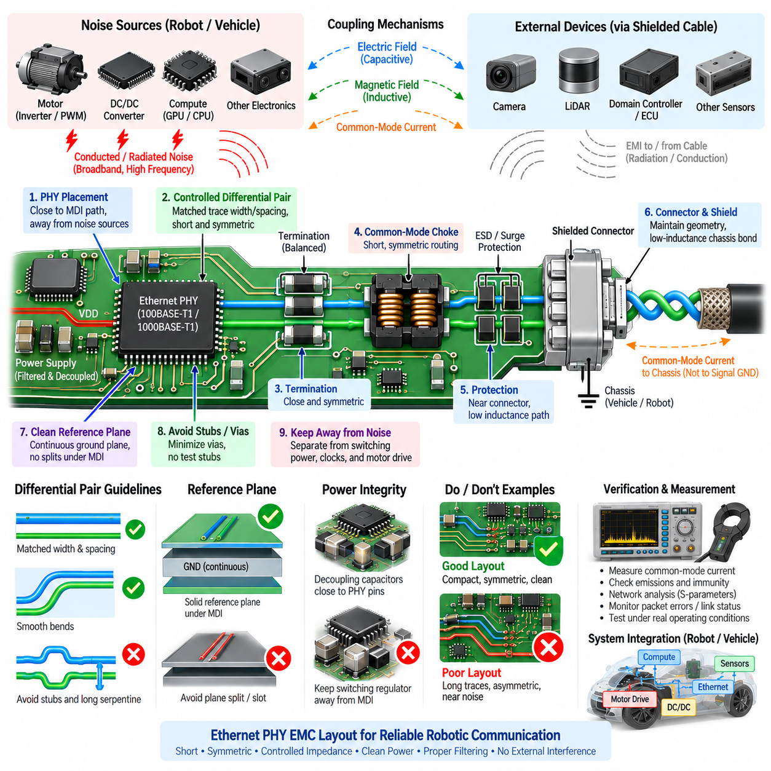
Ethernet PHY EMC layout is the physical implementation discipline that determines whether a theoretically compliant Ethernet circuit remains electrically balanced and electromagnetically robust after it is placed on a PCB. Within 100BASE-T1 and 1000BASE-T1 interfaces, the PHY, MDI traces, termination network, common-mode choke, protection devices, connector, reference planes, and power network must be treated as one high-frequency structure rather than independent schematic blocks.
PHY placement should establish the shortest practical path between the transceiver and the external Ethernet connector while leaving sufficient space for termination, filtering, and transient protection. Long MDI routing increases opportunities for coupling, impedance discontinuities, and differential-to-common-mode conversion. The PHY should therefore be positioned according to the complete interface signal flow instead of being placed only for convenience relative to the processor or digital network controller.
The MDI differential pair is the most EMC-sensitive routing structure around the PHY. Both conductors should experience nearly identical trace geometry, reference environment, component transitions, and parasitic loading. Trace width and spacing should follow the PCB stack-up required for the target differential impedance. Symmetry is essential because imbalance converts part of the intended differential signal into common-mode energy that can propagate onto the external cable and increase radiation.
Differential traces should remain closely coupled and should not be separated unnecessarily when passing through components or changing direction. Large spacing changes modify electromagnetic coupling between the conductors and alter differential impedance. Corners should be routed smoothly with consistent geometry, while unnecessary serpentine length matching should be avoided. Excessive compensation structures can introduce more discontinuity and coupling than the small length mismatch they are intended to correct.
Vias should be minimized in the MDI path because each via introduces additional inductance, capacitance, and geometrical discontinuity. When a layer transition is necessary, both conductors should transition together using symmetric via geometry. Different via counts or significantly different via environments can create imbalance. The surrounding reference structure should also support a predictable high-frequency field transition so that the pair does not encounter an abrupt electromagnetic discontinuity.
Stubs and test points require particular attention. A branch added for probing or manufacturing test can behave as a frequency-dependent resonant structure and degrade return loss or mode conversion. Large test pads can also add unequal parasitic capacitance. High-speed Ethernet debugging access should therefore be planned using compact, symmetric structures or dedicated measurement fixtures rather than attaching long branches to production MDI traces.
Reference-plane continuity is important even though Ethernet uses differential signaling. Electric and magnetic fields extend beyond the two signal traces and interact with nearby conductors. Routing the MDI pair across a plane split, board slot, large copper void, or abrupt change in reference geometry can modify parasitic coupling and common-mode behavior. The reference environment should remain continuous and symmetric throughout the high-frequency signal path according to the selected PHY architecture.
The interface should not be surrounded by uncontrolled ground copper simply because additional ground is assumed to improve EMC. Asymmetric copper near one conductor can change capacitance and disturb balance. Ground fills, stitching vias, chassis structures, and shielding copper should therefore be introduced intentionally. Their geometry should support the defined electromagnetic return path without creating unequal coupling to the positive and negative members of the differential pair.
Termination and coupling components should be positioned close to the locations recommended by the PHY manufacturer. Both sides of the differential path should use equivalent package sizes, pad geometries, and trace lengths. Even when resistor and capacitor values are electrically identical, asymmetric placement can produce different high-frequency parasitic behavior. Compact and mirrored implementation helps maintain longitudinal balance and reduces unintended mode conversion.
The common-mode choke should be integrated into the MDI path with short, symmetric traces. Its footprint should not force the differential pair into excessive separation or complex routing. The choke should be selected and positioned as part of the complete channel because its leakage inductance, parasitic capacitance, winding balance, and self-resonance influence both EMC and signal integrity. Poor layout around a good choke can eliminate much of its expected benefit.
ESD and transient protection should normally be located near the external interface so disturbance current can be diverted before propagating deeply into the PCB. The current path from the protection device to its intended reference should be short and low in inductance. Protection components must present closely matched parasitic capacitance to both MDI conductors, since unequal loading can transform a transient-protection feature into a source of differential imbalance.
The connector transition should preserve the geometry and symmetry established on the PCB. Long traces between protection circuitry and the connector can become exposed antenna structures outside the effective filtering region. If a shielded connector is used, the connector shell should have an intentional low-inductance path to chassis. Shield current should not be forced through long PCB traces or sensitive digital ground before reaching its high-frequency return structure.
A useful layout architecture creates a clear physical sequence from PHY through termination and coupling, common-mode suppression, protection, connector, and cable. Components should not be scattered across the board and interconnected by long traces. A compact interface reduces loop area and parasitic structures while making the electromagnetic current paths easier to understand. The exact component order should follow the validated reference design for the selected PHY.
PHY power layout is equally important because disturbances entering the transceiver supply can affect analog front-end performance, transmitter quality, receiver sensitivity, and clock behavior. Decoupling capacitors should be located close to the relevant power pins with short connections to the appropriate reference plane. The high-frequency current loop between the PHY supply pin and local decoupling capacitor should be minimized rather than relying on distant bulk capacitance.
Different PHY supply domains may require separate filtering or decoupling strategies according to the manufacturer's recommendations. Analog, digital, and internal regulator supplies should not be arbitrarily connected through long shared traces. Ferrite beads or filters, where specified, should be positioned so that noisy currents are contained locally. Power filtering must be designed together with return-current geometry because a filter component cannot compensate for a poorly routed ground path.
Switching regulators supplying the PHY should be physically separated from the MDI region. Switch nodes, inductors, rectifier loops, and high-dI/dt power paths generate strong electric and magnetic fields. Routing the Ethernet pair beside or beneath these structures can inject broadband noise directly into the interface. If board area is limited, component orientation and layer assignment should be used to maximize electromagnetic separation between switching power and sensitive Ethernet circuitry.
The digital side of the PHY also requires careful partitioning. Processor buses, memory interfaces, high-frequency clocks, and other high-speed digital traces can couple into the analog MDI section if routed nearby. The PHY forms a boundary between a noisy digital environment and a cable connected to the outside world. Layout should prevent internal digital energy from reaching the MDI and using the Ethernet harness as an unintended radiating antenna.
Clock circuitry deserves particular attention because repetitive clock harmonics often appear clearly during radiated-emission testing. Crystal or oscillator traces should be short and localized around the PHY, with return paths contained within a small area. Clock traces should not run parallel to the MDI pair or approach the connector region. Reducing clock-loop area and preventing coupling into external wiring can significantly improve system-level emission performance.
Chassis ground and signal ground should have deliberately defined roles around the Ethernet interface. The connector shield and external cable shield may carry high-frequency common-mode current that should return through chassis rather than sensitive circuit references. Any coupling between chassis and PCB ground should therefore be implemented according to the system grounding strategy, with attention to impedance across frequency rather than considering only DC continuity.
Physical partitioning can make the intended EMC architecture visible directly in the PCB layout. The external interface region, PHY analog region, digital processing region, and switching-power region should have understandable boundaries and controlled interconnections. This approach simplifies troubleshooting because engineers can associate measured emissions or immunity failures with specific coupling paths instead of dealing with an electrically mixed board where every subsystem interacts unpredictably.
In robotic controllers, additional separation is required from motor-driver circuits. Gate-drive loops, inverter switch nodes, phase outputs, braking circuits, and high-current bus paths can generate disturbances far stronger than normal digital circuitry. Ethernet PHY and MDI routing should be located away from these structures, and the PCB should complement system-level separation between Ethernet harnesses and motor cables rather than placing both noise classes together at the board interface.
Thermal layout should not be ignored because PHY electrical characteristics and passive-component behavior vary with temperature. Heat from processors, regulators, motor drivers, or power devices can raise the local temperature around the transceiver and alter operating margin. Thermal vias and copper spreading may be required, but their placement must not disturb sensitive MDI geometry. Thermal and EMC requirements should therefore be resolved together instead of optimized independently.
Layout verification should include more than conventional design-rule checking. Differential impedance, trace symmetry, reference continuity, via transitions, component placement, power-current loops, and chassis paths should be reviewed explicitly. For gigabit interfaces, channel simulation or measurement can help evaluate insertion loss, return loss, and mode conversion. EMC-focused layout review should occur before fabrication because many structural problems are difficult to correct with component changes afterward.
Prototype evaluation should combine PHY diagnostics with electromagnetic measurements. Current probes can identify common-mode current flowing on the Ethernet cable, while near-field probes can locate coupling around the PHY, clock, power supply, choke, or connector. Spectrum measurements should be correlated with packet errors and link status. This combination distinguishes signal-integrity limitations from emissions caused by common-mode conversion or internal noise coupling.
Testing should be repeated under representative robot operating conditions, including motor PWM activity, DC/DC converter loading, GPU or processor computation, sensor operation, and realistic cable configurations. A PHY layout that performs well on a quiet laboratory board may behave differently when installed beside high-power electronics. System-level EMC verification is therefore necessary to confirm that the PCB implementation remains robust within the complete electromagnetic environment.
For AMR and Physical AI systems, Ethernet PHY EMC layout ultimately connects circuit design with system EMC architecture. Reliable communication requires controlled differential routing, symmetric component placement, continuous reference geometry, compact filtering, low-inductance protection paths, disciplined power integrity, chassis-aware shielding, and separation from motor and compute noise sources. When these principles are applied together, the PCB preserves the balanced Ethernet channel while preventing the external harness from becoming a major path for conducted or radiated interference.

