Volume 05. Grounding and EMC

Chapter 05. Filtering Design

05.01. EMI Filter Design
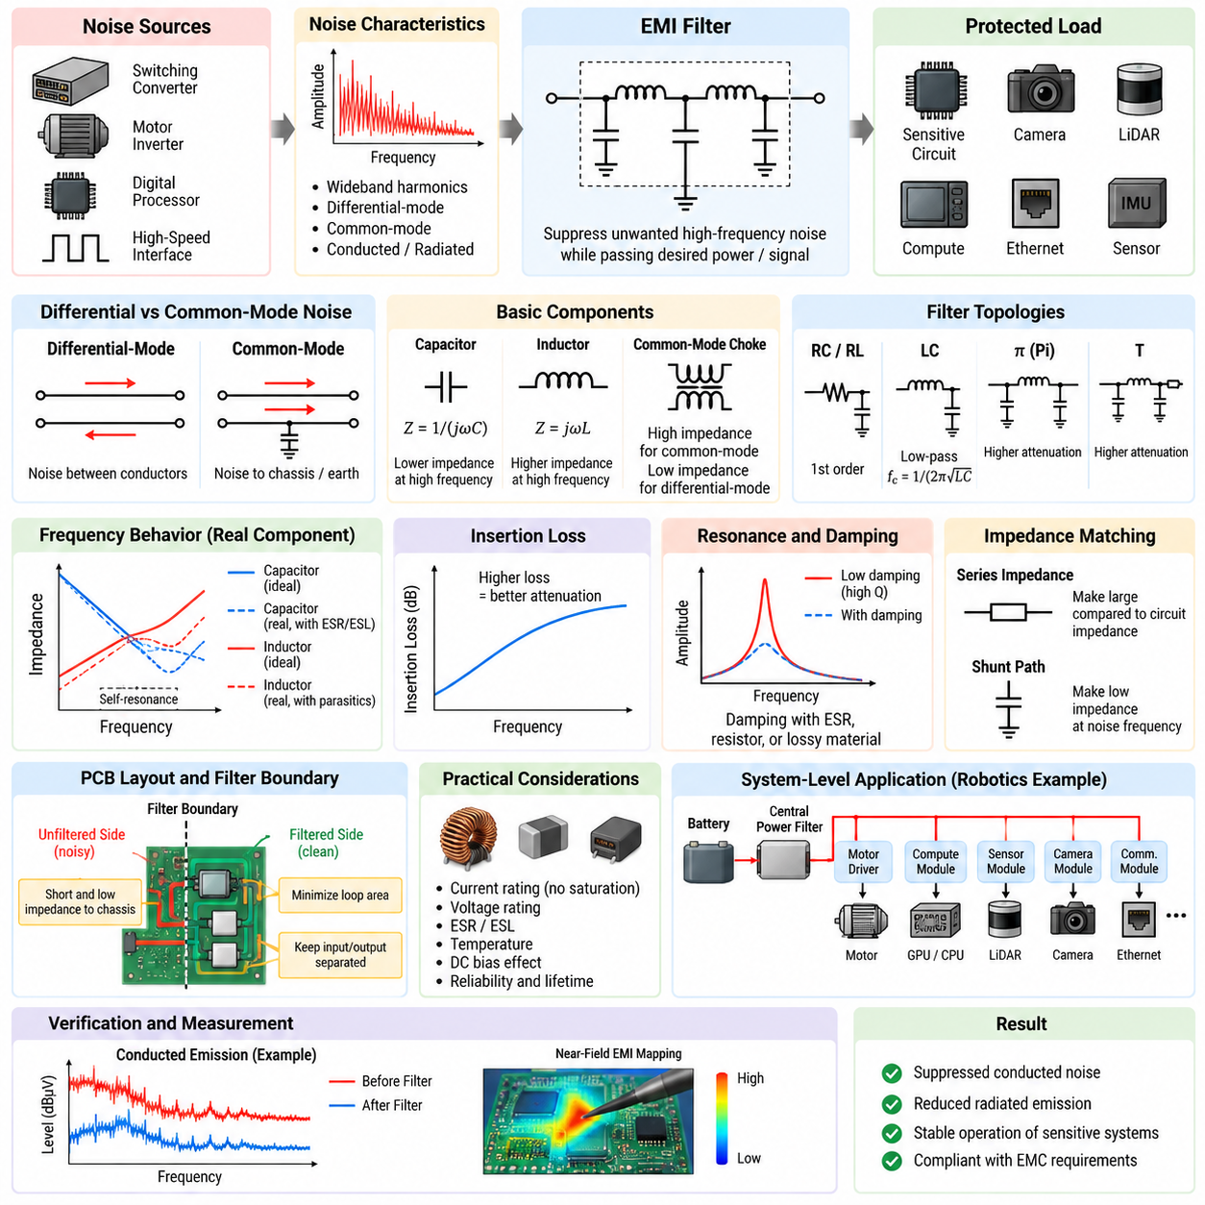
EMI filter design is the systematic process of controlling unwanted conducted electromagnetic energy before it propagates between electronic subsystems, cables, power networks, and sensitive circuits. Within the filtering design structure of this volume, it provides the general foundation for later treatment of ferrite beads, LC filters, common-mode chokes, and filter placement rules.
An EMI filter should be designed from the actual noise mechanism rather than selected only from a nominal frequency range. The engineer first identifies the noise source, propagation path, affected circuit, frequency spectrum, and dominant coupling mode. Information obtained from conducted-emission measurements and near-field EMI mapping can therefore become direct input to the filter design process.
Differential-mode noise appears as an unwanted voltage or current between two conductors, while common-mode noise travels in the same direction on multiple conductors relative to chassis, earth, or another reference structure. These two mechanisms require different filtering strategies. A filter effective against differential-mode switching ripple may provide little attenuation against common-mode cable current.
The fundamental function of an EMI filter is to introduce a frequency-dependent impedance discontinuity that suppresses unwanted high-frequency energy while allowing the intended power or signal energy to pass. Series elements normally increase impedance to noise current, whereas shunt elements provide a low-impedance return path for unwanted energy. Their combination determines the attenuation characteristic.
Capacitors are widely used because their impedance decreases with increasing frequency according to the ideal relationship Z = 1/(jωC). A capacitor placed across power conductors can divert differential-mode noise, while capacitors connected toward chassis can provide paths for common-mode current. Real capacitors, however, include equivalent series resistance and inductance that limit high-frequency performance.
Inductors provide increasing impedance with frequency according to the ideal relationship Z = jωL and are therefore useful as series filtering elements. At practical frequencies, winding resistance, parasitic capacitance, magnetic-core losses, saturation, and self-resonance modify this behavior. An inductor must consequently be selected using impedance-versus-frequency characteristics as well as its nominal inductance.
A simple first-order RC or RL network can suppress moderate high-frequency disturbances, but power electronic systems commonly require LC, π, or T-type networks to obtain stronger attenuation. The ideal cutoff frequency of an LC section is approximately f_c = 1/(2π√LC). This equation provides an initial design estimate, while actual attenuation must include source impedance, load impedance, and parasitic components.
Filter insertion loss is a more meaningful engineering quantity than component values alone. It describes how much unwanted energy is reduced after the filter is inserted between the source and load. A theoretically high-order filter can perform poorly when connected to unexpected impedances, because the source-filter-load combination changes poles, resonances, damping, and the effective transfer characteristic.
Impedance mismatch is therefore central to practical EMI filtering. A series impedance is generally most effective when it is large compared with the surrounding circuit impedance, while a shunt path should present substantially lower impedance to the unwanted frequency components. Designing from this perspective prevents the common mistake of treating an EMI filter as an isolated two-port component.
Resonance requires particular attention in LC-based filters. Low-loss inductors and capacitors can form a high-Q network that produces amplification near resonance instead of uniform suppression. Damping may be introduced through component ESR, intentional resistance, RC damping branches, lossy magnetic materials, or other controlled mechanisms so that attenuation remains stable across realistic operating conditions.
Common-mode filtering requires control of current flowing between the electrical system and chassis or surrounding structures. Common-mode chokes can present high impedance to currents moving in the same direction while allowing differential operating current to pass with relatively little impedance. Chassis-referenced capacitors may then provide a short high-frequency return path that prevents noise from reaching external cables.
Differential-mode filtering primarily targets switching ripple and noise circulating between supply and return conductors. Series inductance combined with a capacitor across the conductors forms a basic low-pass structure. The selected components must withstand operating current, transient voltage, ripple current, temperature, and fault conditions while maintaining adequate filtering throughout the expected frequency range.
Filter design must also consider the source of the noise itself. Switching converters, motor inverters, PWM motor drivers, digital processors, and high-speed interfaces generate different spectral signatures. Fast switching edges contain significant high-frequency harmonics, meaning that reducing only the fundamental switching frequency component may leave substantial conducted and radiated EMI at much higher frequencies.
Parasitic capacitance strongly influences common-mode noise in robotic power systems. High dV/dt switching nodes can capacitively couple current into chassis, motor housings, heat sinks, cable shields, and mechanical structures. Once this current reaches a long cable, the cable may become an efficient antenna. Filtering must therefore control both the conducted path and the unintended high-frequency return path.
Component self-resonance is another practical limitation. Above its self-resonant frequency, a capacitor may become predominantly inductive and an inductor may become increasingly capacitive. Effective broadband filtering therefore often requires components with complementary frequency characteristics rather than one very large capacitor or inductor. Small high-frequency capacitors may supplement larger bulk capacitors where appropriate.
PCB layout can determine whether a correctly calculated EMI filter succeeds or fails. Input and output conductors should be physically separated so that noise cannot bypass the filter through electric or magnetic coupling. Connections to shunt capacitors should be short and low impedance, loop areas should be minimized, and noisy traces should not run parallel to filtered traces across the filter boundary.
The concept of a filter boundary is especially important. The unfiltered side should be treated as electromagnetically different from the filtered side, with controlled current paths between them. If traces, planes, cables, or chassis connections accidentally couple across this boundary, high-frequency energy can bypass the components entirely. Mechanical packaging and connector placement are therefore part of EMI filter design.
Power filters must be evaluated under real electrical loading. Inductors can saturate at peak current, capacitors can lose effective capacitance with DC bias, and ferrite materials can change impedance with current and temperature. Voltage rating, current rating, ripple capability, thermal rise, transient tolerance, insulation requirements, and reliability margins must all be considered together with attenuation.
Robotic systems make this design problem particularly demanding because high-current motor electronics operate close to sensitive perception and computing hardware. Motor drivers, DC/DC converters, GPUs, Ethernet interfaces, LiDARs, cameras, GNSS receivers, IMUs, and safety controllers may share the same battery and chassis environment. Filtering must prevent one subsystem's switching energy from contaminating another subsystem.
An AMR power architecture, for example, may require filtering at several hierarchical boundaries rather than one large filter at the battery. A central power filter can restrict noise propagation through the distribution network, while local filters near motor controllers, compute modules, sensors, and communication equipment suppress subsystem-specific disturbances. This distributed approach reduces the length of uncontrolled high-frequency current paths.
Filter verification should combine circuit measurements with system-level EMC evaluation. Conducted-emission measurements reveal noise remaining on power and signal lines, while near-field probes help identify leakage around components, PCB regions, connectors, and cables. Comparing spectra before and after filter installation shows whether attenuation occurs at the intended frequencies and whether new resonances have appeared.
A robust EMI filter is therefore not simply an arrangement of capacitors and inductors. It is an engineered interface between the noise source, propagation network, load, grounding system, chassis, shielding structure, and physical layout. Successful design requires simultaneous consideration of common-mode and differential-mode behavior, impedance, resonance, parasitics, placement, current capability, and environmental conditions.
The filtering chapter places this general EMI filter methodology before dedicated discussions of ferrite bead selection, LC filter design, common-mode chokes, and filter placement. This sequence reflects the engineering workflow: identify the interference mechanism, establish the required attenuation and impedance strategy, select suitable filtering technologies, and finally implement them at the physical location where noise propagation can be interrupted most effectively.

05.02. Ferrite Bead Selection
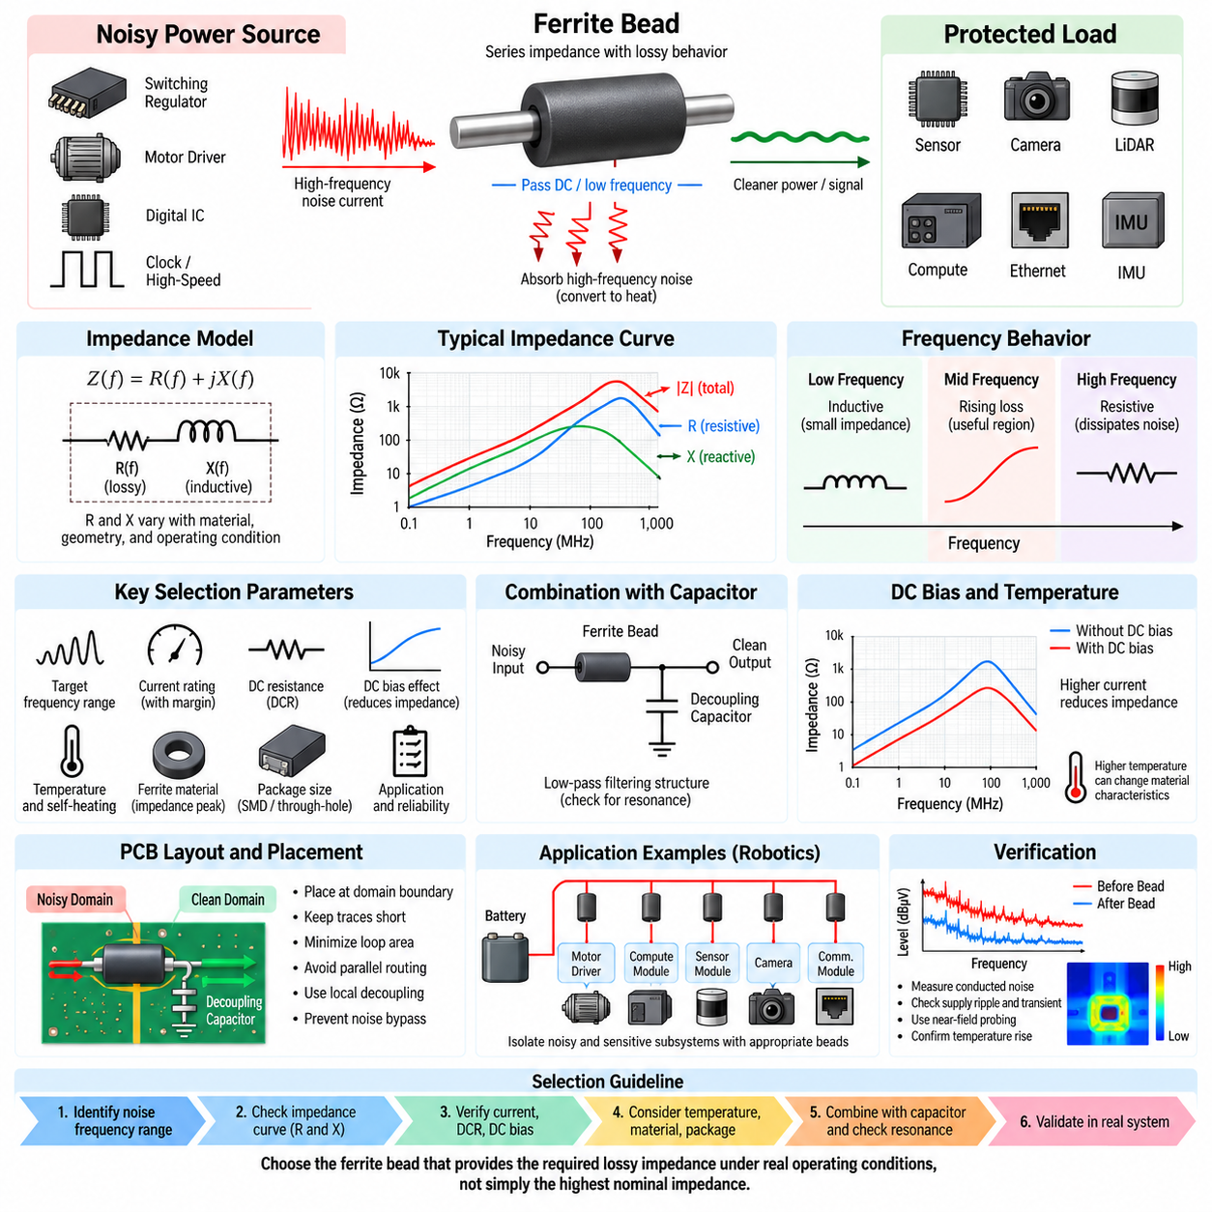
Ferrite bead selection is a frequency-domain impedance engineering task used to suppress unwanted high-frequency currents while allowing the intended DC or low-frequency current to pass with minimal disturbance. Within an EMI filtering architecture, the bead normally acts as a compact series element whose lossy magnetic behavior converts part of the high-frequency interference energy into heat rather than merely storing and returning it.
Unlike an ideal inductor, a ferrite bead exhibits an impedance that changes substantially with frequency. Its impedance can be represented approximately as Z(f) = R(f) + jX(f), where the resistive and reactive components vary according to ferrite material, geometry, winding or conductor structure, and operating conditions. Effective selection therefore requires examination of the complete impedance-versus-frequency characteristic rather than the nominal impedance alone.
At relatively low frequencies, the bead may behave predominantly as a small inductive impedance and introduce little voltage drop into the intended supply current. As frequency rises, magnetic losses increase and the resistive component can become dominant. This lossy region is particularly useful for EMI suppression because high-frequency noise energy is dissipated instead of being strongly reflected back into the source network.
Manufacturers commonly specify ferrite beads using an impedance value measured at a reference frequency, such as 100 MHz. A rating such as 600 Ω at 100 MHz is useful for comparison, but it does not mean that the bead provides 600 Ω across the entire EMI spectrum. Two components with identical nominal ratings can have substantially different impedance curves and therefore different suppression performance in a real circuit.
The first selection step is consequently to identify the frequency range of the unwanted interference. Conducted-emission measurements, oscilloscope observations, spectrum analysis, and near-field EMI mapping can reveal switching fundamentals, harmonics, ringing frequencies, and broadband components. The selected ferrite bead should provide significant lossy impedance over the frequency region where the actual noise energy must be reduced.
Current capability is equally important because ferrite beads used on power rails carry the normal load current in addition to unwanted high-frequency components. The rated current should exceed the maximum expected operating current with appropriate design margin. Excessive current can produce thermal stress, increased DC voltage drop, or magnetic bias effects that reduce the effective impedance available for EMI suppression.
DC resistance, commonly specified as DCR, determines the conduction loss generated by the normal load current. The approximate power dissipation associated with this resistance is P = I²R. A bead with excellent high-frequency impedance but excessive DCR can therefore create unacceptable voltage drop and heating in high-current circuits. Power distribution applications require a deliberate balance between EMI attenuation and low-frequency efficiency.
DC bias can significantly alter ferrite bead performance. As the operating current increases, the magnetic material moves toward a biased operating condition and the effective permeability can decrease. Consequently, a bead that exhibits high impedance under small-signal laboratory measurements may provide considerably lower impedance when carrying substantial DC current. Bias-dependent impedance data should therefore be examined whenever available.
Temperature introduces another practical selection variable. Ferrite material characteristics and conductor resistance vary with temperature, while self-heating caused by load current can further increase component temperature. The engineer must evaluate the bead under the expected ambient temperature, enclosure conditions, airflow, PCB thermal environment, and continuous current rather than assuming that room-temperature catalog characteristics represent actual operation.
Ferrite material composition determines much of the useful frequency range. Different material formulations provide different permeability and loss characteristics, allowing some beads to perform effectively in lower-frequency EMI regions and others to target higher-frequency interference. Selection should therefore match the material's impedance peak and resistive-loss region to the measured noise spectrum instead of simply choosing the largest available impedance rating.
The relationship between resistance and reactance is important when interpreting impedance curves. In the predominantly inductive region, the bead can interact with circuit capacitance and potentially form a resonant network. In the predominantly resistive region, it behaves more like a frequency-selective loss element and can provide useful damping. For EMI suppression, this resistive behavior is often one of the principal advantages of ferrite components.
A ferrite bead is frequently combined with bypass or decoupling capacitors to create a low-pass filtering structure. The bead increases series impedance to high-frequency current, while the capacitor provides a low-impedance local path for that current. This combination can isolate a noisy supply domain from a sensitive domain, but the resulting network must be checked for resonance because the bead, capacitor, PCB inductance, and source impedance interact dynamically.
Capacitor selection therefore affects bead performance. Large bulk capacitance supports lower-frequency energy storage, while smaller ceramic capacitors can provide lower impedance at higher frequencies. Their effective capacitance, equivalent series resistance, equivalent series inductance, package size, and mounting geometry influence the resulting filter response. The bead and capacitor should be treated as one network rather than as independent components.
Placement is critical because a ferrite bead cannot suppress noise that bypasses it through another conductive or electromagnetic path. When isolating a sensitive circuit, the bead should generally be positioned at the boundary between the noisy and protected power domains. The associated decoupling capacitor should be located so that high-frequency current circulates locally on the protected side instead of traveling through long PCB traces.
PCB layout around the bead should minimize unintended coupling between its input and output nodes. If noisy and filtered traces run closely in parallel, electric or magnetic coupling can transfer high-frequency energy around the bead and reduce its effective insertion loss. Short connections, controlled return paths, compact loop areas, and clear separation between the unfiltered and filtered regions preserve the intended filtering boundary.
Package size affects electrical, thermal, and mechanical performance. Smaller surface-mount beads can exhibit low parasitic dimensions and good high-frequency characteristics but may have limited current capability and higher DC resistance. Larger packages can support greater current and lower conduction loss but may introduce different parasitic behavior. Package selection must therefore consider both the required frequency response and power-distribution requirements.
Ferrite beads should not automatically be inserted into every power or signal path. A poorly selected bead can create supply impedance problems, increase transient voltage variation, interact with regulator control loops, or generate resonance with local capacitors. Sensitive high-speed interfaces may also be degraded if a bead is placed directly in a signal path without consideration of signal bandwidth, characteristic impedance, and return-current continuity.
In robotic systems, ferrite beads are particularly useful for local isolation between electrically noisy and sensitive subsystems. Motor drivers, switching regulators, servo electronics, and high-current digital modules can inject broadband noise into shared power networks, while cameras, LiDARs, IMUs, GNSS receivers, communication transceivers, and analog sensing circuits may require cleaner local supplies. Proper bead selection helps restrict this noise propagation.
An AMR may therefore use different ferrite bead characteristics for different electrical domains rather than one universal component. A bead protecting a low-current sensor rail can prioritize high impedance and broadband loss, while a bead on a compute-module auxiliary supply may require much lower DCR and substantially higher current capability. Motor-related circuits may require still different filtering because their switching spectra and current levels are more severe.
Verification should be performed under representative operating conditions after the bead is installed. Conducted-noise spectra can be compared before and after installation, while oscilloscope measurements can reveal changes in supply ripple and transient behavior. Near-field probing can determine whether noise has been reduced locally or merely redirected through another path. Thermal measurements can additionally confirm that current loading remains acceptable.
If suppression is insufficient, selecting a bead with a larger nominal impedance is not automatically the correct solution. The engineer should determine whether the bead's resistive impedance actually overlaps the problematic frequency range, whether DC bias has reduced its effectiveness, whether noise is common-mode rather than differential-mode, and whether PCB coupling or grounding provides an alternative propagation path. The underlying mechanism should guide the correction.
Ferrite bead selection is therefore a multidimensional engineering decision involving impedance-versus-frequency behavior, resistive and reactive components, current rating, DCR, DC bias, temperature, material composition, package size, surrounding capacitance, PCB layout, and actual noise spectrum. A successful component is not necessarily the bead with the highest catalog impedance, but the one that provides the required lossy impedance under real operating conditions.
Within the broader filtering design sequence, ferrite beads provide a compact method for controlling high-frequency interference before more structured LC filtering, common-mode filtering, and physical filter placement are considered. Their effectiveness depends on treating them as frequency-dependent magnetic loss elements embedded within the complete source-filter-load network, establishing the engineering foundation for the subsequent LC filter design and common-mode choke analysis.

05.03. LC Filter Design
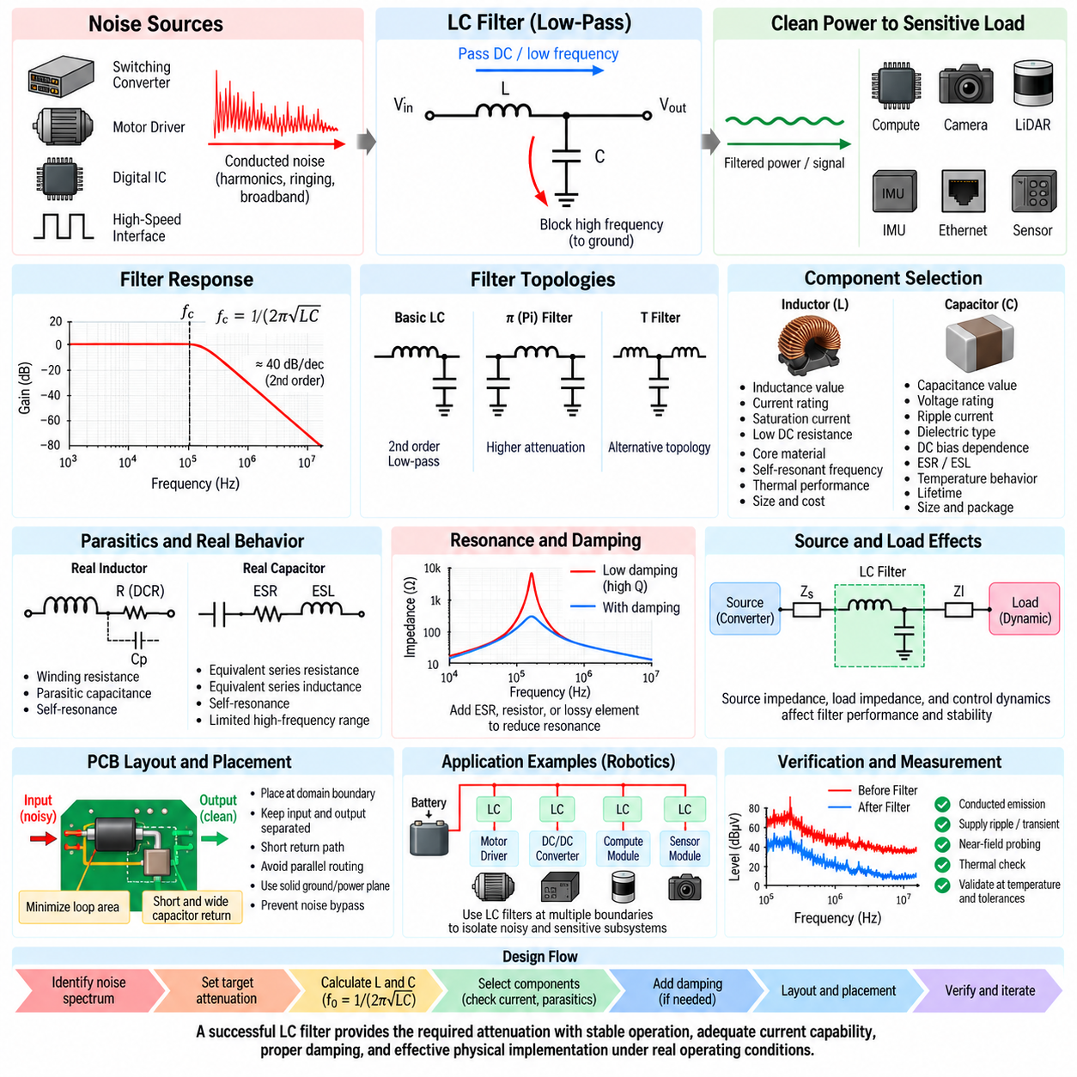
LC filter design is the engineering process of combining inductance and capacitance to attenuate unwanted frequency components while transferring the required DC or low-frequency power with minimal loss. Within EMI filtering, an LC network provides stronger frequency-selective attenuation than a single passive component and is particularly useful when switching converters, motor drivers, or power distribution networks generate significant conducted noise.
The fundamental LC low-pass filter normally places an inductor in series with the power path and a capacitor across the supply and return conductors. The inductor opposes rapid changes in current, while the capacitor provides a low-impedance path for high-frequency voltage components. Together they create a second-order filtering response capable of substantially greater attenuation beyond the cutoff region than a simple first-order network.
For an ideal LC low-pass network, the characteristic resonant or cutoff-related frequency is commonly estimated from f₀ = 1/(2π√LC). This relationship provides an initial basis for selecting inductance and capacitance values. In practical EMI design, however, the required filter corner should be chosen relative to the unwanted noise spectrum while remaining sufficiently separated from the intended operating bandwidth and normal power-system dynamics.
Increasing either inductance or capacitance lowers the characteristic frequency, but larger component values are not automatically better. Higher inductance may increase DC resistance, physical size, cost, and magnetic saturation risk, while larger capacitance may increase inrush current, stored energy, leakage, and interaction with power converters. Component values must therefore balance attenuation requirements against electrical, thermal, mechanical, and dynamic constraints.
The attenuation slope of an ideal second-order LC low-pass filter can approach approximately 40 dB per decade beyond its corner region. Real filters rarely achieve this ideal behavior over the entire frequency range because component parasitics, source and load impedance, PCB geometry, and electromagnetic coupling modify the response. Consequently, calculated component values should be regarded as a starting point rather than a guarantee of EMC performance.
Inductor selection requires more than specifying nominal inductance. The component must carry the maximum operating and transient current without unacceptable saturation or temperature rise. DC resistance should remain sufficiently low to control conduction loss and voltage drop. Core material, current rating, saturation current, thermal characteristics, self-resonant frequency, and impedance behavior across the target EMI spectrum must all be evaluated.
Capacitor selection similarly requires consideration beyond nominal capacitance. Voltage rating, ripple-current capability, dielectric type, DC-bias dependence, equivalent series resistance, equivalent series inductance, temperature behavior, and lifetime can influence filter performance. Ceramic capacitors are particularly effective at high frequencies, but their effective capacitance can decrease significantly under DC bias depending on dielectric material and package construction.
Real inductors and capacitors contain parasitic elements that limit their useful frequency range. An inductor includes winding resistance and parasitic capacitance, while a capacitor includes ESR and ESL. Near and above self-resonance, their behavior can differ substantially from ideal circuit models. Broadband EMI suppression may therefore require multiple capacitor values or filtering elements optimized for different portions of the interference spectrum.
Resonance is one of the most important issues in LC filter design. Because ideal inductors and capacitors store energy rather than dissipating it, a lightly damped LC network can develop a high-Q resonance. Instead of reducing interference uniformly, the filter may amplify disturbances around its resonant frequency, create supply ringing, increase transient overshoot, or interact adversely with the source converter and downstream electronic load.
Damping is therefore frequently required to obtain a stable practical response. Natural ESR and winding resistance provide some damping, but they may be insufficient. Additional resistance, an RC damping branch, a deliberately lossy element, or appropriately selected capacitor ESR can reduce the resonance peak. The objective is not simply maximum theoretical attenuation, but predictable suppression without creating harmful impedance peaks.
Source and load impedance strongly influence the actual transfer function of an LC filter. A filter designed assuming fixed resistive terminations may behave differently when connected between a switching regulator and a dynamic electronic load. The converter output impedance, cable impedance, local decoupling network, and load input impedance collectively determine damping and resonance. The complete source-filter-load system must therefore be evaluated.
Input filters connected to switching converters require particular care because they can interact with converter control dynamics. A tightly regulated converter can exhibit an effective negative incremental input impedance over part of its operating range. If the LC input filter has a strong impedance peak in that region, oscillation or degraded transient response can occur. Filter design must therefore consider both EMC attenuation and power-converter stability.
LC filters can be extended into π filters by adding capacitors on both sides of the series inductor, creating a C-L-C structure. This topology can provide stronger high-frequency attenuation when the surrounding impedances are appropriate. T-type arrangements and cascaded sections are also possible. Additional filter order increases potential attenuation, but simultaneously increases component count, resonance complexity, space requirements, and sensitivity to layout.
The capacitor return path is as important as the series inductor. High-frequency current diverted by the capacitor must return through a short, low-inductance path. Long traces or poorly defined return structures add parasitic inductance and reduce filtering effectiveness. If the capacitor is intended to redirect noise toward chassis, the chassis connection must also provide a controlled high-frequency path rather than a long connection with substantial inductance.
Physical placement determines whether the calculated LC network becomes an effective EMI filter. The filter should normally be positioned near the boundary through which unwanted conducted energy would otherwise propagate. Input and output wiring must remain separated, and noisy conductors should not couple electromagnetically to filtered conductors. Otherwise, high-frequency energy can bypass the LC components and defeat the intended attenuation.
PCB layout should minimize loop area around both the noisy current path and the filtering path. The series inductor should interrupt the intended propagation route directly, while the capacitor should connect through short and wide conductors to its return reference. Ground and power planes must be arranged so that high-frequency current does not cross unintended regions or share sensitive return paths with perception, communication, or control electronics.
Differential-mode LC filters are especially useful for suppressing switching noise circulating between supply and return conductors. They should not be assumed to solve common-mode interference automatically. Common-mode current flowing simultaneously on both conductors relative to chassis may pass through a differential LC filter with limited attenuation. Such conditions may require common-mode chokes, chassis-referenced capacitors, shielding, or improved grounding architecture.
Robotic platforms present demanding LC filter applications because high-power switching electronics and sensitive digital systems frequently share a compact electrical architecture. Motor inverters, servo drives, DC/DC converters, and battery distribution networks can generate conducted disturbances, while GPUs, cameras, LiDARs, IMUs, GNSS receivers, Ethernet interfaces, and safety controllers may require stable and relatively clean supply rails.
An AMR can therefore use LC filters at several electrical boundaries. A filter near a DC/DC converter may prevent switching noise from entering the main power distribution network, while another filter can isolate a sensitive sensor or computing branch. Filters near motor-control electronics can restrict differential switching currents locally. This distributed filtering strategy prevents high-frequency energy from traveling through long harnesses that may also become radiating structures.
Load transients must be included in the design because filtering changes the impedance between the source and load. A large inductor can limit the rate at which source current responds to sudden demand, requiring downstream capacitance to provide temporary energy. If this relationship is poorly designed, a compute module or sensor cluster may experience excessive voltage droop even though the filter provides excellent high-frequency EMI attenuation.
Verification should begin with impedance and frequency-response analysis and continue with measurements on representative hardware. Conducted-emission spectra before and after filtering can quantify suppression, while oscilloscope measurements reveal ripple, ringing, startup behavior, and load-transient response. Near-field probing can identify electromagnetic bypass paths, and thermal measurements can verify that the inductor and capacitors remain within acceptable operating limits.
Component tolerances and environmental conditions should also be included in validation. Inductance can change with current and temperature, capacitance can vary with voltage and dielectric characteristics, and ESR changes across frequency and temperature. A filter that works only with nominal room-temperature component values may become ineffective or unstable at operating extremes. Robust design therefore evaluates worst-case combinations rather than only typical values.
When measured performance differs from simulation, the engineer should investigate the physical network before simply increasing L or C. Parasitic coupling, connector inductance, cable behavior, grounding, capacitor mounting, inductor saturation, component self-resonance, and common-mode propagation may dominate the result. EMI troubleshooting should identify which current path remains uncontrolled and then modify the filter or physical architecture accordingly.
LC filter design is therefore an integrated impedance, resonance, energy-storage, layout, and EMC problem rather than a simple calculation of L and C. Successful filters combine the required frequency attenuation with adequate current capability, low conduction loss, controlled damping, converter stability, transient performance, thermal margin, and effective physical placement under realistic operating conditions.
Within the filtering design structure, LC filter design follows the general EMI filter methodology and ferrite bead selection, and precedes the dedicated treatment of common-mode chokes and filter placement rules. This progression moves from basic suppression elements toward increasingly structured control of differential and common-mode propagation, ultimately integrating electrical filter behavior with the physical EMC architecture of the robotic system.

05.04. Common Mode Choke
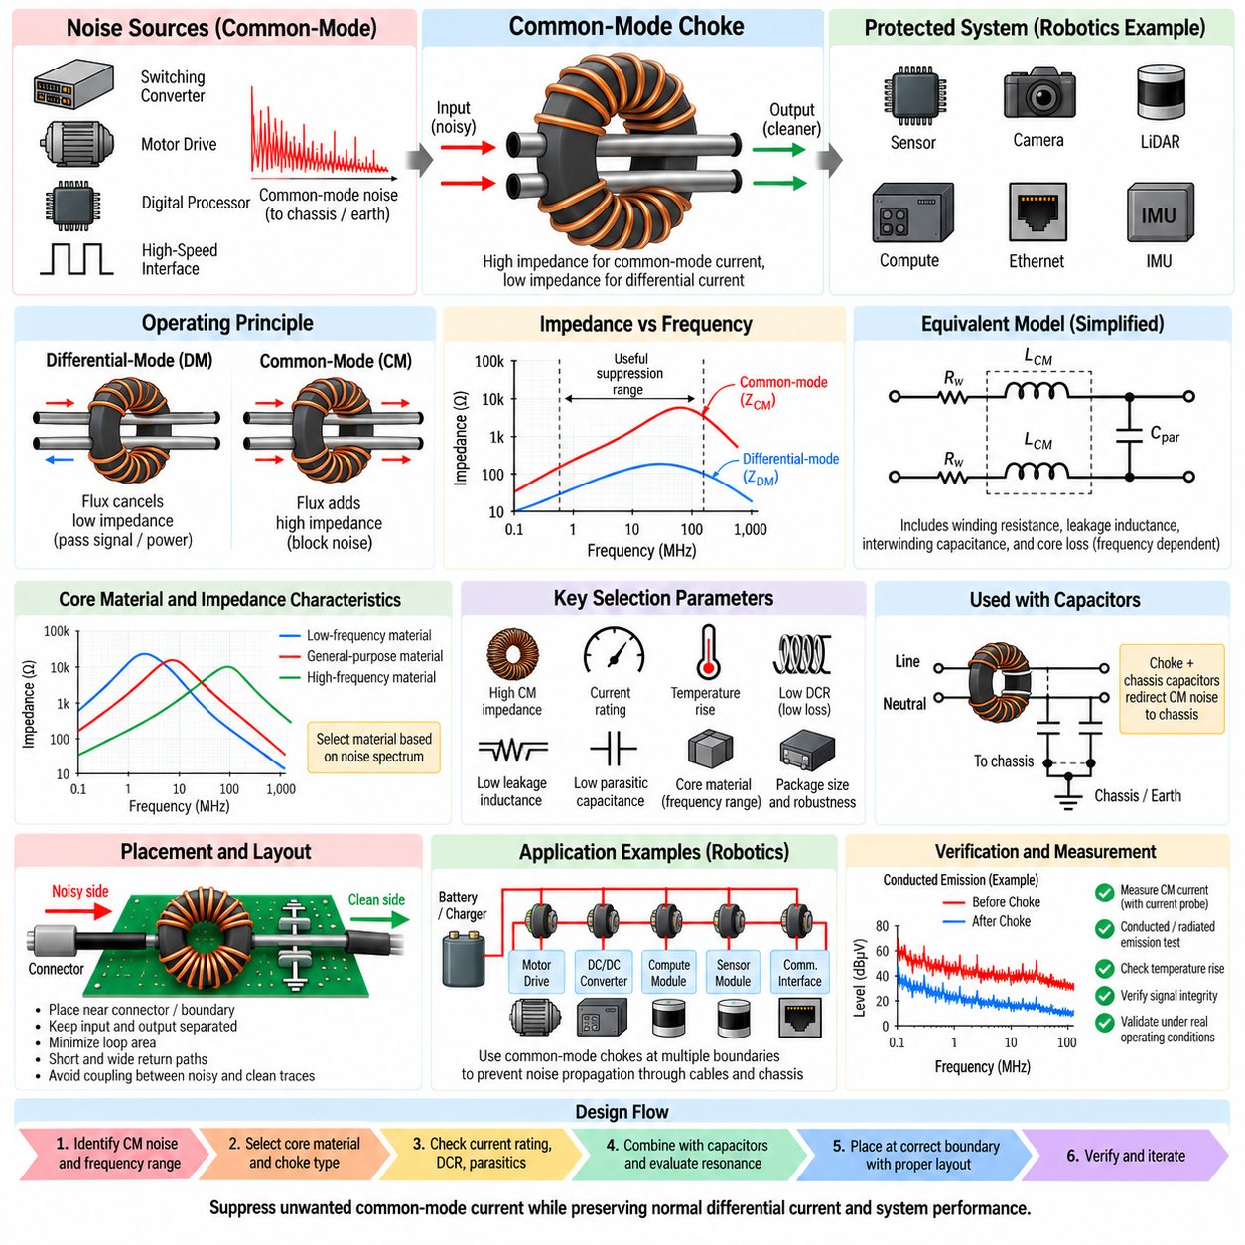
A common-mode choke is a coupled magnetic filtering component designed to suppress unwanted currents that flow in the same direction on two or more conductors while allowing the intended differential current to pass with relatively little impedance. Within the filtering design sequence, it complements ferrite beads and LC filters by specifically addressing common-mode interference that conventional differential-mode filtering may not adequately control.
The operating principle depends on magnetic flux cancellation and reinforcement inside a shared magnetic core. When normal differential current flows outward through one conductor and returns through the other, the magnetic flux produced by the two windings largely cancels. The choke therefore presents relatively low differential-mode inductance and allows the required power or balanced signal current to pass without excessive voltage drop.
Common-mode current behaves differently because noise current flows in the same direction through both conductors relative to chassis, earth, or another external reference. Under this condition, the magnetic flux generated by the windings reinforces rather than cancels. The resulting common-mode inductance becomes large, producing substantial impedance that opposes the unwanted high-frequency current and reduces its propagation through cables and external interfaces.
The common-mode impedance can be approximated conceptually by Z_CM = R(f) + jωL_CM, although practical behavior is strongly frequency dependent. Core loss, winding resistance, leakage inductance, interwinding capacitance, and parasitic coupling modify the ideal response. Consequently, choke selection should be based on measured impedance-versus-frequency data rather than only the nominal inductance printed in a component specification.
A useful choke must provide high common-mode impedance across the frequency range where interference is actually present. Switching converters, motor inverters, PWM drivers, digital processors, and high-speed communication circuits can generate noise over very different spectral regions. Conducted-emission measurements and near-field EMI mapping should therefore identify the dominant frequencies before the magnetic material and choke structure are selected.
Magnetic core material strongly determines the usable suppression range. Different ferrite compositions provide different permeability and loss characteristics, causing the impedance peak and resistive-loss region to occur at different frequencies. A component optimized for relatively low-frequency switching noise may not be effective against several-hundred-megahertz interference, while a high-frequency choke may provide insufficient impedance at lower frequencies.
The resistive component of common-mode impedance is particularly valuable because it dissipates high-frequency interference energy rather than simply storing it magnetically. A highly reactive choke can interact with cable and capacitor parasitics to create resonance. In the lossy frequency region, however, magnetic core losses provide natural damping and can reduce the amplitude of common-mode currents without producing an excessively sharp resonant response.
Leakage inductance is an unavoidable consequence of imperfect magnetic coupling between the windings. Although generally much smaller than the common-mode inductance, it appears as series inductance to differential current and can provide some differential-mode filtering. Excessive leakage inductance, however, may distort high-speed signals, interact with capacitors, or create unwanted voltage transients, so it must be considered rather than assumed to be beneficial.
Current rating is essential in power applications because the normal differential load current flows through the choke windings even though its magnetic flux largely cancels. Conductor resistance still produces I²R loss and temperature rise. The winding must therefore support continuous and transient current without excessive heating, conductor damage, or unacceptable voltage drop while maintaining sufficient common-mode suppression throughout the operating range.
Core saturation must also be considered. Ideally, balanced differential currents generate cancelling magnetic flux, but real systems can contain current imbalance, asymmetric winding behavior, DC offsets, leakage currents, and transient conditions. These effects can produce residual magnetic flux in the core. Adequate magnetic margin is therefore required, especially in motor drives, power converters, and other high-current robotic subsystems.
Interwinding and winding-to-winding parasitic capacitance becomes increasingly important at high frequency. This capacitance can provide an unintended path that allows common-mode noise to bypass the magnetic impedance of the choke. Above a certain frequency, the component can therefore lose effectiveness or exhibit resonant behavior. Physical construction and winding geometry are consequently important parts of high-frequency choke selection.
Common-mode chokes are frequently combined with capacitors to form more complete EMI filters. Chassis-referenced capacitors can provide a controlled low-impedance path for common-mode current after the choke presents a high series impedance. The resulting network redirects high-frequency noise locally instead of allowing it to travel along external cables. Capacitor value and chassis connection must be chosen with electrical safety and leakage-current requirements in mind.
In power systems, capacitors connected from conductors toward chassis are often functionally associated with common-mode suppression, whereas capacitors placed directly between supply and return primarily target differential-mode noise. A practical filter can contain both functions simultaneously. The common-mode choke suppresses currents shared by both conductors, while differential capacitors and leakage inductance contribute to attenuation of noise circulating between them.
Placement is critical because the choke must intercept the actual common-mode current path. It is generally most effective near the connector, cable interface, or subsystem boundary through which interference would otherwise propagate. If a long cable or PCB trace exists between the noise source boundary and the choke, that conductor can already couple energy into the chassis or surrounding structures before the filtering element becomes effective.
The input and output sides of the choke should remain electromagnetically separated. Routing filtered and unfiltered conductors close together can create capacitive or inductive coupling that bypasses the choke. The PCB layout should therefore maintain a clear filtering boundary, minimize loop areas, keep connections short, and prevent high-frequency current from crossing between the noisy and protected regions through uncontrolled ground, plane, or chassis paths.
Cable interfaces are particularly important because common-mode currents on long cables can generate significant radiated emissions. Even relatively small common-mode currents can become problematic when cable length and frequency create efficient antenna behavior. Suppressing the current near the point where the cable leaves an electronic enclosure can therefore reduce both conducted interference and radiated electromagnetic emissions from the complete system.
Common-mode chokes are also widely used in communication interfaces, but signal integrity must be considered carefully. For differential communication links, the choke should provide high common-mode impedance while introducing minimal differential impedance, insertion loss, imbalance, and mode conversion within the signal bandwidth. Parasitic capacitance and leakage inductance become especially important as data rates and spectral bandwidth increase.
Automotive Ethernet, industrial Ethernet, CAN-based networks, and other differential communication systems can benefit from appropriately designed common-mode filtering when EMC requirements demand it. However, a choke cannot compensate for poor differential routing, discontinuous return paths, inadequate connector design, or incorrect shield termination. It should be treated as one element within the complete physical-layer EMC architecture rather than as an independent cure.
Robotic platforms create numerous common-mode noise paths because motor drives, DC/DC converters, batteries, chassis structures, cable shields, sensors, and computing modules are interconnected within a compact mechanical system. High dV/dt switching nodes can capacitively inject current into motor housings, heat sinks, frames, and cable shields, after which the resulting common-mode current may propagate through sensor or communication harnesses.
An AMR can therefore require common-mode chokes at several functional boundaries. Motor-drive power connections may need suppression to prevent switching currents from spreading into the vehicle harness, while sensor power branches can require isolation from noisy distribution networks. Ethernet or other communication interfaces may use specialized chokes designed for their signal bandwidth, and external charging or auxiliary interfaces may require separate filtering strategies.
A common-mode choke should not be selected simply by choosing the highest available impedance. The engineer must consider the target noise spectrum, impedance curve, current rating, DC resistance, leakage inductance, parasitic capacitance, core material, temperature rise, insulation requirements, package size, and mechanical robustness. The correct component provides sufficient common-mode attenuation while preserving normal power delivery or signal integrity.
Verification should be performed with the choke installed in representative hardware because common-mode behavior depends strongly on the complete physical system. Conducted-emission measurements can quantify current or voltage reduction at external interfaces, while current probes can directly examine common-mode cable current. Near-field measurements can reveal remaining coupling paths, and radiated-emission testing can determine whether reduced cable current produces the expected system-level improvement.
If measured suppression remains inadequate, increasing choke impedance alone may not solve the problem. Noise may bypass the component through parasitic capacitance, chassis connections, cable shields, mounting structures, or unintended ground paths. The disturbance may also contain a substantial differential-mode component. Effective troubleshooting therefore separates common-mode and differential-mode mechanisms and identifies the physical return path before modifying the filter.
Common-mode choke design is ultimately a problem of controlling high-frequency current paths through coupled magnetic impedance. Its effectiveness depends on magnetic material, winding coupling, frequency-dependent losses, parasitic capacitance, leakage inductance, current capability, placement, chassis strategy, and surrounding circuitry. When these factors are coordinated, the choke can significantly reduce both conducted and cable-driven radiated interference.
Within the filtering design structure, common-mode choke analysis follows EMI filter design, ferrite bead selection, and LC filter design, and leads directly into filter placement rules. This progression emphasizes that component selection alone is insufficient: effective EMC requires the appropriate filter mechanism to be positioned at the correct electrical and physical boundary so that the unwanted current path is actually interrupted.

05.05. Filter Placement Rules
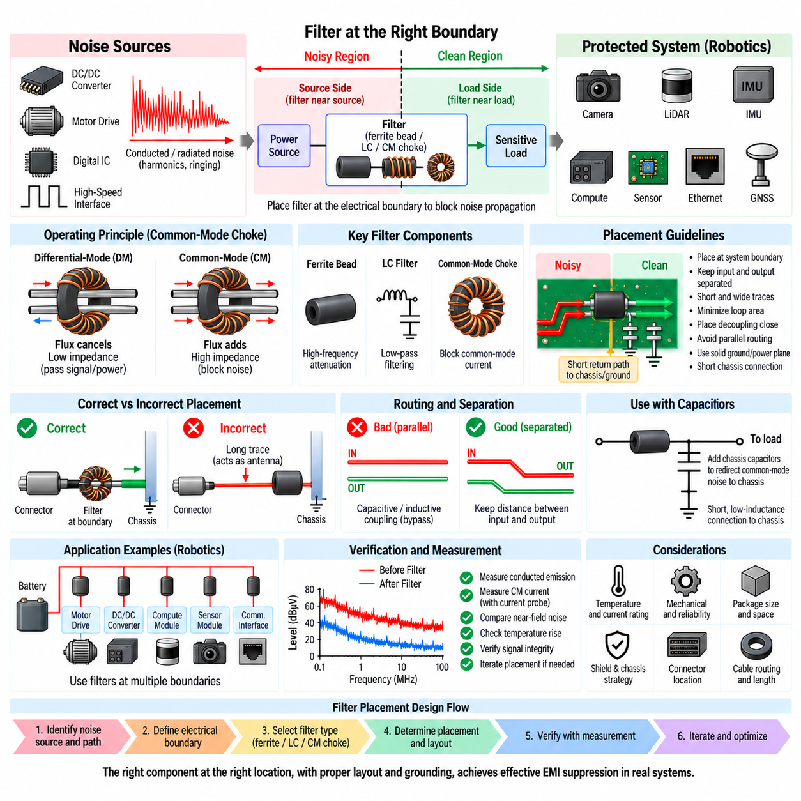
Filter placement is a fundamental part of electromagnetic compatibility because a filter can suppress interference only when it is located within the actual noise propagation path. Even a correctly calculated EMI filter, ferrite bead, LC network, or common-mode choke may provide little system-level improvement if high-frequency current reaches a cable, connector, chassis structure, or sensitive subsystem before encountering the filtering element.
The primary placement rule is to locate the filter at the electrical boundary where unwanted energy enters or leaves a subsystem. For noise generated internally, filtering should normally occur close to the source or interface through which the noise would escape. For sensitive electronics, filtering should be positioned near the point where potentially contaminated power or signals enter the protected domain.
This boundary concept divides the system into noisy and clean regions. Conductors on the unfiltered side should remain physically and electrically separated from conductors on the filtered side. If traces, wires, planes, or components cross-couple around the filter, high-frequency energy can bypass the intended impedance and effectively reconnect the two regions, reducing the insertion loss achieved by the filter network.
Filters should therefore not be positioned arbitrarily in the middle of long PCB traces or cable runs. A long conductor between a noise source and its filter can behave as a coupling structure or antenna, allowing interference to propagate before suppression occurs. Similarly, a long connection between an external connector and an interface filter can permit common-mode current to couple into the enclosure, chassis, or neighboring circuits.
At external cable interfaces, filtering is generally most effective close to the connector or enclosure penetration. This placement prevents unwanted current from flowing along internal wiring and limits the length of conductor that can participate in radiated emission. Common-mode chokes, feedthrough structures, chassis-referenced capacitors, and other interface filters benefit particularly from being located directly at the electromagnetic boundary.
Source-side filtering is especially important for switching power electronics. DC/DC converters, PWM motor drivers, inverters, servo drives, and other fast-switching circuits should contain high-frequency current loops locally whenever possible. Filters positioned close to these circuits prevent switching harmonics and ringing currents from entering the broader power distribution network, where cables and power planes can distribute the disturbance throughout the system.
Load-side filtering is appropriate when the principal objective is protecting a sensitive subsystem from noise already present on a shared network. Cameras, LiDARs, IMUs, GNSS receivers, analog sensors, communication transceivers, and computing modules may use local filtering near their power entry points. The filtered output should then feed the protected circuitry without passing again through electrically noisy regions.
The physical distance between a filter component and its associated bypass capacitor can strongly influence performance. High-frequency current follows paths determined by impedance rather than schematic appearance, and even short PCB traces possess inductance. A shunt capacitor should therefore be connected through short, wide paths so that the unwanted current can return locally instead of traveling through a larger loop before reaching the capacitor.
Return-path placement is as important as placement in the forward conductor. A filter cannot operate as intended if the noise current has an uncontrolled return path that bypasses the filtering boundary. Power return, signal return, chassis, cable shield, mounting structures, and parasitic capacitance can all participate in high-frequency current loops. Placement decisions must therefore consider the complete current path rather than only the positive supply conductor.
Loop area should be minimized on both sides of the filter. The noisy loop should remain compact so that its magnetic field couples weakly into neighboring circuitry, while the filtered loop should avoid sharing paths with high-current switching circuits. Keeping forward and return conductors close together also reduces loop inductance and limits magnetic-field radiation, improving both conducted and radiated EMC behavior.
Input and output traces of a filter should never be routed closely in parallel when avoidable. Such routing creates capacitive and inductive coupling that transfers high-frequency energy directly from the unfiltered side to the filtered side. This electromagnetic bypass becomes increasingly important as frequency rises and can make a theoretically excellent filter ineffective. Physical separation is therefore part of the filter transfer function.
Ground and power planes require similar attention. A filter placed between two domains can be bypassed if a continuous plane underneath it allows uncontrolled high-frequency current to couple across the boundary. Conversely, unnecessarily cutting planes can damage return-current continuity and increase radiation. Plane strategy must therefore be based on the actual common-mode and differential-mode current paths rather than simple geometric separation.
Chassis-referenced filtering requires an especially low-inductance chassis connection. A capacitor intended to redirect common-mode noise toward chassis becomes ineffective if connected through a long narrow trace, wire, or remote grounding point. At high frequencies, the inductance of this connection can dominate the capacitor impedance. Chassis connections should therefore be short, wide, and physically close to the interface being filtered.
Cable shields and filter placement should be coordinated. When a shielded cable enters an enclosure, the shield termination should normally establish the intended high-frequency boundary at the entry point. If the shield current travels deep into the electronics before reaching chassis, common-mode energy can couple into internal circuits. Filter components and shield termination should consequently form one coherent interface EMC structure.
Ferrite beads are most effective when placed at the boundary of the power domain they are intended to isolate. A bead protecting a sensor rail should separate the noisy upstream supply from the local clean supply, with decoupling capacitance positioned on the protected side. Placing the same bead far from the load can leave a long filtered-side trace exposed to coupling from nearby switching nodes or motor-current conductors.
LC filters require additional attention because the inductor and capacitor form an energy-storage network. The series inductor should directly interrupt the noise propagation route, while the shunt capacitor should have a compact return path. Excessive spacing between these components introduces parasitic inductance and coupling, altering the calculated response and potentially creating resonances that were absent from the ideal circuit model.
Common-mode chokes should normally be placed where common-mode current would otherwise enter a long cable or cross a subsystem boundary. Both conductors must pass through the choke as intended, and routing should preserve symmetry where signal integrity is important. The filtered and unfiltered conductor pairs should remain separated so that parasitic coupling does not provide an alternative high-frequency path around the magnetic component.
Filter placement must also account for heat and current capability. Components located close to motor drivers, processors, converters, or other heat sources may operate at significantly higher temperatures than assumed during component selection. Increased temperature can change resistance, magnetic properties, capacitance, and lifetime. The electromagnetically ideal position must therefore also satisfy thermal, mechanical, reliability, and serviceability requirements.
In robotic systems, cable routing makes placement particularly important because power, communication, sensor, and motor harnesses frequently share limited packaging space. A filter cannot compensate for long parallel routing between noisy motor cables and sensitive sensor wiring. Physical separation, controlled crossings, shielding, grounding, and filtering must be coordinated so that noise is suppressed before significant coupling occurs.
An AMR power distribution architecture can benefit from hierarchical filter placement. Noise may first be contained at motor drivers and switching converters, followed by filtering at power-distribution boundaries and additional local filtering near sensitive loads. This approach is generally more effective than relying on one large central filter because it prevents high-frequency currents from propagating through long harness sections between distributed electronic modules.
Communication interfaces require placement that preserves both EMC and signal integrity. Common-mode filtering for Ethernet or other high-speed differential links should be located according to the intended PHY, connector, transformer, shield, and return-path architecture. Excessive trace length between these elements can increase imbalance and mode conversion, allowing differential signal energy to become common-mode radiation or external interference to enter the receiver.
Filtering should also be positioned with respect to enclosure boundaries. A conductive enclosure can provide an effective electromagnetic reference only when cable entry, shield termination, filtering, and chassis bonding are coordinated at its surface. Allowing unfiltered conductors to penetrate deeply into the enclosure before filtering weakens this boundary and permits external and internal electromagnetic environments to couple together.
Verification of placement should be performed on physical hardware because schematic analysis cannot fully represent parasitic coupling. Near-field probes can compare noise levels on the input and output sides of the filter, while current probes can identify common-mode currents on cables. Conducted and radiated emission measurements can determine whether moving the filter changes system behavior, often revealing that placement is as important as component value.
When a filter provides less attenuation than predicted, the engineer should first investigate bypass paths before replacing components. Input-to-output coupling, long capacitor returns, shared ground impedance, cable shields, chassis connections, connector geometry, and nearby noisy traces can all circumvent the filter. Moving an existing component by a relatively small physical distance can sometimes produce greater improvement than substantially increasing its nominal impedance.
Effective filter placement therefore follows the physical flow of high-frequency current rather than the logical organization of the schematic. The engineer must identify the source, coupling path, victim, forward path, and return path, establish an electromagnetic boundary, and place the appropriate filtering mechanism directly across that boundary. Layout, grounding, shielding, connector design, and cable routing then preserve the separation created by the filter.
Within the filtering design structure, filter placement rules complete the sequence following EMI filter design, ferrite bead selection, LC filter design, and common-mode choke analysis. The central principle is that EMC filtering becomes effective only when the correct component, noise mechanism, current path, and physical location are treated as one integrated design problem rather than as independent electrical decisions.

