Volume 05. Grounding and EMC

Chapter 06. Motor Driver EMI

06.01. PWM Switching Noise Spectrum
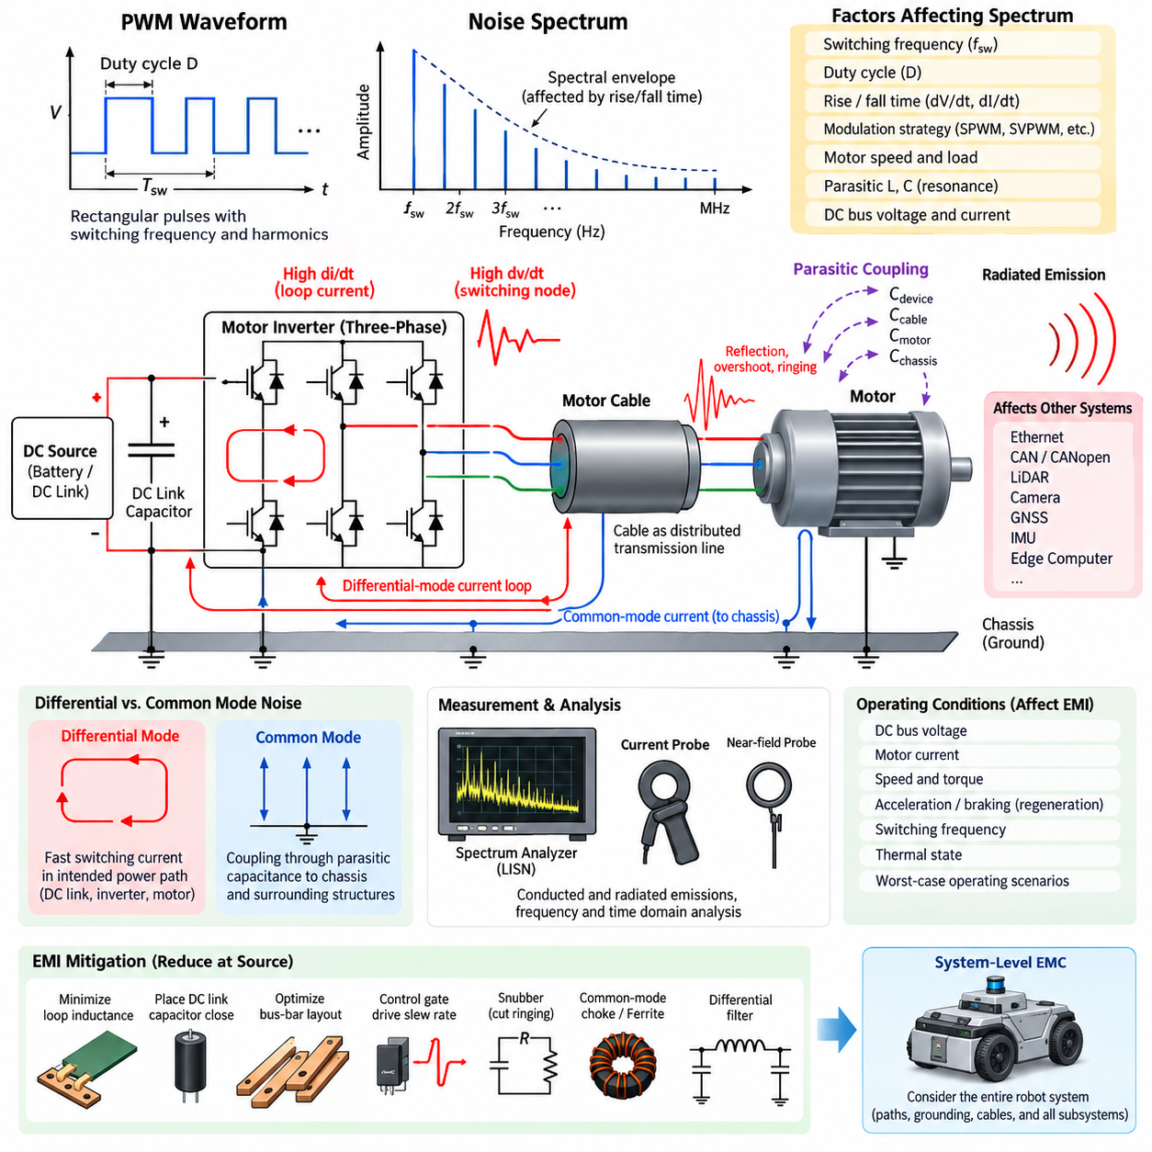
Pulse-width modulation is widely used in motor drives because it provides efficient control of voltage, current, torque, and speed. However, the rapid switching transitions that make PWM efficient also create a broad electromagnetic noise spectrum. A motor inverter therefore behaves not only as a power converter but also as a repetitive high-frequency excitation source whose energy can propagate through power cables, motor windings, chassis structures, and nearby electronic circuits.
An ideal PWM waveform consists of rectangular voltage pulses with a fundamental switching frequency and a series of harmonics extending toward very high frequencies. For a periodic waveform, spectral components appear at integer multiples of the switching frequency, while modulation by the motor electrical frequency produces additional sidebands. The resulting spectrum is therefore more complex than a simple harmonic sequence and varies continuously with duty cycle, modulation strategy, motor speed, and operating load.
The spectral envelope of PWM noise is strongly influenced by pulse rise and fall times. An infinitely fast rectangular edge would theoretically contain frequency components extending without limit, whereas practical semiconductor switching produces finite transition times that gradually reduce high-frequency energy. Faster switching edges increase the frequency range over which significant energy exists. Consequently, EMI behavior depends not only on switching frequency but also on the transition characteristics of MOSFET, IGBT, or SiC switching devices.
Switching frequency determines the basic spacing of prominent spectral components. A motor driver operating at tens of kilohertz produces strong components around its switching frequency and multiples of that frequency, but the electromagnetic disturbance can extend into the megahertz range because individual switching edges are much faster than the PWM period. This distinction is essential in EMC analysis because measuring only the nominal PWM frequency can significantly underestimate the bandwidth of the actual interference source.
Duty-cycle variation changes the relative amplitudes of individual harmonics. At some duty ratios, particular spectral components become strong, while others may be substantially reduced because of the mathematical relationship between pulse width and harmonic amplitude. During normal motor operation, the duty cycle continuously changes as the controller regulates phase current and torque. The measured EMI spectrum therefore becomes a dynamic distribution rather than a fixed set of spectral lines observed under one stationary operating condition.
Three-phase motor inverters create additional spectral complexity because multiple switching nodes operate with controlled phase relationships. Space-vector PWM, sinusoidal PWM, discontinuous PWM, and other modulation strategies distribute switching events differently over each electrical cycle. Their conducted and radiated emission signatures can therefore differ even when the DC-link voltage and average switching frequency are identical. Modulation selection consequently represents both a motor-control decision and an EMC design consideration.
Differential-mode noise is primarily associated with rapidly changing currents flowing through the intended power circuit. The DC-link capacitor, semiconductor bridge, bus structure, motor phases, and associated wiring form high-frequency current loops whose parasitic inductance converts rapid current changes into voltage disturbances. Large loop area increases magnetic-field radiation, while insufficient local decoupling allows switching-current components to propagate toward the battery, DC/DC converter, or upstream power distribution network.
Common-mode noise arises when switching-node voltage transitions couple through parasitic capacitances to the chassis, motor housing, cable shields, heat sink, bearings, and surrounding structures. High dV/dt produces displacement current through these capacitances even when no intentional conductive connection exists. The return path can extend over physically large portions of the robot, making common-mode current particularly important for radiated emissions and for interference coupled into communication or sensor wiring.
Parasitic inductance and capacitance can transform individual switching transitions into damped high-frequency oscillations. Semiconductor package inductance, PCB traces, bus bars, DC-link capacitors, motor cables, motor winding capacitance, and chassis coupling form resonant networks that produce spectral peaks far above the nominal PWM frequency. These resonances often explain unexpected narrowband emission failures and demonstrate why practical EMI diagnosis requires consideration of the complete physical current path rather than only the inverter schematic.
Motor cables significantly influence the observed spectrum because they behave as distributed transmission structures at sufficiently high frequencies. Long cables increase parasitic capacitance and provide larger structures for common-mode current and radiation. Fast voltage edges can also experience reflections when the cable and motor impedances are mismatched, producing overshoot and ringing at the motor terminals. Cable length, routing, shielding, termination, and proximity to chassis surfaces therefore directly affect PWM-related EMC performance.
Spectral analysis should distinguish between conducted emissions measured on power interfaces and radiated emissions detected through electric- or magnetic-field coupling. Current probes, voltage probes, spectrum analyzers, LISNs, and near-field probes reveal different parts of the interference mechanism. Time-domain oscilloscope measurements are equally important because correlation between switching edges, ringing waveforms, and frequency-domain peaks can identify which physical transition is responsible for a particular emission component.
Operating conditions must be controlled during PWM spectrum measurements because inverter emissions change with DC-bus voltage, motor current, rotational speed, torque, regeneration, switching frequency, and thermal state. Testing only an unloaded motor can therefore produce misleading conclusions. Representative worst-case conditions should include high bus voltage, high current, acceleration, braking, low-speed high-torque operation, and other states that maximize switching energy or alter the impedance presented by the motor and power network.
The most effective mitigation begins by reducing noise at its source rather than attempting to suppress it after propagation. Minimizing commutation-loop inductance, placing DC-link capacitors close to switching devices, optimizing bus-bar geometry, and controlling gate-drive slew rate can reduce high-frequency excitation. Snubbers can suppress resonant ringing, while appropriate common-mode chokes, ferrites, and differential filters limit conducted propagation. These measures must be coordinated because improving one frequency region may shift energy into another.
Gate resistance and programmable gate-drive control provide a practical tradeoff between switching loss and EMI. Slowing a semiconductor transition reduces dV/dt and dI/dt and can substantially decrease high-frequency spectral content, but excessive slowing increases switching losses and semiconductor temperature. Conversely, extremely fast SiC or modern MOSFET switching improves converter efficiency while demanding tighter control of parasitic impedance. EMC optimization therefore requires simultaneous electrical, thermal, efficiency, and reliability evaluation.
PWM noise must ultimately be treated as a system-level phenomenon in an AMR or Physical AI robot. Motor-driver emissions can couple into Ethernet, CAN or CANopen networks, LiDAR power lines, camera interfaces, GNSS receivers, IMUs, and edge-computing platforms through shared power, grounding, chassis, and cable paths. Understanding the switching-noise spectrum provides the basis for subsequent bus-bar optimization, gate-drive slew-rate control, motor-cable shielding, and dV/dt filtering, allowing countermeasures to target the actual propagation mechanism rather than symptoms alone.

06.02. Bus Bar Layout Optimization
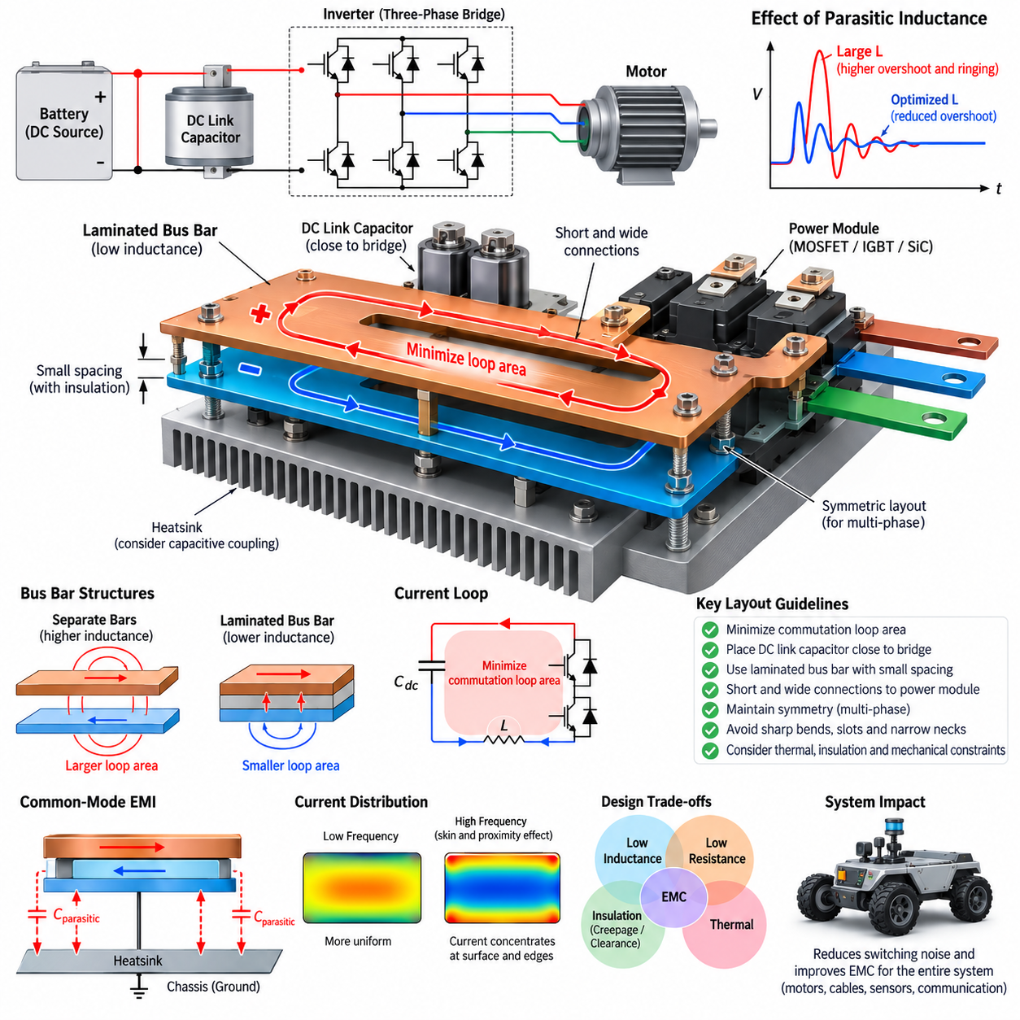
Bus bars are critical conductors in motor-drive power stages because they carry high DC and switching currents between the battery, DC-link capacitors, semiconductor bridge, and associated power components. Their geometry directly influences resistance, parasitic inductance, voltage overshoot, ringing, electromagnetic emission, and semiconductor stress. Bus-bar layout optimization is therefore not simply a packaging task but an essential part of electrical, thermal, and EMC design.
The primary EMC objective of a bus-bar layout is to minimize the area enclosed by high-frequency commutation-current loops. During inverter switching, current transfers rapidly between semiconductor devices and the DC-link capacitor, producing large di/dt. Any inductance within this path generates a transient voltage according to V = L·di/dt. Even a small parasitic inductance can therefore produce substantial voltage spikes when modern MOSFET or SiC devices switch at high speed.
The most important current path is normally the local commutation loop formed by the positive DC-link conductor, switching devices, negative conductor, and DC-link capacitor. These elements should be positioned so that the outgoing and returning currents travel through closely coupled paths. Increasing physical separation enlarges loop area and magnetic flux linkage, increasing both parasitic inductance and radiated magnetic-field energy. Compact current-loop geometry is consequently a fundamental layout principle.
A laminated bus bar is particularly effective because positive and negative conductors can be arranged as broad overlapping planes separated by a thin dielectric layer. Currents flowing in opposite directions create opposing magnetic fields, reducing net magnetic flux and effective loop inductance. Compared with widely separated cables or discrete copper bars, a properly designed laminated structure can provide substantially lower parasitic inductance and more predictable high-frequency electrical behavior.
The spacing between positive and negative bus-bar layers should generally be minimized while maintaining the required insulation voltage, creepage, clearance, manufacturing tolerance, and reliability margin. Reducing layer separation improves magnetic coupling and decreases loop inductance. However, excessive reduction can increase interlayer capacitance and electric-field stress. Optimization must therefore consider inductive and capacitive parasitics together rather than treating minimum physical spacing as an unconditional objective.
DC-link capacitor placement has a decisive influence on bus-bar performance. The high-frequency capacitor should be located electrically and physically close to the switching bridge so that switching current circulates through the smallest possible local loop. Long connections between the capacitor and semiconductor devices add inductance that cannot be eliminated by increasing capacitor value. A large capacitor placed far from the inverter can therefore perform worse at high frequencies than a smaller, low-inductance capacitor positioned directly across the switching bus.
Connections to semiconductor modules require special attention because terminal geometry can dominate the remaining commutation inductance after the main bus structure has been optimized. Wide, short connections are preferable to narrow and elongated conductors. Abrupt changes in current direction, unnecessary bends, long standoffs, and asymmetric terminal paths should be minimized. Where possible, the positive and negative paths should remain geometrically coupled until they reach the power-module terminals.
Symmetry is important in multiphase and parallel power stages. Unequal bus-bar path length, resistance, or inductance can cause uneven current sharing among semiconductor devices or inverter branches. At high switching speeds, apparently small geometric differences can produce different transient voltages and current distributions. A symmetric layout improves electrical balance, simplifies gate-drive optimization, and reduces the probability that one device experiences disproportionately high electrical or thermal stress.
Bus-bar width and thickness must be selected using both low-frequency and high-frequency considerations. Increasing conductor cross-sectional area reduces DC resistance and conduction loss, but high-frequency current distribution is affected by skin effect and proximity effect. Current can concentrate near conductor surfaces or particular edges when neighboring conductors carry opposing currents. Consequently, current density cannot always be estimated accurately by dividing total current by the gross copper cross-sectional area.
Corners, slots, mounting holes, necked regions, and terminal transitions can produce localized current-density concentration. These regions increase resistive heating and may also disturb the magnetic-field distribution around the commutation path. Smooth transitions and adequate conductor width around mechanical features help prevent electrical and thermal hot spots. Mechanical fastening requirements should therefore be incorporated early into electrical layout design rather than added after the current path has already been optimized.
Bus-bar geometry also affects common-mode EMI. Switching nodes with high dV/dt can capacitively couple to the chassis, heat sink, enclosure, motor housing, or nearby conductors. Large switching-node surface area facing grounded structures increases parasitic capacitance and displacement current. The layout should therefore keep high-dV/dt copper regions compact while allowing DC positive and negative conductors, whose opposing currents benefit from close coupling, to use appropriate overlapping geometry.
The relationship between the bus bar and heat sink must be evaluated carefully. A heat sink can act as a significant common-mode coupling structure when semiconductor switching nodes have parasitic capacitance to it. If the heat sink is connected to chassis ground, switching current can flow through this capacitance into the chassis and return through cables or other structures. Physical placement, insulation material, dielectric thickness, and grounding strategy therefore influence both thermal performance and common-mode emissions.
Voltage overshoot and ringing provide useful indicators of inadequate bus-bar layout. When switching current interacts with parasitic inductance and device capacitance, an LC resonant network is formed. The resulting oscillation can increase semiconductor voltage stress and generate narrowband spectral peaks at frequencies far above the PWM switching frequency. Reducing commutation inductance through layout optimization frequently decreases both the amplitude of the transient and the energy available to excite these resonances.
Bus-bar optimization should be validated using both simulation and measurement. Electromagnetic or parasitic-extraction tools can estimate current density, inductance, capacitance, and field distribution before hardware is manufactured. Prototype measurements can then evaluate switching-node overshoot, ringing frequency, current-loop behavior, conducted emissions, and near-field radiation. Correlating simulated parasitic parameters with measured switching waveforms is especially valuable for identifying the physical structure responsible for unexpected EMI.
Measurement technique is important because poor probing can introduce an artificial loop and create misleading high-frequency waveforms. Switching-node voltage should be measured using probes and connections with very small loop area, while current probes and near-field probes can help identify dominant current paths and radiation sources. Measurements should be repeated under representative DC-bus voltage, motor current, torque, acceleration, braking, and regeneration conditions because parasitic effects can become more severe at high switching energy.
Bus-bar layout must also satisfy thermal, mechanical, insulation, serviceability, and manufacturing requirements. Copper thickness and surface area influence temperature rise, while vibration and repeated thermal expansion impose mechanical stress on joints and terminals. Creepage and clearance requirements constrain conductor spacing, and assembly tolerances can alter intended geometry. An electrically excellent layout that cannot maintain insulation integrity or survive robotic vibration is not a practical optimized design.
For AMRs and other Physical AI robotic platforms, bus-bar optimization should be considered part of system-level EMC architecture. A low-inductance inverter power path reduces switching overshoot at its origin and limits the high-frequency energy available to propagate through battery wiring, chassis, motor cables, Ethernet, CAN or CANopen, LiDAR, cameras, GNSS, IMUs, and edge computers. Combined with DC-link optimization, gate-drive slew-rate control, shielding, grounding, and filtering, an optimized bus bar provides one of the most effective foundations for reliable motor-drive EMC performance.

06.03. Gate Drive Slew Rate Control
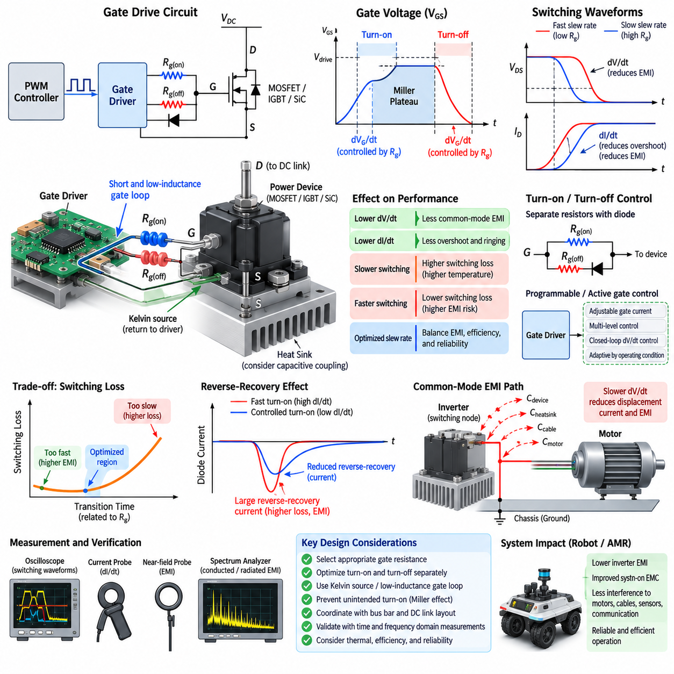
Gate-drive slew-rate control is a fundamental technique for managing the switching behavior of power semiconductors in motor inverters. By controlling how rapidly a MOSFET, IGBT, or SiC device transitions between its ON and OFF states, the designer can influence voltage slew rate, current slew rate, switching loss, overshoot, ringing, and electromagnetic emissions. The objective is not simply to make switching slower, but to achieve an optimized transition for the complete power stage.
During a switching transition, the gate driver must charge or discharge the semiconductor device's gate capacitances. The resulting gate current determines how quickly the gate-source voltage changes and therefore influences the device switching trajectory. A higher gate current generally produces faster transitions, while a lower gate current slows them. Gate resistance is consequently one of the simplest and most widely used parameters for controlling switching speed in practical motor-drive circuits.
The relationship between gate resistance and switching behavior becomes especially important during the Miller plateau. In this interval, gate current is largely used to charge or discharge the gate-drain capacitance while the drain-source or collector-emitter voltage changes rapidly. The available gate current therefore has a direct influence on dV/dt. Adjusting external gate resistance allows the designer to control this voltage transition without changing the PWM switching frequency or the commanded motor operating point.
Current slew rate, expressed as dI/dt, is also influenced by gate-drive strength. Rapid turn-on can cause motor-phase or commutation current to transfer quickly between semiconductor devices, generating voltage across parasitic inductance according to V = L·dI/dt. Excessive dI/dt can therefore increase voltage overshoot, ringing, electromagnetic radiation, and stress on semiconductor packages, DC-link connections, and bus bars. Slew-rate control reduces the excitation of these parasitic structures.
Reducing dV/dt is particularly important for common-mode EMI. Fast switching-node voltage transitions couple through parasitic capacitances between the semiconductor, heat sink, motor winding, cable, chassis, and surrounding structures. The resulting displacement current is approximately proportional to capacitance and dV/dt. Slowing the transition can therefore reduce common-mode current at its source, decreasing the high-frequency energy that propagates through the chassis and motor-cable system.
Slower switching, however, is not universally beneficial. During the transition between blocking and conducting states, the semiconductor simultaneously supports significant voltage and current, producing switching energy loss. Increasing transition time generally increases this overlap and raises switching losses. Excessive gate resistance can therefore increase junction temperature, reduce inverter efficiency, and limit achievable switching frequency or output power. EMC improvement must consequently be balanced against thermal and efficiency requirements.
Turn-on and turn-off behavior often require different optimization. A single gate resistor imposes similar constraints on both directions, but separate turn-on and turn-off resistors can provide greater flexibility. Diodes in the gate network can direct charging and discharging currents through different resistance values. This allows turn-on to be slowed for EMI control while maintaining sufficiently fast turn-off, or the opposite, depending on overshoot, reverse-recovery behavior, short-circuit response, and device requirements.
Gate-drive optimization must also consider reverse-recovery effects in complementary switching devices. When one transistor turns on, current may force the opposite freewheeling diode or body diode through reverse recovery. A very high turn-on dI/dt can produce a large reverse-recovery current peak and additional switching loss. This transient can excite bus-bar and package inductances, producing ringing and EMI. Controlled turn-on can reduce the severity of this commutation event and improve waveform stability.
SiC MOSFETs make slew-rate control particularly important because their low switching losses permit extremely fast voltage and current transitions. These fast edges improve converter efficiency but can generate substantial high-frequency spectral energy if the surrounding power loop is not carefully designed. Small parasitic inductances that were relatively insignificant with slower devices can become dominant. Gate-drive design for SiC must therefore be coordinated closely with DC-link capacitor placement and bus-bar layout optimization.
Gate-loop layout is itself an essential part of slew-rate control. The driver, gate resistor, semiconductor gate, and source or emitter return should form a compact low-inductance loop. Excessive common-source inductance can create feedback voltage proportional to dI/dt, modifying the effective gate voltage during switching. Kelvin source or Kelvin emitter connections are therefore valuable because they separate the gate-drive return path from the high-current power path and improve control of the actual switching transition.
Parasitic gate coupling can also cause unintended switching. High dV/dt at the switching node can inject current through the Miller capacitance of a nominally OFF device, increasing its gate voltage. If this voltage exceeds the threshold, transient turn-on or shoot-through may occur. Appropriate turn-off resistance, negative gate bias, Miller clamps, optimized gate-loop inductance, and suitable driver strength can improve immunity against this mechanism while maintaining the desired switching speed.
More advanced gate drivers can control slew rate dynamically rather than relying on a fixed resistor. Programmable gate current, multi-level gate resistance, active gate control, or closed-loop dV/dt control can divide the switching event into several phases. Strong initial drive may move the device rapidly toward the Miller region, reduced drive can control the critical voltage transition, and stronger drive can then complete the switching event. This approach can reduce EMI without unnecessarily increasing total switching loss.
Active gate control is especially useful when inverter operating conditions vary widely. The optimum gate-drive setting at low current may not be optimum at high current, high DC-bus voltage, regenerative braking, or elevated temperature. A programmable driver can select different slew-rate profiles according to operating state. Such adaptation allows the inverter to maintain acceptable overshoot and EMI while avoiding excessive switching losses under conditions where aggressive suppression is unnecessary.
Snubbers and gate slew-rate control should be considered complementary rather than interchangeable techniques. Gate control reduces the energy used to excite parasitic resonances, while an RC or RCD snubber can damp residual oscillation associated with the power-loop inductance and device capacitance. If severe ringing remains after reasonable slew-rate adjustment, the underlying bus-bar, DC-link, or package parasitics should also be investigated rather than relying solely on a very large gate resistance.
Optimization requires simultaneous time-domain and frequency-domain measurement. An oscilloscope can reveal switching-node dV/dt, device dI/dt, gate voltage, overshoot, ringing, and transition duration, while spectrum or near-field measurements show how these changes affect EMI. Gate resistance should therefore not be selected solely from switching-waveform appearance. The preferred value is one that satisfies device stress, thermal performance, efficiency, control stability, and conducted and radiated emission requirements together.
Measurement technique is critical when evaluating fast gate-drive transitions. Long oscilloscope ground leads or large probe loops can introduce inductance and display ringing that does not exist at the semiconductor terminals. High-bandwidth differential probes, short connections, appropriate current probes, and carefully defined reference points are required. Gate-source voltage should ideally be measured directly at the device or Kelvin terminals so that parasitic voltage in the power-current path is not mistaken for gate-drive behavior.
In an AMR or Physical AI robot, gate-drive slew-rate control contributes directly to system-level EMC robustness. Reducing excessive dV/dt and dI/dt at the motor inverter limits high-frequency energy before it couples into motor cables, chassis structures, battery wiring, Ethernet, CAN or CANopen, LiDAR, cameras, GNSS, IMUs, and edge computers. When combined with optimized bus bars, grounding, shielding, filtering, and motor-cable design, controlled switching provides an effective balance between inverter efficiency, semiconductor reliability, and electromagnetic compatibility.

06.04. Motor Cable Shield Design
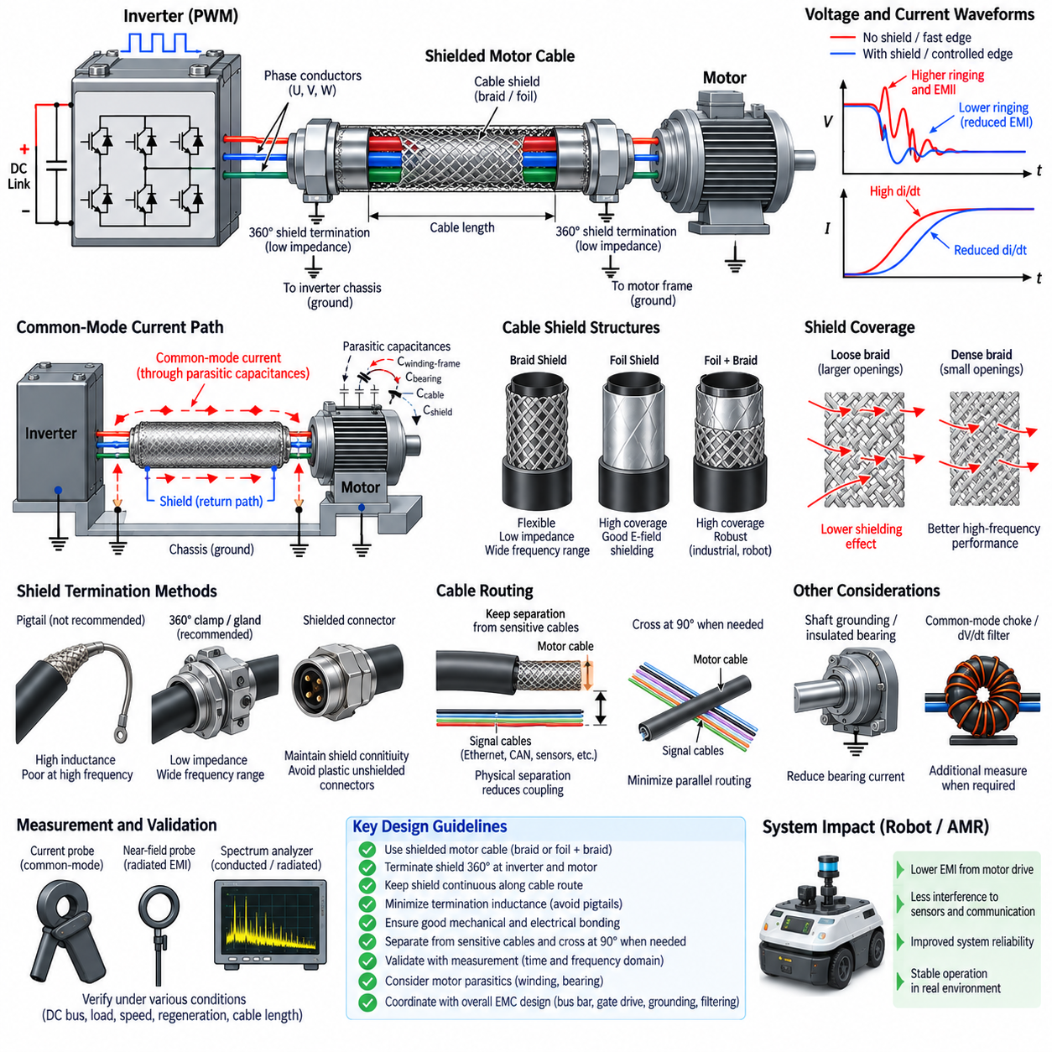
Motor cables are one of the most important electromagnetic coupling paths in PWM-controlled drive systems because they connect a high-dV/dt inverter directly to the motor. Rapid switching transitions generate differential-mode and common-mode currents that can propagate along the cable and radiate into surrounding electronics. Effective motor-cable shield design therefore requires control of both electromagnetic fields and high-frequency return-current paths.
A motor cable normally carries three-phase currents whose fundamental frequencies are relatively low compared with the frequency content generated by inverter switching edges. Although the motor current waveform may appear smooth at the mechanical-system level, each PWM transition contains high-frequency components extending far beyond the switching frequency. The cable must therefore be treated as a high-frequency electromagnetic structure rather than merely as three power conductors sized for RMS current.
Common-mode current is particularly important in shield design. Switching-node voltage changes couple through parasitic capacitances between motor windings, motor frame, cable conductors, shield, inverter enclosure, and chassis. The resulting displacement current seeks a return path toward the inverter. Without a controlled low-impedance path, this current can flow through bearings, structural metal, communication cable shields, sensor grounds, or other unintended paths and create system-level EMI problems.
A cable shield provides a preferential high-frequency return path when it is correctly connected to the inverter enclosure and motor housing. The shield intercepts electric-field coupling from the phase conductors and allows common-mode current to return close to the source rather than spreading through the robot chassis. Its effectiveness therefore depends not only on the shield material itself but also on termination geometry, bonding impedance, coverage, cable length, and installation.
For motor-drive applications, braided copper shields provide good mechanical flexibility and relatively low transfer impedance over a broad frequency range. Foil shields can provide high coverage and good electric-field shielding, but their high-frequency performance may be limited by termination methods and mechanical durability. Combined foil-and-braid constructions are often useful when both high coverage and robust low-impedance bonding are required in electrically noisy robotic environments.
Shield coverage is important because openings in the shield allow electromagnetic fields to couple through the cable structure. A dense braid generally provides better high-frequency performance than a loose braid with large apertures, although braid angle and conductor construction also influence impedance. Shield selection should therefore consider transfer impedance and frequency-dependent performance rather than relying only on a nominal percentage coverage value.
The termination of the cable shield is frequently more important than the shield material itself. A high-quality shield connected through a long drain wire or pigtail can lose much of its effectiveness at high frequencies because the termination adds inductance. Even a short wire can develop significant impedance when switching currents contain megahertz components. The shield should therefore transition to the enclosure through the shortest and widest practical conductive connection.
A 360-degree shield termination is generally preferred at motor-drive interfaces. In this arrangement, the cable shield is bonded around its circumference to a conductive connector shell, gland, clamp, or enclosure surface. The current does not need to converge into a narrow pigtail, so termination inductance is reduced. This provides a more continuous electromagnetic boundary and supports a low-impedance path for common-mode current over a much wider frequency range.
Shield bonding at both ends is commonly appropriate for inverter-fed motor cables because the objective is to control high-frequency common-mode current. The inverter-side shield should bond to the inverter enclosure or designated chassis reference, while the motor-side shield should connect with low impedance to the motor housing. This creates a defined high-frequency return structure surrounding the phase conductors and helps prevent switching current from seeking alternative paths through the robot.
Concerns about low-frequency ground loops should not automatically lead to disconnecting one end of a motor-cable shield. A shield connected at only one end may provide electrostatic shielding at lower frequencies but can perform poorly against high-frequency common-mode currents generated by PWM switching. Grounding architecture should instead distinguish functional low-frequency current paths from high-frequency EMC bonding and provide intentional equipotential connections between inverter, chassis, and motor structures.
Connector design is critical to maintaining shield continuity. A shielded cable connected to an unshielded plastic connector or through a long internal wire can create a discontinuity exactly where high-frequency current must transfer to the enclosure. Conductive connector shells, EMC cable glands, circumferential clamps, and properly prepared shield interfaces help maintain low transfer impedance. Paint, anodizing, corrosion, and loose mechanical joints can significantly increase bonding impedance.
The shield should remain continuous along the cable route whenever possible. Unnecessary interruptions, long unshielded sections, or shield transitions near connectors can become localized radiation sources. Where a cable passes through an enclosure wall, the shield should preferably bond at the penetration rather than extending unbonded deep inside the enclosure. This prevents high-frequency common-mode current from entering the internal electronics compartment before reaching its intended chassis return path.
Motor cable routing must be coordinated with shield design. Even a well-shielded motor cable should be separated from low-level sensor wiring, GNSS antenna cables, camera interfaces, Ethernet, and other noise-sensitive circuits. Parallel routing over long distances increases coupling opportunity, while crossing noisy and sensitive cables approximately perpendicular to each other can reduce interaction. Physical separation remains an effective EMC measure because no practical shield provides infinite attenuation.
The physical relationship between cable shield and chassis can also affect common-mode behavior. A shield routed close to a conductive chassis surface forms distributed capacitance and may alter high-frequency return-current distribution. This can be beneficial when the chassis provides a controlled equipotential reference, but unpredictable bonding points can create multiple resonant paths. Cable installation should therefore be considered part of the electromagnetic design rather than treated solely as a mechanical routing activity.
Motor-side parasitic capacitance is another important factor. High dV/dt applied to the motor windings drives displacement current through winding-to-frame capacitance and potentially through bearing capacitances. Proper bonding between the cable shield and motor housing helps provide a nearby return path for these currents. Additional techniques such as shaft grounding, insulated bearings, common-mode chokes, or dV/dt filters may be required when bearing-current or motor-insulation stress remains significant.
Shield performance should be validated through measurement rather than assumed from cable construction alone. Common-mode current probes can measure high-frequency current on the complete motor cable, while near-field probes can identify radiation around connectors, shield terminations, and enclosure penetrations. Conducted and radiated emission measurements can then determine whether improved bonding or routing actually reduces system-level noise under representative inverter operating conditions.
Testing should include variations in DC-bus voltage, motor current, PWM frequency, torque, speed, acceleration, and regenerative braking because shield current changes with operating condition. Cable length should also be representative of the actual robot configuration, since longer cables alter distributed capacitance, transmission-line behavior, resonance, and reflection. A shield design validated only with a short laboratory cable may therefore perform differently after installation in a full-size AMR.
In an AMR or Physical AI platform, motor-cable shielding forms part of a larger EMC architecture that includes bus-bar optimization, gate-drive slew-rate control, grounding, filtering, enclosure bonding, and dV/dt management. A properly terminated shield confines switching-related electromagnetic energy and provides a controlled common-mode return path, reducing interference with Ethernet, CAN or CANopen, LiDAR, cameras, GNSS, IMUs, and edge computers while improving overall motor-drive reliability.

06.05. dV/dt Filter Design
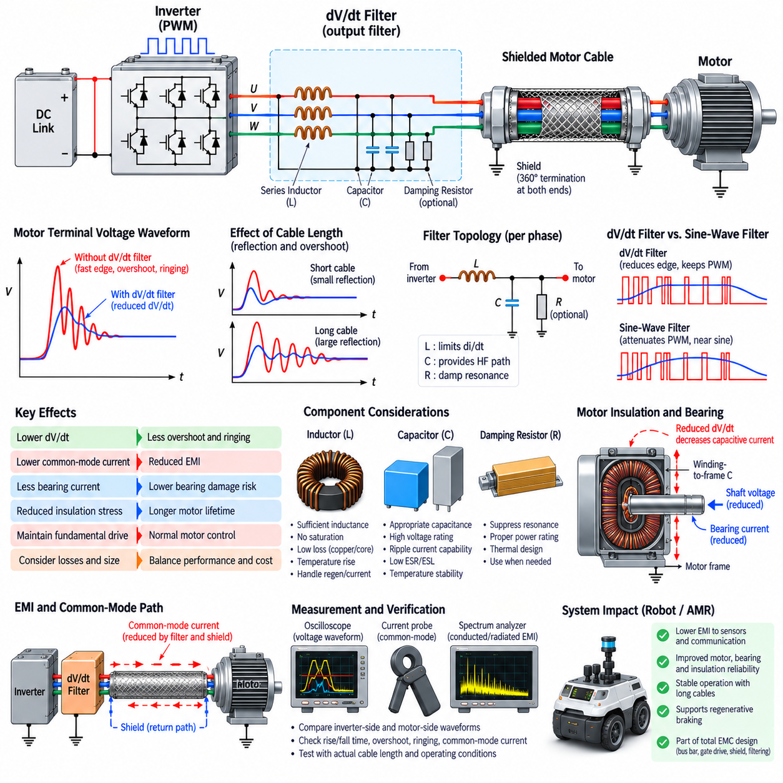
A dV/dt filter is an output-side network used with PWM motor drives to limit the rate of voltage change applied to motor terminals. Modern MOSFET, IGBT, and especially SiC inverters can generate extremely fast switching edges that improve converter efficiency but increase cable reflections, motor insulation stress, common-mode current, bearing current, and electromagnetic interference. The filter modifies these edges before they reach the motor while preserving the fundamental drive waveform.
The need for dV/dt filtering arises because a motor cable behaves increasingly like a transmission line as switching-edge rise time becomes short relative to cable propagation delay. A voltage pulse launched by the inverter travels toward the motor and encounters an impedance discontinuity at the winding terminals. Part of the wave can then be reflected toward the inverter, producing voltage superposition, overshoot, and ringing that may substantially exceed the nominal DC-link-related phase voltage.
Cable length strongly influences this phenomenon because longer cables increase propagation delay, distributed capacitance, and opportunities for reflected waves to interact with subsequent transitions. A drive that operates correctly with a short laboratory cable may therefore produce severe terminal overshoot after installation in a large AMR or industrial robot. Filter design should consequently use the actual cable type, length, routing, motor impedance, and switching characteristics rather than considering only inverter power rating.
A dV/dt filter is commonly implemented using inductive and capacitive elements arranged to slow the voltage transition and attenuate high-frequency switching components. Series inductance opposes rapid changes in current, while capacitive elements provide controlled high-frequency current paths. Damping resistance may be introduced to suppress resonance. The resulting network reduces the slope and peak magnitude of voltage reaching the motor without attempting to reconstruct a nearly sinusoidal output waveform.
This distinction separates a dV/dt filter from a sine-wave filter. A dV/dt filter primarily controls switching-edge steepness, overshoot, and high-frequency ringing while allowing substantial PWM content to remain at the motor terminals. A sine-wave filter provides much stronger attenuation of the PWM carrier and attempts to deliver a waveform dominated by the motor fundamental frequency. The sine-wave approach therefore generally requires larger components and introduces different loss and control considerations.
Filter inductance must be large enough to influence the high-frequency switching transient but not so large that it produces excessive fundamental-frequency voltage drop, current distortion, or dynamic limitations. Motor current passes continuously through the series element, making saturation current, copper loss, core loss, temperature rise, and mechanical size important design parameters. The magnetic component must also withstand acceleration, braking, overload, and regenerative operating conditions without losing its intended filtering characteristics.
Capacitance selection requires similar care. Increasing capacitance can improve attenuation of fast voltage components, but excessive capacitance increases reactive current and switching-related current demand on the inverter. Capacitors also interact with filter inductance, motor inductance, cable capacitance, and parasitic elements to create resonant networks. Voltage rating, ripple-current capability, dielectric behavior, temperature stability, and high-frequency equivalent series resistance and inductance must therefore be evaluated together.
An undamped LC network can produce a resonant peak rather than simply reducing high-frequency energy. If the switching spectrum or cable resonance excites this natural frequency, the filter may create new ringing or even increase voltage stress at particular frequencies. Damping is therefore an important part of practical design. Resistors, lossy magnetic elements, or appropriately selected network topology can dissipate resonant energy and produce a controlled transient response rather than an oscillatory one.
Filter placement is normally close to the inverter output because the objective is to reduce the steep voltage edge before it propagates along the motor cable. If a long unfiltered conductor exists between the inverter and filter, that section can still radiate and participate in high-frequency resonance. Compact placement also reduces parasitic inductance between the switching bridge and filter. Mechanical packaging should therefore treat the inverter and output filter as a coordinated high-frequency power assembly.
The filter affects differential-mode and common-mode behavior differently. Phase-to-phase filtering primarily controls differential switching voltage delivered to the motor, whereas common-mode current depends strongly on capacitances from switching nodes to chassis, motor frame, cable shield, and other structures. Some filter arrangements can reduce both mechanisms, but additional common-mode chokes, shield bonding, grounding, or common-mode filtering may still be required. The two noise mechanisms should therefore be evaluated separately.
Reducing motor-terminal dV/dt can significantly decrease displacement current through winding-to-frame capacitance. Because capacitive current approximately follows i = C·dV/dt, reducing voltage slew rate directly lowers the current driven through parasitic motor capacitances. This can reduce current flowing into the motor housing, cable shield, chassis, and bearings. Consequently, a dV/dt filter can contribute not only to insulation protection but also to reduced common-mode EMI and bearing-related electrical stress.
Motor insulation is an important design consideration because repeated high-voltage edges can stress turn-to-turn, phase-to-phase, and phase-to-frame insulation. Reflected-wave overshoot becomes particularly significant with long cables and high DC-bus voltages. Although each individual pulse may be extremely short, a motor drive can apply millions of switching transitions during operation. Reducing edge steepness and peak terminal voltage therefore contributes to long-term winding insulation reliability.
Bearing currents can also be influenced by inverter switching. High-frequency common-mode voltage can couple through motor parasitic capacitances and establish voltage across bearing lubrication films. When this voltage becomes sufficiently large, discharge events can occur through the bearings and gradually damage race surfaces. A dV/dt filter alone does not eliminate every bearing-current mechanism, but reducing high-frequency motor voltage excitation can complement shaft grounding, insulated bearings, cable shielding, and common-mode filtering.
The filter must be designed for bidirectional energy flow when the robotic drive supports regenerative braking. During regeneration, power flows from the motor toward the DC link, but the filter remains part of the electrical path and continues to experience PWM-related voltage and current stress. Component current ratings, magnetic saturation, capacitor stress, damping losses, and thermal behavior must therefore be verified for both motoring and regenerative operating conditions.
Filter design should be coordinated with gate-drive slew-rate control rather than considered independently. Slowing semiconductor transitions at the gate reduces high-frequency excitation before it reaches the output filter, potentially allowing smaller filtering components. Excessive gate slowing, however, increases semiconductor switching loss. Conversely, relying entirely on a large output filter may increase size, cost, and thermal loss. A balanced design distributes EMI mitigation between semiconductor switching control and passive filtering.
Motor-cable shielding remains necessary even when a dV/dt filter is installed. The filter reduces the magnitude and frequency content of switching excitation, while a properly terminated shield provides a controlled return path for remaining common-mode current and limits electromagnetic radiation. Bus-bar optimization, DC-link placement, gate-drive control, 360-degree shield termination, grounding, and output filtering therefore operate as complementary layers rather than isolated solutions.
Validation should compare inverter-side and motor-side waveforms using measurement methods suitable for fast high-voltage transients. Important quantities include voltage rise and fall time, peak overshoot, ringing frequency, motor-terminal voltage, phase current, common-mode current, and filter temperature. Conducted-emission, near-field, and radiated-emission measurements can then determine whether reduced electrical stress also produces the intended system-level EMC improvement.
Testing should cover representative worst-case operating conditions, including maximum DC-bus voltage, high motor current, low-speed high-torque operation, acceleration, regenerative braking, different PWM frequencies, and realistic cable lengths. Thermal equilibrium is also important because magnetic permeability, winding resistance, capacitor characteristics, and damping losses can change with temperature. Verification should confirm both transient suppression and continuous operating capability rather than evaluating only a few switching pulses.
In an AMR or Physical AI platform, dV/dt filter design completes a coordinated motor-driver EMI strategy that begins with controlling noise at the inverter and continues through the entire power path. Optimized bus bars reduce parasitic inductance, gate-drive control limits switching excitation, shielded motor cables contain residual high-frequency energy, and dV/dt filtering protects the motor interface. Together these measures reduce interference with Ethernet, CAN or CANopen, LiDAR, cameras, GNSS, IMUs, and edge computers while improving motor, bearing, and insulation reliability.

