Volume 06 Automotive Communication

Chapter 7. XCP Calibration

7.1 XCP Protocol Architecture
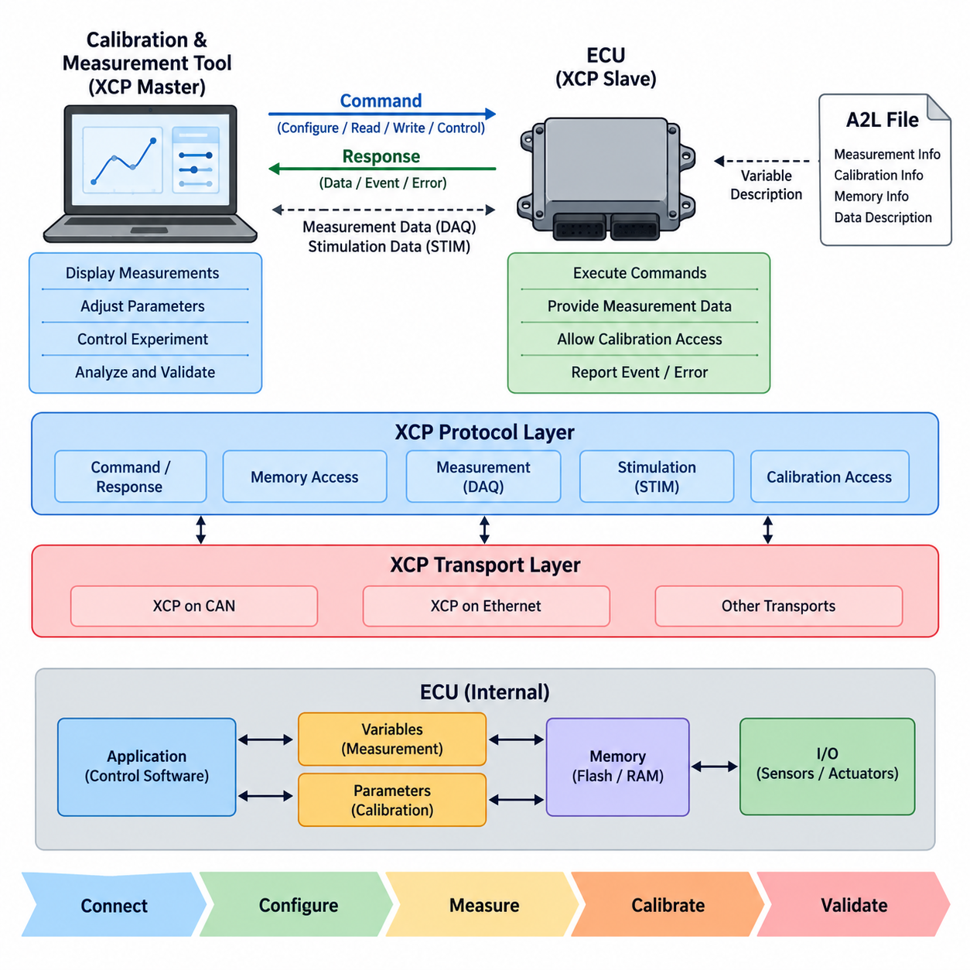
XCP, or Universal Measurement and Calibration Protocol, is a standardized communication protocol designed for measurement, calibration, stimulation, and memory access in embedded control systems. In automotive engineering, it provides a consistent interface between an ECU and external development tools, allowing engineers to observe internal variables and modify calibration parameters while control software is executing.
The XCP architecture follows a master-slave communication model. An external calibration or measurement tool normally operates as the XCP master, while an ECU or another embedded controller acts as the XCP slave. The master initiates commands and configuration activities, and the slave responds according to its implemented XCP services. This centralized interaction simplifies control of measurement and calibration sessions.
A fundamental characteristic of XCP is the separation between the protocol layer and the transport layer. The protocol defines commands, responses, measurement mechanisms, calibration access, and data acquisition behavior independently from the underlying communication network. Transport-layer mappings then allow XCP to operate over technologies such as CAN or Ethernet, which are treated separately within the calibration engineering structure.
Communication between an XCP master and slave includes command-oriented exchanges used to establish and manage the session. The master can request information about the slave, configure communication resources, access memory, and control measurement functions. The slave returns command responses and may also report protocol events or errors. This command-response mechanism forms the control path through which an XCP session is configured.
XCP provides direct access to memory locations inside an ECU when permitted by the implementation. Through memory-oriented operations, development tools can read internal values and modify calibration data associated with control algorithms. Parameters such as controller gains, thresholds, characteristic values, and lookup-table contents can therefore be adjusted without rebuilding the complete software for every calibration change.
Measurement is another central capability of XCP. Engineers frequently need to observe internal ECU variables that are not available as ordinary network signals. XCP allows these variables to be transferred to the measurement system during operation, making it possible to analyze controller states, sensor processing results, intermediate calculations, diagnostic variables, and other software behavior under realistic operating conditions.
For efficient high-rate measurement, XCP uses the Data Acquisition mechanism, commonly called DAQ. Instead of repeatedly requesting every variable individually, the master configures measurement objects that the slave subsequently transmits according to defined acquisition events. This reduces command overhead and supports synchronized observation of multiple internal variables, making DAQ particularly important for real-time ECU development and validation.
DAQ operation is organized around configurable acquisition structures that associate memory locations with measurement events and transmitted data. When a defined event occurs in the ECU, the corresponding data can be collected and transferred through XCP. The relationship between ECU execution events and measurement transmission enables engineers to correlate acquired variables with control-loop timing and internal software execution.
XCP also supports stimulation through the STIM mechanism, which complements data acquisition. While DAQ primarily transfers data from the slave toward the master, STIM allows externally generated values to be supplied toward the ECU for supported applications. This capability can be used in development environments where internal inputs or intermediate values must be replaced or manipulated during controlled testing. DAQ and STIM are treated as a dedicated topic in the volume structure.
Calibration and measurement require more than a communication protocol because the external tool must understand what variables and parameters exist inside the ECU. For this reason, XCP is commonly associated with an A2L description containing information required to interpret measurement and calibration objects. The volume consequently separates A2L file structure from the basic XCP protocol architecture so that protocol operation and data description can be studied independently.
The distinction between XCP and diagnostic protocols is important. Diagnostic communication generally focuses on vehicle service functions, fault information, diagnostic identifiers, ECU programming, and standardized diagnostic services. XCP is primarily an engineering protocol for development-time measurement and calibration. Although both may access ECU information, their purposes, communication models, data organization, and expected engineering workflows are different.
The transport-independent architecture makes XCP adaptable to systems with different communication requirements. XCP on CAN can be suitable where existing ECU networks and moderate data rates are sufficient, whereas Ethernet can provide substantially greater bandwidth for large measurement sets and high-rate acquisition. The protocol concepts remain recognizable even though framing, addressing, throughput, latency, and network configuration depend on the selected transport.
In a practical development workflow, an engineer connects the measurement and calibration system to an ECU, establishes XCP communication, identifies available resources, and configures the required measurement or calibration access. Selected internal variables can then be acquired while parameters are adjusted and system responses are evaluated. This creates a rapid feedback loop between control-algorithm development, parameter tuning, measurement, and validation.
The same architectural principles can extend beyond conventional automotive ECUs to robotic controllers. Motor-control units, steering controllers, power electronics, battery controllers, and other embedded devices may contain parameters and internal states that require systematic measurement and tuning. The volume therefore progresses from XCP architecture through CAN and Ethernet transport, DAQ/STIM operation, A2L descriptions, and finally robot calibration applications.
XCP should therefore be understood as an engineering access architecture connecting embedded control software with measurement and calibration tools. Its master-slave organization, transport independence, memory access, measurement capability, calibration support, and DAQ/STIM mechanisms create a common foundation for observing and modifying real-time embedded systems. These characteristics explain its continuing importance in ECU development and its applicability to increasingly software-intensive automotive and robotic platforms.

7.2 XCP on CAN and Ethernet
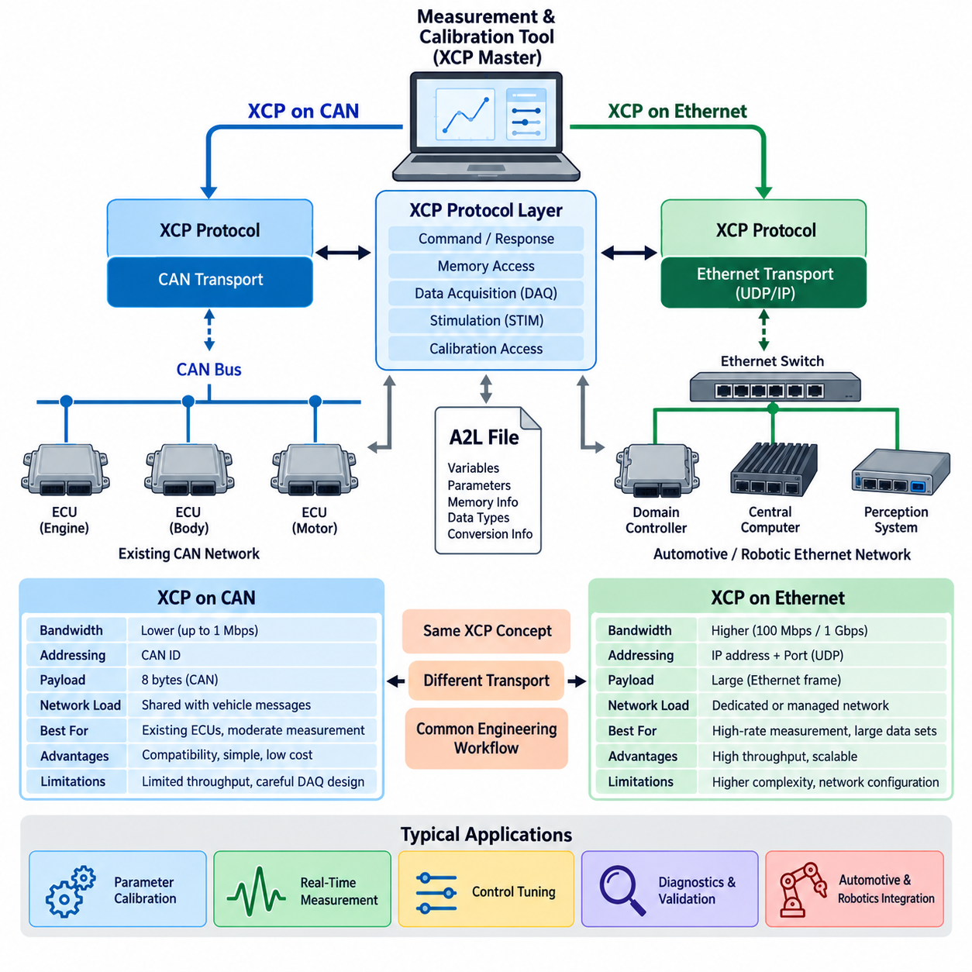
XCP can operate over different communication technologies because its protocol functions are separated from the underlying transport mechanism. Two important implementations are XCP on CAN and XCP on Ethernet. Both provide the same fundamental measurement and calibration concepts, but they differ significantly in bandwidth, addressing, packet handling, latency, network configuration, and the scale of data that can be transferred during development.
XCP on CAN integrates measurement and calibration communication into an existing CAN network. This approach is particularly useful for conventional ECUs, motor controllers, body controllers, and other embedded devices that already contain CAN interfaces. The XCP protocol data is transported through CAN frames using assigned CAN identifiers, allowing development tools to communicate with the target without requiring a separate high-speed physical network.
The major advantage of XCP on CAN is its compatibility with established automotive communication infrastructure. Engineers can use existing CAN transceivers, wiring, interfaces, and development equipment while gaining access to ECU measurement and calibration functions. This makes XCP on CAN practical for embedded controllers with moderate measurement requirements, especially when the available network bandwidth and required sampling rates remain within CAN limitations.
CAN bandwidth, however, imposes practical constraints on XCP measurement performance. Communication capacity must often be shared with normal vehicle messages, diagnostics, and control traffic. Large measurement lists or high-frequency acquisition can therefore increase network load significantly. Engineers must carefully select measured variables, acquisition rates, payload utilization, and communication priorities so that calibration activity does not interfere with time-critical control communication.
XCP on Ethernet addresses many of these bandwidth limitations by transporting XCP communication through an Ethernet-based network. Ethernet can provide substantially higher throughput than classical CAN, making it suitable for ECUs that expose large numbers of internal variables or require high-rate measurement. Modern domain controllers, central computers, perception systems, and high-performance embedded platforms can particularly benefit from this increased measurement capacity.
In an Ethernet implementation, XCP protocol messages are carried through an IP-based communication stack rather than directly through CAN frames. UDP is commonly associated with XCP transport where low overhead and efficient transfer are important, while network configuration introduces concepts such as IP addresses and ports. The XCP application concepts remain largely independent of these transport details, demonstrating the protocol's transport-independent architecture.
The difference in available bandwidth strongly influences Data Acquisition, or DAQ, design. With XCP on CAN, DAQ configurations must account for limited frame capacity and bus utilization, often requiring careful prioritization of the variables that are actually necessary for an experiment. XCP on Ethernet can accommodate larger measurement sets and higher acquisition frequencies, enabling more detailed observation of complex software and control behavior.
Latency characteristics also need to be considered independently from raw bandwidth. A higher-bandwidth Ethernet connection does not automatically guarantee deterministic delivery for every measurement packet. Network switches, operating-system scheduling, protocol processing, buffering, and competing traffic can affect timing. CAN offers lower throughput but provides predictable arbitration behavior, while Ethernet systems may require appropriate architecture and traffic management when timing consistency is important.
Calibration operations generally require less continuous bandwidth than high-rate measurement because parameter values are often read or modified intermittently. Consequently, XCP on CAN can remain effective for many calibration tasks even when its measurement throughput is limited. Ethernet becomes increasingly advantageous when calibration is combined with extensive real-time measurement, large data sets, rapid experimentation, or complex controllers containing many observable internal states.
Transport selection also affects development equipment and system integration. XCP on CAN typically requires a CAN interface between the engineering workstation and the target network, whereas XCP on Ethernet can use an Ethernet interface connected directly or through the development network. In both cases, the measurement and calibration tool communicates with the XCP slave according to the same general master-slave architecture introduced in the protocol architecture section.
The A2L description remains important regardless of whether CAN or Ethernet carries the XCP traffic. The measurement tool must understand variables, parameters, memory locations, data types, conversion information, and other ECU descriptions independently of the transport. This separation allows the engineering description of the ECU to remain conceptually distinct from the communication medium used to reach the corresponding measurement and calibration objects.
XCP transport choice should therefore be based on system-level requirements rather than simply selecting the fastest available network. A small embedded controller with a limited number of calibration parameters may gain little from Ethernet, while a high-performance ECU collecting thousands of rapidly changing variables can quickly exceed practical CAN capacity. Bandwidth, network load, timing requirements, hardware interfaces, cost, software complexity, and existing architecture must all be considered together.
In mixed automotive and robotic architectures, both transports may coexist. Motor controllers, steering controllers, battery systems, and distributed embedded devices may use CAN, while edge computers, perception processors, and high-performance controllers communicate through Ethernet. XCP can provide a consistent measurement and calibration concept across these different communication domains, reducing the need to create unrelated engineering access mechanisms for every controller type.
This transport flexibility is particularly valuable during system integration. Engineers can measure low-level controller variables through XCP on CAN while simultaneously using XCP on Ethernet for high-bandwidth computing nodes. Data from multiple controllers can then support control tuning, timing analysis, fault investigation, performance validation, and system-level calibration, provided that acquisition timing and synchronization are managed appropriately across the different networks.
XCP on CAN and XCP on Ethernet should therefore be viewed as complementary implementations of the same measurement and calibration architecture. CAN emphasizes compatibility, simplicity, and integration with established embedded networks, while Ethernet emphasizes bandwidth and scalability for data-intensive controllers. Understanding their respective strengths and limitations allows engineers to select an appropriate transport while preserving a common XCP-based development workflow.

7.3 DAQ STIM Mode
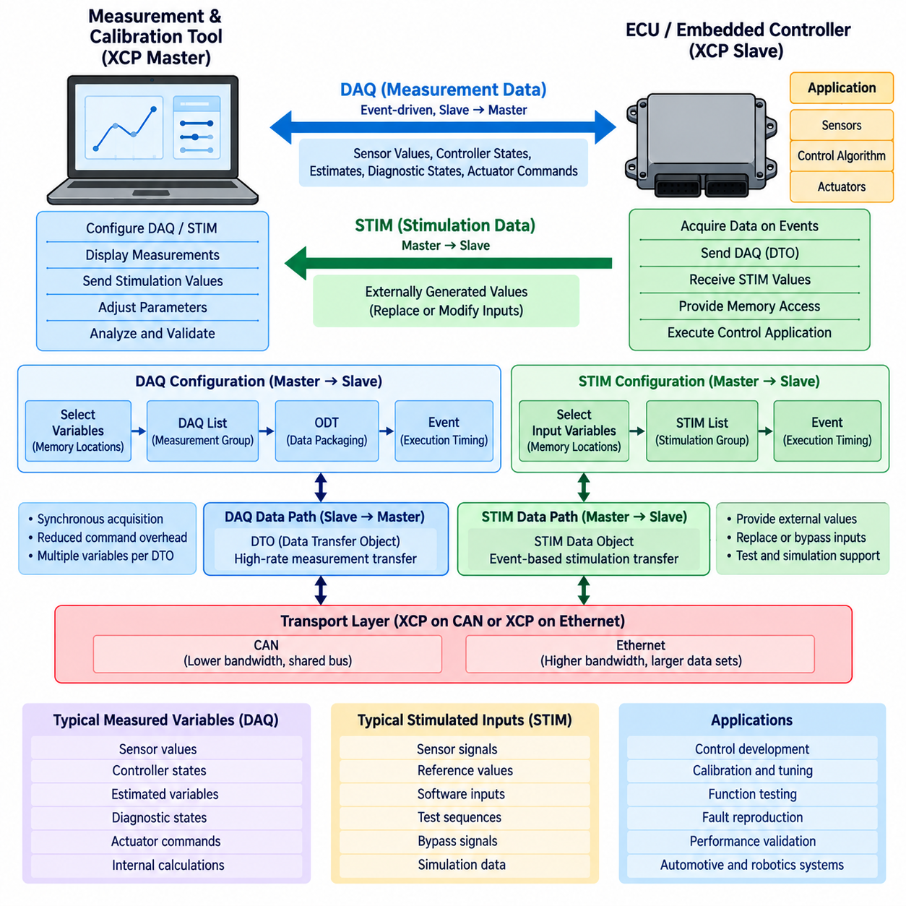
XCP Data Acquisition, commonly called DAQ, is designed for efficient observation of internal variables in a running ECU or embedded controller. Instead of requiring the XCP master to issue an individual read command for every variable, the slave can collect predefined measurement data when specific internal events occur and transmit it automatically. This event-driven approach reduces command overhead and supports high-rate measurement of real-time control behavior.
DAQ communication primarily transfers measurement data from the XCP slave toward the XCP master. The measured information may include sensor values, controller states, estimated variables, diagnostic states, actuator commands, intermediate calculations, and other internal software quantities. Because these values can be observed while the application executes normally, DAQ provides engineers with detailed visibility into behavior that may not be available through ordinary vehicle network signals.
A DAQ configuration associates selected ECU memory locations with acquisition structures and execution events. The master identifies the variables that should be measured and configures the slave accordingly. When the corresponding event occurs, the slave obtains the specified data and prepares it for transmission. This separates measurement timing from repeated master requests and allows acquisition to follow the execution timing of the embedded application.
The XCP DAQ structure is commonly organized using DAQ lists, Object Descriptor Tables, or ODTs, and individual measurement entries. A DAQ list represents a group of acquisition information associated with particular measurement behavior, while ODTs organize the actual data transferred in packets. Individual entries identify the memory locations and sizes of measured objects, allowing multiple variables to be packed efficiently into the available transport payload.
Events provide the timing foundation for synchronous DAQ operation. An event may correspond to a periodic control task, timer interrupt, software runnable, sensor-processing cycle, or another execution point defined by the ECU implementation. For example, variables associated with a 10 ms control loop can be acquired when that loop executes, allowing the resulting measurements to represent a consistent view of the controller at a meaningful software execution point.
DAQ packets are transferred through Data Transfer Objects, or DTOs, after the measurement configuration has been established. This data path differs from the command-response path used to configure and control the XCP session. By separating configuration commands from high-rate measurement transfer, XCP can minimize protocol overhead during acquisition and use the available CAN or Ethernet transport capacity more efficiently.
DAQ performance depends strongly on the selected transport. With XCP on CAN, the number of variables, event frequency, packet size, and existing CAN bus load must be carefully balanced because measurement traffic shares limited communication capacity. With XCP on Ethernet, much larger measurement sets and higher acquisition rates can generally be supported, although buffering, network traffic, operating-system behavior, and synchronization still influence practical performance.
STIM, or Stimulation, provides the complementary data direction. Instead of observing values generated inside the ECU, STIM allows externally generated data to be supplied to supported locations or functions in the XCP slave. The master prepares stimulation values and transfers them to the target, where they can be consumed according to configured execution events. This enables controlled modification of selected inputs while the embedded application is running.
The relationship between DAQ and STIM can therefore be understood as measurement versus stimulation. DAQ exposes internal ECU behavior to the external development environment, whereas STIM introduces externally controlled values into the target system. When combined, they create a bidirectional experimental interface through which engineers can observe system responses while deliberately varying selected inputs under controlled conditions.
STIM is particularly useful in development environments involving bypassing, function testing, and simulation-assisted validation. A sensor value or software input may be replaced by externally generated data so that specific operating conditions can be reproduced without requiring the corresponding physical environment. Engineers can then use DAQ simultaneously to observe how internal states and control outputs respond to the stimulated input.
Timing is critical when DAQ and STIM are used together. Measurement data should correspond to known execution events, while stimulation values must reach the target at the appropriate point in the application cycle. If data arrives too late or is associated with an incorrect event, the experiment may no longer represent the intended control behavior. Event configuration and synchronization are therefore essential parts of meaningful real-time measurement and stimulation.
DAQ and STIM also interact closely with the ECU description used by the measurement and calibration environment. The engineering tool must know which variables are measurable, which objects can participate in stimulation, where they reside in memory, how their raw values are represented, and how they relate to ECU execution events. These descriptions are commonly supplied through the A2L information addressed separately in the following section of the volume.
In control development, DAQ can record parameters such as reference values, measured states, controller errors, internal estimates, and actuator requests during an experiment. STIM can then provide controlled input sequences or substitute selected signals. Comparing the stimulated inputs with the acquired internal responses allows engineers to evaluate control algorithms, reproduce faults, analyze transient behavior, and validate modifications with much greater visibility than normal network monitoring provides.
The same mechanisms are applicable to robotic and autonomous systems containing real-time embedded controllers. Motor controllers, steering systems, battery controllers, servo drives, and low-level motion controllers can expose internal states through DAQ while controlled reference values or test inputs are supplied through STIM. CAN may support compact distributed controllers, whereas Ethernet can support measurement-intensive computing nodes and larger experimental data flows.
DAQ and STIM therefore form the real-time data exchange core of XCP measurement and experimentation. DAQ efficiently moves event-synchronized internal data from the target to the development tool, while STIM provides a controlled path for external data toward the target. Together with memory access, calibration services, transport mappings, and A2L descriptions, they enable systematic observation, modification, testing, and validation of embedded automotive and robotic control systems.

7.4 A2L File Structure
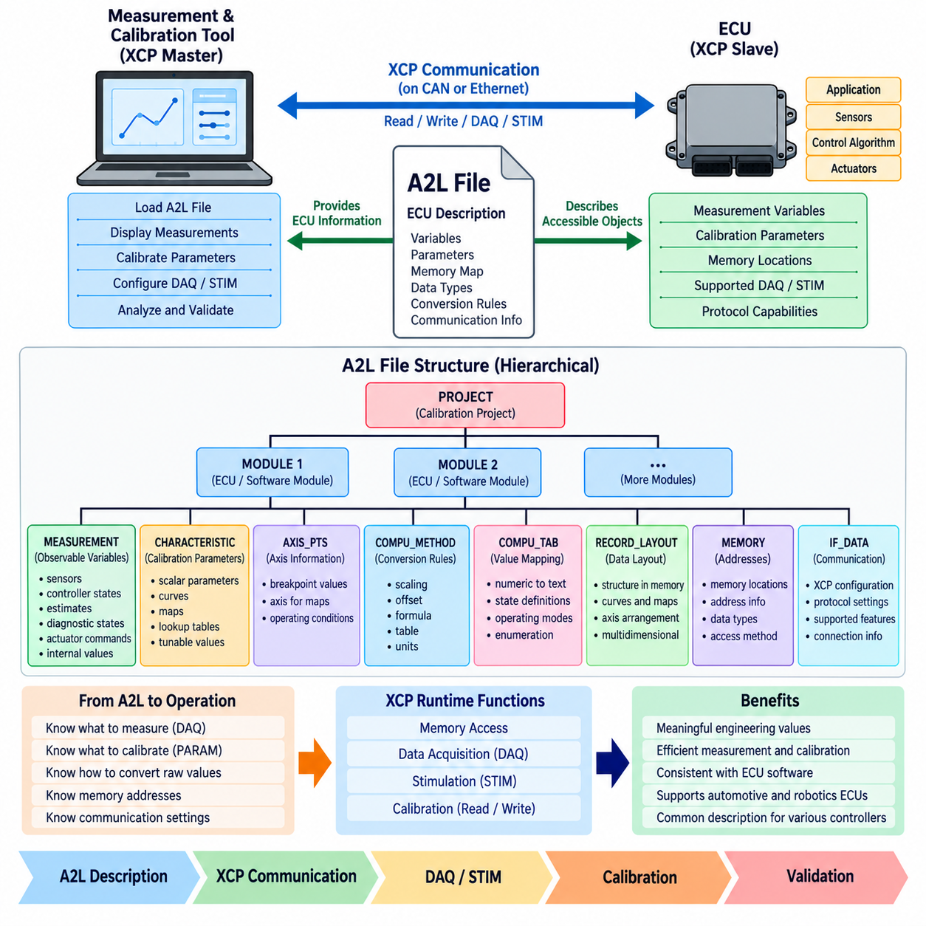
An A2L file is an ECU description file used in measurement and calibration environments to describe how engineering tools can interpret variables, parameters, memory locations, data types, conversion rules, and related ECU resources. While XCP provides the communication mechanism for accessing a running controller, the A2L description provides the semantic information required to understand what the accessed data represents.
A2L is associated with the ASAM MCD-2 MC description format and acts as a structured interface between ECU software information and measurement or calibration tools. The file does not itself perform measurement or calibration communication. Instead, it describes the objects that development tools can access through protocols such as XCP, allowing raw memory-oriented communication to be translated into meaningful engineering quantities.
At a high level, an A2L file is organized as a hierarchical description containing project, module, measurement, calibration, conversion, memory, and communication-related information. A project can contain one or more ECU-related modules, while each module groups the descriptions required for a particular controller. This organization allows a large number of software variables and calibration objects to be managed systematically within a common engineering description.
The PROJECT structure represents the upper organizational level of the description and provides a container for the calibration project. Within it, MODULE definitions describe individual ECU or software-module environments. A module can contain measurement objects, calibration characteristics, conversion methods, record layouts, memory descriptions, communication settings, and other definitions needed by the measurement and calibration system.
MEASUREMENT objects describe ECU quantities that can be observed by the development tool. Typical examples include sensor values, controller states, estimated quantities, diagnostic states, actuator commands, and intermediate calculations. Their descriptions can include information such as data representation, conversion references, valid ranges, units, and ECU access information so that raw values can be displayed as understandable physical quantities.
Calibration parameters are commonly represented through CHARACTERISTIC descriptions. These objects identify quantities that engineers are permitted to inspect or modify during calibration. Depending on the software design, they may represent scalar parameters, curves, maps, lookup tables, or other tunable data structures. Address and layout information allows the calibration tool to associate each engineering parameter with its representation in ECU memory.
AXIS_PTS descriptions are important when calibration objects contain curves or multidimensional maps. They define axis-related information used to interpret breakpoints associated with calibration tables. By describing axes separately from characteristic values, an A2L file can represent relationships between operating conditions and calibrated outputs, such as controller maps indexed by speed, temperature, load, position, or other system variables.
Raw values stored in ECU memory often cannot be interpreted directly as physical engineering values. COMPU_METHOD descriptions define conversion relationships that allow tools to transform internal numerical representations into meaningful units or textual interpretations. Scaling, offsets, formulas, tables, and associated units can therefore be represented so that engineers work with quantities such as voltage, temperature, pressure, speed, torque, or state names rather than raw binary values.
COMPU_TAB and related conversion-table structures can support mappings where numerical ECU values correspond to discrete engineering values or textual states. For example, an internal state value may represent operating modes such as initialization, standby, active operation, or fault. These descriptions improve readability and reduce the need for engineers to manually interpret implementation-specific numerical codes during measurement and calibration.
RECORD_LAYOUT information describes how calibration data structures are arranged in ECU memory. This becomes particularly important for curves, maps, axis values, and multidimensional calibration objects because their physical memory representation may differ from their conceptual engineering representation. Correct layout information allows the calibration tool to access and reconstruct these objects consistently when reading or modifying ECU data.
Memory addresses form an important connection between the A2L description and the actual ECU software implementation. Measurement variables and calibration parameters must ultimately correspond to locations or access mechanisms within the target controller. Because addresses can change when software is rebuilt, the A2L generation process is normally closely connected with software build information so that the description remains consistent with the executable ECU software.
The A2L description also contains information that helps configure communication between the calibration tool and the ECU. For XCP-based development, protocol-related configuration can describe capabilities and parameters required to establish engineering access to the target. The communication description complements the measurement and calibration object definitions, connecting the logical engineering representation with the XCP communication architecture discussed in the preceding sections.
A2L information is closely related to DAQ operation because the XCP master must know which variables can be measured and how they should be interpreted. When engineers select variables for a DAQ experiment, the measurement tool can use A2L descriptions to determine object properties and conversion information. XCP then provides the runtime mechanism for configuring acquisition and transferring the corresponding data from the ECU.
The same relationship applies to calibration and STIM activities. A calibration tool can identify tunable objects from the A2L description, access the corresponding ECU data through XCP, and display values in engineering units. For stimulation, appropriate object and execution information helps the development environment understand which values may participate in externally controlled experiments. A2L therefore complements rather than replaces XCP communication.
Maintaining consistency between the A2L file and ECU software is essential. An outdated description may contain incorrect addresses, data types, ranges, layouts, or conversion information, causing measurements to be interpreted incorrectly or calibration operations to access unintended data. Configuration management should therefore associate the correct A2L description with the corresponding software build, executable image, calibration data set, and development release.
In automotive and robotic development, A2L files can provide a common descriptive layer for controllers ranging from conventional ECUs to motor, steering, battery, servo, and motion-control systems. Combined with XCP on CAN or Ethernet and DAQ/STIM mechanisms, the A2L structure enables development tools to convert low-level ECU memory access into structured engineering measurement and calibration workflows, forming a key bridge between embedded software implementation and system-level validation.

7.5 Robot Calibration with XCP
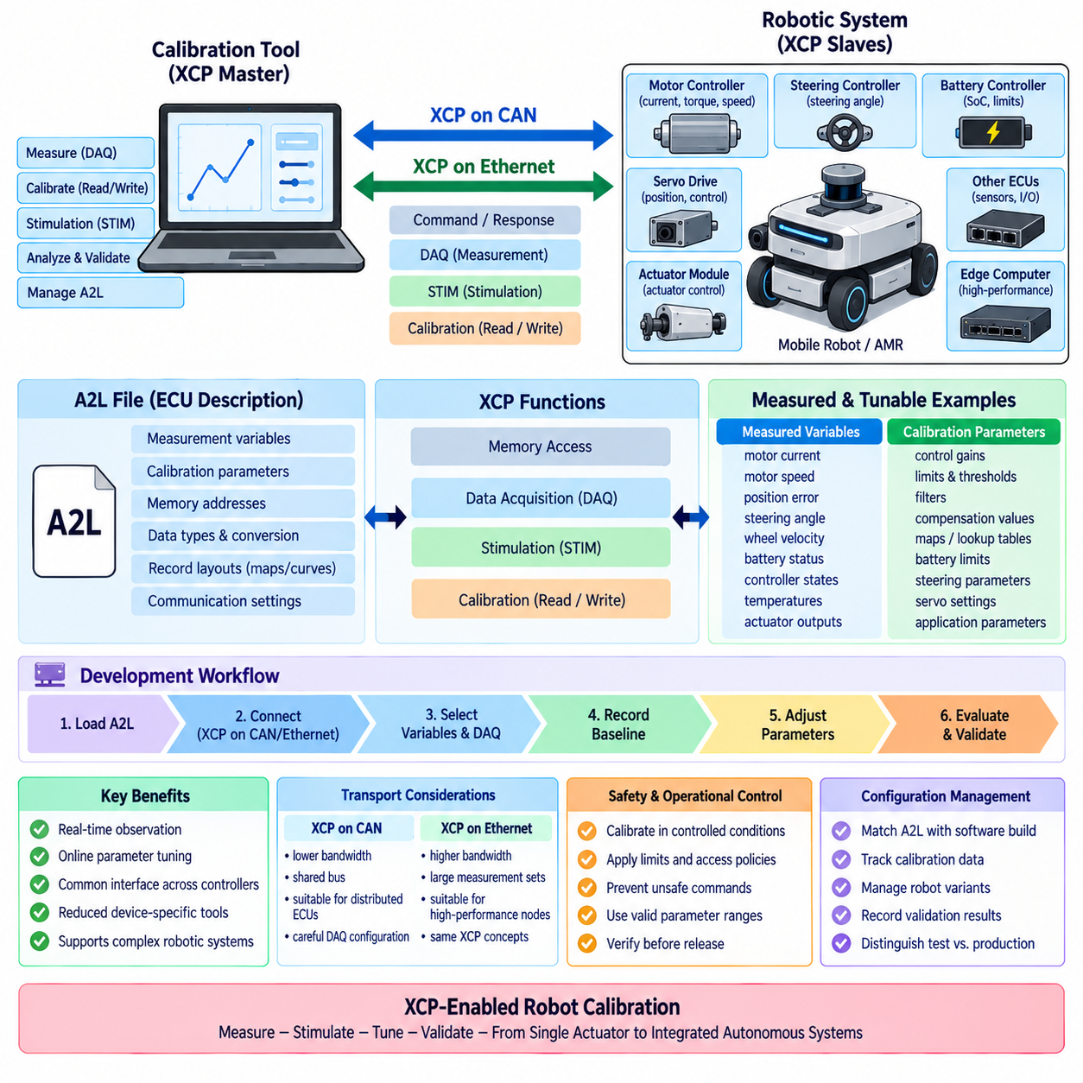
Robot calibration with XCP applies the measurement and calibration capabilities of the Universal Measurement and Calibration Protocol to robotic embedded controllers. Instead of treating calibration as an offline process based only on configuration files, engineers can observe internal controller variables and modify permitted parameters while the robot system is operating. This creates a direct engineering interface between control software, physical hardware, and calibration tools.
A robotic system usually contains multiple controllers with different responsibilities. Motor controllers regulate current, torque, velocity, and position, while steering controllers, battery controllers, servo drives, actuator modules, and other embedded devices manage their own local functions. XCP can provide a common measurement and calibration mechanism across these controllers, reducing dependence on device-specific debugging and parameter-adjustment interfaces.
Motor-control calibration is a representative application. Internal variables such as commanded torque, measured current, motor velocity, position error, controller output, saturation state, and temperature can be observed through XCP measurement functions. Calibration parameters such as control gains, limits, filters, thresholds, and compensation values can then be adjusted while engineers evaluate the resulting motor response under controlled operating conditions.
For mobile robots and AMRs, steering and motion-control calibration can use the same approach. Engineers may observe steering angle, wheel velocity, reference commands, controller errors, actuator outputs, and internal state estimates while modifying permitted control parameters. This allows calibration to be performed while examining the relationship between commanded motion, embedded control behavior, and the actual physical response of the mobile platform.
XCP Data Acquisition, or DAQ, is particularly valuable because robot controllers often execute control loops much faster than high-level computing systems. DAQ can associate measurements with internal execution events so that variables are captured at meaningful points in the control cycle. Engineers can therefore observe controller behavior according to the timing of the embedded software rather than relying only on asynchronous network monitoring from an external computer.
STIM can complement DAQ by supplying controlled external values to supported controller inputs. During development, reference commands, simulated sensor values, or test sequences can be introduced while DAQ records the resulting internal states and actuator commands. This bidirectional experimental capability is useful for reproducing operating conditions, evaluating control responses, investigating abnormal behavior, and validating software modifications without depending entirely on uncontrolled physical events.
A2L descriptions provide the engineering information required to make this process practical. The calibration tool must know which robot-controller variables are measurable, which parameters are adjustable, where objects are located, how raw data is represented, and how numerical values are converted into engineering units. Combining A2L information with XCP allows low-level memory access to appear as meaningful quantities such as current, torque, speed, position, temperature, or controller gain.
XCP on CAN is suitable for many distributed robot controllers because CAN is commonly used for low-level embedded communication. Motor controllers, steering units, battery controllers, and actuator modules can share a CAN network while XCP provides engineering access to selected devices. Measurement traffic must be carefully controlled, however, because DAQ communication competes with normal control and status messages for the available CAN bandwidth.
XCP on Ethernet becomes attractive when the robotic controller exposes larger measurement sets or when higher acquisition rates are required. Edge computers and high-performance control nodes may contain substantially more internal state than small CAN-connected controllers. Ethernet provides greater bandwidth for observing these systems, while the underlying XCP concepts of command access, DAQ, STIM, calibration, and A2L-based interpretation remain consistent with CAN-based implementations.
Calibration should be separated conceptually from normal robot operation. Development access may permit engineers to modify parameters that directly influence actuator behavior, so limits and access policies must prevent inappropriate values from producing unsafe commands. Calibration sessions should therefore be performed under controlled conditions with appropriate operational constraints, parameter ranges, software protections, and verification procedures before modified values are released for normal operation.
Parameter changes also require systematic configuration management. A calibration value that performs well during one experiment must be associated with the correct controller software, hardware configuration, robot variant, and operating conditions. The corresponding A2L description, software build, calibration data, and validation results should remain traceable so that engineers can reproduce the configuration and distinguish experimental values from approved production parameters.
A practical calibration workflow begins by connecting the measurement and calibration tool to the target controller and loading the corresponding A2L description. XCP communication is established over CAN or Ethernet, after which engineers select measurement variables and configure DAQ events. Baseline behavior is recorded before permitted parameters are modified, allowing the effects of each calibration change to be compared against a known controller configuration.
The calibration process then becomes an iterative engineering loop. Measurements reveal controller behavior, parameters are adjusted, the robot response is observed, and the resulting data is analyzed. DAQ can capture high-rate internal states while STIM provides controlled test inputs where appropriate. Once acceptable behavior is obtained, the calibration is verified across relevant operating conditions rather than being accepted solely from a single successful experiment.
This approach can scale from individual actuators to integrated robotic subsystems. A mobile robot may require coordinated calibration of drive motors, steering, braking, battery limits, servo mechanisms, and other embedded functions. XCP does not replace the control algorithms or robot middleware; instead, it provides a standardized engineering access layer through which internal controller behavior can be measured and tunable parameters can be systematically managed.
Robot calibration with XCP therefore connects the protocol architecture, CAN and Ethernet transports, DAQ/STIM operation, and A2L descriptions introduced throughout the XCP calibration chapter. Together, these elements establish a reusable workflow for observing real-time embedded behavior, tuning control parameters, reproducing test conditions, and validating robotic controllers, supporting disciplined development from individual actuator control to integrated autonomous platforms.

