Volume 06 Automotive Communication

Chapter 9. Automotive Ethernet

9.1 100BASE T1 BroadR Reach
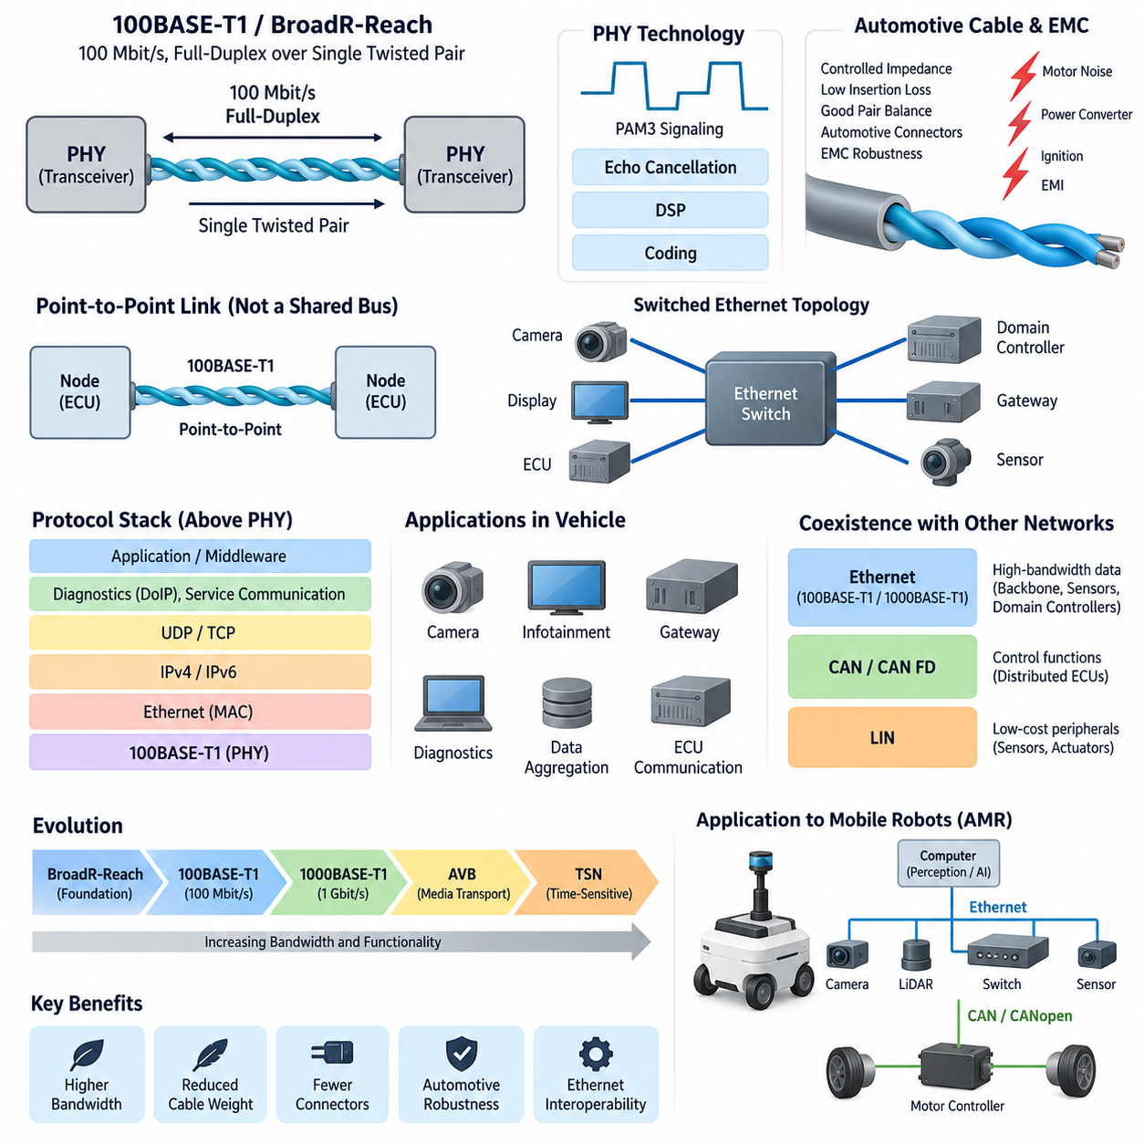
100BASE-T1 is a 100 Mbit/s Automotive Ethernet physical-layer technology designed to provide full-duplex Ethernet communication over a single balanced twisted pair. Its development addressed a fundamental automotive requirement: obtaining substantially higher bandwidth than traditional in-vehicle buses while reducing cable weight, connector complexity, and electromagnetic challenges compared with conventional multi-pair Ethernet cabling.
The historical foundation of 100BASE-T1 is closely associated with BroadR-Reach, a single-pair Ethernet technology originally developed for automotive networking. BroadR-Reach demonstrated that standard Ethernet concepts could be adapted to the electrical, environmental, cost, and packaging constraints of vehicles. This technology helped establish the practical foundation that later evolved into standardized 100BASE-T1 Automotive Ethernet implementations.
Conventional 100BASE-TX Ethernet typically uses multiple wire pairs for transmit and receive paths, whereas 100BASE-T1 communicates bidirectionally over one twisted pair. Both endpoints transmit and receive through the same physical medium simultaneously. This approach significantly reduces the amount of copper and connector contacts required for each link, providing important advantages in vehicles containing many distributed electronic control units, cameras, displays, gateways, and sensors.
Simultaneous bidirectional transmission requires each PHY to distinguish the signal received from the remote device from its own transmitted signal. Echo cancellation and digital signal-processing techniques are therefore fundamental elements of the physical-layer implementation. Rather than separating transmit and receive signals onto independent wire pairs, the transceiver processes the combined electrical waveform and reconstructs the incoming information while suppressing its locally generated component.
100BASE-T1 uses sophisticated signaling to achieve 100 Mbit/s operation within an automotive-compatible frequency range. The physical layer employs three-level pulse amplitude modulation, commonly identified as PAM3, together with coding and signal-processing mechanisms designed for reliable transmission. These techniques allow the link to achieve high data throughput without requiring the cabling structure traditionally associated with office-oriented Fast Ethernet implementations.
The single twisted pair must be treated as a controlled transmission medium rather than as ordinary low-speed wiring. Characteristic impedance, insertion loss, return loss, pair balance, connector characteristics, cable length, and termination behavior directly influence signal quality. Harness engineers must therefore coordinate cable selection, routing, connector design, and physical-layer validation with the requirements of the Ethernet PHY rather than evaluating them as independent electrical components.
Electromagnetic compatibility is especially important because automotive Ethernet operates near motors, DC/DC converters, switching power supplies, ignition-related systems, high-current conductors, and other noise sources. Balanced differential signaling helps reject common-mode disturbances, but performance still depends on pair symmetry and the complete electrical path. Poor routing, excessive untwisting, connector discontinuities, or inappropriate grounding can convert common-mode disturbances into differential noise.
100BASE-T1 commonly supports automotive point-to-point links rather than the shared multidrop topology familiar from CAN or LIN. Two Ethernet PHYs form a dedicated physical connection, and larger networks are constructed by connecting multiple links through Ethernet switches. This produces a switched architecture in which cameras, ECUs, gateways, domain controllers, or other devices communicate through dedicated links while switches forward Ethernet frames toward the required destination.
The point-to-point structure changes network engineering significantly. CAN arbitration manages multiple nodes sharing one communication medium, whereas Ethernet switching distributes traffic across individual links. Consequently, network capacity is no longer determined solely by the utilization of one shared bus. Engineers must instead consider link bandwidth, switch forwarding capacity, buffering, queue behavior, traffic priorities, multicast distribution, and end-to-end latency through the switched network.
A 100 Mbit/s link provides substantially more bandwidth than classical automotive control buses, making 100BASE-T1 attractive for applications involving cameras, infotainment devices, gateways, diagnostic communication, and data aggregation. However, nominal link speed should not be interpreted as guaranteed application throughput. Ethernet framing, higher-layer protocols, network contention, switch behavior, synchronization traffic, and application processing all contribute to actual end-to-end communication performance.
Another important distinction is that 100BASE-T1 defines a physical Ethernet communication technology rather than an entire vehicle communication architecture. Ethernet frames operate above the PHY, and higher protocol layers may include IPv4 or IPv6, UDP, TCP, diagnostics, service-oriented communication, synchronization protocols, or application-specific middleware. Selecting a 100BASE-T1 transceiver therefore addresses only part of the complete communication-system design problem.
The relationship between BroadR-Reach and 100BASE-T1 should also be understood in terms of industrial evolution. BroadR-Reach helped prove and commercialize single-pair automotive Ethernet, while standardized 100BASE-T1 provided a broader interoperable foundation for automotive PHY implementations. Engineers maintaining older systems may consequently encounter BroadR-Reach terminology, while newer component documentation and network specifications more commonly reference standardized 100BASE-T1 terminology.
Interoperability requires more than connecting two devices that nominally support 100 Mbit/s Ethernet. PHY operating modes, link initialization, electrical characteristics, cable assemblies, connectors, EMC behavior, software configuration, and network management must all be compatible. Automotive development therefore relies on component-level and system-level validation to confirm that communication remains reliable across voltage variation, temperature, vibration, aging, electromagnetic disturbances, and production tolerances.
100BASE-T1 also became an important bridge between traditional distributed ECU architectures and newer domain-oriented network designs. High-bandwidth Ethernet links can connect gateways and domain controllers while CAN, CAN FD, or LIN subnetworks remain responsible for suitable lower-bandwidth functions. This heterogeneous architecture allows designers to introduce Ethernet where bandwidth provides genuine value without unnecessarily replacing established communication technologies throughout the vehicle.
The progression from 100BASE-T1 toward 1000BASE-T1 reflects the continuing increase in vehicle data requirements. The attached volume deliberately places 100BASE-T1/BroadR-Reach before 1000BASE-T1, followed by AVB, TSN, and Automotive Ethernet applications in AMRs. This sequence represents a logical engineering progression from the physical link toward higher bandwidth, deterministic networking mechanisms, and complete system-level application.
For autonomous mobile robots, similar principles can be applied when cameras, LiDAR, edge computers, gateways, and other high-data-rate devices must communicate through a lightweight network. Ethernet may provide the perception and computing backbone while CAN or CANopen remains appropriate for motor controllers and embedded control devices. Such separation allows each communication technology to operate where its bandwidth, determinism, cost, and implementation characteristics are most appropriate.
The broader robotics electrical-engineering structure places Automotive Ethernet within automotive communication while separately covering Ethernet EMI, robotics communication, time synchronization, compute architecture, and sensor architecture. This organization emphasizes that 100BASE-T1 should not be treated merely as a faster cable interface. Its successful application depends on coordinated PHY, harness, EMC, switching, timing, protocol, diagnostics, and system-architecture engineering.
Ultimately, 100BASE-T1 represents a major transition in embedded mobility networks because it combines Ethernet interoperability with an automotive-oriented single-pair physical layer. BroadR-Reach demonstrated the feasibility of this approach, and standardized 100BASE-T1 established it as a practical foundation for production networks. Its significance lies not only in 100 Mbit/s bandwidth, but in enabling scalable switched Ethernet architectures that connect traditional embedded electronics with increasingly centralized computing systems.

9.2 1000BASE T1 Architecture
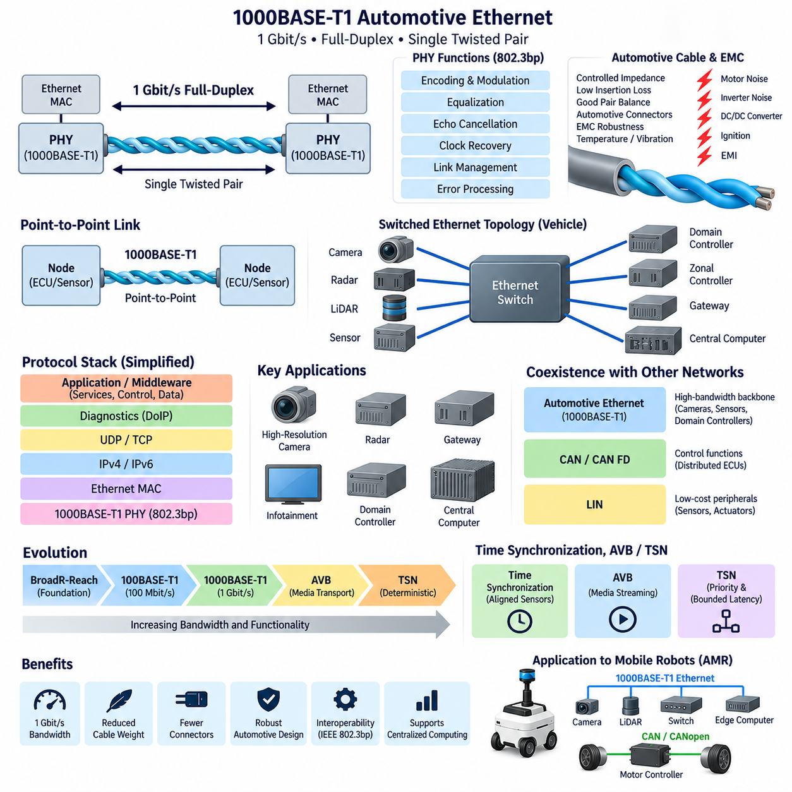
1000BASE-T1 is a Gigabit Automotive Ethernet physical-layer technology designed to transmit 1 Gbit/s full-duplex data over a single balanced twisted pair. It extends the single-pair networking concept established by 100BASE-T1 while providing approximately ten times greater nominal bandwidth. This increase supports the growing communication demands of cameras, gateways, domain controllers, centralized computers, and advanced vehicle sensors.
The architecture retains one of the most important advantages of Automotive Ethernet: simultaneous bidirectional communication over a single twisted pair. Both PHY devices transmit and receive through the same physical medium rather than using separate transmit and receive pairs. Sophisticated signal processing separates the locally transmitted waveform from the incoming signal, enabling full-duplex operation while minimizing cable conductors, connector contacts, harness mass, and packaging requirements.
At each end of a 1000BASE-T1 link, a physical-layer transceiver, or PHY, interfaces the Ethernet MAC with the automotive cable. The PHY performs functions such as encoding, modulation, equalization, echo cancellation, clock recovery, link management, and error-related processing. These functions transform digital Ethernet information into electrical signaling capable of maintaining Gigabit communication through an automotive-qualified single-pair transmission channel.
1000BASE-T1 is standardized within the IEEE 802.3 family, with the automotive Gigabit single-pair physical layer associated with IEEE 802.3bp. Standardization provides common electrical and protocol behavior so PHY devices from different suppliers can be developed around interoperable requirements. Nevertheless, successful interoperability still depends on correct PHY configuration, cable characteristics, connector performance, link parameters, EMC design, and system-level validation.
The physical channel becomes increasingly important as data rate rises. A cable that performs adequately for a lower-speed network cannot automatically be assumed to satisfy Gigabit requirements. Characteristic impedance, insertion loss, return loss, mode conversion, pair balance, propagation characteristics, connector discontinuities, and cable length influence the available signal margin. Harness engineering must therefore be treated as an integral part of the 1000BASE-T1 communication architecture.
Electromagnetic compatibility also becomes a central design concern. Motors, inverters, DC/DC converters, switching regulators, high-current power distribution, and other electrical systems can inject electromagnetic disturbances into nearby communication wiring. Balanced differential signaling and twisted-pair construction provide substantial immunity, but excessive untwisting, poor connector transitions, asymmetric routing, or unsuitable grounding can degrade pair balance and convert common-mode disturbances into differential noise.
1000BASE-T1 is fundamentally a point-to-point communication technology. A physical link normally connects two PHY endpoints, such as a sensor and switch or a switch and domain controller. Larger vehicle networks are constructed by combining many such links through switched Ethernet infrastructure. This differs fundamentally from CAN or LIN, where multiple devices may share the same physical bus, and allows aggregate network bandwidth to increase as additional switched links are introduced.
An Ethernet switch consequently becomes a major architectural component in Gigabit vehicle networks. It receives Ethernet frames from connected ports, examines forwarding information, and directs traffic toward appropriate destinations. Network engineering must therefore account for switch bandwidth, forwarding latency, buffering, queue management, multicast traffic, traffic classes, congestion, and failure behavior rather than considering only the nominal 1 Gbit/s capacity of individual physical links.
Gigabit bandwidth is especially useful for high-data-rate perception systems. High-resolution cameras, radar systems, data acquisition units, gateways, and centralized processing computers can generate or consume significantly more information than traditional CAN-based networks can efficiently transport. 1000BASE-T1 provides a practical backbone connection for these devices, allowing raw or processed sensor information to move between distributed sensing nodes and high-performance computing platforms.
The protocol architecture above 1000BASE-T1 remains based on Ethernet layering. The PHY provides the physical communication channel, while the MAC handles Ethernet frames. Above these layers, systems may employ IPv4 or IPv6, UDP, TCP, diagnostics, synchronization services, service-oriented middleware, or application-specific protocols. Consequently, Gigabit physical bandwidth alone does not determine application latency, determinism, reliability, or software architecture.
Time synchronization becomes increasingly important when Gigabit Ethernet connects multiple perception devices. Camera images, radar detections, LiDAR measurements, IMU information, and computing events may need a common temporal reference before accurate sensor fusion can occur. Ethernet-based time synchronization can distribute a coordinated clock across switches and endpoints, allowing measurements generated by physically separated sensors to be aligned according to their acquisition time rather than their arrival time.
High bandwidth also does not automatically guarantee deterministic communication. Ordinary Ethernet traffic can experience variable delay due to queueing, competing traffic, and switch behavior. Audio Video Bridging, or AVB, and later Time-Sensitive Networking, or TSN, introduce mechanisms that improve synchronization, traffic prioritization, scheduling, and bounded-latency behavior. The attached structure therefore places AVB and TSN immediately after the 100BASE-T1 and 1000BASE-T1 physical-layer topics.
1000BASE-T1 normally operates as part of a heterogeneous vehicle communication architecture rather than replacing every existing bus. LIN remains appropriate for inexpensive peripheral devices, while CAN and CAN FD continue to serve many distributed control functions. Gigabit Ethernet can form the high-bandwidth backbone connecting gateways, domain controllers, zonal controllers, perception sensors, and centralized computers, with gateways providing controlled communication between different network technologies.
This heterogeneous structure is particularly relevant to the transition toward domain and zonal electrical architectures. Instead of connecting every sensor and actuator directly to a dedicated central ECU, local devices can be aggregated through domain or zonal controllers. High-speed Ethernet links then connect these controllers to centralized computing resources. Such an architecture can reduce portions of harness complexity while supporting the increasing software and data requirements of modern vehicles.
Diagnostics and software lifecycle operations can also benefit from Gigabit Ethernet. Large firmware images, logging data, calibration information, and diagnostic records can require substantial transfer capacity. When Ethernet is combined with IP-based diagnostic mechanisms such as Diagnostics over Internet Protocol, high-speed backbone connectivity can accelerate software flashing, manufacturing operations, service procedures, data extraction, and communication with increasingly software-intensive electronic control units.
For autonomous mobile robots, the same architecture can connect cameras, LiDAR, high-performance edge computers, gateways, and Ethernet switches while lower-level motion devices remain connected through CAN or CANopen. The broader engineering structure explicitly includes Automotive Ethernet applications in AMRs after the physical-layer, AVB, and TSN topics. This provides a natural separation between high-bandwidth perception communication and embedded actuator-control networks.
A practical AMR architecture might therefore use 1000BASE-T1 or another Gigabit Ethernet technology between perception sensors and an edge computer while an embedded controller executes faster motor-control functions. Ethernet can transport sensor streams, maps, localization information, AI outputs, diagnostics, and high-level commands, whereas CAN or CANopen can carry commands and feedback associated with motor drives. Each network is then selected according to its actual functional requirements.
The wider robotics electrical architecture also separates automotive communication from grounding and EMC, sensor architecture, compute architecture, robotics communication, and time synchronization. This organization reflects an important engineering principle: successful 1000BASE-T1 deployment requires coordinated design across PHY hardware, cables, connectors, switching, EMC, software protocols, timing, diagnostics, computing systems, and application requirements.
Ultimately, 1000BASE-T1 represents the transition of single-pair Automotive Ethernet from 100 Mbit/s connectivity toward a Gigabit-class communication backbone. Its significance extends beyond the tenfold increase in nominal bandwidth over 100BASE-T1. By combining single-pair cabling, full-duplex communication, switched topology, Ethernet interoperability, and high data capacity, it provides an architectural foundation for sensor-rich vehicles, centralized computing, software-defined platforms, and advanced autonomous robotic systems.

9.3 AVB Audio Video Bridging
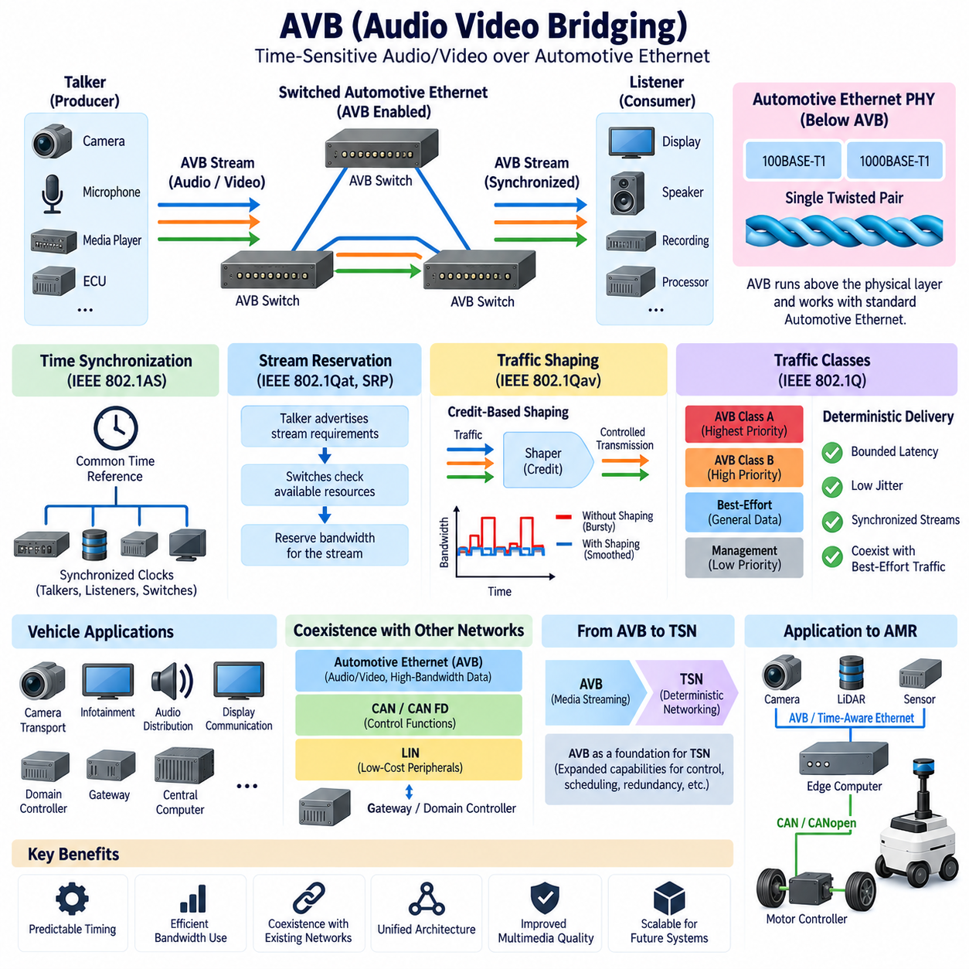
Audio Video Bridging, commonly abbreviated as AVB, is a family of IEEE Ethernet technologies developed to transport time-sensitive audio and video streams with more predictable timing than conventional best-effort Ethernet. In Automotive Ethernet, AVB became important because cameras, displays, infotainment systems, amplifiers, and other multimedia devices require coordinated delivery rather than simply high raw bandwidth.
Conventional Ethernet forwards traffic according to a best-effort model, which works well for many data applications but does not inherently guarantee when a particular frame will arrive. Network congestion, switch queues, and competing traffic can introduce variable delay and packet loss. Audio and video streams are sensitive to these effects because excessive latency, jitter, or dropped packets can cause interrupted sound, unstable playback, or synchronization errors.
AVB addresses this problem by combining several coordinated mechanisms rather than defining a completely separate physical network. It operates above Ethernet physical technologies such as 100BASE-T1 or 1000BASE-T1 and adds capabilities for precise time synchronization, stream reservation, traffic shaping, and controlled forwarding. This allows ordinary Ethernet data and time-sensitive multimedia traffic to coexist on the same switched communication infrastructure.
Time synchronization is one of the fundamental elements of AVB. IEEE 802.1AS provides a generalized Precision Time Protocol mechanism that distributes a common time reference among compatible devices. When talkers, listeners, and Ethernet bridges share synchronized clocks, audio samples and video frames can be associated with consistent timestamps, allowing distributed devices to reproduce or process media according to coordinated timing.
This synchronized time base is particularly valuable in systems containing multiple multimedia endpoints. A vehicle may include several speakers, microphones, displays, cameras, and processing units distributed throughout the electrical architecture. Without synchronization, independent clocks gradually drift relative to one another. AVB synchronization provides a common temporal foundation that helps maintain coordinated playback, acquisition, and processing across networked devices.
AVB introduces the concept of streams between a talker and one or more listeners. A talker produces a time-sensitive stream, while listeners consume that stream, and Ethernet bridges transport it through the network. Unlike arbitrary best-effort communication, an AVB stream can be associated with defined traffic characteristics. This enables network resources to be evaluated before time-sensitive communication is accepted across the required path.
The Stream Reservation Protocol, associated with IEEE 802.1Qat in the original AVB framework, provides mechanisms for reserving network resources for streams. Devices can advertise stream requirements, and bridges determine whether sufficient resources are available along the communication path. This prevents a network from accepting more reserved traffic than it can reliably transport while maintaining the expected quality of service for existing streams.
Traffic shaping is another essential AVB capability. IEEE 802.1Qav defines credit-based shaping, which regulates how selected traffic classes are transmitted through Ethernet ports. Instead of allowing one high-priority stream to monopolize the link, the shaper controls transmission opportunities according to accumulated credit. This reduces burstiness and helps provide predictable service for time-sensitive streams while preserving bandwidth for other Ethernet communication.
Traffic classes allow AVB-capable networks to distinguish time-sensitive streams from ordinary best-effort data. Switches can apply different forwarding and queue-management policies according to the traffic class. The objective is not to make every Ethernet frame deterministic, but to create controlled communication behavior for selected streams whose latency and timing requirements justify special treatment while conventional traffic continues to share the network.
AVB also introduced forwarding and queueing enhancements intended to constrain end-to-end latency across compatible bridges. Predictable latency requires every network component along a stream path to participate correctly. Consequently, AVB performance depends not only on the transmitting and receiving devices but also on Ethernet switches, queue configuration, reserved bandwidth, topology, traffic loading, and synchronization quality throughout the communication path.
In Automotive Ethernet, these capabilities enabled Ethernet to expand beyond ordinary data networking into applications previously dependent on specialized multimedia networks. Audio distribution, infotainment, display communication, camera transport, and other synchronized streams could increasingly share Ethernet infrastructure. This consolidation offered opportunities to reduce dedicated network technologies while creating a more unified communication architecture across vehicle electronic systems.
AVB should nevertheless be distinguished from the Ethernet physical layer itself. 100BASE-T1 and 1000BASE-T1 define how Ethernet information is electrically transmitted over automotive single-pair cabling, whereas AVB defines mechanisms above that physical connectivity for synchronized and time-sensitive traffic. A Gigabit Ethernet link therefore provides bandwidth, but AVB provides additional coordination required when application timing matters.
The attached Automotive Communication structure reflects this layering by placing 100BASE-T1 and 1000BASE-T1 before AVB, followed by Time-Sensitive Networking and Automotive Ethernet applications in AMRs. This progression moves from physical connectivity and increasing bandwidth toward time-aware communication mechanisms and then toward their application within complete vehicle and robotic network architectures.
AVB also represents an important historical and technical foundation for Time-Sensitive Networking, or TSN. TSN expands the time-sensitive Ethernet concept into a broader collection of standards supporting industrial control, automotive communication, scheduled traffic, redundancy, bounded latency, and other deterministic networking requirements. AVB can therefore be understood as a major stage in the evolution from ordinary switched Ethernet toward more comprehensive deterministic Ethernet architectures.
The distinction between multimedia timing and control timing is important. Audio and video streams generally require sustained bandwidth, bounded latency, low jitter, and synchronization, whereas closed-loop control systems may require stricter scheduling and highly predictable worst-case response. AVB addresses the former particularly well, while later TSN mechanisms provide additional capabilities for applications where deterministic control traffic must coexist with other Ethernet communication.
Automotive systems frequently combine AVB-capable Ethernet with CAN, CAN FD, and LIN rather than replacing all established communication technologies. Ethernet can transport multimedia and high-bandwidth data, CAN-based networks can continue supporting distributed control, and LIN can connect inexpensive peripheral devices. Gateways and domain controllers integrate these networks, allowing each communication technology to serve functions appropriate to its bandwidth, timing, cost, and reliability characteristics.
The same principle can extend to autonomous mobile robots. Cameras and other high-bandwidth sensors may communicate with an edge computer through switched Ethernet, while synchronized streams can benefit from time-aware networking concepts. Motor controllers and embedded actuator devices may remain on CAN or CANopen. This separates high-volume perception communication from lower-level motion control while maintaining coordinated timing where sensor information must be correlated.
For sensor-rich robotic systems, synchronization can be as significant as bandwidth. Multiple cameras, microphones, LiDAR units, or distributed acquisition devices may generate data that must be temporally aligned before perception algorithms can combine it correctly. AVB's emphasis on synchronized clocks and controlled stream delivery therefore provides an important conceptual bridge between multimedia networking and the time-coordinated sensor architectures required by advanced autonomous systems.
The broader robotics engineering structure separately includes Ethernet EMI, Automotive Ethernet, robotics communication, sensor architecture, compute architecture, and time synchronization. This reinforces the system-level nature of AVB deployment: reliable time-sensitive networking requires coordinated PHY design, switches, cabling, EMC engineering, clock synchronization, traffic management, middleware, computing resources, and application-level timing requirements.
Ultimately, AVB transformed Ethernet from a primarily best-effort data network into a platform capable of supporting synchronized, bandwidth-reserved, time-sensitive media streams. Through common time, stream reservation, traffic classification, and shaping, it established important mechanisms for predictable communication over switched Ethernet. Its concepts subsequently became part of the foundation for TSN, which extends deterministic Ethernet toward broader automotive, industrial, and robotic applications.

9.4 TSN Time Sensitive Networking
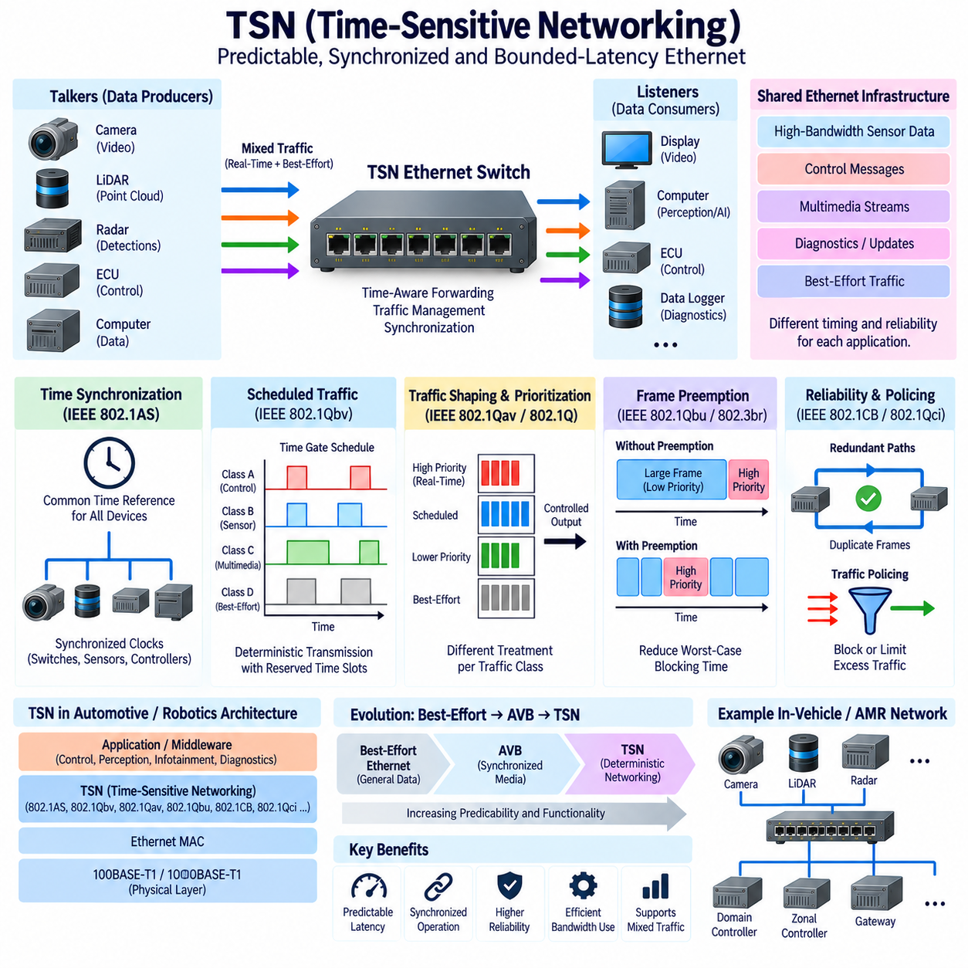
Time-Sensitive Networking, commonly abbreviated as TSN, is a family of IEEE 802.1 standards that extends standard switched Ethernet with mechanisms for predictable, synchronized, and bounded-latency communication. In Automotive Ethernet, TSN enables high-bandwidth sensor data, control messages, multimedia streams, and ordinary best-effort traffic to share the same Ethernet infrastructure while receiving different timing and reliability treatment according to application requirements.
Traditional Ethernet was designed primarily around best-effort packet delivery. When multiple frames compete for the same output port, switches place traffic into queues and transmit it according to configured priorities and available bandwidth. This behavior can produce variable latency and jitter, which may be acceptable for general data transfer but problematic for vehicle functions requiring predictable message delivery, synchronized sensing, or coordinated real-time processing.
TSN does not replace Ethernet or define a new physical layer. Instead, it introduces time-aware and traffic-management capabilities above physical technologies such as 100BASE-T1 and 1000BASE-T1. The existing Ethernet MAC, switching infrastructure, and higher-layer protocols can remain part of the architecture. TSN therefore provides a path for transforming conventional Automotive Ethernet into a communication system capable of supporting increasingly demanding real-time applications.
Precise time synchronization is one of the foundations of TSN. IEEE 802.1AS establishes mechanisms for distributing a common time reference among network devices. Ethernet switches, controllers, sensors, and computing nodes can synchronize their local clocks so events throughout the network are referenced to a coordinated time base. This enables accurate timestamping, coordinated transmission, synchronized sensor acquisition, and consistent interpretation of distributed events.
For autonomous vehicles and robots, this common time base is particularly valuable. Cameras, LiDAR, radar, IMUs, and other sensors may capture information at different physical locations and at different moments. Sensor-fusion algorithms need to determine when each measurement was actually acquired rather than merely when its packet arrived at the processor. Network-wide synchronization allows distributed sensor measurements to be aligned more accurately before perception and localization algorithms combine them.
Scheduled traffic is another important TSN concept. IEEE 802.1Qbv introduces time-aware scheduling that can control when selected queues are permitted to transmit. Transmission gates associated with traffic queues open and close according to a predefined schedule. Critical traffic can therefore receive dedicated transmission windows, reducing interference from lower-priority frames and providing much more predictable communication behavior than ordinary priority-based Ethernet alone.
This time-aware scheduling concept effectively allows Ethernet bandwidth to be organized in the time domain. During one interval, a high-criticality control or sensor stream may be transmitted, while another interval can carry other scheduled or best-effort traffic. Proper engineering of these schedules can reduce queueing uncertainty and establish bounded communication latency, although end-to-end performance still depends on every participating bridge and endpoint being configured consistently.
TSN also includes mechanisms for traffic shaping and prioritization. Different traffic classes can receive different treatment according to their timing and criticality requirements. Safety-related or real-time communication may receive tightly controlled resources, while diagnostics, logging, software updates, and ordinary data can use remaining capacity. This enables one physical Ethernet infrastructure to support applications with significantly different communication characteristics without treating every packet identically.
Frame preemption further improves the handling of urgent traffic. A large lower-priority Ethernet frame can otherwise occupy a link while a critical frame waits for transmission. Mechanisms associated with frame preemption allow suitable lower-priority traffic to be interrupted so higher-priority express traffic can proceed with less delay. This reduces worst-case blocking time and can improve latency predictability for critical messages sharing links with larger data transfers.
Reliability is another important aspect of time-sensitive networking. TSN mechanisms can support redundant communication paths and duplicate frame transmission so that critical information can reach its destination even when a particular path experiences a failure. Redundancy is especially valuable in vehicle and robotic architectures where communication failures may affect perception, control, or safety-related functions and where recovery time must be carefully controlled.
Traffic policing is necessary because deterministic communication can be disrupted by a device that transmits more traffic than expected. TSN-capable bridges can apply rules that identify and constrain streams whose behavior violates configured limits. This protects correctly operating critical traffic from malfunctioning or misconfigured nodes. Determinism therefore depends not only on prioritizing important traffic but also on controlling sources that could otherwise consume excessive network resources.
TSN evolved from technologies established through Audio Video Bridging, or AVB. AVB introduced synchronized clocks, stream reservation, traffic classes, and shaping for time-sensitive multimedia communication. TSN expands these concepts toward broader deterministic networking requirements, including scheduled traffic, improved latency control, redundancy, and applications beyond audio and video. The transition from AVB to TSN therefore represents an expansion from media-oriented timing toward general real-time Ethernet communication.
The attached Automotive Communication structure reflects this progression directly. 100BASE-T1 establishes 100 Mbit/s single-pair Ethernet, 1000BASE-T1 expands the physical link to Gigabit communication, AVB introduces synchronized time-sensitive media transport, and TSN extends these concepts toward more deterministic networking. Automotive Ethernet in AMR then applies these technologies at the complete robotic system level.
TSN is particularly relevant to domain and zonal vehicle architectures. High-performance central computers can communicate with zonal controllers, gateways, sensors, and other processors through a switched Ethernet backbone. Instead of maintaining physically separate networks for every traffic category, TSN can enable selected real-time, sensor, diagnostic, and best-effort communication to coexist while switches enforce timing, scheduling, bandwidth, and priority policies throughout the network.
However, TSN should not be interpreted as automatically making every Ethernet application hard real-time. Deterministic behavior depends on network topology, traffic assumptions, synchronization accuracy, queue configuration, scheduling, switch implementation, endpoint behavior, and end-to-end software processing. Engineers must analyze worst-case latency and resource utilization across the complete communication path rather than assuming that the presence of a TSN-capable switch alone guarantees deterministic operation.
TSN also does not necessarily replace CAN, CAN FD, or LIN. CAN-based networks remain effective for many distributed control functions, while LIN provides economical connectivity for simple peripheral devices. Automotive Ethernet with TSN can serve as the high-bandwidth and time-aware backbone connecting centralized computers, domain or zonal controllers, gateways, and advanced sensors. Gateways can integrate these technologies into a heterogeneous electrical architecture.
This layered approach is highly relevant to autonomous mobile robots. A robot may use Ethernet for cameras, LiDAR, radar, high-performance edge computers, and distributed perception devices while CAN or CANopen connects motor controllers and embedded actuator systems. TSN can improve synchronization and predictable communication across the Ethernet portion without requiring low-level motion-control loops to be transferred unnecessarily from dedicated controllers onto the high-level computing network.
For example, an edge computer may execute perception and planning at tens of cycles per second while embedded motor controllers execute control loops at hundreds or thousands of cycles per second. Ethernet and TSN can coordinate sensor streams, state information, trajectories, and high-level commands, while CAN or CANopen handles appropriate actuator communication. This division separates network-level determinism from the even tighter timing requirements of local servo and motor-control loops.
As robots incorporate Physical AI, world models, multimodal perception, and increasingly centralized computation, communication timing becomes part of the intelligence architecture itself. Correctly synchronized sensor data improves state estimation, while predictable delivery reduces uncertainty between perception, planning, and execution. TSN therefore provides more than bandwidth management: it establishes a time-aware communication foundation connecting distributed sensing and computing resources.
The broader robotics electrical engineering structure includes Automotive Ethernet together with grounding and EMC, sensor architecture, compute architecture, robotics communication, and time synchronization. This emphasizes that TSN performance depends on the entire system, including PHY devices, switches, cables, clock architecture, EMC robustness, middleware, operating systems, processing latency, gateway behavior, and application-level timing requirements.
Ultimately, TSN represents the evolution of Ethernet from best-effort packet networking toward a shared communication infrastructure capable of supporting predictable real-time behavior. Through precise synchronization, scheduled transmission, traffic shaping, prioritization, preemption, policing, and redundancy, TSN allows critical and noncritical traffic to coexist more effectively. This makes it a key enabling technology for centralized vehicles, software-defined architectures, advanced AMRs, and future Physical AI systems.

9.5 Automotive Ethernet in AMR
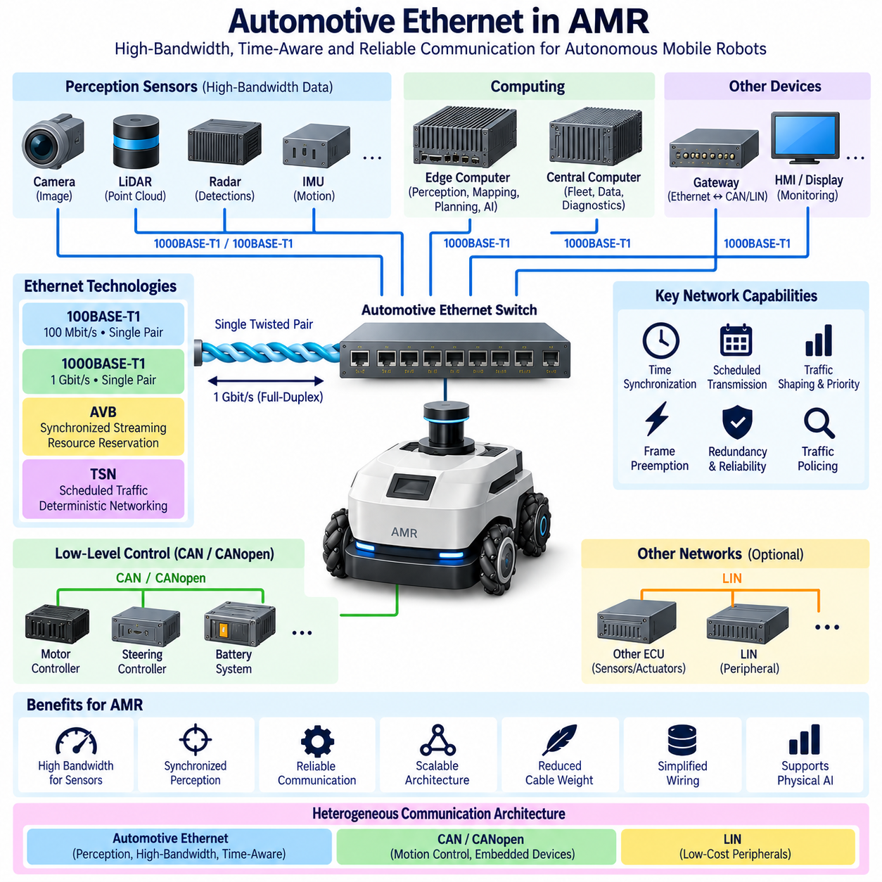
Automotive Ethernet in an Autonomous Mobile Robot, or AMR, provides a high-bandwidth communication backbone for connecting perception sensors, edge computers, gateways, and other data-intensive electronic systems. The same Ethernet technologies developed for modern vehicles can be adapted to mobile robots, where increasing numbers of cameras, LiDARs, computing platforms, and intelligent modules must exchange large volumes of synchronized information.
An AMR communication architecture normally contains several networks rather than one universal bus. Ethernet is well suited to high-bandwidth perception and computing traffic, while CAN or CANopen can remain responsible for motor controllers, steering controllers, battery systems, and embedded devices. This heterogeneous approach allows each network technology to be selected according to bandwidth, latency, determinism, cost, robustness, and implementation requirements.
100BASE-T1 can provide 100 Mbit/s full-duplex communication over a single twisted pair, while 1000BASE-T1 increases the physical-link capacity to 1 Gbit/s. Single-pair cabling is attractive in mobile robots because cable mass, routing space, connector size, and mechanical flexibility influence system integration. These advantages become increasingly important when numerous network links must pass through compact chassis structures or moving assemblies.
High-resolution cameras are among the devices that benefit most directly from Ethernet connectivity. Image streams can require substantially more bandwidth than conventional control buses can provide, particularly when multiple cameras operate simultaneously. Ethernet allows camera data to be transported toward an edge computer or perception processor where object detection, segmentation, visual localization, depth estimation, and other AI-based perception functions can be executed.
LiDAR and radar sensors can also generate substantial quantities of data that must be transferred to localization and perception systems. Ethernet provides sufficient capacity for point clouds, detections, timestamps, configuration data, and sensor status information to coexist within the communication architecture. A switched topology can connect multiple sensing devices while keeping individual physical links independent and allowing aggregate network capacity to scale with system complexity.
An Ethernet switch becomes a central component when several sensors and computers must communicate within the AMR. Cameras, LiDARs, radar units, gateways, and edge computers can connect through individual Ethernet ports, while the switch forwards frames according to their destinations. Network design must therefore consider port bandwidth, switching capacity, buffering, queueing, multicast behavior, traffic priorities, and end-to-end latency rather than evaluating only individual link speeds.
The edge computer typically represents the primary consumer of high-bandwidth perception information. It may execute localization, mapping, sensor fusion, obstacle recognition, path planning, world modeling, or Physical AI functions using data received through Ethernet. The communication backbone therefore connects distributed physical sensing with centralized or partially centralized intelligence, making network performance an important part of the robot's overall perception and decision architecture.
Lower-level motion control has different requirements. Motor controllers may execute current, velocity, or position-control loops at rates substantially higher than the perception and planning cycles running on an edge computer. CAN or CANopen can therefore remain appropriate between embedded controllers and motor drives, while Ethernet transports higher-level commands, trajectories, system states, and perception information. This separation prevents every control function from being unnecessarily moved onto Ethernet.
A practical AMR may consequently use Ethernet between an edge computer and an embedded control computer while CAN or CANopen connects that embedded controller to motor drives. The edge computer determines higher-level motion intentions using perception and planning, whereas the embedded controller executes lower-latency control and safety-related logic. Such hierarchical communication separates AI decision timing from actuator-control timing while preserving coordinated system operation.
Time synchronization becomes critical when multiple sensors participate in perception. Camera images, LiDAR scans, radar measurements, IMU samples, and localization information may arrive through different communication paths and with different delays. The processing computer must know when each measurement was acquired rather than relying only on packet arrival time. Ethernet-based synchronization can establish a common temporal reference across distributed sensing and computing devices.
Audio Video Bridging, or AVB, introduced synchronized streaming, resource reservation, and traffic shaping for time-sensitive Ethernet communication. These mechanisms are useful when an AMR carries continuous camera, audio, or other stream-oriented information that should coexist with ordinary Ethernet traffic. AVB demonstrates how Ethernet can move beyond best-effort communication by providing controlled treatment for streams with defined bandwidth and timing requirements.
Time-Sensitive Networking, or TSN, extends these concepts toward broader deterministic Ethernet communication. Scheduled transmission, precise synchronization, traffic prioritization, shaping, preemption, and redundancy can improve predictable delivery for selected AMR traffic. TSN can therefore support architectures where perception streams, control-related messages, diagnostics, and best-effort data share Ethernet while receiving different treatment according to their timing and criticality requirements.
The attached communication structure deliberately develops these technologies in sequence: 100BASE-T1, 1000BASE-T1, AVB, TSN, and finally Automotive Ethernet in AMR. This organization shows that AMR implementation is a system-level application of the physical-layer bandwidth, switched networking, synchronization, and time-sensitive communication mechanisms introduced in the preceding Automotive Ethernet sections.
Automotive Ethernet does not imply that every AMR connection should use 100BASE-T1 or 1000BASE-T1. Conventional Ethernet physical interfaces may also be appropriate depending on the robot platform, sensor interfaces, environmental requirements, and available hardware. The architectural lesson from Automotive Ethernet is broader: high-bandwidth switched networking, robust physical integration, synchronization, traffic management, and deterministic mechanisms can be applied systematically to robotic communication design.
Electromagnetic compatibility is particularly important in AMRs because communication cables often operate near traction motors, motor drives, DC/DC converters, battery conductors, chargers, relays, and switching power electronics. High-speed Ethernet links require careful attention to cable balance, connector transitions, grounding, shielding strategy, routing, and separation from high-noise circuits. Communication architecture must therefore be coordinated with harness and EMC engineering.
Reliability must also be evaluated at the complete system level. A communication failure affecting a camera or LiDAR link can reduce perception capability, while loss of communication between computing nodes can disrupt navigation or mission execution. Network supervision, diagnostic reporting, link-state monitoring, timeout strategies, degraded operating modes, and appropriate redundancy can therefore become part of the AMR architecture according to the criticality of each communication path.
Diagnostics and maintenance are natural applications for Ethernet connectivity. High-bandwidth links can support software updates, log extraction, sensor configuration, calibration data, diagnostic services, and engineering access. A gateway or central computer can aggregate information from Ethernet, CAN, CANopen, and other networks, providing a unified interface for system monitoring and service while preserving specialized lower-level communication networks inside the robot.
As AMR architectures become more centralized, Ethernet can connect increasingly powerful edge computers with distributed sensors and intelligent controllers. This resembles the transition from distributed ECU architectures toward domain and zonal architectures in modern vehicles. Local devices can be grouped through switches or controllers while a high-bandwidth backbone connects major computing resources, reducing communication fragmentation and creating a clearer path for scalable software integration.
Physical AI increases the importance of this backbone because world models, multimodal perception, vision-language-action systems, and advanced planning algorithms require access to diverse sensor and state information. Ethernet can transport the high-volume data required by these functions, while synchronized timing helps preserve relationships among observations. Communication consequently becomes part of the infrastructure through which physical experience is converted into machine-readable state and intelligent action.
The broader robotics electrical engineering structure separately includes Automotive Ethernet, robotics communication, sensor architecture, compute architecture, grounding and EMC, calibration, and time synchronization. This emphasizes that an AMR Ethernet network cannot be designed independently. Sensor interfaces, computing performance, wiring, connectors, EMC, control architecture, software middleware, diagnostics, safety requirements, and timing must be considered as one integrated system.
Ultimately, Automotive Ethernet in AMRs provides a scalable bridge between distributed sensing, high-performance computing, and embedded control. Ethernet supplies the high-bandwidth backbone, AVB and TSN provide increasingly sophisticated timing and traffic-management capabilities, and CAN or CANopen can continue supporting appropriate low-level control functions. This heterogeneous architecture creates a practical communication foundation for sensor-rich AMRs, autonomous machines, and increasingly capable Physical AI systems.

