Volume 06 Automotive Communication

Chapter 1. Network Fundamentals

1.1 OSI Model in Vehicle Networks
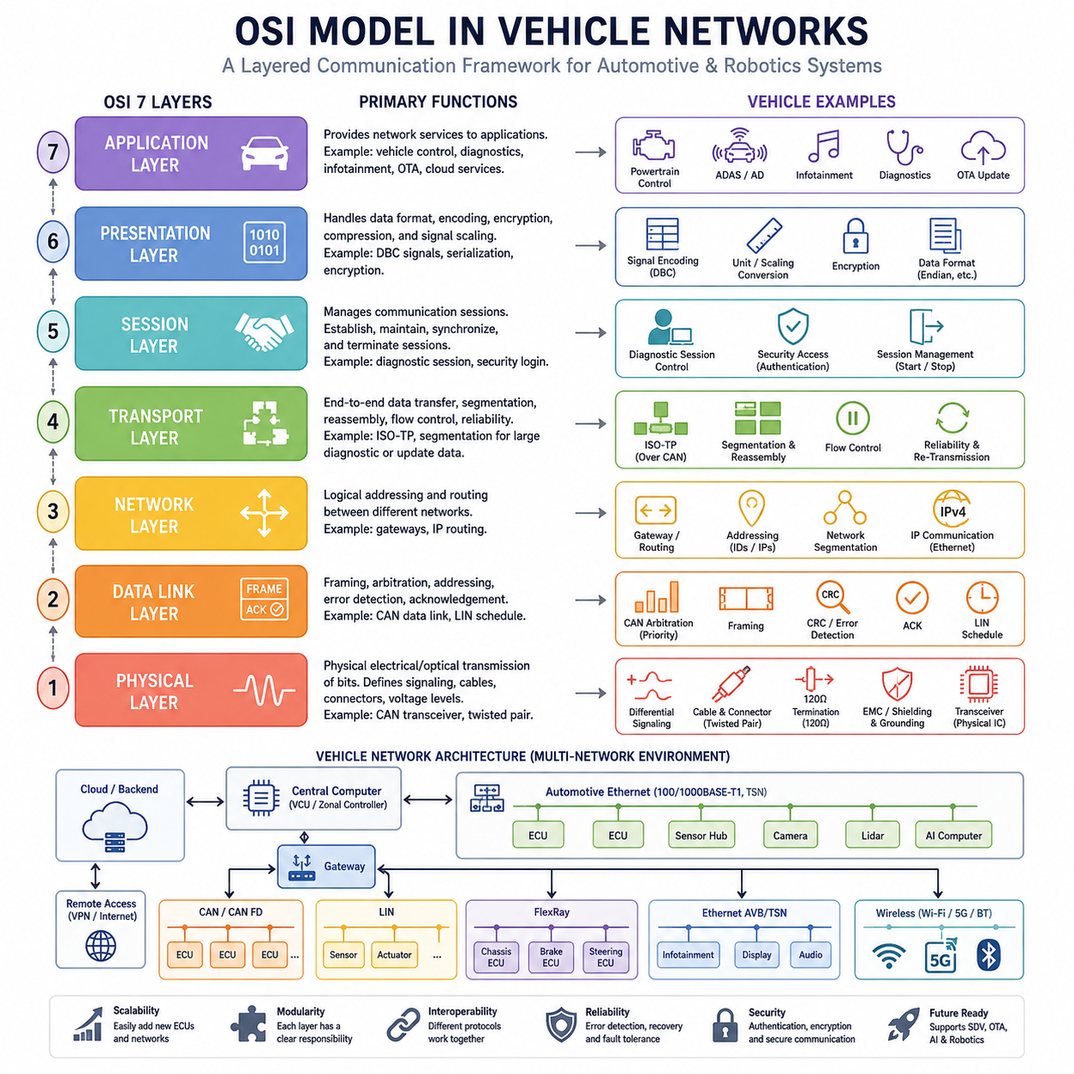
The Open Systems Interconnection (OSI) Model is one of the most fundamental concepts in communication engineering and serves as a universal framework for understanding how information is exchanged between electronic systems. Although the OSI model was originally developed by the International Organization for Standardization (ISO) as a generic networking reference architecture, its principles have become deeply embedded in automotive communication systems. Modern vehicles, autonomous mobile robots (AMRs), industrial vehicles, agricultural machines, mining equipment, humanoid robots, and future Physical AI platforms all rely on communication networks that can be analyzed and designed using the layered approach defined by the OSI model. In automotive engineering, understanding the OSI model is not merely an academic exercise. It provides engineers with a structured methodology for designing, troubleshooting, validating, and scaling communication systems across increasingly complex electronic architectures.
A modern vehicle may contain dozens or even hundreds of Electronic Control Units (ECUs). These ECUs must communicate reliably to coordinate powertrain control, braking systems, steering systems, battery management, body electronics, infotainment systems, advanced driver assistance systems, autonomous driving functions, diagnostics, and over-the-air updates. As vehicles evolve toward software-defined architectures, the communication infrastructure becomes as important as the mechanical design itself. The OSI model offers a conceptual framework that separates communication functions into manageable layers, allowing engineers to focus on specific technical problems without needing to understand every detail of the entire communication stack.
The OSI model consists of seven layers: Physical Layer, Data Link Layer, Network Layer, Transport Layer, Session Layer, Presentation Layer, and Application Layer. Each layer performs a distinct function and communicates with the layers directly above and below it. While not every automotive protocol explicitly implements all seven layers, the OSI model remains an invaluable analytical tool for understanding how automotive networks operate.
The Physical Layer forms the foundation of all communication systems. It defines how bits are transmitted across physical media. In vehicle networks, the Physical Layer includes cables, connectors, transceivers, voltage levels, signal timing, electromagnetic compatibility requirements, and termination schemes. When engineers design a CAN network, for example, they must determine cable impedance, wire gauge, maximum bus length, connector specifications, shielding requirements, and termination resistor placement. These decisions all belong to the Physical Layer.
Within an automotive environment, the Physical Layer faces unique challenges. Vehicles operate in electrically noisy environments containing motors, ignition systems, switching power converters, inverters, battery chargers, and high-current actuators. Electromagnetic interference can significantly affect communication reliability if the physical network is not designed properly. Consequently, automotive communication standards place strong emphasis on differential signaling techniques, cable routing strategies, grounding schemes, shielding methodologies, and termination design.
The CAN bus provides an excellent example of Physical Layer engineering. CAN High and CAN Low lines transmit differential signals that improve immunity to common-mode noise. Termination resistors placed at both ends of the bus maintain signal integrity and minimize reflections. The success of CAN in automotive applications is largely attributable to the robustness of its Physical Layer implementation.
Above the Physical Layer resides the Data Link Layer. This layer defines how devices share access to the communication medium and how data is packaged into frames. The Data Link Layer is responsible for error detection, arbitration, addressing mechanisms, acknowledgment procedures, and frame formatting.
In CAN networks, the Data Link Layer performs one of the most innovative arbitration mechanisms ever developed for distributed control systems. Multiple ECUs may attempt to transmit simultaneously. Instead of causing destructive collisions, CAN uses a priority-based arbitration process where the message with the highest priority continues transmission while lower-priority nodes automatically defer their communication. This approach ensures deterministic behavior and efficient bandwidth utilization.
The Data Link Layer also incorporates error detection mechanisms such as Cyclic Redundancy Check (CRC), frame checks, acknowledgment bits, bit monitoring, and error confinement algorithms. These mechanisms enable communication systems to detect and isolate faults while maintaining overall network stability.
In LIN networks, the Data Link Layer operates differently. LIN employs a master-slave architecture in which a single master node controls communication timing and scheduling. This simplifies implementation and reduces hardware cost but sacrifices some flexibility compared to CAN. The LIN Data Link Layer is optimized for low-cost body electronics applications such as seat controls, window lifters, mirror adjustments, and climate control subsystems.
The Network Layer is responsible for routing information between different network segments. Traditional automotive networks historically had limited use for the Network Layer because most communication occurred within a single bus domain. However, the rise of centralized computing architectures and automotive Ethernet has significantly increased the importance of routing functionality.
Modern vehicles frequently contain multiple CAN networks, LIN clusters, Ethernet domains, FlexRay segments, and wireless communication interfaces. Gateways act as routing devices that transfer messages between these domains. The Network Layer provides mechanisms for addressing, path selection, packet forwarding, and logical segmentation.
In autonomous vehicles and advanced robotics platforms, the Network Layer becomes increasingly important because communication may span multiple computational domains. Sensor processing units, AI accelerators, motion controllers, cloud interfaces, and remote diagnostics systems may all exchange information through interconnected network infrastructures. As a result, IP-based communication architectures are becoming more prevalent.
The Transport Layer provides end-to-end communication management. Its responsibilities include segmentation, reassembly, flow control, retransmission management, and communication reliability. While traditional CAN communication often bypasses a dedicated Transport Layer for small messages, many diagnostic and software update applications require Transport Layer functionality.
For example, Unified Diagnostic Services (UDS) frequently transfers data larger than a single CAN frame can accommodate. Since classical CAN supports only eight bytes of payload per frame, large diagnostic messages must be divided into multiple segments. Protocols such as ISO-TP handle this segmentation and reassembly process, effectively implementing Transport Layer functionality.
With CAN FD and Automotive Ethernet, larger payload sizes have become available, but Transport Layer services remain essential for software downloads, firmware updates, calibration transfers, and diagnostic operations. In software-defined vehicles, Transport Layer performance increasingly influences system responsiveness and update efficiency.
The Session Layer manages communication sessions between systems. It establishes, maintains, synchronizes, and terminates communication exchanges. While the Session Layer is often less visible in traditional automotive networks, it becomes increasingly relevant in diagnostic systems, remote connectivity platforms, cloud-based services, and OTA update frameworks.
For example, a diagnostic tester connecting to a vehicle must establish a communication session before requesting ECU data. Security access procedures, authentication sequences, and diagnostic session control services can be viewed as Session Layer activities. These mechanisms ensure that communication occurs within defined operational contexts and security boundaries.
The Presentation Layer is responsible for data representation, encoding, formatting, compression, and encryption. Its purpose is to ensure that communicating systems interpret exchanged information consistently. In automotive communication systems, Presentation Layer functionality often appears in data serialization formats, signal encoding standards, encryption frameworks, and diagnostic message representations.
Consider a vehicle speed signal transmitted between ECUs. The actual numerical value may be encoded using specific scaling factors, offsets, byte ordering conventions, and unit definitions. Signal databases such as DBC files define these representations. Without standardized encoding rules, different ECUs might interpret identical binary data differently, leading to operational failures.
Cybersecurity technologies further highlight the role of the Presentation Layer. Encryption algorithms, certificate management systems, secure communication protocols, and authentication frameworks all rely on data transformation mechanisms that align with Presentation Layer responsibilities.
At the top of the OSI architecture resides the Application Layer. This layer contains the actual services and functions used by end applications. In automotive systems, Application Layer functions include engine control, battery management, braking commands, steering requests, diagnostics, infotainment services, navigation functions, fleet management services, and autonomous driving algorithms.
When an autonomous driving controller requests steering torque, that command originates at the Application Layer. When a battery management system reports state-of-charge information, that communication is generated at the Application Layer. The lower layers simply provide mechanisms for transporting this information reliably and efficiently.
One of the greatest strengths of the OSI model is abstraction. Engineers can solve problems at one layer without needing to redesign the entire system. A Physical Layer issue involving cable impedance can be addressed independently of Application Layer software. Similarly, cybersecurity improvements at higher layers can often be implemented without changing physical wiring infrastructure.
The OSI model also facilitates protocol comparison. LIN, CAN, CAN FD, CAN XL, FlexRay, Automotive Ethernet, and future communication technologies can all be analyzed according to how they implement various OSI layers. This common framework enables engineers to evaluate tradeoffs involving bandwidth, latency, determinism, complexity, cost, scalability, and reliability.
As automotive architectures evolve toward zonal and centralized computing designs, Ethernet-based communication systems are increasingly replacing traditional bus technologies. In these architectures, the OSI model becomes even more relevant because Ethernet, TCP/IP, TSN, AVB, DoIP, and cloud connectivity protocols naturally align with layered communication concepts.
The same trend is visible in robotics and Physical AI systems. Modern AMRs, mobile manipulators, humanoid robots, quadrupeds, and cargo UAV platforms increasingly integrate heterogeneous communication technologies. Low-level motor control may use CAN FD. Sensor synchronization may use Ethernet TSN. Fleet communication may utilize MQTT. Cloud interfaces may employ REST APIs or gRPC. Despite these differences, all communication flows can be analyzed using the OSI framework.
For Hills Robotics platforms, the OSI model provides a common engineering language across Indoor AMRs, Outdoor Autonomous Vehicles, Mobile Manipulators, Quadruped Robots, Humanoid Systems, and future Cargo UAV architectures. Engineers responsible for electrical systems, communication protocols, embedded software, AI computing platforms, cybersecurity, diagnostics, and cloud infrastructure can use the OSI model to understand how their subsystems interact within a unified communication architecture. This layered approach simplifies integration, accelerates troubleshooting, improves maintainability, and supports long-term scalability as robotic systems continue to evolve toward highly connected, software-defined, and AI-driven mobility platforms. The OSI model therefore remains one of the most important conceptual foundations in vehicle networking and serves as the starting point for understanding every communication protocol discussed throughout this volume.

1.2 Bus Topology Types
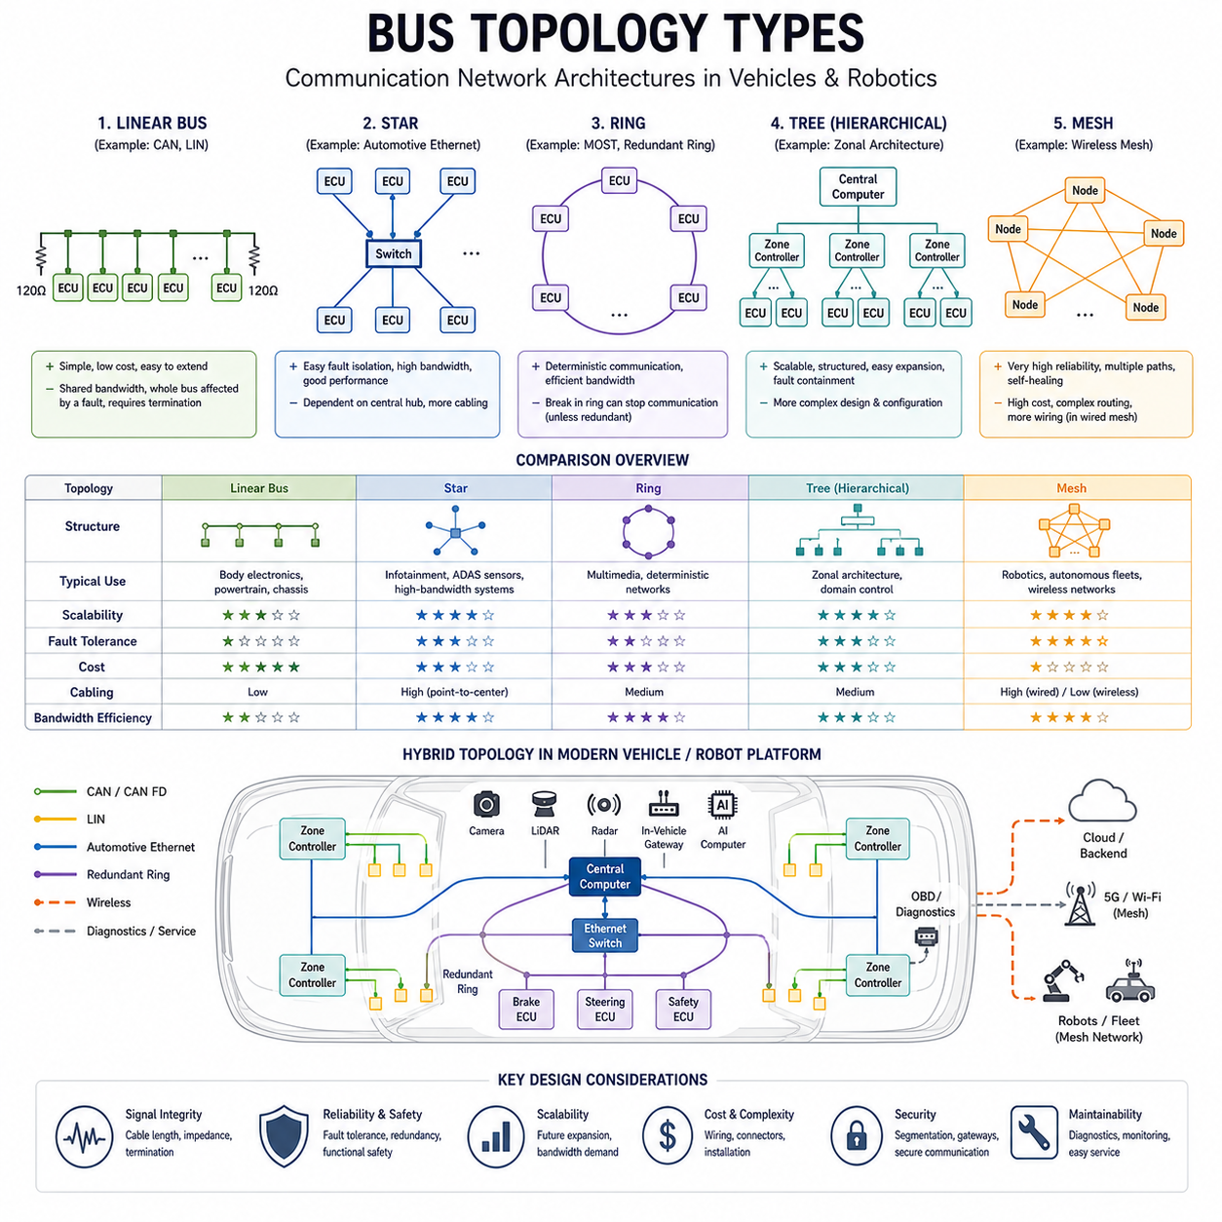
Bus topology is one of the most fundamental concepts in communication network design and serves as the structural foundation upon which all vehicle communication systems are built. Regardless of whether a system uses LIN, CAN, CAN FD, CAN XL, FlexRay, Automotive Ethernet, EtherCAT, or future software-defined communication architectures, the physical arrangement of devices and communication channels significantly influences network performance, reliability, scalability, cost, and maintainability. In automotive engineering, selecting an appropriate bus topology is often as important as selecting the communication protocol itself because the topology determines how electronic control units exchange information, how failures propagate through the system, and how future expansion can be accommodated.
As modern vehicles evolve into distributed computing platforms containing dozens or hundreds of ECUs, sensors, actuators, AI accelerators, and communication gateways, topology selection becomes a major architectural decision. The same principles apply to autonomous mobile robots, industrial robots, mobile manipulators, quadrupeds, humanoids, outdoor autonomous vehicles, and future cargo UAV platforms. Every network architecture must balance performance, fault tolerance, wiring complexity, electromagnetic compatibility, and manufacturing cost.
A bus topology defines the physical and logical arrangement of nodes connected within a communication network. The topology determines how devices are interconnected and how information travels between them. While many communication protocols can theoretically operate over multiple topologies, practical engineering constraints often make certain topologies significantly more effective than others.
Historically, the earliest vehicle communication systems relied on point-to-point wiring. In this architecture, each electronic device was connected directly to every device with which it needed to communicate. While conceptually simple, this approach became increasingly impractical as vehicle functionality expanded. As more ECUs were added, wiring complexity grew exponentially, resulting in increased vehicle weight, larger harnesses, higher manufacturing costs, reduced reliability, and greater difficulty in troubleshooting.
The introduction of network communication fundamentally changed vehicle architecture. Instead of requiring dedicated wiring between every pair of devices, multiple ECUs could share a common communication medium. This dramatically reduced wiring complexity while improving flexibility and enabling more sophisticated electronic functions.
The most widely recognized topology in automotive communication is the linear bus topology. In a linear bus architecture, all nodes connect to a common communication backbone. Messages transmitted by one node propagate along the bus and are received by every node. Individual ECUs determine whether a message is relevant by examining identifiers contained within the communication frame.
CAN is the most prominent example of a protocol utilizing linear bus topology. In a CAN network, all ECUs connect to a pair of communication wires known as CAN High and CAN Low. Messages travel throughout the entire network, and each ECU independently decides whether to process or ignore specific frames.
Linear bus topology offers several significant advantages. Wiring requirements are relatively low because only a single communication backbone is required. New nodes can often be added with minimal modifications. Communication latency remains predictable because all nodes share the same medium. Cost is generally lower than more complex topologies due to reduced cable length and simplified installation.
However, linear bus topology also introduces limitations. Since all nodes share a common communication channel, bandwidth must be shared among all participants. As network traffic increases, bus utilization rises and communication delays may become more significant. Faults affecting the main bus can potentially disrupt communication throughout the network. Proper termination design is essential to maintain signal integrity and prevent reflections.
Termination resistors play a critical role in linear bus architectures. At high communication speeds, signal reflections can cause data corruption and communication instability. By matching cable impedance through appropriate termination resistance, signal quality can be preserved across the entire network.
Another common topology is the star topology. In a star network, every node connects directly to a central communication hub, switch, or controller. Communication between two devices passes through this central point rather than traveling directly between endpoints.
Automotive Ethernet frequently employs star topology. Ethernet switches act as central communication hubs connecting cameras, LiDAR sensors, radar systems, AI computers, infotainment controllers, zonal controllers, and gateways. As vehicle architectures increasingly transition toward centralized computing platforms, star topology has become more important than ever.
The primary advantage of star topology is fault isolation. A failure affecting one communication link generally impacts only the associated node rather than the entire network. Diagnostic procedures become easier because individual communication channels can be monitored independently. Network performance can also improve because dedicated communication paths reduce contention among devices.
Star topology supports high bandwidth applications particularly well. Modern autonomous vehicles generate enormous amounts of sensor data from cameras, LiDAR systems, radar sensors, ultrasonic sensors, GNSS receivers, and high-definition mapping systems. Ethernet-based star networks provide the scalability required to support these data-intensive workloads.
The primary disadvantage of star topology is dependence on the central hub. If the central switch or controller fails, communication across the entire network may be disrupted. Wiring complexity may also increase because each node requires a dedicated connection to the central device. This can result in higher material costs and increased installation effort.
Ring topology represents another important communication architecture. In a ring network, each node connects to two neighboring nodes, forming a closed communication loop. Messages travel around the ring until they reach their intended destination.
Historically, the MOST protocol used ring topology extensively within automotive infotainment systems. Optical fiber rings enabled high-bandwidth transmission of multimedia content among audio amplifiers, displays, navigation systems, CD players, DVD players, and entertainment controllers.
Ring topology provides deterministic communication behavior because message transmission follows a predefined path. Bandwidth utilization can be highly efficient, and communication scheduling may be tightly controlled. However, ring architectures are generally more vulnerable to cable failures. A single break in the communication loop can potentially interrupt network operation unless redundancy mechanisms are implemented.
Modern industrial Ethernet protocols sometimes incorporate redundant ring topologies to improve fault tolerance. If a cable failure occurs, communication traffic can automatically reroute through alternative paths, maintaining operational continuity.
Tree topology combines characteristics of both bus and star architectures. A tree network consists of hierarchical branches extending from a central root node. Subnetworks connect to higher-level aggregation points, creating a structured communication hierarchy.
Many modern vehicle architectures increasingly resemble tree topologies. Central computing platforms connect to zonal controllers, which in turn connect to local ECUs, sensors, and actuators. This hierarchical organization simplifies wiring distribution and supports modular system design.
The rise of zonal vehicle architectures has accelerated adoption of tree-based network structures. Instead of distributing ECUs throughout the vehicle according to function, zonal architectures organize devices according to physical location. Front, rear, left, right, and central zones each contain dedicated controllers responsible for local communication and resource management.
Tree topology supports scalability exceptionally well. Additional branches can be added without fundamentally redesigning the network. Fault containment improves because problems may remain localized within individual branches. Maintenance procedures become more manageable due to the structured organization of communication resources.
Mesh topology represents one of the most robust communication architectures available. In a mesh network, nodes maintain multiple communication paths to other devices. Full mesh implementations provide direct connectivity between every pair of nodes, while partial mesh architectures establish redundant connections only where necessary.
Mesh networks offer exceptional fault tolerance because communication can continue even when multiple links fail. Alternative routes allow data to bypass damaged or unavailable network segments. This characteristic makes mesh topology attractive for safety-critical systems and military applications.
Despite its robustness, mesh topology is rarely implemented fully within automotive environments due to excessive wiring complexity, increased cost, and greater management overhead. However, elements of mesh networking appear in wireless communication systems, autonomous vehicle fleets, industrial robotics networks, and future distributed AI infrastructures.
Hybrid topology combines multiple topology types within a single network architecture. Most modern vehicles employ hybrid topologies because no single topology can satisfy all communication requirements simultaneously.
A typical software-defined vehicle may use CAN bus topology for body electronics, LIN bus topology for low-cost sensors and actuators, Ethernet star topology for high-bandwidth perception systems, ring-based redundancy mechanisms for critical subsystems, and wireless mesh connectivity for cloud communication and fleet coordination. These diverse networks interact through gateways and centralized computing platforms.
Hybrid topology enables engineers to optimize communication architecture according to subsystem requirements. Low-cost functions can utilize inexpensive bus structures, while high-performance systems benefit from dedicated Ethernet connections. Safety-critical applications may incorporate redundancy mechanisms unavailable in simpler architectures.
From a signal integrity perspective, topology selection directly affects communication reliability. Bus length, branch length, node spacing, cable impedance, connector placement, termination design, and electromagnetic compatibility must all be considered. As communication speeds increase from LIN's tens of kilobits per second to multi-gigabit Automotive Ethernet, topology constraints become increasingly important.
CAN networks, for example, impose strict limitations on stub lengths because excessive branch connections can create signal reflections. Automotive Ethernet requires controlled impedance cabling and carefully designed switching infrastructure. Time-sensitive networking systems depend on precise synchronization mechanisms that may be influenced by network topology.
Safety considerations further influence topology selection. Functional safety standards such as ISO 26262 increasingly require fault containment, redundancy, and diagnostic coverage. Topologies supporting fault isolation and graceful degradation often provide advantages in safety-critical applications such as braking systems, steering systems, autonomous driving functions, and drive-by-wire architectures.
Cybersecurity architecture is similarly affected by topology design. Segmentation, gateway placement, intrusion detection systems, firewalls, and secure communication domains all depend on network structure. Star and tree architectures often simplify security management because traffic flows through well-defined control points.
The transition toward software-defined vehicles and AI-native robotic platforms is reshaping topology design principles. Traditional distributed ECU architectures are giving way to centralized and zonal computing systems connected through high-speed Ethernet backbones. In these architectures, communication topology becomes closely integrated with computing architecture, power distribution architecture, functional safety architecture, and cybersecurity architecture.
For Hills Robotics platforms, including Indoor AMRs, Outdoor Autonomous Vehicles, Inspection Robots, Mobile Manipulators, Quadruped Robots, Humanoid Systems, and future Cargo UAVs, topology selection must be driven by system requirements rather than protocol popularity alone. Low-level motor control networks may employ CAN FD linear bus architectures. Safety systems may incorporate redundant communication channels. High-bandwidth perception systems may rely on Ethernet star topologies. Fleet coordination systems may utilize wireless mesh communication. Centralized AI computing platforms may adopt hierarchical tree architectures based on zonal principles.
Understanding bus topology types therefore provides the foundation for designing scalable, reliable, maintainable, and future-ready communication systems. Before selecting a communication protocol, engineers must first understand how devices should be interconnected. The topology ultimately determines how efficiently information flows through the vehicle, how faults are managed, how systems scale over time, and how future generations of intelligent mobility platforms will be constructed. Bus topology is therefore not merely a wiring arrangement; it is a core architectural decision that influences every aspect of vehicle communication system performance and evolution.

1.3 Signal Integrity Basics
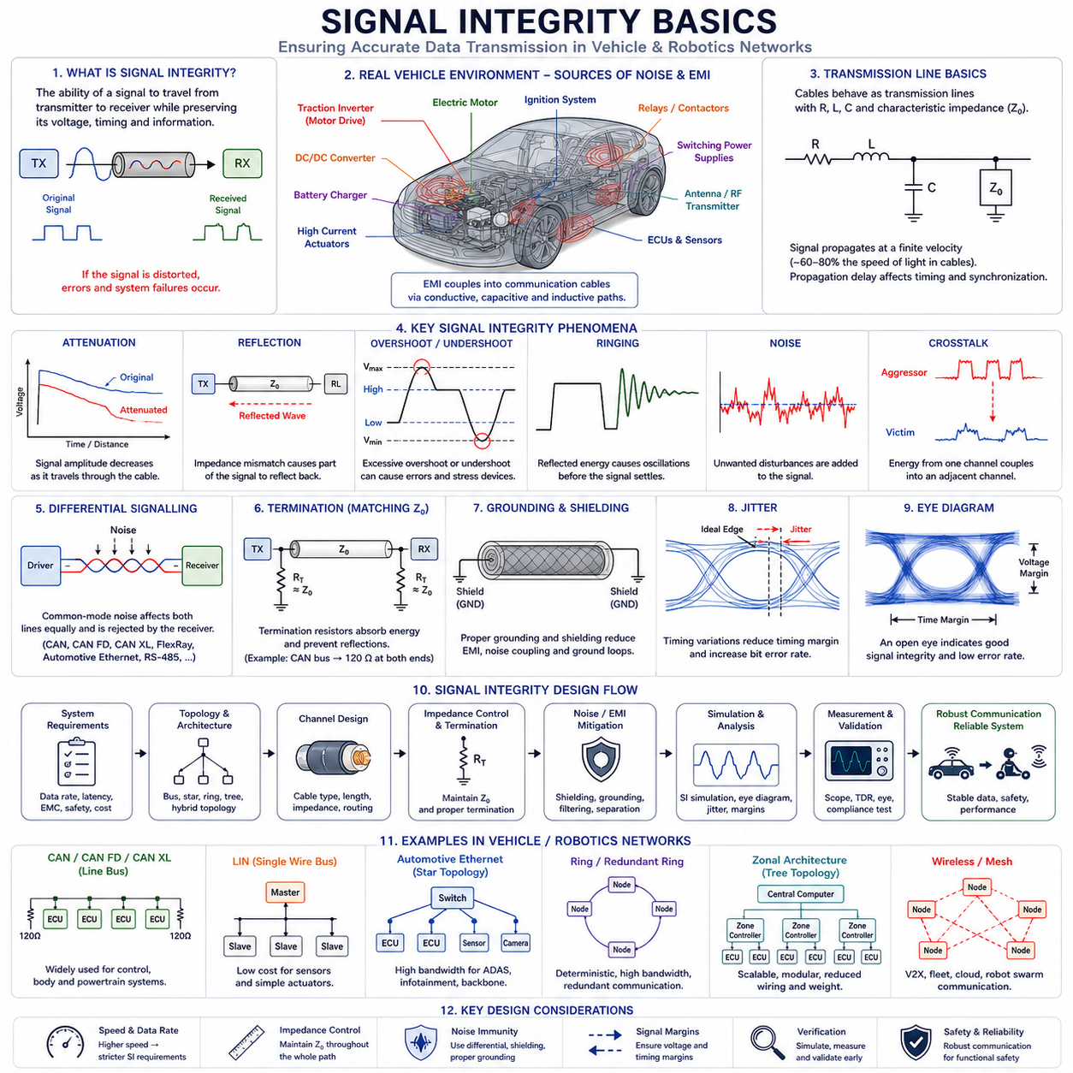
Signal integrity is one of the most important yet frequently underestimated disciplines in modern vehicle communication engineering. As automotive systems evolve from simple distributed control networks into highly connected, software-defined computing platforms, the reliability of communication signals becomes increasingly critical. Every electronic control unit, sensor, actuator, gateway, central computer, autonomous driving controller, battery management system, radar, LiDAR, camera, and cloud connectivity module depends on the accurate transmission of digital information. Regardless of how sophisticated a communication protocol may be, if the electrical signals carrying that information become distorted, corrupted, delayed, or lost, the entire system can suffer degraded performance or even catastrophic failure.
Signal integrity refers to the ability of an electrical signal to travel from a transmitter to a receiver while preserving its intended shape, timing, amplitude, and information content. In an ideal world, a digital signal would transition instantly between logic levels, maintain perfect voltage amplitudes, and arrive at its destination without distortion. In reality, physical communication channels introduce numerous imperfections that alter signal behavior. Understanding these imperfections and designing systems to mitigate them is the foundation of signal integrity engineering.
In automotive communication systems, signal integrity becomes particularly challenging because vehicles operate in electrically hostile environments. Electric motors, traction inverters, DC/DC converters, switching power supplies, battery chargers, ignition systems, high-current actuators, and wireless transmitters all generate electromagnetic disturbances that can interfere with communication networks. At the same time, modern vehicles increasingly rely on high-speed communication technologies such as CAN FD, CAN XL, Automotive Ethernet, FlexRay, and high-bandwidth sensor interfaces. As communication speeds increase, signal integrity concerns become more significant because even small electrical imperfections can produce substantial communication errors.
A useful way to understand signal integrity is to consider the communication channel as more than just a wire. At low frequencies, engineers often think of wires as ideal conductors. However, at higher communication speeds, every cable behaves as a transmission line possessing resistance, inductance, capacitance, and characteristic impedance. These electrical properties influence how signals propagate and determine whether information arrives correctly at the receiving device.
One of the most fundamental concepts in signal integrity is signal propagation. Electrical signals do not travel instantaneously through a cable. Instead, they propagate at a finite velocity determined by the dielectric properties of the cable insulation. In many automotive communication cables, signal propagation occurs at approximately sixty to eighty percent of the speed of light. While these delays may appear negligible, they become significant in high-speed communication systems where timing margins are measured in nanoseconds.
As signal propagation delays increase, communication engineers must carefully consider synchronization, timing budgets, arbitration mechanisms, and protocol behavior. In CAN networks, propagation delays influence bit timing calculations. In Automotive Ethernet systems, propagation delays affect synchronization accuracy and Time Sensitive Networking performance. In autonomous driving systems utilizing multiple synchronized sensors, propagation delay management becomes a critical design consideration.
Another fundamental signal integrity issue is attenuation. As signals travel through cables, energy is gradually lost due to conductor resistance, dielectric losses, connector imperfections, and electromagnetic radiation. This reduction in signal amplitude is known as attenuation. Excessive attenuation can make it difficult for receivers to distinguish between logical ones and zeros, leading to communication errors.
Attenuation generally increases with cable length and communication frequency. High-frequency signal components experience greater losses than low-frequency components. This phenomenon causes signal edges to become less sharp as they travel through the communication channel. As a result, digital waveforms gradually lose their ideal rectangular shape and become increasingly rounded.
The degradation of signal edges directly affects communication reliability because digital systems depend on precise threshold detection. When signal transitions become too slow, timing uncertainty increases and receiver interpretation becomes less predictable. This problem becomes especially important in high-speed Automotive Ethernet networks operating at hundreds of megabits or gigabits per second.
One of the most important signal integrity concepts is impedance. Every transmission line possesses a characteristic impedance determined by its geometry and material properties. Characteristic impedance represents the relationship between voltage and current for signals propagating along the cable.
When signal paths maintain consistent impedance, signals travel smoothly from source to destination. Problems arise when impedance discontinuities occur. Connectors, branch connections, improperly designed PCB traces, damaged cables, or incorrect terminations can all create impedance mismatches. These mismatches cause a portion of the signal energy to be reflected back toward the transmitter.
Signal reflections represent one of the most common causes of communication instability. Reflected signals combine with the original waveform, producing overshoot, undershoot, ringing, and waveform distortion. In severe cases, reflections can cause receivers to misinterpret data bits, resulting in communication errors and network instability.
Termination resistors are used to minimize reflections by matching cable impedance. CAN networks provide a classic example. Standard CAN communication typically employs two 120-ohm termination resistors located at opposite ends of the bus. These resistors match the characteristic impedance of the communication cable and absorb signal energy that would otherwise be reflected.
Proper termination design becomes increasingly important as communication speed increases. Networks operating at low data rates may tolerate imperfect termination, but high-speed communication systems often require carefully engineered impedance matching throughout the entire signal path.
Overshoot and undershoot are additional signal integrity phenomena that frequently occur in high-speed communication systems. Overshoot occurs when signal voltage temporarily exceeds its intended value during transitions. Undershoot occurs when voltage drops below the intended level. These effects are often caused by transmission line reflections, inductive switching behavior, or impedance mismatches.
Excessive overshoot can stress semiconductor devices and reduce long-term reliability. Excessive undershoot may cause unintended logic state changes or trigger protective circuitry. Engineers often use signal integrity simulations and oscilloscope measurements to evaluate these effects and ensure compliance with communication specifications.
Ringing represents another common waveform distortion mechanism. Ringing occurs when reflected energy repeatedly oscillates within a communication channel following a signal transition. Instead of settling quickly to the desired voltage level, the waveform exhibits multiple oscillations before stabilizing.
Ringing can significantly reduce noise margins and increase susceptibility to communication errors. In automotive environments, ringing often results from improper termination, excessive cable lengths, poorly designed PCB layouts, or inappropriate connector selection.
Noise is a pervasive challenge in signal integrity engineering. Electrical noise refers to unwanted disturbances superimposed upon communication signals. Noise sources may originate internally within the communication system or externally from surrounding equipment.
Common automotive noise sources include motor drivers, inverter switching circuits, ignition systems, DC/DC converters, battery chargers, relays, contactors, solenoids, and radio transmitters. These devices generate electromagnetic fields that can couple into communication wiring through conductive, capacitive, or inductive mechanisms.
Differential signaling is one of the most effective techniques for improving noise immunity. CAN, CAN FD, CAN XL, FlexRay, Automotive Ethernet, RS-485, and numerous industrial communication systems utilize differential signaling. Instead of transmitting information using a single voltage referenced to ground, differential systems encode information as the voltage difference between two conductors.
Because external noise tends to affect both conductors similarly, differential receivers can reject common-mode disturbances while preserving the intended signal. This characteristic significantly improves communication reliability in electrically noisy environments.
Electromagnetic interference, commonly abbreviated as EMI, represents a major concern in vehicle communication systems. EMI refers to electromagnetic energy emitted by one device that interferes with the operation of another device. As vehicles incorporate increasing numbers of high-power electronic systems, managing EMI becomes a critical engineering challenge.
Electric vehicle traction inverters are particularly significant EMI sources. Rapid switching of hundreds of amperes generates high-frequency electromagnetic emissions capable of affecting nearby communication networks. Consequently, communication cable routing, shielding design, grounding architecture, and connector selection must all consider EMI mitigation.
Cable shielding is frequently employed to reduce electromagnetic interference. Shielded cables surround communication conductors with conductive layers that block external electromagnetic fields. The effectiveness of shielding depends on material properties, termination methods, grounding strategy, and installation quality.
Grounding itself plays an essential role in signal integrity. Improper grounding can create ground loops, common-mode voltage differences, and noise coupling paths. Modern vehicle communication systems often utilize carefully engineered grounding architectures to minimize interference and maintain stable communication performance.
Crosstalk is another signal integrity challenge encountered in densely packed wiring harnesses and printed circuit boards. Crosstalk occurs when electromagnetic energy from one communication channel couples into an adjacent channel. As communication frequencies increase and wiring density grows, crosstalk becomes increasingly significant.
Automotive Ethernet systems operating at gigabit speeds are particularly sensitive to crosstalk effects. Engineers mitigate crosstalk through cable spacing, shielding, twisted-pair construction, differential signaling, controlled impedance routing, and proper connector design.
Jitter is an important timing-related signal integrity phenomenon. Jitter refers to variations in the timing of signal transitions relative to their expected positions. Excessive jitter can reduce timing margins and increase bit error rates. Sources of jitter include noise, power supply instability, clock inaccuracies, transmission line effects, and electromagnetic interference.
High-speed communication protocols impose strict jitter requirements to ensure reliable operation. Automotive Ethernet, camera interfaces, radar networks, and sensor synchronization systems often require detailed jitter analysis during system validation.
Eye diagrams provide one of the most widely used methods for evaluating signal integrity. An eye diagram overlays many signal transitions on a single display, creating a pattern resembling an eye. The size and shape of the eye opening provide valuable information regarding noise margins, timing margins, jitter, attenuation, and overall communication quality.
A wide-open eye indicates strong signal integrity and reliable communication performance. A partially closed eye suggests increasing signal degradation and reduced communication robustness. Engineers frequently use eye diagrams during validation testing of Automotive Ethernet networks and other high-speed communication systems.
Simulation tools play a major role in modern signal integrity engineering. Before physical hardware is built, engineers often perform transmission line analysis, electromagnetic simulations, impedance modeling, and signal integrity verification using specialized software tools. These simulations help identify potential problems early in the design process and reduce costly redesign efforts.
In autonomous vehicles and advanced robotics platforms, signal integrity extends beyond traditional communication networks. Camera interfaces, LiDAR data channels, radar links, GPU interconnects, memory buses, sensor synchronization networks, and AI computing architectures all require rigorous signal integrity management. As data rates continue increasing, signal integrity engineering becomes increasingly intertwined with system architecture decisions.
For Hills Robotics platforms, including Indoor AMRs, Outdoor Autonomous Vehicles, Inspection Robots, Mobile Manipulators, Quadruped Robots, Humanoid Systems, and Cargo UAV platforms, signal integrity should be treated as a system-level engineering discipline rather than a component-level concern. Communication protocols such as CAN FD, Automotive Ethernet, EtherCAT, TSN, sensor interfaces, and AI computing networks all depend upon robust signal integrity foundations.
Ultimately, signal integrity is the science of ensuring that digital information remains accurate as it travels through physical communication channels. It bridges the gap between theoretical communication protocols and real-world hardware implementation. Engineers who understand signal propagation, impedance control, reflections, attenuation, noise, EMI, crosstalk, jitter, and grounding principles are far better equipped to design reliable vehicle communication systems. As mobility platforms continue evolving toward software-defined architectures, centralized computing, AI-driven autonomy, and high-bandwidth sensor fusion, signal integrity will remain one of the most critical foundations of successful communication system design.

1.4 Termination Resistance Design
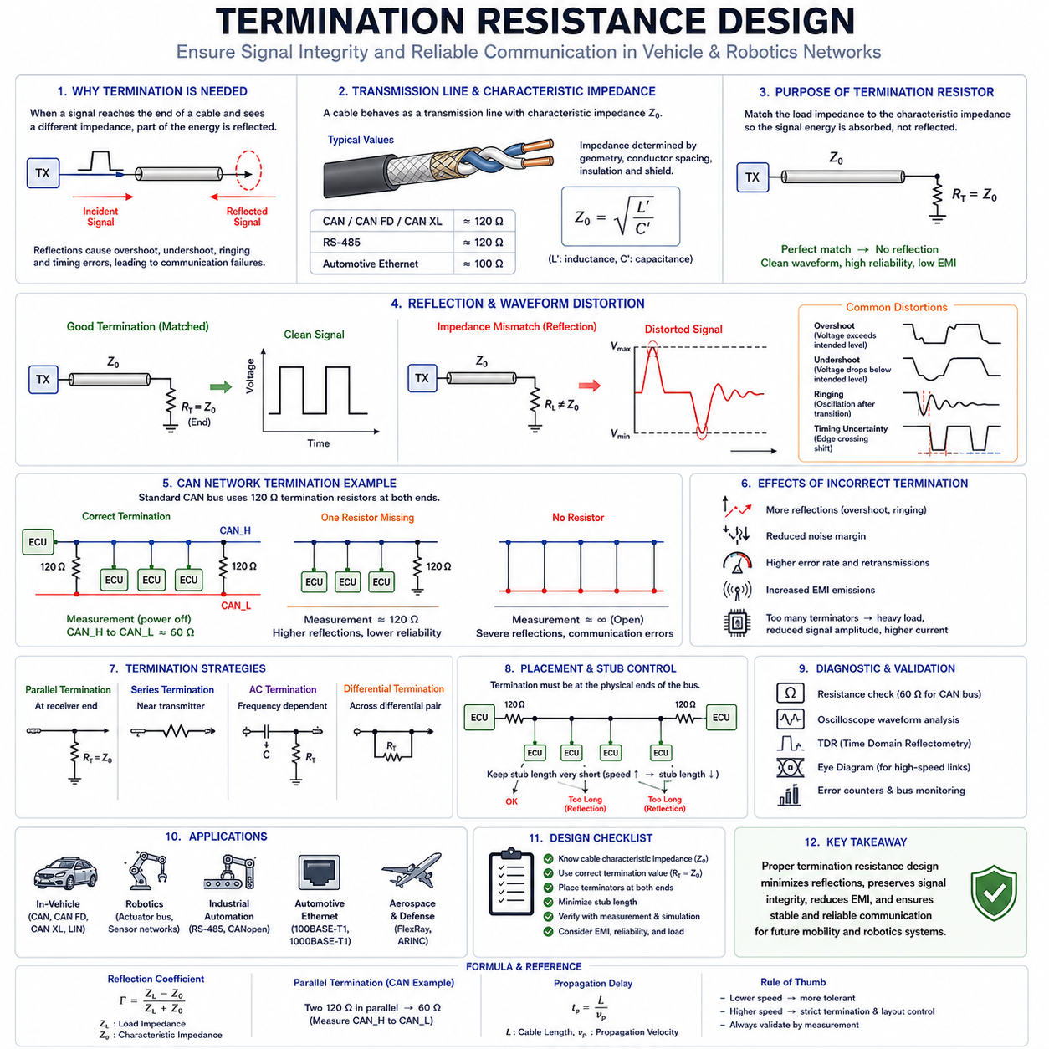
Termination resistance design is one of the most critical yet often misunderstood aspects of communication network engineering. In automotive communication systems, industrial automation networks, robotics platforms, autonomous vehicles, aerospace systems, and high-speed computing infrastructures, proper termination design directly determines signal quality, communication reliability, electromagnetic compatibility, and overall system robustness. While communication protocols such as CAN, CAN FD, CAN XL, FlexRay, Automotive Ethernet, EtherCAT, and RS-485 each have unique electrical characteristics, they all share a common challenge: preventing signal reflections caused by impedance discontinuities within transmission lines.
As communication speeds continue increasing, transmission line behavior becomes increasingly important. Engineers can no longer treat communication wires as simple electrical conductors. Instead, cables must be analyzed as transmission lines with characteristic impedance, propagation delay, distributed capacitance, distributed inductance, and frequency-dependent losses. Within this environment, termination resistance serves as a fundamental mechanism for controlling signal reflections and preserving waveform integrity.
To understand the purpose of termination resistance, it is first necessary to understand how signals propagate through a communication cable. When a transmitter sends a digital signal, the signal travels along the communication channel as an electromagnetic wave. This wave propagates through the cable at a finite velocity determined by the cable's dielectric properties. During propagation, the signal encounters connectors, branch connections, junction points, devices, and eventually the end of the transmission line.
If the electrical impedance at the end of the cable differs from the characteristic impedance of the transmission line, a portion of the signal energy is reflected back toward the transmitter. This reflected signal interferes with the original waveform and creates distortion. The severity of this distortion depends on the magnitude of the impedance mismatch and the communication speed.
At low communication speeds, signal reflections may not significantly affect operation because reflected energy dissipates before the next signal transition occurs. However, at higher speeds, reflections overlap with subsequent data bits and can cause severe communication errors. As modern vehicle communication systems increasingly utilize high-speed networks, reflection management has become a central design concern.
The characteristic impedance of a transmission line represents the ratio of voltage to current for a traveling electromagnetic wave. This impedance is determined by cable geometry, conductor spacing, conductor diameter, insulation material, and shielding structure. For most automotive CAN communication cables, characteristic impedance is approximately 120 ohms. Automotive Ethernet cables typically exhibit characteristic impedances around 100 ohms. RS-485 networks commonly use transmission lines near 120 ohms as well.
The primary objective of termination resistance is to match the impedance seen by the traveling signal to the characteristic impedance of the cable. When impedance matching is achieved, the signal energy is absorbed rather than reflected. The result is clean signal propagation with minimal waveform distortion.
The reflection coefficient is often used to quantify the severity of reflections. It is determined by comparing load impedance and characteristic impedance. A perfect impedance match produces a reflection coefficient of zero, meaning no reflection occurs. A complete mismatch produces a reflection coefficient approaching one, meaning nearly all signal energy is reflected.
Signal reflections manifest themselves in several observable waveform distortions. Overshoot occurs when reflected energy adds to the original signal and temporarily increases voltage beyond its intended level. Undershoot occurs when destructive interference causes voltage to drop below expected levels. Ringing appears as oscillatory behavior following signal transitions. Timing uncertainty increases because waveform crossings occur at unpredictable moments. Collectively, these effects degrade communication reliability and reduce system noise margins.
The most widely recognized example of termination resistance design is found in CAN networks. Classical CAN communication utilizes a differential bus architecture consisting of CAN High and CAN Low conductors. The communication backbone is terminated at both ends using 120-ohm resistors. These resistors match the characteristic impedance of the twisted-pair cable and absorb signal energy reaching the ends of the network.
The dual termination structure serves multiple purposes. First, it minimizes reflections by creating an impedance-matched load. Second, it establishes proper common-mode operating conditions for transceivers. Third, it contributes to electromagnetic compatibility performance by maintaining balanced signal behavior throughout the network.
In a correctly designed CAN network, two 120-ohm termination resistors connected in parallel create an effective network resistance of approximately 60 ohms when measured between CAN High and CAN Low with power removed. This measurement is commonly used during troubleshooting to verify proper termination installation.
If one termination resistor is missing, the measured resistance becomes approximately 120 ohms. Communication may still function under some conditions, particularly at lower speeds and shorter cable lengths, but reliability is significantly reduced. Reflections increase, noise margins decrease, and error rates rise.
If both termination resistors are absent, communication instability becomes severe. Signal reflections dominate waveform behavior, particularly at high bit rates. Under such conditions, intermittent communication failures often occur, especially in electrically noisy environments.
Excessive termination can also create problems. Installing additional termination resistors reduces overall network impedance below the intended value. This increases current demand on transceivers and may reduce signal amplitude. Although reflections may decrease, communication quality can still deteriorate because the transmitter must drive an excessively heavy load.
CAN FD introduces additional challenges because higher data rates increase sensitivity to signal integrity issues. Classical CAN commonly operates at speeds up to one megabit per second, whereas CAN FD may operate with data phases reaching several megabits per second. At these speeds, even relatively small impedance mismatches can generate significant reflections. Consequently, termination design becomes more critical, and cable routing practices must be more carefully controlled.
CAN XL further increases communication speed and bandwidth, making transmission line effects even more important. Engineers designing CAN XL networks must pay close attention to impedance continuity, connector design, PCB trace impedance, branch lengths, and termination placement.
RS-485 networks use similar termination principles. Because RS-485 also employs differential signaling and transmission-line behavior, termination resistors matching cable impedance are typically installed at both ends of the communication bus. Improper termination can produce communication errors, reduced operating distance, and increased susceptibility to electromagnetic interference.
Automotive Ethernet introduces a different set of considerations. Ethernet communication relies on point-to-point links rather than shared buses. Each link is individually terminated according to Ethernet physical layer requirements. Instead of simple discrete termination resistors located at cable ends, Ethernet transceivers incorporate sophisticated impedance matching networks designed to support high-frequency operation.
At gigabit communication speeds, impedance discontinuities become increasingly problematic. Connectors, PCB traces, cable transitions, and magnetics must all be carefully engineered to maintain impedance continuity. Even minor impedance mismatches can significantly degrade signal quality.
FlexRay networks also utilize termination strategies designed to minimize reflections. Because FlexRay supports deterministic communication for safety-critical applications, maintaining signal integrity is essential. Proper termination ensures predictable timing behavior and reliable data transmission throughout the network.
Termination design extends beyond communication cables into printed circuit boards. High-speed PCB traces behave as transmission lines whenever signal rise times become comparable to propagation delays. In such situations, termination techniques may be required directly on the PCB to preserve waveform quality.
Several termination strategies are commonly employed. Parallel termination places a resistor matching characteristic impedance at the receiver end of the transmission line. Series termination places a resistor near the transmitter output to control signal transitions and reduce reflections. AC termination combines resistors and capacitors to achieve frequency-dependent behavior. Differential termination places a resistor directly across differential conductors.
The optimal strategy depends upon communication protocol requirements, power consumption constraints, signal frequencies, and network architecture. Automotive communication systems frequently employ differential termination because differential signaling dominates modern vehicle networks.
Termination placement is equally important. Termination resistors must generally be located at the physical ends of the communication bus. Installing termination resistors at intermediate locations fails to absorb reflected energy effectively and can create additional impedance discontinuities.
Branch connections, often called stubs, introduce further challenges. A stub behaves as a secondary transmission line attached to the primary bus. Signals entering the stub may be reflected back into the main network, creating additional waveform distortion. Consequently, most communication standards impose limits on allowable stub lengths.
CAN network design guidelines frequently specify maximum stub lengths based on communication speed. As bit rates increase, permissible stub lengths decrease. High-speed CAN FD networks often require very short branch connections to maintain signal integrity.
Electromagnetic compatibility considerations are closely related to termination design. Improperly terminated networks often generate increased electromagnetic emissions because reflected energy produces higher-frequency waveform components. At the same time, communication networks experiencing reflections become more susceptible to externally generated interference.
Proper termination therefore contributes not only to communication reliability but also to EMC performance. Automotive manufacturers devote significant effort to optimizing termination design because communication failures and EMC failures often originate from the same underlying signal integrity issues.
Diagnostic engineers frequently evaluate termination integrity during troubleshooting. Resistance measurements, time-domain reflectometry, oscilloscope analysis, eye-diagram evaluation, and network error monitoring are commonly used techniques. A correctly terminated network generally exhibits clean waveform transitions, predictable timing behavior, and low communication error rates.
Time-domain reflectometry is particularly valuable because it allows engineers to identify impedance discontinuities and locate reflection sources within communication cables. By observing reflected wave behavior, faults such as damaged cables, poor connectors, missing terminators, or excessive stubs can be identified accurately.
Modern autonomous vehicles, advanced robotics systems, and AI-native mobility platforms increasingly rely on high-bandwidth communication architectures. Sensor fusion systems combine data from cameras, LiDARs, radars, IMUs, GNSS receivers, and numerous distributed computing nodes. As data rates continue increasing, termination design becomes increasingly critical to maintaining system performance.
For Hills Robotics platforms, including Indoor AMRs, Outdoor Autonomous Vehicles, Inspection Robots, Mobile Manipulators, Quadruped Robots, Humanoid Systems, and future Cargo UAV architectures, termination resistance should be considered a system-level design parameter rather than a simple hardware detail. CAN FD networks supporting motor control, safety communication, battery management systems, and distributed sensors depend upon proper termination. Automotive Ethernet backbones connecting AI computers, perception systems, and centralized controllers require rigorous impedance matching and transmission-line design practices.
Ultimately, termination resistance design represents the practical application of transmission-line theory to real-world communication systems. It ensures that electromagnetic energy propagates efficiently through communication channels without creating harmful reflections. By matching impedance, controlling waveform behavior, minimizing electromagnetic emissions, and preserving signal integrity, termination resistance serves as one of the foundational elements of reliable vehicle communication engineering. As communication bandwidth continues increasing across future software-defined vehicles, autonomous robots, and Physical AI systems, the importance of proper termination design will only continue to grow.

1.5 Network Load Calculation
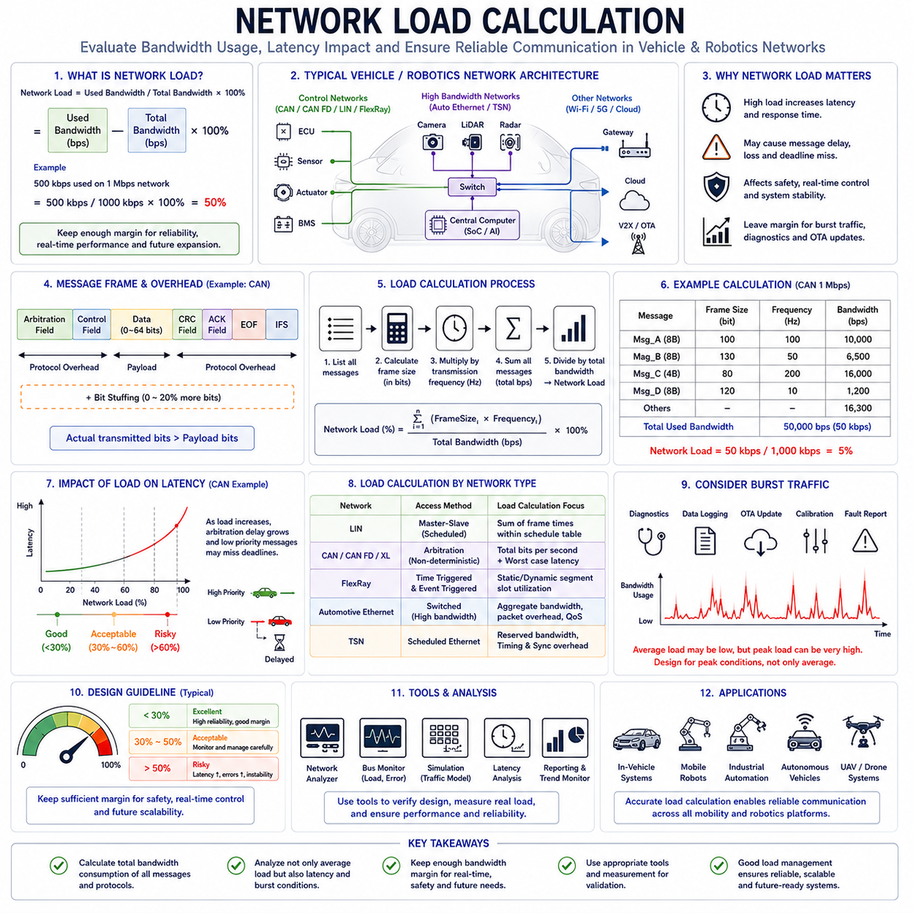
Network load calculation is one of the most important engineering activities in the design, validation, and optimization of vehicle communication systems. Regardless of whether a network uses LIN, CAN, CAN FD, CAN XL, FlexRay, Automotive Ethernet, EtherCAT, or Time Sensitive Networking (TSN), engineers must understand how much communication bandwidth is being consumed and how much capacity remains available for future expansion. A communication network that is overloaded can experience increased latency, missed deadlines, message loss, synchronization problems, and ultimately system failure. Conversely, a properly engineered network maintains sufficient bandwidth margins to ensure reliable operation under all expected conditions.
In modern vehicles and robotic systems, communication networks serve as the nervous system of the entire platform. Electronic Control Units (ECUs), sensors, actuators, battery management systems, autonomous driving controllers, safety systems, perception modules, cloud gateways, and central computing units continuously exchange data. Every message consumes a portion of the available communication bandwidth. As the number of devices increases and data rates grow, network load management becomes a critical architectural concern.
Network load refers to the percentage of available communication bandwidth currently occupied by data transmission. It represents the ratio between actual network usage and maximum theoretical network capacity. Understanding this relationship allows engineers to predict system performance, identify bottlenecks, and determine whether a communication architecture can support future functionality.
The simplest expression of network load can be described as the amount of bandwidth consumed divided by the total available bandwidth. If a communication network supports one megabit per second and the transmitted data occupies five hundred kilobits per second, the resulting network load is fifty percent. Although the concept appears simple, real-world vehicle networks contain numerous complexities that must be considered during accurate load calculations.
In automotive communication systems, network load directly affects message latency. When network utilization is low, messages can generally be transmitted immediately after becoming available. As network utilization increases, messages must wait for access to the communication medium. This waiting period increases transmission delay and reduces system responsiveness.
CAN networks provide a clear example of the relationship between network load and latency. CAN utilizes a priority-based arbitration mechanism that allows multiple ECUs to share a common communication bus. Under low network utilization, arbitration delays are minimal. However, as utilization approaches maximum capacity, lower-priority messages may experience substantial delays while higher-priority messages continue to dominate bus access.
This characteristic makes load calculation particularly important for real-time control systems. Critical functions such as braking, steering, stability control, motor control, and battery management often require deterministic communication timing. Excessive network load can compromise these timing requirements and negatively affect system safety.
To understand network load calculations, it is first necessary to understand message structure. Every communication frame consists of more than just application data. In addition to payload information, communication protocols include identifiers, control fields, cyclic redundancy checks, acknowledgment bits, synchronization fields, delimiters, and other protocol overhead.
For example, a CAN message containing eight bytes of application data actually occupies significantly more than sixty-four bits on the communication bus. The complete frame includes arbitration fields, control bits, CRC fields, acknowledgment bits, inter-frame spacing, and bit-stuffing overhead. Consequently, engineers must calculate total transmitted bits rather than considering payload size alone.
Bit stuffing represents an important consideration in CAN load calculations. CAN communication requires insertion of additional bits whenever specific bit patterns occur within the transmitted data stream. These inserted bits improve synchronization but increase actual bandwidth consumption. Depending on message content, bit stuffing may increase frame size by several percent.
A simplified CAN network load calculation begins by determining the size of each message frame in bits. This frame size is multiplied by the message transmission frequency to determine the total number of transmitted bits per second. Summing the bandwidth consumption of all messages provides total network utilization.
Consider a CAN network operating at one megabit per second. Suppose one ECU transmits a one-hundred-bit message every ten milliseconds. This message is transmitted one hundred times per second, resulting in ten thousand transmitted bits per second. If multiple ECUs generate additional traffic, the total network load becomes the sum of all transmitted bits divided by the available one million bits per second.
In practice, engineers often maintain network utilization below approximately thirty to fifty percent for safety-critical systems. Although CAN networks can technically operate at significantly higher loads, maintaining bandwidth margins improves robustness and accommodates unexpected communication events.
Automotive manufacturers frequently establish internal design guidelines specifying maximum allowable network utilization. These limits vary depending on application requirements, safety classifications, communication priorities, and future scalability considerations.
Network load calculations become more complex when multiple message priorities are involved. In CAN communication, high-priority messages may experience negligible delays even under heavy network utilization. Lower-priority messages, however, may encounter significant arbitration delays. Therefore, engineers must evaluate not only total utilization but also worst-case response times.
Worst-case response time analysis is particularly important for real-time systems. A network operating at sixty percent utilization may appear acceptable from a bandwidth perspective, yet specific low-priority messages could still experience unacceptable delays. Consequently, load analysis often includes latency analysis, schedulability analysis, and priority analysis.
CAN FD introduces additional considerations. Unlike Classical CAN, CAN FD allows higher data rates during the data transmission phase. The arbitration portion of the message may operate at one speed while the payload portion operates at a significantly higher speed. This dual-rate structure increases bandwidth efficiency and reduces network load for large messages.
Because larger payloads can be transmitted more efficiently, CAN FD often reduces overall network utilization compared to Classical CAN. Functions that previously required multiple CAN frames can frequently be transmitted within a single CAN FD frame. As a result, network designers can support more devices and larger datasets without increasing bus speed.
CAN XL extends this concept further by providing substantially larger payload capacities and higher communication rates. As vehicle architectures evolve toward centralized computing and software-defined operation, CAN XL enables efficient communication of increasingly complex data structures while maintaining manageable network utilization.
LIN networks employ a different communication model. Because LIN uses a master-slave architecture with deterministic scheduling, load calculations focus on schedule tables and frame timing rather than arbitration delays. Engineers calculate the total communication time required by all scheduled frames and compare it against the available schedule period.
The deterministic nature of LIN simplifies load analysis but imposes limitations on scalability. As additional devices and messages are added, schedule tables become longer, reducing system responsiveness and increasing communication latency.
FlexRay networks introduce time-triggered communication mechanisms that provide deterministic bandwidth allocation. Network load calculations within FlexRay systems involve static segments, dynamic segments, cycle timing, slot allocation, and communication scheduling. Because bandwidth can be reserved for specific functions, FlexRay enables predictable performance even under heavy utilization.
Automotive Ethernet fundamentally changes the nature of network load analysis. Ethernet networks provide significantly higher bandwidth than traditional fieldbus technologies. Communication speeds ranging from one hundred megabits per second to multiple gigabits per second dramatically increase available capacity.
However, higher bandwidth does not eliminate the need for load calculations. Camera streams, LiDAR point clouds, radar data, high-definition maps, artificial intelligence processing, over-the-air updates, and cloud communication can quickly consume available resources. Engineers must therefore evaluate aggregate bandwidth consumption across switches, links, processors, and storage systems.
A single high-resolution camera may generate hundreds of megabits per second of raw image data. Multiple cameras, combined with LiDAR and radar systems, can produce gigabits of data every second. Consequently, autonomous vehicle communication architectures require comprehensive bandwidth planning.
Network load calculations for Ethernet systems often include packet overhead, protocol overhead, retransmission effects, switch latency, Quality of Service mechanisms, multicast traffic, synchronization traffic, and cybersecurity-related communication. These factors contribute to total bandwidth consumption and influence system performance.
Time Sensitive Networking introduces additional requirements. TSN enables deterministic Ethernet communication by reserving bandwidth and scheduling transmission opportunities. Engineers must calculate not only average utilization but also reserved bandwidth allocations, synchronization overhead, and timing guarantees.
Another important aspect of network load calculation is burst traffic analysis. Average bandwidth utilization alone may not accurately represent network behavior. Many vehicle systems generate traffic bursts during specific operating conditions.
Diagnostic sessions provide a common example. During normal operation, diagnostic communication may consume negligible bandwidth. However, software updates, calibration downloads, data logging, fault reporting, and maintenance activities can temporarily generate extremely high communication loads. Networks must be designed to accommodate these peak demands without disrupting critical functions.
Over-the-air software updates represent another significant source of burst traffic. Modern software-defined vehicles may transfer gigabytes of software data through communication networks. These transfers must coexist with safety-critical control communication without compromising operational integrity.
Sensor fusion systems create additional load calculation challenges. Cameras, LiDARs, radars, IMUs, GNSS receivers, ultrasonic sensors, and environmental monitoring systems continuously generate large volumes of data. Data aggregation, synchronization, filtering, compression, and distribution all contribute to communication bandwidth requirements.
Cybersecurity functions also consume network resources. Authentication procedures, encryption protocols, intrusion detection systems, certificate management services, secure communication channels, and security monitoring traffic must be included in comprehensive load calculations.
Simulation plays an increasingly important role in network load analysis. Modern vehicle communication architectures often contain thousands of signals and hundreds of communication nodes. Manual calculations become impractical. Specialized engineering tools perform traffic modeling, bandwidth analysis, timing verification, and communication simulation to predict system behavior under various operating conditions.
Network monitoring tools provide valuable insight during system validation. Engineers analyze bus utilization, message frequencies, error rates, latency distributions, and bandwidth trends to verify that actual network performance matches design expectations. Continuous monitoring also supports predictive maintenance and operational diagnostics.
As vehicles transition toward zonal architectures, communication load calculations increasingly occur at multiple levels. Local zonal networks, backbone Ethernet networks, wireless communication links, cloud interfaces, and edge computing systems each require separate bandwidth analysis. Communication architects must ensure that bottlenecks do not emerge at interconnection points between these domains.
For Hills Robotics platforms, including Indoor AMRs, Outdoor Autonomous Vehicles, Inspection Robots, Mobile Manipulators, Quadruped Robots, Humanoid Systems, and future Cargo UAV platforms, network load calculation should be integrated into the earliest stages of system architecture development. Motor control networks based on CAN FD, safety communication networks, battery management systems, sensor buses, Automotive Ethernet perception backbones, AI computing clusters, fleet management systems, and cloud connectivity infrastructures all contribute to overall communication load.
A perception system containing multiple cameras, LiDAR sensors, radar units, GNSS receivers, and AI accelerators may generate communication requirements far exceeding those of traditional industrial robots. Accurate load calculations therefore become essential for selecting appropriate communication technologies, determining network segmentation strategies, and ensuring long-term scalability.
Ultimately, network load calculation is much more than a mathematical exercise. It is a fundamental engineering discipline that directly influences communication reliability, real-time performance, safety, cybersecurity, scalability, and future expandability. By accurately understanding how bandwidth is consumed throughout a communication system, engineers can design architectures that remain reliable under normal operation, peak traffic conditions, future software updates, and evolving functional requirements. As autonomous vehicles, AI-native robots, and software-defined mobility platforms continue increasing in complexity, network load calculation will remain one of the foundational activities underlying successful communication system design.

