Volume 06 Automotive Communication

Chapter 4. CAN FD Protocol

4.1 CAN FD Frame Structure
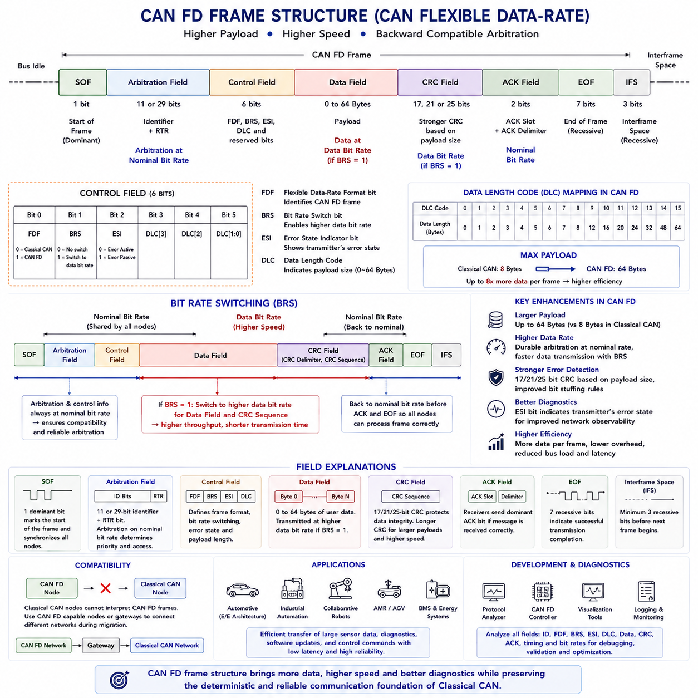
The CAN Flexible Data-Rate protocol, commonly known as CAN FD, extends the capabilities of Classical CAN by increasing payload capacity and supporting higher communication speeds during data transmission. While maintaining the proven arbitration mechanism and robust error detection principles of the original CAN protocol, CAN FD significantly improves communication efficiency for modern embedded systems that exchange larger amounts of sensor data, diagnostic information, software updates, and control commands. The frame structure of CAN FD introduces several new fields and modified control bits that distinguish it from Classical CAN while preserving compatibility during arbitration.
A CAN FD frame retains the fundamental organization of a CAN communication frame, beginning with the Start of Frame followed by the Arbitration Field, Control Field, Data Field, Cyclic Redundancy Check field, Acknowledgement Field, End of Frame, and Interframe Space. Although the overall communication sequence remains familiar to engineers experienced with Classical CAN, several fields have been expanded or redefined to support additional functionality. These structural enhancements allow higher throughput without fundamentally changing the deterministic communication model that has made CAN widely adopted in automotive and industrial applications.
The Start of Frame continues to indicate the beginning of every transmitted message by forcing the communication bus into the dominant state. All connected nodes synchronize their internal bit timing using this transition before receiving the remainder of the frame. Maintaining an identical Start of Frame mechanism ensures that CAN FD preserves the synchronization behavior of Classical CAN, allowing communication controllers to detect message boundaries reliably regardless of message length or communication speed.
The Arbitration Field functions almost identically to that of Classical CAN. It contains either the standard 11-bit identifier or the extended 29-bit identifier together with the Remote Transmission Request related information. During arbitration every transmitting node compares its transmitted bits with the observed bus state, immediately withdrawing whenever a dominant bit overrides its recessive bit. Because arbitration always occurs at the nominal communication speed, CAN FD nodes remain compatible with existing arbitration principles while guaranteeing deterministic bus access based on message priority.
One of the most important differences between Classical CAN and CAN FD appears within the Control Field. Additional control bits indicate whether the transmitted frame follows the Classical CAN format or the CAN FD format. These bits also specify whether Bit Rate Switching is enabled and whether the transmitter supports the enhanced error detection mechanisms associated with CAN FD. Consequently, receiving nodes can immediately recognize the communication format before processing the remainder of the message.
The Flexible Data Format bit, commonly abbreviated as FDF, identifies a frame as a CAN FD message. Classical CAN frames transmit this position differently, allowing communication controllers to distinguish between conventional and flexible data-rate communication without ambiguity. The presence of the FDF bit enables gradual migration from Classical CAN toward CAN FD by allowing compatible communication controllers to recognize both message formats appropriately within mixed development environments.
Another significant addition is the Bit Rate Switch bit, abbreviated as BRS. During arbitration and control information transmission, communication proceeds at the nominal bit rate shared by all participating nodes. If the BRS bit is asserted, communication automatically switches to a higher data bit rate when transmitting the Data Field and portions of the CRC sequence. This mechanism significantly reduces overall transmission time while preserving reliable arbitration among all network participants.
The Error State Indicator, or ESI bit, communicates the transmitter's current error state to other nodes on the network. Controllers operating in the Error Passive state transmit the ESI bit differently from controllers operating in the Error Active state. This information allows diagnostic systems and network monitoring software to identify communication health without requiring additional diagnostic messages. The ESI field therefore improves network observability while consuming only a single communication bit.
The Data Length Code continues to describe payload size but supports substantially larger values than Classical CAN. Whereas Classical CAN limits payload capacity to eight bytes, CAN FD extends the maximum payload to sixty-four bytes. The Data Length Code therefore maps encoded values to larger payload sizes according to predefined conversion rules. This increased capacity dramatically improves communication efficiency because larger amounts of application data can be transmitted within a single communication frame instead of requiring multiple separate messages.
The expanded Data Field represents one of the primary advantages of CAN FD. Modern vehicles, industrial automation systems, collaborative robots, autonomous mobile robots, battery management systems, sensor fusion modules, and advanced driver assistance systems frequently exchange complex datasets that exceed the eight-byte limitation of Classical CAN. Supporting payloads of up to sixty-four bytes allows entire parameter groups, calibration information, diagnostic records, perception outputs, and software update blocks to be transmitted more efficiently with reduced protocol overhead.
Because CAN FD supports longer payloads and higher communication speeds, the Cyclic Redundancy Check mechanism has also been strengthened. Depending upon payload size, different CRC lengths are applied to improve error detection capability while maintaining extremely low probabilities of undetected communication errors. Enhanced CRC generation reflects the increased amount of transmitted information and the faster communication rates employed during the Data Field.
Bit stuffing continues to operate within CAN FD but has been refined to improve communication reliability and support enhanced error detection. Classical CAN inserts complementary bits after five consecutive identical bits throughout most of the frame. CAN FD modifies portions of this process to accommodate longer payloads and stronger CRC protection while preserving synchronization among all communication nodes. These refinements contribute to improved communication robustness despite significantly higher transmission throughput.
The Acknowledgement Field maintains its original function within CAN FD. After successfully receiving a valid message, one or more receiving nodes transmit a dominant acknowledgement bit, informing the transmitter that communication has been completed correctly. The transmitting node monitors this acknowledgement before concluding the transmission process. Maintaining this mechanism preserves compatibility with existing communication reliability principles while supporting the enhanced frame structure of CAN FD.
The End of Frame continues to consist of consecutive recessive bits that indicate successful completion of message transmission. Following the End of Frame, the Interframe Space provides sufficient idle time before the next message begins. These termination mechanisms remain fundamentally unchanged because they continue to provide reliable message separation, synchronization stability, and deterministic communication scheduling regardless of payload size or communication speed.
The introduction of Bit Rate Switching significantly changes transmission timing. Arbitration, identifier transmission, and critical control information always occur at the nominal bit rate shared by every node on the network. Only after arbitration has completed successfully does communication accelerate to the higher data bit rate if permitted by the BRS bit. Before the frame concludes, communication returns to the nominal rate so that every connected controller can correctly interpret frame completion and prepare for subsequent arbitration.
CAN FD controllers must therefore support two independent communication speeds within a single transmitted frame. The nominal bit rate guarantees compatibility during arbitration and network synchronization, while the faster data bit rate minimizes transmission duration during payload transfer. Engineers configure both timing parameters carefully to satisfy physical network constraints including cable length, transceiver characteristics, propagation delay, electromagnetic compatibility, and oscillator accuracy.
Frame efficiency improves substantially under CAN FD because protocol overhead increases only slightly while payload capacity expands dramatically. When transmitting large datasets, the ratio of application data to protocol overhead becomes significantly higher than in Classical CAN. This improved efficiency reduces average bus load, shortens communication latency, and increases total network throughput without requiring additional communication channels or fundamentally different network architectures.
Compatibility between Classical CAN and CAN FD requires careful network planning. Classical CAN controllers cannot correctly interpret CAN FD frames because they do not recognize the modified control bits and higher data rates. Consequently, mixed communication systems typically employ CAN FD capable controllers throughout the network or separate communication domains connected through gateways. During system migration, engineers carefully evaluate compatibility requirements before introducing CAN FD functionality.
Development tools provide extensive visualization of CAN FD frame structures during debugging and validation. Protocol analyzers display every frame field including identifiers, FDF, BRS, ESI, Data Length Code, payload contents, CRC information, acknowledgement status, and timing characteristics. Such detailed visualization assists engineers in verifying protocol implementation, diagnosing communication faults, optimizing bandwidth utilization, and validating interoperability among electronic control units produced by different manufacturers.
In autonomous robotic systems, CAN FD frame structures enable efficient communication among distributed controllers responsible for motion control, battery management, perception processing, localization, functional safety, actuator coordination, environmental sensing, and fleet management. Larger payloads reduce message fragmentation while higher communication speeds decrease latency for complex sensor information and coordinated control commands. These characteristics make CAN FD particularly valuable for intelligent robotic platforms requiring deterministic real-time communication together with increasing computational complexity.
The CAN FD frame structure represents a carefully engineered evolution rather than a complete replacement of Classical CAN. By preserving deterministic arbitration, synchronization mechanisms, acknowledgement procedures, and fault detection principles while introducing larger payloads, enhanced control fields, stronger error detection, and flexible data-rate transmission, CAN FD provides a scalable communication framework capable of supporting the growing data requirements of modern vehicles, industrial automation equipment, and autonomous robotic systems without sacrificing the reliability that has defined CAN technology for decades.

4.2 Bit Rate Switching BRS
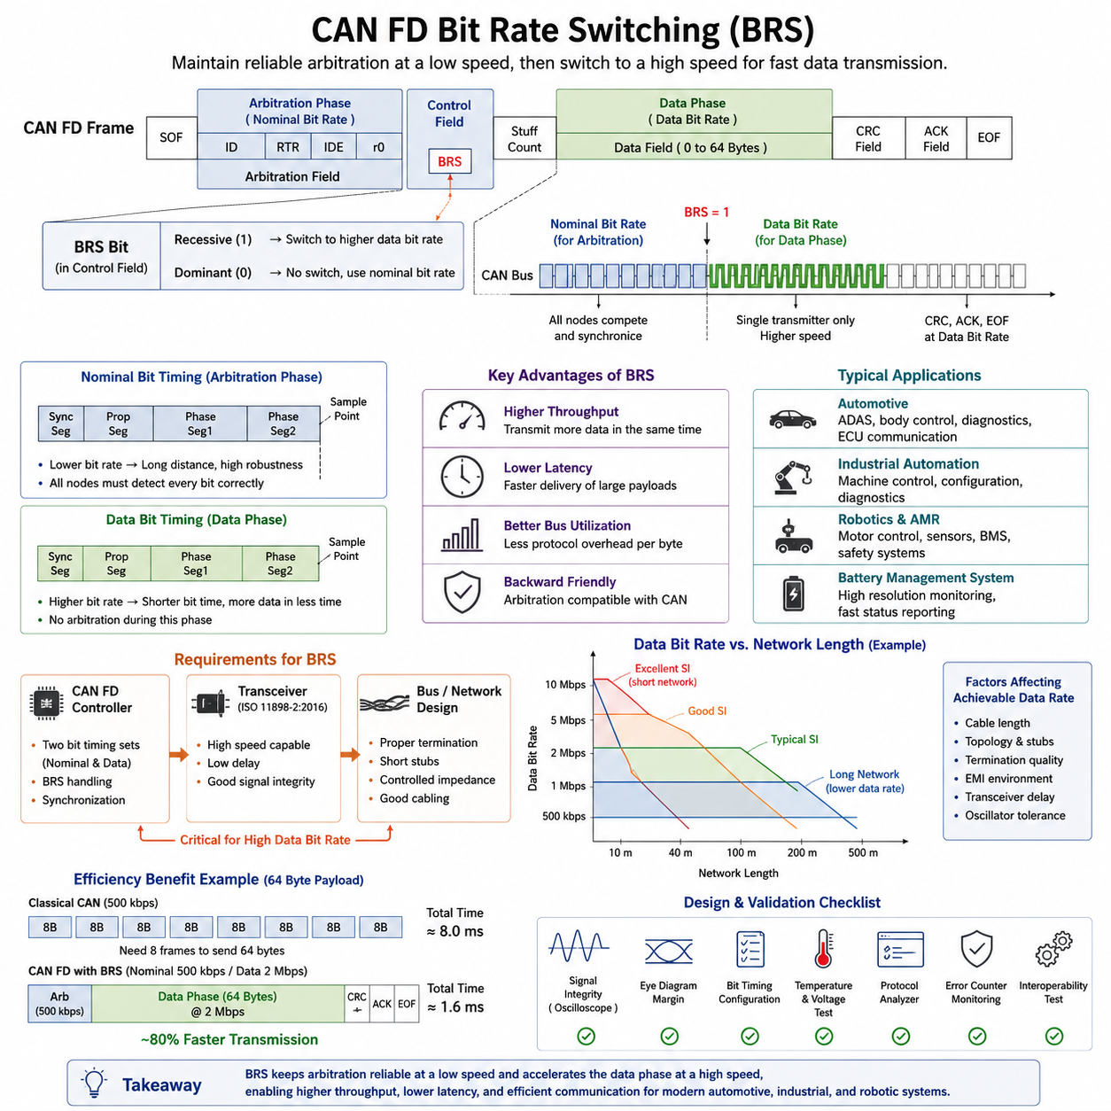
Bit Rate Switching (BRS) is one of the defining capabilities that distinguishes CAN FD from Classical CAN. In a traditional CAN network, every portion of the communication frame is transmitted at a single fixed bit rate determined during network configuration. While this approach guarantees interoperability and predictable timing, it also limits the maximum amount of useful application data that can be transferred within a given time. CAN FD introduces Bit Rate Switching to overcome this limitation by allowing different sections of the same frame to be transmitted at different speeds while preserving compatibility with the arbitration process defined by the CAN protocol. The feature significantly improves network efficiency without fundamentally changing the distributed arbitration mechanism that has made CAN successful for decades.
The operation of BRS begins during the arbitration phase of a CAN FD frame. All nodes on the network participate in arbitration using the nominal bit rate, which is identical to the speed configured for conventional CAN communication. Since every node must observe identical timing during arbitration, the deterministic priority resolution mechanism remains unchanged. Once arbitration has been completed successfully and only one transmitting node remains active, the Bit Rate Switch bit within the frame informs all receiving nodes that the subsequent data phase will be transmitted at a higher communication speed. Every node that supports CAN FD synchronously changes its timing parameters before the beginning of the data field.
Separating arbitration and data transmission into two different bit rates provides a practical balance between robustness and throughput. Arbitration requires long communication distances, stable synchronization, and reliable propagation across all nodes in the network. These requirements favor relatively conservative communication speeds. The payload section, however, is transmitted only after bus ownership has already been determined. Since no competing transmitters exist during this period, significantly higher bit rates can be used without affecting arbitration reliability. This design enables CAN FD to maintain compatibility with proven network architectures while dramatically reducing message transmission time for large payloads.
The Bit Rate Switch mechanism is indicated by the BRS control bit located within the CAN FD frame format. When the bit is recessive, participating controllers recognize that the data phase will operate at the configured higher bit rate. If the bit remains dominant, the entire frame continues to use the nominal communication speed. This flexibility allows individual messages to selectively benefit from high-speed transmission while permitting slower operation for applications requiring maximum robustness or compatibility. Consequently, network designers can optimize communication characteristics according to the requirements of each message rather than forcing a single operating mode for the entire system.
Implementing BRS requires two independent sets of bit timing parameters within every CAN FD controller. The nominal bit timing governs arbitration and acknowledgement fields, while the data bit timing controls the payload transmission interval. Both configurations define synchronization segments, propagation segments, phase buffers, and sampling points appropriate for their respective communication speeds. The controller automatically switches between these timing configurations based on the frame state without requiring software intervention during transmission. This hardware-based transition ensures precise synchronization even at significantly higher data rates.
Because communication speed changes dynamically during transmission, synchronization accuracy becomes more demanding than in Classical CAN. The oscillator tolerance of every participating node, the propagation delay of the communication medium, and the performance of the physical transceiver all influence successful high-speed operation. As data bit rates increase, the available timing margin decreases substantially, making clock accuracy and network design increasingly important. CAN FD controllers therefore employ enhanced synchronization mechanisms that continuously compensate for small timing deviations throughout frame reception.
Transceiver Delay Compensation plays an essential role in reliable Bit Rate Switching operation. At higher communication speeds, the propagation delay introduced by CAN transceivers becomes a significant percentage of the individual bit time. Without compensation, the receiver may sample incoming bits too early or too late, resulting in communication errors. Modern CAN FD controllers estimate the transceiver delay and automatically adjust the sampling point during the high-speed data phase. This mechanism extends reliable operation at several megabits per second while maintaining interoperability between different hardware implementations.
The achievable data bit rate depends upon numerous physical characteristics of the communication network. Cable length, wiring topology, connector quality, stub length, electromagnetic interference, and transceiver characteristics all influence signal integrity. Although CAN FD standards allow considerably higher communication speeds than Classical CAN, practical implementations must evaluate these physical limitations carefully. Many automotive and industrial systems successfully operate with nominal rates of 500 kbps or 1 Mbps while increasing the data phase to 2 Mbps, 5 Mbps, or even 8 Mbps depending on network topology and component quality.
Network length has a particularly strong influence on Bit Rate Switching performance. During arbitration, relatively low communication speeds allow signals to propagate across long cables without violating synchronization requirements. During the high-speed data phase, however, shorter bit times reduce the acceptable propagation delay considerably. As a result, higher data rates generally require shorter network lengths, carefully controlled cable impedance, minimized branch connections, and improved termination quality. System architects must therefore balance communication speed against physical installation constraints when designing CAN FD networks.
The improvement in transmission efficiency becomes especially significant for large payloads. Classical CAN limits the payload to eight bytes, causing protocol overhead to occupy a substantial percentage of total transmission time. CAN FD expands the payload capacity to as many as sixty-four bytes while simultaneously accelerating the data phase through Bit Rate Switching. The combined effect dramatically reduces protocol overhead per byte of useful information, allowing considerably more application data to be exchanged without increasing network utilization proportionally. This higher efficiency is one of the primary motivations for adopting CAN FD in modern embedded systems.
Latency improvements achieved through BRS benefit real-time control applications that exchange large amounts of sensor or actuator information. Instead of transmitting multiple small Classical CAN frames, an application can consolidate related information into a single CAN FD message while completing transmission in less time than would otherwise be required. Reduced bus occupancy lowers communication delays for other nodes as well, improving overall network responsiveness under heavy load conditions. These characteristics are particularly valuable in distributed robotic control systems where deterministic communication remains essential.
Automotive electronic architectures increasingly depend on Bit Rate Switching to support advanced driver assistance systems, centralized computing platforms, high-resolution sensor interfaces, and software-defined vehicle functions. Electronic control units exchange larger diagnostic datasets, firmware update packets, calibration parameters, and sensor measurements than were envisioned when Classical CAN was introduced. CAN FD with BRS satisfies many of these increasing bandwidth requirements while allowing manufacturers to preserve existing CAN infrastructure, wiring practices, engineering knowledge, and network management strategies.
Industrial automation systems also benefit substantially from BRS because machine controllers frequently transfer configuration parameters, process measurements, diagnostics, and maintenance information alongside deterministic control commands. High-speed data transmission shortens maintenance operations, accelerates production parameter downloads, and improves diagnostic responsiveness without requiring an entirely new communication technology. Equipment manufacturers can therefore enhance system capability while maintaining compatibility with mature CAN-based industrial ecosystems that have demonstrated reliability over many years.
Autonomous Mobile Robots and service robots represent another important application area for Bit Rate Switching. Multiple motor controllers, battery management systems, safety controllers, localization modules, perception sensors, and supervisory computers continuously exchange operational information. Although Ethernet often carries high-bandwidth perception data, CAN FD remains highly attractive for deterministic control communication among distributed embedded devices. BRS allows richer diagnostic information, higher-resolution actuator feedback, expanded battery monitoring data, and more comprehensive health reporting to be transmitted efficiently without increasing bus congestion.
Battery management systems illustrate the practical advantages of Bit Rate Switching particularly well. Modern battery packs contain numerous monitoring channels measuring voltage, current, temperature, balancing status, fault conditions, and state estimation variables. CAN FD enables these larger datasets to be transferred within a single communication frame, while BRS minimizes transmission time during the data phase. Faster reporting improves system monitoring responsiveness without sacrificing the deterministic arbitration behavior required for safety-critical battery protection functions.
Software diagnostics and firmware updates similarly benefit from BRS. Service tools often transfer calibration tables, diagnostic logs, software metadata, and configuration parameters significantly larger than eight bytes. CAN FD reduces the number of required communication frames while high-speed payload transmission shortens maintenance sessions. Although Ethernet-based diagnostics may eventually dominate high-end systems, CAN FD remains an attractive solution where cost, simplicity, or existing infrastructure favor continued CAN-based communication.
Designing a reliable BRS network requires careful validation under realistic operating conditions. Engineers typically evaluate signal quality using oscilloscopes, CAN protocol analyzers, eye diagrams, and error counters while testing across temperature extremes, supply voltage variations, electromagnetic interference environments, and maximum network loading. Particular attention is paid to synchronization stability during transitions between nominal and data bit rates. Validation also confirms compatibility among controllers and transceivers supplied by different semiconductor vendors.
Network simulation and timing analysis further assist engineers in optimizing Bit Rate Switching configurations before physical implementation. Bus utilization calculations, propagation delay estimation, oscillator tolerance analysis, and worst-case latency simulations help determine appropriate nominal and data bit rates. These engineering activities ensure that communication remains reliable under all anticipated operating scenarios while maximizing available bandwidth. Proper configuration often delivers substantial performance improvements without requiring changes to higher-level application software.
Despite its advantages, Bit Rate Switching introduces additional engineering complexity compared with Classical CAN. Controllers, transceivers, network topology, cable quality, and timing configuration must all satisfy tighter performance requirements. Legacy CAN nodes that do not support CAN FD cannot correctly interpret CAN FD frames, requiring careful migration planning or gateway-based integration. Engineers must therefore evaluate compatibility, certification requirements, and lifecycle considerations before introducing BRS into mixed communication environments.
As embedded systems continue evolving toward centralized computing, software-defined functionality, and increasingly intelligent robotic platforms, Bit Rate Switching remains a practical technology that extends the useful life of CAN communication while providing significantly greater bandwidth. Its ability to combine reliable low-speed arbitration with efficient high-speed payload transmission offers an elegant engineering solution that balances compatibility, determinism, scalability, and performance. For modern automotive electronics, industrial automation equipment, and autonomous robotic platforms, BRS has become one of the most valuable enhancements introduced by the CAN FD protocol, enabling efficient communication without abandoning the mature and dependable operational principles established by Classical CAN.

4.3 ISO 11898 2 2016 Transceiver
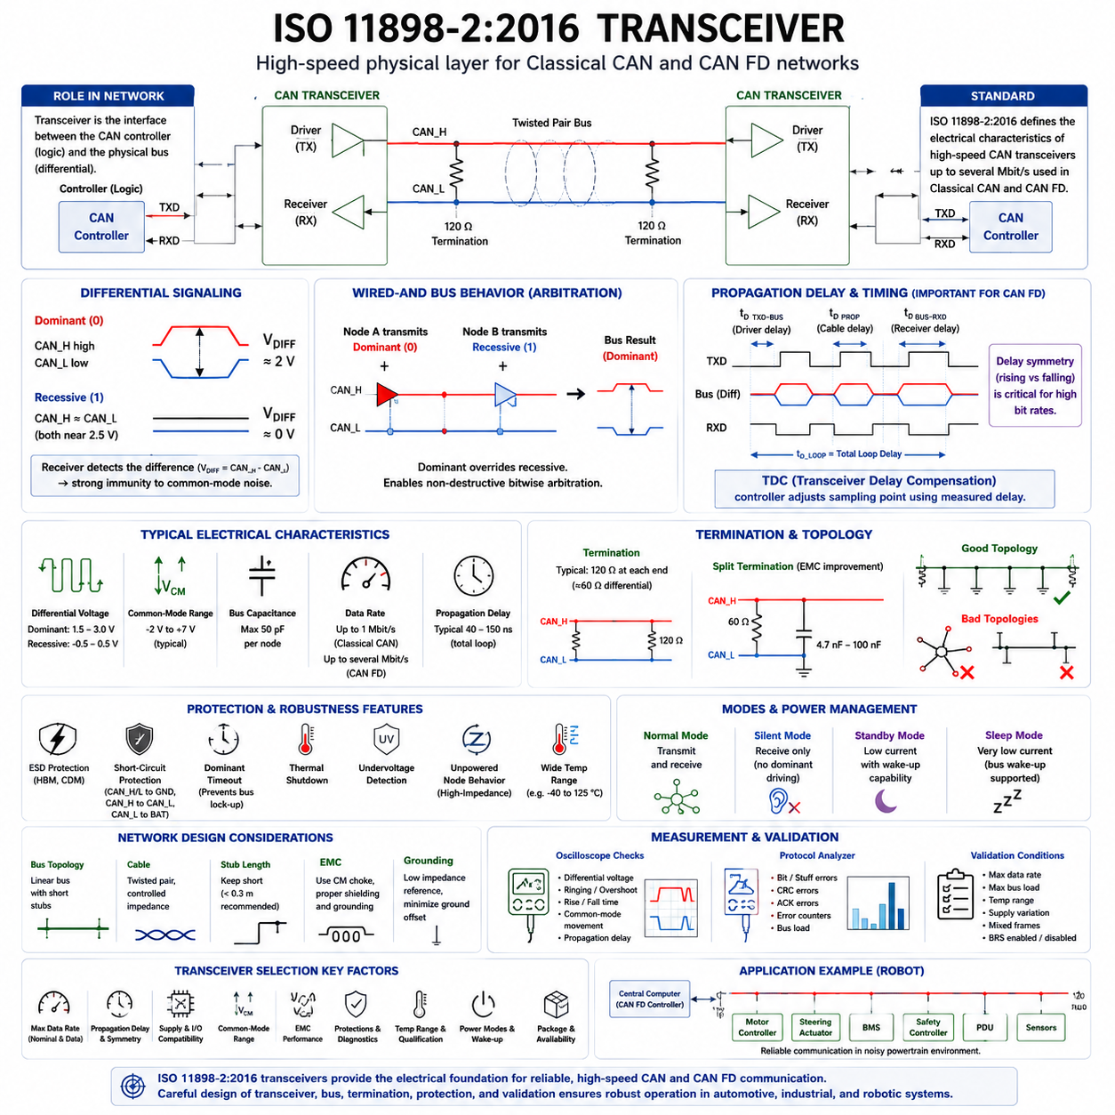
ISO 11898-2:2016 defines the high-speed physical medium attachment requirements used by Classical CAN and CAN FD networks. The standard describes how a transceiver converts the controller’s logical transmit signal into differential voltages on the CAN_H and CAN_L conductors and how it reconstructs the received bus state. Its purpose is to ensure that compliant nodes can communicate reliably despite wiring resistance, propagation delay, electromagnetic noise, ground offset, and variations in component characteristics.
A CAN transceiver forms the electrical interface between the CAN protocol controller and the physical bus. The controller processes frames, arbitration, acknowledgement, error detection, and bit timing, while the transceiver drives and senses the differential pair. On the digital side, the controller normally provides transmit data through the TXD signal and receives the detected bus state through RXD. On the network side, the transceiver connects to CAN_H, CAN_L, supply, ground, and optional mode-control or fault-reporting pins.
Differential signaling is fundamental to the robustness of high-speed CAN. A dominant bus state is produced by driving CAN_H upward and CAN_L downward, creating a positive differential voltage between the two wires. A recessive state is produced when active differential drive is released and the bus returns toward a balanced condition through termination and internal biasing. The receiver determines the logical state primarily from the voltage difference rather than from either conductor’s absolute voltage to ground.
Using the voltage difference between CAN_H and CAN_L provides strong rejection of common-mode interference. External electromagnetic noise often couples with similar polarity and magnitude onto both conductors, shifting their voltages together. Because the differential voltage may remain nearly unchanged, the receiver can still identify the transmitted state correctly. This principle is one reason CAN remains dependable in vehicles, industrial equipment, mobile robots, and electrically noisy powertrain environments.
The wired-AND behavior of CAN is implemented electrically through dominant and recessive states. A dominant transmission overrides a recessive transmission when multiple nodes access the bus simultaneously. This behavior enables nondestructive bitwise arbitration, because a node transmitting a recessive bit can observe a dominant state generated by another node and withdraw without corrupting the frame. The transceiver must reproduce this behavior accurately while preventing excessive current or damaging contention between network participants.
ISO 11898-2:2016 is especially important for CAN FD because the data phase may operate at a considerably higher bit rate than the arbitration phase. The transceiver must therefore support faster signal transitions, lower internal propagation delay, controlled symmetry, and improved timing consistency. A component may work correctly in a Classical CAN network yet fail to provide sufficient timing margin for CAN FD at several megabits per second. Transceiver selection must consequently consider the maximum required data-phase speed.
Propagation delay represents the time between a change at TXD, the corresponding transition on the bus, and the detected change at RXD. This delay includes transmitter switching, cable propagation, receiver detection, and internal logic processing. At low bit rates, the delay occupies only a small portion of the bit time. At high CAN FD data rates, however, it may consume a significant portion of the available sampling window and directly affect reliable bit detection.
Delay symmetry is as important as absolute propagation delay. Rising and falling transitions do not always pass through the transceiver and wiring with identical timing. Excessive asymmetry changes the apparent duration of dominant and recessive bits, creating duty-cycle distortion. At high speed, accumulated distortion can shift edges away from their expected positions and reduce the sampling margin. CAN FD transceivers are therefore designed to maintain tightly controlled timing characteristics across voltage and temperature.
Transceiver Delay Compensation is used by many CAN FD controllers to address the timing impact of the physical transceiver loop. The controller measures or estimates the delay between its transmitted edge and the corresponding received edge, then positions an additional sampling point appropriately during the data phase. This function allows higher bit rates to be used without requiring the primary sample point to absorb the entire transceiver delay. Correct configuration remains dependent on the actual hardware and network topology.
The 2016 edition of ISO 11898-2 consolidated high-speed CAN physical-layer requirements and introduced support relevant to improved CAN FD operation. It includes characteristics associated with high-speed transceivers and defines electrical behavior intended to preserve interoperability among devices from different suppliers. The standard does not define application messages or network management. Instead, it establishes the electrical foundation upon which the CAN and CAN FD data-link protocols operate.
Termination is essential because the CAN bus is a transmission line rather than an ideal lumped electrical connection. A typical high-speed network uses approximately 120-ohm termination at each physical end of the main bus, producing an effective differential load of about 60 ohms. Proper termination absorbs signal energy and limits reflections. Missing, duplicated, incorrectly located, or poorly matched termination can distort edges and create ringing that becomes increasingly severe as the data rate rises.
Split termination may be used to improve electromagnetic compatibility and stabilize the common-mode voltage. Instead of one resistor directly between CAN_H and CAN_L, the termination is divided into two resistors whose midpoint is connected to ground through a capacitor. The resistive values still provide the required differential impedance, while the capacitor offers a path for common-mode high-frequency noise. Component tolerance, grounding quality, and capacitor placement strongly influence the actual benefit.
Bus topology also determines whether a transceiver can operate reliably at the intended speed. A linear trunk with short stubs is generally preferred because it minimizes impedance discontinuities and reflection paths. Star connections, long branches, unused cable extensions, and multiple connector transitions may create delayed echoes that overlap subsequent bits. A network that performs well at 500 kbit/s may become unstable when the CAN FD data phase is increased to 2 or 5 Mbit/s.
Cable characteristics must be matched to the required physical-layer performance. Twisted-pair wiring helps equalize noise coupling and maintain a controlled differential impedance. Conductor resistance affects dominant voltage levels and available current, while capacitance slows signal edges and increases loading. Shielding may be needed in severe electromagnetic environments, but incorrect shield termination can introduce ground loops or unintended current paths. Wiring must therefore be designed as part of the communication system.
Common-mode voltage tolerance allows nodes with moderate ground-potential differences to communicate without immediately losing receiver functionality. Vehicles and mobile robots often contain long power paths, high motor currents, battery return variations, and separated electronic modules. These conditions can cause local ground references to differ. A compliant transceiver must continue interpreting the differential bus signal across its specified common-mode range, although system grounding should still minimize sustained ground offset.
Receiver thresholds determine when the differential input is interpreted as dominant or recessive. The thresholds must tolerate signal attenuation, noise, component variation, and network loading while maintaining adequate hysteresis. Hysteresis reduces unwanted state changes when the input is near the switching threshold. Reliable receiver design is particularly important during slow or distorted edges, because insufficient noise margin may generate false transitions, synchronization errors, or repeated frame retransmission.
The transmitter output stage must generate dominant levels that remain valid under the expected bus load. It must also release the bus quickly enough to produce a clean recessive transition. Current limiting and thermal protection are commonly integrated to protect the device during short circuits or abnormal loading. However, protection behavior differs among products, so designers must examine how the selected transceiver responds to CAN_H-to-ground, CAN_L-to-battery, wire-to-wire short circuits, and prolonged dominant conditions.
Fault tolerance at the transceiver level improves network survivability but does not eliminate the need for system-level protection. Devices may include undervoltage detection, thermal shutdown, dominant timeout, short-circuit protection, and bus-pin protection against automotive electrical disturbances. External components such as transient voltage suppressors, common-mode chokes, series resistors, and filtering capacitors may also be required. Their parasitic capacitance and impedance must not compromise high-speed signal integrity.
A dominant timeout function prevents a malfunctioning controller or damaged TXD signal from holding the entire network permanently dominant. If TXD remains dominant beyond an allowed interval, the transceiver releases the bus even though the controller continues requesting a dominant state. This protection can preserve communication among other nodes. The timeout duration must nevertheless be compatible with the longest valid dominant sequence expected from the supported CAN or CAN FD protocol operation.
Power-supply behavior is another important design consideration. Many transceivers operate from a 5 V supply for the bus interface while providing digital pins compatible with 3.3 V microcontrollers through a separate I/O supply. Others are designed for different supply arrangements. Engineers must verify logic thresholds, output levels, sequencing, and behavior when one supply is present while another is absent. Incorrect assumptions can cause leakage, unintended bus loading, or communication during partial-power conditions.
Unpowered-node behavior is critical in networks where modules can be switched off independently. A powered-down transceiver should not excessively load CAN_H or CAN_L, clamp the bus, or disturb communication between active nodes. This characteristic supports partial networking, sleep strategies, service modes, and fault isolation. It is especially valuable in vehicles and autonomous machines where different subsystems may enter low-power states while safety, battery, or wake-up communication remains active.
Many modern transceivers include standby, sleep, or silent operating modes. Standby reduces supply current while retaining selected wake-up or bus-monitoring capabilities. Silent mode allows the node to receive bus traffic without actively driving dominant bits, which is useful during diagnostics, commissioning, or fault containment. Mode transitions must be controlled carefully because an unexpected state can prevent acknowledgement, block transmission, or create confusing intermittent network behavior.
Wake-up functionality may allow bus activity to reactivate a sleeping electronic control unit. The transceiver detects a specified dominant and recessive pattern or qualified bus event and signals the local power-management circuitry. Proper filtering is necessary so that electromagnetic disturbances do not repeatedly wake the system. The wake-up design must also coordinate with software initialization, controller readiness, and network timing so that the node does not interfere with active communication immediately after power restoration.
Electromagnetic emission is strongly affected by transceiver edge rate and signal symmetry. Faster edges improve timing margin but contain greater high-frequency energy, increasing radiated and conducted emissions. Some devices provide slope control or optimized driver shaping to reduce emissions. For high-speed CAN FD, excessive slope reduction may distort the signal, so the designer must select a transceiver whose edge characteristics balance communication speed, network length, and electromagnetic compatibility requirements.
A common-mode choke can reduce unwanted common-mode current on the cable and improve emission performance. It presents relatively high impedance to common-mode noise while allowing the intended differential CAN signal to pass. Nevertheless, the choke introduces leakage inductance, capacitance, and possible resonance. Poorly selected components can worsen ringing or delay edges. Validation must therefore be performed with the actual transceiver, cable, termination, connector, and protection network rather than with isolated components.
Printed circuit board layout has a direct influence on transceiver performance. CAN_H and CAN_L should be routed as a closely coupled differential pair with balanced geometry and minimal unnecessary length. Protection devices and the connector should be located to minimize exposed paths, while decoupling capacitors should be placed close to the supply pins. Stubs between the transceiver and connector should remain short, and noisy switching nodes from motor drives or DC-DC converters should be kept away.
Grounding strategy must support both signal integrity and fault-current control. The transceiver ground should connect to a stable local reference with low impedance at relevant frequencies. Chassis coupling, cable shield termination, and signal ground connections must be coordinated so that electromagnetic currents do not flow through sensitive logic paths. In robots with high-current traction systems, communication grounding must be considered together with battery return routing, inverter switching, and protective bonding.
Component qualification is determined by the target application. Automotive systems may require devices qualified for wide temperature ranges, electrical transient exposure, long service life, and automotive quality standards. Industrial robots may emphasize isolation, connector robustness, maintenance conditions, and immunity to motor-drive noise. Safety-related systems additionally require diagnostic coverage, failure analysis, and documented behavior under faults. Compliance with ISO 11898-2 alone does not satisfy every product-level requirement.
Galvanic isolation may be introduced between the CAN controller and transceiver or through an integrated isolated CAN device. Isolation helps break ground loops, limit fault-current paths, and protect low-voltage electronics from hazardous or noisy domains. It also adds propagation delay, channel asymmetry, power-isolation requirements, cost, and board area. For CAN FD, the isolation barrier must support the required data rate without consuming excessive timing margin or introducing unacceptable jitter.
Interoperability testing should include transceivers from different vendors, controller implementations, cable lengths, temperature conditions, and supply tolerances. A network may appear reliable when all nodes use identical components yet fail when a replacement module introduces different edge timing or receiver thresholds. Robust design therefore considers worst-case combinations rather than typical laboratory conditions. Error counters, retransmissions, eye patterns, and differential voltage margins should be observed during stress testing.
Oscilloscope measurements provide essential evidence during physical-layer validation. Engineers examine dominant and recessive voltages, differential amplitude, common-mode movement, ringing, overshoot, edge timing, and propagation delay. Measurements should be taken at multiple locations, including the transmitter, both bus ends, and difficult branch nodes. Differential probes with appropriate bandwidth and low loading are preferred because ordinary single-ended probing can misrepresent the actual bus behavior or disturb the circuit.
Protocol analyzers complement electrical measurements by identifying frame errors, bit errors, stuff errors, CRC errors, acknowledgement failures, and error-passive transitions. Correlating analyzer events with oscilloscope captures helps distinguish software configuration problems from physical-layer faults. Testing should include maximum bus load, rapid message bursts, mixed frame lengths, BRS-enabled frames, non-BRS CAN FD frames, and transitions between nominal and data-phase timing configurations.
In an autonomous mobile robot, an ISO 11898-2:2016-compatible transceiver may connect motor controllers, steering actuators, battery management units, safety controllers, power distribution units, and supervisory computers. The network must remain reliable near traction inverters, relays, contactors, charging systems, and long harness routes. CAN FD allows richer status and diagnostic data, but the transceiver and network must be engineered for the selected data-phase rate rather than treated as a direct replacement requiring no validation.
For safety-relevant robot communication, physical-layer faults should be detected and contained through multiple mechanisms. CAN error handling can identify many transmission failures, while controller error counters isolate persistently faulty nodes. System software may monitor message freshness, sequence counters, timeout conditions, and plausibility. Redundant communication or safe-state transitions may be required when communication is lost. The transceiver provides the electrical channel, but functional safety depends on the complete architecture.
Selecting a transceiver should begin with nominal bit rate, maximum CAN FD data rate, supply voltage, I/O compatibility, required operating temperature, common-mode range, propagation delay, and electromagnetic performance. Additional criteria include standby current, wake-up support, fault protection, packaging, qualification, diagnostic features, and availability. The fastest device is not automatically the best choice; the selected component must match the real network topology, cable quality, environmental conditions, and lifecycle strategy.
ISO 11898-2:2016 transceivers enable CAN and CAN FD controllers to communicate over a shared differential bus with predictable electrical behavior. Their performance determines whether protocol-level advantages such as arbitration, error confinement, larger payloads, and bit rate switching can be realized reliably in hardware. Careful attention to delay, termination, topology, EMC, grounding, protection, and validation transforms the transceiver from a simple interface component into a critical element of dependable automotive, industrial, and robotic communication architecture.

4.4 CAN FD Network Design
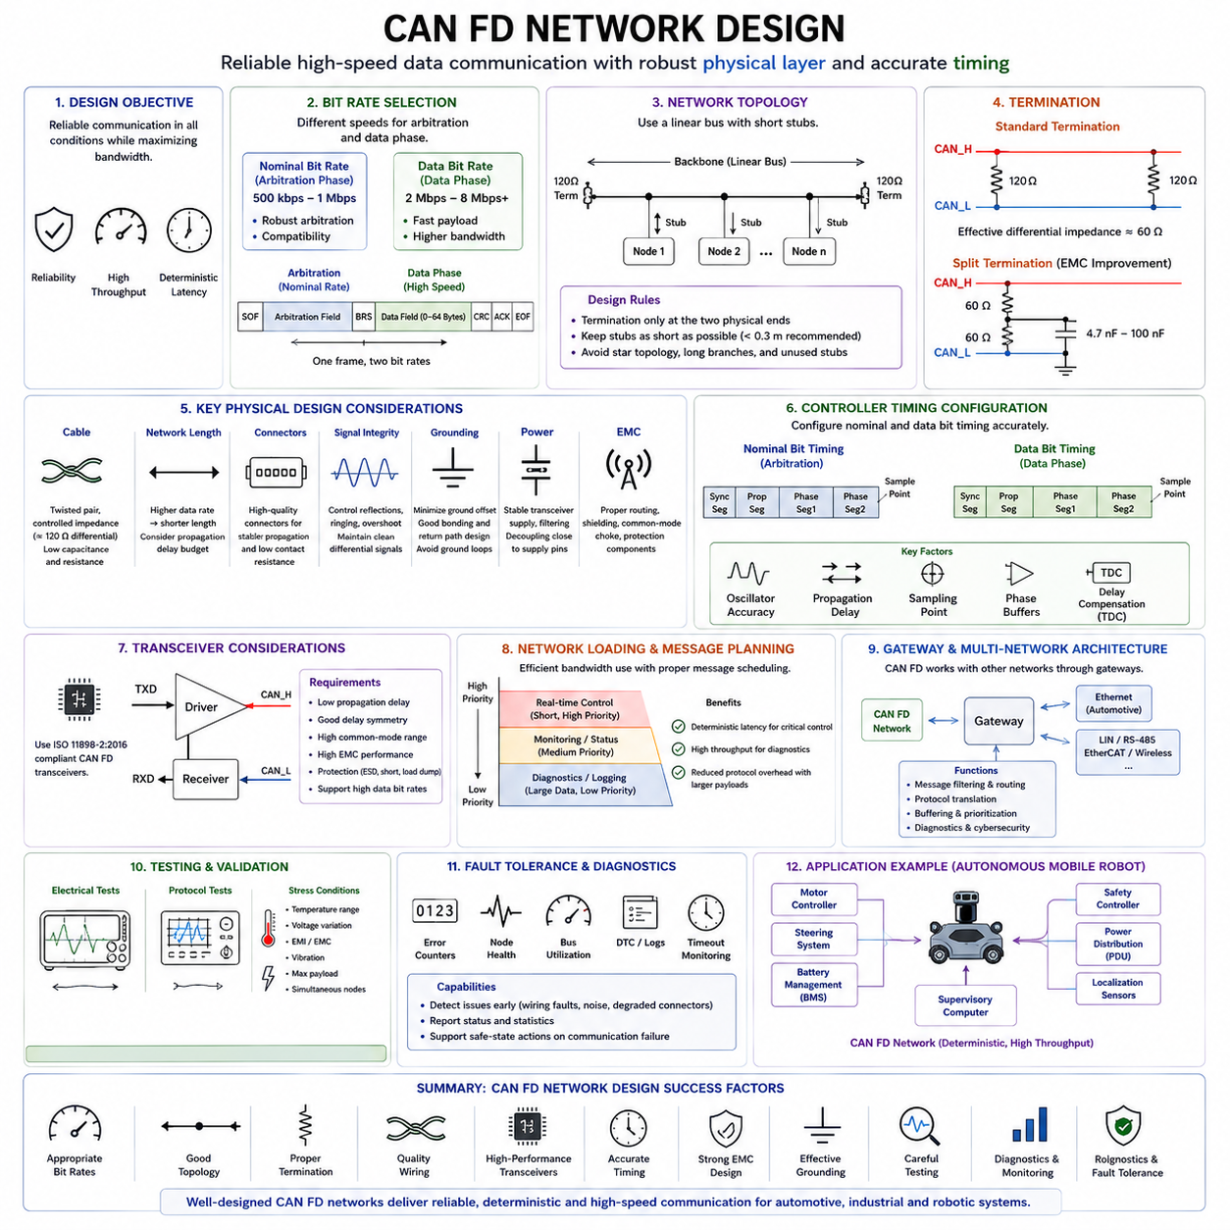
CAN FD network design extends the well-established principles of Classical CAN while introducing additional considerations required to support significantly higher data transmission speeds during the data phase. Although CAN FD preserves the same arbitration mechanism and physical wiring concept, the increased data bit rate places much stricter requirements on signal integrity, propagation delay, topology, transceiver performance, and timing accuracy. A successful CAN FD network therefore requires coordinated design of the controller configuration, physical layer, wiring harness, termination, power distribution, and electromagnetic compatibility rather than simply replacing Classical CAN controllers with CAN FD-compatible devices.
The primary objective of CAN FD network design is to achieve reliable communication under all expected operating conditions while maximizing available bandwidth. Designers must ensure that every node can correctly participate in arbitration at the nominal bit rate and subsequently receive high-speed data without synchronization errors. This requires careful consideration of both logical network architecture and physical implementation. Since the arbitration phase and data phase operate under different timing conditions, the network must satisfy two separate performance requirements within a single communication frame.
One of the most important design decisions is selecting appropriate nominal and data bit rates. The nominal bit rate determines arbitration performance and network compatibility, while the data bit rate defines payload transmission speed. Typical automotive and industrial systems continue using nominal bit rates of 500 kbps or 1 Mbps while increasing the data phase to 2 Mbps, 5 Mbps, or even higher depending on network length and hardware capability. Higher data rates improve throughput but reduce available timing margins, making physical network quality increasingly important.
Bus topology has a dominant influence on CAN FD performance. The preferred architecture remains a linear backbone with termination resistors located only at the two physical ends of the bus. Every communication node connects through a short branch known as a stub. Excessively long stubs introduce impedance discontinuities and delayed signal reflections that become increasingly problematic as data rates rise. While Classical CAN networks may tolerate relatively long branch connections, CAN FD often requires substantially shorter stubs to maintain acceptable signal integrity.
Network length directly limits achievable communication speed. During arbitration, relatively low bit rates allow signals sufficient time to propagate across long cables before sampling occurs. During the high-speed data phase, however, shorter bit times significantly reduce the allowable propagation delay. As a result, increasing the data bit rate generally requires reducing total network length or improving overall physical quality. Designers must evaluate cable routing, connector placement, harness segmentation, and node distribution before selecting the final communication speed.
Termination plays a fundamental role in preserving waveform quality. Standard high-speed CAN networks use approximately 120-ohm termination resistors at each end of the backbone, producing an effective differential impedance of approximately 60 ohms. Proper termination minimizes reflections and stabilizes differential signaling. Incorrect resistance values, improperly located termination, multiple termination points, or missing termination can produce ringing, overshoot, distorted edges, and communication failures, particularly during high-speed CAN FD operation.
Cable selection is equally important. Twisted-pair wiring provides balanced electromagnetic coupling while maintaining controlled characteristic impedance throughout the communication path. Uniform cable construction minimizes impedance variations that could generate reflections. Longer cables increase resistance, capacitance, and propagation delay, reducing available timing margin. Shielded cables may improve electromagnetic performance in harsh environments, although improper shield grounding can introduce unwanted current paths or ground-loop effects.
Connector quality becomes increasingly significant at higher communication speeds. Every connector introduces additional impedance discontinuity, contact resistance, and mechanical tolerance. Poor connector quality may create localized reflections or intermittent communication failures due to vibration, corrosion, or contamination. Automotive and industrial CAN FD networks therefore employ connectors specifically designed for high-speed differential communication with stable electrical characteristics throughout their operational lifetime.
The CAN FD controller configuration must accurately match the physical network characteristics. Both nominal bit timing and data bit timing require careful adjustment of synchronization segments, propagation segments, phase buffers, and sampling points. These parameters determine how the controller interprets incoming edges and compensates for clock variation among network nodes. Incorrect timing configuration may cause reliable operation during light testing while producing sporadic errors under temperature variation, supply voltage changes, or maximum network loading.
Oscillator accuracy is more critical in CAN FD than in Classical CAN. Since high-speed communication reduces available sampling windows, clock frequency errors accumulate more rapidly between synchronization events. Every participating node must satisfy oscillator tolerance requirements compatible with the selected communication speed and network length. Designers should evaluate worst-case frequency deviation over manufacturing variation, temperature range, aging, and supply voltage before finalizing timing parameters.
Propagation delay analysis forms an essential part of CAN FD network engineering. Total delay includes controller delay, transceiver delay, cable propagation, connector delay, and receiver response time. These delays determine whether transmitted bits arrive within the intended sampling window at every receiving node. Excessive propagation delay may not affect arbitration at lower speeds but can produce bit errors during the high-speed data phase if timing margins become insufficient.
Transceiver selection significantly influences achievable network performance. ISO 11898-2:2016 compliant CAN FD transceivers provide lower propagation delay, improved delay symmetry, enhanced signal integrity, and support for higher communication speeds compared with earlier Classical CAN devices. However, different transceiver families exhibit different electrical characteristics, output drive capability, common-mode voltage tolerance, electromagnetic emission, and protection features. Component selection should therefore be based upon complete network requirements rather than communication speed alone.
Transceiver Delay Compensation has become an important feature in many CAN FD systems. The controller measures or estimates the delay introduced by the transceiver loop and adjusts the sampling position during the high-speed data phase accordingly. This mechanism extends reliable operation at several megabits per second while accommodating unavoidable physical-layer delays. Correct implementation nevertheless depends on compatible controller hardware, transceiver characteristics, and proper software configuration.
Signal integrity represents one of the primary engineering challenges in CAN FD network design. Differential voltage amplitude, edge shape, ringing, overshoot, undershoot, common-mode movement, and electromagnetic interference all influence receiver performance. At higher communication speeds, relatively small waveform distortions may reduce available sampling margin sufficiently to generate CRC errors, bit errors, or repeated retransmissions. Network validation therefore requires both protocol analysis and electrical waveform measurement.
Electromagnetic compatibility must be considered from the earliest stages of network development. High-speed signal transitions generate increased high-frequency energy that may both emit electromagnetic interference and become susceptible to external disturbances. Proper cable routing, differential pair consistency, shielding strategy, grounding architecture, connector design, filtering components, and PCB layout all contribute to satisfactory EMC performance. Design modifications performed late in development often prove significantly more expensive than preventive EMC planning.
Grounding strategy influences communication reliability as much as wiring topology. Although CAN uses differential signaling, excessive ground offset between distributed electronic control units may exceed transceiver common-mode tolerance. Mobile robots, electric vehicles, and industrial machines often contain high-current traction systems capable of generating substantial ground-potential differences. Proper bonding, controlled return-current paths, and coordinated grounding architecture help maintain stable communication throughout all operating conditions.
Power distribution should also support reliable CAN FD operation. Stable transceiver supply voltage minimizes output variation and timing drift. Power filtering reduces conducted noise entering sensitive communication circuitry from switching power converters, motor drivers, and battery systems. Decoupling capacitors positioned close to transceiver supply pins reduce transient voltage fluctuations during high-speed communication while improving overall signal stability.
PCB layout has become increasingly important as CAN FD data rates continue increasing. CAN_H and CAN_L traces should be routed as closely coupled differential pairs with consistent spacing and minimal unnecessary length. Stubs between the transceiver and connector should remain extremely short. Protection devices should be located near external connectors, while power decoupling components should be positioned immediately adjacent to supply pins. High-current switching circuits should remain physically separated from communication circuitry whenever practical.
Protection circuitry preserves communication reliability under abnormal electrical conditions. Transient Voltage Suppressors protect against electrostatic discharge and load-dump events. Common-mode chokes may reduce conducted electromagnetic emission without significantly affecting differential communication. Series resistors, filtering capacitors, and surge protection devices should be selected carefully because excessive parasitic capacitance or inductance may reduce signal quality at higher data rates.
Network loading requires careful management even though CAN FD substantially increases available bandwidth. Higher payload capacity reduces protocol overhead and improves efficiency, yet communication scheduling remains important for deterministic systems. Critical control messages should retain high arbitration priority while large diagnostic or logging transfers utilize remaining bandwidth without delaying time-sensitive traffic. Proper message planning frequently improves overall performance more effectively than simply increasing communication speed.
System architects should divide communication into functional categories according to timing requirements. Real-time control messages typically require predictable latency and consistent update periods. Monitoring information may tolerate longer intervals, while diagnostics, firmware updates, and calibration data often transfer opportunistically when network loading permits. This logical separation helps optimize bus utilization while preserving deterministic behavior for safety-related functions.
Gateway design becomes increasingly important as modern vehicles and robots incorporate multiple communication networks. CAN FD gateways exchange information with Automotive Ethernet, LIN, RS-485, EtherCAT, or wireless communication systems. The gateway should prioritize deterministic message forwarding while preventing unnecessary network congestion. Message filtering, routing tables, protocol translation, buffering, and cybersecurity mechanisms all influence overall communication performance.
Network diagnostics should be integrated into the original architecture rather than added after deployment. Error counters, bus utilization monitoring, communication statistics, node health reporting, frame retransmission analysis, and diagnostic trouble codes provide valuable insight during development and maintenance. Continuous monitoring allows emerging wiring faults, connector degradation, or electromagnetic disturbances to be detected before complete communication failure occurs.
Software configuration management also affects CAN FD network reliability. Every node should maintain consistent database definitions, message identifiers, signal encoding, timing configuration, and protocol parameters. Changes to frame length, arbitration identifiers, or timing values require coordinated deployment across all participating controllers. Configuration inconsistency often produces communication failures that appear to be hardware problems despite originating entirely from software.
Testing should begin with individual node verification before progressing toward complete network validation. Engineers normally evaluate controller timing, transceiver operation, waveform quality, bus utilization, synchronization stability, fault recovery, and interoperability under increasing communication load. Validation should include temperature extremes, supply voltage variation, electromagnetic interference, vibration, maximum payload transmission, simultaneous node activity, and worst-case traffic conditions.
Oscilloscope measurements provide detailed visibility into physical-layer performance. Engineers examine dominant and recessive voltages, differential amplitude, edge timing, ringing, propagation delay, common-mode movement, and signal symmetry at multiple network locations. Differential probes minimize measurement error while preserving signal integrity. Electrical analysis complements protocol analysis by identifying waveform abnormalities before they produce observable communication failures.
Protocol analyzers verify logical communication behavior throughout the network. Engineers monitor arbitration success, acknowledgement, CRC verification, error frames, retransmissions, bus loading, and timing consistency while simultaneously correlating these observations with oscilloscope waveforms. Combined electrical and protocol analysis provides significantly greater diagnostic capability than either technique used independently.
Redundancy and fault tolerance should be considered whenever CAN FD supports safety-related or mission-critical functions. Dual communication buses, redundant controllers, independent power supplies, and diverse communication paths improve overall system availability. Software should monitor communication freshness, sequence continuity, timeout conditions, and diagnostic status while initiating appropriate safe-state actions whenever network integrity cannot be guaranteed.
Autonomous Mobile Robots represent an excellent example of comprehensive CAN FD network design. Motor controllers, steering systems, battery management units, safety controllers, power distribution modules, localization sensors, and supervisory computers exchange deterministic control information over the shared communication bus. Higher CAN FD throughput enables richer diagnostics, improved battery monitoring, enhanced actuator feedback, and expanded system health reporting while preserving deterministic arbitration behavior. Successful implementation nevertheless depends upon coordinated optimization of wiring, transceivers, timing configuration, grounding, EMC, and validation rather than merely increasing communication speed.
Future CAN FD network design will increasingly coexist with Automotive Ethernet in centralized electronic architectures. Ethernet will typically transport high-bandwidth perception, mapping, artificial intelligence, and multimedia data, while CAN FD continues providing deterministic real-time communication for distributed embedded control systems. Rather than competing technologies, the two networks complement one another, with CAN FD delivering reliable, low-latency communication for safety-critical controllers and Ethernet supporting data-intensive computing platforms. Careful physical-layer engineering, timing analysis, network planning, and comprehensive validation ensure that CAN FD remains one of the most dependable communication technologies for automotive, industrial automation, and advanced robotic systems.

4.5 CAN FD in AMR Application
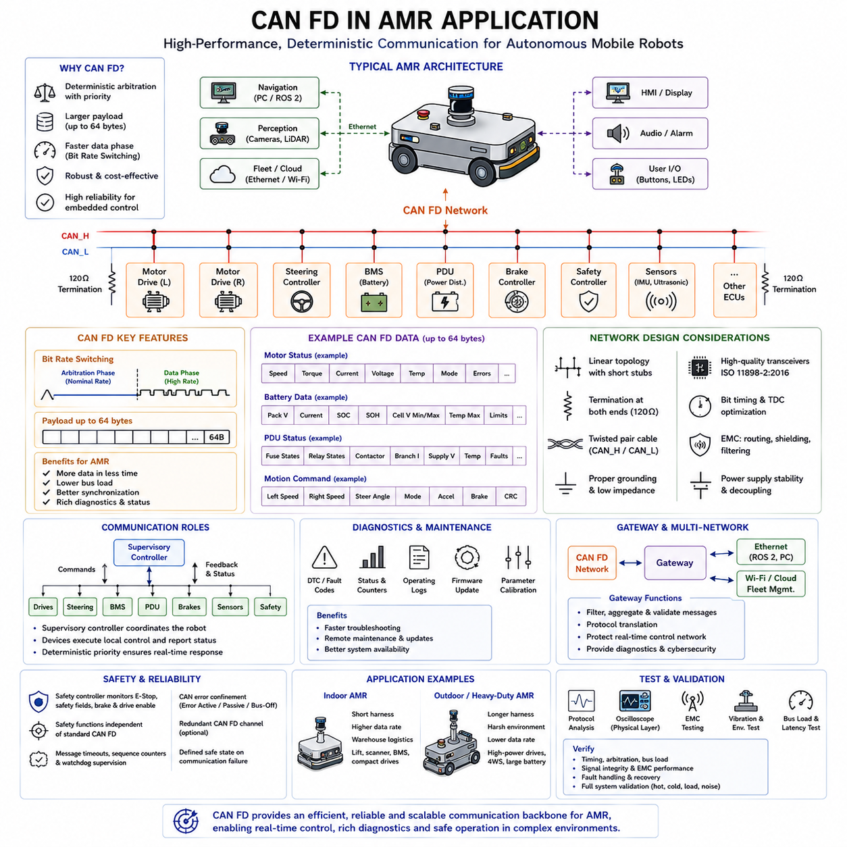
CAN FD is well suited to Autonomous Mobile Robot applications because it combines deterministic arbitration with a larger payload and a faster data phase. An AMR contains many distributed controllers that must exchange motion commands, actuator feedback, battery information, safety states, and diagnostic data in real time. CAN FD provides more bandwidth than Classical CAN while preserving the robust priority-based communication behavior required for embedded control.
In a typical AMR, the CAN FD network connects the supervisory controller with motor drives, steering actuators, the Battery Management System, the Power Distribution Unit, safety controllers, braking modules, and selected sensors. Each device remains responsible for its local control function while sharing status and commands through the common bus. This distributed structure reduces wiring complexity and allows subsystems to be developed, tested, and serviced as modular components.
The supervisory controller usually acts as the main coordination node rather than directly controlling every electrical output. It receives velocity targets from the navigation system, converts them into wheel or steering commands, and transmits the results to lower-level controllers. CAN FD carries these commands with predictable latency while returning encoder values, motor current, temperature, fault status, and operating mode information from each actuator.
Motor control is one of the most important CAN FD applications in an AMR. Each motor controller may report rotational speed, torque estimate, phase current, DC-link voltage, temperature, control state, and diagnostic flags. Classical CAN often requires these values to be divided among several frames. CAN FD can combine related feedback into a larger payload, reducing protocol overhead and improving the consistency of synchronized actuator data.
For differential-drive robots, the left and right wheel controllers must receive coordinated speed or torque commands. Even small timing differences can affect heading accuracy, path tracking, and stopping behavior. High-priority CAN FD messages can deliver both wheel commands within a predictable update cycle, while larger feedback frames return measured wheel speed, encoder position, current consumption, and controller health for motion estimation and fault detection.
Four-wheel-drive and multi-axle AMRs create even greater communication demands. Several drive motors, steering actuators, brakes, suspension modules, and wheel sensors may operate simultaneously. CAN FD allows the supervisory controller to exchange richer data with these distributed devices without increasing bus utilization excessively. This supports coordinated traction control, electronic differential functions, wheel-slip monitoring, and fault-tolerant motion control.
Steering systems also benefit from CAN FD communication. A steering controller may exchange target angle, measured angle, steering velocity, motor current, position-sensor status, calibration data, and fault information. In four-wheel-steering platforms, front and rear steering modules must remain synchronized according to the selected driving mode. CAN FD provides sufficient bandwidth for normal, crab, pivot, and reduced-radius steering commands while preserving deterministic message priority.
The Battery Management System is another major CAN FD node. Modern AMR batteries monitor cell voltages, pack voltage, current, temperatures, insulation status, balancing activity, contactor states, State of Charge, State of Health, and fault conditions. A CAN FD frame can carry more battery information at once, allowing the robot controller to make better decisions about available power, charging, derating, mission completion, and emergency shutdown.
More detailed battery reporting is especially valuable in high-capacity outdoor or heavy-duty AMRs. These platforms may experience rapid current changes during acceleration, climbing, steering, braking, or lifting operations. CAN FD allows the BMS to report dynamic limits such as allowable discharge current, regenerative charge current, thermal restrictions, and contactor readiness. The motion controller can then reduce performance before battery protection is triggered unexpectedly.
The Power Distribution Unit can use CAN FD to report fuse states, relay commands, contactor feedback, branch currents, supply voltages, temperature, and electrical faults. Intelligent PDUs may also support programmable load switching and controlled power sequencing. Through CAN FD, the supervisory controller can start or stop subsystems in the correct order, isolate faulty branches, and record electrical events without requiring separate control wires for every function.
Safety controllers may exchange emergency-stop status, protective field state, brake commands, drive-enable signals, safety relay feedback, and communication health information. Standard CAN FD communication alone does not automatically create a safety-rated network, but it can support safety-related architectures when combined with appropriate hardware, monitoring, redundancy, timing supervision, and application-layer safety mechanisms. Critical safety actions must remain independent of ordinary software failures.
A common design approach separates standard operational communication from certified safety functions. Normal CAN FD carries commands, status, diagnostics, and coordinated control data, while dedicated safety circuits or safety-rated communication handle emergency stopping and protective functions. The CAN FD network can still provide detailed safety status to the robot computer, enabling diagnostics and recovery procedures without becoming the only mechanism responsible for hazard prevention.
Message priority must reflect the operational importance of each AMR function. Emergency or fault-related information should use high-priority identifiers, followed by motion commands and actuator feedback. Battery limits, steering status, and braking information also require predictable delivery. Lower-priority messages may include detailed diagnostics, maintenance counters, event logs, configuration data, and software update traffic. Proper identifier planning preserves deterministic behavior under heavy network load.
CAN FD supports larger payloads of up to sixty-four bytes, which can simplify AMR message design. Related signals may be grouped into one coherent frame rather than divided across many small messages. For example, a motor-status frame may include speed, current, voltage, temperature, torque, mode, error code, and operating limits. This grouping reduces frame overhead and makes it easier for the receiver to process values originating from the same sampling interval.
Larger frames should nevertheless be designed carefully. Combining too many unrelated signals may increase latency for rapidly changing data or force unnecessary transmission of slowly changing values. Engineers should group signals according to function, update rate, priority, and timing sensitivity. Fast control variables may require short periodic frames, while diagnostic and configuration values can use longer CAN FD frames at lower frequencies.
Bit Rate Switching provides an additional performance advantage. Arbitration can occur at a robust nominal speed such as 500 kbps or 1 Mbps, while the data field is transmitted at 2 Mbps, 5 Mbps, or another validated rate. This reduces the time required to send large AMR status frames. The selected data rate must match the cable length, topology, transceiver characteristics, oscillator accuracy, and electromagnetic environment of the actual robot.
AMR wiring conditions can be challenging because the communication harness often passes near motor phases, inverters, DC-DC converters, relays, contactors, battery cables, and charging circuits. These devices generate conducted and radiated electromagnetic noise. The CAN FD network must therefore use a controlled twisted pair, proper termination, short stubs, suitable grounding, and carefully selected transceivers. Physical-layer quality is essential for reliable operation at higher data rates.
A linear bus topology is generally preferred inside the AMR. The two ends of the main backbone are terminated with approximately 120-ohm resistors, and each controller connects through a short stub. Long branches, star connections, and unused harness extensions should be avoided because they create impedance discontinuities and reflections. This becomes particularly important when the CAN FD data phase operates several times faster than the arbitration phase.
The location of termination resistors should be defined in the electrical architecture and wiring documentation. Removable controllers or optional modules can accidentally create missing or duplicated termination if the responsibility is unclear. Service technicians should be able to verify the effective bus resistance during maintenance. A correctly powered-down network typically shows an effective resistance near 60 ohms between CAN_H and CAN_L when two 120-ohm terminations are present.
Transceiver selection must reflect the intended AMR environment. An ISO 11898-2:2016-compatible CAN FD transceiver should support the target data rate, expected common-mode range, operating temperature, and fault conditions. Low propagation delay and good delay symmetry improve high-speed timing margin. Additional features such as dominant timeout, thermal shutdown, short-circuit protection, standby mode, and undervoltage detection improve robustness in mobile robotic systems.
Ground-potential differences can occur between controllers located near the battery, motors, sensors, and computing systems. Although CAN uses differential signaling, excessive ground offset can move bus voltages outside the receiver’s common-mode operating range. The robot grounding architecture should provide low-impedance return paths while preventing traction current from flowing through communication grounds. Isolation may be considered between electrically noisy or independently powered domains.
Galvanically isolated CAN FD can be useful when an AMR contains separate power domains, high-voltage equipment, charging interfaces, or externally connected payloads. Isolation reduces ground-loop current and protects sensitive controllers from abnormal voltages. However, isolated transceivers and digital isolators introduce propagation delay and jitter. Their timing performance must be included in the CAN FD bit-timing and Transceiver Delay Compensation analysis.
The CAN FD controller requires separate nominal and data-phase timing configurations. Engineers must select time quanta, synchronization jump widths, propagation segments, phase segments, and sampling points based on controller clock frequency and network delay. Timing should not be copied blindly from another system because cable length, controller type, transceiver delay, and oscillator tolerance may differ. Worst-case analysis is required for production-level reliability.
Transceiver Delay Compensation is especially important when the AMR uses a high data-phase rate. The controller observes the delay between its transmitted signal and the corresponding received bus signal, then adjusts the secondary sampling point. This helps compensate for the transceiver loop and local physical delay. Incorrect TDC configuration can cause errors that appear only at high speed, elevated temperature, or specific supply voltages.
Bus-load analysis should account for nominal arbitration time, data-phase time, bit stuffing, acknowledgements, error handling, and message repetition. Average utilization alone is not sufficient because AMR traffic often occurs in bursts. Starting motion, applying brakes, changing steering modes, recovering from faults, or connecting a charger may cause many nodes to transmit simultaneously. Worst-case latency should be evaluated for the most critical messages.
A well-designed communication schedule prevents diagnostic traffic from interfering with control loops. Periodic motion commands and feedback frames should have defined update rates and deadlines. Event-driven fault messages may interrupt lower-priority communication when necessary. Large calibration transfers, log uploads, or firmware updates should be rate-limited or performed while the robot is stopped. This preserves control stability and predictable response under all conditions.
CAN FD can support time-correlated actuator and sensor information, but it does not provide global time synchronization automatically. Message timestamps may be generated by the transmitting node or assigned by the supervisory controller. For precise multi-axis control, the system may use synchronization frames, local clock correction, or hardware-triggered sampling. The required method depends on whether the application needs millisecond-level coordination or much tighter timing accuracy.
Diagnostics are significantly improved by the larger payload and greater bandwidth of CAN FD. Each controller can report structured fault codes, operating snapshots, counters, firmware versions, reset causes, voltage history, and thermal conditions. The robot computer can collect these records and associate them with mission events. Richer diagnostic data reduces troubleshooting time and helps distinguish mechanical problems, electrical faults, communication errors, and software defects.
Unified Diagnostic Services may be implemented over CAN FD for controller identification, fault-code management, parameter reading, calibration, security access, and software download. CAN FD shortens many diagnostic transactions because larger transport-layer segments can be transmitted more efficiently. Service tools can access motor drives, BMS units, steering controllers, and other ECUs through a central diagnostic connector or gateway without direct physical access to every device.
Firmware updates are another important use case. Distributed AMR controllers require coordinated software maintenance throughout the product lifecycle. CAN FD can transfer larger software blocks faster than Classical CAN, reducing update time for motor controllers, power modules, and embedded sensors. The update architecture should include authentication, integrity checking, version control, recovery after interruption, and safeguards that prevent incompatible software combinations from being installed.
A communication gateway may connect the CAN FD network to Ethernet, ROS 2, a fleet computer, or a cloud service. High-level navigation and perception systems often use Ethernet because cameras, LiDARs, maps, and artificial intelligence data require much greater bandwidth. The gateway converts selected high-level commands and state information into compact CAN FD messages for distributed actuators while forwarding diagnostic information back to the main computer.
The gateway should not transmit all Ethernet or ROS traffic directly onto CAN FD. It must filter, aggregate, validate, and prioritize information according to the embedded control requirements. For example, a high-level velocity command may be converted into validated wheel-speed targets, while detailed camera data remains entirely on Ethernet. Clear interface boundaries protect the real-time control network from unnecessary traffic and malformed external messages.
Cybersecurity becomes increasingly important when CAN FD is connected to Ethernet, wireless communication, remote diagnostics, or fleet-management systems. Traditional CAN arbitration does not provide message encryption or sender authentication by itself. The system should therefore protect gateway access, diagnostic services, firmware updates, and configuration changes. Application-layer freshness values, message authentication, secure boot, access control, and network segmentation may be required according to the threat analysis.
Fault handling should distinguish communication errors from subsystem faults. A motor controller may stop responding because of a wiring fault, local reset, power loss, software failure, or bus-off condition. The supervisory controller should monitor message timeouts, sequence counters, error states, and controller availability. When communication is lost, the robot should enter a predefined degraded or safe state rather than continuing to operate with stale commands.
CAN error confinement helps prevent one faulty node from continuously disrupting the network. Controllers maintain transmit and receive error counters and may transition through error-active, error-passive, and bus-off states. The AMR software should monitor these conditions and define controlled recovery behavior. Automatic restart without diagnosis may repeatedly reconnect a defective node, while permanent shutdown may unnecessarily disable the robot after a temporary disturbance.
Redundant CAN FD channels may be used in mission-critical or safety-related AMRs. One network can serve as the primary control bus while another provides redundant communication or connects independent safety functions. Redundancy is effective only when common-cause failures are considered. Separate routing, power supplies, transceivers, connectors, and controller resources may be required to prevent one electrical fault from disabling both channels simultaneously.
Testing should include individual-node verification, subsystem integration, and complete-vehicle validation. Engineers must confirm message timing, arbitration behavior, bus utilization, error recovery, diagnostic communication, and software compatibility. Physical-layer testing should measure differential voltage, ringing, propagation delay, edge symmetry, and common-mode movement at multiple locations. Tests should be repeated at minimum and maximum supply voltage and across the required temperature range.
Electromagnetic compatibility testing should reproduce actual AMR operating conditions. Motors should accelerate and brake, steering actuators should move, relays and contactors should switch, chargers should connect, and DC-DC converters should operate at representative loads. Communication should be monitored for errors during these events. A network that performs well with stationary electronics may fail when the complete robot generates realistic electrical noise.
Mechanical and environmental testing is also necessary. Vibration can loosen connectors or create intermittent contact resistance, while moisture, dust, and corrosion may degrade the harness over time. Cable bending near steering or suspension mechanisms can damage conductors. Temperature changes alter oscillator frequency, transceiver delay, and termination resistance. CAN FD validation must therefore include the physical operating environment rather than focusing only on laboratory communication tests.
Maintenance design should make the network easy to inspect and diagnose. Accessible test points, documented termination locations, connector pin definitions, cable identifiers, and expected resistance values help technicians locate faults. Diagnostic software should display bus utilization, active nodes, error counters, missing messages, and recent communication events. Good serviceability reduces downtime and prevents unnecessary replacement of correctly functioning controllers.
In an indoor logistics AMR, CAN FD may connect compact wheel drives, lift mechanisms, brakes, BMS, safety scanners, and the main controller. The relatively short harness allows a high data-phase rate, while deterministic arbitration supports responsive motion control. Rich diagnostic frames help monitor motor temperature, wheel wear, battery condition, and lift status during continuous warehouse operation.
In an outdoor AMR, the same technology must tolerate longer harnesses, stronger electromagnetic noise, wider temperature ranges, water-resistant connectors, and larger power systems. Drive and steering modules may be distributed around a large chassis, increasing cable delay and ground offset. The selected CAN FD data rate may therefore be lower than that of a compact indoor robot, even though the network carries more devices and larger diagnostic datasets.
Heavy-duty AMRs can use CAN FD to coordinate multiple traction motors, four-wheel steering, hydraulic or electric lifting equipment, braking systems, and high-capacity batteries. The network enables centralized supervision while preserving local actuator control. Careful message planning allows safety and motion commands to retain priority over maintenance and logging traffic. Robust wiring, isolation, grounding, and redundant communication may be required for industrial reliability.
CAN FD does not replace Ethernet, EtherCAT, or dedicated safety networks in every AMR function. It is most effective for distributed embedded control where moderate bandwidth, deterministic priority, low cost, and strong fault handling are important. Cameras, 3D LiDARs, and AI computers generally remain on Ethernet, while CAN FD connects actuators, power electronics, safety interfaces, and intelligent peripheral modules. This layered architecture assigns each network technology to the tasks it performs best.
A successful CAN FD implementation in an AMR depends on the integration of protocol design, electrical engineering, software architecture, and validation. Larger payloads and Bit Rate Switching provide valuable performance improvements, but they cannot compensate for poor topology, incorrect termination, weak grounding, incompatible timing, or uncontrolled message traffic. Every controller, transceiver, cable, connector, and software interface must be treated as part of one communication system.
When properly engineered, CAN FD provides an effective communication backbone for modern Autonomous Mobile Robots. It supports deterministic control, detailed actuator feedback, comprehensive battery monitoring, intelligent power distribution, improved diagnostics, and faster software maintenance. Its compatibility with established CAN principles also reduces development risk while allowing AMR platforms to scale from compact indoor robots to complex outdoor and heavy-duty autonomous machines.

