Volume 06 Automotive Communication

Chapter 6. Diagnostics and UDS

6.1 OBD II Overview
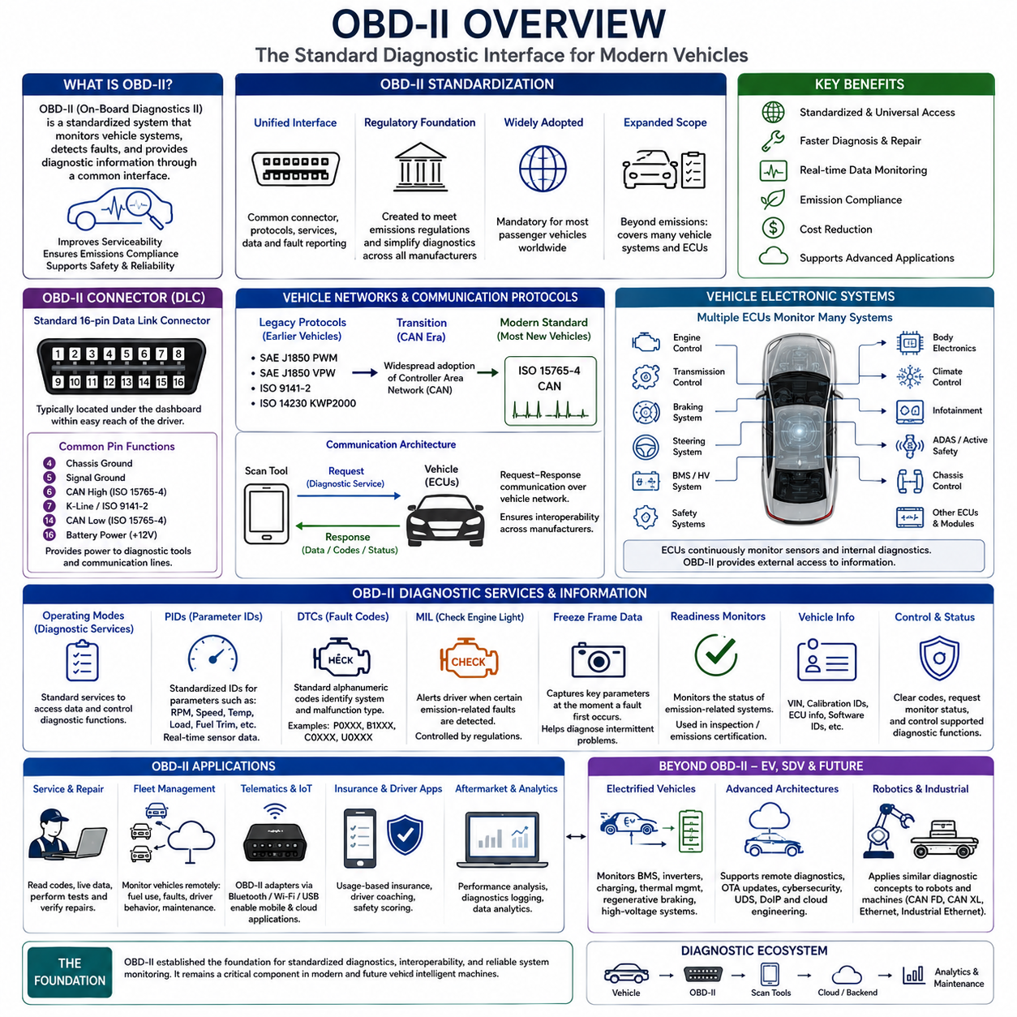
On-Board Diagnostics II (OBD-II) is the standardized diagnostic architecture used in modern road vehicles to monitor the health, performance, and emissions-related operation of electronic systems. Introduced to improve vehicle serviceability and environmental compliance, OBD-II provides a common interface through which diagnostic tools can communicate with electronic control units (ECUs). Instead of relying on manufacturer-specific diagnostic connectors and proprietary communication methods, OBD-II establishes standardized connectors, communication services, diagnostic parameters, and fault reporting mechanisms. Today, OBD-II serves as the foundation for vehicle diagnostics, maintenance, inspection programs, and fleet health monitoring across the global automotive industry.
The original motivation for OBD-II originated from increasingly strict environmental regulations requiring continuous monitoring of emission control systems. Earlier diagnostic systems varied significantly between manufacturers, making service procedures complicated and expensive. Regulatory authorities recognized the need for a unified diagnostic framework capable of detecting emission-related malfunctions regardless of vehicle manufacturer. OBD-II therefore standardized the diagnostic connector, communication protocols, diagnostic trouble code format, parameter identification methods, and malfunction indicator operation. Although emissions monitoring remains its primary legal purpose, the diagnostic capabilities of OBD-II have expanded far beyond environmental compliance.
Modern vehicles contain numerous ECUs responsible for engine management, transmission control, braking, steering, battery management, body electronics, safety systems, climate control, and infotainment. These controllers continuously monitor hundreds or even thousands of operating variables using distributed sensors and internal software diagnostics. OBD-II provides an external communication interface through which technicians, diagnostic equipment, and engineering tools can request operational data, read fault information, verify system status, and perform standardized diagnostic procedures without requiring direct access to individual controller software.
The standardized sixteen-pin Data Link Connector (DLC) represents one of the most recognizable elements of OBD-II. This connector is normally installed beneath the dashboard within convenient reach of the driver compartment, allowing diagnostic equipment to connect quickly during servicing or inspection. The connector provides electrical power for scan tools while exposing communication lines supporting one or more vehicle network protocols. Standardizing the connector location and pin assignment allows universal diagnostic tools to communicate with a wide variety of vehicles without requiring manufacturer-specific hardware adapters.
Although the physical connector is standardized, OBD-II has historically supported multiple communication protocols. Earlier implementations utilized protocols such as SAE J1850 PWM, SAE J1850 VPW, ISO 9141-2, and ISO 14230 Keyword Protocol 2000. As Controller Area Network (CAN) technology became widely adopted throughout the automotive industry, ISO 15765-4 CAN gradually became the mandatory communication protocol for most new passenger vehicles. This transition significantly improved communication speed, reliability, interoperability, and diagnostic capability while simplifying service equipment design across manufacturers.
Communication between diagnostic equipment and vehicle controllers follows a request-response architecture. A scan tool sends a standardized diagnostic request through the vehicle network, and the appropriate ECU returns the requested information if supported. This architecture allows diagnostic devices ranging from professional engineering equipment to inexpensive consumer scan tools to retrieve standardized operational information. The communication process is carefully defined to ensure interoperability among vehicles from different manufacturers while preserving flexibility for manufacturer-specific extensions beyond standardized diagnostic services.
OBD-II organizes diagnostic functionality through standardized operating modes, commonly referred to as diagnostic services. These services provide access to current sensor values, stored fault codes, freeze frame information, oxygen sensor performance, emissions readiness monitors, vehicle identification information, and diagnostic trouble code management. Standardized service definitions enable diagnostic software to operate consistently across multiple manufacturers while allowing individual vehicle platforms to implement additional proprietary diagnostic capabilities when necessary.
Parameter IDs, commonly known as PIDs, provide standardized access to vehicle operating data. Each PID represents a specific measurable parameter such as engine speed, coolant temperature, intake air temperature, vehicle speed, fuel system status, throttle position, manifold pressure, calculated engine load, oxygen sensor outputs, or fuel trim values. Diagnostic software interprets the raw numerical data returned by the ECU according to standardized scaling equations, allowing technicians to observe real-time operating conditions without requiring detailed knowledge of internal controller software implementation.
Diagnostic Trouble Codes (DTCs) form another essential component of the OBD-II architecture. Whenever an ECU detects abnormal operating conditions that satisfy predefined fault detection criteria, it stores a standardized alphanumeric code identifying the affected subsystem and malfunction category. The code structure allows technicians to quickly determine whether the problem relates to powertrain, body electronics, chassis systems, or network communication. Standardized DTC formatting significantly improves diagnostic consistency while reducing ambiguity during maintenance and repair operations.
The Malfunction Indicator Lamp (MIL), often referred to as the Check Engine Light, provides immediate notification to the vehicle operator whenever certain emission-related faults are detected. Rather than indicating every possible abnormal condition, MIL illumination follows carefully defined regulatory requirements intended to identify failures affecting emissions performance or system reliability. Some faults trigger immediate illumination, while others require repeated detection across multiple driving cycles before the warning indicator becomes active. This strategy minimizes unnecessary driver concern while ensuring important problems receive timely attention.
Freeze Frame Data enhances diagnostic accuracy by recording selected operating conditions at the moment a significant fault is first detected. Instead of merely storing the fault code itself, the ECU captures important parameters including engine speed, vehicle speed, engine load, coolant temperature, fuel trim values, throttle position, and other operational variables. This historical snapshot assists technicians in reproducing intermittent problems and understanding the environmental conditions present when the malfunction occurred, significantly improving troubleshooting efficiency.
Readiness monitors represent another important feature of OBD-II diagnostics. Modern vehicles continuously evaluate numerous emissions-related subsystems including catalytic converters, oxygen sensors, evaporative emission control systems, exhaust gas recirculation systems, secondary air injection, misfire detection, and fuel system performance. Each monitor reports whether diagnostic testing has successfully completed since recent fault memory clearing or battery disconnection. Inspection programs often verify monitor completion before accepting vehicles for emissions certification, ensuring all relevant diagnostic evaluations have been executed.
OBD-II plays a central role in modern vehicle maintenance by allowing technicians to observe live operational data while the vehicle remains in normal operating conditions. Real-time monitoring of sensor outputs, actuator commands, fuel system behavior, ignition timing, battery voltage, airflow measurements, and numerous additional parameters enables efficient diagnosis of intermittent faults that may not be apparent during stationary inspection. Continuous data observation also supports preventive maintenance by identifying abnormal operating trends before complete component failure occurs.
Professional diagnostic systems extend beyond standardized OBD-II functionality by integrating manufacturer-specific diagnostic services. While standardized OBD-II primarily focuses on emissions-related functions, advanced diagnostic tools access proprietary controller information supporting body electronics, airbag systems, transmission adaptation, advanced driver assistance systems, suspension control, battery management, and software programming. Nevertheless, standardized OBD-II remains the universal entry point through which diagnostic communication is initially established across nearly all modern passenger vehicles.
The widespread availability of inexpensive OBD-II adapters has enabled entirely new categories of automotive applications. Bluetooth, Wi-Fi, and USB diagnostic interfaces allow smartphones, tablets, laptops, and cloud-connected fleet management systems to retrieve operational vehicle data in real time. Fleet operators monitor fuel consumption, engine utilization, maintenance intervals, fault codes, driver behavior, and vehicle health remotely using standardized diagnostic information. Insurance telematics, driver coaching applications, predictive maintenance platforms, and aftermarket performance analysis tools similarly benefit from standardized OBD-II access.
Electrified vehicles continue to utilize OBD-based diagnostic concepts while expanding monitored subsystems considerably. Hybrid and battery-electric vehicles introduce battery management systems, high-voltage inverters, electric drive units, charging systems, thermal management controllers, regenerative braking systems, and power distribution electronics requiring advanced diagnostic capability. Although many diagnostic principles remain unchanged, future diagnostic architectures increasingly incorporate additional parameters reflecting high-voltage system health, battery condition, charging performance, and electric propulsion operation beyond conventional internal combustion engine diagnostics.
The growing complexity of Software-Defined Vehicles is gradually expanding the role of diagnostic communication. Vehicles increasingly require remote diagnostics, over-the-air software updates, cybersecurity monitoring, predictive maintenance, software version management, digital certificate verification, and cloud-based engineering analysis. Traditional OBD-II continues serving as an important local diagnostic interface, while newer protocols such as Unified Diagnostic Services (UDS) and Diagnostics over Internet Protocol (DoIP) provide additional functionality for increasingly sophisticated electronic architectures. OBD-II therefore remains an essential component within a broader diagnostic ecosystem rather than serving as the sole diagnostic technology.
Autonomous Mobile Robots and intelligent industrial machines increasingly adopt diagnostic principles conceptually similar to OBD-II despite operating outside automotive regulatory environments. Distributed controllers, battery systems, motor drives, perception sensors, navigation computers, safety controllers, and communication gateways all benefit from standardized fault reporting, health monitoring, parameter access, and predictive maintenance capabilities. Future robotic diagnostic architectures may employ communication standards such as CAN FD, CAN XL, Automotive Ethernet, or industrial Ethernet while preserving many organizational concepts established by OBD-II, including standardized fault identification, structured operational data, historical event recording, and systematic health evaluation.
The long-term significance of OBD-II extends well beyond emissions regulation. It established the foundation for standardized electronic diagnostics, interoperable service equipment, structured fault reporting, and universal communication interfaces across the automotive industry. As vehicles continue evolving toward centralized computing, software-defined functionality, cloud connectivity, and autonomous operation, OBD-II remains a fundamental building block supporting maintenance, diagnostics, fleet operations, engineering analysis, and lifecycle management. Its underlying principles continue influencing the design of future diagnostic systems for intelligent vehicles, autonomous robots, and other complex cyber-physical platforms where reliable system health monitoring is essential.

6.2 ISO 14229 UDS Architecture
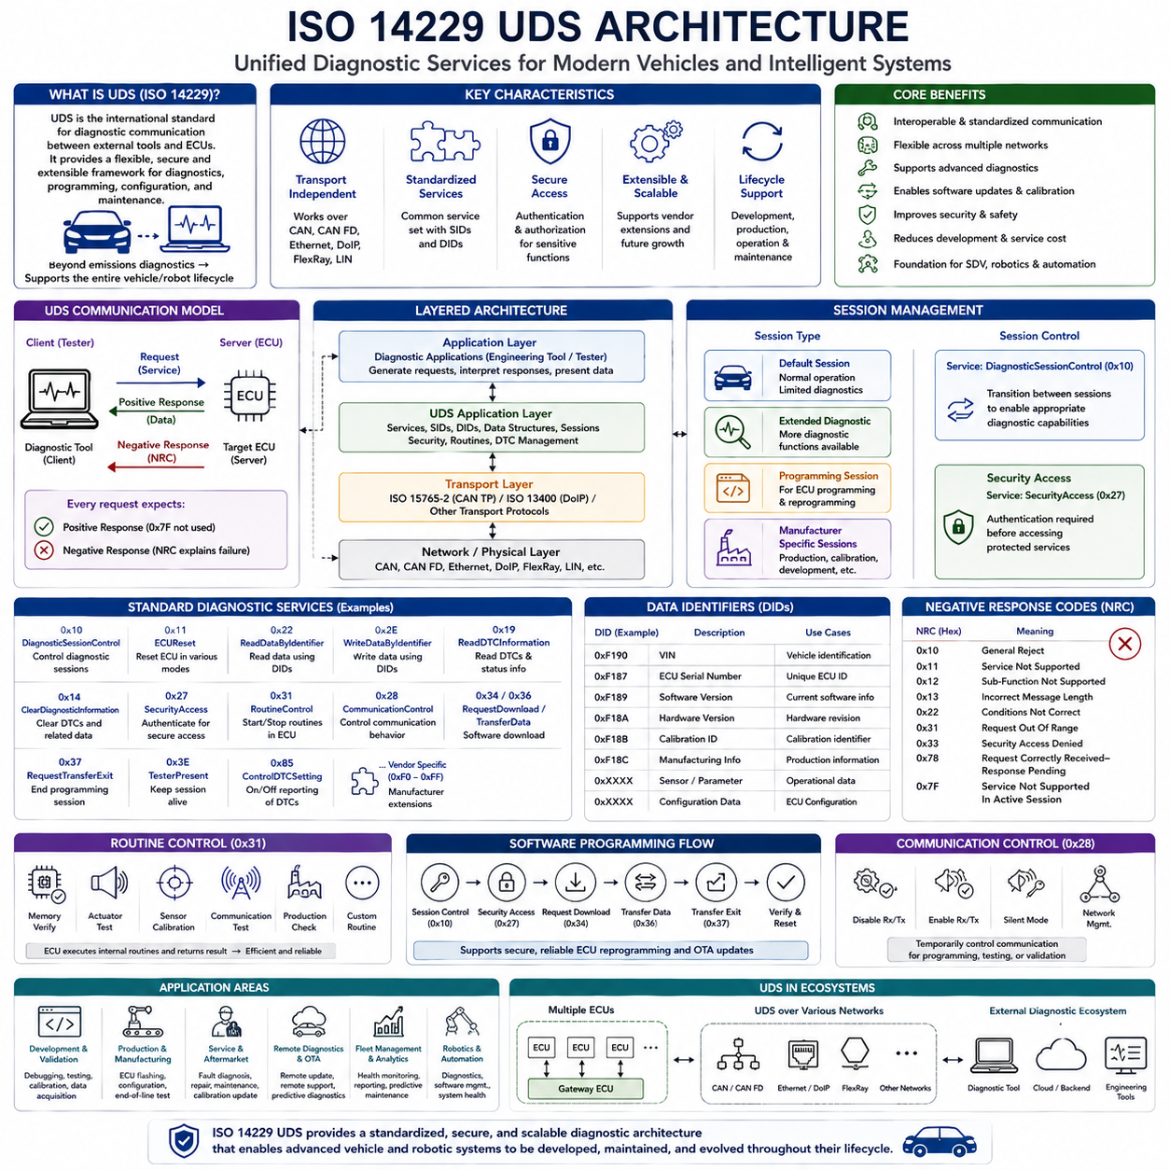
Unified Diagnostic Services (UDS), standardized as ISO 14229, is the primary diagnostic communication architecture used in modern automotive electronic systems. It defines a comprehensive set of diagnostic services that enable external diagnostic equipment to communicate with Electronic Control Units (ECUs) throughout a vehicle. Unlike traditional diagnostic approaches that focused mainly on emission-related information, UDS provides a flexible framework supporting fault diagnosis, software programming, calibration, configuration management, security access, routine execution, data acquisition, and system maintenance. The architecture has become a fundamental component of modern Software-Defined Vehicles (SDVs) and increasingly serves as the foundation for diagnostics in intelligent robotic and industrial platforms.
ISO 14229 was developed to provide a unified diagnostic architecture that operates independently of the underlying communication medium. Rather than being limited to a single physical network, UDS can function over Controller Area Network (CAN), CAN FD, Automotive Ethernet, FlexRay, LIN for selected applications, and Diagnostics over Internet Protocol (DoIP). This separation between diagnostic services and transport mechanisms allows manufacturers to adopt new communication technologies without redesigning the diagnostic software architecture. As vehicle networking evolves, the same diagnostic application layer remains largely unchanged while transport layers continue to improve.
The UDS architecture follows a layered communication model in which the diagnostic application operates above standardized transport protocols. At the highest level, diagnostic applications running on engineering tools or service equipment generate diagnostic requests. These requests pass through communication middleware and transport protocols before reaching the target ECU. The ECU interprets the request, performs the requested operation, and returns either the requested data or an appropriate response message. This layered organization improves modularity, portability, interoperability, and long-term maintainability across different vehicle platforms.
Communication within UDS follows a client-server architecture. The diagnostic tester acts as the client, while individual ECUs function as diagnostic servers. A client initiates every communication transaction by sending a diagnostic request to a selected ECU. The server validates the request, verifies access permissions, executes the requested service, and returns either a positive response indicating successful completion or a negative response describing why the request could not be executed. This deterministic request-response model simplifies communication management while supporting multiple independent ECUs throughout the vehicle.
A diagnostic session represents one of the central concepts within the UDS architecture. Instead of allowing unrestricted access to every diagnostic function at all times, UDS organizes ECU behavior into multiple operating sessions. A default session supports normal vehicle operation with limited diagnostic capability, while extended diagnostic sessions provide access to additional engineering functions. Programming sessions enable software downloading and ECU reprogramming, and manufacturer-defined sessions may support specialized production, calibration, or development activities. Session control improves both operational safety and system security by exposing advanced functions only when appropriate.
Service identifiers, commonly called SIDs, uniquely define every diagnostic operation supported by UDS. Each service corresponds to a specific diagnostic capability such as reading data, writing parameters, controlling routines, clearing fault memory, requesting diagnostic trouble codes, programming software, or managing communication behavior. Standardized service identifiers ensure consistent interpretation across manufacturers while still allowing vendor-specific extensions for proprietary functionality. This structured service organization greatly simplifies diagnostic software development and interoperability between service equipment and vehicle controllers.
The architecture distinguishes clearly between application data and communication management. Application-level services retrieve sensor values, configuration parameters, calibration constants, identification information, and software metadata. Communication management services establish sessions, authenticate users, control timing behavior, maintain communication state, and supervise message sequencing. Separating these responsibilities allows application software to evolve independently from communication infrastructure while improving software reuse across different vehicle platforms.
Diagnostic communication relies heavily on standardized data identifiers known as DIDs. A Data Identifier uniquely specifies a particular information object stored within an ECU. Examples include vehicle identification numbers, ECU serial numbers, software versions, hardware revisions, calibration identifiers, manufacturing information, configuration parameters, operational statistics, and sensor measurements. Diagnostic clients request specific DIDs, and the ECU returns the corresponding information according to standardized message formats. This structured data access mechanism greatly simplifies engineering, manufacturing, servicing, and lifecycle management.
The UDS architecture incorporates robust response handling mechanisms to improve communication reliability. Every request expects either a positive response confirming successful execution or a negative response identifying the reason for failure. Negative responses may indicate unsupported services, invalid parameters, insufficient security privileges, incorrect session state, busy processing conditions, or communication timing violations. Standardized response codes enable diagnostic tools to interpret failures consistently while providing meaningful guidance during troubleshooting and software development.
Timing management represents another important architectural component of ISO 14229. Diagnostic communication often involves operations requiring significantly longer execution times than ordinary control messages. Software programming, memory verification, flash erasure, calibration updates, and routine execution may require hundreds of milliseconds or even several seconds to complete. UDS defines timing parameters and response management procedures allowing ECUs to notify clients that processing continues while preventing unnecessary communication timeouts. These mechanisms improve reliability during complex diagnostic operations.
Security plays a critical role within modern UDS implementations. Advanced diagnostic capabilities such as parameter modification, software programming, security configuration, or actuator control could introduce significant safety risks if unauthorized access were permitted. Consequently, sensitive services are protected through standardized security access procedures. Diagnostic clients must successfully authenticate themselves before privileged functions become available. Although authentication algorithms differ among manufacturers, the architectural framework provided by ISO 14229 supports consistent implementation of secure diagnostic communication across diverse vehicle platforms.
Routine control services provide a standardized mechanism through which diagnostic equipment can request the ECU to execute predefined internal functions. Instead of transferring detailed algorithms to external equipment, the ECU performs built-in diagnostic routines locally and reports the results. Typical routines include memory verification, actuator functional tests, sensor calibration procedures, communication self-tests, checksum validation, production verification, and manufacturing quality inspections. This architecture minimizes communication bandwidth while maintaining software consistency across diagnostic environments.
Communication control services allow diagnostic tools to modify network behavior temporarily during engineering or manufacturing activities. Certain diagnostic operations require suppression of normal network traffic, selective communication disabling, or specialized operating modes to ensure reliable software programming or system validation. UDS defines standardized methods for managing communication behavior without permanently affecting normal vehicle operation. After diagnostic procedures are completed, the ECU returns automatically to standard communication behavior.
Software programming represents one of the most sophisticated applications supported by the UDS architecture. Modern vehicles require periodic firmware updates throughout their operational lifetime to improve functionality, correct software defects, enhance cybersecurity, and support new features. UDS provides standardized services supporting memory preparation, secure data transfer, block verification, integrity checking, programming completion, and post-programming validation. These services form the foundation for both workshop software updates and increasingly important Over-the-Air (OTA) deployment systems.
Diagnostic Trouble Code management is closely integrated into the UDS architecture. ECUs continuously monitor internal hardware, software execution, sensor validity, communication integrity, and system behavior. When abnormal conditions satisfy predefined diagnostic criteria, standardized trouble codes are stored within diagnostic memory together with supporting status information. UDS services allow diagnostic clients to retrieve stored faults, clear diagnostic memory after repairs, obtain detailed status records, and monitor fault evolution throughout the system lifecycle.
The architecture also supports engineering-oriented data acquisition beyond ordinary maintenance activities. Development teams frequently require access to internal controller variables, calibration values, execution counters, software states, communication statistics, thermal conditions, and performance indicators during system validation. UDS provides structured mechanisms for accessing these engineering datasets while preserving compatibility with production diagnostic equipment. This capability significantly reduces development effort by allowing the same diagnostic architecture to support manufacturing, validation, maintenance, and field servicing.
Gateway ECUs have become increasingly important as vehicle electronic architectures grow more complex. Modern vehicles often contain multiple communication domains connected through intelligent gateways. UDS architecture accommodates this evolution by allowing diagnostic requests to be routed transparently between communication networks. Whether the target ECU resides on CAN, CAN FD, Automotive Ethernet, or another supported network, diagnostic applications continue using the same standardized service definitions. Gateway routing therefore simplifies diagnostic tool implementation while supporting heterogeneous network architectures.
The emergence of centralized computing and Software-Defined Vehicles further expands the importance of ISO 14229. Instead of communicating solely with distributed ECUs, future diagnostic systems increasingly interact with high-performance computing platforms managing numerous virtual software functions. UDS continues providing standardized diagnostic services while integrating with cybersecurity frameworks, cloud connectivity, digital certificates, remote maintenance, predictive diagnostics, and lifecycle software management. The protocol therefore evolves alongside vehicle architecture without fundamentally changing its application-layer design principles.
Robotics and intelligent industrial automation increasingly benefit from architectural concepts established by UDS. Autonomous Mobile Robots, humanoid robots, quadrupeds, industrial manipulators, agricultural machines, construction equipment, and autonomous mining vehicles all contain distributed controllers requiring standardized diagnostics, software management, configuration services, and predictive maintenance. Although communication networks may employ CAN FD, CAN XL, Automotive Ethernet, EtherCAT, or industrial Ethernet, the client-server organization, session management, security architecture, standardized services, and structured diagnostic communication defined by ISO 14229 provide valuable design principles for future robotic diagnostic systems.
The long-term significance of ISO 14229 extends beyond automotive diagnostics alone. It establishes a scalable, modular, transport-independent diagnostic architecture capable of supporting increasingly intelligent cyber-physical systems. By separating application services from communication transport, organizing functionality into standardized services, protecting sensitive operations through controlled access, and supporting software lifecycle management, UDS provides an architectural foundation suitable for future generations of connected vehicles, autonomous robots, industrial automation systems, and software-defined machines. As embedded systems continue increasing in complexity, the architectural principles embodied within ISO 14229 will remain essential for reliable diagnostics, maintainability, interoperability, and secure lifecycle management across intelligent engineering platforms.

6.3 UDS Service 0x22 0x2E ReadWrite
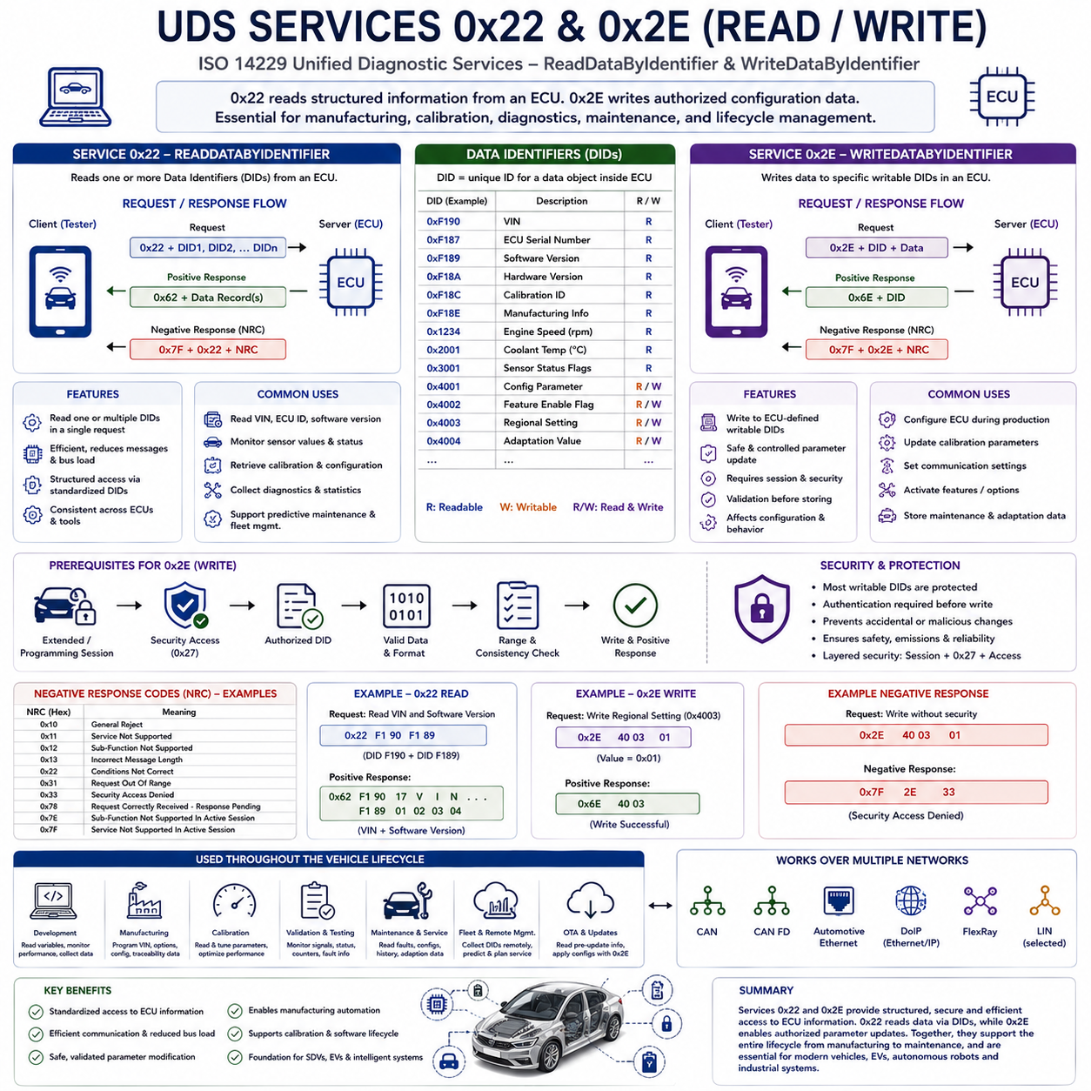
The Unified Diagnostic Services (UDS) protocol defined in ISO 14229 provides a comprehensive collection of standardized diagnostic services that allow external diagnostic equipment to communicate with Electronic Control Units (ECUs). Among these services, Service 0x22 (ReadDataByIdentifier) and Service 0x2E (WriteDataByIdentifier) are two of the most frequently used functions because they provide direct access to structured diagnostic information stored within an ECU. Together they form the foundation of parameter retrieval and parameter modification throughout the entire vehicle lifecycle, including manufacturing, calibration, maintenance, software validation, engineering development, and field diagnostics. Their standardized behavior enables diagnostic tools from different vendors to communicate consistently with compliant ECUs while preserving manufacturer-specific flexibility through configurable Data Identifiers (DIDs).
Service 0x22, formally known as ReadDataByIdentifier, enables a diagnostic client to request specific information stored inside an ECU. Instead of reading arbitrary memory addresses, the client requests predefined Data Identifiers that represent structured information objects managed by the ECU software. Each DID corresponds to a particular item such as a Vehicle Identification Number (VIN), ECU serial number, software version, calibration identifier, hardware revision, production information, sensor value, configuration parameter, or operational statistic. This abstraction layer hides the physical memory organization from the diagnostic client while ensuring consistent access regardless of ECU implementation details.
The architecture of Service 0x22 follows the standard UDS client-server communication model. A diagnostic tester generates a request containing Service Identifier 0x22 followed by one or more Data Identifiers. After validating the request, the target ECU retrieves the requested information from its internal software structures and returns the corresponding data within a positive response. If the requested DID is unsupported, unavailable, protected, or temporarily inaccessible, the ECU generates a standardized Negative Response Code (NRC) describing the reason for rejection. This deterministic request-response mechanism allows engineering tools and service equipment to retrieve information predictably across different vehicle platforms.
One important characteristic of Service 0x22 is its support for multiple Data Identifiers within a single request. Rather than requiring separate communication transactions for each parameter, a diagnostic tester may request several DIDs simultaneously if the ECU implementation supports this capability. Reading multiple information objects together reduces communication overhead, improves diagnostic efficiency, minimizes bus utilization, and accelerates maintenance operations. This feature becomes increasingly valuable in modern vehicles containing numerous distributed controllers with extensive diagnostic information.
Data Identifiers provide a highly structured method for organizing ECU information. Rather than exposing low-level memory locations, every diagnostic object receives a unique numerical identifier defined by the ECU software. Standardized DIDs specified by international standards support common information such as vehicle identification or software versions, while manufacturers define proprietary DIDs representing application-specific variables unique to individual vehicle platforms. This combination of standardized and proprietary identifiers provides both interoperability and design flexibility without compromising software architecture.
Many engineering applications rely heavily on Service 0x22 during product development. Calibration engineers continuously retrieve internal variables to evaluate controller performance under various operating conditions. Validation engineers monitor sensor values, communication statistics, actuator states, execution counters, diagnostic status flags, environmental measurements, and software variables throughout testing campaigns. Production facilities similarly utilize Service 0x22 to verify hardware configuration, manufacturing information, software installation status, and quality assurance parameters before vehicles leave the assembly line.
Service 0x22 also plays an important role in predictive maintenance and fleet management systems. Modern vehicles continuously accumulate operational information regarding battery condition, thermal behavior, actuator utilization, communication quality, environmental exposure, accumulated operating hours, maintenance history, and diagnostic statistics. Fleet management platforms periodically retrieve selected DIDs through onboard diagnostic gateways, allowing maintenance planning to shift from reactive repair toward condition-based servicing. This capability significantly improves vehicle availability while reducing unexpected failures and maintenance costs.
Complementing Service 0x22, Service 0x2E provides standardized WriteDataByIdentifier functionality. Instead of retrieving information from an ECU, this service allows authorized diagnostic equipment to modify predefined configuration data stored within the controller. Unlike unrestricted memory programming, Service 0x2E only permits modification of specific writable Data Identifiers that have been intentionally exposed by ECU software designers. This controlled architecture ensures configuration changes remain safe, traceable, and compatible with overall system integrity.
Writing data to an ECU requires considerably stricter validation than reading information. Before accepting any modification request, the ECU verifies that the requested DID supports write access, confirms the diagnostic session permits parameter modification, validates security authorization, checks message length and formatting, evaluates data ranges, and ensures requested values satisfy application-specific consistency rules. Only after all validation steps have been completed successfully does the ECU store the new parameter and generate a positive response confirming completion of the requested operation.
Security considerations are particularly important for Service 0x2E because unauthorized parameter modification could directly affect vehicle safety, emissions compliance, or operational reliability. Consequently, most writable DIDs remain inaccessible during the default diagnostic session. Diagnostic clients typically enter an Extended Diagnostic Session or Programming Session before requesting Security Access using Service 0x27. Only after successful authentication are protected WriteDataByIdentifier operations permitted. This layered security architecture prevents accidental or malicious modification of critical system parameters while preserving necessary engineering functionality.
Configuration parameters written through Service 0x2E vary significantly depending on ECU functionality. Examples include communication settings, feature activation flags, regional configuration options, calibration constants, adaptation parameters, manufacturing information, customer customization settings, controller initialization values, and maintenance records. Certain safety-related controllers intentionally restrict writable parameters to an absolute minimum, whereas engineering development platforms may expose considerably larger sets of configurable variables during prototype evaluation.
Many production and manufacturing processes depend extensively on Service 0x2E. During final assembly, manufacturing systems configure each ECU according to the specific vehicle being produced. Vehicle Identification Numbers, option codes, regional settings, calibration selections, production timestamps, supplier identifiers, security certificates, and manufacturing traceability information may all be written automatically through standardized diagnostic procedures. This automated configuration process significantly improves manufacturing efficiency while ensuring consistent controller initialization across large production volumes.
Calibration activities similarly utilize WriteDataByIdentifier during engineering development. Control algorithms governing engines, transmissions, batteries, electric motors, braking systems, steering systems, and thermal management frequently require parameter optimization under varying environmental conditions. Engineers may temporarily modify selected calibration values using Service 0x2E during laboratory testing before permanently incorporating optimized parameters into production software through subsequent programming operations. This separation between temporary configuration updates and complete software reprogramming provides considerable development flexibility.
Error handling represents another important aspect of both services. If Service 0x22 requests an unsupported DID, the ECU typically responds with a Negative Response Code indicating that the requested identifier cannot be processed. Similarly, Service 0x2E may reject write requests due to insufficient security privileges, invalid diagnostic session, incorrect message length, unsupported identifiers, out-of-range values, or application-specific validation failures. Standardized error reporting allows diagnostic software to provide meaningful guidance while simplifying troubleshooting during maintenance and development.
Both services contribute significantly to software lifecycle management within Software-Defined Vehicles. As modern vehicles increasingly receive Over-the-Air software updates, configuration changes, cybersecurity improvements, feature activation packages, and cloud-based service enhancements, structured reading and writing of diagnostic information becomes increasingly important. Service 0x22 retrieves current configuration, software metadata, and operational status before updates begin, while Service 0x2E safely modifies configuration parameters required during installation, activation, or migration between software versions.
Gateway ECUs frequently coordinate the operation of Services 0x22 and 0x2E across distributed vehicle networks. Diagnostic requests originating from engineering tools may traverse multiple communication domains including CAN, CAN FD, Automotive Ethernet, or Diagnostics over Internet Protocol before reaching the destination ECU. Gateway controllers transparently forward diagnostic messages while preserving the standardized application-layer behavior defined by ISO 14229. Consequently, diagnostic software continues operating consistently regardless of underlying network topology or transport technology.
Electrified vehicles introduce additional applications for these services. Battery Management Systems, power electronics controllers, charging modules, thermal management systems, and electric drive controllers expose numerous diagnostic parameters through readable Data Identifiers. Authorized write operations configure battery characteristics, charging parameters, regional charging behaviors, thermal control settings, and maintenance information. As electrification continues expanding, structured parameter management through standardized diagnostic services becomes increasingly important throughout vehicle operation and servicing.
Autonomous Mobile Robots and intelligent industrial systems can benefit from architectural concepts established by Services 0x22 and 0x2E. Distributed robot controllers, battery management units, motor drives, perception modules, navigation computers, and safety controllers require standardized mechanisms for retrieving operational information and updating configuration parameters throughout deployment and maintenance. Whether communication occurs through CAN FD, CAN XL, Automotive Ethernet, or industrial Ethernet, the structured identifier-based access model provided by ISO 14229 offers an effective approach for organizing diagnostic information within complex robotic platforms.
The long-term importance of ReadDataByIdentifier and WriteDataByIdentifier extends well beyond ordinary vehicle diagnostics. Together these services establish a standardized mechanism for structured information management across the complete lifecycle of embedded systems. They enable manufacturing automation, engineering development, software validation, predictive maintenance, fleet management, remote diagnostics, cybersecurity management, software-defined functionality, and intelligent lifecycle support while maintaining interoperability across diverse hardware platforms. As vehicles and autonomous machines become increasingly software-centric, the architectural principles embodied in Services 0x22 and 0x2E will continue serving as essential building blocks for secure, scalable, and maintainable diagnostic communication.

6.4 UDS 0x27 Security Access
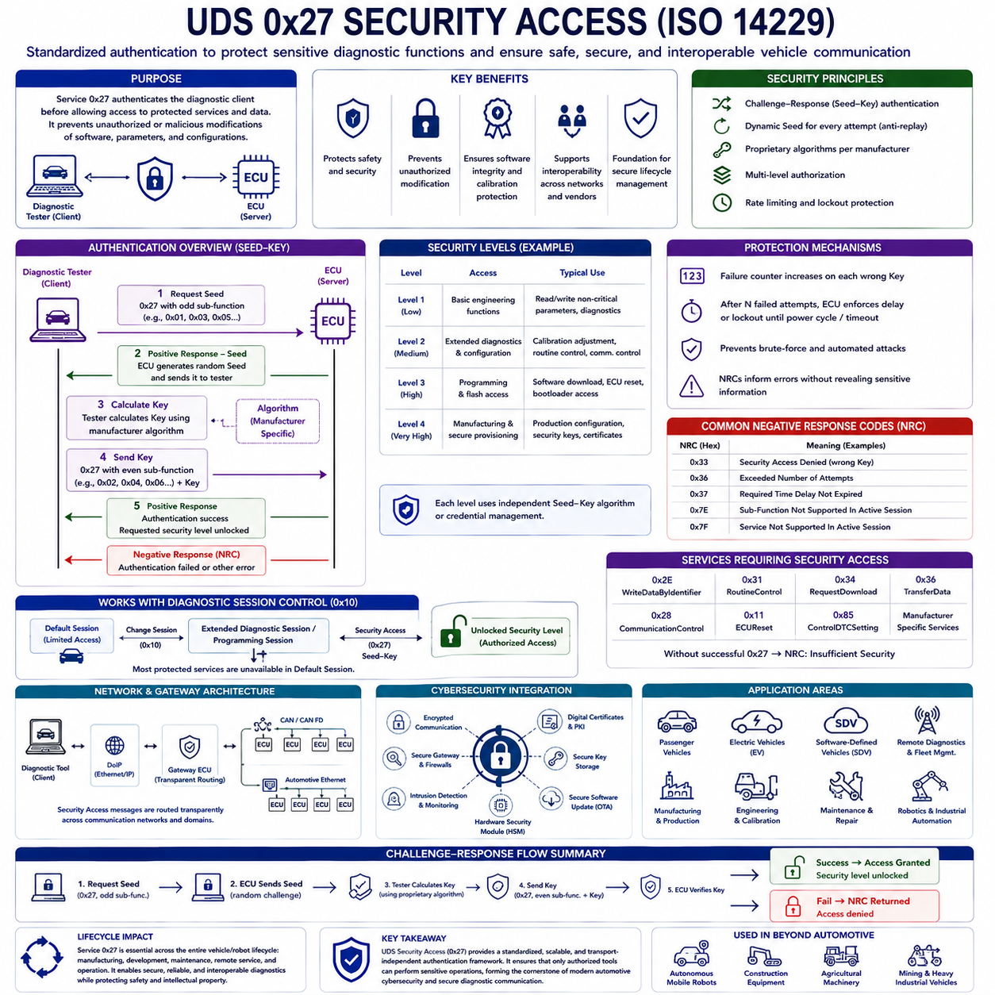
The Unified Diagnostic Services (UDS) protocol defined by ISO 14229 provides numerous diagnostic services that enable external diagnostic equipment to communicate with Electronic Control Units (ECUs). Among these services, Service 0x27, known as Security Access, serves as the primary authentication mechanism protecting sensitive diagnostic functions from unauthorized access. Modern vehicles contain numerous software-configurable features, safety-critical parameters, firmware programming capabilities, and proprietary calibration data that must remain inaccessible to unauthorized users. Service 0x27 establishes a standardized security framework allowing only authenticated diagnostic clients to execute privileged operations while maintaining interoperability across different manufacturers and communication networks.
The primary purpose of Security Access is to prevent accidental, unauthorized, or malicious modification of vehicle software and configuration. Reading basic diagnostic information may generally be permitted without authentication, but operations such as software programming, calibration updates, parameter modification, communication control, routine execution, coding changes, and security configuration require elevated privileges. Rather than permanently exposing these functions, the ECU unlocks protected services only after successfully completing the Security Access procedure. This layered architecture significantly improves system safety, cybersecurity, and software integrity throughout the entire vehicle lifecycle.
Security Access follows a challenge-response authentication model rather than relying on static passwords. Instead of transmitting a secret key directly across the communication network, the ECU generates a random challenge known as a Seed and sends it to the diagnostic tester. The diagnostic client calculates a cryptographic response called the Key using a manufacturer-defined algorithm and returns the result to the ECU. The ECU independently performs the same calculation and compares both values. If the received Key matches the internally calculated value, authentication succeeds and the requested security level becomes available.
This Seed-Key architecture provides considerably stronger protection than simple password authentication. Because the Seed changes with every authentication attempt, replay attacks become much more difficult. An attacker capturing previous communication cannot simply resend an earlier Key because each authentication sequence depends upon a newly generated challenge. Consequently, Security Access remains effective even when diagnostic communication occurs over publicly accessible interfaces such as the Diagnostic Link Connector (DLC) or remote maintenance networks. The dynamic challenge-response mechanism therefore represents one of the fundamental security principles within automotive diagnostics.
The Security Access procedure normally consists of two communication steps. Initially, the diagnostic tester requests a Seed corresponding to a particular security level by sending Service Identifier 0x27 with an odd-numbered sub-function. The ECU validates the request and returns the generated Seed in a positive response. After calculating the appropriate Key, the diagnostic tester sends another Service 0x27 request using the corresponding even-numbered sub-function together with the calculated Key. The ECU verifies the response and either grants access or returns an appropriate Negative Response Code (NRC) indicating authentication failure or another security-related condition.
Multiple security levels are frequently implemented within modern ECUs. Basic engineering operations may require only a lower security level, whereas software programming, bootloader access, production configuration, calibration modification, cryptographic key management, or secure manufacturing operations may require progressively higher authorization levels. Each security level possesses an independent Seed-Key algorithm or credential management process. This hierarchical approach enables manufacturers to separate service functions according to operational risk while minimizing unnecessary exposure of highly sensitive capabilities.
The mathematical algorithm converting the Seed into the Key is intentionally not defined by ISO 14229. Instead, every vehicle manufacturer develops proprietary authentication algorithms suited to its own cybersecurity strategy. Historically, relatively simple arithmetic transformations were sometimes employed, but modern implementations increasingly utilize advanced cryptographic techniques including symmetric encryption, asymmetric cryptography, message authentication algorithms, hardware security modules, secure key storage, and digital certificate infrastructures. The flexibility of ISO 14229 allows security mechanisms to evolve alongside advances in cybersecurity technology.
Brute-force attacks are discouraged through multiple protection mechanisms integrated into Security Access. If an incorrect Key is submitted repeatedly, the ECU typically increments an internal failure counter. After a predefined number of unsuccessful authentication attempts, further requests may be temporarily rejected for a specified delay period. Certain implementations maintain lockout conditions until vehicle power cycles or authorized maintenance procedures occur. These timing restrictions substantially increase the computational effort required to guess authentication credentials while reducing the feasibility of automated attack tools.
Negative Response Codes play an important role during Security Access operations. If the diagnostic client submits an incorrect Key, the ECU may respond with an authentication-related error indicating invalid credentials. Additional response codes identify excessive authentication attempts, invalid message formatting, unsupported security levels, incorrect diagnostic sessions, or required waiting periods before another authentication attempt is permitted. Standardized error reporting simplifies engineering diagnostics while preventing disclosure of excessive information that could assist attackers in compromising the authentication process.
Security Access operates closely with Diagnostic Session Control defined by Service 0x10. Most protected operations are unavailable during the Default Session used for ordinary vehicle operation. Before requesting Security Access, the diagnostic tester generally enters an Extended Diagnostic Session or Programming Session that enables engineering-level functionality. Only after successfully changing sessions does the tester request Seed-Key authentication. This dependency between session management and security management forms an additional defense layer protecting critical ECU functions.
Many other UDS services depend directly upon successful completion of Security Access. Services such as WriteDataByIdentifier (0x2E), RoutineControl (0x31), RequestDownload (0x34), TransferData (0x36), CommunicationControl (0x28), ECUReset (0x11), ControlDTCSetting (0x85), and manufacturer-specific engineering services often require authentication before execution. Without successful Security Access, these services return Negative Response Codes indicating insufficient authorization. Consequently, Service 0x27 functions as the gateway controlling privileged diagnostic capabilities throughout the UDS architecture.
Software programming represents one of the most security-sensitive applications protected by Service 0x27. Firmware updates modify executable software controlling vehicle operation, making unauthorized programming potentially hazardous. Before permitting memory erase, software download, flash programming, or software verification procedures, the ECU requires successful authentication. Only after unlocking the appropriate security level are programming services accepted. This process protects software integrity while supporting authorized maintenance, production programming, and Over-the-Air software updates.
Calibration engineers likewise rely upon Security Access during controller optimization. Development vehicles frequently require modification of calibration parameters governing engine management, electric motor control, battery optimization, thermal regulation, steering assistance, braking systems, or autonomous driving algorithms. Since these parameters directly influence system behavior, unrestricted access could create serious safety risks. Security Access ensures that only authorized engineering personnel possessing appropriate authentication credentials can perform such modifications during development and validation activities.
Manufacturing environments also utilize Security Access extensively. During final vehicle assembly, production equipment authenticates with individual ECUs before writing production information, configuring option codes, initializing security credentials, storing manufacturing traceability records, installing certificates, or enabling market-specific features. Although these operations occur automatically, they remain protected by standardized authentication procedures that prevent unauthorized modification throughout manufacturing and logistics processes.
Remote diagnostics introduce additional cybersecurity challenges addressed by Security Access. Modern vehicles increasingly communicate with cloud platforms, fleet management systems, dealer service centers, and manufacturer support infrastructures through wireless networks. While remote connectivity improves maintenance efficiency, it also increases potential attack surfaces. Security Access therefore forms an essential component within broader automotive cybersecurity architectures that incorporate encrypted communication, secure gateways, intrusion detection, digital certificates, hardware security modules, and secure software update mechanisms.
Gateway ECUs frequently coordinate authentication across multiple communication domains. A diagnostic request originating through Automotive Ethernet or Diagnostics over Internet Protocol (DoIP) may ultimately target an ECU connected to CAN or CAN FD. Gateway controllers transparently route Security Access messages while preserving application-layer behavior defined by ISO 14229. This transport-independent architecture allows consistent authentication procedures regardless of the underlying physical communication technology or vehicle network topology.
Electric vehicles and Software-Defined Vehicles further increase the importance of robust Security Access implementations. Battery Management Systems, charging controllers, high-voltage power electronics, autonomous driving computers, centralized computing platforms, and advanced driver assistance systems contain safety-critical software requiring strict protection. Unauthorized parameter changes could directly affect battery safety, driving performance, charging behavior, or automated vehicle operation. Consequently, Security Access has become an essential building block supporting secure lifecycle management within increasingly software-centric vehicle architectures.
Autonomous Mobile Robots, industrial automation systems, construction machinery, agricultural equipment, mining vehicles, and intelligent manufacturing platforms can adopt architectural concepts established by UDS Security Access. Distributed controllers, navigation computers, perception systems, battery management units, robotic manipulators, and functional safety controllers all require controlled authentication before configuration changes or software updates occur. Whether communication uses CAN FD, CAN XL, Automotive Ethernet, EtherCAT, or industrial Ethernet, the challenge-response authentication model provides a scalable framework for protecting critical embedded systems from unauthorized access.
The long-term significance of Service 0x27 extends well beyond protecting individual diagnostic commands. Security Access establishes a standardized trust mechanism supporting secure software lifecycle management across manufacturing, engineering development, maintenance, remote diagnostics, predictive maintenance, cybersecurity compliance, and intelligent mobility ecosystems. As connected vehicles and autonomous machines continue evolving toward increasingly software-defined architectures, authentication will become as fundamental as diagnostic communication itself. The principles embodied by ISO 14229 Security Access therefore provide a scalable and transport-independent foundation for secure diagnostic communication, ensuring that advanced embedded systems remain maintainable, interoperable, and resilient against unauthorized modification throughout their operational lifetime.

6.5 Robot Diagnostics with UDS
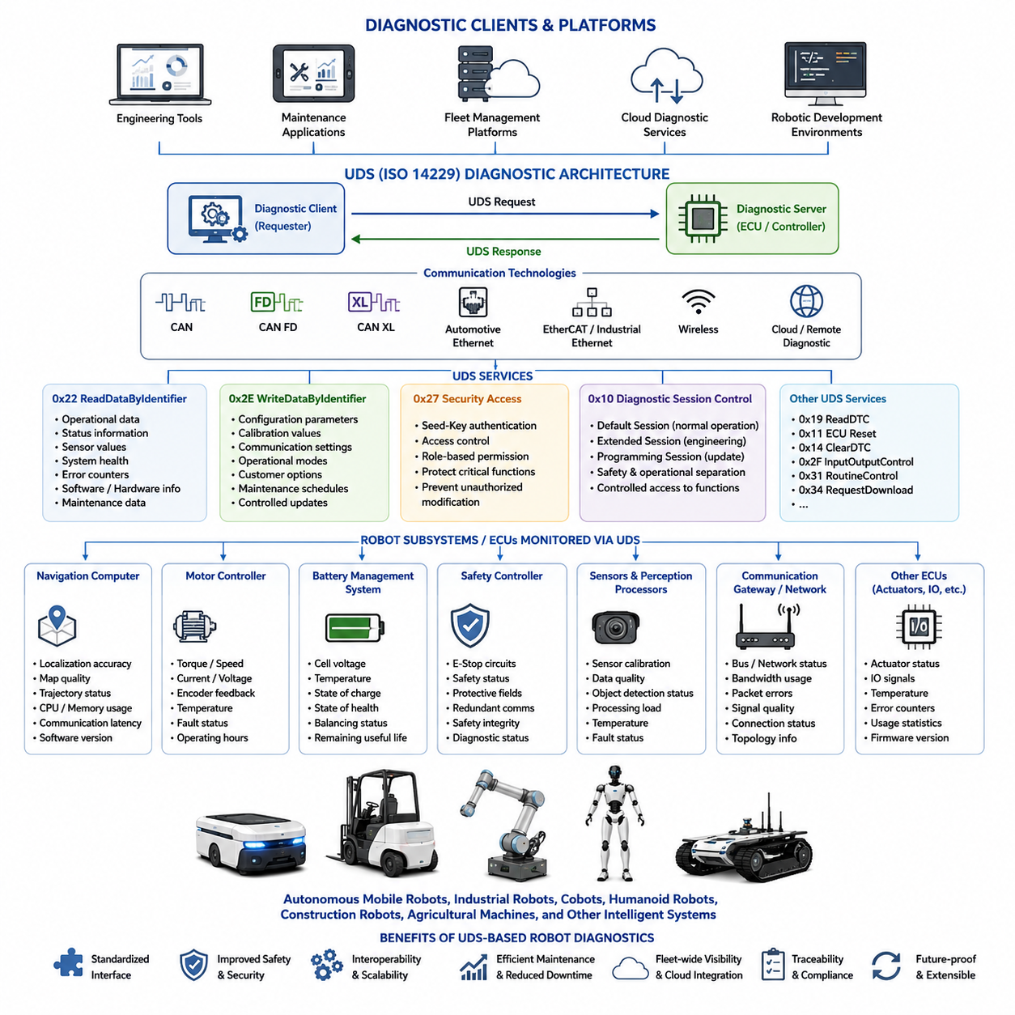
Autonomous Mobile Robots (AMRs), industrial mobile robots, collaborative robots, humanoid robots, construction robots, agricultural machines, and other intelligent autonomous systems are becoming increasingly software-defined and highly distributed. Modern robotic platforms integrate numerous Electronic Control Units (ECUs), embedded controllers, edge computers, perception processors, motor controllers, battery management systems, functional safety controllers, communication gateways, and cloud-connected services. As system complexity continues to grow, maintaining reliable operation throughout the robot lifecycle requires a standardized diagnostic architecture capable of monitoring hardware, software, communication, configuration, and operational health. The Unified Diagnostic Services (UDS) architecture defined by ISO 14229 provides a mature diagnostic framework that can be extended beyond automotive applications to intelligent robotic systems.
Historically, robotic diagnostics have often relied on proprietary communication protocols developed independently by each manufacturer. Individual motor controllers, safety PLCs, navigation systems, manipulators, sensors, and battery controllers typically expose their own diagnostic interfaces with inconsistent data formats, command structures, and maintenance procedures. While these approaches may function adequately within isolated systems, they complicate integration, increase engineering effort, reduce interoperability, and make fleet-wide maintenance considerably more difficult. Adopting a standardized diagnostic architecture such as UDS allows heterogeneous robotic subsystems to communicate through a common diagnostic language regardless of their internal implementation.
The layered architecture of UDS aligns naturally with modular robotic software design. At the highest level, engineering tools, maintenance applications, fleet management platforms, cloud diagnostic services, or robotic development environments operate as diagnostic clients. Individual robot controllers act as diagnostic servers responsible for processing standardized requests and generating corresponding responses. Communication may occur through CAN, CAN FD, CAN XL, Automotive Ethernet, EtherCAT gateways, industrial Ethernet, wireless communication, or cloud-connected remote maintenance systems. Because UDS separates application services from transport mechanisms, diagnostic software remains largely independent of the underlying communication technology.
Robot diagnostic systems require continuous monitoring of numerous operational parameters. Navigation computers maintain localization accuracy, map quality, trajectory status, processor utilization, memory consumption, and communication latency. Motor controllers monitor torque, rotational speed, current, voltage, encoder feedback, thermal conditions, and fault status. Battery Management Systems supervise cell voltage, temperature distribution, charge state, health estimation, balancing status, charging history, and remaining useful life. Safety controllers monitor emergency stop circuits, functional safety status, protective field monitoring, redundant communication channels, and safety integrity diagnostics. UDS provides a structured mechanism for exposing all these variables through standardized Data Identifiers.
ReadDataByIdentifier (Service 0x22) becomes particularly valuable in robotic diagnostics because engineering personnel frequently require access to operational information without disrupting system behavior. Maintenance software may periodically retrieve battery condition, wheel odometry statistics, localization confidence, sensor calibration status, actuator temperatures, communication quality, processor utilization, storage capacity, software versions, hardware identification, operating hours, maintenance history, and error counters. Since each parameter is represented by a Data Identifier rather than a physical memory address, diagnostic software remains stable even as controller implementations evolve across hardware generations.
WriteDataByIdentifier (Service 0x2E) similarly enables controlled configuration management throughout robot deployment. Engineers may update communication parameters, regional settings, calibration coefficients, sensor offsets, wheel diameter compensation, payload configuration, operational modes, localization parameters, docking tolerances, maintenance schedules, or customer-specific options. Because only predefined writable Data Identifiers can be modified, configuration updates remain structured, traceable, and significantly safer than unrestricted memory modification. This controlled approach is especially important for commercial robotic products operating in customer environments.
Security Access (Service 0x27) becomes increasingly important as robots acquire greater autonomy and network connectivity. Unauthorized modification of navigation parameters, safety settings, motion constraints, perception algorithms, or actuator configurations could directly affect operational safety. Therefore, maintenance personnel, production equipment, cloud services, and engineering tools must authenticate before privileged operations become available. The standardized Seed-Key challenge-response mechanism defined by UDS provides a scalable authentication model suitable for distributed robotic controllers while allowing manufacturers to implement proprietary cryptographic algorithms appropriate for their cybersecurity requirements.
Diagnostic Session Control (Service 0x10) further improves operational safety by separating ordinary robot operation from engineering activities. During normal autonomous operation, robots remain in a Default Session exposing only basic diagnostic information. Maintenance technicians may transition into an Extended Diagnostic Session for advanced troubleshooting, while software deployment systems enter Programming Sessions before firmware updates occur. Restricting engineering functionality according to diagnostic sessions minimizes accidental parameter changes during routine operation while simplifying maintenance workflows.
RoutineControl (Service 0x31) offers substantial advantages for robotic maintenance because numerous diagnostic procedures execute directly inside embedded controllers. Rather than transferring large amounts of raw diagnostic information to external software, motor controllers, sensor processors, battery management systems, and safety controllers perform self-tests internally before returning concise results. Examples include actuator verification, encoder calibration, IMU alignment, LiDAR self-diagnosis, camera calibration validation, battery balancing verification, communication integrity testing, storage integrity checking, and hardware functional verification. This distributed diagnostic model reduces communication overhead while improving execution consistency.
Diagnostic Trouble Codes (DTCs) provide a standardized mechanism for recording abnormal operating conditions throughout robotic systems. Navigation failures, localization degradation, communication interruptions, battery abnormalities, motor overload, thermal protection events, sensor failures, calibration inconsistencies, software exceptions, safety violations, or actuator faults can all be represented using structured diagnostic records rather than vendor-specific log messages. Standardized DTC management simplifies troubleshooting, accelerates maintenance, enables historical trend analysis, and facilitates automated fleet-wide health monitoring.
Software programming services become particularly valuable as robotic platforms increasingly support Over-the-Air deployment and continuous software evolution. Modern robots regularly receive improvements to navigation algorithms, perception software, motion planning, artificial intelligence models, cybersecurity components, safety functions, and user interfaces. UDS programming services including RequestDownload, TransferData, RequestTransferExit, and associated verification procedures provide a structured method for performing firmware updates while ensuring software integrity throughout deployment. Integration with Security Access further protects software from unauthorized modification.
Fleet management systems can leverage standardized UDS diagnostics to supervise hundreds or thousands of deployed robots simultaneously. Centralized management platforms periodically collect software versions, hardware configurations, battery health statistics, maintenance records, diagnostic fault information, communication quality, operating hours, mission statistics, environmental conditions, and utilization metrics from every robot within the fleet. Standardized diagnostic communication simplifies cloud integration because identical engineering software can manage heterogeneous robot models sharing the same diagnostic architecture despite differing mechanical designs or functional capabilities.
Remote diagnostics become increasingly practical when UDS communication is combined with modern networking technologies. Service engineers may securely retrieve diagnostic information from robots operating in warehouses, hospitals, factories, construction sites, logistics centers, ports, mines, agricultural fields, airports, or smart cities without physically connecting diagnostic equipment. Gateway controllers translate diagnostic requests between cloud services, industrial Ethernet, CAN FD, CAN XL, wireless communication, and local embedded networks while preserving standardized UDS application-layer behavior. Consequently, engineering workflows remain consistent regardless of deployment environment.
Artificial Intelligence further expands the value of standardized diagnostics. Machine learning algorithms require structured operational data to predict failures before they occur. Standardized diagnostic information retrieved through UDS provides high-quality datasets describing actuator behavior, battery degradation, thermal characteristics, communication performance, localization accuracy, processor utilization, maintenance history, and fault evolution. Predictive maintenance systems analyze these historical records to estimate component lifetime, recommend preventive maintenance schedules, identify abnormal operating patterns, and reduce unexpected equipment downtime across large robotic fleets.
Digital Twin technology similarly benefits from structured diagnostic communication. Virtual representations of deployed robots continuously synchronize operational information retrieved through standardized diagnostic services. Engineering teams monitor controller configuration, software versions, calibration status, hardware utilization, sensor health, actuator performance, environmental conditions, and maintenance activities within the digital twin environment. Because diagnostic information follows standardized Data Identifier definitions, simulation models remain synchronized across hardware revisions while simplifying engineering analysis and lifecycle documentation.
Functional safety represents another area where standardized diagnostics provide significant value. Safety controllers continuously monitor redundant sensors, emergency stop systems, safety scanners, collision detection, communication redundancy, actuator supervision, watchdog timers, and safety-certified software execution. Diagnostic services expose safety status information to engineering tools without interfering with deterministic safety behavior. Maintenance personnel can therefore evaluate system health while preserving compliance with functional safety requirements and minimizing operational interruptions.
Large robotic platforms often contain numerous distributed controllers communicating across multiple networks. Individual wheel controllers, arm controllers, battery management units, perception computers, safety controllers, environmental monitoring modules, payload controllers, and navigation processors may reside on different communication buses. Gateway controllers route UDS messages transparently across these networks, allowing diagnostic clients to access every subsystem using identical service definitions regardless of physical network topology. This transport-independent architecture greatly simplifies integration within increasingly complex robotic systems.
Cybersecurity has become inseparable from robotic diagnostics. Connected robots exchange information with cloud infrastructure, fleet management systems, engineering workstations, manufacturing databases, warehouse management systems, and enterprise resource planning platforms. Standardized diagnostic services integrate naturally with secure gateways, encrypted communication channels, digital certificates, hardware security modules, authentication frameworks, intrusion detection systems, secure boot mechanisms, and software integrity verification. Rather than treating diagnostics and cybersecurity as separate disciplines, modern robotic architectures increasingly integrate both within a unified lifecycle management framework.
The long-term significance of applying UDS to robotic diagnostics extends beyond replacing proprietary maintenance interfaces. ISO 14229 establishes a standardized, scalable, transport-independent diagnostic architecture capable of supporting intelligent machines throughout their complete operational lifecycle. By combining structured diagnostic services, standardized Data Identifiers, secure authentication, software lifecycle management, predictive maintenance, fleet supervision, remote diagnostics, cloud connectivity, digital twins, and artificial intelligence, UDS provides a robust foundation for future autonomous robotic ecosystems. As robots continue evolving toward highly connected, software-defined, and AI-enabled platforms, standardized diagnostic communication will become as essential to robotic reliability and maintainability as it has already become within the modern automotive industry.

