Volume 06 Automotive Communication

Chapter 11. MOST History

11.01. MOST 25/50/150 Evolution
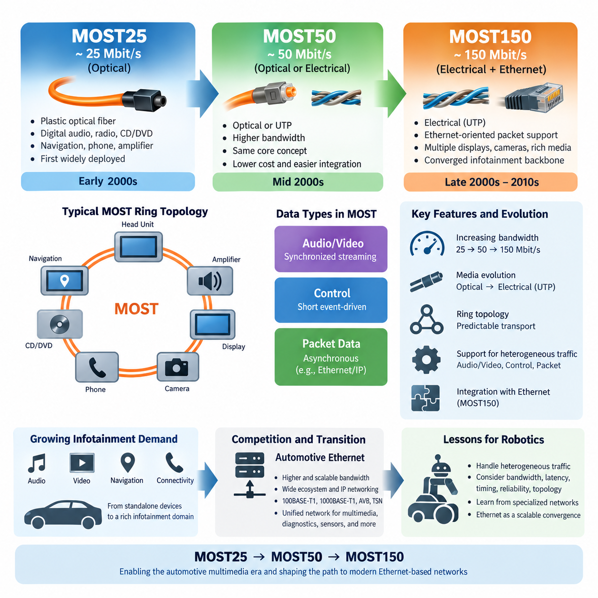
Media Oriented Systems Transport, or MOST, was developed as a dedicated networking technology for transporting multimedia data inside vehicles. Its evolution from MOST25 through MOST50 to MOST150 reflects the rapid increase in automotive infotainment bandwidth requirements. Unlike control-oriented networks such as CAN, MOST was optimized for synchronized audio, video, packet data, and control information across distributed multimedia devices.
MOST25 represented the first widely deployed generation and operated at approximately 25 Mbit/s. It was primarily designed for applications such as digital audio distribution, radio receivers, CD or DVD systems, navigation equipment, telephone interfaces, and amplifiers. At a time when conventional vehicle networks provided relatively limited bandwidth, MOST25 offered an efficient way to interconnect increasingly sophisticated infotainment components.
A major characteristic of MOST25 was its use of optical physical media, particularly plastic optical fiber. Optical transmission provided strong immunity against electromagnetic interference and helped electrically isolate multimedia devices distributed throughout the vehicle. These properties were attractive in automotive environments containing ignition systems, electric motors, switching power supplies, and other potential noise sources, although optical connectors and installation introduced additional engineering constraints.
MOST networks were commonly organized as logical rings in which multimedia data traveled through successive nodes. Each device received the incoming stream, extracted information assigned to it, inserted or forwarded information as required, and passed the communication onward. This architecture provided predictable multimedia transport, but it also meant that node availability, bypass mechanisms, connector quality, and ring integrity became important system-level reliability considerations.
As multimedia functions expanded, MOST25 began to encounter bandwidth limitations. Higher-quality audio, increasingly complex navigation displays, rear-seat entertainment, and richer human-machine interfaces generated more data than earlier systems had anticipated. MOST50 emerged as an intermediate generation offering approximately twice the bandwidth while maintaining the fundamental MOST concept and supporting the automotive industry's transition toward more data-intensive infotainment architectures.
MOST50 operated at approximately 50 Mbit/s and introduced an important physical-layer transition. Rather than relying exclusively on optical transmission, implementations could use electrical transmission over unshielded twisted-pair cabling. This approach reduced some of the cost and handling challenges associated with plastic optical fiber while preserving the synchronized multimedia networking philosophy that distinguished MOST from conventional automotive control buses.
The move toward electrical transmission illustrated a broader engineering tradeoff. Optical fiber offered excellent electromagnetic compatibility and electrical isolation, whereas copper-based communication could simplify harness integration, connector selection, manufacturing, repair, and cost management. MOST50 therefore represented more than a simple increase in bit rate; it demonstrated how an established communication architecture could evolve its physical implementation in response to vehicle manufacturing requirements.
MOST150 marked the most substantial expansion of the technology. With a gross data rate of approximately 150 Mbit/s, it provided significantly greater capacity for advanced infotainment systems containing multiple displays, digital audio channels, cameras, navigation functions, communication interfaces, and other multimedia sources. This increase allowed vehicle manufacturers to consolidate richer entertainment and information services onto a common multimedia network.
An important development in MOST150 was the introduction of an Ethernet-oriented packet communication capability in addition to the established MOST transport mechanisms. This allowed conventional Ethernet frames and IP-related traffic to coexist with synchronized streaming services. The architecture therefore combined deterministic multimedia transport with more flexible packet communication, addressing a period in which vehicle infotainment systems increasingly interacted with Internet-oriented software and networking technologies.
The MOST architecture distinguished several categories of traffic because multimedia systems have different communication requirements. Continuous audio or video streams benefit from predictable bandwidth and timing, while control messages are typically short and event-driven. Packet-oriented communication may be bursty and asynchronous. Separating and managing these traffic types enabled MOST to support heterogeneous infotainment workloads more effectively than a network designed only for conventional ECU control messages.
Across MOST25, MOST50, and MOST150, the evolution can therefore be understood as a progression in bandwidth, physical-layer flexibility, and integration with packet-oriented networking. MOST25 established practical synchronized multimedia networking at roughly 25 Mbit/s, MOST50 increased capacity to roughly 50 Mbit/s and expanded electrical implementation possibilities, while MOST150 raised capacity to roughly 150 Mbit/s and provided stronger integration with Ethernet-style data communication.
This evolution also reflected changes in vehicle electronics themselves. Early infotainment systems consisted of relatively independent devices exchanging audio and basic control information. Later vehicles incorporated navigation computers, high-resolution displays, connectivity modules, multimedia storage, sophisticated amplifiers, cameras, and external communication services. The communication network consequently evolved from a specialized audio distribution system toward a broader digital backbone for the infotainment domain.
Despite these advances, MOST eventually faced increasing competition from Automotive Ethernet. Ethernet benefited from enormous development investment outside the automotive industry, broad silicon availability, familiar IP networking, scalable bandwidth, and an extensive software ecosystem. As 100BASE-T1, 1000BASE-T1, AVB, and later TSN technologies matured, vehicle manufacturers gained an alternative capable of carrying multimedia, diagnostics, sensor information, and general packet traffic through a more unified networking architecture.
The historical importance of MOST is nevertheless substantial. It demonstrated that vehicle communication could move beyond low-bandwidth control buses and support synchronized, bandwidth-reserved multimedia traffic across distributed electronic modules. Concepts involving traffic classes, guaranteed resources, network synchronization, streaming communication, and integrated control and data transport anticipated several requirements that later became important in Ethernet-based automotive architectures.
For robotics and Physical AI systems, the MOST25-to-MOST150 evolution provides a useful architectural lesson even though MOST itself is primarily a legacy automotive multimedia technology. Modern robots similarly combine traffic with very different characteristics, including deterministic motor control, synchronized camera streams, LiDAR data, audio and video, diagnostics, software updates, and AI-compute communication. A single communication technology must therefore be evaluated not only by peak bandwidth but also by latency, timing, reliability, topology, and traffic management.
The broader engineering lesson is that specialized networks can provide excellent performance for a well-defined application domain, yet long-term architecture is also shaped by ecosystem scale and convergence. MOST evolved from 25 to 50 and finally 150 Mbit/s to satisfy growing multimedia requirements, but Ethernet ultimately offered a more scalable convergence path. This transition provides important historical context for understanding why contemporary vehicles and advanced robotic platforms increasingly adopt Ethernet-centered communication backbones.

11.02. MOST Ring Topology
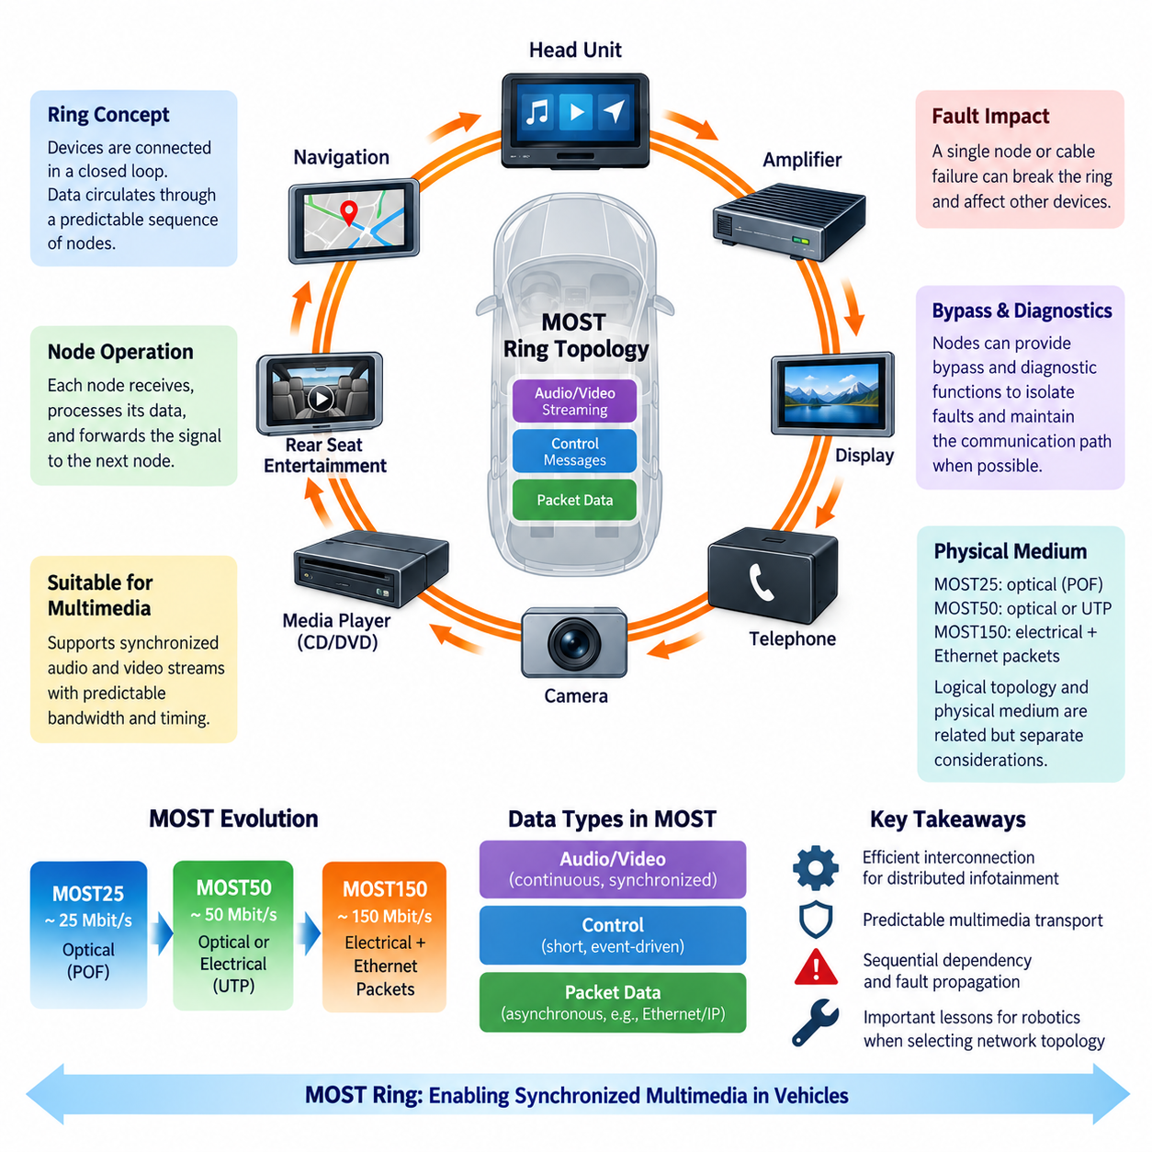
Media Oriented Systems Transport, or MOST, commonly used a ring topology to interconnect multimedia devices distributed throughout a vehicle. Instead of attaching every device to a shared multidrop bus, MOST nodes were connected sequentially so that the communication path formed a closed logical loop. This structure suited continuous multimedia transport because data could circulate through a predictable sequence of infotainment components.
In a typical MOST network, devices such as the head unit, navigation system, amplifier, display, telephone interface, media player, and other multimedia modules participated as nodes in the ring. Each node maintained an upstream connection from the previous device and a downstream connection toward the next device. The final node returned the communication path toward the beginning of the network, completing the logical ring.
Communication within the ring followed an ordered forwarding process. A node received the incoming MOST signal, recovered the transmitted information, processed data relevant to its own function, and forwarded the communication toward the next node. Depending on the implementation and traffic type, the node could consume assigned information or contribute information for other devices while maintaining continuous operation of the communication path.
This sequential organization differed fundamentally from conventional shared-bus networks such as CAN. In CAN, multiple electronic control units contend for access to a common physical medium and arbitration determines which message is transmitted. In a MOST ring, communication progresses through an organized network path. The resulting architecture was particularly appropriate for multimedia applications requiring continuous streams and coordinated delivery rather than primarily event-driven control messages.
The ring architecture supported the synchronized transport that was central to MOST. Digital audio and video applications require more than simply transferring packets successfully; samples must arrive with sufficiently controlled timing to prevent interruptions, distortion, buffer starvation, or synchronization problems. MOST therefore combined its topology with communication mechanisms intended to provide predictable resources for continuous multimedia streams across multiple interconnected devices.
A useful way to understand the topology is to consider an audio stream originating from an infotainment source and destined for an amplifier. The information enters the MOST communication structure and passes through the required sequence of nodes until the amplifier receives its assigned stream. Other nodes can simultaneously participate in different communication activities, allowing audio, control information, and other multimedia-related data to coexist within the network.
The ring also provided an efficient physical organization for multimedia systems distributed around a vehicle cabin. Infotainment components are frequently located in different areas, including the dashboard, center console, luggage compartment, doors, and rear-seat entertainment locations. Connecting neighboring devices sequentially could reduce the need for numerous dedicated point-to-point connections between multimedia components while creating a standardized communication backbone.
MOST25 particularly demonstrated the relationship between ring topology and optical communication. Plastic optical fiber could connect one multimedia module to another while providing electrical isolation and strong immunity to electromagnetic interference. The optical signal traveled from node to node around the ring, making connector integrity, optical attenuation, bending radius, transmitter performance, receiver sensitivity, and correct routing important parts of network engineering.
However, a simple ring introduces an important reliability concern. Because communication passes sequentially through nodes, a failed node, disconnected cable, damaged connector, or interrupted optical path can potentially break the communication loop. A single physical failure may therefore affect devices that are not themselves defective. Network diagnostics and fault-tolerance mechanisms become particularly important when troubleshooting a ring-based architecture.
To reduce this vulnerability, practical MOST systems could incorporate bypass and diagnostic mechanisms capable of identifying or isolating problematic sections of the network. A node that could no longer perform its normal multimedia function might still need to preserve the communication path when possible. Such mechanisms illustrate an important system-design principle: topology determines not only normal data flow but also the propagation and containment of failures.
Ring initialization is another important aspect of MOST operation. The network must recognize participating devices and establish a valid communication structure before normal multimedia services become available. When a vehicle starts, individual multimedia modules may require different boot times. Network management therefore coordinates the transition from powered hardware to an operational communication system in which the expected nodes and services can communicate correctly.
The logical topology must also be distinguished from the detailed implementation of the physical medium. MOST evolved across MOST25, MOST50, and MOST150, and its physical-layer options changed with that evolution. Optical and electrical implementations therefore should not be treated as identical wiring technologies even though the MOST networking concept retained strong continuity. Logical data organization and physical transmission medium are related but separate architectural considerations.
The MOST ring also illustrates why network topology strongly influences diagnostics. When communication disappears, engineers must determine whether the root cause is a defective application module, failed transceiver, power loss, damaged cable, connector problem, excessive optical attenuation, or interruption elsewhere in the ring. Diagnostic procedures therefore need knowledge of the node sequence because the location of a break can determine which portions of the communication path remain observable.
From a system integration perspective, the ring establishes dependencies among otherwise separate infotainment functions. A navigation unit, amplifier, display, and media source may perform very different application tasks, yet their communication availability depends on the health of the shared network structure. Electrical architecture design must consequently consider power sequencing, grounding, connectors, harness routing, electromagnetic compatibility, diagnostics, and communication topology together rather than independently.
The MOST ring topology is historically important because it demonstrates an architecture optimized around the requirements of its application domain. It provided an organized mechanism for transporting synchronized multimedia information at a time when conventional automotive control networks lacked sufficient bandwidth for such workloads. Its strengths were predictable multimedia communication and structured interconnection, while its challenges included sequential dependency, fault propagation, and specialized network hardware.
For robotics and Physical AI systems, the MOST ring offers useful architectural lessons even when MOST itself is not selected. Robots may contain cameras, microphones, displays, speakers, perception computers, motor controllers, and other distributed devices with different bandwidth and timing requirements. Designers must evaluate whether ring, star, switched Ethernet, bus, or redundant topologies provide the appropriate balance among bandwidth, latency, wiring complexity, fault tolerance, serviceability, and cost.
Modern Automotive Ethernet increasingly favors switched and hierarchical network structures rather than the specialized MOST ring. Nevertheless, studying MOST reveals why topology cannot be considered merely a wiring diagram. The arrangement of nodes directly affects communication timing, failure behavior, diagnostics, scalability, and system integration. MOST therefore remains a valuable historical example of how network topology and application requirements must be designed as parts of the same vehicle communication architecture.

11.03. MOST to Ethernet Migration
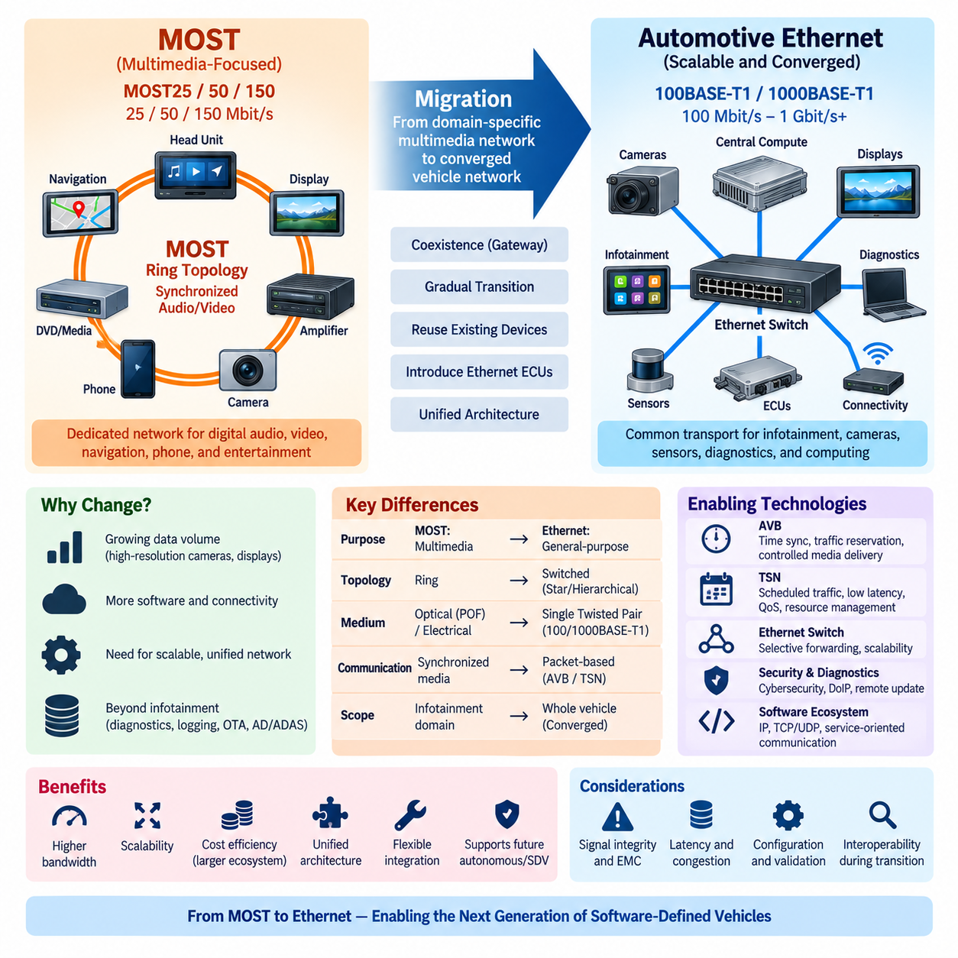
The migration from Media Oriented Systems Transport, or MOST, to Automotive Ethernet represents a major architectural transition in vehicle communication. MOST was created specifically for synchronized multimedia traffic, while Ethernet originated as a general-purpose networking technology. As vehicles became increasingly software-defined and data-intensive, manufacturers required a communication backbone capable of supporting infotainment, diagnostics, sensors, gateways, and computing platforms within a more unified architecture.
MOST successfully addressed an important limitation of earlier automotive networks by providing relatively high-bandwidth transport for digital audio, video, navigation, telephone, and entertainment services. MOST25, MOST50, and MOST150 progressively increased communication capacity while maintaining mechanisms suitable for synchronized multimedia. However, the technology remained strongly associated with the infotainment domain rather than becoming a universal vehicle communication backbone.
The growth of vehicle electronics gradually changed the networking problem. Cameras began generating continuous high-volume streams, displays increased in resolution, navigation systems became connected services, and central computing platforms required communication with many distributed devices. At the same time, diagnostics, software downloading, logging, and external connectivity generated increasing packet-oriented traffic. These workloads favored networks that could scale beyond a specialized multimedia architecture.
Automotive Ethernet provided this scalability by adapting the established Ethernet ecosystem to vehicle requirements. Technologies such as 100BASE-T1 and later 1000BASE-T1 enabled high-speed communication over automotive-oriented single twisted-pair links. Instead of maintaining separate network families for each application domain, manufacturers could increasingly use Ethernet as a common transport technology across infotainment, cameras, gateways, diagnostics, and high-performance computing systems.
The transition was not simply a replacement of one cable technology with another. MOST incorporated communication concepts specifically optimized for multimedia timing and resource allocation, whereas conventional Ethernet historically relied on packet-based, best-effort communication. Automotive applications therefore required additional mechanisms to guarantee timing, bandwidth, synchronization, and traffic priority before Ethernet could replace specialized multimedia networks in demanding real-time applications.
Audio Video Bridging, or AVB, was an important step in solving this problem. AVB introduced mechanisms for synchronized time, traffic reservation, and controlled delivery of audio and video streams across Ethernet networks. These capabilities allowed Ethernet to support applications that previously benefited from specialized multimedia networks such as MOST. The communication architecture could therefore retain predictable media delivery while gaining access to the much broader Ethernet ecosystem.
Time-Sensitive Networking, or TSN, extended these concepts further. TSN provides mechanisms for precise time synchronization, scheduled traffic, traffic shaping, bounded latency, and resource management. These functions make Ethernet increasingly suitable for communication classes extending beyond infotainment. The resulting network can simultaneously carry ordinary packet traffic and time-sensitive streams while controlling interference between traffic classes according to system requirements.
Network topology also changed during the migration. MOST commonly used a logical ring in which information passed sequentially through multimedia nodes. Automotive Ethernet typically uses switched point-to-point links arranged in star, hierarchical, zonal, or backbone structures. Ethernet switches therefore become central communication elements capable of forwarding traffic selectively between endpoints instead of requiring every stream to traverse a predefined sequence of devices.
This switched architecture improves scalability because new devices can be connected through additional switch ports or hierarchical network segments without extending a single communication ring. It also provides greater flexibility for bandwidth allocation and traffic isolation. However, switches introduce their own engineering requirements, including forwarding latency, queue management, traffic prioritization, synchronization, redundancy, cybersecurity, configuration, and diagnostic visibility.
Migration from MOST to Ethernet was consequently often gradual rather than instantaneous. A vehicle platform could contain legacy MOST devices alongside newer Ethernet-based ECUs and computing systems. Gateways were therefore important during transitional architectures because they could bridge communication domains while existing multimedia components remained in production. Such coexistence allowed manufacturers to introduce new networking technologies without redesigning every subsystem simultaneously.
Diagnostics represented another advantage of Ethernet convergence. Traditional automotive diagnostic communication often depended on CAN-based protocols, while high-volume software transfer and data collection increasingly required greater bandwidth. Ethernet enabled diagnostic communication, application data, logging, and software transfer to share a common high-speed infrastructure. This direction eventually supported technologies such as Diagnostics over Internet Protocol, or DoIP, and more extensive software update architectures.
Software architecture was equally important in the transition. Ethernet naturally supports technologies derived from conventional computer networking, including IP, UDP, TCP, service-oriented communication, and standardized software interfaces. This compatibility reduces the conceptual distance between embedded vehicle networks, edge computing platforms, backend infrastructure, and development environments. Vehicle communication consequently becomes more closely integrated with mainstream computing and software engineering practices.
The economic ecosystem also favored Ethernet. MOST depended on a comparatively specialized automotive technology ecosystem, whereas Ethernet benefits from decades of development across enterprise networking, telecommunications, industrial automation, consumer electronics, and data centers. Semiconductor devices, switches, PHYs, protocol stacks, diagnostic tools, development environments, and engineering expertise can therefore evolve across a much larger global technology base.
Nevertheless, migration to Ethernet introduces challenges that did not disappear merely because bandwidth increased. High-speed electrical links require careful signal-integrity design, impedance control, connector engineering, electromagnetic compatibility, cable routing, and validation. Network architects must also control congestion, latency, synchronization, failure propagation, cybersecurity, and quality of service. Greater bandwidth therefore changes the engineering problem rather than eliminating communication constraints.
The MOST-to-Ethernet transition demonstrates a broader movement from domain-specific networks toward converged vehicle communication architectures. Instead of maintaining a dedicated multimedia backbone isolated from other communication domains, modern vehicles increasingly connect centralized or zonal computing systems through high-speed Ethernet. Lower-speed networks such as CAN, CAN FD, and LIN may remain at local endpoints while Ethernet provides aggregation and backbone communication.
This transition has direct relevance to robotics and Physical AI. Modern robots generate heterogeneous traffic from cameras, LiDARs, microphones, motor controllers, safety devices, AI accelerators, storage systems, and remote management interfaces. A scalable Ethernet backbone can connect high-performance computing resources while CAN, CAN FD, EtherCAT, or other specialized networks remain appropriate for particular low-level control functions. Network convergence therefore does not necessarily mean using one protocol everywhere.
The historical migration from MOST to Automotive Ethernet ultimately illustrates how communication architectures evolve when bandwidth, software integration, scalability, and ecosystem requirements become more important than specialization alone. MOST demonstrated effective synchronized multimedia networking, while Ethernet provided a broader path toward converged communication. The lesson for future vehicle and robotic architectures is to preserve deterministic behavior where necessary while building scalable networks capable of integrating increasingly diverse data, computing, and software services.

11.04. Lessons for Robot AV Networks
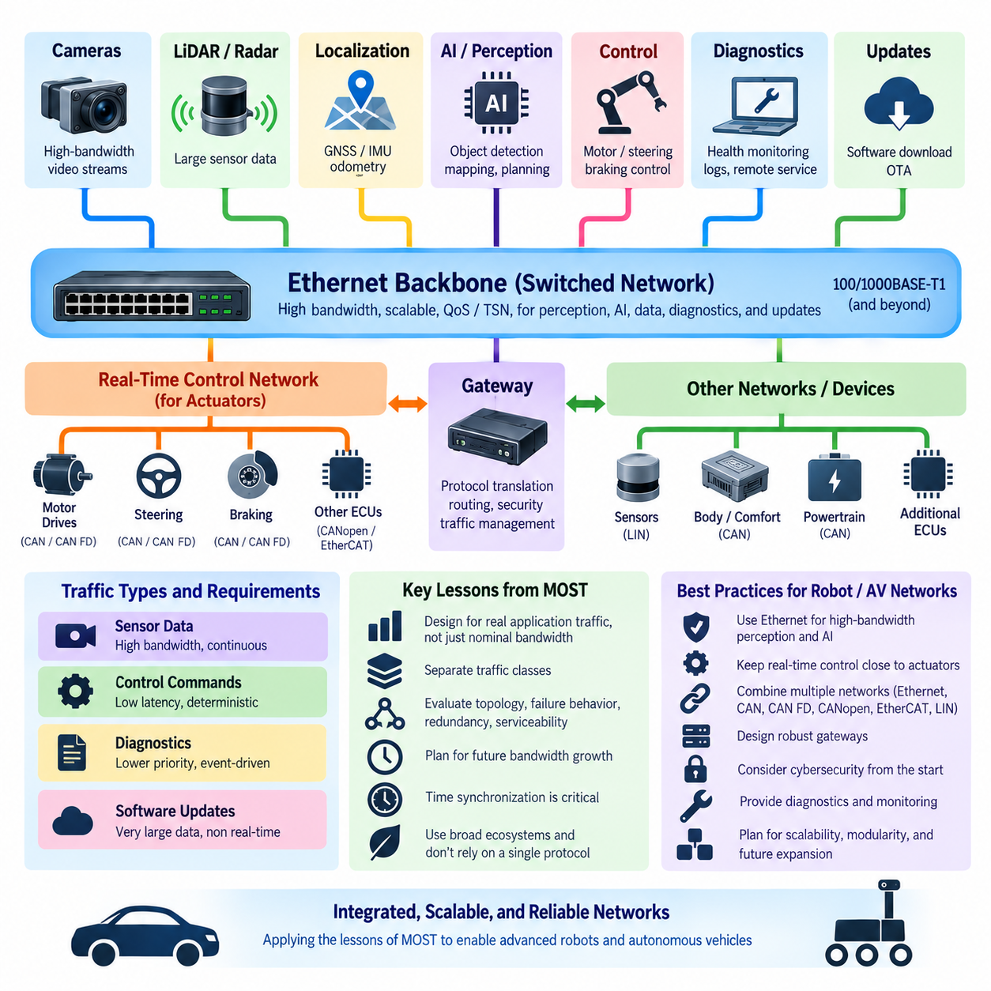
The history of MOST provides several useful lessons for designing communication networks in robots and autonomous vehicles. MOST demonstrated that network architecture must be driven by application traffic rather than nominal bandwidth alone. Modern robotic platforms simultaneously carry control commands, camera streams, LiDAR data, localization information, diagnostics, software updates, and AI-related data, each imposing different timing and reliability requirements.
One important lesson is that heterogeneous traffic should not be treated as though every message has the same communication characteristics. Motor commands may require low and predictable latency, while camera or LiDAR streams demand sustained high bandwidth. Diagnostic messages are generally less time-critical, and software updates may transfer very large data volumes without requiring millisecond-level response. Network architecture should therefore recognize different traffic classes explicitly.
MOST addressed this problem by separating synchronized streaming, control information, and packet-oriented communication. Robot and autonomous-vehicle networks can apply the same principle through modern mechanisms such as Ethernet Quality of Service, traffic prioritization, and Time-Sensitive Networking. The objective is not to reproduce MOST, but to ensure that high-volume perception traffic cannot unexpectedly interfere with latency-sensitive control or safety-related communication.
A second lesson concerns topology. MOST commonly employed a ring architecture that provided an organized and predictable communication path, but the sequential structure also created dependencies among nodes. Modern robots increasingly favor switched Ethernet, star, hierarchical, or zonal structures because these architectures provide more flexible routing and expansion. Nevertheless, topology must always be evaluated in terms of failure propagation, cable complexity, latency, redundancy, and serviceability.
Fault behavior is particularly important for autonomous systems. A communication network that operates perfectly under normal conditions may still be unsuitable if a single cable, connector, switch, or node failure disables critical functions. The MOST experience shows why designers must examine how failures propagate through the network. Robot architectures should identify critical communication paths and determine whether redundant links, independent safety networks, bypass paths, or degraded operating modes are required.
Bandwidth planning provides another lesson. MOST evolved from approximately 25 Mbit/s to 50 Mbit/s and eventually 150 Mbit/s because multimedia requirements continually increased. Robot networks experience an even stronger version of this trend as camera resolution, frame rate, LiDAR density, radar processing, and AI model interaction increase. Designing only for today's average traffic can therefore produce an architecture that reaches its practical limits soon after additional sensors or functions are introduced.
Peak bandwidth alone, however, is not a sufficient design metric. Network utilization, burst behavior, packet size, switch buffering, protocol overhead, latency, jitter, and synchronization requirements must also be considered. A nominal 1 Gbit/s Ethernet link does not guarantee that every application receives predictable service under congestion. Engineering analysis should therefore consider worst-case traffic conditions and the interaction between simultaneous perception, control, logging, diagnostics, and update activities.
Time synchronization becomes especially important when multiple sensors contribute to a common perception model. Camera images, LiDAR point clouds, radar measurements, IMU data, wheel odometry, and GNSS information may need consistent timestamps for accurate sensor fusion. MOST emphasized synchronization because multimedia streams depended on coordinated timing. Modern autonomous systems extend this requirement from media playback to perception, localization, mapping, control, and distributed computing.
The migration from MOST toward Automotive Ethernet also demonstrates the importance of technology ecosystems. A specialized protocol can perform its intended task extremely well, but long-term scalability depends on semiconductor availability, development tools, software support, engineering expertise, interoperability, and industry adoption. Robots benefit from technologies that can leverage broader ecosystems while retaining specialized communication where deterministic control, safety, or device compatibility requires it.
This leads to an important architectural principle: convergence does not require one protocol everywhere. High-bandwidth cameras, AI computers, storage systems, and central controllers may communicate through Ethernet, while motor drives and embedded controllers may use CAN, CAN FD, CANopen, EtherCAT, or other appropriate technologies. A well-designed robot network can therefore be heterogeneous internally while presenting a coherent system-level communication architecture.
Gateways become important when multiple communication domains coexist. They can route or translate information between low-level control networks and high-bandwidth computing networks, but they also introduce latency, processing dependencies, configuration complexity, and potential failure points. Gateway design should therefore define message ownership, routing rules, timing constraints, diagnostic behavior, cybersecurity boundaries, and behavior when either side of the gateway becomes unavailable.
For autonomous vehicles and AMRs, a practical architecture often separates low-level deterministic control from higher-level perception and decision computation. Motor controllers, steering controllers, braking devices, and embedded control units may operate at relatively high control frequencies without depending on every cycle of an AI computer. The AI or edge computer can operate at a different decision rate and exchange commands, trajectories, states, and diagnostics through an appropriate high-speed network.
This separation prevents perception or AI workload variation from directly destabilizing actuator control. A GPU processing cameras and running neural networks may experience variable execution times, whereas a motor-control loop requires predictable timing. Communication architecture should therefore reflect the control hierarchy: fast local loops remain close to actuators, while perception, planning, world modeling, and mission-level intelligence operate at higher computational layers with clearly defined interfaces.
Ethernet is particularly attractive between high-performance computing nodes because perception and AI systems can generate very large datasets. Cameras, LiDARs, mapping modules, edge GPUs, data recorders, and central computers may require hundreds of megabits or multiple gigabits per second. Switched Ethernet also supports scalable segmentation and aggregation, allowing the architecture to expand more naturally than a single shared bus as sensor and computing requirements grow.
Lower-level networks nevertheless remain valuable because bandwidth is not the only requirement. CAN and CAN FD provide robust message-oriented communication for embedded controllers, while CANopen offers standardized device profiles and control mechanisms. Industrial robotics may use EtherCAT where highly synchronized distributed motion control is required. Protocol selection should therefore follow functional requirements instead of assuming that the highest-bandwidth technology is automatically the best choice.
Cybersecurity becomes more significant as robotic networks adopt Ethernet and IP-based communication. Increased connectivity enables remote diagnostics, fleet management, software updates, cloud integration, and service-oriented architectures, but it also expands the attack surface. Segmentation, authentication, secure gateways, controlled external interfaces, update security, and monitoring should consequently be considered part of communication architecture rather than added after network implementation.
Diagnostics and serviceability must also be designed from the beginning. MOST showed how topology can directly influence troubleshooting because a failure at one location can affect communication elsewhere. Robot networks should provide observable link status, node health information, error counters, timestamps, network statistics, diagnostic logs, and clear physical access points. These capabilities become increasingly important when autonomous machines operate remotely or as part of large fleets.
Ultimately, the most important lesson from MOST is that communication technology should serve the complete system architecture rather than dominate it. Robot and autonomous-vehicle networks should combine appropriate protocols according to bandwidth, determinism, synchronization, safety, reliability, cost, and lifecycle requirements. Ethernet can provide the scalable high-speed backbone, while specialized networks remain close to real-time devices where appropriate, creating a layered architecture capable of supporting increasingly sophisticated Physical AI systems.

