Volume 07. Industrial Communication

Chapter 08. IO-Link

08.01. IO-Link Master/Device Architecture
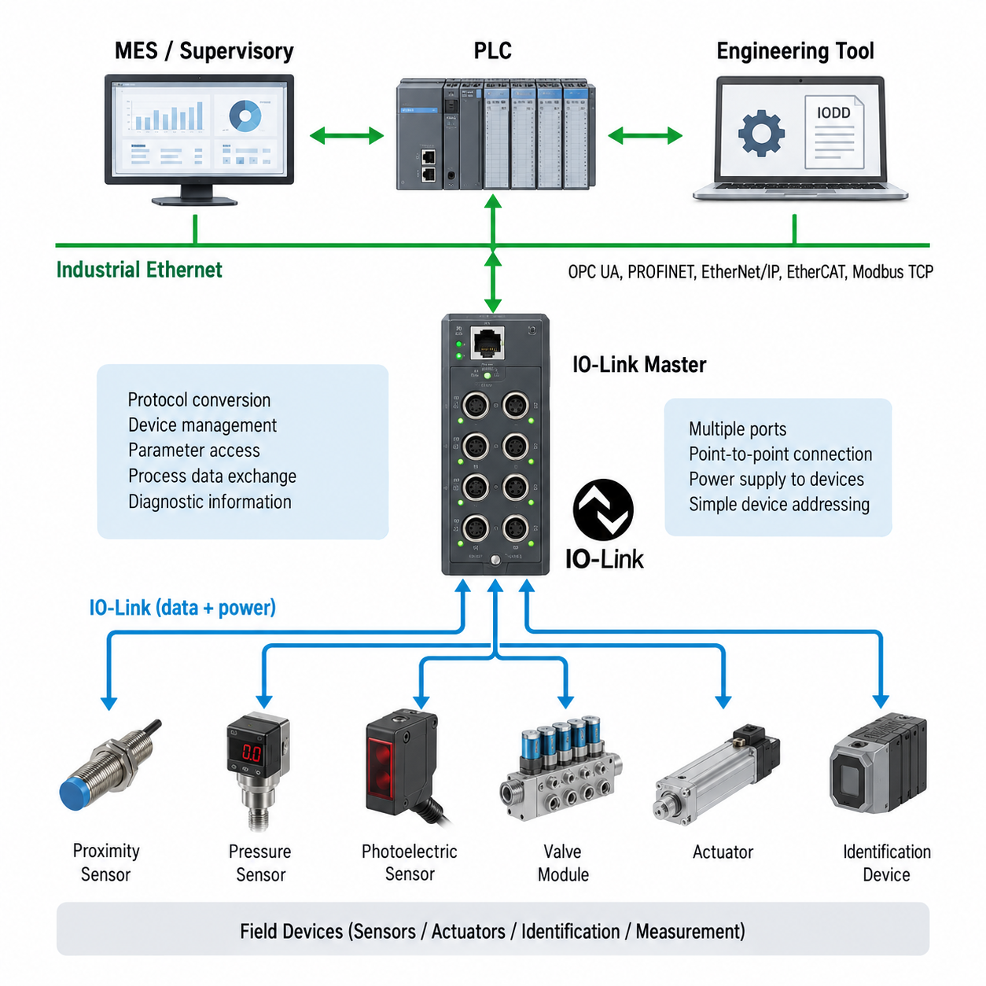
IO-Link Master–Device architecture is a point-to-point industrial communication structure designed to connect intelligent field devices such as sensors, actuators, identification devices, and compact measurement modules to a higher-level automation network. In the Industrial Communication structure, IO-Link is positioned after OPC UA and before PLC integration, providing a field-level interface between individual devices and the controller-side communication infrastructure. Its role is therefore complementary to Ethernet-based industrial networks rather than a replacement for them.
The IO-Link Master is the central interface between IO-Link Devices and the upper automation system. A Master normally provides multiple independent ports, with each port connected to one IO-Link Device through a dedicated cable. The Master manages communication, device configuration, process-data exchange, parameter access, and diagnostic information. On its upper side, the Master can communicate with a PLC or industrial Ethernet system using an appropriate integration mechanism, thereby separating device-level communication from the controller-level network.
An IO-Link Device is typically a smart sensor or actuator that provides more information than a conventional binary or analog device. Instead of transmitting only a simple switching state or measured voltage, the device can exchange process values, configuration parameters, identification information, diagnostic information, and device-specific data. This architecture allows the automation controller to obtain not only the current measurement but also information about device condition, configuration, and abnormal operating conditions.
Communication between the Master and Device uses a standardized point-to-point connection. Each port represents an individual communication relationship, which simplifies device addressing and reduces the complexity normally associated with multidrop fieldbus networks. The physical connection can also provide power to the connected field device, allowing communication and device power to be integrated through the same interface. This is particularly useful for distributed sensors and actuators installed close to machines, robots, conveyors, and other industrial equipment.
The Master performs an important protocol-conversion and management function. At the device side, it handles IO-Link communication and device-specific parameters, while at the controller side it presents the collected information through the industrial automation network. Consequently, the PLC does not need to implement the detailed communication procedure of every individual sensor. The Master abstracts device-level communication and provides a consistent interface that can be integrated into a larger PLC or factory-control architecture.
A major architectural advantage is the separation between cyclic process data and acyclic parameter or diagnostic information. Process data can be exchanged repeatedly during normal operation so that the controller receives current measurements or commands. Parameter and diagnostic information can be accessed when required for configuration, commissioning, maintenance, or fault analysis. This distinction makes IO-Link suitable for intelligent field devices whose operational state includes considerably more information than a simple on/off signal.
Device identification and configuration are also important parts of the architecture. When an IO-Link Device is connected, the Master can use its device information to establish the expected configuration and communication parameters. The device description is represented through the IODD mechanism, which is covered as the next topic in the chapter structure. IODD provides standardized information about device identity, parameters, process data, diagnostics, and supported functions so that engineering tools can understand the connected device.
From a robotics perspective, the IO-Link Master can serve as a concentrated interface for sensors and actuators distributed around a machine or robotic cell. Devices such as proximity sensors, pressure sensors, position sensors, photoelectric sensors, valve modules, and other intelligent field components can be connected to Master ports. The robot or PLC can then access their operational data through the automation network without requiring a separate communication interface for every field device.
Diagnostics become more valuable as the number of field devices increases. A conventional sensor failure may appear only as a missing signal, making it difficult to determine whether the problem originates from the sensor, cable, connector, power supply, or mechanical condition. IO-Link can expose additional diagnostic and identification information, allowing the control system or maintenance application to distinguish device-level conditions and support faster troubleshooting.
The architecture also supports a transition from simple signal acquisition toward smarter device integration. A sensor can provide measurement data together with configuration and diagnostic information, while the Master provides a controlled gateway between these devices and the higher-level automation environment. This creates a layered communication structure in which IO-Link handles field-device connectivity, industrial Ethernet or another controller network handles higher-level control communication, and systems such as PLC, MES, or supervisory software can consume the resulting information.
For Physical AI and robotics systems, this architecture is useful when intelligent perception and high-level computation coexist with conventional industrial devices. A robot may use cameras, LiDAR, and AI computing for complex perception while still depending on proximity sensors, limit sensors, pneumatic valves, and compact actuators for deterministic machine interaction. IO-Link therefore occupies a practical field-device layer, connecting these conventional and intelligent components to the PLC and broader automation architecture without forcing every device to become an independent Ethernet node.

08.02. IODD Device Description
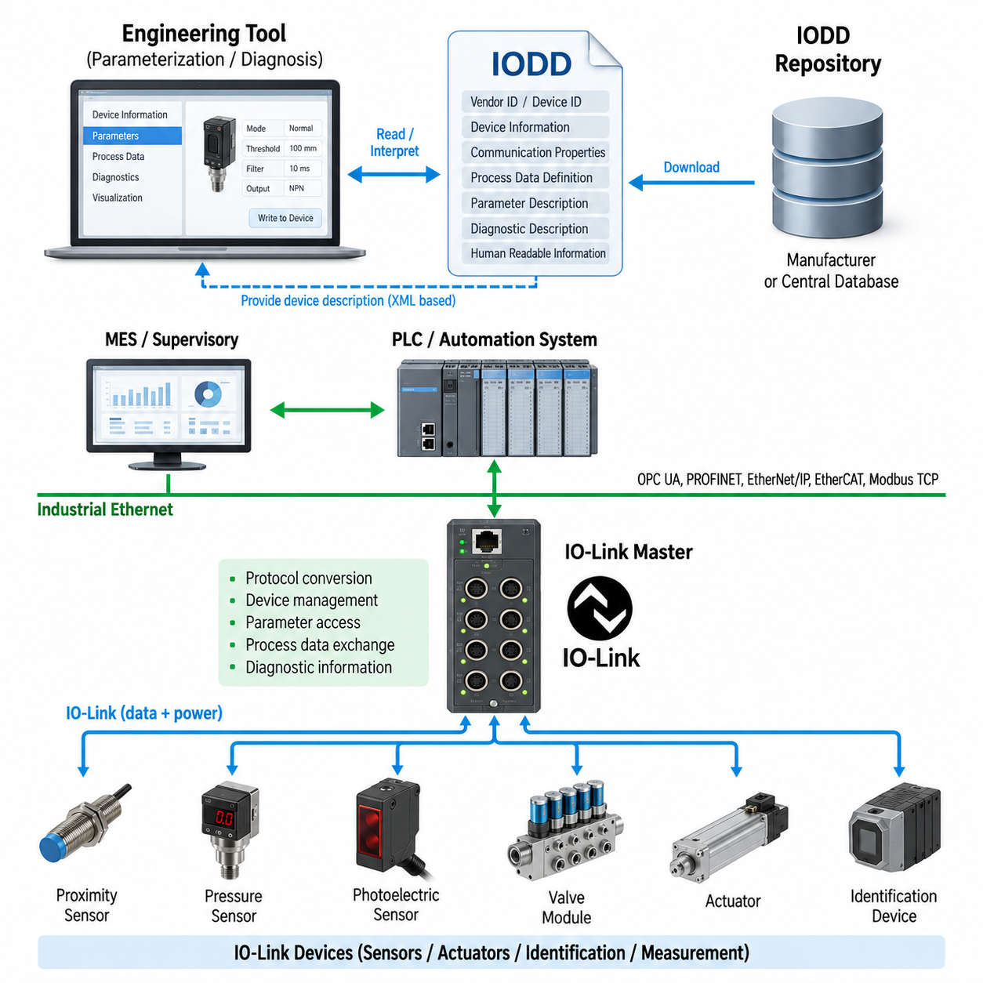
An IODD, or IO Device Description, is the standardized electronic description used to represent the capabilities and characteristics of an IO-Link Device. Within the IO-Link architecture, the physical device exchanges data with an IO-Link Master, while the IODD provides engineering software with the information required to understand that device. It therefore acts as a machine-readable description connecting device hardware, configuration tools, and automation engineering.
The IODD describes a specific IO-Link Device type in a structured and vendor-independent manner while preserving manufacturer-specific characteristics. It contains information such as vendor identification, device identification, product designation, communication properties, parameters, process data, diagnostic definitions, and supported device functions. Engineering tools can interpret this information instead of requiring users to manually define every parameter and data field for each sensor or actuator.
Device identification is fundamental because an automation system must determine which physical component is connected to an IO-Link Master port. Identification information allows engineering and maintenance tools to associate the connected device with the correct description. Vendor ID and Device ID provide important references for this relationship, while additional product information can help distinguish device families, variants, and operational characteristics during commissioning and maintenance.
The IODD also describes the communication characteristics required for interaction between the Master and Device. These definitions allow configuration software to understand how the device organizes its accessible information and which communication features it supports. The Master performs the actual IO-Link communication, whereas the IODD provides the semantic description needed by engineering applications to interpret device data correctly and present meaningful configuration options to the user.
Process data definitions describe information exchanged cyclically during normal machine operation. Depending on the device, this may represent switching states, distance, pressure, temperature, position, quality indicators, actuator commands, or combinations of several values. The IODD defines how these values are organized within the process-data structure, enabling engineering tools and controller configurations to interpret individual fields rather than treating the communication payload as an unexplained sequence of bits.
Parameter descriptions address information that is normally accessed acyclically rather than continuously exchanged as real-time process data. Parameters may control measurement ranges, switching thresholds, operating modes, filtering behavior, timing values, output characteristics, or application-specific functions. By defining these parameters together with their data types, permitted values, ranges, and descriptive information, the IODD enables structured device configuration without requiring knowledge of proprietary register layouts.
Human-readable information is another important function of the IODD. A raw numerical parameter identifier is difficult for an engineer to interpret during commissioning, but an engineering tool can use the device description to display meaningful names, units, value ranges, selections, and explanatory text. This transforms low-level device communication into an understandable engineering interface and reduces the dependence on separate manuals when configuring or diagnosing intelligent sensors and actuators.
Diagnostic descriptions allow device-generated events and conditions to be interpreted consistently. An intelligent sensor may detect conditions such as signal-quality degradation, contamination, temperature limits, measurement problems, or internal device faults. Instead of reporting only an unidentified error value, the IODD can provide information that allows engineering or maintenance software to associate diagnostic codes with meaningful conditions and present them in a form that supports troubleshooting and preventive maintenance.
IODD information is commonly represented using structured XML-based device-description data together with associated resources required by engineering tools. This machine-readable structure enables software from different automation environments to process device information systematically. The description is not the runtime communication protocol itself; rather, it complements IO-Link communication by defining how the information exposed by a particular Device should be interpreted, configured, displayed, and maintained throughout its engineering lifecycle.
The relationship between the IODD, IO-Link Master, and IO-Link Device can therefore be understood as a separation between description and communication. The Device performs sensing or actuation and exposes data, the Master establishes and manages the physical communication channel, and the IODD explains the meaning and structure of the available information. Together, these elements create a reusable device-integration model that is significantly more scalable than manually engineering every sensor interface.
This standardized description also supports device replacement and maintenance workflows. When a field device must be replaced, identification and parameter information can help the automation environment verify the replacement device and restore the required configuration. Combined with Master-side parameter management capabilities, this can reduce manual setup work and configuration errors, particularly in machines containing many similar sensors or actuators distributed across multiple IO-Link Master ports.
For robotics, IODD-based engineering is useful because modern robots increasingly contain numerous intelligent peripheral devices outside the primary motion-control and perception networks. Grippers, vacuum systems, pressure sensors, proximity sensors, photoelectric sensors, position detectors, valve modules, and condition-monitoring devices may each expose different parameters and diagnostics. Their IODDs provide a common descriptive mechanism through which these heterogeneous components can be integrated into a consistent automation engineering environment.
In an intelligent gripper, for example, IO-Link process data may represent gripping status, object detection, position information, or actuator state, while acyclic parameters can define thresholds, operating modes, or device behavior. Diagnostic events can provide information about abnormal conditions or maintenance requirements. The IODD describes how these different information categories are represented, allowing the engineering system to expose them coherently without embedding every device-specific interpretation directly into PLC application logic.
At the factory level, IODD-based device descriptions contribute to the broader transition from simple electrical signals toward information-rich field devices. A conventional sensor interface primarily communicates a value or state, whereas an IO-Link Device can expose identity, configuration, measurement, status, and diagnostic information. The IODD gives these data a defined engineering meaning, enabling higher-level systems to use field-device information more effectively for commissioning, maintenance, asset management, and automation integration.
Within the broader industrial communication architecture, IODD therefore occupies the device-description layer beneath PLC integration and higher-level factory information systems. IO-Link provides the communication path to individual field devices, while the IODD provides the structured knowledge required to understand those devices. This combination establishes an important foundation for smart sensor integration, which naturally leads to the next architectural topic of using IO-Link Devices as information-rich components in robotic and industrial automation systems.

08.03. Smart Sensor Integration
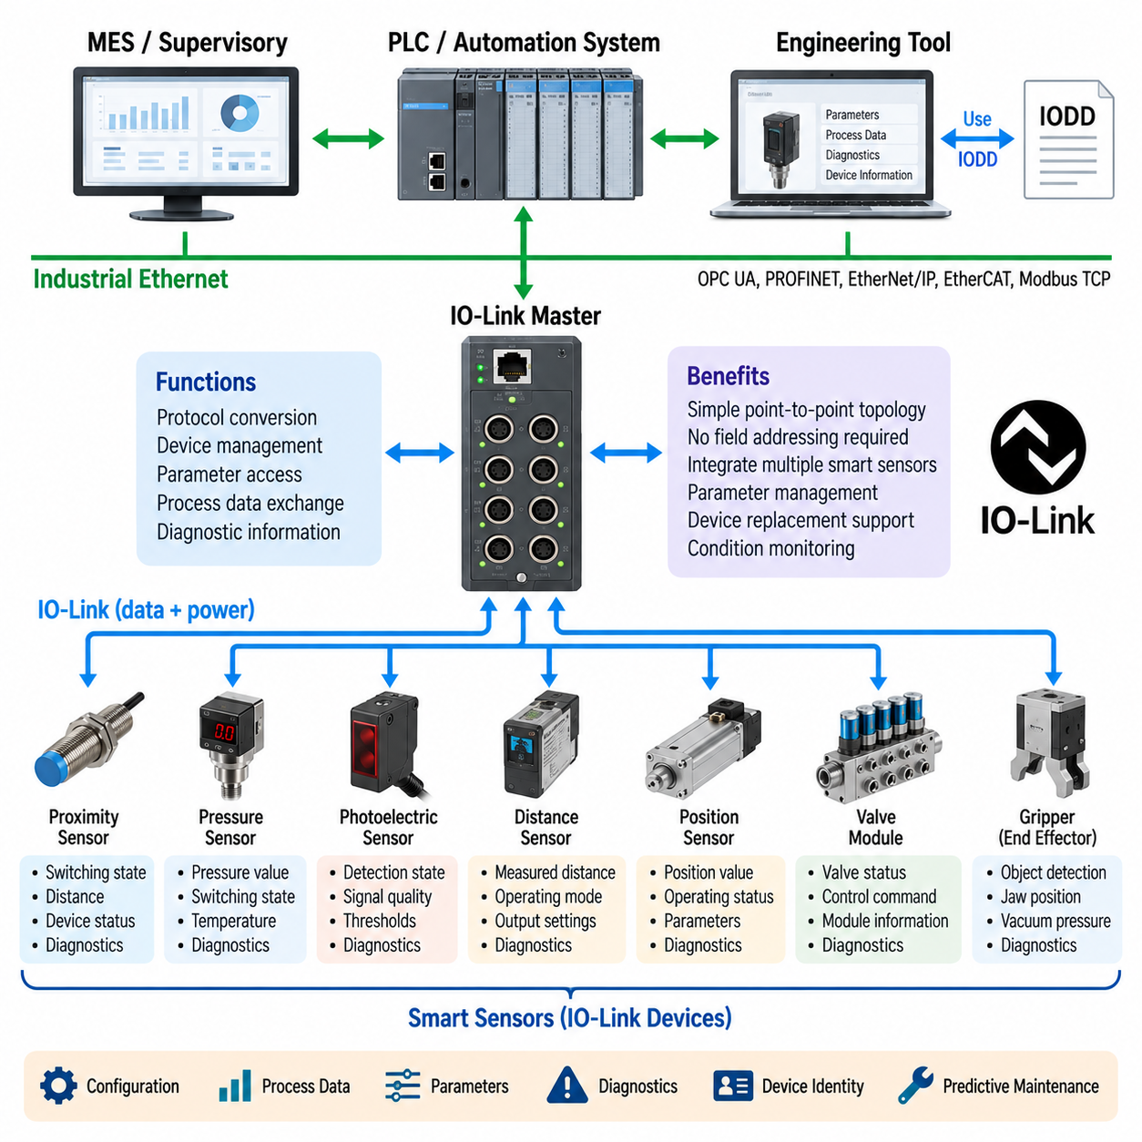
Smart sensor integration extends industrial sensing beyond simple electrical signal acquisition by combining measurement, local processing, configuration, identification, and diagnostics within the field device. In the IO-Link architecture, a smart sensor communicates with an IO-Link Master through a standardized point-to-point connection. This allows the automation system to obtain both operational process data and detailed information describing the condition and configuration of the sensor.
A conventional sensor may provide only a binary switching signal or analog measurement such as 0–10 V or 4–20 mA. A smart sensor can preserve the primary measurement while adding digital information such as device identity, measurement quality, operating status, threshold settings, temperature, diagnostic events, and maintenance indicators. This richer interface transforms the sensor from a passive signal source into an active information component within the automation architecture.
The IO-Link Master provides the communication bridge required to integrate these smart sensors into a PLC or industrial network. Each sensor is normally connected to an individual Master port, creating a simple point-to-point topology without requiring field-level network addressing. The Master exchanges process data and service information with the sensor and then maps the relevant information toward the higher-level controller, allowing multiple heterogeneous sensors to be managed through a common infrastructure.
Process data represents the information required continuously during machine operation. For a distance sensor, this may include measured distance and switching state; for a pressure sensor, it may contain pressure and status information; and for a position sensor, it may represent displacement or detected position. Because this information is transferred digitally, the controller can receive structured values without depending solely on analog signal scaling and conversion at the PLC input module.
Smart sensor integration also provides access to acyclic parameters that define device behavior. Switching thresholds, measurement ranges, filtering parameters, operating modes, response characteristics, and application-specific settings can be changed through the communication interface. This enables sensor configuration to become part of the machine engineering process rather than a manual adjustment performed individually at each physical sensor during installation or maintenance.
The IODD, or IO Device Description, provides the structured description required for engineering tools to understand these parameters and process-data definitions. It describes device identity, communication properties, available parameters, diagnostic information, and human-readable representations. Consequently, the same IO-Link communication architecture can support sensors from different manufacturers while engineering software uses the appropriate IODD to interpret each device correctly.
Parameter management becomes particularly valuable when machines contain many sensors or when devices must be replaced during maintenance. Instead of requiring technicians to manually reproduce every setting, the automation environment can use stored configuration information to support restoration of the required parameters. Device identification can also help verify whether a replacement component corresponds to the expected device type before the machine returns to normal operation.
Diagnostics are another major advantage of smart sensor integration. A sensor may report not only a measurement but also conditions related to signal quality, contamination, temperature, operating limits, internal faults, or other device-specific events. These diagnostic data can be delivered through the IO-Link communication path and interpreted by engineering or maintenance systems, providing considerably more information than a conventional fault represented only by a missing or incorrect input signal.
Condition information can support preventive and condition-based maintenance strategies. For example, an optical sensor whose signal quality gradually deteriorates because of contamination may continue to operate before reaching a complete failure state. If the sensor exposes an appropriate diagnostic indicator, the maintenance system can recognize the degradation and schedule cleaning or inspection before production is interrupted. Smart sensing therefore connects field-level diagnostics with broader equipment-maintenance activities.
Digital communication also reduces some limitations associated with analog measurement interfaces. An analog sensor value may be affected by scaling errors, conversion stages, or interpretation differences between the sensor output and controller input. With a digitally represented process value, measurement information can be transferred together with associated status information. Nevertheless, correct wiring, grounding, electromagnetic compatibility, power quality, and sensor installation remain essential for reliable operation.
At the machine level, smart sensors can be distributed around conveyors, robotic cells, grippers, fixtures, tooling, pneumatic systems, and mobile platforms. Proximity, photoelectric, pressure, temperature, distance, position, and condition-monitoring sensors can connect through IO-Link Masters located close to the equipment. This distributed architecture can reduce long individual signal runs while concentrating sensor communication at strategically positioned field-level interface modules.
In robotic systems, smart sensor integration is particularly useful around end effectors and peripheral equipment. A gripper may require object detection, jaw-position sensing, vacuum pressure monitoring, tool identification, and pneumatic status information. Instead of treating these elements as unrelated discrete signals, IO-Link can provide a common device-level communication mechanism through which the robot controller or PLC obtains process values, parameters, identity, and diagnostic information.
The same architecture can complement higher-bandwidth perception systems rather than competing with them. Cameras, LiDAR, radar, and advanced vision processors may require Ethernet or specialized high-speed interfaces, while proximity sensors, pressure sensors, switches, valves, and compact actuators have different bandwidth and integration requirements. IO-Link provides an appropriate field-device layer for these components, while industrial Ethernet connects the Master to the broader controller and factory network.
Smart sensor data can also become useful beyond immediate PLC control. Device identity, operating status, diagnostic events, and condition indicators can be propagated through the automation architecture toward supervisory, maintenance, asset-management, or manufacturing systems when required. The IO-Link layer therefore serves as an information source at the physical edge, while higher-level industrial communication technologies provide the pathways for selected information to reach broader factory applications.
For AMRs and other Physical AI systems, smart sensors can support machine-level functions that remain necessary even when sophisticated AI perception is available. Local proximity detection, mechanism position confirmation, pressure monitoring, payload handling, docking confirmation, actuator feedback, and equipment diagnostics can be implemented with compact field devices. These signals provide deterministic equipment information that complements the probabilistic perception produced by cameras and AI-based sensing.
Smart sensor integration therefore represents an important transition from signal-oriented automation toward information-oriented field architecture. The sensor is no longer merely an electrical input but a configurable and diagnosable digital component with defined identity and semantics. IO-Link supplies the communication path, the Master provides integration with the automation network, and the IODD provides the device description required to interpret the resulting information consistently across the engineering lifecycle.

08.04. IO-Link Wireless
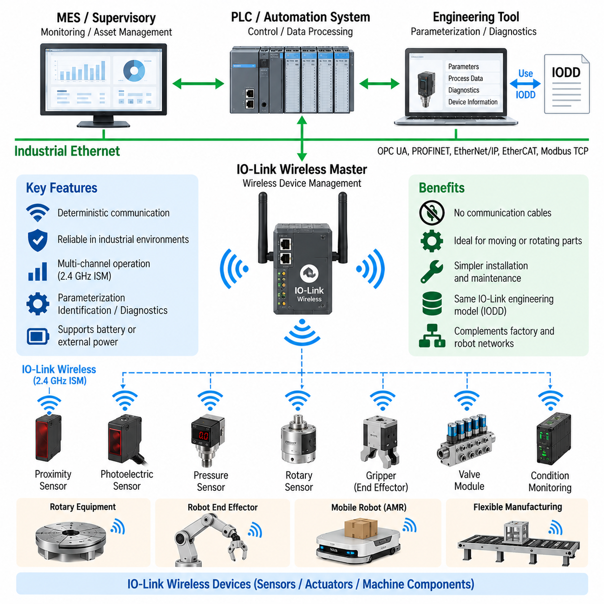
IO-Link Wireless extends the IO-Link device communication concept from a wired point-to-point connection into a deterministic wireless communication environment. It is intended for industrial sensors, actuators, and machine components where cables restrict movement, increase mechanical wear, or complicate installation. Within the IO-Link chapter structure, it follows Master–Device architecture, IODD descriptions, and smart sensor integration as an extension of the same field-device philosophy.
In a conventional wired IO-Link system, each device communicates with an IO-Link Master through a dedicated physical connection. IO-Link Wireless replaces the communication cable with a radio link while maintaining the logical relationship between the automation infrastructure and intelligent field devices. The objective is not simply to provide generic wireless connectivity, but to preserve industrial device communication characteristics such as predictable data exchange, configuration, identification, and diagnostics.
The wireless architecture introduces an IO-Link Wireless Master that coordinates communication with multiple wireless field devices. The Master acts as the bridge between the wireless device domain and the higher-level automation network, similar to the role of a wired IO-Link Master. On the controller side, it can interface with PLC and industrial network infrastructure, while on the field side it manages radio communication, device association, cyclic data exchange, parameter access, and diagnostic information.
A major design requirement is deterministic communication. Industrial automation cannot generally rely on the unpredictable latency and contention behavior acceptable in ordinary consumer wireless networks. IO-Link Wireless therefore organizes radio communication according to controlled timing and coordinated access mechanisms. The Master controls communication opportunities so that connected devices can exchange process information within defined communication cycles rather than competing arbitrarily for access to the radio channel.
Reliability is equally important because industrial radio environments can contain interference, reflections, shielding structures, motors, drives, welding equipment, and other communication systems. Wireless communication must therefore account for packet loss and temporary disturbances that do not normally occur in the same manner on a dedicated cable. Appropriate transmission management, channel usage, timing coordination, and retransmission mechanisms contribute to maintaining dependable device communication under changing factory conditions.
IO-Link Wireless operates in the 2.4 GHz ISM frequency range, allowing deployment without dedicated licensed spectrum in many industrial environments. This frequency range is also used by technologies such as Wi-Fi and Bluetooth, so coexistence becomes an important engineering consideration. The wireless system must be designed to maintain its required communication performance even when other radio systems operate nearby, making radio planning part of industrial network engineering.
The concept of multiple communication channels is important for improving robustness in a shared radio environment. Instead of depending permanently on a single frequency condition, wireless communication can make use of coordinated channel resources to reduce the impact of localized interference. This approach is especially valuable in factories where electromagnetic conditions can change as machines operate, mobile equipment moves, or neighboring wireless systems alter their traffic patterns.
Device configuration remains closely related to the existing IO-Link engineering model. Wireless devices can still expose process data, parameters, identification information, and diagnostics, while IODD-based device descriptions provide engineering tools with information about those functions. This preserves an important architectural advantage: changing the physical communication medium from cable to radio does not require abandoning the structured device-information model established for intelligent IO-Link field devices.
The elimination of communication cables is particularly useful for moving or rotating machine elements. Sensors installed on rotary tables, robotic tools, exchangeable fixtures, grippers, moving carriers, and handling equipment can be difficult to connect using continuously flexing cables. Cable chains, slip rings, and complex routing mechanisms introduce cost and potential failure points. Wireless communication can reduce these constraints when the application requirements and power architecture support cable-free operation.
Wireless communication, however, does not automatically eliminate the need for device power. A wired IO-Link connection can carry both communication and electrical power, whereas a wireless field device requires another power source. Depending on the application, this may involve batteries, local power connections, energy storage, or energy-harvesting approaches. Consequently, wireless architecture design must consider communication and power as separate engineering problems rather than assuming that removal of the data cable makes the device completely wireless.
Battery-powered devices introduce additional considerations involving operating time, maintenance intervals, communication activity, and energy consumption. A sensor that communicates frequently or performs substantial local processing may consume more energy than a simple low-duty-cycle device. Therefore, communication cycle requirements should be balanced against power availability. For rotating, mobile, or difficult-to-access equipment, battery replacement and charging strategy can become as important as radio performance.
In robotic applications, IO-Link Wireless can support sensors and actuators mounted on moving mechanisms where traditional cabling creates packaging or durability problems. A robotic end effector may include object detection, pressure sensing, position sensing, tool identification, or condition monitoring. Wireless connectivity can simplify the communication path between these peripheral devices and the automation system, particularly when tools are exchanged frequently or continuous mechanical motion would repeatedly stress communication cables.
Mobile platforms provide another useful application domain. AMRs, automated carriers, movable fixtures, and transport systems may interact with intelligent sensors distributed across moving equipment or temporary workstations. Wireless field-device communication can reduce dependence on fixed physical connections while preserving structured process data and diagnostic information. It can therefore complement the Ethernet, Wi-Fi, or other communication systems used for higher-level robot navigation, fleet coordination, and supervisory functions.
IO-Link Wireless should be distinguished from general-purpose robot wireless networking. It is primarily a field-device communication technology for sensors, actuators, and related machine components rather than a high-bandwidth network for cameras, LiDAR point clouds, video streams, or AI model data. High-volume perception and computing traffic normally requires other network technologies, while IO-Link Wireless addresses relatively compact but operationally important device-level information.
System integration therefore remains layered. Smart sensors and actuators communicate through the IO-Link Wireless domain, the Wireless Master aggregates and manages those devices, and the PLC or automation controller accesses the required information through the higher-level industrial network. Supervisory and manufacturing systems can subsequently receive selected status, diagnostic, or asset information. This maintains separation between field-device connectivity, machine control, and factory-level information exchange.
For Physical AI systems, this architecture can provide a useful interface between sophisticated AI-driven behavior and conventional machine-level sensing. AI perception may estimate objects, terrain, or human activity, while IO-Link Wireless devices report deterministic equipment states such as tool presence, pressure, mechanism position, proximity, or actuator condition. Combining these information sources allows intelligent robots to retain reliable machine interfaces while reducing wiring constraints on moving components.
IO-Link Wireless therefore extends the smart-device architecture introduced by wired IO-Link into applications requiring greater mechanical freedom and installation flexibility. Its value comes from combining structured device data, parameterization, identification, and diagnostics with coordinated industrial wireless communication. The resulting architecture is especially relevant to robotics, flexible manufacturing, rotating machinery, interchangeable tooling, and mobile automation where communication reliability must coexist with physical mobility.

08.05. IO-Link in Gripper Sensor
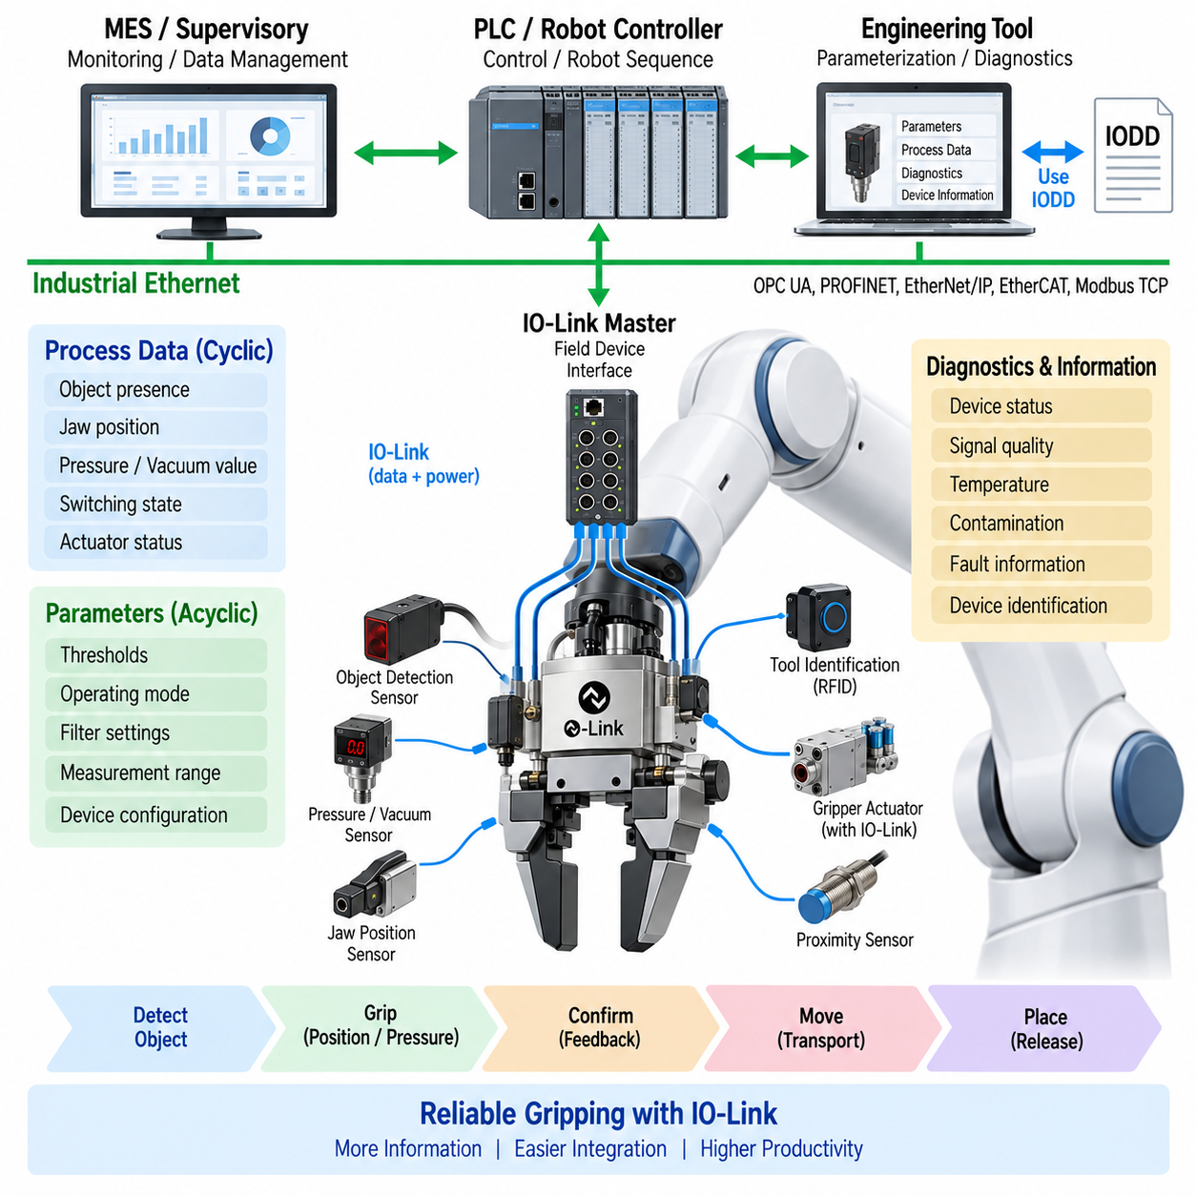
IO-Link provides a practical device-level communication architecture for integrating intelligent sensors and actuators into robotic grippers. A modern gripper may contain jaw-position sensors, proximity detectors, pressure or vacuum sensors, object-presence sensors, identification functions, and actuator feedback. Instead of connecting these functions only as separate discrete or analog signals, IO-Link allows structured process data, parameters, identification, and diagnostics to be exchanged through a standardized interface.
In a typical robotic architecture, the gripper is mounted at the end of a manipulator while an IO-Link Master connects field devices to the PLC, robot controller, or industrial network. Sensors located around the gripper communicate through IO-Link ports, and the Master concentrates their information before forwarding relevant data to the control system. This separates detailed field-device communication from higher-level robot sequencing, motion control, and factory communication.
Object detection is one of the fundamental sensing functions around a gripper. A proximity or photoelectric sensor can indicate whether a workpiece has entered the gripping region, while additional sensing can confirm whether the object remains present after the jaws close. Through IO-Link, this information can be represented as process data together with sensor status and diagnostic information, providing more context than a conventional binary input alone.
Jaw-position information can provide another important indication of gripping condition. Position sensing can distinguish between an open gripper, a fully closed gripper, and an intermediate position corresponding to a captured object. The controller can combine this position information with object detection and commanded gripper state. Such information helps determine whether a grasp was completed correctly and whether the actual mechanical response corresponds to the requested manipulation action.
Pneumatic and vacuum grippers can use pressure sensing as a direct indication of gripping-system condition. In a vacuum gripper, the measured pressure can indicate whether sufficient vacuum has been established to hold an object. A pressure sensor can provide the actual measured value, switching status, operating condition, and diagnostics through IO-Link, allowing the controller to distinguish normal gripping from insufficient vacuum, leakage, or other abnormal conditions.
Cyclic process data is used for information that must be available continuously during robot operation. Object-presence state, jaw position, pressure value, vacuum status, switching state, and actuator condition can be transferred as process information according to the capabilities of the connected devices. The robot or PLC can use these values in its control sequence to determine whether gripping, lifting, transportation, placement, or release operations may proceed.
Acyclic communication provides access to parameters that do not need to be exchanged continuously. Sensor thresholds, filtering settings, operating modes, measurement ranges, switching behavior, and device-specific configuration can be adjusted through the IO-Link interface. This is particularly valuable for flexible robotic cells where the same gripper or sensor arrangement may handle different workpieces requiring different detection thresholds or operating characteristics.
The IODD, or IO Device Description, gives engineering software the structured information required to understand each connected gripper sensor or actuator. It can describe device identity, parameters, process-data organization, diagnostics, and human-readable information. As a result, an engineering tool can present meaningful configuration options rather than requiring technicians to interpret proprietary data structures or manually maintain separate parameter definitions for every device.
Device identification becomes useful when grippers, tools, or sensor modules are exchanged. An automation system can use identification information to determine which compatible device is connected and whether the expected configuration is present. In robotic cells with automatic tool changers, this capability can support verification of peripheral equipment before operation begins, reducing the possibility that the controller operates with an incorrect device configuration.
Diagnostics provide information about the health of the gripper sensing system as well as its immediate process state. A sensor may report contamination, reduced signal quality, temperature conditions, internal faults, or measurement problems in addition to its primary process value. Maintenance software can therefore distinguish between a legitimate process condition, such as no object being present, and a sensor problem that prevents reliable object detection.
This distinction is important because a robot should not automatically interpret every missing sensor signal as the same physical event. An object-detection signal may disappear because the object is absent, because alignment is incorrect, because the optical surface is contaminated, or because the sensor has failed. Additional IO-Link status and diagnostic information can provide the control and maintenance layers with evidence needed to differentiate these conditions and respond appropriately.
Parameter storage and restoration can simplify replacement of gripper sensors during maintenance. When a sensor is replaced, previously defined configuration information can support restoration of the required operating parameters through the IO-Link infrastructure. This reduces the need for manual adjustment at the end effector, which may be difficult to access and may contain several sensors with similar physical appearance but different configuration requirements.
IO-Link can also simplify gripper wiring architecture by concentrating intelligent field-device connections around an appropriate Master or interface module. Instead of routing numerous independent analog and discrete signals over long distances, device-level information can be aggregated before entering the higher-level automation network. The exact physical arrangement depends on the robot and gripper design, but the architectural objective is to reduce interface complexity while retaining detailed device information.
For moving robotic mechanisms, cable routing remains an important engineering consideration. A wired IO-Link implementation must account for repeated bending, torsion, connector retention, electromagnetic compatibility, and mechanical protection along the robot wrist and end-effector interface. Where cable movement becomes particularly difficult, IO-Link Wireless can provide an alternative communication approach, although power supply, radio reliability, latency, and environmental conditions must then be considered separately.
The gripper information can be integrated into a broader PLC–robot handshake. The robot may command a gripping operation, while the gripper subsystem reports object detection, actuator state, position, pressure, and completion information. The PLC or robot controller can use these signals to determine whether the sequence should continue, retry, stop, or generate a diagnostic event. IO-Link therefore supplies detailed device information without replacing the higher-level sequence logic.
In Physical AI systems, gripper sensors form an important connection between AI-based perception and deterministic machine interaction. A vision model may estimate an object's pose and select a grasp point, but the physical system still needs confirmation that the gripper reached the expected state and successfully acquired the object. Position, pressure, proximity, and actuator feedback can provide direct evidence from the end effector after the AI-generated manipulation decision is executed.
This creates a closed information path from perception to physical verification. Vision or AI identifies the object and plans the manipulation, the robot executes the motion, the gripper performs the grasp, and IO-Link-connected devices report the resulting mechanical state. If the expected pressure, position, or object-presence conditions are not achieved, the robot can treat the grasp as incomplete and initiate an appropriate recovery, retry, or fault-handling sequence.
IO-Link integration in gripper sensing therefore combines smart sensor communication, IODD-based engineering, parameter management, diagnostics, and robot-level process feedback within a consistent field-device architecture. It enables grippers to expose richer information than conventional discrete interfaces while remaining connected to established PLC and industrial automation systems. This makes IO-Link particularly suitable for flexible robotic handling, intelligent end effectors, automated tool systems, and increasingly information-rich Physical AI machines.

