Volume 07. Industrial Communication

Chapter 05. PROFINET

05.01. PROFINET RT/IRT
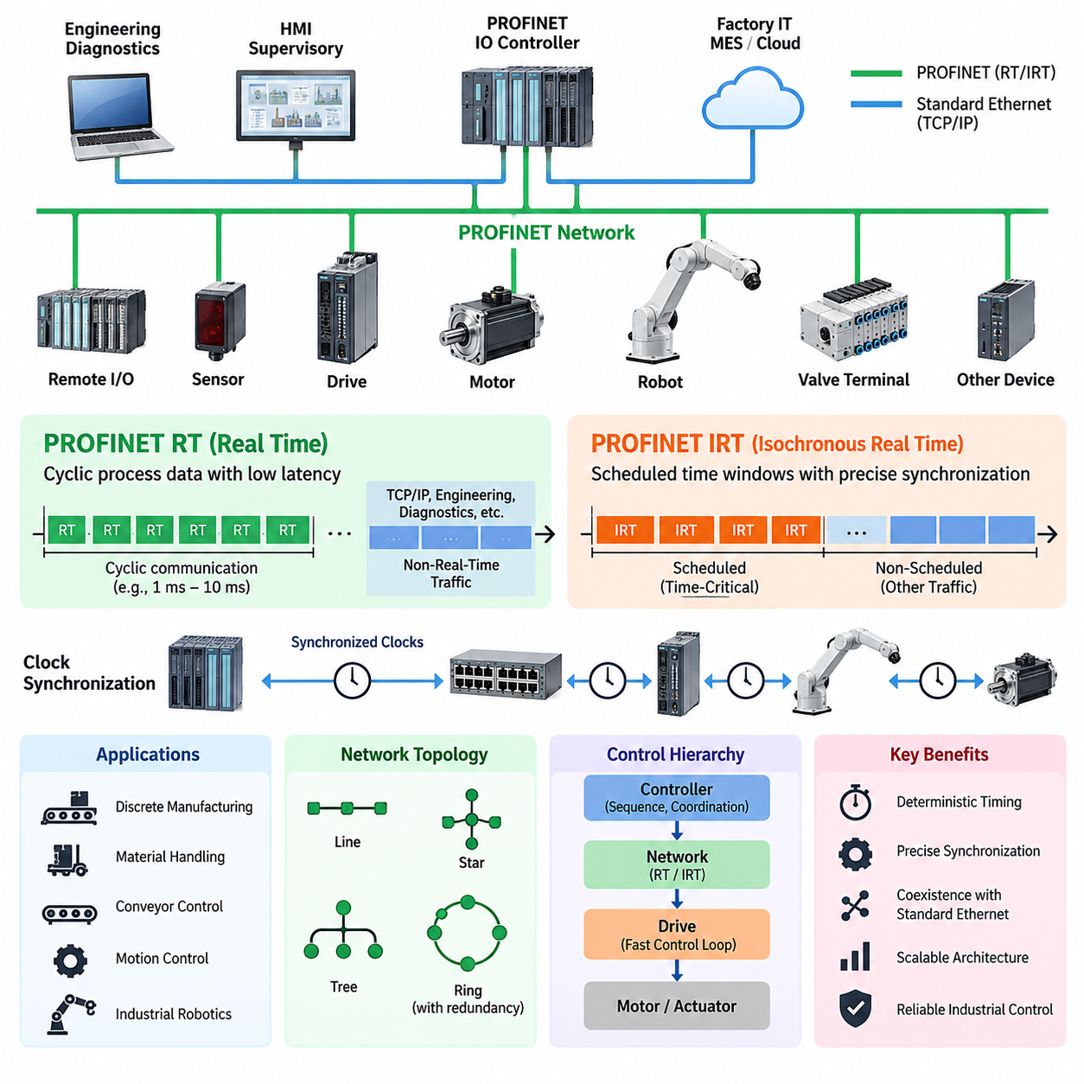
PROFINET is an Industrial Ethernet communication system designed for deterministic data exchange between controllers, distributed I/O devices, drives, robots, and other automation equipment. It uses standard Ethernet technology while adding communication mechanisms optimized for industrial control. PROFINET supports several communication classes, of which Real Time (RT) and Isochronous Real Time (IRT) address applications requiring increasingly predictable timing and synchronization.
PROFINET RT is intended for cyclic process communication in which ordinary TCP/IP processing would introduce unnecessary protocol overhead and timing variation. Real-time frames are transmitted directly through Ethernet mechanisms rather than being processed through the complete TCP/IP stack. This reduces communication latency and allows controllers to exchange process data with field devices at predictable intervals while conventional Ethernet traffic can remain on the same network.
In a typical RT system, a PROFINET IO Controller cyclically exchanges input and output data with multiple IO Devices. Sensors, remote I/O modules, valve terminals, motor controllers, and other devices continuously update their process data according to the configured communication cycle. Engineering, diagnostics, parameterization, and other non-time-critical functions can simultaneously use standard Ethernet services without requiring a physically separate communication infrastructure.
RT communication provides sufficient deterministic behavior for a broad range of factory automation tasks, including discrete manufacturing, material handling, conveyor control, distributed sensing, and general robot peripheral integration. Its timing requirements are typically less demanding than tightly synchronized multi-axis motion control. The network therefore emphasizes practical real-time performance while preserving compatibility with standard switched Ethernet infrastructure and common industrial network architectures.
PROFINET IRT extends this concept for applications where communication must occur with very low timing variation and precise synchronization. Instead of relying only on prioritized Ethernet transmission, IRT organizes communication into carefully scheduled time windows. Time-critical cyclic traffic receives reserved transmission opportunities, preventing ordinary network traffic from interfering with deterministic control communication during the designated real-time portion of each communication cycle.
The communication cycle in an IRT network can be conceptually divided into scheduled and nonscheduled regions. Highly deterministic frames associated with synchronized control are transmitted during reserved intervals, while other PROFINET traffic and conventional Ethernet communication use the remaining bandwidth. This temporal separation allows deterministic industrial communication and ordinary network services to coexist while protecting critical control messages from unpredictable queuing delays and network congestion.
Precise clock synchronization is fundamental to IRT operation. Controllers, switches, drives, and other participating devices coordinate their local timing so that communication and control actions occur according to a common time reference. Accurate synchronization reduces jitter between distributed devices and enables several actuators to update their commands at closely aligned moments. This characteristic is particularly important when mechanical motion depends on coordinated behavior across multiple servo axes.
The practical distinction between RT and IRT is therefore not simply that one network is faster than the other. RT primarily provides efficient and predictable cyclic communication for normal industrial control, whereas IRT introduces stronger temporal coordination for applications requiring tightly bounded latency and jitter. Selecting between them should consequently depend on the control-loop requirements, synchronization accuracy, topology, device capabilities, and required communication cycle rather than nominal Ethernet bandwidth alone.
IRT becomes especially valuable in motion-control systems involving coordinated servo drives, printing machinery, packaging equipment, machine tools, synchronized conveyors, and industrial robots. If several joints or axes must follow trajectories simultaneously, variation in command delivery can appear as motion error or degraded coordination. Deterministic communication scheduling and synchronized device clocks help maintain consistent relationships between trajectory generation, command transmission, drive execution, and feedback acquisition.
Network topology also influences real-time performance. PROFINET installations commonly use switched Ethernet structures arranged as line, star, tree, or combinations of these forms. Industrial devices may contain integrated switch ports, allowing convenient line structures without separate switches at every node. For demanding deterministic operation, however, network components must support the required PROFINET functions, and the engineering configuration must account for communication paths, update timing, synchronization, and topology changes.
PROFINET communication should also be understood as part of a complete automation architecture rather than as an isolated fieldbus replacement. Cyclic RT or IRT traffic handles time-sensitive process information, while additional Ethernet communication supports configuration, diagnostics, asset information, higher-level supervisory systems, and engineering access. This coexistence is one reason PROFINET can connect field-level automation with broader Ethernet-based factory infrastructures while retaining deterministic control capabilities.
For robotics, the choice of communication class depends strongly on where PROFINET is positioned in the control hierarchy. RT is appropriate for exchanging robot status, interlocks, peripheral commands, gripper signals, station handshakes, and general PLC data. IRT is more relevant when network communication participates directly in synchronized motion or tightly coordinated machine processes. Internal high-frequency motor-current or torque loops may still remain inside dedicated servo drives even when IRT coordinates higher-level motion.
This separation of control responsibilities is important because deterministic networking does not eliminate the need for local control. A servo drive can execute fast current, velocity, and position functions locally while receiving synchronized references through the industrial network. The controller therefore manages coordinated machine behavior, the network delivers information within controlled timing boundaries, and the drive performs lower-level actuation. The resulting hierarchy distributes computation according to required response time.
Engineering an RT or IRT system consequently requires more than selecting Ethernet cables and connecting compatible devices. Update times, synchronization requirements, network load, topology, switch behavior, device capabilities, diagnostic requirements, and failure responses must be considered together. Excessively demanding timing increases configuration complexity without necessarily improving machine performance, while insufficient determinism can introduce unacceptable variation into coordinated control processes.
PROFINET RT and IRT ultimately represent two levels of deterministic Industrial Ethernet behavior within the same automation ecosystem. RT provides practical real-time cyclic communication for most controller-to-device exchanges, while IRT adds synchronized scheduling for applications where timing consistency becomes part of control performance itself. This layered approach allows engineers to apply deterministic communication selectively, matching network behavior to the physical dynamics and synchronization requirements of the industrial system.

05.02. GSDML Device Description
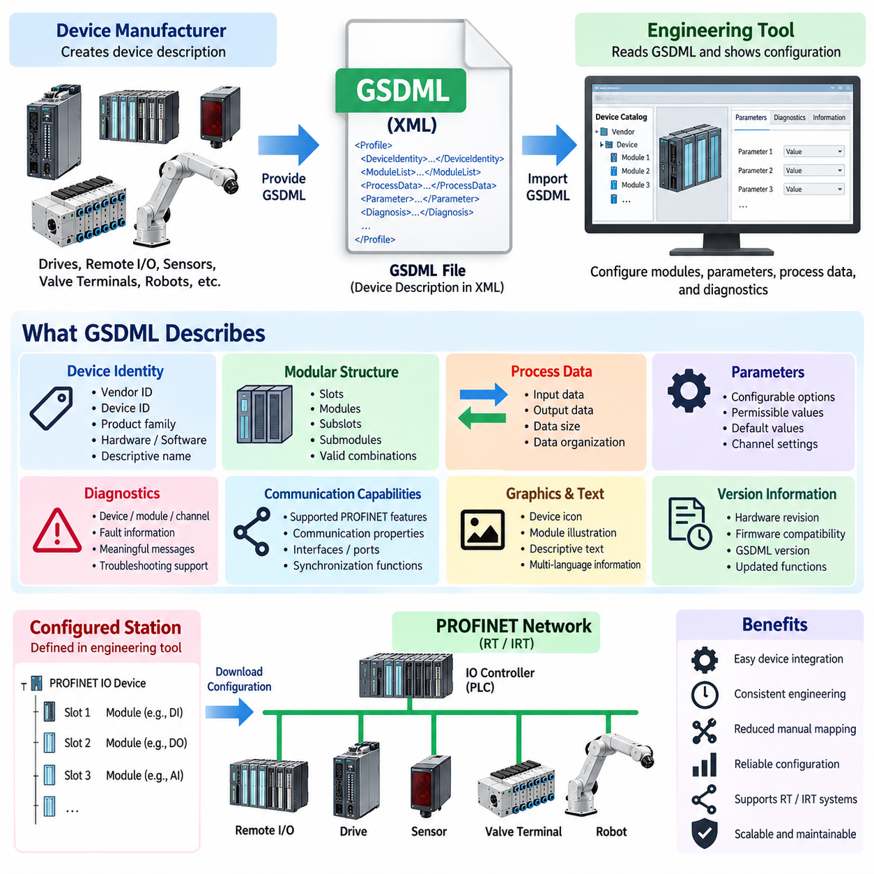
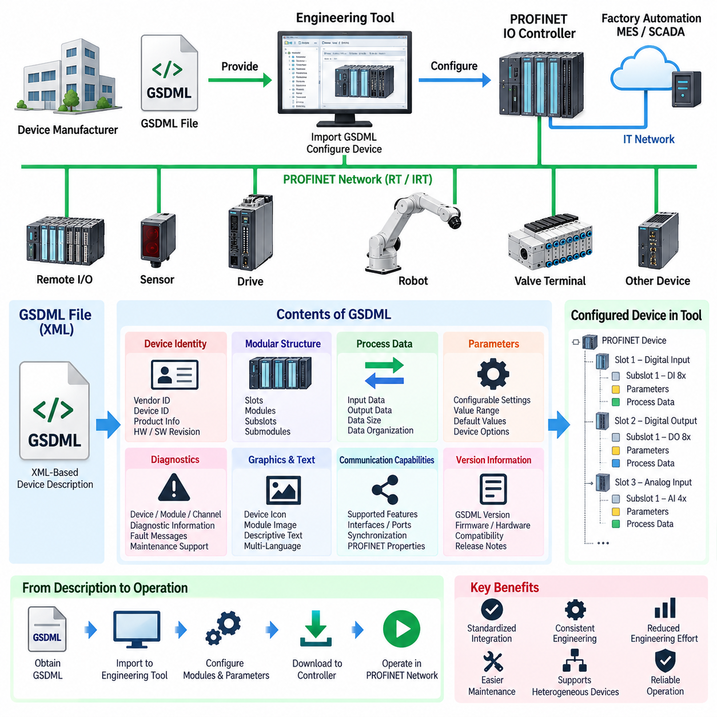
GSDML, or General Station Description Markup Language, is the standardized device-description format used to integrate PROFINET IO devices into engineering systems. It provides a machine-readable representation of a device’s communication capabilities, modular structure, identification information, parameters, diagnostics, and process-data organization. Within the PROFINET chapter structure, GSDML therefore forms the engineering bridge between RT/IRT communication concepts and actual device configuration.
A GSDML description is implemented as an XML-based file that follows a defined PROFINET schema. Instead of requiring an engineering tool to contain proprietary knowledge about every sensor, remote I/O station, drive, valve terminal, or robot interface, the manufacturer supplies a GSDML file describing the device. The engineering software interprets this information and presents the available configuration choices to the automation engineer in a consistent form.
The file normally contains device identity information that allows the engineering environment to distinguish a particular product and its supported variants. Vendor identification, device identification, product family information, hardware and software references, and descriptive names can be represented within the device model. This information helps ensure that the configured PROFINET station corresponds to the intended physical device and provides a foundation for device discovery, configuration, replacement, and maintenance.
One of the most important functions of GSDML is describing the modular structure of a PROFINET IO Device. Many industrial devices are not represented as one fixed block of process data. A remote I/O station, for example, may contain different combinations of digital input, digital output, analog input, analog output, communication, and specialty modules. GSDML defines which modules and submodules are available and how they can be assembled within the supported device configuration.
This modular representation corresponds closely to the PROFINET device model. An IO Device can contain slots populated by modules, while modules can contain subslots associated with submodules. Input and output data are ultimately associated with these configured elements. The engineering system uses the GSDML definitions to determine which combinations are valid, where modules may be inserted, what process data they exchange, and how the resulting station configuration should be represented to the IO Controller.
Process-data definitions are especially important because the controller must understand the size, direction, and organization of cyclic information exchanged with each device. GSDML can describe input data delivered from the device to the controller and output data transmitted from the controller to the device. Engineering tools use these definitions to construct the configured IO data layout, allowing PLC variables and application logic to be associated with the physical signals and functions exposed by the device.
GSDML also provides parameter descriptions required to adapt a device to a particular application. A configurable sensor may expose measurement modes, thresholds, filtering behavior, or operating options, while a distributed I/O module may require channel-specific settings. Rather than embedding these choices directly into the engineering software, the device description defines the supported parameters, their permissible values, default values, and related information so that configuration can be performed systematically.
Diagnostic information is another significant part of device description. Industrial automation requires faults to be represented in a way that supports commissioning, troubleshooting, and maintenance. GSDML can provide information that allows engineering systems to interpret device-, module-, submodule-, or channel-related diagnostic conditions. This enables a raw device condition to be presented as meaningful engineering information and helps technicians identify whether a problem originates from communication, configuration, wiring, channels, or equipment.
The GSDML file can additionally reference graphical and textual resources used by the engineering environment. Device icons, module illustrations, descriptive text, and language-dependent information can make configuration easier to understand. These resources do not control the physical communication itself, but they improve the engineering representation of the device and reduce dependence on manually interpreting product documentation when constructing or diagnosing a PROFINET station.
Device capabilities related to communication are also represented through the description. The engineering system must know which PROFINET features and communication properties a device supports before generating a valid network configuration. Depending on the device and GSDML version, relevant capabilities can include communication relationships, cyclic data characteristics, supported interfaces and ports, synchronization-related functions, and other PROFINET-specific properties required for correct controller-device operation.
This relationship becomes particularly important when RT and IRT requirements are considered. A GSDML file does not itself create deterministic communication; instead, it informs the engineering environment about the capabilities that can participate in the configured PROFINET system. The controller, devices, network infrastructure, topology, timing configuration, and supported communication features must still work together. GSDML provides the structured device knowledge needed to create and validate that engineering configuration.
In practical commissioning, the device manufacturer supplies the appropriate GSDML package, which is imported into a compatible PROFINET engineering environment. The device then becomes available in the engineering catalog, where the user can select the product, configure modules and submodules, assign parameters, define process-data relationships, and integrate the station into the controller project. The resulting engineering configuration is subsequently transferred to the automation system for operation.
Version management is important because device functionality and GSDML specifications can evolve over time. Hardware revisions, firmware changes, newly supported functions, or updated PROFINET features may require corresponding device-description revisions. Engineers should therefore verify compatibility among the physical device, firmware, GSDML version, engineering software, and controller environment instead of assuming that any file carrying the same product family name will describe every possible device revision correctly.
For robotics, GSDML becomes particularly useful at the boundary between a robot system and factory automation equipment. A robot controller, gripper interface, remote I/O station, drive system, or peripheral device can expose standardized process data and parameters to a PLC through its PROFINET description. The PLC engineer can configure these interfaces through the same engineering workflow used for other factory devices, reducing the need for manually constructed communication mappings.
GSDML should therefore be viewed as a formal contract between a PROFINET device and the engineering ecosystem rather than merely as an installation file. It describes what the device is, how it is structurally organized, what data it exchanges, which parameters can be configured, which diagnostics can be interpreted, and which communication capabilities are available. By standardizing this description, PROFINET enables heterogeneous industrial devices to be integrated into controller projects through a consistent and scalable engineering process.

05.03. PROFIsafe Safety Protocol
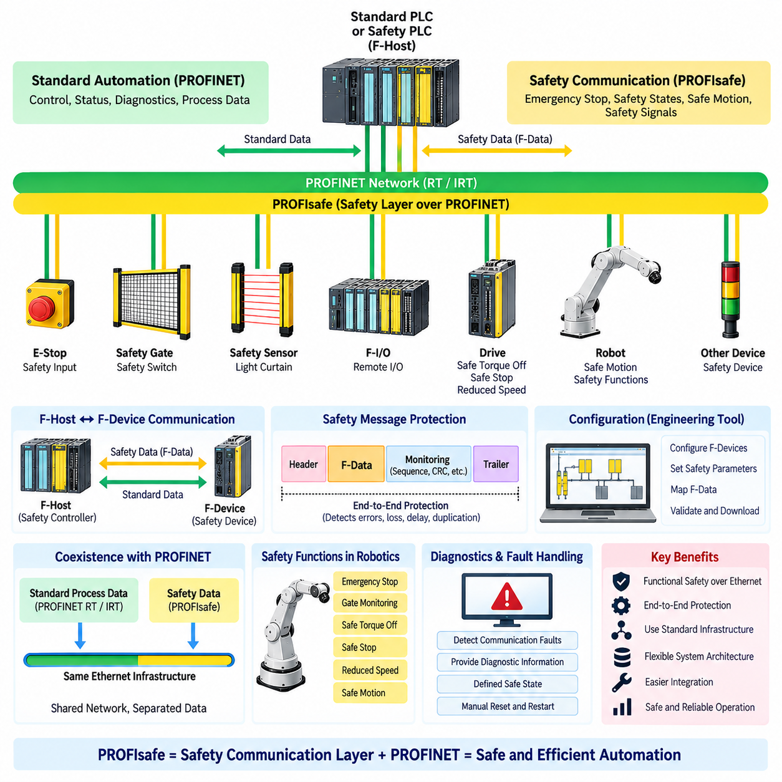
PROFIsafe is the functional safety communication protocol used with PROFINET to transmit safety-related information over the same industrial Ethernet infrastructure that carries standard automation data. Its purpose is not to replace the underlying PROFINET communication, but to add mechanisms that allow safety functions to detect communication errors and place the controlled machine or robot into a defined safe state. It therefore provides a safety layer above the standard communication system.
PROFIsafe is designed around the separation between standard automation communication and safety communication. Normal PROFINET data can continue to carry control, status, and diagnostic information, while PROFIsafe transfers safety-critical signals such as emergency-stop commands, protective-device states, and safe operating conditions. This approach allows standard and safety-related functions to share network infrastructure while maintaining the additional integrity mechanisms required for safety communication.
A central concept in PROFIsafe is the communication relationship between the F-Host and F-Device. The F-Host is typically a safety controller or safety-related control function that evaluates safety logic, while the F-Device is a field device capable of processing safety-related data. Examples include fail-safe remote I/O, safety sensors, safety switches, drives, and other devices used in machine safety systems. The safety application exchanges defined F-data through this relationship.
PROFIsafe does not assume that the underlying network is inherently safe. Ethernet frames may be delayed, repeated, lost, inserted, or delivered to an incorrect logical destination. PROFIsafe therefore incorporates mechanisms that allow the receiving safety function to recognize communication faults. Monitoring information, sequence-related information, and safety-specific protection mechanisms help distinguish valid safety messages from corrupted, duplicated, delayed, or incorrectly associated messages.
A key principle is that safety is achieved through end-to-end protection rather than by making every component of the communication path intrinsically safety-rated. The safety message is protected between the safety application endpoints, while intermediate network components primarily provide communication transport. This allows PROFIsafe to operate across standard PROFINET infrastructure and supports flexible network architectures without requiring every Ethernet switch or communication segment to become part of the safety function.
PROFIsafe uses safety-oriented data structures and monitoring mechanisms to maintain communication integrity. A safety receiver can verify whether received information belongs to the expected communication relationship and whether it arrived within an acceptable timing condition. If the expected safety information is missing or invalid, the safety application can react according to its configured safety logic. The resulting behavior is normally designed around a defined safe state rather than continued operation with uncertain safety information.
Configuration is an important part of a PROFIsafe system because safety communication must be associated with the correct logical safety functions and physical devices. Safety parameters identify communication relationships and define how safety devices participate in the safety system. Engineering tools are used to configure the safety controller, F-Devices, safety parameters, and corresponding process data. Correct configuration and verification are therefore essential parts of commissioning and safety validation.
PROFIsafe can coexist with PROFINET RT and, where supported, PROFINET IRT communication. Standard cyclic process data may be exchanged through normal PROFINET mechanisms, while safety-related information is handled through the PROFIsafe layer. The distinction is important because deterministic communication performance and functional safety are related but different engineering concerns. A network can provide predictable communication timing, but safety integrity still requires independent mechanisms for detecting communication and application-level faults.
In industrial robotics, PROFIsafe can connect safety functions between a safety PLC, robot controller, drives, distributed I/O, and protective devices. Emergency-stop inputs, gate switches, enabling devices, safe motion commands, and other safety-related signals can be exchanged through the industrial network. For example, a safety controller may detect an opened protective gate and transmit the corresponding safety command to a robot or drive system. The receiving system then performs its configured safe response.
The relationship between PROFIsafe and safe motion is particularly important in modern robot and machine architectures. A safety system may need to control functions such as safe torque off, safe stop, reduced speed, or other safety-related operating conditions. PROFIsafe can transport the corresponding safety information, while the drive or robot controller implements the actual safety function. The communication protocol therefore forms part of the safety architecture rather than independently performing the physical shutdown or motion-control function.
Diagnostics and fault handling must be considered together with PROFIsafe communication. A fault can originate from the safety device, communication path, configuration, timing condition, or safety application. When a safety communication error is detected, the system should provide sufficient diagnostic information for maintenance personnel to determine the cause while ensuring that diagnostic activity does not compromise the safety function. Recovery from a safety fault should also follow the defined reset and restart philosophy rather than automatically returning the machine to unrestricted operation.
PROFIsafe should therefore be understood as a safety communication layer integrated with the broader PROFINET architecture. PROFINET provides the industrial Ethernet communication infrastructure, while PROFIsafe adds end-to-end mechanisms and safety-oriented configuration needed for functional safety communication. In a complete robot or factory automation system, the safety PLC, F-Devices, drives, robot controllers, network infrastructure, safety logic, and physical safety functions must be engineered as one coherent safety architecture.

05.04. PROFINET Diagnostics
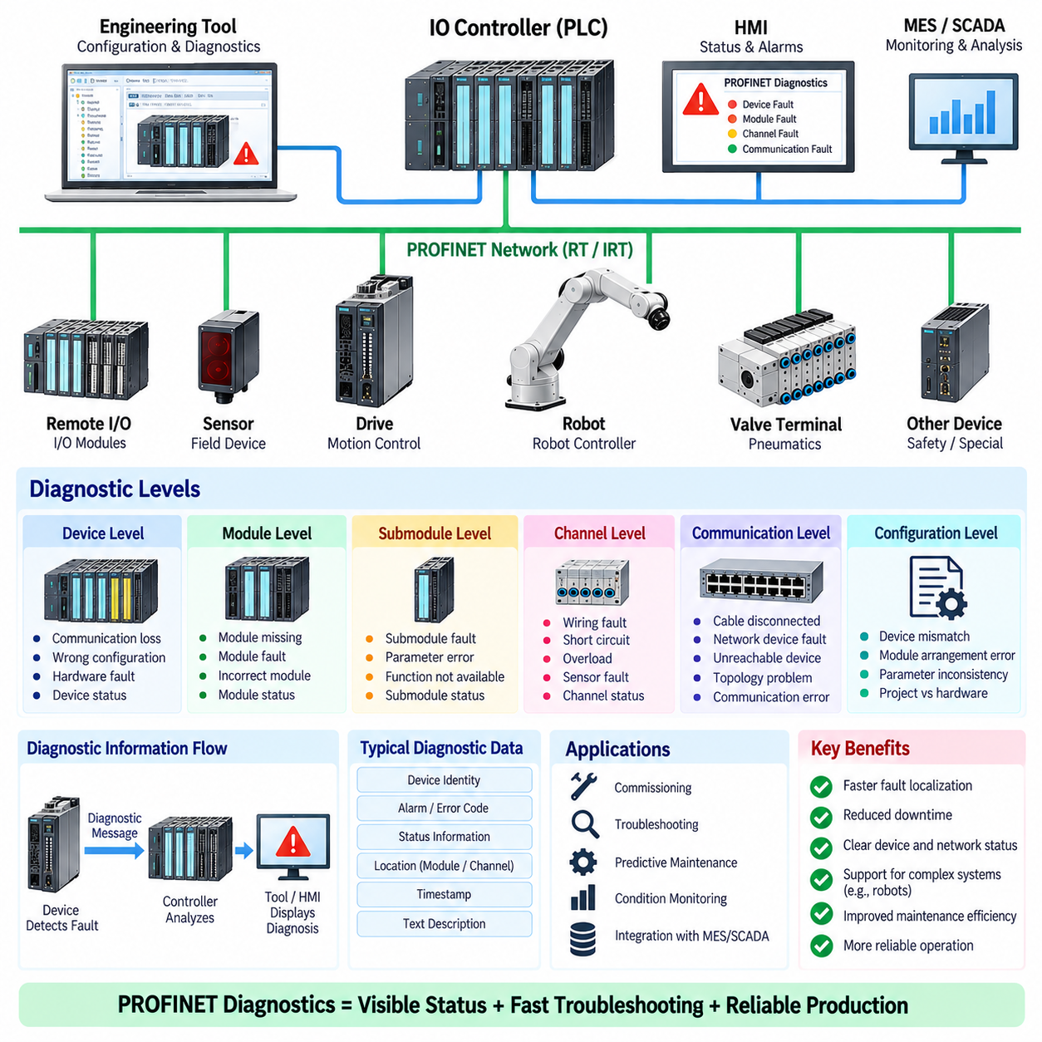
PROFINET diagnostics provides mechanisms for identifying, reporting, and analyzing communication and device conditions within a PROFINET network. It extends ordinary process communication by making device health and network status visible to the engineering and maintenance environment. Diagnostics can help determine whether a problem originates from a controller, IO Device, module, submodule, communication path, configuration, or physical connection, thereby reducing the time required to restore normal automation operation.
A PROFINET IO system continuously exchanges cyclic process data between an IO Controller and connected IO Devices. When communication or device conditions deviate from the configured state, diagnostic information can be generated and made available to the controller and engineering system. The diagnostic mechanism therefore connects real-time automation behavior with maintenance activities. Instead of observing only an unsuccessful process response, an engineer can use diagnostic information to identify the device or functional area associated with the abnormal condition.
Device-level diagnostics provide information about the overall condition of an IO Device. Typical conditions can include communication loss, incorrect device configuration, unavailable modules, hardware faults, or other device-specific problems. The engineering environment can associate these conditions with the corresponding station and present them to the operator or maintenance engineer. This device-oriented view is particularly useful during commissioning because it helps verify that the physical network configuration matches the intended project configuration.
Module and submodule diagnostics provide more detailed information when a device contains a modular structure. A remote I/O station, for example, may contain several input and output modules, each serving different physical channels. If one module develops a fault while the remainder of the station continues operating, diagnostics can identify the affected module or submodule rather than treating the entire station as a single undifferentiated failure. This hierarchical diagnostic model supports more precise troubleshooting and maintenance.
Channel-level diagnostics can provide an even finer level of fault localization. Individual input or output channels may experience conditions such as wiring problems, short circuits, overloads, sensor faults, or other application-specific abnormalities. When supported by the device, channel-related diagnostic information allows maintenance personnel to move from a general station fault toward the physical signal or connection that requires inspection. This can significantly reduce unnecessary replacement of healthy modules or devices.
PROFINET diagnostics are also closely related to configuration consistency. An IO Controller expects a particular device identity, module arrangement, and communication configuration. If the actual device does not correspond to the configured project, communication may fail or a diagnostic condition may be reported. Configuration diagnostics therefore help identify mismatches between engineering data and the installed hardware, which is especially important when devices are replaced, machines are expanded, or hardware revisions are introduced.
Communication diagnostics examine problems affecting the exchange of information between the controller and field devices. A device may become unreachable because of a disconnected cable, power loss, network component failure, incorrect configuration, or another communication problem. Diagnostic information can help distinguish communication availability problems from application-level process faults. This distinction is important because replacing a sensor or modifying PLC logic will not resolve a failure caused by a physical network interruption.
PROFINET network diagnostics can also support analysis of Ethernet infrastructure and communication paths. Industrial networks may contain switches, multiple ports, line segments, and different topology arrangements. A fault in one connection can affect downstream devices and create symptoms that appear at several stations. Network-oriented diagnostic information can therefore help engineers trace the communication path and identify where the abnormal condition begins instead of assuming that every affected device has independently failed.
Diagnostics are particularly important during commissioning. After a PROFINET system is physically assembled, engineers must verify device recognition, module configuration, communication status, process-data exchange, and network connectivity. Diagnostic functions provide feedback during this process and can expose configuration or wiring problems before the machine enters normal production. This makes diagnostics not only a maintenance function but also an important engineering and validation capability.
In an operating factory, diagnostic information supports predictive and condition-based maintenance by making abnormal device conditions visible before they necessarily become complete functional failures. Repeated communication interruptions, device warnings, or module-specific abnormalities can indicate developing problems in wiring, connectors, power supply, network infrastructure, or field devices. When diagnostic information is collected over time, maintenance teams can use it to identify recurring failure patterns and improve the reliability of the automation system.
PROFINET diagnostics also support the relationship between local automation and higher-level maintenance systems. A PLC or engineering tool can interpret device conditions locally, while supervisory or factory systems may collect selected diagnostic information for operational monitoring. The same industrial network can therefore support process communication and maintenance visibility. This becomes increasingly valuable as industrial systems integrate production control, asset management, remote service, and digital maintenance functions.
For industrial robots, PROFINET diagnostics can be used to monitor communication between the PLC, robot controller, drives, remote I/O, sensors, and other peripheral devices. A robot cell may contain many interconnected components, so a single communication problem can produce multiple secondary symptoms. Diagnostic information helps isolate the original fault by identifying which device, module, channel, or communication relationship first entered an abnormal state. This supports faster troubleshooting without unnecessarily changing robot programs or replacing functional equipment.
Effective diagnostic engineering requires a clear distinction between fault detection, fault localization, and fault recovery. Detecting an abnormal condition indicates that something has deviated from the expected state, while localization determines where the problem is likely to exist. Recovery then requires an appropriate corrective action such as restoring power, repairing wiring, correcting configuration, replacing a device, or resetting the system. PROFINET diagnostics primarily provides the information needed for detection and localization; the appropriate recovery procedure remains part of the overall machine engineering and maintenance strategy.
PROFINET diagnostics should therefore be regarded as an integral part of the communication architecture rather than an optional troubleshooting feature. Device, module, submodule, channel, configuration, and network information can be combined to create a structured view of system health. When integrated with engineering tools, PLC logic, maintenance procedures, and higher-level monitoring, diagnostics enables faster commissioning, more effective fault localization, reduced maintenance effort, and more reliable operation of industrial automation and robotic systems.

05.05. PROFINET in Industrial Robot
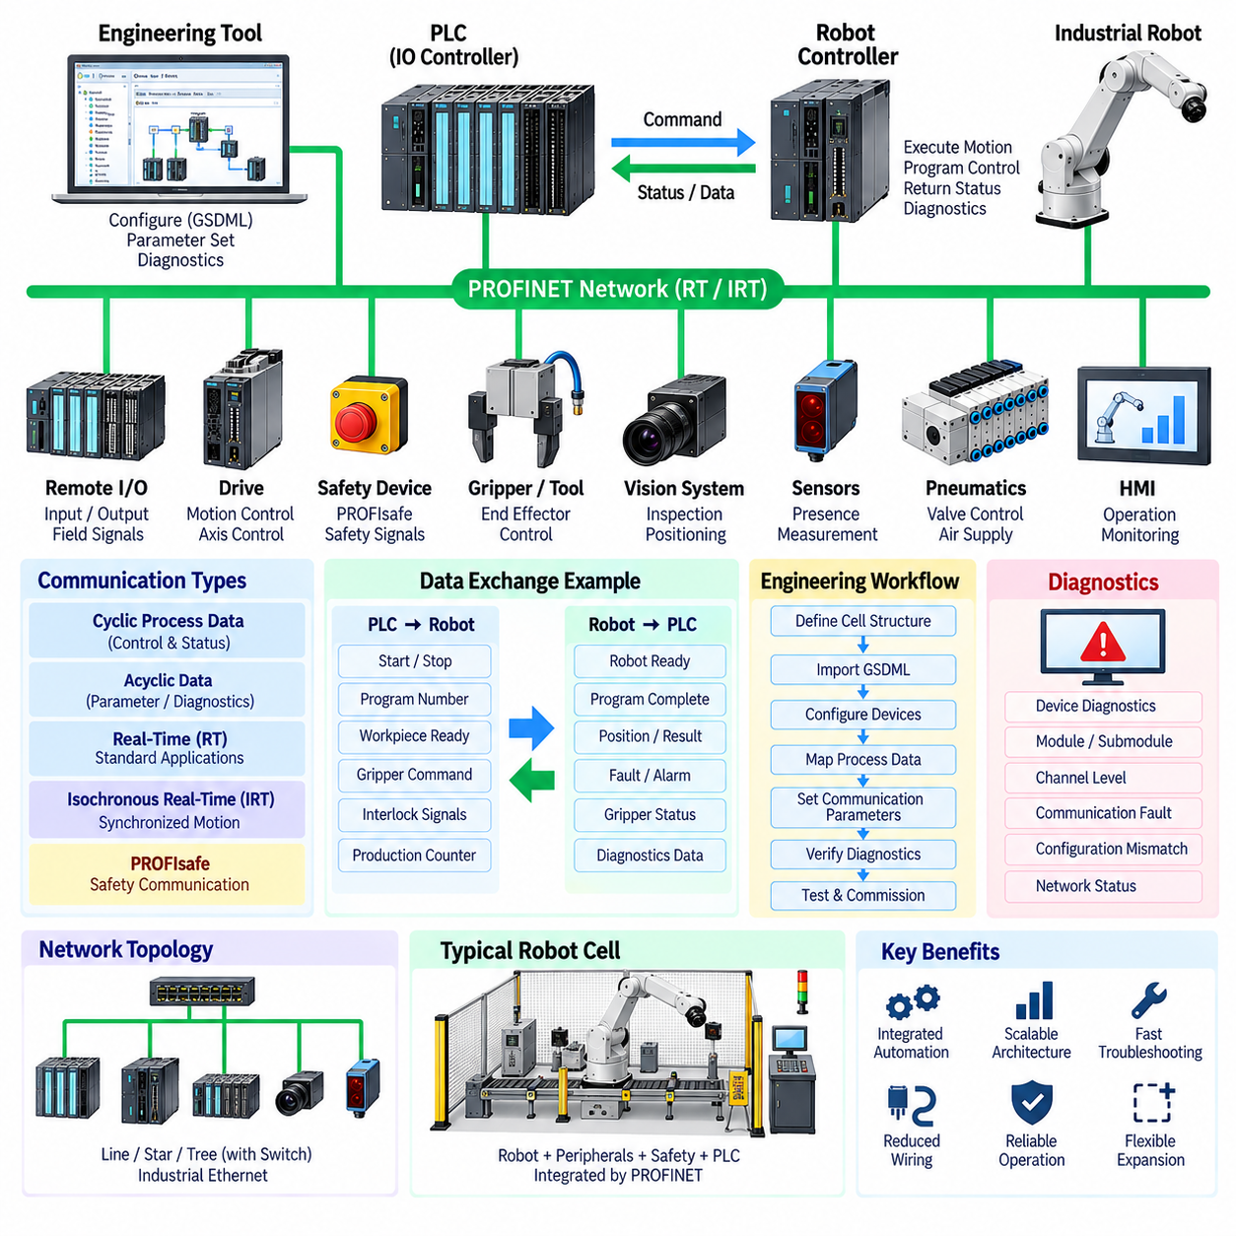
PROFINET provides an industrial Ethernet communication foundation for integrating industrial robots with PLCs, drives, remote I/O, sensors, safety devices, and other factory automation equipment. In a robot cell, it can carry cyclic control data, robot status, peripheral signals, diagnostics, and coordination information through a common network. Its value is not limited to replacing a traditional fieldbus; it provides a scalable communication structure in which robot control and factory automation can exchange information within a consistent engineering environment.
A typical PROFINET robot cell contains an IO Controller, often implemented by a PLC, and one or more IO Devices such as a robot controller, drive, remote I/O station, or intelligent peripheral. The controller exchanges configured input and output data with these devices cyclically. Robot commands, operating states, program-related signals, gripper conditions, interlocks, and production status can therefore be represented as structured process data. This creates a clear interface between the robot application and the surrounding machine-control system.
The robot controller generally remains responsible for executing the robot's motion program and internal servo functions, while the PLC manages machine-level sequencing and coordination. PROFINET provides the communication interface between these control domains. The PLC can request a robot operation, monitor whether the robot is ready, confirm completion, and coordinate the next machine action. The robot can return status, fault, position-related information, and operation results. This separation prevents the PLC from unnecessarily taking over functions that belong inside the robot controller.
For many robot-cell applications, PROFINET RT provides sufficient real-time performance. Cyclic data can be exchanged with predictable update behavior for signals that coordinate machine operation without requiring tightly synchronized multi-axis motion across the entire network. Typical examples include start and stop commands, robot-ready status, program selection, workpiece presence, gripper commands, station interlocks, and production counters. The required update cycle should be selected according to the actual control requirement rather than assuming that the shortest possible cycle is always preferable.
When synchronized motion or demanding servo coordination is required, PROFINET IRT can provide more precise temporal behavior. IRT introduces scheduled communication and synchronized clocks so that time-critical data can be exchanged with controlled timing and reduced jitter. In a robot system, this can be relevant when coordinated axes, external motion devices, or synchronized machine processes depend on closely aligned communication. Nevertheless, the internal high-frequency control loops of robot joints and servo drives normally remain within their dedicated controllers rather than being replaced by network communication.
PROFINET also supports the integration of robot peripherals through distributed I/O and intelligent devices. Grippers, pneumatic valves, sensors, vision systems, tooling interfaces, conveyor equipment, and other peripheral components can participate in the same industrial communication architecture. A robot cell can therefore combine robot control, material handling, sensing, and machine sequencing through a common network. This reduces the need for numerous independent point-to-point interfaces and makes the overall electrical and communication architecture easier to organize.
Safety functions can be integrated through PROFIsafe over the PROFINET infrastructure. Safety-related signals such as emergency-stop conditions, protective-door states, enabling functions, safe motion commands, and other safety information can be exchanged between safety controllers and compatible safety devices. Standard PROFINET data and safety-related PROFIsafe data can share the same physical Ethernet infrastructure while maintaining their different functional roles. The actual safety function remains implemented by the appropriate safety controller, robot controller, drive, or safety device.
GSDML plays an important role when PROFINET devices are integrated into the robot-cell engineering environment. The GSDML description provides the engineering system with information about device identity, modules, submodules, process data, parameters, diagnostics, and supported communication capabilities. A robot controller or peripheral device can therefore be represented in the engineering tool as a defined PROFINET station. This allows engineers to configure the communication interface systematically instead of manually defining every device characteristic and data structure.
Diagnostics are particularly valuable in complex robot cells because many devices may depend on the same communication infrastructure. PROFINET diagnostics can identify device, module, submodule, channel, communication, and configuration problems. For example, a disconnected network cable, missing I/O module, incorrect configuration, or channel-level fault can be distinguished from a robot application problem. This improves commissioning and maintenance because engineers can locate the source of an abnormal condition before modifying robot programs or replacing functioning equipment.
The engineering workflow should begin with a clear definition of the robot-cell communication boundary. The PLC, robot controller, drives, remote I/O, safety devices, sensors, and peripheral equipment should be assigned appropriate communication responsibilities. GSDML files are then imported into the engineering environment, devices and modules are configured, process data are mapped, communication parameters are established, and diagnostics are verified. After configuration, the complete cell should be tested under normal, abnormal, startup, shutdown, and recovery conditions to confirm that communication behavior matches the intended machine sequence.
Network topology and physical implementation are also important for reliable robot operation. PROFINET can use line, star, tree, or combined topologies depending on device capabilities and system requirements. Industrial Ethernet switches, integrated device ports, cable routing, shielding, grounding, and connector quality can all influence communication reliability. Robot cells can contain moving cables, motors, drives, and electrically noisy equipment, so the communication architecture should be considered together with EMC, mechanical routing, serviceability, and environmental requirements.
PROFINET in an industrial robot should therefore be understood as a communication layer connecting robot-level control with machine-level automation rather than as the robot's internal motion-control mechanism. RT provides practical cyclic communication, IRT supports applications requiring stronger timing coordination, PROFIsafe adds safety communication, GSDML supports standardized engineering, and diagnostics support commissioning and maintenance. Together, these functions allow robot controllers, PLCs, drives, sensors, safety systems, and peripheral equipment to operate as an integrated industrial automation system with a consistent and scalable communication architecture.

