Volume 07. Industrial Communication

Chapter 02. RS485 Modbus RTU

02.01. RS485 Multidrop Architecture
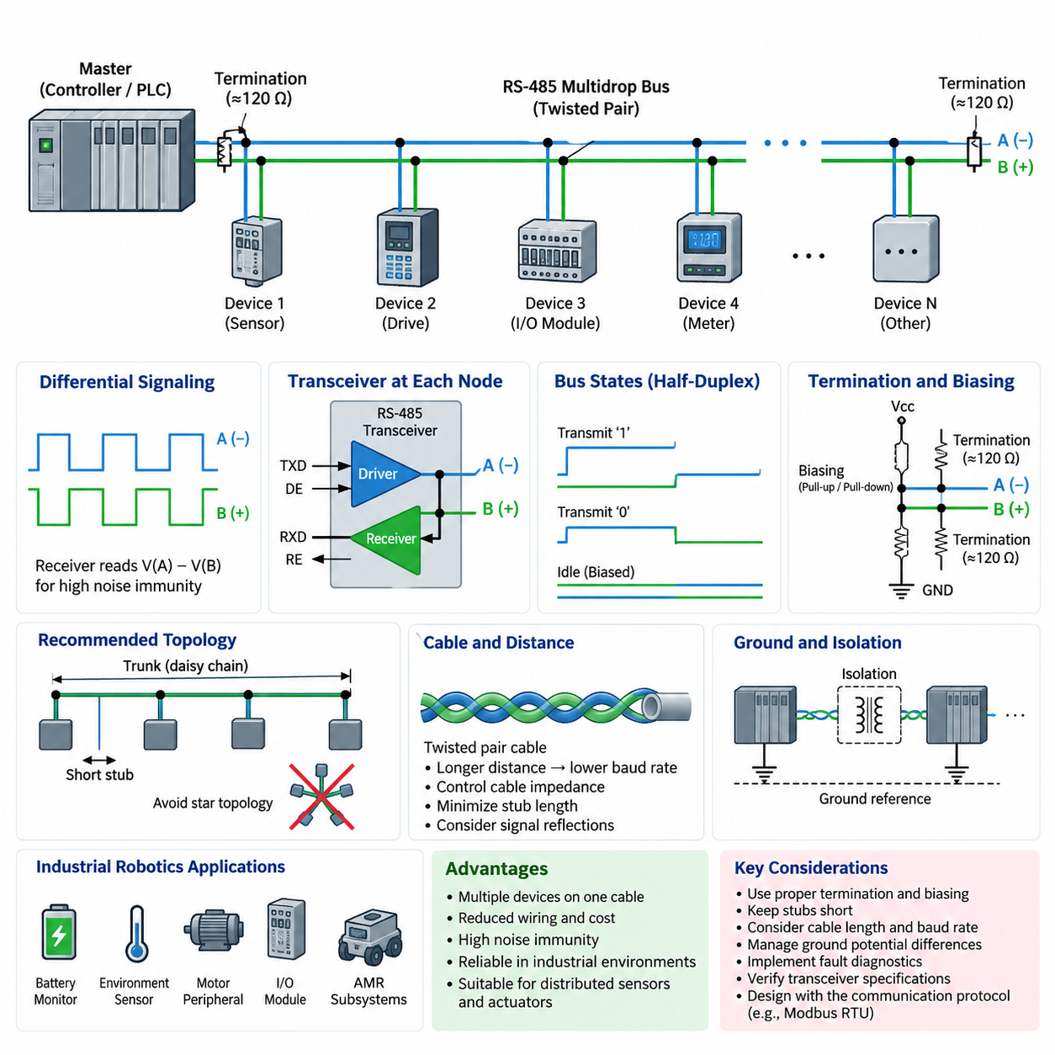
RS-485 is a differential serial communication standard designed for reliable data exchange across relatively long cables and electrically noisy industrial environments. Its most important architectural feature is the ability to connect multiple devices to the same physical communication pair. Unlike point-to-point interfaces, an RS-485 network can form a shared multidrop bus in which one communication medium serves controllers, sensors, drives, meters, and other distributed devices.
The physical layer normally uses a twisted pair carrying two complementary signal lines, commonly identified as A and B. A receiver determines the transmitted logic state from the voltage difference between these conductors rather than measuring either conductor directly against ground. Noise coupled approximately equally onto both wires therefore tends to appear as common-mode interference and can be rejected by the differential receiver, giving RS-485 strong noise immunity in industrial installations.
A multidrop architecture places several transceivers along one shared differential bus. Electrically, the preferred topology resembles a single trunk cable with devices attached using very short branches or stubs. This structure is fundamentally different from a star network. Long branches create impedance discontinuities and signal reflections, so physical placement, cable routing, termination, and stub length become increasingly important as communication speed or cable length increases.
RS-485 itself defines the electrical signaling method rather than a complete communication protocol. It does not inherently define device addresses, message formats, register structures, error-recovery procedures, or application semantics. These functions must be supplied by a higher-layer protocol. Modbus RTU is one of the most common examples, which is why RS-485 and Modbus RTU are frequently discussed together even though they represent different layers of the communication system.
A two-wire RS-485 network generally operates in half-duplex mode. All participating devices share the same differential pair, so transmission and reception occur on the same physical medium at different times. A transmitting node enables its driver, places data on the bus, and then releases the bus after transmission. Other devices must avoid transmitting simultaneously unless the higher-level protocol explicitly provides a mechanism capable of resolving access to the shared medium.
This shared-medium characteristic makes bus-access control essential. In a typical Modbus RTU installation, one client or master initiates communication and addressed server or slave devices respond when requested. Because only the selected device should respond, the protocol prevents arbitrary simultaneous transmissions. The RS-485 physical layer therefore provides multidrop electrical connectivity, while the communication protocol determines which node may transmit, when it may transmit, and how recipients interpret the data.
Each RS-485 node contains a differential driver and receiver, usually integrated into a transceiver. The transmitter converts logic-level data from a UART or communication controller into differential bus signals, while the receiver reconstructs logic-level data from the differential voltage. Driver-enable and receiver-enable signals may also be controlled by software or hardware so that a device can disconnect its transmitter electrically when it does not own the shared bus.
Three important electrical states can consequently appear on the bus: active transmission of one logical state, active transmission of the opposite state, and an idle condition in which participating transmitters are disabled. A multidrop network must maintain a predictable receiver state during idle intervals. Biasing resistors can establish a known differential voltage when no transmitter actively drives the pair, preventing an electrically floating bus from producing unstable or false transitions.
Termination addresses another physical-layer problem. A sufficiently long cable behaves as a transmission line rather than an ideal conductor, particularly when signal edge rates become significant relative to propagation delay. Reflections can occur when signals reach impedance discontinuities or unterminated cable ends. Terminating resistors are therefore normally placed at the two physical ends of the main RS-485 trunk and selected to approximate the characteristic impedance of the cable.
Termination should not be installed indiscriminately at every device. Multiple unnecessary terminating resistors excessively load the differential drivers and can reduce signal amplitude. Similarly, nodes located between the two ends of the trunk are normally connected without additional termination. Correct RS-485 design therefore requires engineers to distinguish physical endpoints from logical roles; the master does not automatically require termination simply because it controls communication.
Cable length, signaling rate, topology, transceiver characteristics, and electromagnetic conditions interact rather than forming independent design parameters. Longer networks generally require more conservative data rates, while high-speed communication demands tighter control of cable impedance, stub length, termination, and routing. Practical RS-485 engineering should therefore evaluate the complete physical channel instead of assuming that a nominal maximum distance or baud rate can be applied independently of installation conditions.
Ground reference must also be considered even though information is transmitted differentially. RS-485 receivers tolerate a specified range of common-mode voltage, but large ground-potential differences between remote devices can exceed that range. Industrial systems may therefore provide a reference conductor, galvanic isolation, or isolated power and transceivers where appropriate. Isolation is especially valuable when equipment is distributed across buildings, machinery, or power domains with substantial electrical disturbances.
The multidrop concept provides an important economic advantage because many devices can share one communication cable rather than requiring an independent serial connection for every endpoint. A PLC, industrial computer, or embedded controller can communicate with numerous distributed sensors and actuators through a compact wiring infrastructure. This reduces cable quantity, connector requirements, controller interface count, and installation complexity, particularly when relatively small amounts of cyclic or supervisory data are exchanged.
In robotics, RS-485 remains useful for devices whose bandwidth requirements are modest but whose wiring distance and noise environment make simple single-ended serial communication undesirable. Battery monitors, environmental sensors, power meters, motor-related peripherals, industrial I/O modules, and auxiliary controllers can be connected along a shared bus. The architecture is especially attractive when deterministic request-response communication is more important than high-bandwidth streaming.
An AMR may therefore contain several communication domains rather than relying on RS-485 for every subsystem. Cameras, LiDARs, and high-performance computing nodes commonly require higher-bandwidth networks, while lower-rate industrial devices can remain on RS-485. A gateway or embedded controller can collect information from these multidrop devices and expose processed data to higher-level computing through Ethernet or another network, creating a hierarchical communication architecture.
Fault behavior must be considered carefully because the shared bus creates common dependencies. A short circuit, incorrectly enabled transmitter, damaged termination, severe grounding problem, or malfunctioning node can affect communication with multiple devices. Diagnostic design should consequently include communication timeouts, CRC monitoring at the protocol layer, node-specific error counters, physical inspection points, and procedures for isolating defective branches or devices during maintenance.
Scalability is therefore not determined only by the theoretical number of transceivers supported by the electrical standard. Every additional node introduces electrical loading, connectors, stub capacitance, installation variation, and another possible failure location. Modern transceivers with reduced unit loading can support substantial node counts, but robust engineering still requires verification of the actual transceiver specifications, cable structure, termination arrangement, baud rate, environmental conditions, and protocol timing.
RS-485 multidrop architecture is best understood as a physical communication backbone rather than a complete networking solution. Differential signaling provides noise resistance, the shared trunk enables economical connection of distributed devices, and tri-state transmitters permit multiple nodes to use the same conductors. Reliable operation emerges only when topology, termination, biasing, grounding, timing, addressing, and higher-layer protocol behavior are engineered as one coordinated system.

02.02. Modbus RTU/ASCII Frame
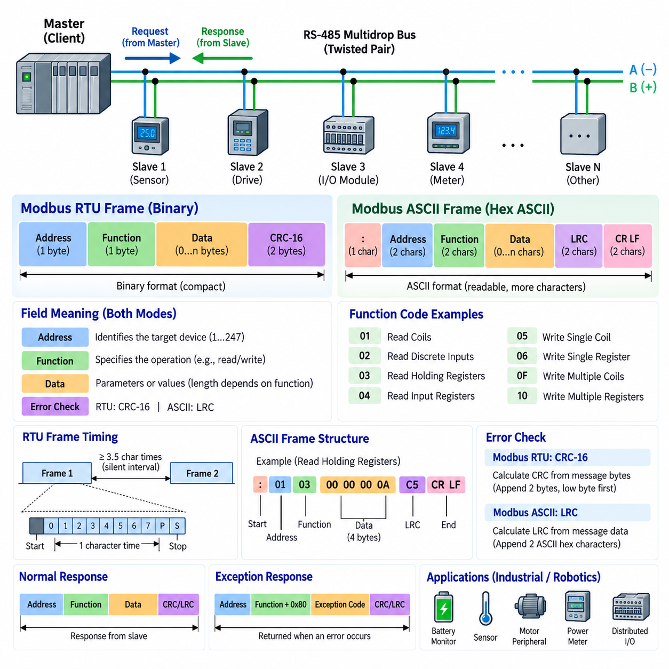
Modbus RTU and Modbus ASCII are serial message formats used to exchange structured information between devices over communication links such as RS-485. While RS-485 defines the electrical signaling and multidrop physical connection, Modbus defines how communicating devices organize requests and responses. Each message contains fields that identify the destination device, specify the requested operation, carry application data, and provide error-detection information.
A Modbus serial network commonly follows a client-server communication model, historically described as master-slave operation. The client initiates a transaction by transmitting a request addressed to a particular server, and the addressed server processes the request and returns an appropriate response. Other devices connected to the same RS-485 multidrop bus observe the transmission but normally remain silent because the address field identifies which device is expected to participate in the transaction.
A Modbus RTU frame is compact because message fields are transmitted primarily as binary values rather than printable characters. The basic frame consists of a device address, a function code, a variable-length data field, and a cyclic redundancy check. The address identifies the intended server, the function code describes the requested operation, the data field supplies parameters or returned values, and the CRC provides protection against transmission errors affecting the frame.
The address field occupies one byte in a conventional Modbus serial application data unit. Addresses are used to distinguish multiple servers sharing the same serial bus. A request sent by the client therefore contains the address of the device expected to execute the command. When that server generates a normal response, it returns its address as part of the response frame, allowing the client to associate the received information with the correct network participant.
The function code is another one-byte field and defines the type of operation being requested. Depending on the supported Modbus implementation, function codes can request the reading or writing of coils, discrete inputs, input registers, or holding registers. The meaning and length of the following data field depend on this function. Consequently, a receiver must interpret the function code before it can correctly decode the remaining application data contained within the frame.
The data field carries parameters associated with the selected function. A register-reading request may contain a starting register address and the number of registers to read, while the corresponding response can contain a byte count followed by the requested register values. A write request instead carries information describing the destination and value to be written. The frame structure therefore remains consistent while the internal interpretation of the data field changes according to the function code.
Modbus RTU uses a 16-bit cyclic redundancy check, commonly called CRC-16, for frame error detection. The transmitting device calculates the CRC from the relevant message bytes and appends the resulting value to the frame. The receiving device independently performs the same calculation and compares its result with the received CRC. If the values differ, the message is considered corrupted and is normally discarded rather than processed as a valid command or response.
Frame boundaries in Modbus RTU are strongly associated with communication timing. Because RTU messages do not contain printable start and end delimiters, a sufficiently long silent interval separates one frame from another. Traditionally, a silent period of at least 3.5 character times indicates the boundary between frames. Timing inside a frame is also constrained, making uninterrupted transmission important for allowing receivers to distinguish a complete message from separate or malformed transmissions.
The concept of character time depends on serial configuration and baud rate. A transmitted character includes not only the data bits but also serial framing elements such as start, parity when configured, and stop bits. Consequently, the absolute duration corresponding to 3.5 character times changes with communication speed. Implementations must therefore configure UART parameters and Modbus timing consistently across all devices participating in the serial network.
Modbus ASCII represents essentially the same protocol information differently. Instead of transmitting frame contents directly as compact binary bytes, the binary values are converted into hexadecimal ASCII characters. One data byte is therefore represented by two printable hexadecimal characters. This makes messages easier for a person to observe with a terminal or serial diagnostic tool, but it increases the number of transmitted characters and consequently reduces communication efficiency compared with RTU.
A Modbus ASCII frame uses explicit characters to identify its boundaries. The message begins with a colon character and normally ends with carriage-return and line-feed characters. Between these delimiters are ASCII representations of the address, function code, data, and error-checking value. Because the frame has visible delimiters, Modbus ASCII is less dependent on the short inter-character timing behavior that is important to RTU framing, although communication timing requirements still apply.
The error-checking method also differs between the two serial modes. Modbus RTU normally uses CRC-16, whereas Modbus ASCII uses a longitudinal redundancy check, or LRC. The LRC is calculated from the message data represented by the ASCII frame and appended before the terminating characters. Both mechanisms are intended to detect communication corruption, but RTU's CRC provides a stronger and widely preferred error-detection mechanism for compact industrial serial communication.
The difference between RTU and ASCII is therefore primarily a difference in serial encoding and framing rather than application meaning. A command to read a particular register can represent the same logical Modbus transaction in either mode, but its physical serial representation differs. RTU transmits compact binary bytes and relies significantly on silent timing intervals, whereas ASCII expands bytes into readable hexadecimal characters and uses explicit start and end delimiters.
RTU is generally preferred in modern RS-485 installations because its binary representation provides better bandwidth efficiency. A given amount of Modbus application data requires fewer transmitted characters than in ASCII mode, allowing shorter transaction times and better utilization of a shared multidrop bus. This advantage becomes important when a controller must periodically poll many sensors, drives, power devices, or distributed I/O modules within a limited communication cycle.
Modbus ASCII can nevertheless be useful in systems where human readability, simple serial monitoring, or compatibility with legacy equipment is more important than bandwidth efficiency. Because the transmitted characters can be viewed directly as hexadecimal text, troubleshooting with basic communication tools can be straightforward. However, engineers should not assume that RTU and ASCII devices can communicate merely because both implement Modbus; every device on a serial segment must use compatible framing and communication settings.
Normal responses generally return the requested function code together with the appropriate response data. If a server receives a valid request but cannot perform the requested operation, Modbus provides an exception-response mechanism. The response indicates that an exception occurred and supplies an exception code describing the general reason. This allows the client to distinguish protocol-level problems from situations in which no valid response was received because of wiring, timing, addressing, or device failures.
Reliable Modbus serial communication therefore depends on more than assembling address, function, data, and error-check fields. Both ends must agree on baud rate, data format, parity, stop-bit configuration, RTU or ASCII framing mode, device addressing, and interpretation of the register map. On RS-485 networks, these protocol requirements must additionally be coordinated with correct termination, biasing, grounding, topology, transmitter control, and multidrop bus-access behavior.
In industrial robots and AMRs, Modbus RTU can provide a practical interface for low-to-moderate-bandwidth equipment such as battery monitors, power meters, environmental sensors, motor-related peripherals, auxiliary controllers, and distributed I/O. Higher-bandwidth perception and computing traffic can remain on Ethernet-based networks while Modbus RTU handles conventional industrial devices, allowing the communication architecture to combine efficient local serial control with higher-level networked computing.
Understanding the Modbus RTU and ASCII frame formats establishes the foundation for interpreting later concepts such as device addresses, register maps, function codes, exception responses, timing, and diagnostics. RS-485 supplies the shared electrical transport, while Modbus serial framing transforms that transport into structured transactions. Correct system behavior emerges when physical-layer integrity, frame encoding, timing rules, error detection, and application-level register definitions are designed as a coordinated communication system.

02.03. Modbus Address and Register Map
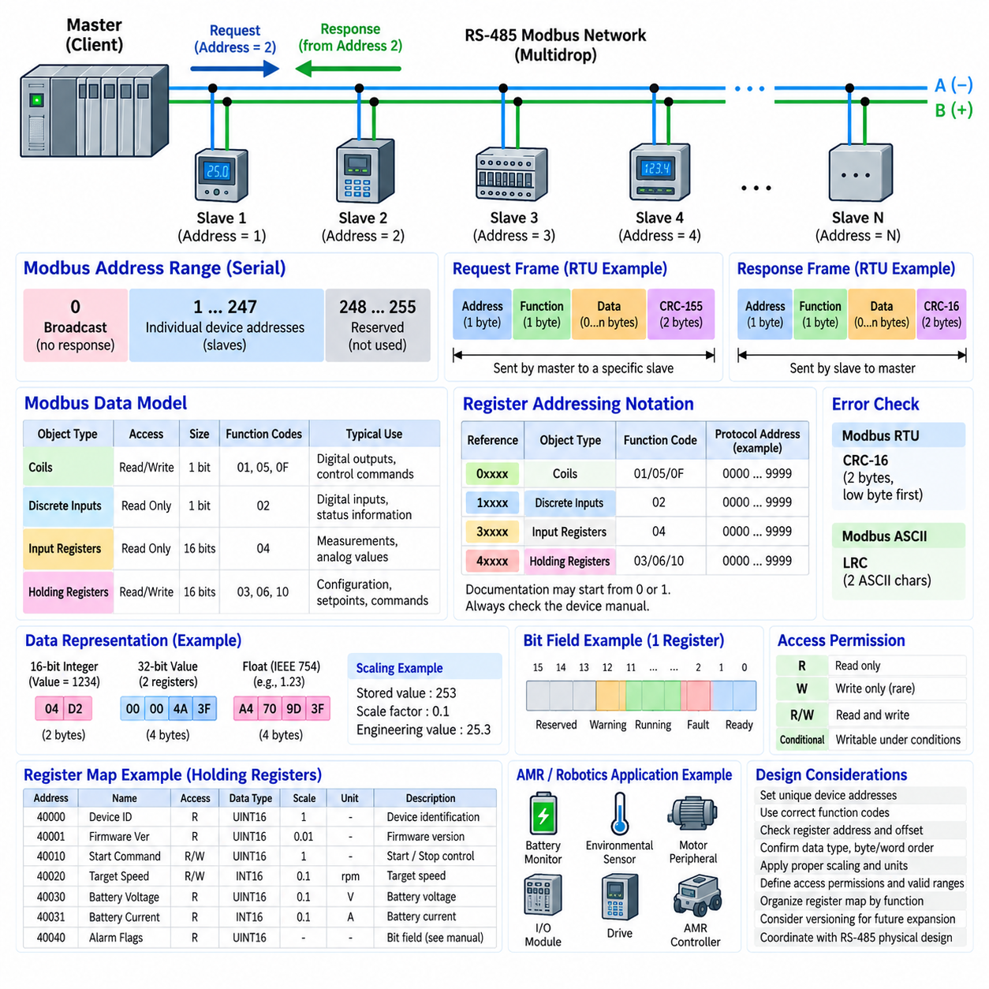
Modbus addressing provides the logical structure that allows one controller to communicate with many devices and access specific data inside each device. On an RS-485 multidrop network, the device address identifies the intended Modbus server, while the register map identifies the information or control point inside that server. Together, these mechanisms transform a shared serial bus into an organized interface for distributed industrial equipment.
In a typical Modbus RTU transaction, the client places the destination server address at the beginning of the request frame. Every server connected to the shared RS-485 bus can electrically receive the transmission, but each device examines the address before processing the request. Only the addressed server normally executes the requested function and returns a response, allowing many independent devices to coexist on the same physical communication medium.
Traditional Modbus serial addressing reserves address 0 for broadcast communication and normally uses addresses 1 through 247 for individually addressed servers. A broadcast request can be used for operations intended for multiple devices, but servers do not return individual responses because simultaneous replies would create collisions on a shared RS-485 bus. Addresses above the normal server range are reserved or unavailable for ordinary device addressing under the standard convention.
Device addressing and data addressing represent two different levels of identification. The device address answers the question of which physical or logical server should process a message, while the data address identifies which coil, discrete input, input register, or holding register is involved. A complete transaction therefore combines a server address, a function code, and one or more data addresses to define precisely where an operation should occur.
The Modbus data model traditionally divides accessible information into four principal object types. Coils represent single-bit read/write values, discrete inputs represent single-bit read-only values, input registers represent 16-bit read-only values, and holding registers represent 16-bit read/write values. This separation allows device designers to distinguish status information, digital commands, measured values, configuration parameters, and control variables through a consistent logical organization.
Coils are commonly associated with binary outputs or writable Boolean states. A coil may represent commands such as enabling a subsystem, activating an output, resetting a condition, or requesting an operating mode. Although the historical terminology originates from PLC relay logic, modern Modbus devices can map coils to software flags or internal control states. Their actual engineering meaning must therefore be defined by the device manufacturer's register map.
Discrete inputs provide single-bit information that the client can read but does not normally write through the corresponding Modbus object type. They are suitable for states such as limit-switch activation, alarm status, interlock conditions, digital sensor states, or hardware-ready indications. The term “input” describes the Modbus data model rather than requiring the information to originate directly from a physical electrical input.
Input registers contain 16-bit values intended primarily for read access. Industrial devices frequently use them for measurements or status quantities such as voltage, current, temperature, speed, pressure, or sensor readings. However, Modbus defines the communication representation rather than the engineering unit or scaling rule. The register map must therefore explain whether a value represents raw counts, scaled integers, encoded status information, or part of a larger data type.
Holding registers are among the most widely used Modbus objects because they support both reading and writing. They can contain configuration parameters, operating commands, thresholds, calibration values, setpoints, or internal state information. A controller can read the current contents and, where permitted by the device implementation, write new values. This flexibility makes holding registers especially important when integrating configurable sensors, drives, controllers, and robotic subsystems.
A register map is the specification that assigns engineering meaning to these logical data locations. A useful map normally identifies the register or object address, access type, data representation, scaling, engineering unit, valid range, default value, and functional description. Without this information, receiving a valid Modbus frame is insufficient because the client may know the numerical contents of a register without knowing what the value physically represents.
One important source of integration errors is the distinction between register reference notation and the actual address transmitted in a Modbus protocol data unit. Documentation may describe objects using familiar ranges such as 0xxxx, 1xxxx, 3xxxx, and 4xxxx, while the protocol request carries a relative data address associated with the selected function code. Implementations can also differ in whether documentation begins numbering at zero or one, creating the well-known zero-based versus one-based addressing problem.
For this reason, engineers should not determine a transmitted address merely by looking at a displayed register number. The device documentation should explicitly state the Modbus function code, logical register reference, and protocol address or offset expected in the request. A one-register displacement can produce values that appear technically valid while actually belonging to neighboring parameters, making addressing errors particularly difficult to diagnose when no communication exception occurs.
The function code provides essential context for interpreting a data address. The same numerical offset does not necessarily refer to the same type of information when used with different Modbus functions. Reading coils, reading discrete inputs, reading input registers, and reading holding registers operate on different logical object spaces. Consequently, a robust register-map specification should associate every accessible item with both its address and the function or access method used to reach it.
Because a basic Modbus register is 16 bits wide, larger data types require multiple consecutive registers. A 32-bit integer or IEEE 754 floating-point value typically occupies two registers, while a 64-bit value requires four. Modbus does not universally define how every manufacturer must order bytes and words for these multi-register values, so byte order and word order must be documented and verified between communicating devices.
Scaling is equally important because many embedded devices avoid transmitting floating-point values directly. A temperature of 25.3 degrees, for example, might be stored as the integer 253 with a scale factor of 0.1. Voltage, current, position, velocity, pressure, battery state, and other quantities can use similar conventions. The register map must specify these conversion rules so that application software can reconstruct meaningful engineering values from the transmitted integers.
Some registers use individual bits as status or control flags rather than treating the entire 16-bit word as one numerical quantity. One bit may indicate a warning, another an operating state, and another a communication or hardware fault. In such cases, the register-map definition should include a bit-field description showing the meaning of each implemented bit and identifying reserved bits that software should ignore or preserve when appropriate.
Access permissions should also be explicit. Registers may be read-only, write-only in unusual implementations, read/write, or writable only under particular operating conditions. Certain configuration values may require the machine to be stopped, while command registers may trigger immediate physical actions. Industrial and robotic software should therefore treat register writes as controlled operations rather than assuming that every holding register can safely accept arbitrary values.
A well-designed register map should reserve logical regions for related information instead of assigning addresses randomly. Device identification, operating status, sensor measurements, commands, configuration parameters, diagnostics, and fault history can occupy separate address ranges. Such organization simplifies software development and troubleshooting while leaving unused address space for future firmware expansion without forcing existing interfaces to change.
Register-map versioning becomes important when firmware evolves. Adding new registers is usually easier to manage than changing the meaning of existing ones because deployed PLC, gateway, robot, or supervisory software may depend on established addresses. Device identification registers can therefore include firmware or interface-version information, allowing client software to determine which capabilities and register definitions are available before using optional features.
For an AMR, a Modbus register map might expose battery voltage, current, state information, environmental measurements, auxiliary I/O status, peripheral alarms, and equipment commands through one or more RS-485 devices. The AMR controller can periodically poll these registers and translate them into internal software states, while higher-bandwidth perception and planning data remain on Ethernet-based networks. This creates a practical separation between industrial device communication and compute-intensive robot networking.
Reliable Modbus integration ultimately depends on treating the address and register map as a formal interface contract. Engineers must agree not only on server addresses but also on function codes, protocol offsets, object types, data widths, byte and word ordering, scaling, units, access permissions, valid ranges, and exception behavior. When these definitions are documented consistently, Modbus provides a simple and effective mechanism for connecting heterogeneous industrial and robotic devices through a shared communication architecture.

02.04. RS485 Termination and Biasing
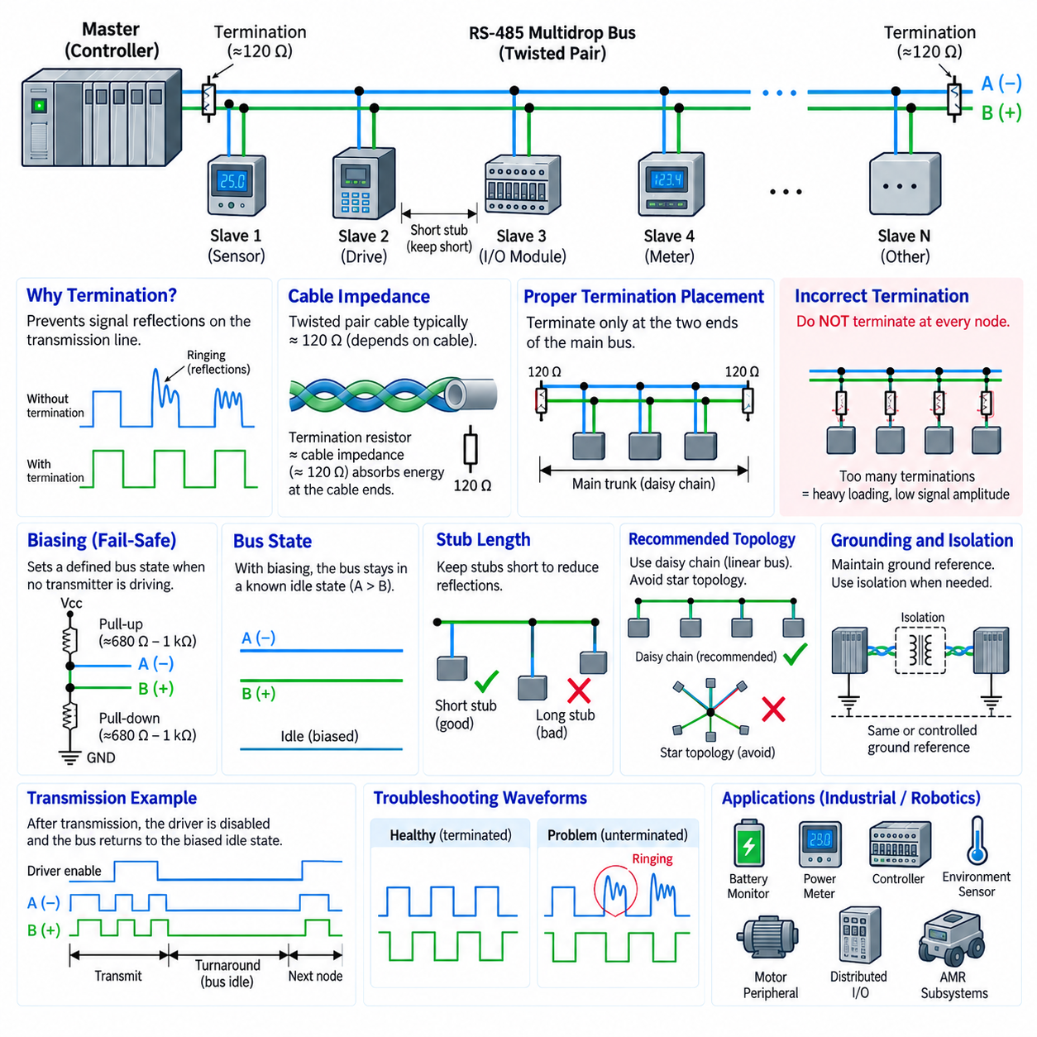
RS-485 termination is a physical-layer technique used to control signal reflections that occur when fast electrical transitions propagate along a communication cable. At sufficiently high signaling rates or long cable lengths, the twisted pair behaves as a transmission line rather than an ideal wire. If the signal reaches an impedance discontinuity, part of its energy can be reflected toward the transmitter and distort the waveform observed by receivers.
The characteristic impedance of the cable is therefore an important RS-485 design parameter. Industrial twisted-pair cables commonly have a characteristic impedance near 120 ohms, although the actual value depends on cable construction. A termination resistor approximately matching this impedance absorbs energy arriving at the physical end of the transmission line and reduces reflections that could otherwise cause ringing, threshold crossings, corrupted bits, or intermittent communication failures.
In a conventional multidrop RS-485 topology, termination resistors are placed at the two physical ends of the main bus trunk. They are connected across the differential signal pair rather than from either signal conductor directly to ground. This arrangement makes the electrical ends of the transmission line approximately match the cable impedance. Devices located between these endpoints normally do not require additional termination because they are not physical ends of the main transmission path.
The physical location of termination is more important than the logical role of a device. A Modbus master or other controller does not automatically require termination simply because it controls network access. If the controller is physically located at one end of the RS-485 trunk, termination is appropriate there. If it is connected somewhere in the middle of the bus, placing a termination resistor at that controller can create unnecessary loading and an impedance discontinuity.
Excessive termination can significantly degrade communication. Every termination resistor connected across the differential pair contributes additional electrical loading to the active driver. Installing termination at every node can reduce the effective bus impedance far below the intended value, requiring excessive driver current and reducing differential signal amplitude. Correct termination therefore means terminating the transmission line endpoints, not simply adding resistors wherever communication problems are observed.
Termination becomes increasingly important as cable propagation delay becomes significant relative to signal transition time. A relatively low baud rate does not always guarantee that reflections can be ignored because modern transceivers may produce fast voltage edges even when data bits change slowly. For this reason, practical design should consider cable length, transceiver slew rate, topology, cable impedance, stub length, and receiver characteristics together rather than evaluating baud rate alone.
Stub connections also affect termination behavior. A device attached to the main trunk through a long branch creates another transmission-line path where a signal can travel, reflect, and return to the trunk. For robust multidrop networks, devices should therefore be connected using short stubs whenever possible. A daisy-chain or linear trunk structure is generally preferable to a star topology, particularly when communication speed and total cable length increase.
Biasing addresses a different problem from termination. Termination controls reflections during signal transitions, whereas biasing establishes a defined bus state when no transmitter is actively driving the RS-485 pair. In a half-duplex multidrop network, transmitters are normally placed in a high-impedance state after completing their messages. Without an active driver, the differential pair can otherwise approach an undefined electrical condition depending on leakage currents, termination, coupled noise, and receiver characteristics.
A bias network intentionally creates a small differential voltage corresponding to a known idle state. A common arrangement uses a pull-up resistor associated with one bus conductor and a pull-down resistor associated with the other. The resulting current flows through the bus network and produces a controlled differential voltage when all transmitters are disabled. This technique is often called fail-safe biasing because it helps receivers interpret an undriven bus as a stable logical state.
Bias resistor values cannot be selected independently of termination. The pull-up resistor, pull-down resistor, and termination resistors form an electrical network that determines the idle differential voltage and the load seen by an active transmitter. Bias resistance that is too large may produce insufficient differential voltage to overcome noise or receiver thresholds, while resistance that is too small increases current consumption and loads the transmitter unnecessarily.
For this reason, biasing should normally be implemented as a coordinated network rather than independently at every RS-485 node. If many devices each install strong external bias resistors, their parallel combination can create excessive loading and alter the expected idle voltage. System designers should identify which device or network location provides the required biasing and verify whether individual transceivers already contain internal fail-safe receiver features before adding external components.
Modern RS-485 transceivers often incorporate receiver fail-safe behavior that forces a predictable receiver output for open-circuit, shorted, or idle-bus conditions within specified limits. However, internal fail-safe functionality should not automatically be treated as equivalent to external network biasing. The exact behavior varies among devices, and termination can reduce the differential voltage present on an undriven pair. Transceiver datasheets must therefore be checked when determining whether additional biasing is required.
Ground reference remains relevant to both termination and biasing even though RS-485 uses differential signaling. The receiver measures the difference between the two signal conductors, but each transceiver can tolerate only a limited common-mode voltage range. Ground-potential differences between distributed equipment can shift both conductors relative to the local electronics. A reference conductor or galvanic isolation may therefore be required in installations with significant ground differences.
Galvanically isolated RS-485 interfaces are particularly useful when devices operate from different power systems or are distributed across electrically noisy industrial equipment. Isolation breaks direct conductive paths that can carry unwanted ground currents while preserving differential communication through an isolation barrier. Termination and biasing are still required according to the bus design, but their placement must be considered relative to the isolated bus side of each transceiver.
Troubleshooting an RS-485 network should distinguish termination problems from biasing problems. Reflection-related faults often become more severe with increased cable length, faster edges, or unfavorable topology and may appear as ringing or repeated threshold crossings. Bias-related problems are more likely to appear when the bus is idle or during turnaround between transmitters, where noise can cause false receiver transitions or unpredictable UART characters.
An oscilloscope with an appropriate differential measurement method can help evaluate these conditions. Engineers can examine differential amplitude, waveform ringing, overshoot, settling behavior, and the idle differential level. Measurements should be made at relevant locations along the bus because a waveform that appears acceptable near the transmitter may differ at a remote endpoint. Electrical measurements can therefore reveal physical-layer problems that protocol analyzers alone cannot identify.
Termination and biasing also interact with Modbus RTU timing. After a server or client completes transmission, its RS-485 driver is disabled so another device can use the shared medium. During this turnaround interval, the bias network helps maintain a stable idle state. Correct driver-enable timing is equally important because disabling the driver too early can truncate a frame, while keeping it enabled too long can interfere with another node's response.
In an AMR or industrial robot, RS-485 may connect battery monitors, power meters, auxiliary controllers, environmental sensors, motor-related peripherals, or distributed I/O modules. These devices can be physically separated by harness sections that pass near motors, inverters, DC/DC converters, contactors, and high-current power cables. Proper twisted-pair routing, grounding, termination, biasing, shielding strategy, and separation from strong noise sources therefore become part of the overall communication design.
A robust RS-485 implementation should treat termination and biasing as complementary but distinct functions. Termination makes the transmission line behave predictably when signals propagate through the cable, while biasing makes the shared bus behave predictably when nobody is transmitting. When combined with a linear multidrop topology, short stubs, suitable cable impedance, correct grounding, controlled driver timing, and appropriate transceiver selection, these techniques provide the electrical foundation for reliable Modbus RTU communication.

02.05. Modbus RTU in AMR Sensor
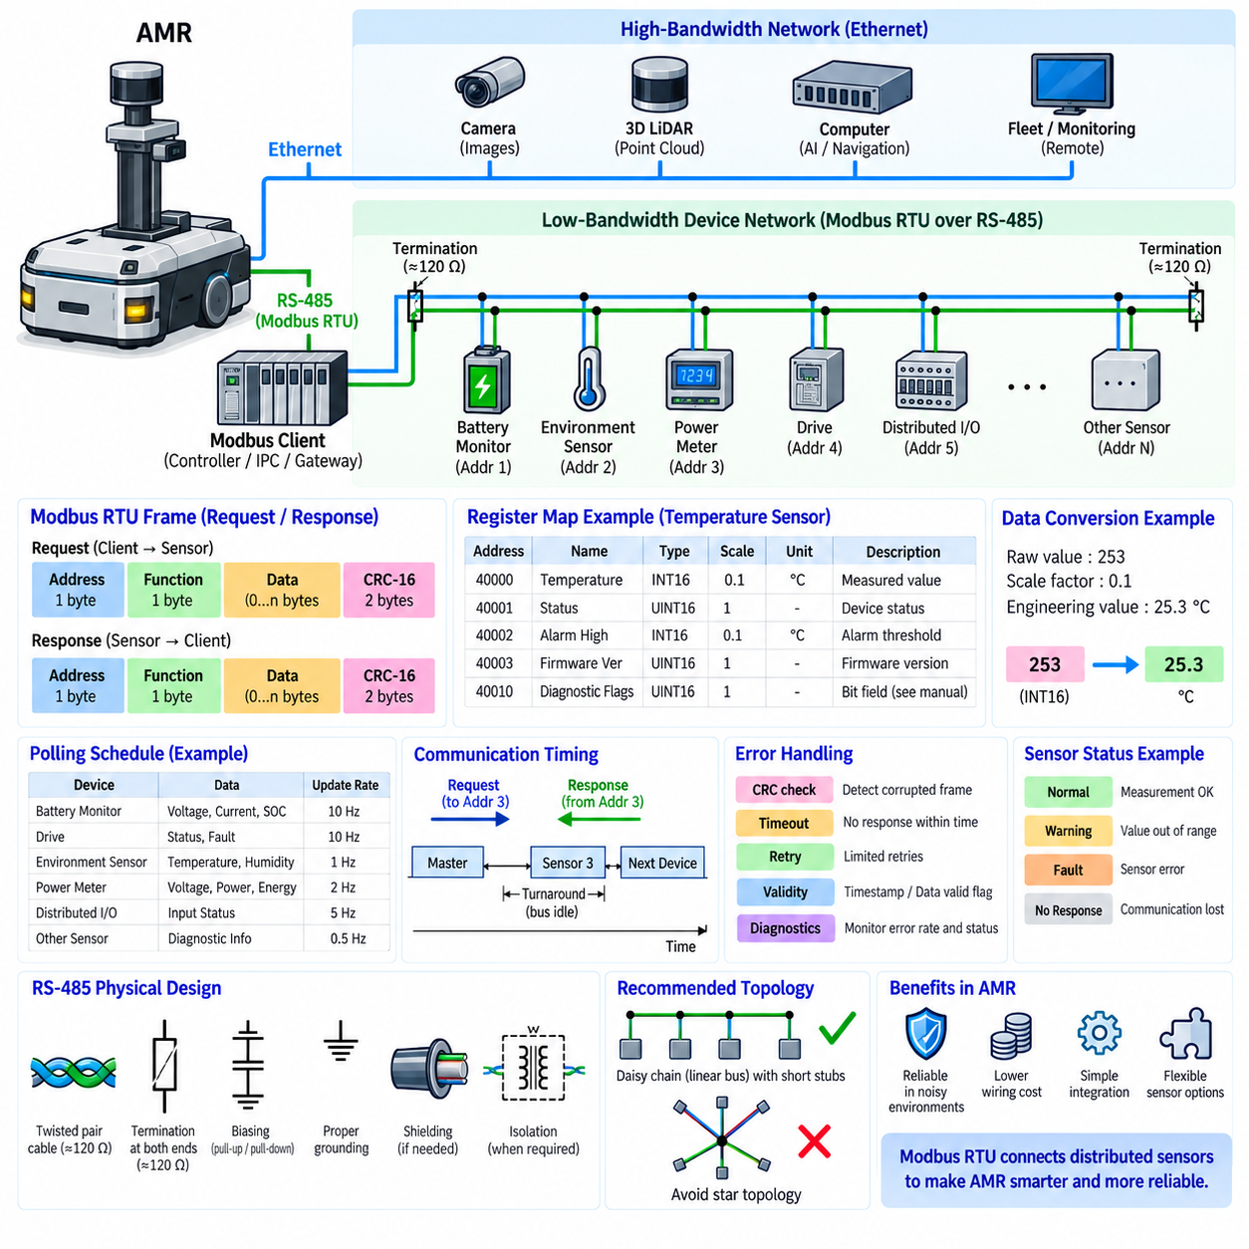
Modbus RTU is widely used in autonomous mobile robots because many industrial sensors and auxiliary devices require modest bandwidth but must operate reliably in electrically noisy environments. An AMR can use an RS-485 multidrop bus as a local device network, while Modbus RTU provides addressing, commands, register access, error checking, and request-response behavior. This combination offers a practical interface between embedded controllers and distributed sensing hardware.
An AMR communication architecture normally contains several networks optimized for different data characteristics. Cameras, 3D LiDARs, and high-performance computing systems may exchange large data streams through Ethernet, while battery monitors, environmental sensors, power meters, auxiliary I/O, and relatively low-rate sensing devices can communicate through Modbus RTU. This separation prevents low-bandwidth peripherals from unnecessarily occupying high-performance network resources.
The Modbus RTU network is commonly connected to an embedded controller, industrial computer, PLC, or dedicated communication gateway acting as the Modbus client. Sensors operate as individually addressed servers on the RS-485 bus. The client periodically sends requests to selected devices, receives their responses, validates the returned frames, converts register values into engineering quantities, and makes the resulting information available to higher-level robot software.
Each sensor on the shared bus requires a unique Modbus server address. When the controller sends a request, every device electrically receives the RS-485 transmission, but only the sensor whose configured address matches the request normally responds. This allows several sensors to share the same twisted pair without requiring an independent serial interface for every device, reducing harness complexity, connector count, controller ports, and installation cost.
The register map defines how the AMR controller interprets information from each sensor. A temperature sensor may provide measured temperature, device status, alarm thresholds, firmware information, and diagnostic flags through different registers. A power monitor may expose voltage, current, energy, and fault information. The controller must know the corresponding function code, protocol address, data type, scaling factor, unit, byte order, and access permission for every required value.
Sensor polling is one of the most important design activities in a Modbus RTU AMR network. Because communication is normally request-response based, the controller sequentially requests information from individual devices. If ten sensors are connected, their required update rates do not necessarily need to be identical. Safety-relevant or rapidly changing information may be requested more frequently, while temperature, configuration, or slowly changing diagnostic information can be polled less often.
The total polling cycle depends on baud rate, frame size, number of devices, response time, inter-frame timing, retry behavior, and the quantity of registers transferred in each request. Designers should therefore calculate communication load instead of simply adding sensors until the network becomes unreliable. Reading several consecutive registers in one transaction can often be more efficient than issuing many separate requests when the device register map permits contiguous access.
Modbus RTU should not normally be treated as the primary network for high-rate perception information. A camera producing images or a LiDAR generating dense point clouds requires bandwidth far beyond typical serial Modbus operation. Modbus RTU is better suited to compact numerical values and status information. Selecting communication technology according to information characteristics produces a more efficient AMR architecture than attempting to force every sensor onto one network.
Data acquisition should also distinguish communication rate from the physical sensor's internal measurement rate. A sensor may internally update a measurement faster than the AMR controller polls its Modbus registers. Conversely, polling much faster than the sensor updates its internal value provides little useful information while increasing bus utilization. The polling schedule should therefore reflect the dynamics of the measured quantity, device update behavior, and application requirements.
After receiving a valid response, the controller must convert raw register contents into meaningful engineering values. A battery voltage register might contain an unsigned integer with a scale factor of 0.1 V, while temperature could use a signed integer with a 0.1-degree scale. Other devices may use 32-bit integers or floating-point values occupying multiple registers. Correct scaling, signedness, byte order, and word order are therefore essential.
Diagnostic information should be handled alongside normal sensor measurements. Modbus devices may expose communication status, sensor faults, over-range conditions, internal errors, calibration status, or warning flags through dedicated registers or bit fields. The AMR controller can translate these values into a unified diagnostic model so that higher-level software does not need to understand every manufacturer's proprietary register organization.
Communication failure must not automatically be interpreted as a physical sensor measurement. If a Modbus sensor stops responding, the last received value may remain stored in controller memory even though it is no longer current. AMR software should therefore associate measurements with validity information, timestamps, communication status, or timeout state. This prevents stale data from being mistaken for a fresh observation after a cable, sensor, or network failure.
Timeout and retry policies must be selected carefully. A controller needs enough time for the addressed sensor to respond, but an excessively long timeout can delay polling of every other device when one sensor fails. Limited retries can recover from occasional corrupted frames, while repeated retries against a disconnected device can consume significant bus time. Robust implementations balance recovery capability against predictable network-cycle performance.
CRC checking provides another important layer of protection. Every received Modbus RTU frame should be validated before its contents are accepted. A CRC failure indicates that the frame may have been corrupted by electrical noise, timing problems, collisions, or physical-layer faults. Repeated CRC errors should therefore be treated as diagnostic evidence rather than merely discarded silently, because increasing error rates can indicate deterioration of the communication channel.
The RS-485 physical design remains critical even when the Modbus software is correctly implemented. AMR wiring can pass close to traction motors, motor drives, DC/DC converters, contactors, charging circuits, and high-current battery cables. Differential twisted-pair wiring, suitable cable routing, correct termination, appropriate fail-safe biasing, grounding, shielding strategy, and galvanic isolation where required help protect sensor communication from these disturbances.
The multidrop bus should normally use a linear trunk with short device stubs. Termination is applied at the two physical ends of the main RS-485 transmission line rather than at every sensor. Biasing maintains a predictable idle state when no transmitter is active. These physical-layer rules become particularly important on an AMR because sensors may be distributed around the chassis and connected through several harness sections and service connectors.
A gateway architecture can provide useful isolation between Modbus devices and the main robot computing system. A microcontroller or embedded controller can manage UART timing, RS-485 driver enable, polling, retries, CRC verification, scaling, and sensor diagnostics locally. It can then publish normalized sensor information to the edge computer through Ethernet or another internal interface, preventing higher-level AI and autonomy software from managing low-level serial timing directly.
This hierarchical approach also improves software abstraction. Higher-level navigation, monitoring, fleet, or diagnostic applications can consume named values such as battery voltage, enclosure temperature, auxiliary current, or peripheral fault state instead of manipulating Modbus addresses and register offsets. The register map remains confined to the device-interface layer, making it easier to replace a sensor or change its Modbus implementation without modifying unrelated autonomy functions.
Not every sensor connected to an AMR should be considered suitable for Modbus RTU merely because it provides an RS-485 interface. Engineers must examine required latency, update frequency, message size, synchronization requirements, failure behavior, and whether the information participates in a safety-critical control loop. Devices requiring tightly synchronized or high-frequency feedback may require another communication architecture with stronger real-time characteristics.
For practical AMR engineering, the Modbus sensor interface should therefore be treated as a complete subsystem rather than simply a serial cable connection. Device addressing, register maps, polling schedules, timeout and retry policies, data conversion, timestamps, diagnostics, RS-485 termination, biasing, grounding, and fault handling must operate together. When these elements are designed coherently, Modbus RTU provides a simple, economical, and robust method for integrating distributed industrial sensors into an AMR communication architecture.

