Volume 07. Industrial Communication

Chapter 10. Factory Automation

10.01. AMR PLC Integration Pattern
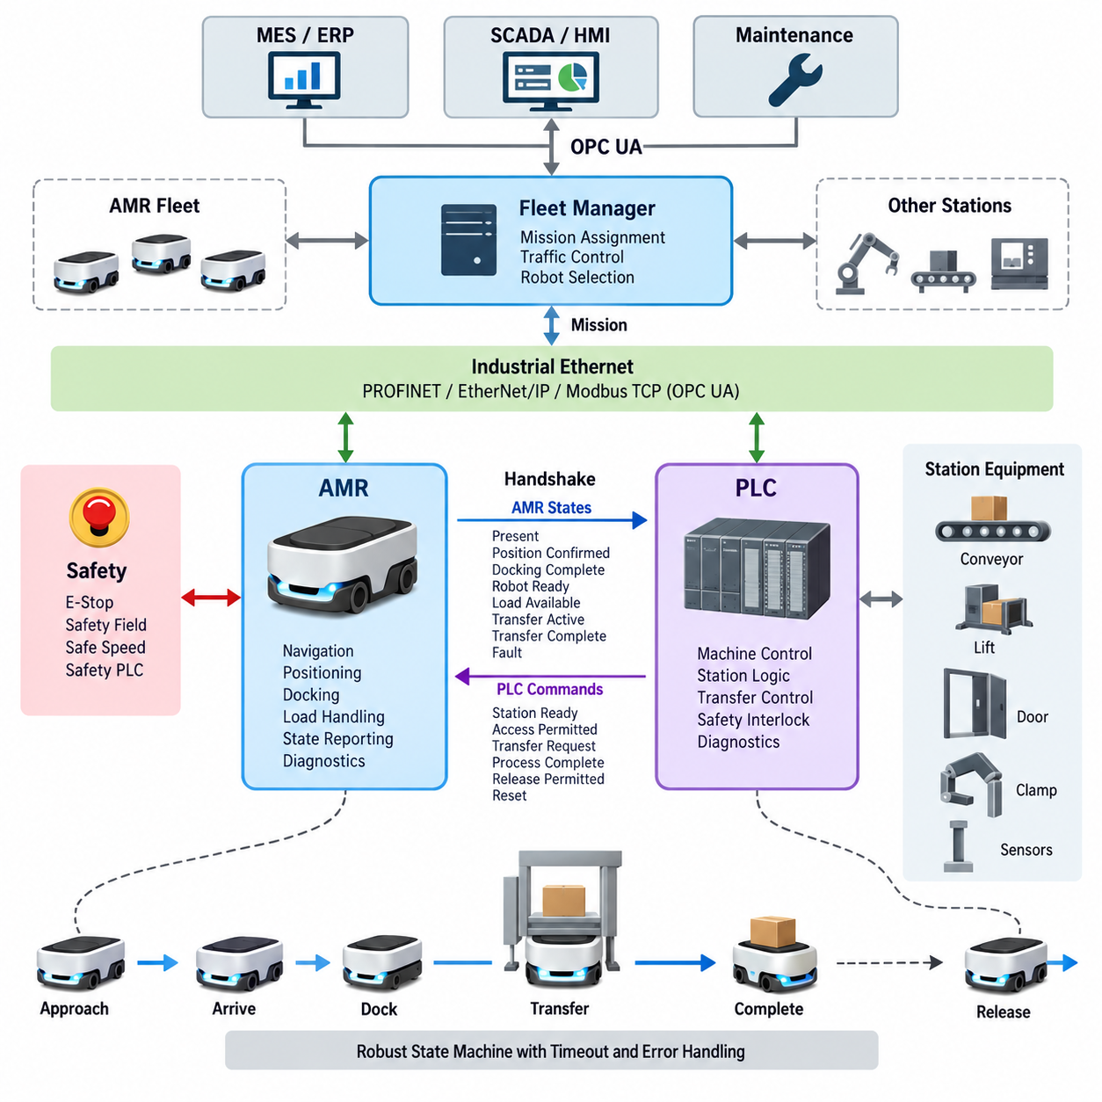
An AMR–PLC integration pattern defines how an autonomous mobile robot exchanges operational states, commands, permissions, and completion signals with factory automation equipment. The PLC normally retains deterministic control of machines and work cells, while the AMR manages navigation and mobility. Integration therefore establishes a controlled boundary between mobile autonomy and fixed automation.
A typical architecture separates fleet-level coordination from machine-level execution. A fleet manager assigns transportation missions and selects an AMR, while the robot approaches a PLC-controlled station through its navigation system. Near the station, the interaction changes from general mission control to a deterministic handshake in which both systems confirm readiness before physical transfer or processing begins.
The PLC interface should expose a compact and clearly defined set of states rather than internal robot variables. Typical information includes AMR present, position confirmed, docking complete, robot ready, load available, transfer active, transfer complete, fault, and emergency condition. The PLC returns corresponding signals such as station ready, access permitted, transfer request, process complete, release permitted, and reset.
Communication can be implemented through industrial Ethernet protocols such as PROFINET, EtherNet/IP, or Modbus TCP, depending on the installed automation environment. OPC UA may provide higher-level information exchange, especially when integration extends toward MES or supervisory systems. The selected protocol should match timing requirements, PLC capabilities, diagnostic needs, and existing factory network standards.
A robust integration pattern treats the AMR and PLC interaction as a state machine rather than a collection of unrelated Boolean signals. For example, an AMR may progress through APPROACHING, ARRIVED, DOCKING, DOCKED, TRANSFER_READY, TRANSFERRING, COMPLETE, and RELEASED states. Explicit transitions make abnormal sequences easier to detect and prevent ambiguous interpretations after communication interruptions.
Docking represents an important boundary between autonomous navigation and factory-controlled interaction. The AMR may navigate freely to a predefined approach area, but final alignment can require additional confirmation from localization markers, proximity sensors, mechanical guides, or station sensors. The PLC should not initiate conveyors, lifts, doors, clamps, or other transfer mechanisms until the required docking conditions have been verified.
Material transfer requires coordinated ownership of the physical operation. At a conveyor station, for example, the PLC can indicate that the receiving conveyor is ready before the AMR enables its onboard conveyor. Sensors on both sides then verify movement and final load position. Completion should be acknowledged by both systems so that neither the AMR nor the stationary equipment assumes that transfer succeeded based only on elapsed time.
Handshake signals should incorporate timeouts and sequence validation. If an expected acknowledgement does not arrive within a specified interval, the interface should enter a defined fault or recovery state instead of waiting indefinitely. Sequence counters, transaction identifiers, or mission identifiers can also prevent a delayed message from a previous operation from being interpreted as confirmation for the current material-transfer cycle.
Safety communication must remain distinct from ordinary production coordination. A normal PLC command such as STOP, HOLD, or WAIT represents operational control and should not automatically be treated as a safety function. Emergency stopping, protective field activation, safe speed supervision, and other safety-related functions require an appropriate safety architecture using safety-rated devices, circuits, controllers, and communication where required.
The integration pattern must also define behavior when communication is lost. The AMR should not continue a machine interaction merely because the last received PLC state indicated permission. Likewise, the PLC should not assume that an AMR remains correctly docked after connectivity disappears. Communication watchdogs, heartbeat monitoring, timeout handling, and predefined fail states allow both sides to move toward predictable and recoverable conditions.
Factory traffic introduces another coordination layer because several AMRs may request access to the same station. The fleet manager normally performs mission allocation, traffic control, and robot selection, whereas the PLC represents the availability and process state of the production station. Keeping these responsibilities separate prevents the PLC from becoming a fleet scheduler and prevents the AMR fleet system from directly controlling detailed machine sequences.
Diagnostics should provide more information than a single fault bit. Useful interface data includes communication status, current handshake state, timeout reason, docking status, transfer state, station identifier, mission identifier, and recovery condition. These values can be exposed to an HMI, SCADA, MES, or maintenance system so technicians can determine whether a failure originated in navigation, communication, docking, material transfer, or machine readiness.
Recovery logic is especially important because an AMR is a mobile system that may leave and later return to a station. After PLC restart, robot reboot, network reconnection, or interrupted transfer, both sides should determine the actual physical condition before resuming operation. A synchronization procedure can compare station occupancy, docking sensors, load presence, mission identity, and current states before selecting resume, retry, rollback, or manual recovery.
Standardization becomes valuable when many production stations and AMRs are deployed. A common interface model can define reusable state names, command semantics, data types, timeout behavior, fault codes, and version information for every compatible station. Individual equipment may then add application-specific data without changing the fundamental handshake pattern, reducing commissioning effort and simplifying future fleet expansion.
The resulting AMR–PLC integration pattern creates a layered factory automation structure in which autonomous navigation, deterministic machine control, material-transfer coordination, safety functions, and enterprise-level information exchange remain clearly separated but synchronized. This separation enables AMRs to operate as standardized mobile automation resources while preserving the predictable behavior expected from PLC-controlled industrial equipment.

10.02. WMS/MES Interface
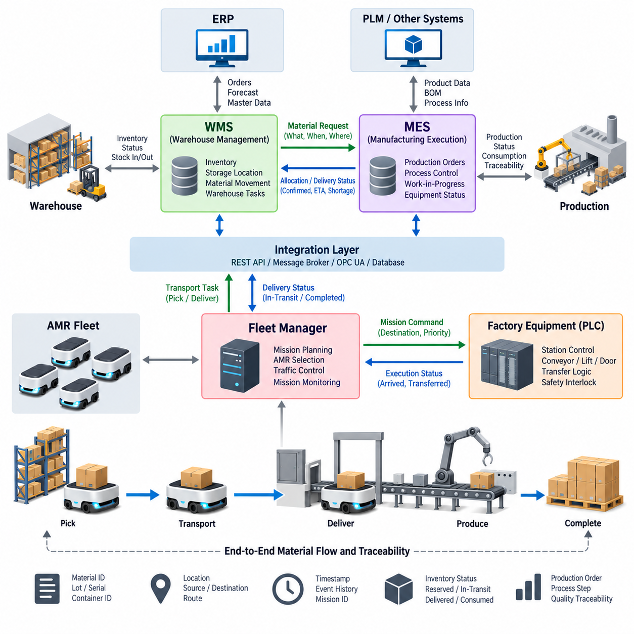
A Warehouse Management System (WMS) and a Manufacturing Execution System (MES) occupy different but closely connected layers of factory operations. The WMS primarily manages inventory, storage locations, material movement, and warehouse resources, while the MES coordinates manufacturing orders, production processes, work-in-progress, and equipment execution. Their interface connects material logistics with production demand.
In an automated factory, production cannot proceed efficiently unless required materials arrive at the correct workstation at the correct time. The MES therefore generates material requirements based on production schedules, work orders, recipes, or process states. These requirements are communicated to the WMS, which determines where the requested material is stored and organizes the corresponding retrieval and transportation operation.
The WMS normally maintains the logistical representation of materials, including item identifiers, quantities, lot numbers, storage locations, containers, pallets, and inventory status. The MES maintains the manufacturing context in which those materials will be consumed. Connecting these information models allows a material request to be associated with a specific production order, process step, workstation, or manufacturing resource.
Material requests should contain sufficient context to prevent ambiguity. Typical information includes material ID, requested quantity, source or inventory constraints, destination station, required delivery time, production order, priority, and tracking identifiers. The WMS may respond with allocation status, selected inventory, estimated delivery state, shortage information, and confirmation that the requested material has been dispatched or delivered.
AMRs provide a physical execution layer between the WMS/MES information systems and factory equipment. After receiving a transportation requirement, the WMS or fleet management layer can generate a mission for an available AMR. The AMR retrieves the assigned container, pallet, rack, or component and transports it to the production station while reporting mission progress and delivery status to higher-level systems.
A clear separation of responsibilities is important. The MES should normally determine what production requires and when it is required, while the WMS determines where the material is located and how inventory is allocated. The fleet manager determines which AMR performs the transportation mission and manages robot traffic. The PLC controls deterministic interaction with conveyors, doors, lifts, fixtures, and other station equipment.
The WMS–MES interface can be implemented through REST APIs, message brokers, database integration, OPC UA, or other enterprise and industrial communication mechanisms. The appropriate method depends on system architecture, transaction frequency, latency requirements, vendor capabilities, and existing IT/OT infrastructure. Asynchronous messaging is particularly useful when operations must remain robust despite temporary delays between systems.
Interface design should distinguish commands, events, and states. A material request is a command or business transaction, while material picked, AMR dispatched, material delivered, and production consumption confirmed are events. Inventory availability, mission status, workstation readiness, and work-order status represent states. Keeping these concepts distinct simplifies synchronization and prevents repeated messages from accidentally creating duplicate operations.
Every transaction should have a unique identifier that can be traced across the MES, WMS, fleet manager, AMR, and production station. A production order may generate a material request identifier, which can then be associated with a warehouse task and an AMR mission. This end-to-end traceability allows operators to determine which physical movement corresponds to a particular manufacturing requirement.
Acknowledgement mechanisms are necessary because successful message transmission does not guarantee successful physical execution. The WMS may acknowledge that a request was accepted, later report that inventory was allocated, and subsequently indicate that transportation began. Final delivery should be confirmed independently, preferably using information from the AMR, destination station, sensors, or PLC-controlled equipment rather than relying only on mission dispatch.
Exception handling must be designed as part of the normal interface rather than added after commissioning. Materials may be unavailable, inventory records may disagree with physical stock, an AMR may become unavailable, a destination may remain occupied, or production may be delayed. The interface should communicate these conditions using defined status and error information so that higher-level systems can reschedule, retry, substitute, or request operator intervention.
Production priorities can change while transportation missions are already active. The MES may accelerate an urgent work order or postpone a process because of equipment downtime. The WMS and fleet management system therefore require mechanisms for updating priorities without creating inconsistent inventory or robot states. Cancellation and modification rules should define which missions can be changed safely and which must first reach a controlled intermediate state.
Inventory synchronization is another critical aspect of the interface. A material may be logically allocated before it physically leaves a storage location, while consumption may be recorded only after it reaches the workstation or enters the manufacturing process. The systems should clearly distinguish available, reserved, picked, in-transit, delivered, staged, consumed, rejected, and returned material states to maintain accurate inventory records.
The interface also supports production traceability. Lot numbers, serial numbers, container identifiers, timestamps, source locations, destination stations, and production-order references can accompany material movements. When these records are synchronized between WMS and MES, manufacturers can reconstruct the relationship between warehouse inventory, transportation activities, production processes, and finished products for quality analysis and operational diagnostics.
Security becomes increasingly important as WMS and MES integration crosses traditional IT and OT boundaries. Authentication, authorization, encrypted communication, network segmentation, controlled API access, logging, and audit trails should protect operational transactions. Interfaces should expose only the information and operations required for integration rather than providing unrestricted access to internal databases or control functions.
A standardized WMS–MES interface ultimately creates a closed information loop between production demand and physical material flow. The MES expresses manufacturing requirements, the WMS converts them into inventory and logistics actions, the fleet system coordinates mobile transportation, and PLC-controlled stations complete physical interaction. Status and completion information then flows upward, allowing production planning to remain synchronized with actual factory execution.

10.03. Factory Network Architecture
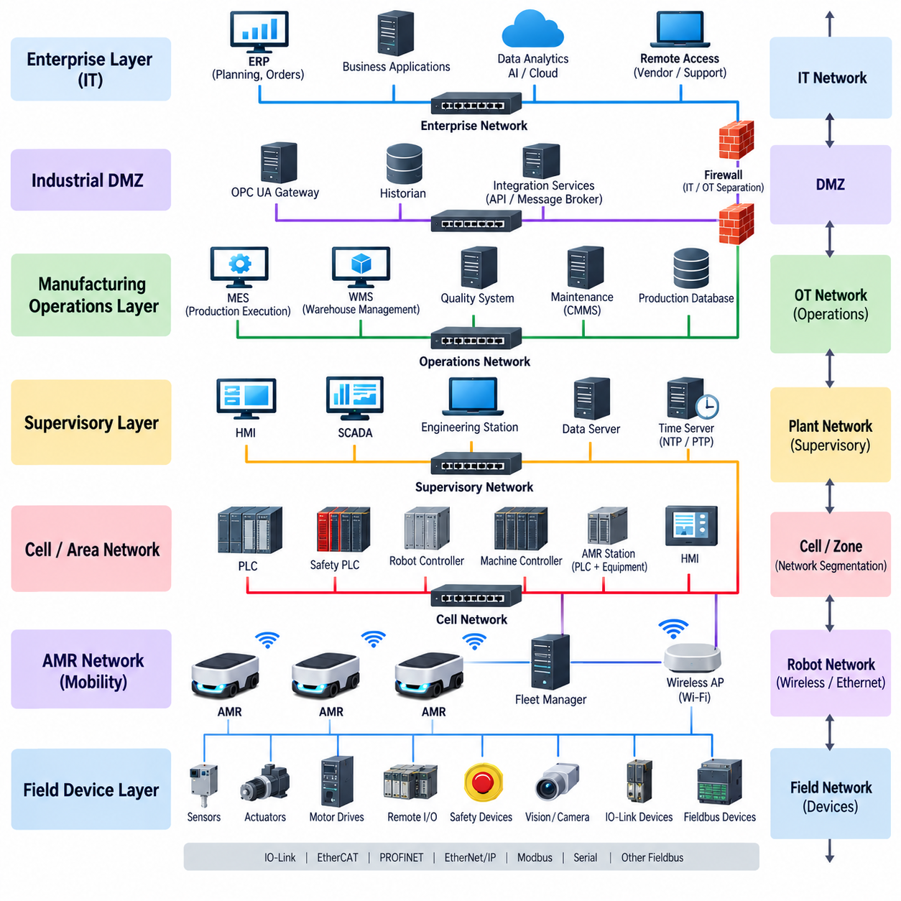
A factory network architecture provides the communication foundation that connects field devices, controllers, robots, production systems, and enterprise applications into a coordinated automation environment. Unlike a conventional office network, it must support deterministic control, high availability, industrial diagnostics, cybersecurity, and predictable communication while accommodating both fixed machinery and mobile systems such as AMRs.
At the lowest level, sensors, actuators, motor drives, remote I/O modules, safety devices, and intelligent instruments interact directly with physical processes. Technologies such as IO-Link, EtherCAT, PROFINET, EtherNet/IP, and traditional serial or fieldbus networks may coexist at this level. Protocol selection depends on cycle time, topology, synchronization, safety requirements, device ecosystem, and installed factory infrastructure.
The control level contains PLCs, safety PLCs, robot controllers, motion controllers, and dedicated machine controllers. These systems execute deterministic logic and coordinate local equipment such as conveyors, lifts, doors, grippers, and production machinery. Industrial Ethernet switches connect controllers and distributed devices while preserving the timing, availability, diagnostics, and traffic characteristics required by automation applications.
Above individual machines, a cell or production-area network connects multiple PLCs, industrial robots, inspection systems, AMR stations, HMIs, and supervisory controllers. Communication at this level coordinates operations between machines rather than controlling every actuator directly. Segmentation into cells or zones limits unnecessary traffic and provides manageable boundaries for configuration, troubleshooting, maintenance, and cybersecurity.
AMRs introduce mobility into an architecture traditionally designed around fixed equipment. Their navigation computers and fleet communication normally use Ethernet and wireless networking, while interaction with production stations may involve PLC-controlled industrial Ethernet interfaces. Reliable Wi-Fi or other appropriate wireless infrastructure is therefore required so that robots can maintain mission communication while moving between warehouse, production, charging, and transfer areas.
The AMR fleet manager occupies a coordination layer above individual mobile robots. It assigns missions, selects available robots, manages traffic conflicts, monitors charging, and coordinates access to shared resources. The fleet system can communicate with WMS, MES, or other supervisory applications while station-level PLCs retain deterministic control of local machinery. This separation prevents enterprise logistics decisions from becoming tightly coupled to machine control logic.
At the supervisory level, HMI and SCADA systems collect equipment status, alarms, operating data, and diagnostic information from multiple controllers. These systems provide operators with a factory-wide operational view without replacing the real-time control performed by PLCs. OPC UA can provide structured information exchange between automation systems and higher-level applications, allowing equipment data to be represented through standardized information models.
The manufacturing operations layer typically contains MES, WMS, quality systems, maintenance applications, and production databases. MES coordinates production execution and work orders, while WMS manages inventory and material logistics. Their commands and transactions can eventually generate physical actions through fleet managers, AMRs, PLCs, and machines, while execution status flows upward to maintain synchronization between digital production records and actual factory operations.
Enterprise IT systems such as ERP operate above manufacturing execution and normally exchange production plans, orders, inventory information, and business data rather than real-time control signals. The architecture should avoid allowing enterprise applications to communicate directly with low-level controllers unless a specifically controlled interface requires it. Integration services, APIs, message brokers, OPC UA gateways, and industrial middleware can establish controlled communication between these layers.
Network segmentation is fundamental because a modern factory may contain thousands of endpoints with very different communication requirements. Logical or physical separation can divide enterprise IT, manufacturing operations, production cells, safety systems, robot networks, engineering systems, and external services. VLANs, routing policies, firewalls, access-control mechanisms, and industrial security gateways can restrict traffic to explicitly required communication paths.
An industrial demilitarized zone, commonly called an Industrial DMZ, can provide an additional boundary between enterprise IT and operational technology networks. Services that must exchange information across this boundary can be placed or mediated through controlled infrastructure rather than exposing production controllers directly. This approach reduces the possibility that an enterprise-side incident can propagate immediately into critical factory automation systems.
Availability must be considered together with segmentation. Failure of a single switch, uplink, power supply, or communication path can stop multiple machines when network dependencies are poorly designed. Managed industrial switches, redundant links, resilient topologies, redundant power, network monitoring, and appropriate recovery mechanisms can reduce single points of failure. Critical communication paths should be identified according to their effect on production and safety.
Time synchronization becomes increasingly important when data from PLCs, robots, cameras, inspection equipment, AMRs, and edge computers must be correlated. Technologies such as NTP and PTP can provide different levels of synchronization depending on application requirements. Consistent timestamps improve event reconstruction, sensor-data alignment, production traceability, distributed diagnostics, and analysis of failures occurring across several networked systems.
Quality of Service and traffic engineering are necessary when control traffic, video streams, diagnostics, engineering access, robot communication, and production data share network infrastructure. High-bandwidth camera or AI traffic should not unintentionally interfere with time-sensitive automation messages. Network design therefore considers bandwidth, latency, jitter, multicast behavior, broadcast domains, traffic priority, and expected peak utilization rather than only nominal link speed.
Cybersecurity should be designed into the architecture instead of being applied after deployment. Device authentication, role-based access, encrypted protocols where appropriate, firewall policies, secure remote access, patch management, logging, asset inventory, and network monitoring contribute to defense in depth. Engineering laptops, vendor maintenance connections, wireless devices, and external cloud interfaces require particular attention because they can create paths across established security boundaries.
Diagnostics and observability are equally important for maintaining a large industrial network. Managed switches and network-management systems can expose port status, errors, utilization, topology changes, communication failures, and device availability. When this information is correlated with PLC alarms, AMR events, MES transactions, and production timestamps, maintenance teams can distinguish network faults from controller, robot, sensor, or application failures.
A well-designed factory network ultimately forms a layered communication structure connecting physical devices, deterministic control, mobile robotics, supervisory automation, manufacturing operations, and enterprise systems. Industrial protocols provide local execution, Ethernet and wireless networks provide scalable connectivity, and controlled IT/OT interfaces support information exchange. The result is a network that enables factory-wide integration without sacrificing control determinism, availability, safety boundaries, maintainability, or cybersecurity.

10.04. IT/OT Convergence
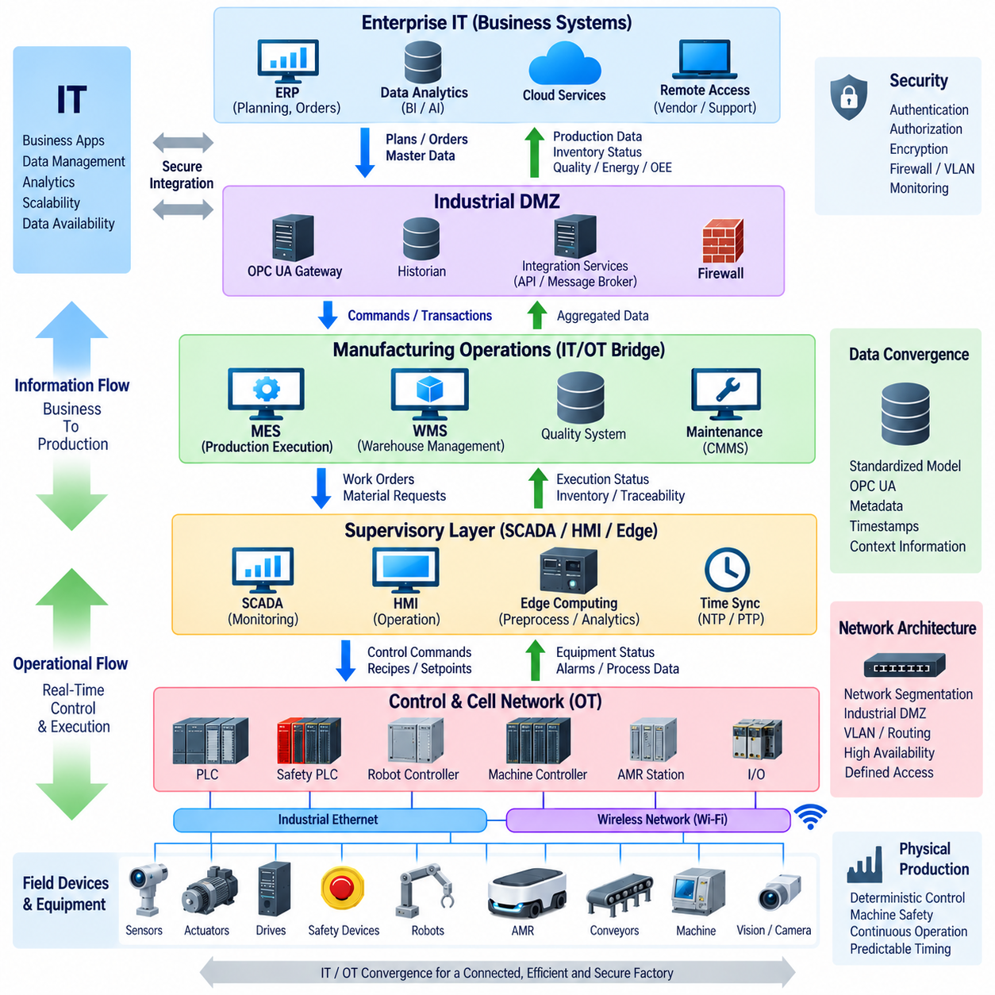
Information Technology (IT) and Operational Technology (OT) convergence describes the integration of enterprise information systems with the industrial systems that monitor and control physical processes. IT traditionally manages business applications, databases, analytics, and enterprise networks, while OT manages PLCs, robots, sensors, actuators, and production equipment. Convergence connects these domains without eliminating their different operational responsibilities.
Traditional factories often separated IT and OT because their engineering priorities were different. IT environments emphasized information processing, interoperability, scalability, and data availability, whereas OT environments emphasized deterministic control, continuous operation, machine safety, and predictable timing. Modern automation increasingly requires information to move between these domains so production decisions can reflect actual equipment and material conditions.
The convergence process can be understood as a controlled flow of information from physical equipment toward business applications and operational commands in the opposite direction. Sensors and controllers generate machine states, alarms, production counts, energy information, and quality data. These values can be aggregated by supervisory and manufacturing systems before being delivered to enterprise applications, analytics platforms, or other authorized services.
MES and WMS provide important intermediate functions between enterprise IT and shop-floor OT. MES converts production plans into manufacturing execution activities and tracks work-in-progress, while WMS manages inventory and material logistics. Their transactions can generate downstream actions involving AMRs, PLC-controlled stations, conveyors, robots, and other equipment, while execution results are returned upward to synchronize digital records with physical operations.
Industrial communication technologies form the technical bridge supporting this convergence. PROFINET, EtherNet/IP, EtherCAT, Modbus TCP, and IO-Link connect controllers and field equipment according to application requirements, while OPC UA can expose structured industrial information to supervisory or higher-level systems. REST APIs and message brokers can further connect manufacturing applications with enterprise software where transactional or asynchronous communication is appropriate.
Edge computing provides another important convergence point because it can process OT data close to machines while supporting IT-oriented software and analytics. An industrial edge computer may collect PLC information, robot status, sensor streams, or inspection data and perform preprocessing, inference, aggregation, or protocol translation. Only required results need to move upward, reducing bandwidth demand and allowing local operations to continue when external connectivity is limited.
AMRs illustrate the convergence of IT and OT particularly well. Their onboard computers perform navigation and autonomous decision functions, fleet managers coordinate missions and traffic, WMS or MES generates logistical requirements, and PLCs control deterministic station interactions. A single material movement can therefore cross several layers, from a digital production request through mobile robot execution to physical transfer and final transaction confirmation.
IT/OT convergence does not mean placing all factory devices on one unrestricted network. Network segmentation remains necessary to separate enterprise systems, manufacturing operations, supervisory networks, production cells, robot networks, safety systems, and field devices. Firewalls, VLANs, routing policies, industrial gateways, and access controls establish defined communication paths while reducing unnecessary exposure between systems with different security and availability requirements.
An Industrial DMZ can provide a controlled transition zone between enterprise IT and production OT. Integration services, historians, gateways, update services, or other shared functions can be positioned or mediated through this boundary according to the architecture. This prevents enterprise applications from requiring unrestricted direct access to PLCs and other controllers while still enabling authorized production information to move between organizational domains.
Cybersecurity becomes a central design consideration because convergence creates communication paths that did not exist in isolated automation systems. Authentication, authorization, encryption where appropriate, secure remote access, asset management, logging, patch management, and network monitoring contribute to defense in depth. Engineering workstations, vendor connections, wireless networks, edge computers, and cloud interfaces require particular attention because they can bridge multiple security zones.
Availability requirements also differ between IT and OT. Restarting a business application may cause temporary inconvenience, while restarting a controller or disrupting an industrial network can stop production or interrupt a physical process. Converged architectures must therefore preserve local control independence wherever practical. A PLC-controlled machine should not become unnecessarily dependent on continuous cloud or enterprise connectivity for basic deterministic operation.
Data modeling is essential because raw controller addresses have limited meaning outside the machine that generated them. A PLC register may represent motor speed, station readiness, production count, or fault status, but higher-level applications require contextual information. OPC UA information models, standardized naming conventions, asset identifiers, timestamps, units, and metadata can transform low-level signals into information that MES, analytics, maintenance, and enterprise applications can interpret consistently.
Time synchronization further improves the value of converged data. PLC events, AMR missions, camera observations, inspection results, MES transactions, and network alarms may originate from different systems. NTP or PTP can provide appropriate synchronization depending on required precision. Consistent timestamps allow engineers to reconstruct production events and correlate a physical machine condition with robot behavior, quality results, network events, or higher-level transactions.
Convergence also enables closed-loop operational improvement. Equipment condition can be collected from OT systems, converted into structured information, analyzed by edge or higher-level applications, and used to support maintenance or production decisions. The resulting action may then return through MES, WMS, fleet management, or controlled automation interfaces. This creates an information cycle linking observation, analysis, planning, execution, and verification.
Governance is necessary because IT and OT teams often manage different technologies, lifecycles, risks, and engineering procedures. Responsibilities for network configuration, controller changes, cybersecurity, software updates, data ownership, remote access, backup, and incident response should be explicitly defined. Effective convergence therefore depends not only on communication protocols but also on coordinated engineering processes and clearly assigned operational authority.
Successful IT/OT convergence ultimately creates a layered factory architecture in which enterprise information systems and physical automation can exchange meaningful information without destroying their necessary boundaries. IT contributes scalable computing, data management, analytics, and business integration, while OT preserves deterministic control and reliable physical execution. Their controlled integration enables connected factories, autonomous logistics, traceable production, intelligent maintenance, and increasingly data-driven industrial automation.

10.05. Digital Twin Integration
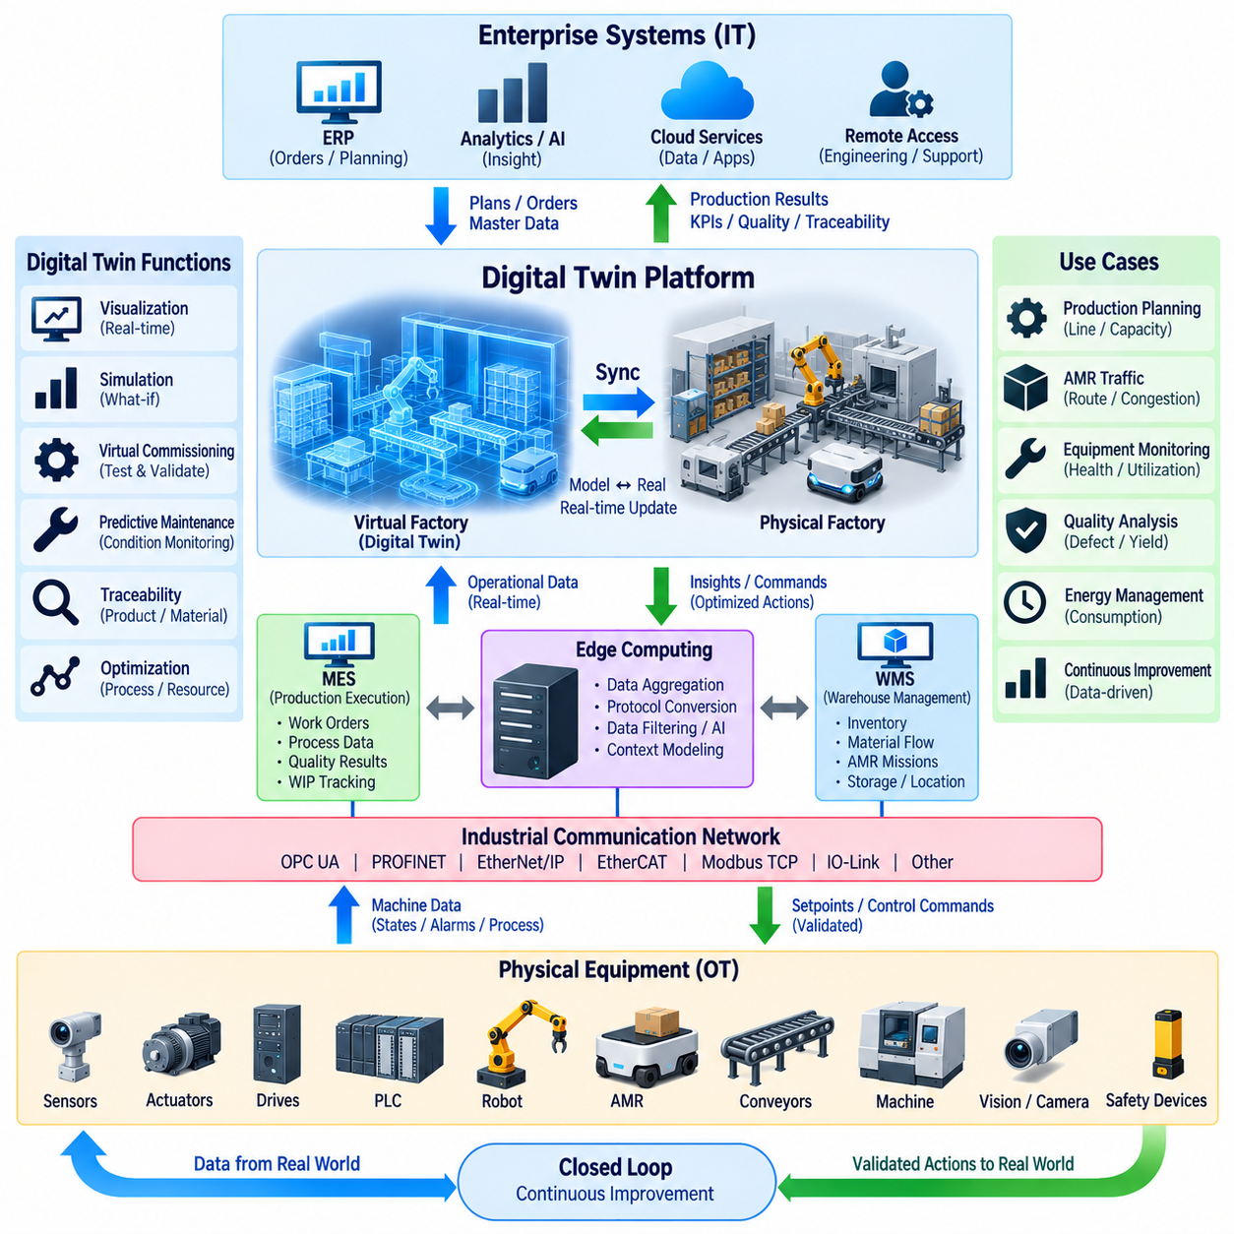
A digital twin is a continuously updated digital representation of a physical asset, machine, robot, production cell, or factory process. In factory automation, it connects engineering models with operational data so that the digital representation reflects relevant conditions of the physical system. Unlike a static CAD model, a digital twin evolves as equipment states, production events, and operating conditions change.
Digital twin integration begins with a clear relationship between physical assets and their digital identities. PLCs, robots, AMRs, conveyors, sensors, drives, and production stations can each be associated with identifiers, configuration data, operating states, and historical records. These relationships allow information from different automation systems to be organized around the actual equipment and processes represented by the twin.
The physical layer generates the operational information required to maintain the digital representation. Sensors measure variables such as position, speed, temperature, current, vibration, load, and environmental conditions, while PLCs and robot controllers provide machine states, alarms, cycle information, and process results. AMRs additionally provide position, mission status, battery condition, payload state, docking status, and navigation-related information.
Industrial communication networks transport this information from equipment toward supervisory and computing systems. PROFINET, EtherNet/IP, EtherCAT, Modbus TCP, IO-Link, and other industrial protocols may provide machine-level connectivity, while OPC UA can expose structured information to higher layers. Gateways and edge computers can aggregate signals, translate protocols, normalize data, and attach context before information enters the digital twin environment.
A digital twin should not simply reproduce every raw signal generated by factory equipment. Instead, integration normally selects information that describes the state and behavior of the represented asset. Raw PLC addresses can be converted into meaningful properties such as machine mode, conveyor speed, station occupancy, robot availability, material presence, or fault condition. Context transforms low-level data into an interpretable digital representation.
Time synchronization is important because the twin may combine information from many independent systems. PLC events, AMR trajectories, robot actions, camera observations, inspection results, and MES transactions must often be correlated according to when they occurred. NTP or PTP can provide suitable synchronization depending on precision requirements, while consistent timestamps support event reconstruction, sequence analysis, diagnostics, and comparison between physical and simulated behavior.
Edge computing can provide an intermediate processing layer between physical equipment and the digital twin platform. An edge computer may filter high-frequency sensor data, calculate features, perform AI inference, detect anomalies, or aggregate events before transmission. This reduces unnecessary network traffic and allows important local processing to remain close to the production system while higher-level twin services receive structured information.
MES and WMS add manufacturing and logistics context that cannot be obtained from machine signals alone. MES can associate equipment behavior with production orders, process steps, quality results, and work-in-progress, while WMS provides inventory, storage, material, and transportation information. Combining this context with OT data allows the digital twin to represent not only machines but also the production activities occurring around them.
AMRs extend digital twins from fixed equipment into dynamic factory space. Their continuously changing position, route, mission, payload, battery state, and destination can be represented together with production stations and warehouse locations. A factory-level twin can therefore visualize or analyze material movement, robot traffic, station utilization, congestion, charging behavior, and interactions between mobile robots and fixed automation.
Bidirectional integration allows the digital twin to support more than monitoring. A change can first be evaluated in a simulation or analytical model before an authorized command is sent toward the physical system. However, the twin should not bypass established control responsibilities. Real-time machine control remains with PLCs, robot controllers, and safety systems, while higher-level changes should pass through controlled MES, fleet, supervisory, or automation interfaces.
Simulation is one of the major capabilities enabled by digital twin integration. Engineers can evaluate production sequences, robot paths, AMR traffic, station capacities, material flow, or equipment utilization before changing the physical factory. Simulation results can reveal bottlenecks and resource conflicts, while operational data from the real system can continuously improve assumptions and parameters used by the digital model.
Digital twins also support virtual commissioning. PLC logic, robot sequences, material-transfer behavior, and equipment interfaces can be tested against simulated machinery before the complete physical system becomes available. This allows engineers to identify sequence errors, interface mismatches, timeout conditions, and abnormal-state behavior earlier in the development process, reducing commissioning effort and production disruption.
Condition monitoring and predictive maintenance can use digital twin information to compare expected and observed equipment behavior. Historical trends from motors, drives, batteries, actuators, or mechanical systems can be combined with operating context to identify degradation. The twin can represent current condition, maintenance history, utilization, and abnormal patterns, allowing maintenance decisions to consider how the equipment has actually been operated.
Digital twin integration also improves traceability by connecting asset state with production and logistics events. Material identifiers, production orders, AMR missions, machine cycles, inspection results, alarms, and timestamps can be associated within a common operational context. Engineers can then reconstruct how a product or material moved through the factory and determine which equipment states or process conditions existed during production.
Cybersecurity and access control remain essential because bidirectional digital twin connections may bridge OT, edge, manufacturing, and enterprise networks. Network segmentation, authentication, authorization, encrypted communication where appropriate, logging, and controlled gateways should limit access to operational systems. A digital twin platform should never become an unrestricted path through which external applications can directly manipulate critical controllers.
A mature digital twin architecture ultimately forms a closed information cycle between the physical factory and its digital representation. Physical systems generate operational data, communication and edge layers convert it into contextual information, and digital models support visualization, analysis, simulation, optimization, and prediction. Validated decisions can then return through controlled automation interfaces, creating a continuously synchronized relationship between physical execution and digital intelligence.

