Volume 07. Industrial Communication

Chapter 06. EtherNet/IP

06.01. CIP (Common Industrial Protocol)
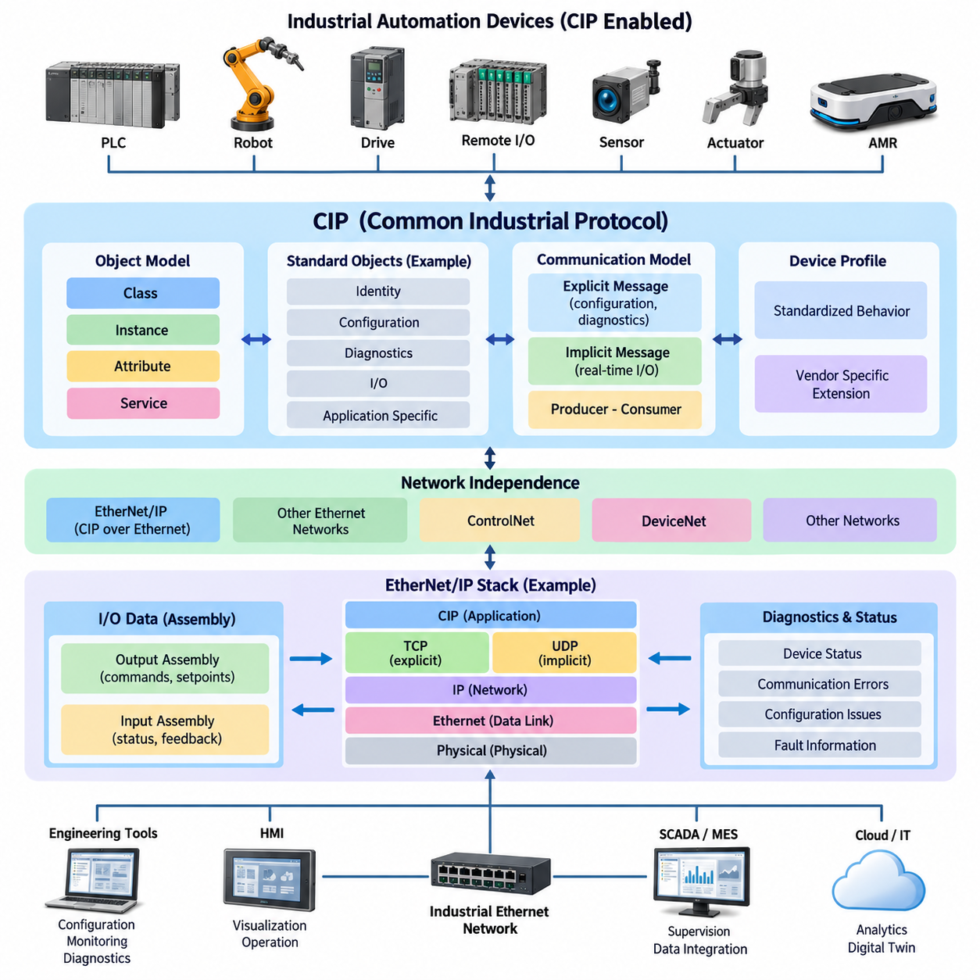
The Common Industrial Protocol (CIP) is an application-layer industrial communication framework designed to provide a consistent way for controllers, sensors, actuators, drives, robots, and other automation devices to exchange information. Within the attached industrial communication structure, CIP forms the conceptual foundation of EtherNet/IP and precedes topics such as explicit and implicit messaging, EDS files, CIP Safety, and AMR integration.
CIP separates the meaning and organization of industrial data from the physical network used to transport that data. Instead of defining only how bits or Ethernet frames move between devices, it specifies how automation information is represented, addressed, accessed, and interpreted. This separation allows a common application model to operate across different network technologies while maintaining consistent device behavior.
A fundamental characteristic of CIP is its object-oriented device model. A CIP-enabled device represents its functions and information as collections of objects rather than as an undifferentiated block of registers. Each object represents a defined aspect of device functionality, such as identity, communication configuration, parameters, diagnostics, discrete I/O, analog data, or application-specific behavior.
Within this object model, information is organized through classes, instances, attributes, and services. A class defines a particular type of object, while an instance represents one occurrence of that class inside a device. Attributes contain the actual properties or state information associated with an object. Services define operations that can be requested, such as reading an attribute, changing a parameter, or resetting functionality.
This organization creates a structured addressing mechanism for industrial information. Instead of requiring every controller to understand an arbitrary memory layout, CIP communication can identify the destination object and the specific information or operation associated with it. Standardized object definitions therefore improve interoperability because devices from different manufacturers can expose important capabilities through commonly understood structures.
The Identity Object is an important example of standardized CIP modeling. It provides information that allows a network participant to identify and characterize a device, including properties associated with vendor, device type, product identification, revision, and operating status. Engineering tools and controllers can use this standardized information during commissioning, configuration, diagnostics, and replacement procedures.
CIP also distinguishes communication relationships according to the purpose of the exchanged information. Configuration parameters, diagnostic information, and occasional commands have different communication requirements from continuously updated control signals. This distinction becomes especially important in EtherNet/IP, where CIP services support both request-response communication and cyclic or event-driven exchanges for real-time automation data.
CIP uses a connection-oriented model when communication requires an established relationship between participating devices. A connection defines how information will be exchanged and provides parameters associated with the communication relationship. This concept supports predictable industrial operation because communicating devices can establish resources and data-transfer expectations before cyclic control information is exchanged.
For cyclic control applications, CIP commonly represents I/O information through assemblies. An Assembly Object groups multiple pieces of application data into a defined structure that can be transferred efficiently between devices. A motor drive, for example, may combine command words and reference values into an output assembly while returning status words, actual velocity, current, or fault information through an input assembly.
This assembly-based approach is particularly useful for PLC-controlled automation because the controller can treat the exchanged information as organized process data rather than repeatedly requesting individual parameters. Once communication is configured, input and output assemblies provide an efficient interface between controller logic and field devices. Their exact structure remains device dependent and must therefore be understood during integration.
CIP communication also incorporates the producer-consumer concept. Traditional communication often assumes that one device sends information directly to one specific receiver. In a producer-consumer architecture, a producer generates information that can potentially be consumed by one or more interested participants. This model is well suited to automation systems where the same state information may be useful to several controllers or supervisory functions.
Network-independent application semantics are one reason CIP can support a family of industrial networks. The application objects and services define what information means, while the underlying network determines how that information is transported. EtherNet/IP applies CIP over standard Ethernet and the TCP/IP and UDP/IP protocol suite, allowing industrial devices to use widely deployed Ethernet infrastructure while retaining automation-oriented semantics.
In EtherNet/IP, TCP is generally associated with communication requiring reliable connection-oriented transport, while UDP is particularly useful for time-sensitive cyclic I/O exchanges where continuously refreshed information is more important than retransmission of an obsolete packet. CIP defines the industrial communication behavior above these transport mechanisms rather than replacing Ethernet, IP, TCP, or UDP themselves.
Device interoperability depends not only on transporting packets successfully but also on agreeing about the meaning, format, direction, and expected behavior of application data. Two Ethernet devices can communicate electrically and at the IP level while still being unable to operate together as an automation system. CIP addresses this higher-level problem by defining standardized communication objects, services, connection concepts, and device profiles.
Device profiles extend this principle by defining expected behavior for particular categories of industrial equipment. A profile can establish common characteristics for devices performing similar functions, helping controllers and engineering tools interact with them in a more consistent manner. Vendor-specific functions can still exist, but standardized portions of the device model provide a common foundation for configuration and operation.
CIP therefore supports both standardized functionality and manufacturer-specific extensions. Standard objects provide interoperable mechanisms for common operations, while additional objects or attributes can represent specialized device capabilities. Good system integration requires engineers to distinguish between standardized behavior that can be expected across compliant equipment and vendor-specific behavior that depends on documentation and configuration tools.
CIP also provides mechanisms for reporting device state and communication-related errors. Because diagnostics are represented within a structured application model, controllers and engineering systems can obtain more meaningful information than simple link availability. Network communication may remain operational while an application object reports a configuration problem, device fault, invalid request, unavailable resource, or other condition requiring maintenance attention.
For robotics and factory automation, this structured diagnostic capability is important because communication health and machine health are not equivalent. A robot controller, servo drive, gripper, remote I/O module, or AMR interface may remain reachable over Ethernet even though its application function cannot execute. CIP objects and status information help supervisory logic distinguish communication failures from equipment or process-level faults.
CIP should consequently be understood as more than a protocol for moving I/O values. It establishes a common industrial information architecture describing devices, their internal functional objects, accessible attributes, supported services, communication relationships, and application data. EtherNet/IP then uses this architecture within an Ethernet-based industrial network, connecting conventional automation semantics with modern switched networking infrastructure.
In a layered engineering view, Ethernet provides the physical and data-link foundation, IP provides network addressing and routing, TCP or UDP supplies transport behavior, and CIP provides the industrial application semantics. Maintaining this distinction is useful during troubleshooting because cable or switch problems, IP configuration errors, transport failures, CIP connection problems, and application-object errors represent different diagnostic layers.
For an AMR or industrial robot integrated into a PLC-controlled factory, CIP can provide the common application framework through which operational commands, status information, interlocks, process values, and diagnostics are exchanged. The detailed communication behavior is then developed through the subsequent EtherNet/IP topics identified in the attached structure: explicit versus implicit messaging, EDS device descriptions, CIP Safety, and AMR integration.

06.02. Explicit vs Implicit Message
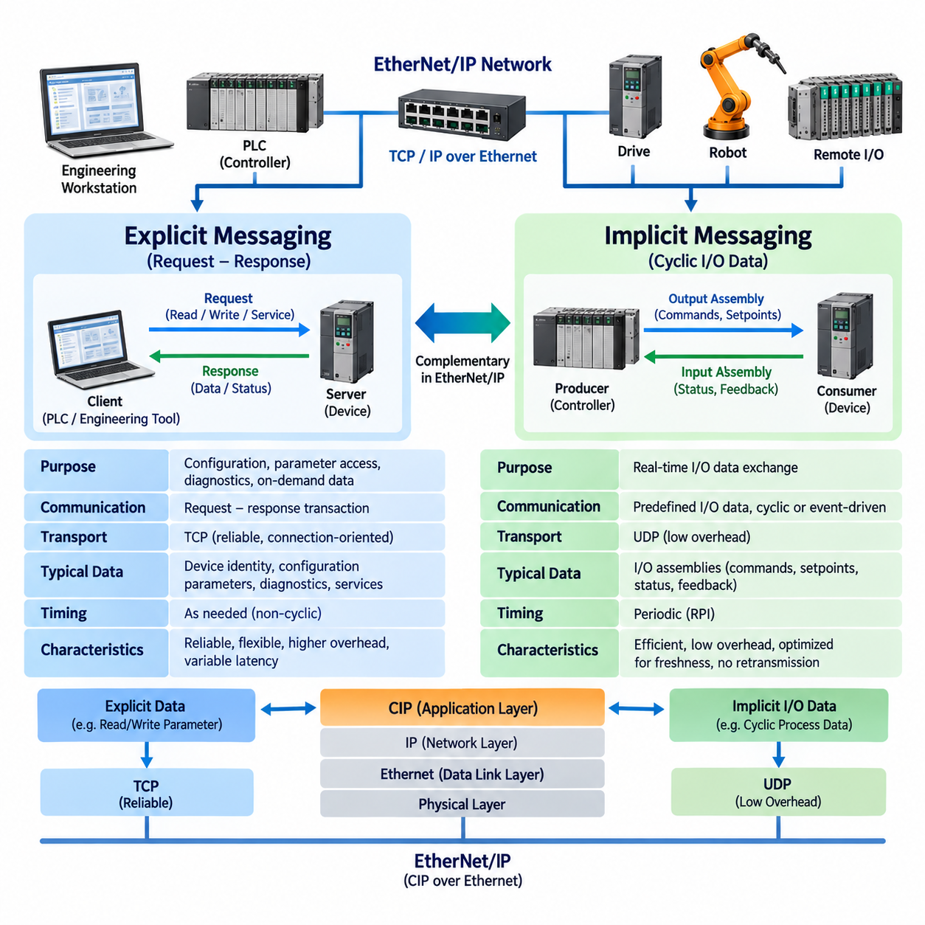
Explicit messaging and implicit messaging are two complementary CIP communication mechanisms used in EtherNet/IP systems. They serve different purposes within industrial automation: explicit messaging is primarily intended for configuration, parameter access, diagnostics, and other request-response transactions, while implicit messaging is optimized for cyclic or event-driven exchange of time-sensitive I/O data between controllers and field devices.
Explicit messaging operates through clearly identified requests and responses. A client device sends a request describing the CIP object, instance, attribute, or service that it wants to access, and the target device processes that request before returning a corresponding response. Because each transaction carries information describing the requested operation, explicit messaging provides considerable flexibility for accessing individual elements of a device's object model.
Typical explicit-message operations include reading configuration parameters, modifying operating settings, retrieving diagnostic information, obtaining device identity data, and invoking specific CIP services. An engineering workstation might request the firmware revision of a drive, while a PLC could read a diagnostic attribute or change an operating parameter. These transactions occur when needed rather than continuously at a fixed control-cycle rate.
Explicit messaging is commonly associated with TCP transport in EtherNet/IP. TCP provides reliable, connection-oriented delivery with mechanisms for sequencing, acknowledgment, retransmission, and error recovery. These properties are valuable for configuration and diagnostic transactions because losing a parameter-writing command or receiving incomplete configuration information could leave a device in an unintended state.
Reliability does not mean that explicit messaging is the preferred mechanism for every industrial data exchange. TCP processing, request-response transactions, and protocol information introduce overhead and potentially variable latency. For information such as motor velocity feedback or continuously changing sensor values, retransmitting an old packet may provide little value because a newer process value may already be available.
Implicit messaging addresses this requirement by focusing on efficient transfer of application data whose meaning and structure have already been established. Instead of describing every requested object operation within every exchange, communicating devices establish the context beforehand. Once the connection is configured, the transmitted data can be interpreted according to the agreed I/O assembly and connection parameters.
The term “implicit” therefore does not mean that the data is undefined or hidden. It means that much of the information required to interpret the message is implicit in the previously established connection. The receiver already knows what the transferred bytes represent, where they belong, and how they should be processed. This reduces recurring communication overhead during real-time I/O exchange.
Implicit messaging is typically used for controller-to-device and device-to-controller I/O communication. A PLC may continuously send command bits, operating modes, velocity references, or actuator setpoints to a drive or robot interface. The device may simultaneously return status bits, measured velocity, position information, operating state, sensor values, and fault indications through its input data.
Assembly Objects are closely associated with this mechanism. An Output Assembly can group commands and setpoints sent from a controller to a field device, while an Input Assembly can group status and feedback returned from the field device. Rather than performing separate explicit reads and writes for each variable, implicit messaging efficiently exchanges these predefined collections of process data.
EtherNet/IP generally uses UDP for this time-sensitive I/O communication. UDP does not provide the retransmission and acknowledgment mechanisms associated with TCP, which reduces transport overhead. In continuously refreshed control applications, receiving the next current value is often more useful than delaying communication while attempting to recover an obsolete value from an earlier control cycle.
Implicit I/O communication is therefore designed around freshness and predictable repetition rather than guaranteed delivery of every individual packet. If one cyclic packet is lost, the following packet can provide updated process information. The application must nevertheless detect excessive packet loss, communication timeout, or loss of the connection because continued operation without valid control or feedback data may create an unacceptable machine state.
The Requested Packet Interval, commonly abbreviated as RPI, is an important parameter in EtherNet/IP implicit communication. It specifies the requested time interval associated with producing or consuming I/O information. Selecting an appropriate RPI requires balancing control-response requirements against network bandwidth, device processing capability, controller loading, and the number of active communication connections.
An unnecessarily short RPI can increase network traffic and processing load without improving actual machine performance. Conversely, an excessively long RPI can make feedback stale and reduce responsiveness. The communication update rate should therefore be selected according to the dynamics of the controlled process rather than simply configured to the smallest value supported by the device.
CIP's producer-consumer model further supports efficient implicit communication. A producing device can generate application information that may be consumed by one or more interested participants. This differs conceptually from repeatedly performing individual point-to-point requests and is particularly valuable when multiple automation components require access to the same periodically updated information.
Explicit and implicit messaging should consequently be viewed as cooperating mechanisms rather than competing alternatives. Explicit communication can establish, configure, inspect, and diagnose a device, while implicit communication can carry the recurring process data required during normal machine operation. A practical EtherNet/IP system frequently uses both mechanisms simultaneously for different categories of information.
Consider a servo drive connected to a PLC. During commissioning, explicit messages may be used to identify the drive, inspect configuration parameters, retrieve diagnostic attributes, and adjust selected settings. During machine operation, implicit messages can continuously transfer enable commands, mode information, torque or velocity references, actual position, measured velocity, drive status, and operating feedback.
A similar pattern applies to industrial robots and AMRs. Explicit messaging can support configuration, identification, diagnostic queries, operating parameters, and non-periodic commands. Implicit messaging can support repeatedly exchanged interface signals such as ready, busy, mission active, docking complete, fault, safety-related status where applicable, command acknowledgments, and process handshake information required by PLC automation.
However, the existence of fast implicit communication does not automatically guarantee deterministic motion control. End-to-end timing also depends on controller task scheduling, device processing, switch behavior, network utilization, topology, update intervals, and application architecture. Engineers must therefore evaluate the complete control loop instead of assuming that the transport mechanism alone determines real-time performance.
Network design should also consider the fundamentally different traffic patterns created by the two messaging methods. Explicit traffic tends to be intermittent and transaction-oriented, whereas implicit traffic may be continuous and periodic across many devices. A large automation system with numerous short-RPI connections can therefore generate substantial recurring traffic even when individual I/O packets are relatively small.
Diagnostics must distinguish transport communication from application communication. An Ethernet link can remain physically active while an implicit I/O connection has timed out, and explicit diagnostic access may remain available even after cyclic process communication has failed. This separation can be extremely useful because maintenance software may still communicate with a device and investigate why its normal I/O relationship was interrupted.
From an engineering perspective, explicit messaging answers questions such as “What parameter should I read or change?” and “What service should this object perform?” Implicit messaging addresses a different requirement: “What predefined process data must continuously flow between these devices?” Recognizing this distinction makes EtherNet/IP configuration, troubleshooting, bandwidth planning, and PLC interface design considerably easier.
A well-designed EtherNet/IP architecture therefore assigns information to the communication mechanism that matches its operational characteristics. Configuration and diagnostic information generally favors flexible, reliable explicit transactions, while frequently refreshed control and status information favors efficient implicit I/O exchange. Together, these mechanisms allow CIP to support both detailed device management and continuous industrial automation within the same network architecture.

06.03. EDS File Structure
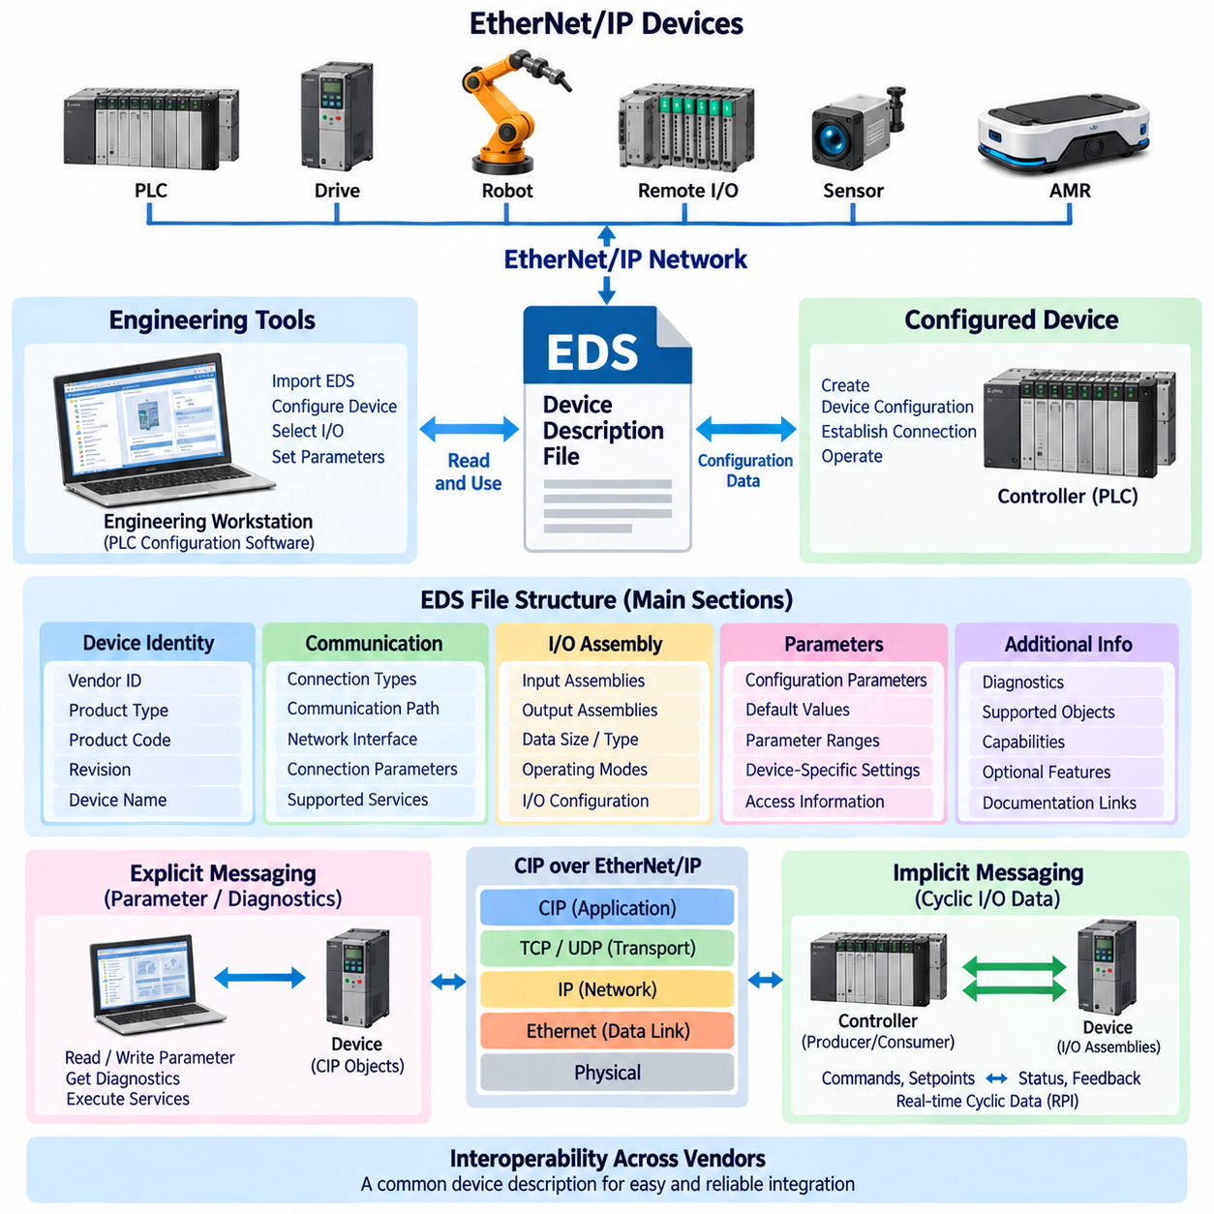
Electronic Data Sheet (EDS) is a standardized device-description file used in EtherNet/IP systems to provide engineering software and controllers with structured information about a network device. In the attached architecture, EDS File Structure is positioned after CIP and explicit versus implicit messaging and before CIP Safety and AMR integration. This placement reflects its role as a practical configuration interface between the CIP device model and engineering tools used to integrate EtherNet/IP devices.
An EDS file describes how an EtherNet/IP device should be recognized, configured, and presented by an engineering environment. Rather than requiring an engineer to manually enter every device characteristic, the EDS provides machine-readable information about the device, its communication capabilities, supported objects, parameters, and I/O assemblies. The engineering tool can use this information to create an appropriate device configuration and reduce configuration errors during system integration.
The information in an EDS is organized as structured sections and key-value definitions rather than as arbitrary application data. Typical information includes the vendor identity, product type, product code, revision, device name, communication characteristics, and supported network interfaces. These fields allow configuration software to distinguish one device from another and associate the selected device with the appropriate communication and configuration information.
Device identity information is particularly important because an EtherNet/IP network can contain many devices with similar functions. The EDS helps an engineering tool determine which vendor and product are being configured and which revision or device characteristics apply. During commissioning, the identity information can also be compared with the actual device identity so that an engineer can detect an incorrect device selection or an incompatible revision before normal operation begins.
An EDS can also describe communication-related characteristics of the device. These characteristics may include supported connection types, communication paths, input and output assemblies, connection parameters, and other information required to establish EtherNet/IP communication. The engineering software uses these definitions when creating the configuration that connects a controller to the target device.
The relationship between an EDS and CIP objects is important for understanding the architecture. CIP defines the object-oriented communication model using classes, instances, attributes, and services, while the EDS provides engineering information that helps software understand how a particular device exposes and uses those capabilities. The EDS therefore does not replace CIP; it describes the device in a form that engineering software can use when configuring the CIP communication model.
I/O assembly information is another important part of device configuration. A device may provide input assemblies containing status and feedback information and output assemblies containing commands or setpoints. The EDS can identify the available assembly structures and associated communication options so that the controller configuration can select the appropriate data interface. This becomes especially important when a device supports multiple operating modes or different I/O data layouts.
The EDS is particularly useful when configuring implicit messaging. Implicit communication depends on predefined I/O data structures and connection parameters rather than repeatedly describing each individual request. Engineering software must therefore know which assemblies are available, what their sizes and directions are, and which communication relationships the device supports. EDS information helps provide this configuration knowledge before cyclic I/O communication begins.
EDS information can also support explicit messaging configuration. Explicit messages may access device parameters, diagnostics, configuration attributes, or CIP services. Although the actual CIP request and response follow the protocol definition, engineering tools need device-specific information to present meaningful parameters and supported functions to the engineer. The EDS can therefore contribute to the configuration and discovery process surrounding explicit communication.
A major benefit of EDS-based configuration is interoperability. EtherNet/IP devices from different manufacturers can be integrated into the same engineering environment when their device descriptions follow the expected format and accurately represent their capabilities. The EDS provides a common mechanism for communicating device information to configuration software, while the underlying CIP model provides standardized communication semantics.
However, an EDS should not be treated as a complete representation of the physical device. It is primarily an engineering and configuration description. Device firmware, electrical characteristics, mechanical behavior, safety functions, application-specific limitations, and detailed operating procedures may require additional manufacturer documentation. Engineers should therefore use the EDS together with the device manual, firmware information, network configuration, and system-level requirements.
Version management is also important because the device description must remain consistent with the actual device. A change in firmware, product revision, supported assembly, parameter definition, or communication capability can affect the validity of an existing configuration. If the EDS does not correspond to the installed device, an engineering tool may present incorrect configuration choices or fail to establish the intended communication relationship.
During commissioning, the EDS can therefore be viewed as part of a configuration chain: the engineering tool loads the device description, the engineer selects the required device and communication options, the controller configuration is generated, and the EtherNet/IP network establishes the required CIP connections. If the configuration is incorrect, the engineer must determine whether the problem originates from device identity, EDS information, IP configuration, connection parameters, assembly selection, or the device itself.
For industrial robots and AMRs, EDS-based configuration becomes especially useful when the machine must exchange standardized operational information with a PLC. An AMR interface may expose commands, status signals, mission information, fault states, and handshake data through predefined assemblies. The EDS helps the PLC engineering environment understand the available interface so that the AMR can be incorporated into a larger EtherNet/IP automation architecture.
EDS also provides a useful boundary between vendor-specific implementation and system-level integration. A device manufacturer can define specialized functions while exposing the necessary configuration and communication information through the device description. The system integrator can then configure the device without needing to understand every internal implementation detail, provided that the required functions are correctly represented by the EDS and supported by the actual firmware.
The engineering value of EDS is therefore not simply that it is a file stored on a computer. Its importance comes from connecting a physical EtherNet/IP device to the configuration model used by engineering software. CIP defines how industrial information is represented and exchanged, while the EDS helps the engineering environment discover and configure the specific device, communication relationships, assemblies, and parameters required to use that model correctly.
In a complete EtherNet/IP workflow, the EDS should consequently be considered a configuration enabler between device capabilities and network engineering. It supports device identification, parameter configuration, I/O assembly selection, connection setup, and interoperability, while explicit and implicit messaging provide the actual communication mechanisms during operation. This makes EDS an important practical component between the conceptual CIP layer and the later topics of CIP Safety and EtherNet/IP integration in AMR and industrial automation systems.

06.04. CIP Safety
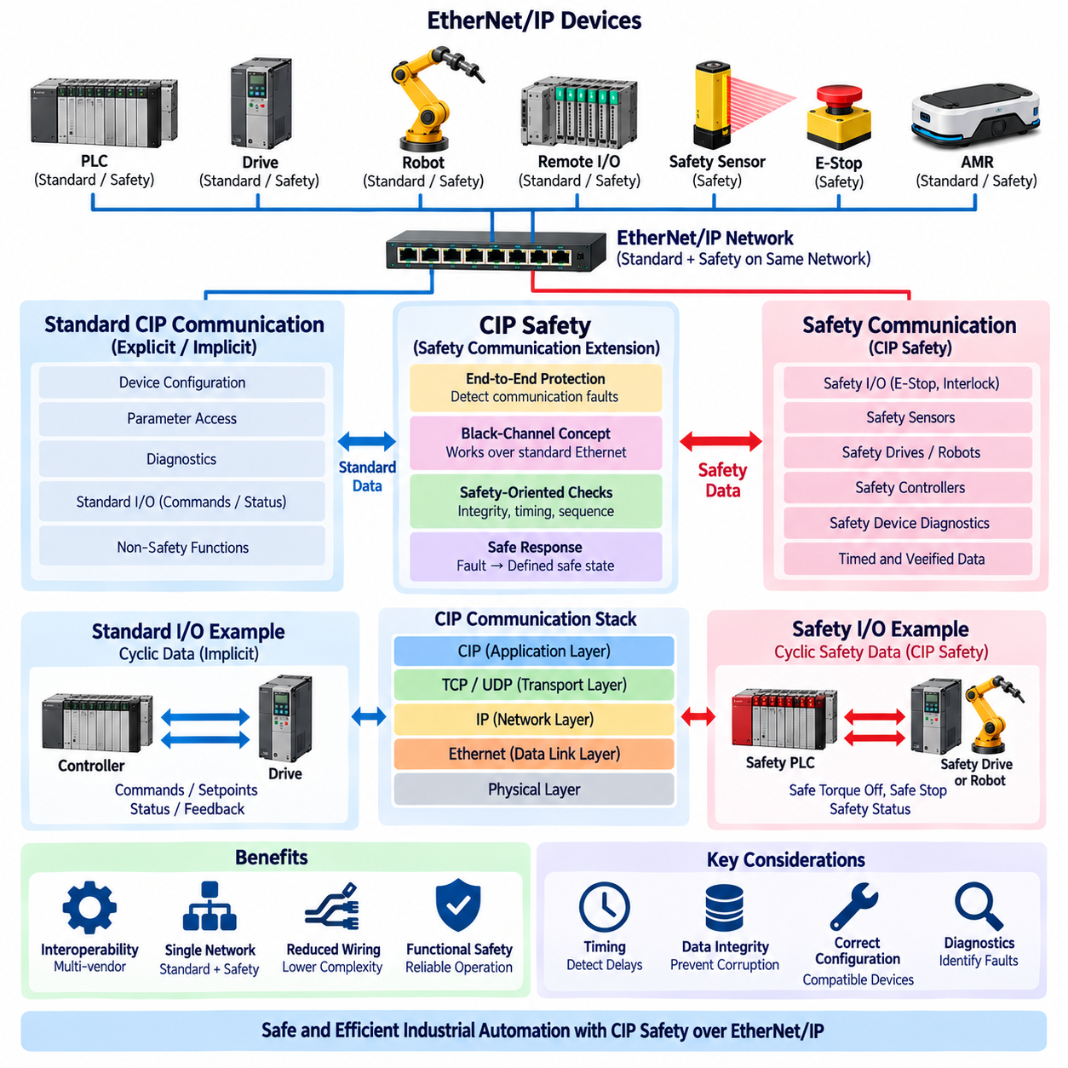
CIP Safety is a safety communication extension of the Common Industrial Protocol (CIP) designed to exchange safety-related information between industrial automation devices. Within the attached structure, CIP Safety follows the foundations of CIP, explicit and implicit messaging, and EDS-based device configuration, and precedes EtherNet/IP integration for AMRs. This position reflects its role in adding functional safety communication to an existing CIP-based automation network.
CIP Safety does not replace the standard CIP communication mechanisms used for ordinary control and diagnostic information. Instead, it provides additional safety mechanisms that allow safety-related data to be exchanged while detecting communication errors that could otherwise result in an unsafe control decision. Standard process communication can therefore coexist with safety communication, while each type of information follows the requirements appropriate to its function.
A central concept of CIP Safety is end-to-end protection of safety data. The safety function must remain protected even when the underlying communication network contains ordinary components that were not specifically designed as safety devices. This approach is often described as a black-channel concept, where the safety protocol provides mechanisms to detect relevant communication faults independently of whether the underlying transport uses Ethernet or another supported network technology.
Safety communication must address more than simple packet delivery. A safety receiver must have confidence that the received information is authentic, timely, correctly associated with the intended communication relationship, and not accidentally reused from an earlier transmission. CIP Safety therefore adds safety-oriented checks and communication rules around the transported data so that corrupted, delayed, duplicated, missing, or incorrectly associated information can be detected.
Timing is particularly important in safety communication. A safety message that arrives after the permitted time may be unsafe even if every bit in the message is technically correct. CIP Safety therefore incorporates time-related monitoring so that communication delays and connection interruptions can cause the safety function to transition toward a defined safe response rather than continuing to rely on potentially stale safety information.
Data integrity is another fundamental requirement. Ordinary industrial communication may tolerate occasional packet loss because a later cyclic packet can provide a newer value. A safety system must additionally consider whether corrupted or incorrectly interpreted information could create a hazardous condition. Safety communication therefore uses dedicated integrity mechanisms to detect errors in the safety data and prevent invalid information from being accepted as a valid safety command or status.
CIP Safety can support safety-related communication between devices such as safety controllers, safety I/O, emergency-stop interfaces, safety sensors, drives, and other safety-capable automation equipment. The actual safety function is implemented by the appropriate safety devices and control logic, while CIP Safety provides the communication mechanism through which safety information can be transferred and monitored.
The distinction between standard I/O and safety I/O is important in an industrial robot or AMR architecture. A normal EtherNet/IP connection may carry operational commands, status information, mission data, and diagnostics, while a safety connection can carry information associated with emergency stop, protective stop, enabling conditions, safety interlocks, or other defined safety functions. These channels should not be treated as interchangeable simply because they use the same physical Ethernet infrastructure.
CIP Safety is therefore closely related to the producer-consumer and connection-oriented concepts introduced by CIP and EtherNet/IP. Safety data can be exchanged within an established communication relationship, but additional safety supervision is applied to the data. The receiving safety function continuously evaluates whether the communication remains valid. If the required safety conditions are no longer satisfied, the system can initiate the predetermined safe reaction.
The use of a common network infrastructure can simplify system architecture. Standard and safety communication may share physical Ethernet components such as cables, switches, and network interfaces when the overall architecture and applicable safety requirements permit it. This can reduce wiring complexity and allow safety functions to be integrated into modern networked automation systems without requiring a completely separate physical communication network.
However, sharing the same physical network does not mean that ordinary Ethernet communication becomes safety-rated automatically. The safety properties originate from the complete safety communication mechanism and the certified safety components and system architecture. Engineers must therefore evaluate the complete safety path, including the safety controller, communication endpoints, network configuration, safety devices, diagnostics, timing, and final safety response.
CIP Safety also requires careful configuration and device compatibility. Safety-capable devices must expose the appropriate safety functions and communication characteristics, and the engineering environment must correctly configure the corresponding safety connections. Device descriptions and configuration information, including the role of EDS-related engineering data where applicable, support integration, but the safety configuration must also be controlled according to the applicable safety engineering process.
Diagnostics are particularly important because a safety communication fault should not simply appear as an ordinary network error. The system needs to distinguish conditions such as loss of communication, invalid safety data, timing violations, configuration problems, and safety-device faults. These diagnostic states help maintenance personnel determine why a safety function has entered its safe state and whether the problem originates from communication, configuration, or the physical safety system.
For industrial robots, CIP Safety can provide a communication path between safety controllers and safety-capable robot or drive systems. A standard EtherNet/IP channel may coordinate robot operation, while CIP Safety can supervise safety-related conditions such as protective stopping or permitted operating states. The exact safety functions depend on the robot controller, safety devices, system architecture, and applicable safety requirements.
For AMRs, the same principle becomes important when the vehicle operates inside a larger automated facility. Standard EtherNet/IP communication can exchange mission commands, operating status, docking information, and PLC handshakes, while safety communication can support defined safety-related functions involving emergency stop, protective devices, safety controllers, or other safety-capable components. The separation between mission control and safety control should remain architecturally clear.
CIP Safety should therefore be understood as a safety layer that extends the CIP communication model rather than as simply a faster or more reliable version of ordinary EtherNet/IP. Its purpose is to provide mechanisms for detecting communication conditions that could compromise a safety function and to ensure that detected failures lead to an appropriate safe response. This distinction is essential when designing networked industrial robots, AMRs, and factory automation systems.
In a complete EtherNet/IP architecture, CIP provides the common industrial communication model, explicit and implicit messaging provide different communication mechanisms, EDS supports device configuration, and CIP Safety adds safety-related communication capabilities. These elements can coexist over a common industrial network, but they have different engineering responsibilities. A robust design therefore keeps normal automation control, diagnostics, and safety functions clearly separated while integrating them into one coordinated system architecture.

06.05. EtherNet/IP in AMR Integration
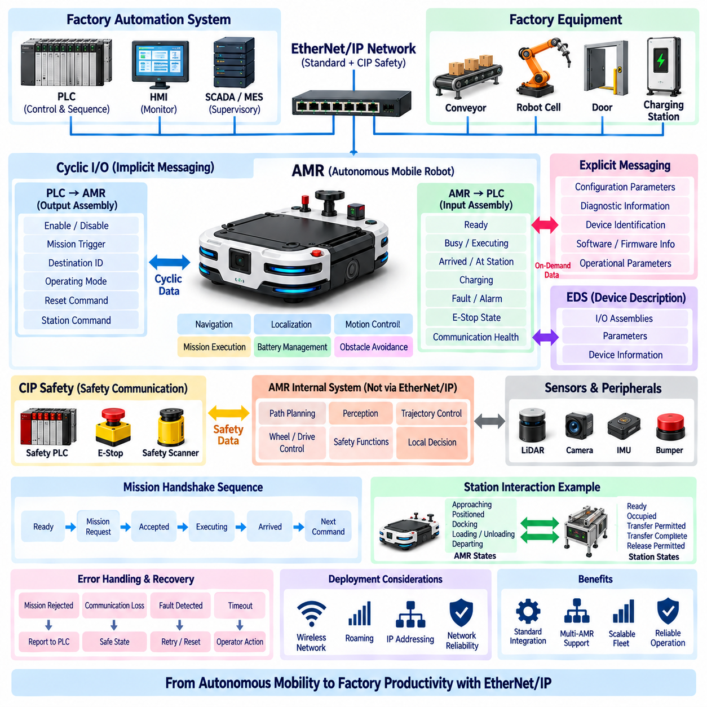
EtherNet/IP integration in an Autonomous Mobile Robot (AMR) is the process of connecting the AMR to a PLC-based industrial automation system through the EtherNet/IP protocol and the Common Industrial Protocol (CIP). Within the attached structure, this topic follows CIP, explicit versus implicit messaging, EDS file structure, and CIP Safety, making it the application-level culmination of the EtherNet/IP section. The purpose is to connect AMR operational functions with factory control, equipment interfaces, and automation sequences.
An AMR integrated through EtherNet/IP should be treated as an industrial automation device rather than simply as a mobile computer connected to an Ethernet network. The AMR has internal functions for navigation, localization, motion control, battery management, obstacle handling, mission execution, and diagnostics, while the factory PLC has responsibility for coordinating machines, conveyors, doors, stations, and process sequences. EtherNet/IP provides an interface through which these two control domains can exchange clearly defined operational information.
The most important integration principle is to separate mission-level behavior from machine-level control. The AMR's internal autonomy system determines how it navigates to a destination, avoids obstacles, and executes its movement. The PLC does not normally need to control individual wheel velocities or localization calculations. Instead, the PLC exchanges higher-level commands and states such as mission requests, destination identifiers, readiness, operating status, arrival conditions, faults, and acknowledgments. This separation preserves the autonomy of the AMR while providing deterministic factory-level coordination.
Implicit messaging is particularly suitable for continuously exchanged AMR interface information. A predefined I/O assembly can contain output data from the PLC such as enable commands, mission triggers, station identifiers, operating modes, or reset requests. The corresponding input assembly can contain AMR status such as ready, busy, executing, arrived, charging, faulted, emergency-stop state, and communication health. Because these signals are repeatedly exchanged, their freshness and communication supervision are important to the overall automation sequence.
Explicit messaging can complement the cyclic I/O interface when the PLC or engineering system needs information that does not need to be exchanged continuously. Examples include configuration parameters, diagnostic information, device identification, software information, or selected operational parameters. This allows the AMR interface to avoid placing every piece of information into a continuously transmitted I/O assembly. Frequently changing control and status information can remain in cyclic I/O, while less frequently accessed information can be handled through explicit communication.
A practical AMR interface therefore begins with an interface definition rather than with a network cable or IP address. The engineering team must define what the PLC is allowed to command, what the AMR reports, which states are mutually acknowledged, and what conditions permit each transition. A command should have an unambiguous meaning, and every important command should have an observable response. This creates a controlled handshake between the factory automation system and the autonomous robot.
A typical mission handshake can begin with the AMR reporting that it is available and ready. The PLC or supervisory controller then provides a mission request and associated destination information. The AMR acknowledges acceptance, changes to an active or busy state, and executes the mission using its internal navigation system. When the requested destination or station condition is reached, the AMR reports arrival or task completion. The PLC can then continue the factory sequence, issue the next command, or request the AMR to leave the station.
The handshake should also define abnormal conditions rather than describing only the successful sequence. A mission may be rejected because the AMR is unavailable, already executing another task, charging, faulted, or unable to reach the requested station. Communication loss must also be distinguished from an application-level rejection. A robust interface therefore defines timeout behavior, reset conditions, command acknowledgment, fault reporting, and recovery states so that the PLC does not remain indefinitely waiting for a response that will never arrive.
AMR integration becomes more complex when the robot interacts directly with factory equipment. A station may contain a conveyor, lift, automatic door, charging system, robotic cell, or inspection machine. In such cases, EtherNet/IP can coordinate the AMR with the station PLC, but the interface must clearly define which system owns each action. For example, the AMR may report that it has reached the station, while the station PLC controls the conveyor sequence. The AMR should not assume that physical arrival automatically means that the station is ready.
Station-level handshaking is therefore an important extension of the AMR interface. The AMR may communicate states such as approaching, positioned, docking, docked, loading, unloading, and departing, while the station communicates conditions such as ready, occupied, transfer permitted, transfer complete, and release permitted. This creates a controlled interaction between mobile autonomy and fixed automation. The exact signals depend on the application, but the ownership of each state and command should always be explicit.
The physical Ethernet network should also be considered as part of the integration architecture. An AMR may communicate through industrial switches, wireless Ethernet infrastructure, access points, or other network components depending on the operating environment. Mobility introduces additional considerations because the AMR changes physical location while maintaining logical network communication. Network coverage, roaming behavior, latency, packet loss, addressing, redundancy, and interference can therefore affect communication availability even when the EtherNet/IP configuration itself is correct.
Network communication should not be confused with the AMR's internal motion-control loop. The EtherNet/IP connection between a PLC and AMR is normally an automation interface, not a substitute for the AMR's low-level motor control. Wheel or actuator control can remain inside the AMR's real-time control architecture, while EtherNet/IP communicates higher-level commands and status. This separation prevents factory-level PLC communication from becoming unnecessarily coupled to the internal high-frequency control loops of the mobile platform.
The distinction becomes especially important for autonomous navigation. An AMR may internally operate localization, perception, path planning, obstacle avoidance, and trajectory control at rates appropriate to its onboard architecture. The PLC generally needs only the resulting operational state and selected commands. For example, the PLC can request movement to a station without calculating the trajectory. The AMR determines the actual path and continuously adapts it according to its perception and navigation system.
CIP Safety should be treated separately from ordinary AMR operational communication. Standard EtherNet/IP can carry mission commands, operating states, station handshakes, and diagnostics, while safety-related functions require appropriate safety communication and safety architecture. Emergency stop, protective stop, safety scanner status, safe drive functions, and other safety-related conditions must be implemented according to the applicable safety design rather than being represented merely as ordinary status bits.
The EDS file also has a practical role during AMR integration. When the AMR exposes an EtherNet/IP interface, the engineering environment can use the appropriate device description to understand available communication assemblies, parameters, and configuration information. The EDS does not define the AMR's autonomous behavior; instead, it helps the PLC engineering environment configure the communication interface correctly. The actual AMR interface specification must therefore remain consistent with the EDS and the installed software and firmware.
Addressing and data mapping must be controlled carefully when integrating multiple AMRs. Each AMR requires an identifiable network endpoint, while the PLC application must distinguish between individual robots and their operational states. A fleet containing many AMRs should avoid creating an interface in which every robot is handled as an unrelated special case. Common command and status structures, consistent state definitions, and standardized diagnostic behavior make fleet expansion considerably easier.
For fleet applications, EtherNet/IP can serve as the interface between the factory control layer and individual AMRs, while higher-level fleet management can determine task allocation and coordination. The PLC may interact with an AMR or an AMR management system depending on the system architecture. This creates an important architectural boundary: EtherNet/IP should provide the required industrial control interface, while fleet-level scheduling, traffic management, and mission optimization can remain within the appropriate AMR or fleet-management layer.
Diagnostics should be designed as part of the interface from the beginning. A useful AMR interface should allow the automation system to distinguish between communication failure, robot fault, mission rejection, blocked path, station unavailable, low battery, charging state, safety stop, and normal completion. Without such distinctions, the PLC may know only that an AMR has stopped responding and cannot determine whether the problem is caused by the network, the robot, the station, or the production process.
Timeout handling is another important engineering consideration. A PLC should not interpret the absence of an expected AMR response as successful completion. Communication supervision should define how long a command may remain unanswered and what state follows a timeout. The recovery behavior should also be defined. Depending on the application, the system may retry a communication transaction, cancel the mission, place the station in a safe state, request operator intervention, or transfer the task to another AMR.
AMR integration should also consider startup and restart behavior. After a PLC restart, network interruption, AMR reboot, or communication recovery, the two systems must re-establish a consistent understanding of the current state. A previously active command should not automatically be interpreted as a new command merely because the communication connection has returned. Initialization, state synchronization, command acknowledgment, and controlled recovery are therefore important parts of a robust EtherNet/IP interface.
A well-designed interface also prevents ambiguous command behavior. Commands such as start, stop, reset, enable, cancel, and mission request should have clearly defined activation conditions and acknowledgment rules. If a command is represented by a single bit, the interface specification must define whether it is level-based or edge-based and how the receiving system responds when the signal remains active. These details can become critical when PLC scan cycles, network updates, and AMR application cycles operate at different rates.
Performance requirements should be defined according to the actual application rather than assuming that EtherNet/IP must operate at the same rate as the AMR's internal control system. Mission-level commands may not require millisecond-level updates, while station interlocks or rapidly changing operational states may require more frequent supervision. The selected communication update interval should therefore reflect the dynamics and consequences of the information being exchanged.
The final integration should be validated at several levels. First, network connectivity and device identification must be confirmed. Next, EDS-based configuration and I/O assembly mapping should be verified. Explicit communication should be tested for configuration and diagnostic access, while implicit communication should be tested for cyclic commands and status. Mission handshakes, station interactions, communication loss, AMR faults, recovery, and safety-related conditions should then be tested under realistic operating scenarios.
The overall objective is not simply to make an AMR communicate with a PLC, but to create a predictable industrial interface between autonomous mobility and factory automation. EtherNet/IP provides the communication foundation, CIP defines the application model, EDS supports configuration, explicit and implicit messaging provide complementary data-transfer mechanisms, and CIP Safety addresses safety-related communication. When these elements are combined with clearly defined AMR states, commands, handshakes, diagnostics, and recovery behavior, an AMR can become a well-integrated participant in a PLC-based industrial automation system.

