Volume 08. Railway and Aerospace Protocols

Chapter 02. MVB

02.01. MVB Physical Layer (ESD/EMD)
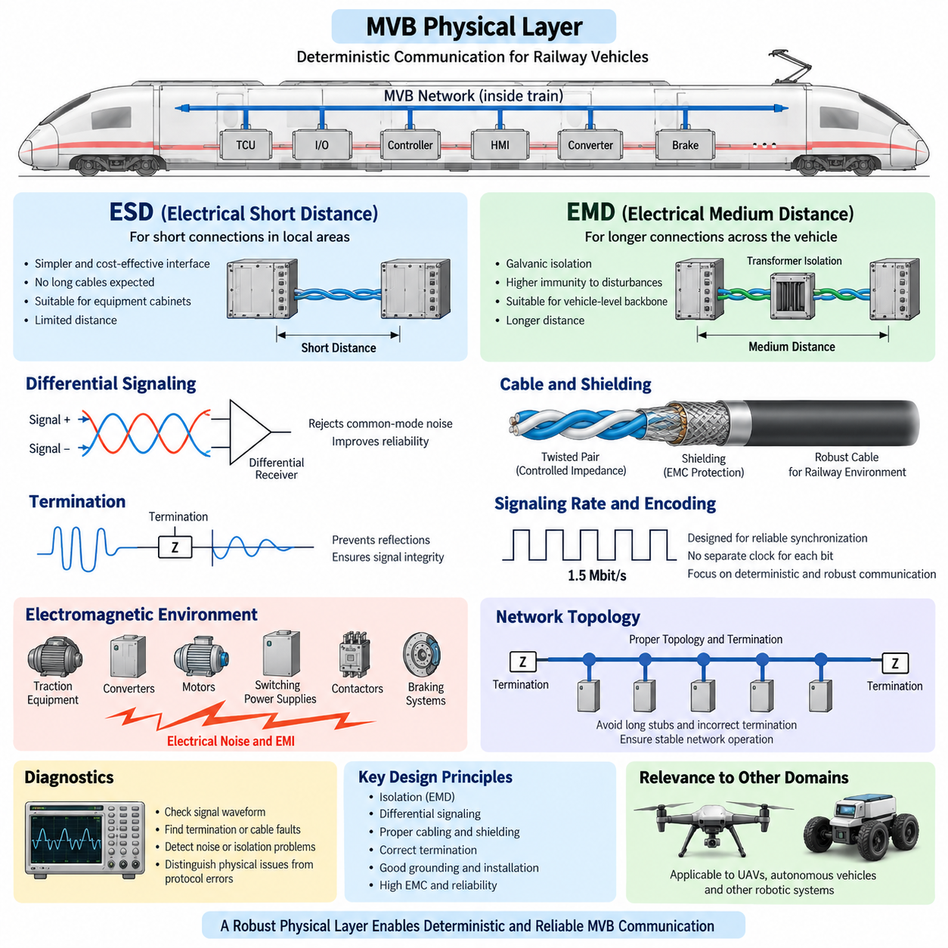
The Multifunction Vehicle Bus (MVB) physical layer provides the electrical and transmission foundation for deterministic communication between devices installed within a railway vehicle or consist. Within the IEC 61375 Train Communication Network architecture, MVB was designed for harsh environments where electrical noise, vibration, long service life, and predictable timing are more important than raw communication bandwidth.
MVB supports several physical transmission approaches so that the communication medium can be adapted to different vehicle installation requirements. Two important electrical implementations are ESD, Electrical Short Distance, and EMD, Electrical Medium Distance. Both carry the same higher-level MVB communication concepts, but they differ substantially in electrical interface design, transmission distance, isolation strategy, cabling, and electromagnetic robustness.
Electrical Short Distance (ESD) is intended primarily for relatively short communication paths between equipment located within a controlled electrical environment. Its physical interface emphasizes simplicity and economical implementation where long cable runs and severe potential differences between devices are not expected. ESD is therefore suitable for localized equipment groups, electronic cabinets, or other installations where network nodes can be connected over limited distances.
The short-distance nature of ESD reduces some of the transmission problems encountered on longer vehicle networks. Cable attenuation, propagation effects, accumulated common-mode disturbances, and differences in local reference potentials are easier to control. Nevertheless, railway equipment remains electrically demanding, so correct grounding, cable routing, termination, connector selection, and separation from high-current circuits remain essential to reliable operation.
Electrical Medium Distance (EMD) extends the MVB physical interface toward communication over substantially longer distances within railway vehicles. The interface is designed with greater attention to electrical isolation and immunity against disturbances that can arise when equipment is distributed across different parts of a vehicle. This makes EMD more appropriate for a vehicle-level communication backbone connecting geographically separated control units.
A central design consideration for EMD is galvanic isolation. Railway vehicles contain traction equipment, converters, contactors, motors, braking systems, auxiliary power converters, and other high-energy electrical systems capable of generating significant conducted and radiated interference. Isolation helps prevent unwanted current paths between network nodes and reduces the influence of ground-potential differences on the communication signal.
Transformer coupling is commonly associated with the robust EMD implementation of MVB. The coupling arrangement provides electrical separation between communication electronics and the transmission line while allowing the required differential signal to pass. This isolation barrier improves tolerance to common-mode disturbances and prevents the communication cable from becoming an unintended low-impedance connection between equipment grounds located at different points in the vehicle.
Differential signaling is another important principle behind robust MVB transmission. Instead of interpreting a signal only as a voltage relative to a common ground, the receiver evaluates the voltage difference between two conductors. Noise coupled similarly onto both conductors therefore tends to appear as common-mode interference and can be rejected by the differential receiver, improving communication reliability in electrically noisy railway installations.
Cable construction strongly affects MVB physical-layer performance. Controlled twisted-pair wiring helps maintain balanced coupling and reduces susceptibility to external electromagnetic fields. Shielding may provide additional protection when routing passes near traction cables, switching power electronics, motors, relays, or other noise sources. Cable impedance and installation characteristics must remain consistent enough to preserve the intended waveform throughout the network.
Termination is required because an MVB cable behaves as a transmission line rather than as an ideal conductor. When the electrical impedance changes abruptly, part of the propagating signal can be reflected toward the transmitter. Reflections may distort edges and reduce the receiver's noise margin. Appropriate termination at defined locations therefore suppresses reflections and contributes directly to stable signal integrity and deterministic network operation.
Network topology must consequently be treated as part of physical-layer engineering. Excessive branch lengths, poorly controlled stubs, incorrect termination placement, unsuitable connectors, or uncontrolled changes in cable characteristics can produce reflections even when every individual device satisfies its electrical requirements. MVB reliability depends on the complete installed network, not merely on the transmitter and receiver circuits considered independently.
The MVB physical layer operates at a nominal signaling rate of 1.5 Mbit/s, which is modest compared with modern Ethernet technologies but well suited to the deterministic exchange of process and control information for which MVB was developed. The engineering objective is not maximum throughput. It is repeatable communication behavior with bounded timing and high availability under railway environmental and electromagnetic conditions.
Signal encoding is designed so that physical transmission supports reliable synchronization and receiver interpretation without depending on an independently distributed clock for each transferred bit. The transmitted waveform must therefore be considered together with timing tolerance, edge quality, cable propagation, receiver thresholds, and distortion. Physical-layer margin becomes particularly important as cable length and the number of connected devices increase.
ESD and EMD should therefore not be interpreted merely as two connector choices. They represent different physical-layer engineering domains. ESD favors short-range simplicity where equipment is electrically close, whereas EMD provides a more robust solution for distributed vehicle communication where isolation, cable length, common-mode disturbances, and electromagnetic compatibility become dominant system-level concerns.
Electromagnetic compatibility is especially important because MVB often operates beside switching converters and traction equipment that generate fast voltage and current transitions. Noise may enter through capacitive coupling, inductive coupling, common impedance, or ground paths. Good installation practice combines differential transmission, appropriate shielding, isolation, controlled grounding, physical separation, and correct termination rather than relying on a single protective mechanism.
Connectors and harness components must preserve these electrical properties throughout the service life of the train. Contact degradation, shield discontinuities, incorrect repairs, excessive untwisting of differential conductors, or replacement with unsuitable cable can reduce communication margin without immediately causing a complete network failure. Maintenance procedures should therefore treat MVB cabling as an engineered communication channel rather than ordinary low-voltage wiring.
Physical-layer diagnostics should distinguish communication-protocol symptoms from electrical causes. Repeated frame errors, intermittent device disappearance, or failures correlated with traction operation may originate from termination defects, damaged shielding, connector resistance, cable discontinuity, excessive noise, or isolation problems. Oscilloscope measurements and suitable network diagnostic equipment can reveal waveform distortion that higher protocol layers expose only as communication errors.
From a system architecture perspective, the MVB physical layer illustrates why deterministic networking begins below the scheduling and frame mechanisms of the data-link layer. Predictable access cannot guarantee dependable communication when the electrical channel is unstable. ESD and EMD therefore provide the physical foundation upon which MVB data-link control, process-data exchange, device communication, supervision, and higher TCN functions can operate reliably.
The distinction between physical medium and communication function is also important when integrating legacy and modern railway systems. An MVB segment may interface through gateways to WTB, Ethernet Train Backbone, or other vehicle networks, yet its ESD or EMD segment must continue satisfying its own electrical constraints. Gateway functionality cannot compensate for poor termination, inadequate isolation, excessive cable disturbance, or defective physical installation.
For robotics and other Physical AI platforms, MVB provides a useful engineering reference even when the protocol itself is not selected. Distributed mobile machines face comparable problems involving motor inverter noise, battery-ground differences, long harnesses, safety-critical control, and multiple embedded controllers. The MVB EMD philosophy demonstrates how isolation, balanced signaling, controlled cabling, and deterministic communication can be engineered as one integrated electrical system.
For cargo UAV and large autonomous vehicle architectures, the most transferable lesson is that network selection cannot be separated from physical installation. High-level protocols may define messages and timing, but cable topology, isolation boundaries, electromagnetic interference, grounding, termination, and connector reliability determine whether those messages can actually be transported predictably. MVB ESD and EMD provide a mature railway example of this principle.

02.02. MVB Data Link Layer
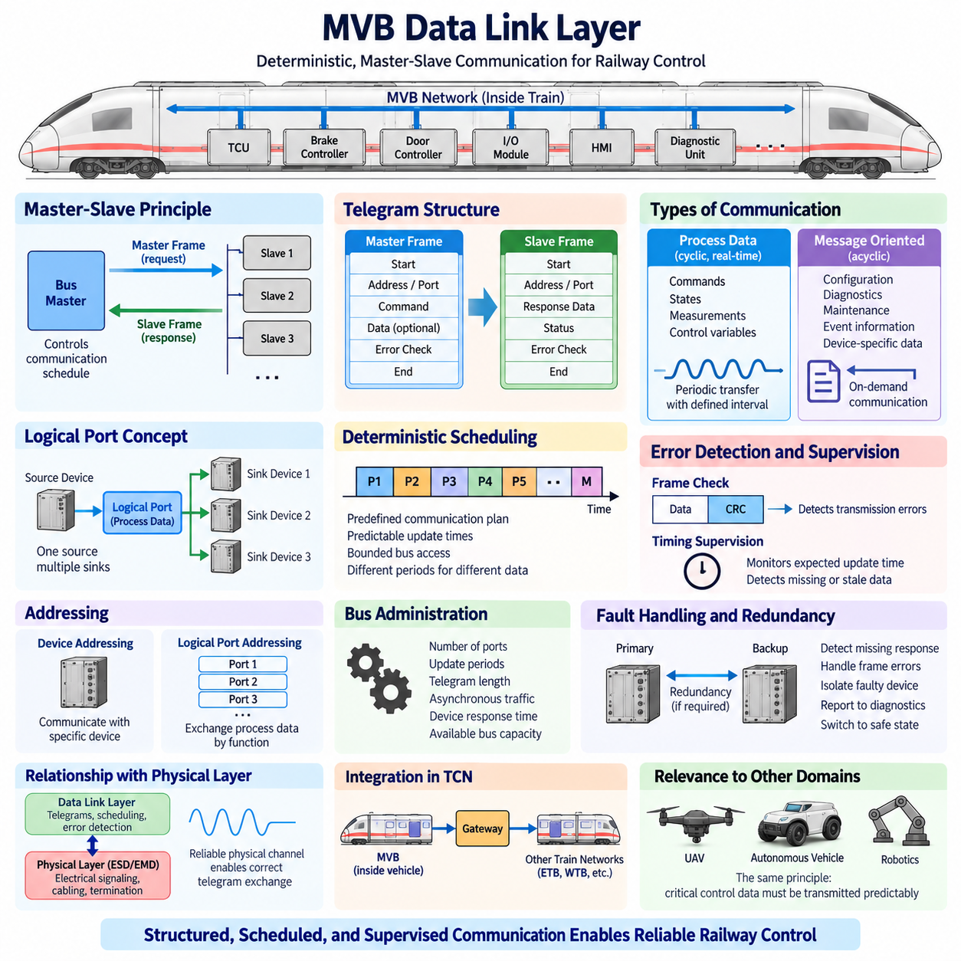
The MVB data link layer provides the deterministic communication mechanism that organizes access to the shared Multifunction Vehicle Bus. While the physical layer defines how electrical signals are transported between railway devices, the data link layer determines when devices may communicate, how telegrams are structured, how process information is exchanged, and how communication errors are detected.
MVB was developed for distributed railway control systems in which predictable timing is more important than opportunistic access to network bandwidth. Controllers, braking equipment, traction systems, doors, input/output modules, human-machine interfaces, and diagnostic units must exchange information within known time boundaries. The data link layer therefore uses controlled bus access rather than allowing devices to transmit whenever they detect an available medium.
A fundamental MVB concept is the master-slave communication principle. A bus master controls communication activity by issuing master frames, while addressed devices respond according to the requested communication operation. This controlled interaction prevents arbitrary transmission competition between devices and makes network behavior easier to schedule, analyze, validate, and reproduce under different operating conditions.
MVB communication is organized around telegrams composed of a master frame followed, when required, by a slave frame. The master frame identifies the communication request and determines which device, port, or function is involved. The corresponding slave response carries the requested information or completes the transaction. This request-response organization provides a structured communication sequence with clearly defined ownership of each bus interval.
The data link layer supports different classes of information because railway networks carry both repetitive real-time values and less frequent communication requests. Process data represents rapidly changing operational information such as commands, states, measurements, and control variables. Message-oriented communication supports less periodic exchanges such as configuration, diagnostics, maintenance information, and other device-specific transactions.
Process data is especially important to deterministic railway control. Instead of treating every transfer as an independent application message, MVB associates process information with logical ports. Devices can produce or consume values associated with these ports, allowing communication schedules to be constructed around known data relationships. This approach separates the logical meaning of process variables from the details of individual physical device connections.
MVB process data communication commonly follows a source-oriented distribution principle. A source device provides a process variable through an assigned port, and one or more sink devices may consume that information. This is useful for railway systems because the same state or command information may be required by several controllers simultaneously, reducing the need to construct separate point-to-point transactions for every receiving device.
Periodic process data transfers are scheduled so that important information is refreshed within predefined intervals. Variables associated with fast control functions can be transferred more frequently, while slower status information can use longer periods. The resulting communication plan forms a deterministic traffic pattern in which bandwidth consumption and worst-case update times can be evaluated before the train enters normal service.
The MVB master is therefore more than an addressing authority. It participates in maintaining the communication schedule and initiates transfers according to the configured bus operation. By controlling the sequence of master frames, the system can allocate communication opportunities according to application requirements. This centralized coordination distinguishes deterministic MVB behavior from contention-based networks whose transmission delay can vary with instantaneous traffic.
Device addressing allows the master to communicate with specific network participants when individual transactions are required. Logical port addressing, meanwhile, supports the exchange of process information according to its communication function. Keeping device identity and process-data organization conceptually distinct helps railway systems maintain structured interfaces even when equipment implementations or internal controller architectures change during a vehicle program.
MVB telegram integrity depends on defined frame fields and error-detection mechanisms. Receivers must determine whether the received information has the expected structure and whether transmission corruption has occurred. Error-detection information allows damaged telegrams to be rejected rather than silently accepted as valid control data. This is essential because electrical interference can occasionally corrupt bits even when the physical network has been engineered for high EMC immunity.
Timing supervision complements frame-level error detection. A railway controller must often distinguish between a valid value and a value that has become obsolete because communication stopped. Consequently, higher communication behavior can supervise whether expected process information is refreshed within its required interval. Missing or delayed updates can then cause the receiving application to enter a defined degraded or safe operating behavior.
MVB data-link determinism results from the combination of controlled master initiation, predefined communication relationships, bounded telegram transactions, and cyclic scheduling. Determinism does not mean that every item is transmitted at the same frequency. It means that communication opportunities and update requirements are engineered so that the maximum relevant delay can be bounded and verified for the intended railway application.
The data link layer must also accommodate asynchronous requirements because not every railway transaction can be predicted as repetitive process traffic. Diagnostic requests, configuration activities, event-related information, and maintenance operations may arise irregularly. MVB therefore needs communication mechanisms that allow such traffic while preserving the resources required for time-critical cyclic process data and preventing background communication from disrupting essential control exchanges.
Bus administration becomes particularly important when many devices share one MVB segment. The communication configuration must consider the number of process ports, required refresh periods, telegram lengths, asynchronous traffic, device response characteristics, and available bus capacity. Poor scheduling can consume excessive bandwidth or increase update latency even when the physical network itself operates without electrical errors.
Redundancy and fault handling can be implemented at system level around MVB communication where railway availability requirements demand them. Communication supervision can identify missing responses, repeated frame errors, inaccessible devices, or stale process values. The application and vehicle control architecture then determine whether the fault should be tolerated temporarily, isolated, reported to diagnostics, or escalated into a defined degraded or safe state.
Diagnostics at the data link layer should therefore examine both communication correctness and communication timing. A physically healthy bus may still exhibit application problems if a device fails to respond correctly, a logical port is misconfigured, or the communication schedule does not provide the expected update rate. Conversely, repeated telegram errors may indicate an underlying physical-layer problem rather than a scheduling or protocol defect.
The relationship between the physical and data link layers is especially important during troubleshooting. ESD or EMD cabling, termination, shielding, isolation, and signal quality establish whether bits can be transported reliably. The data link layer then converts that channel into controlled telegram exchanges. Observing frame errors together with waveform quality, device responses, and timing behavior helps engineers locate faults at the correct architectural layer.
Within the broader Train Communication Network, MVB typically provides communication among devices inside a vehicle or vehicle group, while gateways can connect this traffic to other train-level network technologies. The data link layer gives the local MVB segment deterministic behavior independently of the higher-level backbone, allowing legacy and modern railway communication technologies to coexist through appropriately engineered gateways.
MVB demonstrates that deterministic networking is fundamentally a resource-allocation problem as well as a transmission problem. Reliable electrical signaling alone cannot guarantee predictable control communication. The network must also control who transmits, when transmission occurs, which information has priority in the communication plan, how often critical variables are refreshed, and how failures or missing updates are recognized.
This principle remains relevant to robotics, autonomous vehicles, and Physical AI systems. A robot may combine CAN, CANopen, industrial Ethernet, or other networks instead of MVB, but motor control, braking, steering, safety I/O, and supervisory controllers still require bounded communication behavior. Separating cyclic control traffic from asynchronous diagnostic traffic and explicitly managing communication timing can improve overall system predictability.
For cargo UAVs and large autonomous platforms, the MVB data link layer provides a useful architectural reference for distributed safety-related control. Flight-control computers, propulsion controllers, power systems, actuators, sensors, and mission computers may use different modern protocols, yet they face the same fundamental requirement: critical state and command information must arrive predictably while diagnostic and maintenance traffic remains controlled and observable.
The major engineering lesson of the MVB data link layer is that determinism is created deliberately rather than emerging automatically from a reliable bus. Master-controlled access, structured telegrams, logical process ports, cyclic scheduling, error detection, communication supervision, and controlled asynchronous transactions work together to transform the physical MVB channel into a predictable communication system suitable for long-life railway control applications.

02.03. MVB Port Types (PP/FP/SP)
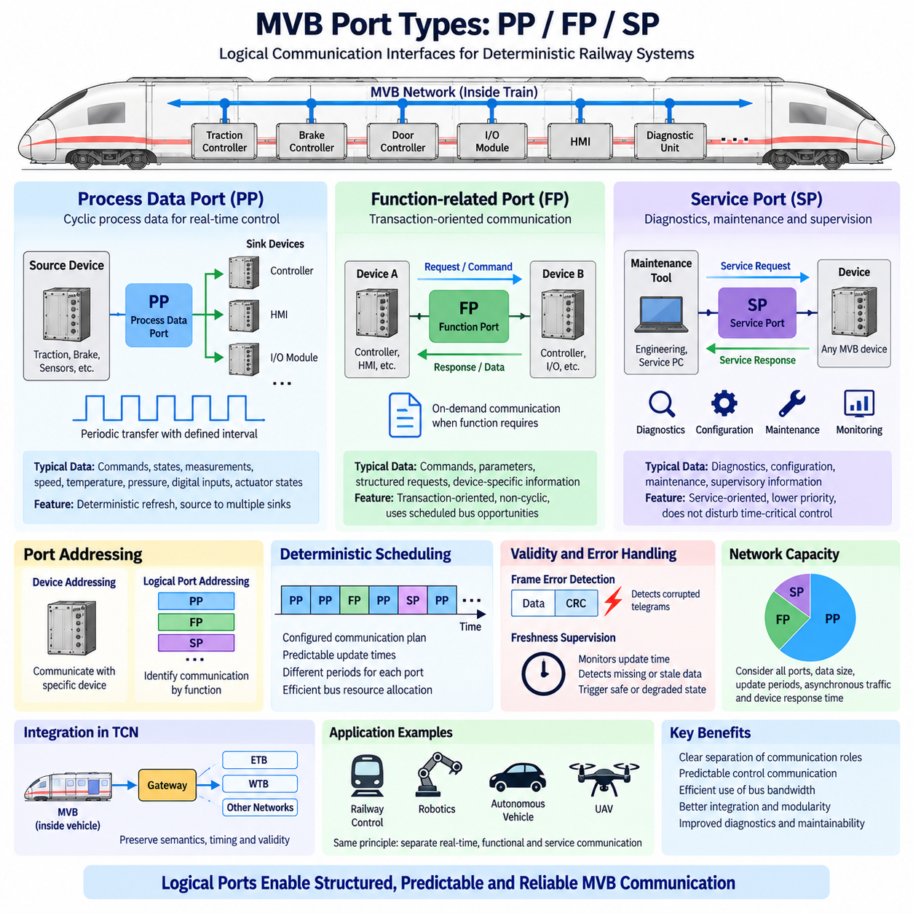
In MVB, the port concept provides a logical interface between application data and deterministic bus communication. Rather than forcing applications to manage every telegram as an individual transaction, MVB organizes information through defined ports. This abstraction allows devices to exchange process variables according to communication functions while keeping application behavior separated from physical bus implementation details.
MVB port organization is commonly discussed through three functional categories: Process Data Ports (PP), Message Data Ports or Function-related communication ports (FP), and Service or supervisory communication ports (SP), depending on the terminology and implementation context. These categories distinguish repetitive real-time information from less frequent functional exchanges and service-oriented communication required for configuration, diagnostics, and maintenance.
Process Data Ports (PP) are associated primarily with cyclic process data that must be exchanged repeatedly within predictable time intervals. Typical information includes traction commands, braking states, door status, speed values, temperatures, pressures, digital inputs, actuator states, and other variables used continuously by distributed railway control functions. Their communication behavior emphasizes deterministic refresh rather than complex transaction handling.
A PP can be understood as a logical container for a defined set of process information. A source device updates the data associated with the port, while one or more sink devices consume that information. Because the communication relationship is configured in advance, the MVB master can schedule transfers so that each required process port is refreshed according to its specified period and timing requirements.
This source-to-multiple-sinks model is particularly valuable in railway systems. A single measurement or state may be needed simultaneously by several control units, displays, and monitoring devices. Instead of creating separate application-level messages for every destination, the source-oriented process-data mechanism allows the information associated with one logical port to be distributed efficiently to all configured consumers.
Process ports also help separate communication scheduling from the internal architecture of individual devices. An application can associate its variables with defined logical ports without depending directly on where every receiving controller is physically located. When equipment is replaced or reorganized, maintaining compatible port definitions can reduce the impact on the wider vehicle communication architecture and preserve stable functional interfaces.
FP communication serves a different purpose from continuously refreshed PP traffic. It is suited to information exchanges that are function-oriented or transaction-oriented rather than strictly cyclic process-variable distribution. Such communication may involve commands, parameters, structured requests, device-specific information, or other exchanges that need a defined interaction between communicating entities instead of continuous broadcast-like process updates.
Unlike PP communication, which is designed around predictable periodic refresh, FP-related exchanges may occur when a particular function requires them. The communication system must therefore provide opportunities for these transactions without disturbing the deterministic schedule assigned to critical process data. This distinction allows MVB to support both tightly controlled real-time operation and more flexible functional communication on the same network.
The separation between PP and FP illustrates an important deterministic-network design principle. High-frequency control information should not compete unpredictably with configuration or transaction-oriented traffic. By treating communication classes differently, bus resources can be allocated according to timing importance. Critical cyclic values receive predictable access, while other exchanges use communication opportunities appropriate to their functional requirements.
SP communication is associated with service-oriented activities such as supervision, device management, commissioning, maintenance, or diagnostics. These exchanges are generally not part of the fastest cyclic control loop. Instead, they provide mechanisms through which network equipment can be examined, configured, monitored, or serviced while the operational communication system continues to perform its primary railway control functions.
Service-oriented ports are especially useful during vehicle commissioning and maintenance. Engineers may need to inspect device states, retrieve diagnostic information, verify configurations, identify communication problems, or perform other management activities. Separating this traffic conceptually from cyclic process communication helps ensure that engineering and maintenance operations do not unintentionally interfere with time-critical control exchanges.
PP, FP, and SP can therefore be viewed as logical communication roles rather than merely physical connector types. They exist above the electrical ESD or EMD transmission mechanism. A device may use the same physical MVB connection while participating in several communication functions. The physical layer transports the bits, while port organization determines how different classes of application information are represented and exchanged across the network.
Port addressing provides the mechanism for identifying these logical communication resources. For process communication, the network can reference the logical data relationship rather than requiring every consumer to initiate an independent device-to-device exchange. This reinforces the source-oriented character of MVB process communication and makes it possible to construct deterministic schedules around known communication objects and their required update periods.
Port configuration must be coordinated across the complete vehicle network. The data producer, intended consumers, data format, update behavior, and timing requirements must agree with the communication database or system configuration. A mismatch can produce symptoms such as missing values, incorrect interpretation, stale information, or unexpected application behavior even when the physical MVB channel and telegram transmission remain electrically correct.
The refresh period assigned to a process port should reflect the dynamics of the associated function. Fast-changing control information may require short update intervals, whereas slowly changing status values can tolerate longer periods. Allocating every port the fastest possible cycle would waste bus bandwidth, while excessively long periods could reduce control performance or delay fault detection. Port timing is therefore a system-engineering decision.
Freshness supervision is closely related to PP operation. Receiving equipment should not assume indefinitely that the last correctly received value remains valid. If the expected port update does not arrive within an acceptable interval, the consumer can identify the information as stale or unavailable. The application may then substitute a defined default value, enter degraded operation, report a fault, or transition toward a safe state.
Error detection at the telegram level and validity supervision at the port level address different failure mechanisms. A corrupted telegram can be rejected using communication error checks, while a correctly formatted but missing or outdated process value requires timing supervision. Combining these mechanisms prevents railway applications from confusing electrical transmission integrity with the operational validity and freshness of the information being consumed.
Port engineering also affects network capacity. Each cyclic PP consumes a portion of available communication time according to its data size and refresh frequency. FP and SP transactions require additional communication opportunities. Network designers must therefore evaluate the complete port population, timing requirements, asynchronous traffic, device response times, and bus utilization rather than considering each port independently.
Diagnostics should examine port behavior as well as raw telegram activity. A bus analyzer may show valid electrical communication while an application still receives incorrect information because the wrong logical port was configured or the expected source was not producing data. Conversely, widespread errors across many unrelated ports may indicate a physical-layer, master-scheduling, or network-level problem rather than individual application faults.
The logical-port approach improves modularity in distributed railway electronics. Traction controllers, brake controllers, door systems, HMIs, I/O modules, and supervisory computers can interact through explicitly defined communication interfaces. This reduces unnecessary dependency on internal software structures and supports integration between equipment supplied by different engineering teams when the required MVB interface definitions are consistently implemented.
Within the wider Train Communication Network, logical port information can also interact with gateway functions connecting MVB to other communication domains. The gateway must preserve the intended semantics, timing, validity, and direction of important information when transferring it between network technologies. Simply forwarding raw values without considering their communication characteristics may destroy the deterministic assumptions of the original control architecture.
The PP, FP, and SP distinction offers a useful reference for robotics and Physical AI networks. Modern robots similarly contain high-rate actuator and safety variables, function-level commands, and lower-priority diagnostic or maintenance traffic. Even when CANopen, EtherCAT, Ethernet, DDS, or another protocol is used, separating these traffic roles helps prevent maintenance or supervisory communication from disturbing time-sensitive machine control.
Large autonomous vehicles and cargo UAVs can apply the same architectural principle. Propulsion, steering, braking, flight-control, battery, and safety information can be treated as tightly supervised process communication, while mission commands and functional transactions occupy another communication class and diagnostics remain separately managed. The actual protocols may differ from MVB, but the separation of communication responsibilities remains valuable.
The major engineering value of MVB port organization is therefore abstraction combined with deterministic resource control. PP supports predictable process-data exchange, FP supports function-oriented transactions, and SP supports service and supervisory activities. Together, these logical interfaces allow a shared vehicle network to carry different information classes without treating all traffic as equivalent, improving predictability, integration, diagnostics, and maintainability.

02.04. MVB Device Integration
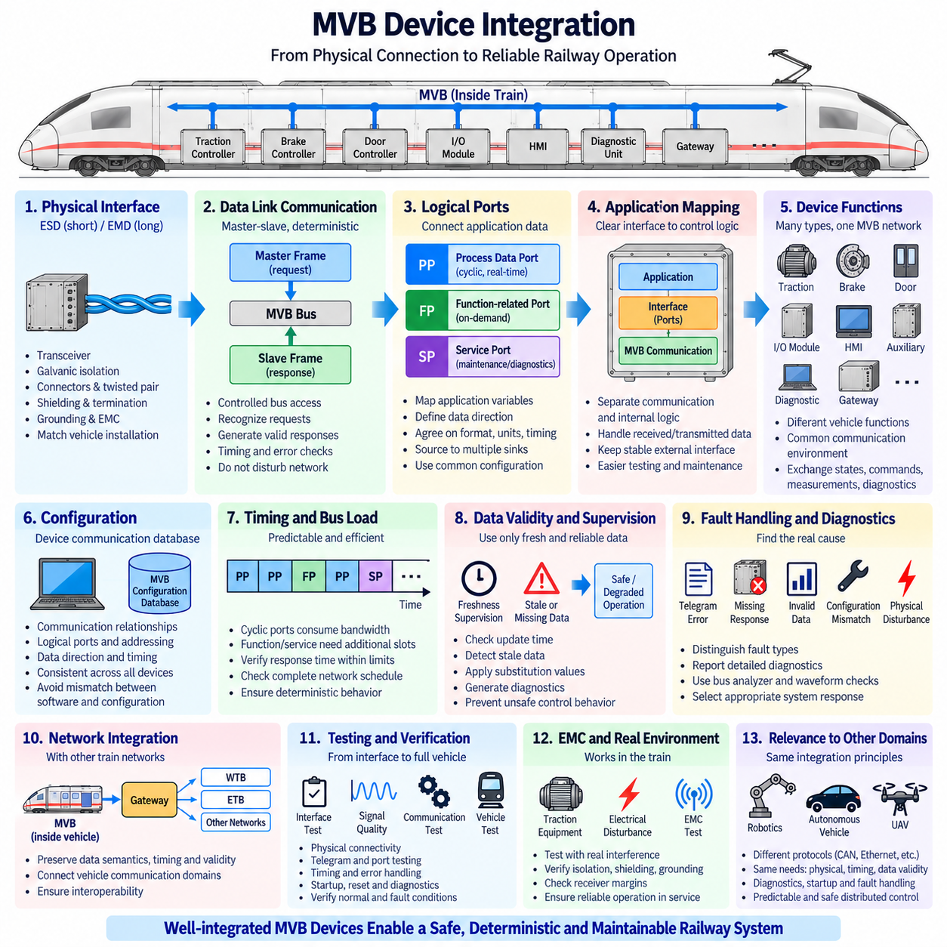
MVB device integration connects railway electronic equipment to the Multifunction Vehicle Bus as functional participants in a deterministic Train Communication Network. Integration involves more than attaching a transceiver to a cable. Each device must combine a compliant physical interface, data-link behavior, logical port configuration, application data mapping, timing supervision, diagnostics, and system-level configuration.
Typical MVB devices include traction controllers, brake controllers, door control units, distributed I/O modules, human-machine interfaces, auxiliary controllers, diagnostic equipment, and gateways. Although these devices perform different vehicle functions, MVB provides a common communication environment through which operational states, commands, measurements, configuration information, and diagnostic data can be exchanged predictably.
The integration process begins at the physical interface. A device must use the appropriate MVB electrical implementation, such as ESD for suitable short-distance connections or EMD where longer distance and stronger electrical isolation are required. Transceiver characteristics, galvanic isolation, connectors, twisted-pair cabling, shielding, termination, grounding, and EMC behavior must match the intended vehicle installation.
Physical integration must be evaluated as part of the complete network rather than only at the device connector. Cable length, topology, stub arrangement, termination placement, shield continuity, and routing near traction or switching equipment influence signal integrity. A correctly designed device interface can still experience communication failures if the installed harness creates reflections, common-mode disturbances, excessive noise, or grounding problems.
Above the physical layer, the device must implement the required MVB data-link behavior. Communication follows controlled bus access in which master frames initiate transactions and participating devices respond according to configured communication relationships. The device must correctly recognize relevant requests, generate valid responses, respect timing requirements, perform frame integrity checks, and avoid behavior that could disturb deterministic network operation.
Logical port integration connects the MVB communication mechanism to the device application. Process information is mapped to defined communication ports so that producers and consumers share a consistent understanding of each variable. A traction controller, for example, may produce operating states while consuming commands and vehicle information. The port configuration defines how those application variables become visible to other MVB participants.
Process Data Ports are particularly important for real-time device integration because they support cyclic information exchange with predictable refresh intervals. Each producer must update its source data correctly, while receiving devices must copy and interpret consumed data consistently. Data size, representation, scaling, units, validity, byte organization, and update timing must therefore be agreed across all participating equipment.
Function-related and service-oriented communication complement cyclic process exchange. Device-specific commands, parameter transactions, diagnostic requests, configuration activities, and maintenance operations may require communication that occurs less regularly. These exchanges must be integrated without consuming resources needed by time-critical process traffic, preserving the deterministic behavior of essential vehicle control functions.
A device communication database or equivalent configuration description is therefore central to integration. It identifies communication relationships, logical ports, data direction, expected refresh behavior, device addressing, and other network parameters. Integration problems frequently occur when software implementations and network configuration disagree, even though individual devices and the physical bus appear to operate correctly when tested independently.
Application mapping must maintain a clear boundary between communication data and internal control logic. Received MVB information should pass through defined interface handling before being used by the application, while transmitted values should be prepared through equally controlled mechanisms. This separation simplifies testing and prevents changes in internal software architecture from unnecessarily altering externally visible network interfaces.
Data validity is as important as the numerical value itself. A receiver must determine whether information is current and trustworthy before allowing it to influence a control function. If expected cyclic information stops arriving, freshness supervision can identify stale data. The application can then apply defined substitution values, inhibit affected functions, enter degraded operation, generate diagnostics, or transition toward a safe state.
Communication fault handling should distinguish different failure categories. A corrupted telegram, missing response, stale process value, unavailable device, configuration mismatch, and physical-layer disturbance do not represent the same problem. Separating these conditions allows diagnostics to identify the probable fault domain and enables the vehicle controller to select an appropriate response rather than treating every communication anomaly identically.
Startup behavior also requires careful integration. When vehicle power is applied, devices may initialize at different speeds, and communication interfaces may become available before application data is valid. The design should define how initial values, validity states, communication supervision, and functional enable conditions are handled so that temporary startup conditions are not incorrectly interpreted as valid operational information.
Device reset and recovery behavior must similarly be predictable. A controller that restarts during operation should return to the network without generating uncontrolled outputs or allowing obsolete data to propagate as current information. Other devices must recognize the temporary communication loss and apply their configured fault responses until the restarted participant has restored valid communication and application state.
Timing analysis is required because every integrated device contributes to overall bus utilization. Cyclic ports consume bandwidth according to their size and refresh periods, while function-related and service communication requires additional capacity. Device response time must remain within permitted limits. Integration therefore includes verification that the complete network schedule satisfies required update times under normal and demanding traffic conditions.
MVB device diagnostics should expose sufficient information to separate application, protocol, and physical faults. Useful observations include communication status, missing responses, telegram errors, port freshness, invalid data, configuration state, and device availability. When combined with bus analyzers and physical waveform measurements, these diagnostics allow engineers to trace failures from application symptoms toward the correct communication layer.
Gateway devices require additional integration discipline because they connect MVB to other parts of the Train Communication Network. A gateway may transfer information between MVB and WTB, ETB, or another vehicle communication domain. It must preserve relevant data semantics, direction, timing, validity, and fault status rather than merely translating electrical interfaces or forwarding values without communication context.
Interoperability is a major objective of disciplined MVB device integration. Equipment supplied by different manufacturers or engineering teams should exchange information according to agreed interface definitions rather than assumptions hidden inside proprietary software. Consistent addressing, port definitions, data formats, timing behavior, error handling, and physical-layer implementation reduce integration risk when assembling the complete railway vehicle.
Integration testing should therefore progress from individual interfaces toward complete vehicle behavior. Physical connectivity and signal quality are verified first, followed by telegram exchange, addressing, port mapping, cyclic timing, asynchronous communication, error handling, startup, reset, and diagnostic behavior. Vehicle-level testing then confirms that interacting devices produce the intended functional response under both normal and fault conditions.
EMC testing remains important after logical communication has been validated. A device may operate perfectly on a laboratory bench but fail when installed near traction converters, motors, contactors, braking equipment, or long vehicle harnesses. Testing under representative electrical disturbances helps confirm that isolation, shielding, grounding, cabling, receiver margins, and communication supervision work together in the actual railway environment.
Maintenance considerations should also be incorporated into the original integration design. Connectors, cabling, device replacement, configuration control, and diagnostic access must support long vehicle service life. A replacement controller should be installable without introducing incompatible port definitions or network parameters, and maintenance personnel should be able to distinguish equipment failure from harness, configuration, or communication problems.
The same integration principles are relevant to robotics and Physical AI platforms. An autonomous machine may use CANopen, EtherCAT, Ethernet, DDS, or other protocols rather than MVB, yet successful device integration still requires coordinated physical interfaces, communication schedules, data definitions, freshness monitoring, diagnostics, startup behavior, and fault responses. Protocol connectivity alone does not create a dependable distributed control system.
Cargo UAVs and large autonomous vehicles provide another useful analogy. Propulsion controllers, battery systems, flight or motion controllers, safety I/O, sensors, actuators, and mission computers must operate as coordinated network participants. MVB demonstrates how device-level interfaces can be engineered around explicit communication contracts so that distributed equipment remains predictable even when individual components have different internal implementations.
The central lesson of MVB device integration is that a networked controller must be treated as part of the complete vehicle architecture rather than as an isolated electronic unit. Physical connectivity, deterministic communication, logical ports, application mapping, timing, validity, fault handling, diagnostics, interoperability, and verification must be engineered together to produce reliable communication throughout the railway system life cycle.

02.05. MVB Diagnostic Tools
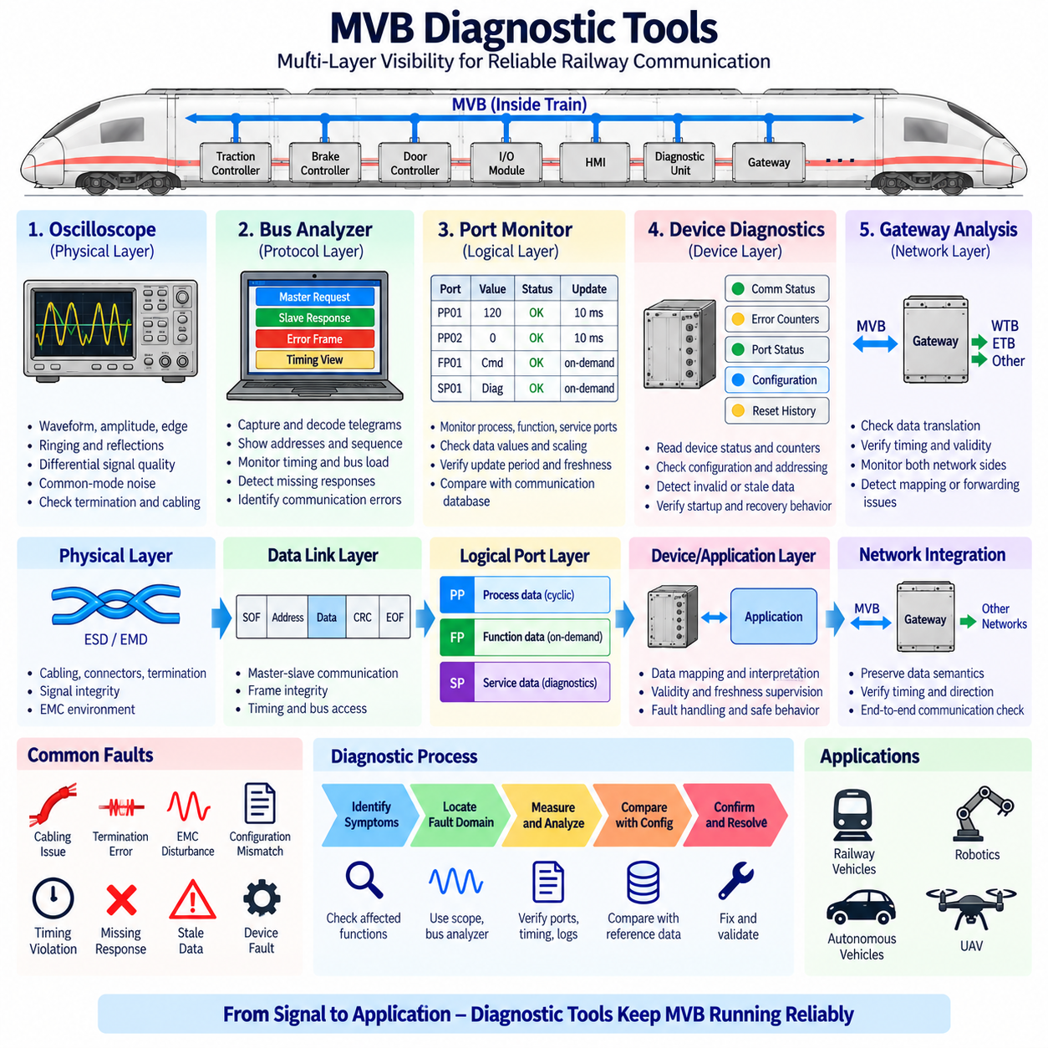
MVB diagnostic tools provide the visibility required to determine whether a Multifunction Vehicle Bus is operating correctly at the physical, data-link, logical-port, device, and application-interface levels. Because an MVB fault may appear as a simple communication failure while originating from cabling, timing, configuration, or software, effective diagnostics must observe several layers rather than relying on a single error indication.
A diagnostic strategy normally begins by identifying the fault domain. Engineers must determine whether the problem originates from the ESD or EMD physical interface, telegram transmission, master scheduling, device addressing, logical-port configuration, data freshness, gateway behavior, or the application using the received information. Layer-oriented troubleshooting prevents unnecessary replacement of devices that are electrically and functionally healthy.
Physical-layer diagnostic equipment is used when signal integrity is suspected. An oscilloscope can reveal waveform amplitude, edge quality, ringing, reflections, common-mode disturbances, and abnormal noise. Measurements taken at different locations along the MVB segment can help identify whether degradation is associated with a particular cable section, connector, termination point, device interface, or electrically noisy installation area.
Differential measurements are particularly valuable because MVB physical communication depends on the quality of the differential signal rather than only the voltage of an individual conductor relative to ground. Engineers can compare the two signal paths and examine common-mode behavior. Excessive imbalance may indicate damaged cabling, poor shielding, grounding problems, connector degradation, or disturbances coupled from nearby power equipment.
Termination problems are a common target of physical diagnostics. Incorrect termination resistance, missing termination, unsuitable placement, or cable discontinuities can generate reflections that distort the received waveform. These problems may produce intermittent telegram errors rather than complete communication loss. Time-domain waveform inspection can therefore reveal faults that appear only occasionally in higher-level protocol diagnostics.
Railway EMC conditions should also be reproduced or observed during troubleshooting. Traction converters, motors, contactors, braking systems, auxiliary power converters, and switching power supplies can introduce conducted or radiated interference. If communication errors correlate with acceleration, braking, contactor operation, or power switching, diagnostic measurements should compare MVB signal quality before, during, and after those operating events.
A bus analyzer provides visibility above the electrical waveform by capturing and interpreting MVB communication activity. Instead of displaying only voltage transitions, the analyzer can help engineers observe master requests, slave responses, addresses, communication sequences, timing relationships, and error events. This allows the investigation to move from the question of whether bits are transported correctly to whether network transactions occur as configured.
Telegram analysis is useful for detecting missing responses, repeated errors, unexpected communication sequences, or communication associated with the wrong device or logical resource. A valid physical waveform does not guarantee correct protocol behavior. A controller may receive electrically correct frames but fail functionally because the requested information, addressing, response behavior, or network configuration differs from the intended vehicle communication design.
Timing analysis is essential in a deterministic network. Diagnostic tools should allow engineers to observe when telegrams occur and whether expected process information is refreshed within its configured interval. A communication sequence may contain no corrupted frames while still violating an application requirement because a critical variable arrives too late. Timing behavior must therefore be examined together with telegram correctness.
Process Data Port diagnostics focus on the relationship between communication and application variables. Engineers should verify that the intended source updates each process port, that configured sink devices receive the correct information, and that the data changes at the expected rate. A port that remains constant unexpectedly may indicate an application mapping problem even when the MVB telegram carrying the port is transmitted normally.
Data interpretation must also be verified. Incorrect scaling, units, byte organization, field mapping, or variable definitions can produce plausible but incorrect application values. These faults are difficult to detect using electrical measurements because the communication channel is functioning correctly. Diagnostic software should therefore compare decoded port information with the expected communication database and known device behavior.
Freshness supervision provides another important diagnostic dimension. Receiving devices must know whether process information has been updated within an acceptable period. Diagnostic tools can identify missing updates, stale values, invalid states, or repeated use of old data. Correlating freshness faults with telegram captures helps determine whether the source stopped producing data, communication was interrupted, or the receiving application failed to process valid updates.
Device-level diagnostic information complements network capture. Individual controllers can maintain counters or status information for communication errors, missing requests, invalid telegrams, configuration problems, stale ports, resets, and interface faults. Comparing these internal observations with bus-analyzer traces is useful because the network view shows what occurred on the bus while device diagnostics reveal how each participant interpreted the event.
Configuration comparison is especially important during integration and maintenance. A replacement controller may be electrically compatible yet contain different addressing, port definitions, timing parameters, or application mappings. Diagnostic tools should help verify that the installed device configuration matches the intended vehicle communication database. Configuration mismatch should be considered before assuming that unexpected communication behavior indicates hardware failure.
Startup diagnostics examine how devices join normal communication after power application. Different controllers may require different initialization times, and communication may become active before application data is valid. Capturing startup traffic allows engineers to determine whether missing responses are expected during initialization, whether validity is established correctly, and whether other devices react appropriately until all required communication participants become operational.
Reset and recovery testing extends this approach to faults occurring during operation. Engineers can intentionally restart or isolate a device and observe how quickly communication supervision detects the loss, how receiving applications handle stale data, and how the network behaves when the device returns. Such tests verify not only communication recovery but also the complete vehicle response to temporary network-participant failure.
Fault injection is therefore a powerful diagnostic and validation technique when performed in a controlled engineering environment. Disconnecting a device, interrupting communication, introducing configuration errors, or simulating missing process updates allows engineers to verify supervision mechanisms and degraded behavior. The objective is to confirm that faults become observable, correctly classified, and associated with predictable system responses.
Gateway diagnostics require observation on both sides of the communication boundary. When MVB information is transferred toward WTB, ETB, or another network, engineers must verify that the gateway preserves data meaning, direction, timing, validity, and fault state. Capturing only the MVB side may be insufficient because the original telegram can be correct while translation or forwarding fails in the gateway.
Diagnostic logging supports faults that cannot be reproduced easily in a workshop. Time-stamped records of communication errors, device resets, missing data, validity changes, operating states, and vehicle events can reveal correlations that would otherwise remain hidden. For example, intermittent communication failures may become understandable when logs show that they repeatedly occur during a specific traction or power-switching condition.
Time correlation between diagnostic sources is particularly valuable. Bus traces, controller logs, vehicle event records, and physical measurements should ideally refer to a common or sufficiently aligned time base. Without correlation, an engineer may know that several faults occurred but not which event happened first. Accurate timing helps reconstruct causal sequences and distinguish a primary network failure from secondary application responses.
A practical diagnostic workflow therefore progresses from symptom to evidence rather than immediately replacing hardware. Engineers can first identify affected functions and devices, inspect network and device logs, capture MVB traffic, verify port behavior and timing, and then examine the physical waveform when necessary. Configuration records and recent maintenance changes should also be checked because many communication faults originate from integration inconsistencies.
Long-term maintenance benefits from establishing known-good reference measurements. Waveforms, bus utilization, expected telegram patterns, port refresh intervals, diagnostic counters, and startup sequences recorded from a healthy vehicle provide useful baselines. When a fault appears later, current measurements can be compared with these references, reducing the time required to determine whether the network has changed electrically, logically, or functionally.
The diagnostic philosophy demonstrated by MVB is equally relevant to robotics and Physical AI systems. CANopen, EtherCAT, Ethernet, DDS, and other networks also require engineers to distinguish physical signal problems from protocol, timing, configuration, and application faults. A packet capture alone cannot identify every failure, just as an oscilloscope alone cannot explain incorrect logical data mapping or stale control information.
For autonomous vehicles and cargo UAVs, integrated diagnostics become even more important because distributed propulsion, steering, braking, flight-control, battery, sensor, and mission systems depend on coordinated communication. Combining physical measurements, protocol traces, device logs, timing analysis, configuration verification, and fault injection provides a systematic method for demonstrating that distributed control remains observable and recoverable.
The essential purpose of MVB diagnostic tools is therefore not simply to display network traffic but to transform communication failures into traceable engineering evidence. Oscilloscopes reveal electrical behavior, bus analyzers expose telegram and timing activity, port monitoring verifies logical information, device diagnostics explain local interpretation, and correlated logs reconstruct system events, enabling efficient fault isolation throughout the railway system life cycle.

