Volume 08. Railway and Aerospace Protocols

Chapter 06. TRDP

06.01. TRDP Pub/Sub Architecture
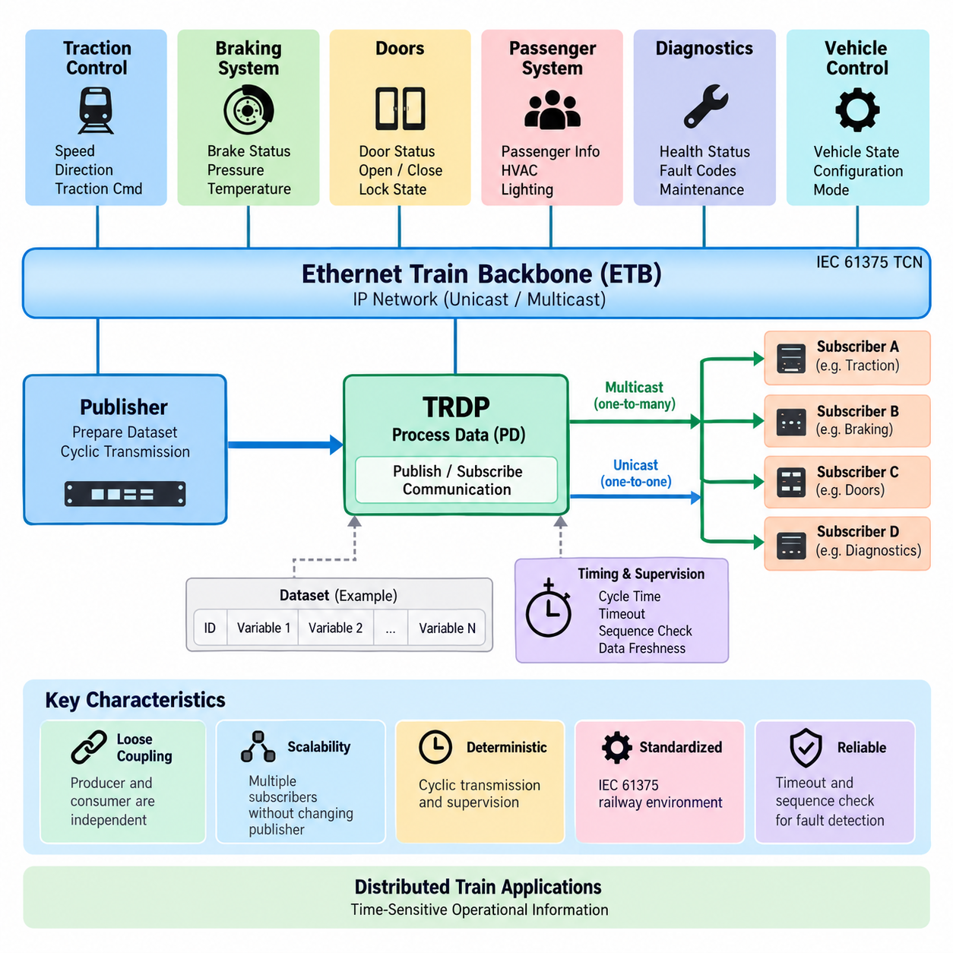
Train Real-time Data Protocol (TRDP) is an Ethernet-based communication protocol used within the IEC 61375 Train Communication Network framework. In the attached structure, TRDP follows the Ethernet Train Backbone and precedes message-data and safety topics, positioning it as the application-oriented communication mechanism operating over an IP-based railway network.
The Publish/Subscribe architecture of TRDP is primarily associated with Process Data communication. Instead of requiring every receiving device to establish a dedicated request-response transaction, a publisher periodically produces a defined dataset and distributes it through the network. Subscribers interested in that dataset receive and process the corresponding information according to their configured communication relationships.
This architecture separates the producer of information from its consumers. A publisher does not need detailed knowledge of every application that uses its data, while subscribers can obtain required information without directly controlling the publisher. This loose coupling is particularly useful in distributed railway systems containing traction controllers, braking systems, doors, passenger systems, diagnostic units, and vehicle control equipment.
TRDP Process Data is typically transmitted cyclically because many train-control variables represent continuously changing operational states. Examples include speed, direction, braking status, door conditions, traction commands, temperatures, and equipment states. Cyclic transmission allows receivers to maintain an updated representation of the train without repeatedly initiating explicit communication transactions.
Each Process Data communication relationship is identified logically rather than being defined only by physical wiring. TRDP therefore allows application information to be mapped onto an Ethernet network through communication identifiers, source and destination addressing, datasets, and timing parameters. This logical abstraction is important because modern train networks may contain many devices whose relationships cannot efficiently be represented by dedicated point-to-point connections.
A publisher prepares application variables as a predefined dataset and passes them to the TRDP communication stack. The stack constructs the corresponding Process Data telegram and transfers it using the underlying IP and Ethernet communication infrastructure. At the receiving side, TRDP identifies the telegram, verifies relevant protocol information, and makes the received dataset available to applications registered as subscribers.
Multicast communication is especially compatible with the Publish/Subscribe model. When the same operational information is required by several devices, the publisher can transmit one multicast data stream rather than generating separate copies for every receiver. Ethernet switches and IP multicast mechanisms can then distribute the information toward the required network participants, reducing unnecessary transmission and simplifying one-to-many communication.
Unicast transmission can also be used when information is intended for a specific destination. Consequently, Publish/Subscribe should not be interpreted as being identical to multicast. Publish/Subscribe describes the logical relationship between information producers and consumers, whereas unicast or multicast describes how packets are addressed and transported across the network. TRDP can combine these concepts according to system requirements.
Communication identifiers provide an important abstraction between application semantics and network addressing. An application can associate a particular identifier with a defined type of Process Data, allowing subscribers to distinguish operational information independently of the physical location of the publishing equipment. This mechanism supports modular train architectures in which devices or consists may be reorganized while preserving logical communication relationships.
Dataset definitions are equally important because publisher and subscriber must interpret the transmitted payload consistently. A dataset specifies the sequence and representation of application variables carried within the telegram. Correct configuration therefore requires agreement on identifiers, data types, sizes, byte representation, update behavior, and semantic meaning. Network connectivity alone cannot guarantee interoperability when dataset definitions differ.
Timing is a fundamental characteristic of TRDP Process Data. A publisher normally sends information according to a configured cycle time, while a subscriber supervises whether expected telegrams continue to arrive. The communication design must therefore consider publication periods, network delay, processing latency, timeout limits, and application reaction times as parts of a coordinated timing model rather than as independent parameters.
Timeout supervision transforms cyclic communication into a useful mechanism for detecting missing information. If a subscriber expects updates within a specified interval and the publisher or communication path fails, the absence of new telegrams can be recognized. The receiving application can then invalidate the affected data, substitute a defined fallback value, report a communication fault, or initiate another system-level response.
Sequence-related information can help receivers distinguish successive telegrams and recognize abnormal communication behavior. Combined with timeout monitoring and protocol validation, this supports supervision of Process Data freshness. Such mechanisms are important because receiving an Ethernet packet is not sufficient by itself; the application must determine whether the information is current, expected, correctly associated, and suitable for further processing.
TRDP Publish/Subscribe communication also supports architectural scalability. A train may contain many subsystems producing operational states at different rates, yet subscribers need only register for information relevant to their functions. This reduces direct dependencies between applications and allows communication relationships to be configured systematically. New consumers can often be integrated without redesigning the publishing application's fundamental behavior.
The architecture becomes especially valuable when TRDP operates over an Ethernet Train Backbone. The attached volume places “TRDP over ETB” immediately before the TRDP chapter, reflecting the relationship between the Ethernet transport infrastructure and the protocol-level data exchange above it. ETB provides backbone connectivity, while TRDP organizes how railway applications publish, distribute, receive, and supervise operational information.
TRDP should therefore be understood as more than a simple Ethernet packet format. Its Publish/Subscribe model creates an information-oriented communication layer in which distributed railway applications exchange predefined datasets through controlled cyclic relationships. Ethernet provides bandwidth and connectivity, while TRDP supplies railway-specific communication semantics, identification, timing, supervision, and application-facing data distribution.
From a system-engineering perspective, the most important design task is defining communication relationships before implementing individual network endpoints. Engineers must determine which subsystem owns each item of information, which applications consume it, how frequently it changes, how quickly stale data must be detected, and what behavior is required when communication disappears. These decisions establish the functional communication contract.
This approach also creates a useful conceptual bridge toward modern distributed robotic and Physical AI systems. A mobile robot fleet similarly contains many producers of state information and many consumers requiring selected portions of that state. Localization, battery condition, velocity, mission state, actuator status, and health information can conceptually be organized as published datasets consumed by navigation, supervision, diagnostics, or fleet-management functions.
However, TRDP remains a railway-oriented protocol within the broader IEC 61375 communication environment rather than a generic robotics middleware. The attached hierarchy intentionally places TRDP in the railway and aerospace protocol volume, while DDS, ROS 2 middleware, MQTT, fleet communication, and Physical AI networks are treated separately in the robotics communication volume. This separation clarifies both the similarities and the application-domain boundaries.
The Publish/Subscribe architecture ultimately provides TRDP with a scalable way to distribute time-sensitive operational information among networked train devices. Publishers define authoritative streams of Process Data, subscribers select the information they require, datasets establish shared interpretation, communication identifiers establish logical relationships, and cyclic transmission with supervision maintains continuously updated distributed state across the train.
This foundation is also important for understanding the subsequent TRDP topics in the attached structure. Publish/Subscribe primarily explains the recurring Process Data communication model, while Message Data addresses transaction-oriented exchanges, and later sections can examine communication supervision, safety-related mechanisms, and implementation practices. Together these elements form a structured progression from communication architecture toward dependable railway integration.

06.02. TRDP MD (Message Data)
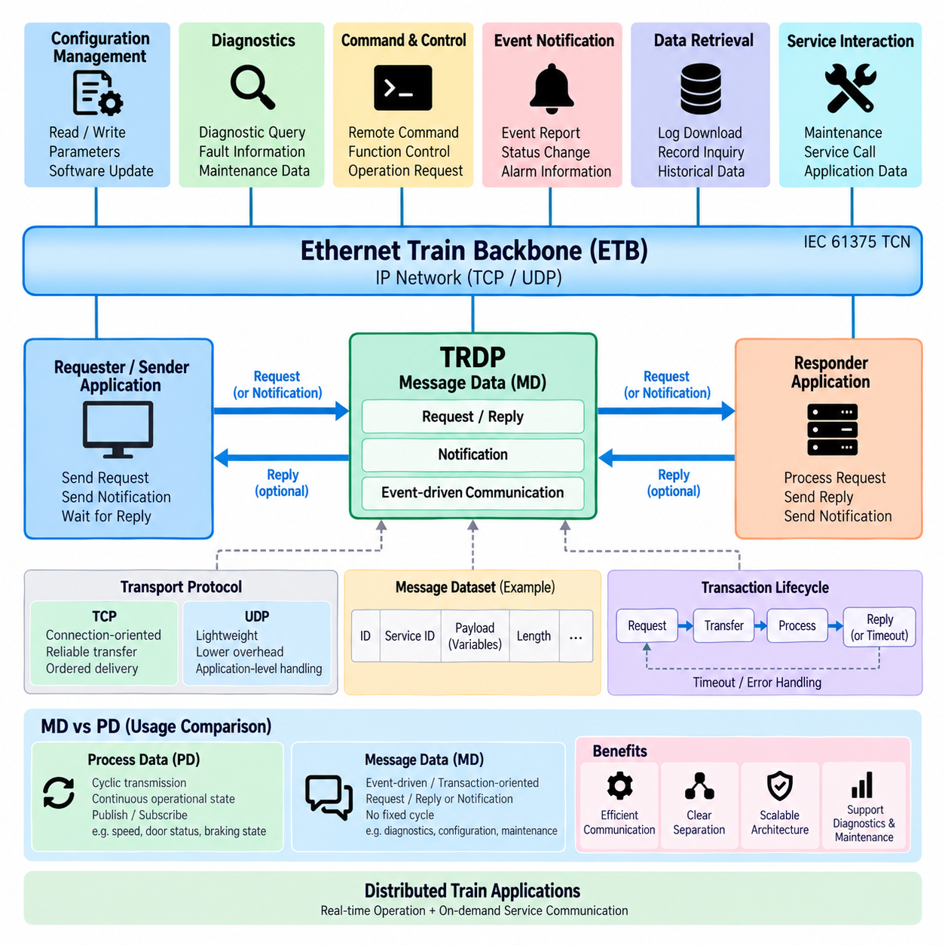
Train Real-time Data Protocol (TRDP) provides two complementary communication models for distributed railway applications: Process Data (PD) and Message Data (MD). While Process Data is optimized for cyclic Publish/Subscribe exchange of continuously changing operational states, Message Data supports event-driven and transaction-oriented communication when applications need explicit exchanges rather than continuously repeated updates.
Message Data is suitable for information that does not require fixed cyclic transmission. Instead of repeatedly publishing the same type of state information, an application generates an MD transaction when a specific event, request, command, diagnostic operation, or information exchange occurs. This approach avoids consuming network resources with unnecessary periodic traffic when information is needed only occasionally.
The fundamental distinction between PD and MD therefore concerns communication behavior rather than simply the size or importance of the transmitted information. PD represents continuously refreshed distributed state, whereas MD represents discrete communication transactions. A train-control system may use PD for speed and door status while using MD for configuration retrieval, diagnostic queries, maintenance information, or application-specific commands.
TRDP Message Data uses an application-to-application communication relationship in which a requesting or sending application exchanges a defined message with another application. Depending on the required interaction, communication can follow request/reply behavior or notification-oriented behavior. This enables applications to initiate explicit transactions while remaining within the same TRDP-based railway communication environment used for real-time operational information.
In a request/reply transaction, one application sends a request containing the information necessary for a remote function to perform an operation or provide information. The receiving application processes the request and returns a corresponding reply. This communication pattern is appropriate when the initiating application must know whether the requested operation was processed or needs information that only the destination application can provide.
A notification-style exchange is useful when an application needs to communicate an event or information without requiring the same conversational sequence as a request/reply transaction. Such behavior can support event reporting, status changes, maintenance notifications, or other asynchronous application interactions. The communication architecture can therefore represent both interactive transactions and one-directional event-oriented exchanges.
Message Data communication is generally associated with TCP or UDP transport depending on the TRDP communication mode and implementation requirements. The transport choice influences connection behavior, reliability characteristics, latency, and resource consumption. Engineers must therefore consider the semantics of the application transaction rather than selecting transport mechanisms solely from conventional Ethernet networking practices.
TCP-based communication can provide connection-oriented transport and mechanisms such as ordered delivery and retransmission. These characteristics are useful when successful transfer of complete application information is more important than minimizing communication overhead. Configuration transfer, maintenance information, or diagnostic transactions may benefit from transport behavior in which lost information can be recovered rather than simply replaced by the next cyclic update.
UDP-oriented communication offers a lighter transport mechanism without establishing the same connection-oriented session behavior. It can be appropriate where application-level communication semantics, timing requirements, or system architecture make lower overhead desirable. However, the application and TRDP configuration must account for the different delivery characteristics because UDP itself does not provide the same reliability mechanisms as TCP.
An MD transaction must be logically associated with the intended application service. Communication identifiers and addressing information allow TRDP participants to determine the purpose and destination of exchanged messages. As with Process Data, the physical Ethernet connection alone does not define application meaning. Logical identifiers, dataset definitions, addressing, and application configuration establish the actual communication relationship.
Message payloads are interpreted according to agreed dataset definitions. Both communicating applications must therefore share consistent knowledge of the structure, ordering, representation, and meaning of the transmitted variables. A correctly delivered Ethernet message is not useful if the sender and receiver interpret its payload differently. Dataset management is consequently an important part of TRDP interoperability for both PD and MD communication.
TRDP MD communication also introduces the concept of a transaction lifecycle. A transaction may begin when an application generates a request, continue while the message is transferred and processed, and terminate when the expected response is received or when a timeout condition occurs. The application can then determine whether the transaction completed successfully, failed, or requires another system-level recovery action.
Timeout management is particularly important because distributed railway applications cannot wait indefinitely for a response. When an expected reply does not arrive within the configured interval, the requesting application must recognize the abnormal condition. Depending on system requirements, it may retry the transaction, report a communication fault, enter a degraded operating mode, or transfer responsibility to another diagnostic or supervisory function.
Message Data should not be regarded as a replacement for Process Data. Using request/reply transactions for rapidly changing variables such as vehicle speed or braking state would create unnecessary communication overhead and tightly couple consumers to producers. Conversely, cyclically broadcasting large diagnostic or configuration information that changes infrequently would waste bandwidth. TRDP separates these communication patterns so each can be applied appropriately.
A practical railway system therefore commonly combines PD and MD within the same network architecture. Process Data maintains the continuously updated operational state required by distributed control functions, while Message Data handles explicit transactions that occur according to events or application needs. This combination allows real-time state distribution and asynchronous service communication to coexist over the Ethernet-based Train Communication Network.
For example, a traction controller may continuously publish operating state through PD while accepting diagnostic requests through MD. A door controller may publish open, closed, locked, and fault states cyclically but use Message Data when maintenance equipment requests detailed diagnostic records or configuration parameters. The same physical device can therefore participate simultaneously in different TRDP communication relationships.
This separation also improves network engineering because traffic can be classified according to its functional behavior. Cyclic PD traffic can be designed around update periods, latency, jitter, multicast distribution, and freshness supervision. MD traffic can instead be analyzed according to transaction frequency, message size, response time, timeout behavior, connection resources, and expected concurrency between communicating applications.
From a system integration perspective, engineers must define which information belongs to PD and which belongs to MD before implementing interfaces. The decision should be based on whether information represents continuously changing state or a discrete transaction, whether multiple consumers require it, how quickly stale information becomes unacceptable, whether a response is required, and how communication failure should affect the application.
This PD/MD distinction provides a useful architectural analogy for distributed robotics and Physical AI systems. A robot may continuously publish localization, velocity, battery condition, and actuator status while using transaction-oriented communication for map requests, configuration changes, diagnostic retrieval, software management, or mission-related service calls. The underlying protocols may differ, but the separation between state streams and explicit transactions remains valuable.
Within the attached book structure, TRDP Message Data follows the Publish/Subscribe architecture and precedes TRDP safety mechanisms and implementation guidance. This sequence establishes a logical progression: first understanding cyclic Process Data distribution, then transaction-oriented Message Data, followed by mechanisms required for dependable communication and practical integration. TRDP can therefore be studied as a coordinated communication architecture rather than as a single message format.
Together, Process Data and Message Data allow TRDP to support the different communication behaviors required by modern railway systems. PD efficiently maintains distributed real-time operational state, while MD provides controlled event-driven and request/reply exchanges. Their coordinated use enables train subsystems to combine continuous monitoring and control with diagnostics, configuration, maintenance, and higher-level application interactions over a common Ethernet infrastructure.

06.03. TRDP Safety Mechanisms
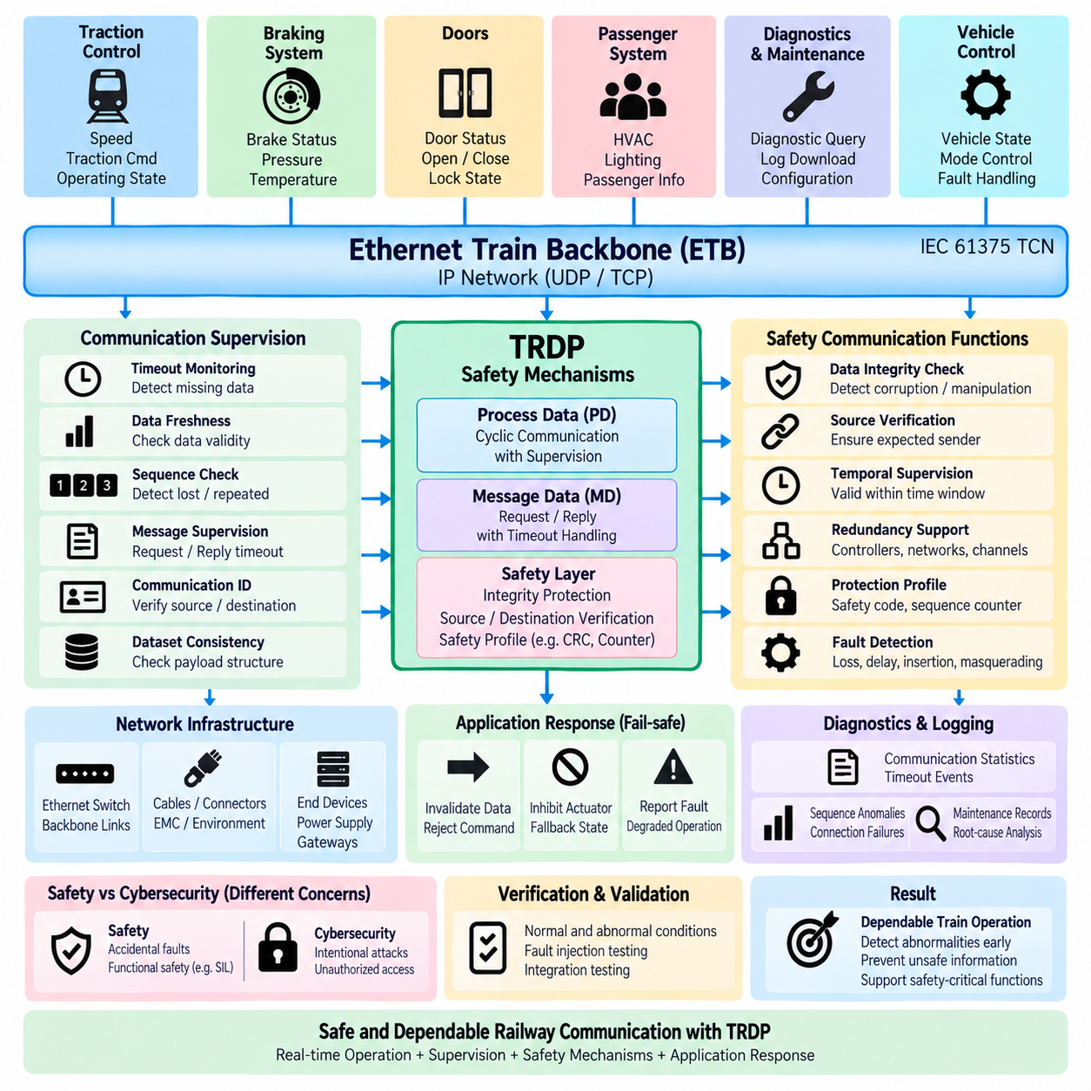
Train Real-time Data Protocol (TRDP) operates within railway communication systems where dependable exchange of operational information is essential. Safety-related communication cannot rely only on successful Ethernet packet delivery; applications must also determine whether received information is correct, current, expected, and associated with the proper communication relationship. TRDP therefore provides communication supervision mechanisms that can support dependable system behavior.
A fundamental mechanism is timeout supervision. Process Data is normally transmitted cyclically, allowing a subscriber to know when the next telegram should approximately arrive. If no valid telegram is received within the configured timeout interval, the subscriber can identify the information as unavailable or stale. The application can then reject the affected data and initiate a predefined fault-handling or degraded-operation strategy.
Data freshness is closely related to timeout monitoring. A telegram that was once valid cannot necessarily remain valid indefinitely because train operating conditions continuously change. Speed, braking state, traction status, door conditions, and other variables may become unsafe to use when they are outdated. TRDP communication design must therefore associate operational information with suitable update periods and validity expectations.
Sequence information can be used to supervise the progression of received telegrams. Successive messages should follow the expected communication sequence, enabling receivers to detect repeated, missing, or unexpectedly ordered information. Sequence supervision does not independently guarantee functional safety, but it provides an important communication-level indication that the received data stream behaves differently from the expected cyclic relationship.
Message Data requires a different form of supervision because communication is transaction-oriented rather than continuously cyclic. A requesting application may expect a corresponding reply within a defined period. If the reply is not received, the transaction can terminate through timeout handling rather than waiting indefinitely. This allows the application to identify unsuccessful communication and determine whether retry, fault reporting, fallback behavior, or another recovery action is required.
Communication identifiers and addressing also contribute to dependable data handling. A receiver must determine that incoming information belongs to the expected logical communication relationship before using its payload. Correct Ethernet delivery alone is insufficient if data is associated with the wrong application function. TRDP therefore relies on consistent configuration of communication identifiers, source and destination relationships, and dataset definitions across participating devices.
Dataset consistency is another essential integration requirement. Publishers and subscribers must share the same interpretation of payload structure, variable ordering, data types, lengths, and application semantics. A telegram can be technically delivered without network errors while still being incorrectly interpreted by the receiving application. Configuration management and interface verification are therefore necessary parts of building dependable TRDP-based systems.
TRDP communication supervision must be distinguished from complete functional safety. Detecting a missing telegram, timeout, unexpected sequence, or communication inconsistency does not by itself prove that a railway function satisfies a required Safety Integrity Level. Functional safety depends on the complete system architecture, including hazard analysis, application logic, redundancy, failure reactions, hardware behavior, software development processes, verification, and validation.
For safety-related data communication, railway systems may therefore apply additional safety mechanisms above the ordinary transport service. The purpose is to protect safety information against communication failure modes that cannot be sufficiently controlled merely by Ethernet, IP, UDP, TCP, or standard TRDP communication behavior. Such protection is commonly implemented through a safety layer or safety-related communication profile associated with the application data.
Typical safety communication principles include mechanisms for detecting data corruption, repetition, loss, incorrect sequence, excessive delay, insertion, or masquerading of information. Depending on the applicable safety architecture, additional safety information may be associated with the application payload so that the receiving safety function can verify that the data belongs to the expected source, sequence, communication context, and validity interval before accepting it.
A safety code or safety-oriented integrity check can provide stronger protection against accidental data corruption than relying exclusively on ordinary lower-layer error detection. The receiver calculates or verifies the corresponding protection information and rejects the safety telegram when the expected relationship is not satisfied. The exact safety mechanism must follow the selected railway safety profile and system requirements rather than being improvised at application level.
Source and destination identification are also important in safety communication because correctly formatted information received from an unintended communication participant can still create a hazardous condition. Safety-related communication therefore needs a means of confirming the logical relationship between sender and receiver. This protection complements ordinary IP addressing because network addresses alone do not represent the complete safety context of an application function.
Temporal supervision is equally significant. Safety information must arrive not only without corruption but also within the period in which it remains operationally meaningful. Cycle counters, sequence supervision, timeout monitoring, and age-related validity checks can help identify delayed or repeated information. Once the permitted temporal relationship is violated, the receiving application should treat the information according to its predefined safe or degraded behavior.
Redundancy can further increase system dependability when required by the railway architecture. Redundant controllers, network paths, interfaces, or communication channels may reduce the probability that a single failure causes loss of a critical function. TRDP can participate in such architectures, but redundancy management must be designed at system level, including failure detection, channel selection, synchronization, switchover behavior, and prevention of common-cause failures.
Network infrastructure also influences communication dependability. Ethernet switches, backbone links, end devices, power supplies, connectors, and gateways can become failure points even when the TRDP software operates correctly. Railway network design therefore considers communication supervision together with physical redundancy, environmental qualification, electromagnetic compatibility, equipment reliability, diagnostics, and maintainability rather than treating the protocol as an isolated safety component.
Fail-safe behavior must ultimately be defined by the receiving application. When communication supervision identifies invalid or missing information, TRDP can report the communication condition, but the application determines the operational reaction. Depending on the function, this may mean invalidating a command, inhibiting an actuator action, maintaining a controlled fallback state, generating a diagnostic event, or requesting intervention from another supervisory function.
Diagnostics provide another important layer of dependability. Communication statistics, timeout events, sequence anomalies, connection failures, invalid telegrams, and configuration mismatches can be recorded and exposed to maintenance systems. These records help engineers distinguish transient network disturbances from persistent equipment faults and support root-cause analysis during commissioning, operation, and maintenance of complex distributed train systems.
Safety and cybersecurity must also be treated as distinct engineering concerns. Safety mechanisms primarily address accidental faults and their potential hazardous consequences, whereas cybersecurity addresses intentional manipulation, unauthorized access, spoofing, malicious traffic, and other hostile actions. A dependable railway Ethernet architecture therefore requires appropriate safety engineering and cybersecurity controls rather than assuming that one discipline automatically provides the other.
Verification of TRDP safety-related communication should include abnormal conditions as well as nominal data exchange. Engineers need to evaluate missing telegrams, delayed communication, repeated information, corrupted data, incorrect configuration, unavailable destinations, interrupted links, restart behavior, and recovery after communication failures. Fault-injection and integration testing can demonstrate whether supervision mechanisms and application reactions operate according to the defined requirements.
The attached book structure places TRDP safety mechanisms after Publish/Subscribe architecture and Message Data, followed by an implementation guide. This progression is appropriate because safety-related behavior can be understood only after the underlying PD and MD communication models are established. It also connects naturally with the broader volume structure covering deterministic railway communication, TCN architecture, ETB, and railway certification topics.
For distributed robotics and Physical AI systems, the same engineering principle remains valuable even when TRDP itself is not used. Communication carrying motion commands, localization state, actuator status, or safety information should be evaluated for freshness, sequence, integrity, timeout, source validity, and failure response. The protocol technology may change, but dependable distributed control still requires explicit assumptions about when received information can be trusted.
TRDP safety mechanisms should therefore be viewed as part of a layered dependability strategy rather than as a single feature that makes Ethernet communication intrinsically safe. Communication identification, sequence and timeout supervision, data integrity protection, safety-layer mechanisms, redundancy, diagnostics, and application-level fail-safe reactions must work together. Their coordinated design allows railway systems to detect communication abnormalities and respond predictably before invalid information can propagate into critical control functions.

06.04. TRDP Implementation Guide
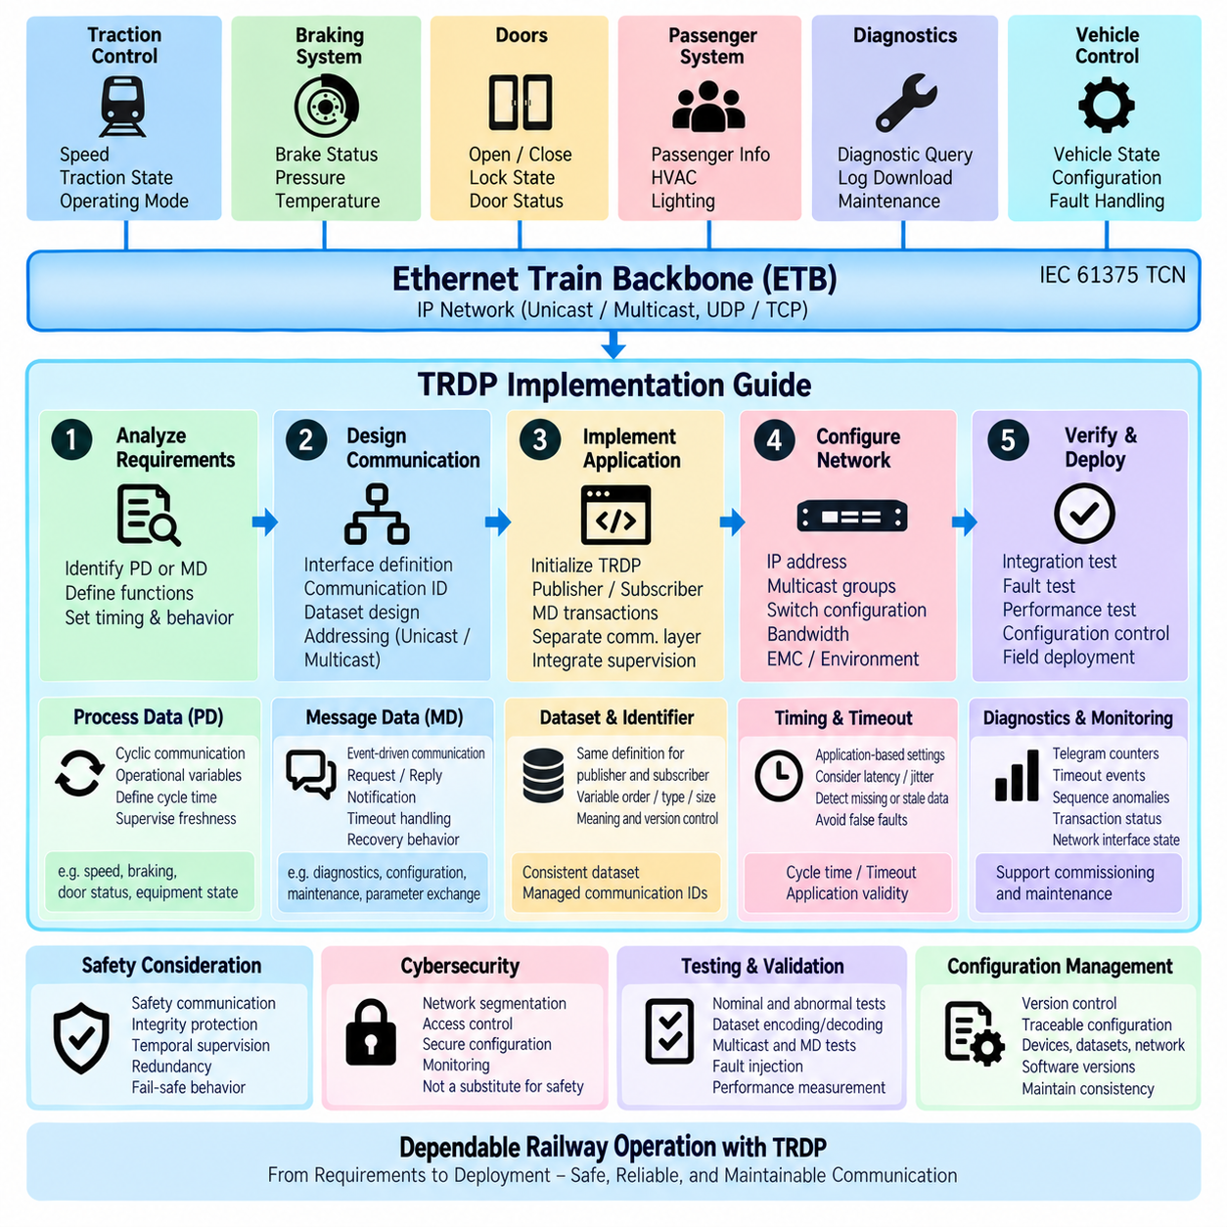
TRDP implementation should begin with a clear communication model rather than directly configuring Ethernet sockets. The system designer first identifies which application information belongs to cyclic Process Data (PD) and which requires transaction-oriented Message Data (MD). This distinction establishes the foundation for communication timing, addressing, dataset design, supervision, and application interfaces throughout the implementation.
Process Data should be selected for operational variables that must remain continuously available to distributed applications. Typical examples include speed, traction state, braking information, door status, equipment state, and other frequently updated signals. Engineers define a publication cycle for each communication relationship and configure subscribers to receive the corresponding information while supervising its freshness and availability.
Message Data should be assigned to communication that occurs according to events or explicit application requests. Diagnostic queries, configuration operations, maintenance information, parameter exchange, and service-oriented interactions are representative candidates. The implementation must define whether the communication requires request/reply behavior, notification behavior, timeout handling, and application-level recovery when a transaction cannot be completed.
After PD and MD relationships are classified, engineers should create an interface definition describing the information exchanged between applications. Each interface should identify the data owner, consumers, communication identifier, dataset, transmission behavior, expected timing, and failure reaction. Treating this definition as a communication contract reduces ambiguity between software teams and prevents network configuration from becoming disconnected from functional requirements.
Dataset engineering is one of the most important implementation activities. Publisher and subscriber applications must use identical definitions for the variables contained in each payload, including their order, type, size, representation, and semantic meaning. Dataset definitions should be controlled as configuration items because even a small mismatch can cause correctly transmitted Ethernet data to be interpreted incorrectly by the receiving application.
Communication identifiers should be allocated systematically and documented centrally. They provide the logical relationship between application information and TRDP communication, allowing applications to identify data independently of physical Ethernet wiring. Duplicate, inconsistent, or undocumented identifiers can produce integration problems that are difficult to diagnose, so identifier allocation should follow a controlled project-level naming and configuration strategy.
Network addressing must then be designed according to the required communication relationship. Unicast is appropriate when information has a specific destination, while multicast is useful when the same Process Data must be distributed efficiently to several subscribers. Engineers should coordinate IP addressing, multicast groups, subnet configuration, routing requirements, and Ethernet switch behavior with the logical TRDP communication design.
Multicast implementation requires particular attention to network infrastructure. A publisher may transmit one multicast stream for several subscribers, but switches and network interfaces must handle multicast traffic correctly. Poor multicast configuration can distribute unnecessary traffic throughout the network or prevent intended subscribers from receiving information. TRDP configuration and Ethernet switch configuration should therefore be validated as parts of the same system integration activity.
Timing parameters should originate from application requirements rather than arbitrary default values. PD cycle times determine how frequently distributed state is refreshed, while subscriber timeouts determine when missing information becomes invalid. Engineers must consider application response time, network latency, jitter, processing delay, expected packet loss behavior, and available bandwidth when selecting publication periods and supervision limits.
Timeout values should provide sufficient tolerance for normal communication variation while still detecting failures before stale information becomes operationally unacceptable. A timeout that is too short can generate false communication faults, whereas an excessively long timeout allows invalid information to remain usable for too long. The relationship between cycle time, timeout, application validity, and fail-safe reaction should therefore be explicitly documented.
Application software should separate communication handling from functional processing whenever practical. A TRDP interface layer can receive, validate, and expose datasets while application functions operate on defined data objects rather than raw Ethernet packets. This separation improves maintainability and allows communication configuration, diagnostics, and supervision to evolve without unnecessarily modifying traction, braking, door, diagnostic, or supervisory algorithms.
Initialization is another important implementation phase. Before normal communication begins, the software must establish the required TRDP environment, configure network interfaces, create communication sessions, register publishers and subscribers, prepare datasets, and activate the required PD or MD relationships. Initialization failures should be detected explicitly so that the application does not enter normal operation with partially configured communication resources.
Runtime processing must execute communication functions with predictable timing. Cyclic PD publication and reception should be integrated with the application's scheduling architecture so that communication timing remains consistent with control and monitoring tasks. The software design should avoid unnecessary blocking operations in time-sensitive execution paths and should monitor processing delays that could interfere with expected publication or reception behavior.
MD implementation requires careful management of transaction resources. Applications should track outstanding requests, expected replies, transaction identifiers, timeout conditions, and completion states. Multiple simultaneous transactions may require controlled resource allocation so that one delayed or failed request does not prevent unrelated communication. Retry behavior should also be bounded to prevent persistent communication failures from creating uncontrolled network traffic.
Communication supervision should be integrated from the beginning rather than added after basic communication is functioning. Subscribers should monitor missing or stale PD, while MD clients should detect unanswered transactions. Sequence behavior, communication identifiers, dataset validity, and other available protocol information should be checked before received information is passed to application functions that depend on it.
Failure handling must be defined at application level. TRDP can identify communication conditions, but the receiving function determines the operational consequence. Invalid data may be rejected, commands may be inhibited, fallback values may be applied, diagnostic events may be generated, or a subsystem may enter a degraded state. These reactions should be specified together with communication requirements rather than discovered during integration testing.
Diagnostics should expose enough information to determine why communication failed. Useful observations include received and transmitted telegram counts, timeout events, sequence anomalies, invalid identifiers, transaction failures, connection state, and network interface conditions. Diagnostic information should distinguish communication-layer problems from application faults so that commissioning and maintenance personnel can locate failures efficiently.
Safety-related applications require additional engineering beyond ordinary TRDP communication. Standard communication supervision should not be interpreted as proof of functional safety. Where safety requirements apply, appropriate safety communication mechanisms, integrity protection, temporal supervision, source verification, redundancy, fail-safe reactions, and railway safety lifecycle activities must be incorporated according to the applicable system architecture and safety requirements.
Cybersecurity should likewise be considered separately from communication reliability. Network segmentation, access control, device configuration protection, secure maintenance procedures, and monitoring may be required to protect the railway Ethernet environment from unauthorized or malicious activity. Reliable delivery and timeout detection do not by themselves provide authentication, authorization, confidentiality, or comprehensive protection against deliberate attacks.
Integration testing should progress from individual communication relationships toward complete train-network operation. Engineers can first verify dataset encoding and decoding, then publisher/subscriber communication, multicast behavior, MD transactions, timing, and timeout supervision. Testing should subsequently include multiple devices and realistic traffic so that interactions involving bandwidth, switch behavior, processing load, and concurrent communication become visible.
Fault testing is essential before deployment. Tests should intentionally introduce missing telegrams, delayed packets, interrupted links, unavailable subscribers, incorrect configurations, application restarts, and failed MD transactions. The objective is not merely to demonstrate that communication works under nominal conditions, but to confirm that abnormal conditions are detected and that each application enters the intended recovery, degraded, or fail-safe state.
Performance validation should measure actual behavior rather than assuming that configured values guarantee timing. Engineers should observe PD cycle accuracy, end-to-end latency, jitter, network utilization, packet loss, CPU loading, and MD response times under representative operating conditions. Measurements should include high-load situations because a communication architecture that performs correctly during laboratory idle conditions may behave differently when the complete train system is active.
Configuration management becomes increasingly important as the number of devices and communication relationships grows. Dataset definitions, communication identifiers, IP addresses, multicast groups, cycle times, timeout values, software versions, and network configurations should be version controlled and traceable. Consistent configuration across publishers, subscribers, switches, gateways, and maintenance tools is essential for reproducible integration and field service.
The attached structure places this implementation guide after TRDP Publish/Subscribe Architecture, TRDP MD Message Data, and TRDP Safety Mechanisms. The sequence reflects a practical engineering progression from understanding PD communication, through transaction-oriented MD communication and dependable communication principles, toward implementation and validation. It also completes the TRDP chapter before the volume transitions to aerospace protocols such as ARINC 429.
A successful TRDP implementation therefore results from coordinated application, communication, network, safety, and validation engineering rather than from protocol configuration alone. PD and MD classification, controlled datasets, identifiers, addressing, timing, supervision, diagnostics, failure reactions, testing, and configuration management must remain consistent throughout development. This disciplined approach allows TRDP to serve as a dependable communication foundation for distributed Ethernet-based railway systems.

