Volume 08. Railway and Aerospace Protocols

Chapter 10. TT-Ethernet

10.01. IEEE 802.1Qbv (TAS)
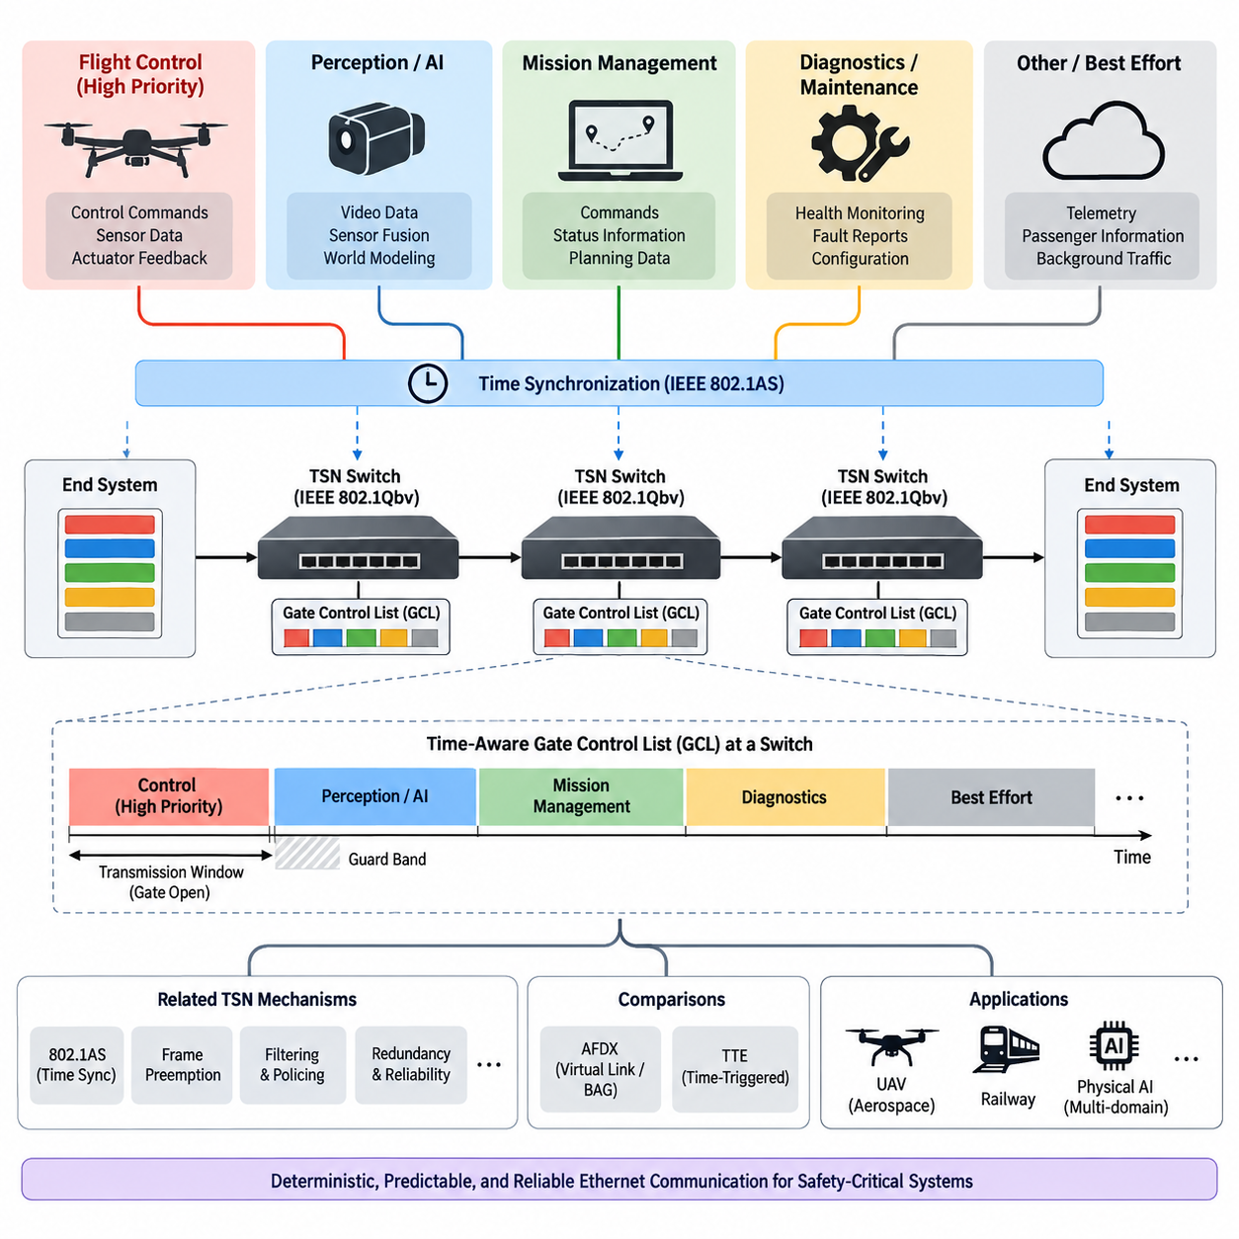
IEEE 802.1Qbv Time-Aware Shaper (TAS) is a Time-Sensitive Networking (TSN) mechanism designed to provide deterministic Ethernet communication by controlling when Ethernet frames are allowed to transmit. Instead of allowing traffic to compete continuously for access to an Ethernet link, TAS divides communication time into precisely defined transmission windows. Each traffic class is associated with a gate that opens or closes according to a repeating time schedule. This transforms a conventional Ethernet switch from a best-effort forwarding device into a network element capable of enforcing predictable transmission timing.
The fundamental concept of TAS is the Time-Aware Gate Control List (GCL). A GCL specifies the sequence of gate states and the duration for which each state remains active. During a particular time interval, the gate for a high-priority traffic class may be opened while other gates remain closed. During another interval, a different class may be permitted to transmit. Because every participating network device follows a synchronized schedule, traffic can be assigned deterministic transmission opportunities. This approach is particularly important when communication timing itself is part of the system requirement rather than merely the delivery of data.
TAS depends strongly on network-wide time synchronization. The transmission schedule is meaningful only when switches and end stations share a sufficiently accurate common time reference. In a TSN system, IEEE 802.1AS provides the synchronization foundation typically used to establish a common time base. The synchronized clocks allow each bridge and end system to execute its local GCL according to the same global notion of time. Consequently, a scheduled frame can progress through a sequence of transmission windows without relying solely on instantaneous queue priority or contention resolution.
A TAS transmission cycle is normally constructed from repeated time intervals that correspond to different traffic requirements. A safety-critical control message may receive a dedicated transmission window, while less time-sensitive telemetry or diagnostic traffic uses other intervals. The cycle then repeats continuously. The exact duration of each interval depends on application timing, frame size, link speed, propagation delay, switching delay, processing time, and required guard margins. Proper schedule construction therefore requires communication timing to be considered together with the physical and logical architecture of the network.
The gate mechanism separates traffic according to transmission eligibility rather than simply assigning static priority. A frame belonging to an enabled traffic class can be transmitted when its corresponding gate is open, whereas a frame associated with a closed gate must remain queued. This provides a stronger timing model than conventional priority-based Ethernet, because a high-priority frame does not automatically transmit whenever the link becomes available. Instead, transmission is constrained by the predefined temporal schedule. The resulting behavior makes network timing more analyzable and repeatable.
One important design issue is the interaction between scheduled traffic and unscheduled traffic. A TSN network rarely carries only deterministic control messages. It may simultaneously transport perception data, diagnostics, maintenance information, configuration traffic, and other background communication. TAS allows these traffic categories to coexist by assigning different transmission opportunities to them. Critical traffic can be protected within reserved windows, while non-critical traffic uses remaining capacity. This enables a common Ethernet infrastructure to support multiple levels of communication criticality without requiring completely separate physical networks.
Guard bands are an important part of practical TAS operation. When a scheduled high-priority transmission window is about to begin, a lower-priority frame already occupying the link must not extend into that window. The network therefore needs sufficient protection time before the next scheduled transmission opportunity. Depending on the TSN implementation, mechanisms such as frame preemption may reduce the bandwidth consumed by these restrictions. Without appropriate guard-band or preemption considerations, a theoretically correct schedule can still experience timing interference caused by frames that began transmission during an earlier interval.
The deterministic behavior of TAS becomes increasingly important as a system integrates multiple communication domains. In railway systems, for example, communication may involve control functions, vehicle status, diagnostics, passenger information, and higher-level coordination. In aerospace or UAV systems, similar separation can exist between flight-control information, actuator coordination, navigation, health monitoring, mission data, and maintenance communication. TAS provides a conceptual mechanism for assigning different temporal guarantees to these traffic classes while retaining a common Ethernet-based communication infrastructure.
For UAV avionics, TAS can be considered as a means of establishing deterministic Ethernet communication between computing and control subsystems. A flight-control computer may require periodic communication with actuator controllers and sensor-processing units. A perception computer may generate larger but less strictly periodic data streams, while mission-management software may exchange command and status information at a lower rate. TAS can allocate transmission windows according to these requirements so that critical control traffic receives predictable network access without requiring the entire Ethernet network to operate as a single undifferentiated priority queue.
The relationship between TAS and the processing architecture is also important. A physical AI system may contain high-performance computing nodes responsible for perception, world modeling, planning, and decision making, while lower-level controllers operate at substantially higher frequencies. These functions do not necessarily require identical communication timing. TAS can therefore be used to establish deterministic communication windows for time-sensitive control information while allocating other periods to high-bandwidth perception or diagnostic traffic. The communication schedule becomes an architectural boundary between different computational time scales.
TAS is particularly valuable when network latency must be bounded rather than merely optimized on average. Conventional Ethernet performance is often described using average latency, throughput, and packet-loss characteristics. These metrics are insufficient for systems in which the maximum communication delay must remain within a defined bound. TAS addresses this problem by constraining transmission opportunities in time. If the schedule, synchronization accuracy, forwarding delays, and traffic assumptions are properly engineered, the resulting communication behavior becomes much more predictable.
However, TAS does not automatically make an Ethernet system deterministic. Determinism depends on the complete configuration of the TSN system. Clock synchronization, GCL configuration, queue assignment, frame transmission time, bridge forwarding delay, topology, traffic generation, and link utilization must all be considered. A schedule that is valid for one network topology may become invalid after a switch or end system is added. Consequently, TAS should be treated as an architectural engineering mechanism rather than simply a switch feature that can be enabled without system-level analysis.
Schedule synthesis is therefore an important engineering activity. The designer must first identify the traffic streams, their periods, deadlines, frame sizes, priorities, routes, and required reliability. These streams are then mapped to traffic classes and transmission windows. The GCL is generated so that each bridge along a traffic path permits the appropriate frame at the appropriate time. The schedule must also account for propagation and forwarding delays between successive network elements. As the number of nodes and traffic streams increases, manual configuration becomes increasingly difficult, making automated schedule-generation and verification tools valuable.
The end-to-end timing of a scheduled Ethernet message is determined by more than the transmission window at its source. A frame may pass through multiple bridges before reaching its destination, and each bridge has its own gate schedule. The schedules therefore need to be coordinated across the entire communication path. The source transmission time, switch forwarding behavior, queue residence time, link transmission time, and synchronization error collectively determine the final delivery time. This end-to-end perspective is essential for safety-critical applications because a locally correct GCL does not guarantee a globally correct communication schedule.
TAS also introduces a different way of thinking about network utilization. In a conventional Ethernet network, unused link capacity is generally available immediately to whichever traffic is eligible to transmit. In a scheduled network, capacity can effectively be reserved for future transmission windows. This reservation improves predictability but may reduce flexibility if the schedule is poorly designed. Therefore, engineering a TAS network requires a balance between deterministic guarantees and efficient utilization. Excessively conservative schedules can waste bandwidth, whereas excessively dense schedules may leave insufficient margin for timing variation and unexpected traffic behavior.
The distinction between periodic deterministic traffic and event-driven traffic must also be considered. Flight-control loops, actuator commands, and certain sensor updates often have regular timing characteristics that fit naturally into scheduled transmission windows. Diagnostic messages, fault reports, and maintenance data may occur asynchronously. A robust TAS architecture therefore needs to define how event-driven traffic is accommodated without compromising scheduled traffic. Such traffic may be assigned to lower-priority windows or controlled through appropriate traffic-shaping mechanisms so that unexpected bursts cannot interfere with critical communication.
TAS is closely related to other TSN mechanisms because deterministic Ethernet normally requires a combination of functions rather than one isolated feature. IEEE 802.1Qbv controls transmission opportunities according to time. IEEE 802.1AS establishes the common time reference required by the schedule. Frame preemption can reduce blocking effects between traffic classes, while other TSN mechanisms can provide additional redundancy, filtering, policing, or latency control. The resulting architecture can be viewed as a coordinated deterministic communication framework in which time synchronization, traffic classification, scheduling, forwarding, and fault handling work together.
The comparison with AFDX is particularly relevant in aerospace communication architecture. AFDX uses Virtual Links and Bandwidth Allocation Gap mechanisms to provide controlled and predictable Ethernet-based communication. TAS takes a different approach by explicitly controlling transmission opportunities according to synchronized time. AFDX therefore emphasizes controlled bandwidth allocation and traffic isolation through Virtual Links, whereas TAS emphasizes temporal scheduling at Ethernet bridges and end systems. Both approaches seek deterministic behavior, but they provide that determinism through different architectural mechanisms.
The comparison with Time-Triggered Ethernet (TTE) is also significant. TTE systems place strong emphasis on globally coordinated time-triggered communication, making temporal behavior a central architectural principle. TAS provides a standardized TSN mechanism for scheduled transmission within Ethernet networks and can coexist with other traffic classes and TSN functions. The distinction is therefore not simply that one is deterministic and the other is not. Rather, the engineering models, synchronization assumptions, scheduling mechanisms, certification approaches, and ecosystem considerations differ. Understanding these distinctions is important when selecting a communication architecture for critical systems.
For railway applications, TAS provides an evolutionary path toward integrating deterministic Ethernet concepts with the communication principles developed in earlier railway networks. Traditional railway communication architectures such as TCN, MVB, WTB, and ETB were designed around controlled communication behavior and operational requirements. The migration toward Ethernet-based backbones increases bandwidth and flexibility but also creates a need to preserve deterministic timing where required. TAS can contribute to this transition by providing scheduled Ethernet transmission while allowing Ethernet to remain a common infrastructure for multiple application domains.
For cargo UAV architectures, TAS becomes especially interesting when the vehicle contains multiple computing domains that must cooperate under strict timing constraints. Flight-control functions, navigation, actuator control, perception processing, health monitoring, and mission-level orchestration may operate at different update frequencies. A deterministic Ethernet backbone can provide structured communication between these domains. In such an architecture, TAS does not replace the local real-time controller or the actuator-level communication protocol. Instead, it provides a deterministic communication layer between higher-level computing and distributed subsystems.
This distinction is important because communication determinism and control-loop determinism are related but not identical. A motor controller may execute its internal control loop at a much higher frequency than the supervisory computer that sends its commands. The network therefore does not need to reproduce the internal actuator-control frequency. Instead, it must deliver supervisory commands and feedback within predictable timing bounds appropriate to the control architecture. TAS can support this separation by providing deterministic Ethernet communication between computational nodes while lower-level buses and controllers continue to perform their own real-time functions.
The same principle applies to Physical AI systems. A perception or world-modeling process may operate at one rate, planning at another rate, and low-level motion control at a much higher rate. A communication architecture should not force all functions into a single timing domain. Instead, it should provide predictable interfaces between domains. TAS can serve as one mechanism for defining these interfaces, especially when multiple critical data streams share the same Ethernet infrastructure. In this sense, time-aware networking becomes part of the system architecture rather than merely part of the communication implementation.
Verification is essential because the deterministic behavior promised by TAS must be demonstrated under defined operating conditions. Verification should examine whether every scheduled frame has a valid transmission opportunity, whether consecutive windows provide sufficient timing margin, whether synchronization errors remain within the assumed limits, and whether queueing or forwarding delays violate end-to-end deadlines. Traffic overload and fault conditions should also be evaluated. The objective is not simply to prove that packets are eventually delivered, but to demonstrate that critical communication remains within its required temporal boundaries.
A TAS implementation should therefore be accompanied by explicit timing requirements and traceable assumptions. Each critical communication stream should have a defined period, maximum frame size, deadline, route, traffic class, and required timing margin. These parameters can then be mapped into the schedule and verified against the physical network configuration. Such traceability is especially valuable in railway and aerospace environments, where communication behavior may form part of a larger safety or certification argument.
The principal value of IEEE 802.1Qbv TAS is that it introduces time as a first-class resource in Ethernet communication. Conventional Ethernet primarily decides which eligible frame should transmit next, whereas TAS additionally determines when a traffic class is permitted to transmit. This temporal control enables multiple communication classes to share a common Ethernet infrastructure while maintaining predictable transmission opportunities. When combined with accurate time synchronization and appropriate TSN mechanisms, TAS can support the deterministic communication requirements of modern railway, aerospace, UAV, and Physical AI architectures.

10.02. IEEE 802.1Qch (CQF)
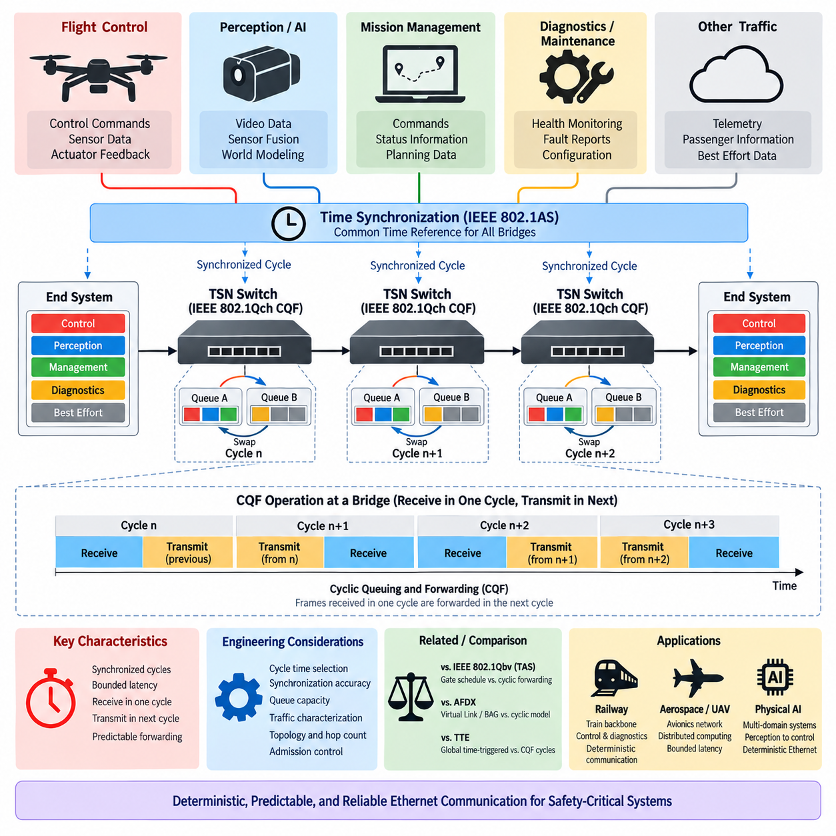
IEEE 802.1Qch Cyclic Queuing and Forwarding (CQF) is a Time-Sensitive Networking (TSN) mechanism designed to provide bounded and predictable Ethernet latency by coordinating frame reception and transmission in repeating cycles. Instead of forwarding frames immediately whenever an output port becomes available, CQF organizes communication into synchronized time intervals. Frames received during one cycle are normally stored and forwarded during the following cycle, creating a controlled progression of traffic through successive network bridges.
The fundamental principle of CQF is often described as receive in one cycle and transmit in the next. Each participating bridge maintains queues whose operation alternates according to a common cycle. While one queue receives frames arriving during the current interval, another queue transmits frames collected during the previous interval. At the cycle boundary, their functions are exchanged. This cyclic behavior separates reception from forwarding and reduces the uncertainty normally introduced by variable queue residence times in conventional Ethernet switching.
CQF depends on synchronized operation across the network. Bridges participating in the deterministic forwarding path must maintain sufficiently aligned cycle boundaries so that frames transmitted by one bridge arrive within the expected receiving cycle of the next bridge. IEEE 802.1AS-based time synchronization can provide the common time reference required for this coordinated behavior. The synchronization requirement means that CQF should be considered together with the network timing architecture rather than as an independent queue-management function.
The CQF cycle time is a fundamental engineering parameter. It must be long enough to accommodate the frames expected during the cycle while considering link transmission time, propagation delay, processing delay, synchronization error, and implementation margin. A very short cycle can reduce latency but increases timing sensitivity and scheduling complexity. A longer cycle provides greater timing tolerance but increases end-to-end delay. Selecting the cycle duration therefore requires balancing deterministic performance, bandwidth utilization, topology, and implementation constraints.
A simplified CQF bridge can be understood as having alternating queue sets associated with each traffic class. During cycle n, one queue receives incoming frames while another queue transmits frames that were received during cycle n−1. When cycle n+1 begins, the receiving queue becomes eligible for transmission and the previously transmitting queue changes role. This repeated queue rotation creates a pipeline in which traffic advances approximately one network hop during each cycle, assuming that the network is engineered according to the required timing conditions.
This pipeline behavior makes end-to-end latency easier to analyze. If a frame traverses several CQF-enabled bridges, its forwarding progress can be related to the number of network hops and the configured cycle duration. Unlike conventional Ethernet, where congestion can produce highly variable queueing delay, CQF constrains when frames are received and forwarded. The resulting latency is therefore associated with the cyclic forwarding structure rather than uncontrolled contention at every individual bridge.
An important advantage of CQF is that deterministic forwarding can be achieved without defining an individual transmission instant for every frame. The network instead establishes repeating forwarding cycles and assigns traffic to controlled queues. This differs from highly detailed time-triggered scheduling in which individual flows may receive explicitly defined transmission windows. CQF can therefore provide a useful architectural compromise between strict temporal scheduling and conventional asynchronous Ethernet forwarding.
CQF is closely related to IEEE 802.1Qbv Time-Aware Shaper (TAS), but the two mechanisms emphasize different aspects of deterministic communication. TAS uses a Gate Control List (GCL) to open and close traffic-class gates at specified times, directly controlling transmission opportunities. CQF focuses on cyclic queueing and forwarding, where frames received during one interval become eligible for transmission during a subsequent interval. Both mechanisms rely on coordinated time behavior and can form part of a broader TSN architecture.
The difference between TAS and CQF can also be viewed from the perspective of schedule complexity. TAS can provide precise control over when different traffic classes use an output link, but detailed gate schedules must be designed and coordinated across the network. CQF uses repeated cycles to structure forwarding behavior, which can simplify latency analysis for suitable traffic patterns. However, this simplicity does not eliminate engineering requirements because cycle duration, synchronization accuracy, queue capacity, traffic load, and topology must still be carefully designed.
Traffic arriving at a CQF bridge must fit within the timing assumptions associated with the receiving cycle. If a frame arrives too late relative to a cycle boundary, it may miss the intended forwarding opportunity and be delayed until a later cycle. This can increase latency beyond the nominal forwarding model. Consequently, propagation delay, transmission delay, clock synchronization error, and processing variation must be bounded sufficiently to ensure that frames are classified into the intended receiving interval.
Queue capacity is another important consideration. Because frames are accumulated during a receiving cycle before being forwarded, the queue must be capable of storing the traffic that can legitimately arrive within that interval. If the traffic exceeds the engineered assumptions, queue overflow or unexpected delay can occur. CQF therefore requires traffic characterization and admission control concepts similar to other deterministic networking mechanisms. Predictability depends not only on time synchronization but also on respecting the assumed traffic envelope.
The cyclic architecture also provides a useful way to isolate deterministic traffic from less critical communication. A TSN network may simultaneously carry control commands, sensor status, diagnostics, maintenance information, perception data, and best-effort traffic. CQF-controlled queues can be used for streams requiring bounded forwarding latency, while other traffic classes can use different scheduling or shaping mechanisms. This enables critical and non-critical communication to share an Ethernet infrastructure while maintaining different quality-of-service requirements.
For railway communication, CQF is relevant because modern Ethernet backbones must combine increasing bandwidth with predictable delivery behavior. Railway systems can contain traction control, braking information, vehicle status, diagnostics, passenger systems, and backbone communication with different timing requirements. Cyclic forwarding provides a model in which critical traffic can progress through the network according to synchronized intervals, making end-to-end timing more structured than ordinary switched Ethernet.
The relationship with earlier railway communication principles is particularly meaningful. Traditional railway networks such as MVB and TCN were designed around controlled communication behavior, while ETB introduced Ethernet into train backbone architectures. TSN mechanisms such as CQF provide a path toward retaining deterministic characteristics while using modern Ethernet technology. CQF does not reproduce older railway buses directly, but it reflects the same engineering objective of controlling communication timing rather than allowing unpredictable network contention.
In aerospace and UAV avionics, CQF can support deterministic communication among distributed computing nodes. Flight-control computers, navigation processors, actuator interfaces, health-monitoring systems, and mission computers may exchange periodic data with different timing requirements. By forwarding selected traffic according to synchronized cycles, CQF can provide bounded communication behavior across multiple Ethernet switches while allowing the physical network to support higher bandwidth than traditional low-speed avionics buses.
A cargo UAV provides a useful example because its communication architecture can contain several computational time scales. Low-level actuator controllers may execute control loops at hundreds or thousands of hertz, while an edge computer performs navigation, perception, planning, or world-model processing at lower frequencies. CQF does not replace the local motor-control network. Instead, it can provide deterministic Ethernet communication between distributed computing domains where bounded delivery time is more important than reproducing the internal control frequency of each subsystem.
This distinction demonstrates that network cycles and control cycles do not necessarily have to be identical. A controller may execute many internal control iterations during one Ethernet communication cycle. The important requirement is that supervisory commands, state updates, and feedback reach their destinations within defined timing bounds. CQF can therefore serve as a deterministic interface between computational layers while CAN, CANopen, EtherCAT, or other local networks continue to handle actuator-level communication where appropriate.
CQF is also relevant to Physical AI systems in which perception, world modeling, planning, motion generation, and low-level control operate at different rates. High-bandwidth perception data may not require the same latency guarantees as motion commands or safety-related state information. A TSN architecture can classify these streams according to their timing requirements, and CQF can provide cyclic forwarding for streams that require predictable multi-hop delivery. This helps separate communication criticality from raw data bandwidth.
The hop-by-hop nature of CQF makes network topology an important part of latency engineering. Adding another bridge to the communication path can introduce another forwarding cycle into the nominal latency model. Therefore, topology changes cannot be treated as purely physical modifications. They may alter the deterministic timing characteristics of the network. Network architecture, switch placement, redundant paths, and communication routes should consequently be evaluated together with the selected CQF cycle time.
Redundancy introduces additional considerations. Safety-critical railway and aerospace systems may use redundant links, switches, or communication paths to tolerate failures. When CQF is combined with redundancy mechanisms, both paths must preserve timing assumptions sufficiently for the receiving application to process replicated or recovered traffic correctly. Other TSN mechanisms can provide frame replication, elimination, filtering, policing, or reliability functions, while CQF contributes predictable forwarding timing as part of the integrated deterministic network.
Verification of a CQF network must examine more than successful packet delivery. Engineers should confirm that frames arrive within the intended cycle, that queue capacities are sufficient, that cycle boundaries remain synchronized, and that the traffic load does not violate the assumptions used during design. End-to-end latency should be evaluated across the complete communication path, including link transmission, bridge forwarding, synchronization error, processing variation, and the number of CQF hops.
Fault and overload behavior should also be analyzed. A deterministic network must define what happens when a node generates more traffic than expected, synchronization quality deteriorates, a frame arrives near a cycle boundary, or a communication path changes because of a network fault. Without appropriate traffic policing and fault management, abnormal traffic can undermine assumptions used to establish deterministic latency. CQF therefore belongs within a broader architecture that includes synchronization supervision, traffic control, diagnostics, and network health monitoring.
Compared with AFDX, CQF introduces a more explicitly time-coordinated forwarding model. AFDX controls traffic through Virtual Links and Bandwidth Allocation Gap (BAG), providing bounded behavior through regulated transmission and switched Ethernet architecture. CQF instead structures forwarding around synchronized cycles and alternating queues. Both technologies seek predictable Ethernet communication, but their timing models, traffic-control mechanisms, configuration methods, and certification approaches are different.
Compared with Time-Triggered Ethernet (TTE), CQF provides deterministic behavior within the broader IEEE TSN ecosystem rather than making globally scheduled time-triggered communication the sole organizing principle. TTE can provide tightly coordinated time-triggered traffic together with other traffic classes, whereas CQF focuses on cyclic forwarding between bridges. The appropriate choice depends on required latency bounds, fault tolerance, certification objectives, topology, ecosystem compatibility, and overall system architecture.
CQF should therefore be understood as one component of deterministic Ethernet rather than a complete solution by itself. IEEE 802.1AS can provide synchronization, IEEE 802.1Qbv can provide time-aware transmission scheduling, and additional TSN mechanisms can address traffic policing, frame preemption, redundancy, and reliability. The combination selected for a particular system depends on whether the primary objective is precise transmission scheduling, bounded multi-hop forwarding, bandwidth protection, fault tolerance, or a combination of these requirements.
The principal value of IEEE 802.1Qch CQF is its transformation of Ethernet forwarding into a predictable cyclic pipeline. Frames are collected during controlled intervals and advanced through the network according to synchronized forwarding cycles, reducing uncertainty caused by arbitrary queueing. For railway, aerospace, cargo UAV, and Physical AI systems, this provides a practical mechanism for connecting distributed computing domains with bounded latency while retaining the bandwidth, scalability, and integration advantages of Ethernet-based communication.

10.03. Time Triggered Ethernet (TTE)
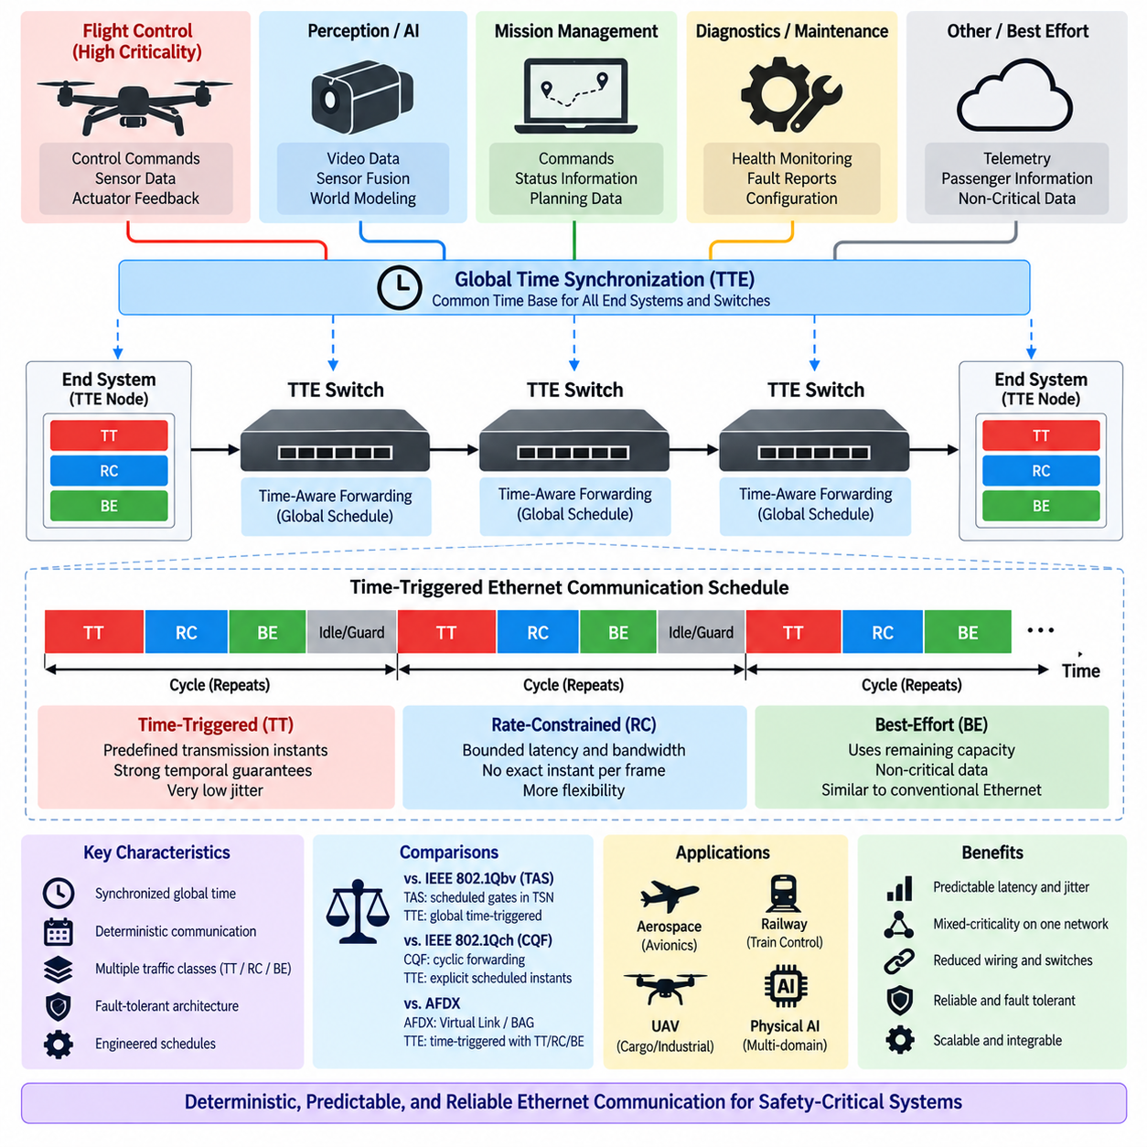
Time-Triggered Ethernet (TTE) is a deterministic Ethernet technology developed for safety-critical distributed systems where communication timing must remain predictable even when multiple traffic classes share the same physical network. Unlike conventional Ethernet, which primarily forwards frames according to availability and priority, TTE introduces a synchronized global time model that allows critical messages to be transmitted at predefined instants. This makes communication timing an explicitly engineered property of the system.
The central concept of TTE is the establishment of a common notion of time among communicating end systems and switches. Participating devices synchronize their local clocks so that scheduled communication activities can occur according to a coordinated temporal plan. Once synchronization is established, critical frames can be transmitted and forwarded at predetermined times. This temporal coordination reduces dependence on runtime contention and variable queueing behavior, allowing communication latency and jitter to be tightly controlled.
TTE commonly distinguishes three traffic classes: Time-Triggered (TT), Rate-Constrained (RC), and Best-Effort (BE) traffic. TT traffic provides the strongest temporal guarantees and is transmitted according to a predefined global schedule. RC traffic provides bounded communication behavior without requiring an exact transmission instant for every frame. BE traffic behaves more like conventional Ethernet and uses network capacity remaining after higher-criticality communication requirements have been satisfied.
Time-Triggered (TT) traffic is intended for communication requiring highly deterministic timing. Transmission opportunities are calculated during system design and incorporated into a global communication schedule. Each participating device knows when relevant TT frames should be transmitted or forwarded. Because these opportunities are predetermined, TT communication can avoid contention with other scheduled critical traffic. This behavior is useful for flight control, distributed control, synchronization-sensitive sensing, and other functions requiring very low jitter.
Rate-Constrained (RC) traffic provides an intermediate service between strictly scheduled TT traffic and ordinary Best-Effort communication. RC traffic is controlled according to defined bandwidth and timing constraints but does not necessarily require globally predetermined transmission instants. It can therefore support functions requiring bounded latency and controlled bandwidth while retaining more flexibility than TT traffic. Health monitoring, status exchange, and some mission-management communication can fit this communication model.
Best-Effort (BE) traffic uses network resources that remain available after deterministic traffic requirements are protected. Diagnostic transfers, maintenance information, configuration data, or other non-critical communication may use this class where strict latency guarantees are unnecessary. Integrating BE traffic with TT and RC traffic allows one Ethernet infrastructure to carry communication with substantially different criticality and timing requirements while preserving deterministic resources for critical functions.
Clock synchronization is fundamental to TTE because the TT communication schedule depends on a consistent global time base. The network must tolerate differences among local clocks and maintain synchronization within limits required by the communication design. Synchronization therefore becomes part of the fault-tolerance architecture rather than merely a convenience for timestamping. If time synchronization deteriorates beyond acceptable bounds, the deterministic assumptions of scheduled communication can be affected.
TTE synchronization mechanisms are designed with safety-critical distributed operation in mind. Multiple devices participate in establishing and maintaining synchronized time, and the architecture can be designed to tolerate certain faulty components or inconsistent timing information. This is particularly important in aerospace systems, where a single timing fault should not necessarily compromise the entire communication architecture. Deterministic communication therefore depends on both temporal coordination and controlled fault containment.
A TTE network generally consists of end systems connected through TTE-capable switches. End systems generate and consume application data, while switches forward frames according to the configured communication policy and temporal schedule. For TT traffic, the forwarding behavior of each network element must be coordinated along the complete communication path. The schedule therefore represents an end-to-end network property rather than an isolated configuration applied independently to individual switch ports.
Schedule design is one of the most important engineering activities in a TTE system. Designers must identify communication streams, message periods, frame sizes, deadlines, routes, redundancy requirements, and dependencies between distributed functions. Transmission opportunities can then be allocated so that critical messages traverse the network without conflicting with other scheduled traffic. The resulting schedule must account for link transmission time, switching delay, propagation delay, synchronization accuracy, and required engineering margins.
The deterministic characteristics of TTE make end-to-end latency easier to analyze than in ordinary switched Ethernet. A TT message follows a predefined temporal path from its transmitting end system through intermediate switches to its destination. Because forwarding opportunities are known in advance, queueing uncertainty can be greatly reduced. The designer can therefore evaluate whether a message reaches its destination within the deadline required by the associated control, monitoring, or safety function.
TTE also supports architectural separation between communication criticality levels. Flight-control commands may use TT communication, system health information may use RC traffic, and maintenance transfers may use BE traffic. These different traffic classes can coexist on the same physical Ethernet infrastructure without being treated as equivalent communication. This capability is especially valuable when reducing wiring, switch count, connector complexity, and network fragmentation is desirable while maintaining temporal isolation for critical functions.
Redundancy is another important aspect of safety-critical TTE architectures. Critical communication can be transmitted through redundant network paths so that a single link or switch failure does not necessarily prevent message delivery. Redundant channels must be designed together with timing requirements because replicated frames should reach their destinations within acceptable temporal bounds. Network redundancy, clock synchronization, schedule design, and fault management therefore form an integrated dependability architecture.
TTE is particularly relevant to aerospace systems because avionics networks combine stringent timing, reliability, fault-containment, and certification requirements. Flight-control computers, navigation systems, actuator interfaces, sensor-processing units, and mission computers may all need to exchange information while maintaining predictable temporal behavior. TTE provides an Ethernet-based architecture in which communication can be organized according to the criticality and timing requirements of these distributed functions.
For cargo UAV systems, TTE can provide a deterministic backbone between major avionics and computing domains. Flight control, navigation, propulsion supervision, actuator coordination, health monitoring, mission management, and high-level computing may operate at different frequencies. TT traffic can protect communication with strict timing requirements, while RC and BE traffic can accommodate less critical information. This allows a common network to support heterogeneous computational workloads without assigning identical timing guarantees to every data stream.
TTE does not imply that every control loop must operate directly over the Ethernet backbone. A motor controller or flight-control actuator may execute internal control loops at hundreds or thousands of hertz using local electronics or dedicated field communication. The TTE backbone can instead carry supervisory commands, synchronized state information, and coordination data between distributed computing domains. This separation prevents network architecture from being unnecessarily coupled to the highest internal control frequency.
The same principle is applicable to Physical AI systems. Perception, world modeling, planning, decision making, motion generation, and actuator control naturally operate at different computational rates. A deterministic backbone can protect timing-sensitive coordination traffic while allowing high-bandwidth or non-critical data to use less restrictive communication classes. TTE can therefore provide temporal separation between computational domains rather than forcing perception, planning, and low-level control into one common execution rate.
Compared with IEEE 802.1Qbv Time-Aware Shaper (TAS), TTE places global time-triggered communication at the center of its architecture. TAS provides scheduled gate control within the broader Time-Sensitive Networking (TSN) framework, allowing selected traffic classes to transmit during configured windows. TTE similarly uses synchronized time for deterministic communication, but its TT traffic model, synchronization architecture, fault-tolerance concepts, and system-level scheduling approach form a more tightly integrated time-triggered communication architecture.
Compared with IEEE 802.1Qch Cyclic Queuing and Forwarding (CQF), TTE provides more explicit control over the transmission timing of critical TT traffic. CQF structures forwarding into synchronized cycles so that frames received during one cycle are typically forwarded during a subsequent cycle. TTE can assign specific scheduled communication opportunities according to a global temporal plan. CQF therefore emphasizes predictable cyclic forwarding, whereas TTE emphasizes globally coordinated time-triggered execution for its most critical traffic.
AFDX provides another useful comparison. AFDX achieves predictable Ethernet communication primarily through Virtual Links, traffic regulation, and Bandwidth Allocation Gap (BAG). It controls bandwidth and isolates communication flows without requiring every critical frame to be transmitted according to a globally synchronized time-triggered schedule. TTE adds a stronger explicit temporal dimension through TT communication, while also supporting less strictly scheduled traffic classes. Both approaches are relevant to deterministic aerospace networking but use different engineering models.
The selection between TTE, AFDX, and TSN mechanisms should therefore be based on system requirements rather than Ethernet bandwidth alone. Required latency and jitter, synchronization accuracy, fault tolerance, redundancy, topology, certification strategy, traffic diversity, hardware ecosystem, and lifecycle constraints all influence the decision. A system requiring strongly coordinated distributed execution may benefit from time-triggered communication, while other systems may achieve sufficient determinism through regulated or cyclic Ethernet mechanisms.
Verification of TTE requires demonstrating that the implemented network behaves according to its temporal design. Engineers must verify synchronization accuracy, schedule execution, end-to-end message latency, redundant path behavior, traffic-class isolation, and operation under fault conditions. The verification process should also consider unexpected traffic, timing disturbances, component failures, and communication overload. Determinism is meaningful only when required timing properties remain valid within the defined operational and fault assumptions.
Configuration management is particularly important because changes to network topology or application communication can affect the global schedule. Adding a node, changing a message period, modifying a route, or increasing frame size may influence transmission opportunities elsewhere in the system. TTE architecture therefore encourages communication requirements to be treated as system-level design data. Network configuration, timing assumptions, application interfaces, and safety requirements should remain traceable throughout development and certification.
The principal value of Time-Triggered Ethernet is its ability to combine synchronized time, deterministic communication, mixed-criticality traffic, and fault-tolerant networking within an Ethernet-based architecture. TT traffic provides tightly controlled temporal behavior, RC traffic supports bounded communication with greater flexibility, and BE traffic accommodates ordinary non-critical data. For railway, aerospace, cargo UAV, and Physical AI systems, this architecture provides a powerful model for connecting distributed computing domains while preserving predictable timing and dependable communication.

10.04. TSN for UAV Avionics
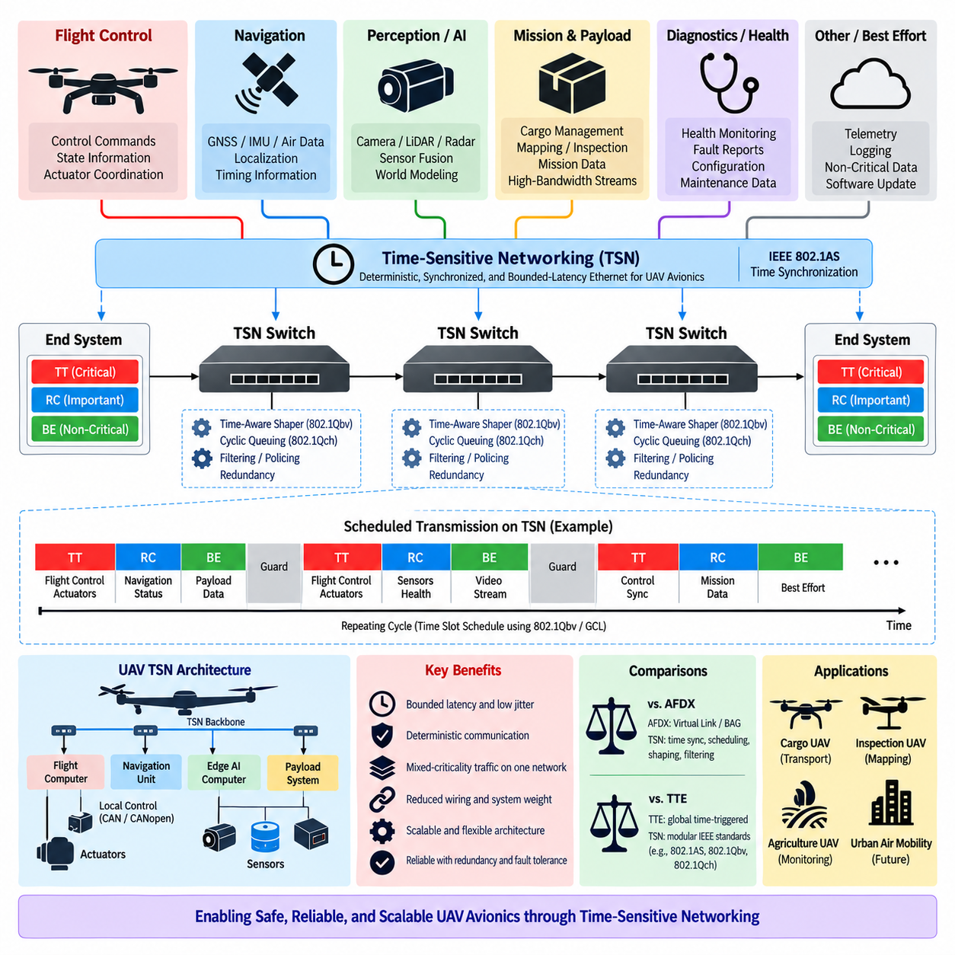
Time-Sensitive Networking (TSN) provides a set of standardized Ethernet mechanisms that can support deterministic, synchronized, and bounded-latency communication in UAV avionics. Modern UAVs increasingly integrate flight-control computers, navigation processors, sensor-fusion systems, mission computers, payload controllers, and high-performance AI processors. TSN allows these heterogeneous systems to share an Ethernet backbone while assigning different timing guarantees to traffic according to operational criticality.
Traditional Ethernet provides high bandwidth and broad interoperability, but ordinary best-effort forwarding cannot by itself guarantee that safety-critical frames will arrive within strict deadlines. Network contention, queueing, and competing high-bandwidth traffic can introduce variable latency and jitter. In UAV avionics, such uncertainty can affect distributed control and coordination. TSN extends switched Ethernet with synchronization, scheduling, traffic shaping, filtering, and reliability mechanisms that make network behavior more predictable.
A practical UAV TSN architecture begins with a common time base shared among participating end systems and Ethernet bridges. IEEE 802.1AS provides time synchronization mechanisms that allow distributed nodes to maintain closely coordinated clocks. Once devices operate according to synchronized time, network transmission can be organized around deterministic schedules or cycles. The common time reference can also support coordinated sensing, timestamp alignment, sensor fusion, control execution, and distributed event correlation.
IEEE 802.1Qbv Time-Aware Shaper (TAS) can provide scheduled transmission opportunities for critical UAV traffic. Each traffic class is associated with gates controlled by a Gate Control List (GCL). Flight-control or actuator-coordination traffic can receive protected transmission windows, while perception, diagnostics, mission data, or best-effort traffic uses other intervals. This temporal separation prevents lower-criticality traffic from unexpectedly consuming link access needed by deadline-sensitive communication.
IEEE 802.1Qch Cyclic Queuing and Forwarding (CQF) provides another deterministic forwarding model. Frames received during one synchronized cycle are normally forwarded during a subsequent cycle, creating a predictable pipeline across Ethernet bridges. For UAV networks containing several switch hops, this approach can make multi-hop latency easier to analyze. The network designer can relate communication delay to cycle duration, topology, forwarding behavior, and synchronization accuracy instead of relying on uncontrolled queueing behavior.
TSN should not be interpreted as requiring every UAV communication stream to have identical timing characteristics. Flight-control state, actuator commands, navigation information, perception data, health monitoring, payload data, and maintenance traffic naturally have different requirements. The network should therefore classify streams according to criticality, period, deadline, frame size, bandwidth, and reliability requirements. Deterministic resources can then be reserved for the streams that genuinely require them while other traffic uses remaining capacity efficiently.
This mixed-criticality capability is especially important as UAV computing architectures become more heterogeneous. A flight-control processor may execute deterministic control software, while an edge GPU performs vision, object detection, world modeling, or AI-based planning. Payload systems may simultaneously generate large camera or sensor streams. TSN allows these functions to coexist on an Ethernet infrastructure without treating a high-bandwidth perception stream as equivalent in timing importance to a flight-control command.
The separation between the avionics backbone and local actuator control is equally important. Motor controllers, servo drives, or propulsion controllers may execute internal loops at hundreds or thousands of hertz using dedicated electronics and local communication such as CAN, CANopen, or another real-time interface. The TSN backbone does not need to reproduce every internal control iteration. Instead, it can provide bounded communication for supervisory commands, state updates, synchronization, and coordination between higher-level distributed subsystems.
For example, a UAV edge computer may perform perception and planning at tens of hertz while a lower-level flight controller executes stabilization loops at substantially higher frequencies. TSN can provide predictable communication between these computational domains without forcing both systems into the same execution rate. This creates a layered architecture in which high-level intelligence, deterministic flight control, and actuator-level regulation operate at appropriate time scales while exchanging information through explicitly engineered interfaces.
Sensor integration is another strong application for TSN. Cameras, LiDAR, radar, GNSS, IMU, and other sensors can generate data with very different bandwidth and timing characteristics. Accurate timestamps and synchronized acquisition can improve the temporal consistency of sensor fusion. High-bandwidth sensor streams may receive controlled network resources, while compact but highly time-sensitive navigation or control information receives stronger latency protection. The network therefore becomes part of the sensor architecture rather than merely a transport medium.
Navigation functions can particularly benefit from synchronized communication. GNSS, IMU, air-data sensors, vision-based localization, and other navigation sources may need to be correlated precisely in time. A common network time reference can reduce ambiguity when measurements generated by different devices are fused. However, synchronization accuracy must be treated as an engineering requirement, because timestamp consistency, network scheduling, and application execution all contribute to the final temporal accuracy of the navigation solution.
Mission and payload systems create another important traffic domain. Cargo management, inspection cameras, mapping sensors, communication payloads, or mission computers may generate substantial data without requiring flight-control-level latency. TSN enables this traffic to share the avionics backbone while preventing it from interfering with more critical communication. This is particularly valuable for cargo UAVs, where flight systems, payload management, mission orchestration, health monitoring, and high-performance computing may coexist within one vehicle.
Network topology strongly influences deterministic performance. A communication path passing through several Ethernet switches accumulates transmission, propagation, forwarding, and scheduling delays. The designer must therefore analyze end-to-end timing rather than evaluating each link independently. Switch placement, redundant paths, link speeds, traffic routes, and synchronization distribution should be considered together. Adding a switch or rerouting a stream can alter the timing assumptions used for critical communication.
Redundancy is important because a cargo or safety-critical UAV should not depend unnecessarily on a single communication path. Redundant Ethernet links, switches, or network channels can be combined with suitable TSN reliability mechanisms so that critical information remains available after certain failures. Redundancy must nevertheless be engineered together with timing because duplicated or recovered frames still need to satisfy application deadlines. Reliability and determinism therefore form interconnected network requirements.
Traffic policing and filtering are also essential in mixed-criticality avionics. A malfunctioning camera, payload computer, or software process should not be able to generate excessive traffic that disrupts flight-critical communication. TSN mechanisms can constrain traffic according to defined assumptions and isolate abnormal behavior. This contributes to fault containment by preventing a non-critical subsystem from consuming network resources beyond its allocated envelope and disturbing deterministic traffic elsewhere in the vehicle.
TSN scheduling requires detailed communication requirements. Each important stream should have a defined source, destination, route, period, maximum frame size, deadline, traffic class, and reliability requirement. These parameters can be used to construct gate schedules, forwarding cycles, queue assignments, and bandwidth allocations. The resulting network configuration should be treated as part of the UAV system architecture because changes to application behavior or network topology can invalidate previously established timing guarantees.
Verification must demonstrate end-to-end behavior under realistic operating conditions. It is insufficient to verify that an individual Ethernet link achieves its nominal bandwidth. Testing should evaluate latency, jitter, synchronization error, queue behavior, traffic interference, overload conditions, redundant-path operation, and relevant component failures. Critical streams should continue to satisfy their deadlines within the assumptions established for normal and fault conditions. This evidence becomes particularly important when network behavior contributes to a safety argument.
Compared with AFDX, TSN offers a broader family of Ethernet mechanisms for synchronization, scheduling, shaping, filtering, and reliability. AFDX provides deterministic aerospace networking through Virtual Links, controlled bandwidth, and Bandwidth Allocation Gap (BAG). TSN can instead combine mechanisms such as synchronized time, time-aware scheduling, and cyclic forwarding. The technologies therefore represent different approaches to achieving controlled Ethernet behavior rather than a simple progression from an older network to a newer one.
Compared with Time-Triggered Ethernet (TTE), TSN provides deterministic communication through a modular collection of IEEE Ethernet standards. TTE places globally coordinated time-triggered communication and mixed traffic classes within a tightly integrated architecture. TSN allows designers to select mechanisms according to system requirements, such as IEEE 802.1AS synchronization, IEEE 802.1Qbv scheduling, or IEEE 802.1Qch cyclic forwarding. This flexibility can be valuable, but it also places responsibility on system engineers to construct and verify the complete deterministic architecture.
TSN can also support the evolution toward Physical AI-enabled UAVs. Future UAVs may combine conventional flight-control functions with world models, vision-language-action systems, adaptive planning, fleet intelligence, and high-bandwidth multimodal sensing. These workloads increase network traffic while introducing multiple computational time scales. TSN can provide deterministic boundaries between safety-critical control, real-time coordination, AI processing, mission data, and non-critical communication without requiring every workload to use an identical communication model.
In a cargo UAV, this can produce a layered communication architecture. Local controllers perform fast actuator regulation, flight computers execute deterministic vehicle control, edge computing nodes perform perception and intelligent decision making, and mission systems coordinate cargo and operational objectives. A TSN Ethernet backbone can connect these domains while allocating network resources according to their timing and criticality requirements. The resulting architecture preserves local real-time control while enabling higher-level computing to scale in bandwidth and complexity.
Cybersecurity must also be considered because deterministic networking does not automatically provide protection against malicious communication. Authentication, secure configuration, network segmentation, software integrity, and monitoring remain necessary. Security mechanisms must be designed so that their computational and communication overhead does not violate timing requirements. In critical UAV systems, safety, cybersecurity, synchronization, and deterministic communication should therefore be analyzed as interacting architectural concerns rather than isolated engineering disciplines.
The principal value of TSN for UAV avionics is its ability to transform high-bandwidth Ethernet into a communication infrastructure whose timing behavior can be explicitly engineered. Synchronization establishes a common temporal foundation, scheduling protects critical transmission opportunities, cyclic forwarding can bound multi-hop behavior, and traffic-control mechanisms help isolate competing workloads. Together, these capabilities provide a scalable foundation for integrating flight control, navigation, sensors, mission systems, cargo functions, and Physical AI computing within future UAV architectures.

10.05. TTE vs AFDX Comparison
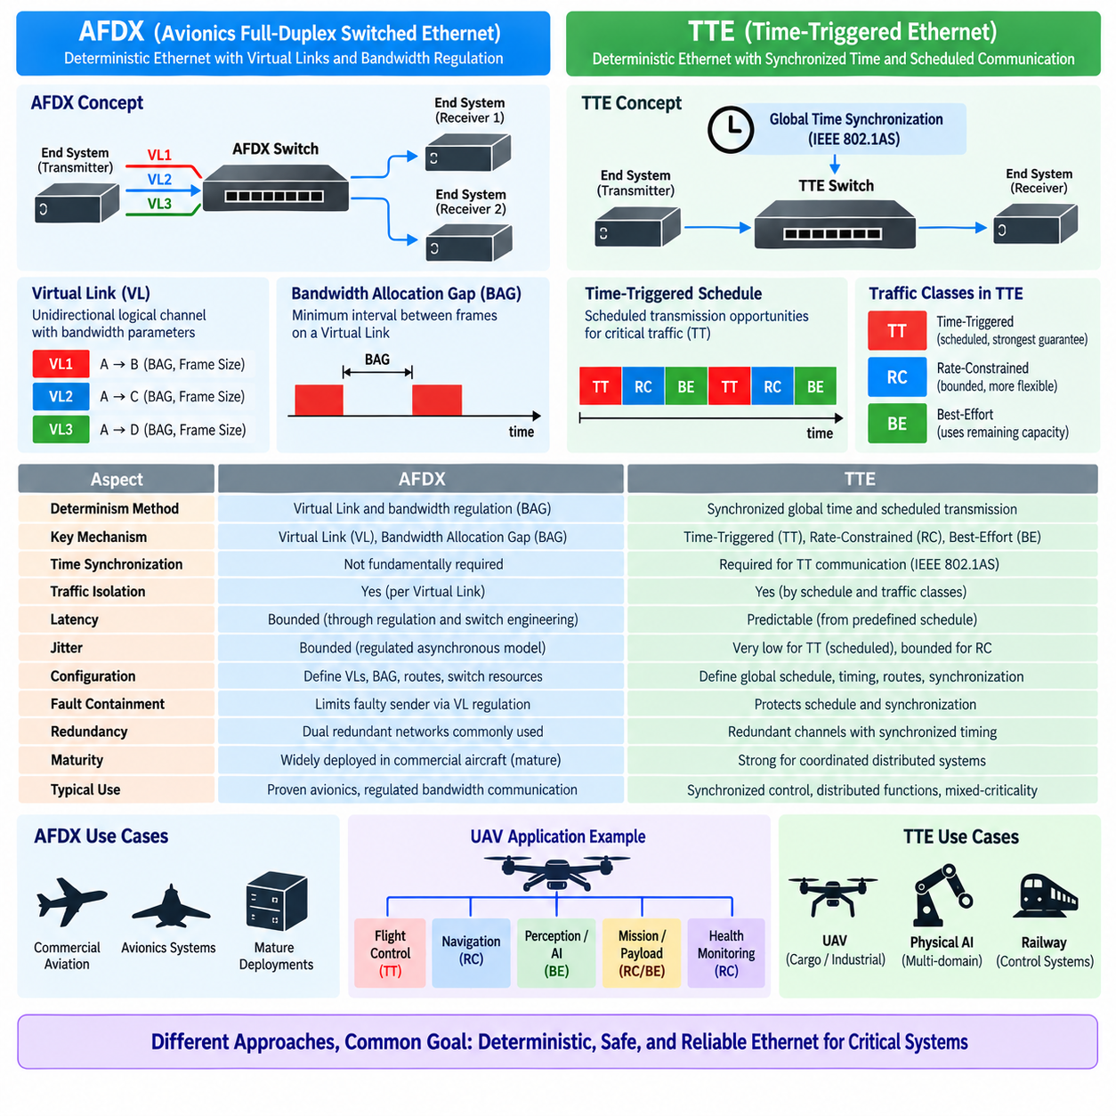
Time-Triggered Ethernet (TTE) and Avionics Full-Duplex Switched Ethernet (AFDX) are deterministic Ethernet technologies developed to support communication in safety-critical distributed systems. Both replace uncontrolled Ethernet contention with engineered communication behavior, but they achieve predictability through different principles. AFDX primarily regulates traffic through Virtual Links and bandwidth constraints, whereas TTE introduces synchronized global time and scheduled transmission for its most timing-critical traffic.
AFDX was developed as an Ethernet-based avionics network capable of providing predictable communication while retaining familiar switched Ethernet principles. Communication is organized around unidirectional logical channels called Virtual Links (VLs). Each Virtual Link connects one transmitting end system to one or more receiving end systems and is assigned parameters controlling its bandwidth and transmission behavior. This structure provides traffic isolation and makes network resource utilization analyzable.
A central AFDX parameter is the Bandwidth Allocation Gap (BAG), which defines the minimum interval between successive frames transmitted on a Virtual Link. Combined with the maximum frame size, the BAG constrains the bandwidth that each Virtual Link can inject into the network. Because every communication flow is regulated according to predefined assumptions, switches can be engineered to provide bounded latency without requiring all network devices to share a globally scheduled transmission timeline.
TTE approaches determinism differently. Its most critical communication uses Time-Triggered (TT) traffic, for which transmission and forwarding opportunities are defined according to a synchronized global schedule. End systems and switches maintain a coordinated notion of time and execute communication actions at predefined temporal positions. Rather than primarily controlling how frequently a source may transmit, TTE can determine when critical communication should occur within the global communication schedule.
This distinction produces different models of temporal predictability. AFDX provides bounded communication behavior by regulating traffic rates, controlling Virtual Links, and engineering switch resources so that contention remains within known limits. TTE can reduce contention for TT traffic more directly by allocating non-conflicting transmission opportunities before runtime. Consequently, AFDX determinism is strongly associated with constrained asynchronous traffic, while TTE adds explicitly scheduled synchronous communication.
TTE also supports Rate-Constrained (RC) and Best-Effort (BE) traffic in addition to TT communication. RC traffic provides bounded communication without requiring an exact scheduled transmission instant for every frame, conceptually addressing requirements closer to rate-regulated networking. BE traffic uses network capacity without the strongest deterministic guarantees. TTE can therefore combine tightly scheduled control communication and more flexible data traffic on the same physical infrastructure.
Time synchronization represents one of the clearest architectural differences. AFDX does not fundamentally depend on a network-wide synchronized global clock to enforce its Virtual Link and BAG model. TTE's TT communication, in contrast, requires participating devices to maintain a sufficiently consistent global time reference. Clock synchronization is consequently an integral part of TTE's deterministic and fault-tolerant architecture rather than merely an application-level service.
The different timing models influence network configuration. An AFDX design defines Virtual Links, BAG values, maximum frame sizes, routes, switch resources, and redundancy assumptions. A TTE design must additionally construct and maintain a global communication schedule for TT traffic. Message periods, deadlines, routes, transmission opportunities, synchronization assumptions, and interactions with other traffic classes must be considered together. TTE can therefore provide tighter temporal coordination at the cost of greater schedule dependency.
End-to-end latency is predictable in both architectures, but the reasoning process differs. In AFDX, latency analysis considers traffic regulation, competing Virtual Links, switch forwarding, frame sizes, link utilization, and topology. In TTE TT communication, transmission and forwarding opportunities can be known before runtime, reducing variable queueing effects. The resulting latency can be closely associated with the configured temporal schedule and communication path.
Jitter also illustrates the architectural distinction. AFDX can bound variation by controlling source transmission and network traffic, but frames still operate within a regulated asynchronous switching model. TTE TT traffic is transmitted according to predefined temporal positions, allowing very low communication jitter when synchronization and schedule assumptions are maintained. This characteristic can be valuable for tightly coordinated distributed control and synchronized sensing.
Both technologies place strong emphasis on redundancy. AFDX commonly employs physically redundant networks so that frames can be transmitted through independent paths. Receiving systems can use valid information from either channel, reducing dependence on a single communication path. TTE can likewise use redundant channels and replicated communication, but redundancy can be integrated with its synchronized timing and fault-tolerance model so that both spatial and temporal behavior are engineered together.
Fault containment is important in both architectures. AFDX limits the effect of a malfunctioning transmitter by regulating the traffic associated with configured Virtual Links and by controlling network resources. TTE must additionally protect the global timing model from faulty timing participants and ensure that communication does not violate scheduled temporal boundaries. The fault model therefore extends beyond excessive data transmission to include faults capable of disturbing synchronization or scheduled execution.
AFDX has a major advantage in its established aerospace deployment history. Its architecture has been used in large commercial aircraft and provides a mature engineering model for deterministic switched Ethernet avionics. Development processes, network analysis techniques, hardware ecosystems, and certification experience have accumulated around this approach. For systems where proven aerospace deployment and established certification practices are dominant considerations, this maturity can be highly significant.
TTE is attractive where stronger temporal coordination among distributed functions is required. A globally synchronized network can support deterministic control communication, synchronized sensor acquisition, coordinated computation, and mixed-criticality integration. This becomes particularly relevant as avionics architectures incorporate increasingly distributed computing and autonomous functions. However, stronger temporal coordination also means that schedule generation, synchronization, configuration management, and verification become central system-engineering activities.
The technologies therefore differ in how they respond to architectural change. In AFDX, adding or modifying a Virtual Link requires re-evaluating bandwidth, routing, switch loading, and latency assumptions. In TTE, modifying a TT message can affect the global communication schedule and potentially influence transmission opportunities elsewhere. Neither architecture allows unrestricted change without analysis, but TTE's explicit temporal schedule can create stronger coupling between communication configuration and system timing.
Bandwidth efficiency cannot be judged simply by comparing nominal Ethernet link speeds. AFDX reserves communication capacity indirectly through Virtual Link traffic constraints and network engineering. TTE reserves temporal opportunities for scheduled TT communication while allowing RC and BE traffic to use other resources. Actual efficiency depends on traffic characteristics, schedule design, topology, redundancy, frame sizes, required margins, and the amount of capacity intentionally reserved for deterministic operation.
For flight-control communication, TTE can be advantageous when distributed nodes require precisely coordinated transmission and very low jitter. AFDX can still provide bounded latency suitable for many avionics functions, but its BAG-based regulation does not inherently assign an exact global transmission instant to each critical frame. The choice therefore depends on whether bounded delivery is sufficient or whether the system requires communication to participate directly in a globally coordinated temporal execution model.
For high-bandwidth mission and payload traffic, both architectures require careful separation between critical and less critical data. AFDX can assign different Virtual Links and bandwidth constraints to individual communication flows. TTE can classify traffic as TT, RC, or BE according to temporal requirements. In either case, large sensor, maintenance, or payload transfers must not compromise resources reserved for flight-critical communication.
Cargo UAVs provide a useful context for comparing the two approaches. Flight control, navigation, propulsion supervision, payload management, health monitoring, mission computing, and AI processing may coexist within one vehicle. AFDX offers an aerospace-proven model based on regulated Virtual Links, while TTE offers stronger synchronized scheduling for functions requiring temporal coordination. The appropriate architecture depends on certification goals, system scale, timing requirements, hardware availability, and integration strategy.
Physical AI introduces additional communication requirements because perception, world modeling, planning, and intelligent decision making generate high-bandwidth and computationally irregular workloads. These workloads should not be allowed to disturb deterministic flight communication. AFDX can isolate them through Virtual Link and bandwidth engineering, while TTE can separate critical TT traffic from RC or BE workloads. In both architectures, communication criticality should remain independent from raw data volume.
Neither TTE nor AFDX replaces local real-time actuator control. Motor controllers, servo drives, and propulsion controllers may continue to execute fast internal loops over local electronics or protocols such as CAN or CANopen. The avionics Ethernet backbone primarily coordinates distributed computers and subsystems. This layered approach allows high-frequency local control to remain close to the actuator while deterministic Ethernet handles bounded communication between higher-level domains.
Verification strategies reflect the different deterministic models. AFDX verification focuses strongly on Virtual Link configuration, BAG compliance, bandwidth allocation, routing, switch behavior, redundancy, and worst-case latency. TTE verification must additionally demonstrate synchronization accuracy, correct execution of the global schedule, temporal isolation, and behavior under timing faults. Both require end-to-end analysis rather than relying solely on nominal Ethernet performance.
The comparison should therefore not be reduced to the claim that TTE is newer and consequently superior to AFDX. AFDX provides a mature, well-established deterministic avionics networking approach with substantial aerospace experience. TTE provides a different architectural model centered on synchronized time-triggered communication and mixed traffic classes. Their relative value depends on system requirements, certification strategy, integration complexity, required temporal precision, fault tolerance, and lifecycle constraints.
A future UAV architecture may also combine concepts rather than treating deterministic networking as a single universal solution. Legacy avionics domains may retain AFDX or other established interfaces, while newer computing domains adopt synchronized Ethernet technologies. Gateways can provide controlled boundaries between these networks, although gateway latency, failure behavior, timing conversion, and certification impact must then be analyzed as part of the complete communication architecture.
The fundamental difference can therefore be summarized through the resource each architecture controls most explicitly. AFDX primarily controls communication flows and bandwidth through Virtual Links and BAG regulation, producing bounded behavior within a switched Ethernet network. TTE additionally controls time itself as a network resource by scheduling critical communication against a synchronized global clock. Both can provide deterministic avionics communication, but they reach that objective through fundamentally different temporal architectures.
For railway, aerospace, cargo UAV, and advanced Physical AI platforms, the engineering decision should begin with required communication behavior rather than protocol preference. If established aerospace deployment, regulated bandwidth, and Virtual Link isolation dominate the requirements, AFDX provides a strong architecture. If globally synchronized execution, extremely low jitter, and tightly coordinated distributed functions dominate, TTE provides additional capabilities. The final choice must balance determinism, certification, fault tolerance, complexity, scalability, and long-term system evolution.

