Volume 08. Railway and Aerospace Protocols

Chapter 04. TCN Architecture

04.01. TCN Full Architecture
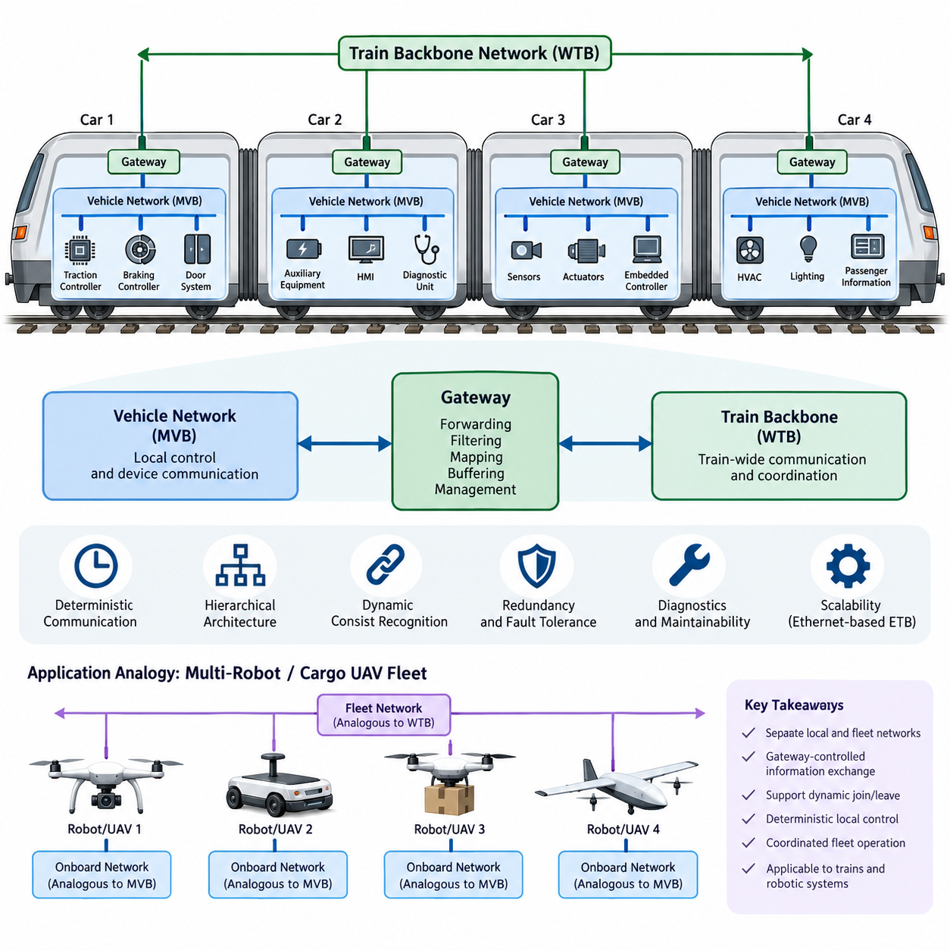
The Train Communication Network (TCN) is a hierarchical communication architecture standardized within the IEC 61375 family for exchanging operational, control, diagnostic, and passenger-related information throughout a railway vehicle or complete train. Its fundamental architectural principle is to divide communication into a train-level backbone and vehicle-level networks. This separation allows individual vehicles to maintain their own internal communication while participating in a dynamically configured train-wide network.
At the highest level, the TCN architecture connects multiple railway vehicles through a train backbone network. In the classical architecture, the Wire Train Bus (WTB) performs this function by extending communication across vehicles that may be mechanically coupled or uncoupled during operation. Each vehicle or consist can therefore become a network participant, while the backbone provides the communication path required for train-wide control, supervision, status distribution, and coordinated operation.
Inside each vehicle, the Multifunction Vehicle Bus (MVB) provides communication among distributed electronic devices. Typical participants include traction controllers, braking controllers, door systems, auxiliary equipment, diagnostic units, human-machine interfaces, and other embedded control devices. MVB is designed for predictable communication behavior and supports cyclic process data together with other information required by distributed railway control systems.
The complete TCN architecture can therefore be understood as a network of networks. Vehicle-level MVB segments organize local devices, while WTB connects those vehicle networks into a train-wide communication domain. Gateways form the architectural boundary between these domains. Rather than treating every device as a direct participant on the train backbone, the gateway transfers selected information between local vehicle communication and train-level communication according to defined routing and application requirements.
This hierarchical organization provides an important form of functional containment. High-frequency information required only inside one vehicle can remain on its local MVB instead of consuming train-backbone communication capacity. Conversely, information that affects coordinated train behavior can be transferred through the gateway and distributed across the WTB. The architecture consequently separates local control traffic from train-wide information while preserving controlled communication between both domains.
WTB has an additional architectural responsibility because railway consists can change when vehicles are coupled or uncoupled. The train network must recognize its current composition and establish communication relationships that correspond to the actual physical formation. Train inauguration and consist recognition mechanisms therefore allow the communication architecture to adapt to a changing topology, giving the classical TCN a dynamic structural characteristic that differs from many permanently wired industrial networks.
Communication behavior within TCN is closely associated with deterministic operation. Railway control systems require important process information to be transferred within bounded and predictable timing conditions rather than merely achieving high average throughput. Cyclic process-data exchange supports this objective by providing repeated transmission of operational variables. Network scheduling, controlled access, and defined communication behavior allow distributed controllers to operate with a known temporal relationship.
The architecture also accommodates information whose timing characteristics differ from continuously exchanged control variables. Process data may represent states such as speed, braking demand, door status, traction commands, or equipment conditions, whereas diagnostic and configuration information may be exchanged less frequently. Separating communication services according to their operational purpose prevents the network from being viewed simply as a generic data pipe and reinforces its role as part of the distributed control architecture.
A TCN gateway is consequently more than a physical interface between two communication media. It represents a system boundary at which information from one network domain is made available to another. Gateway functions can include forwarding, filtering, mapping, buffering, and management of communication relationships. Because failures or incorrect data propagation at this boundary can influence multiple vehicles, gateway design must consider deterministic behavior, fault handling, diagnostics, and system-level availability.
The hierarchical structure also improves maintainability and fault localization. A communication problem inside one vehicle can initially be investigated within its local network, while failures involving several vehicles can be examined at the backbone or gateway level. Diagnostic information can be propagated through the architecture without requiring every diagnostic tool to connect directly to every device. This layered organization therefore supports both operational communication and systematic maintenance of complex rolling stock.
Redundancy and fault tolerance can be incorporated according to the reliability requirements of the railway application. Critical communication paths may employ redundant interfaces, duplicated network paths, or equipment-level redundancy so that a single communication fault does not immediately eliminate essential functions. The precise implementation depends on vehicle architecture and safety requirements, but the TCN concept provides a structured framework in which communication availability can be engineered at several architectural levels.
Modern railway networking extends the original TCN concept beyond the classical WTB and MVB combination. Ethernet-based technologies such as the Ethernet Train Backbone (ETB) provide substantially greater bandwidth for modern applications, while preserving the architectural distinction between train-level and consist- or vehicle-level communication. This evolution enables video, advanced diagnostics, passenger information, condition monitoring, and software-intensive functions to coexist with operational communication requirements.
Within such modern implementations, the essential TCN idea remains hierarchical integration rather than dependence on one particular physical bus. A train contains distributed devices, those devices belong to local communication domains, local domains are connected through gateways, and a backbone integrates the complete train. Technologies may evolve from MVB and WTB toward Ethernet-based networks, but deterministic behavior, topology management, interoperability, diagnostics, and controlled information exchange remain central architectural concerns.
TCN can also be interpreted as a useful reference architecture for distributed robotic systems. An autonomous mobile robot or cargo UAV contains sensors, actuators, controllers, power-management devices, and embedded computers that require local deterministic communication, while multiple platforms may need a higher-level coordination network. The railway distinction between local vehicle networks and a train backbone therefore resembles the separation between platform-internal control networks and fleet-level communication.
For cargo UAV or multi-robot architectures, the analogy is particularly useful when platforms can dynamically join or leave an operational group. The TCN concepts of consist recognition, hierarchical networking, gateway-controlled information exchange, deterministic local control, and coordinated backbone communication provide design principles for such systems. The technologies themselves need not be copied directly; rather, the architectural lessons can guide robust separation of local control, platform integration, and fleet coordination.

04.02. MVB/WTB Integration
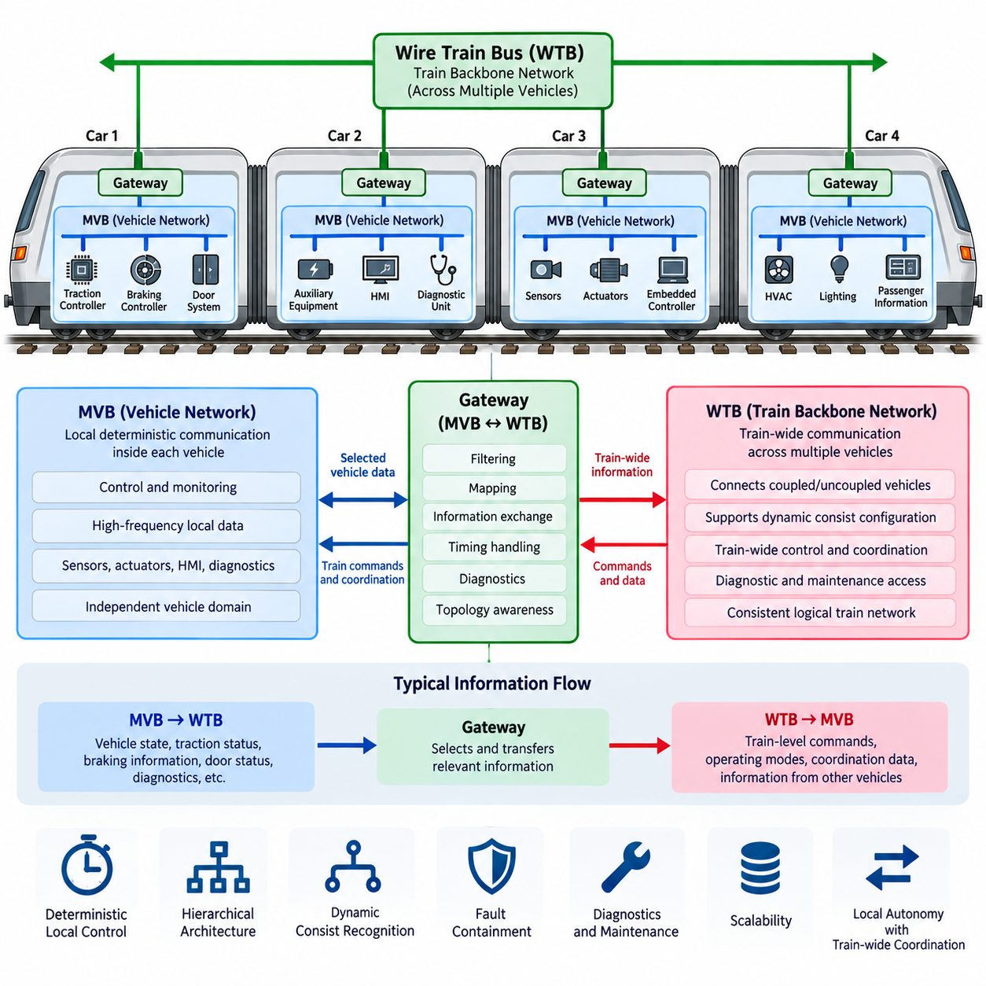
The integration of the Multifunction Vehicle Bus (MVB) and Wire Train Bus (WTB) forms the classical hierarchical structure of the Train Communication Network (TCN). MVB provides communication among distributed devices inside a railway vehicle, while WTB extends communication across multiple coupled vehicles. Their integration allows locally controlled equipment to participate in coordinated train-wide functions without requiring every device to communicate directly on the train backbone.
Within each vehicle, MVB establishes a deterministic communication domain for controllers, sensors, actuators, diagnostic equipment, and other electronic subsystems. Traction control, braking, doors, auxiliary systems, and human-machine interfaces can exchange process and supervisory information through this local network. The vehicle therefore operates as a structured communication domain whose internal traffic can remain largely independent from backbone communication.
WTB operates at the higher architectural level and connects individual vehicles or consists into a complete train communication system. Unlike the relatively stable network configuration inside a vehicle, the train-level topology can change whenever vehicles are coupled, uncoupled, or rearranged. WTB must consequently support communication across these changing physical formations while maintaining a consistent logical representation of the train network.
The connection between MVB and WTB is normally established through a gateway that participates in both communication domains. On one side, the gateway exchanges information with devices or functions available through the local MVB. On the other side, it communicates with other train-level nodes through WTB. This dual relationship enables the gateway to act as the controlled information boundary between vehicle-level and train-level communication.
Gateway integration does not mean that all MVB traffic is automatically forwarded to WTB. Most high-frequency local control information may remain within the vehicle because it has no relevance to other vehicles. Only information required for train-wide operation is transferred across the architectural boundary. This filtering principle reduces unnecessary backbone traffic and prevents local implementation details from being exposed throughout the entire train.
Typical information transferred from MVB toward WTB includes vehicle operating states, traction availability, braking information, door conditions, diagnostic status, and other data required by distributed train functions. Information traveling in the opposite direction may include train-level commands, operating modes, coordination information, and data originating from other vehicles. The gateway therefore supports controlled bidirectional information exchange rather than simple electrical interconnection.
The MVB-WTB integration also separates communication according to temporal scope. Fast control loops that depend primarily on equipment located inside one vehicle can remain on the local MVB, while information requiring coordination among several vehicles is propagated through WTB. This hierarchical traffic organization allows the communication architecture to preserve deterministic local behavior while supporting synchronized train-level operation across physically separated vehicles.
Process data is particularly important within this integrated architecture because distributed controllers require regularly updated operating variables. Cyclic exchange can provide predictable availability of selected information, allowing receiving functions to determine when updated values should be available. When process information crosses the MVB-WTB boundary, gateway behavior must preserve the timing assumptions required by the train-level application as far as the architecture requires.
The integration becomes more complex because WTB must accommodate changes in train composition. When vehicles are coupled or separated, the train network must identify the resulting formation before reliable train-wide communication relationships can be established. Train inauguration and consist recognition therefore interact directly with gateway operation. A gateway must understand its position and communication relationships within the currently recognized train configuration.
This dynamic configuration capability distinguishes MVB-WTB integration from many fixed industrial network installations. An MVB segment can represent a relatively persistent vehicle-level system, while its relationship with other vehicle networks may change during train formation. WTB provides the mechanism for creating the train-wide communication structure, and gateways connect otherwise independent vehicle domains according to the currently established consist topology.
Fault containment is another major benefit of the hierarchical arrangement. A malfunctioning local device or communication problem does not necessarily need to propagate beyond its MVB domain. Gateways can limit which information crosses into WTB, while diagnostic mechanisms help identify whether a fault belongs to a local vehicle network, gateway interface, or train backbone. This separation simplifies systematic troubleshooting of large distributed railway systems.
At the same time, gateway failures require careful consideration because the gateway represents a critical connection between communication levels. If the gateway becomes unavailable, local MVB functions may continue operating while train-level access to those functions can be degraded or lost. System architecture must therefore consider communication availability, fault detection, recovery behavior, redundancy, and the consequences of losing communication between a vehicle and the train backbone.
Diagnostics benefit significantly from MVB-WTB integration. Equipment-level status can be collected within a vehicle, aggregated or mapped by the gateway, and made available to train-level diagnostic functions. Maintenance personnel can consequently observe distributed subsystem conditions without independently accessing every electronic device. The same architecture supports identification of communication failures by distinguishing local network conditions from backbone and inter-vehicle communication problems.
From a system-engineering perspective, the gateway also provides an abstraction boundary. Train-level applications do not necessarily need detailed knowledge of every local device or internal MVB communication relationship. Instead, selected vehicle functions can be represented through defined train-level information. This abstraction reduces coupling between local implementation and train-wide operation, making vehicle integration and subsystem evolution easier to manage.
The MVB-WTB architecture demonstrates how heterogeneous communication layers can cooperate without collapsing into one unrestricted network. MVB specializes in deterministic vehicle-level communication, WTB provides dynamically configurable train-level connectivity, and gateways control interaction between them. Together they create a scalable architecture in which local autonomy, train-wide coordination, diagnostics, topology management, and communication containment can coexist within the same TCN framework.
The same architectural principle can provide useful guidance for distributed robotic and cargo UAV systems represented elsewhere in the broader robotics electrical architecture. A robot or UAV may maintain deterministic onboard communication among controllers and actuators while a higher-level fleet network coordinates multiple platforms. A gateway or edge computer can then control which local states and commands cross between platform-level and fleet-level communication domains.

04.03. TCN Gateway Design
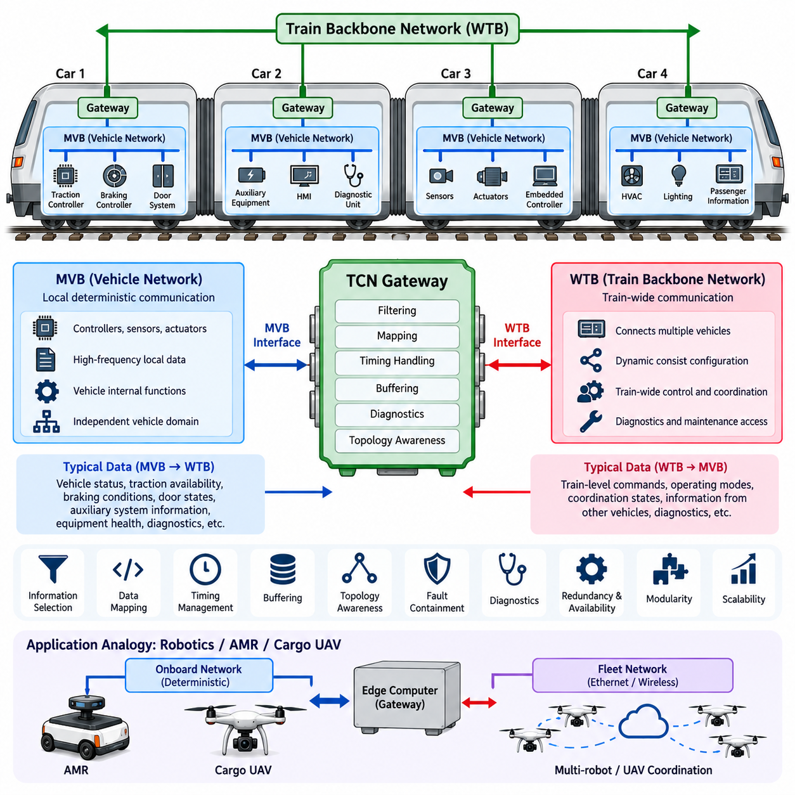
A Train Communication Network gateway is the architectural element that interconnects communication domains within the hierarchical TCN structure. In the classical architecture, it commonly provides the controlled interface between a vehicle-level Multifunction Vehicle Bus (MVB) and the train-level Wire Train Bus (WTB). Its purpose is not simply to repeat traffic between networks, but to determine how selected operational information is exchanged across communication boundaries.
The gateway typically contains interfaces for both network domains and communication-processing functions between them. The MVB-facing side communicates with controllers, sensors, actuators, diagnostic equipment, and other vehicle devices, while the WTB-facing side participates in train-wide communication. Internal processing connects these interfaces through controlled data-transfer mechanisms so that each network can retain its own communication characteristics.
A fundamental gateway design principle is information selection. Most vehicle-level traffic does not need to leave the local MVB because high-frequency signals associated with internal control may only be relevant to equipment within that vehicle. The gateway therefore identifies information required by train-level functions and transfers only appropriate data to WTB, reducing unnecessary backbone traffic and maintaining separation between local and global communication domains.
Data mapping is required because information used within a vehicle may need a different representation when exposed to train-wide applications. The gateway can associate local variables with defined train-level information objects, ensuring that receiving systems interpret the transferred values consistently. This mapping establishes an abstraction boundary between internal vehicle implementation and the logical information expected by other vehicles or train-level control functions.
Traffic traveling from MVB toward WTB can include vehicle status, traction availability, braking conditions, door states, auxiliary-system information, equipment health, and diagnostic indicators. In the opposite direction, the gateway can distribute train-level operating commands, coordination states, mode information, and selected data originating from other vehicles. Bidirectional transfer must remain controlled so that inappropriate information does not cross domain boundaries.
Timing behavior is an important aspect of gateway design because TCN supports distributed functions that depend on predictable communication. Local MVB process data may be updated cyclically, while WTB communication follows train-level communication behavior. The gateway must therefore manage the temporal relationship between incoming and outgoing data, including acquisition, buffering, transfer, and availability of updated information to receiving applications.
Buffering provides temporary separation between communication domains whose transmission opportunities and update cycles may not occur at exactly the same instant. However, buffering must be carefully controlled because excessive delay can make process information stale. Gateway implementation should therefore distinguish between information requiring timely propagation and less time-sensitive diagnostic, configuration, or maintenance data when managing communication resources.
Topology awareness is particularly important on the WTB side because the physical train formation can change. Vehicles may be coupled, uncoupled, or rearranged, creating a train configuration that differs from the previous operating state. Train inauguration and consist recognition establish the current network structure, and the gateway must participate in communication according to the valid topology rather than assuming permanently fixed relationships between vehicles.
This topology-dependent behavior means that gateway design must consider both physical connectivity and logical communication relationships. A vehicle may retain essentially the same internal MVB configuration while its position and neighbors within the train change. The gateway provides the architectural mechanism that allows the stable local vehicle domain to participate in a dynamically assembled train-wide network without requiring extensive reconfiguration of individual local devices.
Fault containment is another essential gateway responsibility. A malfunctioning device, invalid local message, or communication disturbance should not automatically propagate throughout the train backbone. Filtering and controlled forwarding can help isolate local problems, while gateway diagnostics can distinguish failures associated with the MVB interface, internal gateway processing, WTB interface, or external train network. This supports structured fault localization and maintenance.
The gateway itself can become a critical communication point because failure may isolate a vehicle-level network from train-wide functions. Local control functions may continue operating when they depend only on MVB, but information required by other vehicles may become unavailable. Gateway design must consequently consider failure detection, degraded operating modes, communication recovery, availability requirements, and redundancy where required by the overall railway system architecture.
Diagnostic capability should therefore be integrated into gateway operation rather than treated as an external feature. The gateway can monitor communication status, interface conditions, data validity, and internal processing states. Diagnostic information can then be made available to maintenance or supervisory functions, helping engineers determine whether a communication problem originates from a vehicle device, local bus, gateway, backbone interface, or another train-level component.
Gateway design must also preserve architectural independence between network domains. Train-level applications should not require detailed knowledge of every local MVB device, and local devices should not need to understand the complete train topology. The gateway hides unnecessary implementation details and exposes only the information needed across the boundary. This reduces coupling and allows vehicle subsystems to evolve without forcing corresponding changes throughout the entire train network.
Modern TCN implementations can extend the same gateway principle to Ethernet-based communication. As railway networks evolve toward Ethernet Train Backbone (ETB) and higher-bandwidth services, gateways may connect legacy or specialized vehicle networks with Ethernet-based train communication. The physical technologies and protocols can change, but filtering, mapping, timing management, diagnostics, topology awareness, and fault containment remain fundamental gateway functions.
From a broader system perspective, the TCN gateway demonstrates how heterogeneous networks can be integrated without converting the complete system into one unrestricted communication domain. Local deterministic communication remains close to controllers and devices, while backbone communication distributes information required for coordinated operation. The gateway provides the controlled transition between these levels and becomes a key architectural component for scalability and modularity.
The same design concept is relevant to distributed robotics, AMRs, and cargo UAV systems included in the broader robotics electrical architecture. An onboard gateway or edge computer can separate deterministic device networks from Ethernet or fleet communication, forwarding only required states, commands, diagnostics, and coordination information. TCN gateway principles therefore provide a useful reference for designing modular Physical AI systems with local autonomy and coordinated multi-platform operation.

04.04. TCN Certification (EN 50155)
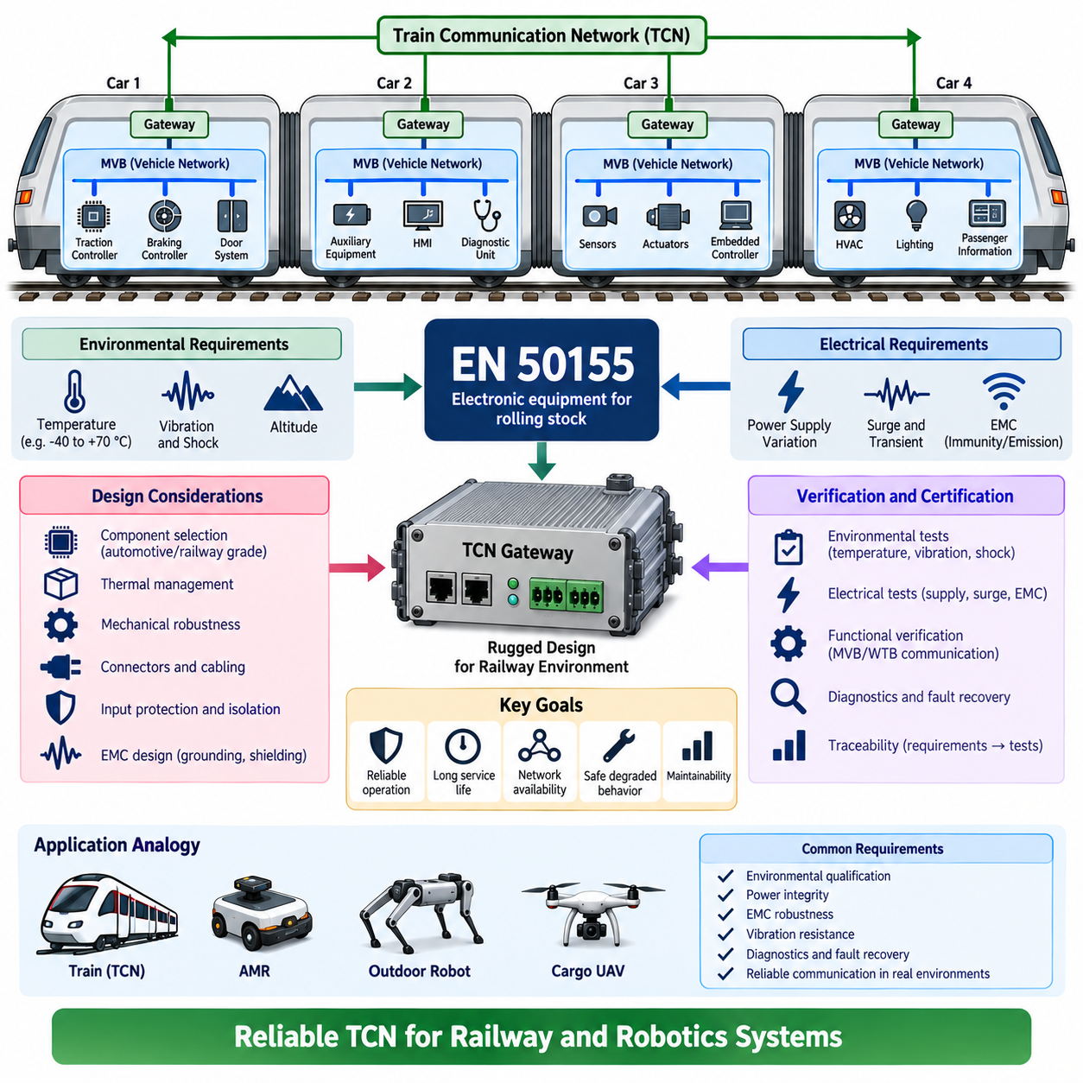
EN 50155 defines environmental, electrical, and operational requirements for electronic equipment installed on railway rolling stock. For Train Communication Network equipment, the standard provides an important qualification framework because gateways, MVB devices, WTB interfaces, network controllers, and associated electronics operate in an environment exposed to temperature variation, vibration, electrical disturbances, and long service periods.
TCN certification should be understood as more than verifying that communication frames are transmitted correctly. A network device can implement MVB, WTB, or gateway functions correctly at the protocol level while still being unsuitable for installation on rolling stock. Railway qualification therefore considers both communication functionality and the ability of the electronic equipment to maintain intended operation under environmental and electrical conditions representative of railway service.
Temperature is one of the fundamental environmental considerations for onboard communication equipment. Electronic modules may be installed in passenger compartments, cabinets, equipment rooms, or other locations with different thermal conditions. Components, printed circuit boards, connectors, power converters, and communication transceivers must therefore be selected and designed so that network functions remain reliable throughout the temperature conditions specified for the intended installation environment.
Thermal design is closely related to equipment packaging and power dissipation. A TCN gateway may contain processors, communication controllers, isolation devices, memory, and multiple network interfaces that continuously generate heat. Enclosure design, component placement, conductive heat paths, ventilation strategy, and thermal margins must prevent excessive component temperatures. Qualification testing verifies that communication and processing functions remain stable under relevant thermal conditions.
Railway electronics are also exposed to mechanical vibration and shock generated by vehicle motion, track irregularities, coupling events, and equipment mounting conditions. TCN hardware must maintain electrical continuity and communication integrity despite these mechanical stresses. Printed circuit assemblies, connectors, terminal interfaces, mounting structures, and heavier components require mechanical design practices that prevent intermittent contacts, fatigue failures, or structural damage during service.
Power-supply behavior is particularly important because onboard railway electrical systems cannot be treated as ideal laboratory power sources. Communication equipment must tolerate the supply characteristics applicable to its installation while continuing to perform its intended functions or entering defined safe operating states. Input protection, filtering, isolation, conversion stages, transient protection, and supervisory circuits consequently become part of the practical design of a certifiable TCN device.
Electromagnetic compatibility is another essential aspect of railway communication equipment qualification. Traction equipment, converters, motors, switching devices, contactors, and high-current power distribution can generate electromagnetic disturbances near communication electronics. TCN interfaces must therefore be designed with appropriate grounding, shielding, filtering, isolation, cable routing, and connector practices to prevent disturbances from corrupting communication or destabilizing electronic equipment.
Immunity and emissions must be considered together. A gateway or communication controller should resist disturbances originating from surrounding railway equipment while avoiding unacceptable electromagnetic interference with neighboring systems. Interface circuitry, enclosure construction, PCB layout, cable shields, grounding architecture, and power filtering therefore influence certification performance. Communication reliability cannot be separated from the physical electrical design surrounding the protocol implementation.
Functional verification remains necessary in addition to environmental qualification. MVB, WTB, and TCN gateway equipment must demonstrate that required communication functions operate correctly before, during, and after applicable tests. Engineers should observe network initialization, process-data exchange, gateway forwarding, diagnostic behavior, interface status, and fault recovery where relevant. Environmental survival alone is insufficient if communication behavior becomes unreliable under stress.
Gateway equipment deserves particular attention because it connects vehicle-level and train-level communication domains. A gateway failure can isolate an otherwise functional MVB network from WTB communication. Qualification should therefore examine not only hardware survival but also startup behavior, communication recovery, interface initialization, watchdog operation, error handling, and restoration after disturbances. Defined degraded behavior is preferable to unpredictable communication when abnormal conditions occur.
Certification-oriented development requires traceability between requirements, design decisions, verification procedures, and test evidence. Hardware requirements should identify environmental and electrical constraints, while communication requirements define intended TCN behavior. Test specifications then demonstrate that the implemented equipment satisfies those requirements. Maintaining this relationship allows failures discovered during qualification to be traced back to the relevant design assumption or implementation decision.
Component selection also affects long-term railway qualification. Devices used in communication controllers should have suitable operating margins, predictable availability, and characteristics appropriate for the intended service environment. Designers must consider not only processor and transceiver performance but also capacitors, isolation components, connectors, oscillators, memory, power devices, and protection components whose degradation could eventually influence network reliability.
Connectors and cabling form part of the communication system even when certification attention is focused on electronic modules. Poor termination, insufficient shielding, mechanical loosening, contamination, or inadequate strain relief can degrade otherwise correct network electronics. TCN equipment design should therefore treat external interfaces as engineered system boundaries, with connector retention, shielding continuity, grounding, mechanical robustness, and serviceability considered from the beginning.
Verification planning is most effective when certification requirements are incorporated early in development rather than addressed after prototype completion. PCB architecture, enclosure design, connector selection, thermal management, grounding, filtering, and diagnostic provisions become expensive to change late in the project. Designing for qualification from the beginning reduces the risk that a functionally successful TCN prototype will require major redesign before railway deployment.
EN 50155 should also be considered together with the broader railway engineering and certification environment rather than as an isolated communication protocol specification. TCN communication requirements originate from the IEC 61375 family, while rolling-stock electronics must satisfy applicable equipment-level environmental and electrical expectations. The resulting product therefore requires coordinated protocol, hardware, EMC, mechanical, software, and system verification activities.
The broader lesson is directly relevant to communication equipment for AMRs, outdoor robots, and cargo UAVs included in the surrounding robotics electrical architecture. A communication gateway is not deployment-ready merely because Ethernet, CAN, or another protocol operates correctly on a laboratory bench. Reliable Physical AI platforms similarly require environmental qualification, power integrity, EMC robustness, vibration resistance, diagnostics, fault recovery, and traceable verification.

