Volume 08. Railway and Aerospace Protocols

Chapter 11. Future Critical Communication

11.01. DO-326A Cybersecurity
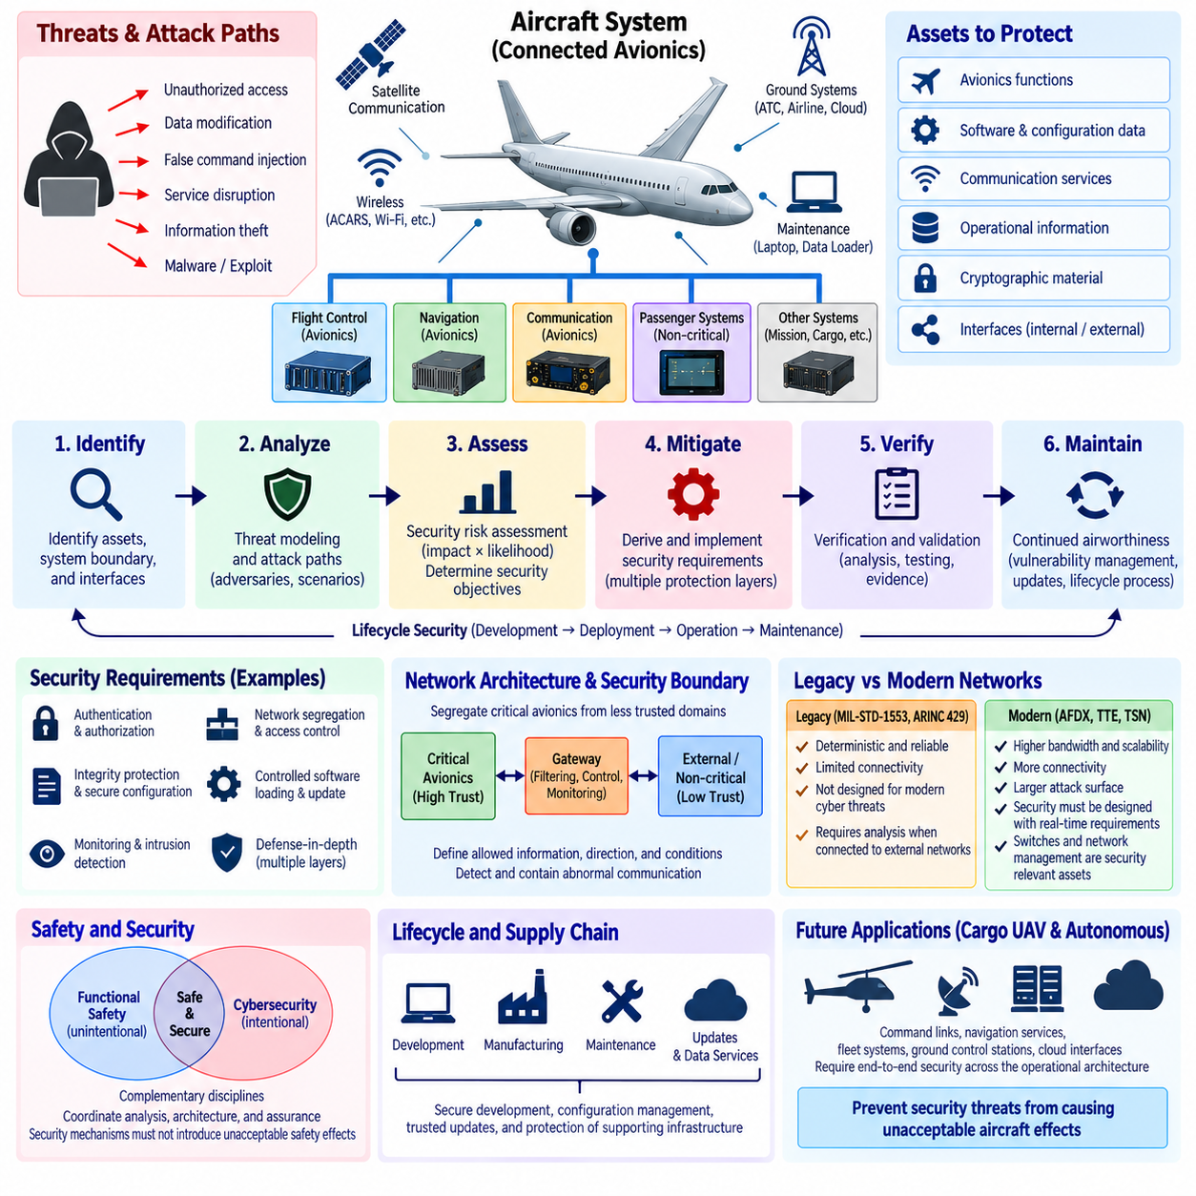
DO-326A defines an aviation security process for addressing intentional unauthorized electronic interaction with aircraft systems throughout their lifecycle. Unlike traditional safety engineering, which primarily considers accidental failures and unintended conditions, aviation cybersecurity must consider deliberate actions performed by capable adversaries. The objective is not simply to protect individual computers or networks, but to ensure that security threats cannot produce unacceptable effects on aircraft operation, safety, or continued airworthiness.
The standard is closely associated with airworthiness security because modern aircraft increasingly depend on interconnected digital systems. Avionics networks, maintenance interfaces, wireless communication, ground systems, software-loading mechanisms, and external data services create pathways through which information enters or leaves the aircraft. Security engineering must therefore examine the complete system boundary rather than treating cybersecurity as an isolated information-technology function. Connectivity that improves operational capability can simultaneously increase the number of potential attack paths requiring analysis and protection.
A central concept is the identification of assets that require protection. These assets can include avionics functions, software, configuration data, communication services, operational information, cryptographic material, and interfaces whose compromise could affect aircraft behavior. Security analysis examines how these assets interact with external and internal systems and determines where unauthorized access, manipulation, corruption, or disruption could occur. Asset identification provides the foundation for relating cybersecurity concerns to actual aircraft functions instead of evaluating threats only as abstract network events.
Threat modeling considers potential adversaries, attack paths, interfaces, and possible consequences of unauthorized interaction. An attacker may attempt to modify information, inject false commands, disrupt communication, obtain protected information, or exploit software and configuration weaknesses. The important engineering question is not merely whether an attack is technically possible, but what aircraft-level effect could result if the attack succeeds. Cybersecurity assessment therefore connects threat scenarios with system functions and operational consequences, allowing security requirements to be derived according to the significance of the resulting effects.
Security risk assessment evaluates identified threats together with their potential impact and the difficulty or feasibility of successful exploitation. This allows engineering effort to focus on scenarios that could create meaningful aircraft consequences rather than applying identical protection to every interface. The resulting security objectives can then be allocated to systems, networks, software, hardware, operational procedures, and supporting infrastructure. In this sense, DO-326A promotes a risk-based engineering process in which cybersecurity controls are justified by the threats and aircraft effects they are intended to address.
Security requirements may include authentication, authorization, integrity protection, access control, network segregation, secure configuration, controlled software loading, monitoring, and protection of sensitive communication. No single mechanism is sufficient for every architecture. Instead, multiple protection layers can be combined so that failure or compromise of one mechanism does not automatically expose critical aircraft functions. This defense-in-depth principle is particularly important where external connectivity must coexist with safety-critical avionics and where complete physical isolation is impractical.
Network architecture is therefore a major cybersecurity consideration. Critical avionics domains should be protected from less trusted domains through appropriate partitioning, gateways, filtering, controlled interfaces, and information-flow restrictions. A communication gateway should not be considered merely a protocol converter; it may also represent a security boundary between systems with different levels of trust. The design must determine which information is permitted to cross that boundary, in which direction, under what conditions, and how abnormal communication is detected or contained.
Legacy deterministic networks such as MIL-STD-1553 or ARINC 429 were developed primarily around reliability, predictable communication, and controlled system integration rather than contemporary cybersecurity threats. Their constrained communication behavior can reduce some forms of uncontrolled network interaction, but determinism alone does not provide cybersecurity. When such networks are connected through gateways to Ethernet, wireless links, maintenance systems, or external services, the resulting attack surface must be evaluated at the complete architecture level. A trusted legacy bus can become exposed indirectly through a poorly protected integration path.
Modern Ethernet-based avionics networks such as AFDX, TTE, and emerging TSN-based architectures provide greater bandwidth and connectivity, but increased connectivity also expands cybersecurity considerations. Switches, end systems, configuration data, synchronization mechanisms, gateways, and network-management functions can become security-relevant assets. Deterministic scheduling can constrain expected communication patterns, which may assist monitoring, but it does not replace authentication, integrity protection, secure configuration, or access control. Cybersecurity must therefore be designed alongside real-time communication requirements.
Aircraft cybersecurity also extends beyond operation in flight. Software development environments, manufacturing systems, maintenance equipment, data loaders, diagnostic tools, update infrastructure, and ground networks can influence the security of airborne systems. An attacker does not necessarily need direct access to an aircraft network if malicious software or corrupted configuration data can enter through the supply chain or maintenance process. Lifecycle security consequently requires controlled development, configuration management, trusted update mechanisms, vulnerability management, and protection of supporting infrastructure.
Verification and validation are necessary to demonstrate that security requirements have been implemented correctly and that the resulting architecture provides the intended protection. Analysis can include examination of interfaces, security controls, data flows, failure and attack scenarios, and evidence that unauthorized interactions are adequately prevented, detected, or contained. Security testing complements analytical activities by examining how implemented systems behave when exposed to malformed inputs, unauthorized access attempts, unexpected communication, or other adversarial conditions relevant to the defined threat model.
Cybersecurity differs from functional safety, but the two disciplines must interact closely. A safety analysis may identify an aircraft function whose incorrect behavior could produce a hazardous consequence, while security analysis considers whether intentional electronic interaction could cause that same behavior. Security mechanisms themselves must also avoid introducing unacceptable safety effects. For example, authentication, filtering, isolation, or security monitoring must not create timing behavior or failure modes that violate critical real-time requirements. Safety and security therefore require coordinated architecture and assurance activities.
Continued airworthiness introduces another important dimension because cyber threats evolve after an aircraft enters service. Newly discovered vulnerabilities, changes in external systems, new attack techniques, and software updates can alter the security environment even when the original aircraft architecture remains unchanged. Operators and manufacturers therefore need processes for receiving vulnerability information, assessing its relevance, implementing appropriate mitigations, and maintaining configuration control. Cybersecurity becomes a lifecycle activity rather than a one-time certification exercise completed at initial entry into service.
For future cargo UAVs and increasingly autonomous aerospace systems, the principles associated with DO-326A become even more significant because command links, navigation services, fleet systems, ground control stations, cloud interfaces, maintenance networks, and onboard autonomous computers create a larger connected ecosystem. Security boundaries must extend beyond the individual vehicle to the complete operational architecture. The fundamental engineering objective remains consistent: identify critical assets, understand credible attack paths, evaluate aircraft-level consequences, establish proportionate security requirements, verify their effectiveness, and maintain those protections throughout the operational lifecycle.

11.02. TSN in Aerospace
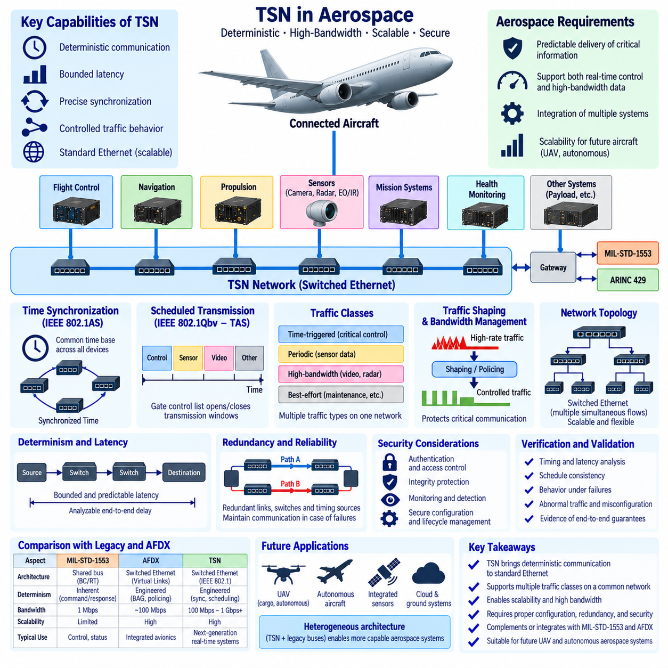
Time-Sensitive Networking (TSN) extends standard Ethernet with mechanisms that support deterministic communication, bounded latency, precise synchronization, and controlled traffic behavior. These capabilities make TSN relevant to aerospace systems that increasingly depend on high-bandwidth sensors, distributed computing, autonomous functions, and integrated avionics. Unlike conventional Ethernet, where delay can vary with traffic conditions, properly engineered TSN networks can provide predictable communication behavior while retaining the scalability and ecosystem advantages of Ethernet.
The fundamental aerospace requirement is not simply high network speed but predictable delivery of critical information. Flight-control commands, navigation states, actuator data, synchronization information, and health-monitoring messages may have strict timing constraints, while cameras, radar, mission data, diagnostics, and software services can require substantially greater bandwidth. TSN provides mechanisms for carrying these different traffic types over a common Ethernet infrastructure while controlling how network resources are allocated among them.
Precise time synchronization is one of the foundations of TSN. Distributed computers, sensors, switches, and control devices require a consistent understanding of network time so that scheduled communication and coordinated processing can occur correctly. IEEE 802.1AS provides mechanisms for distributing synchronized time across participating network devices. In an aerospace architecture, this common time base can support coordinated sensing, timestamping, distributed control, data fusion, and deterministic transmission schedules across multiple computing nodes.
IEEE 802.1Qbv introduces the Time-Aware Shaper (TAS), which controls when selected traffic queues are allowed to transmit. Switch output ports can follow a repeating Gate Control List that opens and closes transmission gates according to a predefined schedule. Critical traffic can therefore receive protected transmission windows in which competing lower-priority traffic is prevented from interfering. Conceptually, this brings a TDMA-like scheduling principle into switched Ethernet while allowing different communication classes to share the same physical network infrastructure.
Scheduled transmission helps establish bounded latency because engineers can analyze when a critical frame is permitted to leave each switch along its path. If synchronization, schedules, frame sizes, and routes are properly configured, worst-case communication delay can be evaluated more systematically than in ordinary best-effort Ethernet. This is particularly valuable for distributed aerospace control functions where network delay becomes part of the complete sense-compute-actuate timing chain and must remain within defined real-time limits.
TSN also supports traffic classes that do not require strict time-triggered transmission. Critical control messages may use scheduled communication, while other traffic can use priority-based or shaped transmission according to its timing requirements. This allows one physical Ethernet architecture to support hard real-time control, periodic sensor traffic, diagnostic communication, and less time-sensitive data. The ability to integrate multiple traffic classes is important as aerospace platforms move toward increasingly consolidated computing and communication architectures.
Traffic shaping and bandwidth management are essential because high-rate sources can otherwise interfere with critical communication. Cameras, radar, high-resolution perception sensors, data recorders, and autonomous computing systems may generate large traffic bursts. TSN mechanisms can regulate these flows so that bandwidth-intensive traffic does not consume resources reserved for critical functions. Network design therefore becomes an explicit resource-allocation problem involving bandwidth, latency, queue behavior, transmission schedules, and end-to-end paths.
Switched Ethernet topology provides important scalability advantages over traditional shared buses. Individual end systems connect through switches, allowing multiple communication flows to occur simultaneously on different links. Additional sensors and computing nodes can be integrated without forcing every device to share one serial transmission medium. For modern aircraft, cargo UAVs, and autonomous aerospace platforms, this scalability becomes increasingly important as onboard perception, AI processing, mission computing, and distributed control generate larger and more diverse communication requirements.
Redundancy must be designed together with deterministic communication. Critical aerospace systems cannot depend on a single switch, link, timing source, or communication route if failure of that element could create unacceptable system effects. TSN-based architectures can employ redundant physical paths, duplicated network components, and appropriate recovery or replication strategies. However, additional redundancy increases configuration complexity, so engineers must verify not only normal timing behavior but also communication behavior after failures and during degraded operation.
TSN differs fundamentally from MIL-STD-1553 in the way determinism is achieved. MIL-STD-1553 uses a centralized Bus Controller and command-response transactions on a shared bus, making communication authority inherently explicit. TSN uses switched Ethernet and obtains deterministic behavior through synchronization, scheduling, traffic shaping, prioritization, and engineered network configuration. TSN therefore offers much greater bandwidth and scalability, but its deterministic properties depend on correct system-level configuration rather than emerging automatically from ordinary Ethernet operation.
Compared with AFDX, TSN represents a broader standardized Ethernet technology family with mechanisms that can support increasingly sophisticated real-time communication. AFDX uses configured Virtual Links, Bandwidth Allocation Gap, traffic policing, and redundant networks to constrain Ethernet behavior for avionics. TSN adds standardized techniques for precise synchronization and scheduled traffic, among other mechanisms. Aerospace adoption therefore involves determining which TSN capabilities can satisfy the timing, fault tolerance, verification, interoperability, and certification requirements of a particular aircraft architecture.
Cybersecurity becomes increasingly important as Ethernet connectivity expands. Switches, synchronization services, configuration data, gateways, network-management interfaces, and connected end systems can become security-relevant assets. An attacker who alters a communication schedule, configuration, or synchronization source could potentially affect deterministic behavior even without directly modifying application data. TSN security must therefore be considered together with aerospace cybersecurity processes, network segregation, authentication, integrity protection, controlled configuration, monitoring, and secure lifecycle management.
Verification of a TSN aerospace network must address more than basic connectivity. Engineers need evidence that critical frames meet their latency and delivery requirements under expected traffic loads, that schedules remain consistent across switches, and that lower-priority traffic cannot violate reserved communication behavior. Verification must also consider synchronization errors, link failures, switch failures, abnormal traffic, configuration mistakes, and degraded modes. Deterministic networking becomes useful for critical aerospace systems only when its timing guarantees can be demonstrated at the complete end-to-end architecture level.
Future cargo UAVs and autonomous aircraft provide a strong application case for TSN because their onboard networks may combine flight control, navigation, propulsion, perception, AI computing, mission systems, health monitoring, and high-bandwidth sensors. A heterogeneous architecture may retain proven legacy buses for selected equipment while using TSN-based Ethernet as a higher-capacity backbone. Gateways can connect these domains while preserving their timing and fault-containment requirements. TSN therefore represents an important direction for future critical aerospace communication, combining Ethernet scalability with engineered determinism for increasingly connected and computationally intensive aircraft systems.

11.03. UAV Datalink Evolution
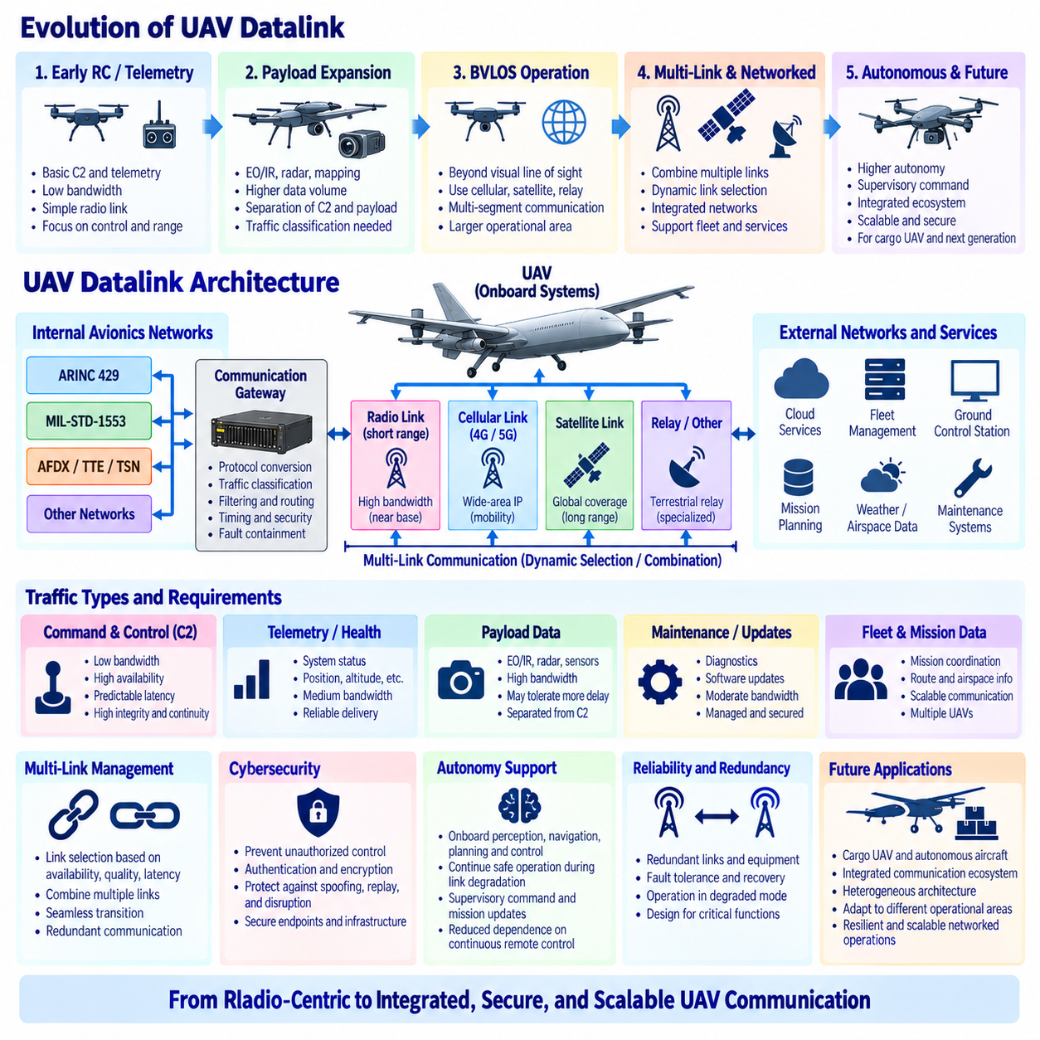
Unmanned Aerial Vehicle (UAV) datalinks have evolved from relatively simple remote-control radio channels into integrated communication systems that support command and control, telemetry, navigation assistance, payload data, mission coordination, and increasingly autonomous operation. This evolution reflects a broader change in UAV architecture: the aircraft is no longer merely a remotely piloted platform, but a distributed computing node connected to ground stations, other aircraft, fleet services, and external information systems.
Early UAV communication architectures were primarily designed around command and control (C2) and basic telemetry. The ground operator transmitted flight commands while the aircraft returned information such as position, altitude, speed, system status, and basic sensor measurements. Bandwidth requirements were relatively modest because most onboard processing and mission functions were limited. Communication design therefore emphasized reliable radio coverage, sufficient range, simple modulation, and the ability to maintain control of the aircraft rather than continuous transmission of large data volumes.
As UAV payload capabilities expanded, the datalink became responsible for substantially more information. Electro-optical and infrared cameras, radar, mapping sensors, and other mission payloads generated data streams that could exceed the requirements of traditional control links by several orders of magnitude. This created a natural separation between low-bandwidth but highly critical C2 traffic and high-bandwidth payload communication. The two traffic categories have fundamentally different requirements, making traffic classification and resource allocation increasingly important in UAV communication architecture.
Command-and-control communication must prioritize availability, predictable latency, integrity, and continuity over maximum throughput. A delayed video frame may reduce mission effectiveness, but excessive delay or corruption in a flight command can directly influence vehicle operation. Modern UAV architectures therefore need to protect C2 traffic from congestion caused by payload or maintenance data. Priority mechanisms, dedicated channels, traffic shaping, redundant links, or logically separated communication services can be used to ensure that high-rate application traffic does not interfere with safety-relevant control information.
The growth of Beyond Visual Line of Sight (BVLOS) operation further changes datalink requirements. A UAV operating beyond direct visual range may depend on communication infrastructure extending far beyond a local ground-control radio. Cellular networks, satellite communication, terrestrial relay systems, or combinations of several communication technologies can become part of the end-to-end link. The datalink must consequently be considered as a communication system composed of multiple segments rather than a single radio connection between one aircraft and one ground station.
Modern cellular technologies introduce another path for UAV connectivity. 4G and 5G networks can provide wide-area IP connectivity, substantial bandwidth, mobility support, and access to terrestrial communication infrastructure. Such connectivity can support telemetry, mission updates, payload data, fleet coordination, maintenance information, and selected C2 functions where the operational and assurance requirements are satisfied. However, cellular communication is dependent on coverage, network loading, mobility behavior, infrastructure availability, and service configuration, so its use in critical UAV functions requires careful end-to-end engineering.
Satellite communication becomes particularly important when UAV operations extend beyond terrestrial network coverage. Long-range cargo aircraft, maritime UAVs, remote inspection platforms, and other extended-range systems may require satellite links for command, telemetry, tracking, or mission communication. Satellite links can provide broad geographic coverage but introduce constraints such as latency, antenna requirements, link availability, bandwidth cost, and environmental sensitivity. A robust UAV architecture may therefore combine satellite communication with terrestrial links rather than depending exclusively on either technology.
Multi-link communication represents a major direction in datalink evolution. Instead of designing the aircraft around one radio technology, future UAVs can contain several communication interfaces and dynamically select or combine them according to mission conditions. A short-range high-bandwidth link may be preferred near the operating base, cellular communication may support regional flight, and satellite connectivity may provide coverage in remote areas. Link-management logic then becomes responsible for evaluating availability, quality, latency, security, and mission requirements before selecting an appropriate communication path.
This transition also changes the role of the onboard communication gateway. The gateway must increasingly connect internal deterministic avionics networks with external IP-based wireless networks. Internal communication may use ARINC 429, MIL-STD-1553, AFDX, TTE, TSN, or other vehicle-specific technologies, while external links may use cellular, satellite, or specialized radio systems. The gateway therefore becomes both a protocol boundary and an architectural boundary where traffic classification, filtering, routing, timing, cybersecurity, and fault containment must be carefully controlled.
Cybersecurity becomes more important as UAV datalinks evolve toward IP connectivity and distributed services. Command channels must be protected against unauthorized control, manipulation, spoofing, replay, and disruption. Telemetry and mission information may require confidentiality and integrity protection, while communication endpoints need appropriate authentication and authorization. Ground stations, fleet servers, maintenance systems, cloud services, and update infrastructure also become part of the attack surface. Datalink security must consequently extend beyond encryption of the radio channel to the complete operational architecture.
Autonomy changes communication requirements in another important way. A highly autonomous UAV should not require continuous high-rate remote piloting commands for every movement. Onboard perception, navigation, planning, and control allow the aircraft to continue safe operation during temporary communication degradation according to predefined operational rules. The datalink can therefore evolve from continuous low-level control toward supervisory command, mission updates, health reporting, fleet coordination, and exception handling. Greater autonomy can reduce dependence on uninterrupted communication, although it does not eliminate the need for reliable C2 connectivity.
Fleet operation expands the communication model from one ground station and one aircraft to many vehicles and distributed services. Cargo UAV fleets may exchange mission assignments, route constraints, health information, airspace data, weather information, charging status, maintenance requirements, and fleet-level coordination messages. Communication architecture must therefore support scalable addressing, service discovery, traffic prioritization, time synchronization, and secure management of many connected nodes. The UAV becomes part of a networked operational system rather than an isolated airborne platform.
Future UAV datalinks are consequently likely to use heterogeneous communication architectures combining multiple radio technologies, onboard deterministic networks, IP-based services, redundant communication paths, and intelligent link management. Critical C2 traffic can be separated from high-bandwidth payload and maintenance traffic while gateways enforce security and fault-containment boundaries. Cellular, satellite, and specialized aviation links can complement one another according to coverage and mission requirements, allowing communication resources to adapt as the aircraft moves through different operational environments.
For future cargo UAV and autonomous aerospace systems, datalink evolution ultimately represents a transition from a radio-centric design to an integrated communication architecture. The engineering objective is no longer simply to maintain a wireless connection, but to guarantee appropriate communication behavior across aircraft networks, external links, ground systems, fleet services, and operational infrastructure. Reliability, latency, bandwidth, redundancy, cybersecurity, autonomy, and coverage must be designed together, creating a resilient communication fabric capable of supporting increasingly connected, distributed, and autonomous aerospace operations.

11.04. 5G in Critical Systems
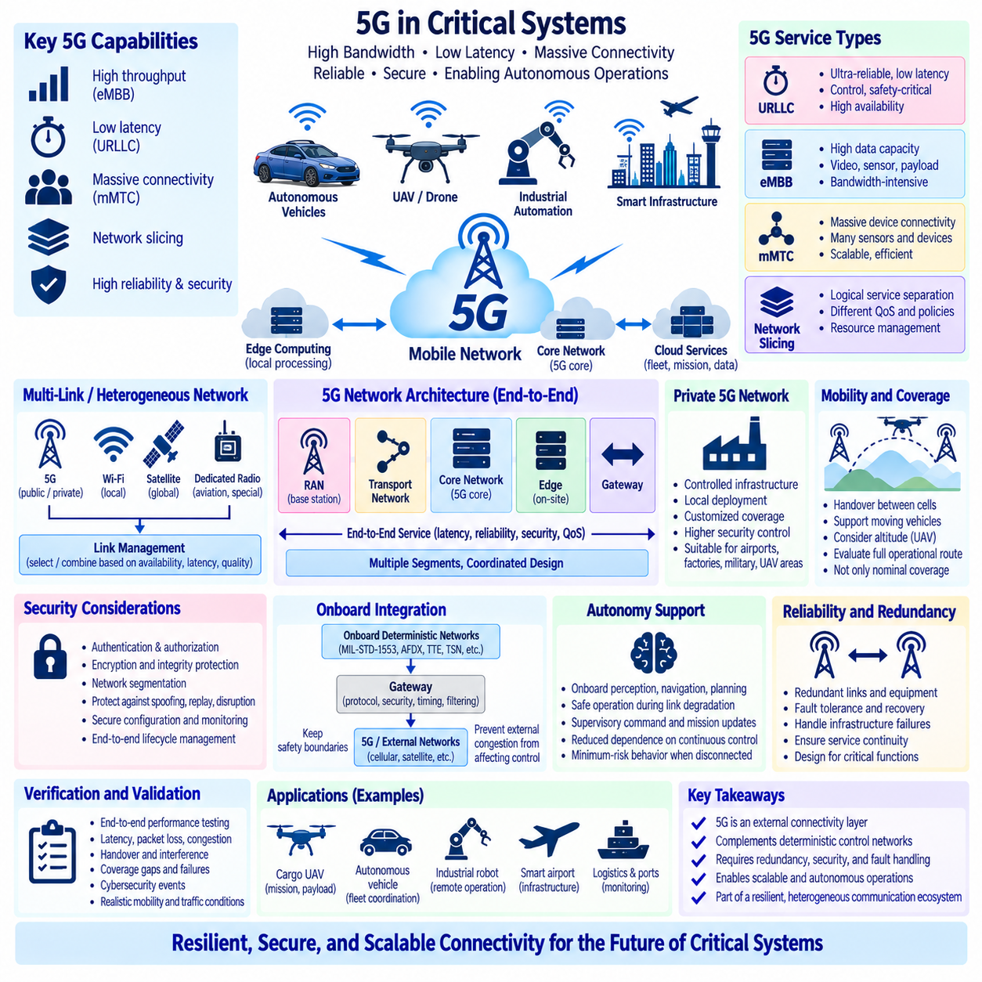
Fifth-generation mobile communication, commonly known as 5G, introduces capabilities that make cellular networking increasingly relevant to critical transportation, industrial, aerospace, and autonomous systems. Compared with earlier generations, 5G is designed to support higher throughput, lower latency, massive device connectivity, and differentiated communication services. However, using 5G in a critical system requires more than achieving high radio performance. Availability, bounded delay, security, redundancy, coverage, fault behavior, and end-to-end service assurance must be engineered together.
One of the most important 5G concepts for critical applications is Ultra-Reliable Low-Latency Communication (URLLC). URLLC is intended for services where information must be delivered with high reliability and low delay, such as industrial control and other time-sensitive applications. For autonomous vehicles or UAVs, these characteristics can support supervisory control, coordinated operations, telemetry, and selected real-time services. Nevertheless, radio-interface latency alone does not define system performance because the complete communication path may also include the radio access network, transport network, core network, gateways, and application servers.
Enhanced Mobile Broadband (eMBB) addresses a different requirement by providing high data capacity for bandwidth-intensive applications. Critical autonomous platforms may generate high-resolution camera streams, radar information, mapping data, diagnostic records, and mission payload data that require substantially more bandwidth than conventional control messages. A 5G architecture can therefore support both low-rate critical information and high-rate application data, but these traffic classes must be appropriately separated and managed so that bandwidth-intensive services do not interfere with more important control or health-monitoring functions.
Massive Machine-Type Communication (mMTC) extends the architecture toward large populations of connected devices. In industrial sites, airports, logistics facilities, smart infrastructure, and fleet environments, many sensors, machines, vehicles, and monitoring devices may exchange relatively small amounts of information. For critical systems, the significance of mMTC is not simply the number of devices that can connect. Identity management, traffic isolation, resource allocation, congestion behavior, cybersecurity, and failure containment become increasingly important as the communication ecosystem grows.
Network slicing provides a mechanism for creating logically differentiated communication services over shared 5G infrastructure. A critical-control service can conceptually be separated from payload data, maintenance traffic, passenger services, or general information exchange by assigning different service characteristics and policies. This separation can improve resource management and architectural clarity. However, logical isolation must not automatically be interpreted as complete physical independence. Critical-system designers still need to understand which infrastructure components, radio resources, core-network functions, and operational dependencies remain shared.
Private 5G networks are particularly relevant to factories, airports, ports, logistics centers, military facilities, and controlled UAV operating areas. A private network can provide greater control over radio coverage, infrastructure configuration, access policies, quality of service, and cybersecurity than dependence solely on a public cellular service. Local deployment can also place computing resources close to operational systems. Nevertheless, private ownership does not itself guarantee critical-system reliability; base stations, core functions, timing sources, power supplies, backhaul connections, and management systems still require appropriate fault-tolerance engineering.
Edge computing can reduce dependence on distant cloud infrastructure by placing application processing near the radio network or operational site. A UAV fleet, autonomous ground vehicle, or industrial robot can exchange information with a nearby edge server for perception support, fleet coordination, map distribution, diagnostics, or mission services. Shorter communication paths can reduce latency and external-network dependency. For safety-critical functions, however, designers must determine what happens if the edge service becomes unavailable and which capabilities must remain executable locally on the vehicle.
Mobility introduces additional complexity because critical vehicles may move between radio cells, coverage areas, or even different communication technologies. Handover procedures must maintain acceptable communication continuity while the system transitions between serving cells. UAVs create additional challenges because altitude and flight trajectory can produce radio conditions different from terrestrial users. A critical architecture should therefore evaluate coverage along the complete operational route rather than relying only on nominal network coverage maps or average performance measurements.
Communication availability can be improved through multi-link and heterogeneous networking. A critical platform does not necessarily need to depend exclusively on 5G. It may combine 5G with Wi-Fi, dedicated radio, satellite communication, aviation-specific links, or other technologies. Link-management logic can select or combine paths according to availability, latency, signal quality, security, and mission requirements. This approach treats 5G as one component of a resilient communication architecture rather than assuming that a single wireless technology can satisfy every operational condition.
Cybersecurity is fundamental because 5G connects critical platforms to a broader IP-based communication ecosystem. Authentication, authorization, encryption, integrity protection, secure configuration, network segmentation, monitoring, and lifecycle management must extend across user equipment, radio infrastructure, core-network functions, edge servers, gateways, and applications. Compromise of configuration or management systems can be as significant as compromise of application data. Security architecture must therefore protect both the communication traffic and the infrastructure responsible for providing the communication service.
Deterministic onboard networks and 5G serve different architectural purposes. Technologies such as MIL-STD-1553, AFDX, TTE, or TSN can provide controlled communication among onboard sensors, computers, and actuators, while 5G provides wireless connectivity between the vehicle and external infrastructure. A gateway may connect these domains, but it must preserve timing, security, and fault-containment boundaries. External network congestion or loss should not automatically propagate into the internal control architecture in a way that destabilizes safety-critical vehicle functions.
Autonomy can reduce the safety consequences of temporary wireless communication loss. A critical autonomous vehicle should ideally maintain essential stabilization, navigation, collision avoidance, and minimum-risk behavior using onboard capabilities when external communication becomes degraded. 5G can then support supervisory commands, mission updates, fleet coordination, high-bandwidth data exchange, and operational monitoring without becoming the sole mechanism required for every low-level control action. This separation between onboard autonomy and external connectivity is particularly important for UAV and robotic systems.
Verification of 5G-based critical communication must evaluate the complete end-to-end service rather than only nominal radio performance. Testing should consider latency distributions, packet loss, congestion, handovers, interference, coverage gaps, infrastructure failures, cybersecurity events, backhaul degradation, and recovery behavior. Performance should also be evaluated under realistic mobility and traffic conditions. A network that performs well during laboratory testing may behave differently when many users, moving vehicles, environmental obstacles, or infrastructure failures are introduced.
For future cargo UAVs and other autonomous aerospace platforms, 5G can provide an important communication layer for telemetry, fleet coordination, mission management, maintenance, payload transfer, and selected command-and-control functions. Private 5G may support controlled operating zones, while public cellular networks can extend regional connectivity and satellite links can provide coverage beyond terrestrial infrastructure. The resulting architecture is likely to be heterogeneous, combining onboard deterministic networks, autonomous fallback behavior, edge computing, multiple wireless links, and secure gateways.
The role of 5G in critical systems is therefore best understood as part of a resilient communication ecosystem rather than as a direct replacement for deterministic control networks. Its high bandwidth, low-latency capabilities, service differentiation, mobility support, edge integration, and broad connectivity create significant opportunities, but critical operation requires systematic treatment of failures and dependencies. When redundancy, cybersecurity, autonomy, coverage, service assurance, and fault containment are designed together, 5G can become a powerful external connectivity layer for increasingly distributed and autonomous critical systems.

11.05. Quantum Safe Communication
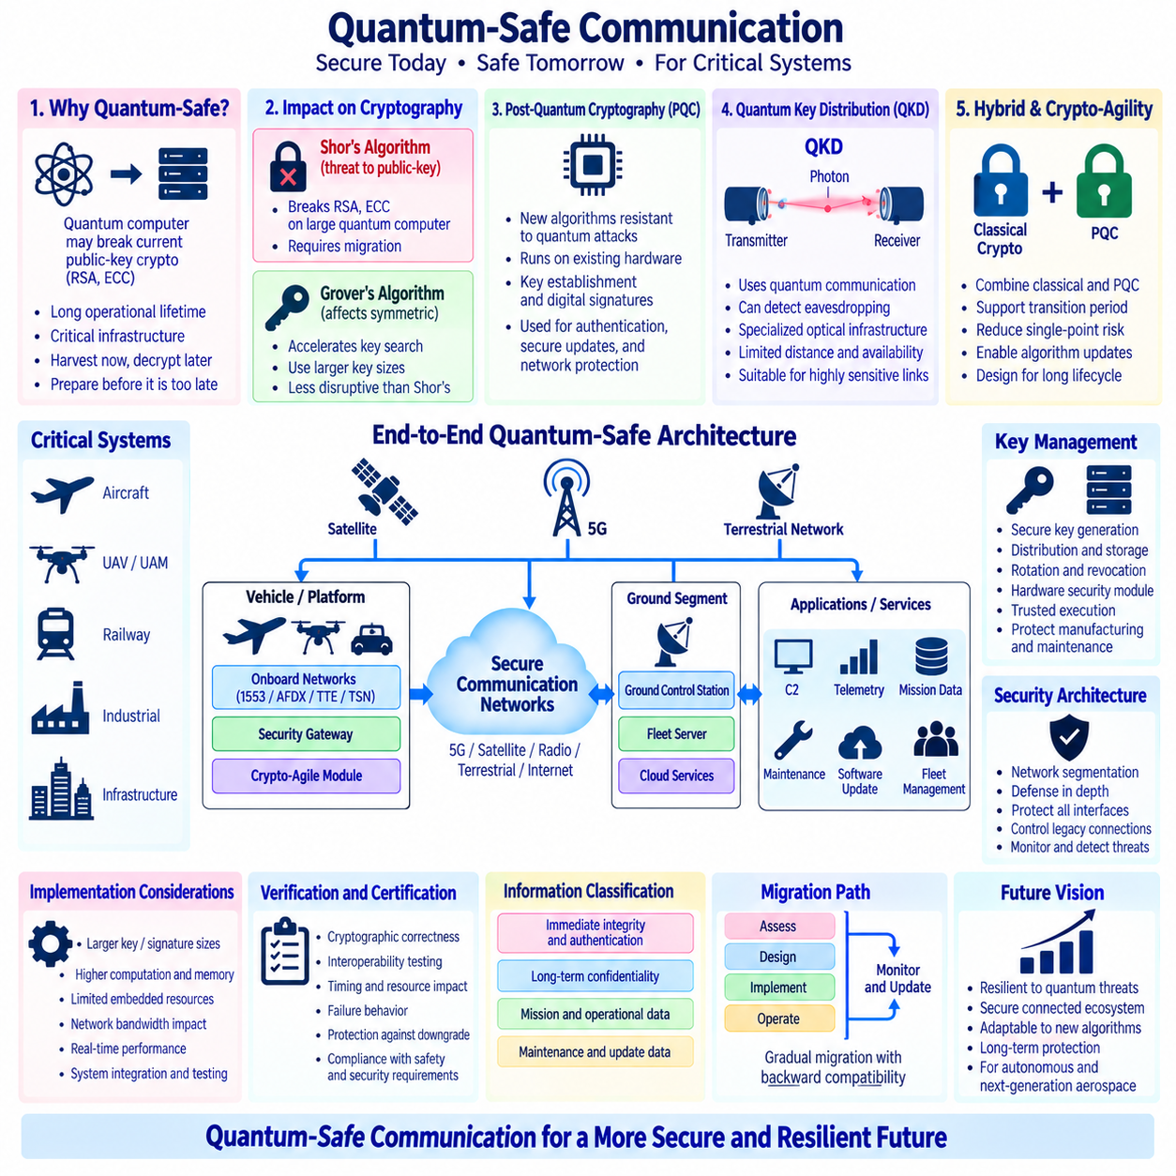
Quantum-safe communication addresses the long-term security risk created by the development of large-scale quantum computers. Many current digital systems depend on public-key cryptography whose security is based on mathematical problems that are extremely difficult for classical computers. A sufficiently capable quantum computer could fundamentally change this assumption. Critical aerospace, railway, industrial, and autonomous systems with long operational lifecycles must therefore consider how protected communication can remain secure in a future quantum-computing environment.
The principal concern arises from quantum algorithms that affect widely deployed asymmetric cryptography. Shor’s algorithm provides a theoretical means of efficiently solving the mathematical problems underlying RSA and elliptic-curve cryptography when executed on a sufficiently powerful fault-tolerant quantum computer. This does not mean that present quantum computers can immediately break deployed systems, but it creates a strategic migration requirement because aircraft, infrastructure, and critical platforms may remain operational for decades.
Symmetric cryptography is affected differently by quantum computing. Grover’s algorithm can theoretically accelerate exhaustive key search, but its impact is less disruptive than Shor’s algorithm is for public-key cryptography. Increasing symmetric key sizes can provide additional security margin against this type of quantum acceleration. Quantum-safe architecture therefore does not require abandoning all conventional cryptography. Instead, it requires understanding which cryptographic functions are most exposed and selecting appropriate algorithms, key sizes, protocols, and migration strategies.
Post-Quantum Cryptography (PQC) is one of the primary approaches to quantum-safe communication. PQC uses mathematical problems that are believed to remain computationally difficult for both classical and quantum computers. These algorithms are designed to operate on conventional processors and communication networks, making them attractive for existing digital infrastructure. Their applications include key establishment and digital signatures, which are essential for secure software updates, authentication, command systems, configuration management, and protected network sessions.
PQC migration is not simply an algorithm replacement. New cryptographic mechanisms can have different public-key, ciphertext, signature, memory, computation, and communication characteristics. Critical embedded systems may have limited processors, storage, network bandwidth, or deterministic timing budgets. Engineers must therefore evaluate whether quantum-safe operations can be integrated without violating real-time requirements or creating unacceptable resource consumption. Cryptographic performance becomes part of system architecture rather than an isolated cybersecurity implementation detail.
Quantum Key Distribution (QKD) represents a fundamentally different approach. Instead of relying only on computational difficulty, QKD uses properties of quantum communication to establish cryptographic key material while providing mechanisms that can reveal certain forms of interception. QKD is conceptually attractive for highly sensitive communication, but it requires specialized physical infrastructure and has practical constraints involving distance, optical channels, equipment complexity, availability, and integration. It should therefore be distinguished clearly from software-based post-quantum cryptography.
For aerospace and mobile autonomous systems, PQC is generally more directly compatible with existing radio and IP communication architectures because it can operate over conventional communication channels. QKD may be more applicable to selected fixed infrastructure, terrestrial backbone connections, specialized optical links, or future satellite-based security services. A complete quantum-safe strategy can therefore contain different technologies at different architectural layers rather than assuming that one security mechanism will protect every communication path.
The concept of “harvest now, decrypt later” creates an immediate reason to consider future quantum threats before large quantum computers become available. An adversary can potentially capture encrypted information today and preserve it until future computing capabilities allow decryption. Information that must remain confidential for many years is particularly exposed to this strategy. Long-lived military, aerospace, infrastructure, intellectual-property, and mission information may consequently require quantum-resistant protection well before practical cryptographically relevant quantum computers exist.
Crypto-agility is therefore a central architectural requirement. A system should ideally allow cryptographic algorithms, key sizes, certificates, trust anchors, and related protocols to be updated without redesigning the entire platform. This is especially important for aircraft, UAVs, railway systems, and industrial equipment whose operational lives may greatly exceed the lifecycle of a particular cryptographic algorithm. Crypto-agile design transforms cryptography from a permanently embedded implementation choice into a managed and replaceable security capability.
Hybrid cryptographic approaches can support migration by combining established classical cryptography with post-quantum mechanisms. During a transition period, systems can derive protection from more than one cryptographic technique while interoperability, implementation maturity, and operational experience with PQC continue to develop. Hybrid designs can reduce dependence on a single new mechanism, but they also increase protocol and key-management complexity. Their security benefits therefore depend on careful composition, implementation, testing, and lifecycle management.
Key management remains essential regardless of the cryptographic algorithms selected. Strong quantum-resistant mathematics cannot compensate for poorly protected private keys, compromised credentials, insecure provisioning, weak random-number generation, or uncontrolled certificate management. Critical systems require secure key generation, distribution, storage, rotation, revocation, recovery, and destruction. Hardware security modules, secure elements, trusted execution mechanisms, and protected manufacturing or maintenance processes can become important components of the overall architecture.
Quantum-safe communication must also integrate with network segmentation and defense-in-depth. An aerospace platform may contain deterministic onboard networks, Ethernet backbones, wireless datalinks, maintenance interfaces, gateways, ground stations, fleet servers, and cloud services. Not every interface requires identical cryptographic protection, but security boundaries must be defined according to assets, threats, data lifetime, and operational consequences. Gateways become particularly important because they can connect legacy communication domains with modern IP-based systems using different security capabilities.
Future UAV and autonomous aerospace architectures illustrate this challenge clearly. Command and control, telemetry, mission planning, fleet coordination, software updates, navigation information, maintenance data, and payload services may traverse 5G, satellite, specialized radio, or terrestrial networks. Some information requires immediate integrity and authentication, while other information may require confidentiality for many years. Quantum-safe design must therefore classify communication according to security objectives rather than applying the same cryptographic mechanism indiscriminately to every data flow.
Verification and certification will need to consider both cryptographic correctness and system-level behavior. Engineers must verify implementation, key handling, interoperability, timing, resource consumption, failure behavior, update mechanisms, and protection against downgrade to weaker algorithms. For critical real-time systems, security mechanisms must not create unpredictable delays or resource exhaustion that compromise essential functions. Quantum-safe communication therefore intersects with cybersecurity assurance, functional safety, real-time networking, configuration management, and continued airworthiness.
The transition toward quantum-safe critical communication will be gradual rather than instantaneous. Existing systems will continue using established cryptography while new platforms introduce crypto-agile architectures, post-quantum algorithms, hybrid mechanisms, and stronger lifecycle management. Legacy equipment may require secure gateways rather than direct modification. The long-term objective is not simply to deploy a particular quantum-resistant algorithm, but to build communication architectures capable of adapting as cryptographic standards, quantum capabilities, vulnerabilities, and operational requirements evolve.
For future critical communication, quantum safety represents a lifecycle engineering problem extending from individual algorithms to complete connected systems. Post-quantum cryptography can protect conventional digital networks, QKD can provide specialized key-distribution capabilities where suitable, and crypto-agility enables future migration. Combined with secure key management, segmentation, redundancy, monitoring, and controlled updates, these technologies can form a resilient security architecture for aircraft, cargo UAVs, autonomous systems, and critical infrastructure expected to remain operational through the transition into the quantum-computing era.

