Volume 08. Railway and Aerospace Protocols

Chapter 01. Railway Communication Overview

01.01. IEC 61375 (TCN) Standard
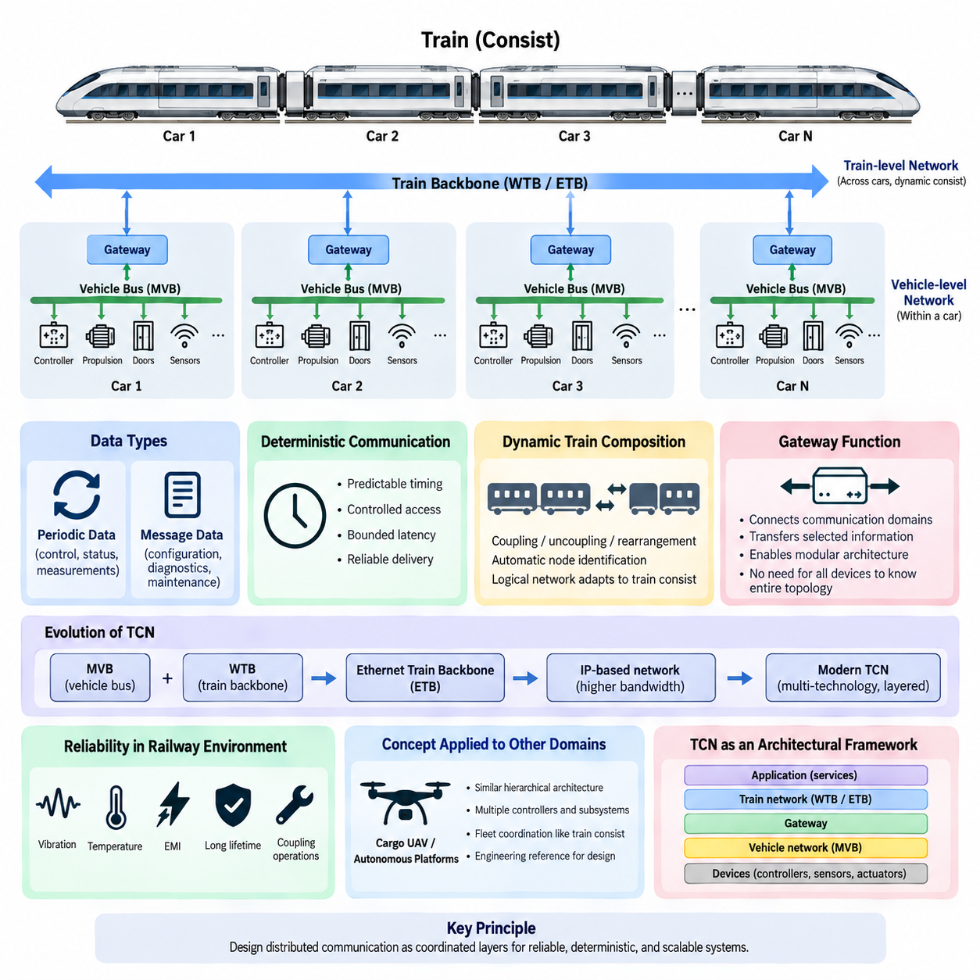
IEC 61375 defines the Train Communication Network (TCN), a standardized communication framework developed for reliable data exchange among electronic systems distributed throughout railway vehicles and train consists. It provides common architectural principles, communication interfaces, and network services that allow equipment from different suppliers to exchange operational, diagnostic, and control information within a coordinated train-wide system.
The fundamental idea of TCN is to organize railway communication hierarchically rather than treating every electronic device as a participant in one large network. A train may contain multiple vehicles, and each vehicle may contain controllers, sensors, propulsion equipment, braking systems, doors, passenger systems, and diagnostic devices. IEC 61375 therefore distinguishes communication inside a vehicle or consist from communication across the complete train.
Traditional TCN architecture is closely associated with two important network technologies: the Multifunction Vehicle Bus (MVB) and the Wire Train Bus (WTB). MVB provides communication among devices located within a vehicle or a relatively fixed group of vehicles, while WTB provides a train-level backbone capable of connecting consists. Together, these networks establish a structured path from local equipment communication to train-wide information exchange.
This separation is particularly important because railway vehicles have different communication requirements at different architectural levels. Local control information may require short and predictable communication cycles, while train-level information must travel across vehicle boundaries and accommodate changes in train composition. TCN allows these requirements to be handled by specialized network segments while gateways transfer required information between them.
A distinctive railway requirement is the ability to manage train composition dynamically. Cars or consists may be coupled, uncoupled, or rearranged during operation, meaning that the communication architecture cannot always depend on a permanently fixed physical configuration. TCN mechanisms associated with train backbone communication support identification and organization of connected nodes so that the logical communication structure can reflect the actual train configuration.
Deterministic behavior is another central principle behind railway communication. Control systems must know not only whether information will eventually arrive but also whether it can arrive within an acceptable time interval. TCN therefore emphasizes controlled communication behavior, bounded access to network resources, and predictable transmission characteristics. These properties distinguish critical railway networks from ordinary best-effort information networks.
TCN communication must also support different categories of railway data. Periodic process data can represent continuously changing operating variables such as status, commands, measurements, and control states, while message-oriented communication can carry less repetitive information such as configuration, diagnostics, and maintenance data. Separating these communication patterns allows network resources to be allocated according to the temporal characteristics of each application.
Gateways play an essential role in the complete TCN architecture. A gateway connects communication domains and transfers selected information between vehicle-level and train-level networks without requiring every device to understand the entire train topology. This approach creates architectural modularity: subsystems can remain locally organized while selected operational information is propagated to other vehicles, supervisory controllers, or train management functions.
The IEC 61375 family has evolved beyond the original MVB and WTB-centered architecture as railway systems have required substantially higher bandwidth. Ethernet-based technologies, particularly the Ethernet Train Backbone (ETB), extend the TCN concept into modern IP-capable railway networks. Higher bandwidth enables applications such as advanced diagnostics, passenger information, condition monitoring, software services, and data-intensive train management functions.
Modern TCN should therefore be understood as an architectural framework rather than as a single physical bus. Different communication technologies can occupy different parts of the railway network while following standardized principles for train and consist communication. This layered perspective allows legacy deterministic buses and newer Ethernet-based networks to coexist, providing a migration path from traditional distributed control toward increasingly software-defined railway platforms.
Reliability is fundamental because railway communication operates in an electrically and mechanically demanding environment. Network equipment must function despite vibration, temperature variation, electromagnetic interference, long vehicle lifetimes, and repeated coupling operations. Communication design must consequently be considered together with physical-layer engineering, topology, redundancy, diagnostics, fault containment, and the environmental qualification requirements applied to railway electronic equipment.
IEC 61375 also provides an important conceptual foundation for understanding later critical communication technologies discussed in railway and aerospace systems. Its hierarchy of local networks, backbone communication, gateways, deterministic data exchange, and dynamic system organization illustrates how distributed machines can coordinate many embedded controllers as one operational system. Similar architectural problems appear in mobile robots, autonomous fleets, and distributed aerospace platforms.
For cargo UAV and Physical AI architectures, TCN is valuable primarily as an engineering reference rather than as a protocol that must be copied directly. A large autonomous platform may similarly contain flight controllers, propulsion controllers, battery systems, sensors, payload equipment, edge computers, and communication gateways. A fleet introduces another hierarchy above the individual vehicle, resembling the transition from vehicle-level communication to train-level coordination.
The broader lesson of IEC 61375 is that dependable distributed communication requires explicit architectural boundaries. Device networks, vehicle networks, backbone networks, gateways, timing behavior, fault handling, and system configuration should be designed as coordinated layers instead of being assembled as independent interfaces. This principle provides the conceptual starting point for studying MVB, WTB, complete TCN architecture, ETB, and other deterministic critical communication technologies.

01.02. Safety Integrity in Railway
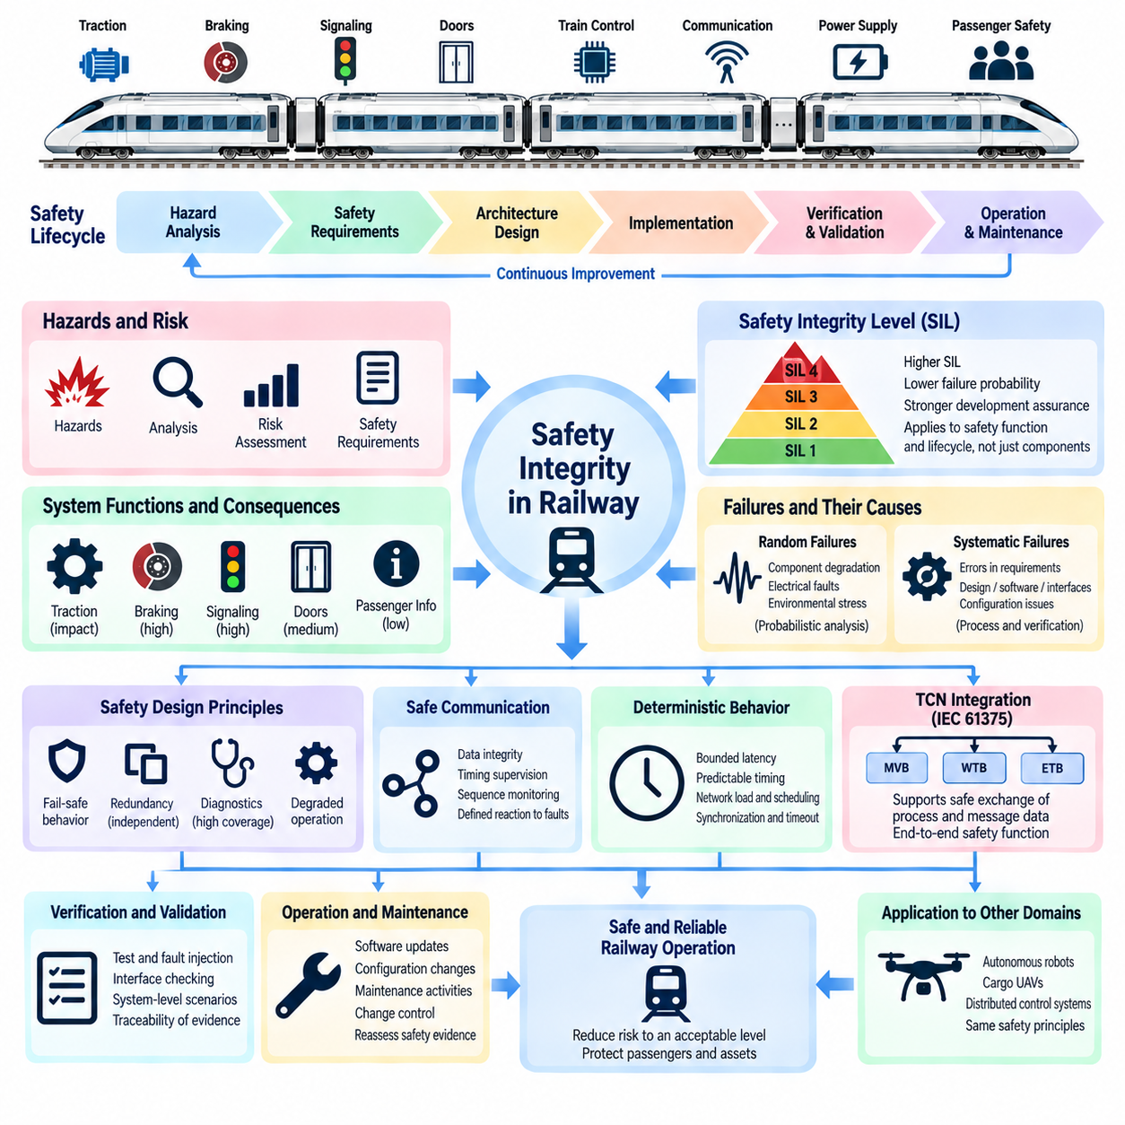
Railway safety integrity describes the degree of confidence that safety-related functions will perform correctly when required and will not introduce unacceptable risk through systematic or random failures. In railway engineering, safety is therefore not treated as a property added after implementation. It is established through a structured lifecycle connecting hazard analysis, system requirements, architecture, implementation, verification, validation, operation, and maintenance.
A railway system contains many interacting subsystems, including traction, braking, signaling, doors, train control, communication networks, power equipment, and passenger protection systems. Failure consequences vary greatly among these functions. A malfunction affecting passenger information may reduce service quality, whereas an incorrect braking or movement-authority command can create a hazardous condition. Safety engineering therefore evaluates functions according to their potential consequences.
The concept of safety integrity provides a systematic method for determining how much risk reduction must be provided by a safety-related function. Hazards are identified, their causes and consequences are analyzed, and appropriate safety requirements are allocated to systems and subsystems. The required integrity influences architecture, redundancy, diagnostics, development processes, verification rigor, and evidence needed to demonstrate that residual risk has been reduced to an acceptable level.
Railway safety engineering commonly uses Safety Integrity Levels (SILs) to express different levels of required integrity. Higher SIL requirements correspond to functions for which failure must be made increasingly unlikely and for which stronger development assurance is necessary. SIL should not be interpreted simply as a component quality ranking. It applies to safety functions and their lifecycle assurance, including hardware, software, communication, diagnostics, verification, and operational assumptions.
An important distinction exists between random hardware failures and systematic failures. Random failures arise from physical mechanisms such as component degradation, electrical faults, or environmental stress and can often be analyzed probabilistically. Systematic failures originate from errors in requirements, architecture, software, interfaces, configuration, or engineering processes. Their reduction depends heavily on disciplined development methods, independent verification, traceability, testing, and configuration control.
Hazard analysis establishes the foundation of safety integrity. Engineers examine operating scenarios, abnormal conditions, equipment failures, communication faults, human interactions, and environmental influences to identify situations capable of causing harm. Safety requirements are then derived to prevent hazardous events, detect failures, limit their consequences, or place the railway system into a defined safe state when continued normal operation cannot be guaranteed.
Fail-safe behavior is a fundamental railway design principle, but it does not mean that every failure immediately stops the entire train. Instead, the system should respond to detected faults in a manner consistent with the safety requirements of the affected function. Depending on the architecture, this may involve emergency braking, inhibition of movement, isolation of faulty equipment, degraded operation, restricted functionality, or transfer to a redundant control channel.
Redundancy can increase safety integrity when independent channels prevent a single failure from causing a hazardous outcome. However, duplicated hardware alone does not guarantee safety because redundant channels may share power supplies, communication paths, software defects, environmental exposure, or incorrect requirements. Common-cause and common-mode failures must therefore be considered when designing redundant controllers, sensors, networks, power systems, and voting mechanisms.
Diagnostics provide another major layer of protection. Safety-related equipment continuously or periodically checks processor execution, memory integrity, communication status, sensor plausibility, power conditions, input and output behavior, and internal faults. Diagnostic coverage determines how effectively dangerous failures can be detected before they contribute to a hazardous event. Detected faults must also trigger an appropriate and predictable system response.
Communication networks become part of the safety argument when safety-related information is transmitted between distributed railway controllers. Messages may be corrupted, repeated, lost, delayed, reordered, inserted, or delivered to an incorrect destination. Safety communication mechanisms therefore use techniques such as sequence monitoring, timing supervision, source and destination identification, integrity checks, freshness information, and defined reactions to communication failures.
Deterministic communication is closely related to safety integrity because correct data that arrives too late may be functionally equivalent to incorrect data. Safety-related railway control therefore requires explicit timing assumptions and bounded communication behavior. Network load, gateway delays, scheduling, synchronization, fault recovery, and timeout mechanisms must be considered when determining whether information can reach its destination within the required safety response time.
The Train Communication Network (TCN) defined by IEC 61375 provides the communication architecture through which many distributed railway devices exchange process and message data. TCN technologies such as MVB, WTB, and later Ethernet-based train networks must be integrated with the safety requirements of the applications using them. The communication network provides transport mechanisms, while the complete safety function depends on end-to-end system behavior.
Verification and validation are essential because safety integrity must be demonstrated through evidence rather than assumed from design intent. Requirements are reviewed for completeness and consistency, implementations are tested against specified behavior, interfaces are examined, fault conditions are injected where appropriate, and system-level scenarios are validated. Traceability connects identified hazards to safety requirements, design elements, implementation, tests, and final verification evidence.
Safety integrity continues throughout the operational lifecycle. Software updates, replacement components, network configuration changes, maintenance activities, and modifications to train composition can alter assumptions established during development. Configuration management and change control are therefore safety activities rather than purely administrative processes. Any significant modification must be assessed to determine whether previous hazard analyses, tests, or safety evidence remain valid.
For autonomous robots, cargo UAVs, and Physical AI systems, railway safety integrity offers a valuable engineering model. These platforms similarly combine distributed sensors, controllers, communication networks, actuators, power systems, and intelligent computing. The transferable principle is that safety cannot depend solely on AI accuracy or component reliability; hazards, communication failures, timing, redundancy, diagnostics, degraded operation, and lifecycle evidence must be addressed as one coordinated system.

01.03. Deterministic Communication Principle
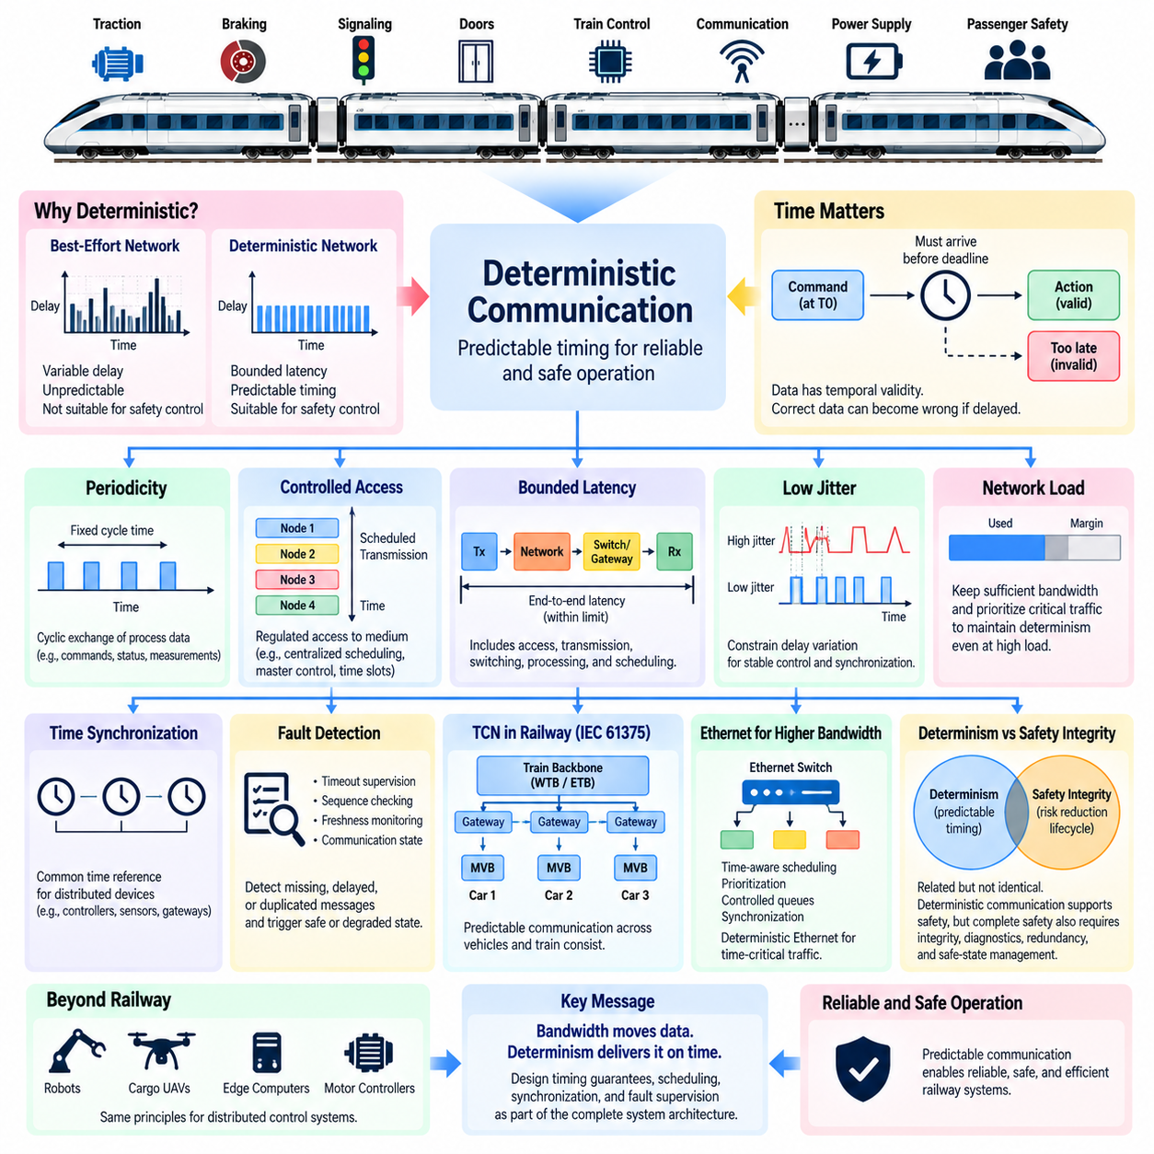
Deterministic communication is a networking principle in which the timing of data delivery is predictable within defined limits. In railway systems, successful communication is not determined only by whether a message eventually reaches its destination. Control information must also arrive before a specified deadline, because delayed braking, traction, door, or signaling information can become functionally incorrect even when the transmitted data itself is valid.
This requirement distinguishes deterministic networks from conventional best-effort communication. In a best-effort network, packets compete for available resources and transmission delays may vary according to traffic conditions. Such behavior is acceptable for many information services, but safety-related railway control requires bounded latency, controlled network access, and predictable response times so that system behavior can be analyzed before deployment.
A deterministic communication system therefore considers time as part of the information being transferred. A control value has both logical meaning and temporal validity. For example, a speed command generated at one instant may no longer represent the correct operating condition after an excessive delay. Railway communication architectures consequently define timing constraints that determine when information must be transmitted, received, processed, and considered invalid.
Periodicity is one method used to establish predictable communication. Many railway control variables are exchanged cyclically at predefined intervals, allowing controllers to know when new information should become available. Periodic process data can include commands, equipment states, measurements, and status information. A stable communication cycle simplifies scheduling and allows missing or excessively delayed updates to be detected through timing supervision.
Controlled access to the communication medium is equally important. If multiple devices transmit without coordinated access, collisions, congestion, or unpredictable waiting times can occur. Deterministic networks therefore employ mechanisms that regulate when each participant may transmit. Depending on the technology, this can involve centralized scheduling, master-controlled communication, predefined transmission opportunities, traffic classes, or time-aware scheduling of network resources.
Bounded latency represents the maximum acceptable time between generation of information and its required reception. The complete latency is not limited to cable transmission time. It can include waiting for network access, frame transmission, switching or gateway delays, protocol processing, receiving-node execution, and scheduling delays. End-to-end timing analysis must therefore examine the entire communication path rather than only the nominal network data rate.
Jitter is another important characteristic because repeated messages may experience different transmission delays even when their average latency remains acceptable. Excessive jitter can disturb control loops, synchronization, sensor fusion, and coordinated actuator behavior. Deterministic communication attempts to constrain this variation so that cyclic tasks and distributed controllers can operate using known timing assumptions instead of continuously adapting to unpredictable network behavior.
Network load must also remain controlled. A communication system that behaves predictably at low utilization may become nondeterministic when traffic approaches its capacity. Railway network engineering therefore considers bandwidth allocation, message priorities, communication cycles, maximum frame sizes, gateway traffic, and abnormal conditions. Sufficient communication margin is required so that critical traffic remains predictable even when other network services generate additional load.
Time synchronization complements deterministic transmission when distributed devices must share a common temporal reference. Controllers, sensors, gateways, and monitoring equipment may need synchronized clocks to correlate events, evaluate message freshness, coordinate scheduled transmissions, or reconstruct failures. Synchronization accuracy must be appropriate for the control function, because precise network scheduling has limited value if participating devices disagree significantly about time.
Fault detection is closely connected to deterministic behavior. A receiver can detect missing information when it knows when a message should have arrived. Timeout supervision, sequence checking, freshness monitoring, and communication-state monitoring allow controllers to distinguish valid current information from delayed, duplicated, or missing data. Once a communication fault is detected, the application must perform a defined transition to a safe or degraded operating state.
The Train Communication Network (TCN) defined by IEC 61375 applies these principles to distributed railway communication. Traditional technologies such as the Multifunction Vehicle Bus (MVB) support predictable exchange of process data within vehicles, while train-level networks connect communication domains across a consist. Gateways must preserve the required timing behavior when information crosses network boundaries because gateway processing becomes part of the end-to-end communication path.
Modern railway systems increasingly use Ethernet-based communication, including the Ethernet Train Backbone (ETB). Ethernet provides substantially higher bandwidth, but high bandwidth alone does not guarantee determinism. Switching behavior, queues, competing traffic, prioritization, scheduling, synchronization, and congestion must still be controlled. Modern deterministic Ethernet technologies therefore combine Ethernet capacity with mechanisms intended to provide predictable delivery for time-critical traffic.
Determinism and safety integrity are related but should not be treated as identical concepts. Deterministic communication provides predictable timing characteristics, while safety integrity addresses whether a safety-related function achieves the required level of risk reduction throughout its lifecycle. A deterministic network can support a safety function, but complete safety also depends on message integrity, fault detection, system architecture, software behavior, redundancy, diagnostics, and safe-state management.
The principle extends naturally beyond railway systems. Autonomous robots, cargo UAVs, and Physical AI platforms contain distributed sensors, edge computers, motor controllers, flight controllers, and actuators operating at different update rates. Their communication architecture must distinguish high-rate control traffic from slower perception, diagnostics, logging, and fleet data. Deterministic interfaces can prevent noncritical traffic from interfering with time-sensitive control paths.
The central engineering lesson is that communication performance should be specified using timing guarantees rather than average speed alone. Bandwidth determines how much information a network can transport, but deterministic behavior determines whether critical information arrives when the system needs it. Designing latency bounds, communication cycles, scheduling, synchronization, fault supervision, and degraded behavior together creates a network whose temporal behavior can be verified as part of the complete system architecture.

01.04. Railway Network Topology
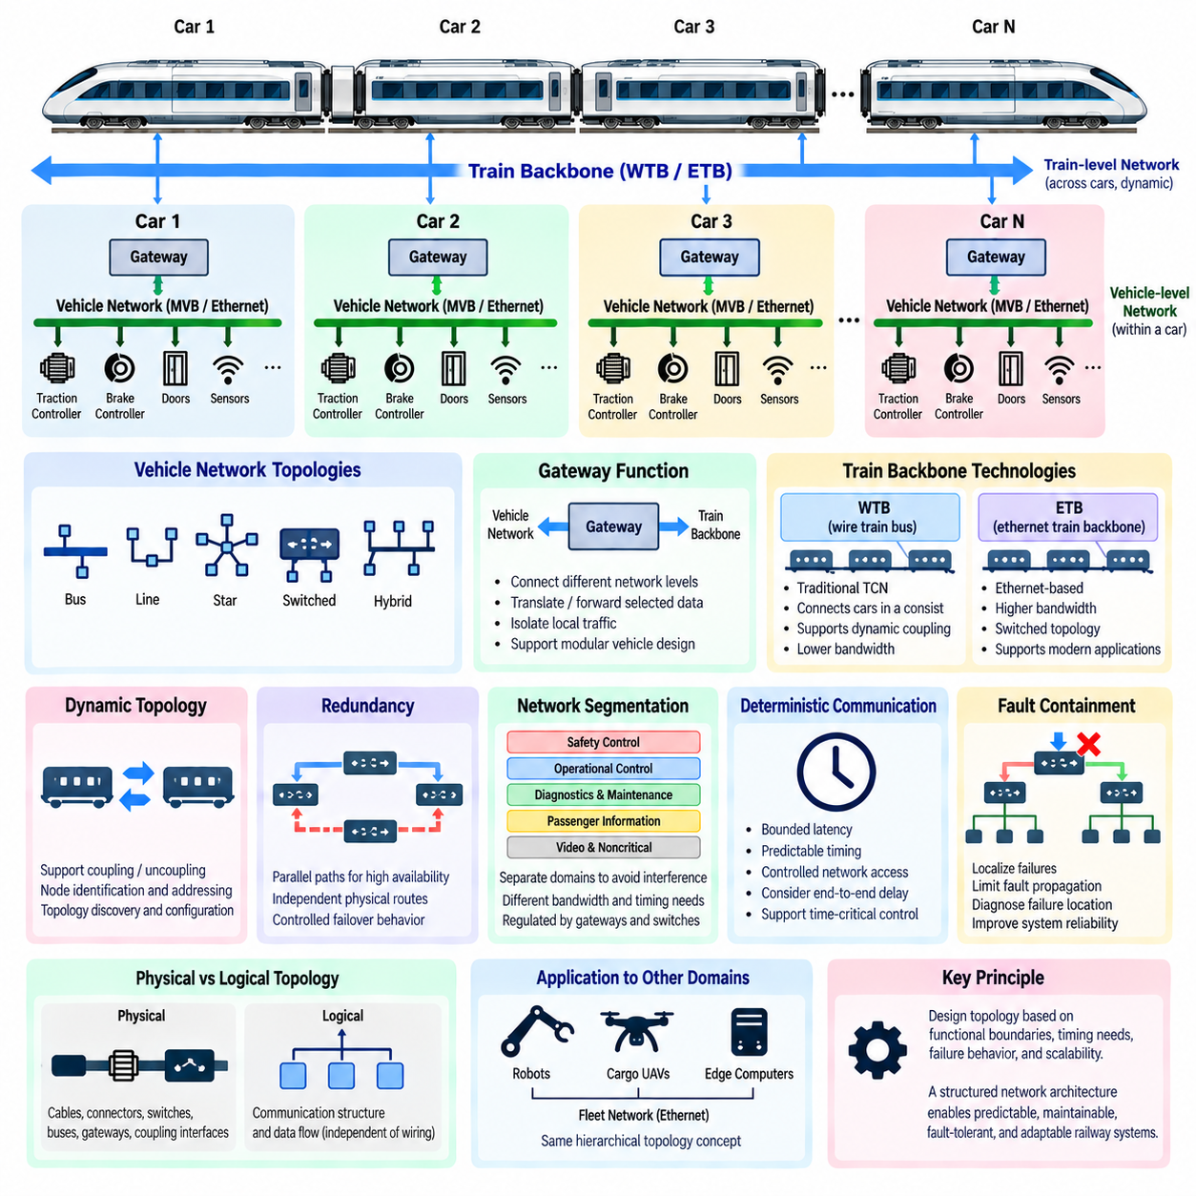
Railway network topology defines how communication devices, vehicle networks, train backbones, gateways, and redundant paths are physically and logically interconnected across a railway system. Unlike a fixed industrial machine, a train consists of multiple vehicles that may be coupled or separated during operation. The topology must therefore support both stable communication inside individual vehicles and adaptable communication across the complete train consist.
At the lowest architectural level, electronic devices are connected within a vehicle or functional subsystem. Controllers, sensors, traction equipment, braking units, door controllers, passenger systems, and diagnostic devices exchange information through a local communication network. This vehicle-level topology limits unnecessary train-wide traffic and allows time-critical control functions to remain close to the equipment that produces and consumes their data.
A vehicle network can use bus, line, star, switched, or hybrid arrangements depending on the communication technology and system requirements. Traditional railway networks frequently employ shared-bus structures because they provide predictable communication with relatively simple wiring. Modern Ethernet-based systems increasingly use switched topologies, where devices or subnetworks connect through Ethernet switches that provide greater bandwidth and more flexible traffic management.
The Multifunction Vehicle Bus (MVB) is traditionally associated with communication among devices inside railway vehicles or fixed consists. Its topology supports distributed controllers exchanging process and message data through a controlled communication environment. MVB allows vehicle equipment to participate in a coordinated network without requiring every device to communicate directly with equipment located throughout the entire train, preserving clear architectural boundaries.
Above the vehicle network is the train-level backbone, which connects communication domains located in different vehicles or consists. The Wire Train Bus (WTB) was designed for this role in traditional Train Communication Network (TCN) architecture. Because railway vehicles can be coupled and uncoupled, the backbone must accommodate changes in physical train composition and establish a logical network corresponding to the currently connected consist.
This dynamic topology requirement is one of the major differences between railway communication and many conventional embedded networks. A train assembled from several consists may not always contain the same number or sequence of vehicles. Communication nodes therefore require mechanisms for identification, addressing, topology discovery, and configuration so that train-wide functions can determine which communication participants are currently present and how they are interconnected.
Gateways form the architectural boundary between different network levels. A gateway may connect a vehicle network to the train backbone, translate or forward selected information, isolate local traffic, and prevent every local device from needing direct knowledge of the complete train network. Gateway-based topology therefore supports modular vehicle design while allowing train-level controllers and management systems to access information required from distributed subsystems.
Modern railway communication extends this hierarchical concept through the Ethernet Train Backbone (ETB). ETB provides higher-bandwidth Ethernet connectivity across train consists and can support applications that would be difficult to accommodate using earlier low-bandwidth buses. Switched Ethernet enables flexible logical connections, but network topology must still control traffic paths, switching delays, priorities, redundancy, and failure propagation for critical railway applications.
Physical topology and logical topology should be distinguished. Physical topology describes actual cables, connectors, switches, buses, gateways, and coupling interfaces. Logical topology describes how devices communicate and how data flows between applications regardless of the exact wiring arrangement. A physically redundant network, for example, may present a simpler logical communication structure to applications while maintaining multiple physical paths underneath.
Redundancy is an important topology consideration because a single cable, connector, switch, or gateway failure should not necessarily disable critical train communication. Redundant paths can provide alternative routes when faults occur, but their effectiveness depends on physical independence and controlled failover behavior. Routes that share the same connector, power supply, cable bundle, or vulnerable installation location may still be affected by a common-cause failure.
Network segmentation also improves reliability and manageability. Safety-related control, operational control, diagnostics, passenger information, video, and maintenance services may have very different bandwidth and timing requirements. Separating communication domains can prevent high-volume or noncritical traffic from interfering with deterministic control traffic. Gateways and switches can then regulate which information is allowed to cross boundaries between these domains.
Topology directly affects deterministic communication performance. Every bus access mechanism, switch, gateway, and network transition introduces some combination of transmission and processing delay. A communication path that crosses several network domains may therefore have significantly different timing characteristics from a local vehicle-level path. Railway architecture must evaluate end-to-end latency rather than assuming that high nominal bandwidth automatically provides predictable communication.
Fault containment is another reason for organizing railway networks hierarchically. If all equipment were connected through one unrestricted communication domain, a malfunctioning node or excessive traffic source could affect a large portion of the system. Segmented topology allows faults to be localized, while gateways and switches can limit propagation. Diagnostics can also identify whether a failure originates from a device, local network, backbone, gateway, or coupling interface.
The railway topology concept provides a useful reference for autonomous robots, cargo UAVs, and Physical AI fleets. An individual platform can contain local actuator and sensor networks connected to an edge computer, while a higher-level Ethernet backbone integrates perception, control, diagnostics, and payload systems. Multiple autonomous platforms can then communicate through a fleet network, creating a hierarchy analogous to device, vehicle, and train-level communication.
The central architectural principle is to design topology according to functional boundaries, timing requirements, failure behavior, and system scalability rather than simply connecting every available device to one network. Vehicle networks, train backbones, gateways, redundant paths, and logical communication domains together create a structured communication architecture. This hierarchy allows railway systems to remain predictable, maintainable, fault-tolerant, and adaptable as train configurations and communication technologies evolve.

01.05. Relevance to Cargo UAV
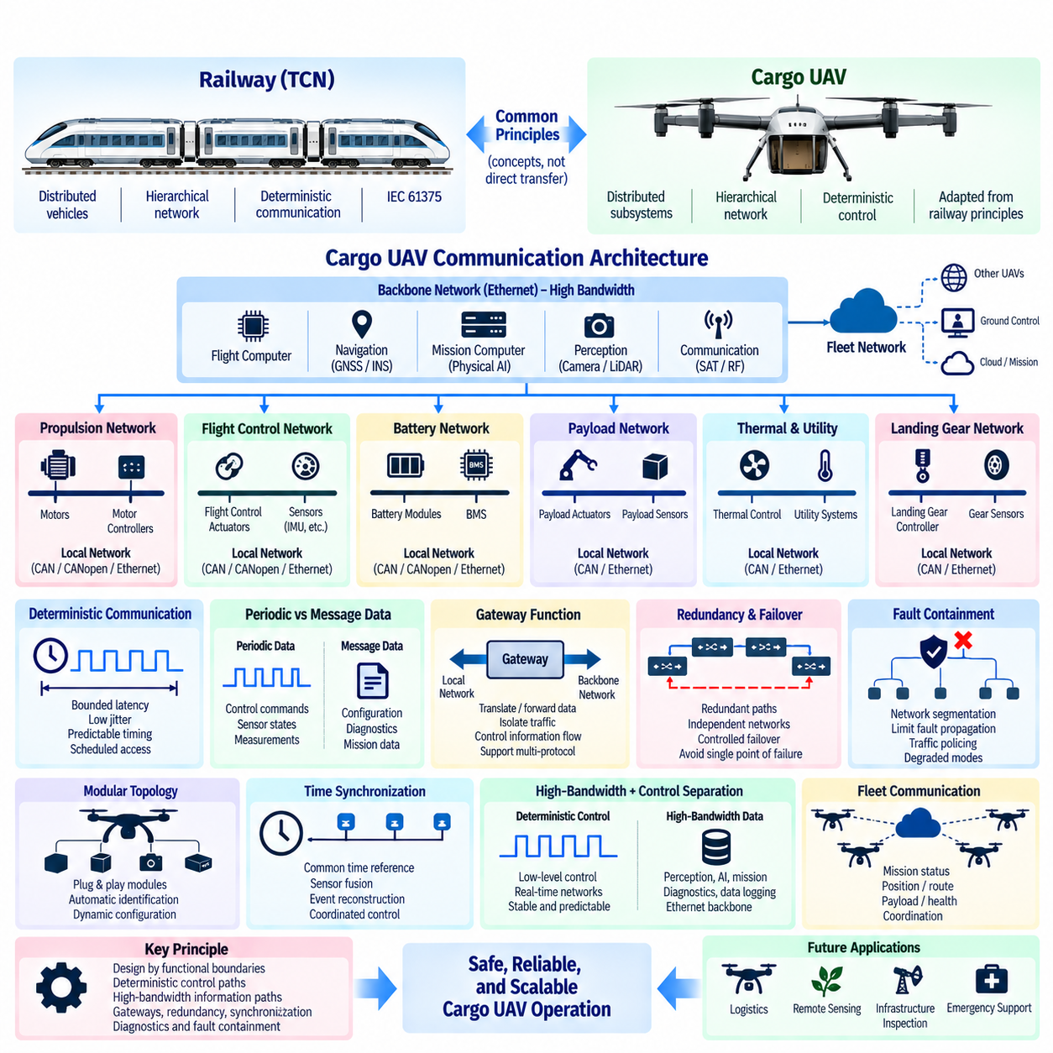
The communication principles introduced by railway systems provide a useful engineering reference for cargo UAV architecture because both domains operate complex mobile platforms containing many distributed electronic subsystems. A cargo UAV may integrate flight control, propulsion, battery management, navigation, payload handling, sensing, communication, and mission computers, creating communication challenges similar to those encountered in distributed railway vehicles.
The relevance does not imply that Train Communication Network (TCN) technologies should be transferred directly into an aircraft. Railway and aerospace platforms operate under different environmental, certification, weight, bandwidth, and safety constraints. Instead, concepts established through IEC 61375 can be studied as architectural patterns for organizing distributed communication into clearly separated local networks, backbone networks, gateways, and supervisory communication domains.
A large cargo UAV can contain numerous propulsion units, motor controllers, battery modules, actuators, sensors, and local embedded controllers. Connecting every component directly to one central computer would increase wiring complexity, communication traffic, and failure propagation. A hierarchical architecture can instead group related equipment into local communication domains and connect those domains through higher-level backbone networks.
This structure resembles the separation between vehicle-level and train-level communication in railway systems. Local UAV networks can support propulsion, flight-control actuators, landing gear, payload mechanisms, or battery subsystems, while a higher-level backbone connects flight computers, navigation systems, mission computers, perception processors, and communication gateways. Functional separation makes interfaces clearer and allows each network domain to be engineered according to its timing and reliability requirements.
Deterministic communication is particularly relevant to cargo UAV control. Propulsion commands, actuator states, flight-control measurements, and safety information must arrive within known timing limits. High average bandwidth alone cannot guarantee correct control behavior. Communication architecture must consider bounded latency, jitter, update periods, scheduling, synchronization, network loading, and timeout behavior as part of the complete end-to-end control path.
The railway distinction between periodic process data and message-oriented data also provides a useful analogy. Cargo UAVs continuously exchange cyclic information such as actuator commands, motor status, inertial measurements, battery states, and flight-control variables. Configuration parameters, diagnostic reports, maintenance records, mission information, and software-management traffic can tolerate different communication characteristics and should not unnecessarily interfere with time-critical control traffic.
Gateway-based architecture is another transferable principle. A cargo UAV may contain CAN, CANopen, Ethernet, serial interfaces, avionics networks, or other specialized communication technologies. Gateways can connect these domains while controlling which information crosses architectural boundaries. This allows low-level controllers to remain isolated from high-bandwidth perception or mission traffic while still providing required information to supervisory computers.
Redundancy becomes increasingly important as cargo UAV size and payload capacity increase. A communication failure affecting a small subsystem should not automatically disable every critical function. Independent network paths, redundant controllers, duplicated sensors, alternative power sources, and controlled failover mechanisms can reduce single points of failure. However, physical separation is necessary because duplicated networks routed through the same vulnerable location may share the same failure mechanism.
Fault containment is therefore as important as redundancy. Communication domains should be structured so that a malfunctioning sensor, controller, switch, or software service cannot generate uncontrolled traffic that disrupts flight-critical communication. Segmentation, gateways, traffic policing, priority mechanisms, health monitoring, and defined degraded modes can limit failure propagation and help the system maintain essential functionality after faults occur.
Dynamic topology in railway systems also offers an interesting conceptual analogy for modular cargo UAVs. Railway consists change when vehicles are coupled or uncoupled, while future cargo UAV platforms may support interchangeable payload modules, battery packs, sensor packages, mission equipment, or detachable subsystems. Automatic identification and configuration mechanisms can allow the platform to recognize installed modules and establish the appropriate communication configuration.
Time synchronization becomes essential when information from distributed systems must be combined. Cameras, LiDAR, radar, GNSS, IMUs, flight controllers, edge computers, and payload sensors may operate at different rates and generate independent timestamps. A shared temporal reference enables sensor fusion, event reconstruction, coordinated control, fault analysis, and deterministic scheduling. The required synchronization accuracy should be derived from the functions that depend on the data.
Modern Ethernet-based railway architectures provide another useful reference because cargo UAVs increasingly require communication between conventional embedded control and high-bandwidth computing. Cameras and perception systems can generate far more data than traditional control buses can efficiently transport. A layered architecture can therefore retain deterministic embedded networks for low-level control while using higher-bandwidth Ethernet for perception, mission computing, diagnostics, and data aggregation.
This separation is especially relevant to Physical AI functions. AI perception, world models, autonomous planning, and mission-level reasoning may operate on powerful edge computers, while flight stabilization and actuator control require much faster and more predictable execution. The communication architecture should preserve this boundary so that variable AI computation or high-volume sensor processing cannot directly disturb the deterministic control loops responsible for vehicle stability.
A fleet of cargo UAVs introduces another communication hierarchy above the individual aircraft. Each UAV can maintain its own safety-critical internal networks while exchanging mission status, position, route, payload, health, and coordination information through a fleet communication layer. This resembles the architectural idea of maintaining local control domains while connecting multiple mobile units through a higher-level communication structure.
The main lesson transferred from railway communication is therefore architectural rather than protocol-specific. Cargo UAV communication should be designed as coordinated layers with explicit functional boundaries, deterministic control paths, high-bandwidth information paths, gateways, redundancy, synchronization, diagnostics, and fault containment. Applying these principles can help large autonomous aircraft evolve from collections of interconnected devices into structured, scalable, and safety-oriented distributed systems.

